SMTP(Simple Mail Transfer Protocol)
Package Name : postfix
Configuration file : /etc/postfix/main.cf
Port number : 25
Service name : postfix.service
Postfix:
Postfix is a software program that acts as a mail server on Linux systems. Its main job is to send and receive emails between computers over the internet.
Install package:
# yum install postfix
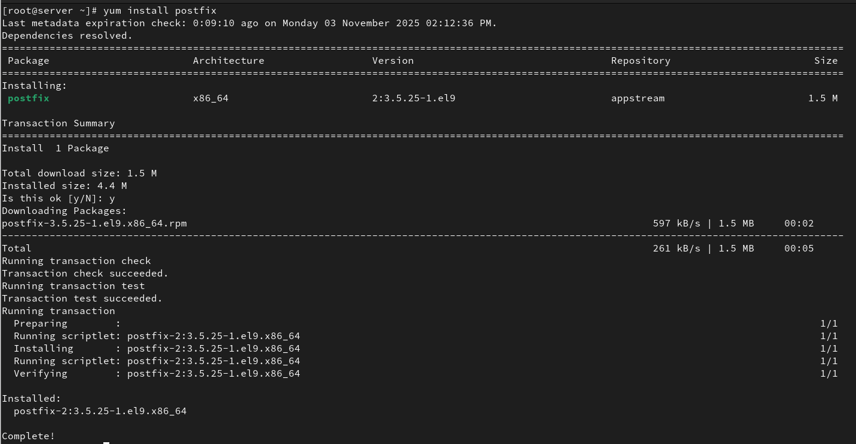

Start and enable Postfix so it runs after a reboot:
# systemctl enable --now postfix.service

Edit configuration file:
#vi /etc/postfix/main.cf

Restart the service
# systemctl restart postfix.service
Create a user
# useradd mailuser
Sending mail to a user:
# mail -s "Test Email" mail@localhost
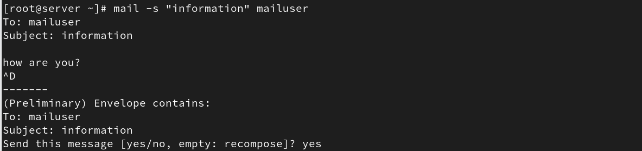

To check logs of mail:
# tail /var/log/maillog
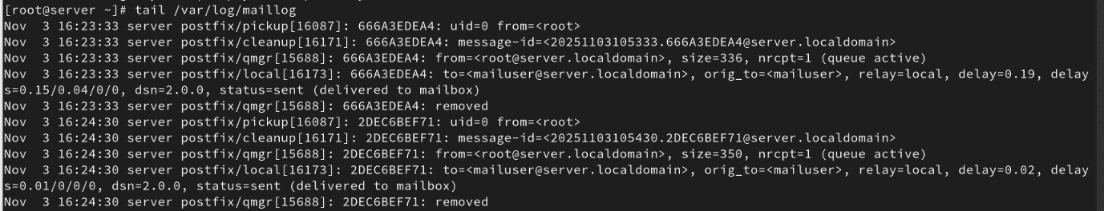
Check mail is send to another user:
# su – mailuser
# mail
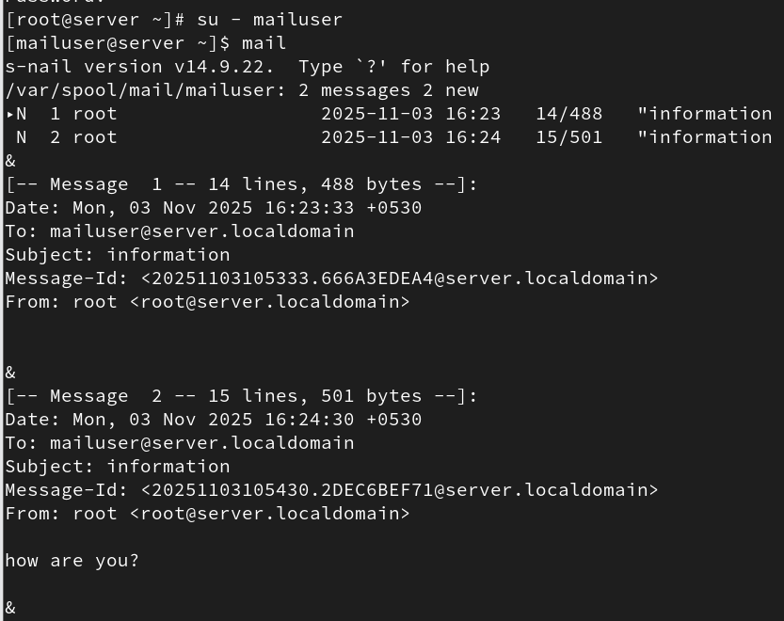

Create one user and add multiple users in config file:
# vi /etc/ aliases

Save the file and update aliases:
# newaliases
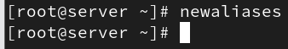

Send mail to a group:
# mail -s “subject” groupname
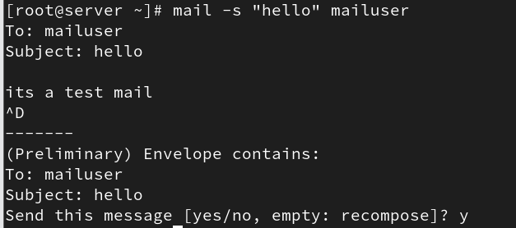

Check mail is send to 2 users:
