Kernel Panic / initramfs Recovery

Overview
To fix kernel panic issues caused by missing or corrupted initramfs files in CentOS 9, using Rescue Mode and dracut to regenerate the missing kernel files.

Step 1: Check /boot Directory and initramfs Files
• Boot process loads GRUB from /boot.
• GRUB loads the kernel (vmlinuz) and initramfs.
• If initramfs is missing or corrupted, system fails to boot.
• Navigate to /boot and list initramfs files.
• /boot modifications require root privileges.
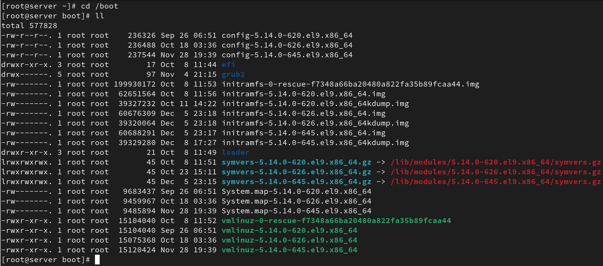

Step 2: Remove Corrupted initramfs File
• Remove the corrupted or problematic initramfs file from /boot.
• This file will later be regenerated using rescue mode.
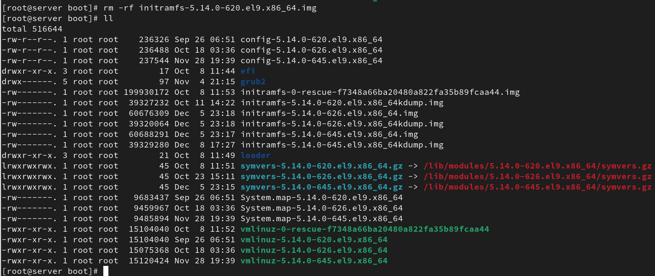

Step 3: Reboot and Remove ‘autonist’ Entry
• Reboot the system.
• Before rebooting, open VM settings → Hard Disk.
• Remove the entry labeled 'autonist'.
• Save and reboot again.

Step 4: Boot From CD-ROM
• While the system restarts, press ESC within 5 seconds.

• Open the boot menu.
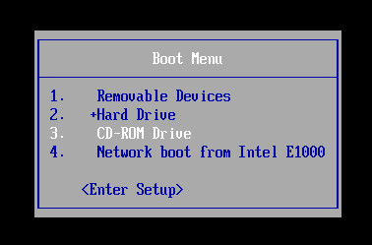

• Select **CD-ROM Drive** to boot from installation media.

Step 5: Enter Rescue Mode
• On CentOS installation screen, select 'Troubleshooting'.
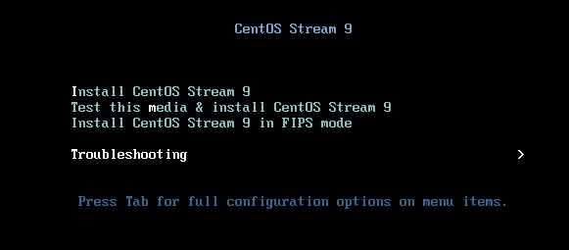

• Select 'Rescue a CentOS Stream system'.

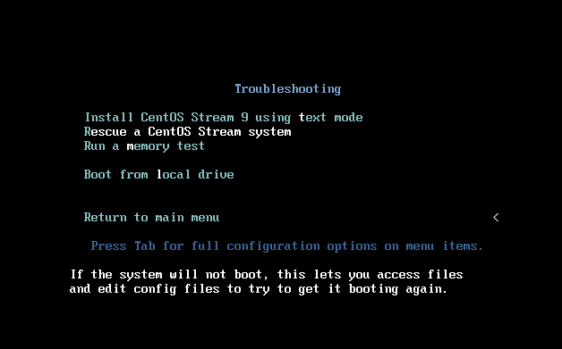
• System loads rescue environment.

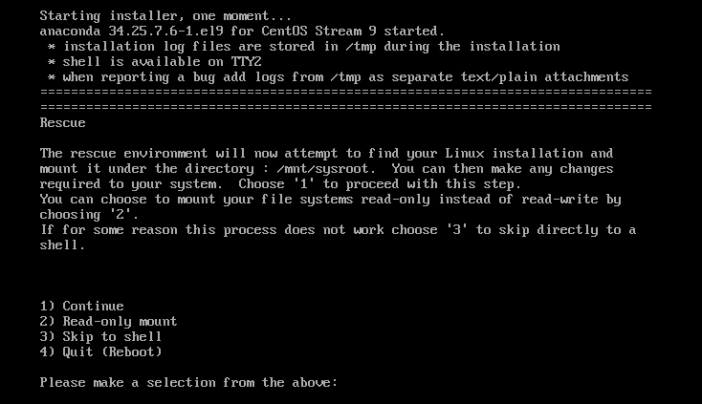

• Press 1 to continue.

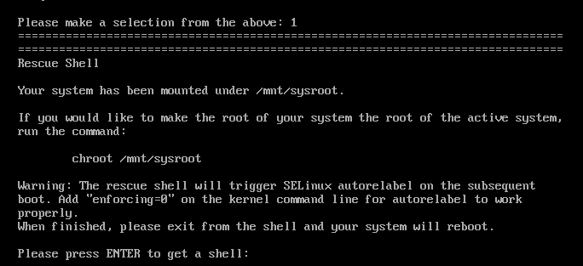

• Enter the rescue shell.

Step 6: Regenerate initramfs Using dracut
Run the following commands:

1) chroot /mnt/sysroot
- Changes root directory to installed system.

2) dracut --regenerate-all --force
- Rebuilds initramfs for all installed kernels.
- Fixes missing/broken kernel initramfs images.

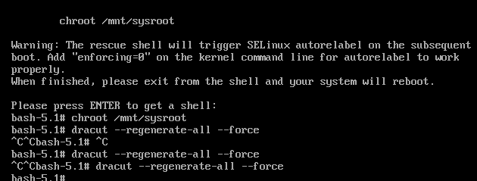

Step 7: Reboot and Verify
• Exit chroot and reboot system.
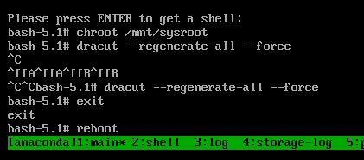
• After system boots normally, log in as root.
• Navigate to /boot and verify that the missing initramfs file is now restored.
