Patching

1. What is Patching?
Patching means applying updates to the operating system or software to fix bugs, close security holes, or add features.

Example: Updating packages using yum, installing packages, and applying Linux software and kernel updates.

2. Types of Patching

Security Patching:
• Security team scans packages weekly and provides reports. OS packages are scanned once every 3 months.
• Purpose: Fix security vulnerabilities or loopholes that could be exploited by attackers.
• Severity:
- High = Fix high priority issues
- Medium = Medium priority issues
- Low = Low priority issues
• Frequency: Often released urgently or monthly.
• Examples: OS security updates, antivirus definitions, CVE fixes.

Normal or Regular Patching:
• Purpose: Improve stability, fix bugs, or enhance features (not security-focused).
• Frequency: Periodic vendor-released updates.
• Examples: Minor version updates, bug fixes, driver updates.

Complete Patch (Full/Service Pack or Cumulative Update):
• Purpose: A comprehensive update with all previous patches (security + functional) and major changes.
• Frequency: Less frequent, usually after major releases.
• Examples: Windows Service Packs, cumulative patches, firmware updates.

3. Verify OS Version and Release
cat /etc/os-release:
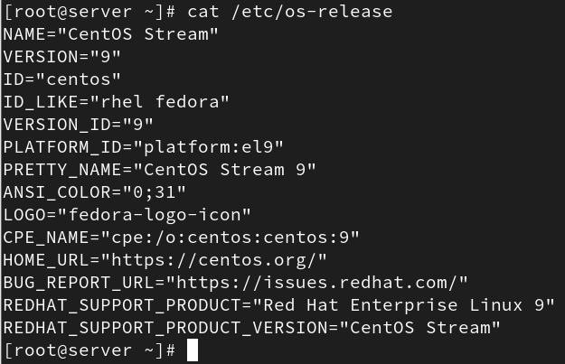

• Displays detailed OS information.
• Works on most modern Linux distributions.
• Output includes:
- NAME
- VERSION
- ID
- PRETTY_NAME
- VERSION_ID

cat /etc/redhat-release:
• Shows OS version (one line).
• Used in RHEL/CentOS/Fedora.
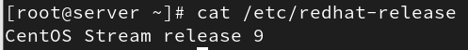

hostnamectl:
• Displays system information including OS version, kernel, architecture.
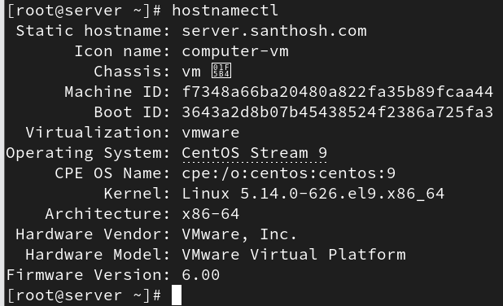

4. Practical Work: Patching, Updates, and Installing Packages

Dry Run:
A dry run downloads and stores packages in cache without installing them.

Edit yum config:
vi /etc/yum.conf
Add:
tsflags=test
This simulates the transaction without actual installation.
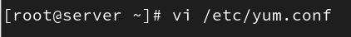

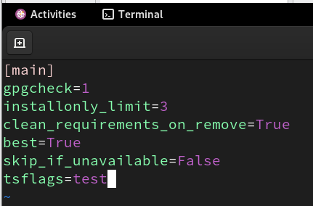

Before that:
yum clean all → Clears stored packages.

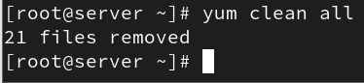

Check for updates:
yum check-update
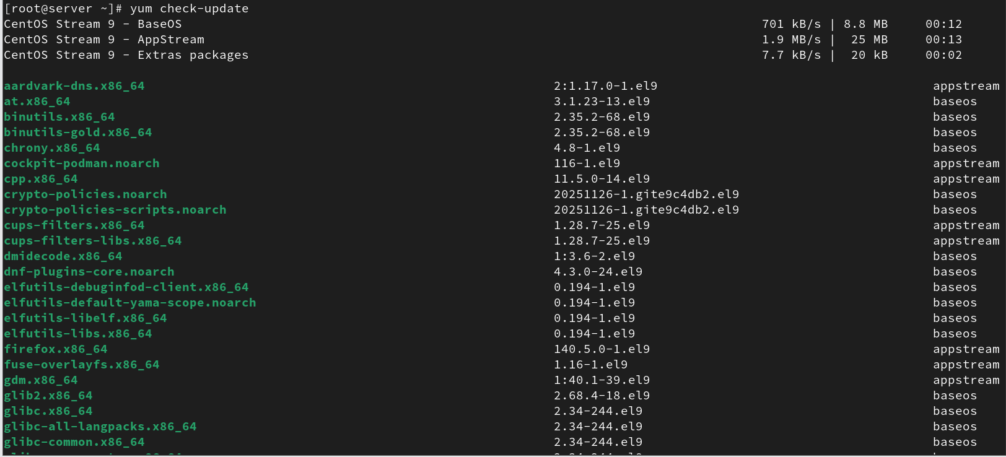

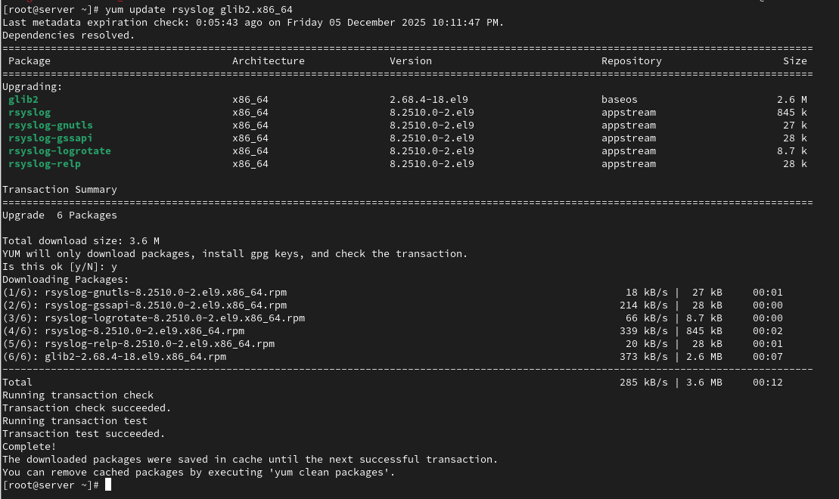

Using tsflags=test:
yum update webkit2gtk3-jsc.x86_64
Packages are downloaded and stored in cache but not installed.
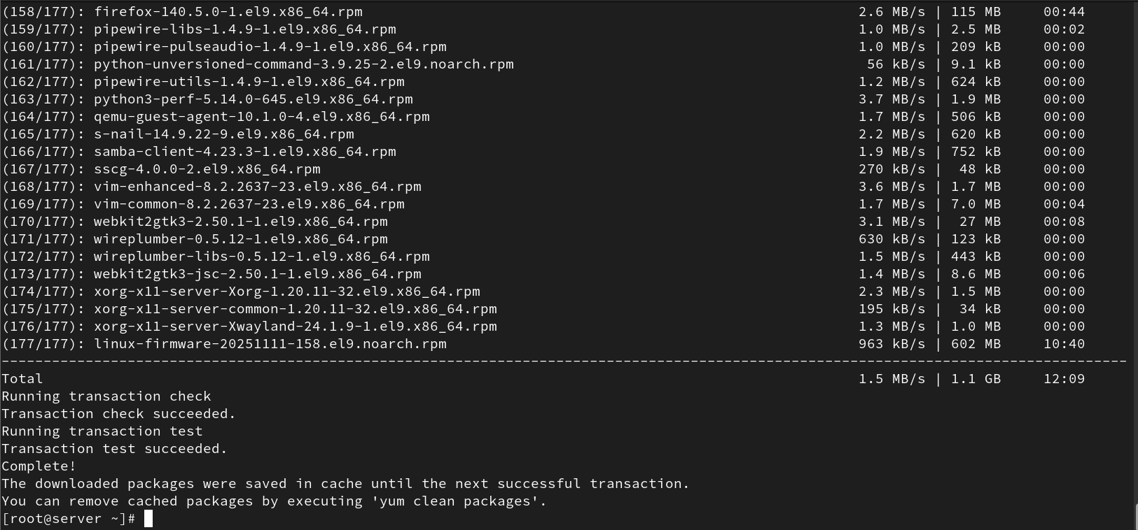

Without tsflags=test:
Remove tsflags=test from /etc/yum.conf

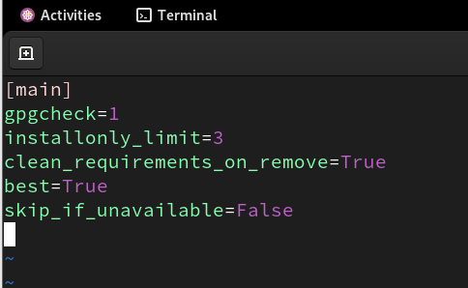

Then run:
yum update
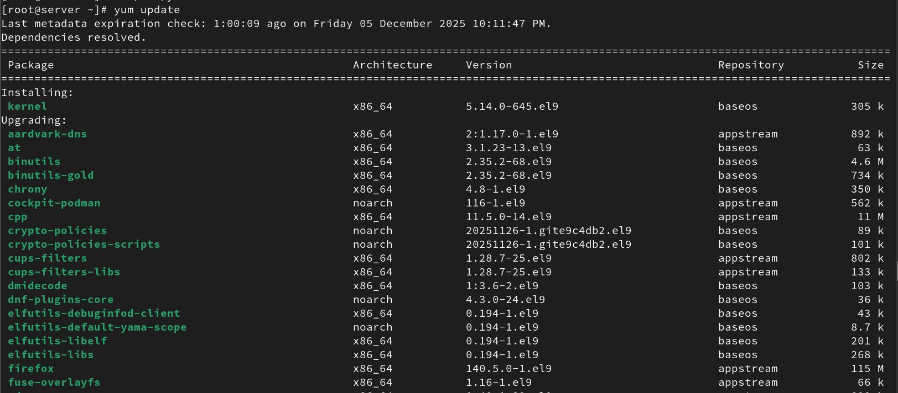

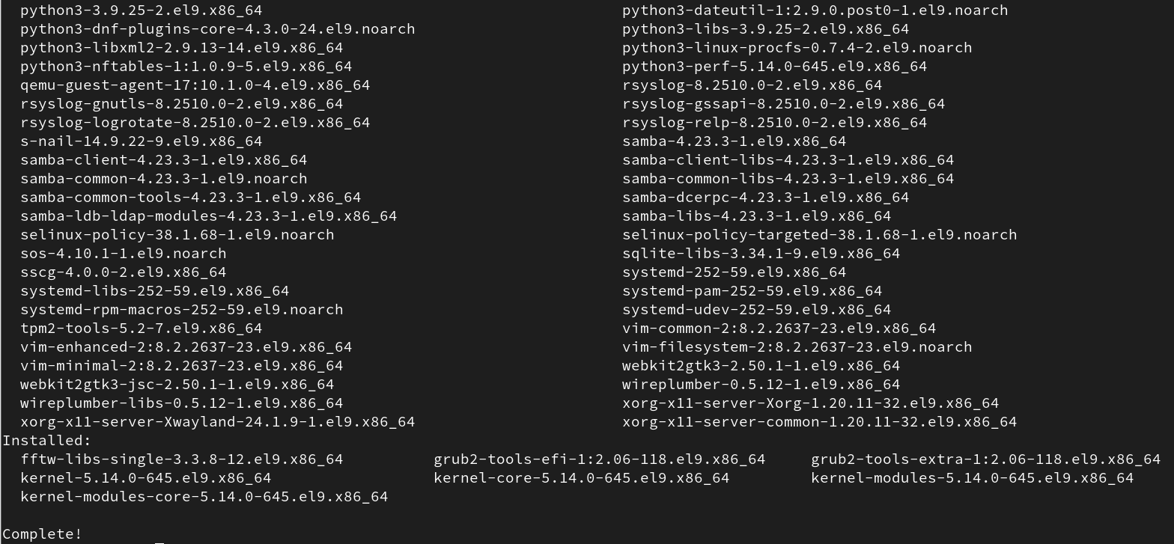

Downloaded packages are stored under:
/var/cache/dnf/appstream/packages/

Once updated, they will no longer appear in the cache.

