Swap
Swap is a space on a disk that is used when the amount of physical RAM memory is full. When a Linux system runs out of RAM, inactive pages are moved from the RAM to the swap space. Swap space can take the form of either a dedicated swap partition or a swap file.

Checking Swap
To check swap usage:
- # free -m
# free -g
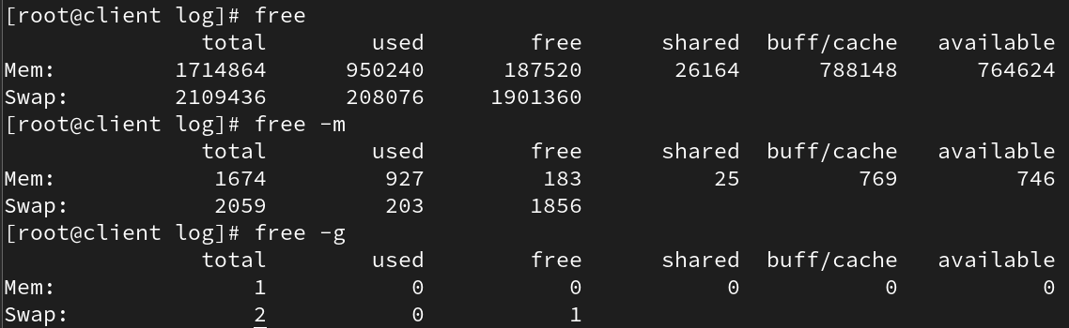

Creating Swap Space
Swap can be created in two ways:
- Disk Partition,
- File
To check available space:
# df -h
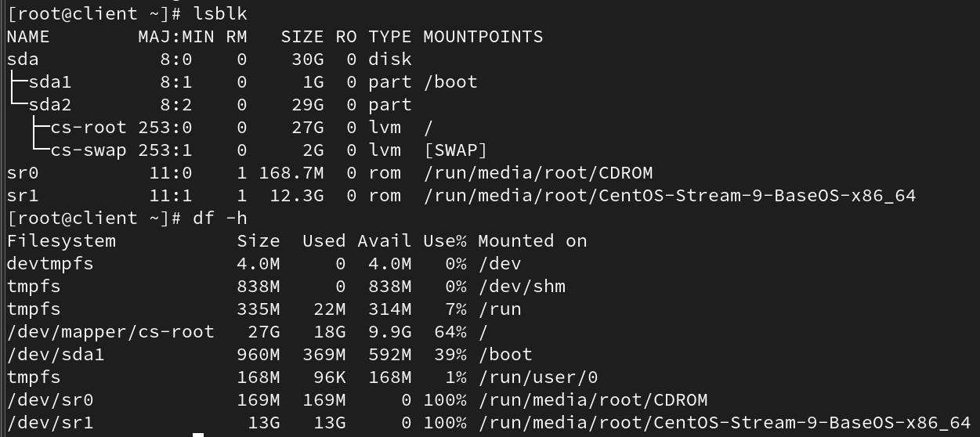

Steps to create a swap file:
- Create file with specific size:
# fallocate -l 1G /swapfile

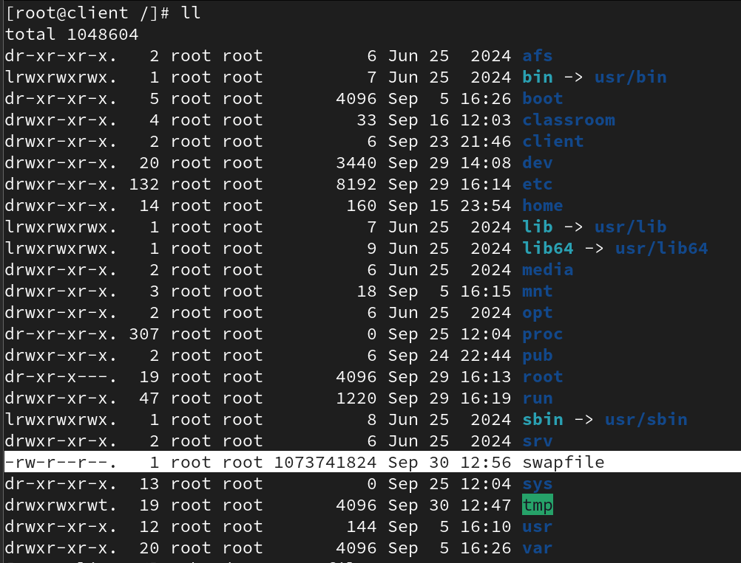

- Set permissions so only root can access:
# chmod 600 /swapfile

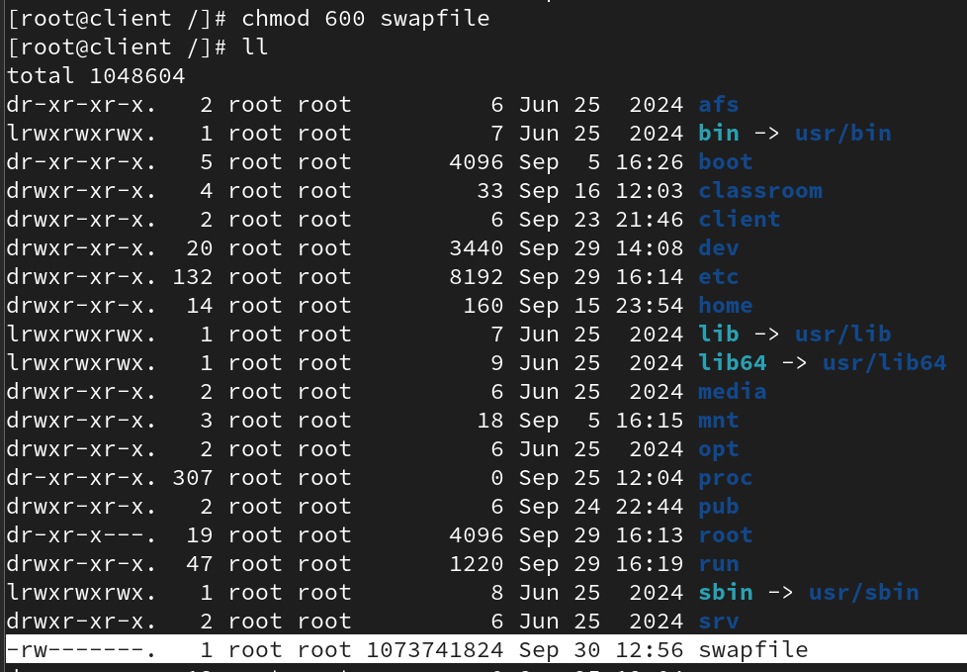

- Make file a swap area:
# mkswap /swapfile
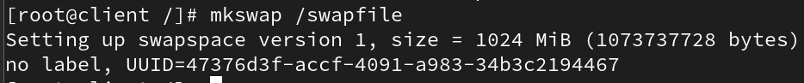

- Enable swap:
# swapon /swapfile

- Verify: # free -m

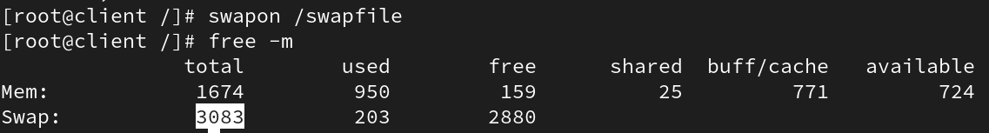

It will only hold on till you reboot

To make permanent changes,

#vi /etc/fstab and add an entry like:
swapfile swap swap defaults 0 0
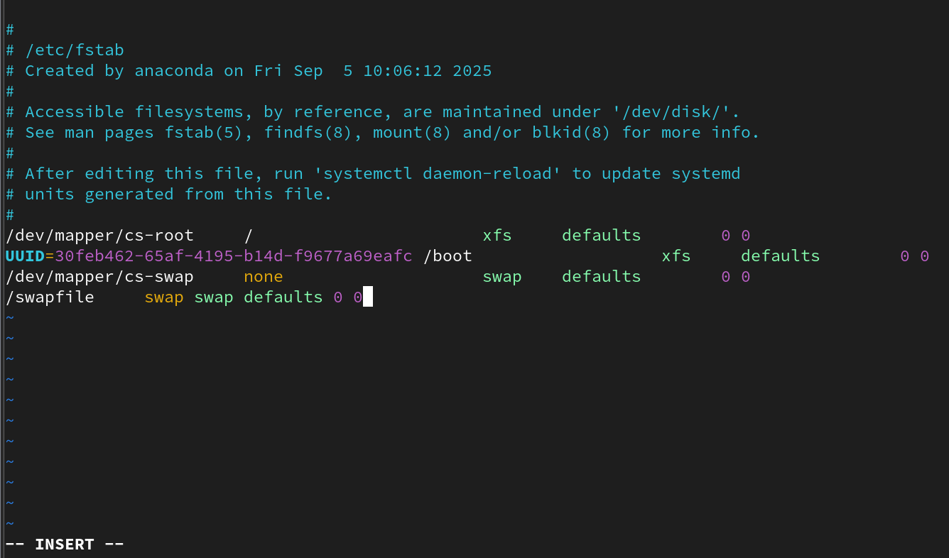

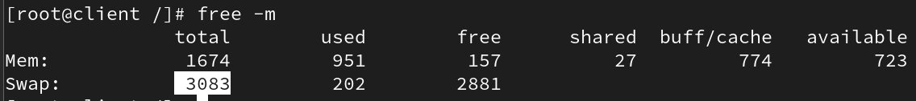

Explanation of /etc/fstab Swap Entry
The following explains the meaning of each field in the /etc/fstab entry for a swap file:
/swapfile01 swap swap defaults 0 0

Field | Example | Meaning
1. Device | /swapfile01 | The path to the swap file (or device). Here it’s a file called /swapfile01.
2. Mount Point | swap | Indicates that this entry is a swap area, not a normal directory mount.
3. Filesystem Type | swap | Specifies the type of filesystem. For swap space, this is always swap.
4. Options | defaults | Mount options. For swap, just defaults (use default behavior).
5. Dump | 0 | Used by the dump backup utility.  0 = do not back up.  1= backup
6. Pass | 0 | Used by fsck at boot to check filesystems.  0 = do not check.  1 = check main file /  2 = check all files other than /

Removing Swap
Steps to remove swap:
- Delete swap entry from /etc/fstab

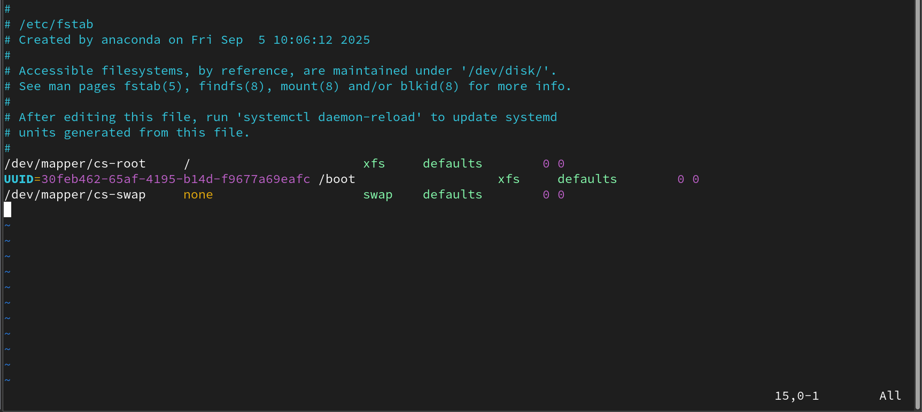

- Turn off swap: # swapoff /swapfile

- Remove file: # rm /swapfile

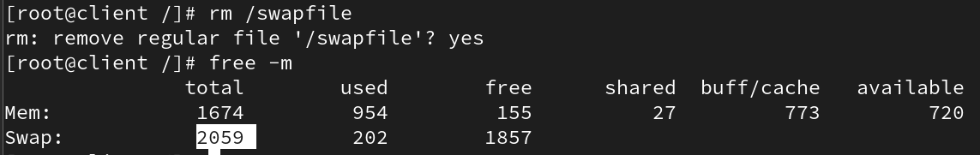

Swappiness Value
Swappiness is a Linux kernel property that defines how often the system will use the swap space. It can have a value between 0 and 100. A low value makes the kernel avoid swapping, while a high value makes it use swap more aggressively.
Default values:
- CentOS 7: 30
- CentOS 9: 60
Example:
Swappiness 10 → 90% RAM used before swapping
Swappiness 90 → 10% RAM used before swapping

To check swappiness:
# sysctl vm.swappiness

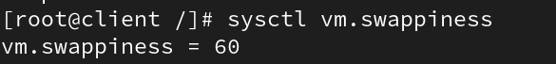

# cat /proc/sys/vm/swappiness

To change temporarily:
# sysctl vm.swappiness=10
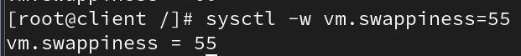

Red Hat Swap Memory Recommendation
Recommended swap size according to Red Hat:
- Up to 2GB RAM → 2 × RAM
- 2GB - 8GB RAM → Equal to RAM
- 8GB - 64GB RAM → 0.5 × RAM
- 64GB or more → 4GB of swap space

