**15U Closed Wall Mount Network Rack:**

Specifications:

15U (W 600mm / D 600mm) Close rack 19" Wall mount Front Door S12C 19" / 15U AC Distribution Box + H/W (5 Points of 5/15 AMP sockets - (Horizontal)x2 19" 1U Cable Manager PVC with duct fingers x 5 Fan housing unit 2 Fan POSN Fans 90 CFM 230 VAC Mounting Hardware (Pack of 10) x 5

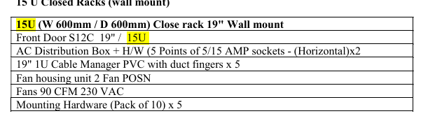

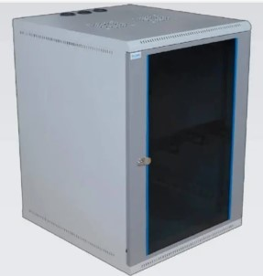

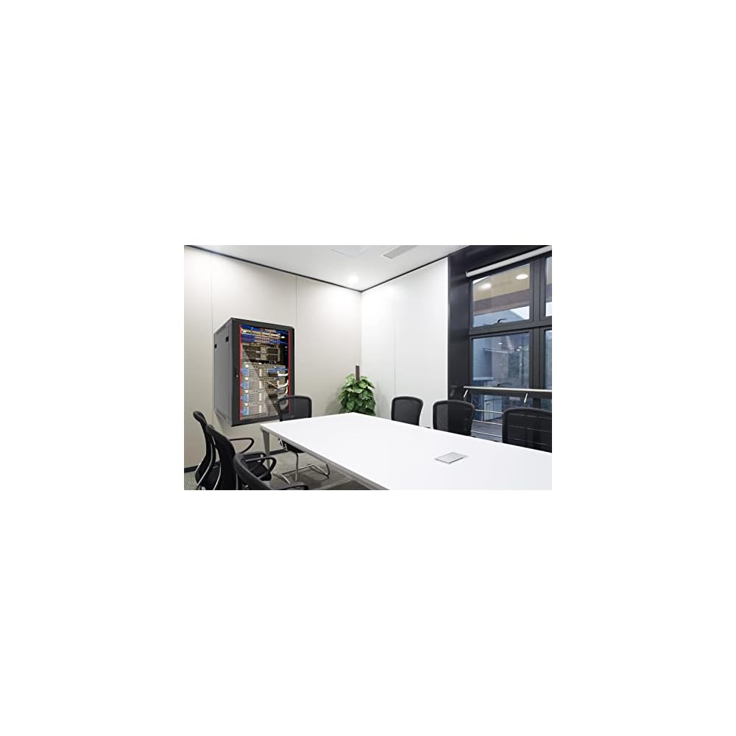

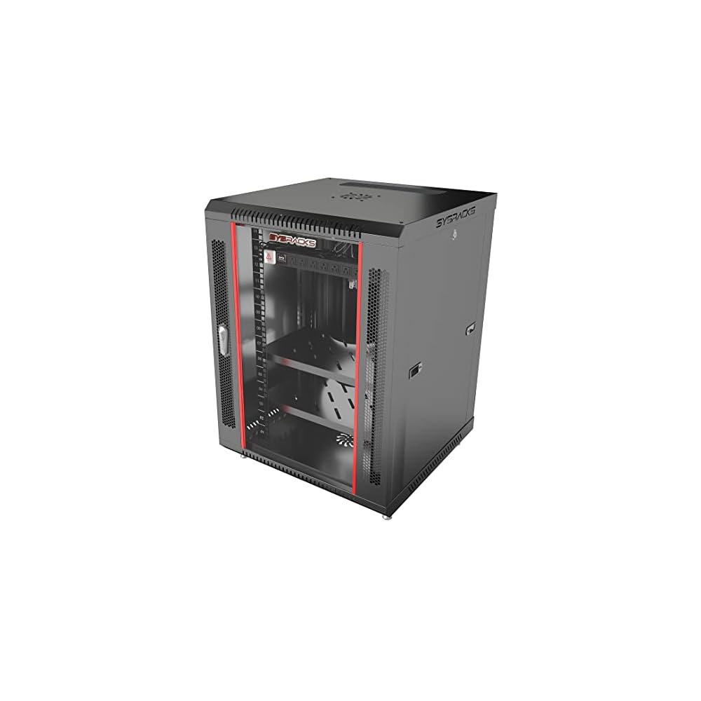

1. Floor switch rack 15 u

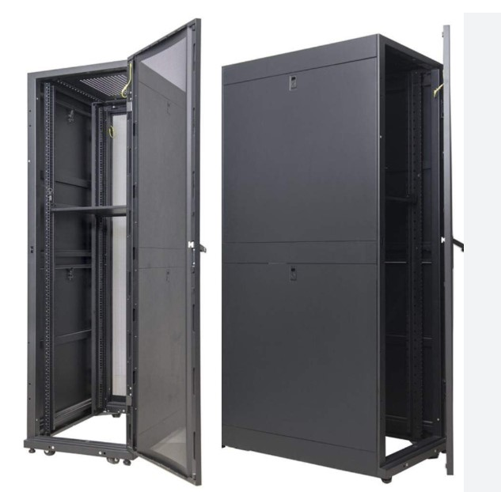

1. Data center switch rack 45u
2. 45U SmartRack enclosure with doors and side panels
3. 4 interior vertical posts with unthreaded square hole openings
4. Standard 24" (600mm) width and 42" (1050mm) depth for optimizing floor space
5. Ships fully assembled
6. Massive front to rear ventilation capacity
7. 3500 lbs (1588 kgs) stationary / 2250 lbs (1020.6 kgs) rolling load capacity
8. Locking, removable, reversible front and rear doors
9. Locking, removable side panels keyed alike with doors
10. Pre-installed casters and leveling feet
11. Includes 50 pieces of M6 cage nuts and 50 pieces of M6 screws (equipment mounting hardware)
12. Meets all enclosure requirements towards PCI DSS (Payment Card Industry Data Security Standard) Compliance
13. 5-year limited warranty

**LIST OF SERVICES**

|  |  |  |
| --- | --- | --- |
| SNO | NAME OF THE SERVICE | PURPOSE |
| 1 | Internet |  |
| 2 | Wi-Fi |  |
| 3 | Admin Office |  |
| 4 | Finance Data and Tally |  |
| 5 | Scientific Software Resources |  |
| 6 | HPC Service |  |
| 7 | CC Camera |  |
| 8 | Biometric Devices |  |
| 9 | IP Phone |  |
| 10 | BMS |  |
| 11 | IT ADMIN (RESOURCES) |  |
| 12 | ERP DEVELOPERS |  |

**DISTANCE BETWEEN THE BUILDING ALONG THE ROADS**

|  |  |  |
| --- | --- | --- |
|  |  |  |
| Main Gate | EAB(Server Room) | 500 M |
| EAB | Guest House |  |
| Guest House | Hostel 1 |  |
| Guest House | Hostel 2 |  |
| Hostel 1 | Mess Block |  |
|  |  |  |
|  |  |  |

**CABLING**

|  |  |  |
| --- | --- | --- |
| **NETWORK A** | | |
| Main Gate | EAB(Server Room) | OFC 12 Core |
| Main Gate | Substation | OFC 6 Core |
| EAB | Workshop /Substation/  Plant Room/Fire Pump Room | OFC 6 Core |
| **FLOOR TO FLOOR CONNECTIVITY IN EAB** | | |
| CHEMISTRY BLOCK | | OFC 6 Core |
| CENTRAL BLOCK | | OFC 6 Core |
| EARTH SCIENCE BLOCK | | OFC 6 Core |
|  | |  |
| **DISTRIBUTION NETWORK** | | |
| EAB (Data Center) | Guest House | OFC 144 Core |
| Guest House | EAB (Data Center) | OFC 144 Core |
|  |  |  |
| **NETWORK B** | | |
| Guest House | Hostel 1 | OFC 12 Core |
| Guest House | Director’s Residence | OFC 6 Core |
| Guest House | Hostel 1/2 | OFC 12 Core |
| Hostel 1 | Hostel 2 | OFC 12 Core |
| Hostel 1/2 | Mess Block | OFC 6 Core |
|  |  |  |
| Guest House | Residential Complex (Type III/V) | OFC 12 Core |

**CHAMBER REQUIREMENT FOR OFC UG CABLING:**