Brainstorm & Idea Prioritization Template

Date: 31 January 2025

Team ID: EDUAI-GEN01

Project Name: Edu Tutor AI – Smart Personalized Learning Assistant

Maximum Marks: 4 Marks

---

# Step 1: Team Gathering, Collaboration and Select the Problem Statement

Problem Statement Chosen:  
Students today face challenges in accessing personalized learning resources tailored to their learning pace, style, and curriculum. There is a need for an AI-powered platform that offers interactive, intelligent, and adaptive tutoring using multimodal learning techniques.

Team Collaboration Approach:  
The team used collaborative online whiteboarding tools (e.g., Miro, Mural) and Google Meet for real-time discussions. We brainstormed around major pain points in digital education and narrowed our focus to three core needs:  
- Personalized tutoring  
- AI-powered doubt resolution  
- Multi-format learning material (text, audio, video)

Illustration: AI-powered tutoring concept in a classroom

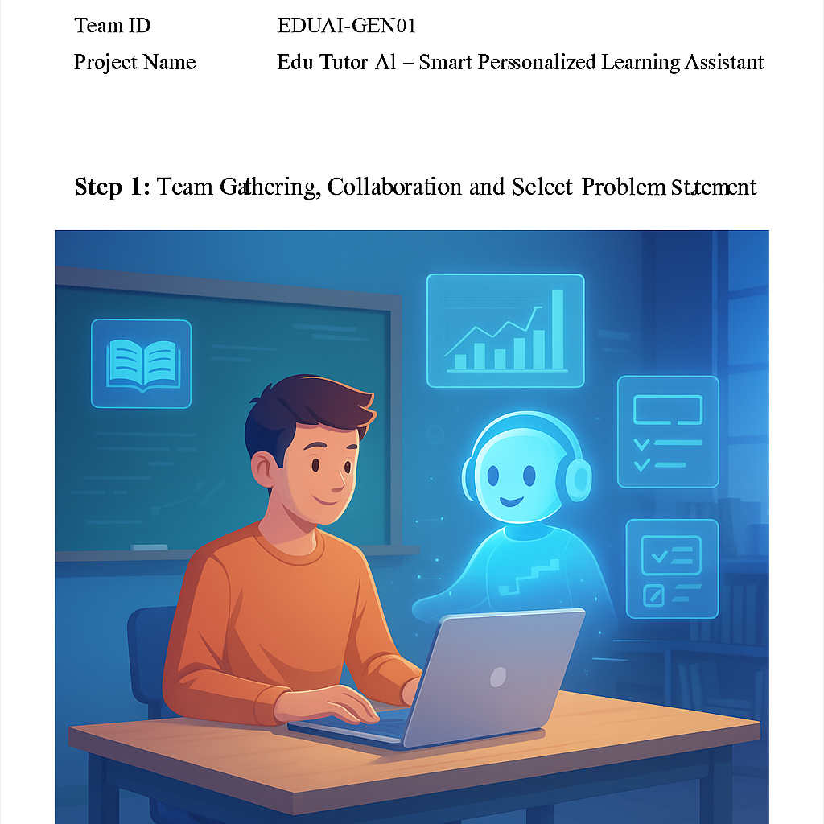

---

# Step 2: Brainstorm, Idea Listing and Grouping

Raw Ideas Generated:  
1. AI chatbot for concept-based question answering  
2. Voice-based tutor for accessibility  
3. Personalized study plan generator  
4. Video summaries of textbook chapters  
5. Homework helper and doubt solver  
6. Quiz generator for exam prep  
7. Learning progress tracker  
8. Integration with school curriculum  
9. Notification system for reminders and suggestions  
10. Offline access for key materials  
11. Multilingual support for regional learners

Grouped Ideas into Themes:  
- Personalization & Progress: Personalized study plans, learning progress tracker  
- AI Tutoring: Chatbot Q&A, doubt solver, voice tutor  
- Content Delivery: Video summaries, quiz generator, curriculum mapping  
- Utility Features: Notifications, offline access, multilingual support

---

# Step 3: Idea Prioritization

|  |  |  |  |
| --- | --- | --- | --- |
| Idea | Feasibility | Impact | Priority |
| AI Chatbot (Q&A + Doubts) | High | High | High |
| Personalized Study Planner | Medium | High | High |
| Voice Tutor (Accessibility) | Medium | Medium | Medium |
| Video Summaries | Low | High | Medium |
| Quiz Generator | High | High | High |
| Progress Tracker | Medium | Medium | Medium |
| Curriculum Mapping | Medium | High | High |
| Notifications & Reminders | High | Medium | Medium |
| Offline Access | Low | Medium | Low |
| Multilingual Support | Medium | High | Medium |

Top Prioritized Features for MVP:  
- AI Chatbot Tutor  
- Personalized Study Plan Generator  
- Quiz Generator  
- Curriculum-based Content Mapping