**Ex. No. : 07 Date :**

**Register No. : 221701701 Name : VISHAL V P**



**Telephony Services**

**Aim**

Develop an android application to display the information of the telephony services.

***Procedure:***

**Step 1 :** File → New Project  
 Provide the application name (e.g.,"TelephonyServices") and click “Next”.

**Step 2 :** Select the target Android devices  
 Select the minimum SDK to run the application. Click “Next”.

**Step 3 :** Choose the activity for the application  
 By default, choose “Blank Activity”. Click “Next”.

**Step 4 :** Enter activity name and click “Finish”.

**Step 5 :** Edit the program

Request necessary permissions Request in the manifest file.

Use Kotlin code in MainActivity.kt to implement telephony features ‘

such as dialing a number or retrieving SIM info

**Step 6 :** Run the application  
 Two ways to run the application:

1. Running through emulator (with SD card configured)  
   
 2. Running through mobile device

***AndroidManifest.xml***

**<?xml version="1.0" encoding="utf-8"?>**

**<manifest xmlns:android="http://schemas.android.com/apk/res/android"**

**package="com.example.telephony services">**

**<!-- Telephony permissions -->**

**<uses-permission android:name="android.permission.READ_PHONE_STATE" />**

**<uses-permission android:name="android.permission.READ_PHONE_NUMBERS" />**

**<!-- Feature requirements -->**

**<uses-feature android:name="android.hardware.telephony" android:required="false" />**

**<application**

**android:allowBackup="true"**

**android:icon="@mipmap/ic_launcher"**

**android:label="@string/app_name"**

**android:roundIcon="@mipmap/ic_launcher_round"**

**android:supportsRtl="true"**

**android:theme="@style/Theme.TelephonyServices">**

**<activity**

**android:name=".MainActivity"**

**android:exported="true">**

**<intent-filter>**

**<action android:name="android.intent.action.MAIN" />**

**<category android:name="android.intent.category.LAUNCHER" />**

**</intent-filter>**

**</activity>**

**</application>**

**</manifest>**

***Activity_main.xml***

**<?xml version="1.0" encoding="utf-8"?>**

**<LinearLayout xmlns:android="http://schemas.android.com/apk/res/android"**

**xmlns:app="http://schemas.android.com/apk/res-auto"**

**xmlns:tools="http://schemas.android.com/tools"**

**android:layout_width="match_parent"**

**android:layout_height="match_parent"**

**android:orientation="vertical"**

**tools:context=".MainActivity">**

**<TextView**

**android:layout_width="match_parent"**

**android:layout_height="wrap_content"**

**android:text="Telephony Services"**

**android:textSize="22sp"**

**android:textStyle="bold"**

**android:textColor="@android:color/white"**

**android:padding="16dp"**

**android:background="#6200EE" />**

**<!-- Network Operator Name -->**

**<TextView**

**android:layout_width="match_parent"**

**android:layout_height="wrap_content"**

**android:text="Network Operator Name"**

**android:textSize="14sp"**

**android:paddingStart="16dp"**

**android:paddingTop="8dp"**

**android:textColor="#757575"/>**

**<TextView**

**android:id="@+id/networkOperatorNameTextView"**

**android:layout_width="match_parent"**

**android:layout_height="wrap_content"**

**android:background="@drawable/text_view_border"**

**android:padding="16dp"**

**android:textSize="16sp"**

**android:textColor="#212121"**

**tools:text="Android" />**

**<!-- Phone Type -->**

**<TextView**

**android:layout_width="match_parent"**

**android:layout_height="wrap_content"**

**android:text="Phone Type"**

**android:textSize="14sp"**

**android:paddingStart="16dp"**

**android:paddingTop="8dp"**

**android:textColor="#757575"/>**

**<TextView**

**android:id="@+id/phoneTypeTextView"**

**android:layout_width="match_parent"**

**android:layout_height="wrap_content"**

**android:background="@drawable/text_view_border"**

**android:padding="16dp"**

**android:textSize="16sp"**

**android:textColor="#212121"**

**tools:text="GSM" />**

**<!-- Network Country ISO -->**

**<TextView**

**android:layout_width="match_parent"**

**android:layout_height="wrap_content"**

**android:text="Network Country ISO"**

**android:textSize="14sp"**

**android:paddingStart="16dp"**

**android:paddingTop="8dp"**

**android:textColor="#757575"/>**

**<TextView**

**android:id="@+id/networkCountryIsoTextView"**

**android:layout_width="match_parent"**

**android:layout_height="wrap_content"**

**android:background="@drawable/text_view_border"**

**android:padding="16dp"**

**android:textSize="16sp"**

**android:textColor="#212121"**

**tools:text="US" />**

**<!-- SIM Country ISO -->**

**<TextView**

**android:layout_width="match_parent"**

**android:layout_height="wrap_content"**

**android:text="SIM Country ISO"**

**android:textSize="14sp"**

**android:paddingStart="16dp"**

**android:paddingTop="8dp"**

**android:textColor="#757575"/>**

**<TextView**

**android:id="@+id/simCountryIsoTextView"**

**android:layout_width="match_parent"**

**android:layout_height="wrap_content"**

**android:background="@drawable/text_view_border"**

**android:padding="16dp"**

**android:textSize="16sp"**

**android:textColor="#212121"**

**tools:text="US" />**

**<!-- Device Software Version -->**

**<TextView**

**android:layout_width="match_parent"**

**android:layout_height="wrap_content"**

**android:text="Device Software Version"**

**android:textSize="14sp"**

**android:paddingStart="16dp"**

**android:paddingTop="8dp"**

**android:textColor="#757575"/>**

**<TextView**

**android:id="@+id/deviceSoftwareVersionTextView"**

**android:layout_width="match_parent"**

**android:layout_height="wrap_content"**

**android:background="@drawable/text_view_border"**

**android:padding="16dp"**

**android:textSize="16sp"**

**android:textColor="#212121"**

**tools:text="---" />**

**<View**

**android:layout_width="match_parent"**

**android:layout_height="0dp"**

**android:layout_weight="1" />**

**<Button**

**android:id="@+id/getServicesButton"**

**android:layout_width="match_parent"**

**android:layout_height="wrap_content"**

**android:text="Get Telephony Services"**

**android:textColor="@android:color/white"**

**android:backgroundTint="#6200EE"**

**android:padding="16dp"**

**android:layout_margin="16dp"/>**

**</LinearLayout>**

***MainActivity.kt***

**package com.example.telephony services**

**import android.Manifest**

**import android.content.Context**

**import android.content.pm.PackageManager**

**import android.os.Bundle**

**import android.telephony.TelephonyManager**

**import android.widget.Button**

**import android.widget.TextView**

**import android.widget.Toast**

**import androidx.appcompat.app.AlertDialog**

**import android.appcompat.app.AppCompatActivity**

**import android.core.app.ActivityCompat**

**import androidx.core.content.ContextCompat**

**class MainActivity : AppCompatActivity() {**

**private lateinit var networkOperatorNameTextView: TextView**

**private lateinit var phoneTypeTextView: TextView**

**private lateinit var networkCountryIsoTextView: TextView**

**private lateinit var simCountryIsoTextView: TextView**

**private lateinit var deviceSoftwareVersionTextView: TextView**

**private lateinit var getServicesButton: Button**

**private val TELEPHONY_PERMISSION_CODE = 101**

**override fun onCreate(savedInstanceState: Bundle?) {**

**super.onCreate(savedInstanceState)**

**setContentView(R.layout.activity_main)**

**// Initialize UI components**

**networkOperatorNameTextView = findViewById(R.id.networkOperatorNameTextView)**

**phoneTypeTextView = findViewById(R.id.phoneTypeTextView)**

**networkCountryIsoTextView = findViewById(R.id.networkCountryIsoTextView)**

**simCountryIsoTextView = findViewById(R.id.simCountryIsoTextView)**

**deviceSoftwareVersionTextView = findViewById(R.id.deviceSoftwareVersionTextView)**

**getServicesButton = findViewById(R.id.getServicesButton)**

**// Set click listener for button**

**getServicesButton.setOnClickListener {**

**checkTelephonyPermission()**

**}**

**}**

**private fun checkTelephonyPermission() {**

**if (ContextCompat.checkSelfPermission(**

**this,**

**Manifest.permission.READ_PHONE_STATE**

**) != PackageManager.PERMISSION_GRANTED**

**) {**

**// Show permission explanation dialog**

**showPermissionDialog()**

**} else {**

**// Permission already granted, get telephony info**

**getTelephonyInfo()**

**}**

**}**

**private fun showPermissionDialog() {**

**AlertDialog.Builder(this)**

**.setTitle("Allow Telephony Services")**

**.setMessage("to make and manage phone calls?")**

**.setIcon(R.drawable.ic_phone)**

**.setPositiveButton("ALLOW") { _, _ ->**

**// Request permission**

**ActivityCompat.requestPermissions(**

**this,**

**arrayOf(Manifest.permission.READ_PHONE_STATE),**

**TELEPHONY_PERMISSION_CODE**

**)**

**}**

**.setNegativeButton("DENY") { dialog, _ ->**

**dialog.dismiss()**

**Toast.makeText(**

**this,**

**"Permission denied. Cannot access telephony services.",**

**Toast.LENGTH_SHORT**

**).show()**

**}**

**.create()**

**.show()**

**}**

**private fun getTelephonyInfo() {**

**val telephonyManager = getSystemService(Context.TELEPHONY_SERVICE) as TelephonyManager**

**// Get network operator name**

**val networkOperatorName = if (ActivityCompat.checkSelfPermission(**

**this,**

**Manifest.permission.READ_PHONE_STATE**

**) == PackageManager.PERMISSION_GRANTED**

**) {**

**telephonyManager.networkOperatorName.ifEmpty { "Android" }**

**} else {**

**"Permission required"**

**}**

**networkOperatorNameTextView.text = networkOperatorName**

**// Get phone type**

**val phoneType = when (telephonyManager.phoneType) {**

**TelephonyManager.PHONE_TYPE_GSM -> "GSM"**

**TelephonyManager.PHONE_TYPE_CDMA -> "CDMA"**

**TelephonyManager.PHONE_TYPE_SIP -> "SIP"**

**TelephonyManager.PHONE_TYPE_NONE -> "NONE"**

**else -> "UNKNOWN"**

**}**

**phoneTypeTextView.text = phoneType**

**// Get network country ISO**

**val networkCountryIso = telephonyManager.networkCountryIso.uppercase().ifEmpty { "US" }**

**networkCountryIsoTextView.text = networkCountryIso**

**// Get SIM country ISO**

**val simCountryIso = telephonyManager.simCountryIso.uppercase().ifEmpty { "US" }**

**simCountryIsoTextView.text = simCountryIso**

**// Get device software version**

**val deviceSoftwareVersion = if (ActivityCompat.checkSelfPermission(**

**this,**

**Manifest.permission.READ_PHONE_STATE**

**) == PackageManager.PERMISSION_GRANTED**

**) {**

**telephonyManager.deviceSoftwareVersion ?: "---"**

**} else {**

**"---"**

**}**

**deviceSoftwareVersionTextView.text = deviceSoftwareVersion**

**Toast.makeText(this, "Telephony information updated", Toast.LENGTH_SHORT).show()**

**}**

**override fun onRequestPermissionsResult(**

**requestCode: Int,**

**permissions: Array<String>,**

**grantResults: IntArray**

**) {**

**super.onRequestPermissionsResult(requestCode, permissions, grantResults)**

**if (requestCode == TELEPHONY_PERMISSION_CODE) {**

**if (grantResults.isNotEmpty() && grantResults[0] == PackageManager.PERMISSION_GRANTED) {**

**// Permission granted, get telephony info**

**getTelephonyInfo()**

**} else {**

**Toast.makeText(**

**this,**

**"Permission denied. Cannot access telephony services.",**

**Toast.LENGTH_SHORT**

**).show()**

**}**

**}**

**}**

**}**

***Output***

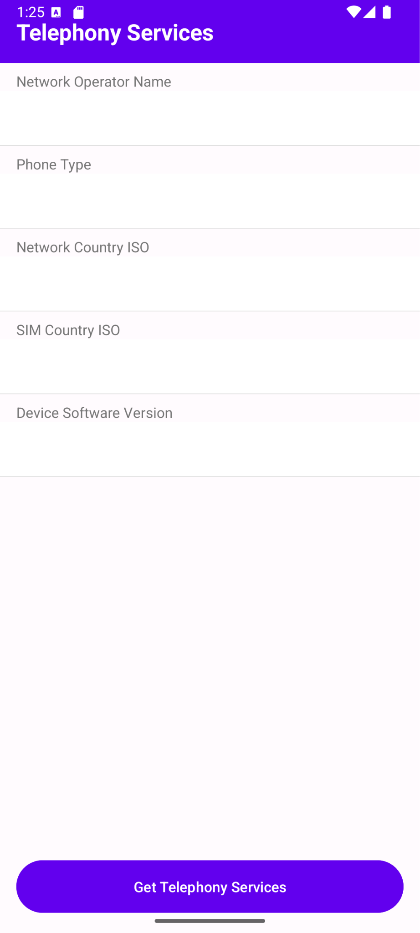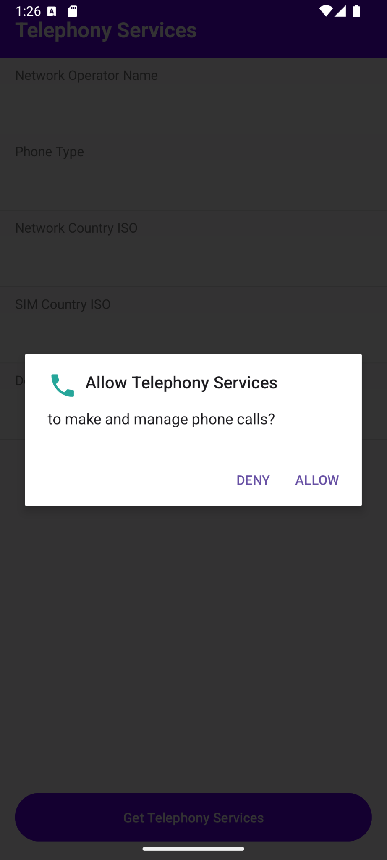

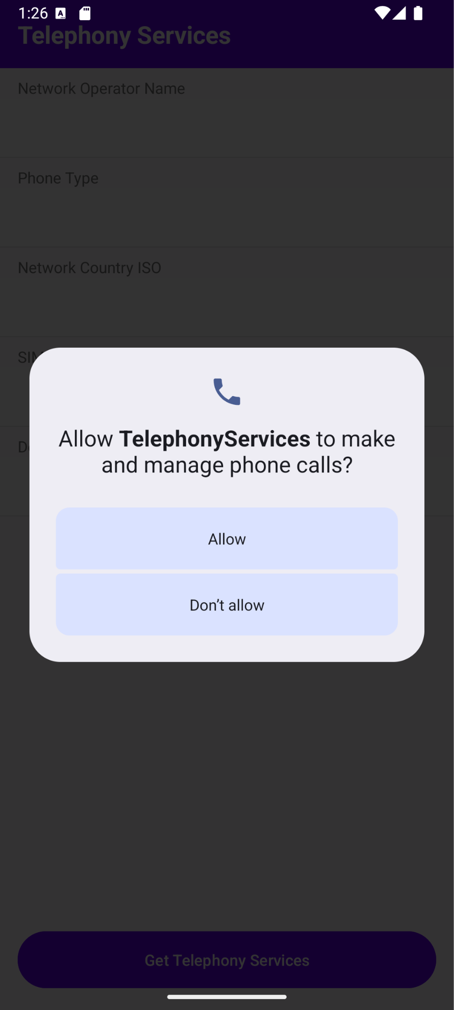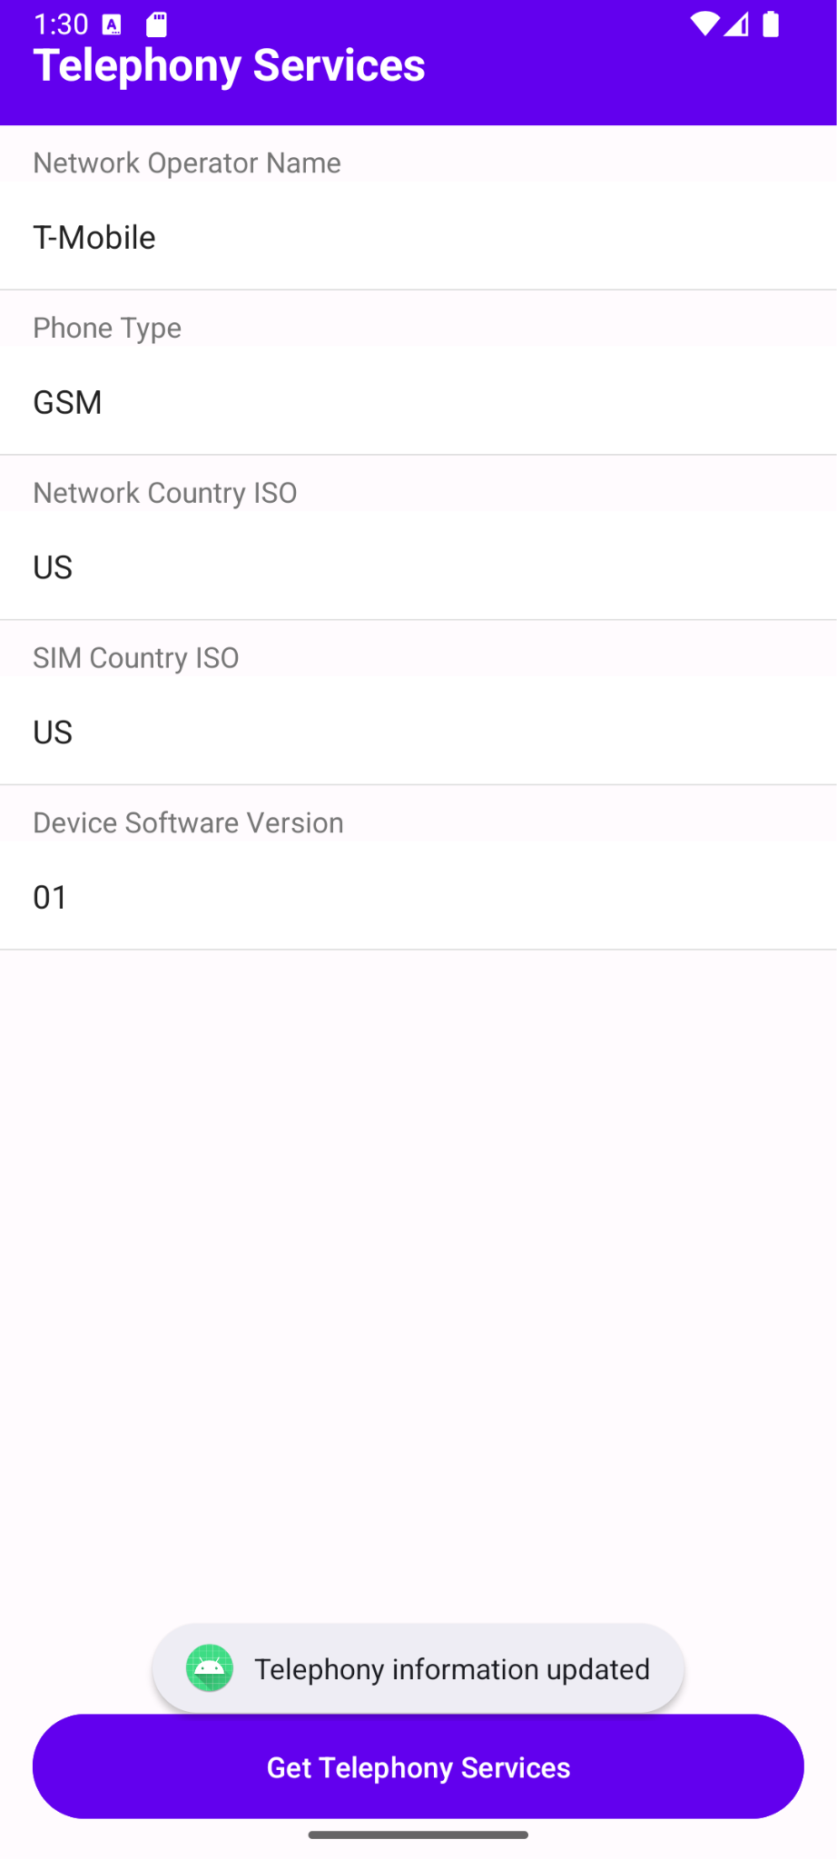

**Result:**

The Telephony Services application successfully accesses telephony features like initiating phone calls or displaying SIM and network information on a mobile device with granted permissions.