**Ex. No. : 08 - B Date :**

**Register No. : 221701701 Name : VISHAL V P**



**Send EMAIL**

**Aim**

Develop an application to send Email.

***Procedure:***

**Step 1 :** File → New Project  
 Provide the application name (e.g.,"Email") and click “Next”.

**Step 2 :** Select the target Android devices  
 Select the minimum SDK to run the application. Click “Next”.

**Step 3 :** Choose the activity for the application  
 By default, choose “Blank Activity”. Click “Next”.

**Step 4 :** Enter activity name and click “Finish”.

**Step 5 :** Edit the program

Design the UI for entering recipient email, subject, and message.

Use an implicit intent (Intent.ACTION_SEND) in MainActivity.kt to

trigger the email client with pre-filled details.

**Step 6 :** Run the application  
 Two ways to run the application:

1. Running through emulator  
   
 2. Running through mobile device

***AndroidManifest.xml***

**<?xml version="1.0" encoding="utf-8"?>**

**<manifest xmlns:android="http://schemas.android.com/apk/res/android"**

**package="com.example.email">**

**<!-- Add internet permission -->**

**<uses-permission android:name="android.permission.INTERNET" />**

**<application**

**android:allowBackup="true"**

**android:icon="@mipmap/ic_launcher"**

**android:label="@string/app_name"**

**android:roundIcon="@mipmap/ic_launcher_round"**

**android:supportsRtl="true"**

**android:theme="@style/Theme.SendEmail">**

**<activity**

**android:name=".MainActivity"**

**android:exported="true">**

**<intent-filter>**

**<action android:name="android.intent.action.MAIN" />**

**<category android:name="android.intent.category.LAUNCHER" />**

**</intent-filter>**

**</activity>**

**</application>**

**</manifest>**

***Activity_main.xml***

**<?xml version="1.0" encoding="utf-8"?>**

**<LinearLayout xmlns:android="http://schemas.android.com/apk/res/android"**

**xmlns:tools="http://schemas.android.com/tools"**

**android:layout_width="match_parent"**

**android:layout_height="match_parent"**

**android:orientation="vertical"**

**tools:context=".MainActivity">**

**<!-- Header -->**

**<TextView**

**android:layout_width="match_parent"**

**android:layout_height="wrap_content"**

**android:background="@color/purple_primary"**

**android:padding="16dp"**

**android:text="Send Email"**

**android:textColor="@android:color/white"**

**android:textSize="20sp"**

**android:textStyle="bold"**

**android:contentDescription="Send Email screen" />**

**<!-- Email To Field -->**

**<TextView**

**android:layout_width="wrap_content"**

**android:layout_height="wrap_content"**

**android:layout_marginStart="16dp"**

**android:layout_marginTop="16dp"**

**android:text="To"**

**android:textColor="@android:color/black"**

**android:labelFor="@+id/to_edit_text" />**

**<EditText**

**android:id="@+id/to_edit_text"**

**android:layout_width="match_parent"**

**android:layout_height="wrap_content"**

**android:layout_marginStart="16dp"**

**android:layout_marginEnd="16dp"**

**android:background="@drawable/edit_text_bottom_line"**

**android:hint="Email address"**

**android:importantForAutofill="yes"**

**android:autofillHints="emailAddress"**

**android:inputType="textEmailAddress"**

**android:padding="16dp"**

**android:minHeight="48dp"**

**android:textSize="16sp" />**

**<!-- Subject Field -->**

**<TextView**

**android:layout_width="wrap_content"**

**android:layout_height="wrap_content"**

**android:layout_marginStart="16dp"**

**android:layout_marginTop="16dp"**

**android:text="Subject"**

**android:textColor="@android:color/black"**

**android:labelFor="@+id/subject_edit_text" />**

**<EditText**

**android:id="@+id/subject_edit_text"**

**android:layout_width="match_parent"**

**android:layout_height="wrap_content"**

**android:layout_marginStart="16dp"**

**android:layout_marginEnd="16dp"**

**android:background="@drawable/edit_text_bottom_line"**

**android:hint="Subject"**

**android:importantForAutofill="yes"**

**android:autofillHints="subject"**

**android:inputType="textCapSentences"**

**android:padding="16dp"**

**android:minHeight="48dp"**

**android:textSize="16sp" />**

**<!-- Message Field -->**

**<TextView**

**android:layout_width="wrap_content"**

**android:layout_height="wrap_content"**

**android:layout_marginStart="16dp"**

**android:layout_marginTop="16dp"**

**android:text="Message"**

**android:textColor="@android:color/black"**

**android:labelFor="@+id/message_edit_text" />**

**<EditText**

**android:id="@+id/message_edit_text"**

**android:layout_width="match_parent"**

**android:layout_height="wrap_content"**

**android:layout_marginStart="16dp"**

**android:layout_marginEnd="16dp"**

**android:background="@drawable/edit_text_bottom_line"**

**android:gravity="top"**

**android:hint="Type your message"**

**android:importantForAutofill="yes"**

**android:autofillHints="emailBody"**

**android:inputType="textMultiLine"**

**android:minLines="3"**

**android:minHeight="96dp"**

**android:padding="16dp"**

**android:textSize="16sp" />**

**<!-- Send Button -->**

**<Button**

**android:id="@+id/send_button"**

**android:layout_width="match_parent"**

**android:layout_height="wrap_content"**

**android:layout_marginStart="16dp"**

**android:layout_marginTop="24dp"**

**android:layout_marginEnd="16dp"**

**android:background="@drawable/purple_button_background"**

**android:text="Send"**

**android:textAllCaps="false"**

**android:textColor="@android:color/white"**

**android:minHeight="48dp"**

**android:textSize="16sp" />**

**</LinearLayout>**

***MainActivity.kt***

**package com.example.email**

**import android.content.Intent**

**import android.net.Uri**

**import android.os.Bundle**

**import android.widget.Button**

**import android.widget.EditText**

**import android.widget.Toast**

**import android.appcompat.app.AppCompatActivity**

**class MainActivity : AppCompatActivity() {**

**private lateinit var toEditText: EditText**

**private lateinit var subjectEditText: EditText**

**private lateinit var messageEditText: EditText**

**private lateinit var sendButton: Button**

**override fun onCreate(savedInstanceState: Bundle?) {**

**super.onCreate(savedInstanceState)**

**setContentView(R.layout.activity_main)**

**// Initialize UI components**

**toEditText = findViewById(R.id.to_edit_text)**

**subjectEditText = findViewById(R.id.subject_edit_text)**

**messageEditText = findViewById(R.id.message_edit_text)**

**sendButton = findViewById(R.id.send_button)**

**// Set up send button click listener**

**sendButton.setOnClickListener {**

**sendEmail()**

**}**

**}**

**private fun sendEmail() {**

**val recipient = toEditText.text.toString().trim()**

**val subject = subjectEditText.text.toString().trim()**

**val message = messageEditText.text.toString().trim()**

**// Basic validation**

**if (recipient.isEmpty()) {**

**Toast.makeText(this, "Please enter recipient email", Toast.LENGTH_SHORT).show()**

**return**

**}**

**try {**

**// Try first with ACTION_SENDTO (preferred way for email)**

**val emailIntent = Intent(Intent.ACTION_SENDTO).apply {**

**data = Uri.parse("mailto:") // only email apps should handle this**

**putExtra(Intent.EXTRA_EMAIL, arrayOf(recipient))**

**putExtra(Intent.EXTRA_SUBJECT, subject)**

**putExtra(Intent.EXTRA_TEXT, message)**

**}**

**// Check if there's a matching activity**

**if (emailIntent.resolveActivity(packageManager) != null) {**

**startActivity(emailIntent)**

**return**

**}**

**// Fallback to ACTION_SEND (more general, will show more apps)**

**val sendIntent = Intent(Intent.ACTION_SEND).apply {**

**type = "message/rfc822" // email mime type**

**putExtra(Intent.EXTRA_EMAIL, arrayOf(recipient))**

**putExtra(Intent.EXTRA_SUBJECT, subject)**

**putExtra(Intent.EXTRA_TEXT, message)**

**}**

**// Use createChooser to always show options even if default is set**

**startActivity(Intent.createChooser(sendIntent, "Send email using..."))**

**} catch (e: Exception) {**

**// Show more detailed error message**

**Toast.makeText(**

**this,**

**"No email app available. Error: ${e.message}",**

**Toast.LENGTH_LONG**

**).show()**

**e.printStackTrace()**

**}**

**}**

**}**

***Output***

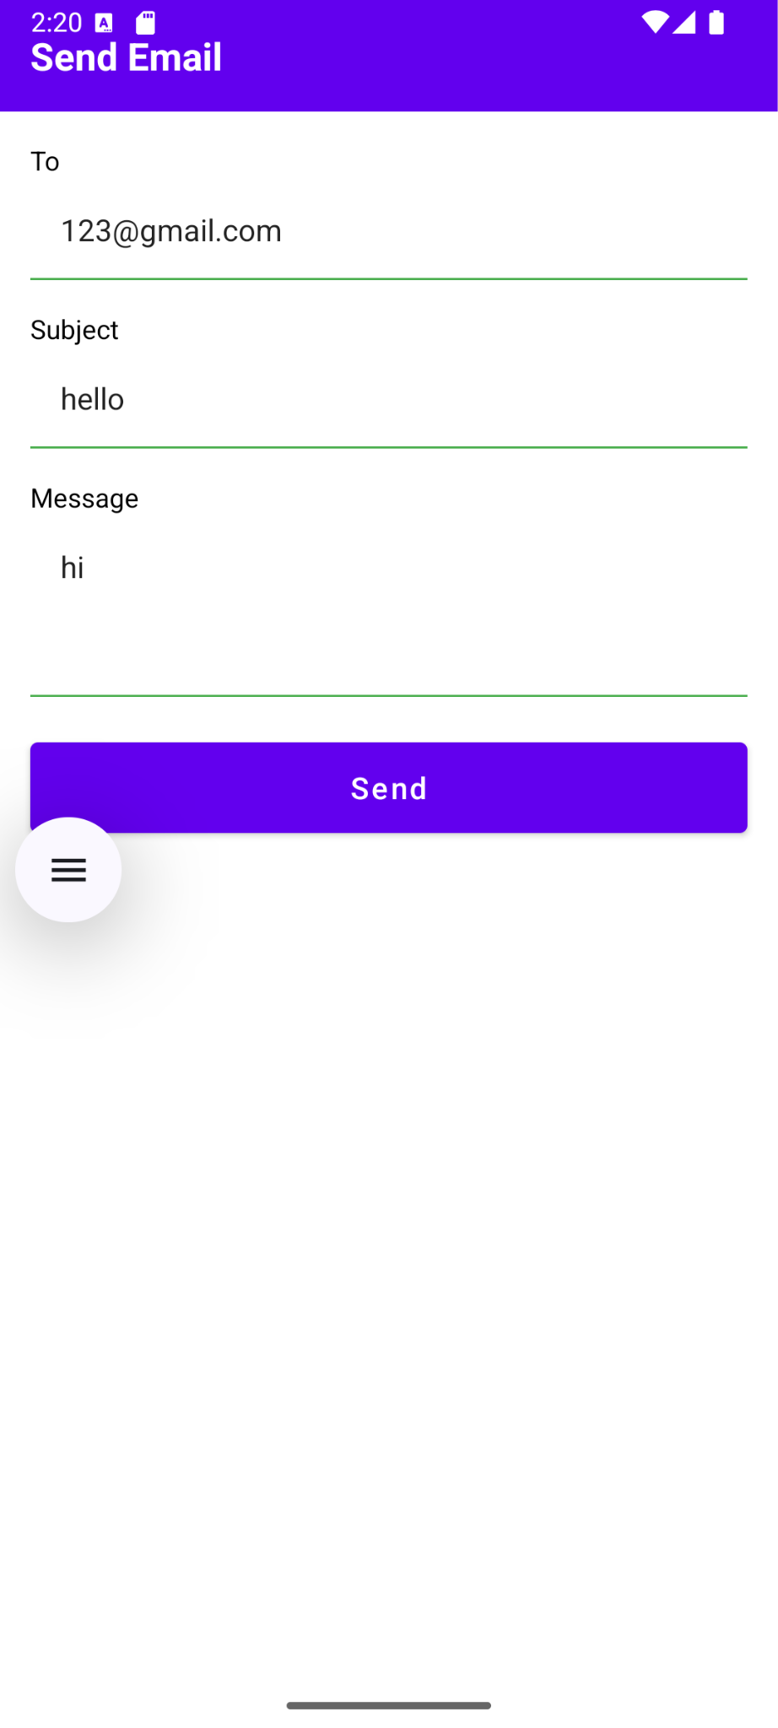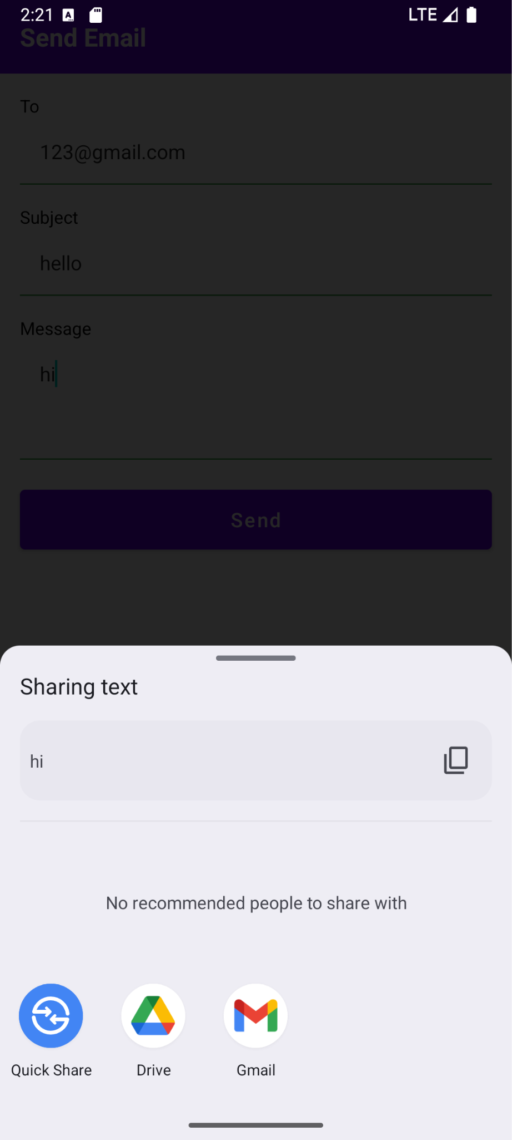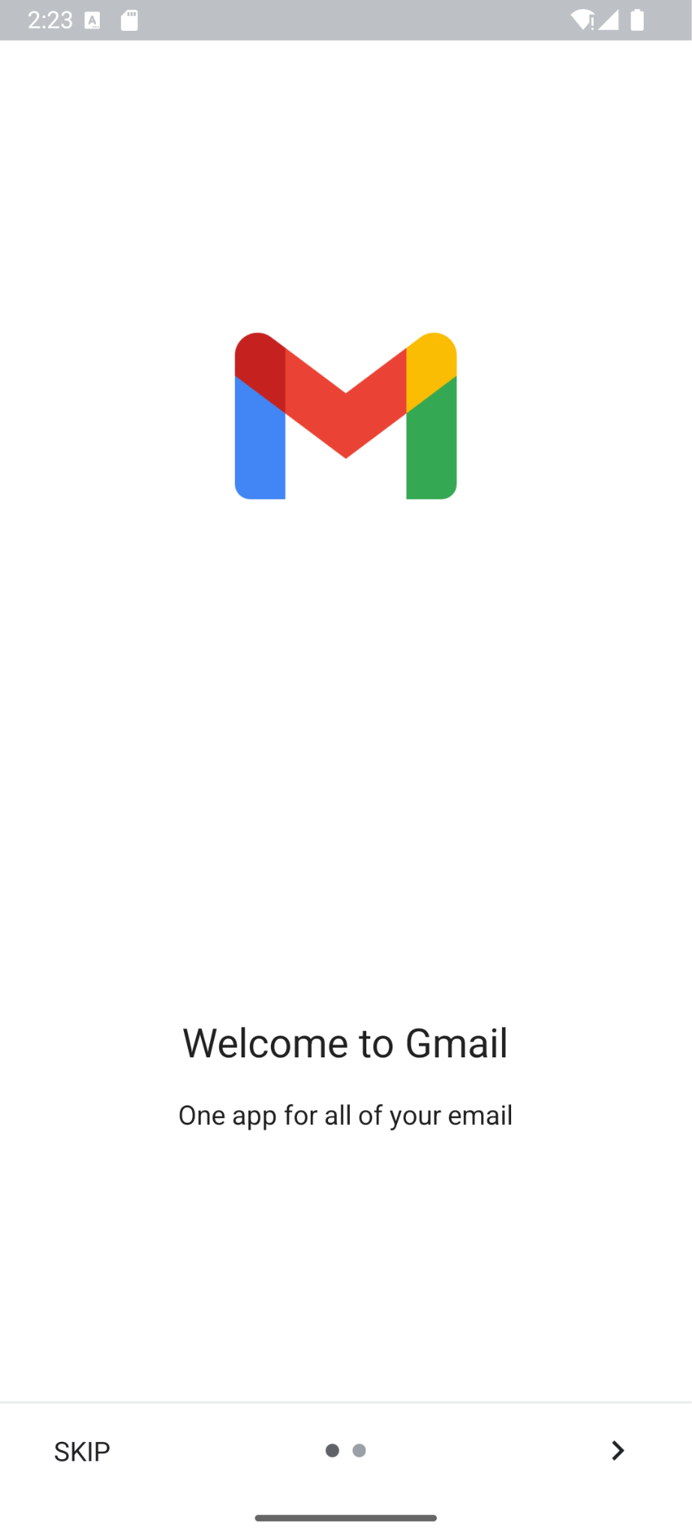

**Result:**

The Email application successfully opens the email client with pre-filled recipient, subject, and message, allowing the user to send an email via their preferred email app.