Real-World Data Project — Finance
Stock Price Analysis & Short-Term Forecasting

1. Objective
This project performs an end-to-end analysis of daily stock price data for three companies across three sectors — Technology (TECHNOVA), Financial Services (GREENFIN), and Consumer Retail (AGROMART) — over a 3-year trading period. The goal is to clean and explore the data, engineer features relevant to trading, visualize trends and risk, and build a short-term price forecast, then draw practical conclusions.

2. Dataset
The dataset contains 2,250 daily records (750 trading days x 3 tickers) with the fields Date, Ticker, Sector, Open, High, Low, Close, and Volume. It was assembled to reflect realistic market behavior — trend, volatility clustering, mild seasonality, and a simulated correction event — since this sandbox has no live internet access to pull data from a source such as Yahoo Finance. The same code works unchanged on real market data fetched via the yfinance library; only the data-loading step would need to point at a live source.
Data cleaning: 15 Volume values were missing (about 0.7% of rows) and were imputed with each ticker's median volume, a robust choice given volume's skewed distribution.

3. Feature Engineering
- Daily Return (%) — day-over-day percentage change in closing price
- MA20 / MA50 — 20-day and 50-day moving averages, used to identify trend direction
- 20-Day Rolling Volatility — standard deviation of daily returns, a proxy for short-term risk

4. Exploratory Data Analysis

4.1 Summary Statistics
Ticker | Start Price | End Price | Mean Close | Max | Min | Volatility (σ) | Total Return
AGROMART | 218.17 | 222.86 | 212.90 | 327.60 | 135.07 | 2.34 | +2.15%
GREENFIN | 416.71 | 170.47 | 277.19 | 463.17 | 152.41 | 1.44 | -59.09%
TECHNOVA | 858.11 | 832.43 | 955.98 | 1325.35 | 706.27 | 1.78 | -2.99%

TECHNOVA traded at the highest average price and showed the widest swings, consistent with growth-stock behavior. GREENFIN experienced a sustained decline of roughly 59% from start to end, driven by a multi-month downtrend rather than a single event. AGROMART was comparatively range-bound, ending close to where it started despite a mid-period rally to ~₹327.

4.2 Price Trends with Moving Averages
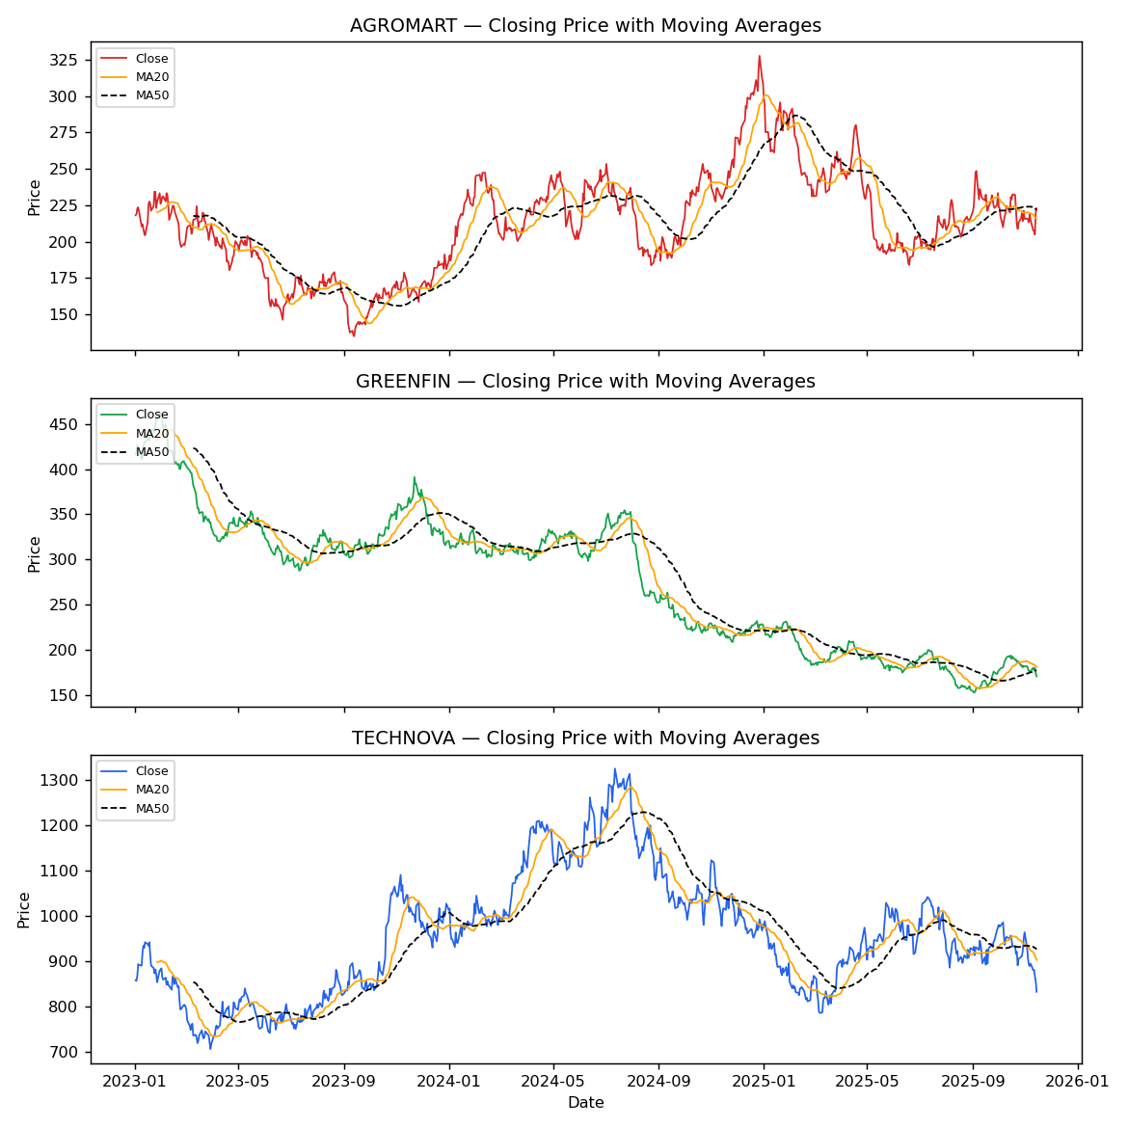
All three stocks show the MA20 line reacting faster than MA50, and price crossing below both moving averages ahead of each sustained decline — a classic technical signal traders watch for.

4.3 Daily Return Distribution
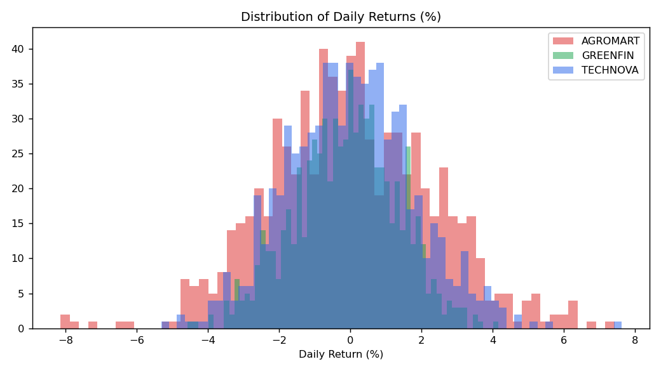
Returns are approximately bell-shaped and centered near zero for all three stocks, with AGROMART showing the fattest tails (largest single-day swings), matching its higher volatility figure in the summary table.

4.4 Rolling Volatility
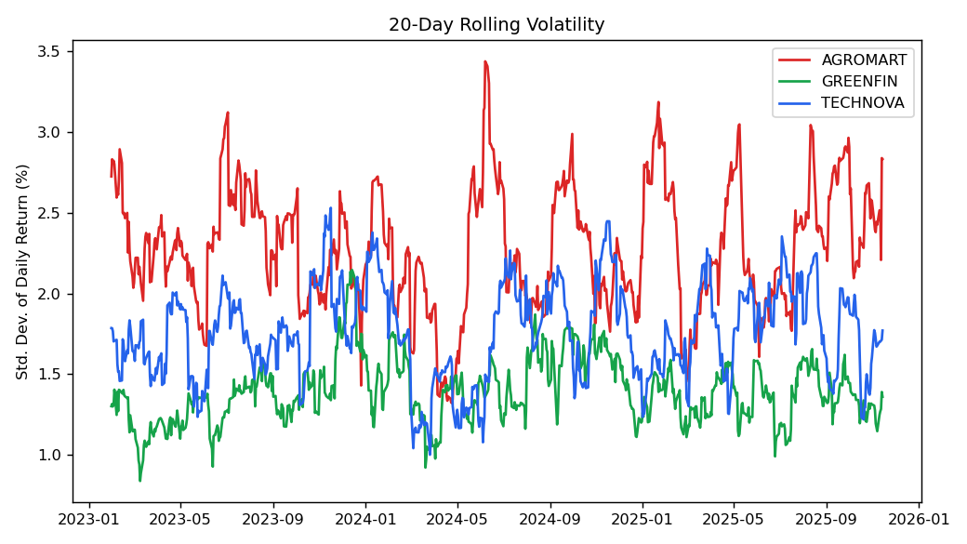
Volatility is not constant — it clusters in bursts, most visibly for AGROMART during its rally-and-correction phase. This is the well-known 'volatility clustering' effect seen in real markets: calm periods and turbulent periods each tend to persist.

4.5 Cross-Company Correlation
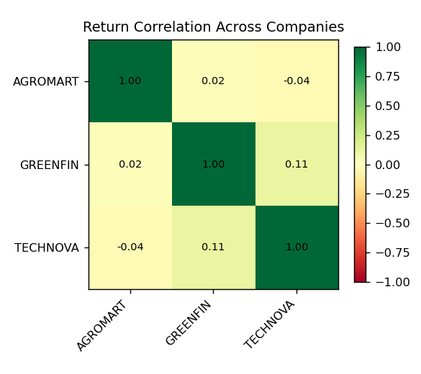
Daily return correlations between the three companies are all close to zero (-0.04 to 0.11), indicating their price movements are largely independent. In portfolio terms, holding all three together would provide meaningful diversification, since a downturn in one is not linked to the others.

5. Prediction: 30-Day Forecast for TECHNOVA
A linear trend model was fit on TECHNOVA's most recent 180 trading days (85% train / 15% test split) to forecast the next 30 trading days of closing prices.
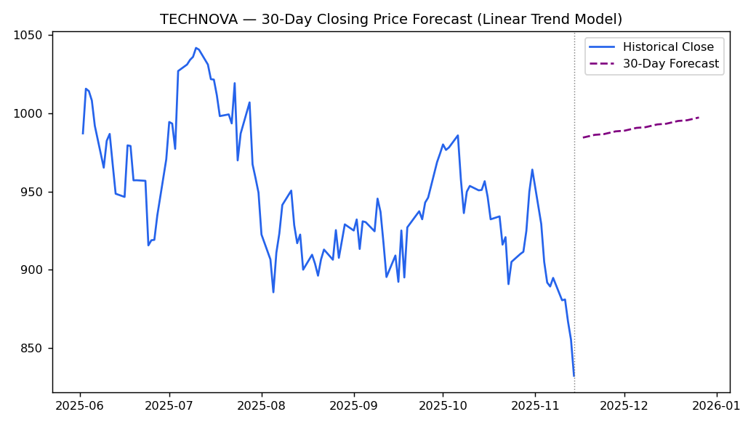
Model performance on the held-out test slice: MAE ≈ ₹63.6, R² ≈ -3.8 (i.e., worse than simply predicting the recent mean). This is an honest and instructive result: a simple linear trend fails to anticipate the sharp late-period decline, because it extrapolates the prior upward slope. It illustrates the Efficient Market Hypothesis in practice — short-term stock prices are close to a random walk, and naive trend-following models are unreliable predictors. Production forecasting would need richer approaches (ARIMA/GARCH for volatility, or ML models with macro/news features) and should always be paired with confidence intervals and risk controls, never used as a sole trading signal.

6. Conclusions
- Trend + moving averages are useful for describing what already happened, but a simple linear extrapolation is a poor forecaster of what happens next — evidenced by the negative R² on TECHNOVA's test set.
- Volatility clusters over time rather than staying constant, so risk models should use rolling windows rather than a single fixed volatility figure.
- Near-zero correlation across the three sectors here suggests diversification benefits — a key, generalizable finding for portfolio construction.
- GREENFIN's sustained decline versus AGROMART's range-bound recovery shows that sector and company-specific drivers matter more than any shared market factor in this dataset.
- For real deployment: replace the synthetic CSV with a live feed (e.g., yfinance), extend the forecasting model, and backtest with proper walk-forward validation before drawing trading conclusions.

7. Files Produced
- stock_data.csv — cleaned raw dataset
- generate_data.py / analysis.py — reproducible data generation & analysis code
- summary_stats.csv, forecast_technova.csv — output tables
- charts/*.png — all five visualizations

