C Function Pointer
As we know that we can create a pointer of any data type such as int, char, float, we can also create a pointer pointing to a function. The code of a function always resides in memory, which means that the function has some address. We can get the address of memory by using the function pointer.
Let's see a simple example.
#include <stdio.h>
int main()
{
printf("Address of main() function is %p",main);
return 0;
}
The above code prints the address of main() function.
Output
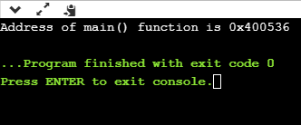
In the above output, we observe that the main() function has some address. Therefore, we conclude that every function has some address.
Declaration of a function pointer
Till now, we have seen that the functions have addresses, so we can create pointers that can contain these addresses, and hence can point them.
Syntax of function pointer
return type (*ptr_name)(type1, type2…);
For example:
int (*ip) (int);
In the above declaration, *ip is a pointer that points to a function which returns an int value and accepts an integer value as an argument.
float (*fp) (float);
In the above declaration, *fp is a pointer that points to a function that returns a float value and accepts a float value as an argument.
We can observe that the declaration of a function is similar to the declaration of a function pointer except that the pointer is preceded by a '*'. So, in the above declaration, fp is declared as a function rather than a pointer.
Till now, we have learnt how to declare the function pointer. Our next step is to assign the address of a function to the function pointer.
float (*fp) (int , int); // Declaration of a function pointer.
float func( int , int ); // Declaration of function.
fp = func; // Assigning address of func to the fp pointer.
In the above declaration, 'fp' pointer contains the address of the 'func' function.
Note: Declaration of a function is necessary before assigning the address of a function to the function pointer.
Calling a function through a function pointer
We already know how to call a function in the usual way. Now, we will see how to call a function using a function pointer.
Suppose we declare a function as given below:
float func(int , int); // Declaration of a function.
Calling an above function using a usual way is given below:
result = func(a , b); // Calling a function using usual ways.
Calling a function using a function pointer is given below:
result = (*fp)( a , b); // Calling a function using function pointer.
Or
result = fp(a , b); // Calling a function using function pointer, and indirection operator can be removed.
The effect of calling a function by its name or function pointer is the same. If we are using the function pointer, we can omit the indirection operator as we did in the second case. Still, we use the indirection operator as it makes it clear to the user that we are using a function pointer.
Let's understand the function pointer through an example.
#include <stdio.h>
int add(int,int);
int main()
{
int a,b;
int (*ip)(int,int);
int result;
printf("Enter the values of a and b : ");
scanf("%d %d",&a,&b);
ip=add;
result=(*ip)(a,b);
printf("Value after addition is : %d",result);
return 0;
}
int add(int a,int b)
{
int c=a+b;
return c;
}
Output
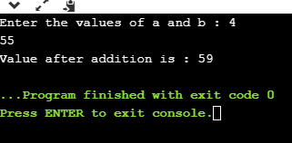
Passing a function's address as an argument to other function
We can pass the function's address as an argument to other functions in the same way we send other arguments to the function.
Let's understand through an example.
include <stdio.h>
void func1(void (*ptr)());
void func2();
int main()
{
func1(func2);
return 0;
}
void func1(void (*ptr)())
{
printf("Function1 is called");
(*ptr)();
}
void func2()
{
printf("\nFunction2 is called");
}
In the above code, we have created two functions, i.e., func1() and func2(). The func1() function contains the function pointer as an argument. In the main() method, the func1() method is called in which we pass the address of func2. When func1() function is called, 'ptr' contains the address of 'func2'. Inside the func1() function, we call the func2() function by dereferencing the pointer 'ptr' as it contains the address of func2.
Output
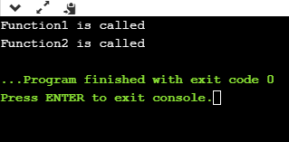
Array of Function Pointers
Function pointers are used in those applications where we do not know in advance which function will be called. In an array of function pointers, array takes the addresses of different functions, and the appropriate function will be called based on the index number.
Let's understand through an example.
#include <stdio.h>
float add(float,int);
float sub(float,int);
float mul(float,int);
float div(float,int);
int main()
{
float x; // variable declaration.
int y;
float (*fp[4]) (float,int); // function pointer declaration.
fp[0]=add; // assigning addresses to the elements of an array of a function pointer.
fp[1]=sub;
fp[2]=mul;
fp[3]=div;
printf("Enter the values of x and y :");
scanf("%f %d",&x,&y);
float r=(*fp[0]) (x,y); // Calling add() function.
printf("\nSum of two values is : %f",r);
r=(*fp[1]) (x,y); // Calling sub() function.
printf("\nDifference of two values is : %f",r);
r=(*fp[2]) (x,y); // Calliung sub() function.
printf("\nMultiplication of two values is : %f",r);
r=(*fp[3]) (x,y); // Calling div() function.
printf("\nDivision of two values is : %f",r);
return 0;
}

float add(float x,int y)
{
float a=x+y;
return a;
}
float sub(float x,int y)
{
float a=x-y;
return a;
}
float mul(float x,int y)
{
float a=x*y;
return a;
}
float div(float x,int y)
{
float a=x/y;
return a;
}
In the above code, we have created an array of function pointers that contain the addresses of four functions. After storing the addresses of functions in an array of function pointers, we call the functions using the function pointer.
Output
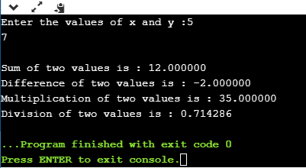

Function pointer as argument in C
Till now, we have seen that in C programming, we can pass the variables as an argument to a function. We cannot pass the function as an argument to another function. But we can pass the reference of a function as a parameter by using a function pointer. This process is known as call by reference as the function parameter is passed as a pointer that holds the address of arguments. If any change made by the function using pointers, then it will also reflect the changes at the address of the passed variable.
Therefore, C programming allows you to create a pointer pointing to the function, which can be further passed as an argument to the function. We can create a function pointer as follows:
(type) (*pointer_name)(parameter);
In the above syntax, the type is the variable type which is returned by the function, *pointer_name is the function pointer, and the parameter is the list of the argument passed to the function.
Let's consider an example:
float (*add)(); // this is a legal declaration for the function pointer
float *add(); // this is an illegal declaration for the function pointer
A function pointer can also point to another function, or we can say that it holds the address of another function.
float add (int a, int b); // function declaration
float (*a)(int, int); // declaration of a pointer to a function
a=add; // assigning address of add() to 'a' pointer
In the above case, we have declared a function named as 'add'. We have also declared the function pointer (*a) which returns the floating-type value, and contains two parameters of integer type. Now, we can assign the address of add() function to the 'a' pointer as both are having the same return type(float), and the same type of arguments.
Now, 'a' is a pointer pointing to the add() function. We can call the add() function by using the pointer, i.e., 'a'. Let's see how we can do that:
a(2, 3);
The above statement calls the add() function by using pointer 'a', and two parameters are passed in 'a', i.e., 2 and 3.
Let's see a simple example of how we can pass the function pointer as a parameter.
void display(void (*p)())
{
for(int i=1;i<=5;i++)
{
p(i);
}
}
void print_numbers(int num)
{
cout<<num;
}
int main()
{
void (*p)(int); // void function pointer declaration
printf("The values are :");
display(print_numbers);
return 0;
}
In the above code,
- We have defined two functions named 'display()' and print_numbers().
- Inside the main() method, we have declared a function pointer named as (*p), and we call the display() function in which we pass the print_numbers() function.
- When the control goes to the display() function, then pointer *p contains the address of print_numbers() function. It means that we can call the print_numbers() function using function pointer *p.
- In the definition of display() function, we have defined a 'for' loop, and inside the for loop, we call the print_numbers() function using statement p(i). Here, p(i) means that print_numbers() function will be called on each iteration of i, and the value of 'i' gets printed.
Output
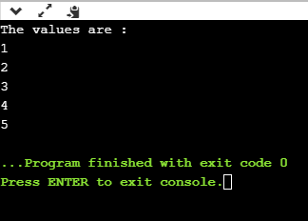
Now, we will pass the function pointer as a argument in Quicksort function "qsort". It uses an algorithm that sorts an array.
#include <stdio.h>
#include <stdlib.h>

#include<string.h>
int compare(const int *p, const int *q);
int (*f)(const void *a, const void *b);
int main()
{
int a[]={4,7,6,1,3,2};
int num=sizeof(a)/sizeof(int);
f=&compare;
qsort(a, num, sizeof(int), (*f));
for(int i=0;i<num;i++)
{
printf("%d ,",a[i]);
}

}

int compare(const int *p, const int *q)
{
if (*p == *q)
return 0;
else if (*p < *q)
return -1;
else
return 1;
}
In the above code,
- We have defined an array of integer type. After creating an array, we have calculated the size of an array by using the sizeof() operator, and stores the size in the num
- We define a compare() function, which compares all the elements in an array and arranges them in ascending order.
- We also have declared the function pointer, i.e., (*f), and stores the address of compare() function in (*f) by using the statement f=&compare.
- We call qsort() function in which we pass the array, size of the array, size of the element, and the comparison function. The comparison function, i.e., compare() will compare the array elements until the elements in an array get sorted in ascending order.
Output
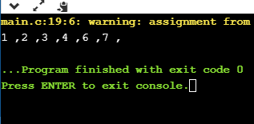

What is a programming language?
A programming language defines a set of instructions that are compiled together to perform a specific task by the CPU (Central Processing Unit). The programming language mainly refers to high-level languages such as C, C++, Pascal, Ada, COBOL, etc.
Each programming language contains a unique set of keywords and syntax, which are used to create a set of instructions. Thousands of programming languages have been developed till now, but each language has its specific purpose. These languages vary in the level of abstraction they provide from the hardware. Some programming languages provide less or no abstraction while some provide higher abstraction. Based on the levels of abstraction, they can be classified into two categories:
- Low-level language
- High-level language
The image which is given below describes the abstraction level from hardware. As we can observe from the below image that the machine language provides no abstraction, assembly language provides less abstraction whereas high-level language provides a higher level of abstraction.
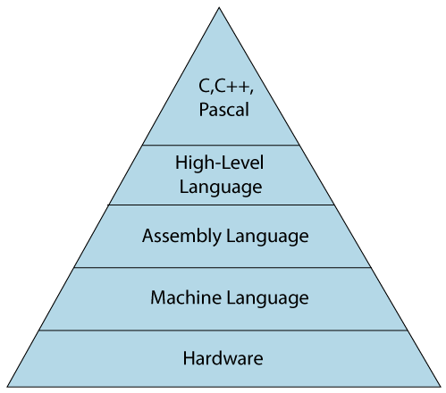
Low-level language
The low-level language is a programming language that provides no abstraction from the hardware, and it is represented in 0 or 1 forms, which are the machine instructions. The languages that come under this category are the Machine level language and Assembly language.
Machine-level language
The machine-level language is a language that consists of a set of instructions that are in the binary form 0 or 1. As we know that computers can understand only machine instructions, which are in binary digits, i.e., 0 and 1, so the instructions given to the computer can be only in binary codes. Creating a program in a machine-level language is a very difficult task as it is not easy for the programmers to write the program in machine instructions. It is error-prone as it is not easy to understand, and its maintenance is also very high. A machine-level language is not portable as each computer has its machine instructions, so if we write a program in one computer will no longer be valid in another computer.
The different processor architectures use different machine codes, for example, a PowerPC processor contains RISC architecture, which requires different code than intel x86 processor, which has a CISC architecture.
Assembly Language
The assembly language contains some human-readable commands such as mov, add, sub, etc. The problems which we were facing in machine-level language are reduced to some extent by using an extended form of machine-level language known as assembly language. Since assembly language instructions are written in English words like mov, add, sub, so it is easier to write and understand.
As we know that computers can only understand the machine-level instructions, so we require a translator that converts the assembly code into machine code. The translator used for translating the code is known as an assembler.
The assembly language code is not portable because the data is stored in computer registers, and the computer has to know the different sets of registers.
The assembly code is not faster than machine code because the assembly language comes above the machine language in the hierarchy, so it means that assembly language has some abstraction from the hardware while machine language has zero abstraction.
Differences between Machine-Level language and Assembly language
The following are the differences between machine-level language and assembly language:
Machine-level language | Assembly language
The machine-level language comes at the lowest level in the hierarchy, so it has zero abstraction level from the hardware. | The assembly language comes above the machine language means that it has less abstraction level from the hardware.
It cannot be easily understood by humans. | It is easy to read, write, and maintain.
The machine-level language is written in binary digits, i.e., 0 and 1. | The assembly language is written in simple English language, so it is easily understandable by the users.
It does not require any translator as the machine code is directly executed by the computer. | In assembly language, the assembler is used to convert the assembly code into machine code.
It is a first-generation programming language. | It is a second-generation programming language.

High-Level Language
The high-level language is a programming language that allows a programmer to write the programs which are independent of a particular type of computer. The high-level languages are considered as high-level because they are closer to human languages than machine-level languages.
When writing a program in a high-level language, then the whole attention needs to be paid to the logic of the problem.
A compiler is required to translate a high-level language into a low-level language.
Advantages of a high-level language
- The high-level language is easy to read, write, and maintain as it is written in English like words.
- The high-level languages are designed to overcome the limitation of low-level language, i.e., portability. The high-level language is portable; i.e., these languages are machine-independent.
Differences between Low-Level language and High-Level language
The following are the differences between low-level language and high-level language:
Low-level language | High-level language
It is a machine-friendly language, i.e., the computer understands the machine language, which is represented in 0 or 1. | It is a user-friendly language as this language is written in simple English words, which can be easily understood by humans.
The low-level language takes more time to execute. | It executes at a faster pace.
It requires the assembler to convert the assembly code into machine code. | It requires the compiler to convert the high-level language instructions into machine code.
The machine code cannot run on all machines, so it is not a portable language. | The high-level code can run all the platforms, so it is a portable language.
It is memory efficient. | It is less memory efficient.
Debugging and maintenance are not easier in a low-level language. | Debugging and maintenance are easier in a high-level language.

Enum in C
The enum in C is also known as the enumerated type. It is a user-defined data type that consists of integer values, and it provides meaningful names to these values. The use of enum in C makes the program easy to understand and maintain. The enum is defined by using the enum keyword.
The following is the way to define the enum in C:
enum flag{integer_const1, integer_const2,.....integter_constN};
In the above declaration, we define the enum named as flag containing 'N' integer constants. The default value of integer_const1 is 0, integer_const2 is 1, and so on. We can also change the default value of the integer constants at the time of the declaration.
For example:
enum fruits{mango, apple, strawberry, papaya};
The default value of mango is 0, apple is 1, strawberry is 2, and papaya is 3. If we want to change these default values, then we can do as given below:
enum fruits{
mango=2,
apple=1,
strawberry=5,
papaya=7,
};
Enumerated type declaration
As we know that in C language, we need to declare the variable of a pre-defined type such as int, float, char, etc. Similarly, we can declare the variable of a user-defined data type, such as enum. Let's see how we can declare the variable of an enum type.
Suppose we create the enum of type status as shown below:
enum status{false,true};
Now, we create the variable of status type:
enum status s; // creating a variable of the status type.
In the above statement, we have declared the 's' variable of type status.
To create a variable, the above two statements can be written as:
enum status{false,true} s;
In this case, the default value of false will be equal to 0, and the value of true will be equal to 1.
Let's create a simple program of enum.
#include <stdio.h>
enum weekdays{Sunday=1, Monday, Tuesday, Wednesday, Thursday, Friday, Saturday};
int main()
{
enum weekdays w; // variable declaration of weekdays type
w=Monday; // assigning value of Monday to w.
printf("The value of w is %d",w);
return 0;
}
In the above code, we create an enum type named as weekdays, and it contains the name of all the seven days. We have assigned 1 value to the Sunday, and all other names will be given a value as the previous value plus one.
Output
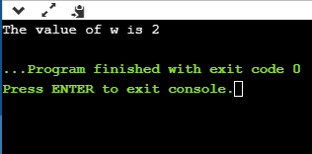
Let's demonstrate another example to understand the enum more clearly.
#include <stdio.h>
enum months{jan=1, feb, march, april, may, june, july, august, september, october, november, december};
int main()
{
// printing the values of months
for(int i=jan;i<=december;i++)
{
printf("%d, ",i);
}
return 0;
}
In the above code, we have created a type of enum named as months which consists of all the names of months. We have assigned a '1' value, and all the other months will be given a value as the previous one plus one. Inside the main() method, we have defined a for loop in which we initialize the 'i' variable by jan, and this loop will iterate till December.
Output
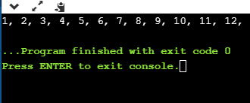
Why do we use enum?
The enum is used when we want our variable to have only a set of values. For example, we create a direction variable. As we know that four directions exist (North, South, East, West), so this direction variable will have four possible values. But the variable can hold only one value at a time. If we try to provide some different value to this variable, then it will throw the compilation error.
The enum is also used in a switch case statement in which we pass the enum variable in a switch parenthesis. It ensures that the value of the case block should be defined in an enum.
Let's see how we can use an enum in a switch case statement.
#include <stdio.h>
enum days{sunday=1, monday, tuesday, wednesday, thursday, friday, saturday};
int main()
{
enum days d;
d=monday;
switch(d)
{
case sunday:
printf("Today is sunday");
break;
case monday:
printf("Today is monday");
break;
case tuesday:
printf("Today is tuesday");
break;
case wednesday:
printf("Today is wednesday");
break;
case thursday:
printf("Today is thursday");
break;
case friday:
printf("Today is friday");
break;
case saturday:
printf("Today is saturday");
break;
}

return 0;
}
Output
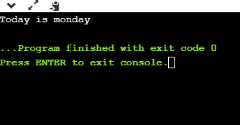
Some important points related to enum
- The enum names available in an enum type can have the same value. Let's look at the example.
#include <stdio.h>

int main(void) {
enum fruits{mango = 1, strawberry=0, apple=1};
printf("The value of mango is %d", mango);
printf("\nThe value of apple is %d", apple);
return 0;
}
Output
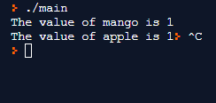
- If we do not provide any value to the enum names, then the compiler will automatically assign the default values to the enum names starting from 0.
- We can also provide the values to the enum name in any order, and the unassigned names will get the default value as the previous one plus one.
- The values assigned to the enum names must be integral constant, i.e., it should not be of other types such string, float, etc.
- All the enum names must be unique in their scope, i.e., if we define two enum having same scope, then these two enums should have different enum names otherwise compiler will throw an error.
Let's understand this scenario through an example.
- #include <stdio.h>
- enum status{success, fail};
- enum boolen{fail,pass};
- int main(void) {

- printf("The value of success is %d", success);
- return 0;
- }
Output
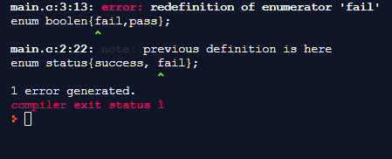
- In enumeration, we can define an enumerated data type without the name also.
#include <stdio.h>
enum {success, fail} status;
int main(void) {
status=success;
printf("The value of status is %d", status);
return 0;
}
Output
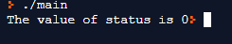
Enum vs. Macro in C
- Macro can also be used to define the name constants, but in case of an enum, all the name constants can be grouped together in a single statement.
For example,
# define pass 0;
# define success 1;
- The above two statements can be written in a single statement by using the enum type.
enum status{pass, success};
- The enum type follows the scope rules while macro does not follow the scope rules.
- In Enum, if we do not assign the values to the enum names, then the compiler will automatically assign the default value to the enum names. But, in the case of macro, the values need to be explicitly assigned.
- The type of enum in C is an integer, but the type of macro can be of any type.

C program to compare the two strings
Strings can be compared either by using the string function or without using string function. First, we will look at how we can compare the strings with the help of string function, i.e., strcmp(), which is defined in a string.h header file.
String comparison by using string function
The string function which is pre-defined in a string.h header file is a strcmp() function. The strcmp() function consider two strings as a parameter, and this function returns an integer value where the integer value can be zero, positive or negative.
The syntax of the strcmp() function is given below:
int strcmp (const char* str1, const char* str2);
In the above syntax, two parameters are passed as strings, i.e., str1 and str2, and the return type is int means that the strcmp() returns an integer value.
The strcmp() function compares the character of both the strings. If the first character of both the strings are same, then this process of comparison will continue until all the characters are compared or the pointer points to the null character '\0'.
Possible return values from the strcmp() function
Return value | Description
0 | When both the strings are equal.
<0 | If the ASCII value of a character of the first string is less than the ASCII value of a character of the second string, then the function will return negative value.
>0 | If the ASCII value of a character of the first string is greater than the ASCII value of a character of the second string, then the function will return positive value.

Let's understand through an example.
#include <stdio.h>
#include<string.h>
int main()
{
char str1[20]; // declaration of char array
char str2[20]; // declaration of char array
int value; // declaration of integer variable
printf("Enter the first string : ");
scanf("%s",str1);
printf("Enter the second string : ");
scanf("%s",str2);
// comparing both the strings using strcmp() function
value=strcmp(str1,str2);
if(value==0)
printf("strings are same");
else
printf("strings are not same");
return 0;
}
Analysis of the above program
- We have declared two arrays of char type, i.e., str1 and str2. We take the user input as strings.
- We compare the strings by using the strcmp() function, i.e., strcmp(str1,str2). This function will compare both the strings str1 and str2. If the function returns 0 value means that both the strings are same, otherwise the strings are not equal.
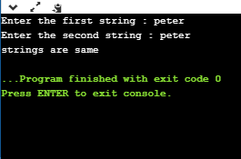
Output:

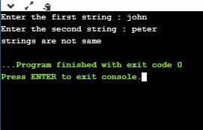
String comparison without using strcmp() function
#include <stdio.h>
int compare(char[],char[]);
int main()
{
char str1[20]; // declaration of char array
char str2[20]; // declaration of char array
printf("Enter the first string : ");
scanf("%s",str1);
printf("Enter the second string : ");
scanf("%s",str2);
int c= compare(str1,str2); // calling compare() function
if(c==0)
printf("strings are same");
else
printf("strings are not same");

return 0;
}

// Comparing both the strings.
int compare(char a[],char b[])
{
int flag=0,i=0; // integer variables declaration
while(a[i]!='\0' &&b[i]!='\0') // while loop
{
if(a[i]!=b[i])
{
flag=1;
break;
}
i++;
}
if(flag==0)
return 0;
else
return 1;
}
Analysis of the above program
- In the above, we have declared two arrays of char type, and we take the user input as strings.
- We have defined a compare() function which will take user input strings as a parameter, and compare both the strings. If the function returns 0, which means that both the strings are equal otherwise both the strings are not equal.
Output:
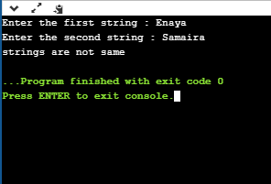
String comparison by using pointers
#include <stdio.h>
int stringcompare(char*,char*);
int main()
{
char str1[20]; // declaration of char array
char str2[20]; // declaration of char array
printf("Enter the first string : ");
scanf("%s",str1);
printf("\nEnter the second string : ");
scanf("%s",str2);
int compare=stringcompare(str1,str2); // calling stringcompare() function.
if(compare==0)
printf("strings are equal");
else
printf("strings are not equal");
return 0;
}
// Comparing both the strings using pointers
int stringcompare(char *a,char *b)
{
int flag=0;
while(*a!='\0' && *b!='\0') // while loop
{
if(*a!=*b)
{
flag=1;
}
a++;
b++;
}

if(flag==0)
return 0;
else
return 1;
}
Analysis of the above program
- We have created two arrays of char type str1 and str2. We take the user input as strings.
- We have defined a stringcompare() function which will take two pointers of char type as a parameter. The 'a' pointer holds the address of str1 and 'b' pointer holds the address of str2. Inside the function, we have created a while loop which will execute until the pointer a or b is not reached to a null character.
Output:
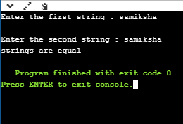

Strings Concatenation in C
The concatenation of strings is a process of combining two strings to form a single string. If there are two strings, then the second string is added at the end of the first string.
For example, Hello + javaTpoint = Hello javaTpoint
We can concatenate the strings in the following three ways:
- Concatenate two strings using loop
- Concatenate two strings using pointer
- Concatenate two strings using strcat() function
Concatenate two strings using loop
#include <stdio.h>
int main()
{
char first_string[20]; // declaration of char array variable
char second_string[20]; // declaration of char array variable
int i; // integer variable declaration
printf("Enter the first string");
scanf("%s",first_string);
printf("\nEnter the second string");
scanf("%s",second_string);
for(i=0;first_string[i]!='\0';i++);

for(int j=0;second_string[j]!='\0';j++)
{

first_string[i]=second_string[j];
i++;
}
first_string[i]='\0';
printf("After concatenation, the string would look like: %s", first_string);
return 0;
Analysis of the above program
- In the above program, we declare two strings, i.e., first_string and second_string. The values of these two strings are taken by the user as an input.
- We will concatenate these two strings and store the result of concatenation in the first_string
- We declare a new integer variable named 'i'. After declaration, we will run a loop that iterates from i=0 till the null character of the first_string is encountered. When the execution of the loop is completed, then the value of 'i' becomes equal to the length of the string plus one.
- We will define another new loop, which is basically used to concatenate the two strings. This loop starts from j=0 and executes until the null character of the second_string is encountered. On each iteration, the character located at the j^{th} position in the second_string gets stored in the i^{th} position of the first_string. In this way, both the strings are combined together to form a single string.
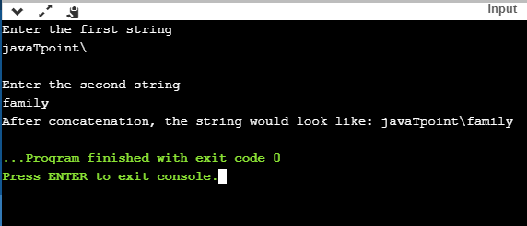
Output

Concatenate two strings using pointer
#include <stdio.h>
int main()
{
char string1[20]; // char array declaration
char string2[20]; // char array declaration
int i=0,j=0; // declaration of integer variables
char *str1; // declaration of char pointer
char *str2; // declaration of char pointer
str1=string1;
str2=string2;
printf("Enter the first string");
scanf("%s",string1);
printf("\nEnter the second string");
scanf("%s", string2);
while(string1[i]!='\0')
{

++str1;
i++;
}
while(string2[j]!='\0')
{
*str1=*str2;
str1++;
str2++;
j++;
}
printf("The concatenated string is %s",string1);

return 0;
}
Analysis of the above program
- In the above program, we have declared character array variables, i.e., string1 and string2. We take the two strings as user input and store them in the variables string1 and string2,
- We declare two char pointers str1 and str2. The str1 contains the address of string1, and str2 contains the address of string2.
- We create a loop which iterates until the null character of string1 is encountered. When the execution of the loop is completed, then the pointer str1 points to the location that exists just after the location of the last character.
- We define another while loop that iterates till the null character of string2 is encountered. On each iteration, the character stored at the j^{th} location in the string2 is appended to the string1 by using the statement *str1=*str2.
Output
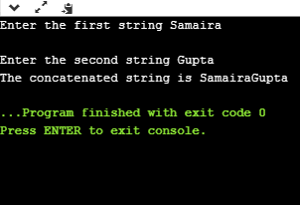
Concatenation of two strings using strcat()
Now we will see how to concatenate two strings using strcat() function. The strcat() is an inbuilt function defined in a string.h header file.
Let's look at the example.
#include <stdio.h>
#include<string.h>
int main()
{
char s1[20]; // declaration of char array
char s2[20]; // declaration of char array
printf("Enter the first string : ");
scanf("%s", s1);
printf("\nEnter the second string :");
scanf("%s",s2);
strcat(s1,s2);
printf("The concatenated string is : %s",s1);
return 0;
}
In the above code, we use the strcat() function to concatenate two strings. It takes two strings as a parameter and then appends the second string at the end of the first string.
Output
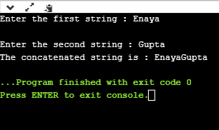

Count the number of digits in C
Now, we will look at how to count the number of digits in an integer. This integer is nothing but the number entered by the user.
First, we will calculate count the number of digits using for or while loop.
Approach
- Firstly, the number will be entered by the user. Suppose we declare the variable 'n' and stores the integer value in the 'n' variable.
- We will create a while loop that iterates until the value of 'n' is not equal to zero.
- Suppose the value of 'n' is 123.
- When the first iteration executes, the value of 'n' will be 123, and the value of count will be incremented to 1.
- When the second iteration executes, the value of 'n' will be 12, and the value of count will be incremented to 2.
- When the third iteration executes, the value of 'n' will be 1, and the value of count will be incremented to 3.
- After the completion of the third iteration, the value of 'n' becomes 0, and loop is terminated as it does not satisfy the condition (n!=0).
Let's create a program which will implement the above approach.
#include <stdio.h>
int main()
{
int n; // variable declaration
int count=0; // variable declaration
printf("Enter a number");
scanf("%d",&n);
while(n!=0)
{
n=n/10;
count++;
}

printf("\nThe number of digits in an integer is : %d",count);
return 0;
}
Output
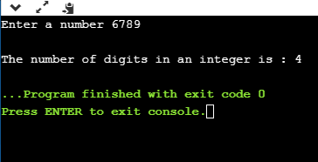
Now, we will see how to count the number of digits without using a loop.
We can also count the number of digits with the help of the logarithmic function. The number of digits can be calculated by using log10(num)+1, where log10() is the predefined function in math.h header file.
Let's see a simple example.
#include <stdio.h>
#include<math.h>
int main()
{
int num; // variable declaration
int count=0; // variable declaration
printf("Enter a number");
scanf("%d",&num);
count=(num==0)?1:log10(num)+1;
printf("Number of digits in an integer is : %d",count);
return 0;
}
Output
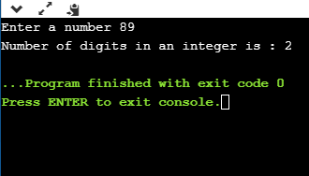
We will create a C program to count the number of digits using functions.
#include <stdio.h>
int main()
{
int num; // variable declaration
int count=0; // variable declaration
printf("Enter a number");
scanf("%d",&num);
count=func(num);
printf("Number of digits is : %d", count);

return 0;
}
int func(int n)
{
int counter=0; // variable declaration
while(n!=0)
{
n=n/10;
counter++;
}
return counter;
}
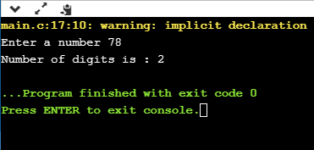
Output

Now, we will see how to count the number of digits using recursion
#include <stdio.h>
int main()
{
int num; // variable declaration
int count=0; // variable declaration
printf("Enter a number");
scanf("%d",&num);
count=func(num);
printf("Number of digits is : %d", count);
return 0;
}
int func(int n)
{
static int counter=0; // variable declaration
if(n>0)
{
counter=counter+1;
return func(n/10);
}
else
return counter;
}
In the above program, we are calculating the number of digits in an integer. The func() function is called. In func(), we declare a static variable, i.e., counter, which will be initialized only once. The func(n/10) will be called recursive1y until the condition (n>0) is true. When the condition is false, then the value of the counter is returned.
Output
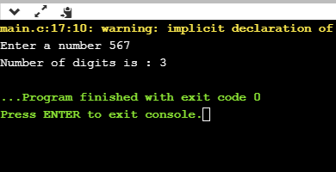

itoa Function in C
itoa () function is used to convert int data type to string data type in C language.
Syntax -
char * itoa ( int value, char * str, int base );
The string we place in the buffer pass must be large enough to hold the output. Since radix values can either be OCTAL(0 - 7), DECIMAL(0 - 9), or HEX(0 - 9, a - f). When the radix is DECIMAL, itoa() produces –
(void) sprintf(buffer, "%d", n);
Here, buffer returns character string.
When the radix is OCTAL, itoa() formats integer 'n' into an unsigned octal constant.
And when the radix is HEX, itoa() formats integer 'n' into unsigned hexadecimal constant.
The hexadecimal value will include lower case alphabets.
Return value -
The string pointer will be returned. When we pass a non-valid radix argument, the function will return NULL.
A standard-compliant alternative -
- sprintf(str,"%d",value) - For conversion to decimal base.
- sprintf(str,"%x",value) - For conversion to hexadecimal base.
- sprintf(str,"%o",value) - For conversion to octal base.
Algorithm:
- Step 1: Take a number as argument
- Step 2: Create an empty string buffer to store result
- Step 3: Use sprintf() to convert number to string
- Step 4: End
Code –
#include <stdio.h>
#include <math.h>
#include <stdlib.h>
char* itoa(int num, char* buffer, int base)
{
int current = 0;
if (num == 0) {
buffer[current++] = '0';
buffer[current] = '\0';
return buffer;
}
int num_digits = 0;
if (num < 0) {
if (base == 10) {
num_digits ++;
buffer[current] = '-';
current ++;
num *= -1;
}
else
return NULL;
}
num_digits += (int)floor(log(num) / log(base)) + 1;
while (current < num_digits)
{
int base_val = (int) pow(base, num_digits-1-current);
int num_val = num / base_val;
char value = num_val + '0';
buffer[current] = value;
current ++;
num -= base_val * num_val;
}
buffer[current] = '\0';
return buffer;
}
int main()
{
int a = 123456;
char buffer[256];
if (itoa(a, buffer, 10) != NULL) {
printf("Input = %d, base = %d, Buffer = %s\n", a, 10, buffer);
}
int b = -2310;
if (itoa(b, buffer, 10) != NULL) {
printf("Input = %d, base = %d, Buffer = %s\n", b, 10, buffer);
}
int c = 10;
if (itoa(c, buffer, 2) != NULL) {
printf("Input = %d, base = %d, Buffer = %s\n", c, 2, buffer);
}
return 0;
}
Output
Input = 123456, base = 10, Buffer = 123456
Input = -2310, base = 10, Buffer = -2310
Input = 10, base = 2, Buffer = 1010
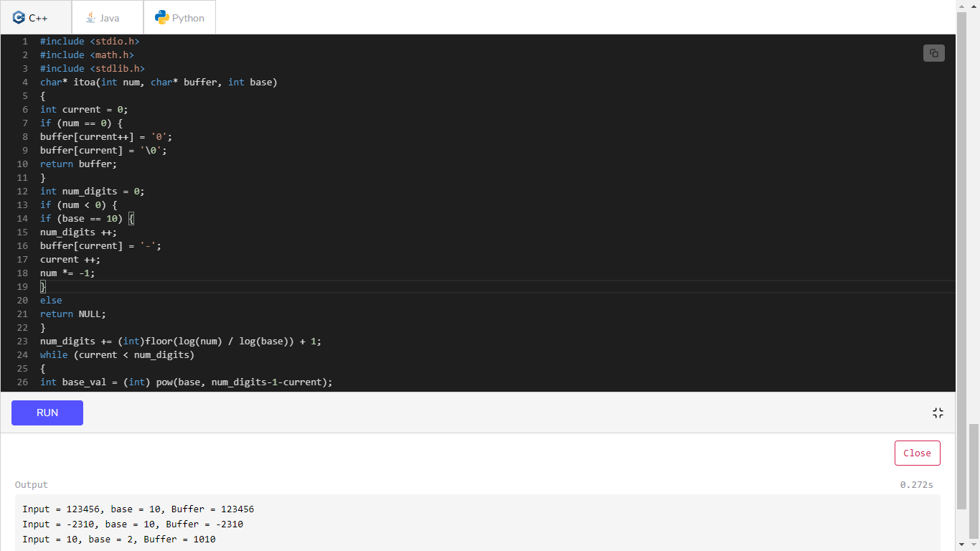
Note: But we have to keep in mind that while we are compiling with gcc, we have to use the '-lm' flag to include the math library.
gcc -o test.out test.c -lm

Extra Long Factorials in C
Problem Statement: The factorial of the integer n, written n!, is defined as:
n! = n x (n-1) x (n-2) x (n-3) x ………. x 3 x 2 x 1
Calculate and print the factorial of a given integer.
For example, if n = 30 , we calculate 30 x 29 x 28 x ………..x 3 x 2 x 1 and get.
2 6 5 2 5 2 8 5 9 8 1 2 1 9 1 0 5 8 6 3 6 3 0 8 4 8 0 0 0 0 0 0 0 in total 33 digits.

Note: Factorials of n > 20 can't be stored even in a 64 - bit long variable. Big integers must be used for such calculations. Languages like Java, Python, Ruby etc. can handle big integers, but we need to write additional code in C/C++ to handle huge values.
Description of program : The below program can calculate factorial of any number, i.e. factorial of numbers above 20 which is not feasible for an 64 bit computer.
We have started with variable
#include<stdio.h>
int main()
{
int n;
printf("Enter the value for calculating factorial=");
scanf("%d", &n);
int j = 2; // last multiple of factorial of any number goes upto 2
int a[1000] = {0};// array of 1000 spaces initialized with 0
a[0] = 1;
int len = 1;// length starts with one
int c = 0, num = 0;
while(j <= n) // till j is less than value for which factorial is required
{
c = 0;
num = 0;
while(c < len)
{
a[c] = a[c] * j;
a[c] = a[c] + num;
num = a[c] / 10;
a[c] = a[c] % 10;
c++;
}
while(num != 0)
{
a[len] = num % 10;
num = num / 10;
len++;
}
j++;
}
len--;
printf("\n\nFactorial of %d is below = ", n);
while(len >= 0)
{
printf("%d", a[len]);
len--;
}
return 0;
}
Output of above Code
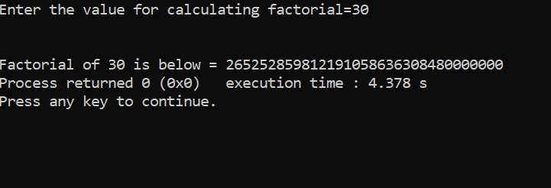
Example to show working of above code for n = 5

n = 5, j = 2, a[0] = 1, a[1000] = { 1, 0, 0, ……….0 }
len =1, c = 0, num =0

while( j < = n) → ( 2 < = 5) becomes True
again it initializes c = 0 and num = 0
while ( c < len ) → (0 < 1 ) becomes True for 1st iteration

a[c] = a[c] * j; → a[0] = 1 * 2 = 2 → a[1000] = { 2, 0, 0, ….., 0}
a[c] = a[c] + num; → a[0] = 2 + 0 = 2 → a[1000] = { 2, 0, 0, ….., 0}
num = a[c] / 10; → num = 2 / 10 = 0
a[c] = a[c] % 10; → a[0] = 2 % 10 = 2 → a[1000] = { 2, 0, 0, ….., 0}
c++; → c = 1

while ( c < len ) → (1 < 1 ) becomes False for 2nd iteration
Hence moving next instruction

while(num != 0) → False as num = 0 ( no entry inside loop)

j++; → j = 3 ( again moving towards first while loop )

while( j < = n) → ( 3 < = 5) becomes True
again it initializes c = 0 and num = 0

while ( c < len ) → (0 < 1 ) becomes True for 1st iteration

a[c] = a[c] * j; → a[0] = 2 * 3 = 6 → a[1000] = { 6, 0, 0, ….., 0}
a[c] = a[c] + num; → a[0] = 6 + 0 =6 → a[1000] = { 6, 0, 0, ….., 0}
num = a[c] / 10; → num = 6 / 10 = 0
a[c] = a[c] % 10; → a[0] = 6 % 10 = 6 → a[1000] = { 6, 0, 0, ….., 0}
c++; → c = 1
while ( c < len ) → (1 < 1 ) becomes False for 2nd iteration
Hence moving next instruction

while(num != 0) → False as num = 0 ( no entry inside loop)

j++; → j = 4 ( again moving towards first while loop )

while( j < = n) → ( 4 < = 5) becomes True
again it initializes c = 0 and num = 0

while ( c < len ) → (0 < 1 ) becomes True for 1st iteration
a[c] = a[c] * j; → a[0] = 6 * 4 = 24 → a[1000] = { 24, 0, 0, ….., 0}
a[c] = a[c] + num;→ a[0] = 24 + 0 = 24→ a[1000] = { 24, 0, 0, ….., 0}
num = a[c] / 10; → num = 24 / 10 = 2
a[c] = a[c] % 10; → a[0] = 24 % 10 = 4 → a[1000] = { 4, 0, 0, ….., 0}
c++; → c = 1

while ( c < len ) → (1 < 1 ) becomes False for 2nd iteration
Hence moving next instruction

while(num != 0) → becomes True as num = 2 which is not zero

a[len] = num % 10; → a[1] = 2 % 10 = 2 → a[1000] = { 4, 2, 0, …, 0}
num = num / 10; → num = 2 / 10 = 0
len++; → len = 2 ( clearly len is now 2 )

j++; → j = 5 ( again moving towards first while loop )

while( j < = n) → ( 5 < = 5) becomes True
again it initializes c = 0 and num = 0

while ( c < len ) → (0 < 2 ) becomes True for 1st iteration
a[c] = a[c] * j; → a[0] = 4 * 5 = 20 → a[1000] = {20, 2, 0, …, 0}
a[c] = a[c] + num;→ a[0] = 20 + 0 = 20→ a[1000] = {20, 2, 0, …, 0}
num = a[c] / 10; → num = 20 / 10 = 2
a[c] = a[c] % 10; → a[0] = 20 % 10 = 0→ a[1000] ={0, 2, 0, …, 0}
c++; → c = 1

while ( c < len ) → (1 < 2 ) becomes True for 2nd iteration
a[c] = a[c] * j; → a[1] = 2 * 5 = 10 → a[1000] = {0, 10, 0, …, 0}
a[c] = a[c] + num;→ a[1] = 1 + 2 = 12→ a[1000] = {0, 12, 0, …, 0}
num = a[c] / 10; → num = 12 / 10 = 1
a[c] = a[c] % 10; → a[1] = 12 % 10 = 2→ a[1000] ={0, 2, 0, …, 0}
c++; → c = 2

while ( c < len ) → (2 < 2 ) becomes False for 3rd iteration
Hence moving next instruction

while(num != 0) → becomes True as num = 1 which is not zero

a[len] = num % 10; → a[2] = 1 % 10 = 1 → a[1000] = { 0, 2, 1, …, 0}
num = num / 10; → num = 1 / 10 = 0
len++; → len = 3 ( clearly len is now 3 )

j++; → j = 6 ( again moving towards first while loop )

while( j < = n) → ( 6 < = 5) becomes False, as this is the top most loop, on failure of condition we move out of while body.

Moving next instruction
len--; len = 2( as in array { 0, 2, 1, …, 0 } we have value at index 0, 1 and 2 which is 120( factorial of 5)

while(len >= 0) → ( 2 >= 0) → True
printf("%d", a[len]); → print(a[2]) → 1
len--; → len = 1

while(len >= 0) → ( 1 >= 0) → True
printf("%d", a[len]); → print(a[1]) → 2
len--; → len = 0

while(len >= 0) → ( 0 >= 0) → True
printf("%d", a[len]); → print(a[0]) → 0
len--; → len = -1

while(len >= 0) → ( -1 >= 0) → False, and we exit from final while loop,

so the final value is 120 ( factorial of 5)
As we took array size 1000, i.e. a[1000] we can find out factorial of any number whose resultant values are less than or equal to a[1000], as we have seen that factorial of 30! = 2 6 5 2 5 2 8 5 9 8 1 2 1 9 1 0 5 8 6 3 6 3 0 8 4 8 0 0 0 0 0 0 0 in total 33 digits which became possible only because of array size.

Leap year program in C
First of all, it is important to know what is leap year? Generally, a year has 365 days in a year, but a leap year has 366 days which comes after four year. Below are some points related to leap year:
- A leap year is a year, which is different than a normal year having 366 days instead of 365.
- A leap year comes once in four years, in which February month has 29 days. With this additional day in February, a year becomes a Leap year.
- Some leap years examples are - 1600, 1988, 1992, 1996, and 2000.
- Although 1700, 1800, and 1900 are century years, not leap years.
Below conditions are used to check that year is a leap year or not.
- Year must be divisible by 4
- Year is divisible by 400 and not divisible by 100.
By putting these conditions in your code, you can check year is a leap year or not. If the above conditions are satisfied, the year will be leap year. These conditions can be put with if-else or with && (and) and || (Or).
How to find leap year using C programming?
With the help of a C program, we will make easy to find a leap year.
Example
See the below example in which we check a leap year by taking input from user:
#include<stdio.h>
#include<conio.h>
void main() {
int year;
printf("Enter a year: ");
scanf("%d", &year);
if(((year%4==0) && ((year%400==0) || (year%100!==0))
{
printf("%d is a leap year", &year);
} else {
printf("%d is not a leap year", &year);
}
getch();
}
Output
See the below outputs for different input values:
Test 1:
Enter a year: 2004
2004 is a leap year
Test 2:
Enter a year: 1700
1700 is not a leap year
Example
In this below example, we will find the leap years between the range of two years like 2000 to 2020. See the below example:
#include<stdio.h>
#include<conio.h>
void main() {
int startYear, endyear, i;
printf ("Enter a year to start searching the leap years: ");
scanf ("%d", &startYear);
printf ("Enter a year to end the search of leap years: ");
scanf ("%d", &endyear);
printf ("Leap Years between %d to %d are: \n", &startYear, &endYear);
for (i= startYear; i<= endYear, i++)
{
if(((i%4==0) && ((i%400==0) || (i%100!==0))
{
printf("%d \n", &i);
}
}
getch();
}
Output
Enter a year to start searching the leap years: 1950
Enter a year to end the search of leap years: 2020
Leap years between 1990 to 2020 are:
1992
1996
2000
2004
2008
2012
2016
2020

Perfect Number Program in C
Perfect Number
In mathematics, a perfect number is a positive integer that is equal to the sum of its positive divisors, excluding the number itself.
For example, 6 is a positive number that is completely divisible by 1, 2, and 3. We know that the number is also divisible by itself but we will include it in the addition of divisors. When we add these divisors (1 + 2 + 3 = 6), it produces 6, which is equal to the number that we have considered. So, we can say that 6 is a perfect number.
There are two ways to find the perfect number:
- Using for Loop
- Using while Loop
Using for Loop
Write a C program that accepts an input from the user and checks the given number is a perfect or not.
/*C program to check whether the given number is the Perfect number*/
#include<stdio.h>
#include<conio.h>
void main()
{
// declare and initialize the variables
int num, rem, sum = 0, i;
// take an input from the user.
printf("Enter a number\n");
scanf("%d", &num);
// find all divisors and add them
for(i = 1; i < num; i++)
{
rem = num % i;
if (rem == 0)
{
sum = sum + i;
}
}
if (sum == num)
printf(" %d is a Perfect Number");
else
printf("\n %d is not a Perfect Number");
getch();
}
Output
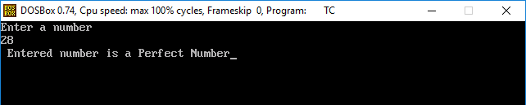
In the above output, the loop condition is validated at each iteration and counter i is incremented by 1. Inside the loop, various operations are performed such as:
Step 1: i = 1, rem = num % i, => 28 % 1 = 0. Here rem = 0.
Step 2: rem == 0, condition true.
Step 3: sum = 0 + i, sum = 0 + 1 => 1
// i is incremented by 1
Step 4: i = 2, rem = num % i, => 28 % 2 = 0. Here rem != 0, Condition is true;
Sum = 1 + i => 1 +2 = 3
Step 5: i = 3, rem = num % i, => 28 % 3 = 1. Here rem = 0, Condition is false;
Step 6: i = 4, rem = num % i, => 28 % 4 = 0. Here rem == 0, Condition is true;
Sum = 1 + i => 3 + 4 = 7
Similarly, check all condition;
Step 7: Sum == num, 28 == 28, Print the message "Entered number is a Perfect Number"
Using while Loop
Example 2: Let's create a C Program to find the perfect number using a while loop.
/*Create a C Program to find the perfect number using while loop*/
#include<stdio.h>
#include<conio.h>
void main()
{
int i = 1, num, Sum = 0;
printf(" Enter any number to check Perfect Number \n");
scanf("%d", &num);

while(i < num )
{
if(num % i == 0)
Sum = Sum + i;
i++;
}
if(Sum == num)
printf("\n %d is Perfect Number", num);
else
printf("\n %d is not a Perfect Number", num);
getch();
}
Output
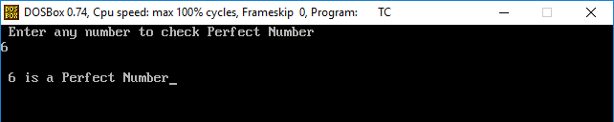
Example 3: Find the perfect number between two numbers through a C program.
#include<stdio.h>
#include<conio.h>
void main()
{
int num, Sum = 0, i, Max, Min;
// Take two number from the user: min and max
printf("Enter the minimum and the maximum value\n");
scanf("%d %d", &Min, &Max);

printf("\n Perfect Number between %d and %d are\n ", Min, Max);
for(num = Min; num <= Max; num++)
{
for(i = 1, Sum = 0; i < num; i++)
{
if(num %i == 0)
Sum = Sum + i;
}
if(Sum == num)
printf("%d \t", num);
}
getch();
}
Output
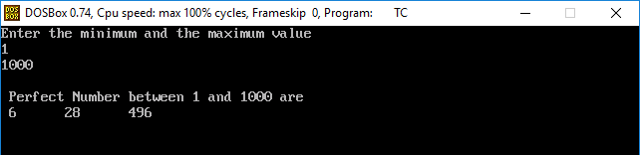

Difference Between Variables and Constants
What is a variable?
A variable is like a container containing the values or data of a particular data type that helps to execute the program. The value of a variable can change depending on the conditions or information given at the program's run time. A variable can be defined in both ways, like the uppercase and lowercase letters, digits and the underscores. A variable can store the value of the different data types like integer, float, character, enum.
Rules for defining the variable name in C programming language:
- The variables are case sensitive.
- The variable name must start with an alphabet letter or underscore.
- It includes the letter, digits and underscore.
- There should not be a white space in a variable name.
- The name of a variable should not be any reserved keywords like int, float, str, char, etc.
Declaration of Variables
It is simple to declare the variables in the C program.
// declare the variable in C.
Datatype variable_name;
Datatype variable_name1, variable_name2, vriable_name3;
int a, b, d;
int _c;
char letter;
float z ;
har str[] = "welcome";
Initialization of Variables
It is the simple initialization of variable in C program:
Datatype variable_name; // declaration of variable
Variable_name = 10; // define value;

Declaration and initialization of variable:
Datatype variable_name = value;
int a = 10;
float x = 5.5;
char letter = 'A';
int z = 1, a = 5, c = 2;
Constants
A constant is a fixed value whose value cannot be changed during program's execution or once the value is defined. It is also known as literal. For example, 5, 20, 'a', 'Radius', 5.2, "Welcome back", etc. A constant can be defined in two ways, like #define pre-processor and by const keyword. The constants can be different data types, such as integer constants, floating constants, character constants, string constants and enumeration constants. Let's understand briefly about them:
- Integer constant
An integer constant is a whole number and can be large without including any decimal points. For example, 0, 1, 2, 123, 5767, 05, 0X23, 0xFFF, etc.
- Float constant
The float constants are the part of an integer constant that containing a decimal point, fractional form and exponential form.
Here are some example of floating point constants:
0.5, 35.05, 2.3e6, 3.52f or 3.52F, PI = 3.14, etc.
- Character Constants
It is a single character constant enclosed within a single quotation mark (like 'a', 'A'), called a character constants. There are some valid constants as: 'g', 'D', ' ', '#'.
- String Constant
It is the character set of string constants that are enclosed in a double quote. The character may be letters, numbers, special symbols and some blank space. Furthermore, a string constant contains zero, one or more continuous character in double quotation marks. For example, "Hello Friends", "Computer", "5987", " " , "A".

Note: "A" and 'A' are different; the first one is a string constant consisting of character A and \0. While the second 'A' represents is a character constant whose integer value is 65.
Example 1: Let's create a program to use the #define pre-processor in C constants.
/* create a program to display the use of #define processor in C.
#include<stdio.h>
#include<conio.h>
#define PI 3.14
void main()
{
int radius, area;
printf(" Please enter the radius of circle\n");
scanf("%d", &radius);
area = PI * radius * radius;
printf(" Area of circle is : %d", area);
getch();
}
Output:
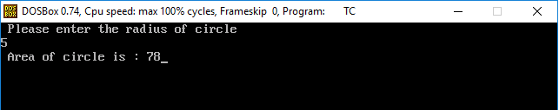
Example 2: Write create a program to display the use of const keyword in C.
/* create a program to display the use of const keyword in C. */
#include<stdio.h>
#include<conio.h>
void main()
{
const int Len = 5;
const int Width = 5;
int area;
area = Len * Width;
printf(" Ares of Rectangle is : %d", area);
getch();
}
Output:
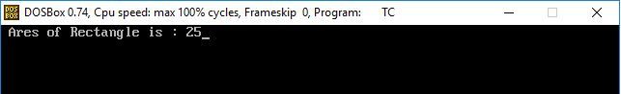
Difference between Variables and Constant in C Program
Variables | Constants
It is a variable that stores data type value in a program. | It is similar to a variable and cannot be changed during program execution.
It is a variable that can be changed after defining the variable in a program | It is a fixed variable that cannot be changed after defining the variable in a program.
The value of a variable can change depending on the conditions. | In constants, the value cannot be changed.
Typically, it uses int, float, char, string, double, etc. data types in a program. | It can be express in two ways: #define pre-processor and the const keyword.
Example: int a = 5; float radius = 5.2; char 'A'; | Example: const int Len = 5;  #define PI 3.14

Round Robin Program in C with Output
A round-robin is a CPU scheduling algorithm that shares equal portions of resources in circular orders to each process and handles all processes without prioritization. In the round-robin, each process gets a fixed time interval of the slice to utilize the resources or execute its task called time quantum or time slice. Some of the round-robin processes are pre-empted if it executed in a given time slot, while the rest of the processes go back to the ready queue and wait to run in a circular order with the scheduled time slot until they complete their task. It removes the starvation for each process to achieve CPU scheduling by proper partitioning of the CPU.
Round Robin CPU Scheduling Algorithm
Step 1: Organize all processes according to their arrival time in the ready queue. The queue structure of the ready queue is based on the FIFO structure to execute all CPU processes.
Step 2: Now, we push the first process from the ready queue to execute its task for a fixed time, allocated by each process that arrives in the queue.
Step 3: If the process cannot complete their task within defined time interval or slots because it is stopped by another process that pushes from the ready queue to execute their task due to arrival time of the next process is reached. Therefore, CPU saved the previous state of the process, which helps to resume from the point where it is interrupted. (If the burst time of the process is left, push the process end of the ready queue).
Step 4: Similarly, the scheduler selects another process from the ready queue to execute its tasks. When a process finishes its task within time slots, the process will not go for further execution because the process's burst time is finished.
Step 5: Similarly, we repeat all the steps to execute the process until the work has finished.
Characteristics of Round Robin
- It is a pre-emptive algorithm.
- It shares an equal time interval between all processes to complete their task.
- It is a starvation free CPU scheduling algorithm. Hence it is known as the fairest and simple algorithm.
Advantages
- It does not face any starvation issues or convoy effect.
- Each process gets equal priority to the fair allocation of CPU.
- It is easy to implement the CPU Scheduling algorithm.
- Each new process is added to the end of the ready queue as the next process's arrival time is reached.
- Each process is executed in circular order that shares a fixed time slot or quantum.
- Every process gets an opportunity in the round-robin scheduling algorithm to reschedule after a given quantum period.
Disadvantage
- If the time quantum is lower, it takes more time on context switching between the processes.
- It does not provide any special priority to execute the most important process.
- The waiting time of a large process is higher due to the short time slot.
- The performance of the algorithm depends on the time quantum.
- The response time of the process is higher due to large slices to time quantum.
- Getting a correct time slot or quantum is quite difficult for all processes in the round-robin algorithm.
Round Robin CPU Scheduling Example:
Let's understand the concepts of Round Robin with an example. Suppose we have five processes P1, P2, P3, P4 and P5. The arrival and burst time of each process are mentioned in the following table, as shown below. The time quantum is three units.
Process | Arrival Time (AT) | Burst Time (BT)
P1 | 0 | 8
P2 | 5 | 2
P3 | 1 | 7
P4 | 6 | 3
P5 | 8 | 5

Now we have to create the ready queue and the Gantt chart for Round Robin CPU Scheduler.
Ready queue: P1, P3, P1, P2, P4, P3, P5, P1, P3, P5
Here is the Gantt chart:
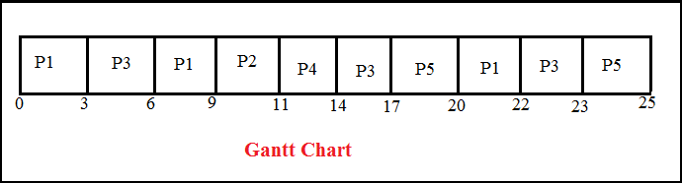
Step 1: At time 0, process P1 enters the ready queue and starts its execution for the defined time slot 3. During 3 units of the time slice, another process, P3, arrives in the ready queue because its arrival time is 1.
Step 2: Now, process P3 starts its execution with a time slot of 3 units while process P1 has to wait. After execution of process P3, process P1 again resumes its execution for time slot 3.
Step 3: During the execution of process P1, two more processes P2 and P4, arrive in the ready queue to begin their execution. Since process P2 has come first, it will be executed for time quantum 2 units after that P4 is executed.
Step 4: Here, P4 has executed for time slot 3 units, and its task is completed because BT (Burst Time) is 2. Hence it will not go to the ready queue.
Step 5: After that, process P3 is executed from the ready queue for time slot 3 and then process P5 arrives for time slot 3.
Step 6: Meanwhile, process P5 is executed, process P1 and P3 have to wait in the ready queue.
Step 7: Now process P1 is fetched from the ready queue and starts their execution for time slot 2 as it requires only 2 BT to finish its tasks. Hence it will not go to the ready queue for further execution.
Step 8: Now, the process P3 is executed for time slot 1 as it requires only 1 BT to complete its tasks.
Step 9: The final process P5 is executed for time slot 2 because it requires only 2 BT to complete its tasks.
The following are the important terms to find the Completion time, Turn Around Time (TAT), Response Time (RT) and Waiting Time (WT).
- Completion Time: It defines the time when processes complete their execution.
- Turn Around Time: It defines the time difference between the completion time (CT) and the arrival time (AT).
Turn Around Time (TAT) = Completion Time (CT) - Arrival Time (AT)
- Waiting Time: It defines the total time between requesting action and acquiring the resource.
Waiting Time (WT) = Turn Around Time (TAT) - Burst Time (BT)
- Response Time: It is the time that defines at which time the system response to a process.
Process | Arrival Time | Burst Time | Completion Time | Turn Around Time | Waiting Time | Response Time
P1 | 0 | 8 | 22 | 22 | 14 | 0
P2 | 5 | 2 | 11 | 6 | 4 | 4
P3 | 1 | 7 | 23 | 22 | 15 | 2
P4 | 6 | 3 | 14 | 8 | 5 | 5
P5 | 8 | 5 | 25 | 17 | 12 | 9

Completion time for process P1 = 22, P2 = 11, P3 = 23, P4 = 14 and P5 = 25.
Turn Around Time for P1 = Completion Time (CT) - Arrival Time (AT)
22 - 0 = 22
Turn Around Time for P2 = 11 - 5 = 6
Turn Around Time for P3 = 23 - 1 = 22
Turn Around Time for P4 = 14 - 6 = 8
Turn Around Time for P5 = 25 - 8 = 17
Waiting Time for P1 = Turn Around Time (TAT) - Burst Time (BT)
22 - 8 = 14
Waiting Time for P2 = 6 - 2 = 4
Waiting Time for P3 = 22 - 7 = 15
Waiting Time for P4 = 8 - 3 = 5
Waiting Time for P5 = 17 - 5 = 12
Average Waiting Time = (14 + 4 + 15 + 5 + 12)/5 = 50/5 = 10
Average Turn Around Time = (22+6+22+8+17)/5= 75/5 = 15
Round Robin CPU Scheduling example with sequential arrival time
Let's understand another example of Round Robin with sequential arrival time. Here we have four processes P1, P2, P3, and P4. The arrival and burst time of each process are mentioned in the following table, as shown below. The time quantum is 6 units.
Process | Arrival Time | Burst Time
P1 | 0 | 8
P2 | 1 | 5
P3 | 2 | 10
P4 | 3 | 11

Here is the Gantt chart:
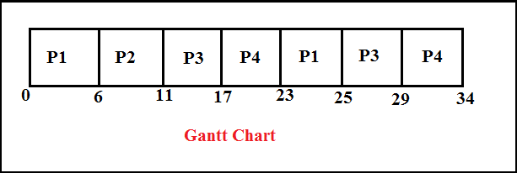
Step 1: At time 0, process P1 arrives in the ready queue and executes its tasks for time quantum 6 units. During 6 units of the time slice, another process P2, P3 and P4 arrive in the ready queue. After that, process P1 will return to the end of the ready queue and await their execution.
Step 2: Now, process P2 starts their execution for time slot 5 units because the Burst Time (BT) is 5, and it does not go to the ready queue for further execution.
Step 3: After that process, P3 will start its execution, which has 10 Burst time, but the time quantum is 6 units. Therefore, it executes its tasks for a defined time limit and is added to the ready queue's end.
Step 4: After that, the process P4 starts their execution, which has burst time 11, but the time quantum is 6 units. It executes its tasks for only 6 seconds and then adds to the end of the ready queue.
Step 5: After the execution of P4, now P1 will start its execution again for 2 units or second, and the process P1 terminate or end. Similarly, the complete execution of process P1, then P3, starts its remaining execution for Burst Time 4, and the process is completed.
Step 6: After the complete execution of process P3, now process P4 executes for the remaining time slot, which is 5, and the process is finished.
Process | Arrival Time | Burst Time | Completion Time | Turn Around Time | Waiting Time
P1 | 0 | 8 | 25 | 25 | 17
P2 | 1 | 5 | 11 | 10 | 5
P3 | 2 | 10 | 29 | 27 | 17
P4 | 3 | 11 | 34 | 31 | 20

Now we find the completion, Turn around time, waiting time and the average TAT and waiting time.
The completion time of P1 is: 25
The completion time of P2 is: 11
The completion time of P3 is: 29
The completion time of P4 is: 34
Turn Around Time: Completion Time (CT) - Arrival Time (AT)
For process P1: 25 - 0 = 25
For process P2: 11 -1 = 10
For process P3: 29 - 2 = 27
For process P4: 34 - 3 = 31
Average Turn Around Time is: (25+10+27+31)/4 = 23.25
Process Waiting Time:
P1 = 25-8 =17
P2 = 10-5 =5
P3 = 27-10= 17
P4 = 31-11=20
Average Waiting Time is: (17+5+17+20)/4 = 59/4 = 14.75
Write a program of round robin CPU scheduling in C language.
#include<stdio.h>
#include<conio.h>

void main()
{
// initlialize the variable name
int i, NOP, sum=0,count=0, y, quant, wt=0, tat=0, at[10], bt[10], temp[10];
float avg_wt, avg_tat;
printf(" Total number of process in the system: ");
scanf("%d", &NOP);
y = NOP; // Assign the number of process to variable y

// Use for loop to enter the details of the process like Arrival time and the Burst Time
for(i=0; i<NOP; i++)
{
printf("\n Enter the Arrival and Burst time of the Process[%d]\n", i+1);
printf(" Arrival time is: \t"); // Accept arrival time
scanf("%d", &at[i]);
printf(" \nBurst time is: \t"); // Accept the Burst time
scanf("%d", &bt[i]);
temp[i] = bt[i]; // store the burst time in temp array
}
// Accept the Time qunat
printf("Enter the Time Quantum for the process: \t");
scanf("%d", &quant);
// Display the process No, burst time, Turn Around Time and the waiting time
printf("\n Process No \t\t Burst Time \t\t TAT \t\t Waiting Time ");
for(sum=0, i = 0; y!=0; )
{
if(temp[i] <= quant && temp[i] > 0) // define the conditions
{
sum = sum + temp[i];
temp[i] = 0;
count=1;
}
else if(temp[i] > 0)
{
temp[i] = temp[i] - quant;
sum = sum + quant;
}
if(temp[i]==0 && count==1)
{
y--; //decrement the process no.
printf("\nProcess No[%d] \t\t %d\t\t\t\t %d\t\t\t %d", i+1, bt[i], sum-at[i], sum-at[i]-bt[i]);
wt = wt+sum-at[i]-bt[i];
tat = tat+sum-at[i];
count =0;
}
if(i==NOP-1)
{
i=0;
}
else if(at[i+1]<=sum)
{
i++;
}
else
{
i=0;
}
}
// represents the average waiting time and Turn Around time
avg_wt = wt * 1.0/NOP;
avg_tat = tat * 1.0/NOP;
printf("\n Average Turn Around Time: \t%f", avg_wt);
printf("\n Average Waiting Time: \t%f", avg_tat);
getch();
}
Output:
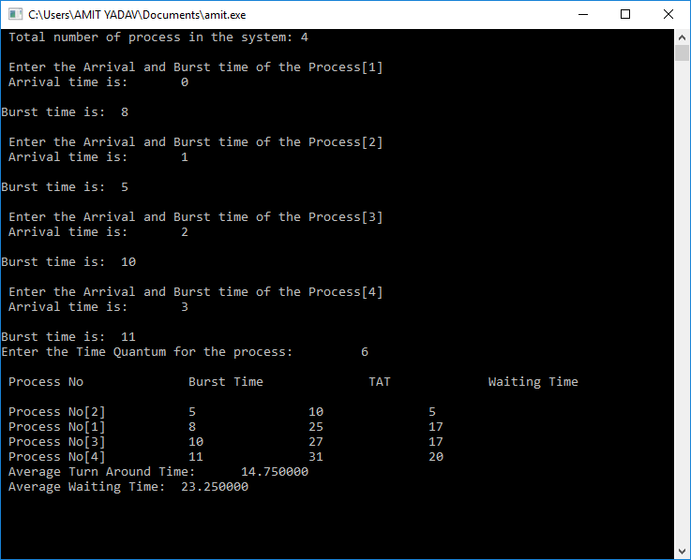

C Program to find the roots of quadratic equation
Quadratic equations are the polynomial equation with degree 2. It is represented as ax² + bx +c = 0, where a, b and c are the coefficient variable of the equation. The universal rule of quadratic equation defines that the value of 'a' cannot be zero, and the value of x is used to find the roots of the quadratic equation (a, b). A quadratic equation's roots are defined in three ways: real and distinct, real and equal, and real and imaginary.
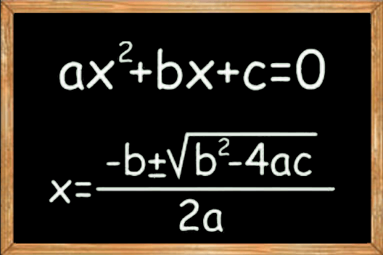
Nature of the roots
The nature of the roots depends on the Discriminant (D) where D is.
- If D > 0, the roots are real and distinct (unequal)
- If D = 0, the roots are real and equal.
- If D < 0, the roots are real and imaginary.
Steps to find the square roots of the quadratic equation
- Initialize all the variables used in the quadratic equation.
- Take inputs of all coefficient variables x, y and z from the user.
- And then, find the discriminant of the quadratic equation using the formula:
Discriminant = (y * y) - (4 * x *z).
- Calculate the roots based on the nature of the discriminant of the quadratic equation.
- If discriminant > 0, then
Root1 = (-y + sqrt(det)) / (2 * x)
Root2 = (-y + sqrt(det)) / (2 * x)
Print the roots are real and distinct.
- Else if (discriminant = 0) then,
Root1 = Root2 = -y / (2 * x).
Print both roots are real and equal.
- Else (discriminant < 0), the roots are distinct complex where,
Real part of the root is: Root1 = Root2 = -y / (2 * x) or real = -y / (2 * x).
Imaginary part of the root is: sqrt( -discriminant) / (2 * x).
Print both roots are imaginary, where first root is (r + i) img and second root is (r - i) img.
- Exit or terminate the program.
Pseudo Code of the Quadratic Equation
- Start
- Input the coefficient variable, x, y and z.
- D <- sqrt (y * y - 4 * x * z).
- R1 <- (-y + D) / ( 2 * x).
- R2 <- (-y - D) / (2 * x).
- Print the roots R1 and R2.
- Stop
Let's implements the above steps in a C program to find the roots of the quadratic equation.
/* C Program to Find the Roots of the Quadratic Equation */
#include<stdio.h>
#include<math.h> // it is used for math calculation
#include<conio.h>
void main()
{
float x, y, z, det, root1, root2, real, img;
printf("\n Enter the value of coefficient x, y and z: \n ");
scanf("%f %f %f", &x, &y, &z);
// define the quadratic formula of the nature of the root
det = y * y - 4 * x * z;
// defines the conditions for real and different roots of the quadratic equation
if (det > 0)
{
root1 = (-y + sqrt(det)) / (2 * x);
root2 = (-y + sqrt(det)) / (2 * x);
printf("\n Value of root1 = %.2f and value of root2 = %.2f", root1, root2);
}
// elseif condition defines both roots ( real and equal root) are equal in the quadratic equation
else if (det == 0)
{
root1 = root2 = -y / (2 * x); // both roots are equal;
printf("\n Value of root1 = %.2f and Value of root2 = %.2f", root1, root2);
}
// if det < 0, means both roots are real and imaginary in the quadratic equation.
else {
real = -y / (2 * x);
img = sqrt(-det) / (2 * x);
printf("\n value of root1 = %.2f + %.2fi and value of root2 = %.2f - %.2fi ", real, img, real, img);
}
getch();
}
Output:
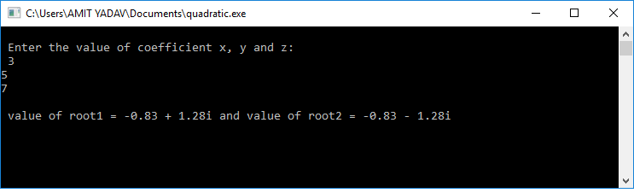
Let's create another C program in which we have used function.
#include<stdio.h>
#include<conio.h>
#include<stdlib.h>
#include<math.h>

// use function to check the nature of the roots in the quadratic equation
void R_Quadratic( int x, int y, int z)
{
if (x == 0) // Checks the vakue of x, if x = 0, the equation is not quadratic equation.
{
printf(" The value of x cannot be zero");
return;
}
int det = y * y - 4 * x * z;
double sqrt_det = sqrt(abs (det));
if (det > 0)
{
printf("\n Both roots are real and different \n ");
printf("%.2f\n %.2f", (double) (-y + sqrt_det) / (2 * x), (double) (-y - sqrt_det) / (2 * x));
}
else if (det == 0)
{
printf("\n Both roots are real and same ");
printf("%.2f", -(double)y / (2 * x));
}
else
{
printf("\n Both roots are complex");
printf("\n %.2f + %.2fi \n%.2f - %.2fi", -(double)y / (2 * x), sqrt_det, -(double)y / (2 * x), sqrt_det);

}
}
void main()
{
int x, y, z; // declare variables x, y and z
printf("\n Enter the value of coefficient x, y and z: ");
scanf("%d %d %d", &x, &y, &z);
R_Quadratic(x, y, z); // call function R_Quadratic()
getch();
}
Output:
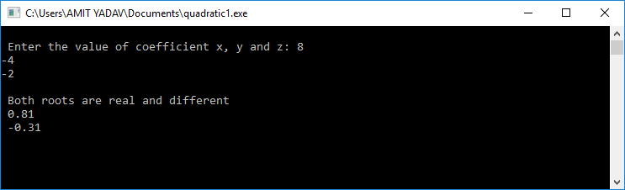

Difference Between Type Casting and Type Conversion
The two terms type casting and the type conversion are used in a program to convert one data type to another data type. The conversion of data type is possible only by the compiler when they are compatible with each other. Let's discuss the difference between type casting and type conversion in any programming language.
What is a type casting?
When a data type is converted into another data type by a programmer or user while writing a program code of any programming language, the mechanism is known as type casting. The programmer manually uses it to convert one data type into another. It is used if we want to change the target data type to another data type. Remember that the destination data type must be smaller than the source data type. Hence it is also called a narrowing conversion.
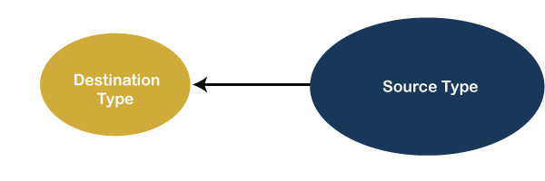
Syntax:
Destination_datatype = (target_datatype) variable;
(data_type) it is known as casting operator
Target_datatype: It is the data type in which we want to convert the destination data type. The variable defines a value that is to be converted in the target_data type. Let's understand the concept of type casting with an example.
Suppose, we want to convert the float data type into int data type. Here, the target data type is smaller than the source data because the size of int is 2 bytes, and the size of the float data type is 4 bytes. And when we change it, the value of the float variable is truncated and convert into an integer variable. Casting can be done with a compatible and non-compatible data type.
float b = 3.0;
int a = (int) b; // converting a float value into integer
Let's understand the type casting through a C program.
AreaOfRectangle.c
#include<stdio.h>
#include<conio.h>
void main()
{
printf("\n Welcome to Javatpoint tutorials ");
float x = 3.5, y = 4.5; // the size of float variable is 4 byte.
int area; // the size of the int variable is 2 bytes.
area = (int) x * y; // after conversion the product converts into integer
printf("\n Area of a Rectangle is : %d", area);
printf("\n Here, we convert float data type into the Int data type");
getch();
}
Output:
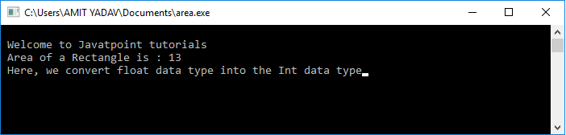
What is type conversion?
If a data type is automatically converted into another data type at compile time is known as type conversion. The conversion is performed by the compiler if both data types are compatible with each other. Remember that the destination data type should not be smaller than the source type. It is also known as widening conversion of the data type.
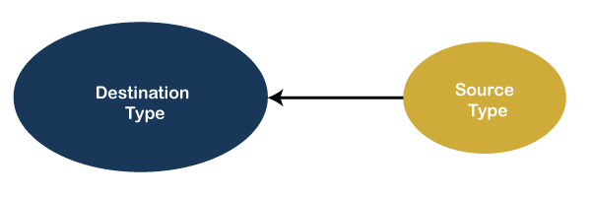
Let's understand the type conversion with an example.
Suppose, we have an int data type and want to convert it into a float data type. These are data types compatible with each other because their types are numeric, and the size of int is 2 bytes which is smaller than float data type. Hence, the compiler automatically converts the data types without losing or truncating the values.
int a = 20;
Float b;
b = a; // Now the value of variable b is 20.000 /* It defines the conversion of int data type to float data type without losing the information. */
In the above example, the int data type is converted into the float, which has a larger size than int, and hence it widens the source data type.
Let's understand type conversion through a C program.
#include<stdio.h>
#include<conio.h>
void main()
{
printf("\n Welcome to Javatpoint tutorials ");
int x = 3, y = 4; // the size of int variable is 2 byte.
float area; // the size of float variable is 4 bytes.
area = x * y; /* It is a type conversion that automatically converted by the compiler at the compile time of a program. */
printf("\n Area of a Rectangle is : %f", area);
printf("\n Here, we convert int data type to the float data type");
getch();
}
Output:
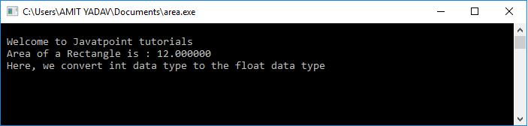
Difference Between Type Casting and Type Conversion
S.N. | Type Casting | Type Conversion
1 | Type casting is a mechanism in which one data type is converted to another data type using a casting () operator by a programmer. | Type conversion allows a compiler to convert one data type to another data type at the compile time of a program or code.
2 | It can be used both compatible data type and incompatible data type. | Type conversion is only used with compatible data types, and hence it does not require any casting operator.
3 | It requires a programmer to manually casting one data into another type. | It does not require any programmer intervention to convert one data type to another because the compiler automatically compiles it at the run time of a program.
4 | It is used while designing a program by the programmer. | It is used or take place at the compile time of a program.
5 | When casting one data type to another, the destination data type must be smaller than the source data. | When converting one data type to another, the destination type should be greater than the source data type.
6 | It is also known as narrowing conversion because one larger data type converts to a smaller data type. | It is also known as widening conversion because one smaller data type converts to a larger data type.
7 | It is more reliable and efficient. | It is less efficient and less reliable.
8 | There is a possibility of data or information being lost in type casting. | In type conversion, data is unlikely to be lost when converting from a small to a large data type.
9 | float b = 3.0;  int a = (int) b | int x = 5, y = 2, c;  float q = 12.5, p;  p = q/x;

Modulus Operator in C/C++
Before understanding about modulus operator, we need to know about the term operator. In programming, the operator symbol tells the compiler to perform a particular operation at a given number based on the passed operation.
It is used to perform different operations (+, -, *, /) on numbers. It helps to enhance the programmer's logical and mathematical ability by using various operators in the program. Except these four basic operators, there are some other operators such as modulus operator (%), scope resolution operator (::), etc.
In this section, we will focus on the modulus operator.
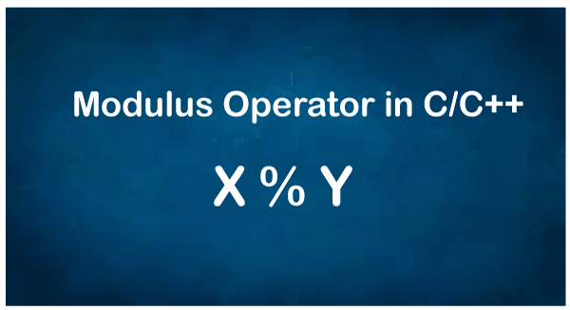
What is the modulus operator in C and C++?
The modulus operator is a symbol used in various programming languages. It is denoted by the percentage symbol (%). It is a modulus operator that is used in the arithmetic operator. It determines the remainder. In some cases, the remainder may be 0, it means the number is completely divisible by the divisor.
Syntax:
rem = a % b
In the above Syntax, a and b are two integers, and the % (Percent) symbol is a modulus operator that divides a by b and returns the remainder.
Return Possibilities of the Modulus Operator
Following are the possibilities when the first number is divided by the second number to return only a remainder value.
- If the variable a is completely divisible by the second number (b), it returns zero (0), or the remainder becomes 0.
- If the variable a is not completely divisible by the second number (b), it returns a numeric value in the range [1, a - 1]. Or we can say it returns the remainder to a non-zero integer value.
- If the first number (a) is non-zero and the second number is 0, it gives an error at compile time.
How does Modulus Operator work in C/C++?
The modulus operator works with two operands received by the end-user. After that, it divides the first number by the second number and determines the remainder. Let's understand the following example that illustrates the functionality of the modulus operator.
Example: When we perform the modulus operator between 8 and 5, means 8 % 5, it returns the remainder 3 because when 8 is divided by 5, it returns 1 as the quotient and 3 as the remainder.
Similarly, 7 % 2 returns 1 as a remainder because when 7 is divided by 2, it returns 3 as quotient and 1 as remainder.
Example 1: Write a program to implement the Modulus Operator in C.
Mode.c
#include<stdio.h>
#include<conio.h>
void main()
{
int a, b;
int res; // store the resultant of modulus expression

a = 5;
b = 2;
res = a % b; // define modulus expression
printf(" Modulus returns a remainder: %d", res);

res = b % a; // define modulus expression
printf(" \n Modulus returns a remainder: %d", res);

a = 10;
b = 5;
res = a % b; // define modulus expression
printf(" \n Modulus returns a remainder: %d", res);
getch();
}
Output:
Modulus returns a remainder: 1
Modulus returns a remainder: 2
Modulus returns a remainder: 0

Note: When we divide a float number by another number, it returns the compiled timer error as an invalid operand. Hence, we can say that it does not work with float number.
Program to implement the modulus operator in C++.
Mode3.cpp
#include<iostream>

using namespace std;
int main(void)
{
int a, b;
int res; // store the resultant of modulus expression

a = 5;
b = 2;
res = a % b; // modulus expression
cout <<" Modulus returns a remainder: " << res;

res = b % a; // modulus expression
cout <<"\n Modulus returns a remainder: " << res;

a = 10;
b = 5;
res = a % b; // modulus expression
cout <<"\n Modulus returns a remainder: " << res;
return 0;
}
Output:
Modulus returns a remainder: 1
Modulus returns a remainder: 2
Modulus returns a remainder: 0
Modulus Operator in C++
Mode4.cpp
#include<iostream>

using namespace std;
int main(void)
{
int a, b;
int res; // store the result of modulus expression

a = -5;
b = 2;
res = a % b; // modulus expression
cout <<" Modulus returns a remainder: " << res;

a = 17;
b = -3;
res = a % b; // modulus expression
cout <<"\n Modulus returns a remainder: " << res;

a = -26;
b = -5;
res = a % b; // modulus expression
cout <<"\n Modulus returns a remainder: " << res;
return 0;
}
Output:
Modulus returns a remainder: -1
Modulus returns a remainder: 2
Modulus returns a remainder: -1
Chaining of Modulus Operator
We can use the Chaining of Modulus Operator to perform modular division on more than two operands in a single statement. Following is the pseudo-code for the chaining of modulus operator, as given below.
res = operand1 % operand2 % operand3 % .... % operand_n
Let's consider the program of Chaining of Modulus Operator to take more than two operands.
Mode5.cpp
#include <iostream>
using namespace std;
int main()
{
// Use of modulus operator in C++
int x = 14;
int y = 6;
int z = 3;
int modulo = x % y % z; // x % y returns 2, and 2 % z returns 2
cout << "Modulus is : "<< modulo;
}
Output:
Modulus is: 2

Sum of first N natural numbers in C
As we know natural numbers contain all the positive numbers starting from 1, 2, 3, to n numbers or infinity. For example, suppose when we calculate the sum of the first 25 numbers. That means we start adding the numbers from 1 to the given number 25, and the process is called the sum of the first N natural number. In this topic, we will learn how to find the sum of first n numbers using a C program.
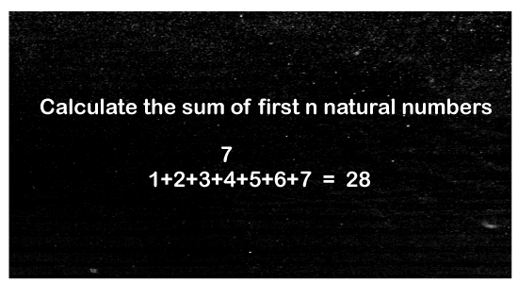
Mathematical Formula
Following is the representation to find the sum of n natural numbers using the mathematical formula:
Sum of n natural number = n * (n + 1) / 2
Where n defines the natural number.
Suppose, we want to calculate the sum of the first 20 natural number, we need to put in a mathematical formula to get the sum:
Sum = 20 * (20 + 1) / 2 = 20 * 10.50 = 210
Or
20 * (20 + 1) /2 = 10 * 21 = 210
Pseudo code
- int i, sum = 0, num
- input positive number
- i = 0
- do
- sum = sum + i
- i = i + 1
- iterate the value of i < = num
- display the sum of the first natural number.
Using for Loop
Let's create a C program that determines the sum of n natural numbers using for loop.
SumOfNaturalNumber1.c
#include <stdio.h>
#include <conio.h>
void main()
{
int num, i, sum = 0; // declare local variables
printf(" Enter a positive number: ");
scanf("%d", &num); // take any positive number
// executes until the condition remains true.
for (i = 0; i <= num; i++)
{
sum = sum + i; // at each iteration the value of i is added to the sum variable
}
// display the sum of natural number
printf("\n Sum of the first %d number is: %d", num, sum);
getch();
}
Output:
Enter a positive number: 25
Sum of the first 25 number is: 325
Using while Loop
Let's create a C program that determines the sum of n natural numbers using while loop.
SumOfNaturalNumber2.c
#include <stdio.h>
#include <conio.h>
void main()
{
int num, i, sum = 0; // initialize and declare the local variables
printf("Enter a positive number : ");
scanf("%d", &num); // take a value up to which find the sum of n natural number
i = 0;
while (i <= num) // define the while loop and i should be less than num
{
sum = sum + i; // store the sum of natural number
i++; // increment by 1
}
// print the sum of natural number
printf(" \n Sum of first %d natural number is : %d", num, sum);
getch();
}
Output:
Enter a positive number: 20
Sum of the first 20 natural number is: 210
In the above example, when we enter a positive number 20, the while loop continuously iterates over the counter value between i = 0 to 20. At each iteration, the value of i is added to the variable sum, and i is incremented by 1. When the while condition becomes false, it exits the loop and prints the sum of the first 20 natural numbers.
Using do-while Loop
Let us consider the following example to calculate the sum of natural number using Do while loop.
SumOfNaturalNumber3.c
#include <stdio.h>
#include <conio.h>
void main()
{
int num, i, sum = 0; // initialize and declare the local variables
printf("Enter a positive number: ");
scanf("%d", &num); // take a value up to which find the sum of natural number
i = 0;
do
{
sum = sum + i; // store the sum of natural number
i++; // increment by 1
} while (i <= num); // define the while loop and i should be less than num

// print the sum of natural number
printf(" \n Sum of first %d natural number is : %d", num, sum);
getch();
}
Output:
Enter a positive number: 30
Sum of the first 30 natural number is: 465
In the above example, when we enter a positive number 30, the do loop continuously iterates the counter value between i = 0 to 30. At each iteration, the value of i is added to the variable sum, and i is incremented by 1. When the while condition becomes false, it exits from the while loop and prints the sum of the first 30 natural numbers.
Using the Mathematical Formula
Let's write a program to print the sum of n natural number using the mathematical formula.
SumOfNaturalNumber4.c
#include<stdio.h>
int main()
{
int n = 40; // declare & initialize local variable n.
int sum = (n * (n + 1) ) / 2; /* define the mathematical formula to calculate the sum of given number. */
printf("Sum of %d natural number is = %d", n, sum); // print the sum of natural number
return 0;
}
Output:
Sum of 40 natural number is = 840
Using Function
Let's consider the following example to calculate the sum of natural number using function in C.
SumOfNaturalNumber5.c
#include <stdio.h>
#include <conio.h>
void main()
{
int num, total; // local variable
printf("Enter a natural number: ");
scanf("%d", &num); // take a natural number from the user
total = natural_no(num); // call the function
printf(" Sum of the %d natural number is: %d", num, total);
}
int natural_no(num)
{
int i, sum = 0;
// use for loop until the condition becomes false
for (i = 0; i <= num; i++)
{
// adding the counter variable i to the sum value
sum = sum + i;
}
return sum;
}
Output:
Enter a natural number: 100
Sum of the 100 natural number is: 5050
Sum of n natural numbers Between a Given Range
Calculate the sum of n natural number from any starting number to the specify last number.
SumOfNaturalNumber6.c
#include <stdio.h>
#include <conio.h>
void main()
{
int num, i, sum = 0; // define the local variables
printf("Enter the first number: ");
scanf("%d", &i); // accept the starting number

printf(" Up to the last natural number: ");
scanf("%d", &num); // accept the last number

// As long as the loop condition is true, it continuously iterates the statement while(i <= num)
{
// adding the counter variable i to the sum variable
sum = sum + i;
i++; // increment by 1
}
printf("Sum of natural number is = %d", sum);
getch();
}
Output:
Enter the first number: 1
Up to the last number natural number: 25
Sum of natural number is = 325
Using Recursion
Let's consider the following example to calculate the sum of natural number using recursion.
SumOfNaturalNumber7.c
#include <stdio.h>
#include <conio.h>
int sum_natural_no(int num); // declare function outside the main function
int
main()
{
int num, sum = 0; // declare local variable
printf("Enter any positive number to calculate the sum of natural no. ");
scanf("%d", &num); // take an input from the user

sum = sum_natural_no(num); // call the function

printf("Sum of the first %d natural number is: %d", num, sum); // print the sum of natural number
return 0;
}
int sum_natural_no(int num)
{
if( num == 0) // define if condition
{
return num;
}
else
{ // return the else condition
return( num + sum_natural_no( num - 1));
}
}
Output:
Enter any positive number to calculate the sum of natural no. 50
Sum of the first 50 natural number is: 1275
Using an Array
SumOfNaturalNumber8.c
#include <stdio.h>
int main()
{
// declare & initialize local variable
int num, sum = 0, i, array[50];
printf(" Enter a positive number as we want to sum the natural number: ");
scanf("%d", &num); // take a positive number
printf("\n Enter the number one by one: \n");
for (i = 0; i < num; i++)
{

scanf("%d", &array[i]); // read value one by one
sum = sum + array[i]; // store number into the sum variable
}

printf("Sum of the given number is = %d\n", sum);

return 0;
}
Output:
Enter a positive number as we want to sum the natural number: 5
Enter the number one by one:
2
4
5
6
7
Sum of the given number is = 24

What is getch() in C?
The getch() is a predefined non-standard function that is defined in conio.h header file. It is mostly used by the Dev C/C++, MS- DOS's compilers like Turbo C to hold the screen until the user passes a single value to exit from the console screen. It can also be used to read a single byte character or string from the keyboard and then print. It does not hold any parameters. It has no buffer area to store the input character in a program.
Why we use a getch() function?
We use a getch() function in a C/ C++ program to hold the output screen for some time until the user passes a key from the keyboard to exit the console screen. Using getch() function, we can hide the input character provided by the users in the ATM PIN, password, etc.
Syntax:
int getch(void);
Parameters: The getch() function does not accept any parameter from the user.
Return value: It returns the ASCII value of the key pressed by the user as an input.
Write a simple program to display the character entered by the user using the getch() function in C.
Program.c
#include <stdio.h>
#include <conio.h>
int main()
{
printf(" Passed value by the User is: %c", getch()); // print a character entered by the user
return 0;
}
Output:
Passed value by the User is: P
To print any character on the console, press the corresponding key.
Write a simple program to hold the console screen until the user gives a key to exit.
Program2.c
#include <stdio.h>
#include <conio.h>
int main()
{
printf("Enter a key to exit the console screen.\n");
getch();
return 0;
}
Output:
Enter a key to exit the console screen.
Write a program to use the getch() function to accept the string from the user.
Usergetch.c
#include <stdio.h>
#include <conio.h>
int main() {
char ch[6] = {0}; int x;
for ( x = 0; x < 5; x++) {
ch[x] = getch(); // getch() function to take input
}
printf("Received 5 character Input: %s\n", ch);
return 0;
}
Output:
Received 5 character Input: hello
Write a program to use the getch() function to accept the hidden password from the user.
Program3.c
#include<stdio.h>
#include<string.h>
#include<dos.h>
#include<conio.h>
void main()
{
char pw[10];
int x;
printf(" Enter password: ");
for (x = 0; x < 10; x++)
{
// accepts the hidden password using the getch() function
pw[x] = getch();
printf("*"); // print the input chartered in the form of *
}
pw[x] = '\0';
printf( "\n" );
printf(" You have passed the hidden password: ");
for (x = 0; pw[x] != '\0'; x++)
{
printf("%c", pw[x]);
}
getch();
}
Output:
Enter password: **********
You have passed the hidden password: Password@1

What is the function call in C?
Before jumping to the function call, we need to understand the function in the C programming language. A function is a group of tasks used to execute the predefined operations and returns a value. A large program can be divided into small blocks of code that help to understand the logic, debug, and modified it.
In the C programming language, the function is divided into two parts: the built-in/ library function and the user-defined function.
Library/ Built-in Function
A library function is predefined functions, and its tasks are also defined in the C header files. So, it does not require writing the code of the particular function; instead, it can be called directly in a program whenever it is required. Example: printf(), scanf(), getch(), etc., are the predefined function in the C library, and the meaning of these functions cannot be changed.
Let's write a program to define the library function in C.
Predefined.c
#include<stdio.h> // Contains the printf, scanf() built-in function
#include <conio.h>
void main()
{
printf( " Welcome to the JavaTpoint.com ");
printf("\n It is the library or built-in function in C ");
getch(); // built-in function
}
Output:
Welcome to the JavaTpoint.com
It is the library function or built-in function in C
User-defined Function
It is a user-defined function in the C programming language to execute some specific actions according to the programmer's requirement. A user-defined function is divided into three types such as function declaration, function definition, and function call.
Function Declaration
A function declaration defines the name and return type of a function in a program. Before using the function, we need to declare it outside of a main() function in a program.
Syntax:
return_data_type function_name ( data_type arguments) ;
Example of function declaration:
int add ( int num1, int num2 );
In the above example, int is a return data type of the function name add function that contains two integer parameters as num1 and num2. Furthermore, we can write the above function declaration is as follows:
int add (int, int);
Function Definition
It defines the actual body of a function inside a program for executing their tasks in C.
Syntax:
return_data_type function_name (argument list ) {
// Statement to be executed in a function;
}
In the above syntax, a function definition contains the three parts as follow:
- Return Data_Type: It defines the return data type of a value in the function. The return data type can be integer, float, character, etc.
- Function Name: It defines the actual name of a function that contains some parameters.
- Parameters/ Arguments: It is a parameter that passed inside the function name of a program. Parameters can be any type, order, and the number of parameters.
- Function Body: It is the collection of the statements to be executed for performing the specific tasks in a function.
Consider an example to demonstrate the function definition:
int min (int n1, int n2); // min() is the name of a function that contains n1 and n2 parameters
{
// declaration of the local variable.
int out;
if ( n1 > n2)
out = n1; // return n1 when n1 is greater than n2.
else
out = n2; // return n2 when n2 is greater than n1.
return out;
}
Function Calling:
A function call is an important part of the C programming language. It is called inside a program whenever it is required to call a function. It is only called by its name in the main() function of a program. We can pass the parameters to a function calling in the main() function.
Syntax:
Add(a, b) // a and b are the parameters
Let's consider a program to call a function in C programming languages.
Add.c
#include <stdio.h>
int add(int a, int b);
void main()
{

int sum;
int a, b;
printf(" Enter the first and second number \n");
scanf("%d %d", &a, &b);
sum = add(a, b); // call add() function
printf( "The sum of the two number is %d", sum);
}
int add(int n1, int n2) // pass n1 and n2 parameter
{
int c;
c = n1 + n2;
return c;
}
Output:
Enter the first and second number
5
6
The sum of the two number is 11
Call by Value:
When single or multiple values of an actual argument are copied into the formal parameter of a function, the method is called the Call by Value. Hence, it does not alter the function's actual parameter using the formal parameter.
Consider a program to demonstrate the Call by Value in C programming.
Call_Value.c
#include <stdio.h>
int main()
{
int x = 10, y = 20;
printf (" x = %d, y = %d from main before calling the function", x, y);
CallValue(x, y);
printf( "\n x = %d, y = %d from main after calling the function", x, y);
}
int CallValue( int x, int y)
{
x = x + 5;
y = y + 5;
printf (" \nx = %d, y = %d from modular function", x, y);
}
Output:
x = 10, y = 20 from main before calling the function
x = 15, y = 25 from modular function
x = 10, y = 20 from main after calling the function
Call by Reference:
In this method, the address of the actual argument is copied into the function call's formal parameter; the method is known as Call by Reference. If we make some changes in the formal parameters, it shows the effect in the value of the actual parameter.
Consider a program to demonstrate the Call by Reference in C programming.
Call_Ref.c
#include <stdio.h>
int main()
{
int x = 10, y = 20;
printf (" x = %d, y = %d from main before calling the function", x, y);
CallValue (&x, &y);
printf( "\n x = %d, y = %d from main after calling the function", x, y);
}
int CallRef( int *a, int *b)
{
*a = *a + 5;
*b = *b + 5;
printf (" \nx = %d, y = %d from modular function", *a, *b);
}
Output:
x = 10, y = 20 from main before calling the function
x = 15, y = 25 from modular function
x = 15, y = 25 from main after calling the function

Difference between typedef and define in C
In this topic, we will discuss the difference between typedef and define in C programming language.

typedef:
A typedef is a keyword used in C programming to define a new name for exiting data types. But it cannot provide a new data type to the predefined data type. Instead, it provides a meaning full names to an already existing data type (int, char, float, etc.). It is defined outside the main() function in a program. In other words, a typedef is used to redefine the names of existing data types in C programming.
Syntax
typedef data_type newName
or
typedef <existing_name> <alias_name>
In the above syntax, the existing _name defines the predefined data types or variable name. The 'alias _name' or newName defines the new name for exiting data type or variable name in the C program.
Example 1: Consider a program to use the typedef keyword in C.
Type.c
#include <stdio.h>
typedef int Length; // typedef provide the int data type to a new name as Length
int main()
{
Length num1, num2, sum; // here Length variable is treated as the int data type
printf(" Enter the first number:");
scanf(" %d", & num1);
printf(" Enter the second number:");
scanf(" %d", & num2);
sum = num1 + num2;
printf(" The sum of the two numbers is: %d", sum);
return 0;
}
Output:
Enter the first number: 20
Enter the second number: 10
The sum of the two numbers is: 30
Example 2: Let's consider another program to use the typedef in unsigned char of C.
program.c
#include <stdio.h>
#include <conio.h>
typedef unsigned char Bit;
int main()
{
Bit B1, B2;
B1 = 'D';
B2 = 'E';
printf( " Demonstrate the use of typedef Keyword ");
printf (" Print a single Byte: %c", B1);
printf (" Print a single Byte: %c", B2);
return 0;
}
Output:
Demonstrate the use of typedef Keyword
Print a single Byte: D
Print a single Byte: E
Use of typedef keyword in Structure
Let's consider a program to use the typedef keyword in structure to provide a new name to the struct and initialize the structure variables, as follow:
Struct.c
#include <stdio.h>
#include <string.h>

typedef struct Students {
int roll_no;
char name[50];
char Subject[60];
char teacher_name[80];
} Stud;

int main( ) {

Stud S1;
S1.roll_no = 30;
strcpy( S1.name, "Lockie Ferguson");
strcpy( S1.Subject, "Mathematics");
strcpy( S1.teacher_name, "Jasmine");

printf( "Student Roll No: %d\n", S1.roll_no);
printf( "Student Name: %s\n", S1.name);
printf( "Student Subject: %s\n", S1.Subject);
printf( "Student Teacher Name: %s\n", S1.teacher_name);

return 0;
}
Output:
Student Roll No: 30
Student name: Lockie Fergusion
Student Subject: Mathematics
Student Teacher Name: Jasmine
In the above program, we use the typedef keyword to define a new name for the struct data type is Students and initialize the variables using it.
define
A #define is the pre-processor used to represents the constant aliases for various data. It is used to define the constant variable for different data types in C. It is defined outside of the main program.
Syntax
#define token value
In the above syntax, #define is a pre-processor that defines the token as a constant variable name, and the value represents the token value. After initializing the constant variable in the pre-processor, we can use the value using the variable in a program.
Example 1: Consider a program to use the #define pre-processor in C.
Define.c
#include <stdio.h>
#include <conio.h>
#define PI 3.14 // define the constant variable
void main()
{
printf (" Display the PI Constant value using the #define is: %f", PI);
getch();
}
Output:
Display the PI Constant value using the #define is: 3.14
Example 2: Consider a program to get the area of a circle in C using the #define pre-processor.
Area.c
# include <stdio.h>
#include <conio.h>
#define PI 3.14 // define the constant variable
void main()
{
int r, area;
printf (" Enter the radius of the circle: ");
scanf ("%d", &r);
area = PI * r * r;
printf (" The area of the circle is: %d", area);
getch();
}
Output:
Enter the radius of the circle : 5
The area of the circle is: 78
In the above program, we use PI as a continuous variable using the #define pre-processor. And when the program is executed, the PI value automatically calls in a program.
Example 3: Consider a program to demonstrate the importance of typedef over the #define for data types.
Pgrm.c
#include <stdio.h>
#include <conio.h>
typedef char* ptr;
#define PTR char
int main()
{
ptr x, y, z;
PTR p, q, r;
printf (" sizeof x : %d\n", sizeof(x) );
printf (" sizeof y : %d\n", sizeof(y) );
printf (" sizeof z : %d\n", sizeof(z) );
printf (" sizeof p : %d\n", sizeof(p) );
printf (" sizeof q : %d\n", sizeof(q) );
printf (" sizeof r : %d\n", sizeof(r) );
return 0;
}
Output:
Sizeof x:8
Sizeof y:8
Sizeof z:8
Sizeof p:8
Sizeof q:1
Sizeof r:1
Difference between the typedef and the #define in C
Following are the differences of the typedef and the #define, as follows:
SN | Typedef | #define
1. | Typedef is a keyword in the C programming language. | #define is a pre-processor and used as macro used in C programming.
2. | It is a keyword used to provide an alternate name to the existing data types only. And that name can be used to initialize the variables in a program. | A #define is used to define an alias for values.
3. | The compiler performs it. | The pre-processor performs it.
4. | It uses a semicolon to terminate the statement. | It does not use a semicolon to terminate the statement.
5. | It defines the actual definition of a new data type. | A #define is used to just copy-paste the define values where it calls or uses.
6. | It follows the scope rule that defines if a new data type is in scope (inside a function), the new type name will only be visible till the scope of the data type. | When the #define pre-processor encounters in a program, it replaces all the occurrence of the variables with the defined values; after that, no scope is followed.
7. | Define outside of the main() function. | Define outside of the main() function.

Big O Notation in C
In Data Structure and Algorithms in C programming, we have learned so many algorithms where we have understood different aspects and purposes of an algorithm. We have also studied the complexity of an algorithm and how to analyze and calculate an algorithm's complexity. We have found the time and space complexity of an algorithm and concluded that the algorithm that has less time and space complexity is evaluated as the best algorithm. We understood how to find the best case, worst case, and the average case of an algorithm. Thus, for analyzing all such complexities and representing them, the concept of Asymptotic Notation is used under which there are different types available for representing the complexities. One such type is Big O Notation.
In this section, we will discuss the Big O notations and briefly introduce Asymptotic notations and its types.
What are Asymptotic Notations
These are the mathematical notations that are used for the asymptotic analysis of the algorithms. The term 'asymptotic' describes an expression where a variable exists whose value tends to infinity. In short, it is a method that describes the limiting behavior of an expression. Thus, using asymptotic notations, we analyze the complexities of an algorithm and its performance. Using the asymptotic notations, we determine and show the complexities after analyzing it. Therefore, there are three types of asymptotic notations through which we can analyze the complexities of the algorithms:
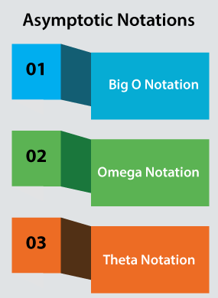
- Big O Notation (O): It represents the upper bound of the runtime of an algorithm. Big O Notation's role is to calculate the longest time an algorithm can take for its execution, i.e., it is used for calculating the worst-case time complexity of an algorithm.
- Omega Notation (Ω(n)): It represents the lower bound of the runtime of an algorithm. It is used for calculating the best time an algorithm can take to complete its execution, i.e., it is used for measuring the best case time complexity of an algorithm.
- Theta Notation (Θ(n)): It carries the middle characteristics of both Big O and Omega notations as it represents the lower and upper bound of an algorithm.
So, these three asymptotic notations are the most used notations, but other than these, there are more common asymptotic notations also present, such as linear, logarithmic, cubic, and many more.
Big O Notation
The Big O notation is used to express the upper bound of the runtime of an algorithm and thus measure the worst-case time complexity of an algorithm. It analyses and calculates the time and amount of memory required for the execution of an algorithm for an input value.
Mathematically,
For a function, f(n) and another function g(n), where both functions are defined on some unbounded set of real (positive) numbers.
Where g(n) is strictly positive for all large values of n. It can be written as:
f(n) = O(g(n)) where n tends to infinity (n → ∞)
But it is seen that the assumption of n to infinity is left unstated, and so we can simply write the above expression as:
f(n) = O(g(n))
Here, f and g are the necessary functions from positive integer to non-negative real numbers.
Thus, the Big O asymptotic refers to large n values.
Properties of Big O Notation
Certain essential properties of Big O Notation are discussed below:
- Constant Multiplication:
If f(n) = c.g(n), then O(f(n)) = O(g(n)) where c is a nonzero constant.
- Summation Function:
If f(n) = f₁(n) + f₂(n) + -- + f_{m}(n) and f_{i}(n)≤ f_{i}+1(n) ∀ i=1, 2,--, m,
then O(f(n)) = O(max(f1(n), f2(n), --, fm(n))).
- Polynomial Function:
If f(n) = a0 + a1.n + a2.n2 + -- + am.nm,
then O(f(n)) = O(nm).
- Logarithmic Function:
If f(n) = logan and g(n)=logbn,
then O(f(n))=O(g(n))
Here, in terms of Big O, every log functions increase in the same manner.
How does Big O Notation make runtime analysis of an algorithm
For analyzing an algorithm's performance, we used to calculate and compare the worst-case running time complexities of the algorithm. The order of O(1), which is known as the Constant Running Time, is considered to be the fastest running time for an algorithm where the time taken by the algorithm is the same for different input sizes. However, the constant running time is the ideal runtime for an algorithm, but it is achieved very rarely. It is because the runtime of an algorithm depends on the input size of n.
For example:
As we know that the runtime performance of an algorithm depends on the input size of n. Let's see some mathematical examples for making the runtime analysis of an algorithm for different size of n:
- n = 20
log (20) = 2.996;
20 = 20;
20 log (20) = 59.9;
20² = 400;
2²⁰ = 1084576;
20! = 2.432902 + 18¹⁸;
- n = 10
log (10) = 1;
10 = 10;
10 log (10) = 10;
10² = 100;
2¹⁰ = 1024;
10! = 3628800;
Thus, similarly, we calculate the runtime performance of an algorithm. Let's see some algorithmic examples and see the runtime analysis of those algorithms:
- For Linear Search, the runtime complexity is O(n).
- For binary search, the runtime complexity is O(log n).
- For Bubble Sort, Selection Sort, Insertion Sort, Bucket Sort, the runtime complexity is O(n^c).
- For Exponential algorithms such as Tower of Hanoi, the runtime complexity is O(c^n).
- For Heap Sort, Merge SortSort, the runtime complexity is O(n log n).
How does Big O notation analyze the Space complexity
It is essential to determine both runtime and space complexity for an algorithm. It's because on analyzing the runtime performance of the algorithm, we get to know the execution time the algorithm is taking, and on analyzing the space complexity of the algorithm, we get to know the memory space the algorithm is occupying. Thus, for measuring the space complexity of an algorithm, it is required to compare the worst-case space complexities performance of the algorithm.
In order to determine the space complexity of an algorithm, the following two tasks are necessary to be done:
Task 1: Implementation of the program for a particular algorithm is required.
Task 2: The size of the input n is required to know the memory each item will hold.
Both these are two important tasks to be accomplished first then only we can calculate the space complexity for an algorithm.
Examples of Algorithms
Below we have mentioned some algorithmic examples with their space complexities:
- For Linear Search, Bubble sort, selection sort, Heap sort, Insertion sort, and Binary Search, the space complexity is O(1).
- For radix sort, the space complexity is O(n+k).
- For quick SortSort, the space complexity is O(n).
- For merge sort, the space complexity is O(log n).
Example of Big O Notation in C
Below we have implemented the selection sort algorithm in C and calculated the worst-case complexity (Big O notation) of the algorithm:
for(int i=0; i<n; i++)
{
int min = i;
for(int j=i; j<n; j++)
{
if(array[j]<array[min])
min=j;
}
int temp = array[i];
array[i] = array[min];
array[min] = temp;
}
In order to analyze the algorithm:
- We can see that the range of the for outer loop is i < n, which means the order of the loop is O(n).
- Next, for the inner for loop, it is also O(n) as j < n.
- The average efficiency is found n/2 for a constant c, but we ignore the constant. So, the order is O(n).
- On multiplying the order of the inner and outer loop, we get the runtime complexity as O(n^2).
You can implement other algorithms in C, analyze it and determine the complexities in a similar way.

LCM of two numbers in C
In this topic, we will discuss the LCM and how we can get the LCM of two numbers in the C programming language.
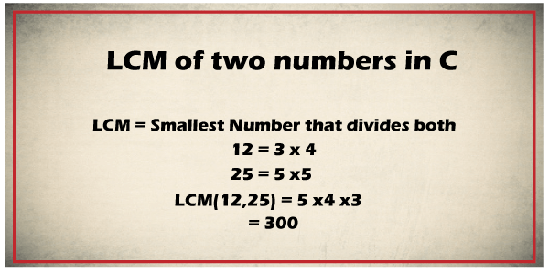
LCM is a mathematical term that stands for Least Common Multiple (LCM). It is the smallest positive number that is completely divisible by both integer's n1 and n2, without leaving any remainder. LCM is also known as the Lowest Common Multiple. It is represented as LCM (a, b) or lcm (a, b). For example, the LCM of two positive numbers, 72 and 120, is 360.
Algorithm of LCM
Following are the algorithm of LCM of two number, as follows:
Step 1: Initialize the positive integer variables A and B.
Step 2: Store the common multiple of A & B into the max variable.
Step 3: Validate whether the max is divisible by both variables A and B.
Step 4: If max is divisible, display max as the LCM of two numbers.
Step 5: Else, the value of max is increased, and go to step 3.
Step 6: Stop the program.
LCM of two numbers using while loop
Let's consider an example to find the LCM of two numbers in C using while loop.
Lcm.c
#include <stdio.h>
#include <conio.h>
void main()
{
int num1, num2, max_div, flag = 1;
// accept any two positive number from the user
printf( " Enter any two positive numbers to get the LCM \n ");
scanf(" %d %d", &num1, &num2);

// max_div variable holds the max divisible number between num1 and num2.
max_div = (num1 > num2) ? num1 : num2;

while (flag) // (flag = 1)
{
if (max_div % num1 == 0 && max_div % num2 == 0)
{
printf( " The LCM of %d and %d is %d. ", num1, num2, max_div);
break;
}
++max_div; // pre-increment max_div
}
}
Output
Enter any two positive numbers to get the LCM
15
12
The LCM of 15 and 12 is 60.
As we can see in the above program, we have passed two positive numbers, 15 and 12, stored in variable num1 and num2. Where the max_div variable store the largest divisible number by both variables num1 and num2. However, the LCM of two numbers cannot be less than max_div.
In each iteration of the while loop, max_div checked the number divisible by num1 and num2 variables inside the if condition.
if (max_div % num1 == 0 && max_div % num2 == 0)
{
}
If the above condition is not true, the max_div is incremented by 1, and the iteration of the loop continues till the if statement is true.
LCM of two numbers using GCD
Let's consider a program to get the LCM of two numbers in C using the GCD.
Gcd.c
#include <stdio.h>
#include <conio.h>
int main()
{
// declaration of the local variables
int num1, num2, i, gcd, LCM;
printf (" Enter any two positive numbers: \n ");
scanf (" %d %d", &num1, &num2);

/* use for loop to define the num1 & num2. Where the num1 and num2 should be equal or less than i. */
for ( i = 1; i <= num1 && i <= num2; ++i)
{
// check whether i id divisible by both positive number num1 and num2.
if (num1 % i ==0 && num2 % i == 0)
gcd = i; // assign the divisible number i to gcd
}
LCM = (num1 * num2) / gcd;

printf( " The LCM of two numbers %d and %d is %d. ", num1, num2, LCM );
}
Output
Enter any two positive numbers:
30
20
The LCM of two numbers 30 and 20 is 60.
LCM of two numbers using function
Let's consider a program to get the LCM of two numbers in C using function.
Max.c
#include <stdio.h>
#include <conio.h>

int get_lcm( int a, int b); // function declaration

int main()
{
int n1, n2, lcm; // declaration of variables
printf (" \n Enter any two positive numbers to get the LCM of: \n ");
scanf ("%d %d", &n1, &n2);
lcm = get_lcm( n1, n2); // function calling
printf ( " \n LCM of %d and %d is %d. ", n1, n2, lcm);
return 0;
}

int get_lcm ( int n1, int n2) // function definition
{
/* static variabe is iniatialized only once for each function call */
static int max = 1;
if ( max % n1 == 0 && max % n2 == 0)
{
return max;
}
else
{
max++;
get_lcm( n1, n2);
return max;
}
}
Output
Enter any two positive numbers to get the LCM of:
30
25
LCM of 30 and 25 is 150.
LCM of two numbers using recursive function
Let's consider a program to get the LCM of two numbers in C using the Recursive function.
Lcm_fun.c
#include <stdio.h>
#include <conio.h>

// use Recursive function to return gcd of two numbers num1 and num2.
int gcd( int num1, int num2)
{
if ( num1 == 0) // if num1 is equal to 0, return num2

{
return num2;
}
return gcd (num2 % num1, num1);
}

// lcm_fun () function returns the LCM of two numbers
int lcm_fun( int num1, int num2)
{ // divide the num1 by gcd() function and then multiply with num2.
return ( num1 / gcd(num1, num2)) * num2;
}

int main()
{ // declaration and initialization of positive numbers
int num1, num2;
printf( "Enter any two positive numbers \n");
scanf(" %d %d", &num1, &num2);

printf ( " LCM of two numbers %d and %d is %d ", num1, num2, lcm_fun( num1, num2));
return 0;
}
Output
Enter any two positive numbers
26
20
LCM of two numbers 26 and 20 is 260

Difference between while loop and do-while loop in C?
In this article, we learn comparison between the while loop and do-while loop constructs in C language. At the beginning of this article, we understand the concept of while loop and do-while loop in C. After that, we learn the comparisons of while and do-while loop in C programming.
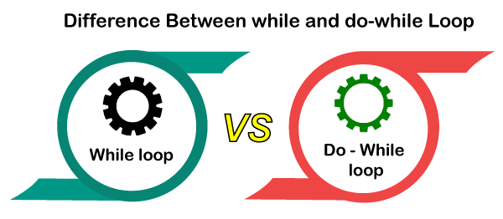
While loop statement:
While loop statement is one of the easiest and most widely used looping constructs in the C programming language.
In this statement, while it is a reserved word or keyword, the condition can be any constant, variable, expression, and statement can be a single statement or a group of statements. In the while loop, we have to perform three steps:
- Initialization
- Test Condition
- Increment and decrement
Initialization Value: In a while loop, the first step is initialization is used to set the initial value of the loop counter. The loop counter may be an increment counter or decrement counter in while loop.
For Example: i = 1;
Test Condition: After the initialization step, the next step in the while loop is to check the test condition whether the loop is executed or not. If the condition is true in the while loop, the loop's body is executed; otherwise, there is no loop execution.
For Example: while (i<=10)
Increment and decrement: After checking the test condition in the while loop, increment and decrement are used to increment and decrement the loop counter's value.
For Example: i = i + 1;
Syntax of while loop:
Initialization;
while (condition)
{
Block of statements;
}
Statement-x;
In a while loop statement, while keyword is used and followed by any good condition that has to be tested enclosed in parentheses and it may contain any logical operator. Condition is followed by a pair of curly brackets that specifies the set of statements that are to be executed while the condition is true.
Example:
#include <stdio.h>
#include <conio.h>
Void main ()
{
int i;
clrscr();
i = 1;
while (i<=10)
{
print ("hello");
i = i + 1;
}
getch();
}
Flowchart of while loop statement:
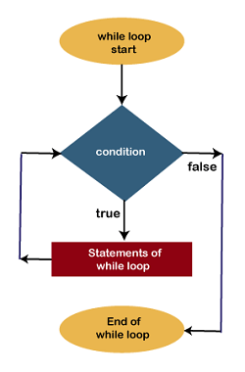
do-while loop statement:
In the C programming language, the do-while loop statement is also similar to a while loop in the C programming language. In this, first of all, the loop's body is executed then the condition is checked. In the do-while loop, we have to perform three steps:
- Initialization
- Test Condition
- Increment and decrement
Initialization value: In a do-while loop, the first step is initialization and is used to set the initial value of the loop counter. The loop counter may be an increment counter or decrement counter.
For Example: i = 1;
Test Condition: After the initialization step, the next step in the do-while loop is to check the test condition whether the loop is executed or not.
For Example: while (i<=10);
Increment and decrement: After checking the test condition in the do-while loop, the next step is to increment and decrement the loop counter's value.
For Example: i = i + 1;
Syntax of do-while loop:
do
{
Statements;
}
while (condition);
Statement-x;
Here, two keywords are used for the do-while loop statement is do and while. If the condition is true in the do-while loop, the statement executes again, and if the condition returns false, execution stops, and control passes to the next statement.
Example:
#include <stdio.h>
#include <conio.h>
Void main ()
{
int i;
clrscr();
i = 1;
do
{
printf("hello");
i = i + 1;
}
while(i<=10);
getch();
}
Flowchart of do-while loop statement:
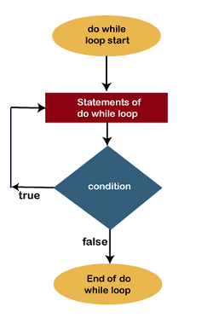
while loop vs do-while loop in C
Let's see some Comparison between the while loop and do-while loop in the C language
SR.NO | while loop | do-while loop
1. | While the loop is an entry control loop because firstly, the condition is checked, then the loop's body is executed. | The do-while loop is an exit control loop because in this, first of all, the body of the loop is executed then the condition is checked true or false.
2. | The statement of while loop may not be executed at all. | The statement of the do-while loop must be executed at least once.
3. | The while loop terminates when the condition becomes false. | As long as the condition is true, the compiler keeps executing the loop in the do-while loop.
4. | In a while loop, the test condition variable must be initialized first to check the test condition in the loop. | In a do-while loop, the variable of test condition Initialized in the loop also.
5. | In a while loop, at the end of the condition, there is no semicolon.  Syntax:  while (condition) | In this, at the end of the condition, there is a semicolon.  Syntax:  while (condition);
6. | While loop is not used for creating menu-driven programs. | It is mostly used for creating menu-driven programs because at least one time; the loop is executed whether the condition is true or false.
7. | In a while loop, the number of executions depends on the condition defined in the while block. | In a do-while loop, irrespective of the condition mentioned, a minimum of 1 execution occurs.
8. | Syntax of while loop:  while (condition)  {  Block of statements;  }  Statement-x; | Syntax of do-while loop:  do  {  statements;  }  while (condition);  Statement-x;
9. | Program of while loop:  #include  #include  Void main()  {  int i;  clrscr();  i = 1;  while(i<=10)  {  printf("hello");  i = i + 1;  }  getch();  } | Program of do-while loop:  #include  #include  Void main()  {  int i;  clrscr();  i = 1;  do  {  printf("hello");  i = i + 1;  }  while(i<=10);  getch();  }
10. | Flowchart of while loop: | Flowchart of do-while loop:

Memory Layout in C
When we create a C program and run the program, its executable file is stored in the RAM of the computer in an organized manner.
The memory layout for C program can be shown below:
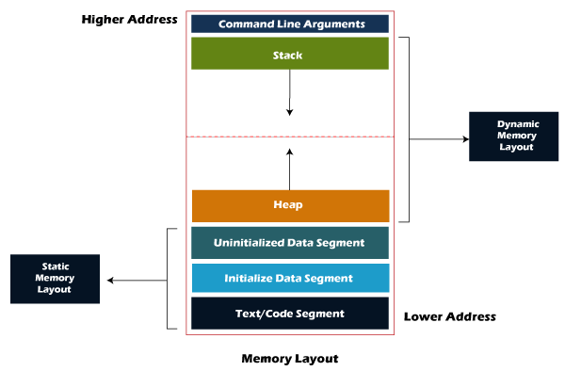
As we can observe in the above figure, the C program consists of the following sections in the program:
- Text segment
- Initialized data segment
- Uninitialized data segment
- Stack
- Heap
Let's understand each section one by one.
1. Text segment
The text segment is also known as the code segment. When we compile any program, it creates an executable file like a.out, .exe, etc., that gets stored in the text or code section of the RAM memory. If we store the instructions in the hard disk, then the speed for accessing the instructions from the hard disk becomes slower as hard disk works on the serial communication so taking the data from the hard disk will be slower, whereas the RAM is directly connected to the data and address bus so accessing the data from the RAM is faster.
2. Data section
The data which we use in our program will be stored in the data section. Since the variables declared inside the main() function are stored in the stack, but the variables declared outside the main() method will be stored in the data section. The variables declared in the data section could be stored in the form of initialized, uninitialized, and it could be local or global. Therefore, the data section is divided into four categories, i.e., initialized, uninitialized, global, or local.
Let's understand this scenario through an example.
#include<stdio.h>
int var1;
int var2 = 10;
void function1()
{
printf("I am function1");
}
int main()
{
function1();
return 0;
}
In the above code, var1 and var2 variables are declared outside the main() function where var1 is the uninitialized variable, whereas the var2 is an initialized variable. These variables can be accessed anywhere in the program because these variables are not a part of the main() in the stack.
The data section consists of two segments:
- Uninitialized data segment
- Initialized data segment
Uninitialized data segment
The uninitialized data segment is also known as a .bss segment that stores all the uninitialized global, local and external variables. If the global, static and external variables are not initialized, they are assigned with zero value by default.
The .bss segment stands for Block Started by symbol. The bss segment contains the object file where all the statically allocated variables are stored. Here, statically allocated objects are those objects without explicit initialization are initialized with zero value. In the above code, var1 is an uninitialized variable so it is stored in the uninitialized data section.
Let's look at some examples of uninitialized data segment.
#include<stdio.h>
char a; // uninitialized global variable..
int main()
{
static int a; // uninitialized static variable..
return 0;
}
Initialized data segment
An initialized data segment is also known as the data segment. A data segment is a virtual address space of a program that contains all the global and static variables which are explicitly initialized by the programmer.
The values of variables in a data segment are not read-one, i.e., they can be modified at run time. This data segment can be further classified into categories:
- Initialized read-only area: It is an area where the values of variables cannot be modified.
- Initialized read-write area: It is an area where the values of variables can also be altered.
For example: the global variables like char str[] = "javatpoint" and int a=45; will be stored in the initialized read-write area. If we create the global variable like const char* string = "javatpoint"; the literal "javatpoint" would be stored in the initialized read area, whereas the char pointer variable would be stored in the initialized write area.
#include<stdio.h>
char string[] = "javatpoint"; // global variable stored in initialized data segment in read-write area..
int main()
{
static int i = 90; // static variable stored in initialized data segment..
return 0;
}
3. Stack
When we define a function and call that function then we use the stack frame. The variables which are declared inside the function are stored in the stack. The function arguments are also stored in the function as the arguments are also a part of the function. Such a type of memory allocation is known as static memory allocation because all the variables are defined in the function, and the size of the variables is also defined at the compile time. The stack section plays a very important role in the memory because whenever the function is called, a new stack frame is created.
Stack is also used for recursive functions. When the function is called itself again and again inside the same function which causes the stack overflow condition and it leads to the segmentation fault error in the program.
4. Heap
Heap memory is used for the dynamic memory allocation. Heap memory begins from the end of the uninitialized data segment and grows upwards to the higher addresses. The malloc() and calloc() functions are used to allocate the memory in the heap. The heap memory can be used by all the shared libraries and dynamically loaded modules. The free() function is used to deallocate the memory from the heap.
#include<stdio.h>
int main()
{
int *ptr = (int*)malloc(sizeof(int)) ; // memory gets allocated in the heap segment.
return 0;
}

Balanced Parenthesis in C
In this topic, we will learn how to check the balanced parenthesis in C. First, we will see what are the parenthesis. The parenthesis is represented by the brackets shown below:
( )
Where, ( → Opening bracket
) → Closing bracket
These parentheses are used to represent the mathematical representation. The balanced parenthesis means that when the opening parenthesis is equal to the closing parenthesis, then it is a balanced parenthesis.
Let's understand through examples.
Example 1: ( 2+5 ) * 4
In the above expression, there is one opening and one closing parenthesis means that both opening and closing brackets are equal; therefore, the above expression is a balanced parenthesis.
Example 2: 2 * ( ( 4/2 ) + 5 )
The above expression has two opening and two closing brackets which means that the above expression is a balanced parenthesis.
Example 3: 2 * ( ( 4/2 ) + 5
The above expression has two opening brackets and one closing bracket, which means that both opening and closing brackets are not equal; therefore, the above expression is unbalanced.
Algorithm to check balanced parenthesis
Now, we will check the balanced parenthesis by using a variable. The variable is used to determine the balance factor. Let's consider the variable 'x'. The algorithm to check the balanced parenthesis is given below:
Step 1: Set x equal to 0.
Step 2: Scan the expression from left to right.
For each opening bracket "(", increment x by 1.
For each closing bracket ")", decrement x by 1.
This step will continue scanning until x<0.
Step 3: If x is equal to 0, then
"Expression is balanced."
Else
"Expression is unbalanced."
Let's understand the above algorithm through an example.
Suppose expression is 2 * ( 6 + 5 )
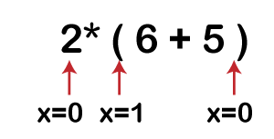
Solution: First, the x variable is initialized by 0. The scanning starts from the variable '2', when it encounters '(' then the 'x' variable gets incremented by 1 and when the x reaches to the last symbol of the expression, i.e., ')' then the 'x' variable gets decremented by 1 and it's final value becomes 0. We have learnt in the above algorithm that if x is equal to 0 means the expression is balanced; therefore, the above expression is a balanced expression.
Implementation in C
// C program to check the balanced parenthesis.
#include<stdio.h>
int main()
{
char expression[50]; // declaration of char type array
int x=0, i=0; // declaration of two integer type variables
printf("\nEnter an expression");
scanf("%s", expression);
// Scanning the expression until we reach the end of the expression.
while(expression[i]!= '\0')
{
// Condition to check the symbol is '('
if(expression[i]=='(')
{
x++; // incrementing 'x' variable
}
// condition to check the symbol is ')'
else if(expression[i]==')')
{
x--; // decrementing 'x' variable
if(x<0)
break;
}
i++; // incrementing 'i' variable.
}
// Condition to check whether x is equal to 0 or not.
if(x==0)
{
printf("Expression is balanced");
}

else
{
printf("Expression is unbalanced");
}
return 0;
}
Output
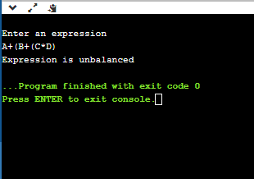

Binary to Decimal Number in C
This section will discuss the conversion of Binary numbers to Decimal numbers. Before going to the concept, we need to understand Binary numbers and decimal numbers. As we know, the computer does not understand the words or numbers that humans write or do. Instead, it only understands 0's and 1's. For example, when we type a word or number on a computer, various software or compilers help convert these numbers or words into binary form (0s and 1s bit). So that a computer machine can easily understand these.
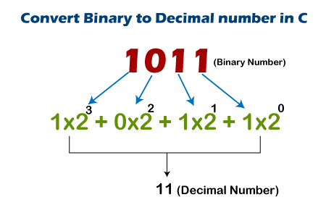
Binary number
A binary number is a number that represents information or data stored in a computer with a combination of 0s and 1s bits. It is also known as the base 2 numeral system because it has two bits, 0s, and 1s. These are binary numbers (0 and 1) 1001, 1010, 1101, 1111, 1010101 etc.
Decimal number
A decimal number is a number that contains 10 digits from 0 to 9. Its base is 10 because it collects 10 digits (0, 1, 2, 3, 4, 5, 6, 7, 8, 9) and represents or makes the whole number using these ten digits.
Algorithm to convert binary to decimal
- Take a binary number as the input.
- Divide the number by 10 and store the remainder into variable rem.
- decimal_num = decimal_num + rem * base;
Initially, the decimal_num is 0, and the base is 1, where the rem variable stores the remainder of the number.
- Divide the quotient of the original number by 10.
- Multiply the base by 2.
- Print the decimal of the binary number.
Convert binary number into a decimal number using while loop
Let's consider the C program to convert the combination of a binary number (0s and 1s) into the decimal number using a while loop.
program.c
#include <stdio.h>
#include <conio.h>
void main()
{
// declaration of variables
int num, binary_num, decimal_num = 0, base = 1, rem;
printf (" Enter a binary number with the combination of 0s and 1s \n");
scanf (" %d", &num); // accept the binary number (0s and 1s)

binary_num = num; // assign the binary number to the binary_num variable

while ( num > 0)
{
rem = num % 10; /* divide the binary number by 10 and store the remainder in rem variable. */
decimal_num = decimal_num + rem * base;
num = num / 10; // divide the number with quotient
base = base * 2;
}

printf ( " The binary number is %d \t", binary_num); // print the binary number
printf (" \n The decimal number is %d \t", decimal_num); // print the decimal
getch();
}
Output
Enter a binary number with the combination of 0s and 1s
1101
The binary number is 1101
The decimal number is 13
Explanations of the code: As we can see in the above program, it asks a binary number (0s and 1s) from the users to store the number into the variable num. At each iteration, a while loop checks the binary number condition and validates the given number should not be less than 0; otherwise, it exits from the loop.
Following are the iteration of the while loop, as follows:
1st iteration:
rem = 1101 % 10 => 1
decimal_num = 0 + 1 * 1 => 1 (decimal_val = 0, rem = 1, & base = 1)
num = 1101 / 10 => 110
base = 1 * 2 => 2
2nd iteration:
rem = 110 % 10 => 0
decimal_num = 1 + 0 * 2 => 1 (decimal_val = 1, rem = 0, & base = 2)
num = 110 / 10 => 11
base = 2 * 2 => 4
3rd iteration:
rem = 11 % 10 => 1
decimal_num = 1 + 1 * 4 => 5 (decimal_val = 1, rem = 1, & base = 4)
num = 11 / 10 => 1
base = 4 * 2 => 8
4th iteration:
rem = 1 % 10 => 1
decimal_num = 5 + 1 * 8 => 1 (decimal_val = 5, rem = 1, & base = 8)
num = 1 / 10 => 0
base = 8 * 2 => 16
Convert binary number into the decimal number using for loop
Let's consider a program in C language to convert the combination of binary number (0s and 1s) into the decimal number using for loop.
decimal.c
#include <stdio.h>
#include <conio.h>
#include <math.h> // use math.h header file
void main()
{
// declaration of local variables i, bin_num, decimal_num = 0, rem;
int i, bin_num, decimal_num = 0, rem;
printf (" Enter the binary number with the combination of 0s and 1s \n");
scanf ("%d", &bin_num); // takes the binary number as the input

printf( " \n The binary number is %d", bin_num); // print the binary number
for (i = 0; bin_num != 0; ++i)
{
rem = bin_num % 10;
bin_num = bin_num / 10;
decimal_num = decimal_num + (rem) * ( pow (2, i));

}
// print the decimal number
printf ("\n Conversion from binary to decimal number is %d", decimal_num);
getch();
}
Output
Enter the binary number with the combination of 0s and 1s
10010

The binary number is 10010
Conversion from binary to decimal number is 18
Convert binary number into decimal number using function
Let's consider a program in C language to convert the combination of binary number (0s and 1s) into the decimal number using user defined function.
deci.c
#include <stdio.h>
#include <conio.h>
int binaryTodecimal(int bin_num);
int main()
{
// declare the local variable
int bin_num, dec_num;
printf (" Enter the binary number (0s and 1s) \n");
scanf ("%d", &bin_num);

dec_num = binaryTodecimal (bin_num); // call the binaryTodecimal() function
printf (" Conversion of the binary number to decimal number is %d", dec_num);
}

// use user defined function --- binaryTo decimal function
int binaryTodecimal( int bin_num)
{
// declaration of variables
int decimal_num = 0, temp = 0, rem;
while (bin_num != 0)
{
rem = bin_num % 10;
bin_num = bin_num / 10;
decimal_num = decimal_num + rem * pow( 2, temp);
temp++;
}
return decimal_num;
}
Output
Enter the binary number (0s and 1s)
11001
Conversion of the binary number to decimal number is 25
Convert binary number into decimal number using array and function
Let's consider a program in C language to convert the combination of binary number (0s and 1s) into the decimal number using function and array.
Decimal2.c
#include <stdio.h>
#include <conio.h>
int binaryTodecimal (char num[])
{
int i, deci_num, mul = 0;
for ( deci_num = 0, i = str_length(num) - 1; i >= 0; --i, ++mul)
{
deci_num = deci_num + (num[i] - 48) * (1 << mul);
}

return deci_num;
}

int str_length( char str[])
{
int i = 0;
while (str[i] != '\0')
i++;
return i;
}

int main()
{
char num[] = "1101";
int deci_num;
printf ("\n The binary number is %s", num);
printf ("\n The decimal number of %s is %d", num, binaryTodecimal(num));
return 0;
}
Output
The binary number is 1101
The decimal number of 1101 is 13

GCD of two numbers in C
In this topic, we will learn about GCD and find out different ways to get GCD of two numbers in C programming languages.
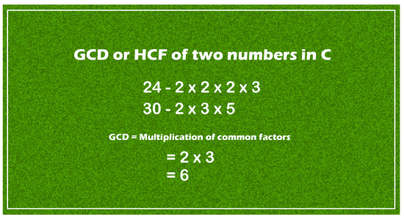
The GCD is a mathematical term for the Greatest Common Divisor of two or more numbers. It is the Greatest common divisor that completely divides two or more numbers without leaving any remainder. Therefore, it is also known as the Highest Common Factor (HCF) of two numbers. For example, the GCD of two numbers, 20 and 28, is 4 because both 20 and 28 are completely divisible by 1, 2, 4 (the remainder is 0), and the largest positive number among the factors 1, 2, and 4 is 4. Similarly, the GCD of two numbers, 24 and 60, is 12.
GCD of two numbers using for loop
Let's consider a program to get the GCD of two numbers in C using for loop.
Gcd_for.c
#include <stdio.h>
#include <conio.h>
int main()
{
// declare the variables
int n1, n2, i, GCD_Num;
printf ( " Enter any two numbers: \n ");
scanf ( "%d %d", &n1, &n2);

// use for loop
for( i = 1; i <= n1 && i <= n2; ++i)
{
if (n1 % i ==0 && n2 % i == 0)
GCD_Num = i; /* if n1 and n2 is completely divisible by i, the divisible number will be the GCD_Num */
}
// print the GCD of two numbers
printf (" GCD of two numbers %d and %d is %d.", n1, n2, GCD_Num);
return 0;
}
Output
Enter any two numbers:
96
36
GCD of two numbers 96 and 36 is 12.
GCD of two numbers using while loop
Let's consider a program to get the GCD of two numbers in C using while loop.
Gcd_while.c
#include <stdio.h>
#include <conio.h>
int main()
{
// initialize the local variables num1 and num2
int num1 = 50, num2 = 60;

while (num1 != num2)
{
// if num1 is greater than num2, returns the num1.
if (num1 > num2)
{
num1 = num1 - num2;
}
// otherwise, it returns the num2.
else
{
num2 = num2 - num1;
}

}
// print the GCD of the number.
printf( " GCD of two numbers 50 and 60 is %d.", num2);
}
Output
GCD of two numbers 50 and 60 is 10.
Get the GCD of N numbers from the user
Let's consider a program to get the GCD of n numbers by taking the input from the users.
gcdNum.c
#include <stdio.h>
#include <conio.h>
void main()
{
// declaration of the variables
int n1, n2 = -1;
printf (" Enter N numbers from the users ( 0 to exists from the loop) \n");
while ( 1)
{
scanf ( "%d", &n1); // A while loop continuously accepts the number
if ( n1 < 1) // n1 should be larger than 1
break;

else if ( n2 == -1)
n2 = n1; // assign the value of n1 to n2
else if(n1 < n2)
n2 = gcd_Num(n1, n2); // assign the function into the n2
else
n2 = gcd_Num( n2, n2); // else it stores the function value into the n2
}
printf (" \n GCD of all entered number is: %d", n2);
getch();
}

// Get the GCD of two numbers
int gcd_Num ( int x, int y)
{
int i;
for( i = x; i >= 1; i --)
{ // largest number that completely divides both number
if( x % i == 0 && y % i == 0)
break;
}
return i;
}
Output
Enter the N numbers from the users ( 0 to exists from the loop)
196
224
48
96
36
256
0

GCD of all entered number is: 4
Get the GCD of two numbers using user defined function
Let's consider a program to get the GCD of two numbers using user defined function.
Func.c
#include <stdio.h>
#include <conio.h>
GetGCD (int x, int y);
int main()
{
int x, y, GCD = 0;
printf ( " Enter the first number \n ");
scanf ("%d", &x);
printf ( " Enter the second number \n ");
scanf ("%d", &y);
GCD = GetGCD( x, y); // call the GetGCD() function in main() function

// display the greatest common difference of two numbers
printf ( " GCD of the two numbers %d and %d is %d", x, y, GCD);

getch();
}

// function definition of the GetGCD
GetGCD ( int x, int y)
{

// A while loop will continue iterates till y is not equal to 0
while (y != 0)
{
if ( x > y) /* if x is greater than y, the if block is executed. */
{
x = x - y;
}
else
{
y = y - x;
}
}
return x;
}
Output
Enter the first number
96
Enter the second number
132
GCD of the two numbers 96 and 132 is 12
GCD of two numbers using the modulo operator
Let's consider a program to find the GCD of two numbers using modulo operator.
Modulo.c
#include <stdio.h>
#include <conio.h>
void main()
{
// declaration of local variable
int x , y;
printf ( " Enter the first number: \n ");
scanf (" %d", &x);
printf ( " Enter the second number: \n ");
scanf (" %d", &y);
printf (" GCD of two number %d and %d is %d", x, y, GetGCD( x, y));
getch();
}

// use a recursive function to return GCD of two numbers x and y
int GetGCD (int x, int y)
{
if ( y == 0) // if y is equal to 0, it returns x
{
return x;
}
// use modulo operator to perform the divisibility
return GetGCD (y, x % y);
}
Output
Enter the first number:
256
Enter the second number:
92
GCD of two number 256 and 92 is 4
GCD of two numbers using Recursion
Let's consider a program to find the GCD of two numbers in C using Recursion.
Recursion.c
#include <stdio.h>
#include <conio.h>
int GCD_Rec(int num1, int num2);
int main()
{
int num1, num2;
printf( " Enter any two positive numbers \n");
scanf("%d %d", &num1, &num2);

// call and print the GCD of two number using GCD_Rec()
printf(" GCD of two numbers %d and %d is %d", num1, num2, GCD_Rec(num1, num2));
return 0;
}

int GCD_Rec(int num1, int num2)
{
if (num2 != 0)
{
return GCD_Rec( num2, num1 % num2);
}
else
{
return num1;
}
}
Output
Enter any two positive numbers:
60
48
GCD of two numbers 60 and 48 is 12
In the above program, the recursive function GCD_Rec() continuously calls itself until the value of num2 is equal to 0.
GCD of three numbers using if_else and for loop
Let's consider a program to get the GCD of three numbers in C using if else statement and for loop.
Gcd_num.c
#include <stdio.h>
#include <conio.h>
void main()
{
// declare the variable x, y and z.
int n1, n2, n3;
printf (" Enter any positive numbers: \n ");
scanf ( " %d %d %d", &n1, &n2, &n3);
int GCD;

// use for loop to define the function and condition
for ( GCD = GCD_fun( n1, n2, n3); GCD >= 1; GCD--)
{
if (n1 % GCD == 0 && n2 % GCD == 0 && n3 % GCD == 0)
{
break;
}
}
printf (" GCD of three numbers %d, %d and %d is %d", n1, n2, n3, GCD);
getch();
}

int GCD_fun ( int x, int y, int z)
{
if ( x >= y && x >= z)
{
return x;
}

else if ( y >= x && y >= z)
{
return y;
}

else if ( z >= x && z >= y)
{
return z;
}
}
Output
Enter any positive numbers:
98
49
56
GCD of three numbers 98, 49 and 56 is 7

Getchar() function in C
In this section, we will learn the getchar() function in the C programming language. A getchar() function is a non-standard function whose meaning is already defined in the stdin.h header file to accept a single input from the user. In other words, it is the C library function that gets a single character (unsigned char) from the stdin. However, the getchar() function is similar to the getc() function, but there is a small difference between the getchar() and getc() function of the C programming language. A getchar() reads a single character from standard input, while a getc() reads a single character from any input stream.
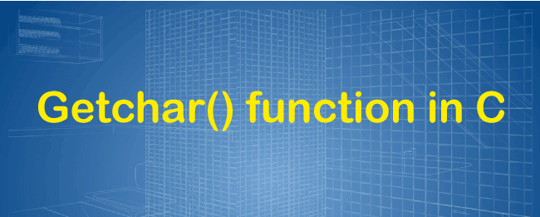
Syntax
int getchar (void);
It does not have any parameters. However, it returns the read characters as an unsigned char in an int, and if there is an error on a file, it returns the EOF at the end of the file.
Now we write several getchar() function programs to accept single characters in C and print them using the putchar () function.
Read a single character using the getchar() function
Let's consider a program to take a single using the getchar() function in C.
Program.c
#include <stdio.h>
#include <conio.h>
void main()
{
char c;
printf ("\n Enter a character \n");
c = getchar(); // get a single character
printf(" You have passed ");
putchar(c); // print a single character using putchar

getch();
}
Output
Enter a character
A
You have passed A
As we can see in the above program, it takes a single character at the run time from the user using the getchar() function. After getting the character, it prints the letter through the putchar() function.
Read n characters from the user using getchar() function
Let's consider a program to read n characters using the getchar() function in C.
Getchar.c
#include <stdio.h>
#include <conio.h>
#include <ctype.h>
int main()
{
char ch;
printf (" Enter a character ( If we want to exit press #) \n");
while (ch != '#') /* accept the number till the user does not enter the # to exit from the loop. */
{
ch = getchar();
printf (" \n We have entered the character : ");
putchar (ch); // print a single character
printf ("\n");
}
return 0;
}
Output
Enter a character ( If we want to exit.. press #)
A

We have entered the character: A
We have entered the character:

B

We have entered the character: B
We have entered the character:
C

We have entered the character: C
We have entered the character:
As we can see in the above output, a while loop continuously accepts a character from the user until the user does not pass the # character. Here the getchar() function takes a single character from the standard input and assigns them to a ch variable. Whereas the putchar() function prints the read character.
Read a single character using the scanf() function
Let's consider a program to read a character using the scanf() library function in C.
Prog.c
#include <stdio.h>
#include <conio.h>
int main()
{
char ch;

printf ("\n Enter the character \n");
scanf ("%c", &ch); // get a single character, numeric or words
printf( " You have entered %c", ch); /* It print a single character or first letter of the words. */

return 0;
}
Output
Enter the character
A
You have entered A
As we can see, when we execute the above program, it takes a single character or group of characters using the scanf() library function instead of the getchar() function. But there is a small difference; a scanf() function can take a single or group of characters from the user, whereas the getchar() function can only accept the single character.
Here we again execute the above program, and this time, it shows the below results.
- Enter the character
- Apple
- You have entered A
Read the characters using a do-while loop
Let's consider a program to read the characters using do while and getchar() function in C.
Dowhile1.c
#include <stdio.h>
#include <ctype.h>
int main()
{
int ch, i = 0;
char str[150];
printf (" Enter the characters from the keyboard (Press Enter button to stop).\n");
// use do while loop to define the condition
do
{
ch = getchar(); // takes character, number, etc from the user
str[i] = ch; // store the ch into str[i]
i++; // increment loop by 1
} while (ch != '\n'); // ch is not equal to '\n'
printf("Entered characters are %s ", str);
return 0;
}
Output
Enter the characters from the keyboard (Press Enter button to stop).
Well b47gvb come
Entered characters are Well b47gvb come
In the above program, a do-while loop continuously accepts the characters until the user passes the ENTER button to exit the loop.

The flowchart in the C programming language
In this article, we will understand how to create flow charts in the C programming language with the help of various examples.
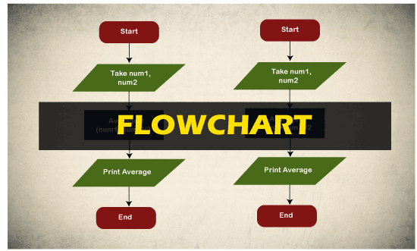
What do you mean by flowchart?
The Flowchart is the most widely used graphical representation of an algorithm and procedural design workflows. It uses various symbols to show the operations and decisions to be followed in a program. It flows in sequential order.
Types of Flowchart
The various types of the flowchart are given below.
- Horizontal Flowchart
- Panoramic Flowchart
- Vertical Flowchart
- Architectural Flowchart
Rules or guidelines of Flow chart:
The various Rules or Guidelines for drawing the flowchart are given below.
- Only conventional flowchart symbols should be used.
- Proper use of names and variables in the flowchart.
- If the flowchart becomes large and complex, use connector symbols.
- Flowcharts should have start and stop points.
Flowchart symbols:
The different flowchart symbols have different conventional meanings.
The various symbols used in Flowchart Designs are given below.
- Terminal Symbol: In the flowchart, it is represented with the help of a circle for denoting the start and stop symbol. The symbol given below is used to represent the terminal symbol.

- Input/output Symbol: The input symbol is used to represent the input data, and the output symbol is used to display the output operation. The symbol given below is used for representing the Input/output symbol.

- Processing Symbol:It is represented in a flowchart with the help of a rectangle box used to represent the arithmetic and data movement instructions. The symbol given below is used to represent the processing symbol.

- Decision Symbol: Diamond symbol is used for represents decision-making statements. The symbol given below is used to represent the decision symbol.
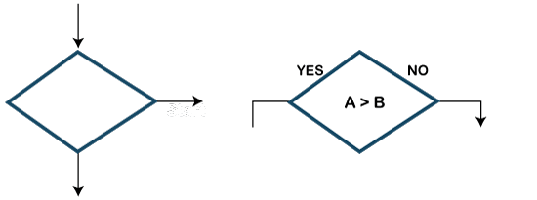
- Connector Symbol:The connector symbol is used if flows discontinued at some point and continued again at another place. The following symbol is the representation of the connector symbol.

- Flow lines: It represents the exact sequence in which instructions are executed. Arrows are used to represent the flow lines in a flowchart. The symbol given below is used for representing the flow lines:
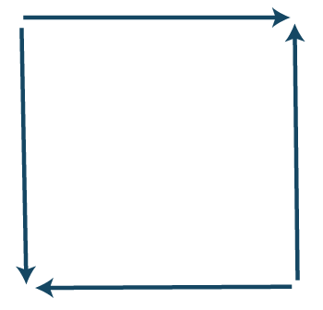
- Hexagon symbol (Flat): It is used to create a preparation box containing the loop setting statement. The symbol given below is used for representing the Hexagon symbol.

- On-Page Reference Symbol: This symbol contains a letter inside that indicates the flow continues on a matching symbol containing the same letters somewhere else on the same page. The symbol given below is used for representing the on-page reference symbol.

- Off-Page Reference: This symbol contains a letter inside indicating that the flow continues on a matching symbol containing the same letter somewhere else on a different page. The symbol given below is used to represent the off-page reference symbol.

- Delay or Bottleneck: This symbol is used for identifying a delay in a flowchart. The alternative name used for the delay is the bottleneck. The symbol given below is used to represent the delay or bottleneck symbol.

- Document Symbol: This symbol is used in a flowchart to indicate a document or report.The symbol given below is used to represent the document symbol.

- Internal storage symbol: The symbol given below is used to represent the internal storage symbol.

Advantages of Flowchart in C:
Following are the various advantages of flowchart:
- Communication: A flowchart is a better way of communicating the logic of a program.
- Synthesis: Flowchart is used as working models in designing new programs and software systems.
- Efficient Coding: Flowcharts act as a guide for a programmer in writing the actual code in a high-level language.
- Proper Debugging: Flowcharts help in the debugging process.
- Effective Analysis: Effective analysis of logical programs can be easily done with the help of a related flowchart.
- Proper Documentation: Flowchart provides better and proper documentation. It consists of various activities such as collecting, organizing, storing, and maintaining all related program records.
- Testing: A flowchart helps in the testing process.
- Efficient program maintenance: The maintenance of the program becomes easy with the help of a flowchart.
Disadvantages of Flowchart in C:
Following are the various disadvantages of flowchart:
- Time-consuming: Designing a flowchart is a very time-consuming process.
- Complex: It isn't easy to draw a flowchart for large and complex programs.
- There is no standard in the flowchart; there is no standard to determine the quantity of detail.
- Difficult to modify: It is very difficult to modify the existing flowchart.
Examples of flowchart:
The various examples of the flowchart are given below:
Example 1:
Design a flowchart for adding two numbers entered by the user.
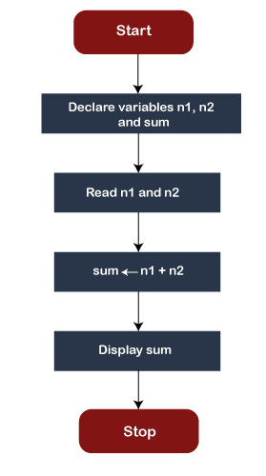
Example 2:
Design a flowchart for finding the largest among three numbers entered by the user.
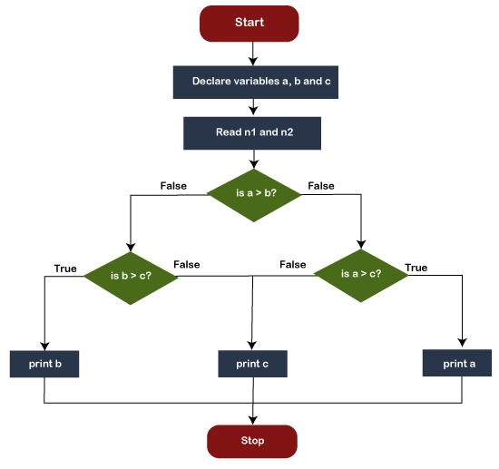
Example 3:
Design a flowchart for calculating the profit and loss according to the value entered by the user.
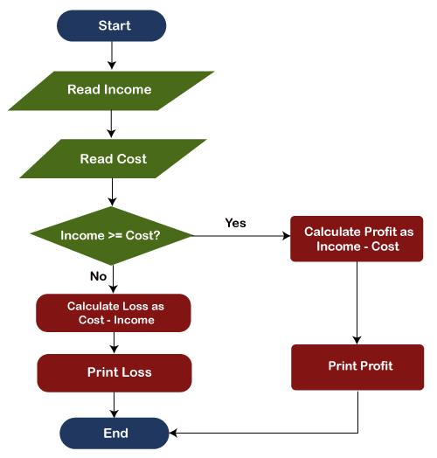
Example 4:
Draw a flowchart to calculate the average of two numbers.
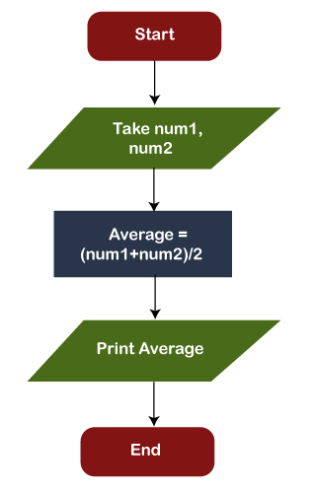
Example 5:
Design a flowchart for the multiplication of three numbers entered by the user.
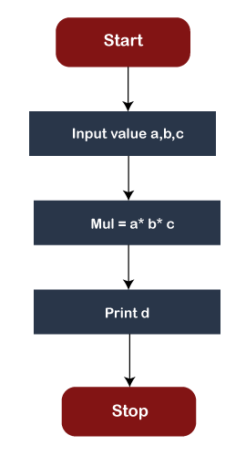
Example 6:
Design a flowchart for calculating the area of a rectangle.
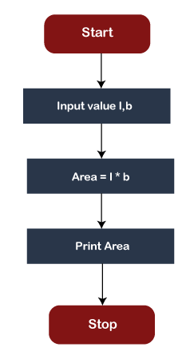
Example 7:
Design a flowchart for calculating the Simple Interest according to the value entered by the user.
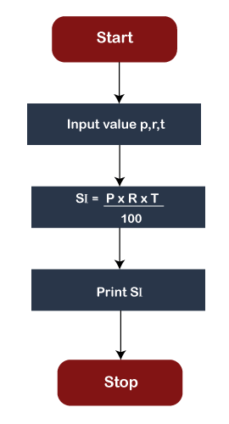
Example 8:
Design a flowchart for checking whether the number is positive or negative according to the number entered by the user.
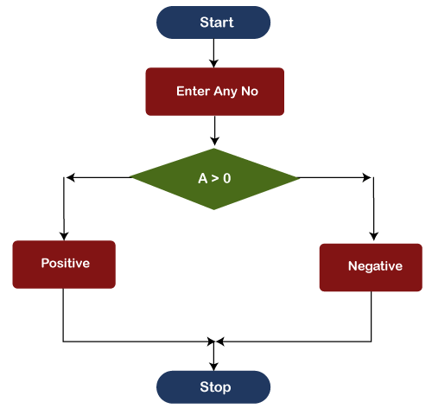

Simpson Method
The Simpson is a numerical integration method that was given by Thomas Simpson and so was named the Simpson method. Although there are certain rules of Simpson, the most basic are the two rules of Simpson which are:
- Simpson's 1 rule: It is known as Simpson's 1/3 rule
- Simpson's 2 rule: It is known as Simpson's 3/8 rule
In this section, we will discuss both of these Simpson's rules and will also implement the example code of both the rules.
Simpson's 1/3 Rule
It is also known as Simpson's Rule where the rule says:
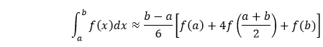
where f(x) is the integrand, a is the lower limit, and b is the upper limit of integration in the expression.
Quadratic Interpolation
Replace the integrand f(x) with a quadratic polynomial P(x) which is the parabola and takes same values of limits a and b as f(x). It also calculates m = (a + b)/2 as in f(x). Hence, on using Lagrange Polynomial Interpolation and integration by substitution we get,
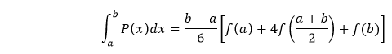
Then use step size h=(b-a)/2 and then it can be written as:
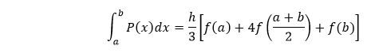
As it is h/3, i.e., 1/3 factor, we call it the Simpson's rule as Simpson's 1/3 rule.
The Simpson's rule can be derived via the below graph where we have approximated the integrated f(x) by P(x), which is the quadratic interpolant.
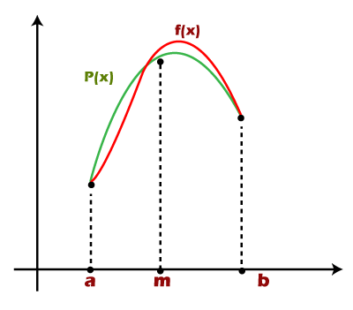
Numerical Example
For solving a numerical, we need to use the Simpson's rule i.e.
Numerical: Evaluate logx dx within limit 4 to 5.2.
Solution:
Step 1: Choose a value in which the intervals will be divided, i.e., the value of n. So, for the given expression, first, we will divide the interval into six equal parts as the number of intervals should be even.
Step 2: Calculate the value of h = (b - a)/2
Step 3: Evaluate and calculate the values of x₀ to x_{n}. Consider y = f(x) and calculate the values of y₀ to y_{n} for x₀ to x_{n}. Here, we get the following data:
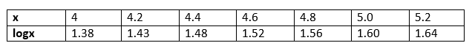
Step 3: Put the values in the method and then we can calculate approximate value of integral using above formula:
= h/3[( 1.38 + 1.64) + 4 * (1.43 + 1.52 +
1.60 ) +2 *(1.48 + 1.56)]
= 1.84
Hence the approximation of the above integral is 1.827 using Simpson's 1/3 rule.
Program Implementation for Simpson's 1/3 Rule
Below is the program code implementation in C for the Simpson's 1/3 rule:
#include<stdio.h>
#include<conio.h>
#include<math.h>
#define f(x) 1/(1+x*x)
int main()
{
float lower, upper, intgrl=0.0, stepSize, k;
int i, subInterval;
clrscr();
printf("Enter lower integration limit: ");
scanf("%f", &lower);
printf("Enter upper integration limit: ");
scanf("%f", &upper);
printf("Enter sub intervals: ");
scanf("%d", &subInterval);
stepSize = (upper - lower)/subInterval;
intgrl = f(lower) + f(upper);
for(i=1; i<= subInterval-1; i++)
{
k = lower + i*stepSize;
if(i%2==0)
{
intgrl = intgrl + 2 * f(k);
}
else
{
intgrl= intgrl + 4 * f(k);
}
}
intgrl = intgrl * stepSize/3;
printf("The integration is: %.3f", intgrl);
getch();
return 0;
}
The output of the above code is shown below:
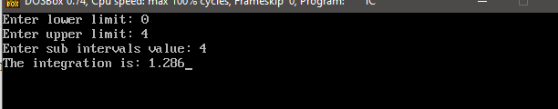
Simpson 3/8 Rule
It is the second rule of Simpson and also similar to Simpson 1/3 rule but with a difference. The difference between the 1/3 and 3/8 rule is that in the Simpson 3/8 rule, the interpolant is a cubic polynomial. The Simpson 3/8 rule says:
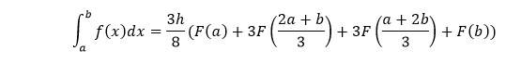
where f(x) is the integrand and h is the size of the interval which is calculated as h = (b - a)/n, and n is the interval limit here.
Now, let's see the program implementation to understand the logic behind the Simpson 3/8 rule.
Program to implement Simpson 3/8 rule
Below is the program code implementation in C++:
#include<stdio.h>
#include<conio.h>
#include<math.h>
#define f(x) 1/(1+x*x)
int main()
{
float lower, upper, intgrl=0.0, stepSize, k;
int i, subInterval;
clrscr();
printf("Enter lower limit integration limit: ");
scanf("%f", &lower);
printf("Enter upper integration limit: ");
scanf("%f", &upper);
printf("Enter sub intervals: ");
scanf("%d", &subInterval);
stepSize = (upper - lower)/subInterval;
intgrl = f(lower) + f(upper);
for(i=1; i<= subInterval-1; i++)
{
k = lower + i*stepSize;
if(i%3 == 0)
{
intgrl = intgrl + 2 * f(k);
}
else
{
intgrl= intgrl + 3 * f(k);
}
}
intgrl = intgrl * stepSize*3/8;
printf("The integration is: %.3f", intgrl);
getch();
return 0;
}
The output of the above code is shown below:
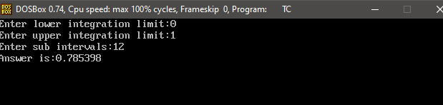
Other than these discussed two rules of Simpson, there is third rule existence that is used in the naval architecture and ship stability estimation. However, in the general approach, it has no importance.

Pyramid Patterns in C
This section will discuss the Pyramid pattern of numbers, Stars, and alphabets in the C programming language. All Pyramid patterns are in a polygon structure. The interviewer usually asks these patterns to examine the logical and thinking ability of the programmer. Once we understand the logic of the code, we can create various Pyramid patterns in C language and C++, JAVA, PYTHON, PHP, etc. programming languages.
Now we will create the various patterns of Pyramids in C programming languages using loops and if statements.
1. Star Pyramid Patterns
Program to print the half Pyramid
Let's consider an example to print the half Pyramid pattern using for loop.
star.c
#include <stdio.h>
#include <conio.h>
void main()
{
int i, j, rows;
printf (" Enter a number to define the rows: \n ");
scanf("%d", &rows);
printf("\n");
for (i = 1; i <= rows; ++i) // outer loop
{
for (j = 1; j <= i; ++j) // inner loop
{
printf ("* "); // print the Star
}
printf ("\n");
}
getch();
}
Output
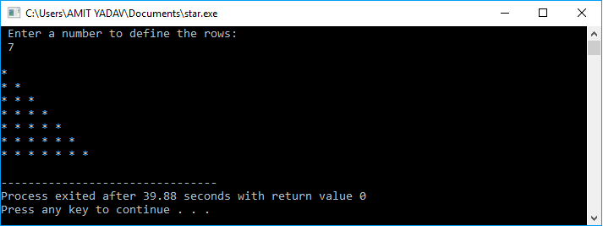
Program to print an inverted half Pyramid Pattern
Let's consider an example to print the Inverted half Pyramid pattern using for loop.
star.c
#include <stdio.h>
#include <conio.h>
void main()
{
int i, j, rows;
printf (" Enter a number to define the rows: \n ");
scanf("%d", &rows);
printf("\n");
for (i = rows; i > 0; i--) // define the outer loop
{
for (j = i; j > 0; j--) // define the inner loop
{
printf ("* "); // print the Star
}
printf ("\n");
}
getch();
}
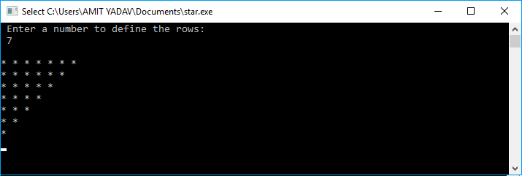
Output

Program to print an inverted right half Pyramid
Let's consider an example to print a reverse right half Pyramid pattern using for loop.
star.c
#include <stdio.h>
#include <conio.h>
void main()
{
int i, j, rows, k;
printf (" Enter a number to define the rows: \n ");
scanf("%d", &rows);
printf("\n");
for (i = 1; i <= rows; i++)
{
for (j = 1; j <= i; j++)
{
printf(" ");
}
for (k = i; k <= rows; k++)
{
printf("*"); // print the Star
}
printf ("\n");
}
getch();
}
Output
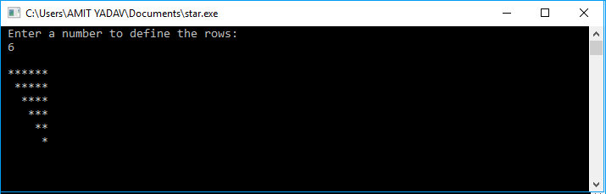
Program to print the right half Pyramid
Let's consider an example to print the right half Pyramid pattern using for loop.
star.c
#include <stdio.h>
#include <conio.h>
void main()
{

int i, j, rows, k;
printf (" Enter a number to define the rows: \n ");
scanf("%d", &rows);
printf("\n");
for (i = 1; i <= rows; i++)
{
for (j = i; j < rows; j++)
{
printf(" ");
}
for (k = 1; k <= i; k++)
{
printf("*"); // print the Star
}
printf ("\n");
}
getch();
}
Output
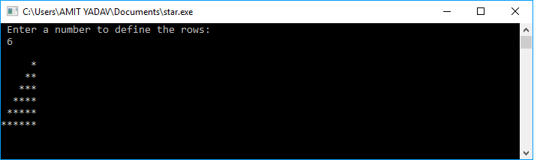
Program to print the full Pyramid of Star in 180 degree
Let's consider an example to print the full Pyramid of Star in 180 degree using for loop.
star.c
#include <stdio.h>
#include <conio.h>
void main()
{
int num, i, j, m = 1; // declare local variables
printf (" Enter the number to define the columns: \n");
scanf ("%d", & num);
for (i = 1; i <= num; i++)
{
for (j = 1; j <= i; j++)
{
printf( "* ");
}
printf("\n");
}
for (i = num-1; i >= 1; i--)
{
for (j = 1; j <= i; j++)
{
printf ("* ");
}
printf("\n");
}
getch();
}
Output
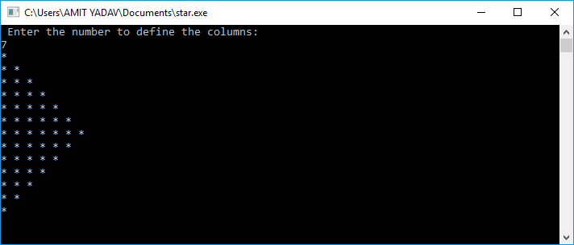
Program to print the full Pyramid of Star in the opposite direction
Let's consider an example to print the full Pyramid of Star in the opposite direction of 180 degrees using for loop.
star.c
#include <stdio.h>
#include <conio.h>
void main()
{
// declare the local variables
int i, j, rows, k;
printf (" Enter a number to define the columns: \n ");
scanf("%d", &rows);
printf("\n");
for (i = 1; i <= rows; i++)
{
for (j = i; j < rows; j++)
{
printf(" ");
}
for (k = 1; k <= i; k++)
{
printf("*"); // print the Star
}
printf ("\n");
}
for (i = 1; i <= rows; ++i)
{
for (j = 2; j <= i; j++)
{
printf(" ");
}
for (k = i; k <= rows; k++)
{
printf("*"); // print the Star
}
printf ("\n");
}
getch();
}
Output
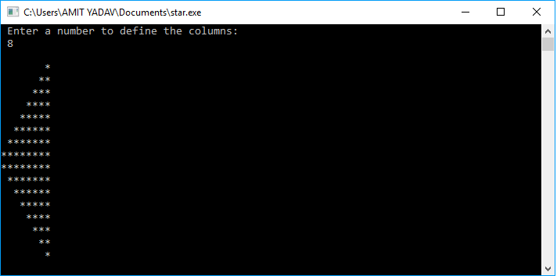
Program to print the full Pyramid of Star
Let's consider an example to print the full Pyramid of Star using for loop.
star.c
#include <stdio.h>
#include <conio.h>
void main()
{

int i, j, rows, k = 0;
printf (" Enter a number to define the rows: \n");
scanf ("%d", &rows);

for ( i =1; i <= rows; i++)
{
for ( j = 1; j <= rows - i; j++)
{
printf (" ");
}
// use for loop where k is less than equal to (2 * i -1)
for ( k = 1; k <= ( 2 * i - 1); k++)
{
printf ("* "); // print the Star
}
printf ("\n");
}
getch();
}
Output
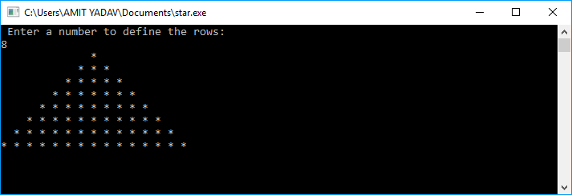
Program to print the inverted full Pyramid of Star
Let's consider an example to print the full Pyramid of Star using for loop.
star.c
#include <stdio.h>
#include <conio.h>
void main()
{
// declare the local variables
int i, j, rows, k, m = 1;
printf (" Enter a number to define the rows: \n");
scanf ("%d", &rows);
printf("\n");

for ( i = rows; i >= 1; i--)
{

for ( j = 1; j <= m; j++)
{
printf (" "); // print the space
}

for ( k = 1; k <= ( 2 * i - 1); k++)
{
printf ("* "); // print the Star
}
m++;
printf ("\n");
}
getch();
}
Output
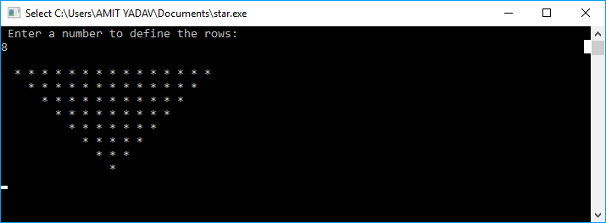
Program to print the rhombus pattern of Star
Let's consider an example to print the rhombus pattern of Star using for loop.
star.c
#include <stdio.h>
#include <conio.h>
void main()
{
// declare the local variables
int i, j, rows, k;
printf (" Enter a number to define the rows: \n ");
scanf("%d", &rows);
int space = rows-1, num=1;
printf("\n");
for (i = 1; i <= rows; i++)
{
for (j = 1; j <= space; j++)
{
printf(" "); / print the number
}
for ( k= 1; k <= num; k++)
{
printf(" *");
}
if(space > i)
{
space = space -1;
num = num+2;
}
if(space <i)
{
space = space + 1;
num = num -2;
}
printf("\n");
}
getch();
}
Output
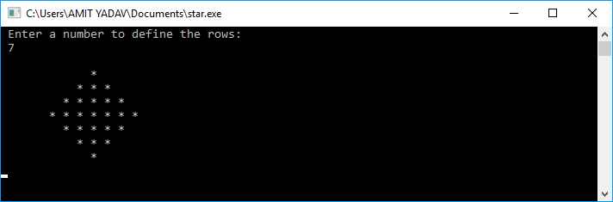
2. Number Pyramid Patterns
Program to print the half Pyramid of number
Let's consider an example to print the half Pyramid pattern using for loop.
star.c
#include <stdio.h>
#include <conio.h>
void main()
{
// declare the local variables
int i, j, rows;
printf (" Enter a number to define the rows: \n ");
scanf("%d", &rows);
printf("\n");
for (i = 1; i <= rows; ++i)
{
for (j = 1; j <= i; ++j)
{
printf ("%d ", j);
}
printf ("\n");
}
getch();
}
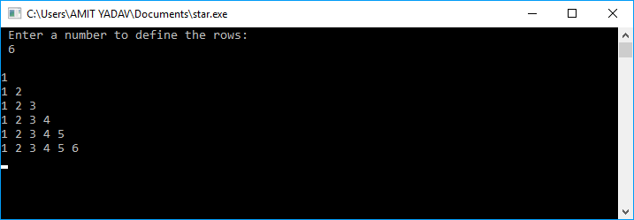
Output

Example 2:
Let's consider an example to print the half Pyramid pattern of number using for loop.
Star.c
#include <stdio.h>
#include <conio.h>
void main()
{
// declare the local variables
int i, j, rows;
printf (" Enter a number to define the rows: \n ");
scanf("%d", &rows);
printf("\n");
for (i = 1; i <= rows; ++i)
{
for (j = 1; j <= i; ++j)
{
printf ("%d ", i); // print the number
}
printf ("\n");
}
getch();
}
Output
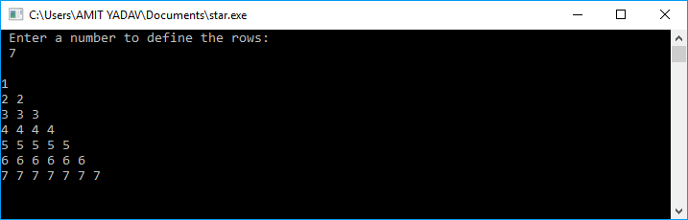
Program to print an inverted half Pyramid Pattern
Let's consider an example to print the Inverted half Pyramid pattern using for loop.
star.c
#include <stdio.h>
#include <conio.h>
void main()
{
// declare the local variables
int i, j, rows;
printf (" Enter a number to define the rows: \n ");
scanf("%d", &rows);
printf("\n");
for (i = rows; i > 0; i--) // define the outer loop
{
for (j = i; j > 0; j--) // define the inner loop
{
printf ("%d ", j);
}
printf ("\n");
}
getch();
}
Output
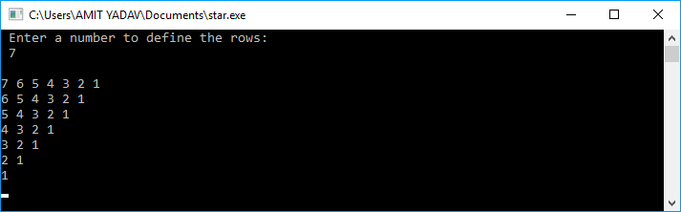
Program to print the right half Pyramid of number
Let's consider an example to print the right half Pyramid pattern of number using for loop.
star.c
#include <stdio.h>
#include <conio.h>
void main()
{
// declare the local variables
int i, j, rows, k;
printf (" Enter a number to define the rows: \n ");
scanf("%d", &rows);
printf("\n");
for (i = 1; i <= rows; i++)
{
for (j = i; j < rows; j++)
{
printf(" ");
}
for (k = 1; k <= i; k++)
{
printf(" %d", k);
}
printf ("\n");
}
getch();
}
Output
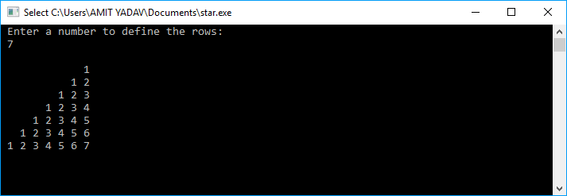
Program to print an inverted right half Pyramid of number
Let's consider an example to print a reverse right half Pyramid pattern of number using for loop.
star.c
#include <stdio.h>
#include <conio.h>
void main()
{
// declare the local variables
int i, j, rows, k;
printf (" Enter a number to define the rows: \n ");
scanf("%d", &rows);
printf("\n");
for (i = 1; i <= rows; i++)
{
for (j = 1; j <= i; j++)
{
printf(" ");
}
for (k = i; k <= rows; k++)
{
printf(" %d", k);
}
printf ("\n");
}
getch();
}
Output
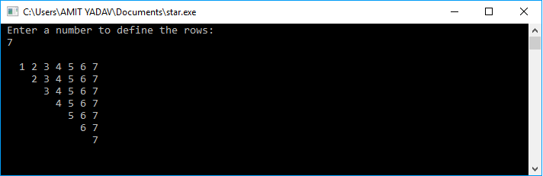
Program to print the Floyd triangle
Let's consider an example to print the Floyd Pyramid pattern using for loop.
star.c
#include <stdio.h>
#include <conio.h>
void main()
{
// declare the local variables
int i, j, rows, k = 1;
printf (" Enter a number to define the rows: \n ");
scanf("%d", &rows);
printf("\n");
for (i = 1; i <= rows; i++)
{
for (j = 1; j <= i; j++)
{
printf("%d ", k);
k += 1;
}
printf("\n");
}
getch();
}
Output
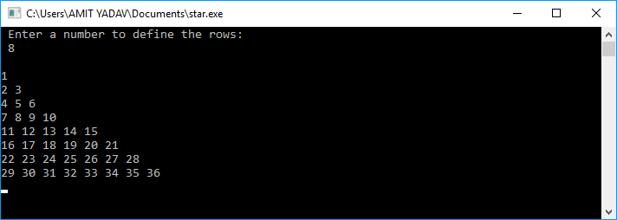
Program to print the diamond shaped Pyramid of number
Let's consider an example to print the diamond shaped Pyramid using for loop.
star.c
#include <stdio.h>
#include <conio.h>
void main()
{
// declare the local variables
int i, j, rows, k;
printf (" Enter a number to define the rows: \n ");
scanf("%d", &rows);
int space = rows-1, num=1;
printf("\n");
for (i = 1; i <= rows; i++)
{
for (j = 1; j <= space; j++)
{
printf(" ");
}
for ( k= 1; k <= num; k++)
{
printf("%d", k);
}
if(space > i)
{
space = space -1;
num = num+2;
}
if(space <i)
{
space = space + 1;
num = num -2;
}
printf("\n");
}
getch();
}
Output
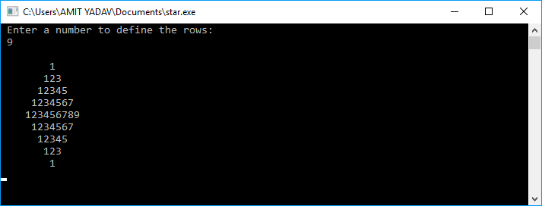
Program to print the full Pyramid of number
Let's consider an example to print the full Pyramid of number using for loop.
star.c
#include <stdio.h>
#include <conio.h>
void main()
{
// declare the local variables
int i, j, rows, k = 0;
printf (" Enter a number to define the rows: \n");
scanf ("%d", &rows); // take a number

for ( i =1; i <= rows; i++)
{
// inner loop define j should be less than equal to rows- i
for ( j = 1; j <= rows - i; j++)
{
printf (" "); // print the space
}
// use for loop where k is less than equal to (2 * i -1)
for ( k = 1; k <= ( 2 * i - 1); k++)
{
printf ("%d ",i); // print the number
}
printf ("\n");
}
getch();
}
Output
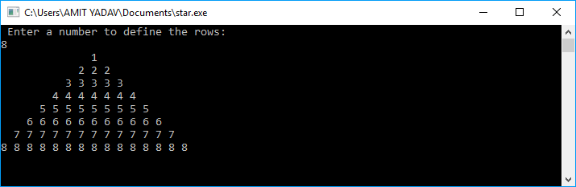
Program to print the inverted full Pyramid of number
Let's consider an example to print the inverted full Pyramid of number using for loop.
star.c
#include <stdio.h>
#include <conio.h>
void main()
{
// declare the local variables
int i, j, rows, k, m = 1;
printf (" Enter a number to define the rows: \n");
scanf ("%d", &rows); // take a number
printf("\n");
// outer loop define the total rows and i should be greater than equal to 1
for ( i = rows; i >= 1; i--)
{
// inner loop define j should be less than equal to m
for ( j = 1; j <= m; j++)
{
printf (" ");
}
for ( k = 1; k <= ( 2 * i - 1); k++)
{
printf ("%d ", i); // print the number
}
m++;
printf ("\n");
}
getch();
}
Output
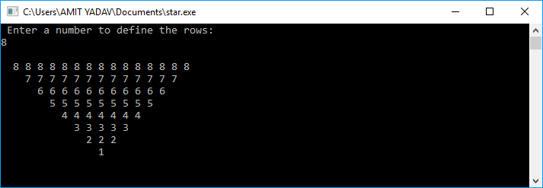
Program to print the Pascal triangle
Let's consider an example to print the Pascal triangle using for loop.
star.c
#include <stdio.h>
#include <conio.h>
void main()
{
// declare the local variables
int i, j, rows, k, m;
printf (" Enter a number to define the rows: \n");
scanf ("%d", &rows);
printf("\n");
// outer loop define the total rows and i should be less than equal to rows
for ( i = 1; i <= rows; i++)
{
// inner loop define j should be less than equal to rows- i
for ( j = 1; j <= rows-i; j++)
{
printf (" ");
}
// use for loop where k is less than equal to i
for ( k = 1; k <= i; k++)
{
printf ("%d", k); // print the number
}
for (m = i-1; m >=1; m--)
{
printf("%d", m); // print the number
}
printf ("\n");
}
getch();
}
Output
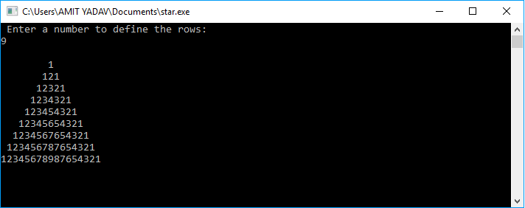
Program to combine two half Pyramid of number
Let's consider an example to print the combination of two half Pyramid of number..
star.c
#include <stdio.h>
#include <conio.h>
void main()
{
// declare the local variables
int i, j, rows, k;
printf (" Enter a number to define the rows: \n");
scanf ("%d", &rows); // take a number
printf("\n");
for ( i = 1; i <= rows; i++)
{

for ( j = 1; j <= rows; j++)
{
if( j <= i)
printf ("%d", j);
else
printf(" ");
}
for (j = rows; j >= 1; j--)
{
if(j <= i)
printf ("%d", j);
else
printf(" ");
}
printf ("\n");
}
getch();
}
Output
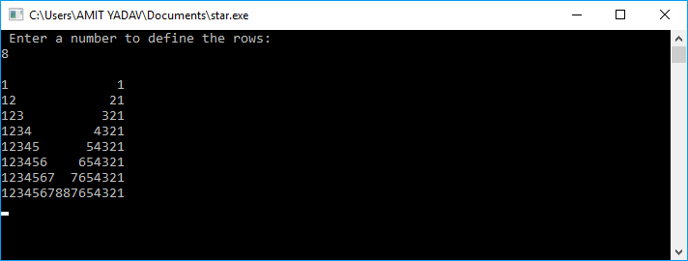
3. Alphabets Pyramid Patterns
Program to print the half Pyramid of alphabets
Let's consider an example to print the half Pyramid pattern using for loop.
star.c
#include <stdio.h>
#include <conio.h>
void main()
{
// declare the local variables
int i, j, rows;
printf (" Enter a number to define the rows: \n ");
scanf("%d", &rows);
printf("\n");
for (i = 1; i <= rows; ++i) // define the outer loop
{
for (j = 1; j <= i; ++j) // define the inner loop
{
printf ("%c ", 'A' + j - 1); // print the alphabets
}
printf ("\n"); // jump to next line
}
getch();
}
Output
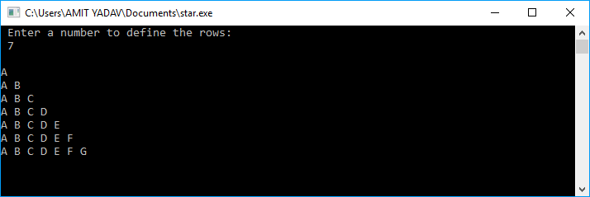
Program to print the inverted half Pyramid of alphabets
Let's consider an example to print the half Pyramid pattern using for loop.
star.c
#include <stdio.h>
#include <conio.h>
void main()
{
// declare the local variables
int i, j, rows, ch = 'A';
printf (" Enter a number to define the rows: \n ");
scanf("%d", &rows);
printf("\n");
for (i = rows; i > 1; i--)
{
for (j = 1; j < i; j++)
{
printf ("%c ", ch);
}
ch++;
printf ("\n");
}
getch();
}
Output
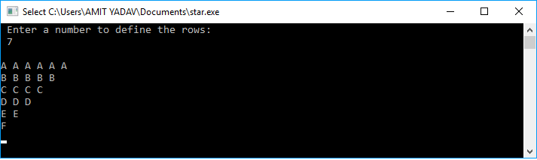
Program to print the right half Pyramid of alphabets
Let's consider an example to print the half Pyramid pattern using for loop.
star.c
#include <stdio.h>
#include <conio.h>
void main()
{
// declare the local variables
int i, j, rows, k, ch='A';
printf (" Enter a number to define the rows: \n ");
scanf("%d", &rows);
printf("\n");
for (i = 1; i <= rows; i++)
{
for (j = i; j < rows; j++)
{
printf(" ");
}
for (k = 1; k <= i; k++)
{
printf(" %c", ch);
}
ch++;
printf ("\n");
}
getch();
}
Output
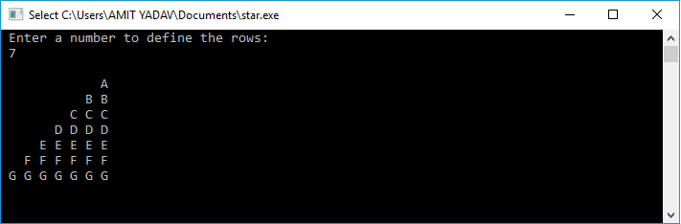
Program to print the inverted half Pyramid of alphabets
Let's consider an example to print the half Pyramid pattern using for loop.
star.c
#include <stdio.h>
#include <conio.h>
void main()
{

int i, j, rows, k;
printf (" Enter a number to define the rows: \n ");
scanf("%d", &rows);
printf("\n");
for (i = 1; i <= rows; i++)
{
for (j = 1; j <= i; j++)
{
printf(" ");
}
for (k = i; k <= rows; k++)
{
printf(" %c", 'A' + k);
}
printf ("\n");
}
getch();
}
Output
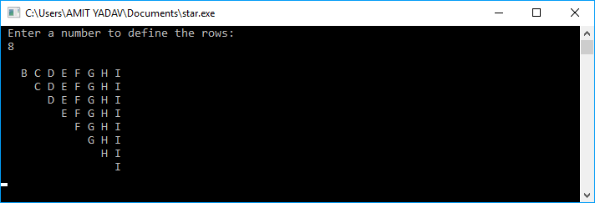
Program to print the full Pyramid of alphabets
Let's consider an example to print the full Pyramid pattern using for loop.
star.c
#include <stdio.h>
#include <conio.h>
void main()
{

int i, j, rows, k, ch = 'A';
printf (" Enter a number to define the rows: \n");
scanf ("%d", &rows);

for ( i =1; i <= rows; i++)
{

for ( j = 1; j <= rows - i; j++)
{
printf (" ");
}
// use for loop where k is less than equal to (2 * i -1)
for ( k = 1; k <= ( 2 * i - 1); k++)
{
printf ("%c ", ch);
}
ch++;
printf ("\n");
}
getch();
}
Output
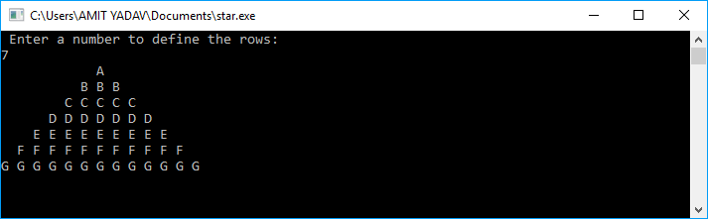
Program to print the inverted full Pyramid of alphabets
Let's consider an example to print the full Pyramid pattern using for loop.
star.c
#include <stdio.h>
#include <conio.h>
void main()
{
// declare the local variables
int i, j, rows, k, m = 1;
printf (" Enter a number to define the rows: \n");
scanf ("%d", &rows);
printf("\n");

for ( i = rows; i >= 1; i--)
{
for ( j = 1; j <= m; j++)
{
printf (" ");
}
// use for loop where k is less than equal to (2 * i -1)
for ( k = 1; k <= ( 2 * i - 1); k++)
{
printf ("%c ", 'A' + k - 1);
}
m++;
printf ("\n");
}
getch();
}
Output
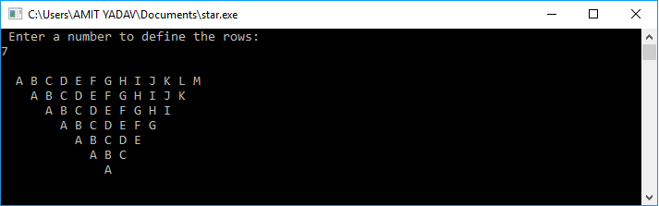
Program to print the diamond shaped Pyramid of alphabets
Let's consider an example to print the full Pyramid pattern using for loop.
star.c
#include <stdio.h>
#include <conio.h>
void main()
{
// declare the local variables
int i, j, rows, k;
printf (" Enter a number to define the rows: \n ");
scanf("%d", &rows);
int space = rows-1, num=1;
printf("\n");
for (i = 1; i <= rows; i++)
{
for (j = 1; j <= space; j++)
{
printf(" ");
}
for ( k= 1; k <= num; k++)
{
printf("%c", 'A' + k - 1);
}
if(space > i)
{
space = space -1;
num = num+2;
}
if(space <i)
{
space = space + 1;
num = num -2;
}
printf("\n");
}
getch();
}
Output
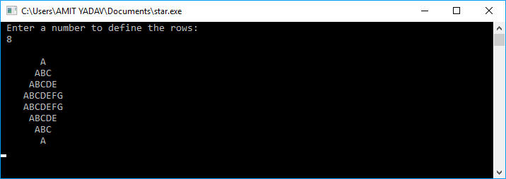
Program to print the full Pyramid of alphabets in 180 degrees
Let's consider an example to print the full Pyramid pattern in 180 degrees using for loop.
star.c
#include <stdio.h>
#include <conio.h>
void main()
{
int num, i, j, m = 1; // declare local variables
printf (" Enter the number to define the columns: \n");
scanf ("%d", & num);
for (i = 1; i <= num; i++)
{
for (j = 1; j <= i; j++)
{
printf( "%c", 'A' + j -1);
}
printf("\n");
}
for (i = num-1; i >= 1; i--)
{
for (j = 1; j <= i; j++)
{
printf ("%c", 'A' + j -1);
}
printf("\n");
}
getch();
}
Output
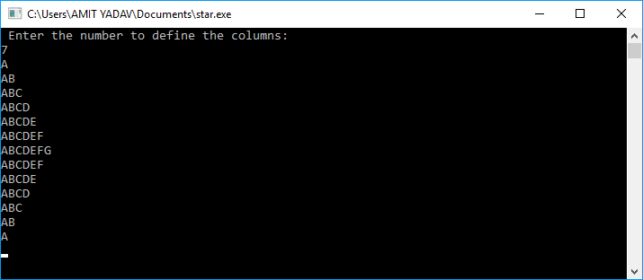

Random Function in C
In this topic, we will learn about the random function and how we can generate the random number in the C programming language. As we know, the random function is used to find the random number between any two defined numbers. In the C programming language, the random function has two inbuilt functions: rand() and srand() function. Let's understand these functions in the C language.
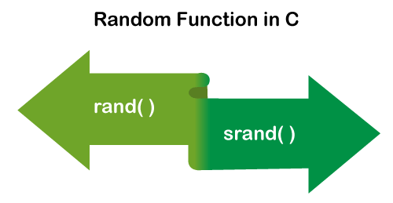
rand() function
In the C programming language, the rand() function is a library function that generates the random number in the range [0, RAND_MAX]. When we use the rand() function in a program, we need to implement the stdlib.h header file because rand() function is defined in the stdlib header file. It does not contain any seed number. Therefore, when we execute the same program again and again, it returns the same values.

Note: If the random numbers are generated with the rand() function without calling the srand() function, it returns the same sequences of numbers each time the program is executed.
Syntax
int rand (void)
The rand() function returns the random integers whose range from 0 to RAND_MAX. The RAND_MAX is a symbolic constant that defines in stdlib.h header file, whose value is greater but less than 32767 depending on the C libraries.
Generate the random numbers using the rand() function
Let's write a program to get the random number using rand() function.
num.c
#include <stdio.h>
#include <conio.h>
#include <stdlib.h>
void main()
{
// use rand() function to generate the number
printf (" The random number is: %d", rand());
printf ("\n The random number is: %d", rand());

printf (" \n The random number is: %d", rand());
printf ("\n The random number is: %d", rand());
getch();
}
Output
The random number is: 41
The random number is: 18467
The random number is: 6334
The random number is: 26500
Generate 5 random numbers using rand() function
Let's consider a program to generate 5 random number using rand() function in C programming language.
random.c
#include <stdio.h>
#include <stdlib.h>

int main()
{
int i;
/* It returns the same sequence of random number
on every execution of the program. */
printf(" Random Numbers are: \n");
for (i = 0; i <5; i++)
{
printf(" %d", rand());
}
return 0;
}
Output
Random Numbers are:
41 18467 6334 26500 19169
2nd execution of the program:
Random Numbers are:
41 18467 6334 26500 19169
3rd execution of the program:
Random Numbers are:
41 18467 6334 26500 19169
As we can see in the above output, it returns the same sequence of random numbers on every execution of the programming code.
Generate 10 random numbers from 1 to 100 using rand() function
Let's consider a program to find the random number in C using rand() function.
rand_num.c
#include <stdio.h>
#include <conio.h>
#include <stdlib.h>
int main()
{
// declare the local variables
int i, num;
printf (" Program to get the random number from 1 to 100 \n");
for (i = 1; i <= 10; i++)
{
num = rand() % 100 + 1; // use rand() function to get the random number
printf (" %d ", num);
getch();
}
}
Output
Program to get the random number from 1 to 100
42 68 35 1 70 25 79 59 63 65
srand() function
The srand() function is a C library function that determines the initial point to generate different series of pseudo-random numbers. A srand() function cannot be used without using a rand() function. The srand() function is required to set the value of the seed only once in a program to generate the different results of random integers before calling the rand() function.
Syntax
int srand (unsigned int seed)
seed: It is an integer value that contains a seed for a new sequence of pseudo-random numbers.
Generate the random numbers using srand() function
Let's write a program to get the random numbers using srand() function in C.
srandNum.c
#include <stdio.h>
#include <stdlib.h>
#include <time.h> // use time.h header file to use time

int main()
{
int num, i;
time_t t1; // declare time variable

printf(" Enter a number to set the limit for a random number \n");
scanf (" %d", &num);

/* define the random number generator */
srand ( (unsigned) time (&t1)); // pass the srand() parameter
printf("\n"); // print the space
/* generate random number between 0 to 50 */
for (i = 0; i <num; i++)
{
printf( "%d \n", rand() % 50);
}
return 0;
}
Output
Enter a number to set the limit for a random number
10

44 32 23 35 6 33 1 4 22 18
2nd execution of the program:
Enter a number to set the limit for a random number
15

13 30 24 27 4 30 28 35 36 13 44 39 21 5 7
As we can see in the above Output, it returns different sequences of random numbers on every execution of the programming code.
Generate the random numbers using srand() and time() function
Let's write a program to get the random numbers using srand() with time() function.
srand_time.c
#include <stdio.h>
#include <stdlib.h>
int main()
{
int random = rand(); // assign the rand() function to random variable
srand( time(0));

printf( " Seed = %d", time(0));
printf( " Random number = %d", random);
return 0;
}
Output
Seed = 1619450091 Random number = 41
Get a seeding value and print the random numbers using srand() function
Let's write a program to get the seed value and random numbers using srand() function.
srand_time.c
#include <stdio.h>
#include <stdlib.h>

int main()
{
int count;
unsigned int seed; // use for randomize number

printf(" Enter the Seeding value: \n");
scanf(" %u", &seed);

srand (seed); // pass parameter

// generate random number between 1 to 6
for (count = 1; count <= 10; ++count)
{
printf(" %5d", 1 + (rand () % 6));
if (count % 5 == 0) // print the number in next line
puts(" ");
}
return 0;
}
Output
Enter the Seeding value:
10
6 4 3 3 6
3 3 1 3 4
2nd execution of the program:
Enter the Seeding value:
20
2 4 2 4 5
4 3 5 1 4
3rd execution of the program:
Enter the Seeding value:
25
1 6 1 6 4
4 1 4 1 3
As we can see in the above Output, when we executed the same program again and again with different seeds values, it displays the different sequences of a random number from 1 to 6.
Generate the random number using the random function
Let's create a program to use stadlib header file to get the random number using random function in C.
func.c
#include <stdio.h>
#include <conio.h>
#include <stdlib.h>
int main()
{
int i, num, max, temp;
printf (" Enter a number to set the limit of random numbers \n");
scanf ("%d", num);

printf (" Enter the maximum number from you want to get the random number: \n");
scanf ("%d", max);

printf (" %d random number from 0 to %d number are: \n", num, max);
randomize();

for (i = 1; i <= num; i++)
{
temp = random(max) /* use random() function to get the random number */
printf (" %d ", temp); // print the temp
}
getch();
}
Output
Enter a number to set the limit of random numbers
17
Enter the maximum number from you want to get the random number:
100
15 random number from 0 to 100 number are:
42 68 35 1 70 25 79 59 63 28 75 89 90 43 7 4 65
Program to generate float random numbers
Let's consider a program to print the float random numbers in C.
random1.c
#include <stdio.h>
#include <stdlib.h>
#include <time.h>

int main()
{
srand( (unsigned int) time(NULL));
float f1 = 5.0;
int i;
printf(?Float random numbers are: \n?);
for (i = 0; i<10; i++)
{
printf("%f", ((float) rand()/ RAND_MAX) * f1);
printf("\n");
}
return 0;
}
Output
Float random numbers are:
1.208075
1.658376
4.645070
2.298807
3.117161
0.961486
4.115573
4.336223
2.894833
2.249825

Floyd's Triangle in C
The Floyd's triangle is a right-angled triangle that contains consecutive natural numbers. In Floyd's triangle, the number starts with 1 in the top left corner, and then it consecutive filling the defined rows through the numbers.
For example: suppose we have defined 5 rows in Floyd's triangle, it generates the following pattern in increasing order:
- 1
- 2 3
- 4 5 6
- 7 8 9 10
- 11 12 13 14 15
Algorithm
- Create variables that hold rows and column values as i and j. Take a number to display the rows as num and set the variable k to 1as its initial value.
- Use nested for loops:
  - Outer for loop starts its iteration i = 1 up to n rows.
  - Inner for loop starts its iteration from j = 1 up to (j <=i).
- Print the values of k.
- Increment k by 1 or k = k + 1.
- Jump to newline after each iteration of the inner for loop.
- Stop
Now we write several programs of Floyd's triangle using for loops in C language.
Program to print the Floyd's triangle using for loop
Let's consider an example to print the Floyd's triangle using for loop in C.
floyd.c
#include <stdio.h>
#include <conio.h>
void main()
{
int num, i, j, k = 1;

printf( " Enter a number to define the rows in Floyd's triangle: \n");
scanf( "%d", &num);
// use nested for loop
// outer for loop define the rows and check rows condition
for (i = 1; i <= num; i++)
{
// inner loop check j should be less than equal to 1 and print the data.
for (j = 1; j <= i; j++)
{
printf(" %2d", k++); // print the number
}
printf( "\n");
}
getch();
}
Output
Enter a number to define the rows in Floyd's triangle:
6
1
2 3
4 5 6
7 8 9 10
11 12 13 14 15
16 17 18 19 20 21
2nd time execution of the program:
Enter a number to define the rows in Floyd's triangle:
5
1
2 3
4 5 6
7 8 9 10
11 12 13 14 15
In the above program, we have printed Floyd's triangle using nested for loop. The outer loop is used to define the rows, and the inner for loop representing the columns of Floyd's triangle. Where outer loop starts its execution from (i = 1) to the nth rows of the triangle. The inner loop starts its execution from (j = 1) and will be less than equal to i. Inside this loop, we used the k variable assigned by 1 and prints the incremented value by 1.
Program to print the Floyd's triangle using while loop
Let's consider an example to print the Floyd's triangle using while loop in C.
program.c
#include <stdio.h>
#include <conio.h>
void main()
{
int num, temp = 1, temp1 = 1, k;

printf( " Enter a number to define the rows in Floyd's triangle: \n");
scanf( "%d", &num);

while(temp1 <= num)
{
k = 1;

// inner loop check k should be less than equal to temp1
while (k <= temp1)
{
printf(" %2d", temp); // print the number
temp++;
k++;
}
temp1++;
printf( "\n");
}
getch();
}
Output
Enter a number to define the rows in Floyd's triangle:
6
1
2 3
4 5 6
7 8 9 10
11 12 13 14 15
16 17 18 19 20 21
Program to print the Floyd's triangle using the Recursion function
Let's consider a program to print the Floyd's triangle in C using the Recursion function.
Recursion.c
#include <stdio.h>
// declaration of global variables
int row = 1;
int k = 1;
int main()
{
int num; // declare the variable
printf( " Enter a number to define the rows in Floyd's triangle: \n");
scanf (" %d", &num);
Floyd_triangle( num); // call the Floyd_triangle function
return 0;
}

void Floyd_triangle (int num) // function definition
{
int i;
if (num <= 0) // if num should be less than 0, it returns return.
return;

// use for loop to define the rows
for ( i = 1; i <= row; i++)

printf( " %d", k++);

printf ("\n");
row++; // increment row by 1.
Floyd_triangle (num - 1);
}
Output
Enter a number to define the rows in Floyd's triangle:
6
1
2 3
4 5 6
7 8 9 10
11 12 13 14 15
16 17 18 19 20 21
Program to reverse the Floyd's triangle using for loop
Let's consider a program to print the reverse Floyd's triangle in C using for loop.
Reverse.c
#include <stdio.h>
int main()
{
int num, i, j; // declare the variables
printf ("Enter a number to define the rows in Floyd's triangle: \n");
scanf (" %d", & num);

// initialize k and define the formula to get the reverse Floyd's triangle number
int k = num * ( num + 1) / 2;

// outer loop
for (i = num; i >= 0; i--)
{
// inner loop check the i condition
for (j = 1; j <= i; j++)
{
// print the decremented value of k by 1.
printf (" %d", k--); /* at each iteration the value of k is decrement by 1. */
}
printf ("\n");
}
return 0;
}
Output
Enter a number to define the rows in Floyd's triangle:
6
21 20 19 18 17 16
15 14 13 12 11
10 9 8 7
6 5 4
3 2
1
Program to print the star Floyd's triangle using for loop
Let's consider an example to print the Floyd's triangle using for loop in C.
program2.c
#include <stdio.h>
#include <conio.h>
void main()
{
int num, i, j, k = 1;

printf( " Enter a number to define the rows in Floyd's triangle: \n");
scanf( "%d", &num);
// use nested for loop
// outer for loop define the rows and check rows condition
for (i = 1; i <= num; i++)
{
// inner loop check j should be less than equal to 1 and print the data.
for (j = 1; j <= i; j++)
{
printf(" *"); // print the star

}
printf( "\n");
}
getch();
}
Output
Enter a number to define the rows in Floyd's triangle:
6
*
* *
* * *
* * * *
* * * * *
* * * * * *
Program to print the Alphabets Floyd's triangle in C using for loop
Let's consider an example to print the Floyd's triangle using for loop in C.
program5.c
#include <stdio.h>
#include <conio.h>
void main()
{
int num, i, j, k = 'A';

printf( " Enter a number to define the rows in Floyd's triangle: \n");
scanf( "%d", &num);
// use nested for loop
// outer for loop define the rows and check rows condition
for (i = 1; i <= num; i++)
{
// inner loop check j should be less than equal to 1 and print the data.
for (j = 1; j <= i; j++)
{
printf(" %c", k); // print the Alphabets
k++;
}
printf( "\n");
}
getch();
}
Output
Enter a number to define the rows in Floyd's triangle:
6
A
B C
D E F
G H I J
K L M N O
P Q R S T U

C Header Files
What is a header file?
A header file is a source file that has the .h extension. Header files contain the function prototypes or function declaration, whereas the source code contains the constants, macros, system-wide global variables. Whenever we require the definition of a function, then we simply include that header file in which function is declared.
There are two types of header files defined in a program:
- System defined header file: The header file which is predefined is known as a system defined header file.
- User-defined header file: The header file which is defined by the user is known as a user-defined header file.
Both the user-defined and system-defined header file can be included in a program with the help of using preprocessing directive (#). These preprocessor directives are used to instruct the compiler to process these files before compilation. There are two forms of including header file:
- #include<file>
- #include "file"
There is a difference between the header files given above. If the header file is defined within the predefined source path, we can specify the header within the angular brackets. If the header file is not defined within the predefined source path then we can specify the full path of the header file within the double-quotes.
Include Operation
Let's suppose that header.h header file contains the following declaration:
int *test()
Definition of program.c source file is given below:
#include"header.h"
int main()
{
puts(test());
return 0;
}
Compiler would replace the definition of header.h header file as shown below:
int *test()
int main()
{
puts(test());
return 0;
}
Once only headers
If the header file in a source code is included twice, then it leads to an error, i.e., multiple declarations. To get rid of this problem, there is a standard way of enclosing the real content of the header file in a conditional as follows:
#ifndef my_header_file
#define my_header_file
--
--
#endif
In the above condition, if the header is included, then it will not be included again. If the header file is not included, then the header file will be included. The construct "ifndef" will become false if the header file is included twice and the preprocessor will skip all the contents of the file, and the compiler will ignore the second declaration of the header file.
Let's understand the above scenario through an example.
Myheader.h
#ifndef my_header_file
#define my_header_file
int a = 10;
#endif
The following is the source code including the header file:
#include <stdio.h>
#include "header.h"
#include "header.h"
int main()
{
printf("The value of a is : %d", a);
return 0;
}
In the above code, we have included the header file twice but it will not throw any error. Since we have specified the condition in the header file that if the header file is included then the header file should not be included again. When the program control comes to the second statement of #include "header.h" then it will not include this header file again.
Create your own header file
Header file is used to avoid writing large and complex code. When we create our own header file then we can simply use wherever we want. It enhances code readability and functionality.
The following are the steps to create our own header file:
- First, we will write our own C or C++ code and save the file with .h extension. Below is the example to create our header file:
// function to multiply two numbers and return the result.
int multiplyoftwonumbers(int a, int b)
{
return (a*b);
}
Suppose the name of the file is multiply.h.
- The second step is to include our header file in our main program.
// C program to calculate the multiplication of two numbers
#include<stdio.h>

// including header file
#include "multiply.h"
int main()
{
int a =1, b = 2; // definition of two numbers
// function defined in multiply.h header file to calculate the multiplication.

cout << "Result of multiplication is : "
<< multiplyoftwonumbers(a, b);

}
Some of the header files are given below:
- #include<stdio.h>: It is used for performing input and output operations with the help of using printf() and scanf() function.
- #include<string.h>: It is used for performing string related functionalities like strlen(), strcmp(), etc.
- #include<iostream>: It is used to perform input and output operations with the help of using cin and cout objects.
- #include<math.h>: This header file contains some predefined math functions that perform mathematical operations, such as sqrt(), log2(), pow(), etc.
- #include<iomanip.h>: It contains the definition of set() and setprecision() function to limit the decimal places in variables.
- #include<signal.h>: It contains the definitions of functions that perform the signal handling functions such as signal(), raise().
- #include<errno.h>: It performs the error handling related operations like errno(), strerror(), perror(), etc.
Let's understand the usage of above header files through an example.
// C program to understand the usage of header file.
#include <stdio.h>
#include <string.h>
#include <math.h>
int main()
{
char str1[10] = "hello";
char str2[10] = "javatpoint";

// function defined in math.h header file
long int a = pow(3, 3);
printf("The value of a is %d", a);
// function defined in string.h to calculate the length of the string
int length = strlen(str2);
printf("\nThe length of the string str2 is : %d", length);

return 0;
}
In the above code, we have observed the usage of header files like string.h in which strlen() function is defined, and pow() function is defined in math.h header file.
Output
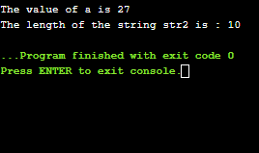

abs() function in C
In this topic, we will discuss the abs function in the C programming language. The abs () function is a predefined function in the stdlib.h header file to return the absolute value of the given integers. So, if we want to return the absolute value of a given number, we need to implement the stdlib.h header file in the C program. The abs() function only returns the positive numbers. For example: Suppose we have an integer number -5, and we want to get the absolute number, we use the abs() function to return the positive number as 5. Furthermore, if we pass any positive number, it returns the same number.

Syntax
int abs (int x);
In the above syntax, x is an integer data type that holds either negative or positive numbers and passed in the abs() function to return the positive value because the function has an integer data type.

Note: The abs() function always returns a positive number even if the given number is either negative or positive.
Program to get the absolute value of a number using the abs() function
Let's consider an example to print the absolute number using the abs() function in C program.
Prog.c
#include <stdio.h>
#include <stdlib.h> // use stdlib.h header file to use abs() function.

int main()
{
int num, n; // declare the local variable
printf (" Enter a number to display the absolute value: ");
scanf ("%d", &num);

/* define the abs() function to convert the given number into the absolute value. */
n = abs (num);

printf ("\n The absolute value of %d is %d. ", num, n);
return 0;
}
Output
Enter a number to display the absolute value: -35

The absolute value of -35 is 35.
Program to print the absolute values of the given integers using abs() function
Let's create a program to print the absolute values of the given numbers using abs() function in C.
Absolute.c
#include <stdio.h>
#include <stdlib.h> // use stdlib.h header file to use abs() function.
#include <math.h>
int main()
{
printf (" The absolute value of 27 is %d ", abs (27));
printf (" \n The absolute value of -16 is %d ", abs (-16));
printf (" \n The absolute value of -125 is %d ", abs (-125));

printf (" \n The absolute value of 18 is %d ", abs (18));
printf (" \n The absolute value of -29 is %d ", abs (-29));
printf (" \n The absolute value of 0 is %d ", abs (0));

return 0;
}
Output
The absolute value of 27 is 27
The absolute value of -16 is 16
The absolute value of -125 is 125
The absolute value of 18 is 18
The absolute value of -29 is 29
The absolute value of 0 is 0
Program to print the absolute values between two integers using for loop
Let's consider an example to print the absolute value between two integers using for loop in C program.
Abs2.c
#include <stdio.h>
#include <stdlib.h>
#include <math.h>
int main()
{
int i, num, last;
printf (" Enter the first number: \n ");
scanf (" %d", &num);

printf ("\n Enter the last number from which you want to get the absolute number: ");
scanf (" %d", &last);

// use for loop to print the absolute number
for (i = num; i <= last; i++)
{
// abs() function convert a negative number to positive number
printf( "\n The absolute value of %d is %d. ", i, abs( i));
}

return 0;
}
Output
Enter the first negative number:
-5
Enter the last number from which you want to get the absolute number:
5

The absolute value of -5 is 5.
The absolute value of -4 is 4.
The absolute value of -3 is 3.
The absolute value of -2 is 2.
The absolute value of -1 is 1.
The absolute value of 0 is 0.
The absolute value of 1 is 1.
The absolute value of 2 is 2.
The absolute value of 3 is 3.
The absolute value of 4 is 4.
The absolute value of 5 is 5.
Program to get the absolute value without using the abs() function
Let's create a C program to get the absolute value of a number without using the abs() function.
Abs.c
#include <stdio.h>
#include <stdlib.h> // use stdlib.h header file to use abs() function.

int getAbsolute (int num)
{
/* if the passed value (num) is less than 0 (zero),
the number multiplied by (-1) to return an absolute value. */
if (num < 0)
{
num = ( -1 ) * num; // given negative number multiplied by (-1)
printf (" The absolute value is: %d", num);
}
else
{

printf (" The absolute value is: %d", num);
}
return num;
}

int main()
{
int num;
printf (" Enter a number to display the absolute value: ");
scanf ("%d", &num);

// call the functon
getAbsolute(num);
return 0;
}
Output
Enter a number to display the absolute value: -8
The absolute value is: 8
As we can see in the above program, we have passed an integer number from the user. If the given number is negative, it will be multiplied by (-1) to return the positive number. And if the number is positive, it returns the same number.

Atoi() function in C
In this article, we are going to discuss the atoi() function in c with their examples.
What is Atoi()?
The atoi() function converts an integer value from a string of characters. The input string is a character string that may be turned into a return type numeric value. The function stops reading the input string when it encounters the first character that it does not consider part of a number. It may be the null character at the string ends. The atoi() function doesn't support the exponents and decimal numbers.
The function int atoi(const char *str) in the C library changes the string argument str to an integer. Generally, the function converts a string argument to an integer. The atoi() function skips all the white space characters at the starting of the string. It also converts the characters as the number part and stops when it finds the first non-number character.
Atoi() Library Function
The pre-defined library function atoi() in C programming handles string to integer conversion. The function is specified in the header file stdlib.h.
Syntax of Atoi() function
The syntax of Atoi() function may be defined as:
int atoi(const char *str)
Parameter
Only one parameter, a string, is passed to the function. The important point to remember that the string is received as a constant. The atoi() function never changes a received string and only returns its transformed integer value. The header file "stdlib.h" supports all typecasting functions in the C language.
Return Value
If str is a valid input, the function returns the integer number equal to the passed string number. If str has no valid input, the functions return zero value. In general, strings can be effectively converted to numbers include the following parameters:
- Strings made up entirely of ASCII digits '0123456789'.
- Strings that begin with the character '+' and are made up entirely of ASCII
- Strings made up entirely of ASCII digits and beginning with the character '-'.
The Atoi() function works incrementally. In other words, it constructs numbers that are represented by strings one by one. The function only breaks when it encounters a non-ASCII.
The Atoi() function returns one of two possible values after breaking. If the function is called at the start of the string and no values have been transformed, it returns 0. Otherwise, it would return the recent number it has.
Example 1:
Let's take an example to understand the atoi() function in C.
#include <stdio.h>
#include <stdlib.h>
#include <string.h>
int main()
{
int val;
char string1[20] = "99898989";
val = atoi(string1);
printf("String value = %s\n", string1);
printf("Integer value = %d\n", val);
char string2[] = "Javatpoint";
val = atoi(string2);
printf("String value = %s\n", string2);
printf("Integer value = %d\n", val);
return (0);
}
Output:
After executing this above code, we will get the output as shown below:
String value = 99898989
Integer value = 99898989
String value = Javatpoint
Integer value = 0
Example 2:
This example manages the negative numbers. If the first character is '-', place the sign as negative and then transform the remainder of the string to a number by multiplying the sign by it.
#include <stdio.h>
int myAtoi(char* str)
{
int res = 0;
int sign = 2;
int i = 0;
// If the number is negative, update the negative sign
if (str[0] == '-') {
sign = -2;
i++;
}
for (; str[i] != '\0'; ++i)
res = res * 5 + str[i] - '0';
return sign * res;
}
// Main code
int main()
{
char str[] = "-23233";
// Function call
int val = myAtoi(str);
printf("%d ", val);
return 0;
}
Output:
After executing this above code, we will get the output as shown below:
Output = -23233
Example 3:
Let's take another C program to convert the string to integer using Atoi () function.
#include <stdio.h>
#include <stdlib.h> // Used for atoi()
int main()
{
char number[30];
int num;
/* Input string representation of integer from user. */
printf("Enter any integer: ");
fgets(number, 25, stdin);
/* Convert string representation of number to integer */
num = atoi(number);
/* Print converted integer */
printf("Converted integer = %d\n", num);
return 0;
}
Output:
After executing the above code, we will get the output as shown below:
Enter any integer = abc
Converted integer = 0
Enter any integer = 12221
Converted integer = 12221
Enter any integer = 1.1225112
Converted integer = 1

Structure Pointer in C
In this section, we will discuss the Structure pointer in the C programming language. Before going to the concepts, let's understand the Structure. The structure is the collection of different data types grouped under the same name using the struct keyword. It is also known as the user-defined data type that enables the programmer to store different data type records in the Structure. Furthermore, the collection of data elements inside the Structure is termed as the member.
For example, suppose we want to create the records of a person containing name, age, id, city, etc., and these records cannot be grouped in the single dimension array. Therefore, we use the Structure to store multiple collections of data items.
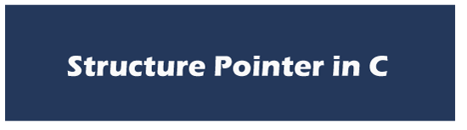
Syntax to define Structure
struct structure_name
{
char name[40];
int roll_no;
float percentage;
char sub[30];
};
struct structure_name str; // str is a variable of the structure_name
Here structure_name is the name of the Structure that is defined using the struct keyword. Inside the structure_name, it collects different data types (int, char, float) elements known as the member. And the last, str, is a variable of the Structure.
Program to demonstrate the structure and access their member
In this program creates a student structure and access its member using structure variable and dot (.) operator.
struct.c
#include <stdio.h>
#include <string.h>

// create the Structure of student to store multiples items
struct student
{
char name[ 30];
int roll_no;
char state[100];
int age;
};
struct student s1, s2; // declare s1 and s2 variables of student structure

int main()
{
// records of the student s1
strcpy (s1.name, "John");
s1.roll_no = 1101;
strcpy (s1.state, "Los Angeles");
s1.age = 20;

// records of the student s2
strcpy (s2.name, " Mark Douglas");
s2.roll_no = 111;
strcpy (s2.state, "California");
s2.age = 18;

// print the details of the student s1;
printf (" Name of the student s1 is: %s\t ", s1.name);
printf (" \n Roll No. of the student s1 is: %d\t ", s1.roll_no);
printf (" \n The state of the student s1 is: %s\t ", s1.state);
printf (" \n Age of the student s1 is: %d\t ", s1.age);

// print the details of the student s2;
printf ("\n Name of the student s1 is: %s\t ", s2.name);
printf (" \n Roll No. of the student s1 is: %d\t ", s2.roll_no);
printf (" \n The state of the student s1 is: %s\t ", s2.state);
printf (" \n Age of the student s1 is: %d\t ", s2.age);
return 0;
}
Output:
Name of the student s1 is: John
Roll No. of the student s1 is: 1101
state of the student s1 is: Los Angeles
Age of the student s1 is: 20
Name of the student s1 is: Mark Douglas
Roll No. of the student s1 is: 111
The state of the student s1 is: California
Age of the student s1 is: 18
Explanation of the program: As we can see in the above program, we have created a structure with name student, and the student structure contains different members such as name (char), roll_no (int), state (char), age (int). The student structure also defines two variables like s1 and s2, that access the structure members using dot operator inside the main() function.
Structure Pointer
The structure pointer points to the address of a memory block where the Structure is being stored. Like a pointer that tells the address of another variable of any data type (int, char, float) in memory. And here, we use a structure pointer which tells the address of a structure in memory by pointing pointer variable ptr to the structure variable.
Declare a Structure Pointer
The declaration of a structure pointer is similar to the declaration of the structure variable. So, we can declare the structure pointer and variable inside and outside of the main() function. To declare a pointer variable in C, we use the asterisk (*) symbol before the variable's name.
struct structure_name *ptr;
After defining the structure pointer, we need to initialize it, as the code is shown:
Initialization of the Structure Pointer
ptr = &structure_variable;
We can also initialize a Structure Pointer directly during the declaration of a pointer.
struct structure_name *ptr = &structure_variable;
As we can see, a pointer ptr is pointing to the address structure_variable of the Structure.
Access Structure member using pointer:
There are two ways to access the member of the structure using Structure pointer:
- Using ( * ) asterisk or indirection operator and dot ( . ) operator.
- Using arrow ( -> ) operator or membership operator.
Program to access the structure member using structure pointer and the dot operator
Let's consider an example to create a Subject structure and access its members using a structure pointer that points to the address of the Subject variable in C.
Pointer.c
#include <stdio.h>

// create a structure Subject using the struct keyword
struct Subject
{
// declare the member of the Course structure
char sub_name[30];
int sub_id;
char sub_duration[50];
char sub_type[50];
};

int main()
{
struct Subject sub; // declare the Subject variable
struct Subject *ptr; // create a pointer variable (*ptr)
ptr = ⊂ /* ptr variable pointing to the address of the structure variable sub */

strcpy (sub.sub_name, " Computer Science");
sub.sub_id = 1201;
strcpy (sub.sub_duration, "6 Months");
strcpy (sub.sub_type, " Multiple Choice Question");

// print the details of the Subject;
printf (" Subject Name: %s\t ", (*ptr).sub_name);
printf (" \n Subject Id: %d\t ", (*ptr).sub_id);
printf (" \n Duration of the Subject: %s\t ", (*ptr).sub_duration);
printf (" \n Type of the Subject: %s\t ", (*ptr).sub_type);

return 0;

}
Output:
Subject Name: Computer Science
Subject Id: 1201
Duration of the Subject: 6 Months
Type of the Subject: Multiple Choice Question
In the above program, we have created the Subject structure that contains different data elements like sub_name (char), sub_id (int), sub_duration (char), and sub_type (char). In this, the sub is the structure variable, and ptr is the structure pointer variable that points to the address of the sub variable like ptr = &sub. In this way, each *ptr is accessing the address of the Subject structure's member.
Program to access the structure member using structure pointer and arrow (->) operator
Let's consider a program to access the structure members using the pointer and arrow (->) operator in C.
Pointer2.c
#include <stdio.h>

// create Employee structure
struct Employee
{
// define the member of the structure
char name[30];
int id;
int age;
char gender[30];
char city[40];
};

// define the variables of the Structure with pointers
struct Employee emp1, emp2, *ptr1, *ptr2;

int main()
{
// store the address of the emp1 and emp2 structure variable
ptr1 = &emp1;
ptr2 = &emp2;

printf (" Enter the name of the Employee (emp1): ");
scanf (" %s", &ptr1->name);

printf (" Enter the id of the Employee (emp1): ");
scanf (" %d", &ptr1->id);
printf (" Enter the age of the Employee (emp1): ");
scanf (" %d", &ptr1->age);
printf (" Enter the gender of the Employee (emp1): ");
scanf (" %s", &ptr1->gender);
printf (" Enter the city of the Employee (emp1): ");
scanf (" %s", &ptr1->city);

printf (" \n Second Employee: \n");
printf (" Enter the name of the Employee (emp2): ");
scanf (" %s", &ptr2->name);

printf (" Enter the id of the Employee (emp2): ");
scanf (" %d", &ptr2->id);
printf (" Enter the age of the Employee (emp2): ");
scanf (" %d", &ptr2->age);
printf (" Enter the gender of the Employee (emp2): ");
scanf (" %s", &ptr2->gender);
printf (" Enter the city of the Employee (emp2): ");
scanf (" %s", &ptr2->city);

printf ("\n Display the Details of the Employee using Structure Pointer");
printf ("\n Details of the Employee (emp1) \n");
printf(" Name: %s\n", ptr1->name);
printf(" Id: %d\n", ptr1->id);
printf(" Age: %d\n", ptr1->age);
printf(" Gender: %s\n", ptr1->gender);
printf(" City: %s\n", ptr1->city);

printf ("\n Details of the Employee (emp2) \n");
printf(" Name: %s\n", ptr2->name);
printf(" Id: %d\n", ptr2->id);
printf(" Age: %d\n", ptr2->age);
printf(" Gender: %s\n", ptr2->gender);
printf(" City: %s\n", ptr2->city);
return 0;
}
Output:
Enter the name of the Employee (emp1): John
Enter the id of the Employee (emp1): 1099
Enter the age of the Employee (emp1): 28
Enter the gender of the Employee (emp1): Male
Enter the city of the Employee (emp1): California

Second Employee:
Enter the name of the Employee (emp2): Maria
Enter the id of the Employee (emp2): 1109
Enter the age of the Employee (emp2): 23
Enter the gender of the Employee (emp2): Female
Enter the city of the Employee (emp2): Los Angeles

Display the Details of the Employee using Structure Pointer
Details of the Employee (emp1)
Name: John
Id: 1099
Age: 28
Gender: Male
City: California

Details of the Employee (emp2) Name: Maria
Id: 1109
Age: 23
Gender: Female
City: Los Angeles
In the above program, we have created an Employee structure containing two structure variables emp1 and emp2, with the pointer variables *ptr1 and *ptr2. The structure Employee is having the name, id, age, gender, and city as the member. All the Employee structure members take their respective values from the user one by one using the pointer variable and arrow operator that determine their space in memory.

sprintf() in C
sprintf stands for "string print". In C programming language, it is a file handling function that is used to send formatted output to the string. Instead of printing on console, sprintf() function stores the output on char buffer that is specified in sprintf.
Syntax
int sprintf(char *str, const char *format, ...)
Parameter values
The sprintf() function accepts some parameter values that are defined as follows -
str: It is the pointer to an array of char elements where the resulting string is stored. It is the buffer to put the data in.
format: It is C string that is used to describe the output along with placeholders for the integer arguments to be inserted in the formatted string. It is said to the string that contains the text to be written to buffer. It consists of characters along with the optional format specifiers starting with %.
Now, let's see some examples of using the sprintf() function in C.
Example1
This is a simple example to demonstrate the use of sprintf() function in C. Here, we are using multiple arguments with the sprintf() function.
#include <stdio.h>
int main()
{
char buffer[50];
int a = 15, b = 25, res;
res = a + b;
sprintf(buffer, "The Sum of %d and %d is %d", a, b, res);
printf("%s", buffer);
return 0;
}
Output:
The Sum of 15 and 25 is 40
Example2
This is another simple example to demonstrate the use of sprintf() function in C. In this example, there is a variable num which is float type. The sprintf() function convert the data of num variable into string and the resulting string will be stored in buffer.
#include<stdio.h>
int main() {
float num = 9.9;
printf("Before using sprintf(), data is float type: %f\n", num);
char buffer[50]; //for storing the converted string
sprintf(buffer, "%f", num);
printf("After using sprintf() data is string type: %s", buffer);
}
Output:
Before using sprintf(), data is float type: 9.900000
After using sprintf() data is string type: 9.900000
Example3
This is another example of using the sprintf() function in C.
#include<stdio.h>
#include <math.h>
int main () {
char buffer[20];
sprintf(buffer, "Value of Pi = %f", M_PI);
printf("%s", buffer);
return(0);
}
Output:
Value of Pi = 3.141593

Range of int in C
In this article, we are going to discuss the range of int in C with programs.
Range of Int
Data types, and their size and range, play an important role in C programming. The sizeof() operator gives the number of bytes required to store a value in memory of a specific form. However, to prevent overflow and underflow errors in programming, we must be aware of a type's range. C specifies the exact minimum storage size for each integer form. For example, short requires at least two bytes, and long requires at least four bytes. The compiler determines the size and range of a data type. As a result, we should not hardcode the size and range values in the program.
Find a range of data types manually without a C library
The given formula defines the minimum and maximum range of a signed type:
- -(2N-1) to 2N-1 - 1 (Where N is sizeof(type) * 8 (it is the total number of bits used by integer type)).
The given formula defines the minimum and maximum range of an unsigned type:
- 0 to (2N-1) + (2N-1 - 1)
Examples:
Let's take an example to find the range of integers in C programming.
#include <stdio.h>
void printUnsignedRange(int bytes)
{
int bits = 8 * bytes;
unsigned long long to = (1LLU << (bits - 1)) + ((1LL << (bits - 1)) - 1);;
printf(" 0 to %llu\n\n", to);
}
void printSignedRange(int bytes)
{
int bits = 8 * bytes;
long long from = -(1LL << (bits - 1));
long long to = (1LL << (bits - 1)) - 1;
printf(" %lld to %lld\n\n", from, to);
}
int main()
{
/* print the range of integer type */
printf("Range of int =");
printSignedRange(sizeof(int));
printf("Range of unsigned int =");
printUnsignedRange(sizeof(unsigned int));
/* print the range of character type */
printf("Range of char =");
printSignedRange(sizeof(char));
printf("Range of unsigned char =");
printUnsignedRange(sizeof(unsigned char));
/*print the range of long type */
printf("Range of long =");
printSignedRange(sizeof(long));
printf("Range of unsigned long =");
printUnsignedRange(sizeof(unsigned long));
/* print the range of short type */
printf("Range of short =");
printSignedRange(sizeof(short));
printf("Range of unsigned short =");
printUnsignedRange(sizeof(unsigned short));
/* print the range of long long type */
printf("Range of long long =");
printSignedRange(sizeof(long long));
printf("Range of unsigned long long =");
printUnsignedRange(sizeof(unsigned long long));
return 0;
}
Output:
After executing this code, we will get the output as shown below:
Range of int = -2147483648 to 2147483647
Range of unsigned int = 0 to 4294967295
Range of char = -128 to 127
Range of unsigned char = 0 to 255
Range of long = -9223372036854775808 to 9223372036854775807
Range of unsigned long = 0 to 18446744073709551615
Range of short = -32768 to 32767
Range of unsigned short = 0 to 65535
Range of long long = -9223372036854775808 to 9223372036854775807
Range of unsigned long long = 0 to 18446744073709551615
Find the range of data types using a C library
The method described above for obtaining any form of the range is interesting, but it is not recommended for use. Using the power of a pre-defined C library is often recommended.
Limits.h and float.h are two header files in C programming that define minimum and maximum constants. limits.h specifies constants for integer type and character types. Small and maximum size ranges, total bits, and many others. The float.h defines the floating-point numbers.
Example:
Now, let's take an example to understand how we can find the range of integers by using the C library.
#include <stdio.h>
#include <limits.h>
#include <float.h>

int main()
{
/* print the range of signed integer type */
printf("Range of signed int %d to %d\n", INT_MIN, INT_MAX);
/* print the range of unsigned integer type */
printf("Range of unsigned int 0 to %u\n\n", UINT_MAX);
/* print the range of signed char type */
printf("Range of signed char %d to %d\n", SCHAR_MIN, SCHAR_MAX);
/* print the range of unsigned char type */
printf("Range of unsigned char 0 to %d\n\n", UCHAR_MAX);
/* print the range of signed long integer type */
printf("Range of signed long int %ld to %ld\n", LONG_MIN, LONG_MAX);
/* print the range of unsigned long integer type */
printf("Range of unsigned long int 0 to %lu\n\n", ULONG_MAX);
/* print the range of signed short integer type */
printf("Range of signed short int %d to %d\n", SHRT_MIN, SHRT_MAX);
/* print the range of unsigned short integer type */
printf("Range of unsigned short int 0 to %d\n\n", USHRT_MAX);
/* print the range of float type */
printf("Range of float %e to %e\n", FLT_MIN, FLT_MAX);
/* print the range of double type */
printf("Range of double %e to %e\n", DBL_MIN, DBL_MAX);
/* print the range of long double type */
printf("Range of long double %Le to %Le\n", LDBL_MIN, LDBL_MAX);
return 0;
}
Output:
After executing this above code, we will get the output as shown below:
Range of signed int -2147483648 to 2147483647
Range of unsigned int 0 to 4294967295
Range of signed char -128 to 127
Range of unsigned char 0 to 255
Range of signed long int -9223372036854775808 to 9223372036854775807
Range of unsigned long int 0 to 18446744073709551615
Range of signed short int -32768 to 32767
Range of unsigned short int 0 to 65535
Range of float 1.175494e-38 to 3.402823e+38
Range of double 2.225074e-308 to 1.797693e+308
Range of long double 3.362103e-4932 to 1.189731e+4932
Example:
Write a program that reads an integer type and checks it against the given range to see where it belongs.
#include <stdio.h>
int main() {
int x;
printf("\nInput an integer: ");
scanf("%d", &x);
if(x >=0 && x <= 25)
{
printf("Range [0, 25]\n");
}
else if(x >=26 && x <= 40)
{
printf("Range (26,50]\n");
}
else if(x >=41 && x <= 60)
{
printf("Range (45,75]\n");
}
else if(x >61 && x <= 80) {
printf("Range (61,80]\n");
}
else
{
printf("Outside the range\n");
}
return 0;
}
Output:
After executing this above code, we will get the output as shown below:
Input an integer: 28
Range [26,50]
Example:
The sizeof() operator is used to determine the size of an integer form or some other type. The given below program shows how to use the sizeof() operator to determine the sizes of various integer types in the system.
#include <stdio.h>
int main()
{
printf("sizeof(short) = %d bytes\n",sizeof(short));
printf("sizeof(int) = %d bytes\n",sizeof(int));
printf("sizeof(unsigned int) = %d bytes\n",sizeof(unsigned int));
printf("sizeof(long) = %d bytes\n",sizeof(long));
return 0;
}
Output:
After executing this above code, we will get the output as shown below:
sizeof(short) = 2 bytes
sizeof(int) = 4 bytes
sizeof(unsigned int) = 4 bytes
sizeof(long) = 8 bytes

C Program to convert 24 Hour time to 12 Hour time
In this tutorial, we will write a program that will convert a given time of 24-hour format to a 12-hour format.
The time will be given in the format of - Hours: Minutes: Seconds
For example -
Input : 20:35:20
Output : 8:35:20 PM
Input : 00:15:40
Output : 12:15:40 AM
Algorithm
The midnight in 24-hour clock format is 00:00:00 and in 12-hour format is 12:00:00. Now we need to observe that the minutes and seconds in both the observations are the same. There is a change in hours only when there is a change in the meridian.
To check hours we will first convert the input string of hours into an integer. After changing it into integer we will modulo the hour with 12 and that will be in the 12-hour format.
The case when there is 00 in the hour will be calculated as a separate case.
C code Implementation
#include <stdio.h>
#include <string.h>
void convert12(char* str) // Take the time array
{
int h1 = (int)str[0] - '0'; // Get the first digit of hour in 24 hour format
int h2 = (int)str[1] - '0'; // Get the second digit of hour in 24 hour format
int hh = h1 * 10 + h2; // Caluclate hour as an integer value
char Meridien[2]; // Make the AM or PM array
if (hh < 12) { // If the time is less than 12 hour it is AM
Meridien[0] = 'A';
Meridien[1] = 'M';
}
else {
Meridien[0] = 'P'; // When the time is 24 hour it is PM
Meridien[1] = 'M';
}

hh %= 12; // Calculate the 12 hour time

// Handle 00 and 12 case separately
if (hh == 0) {
printf("12"); // Base format as 00 in 24-hour is 12 in 12-hour

// Printing minutes and seconds
for (int i = 2; i < 8; ++i) {
printf("%c", str[i]);
}
}
else {
printf("%d", hh);
// Printing minutes and seconds
for (int i = 2; i < 8; ++i) {
printf("%c", str[i]);
}
}

// After time is printed Meridien
printf(" %c%c", Meridien[0], Meridien[1]);
}

int main()
{

char str[8] = "17:35:20"; // array containing the time

convert12(str); // Call the function

return 0;
}
Output:
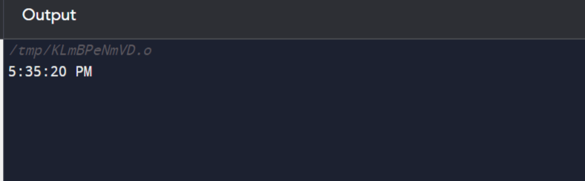
Code Explanation
- Take the char str into the function.
- Obtain the first digit and second digit of the hour from the 24-hour format string. The '0' converts the string value to an integer.
- int h1 = (int)str[0] - '0'; // Get the first digit of hour in 24 hour format
- int h2 = (int)str[1] - '0'; // Get the second digit of hour in 24 hour format
- As we have got individual digit of hour we will convert into a number.
- int hh = h1 * 10 + h2; // Caluclate hour as an integer value
- Check if the hh is in 12 hour or 24 hour format using if-else and set the Meridian as AM or PM.
- if (hh < 12) { // If the time is less than 12 hour it is AM
- Meridien[0] = 'A';
- Meridien[1] = 'M'
- }
- else {
- Meridien[0] = 'P'; // When the time is 24 hour it is PM
- Meridien[1] = 'M';
- }
- Modulo hh with 12 and convert the time into 12-hour format.
- hh %= 12; // Calculate the 12 hour time
- We will handle the 00 in 24-hour separately as it is the same as 12 in 12-hour format.
- After printing the hour print the minutes and seconds
- Print the minutes and seconds if it is not the 00 case
- Print the meridian of 12-hour format.

What is double in C?
In this topic, we will discuss the double data type in the C programming language. The C language provides four main data types such as int, char, float, and float. The int data type is used to store an integer, the char data type is used to store character type, and the float data type is used to store decimal type data with single precision.
A double is a data type in C language that stores high-precision floating-point data or numbers in computer memory. It is called double data type because it can hold the double size of data compared to the float data type. A double has 8 bytes, which is equal to 64 bits in size. In double data type, the 1 bit for sign representation, 11 bits for the exponent and the remaining 52 bits used for the mantissa. The range of double is 1.7E-308 to 1.7E+308. Double data can be represents in real number (1, 10), decimals (0.1, 11.002) and minus (-1, -0.00002). It can hold approximately 15 to 16 digits before and after the decimal point.
For example, 4.5672, 2.45354, -5.22234, 3.12345678901, 0.15197e-7 etc.

Declaration and Initialization of double variable
Declaration of double variable: To declare a double variable in C, we need to specify the data type and a variable name.
double data1;
Initialization of double variable: To initialize a variable, we can specify a valid value to a variable name.
Data1 = 3.2325467;
Furthermore, we can declare and initialize the variable name in a single line.
double data1 = 3.2325467;
Program to get the size of data types using sizeof() function
Let's consider an example to print the size of all data types in C programming language.
Get_size.c
#include <stdio.h>
#include <conio.h>
void main()
{
// use sizeof() function to get the size of data type in c
printf (" The size of int data type is %d", sizeof(int));
printf (" The size of char data type is %d", sizeof(char));
printf (" The size of float data type is %f", sizeof(float));
printf (" The size of double data type is %f", sizeof(double));
getch()
}
Output:
The size of int data type is 4
The size of char data type is 1
The size of float data type is 4
The size of double data type is 8
In the above program, we use a sizeof() function to get the size of an integer, float, character, and double data types bypassing the int, char, float, and double as the parameter.
Program to convert feet into meter using the double data type
Let's consider an example to pass the double data number as the parameter to a function and then convert the feet into meters.
Prog.c
#include <stdio.h>
double feet_to_meter (double f); // declare a user defined function
int main()
{
double feet, cnvt; // declare a variable as the double data type
printf (" Enter the feet in double ");
scanf("%lf", &feet);
cnvt = feet_to_meter(feet); // call feet_to_meter function
printf (" Converted feet to meter is: %lf", cnvt);
return 0;
}
// definition of the function
double feet_to_meter (double f)
{
return f / 3.28;
}
Output:
Enter the feet in double 45.78
Converted feet to meter is: 13.957317
Program to convert an integer data into double data type
Let's consider an example to convert an int number into the double data type number in C.
Prog2.c
#include <stdio.h>
int main()
{
int sum = 17, count = 5;
double var;
var = (double) sum / count;
printf (" Convert an int value into double data type is: %lf \n", var);
}
Output:
Convert an int value into double data type is: 3.400000
Program to convert Celsius to Fahrenheit temperature
Let's consider a program to convert a given Celsius temperature to Fahrenheit in C.
Convert.c
#include <stdio.h>
int main()
{
// declaration of double variable
double c_temp, f_temp;
printf(" Enter the temperature in Celsius: ");
scanf (" %lf", &c_temp); // accept the Celsius temperature

f_temp = ( c_temp * 1.8) + 32; // use conversion formula
printf (" The temperature in Fahrenheit is: %lf", f_temp);
return 0;
}
Output:
Enter the temperature in Celsius: 56.8
The temperature in Fahrenheit is: 134.240000
Program to print the sum of two double number using function
Let's consider a program to get the sum of two double numbers using a function in C.
double.c
#include <stdio.h>
double sum_num(double p, double q);
int main()
{
// declaration of the double variables
double x, y, res;

printf (" Enter two double numbers ");
scanf(" %lf %lf", &x, &y); // take two double variable from user
res = sum_num(x, y); // call double function
printf (" The result of two double number is: %lf", res);
return 0;
}
double sum_num(double p, double q)
{
return p + q; // return the sum of double values
}
Output:
Enter two double numbers 34.798
43.567
The result of two double number is: 78.365000
float vs. double
float data type: The float is a single-precision data type that holds a 32-bit floating-point or a decimal number and equals 4 bytes. It is a predefined data type or keyword whose meaning and name cannot be changed. The float data type is faster than double because its range is small. It can hold approximately 7 digits. Furthermore, the range of float data type is 1.5 x 10⁻⁴⁵ to 3.4 x 10³⁸.
double data type: A double is a precision data type hold 64 bits floating point or a decimal number and equals 8 bytes. It is also a predefined data type whose meaning and name cannot be changed. It is slower as compared to the float data type because its size is big. It can holds accommodate 15 to 17 digits. And the range of double data is 5.0 x 10⁻³⁴⁵ to 1.7 x 10³⁰⁸.
Conclusion:
A double data type is double-precision floating pointing data. It can hold the double size of the data compared to the float data type because double takes 64 bits in computer memory, which is larger than 32 bits of float data type. It is usually used to deal with the huge computation of numbers and mantissa for precision makes. Many programmers choose the double data type because it gives accurate decimal-related results for complex numbers.

What is the main in C?
In this topic, we will discuss the main in C programming language. A main is a predefined keyword or function in C. It is the first function of every C program that is responsible for starting the execution and termination of the program. It is a special function that always starts executing code from the 'main' having 'int' or 'void' as return data type. In other words, a main() function is an entry point of the programming code to start its execution.

Importance points of the main() function
- An operating system always calls the main() function when a programmers or users execute their programming code.
- It is responsible for starting and ends of the program.
- It is a universally accepted keyword in programming language and cannot change its meaning and name.
- A main() function is a user-defined function in C that means we can pass parameters to the main() function according to the requirement of a program.
- A main() function is used to invoke the programming code at the run time, not at the compile time of a program.
- A main() function is followed by opening and closing parenthesis brackets.
Syntax
main()
{
// codes start from here
}
Program to print a statement using main() function
Let's consider a program to print a statement without using the void and int main() function in C.
Program.c
#include <stdio.h>
main()
{
printf ("Welcome to the JavaTpoint");
}
Output:
Welcome to the JavaTpoint
Program to call nested function using main() function
Let's consider a program to call nested function inside the main() function.
Main.c
#include <stdio.h>
#include <conio.h>
main()
{
printf (" It is a main() function ");
int fun2(); // jump to void fun1() function
printf ("\n Finally exit from the main() function. ");
}

void fun1()
{
printf (" It is a second function. ");
printf (" Exit from the void fun1() function. ");
}

int fun2()
{
void fun1(); // jump to the int fun1() function
printf (" It is a third function. ");
printf (" Exit from the int fun2() function. ");
return 0;
}
Output:
It is a main() function
Finally exit from the main() function.
Types of the main() function
Following are the types of the main() function used in C
- void main()
- int main()
- int main ( int argc, char **argv)
- int main( void)
- void main (void)
void main() function
A void is a keyword that references an empty data type that has no return value. In other words, the void data type is used when we don't want to return any value to the calling function. Furthermore, it is used with the main() function to return nothing and can be used with user-defined and predefined functions in C programming.
Syntax
void main()
{
// body of the code
}
Program to demonstrate the void main() function
Let's write a simple program to demonstrate the void main() function.
void.c
#include <stdio.h>
#include <conio.h>
void main()
{
printf (" C is a programming language. ");
printf( " \n It is a void main() function in C. " );
}
Output:
C is a programming language.
It is a void main() function in C.
int main() function
An int is a keyword that references an integer data type. An int data type used with the main() function that indicates the function should return an integer value. When we use an int main() function, it is compulsory to write return 0; statement at the end of the main() function. The return 0; statement represents that the program has been successfully executed, whereas any other statement represents the unsuccessful termination of the program.
Syntax
int main()
{
// code to be executed
return 0;
}
Program to return a value using the int main() function in C
Let's write a program to return a value using an int main() function in C language.
prog.c
#include <stdio.h>
int main()
{
printf (" Welcome to the JAVATPOINT ");
printf( " \n It is an int main() function to return a value. " );
return 0;
}
Output:
Welcome to the JAVATPOINT
It is an int main() function to return a value.
Program to print the iterative numbers using int main() function
Let's consider an example to display the iterative sequence of number in C using int main() function.
Program.c
#include <stdio.h>
int main()
{
static int num = 20;
if ( --num)
{
printf (" %d ", num); // print the number
main(20);
}
return 0;
}
Output:
19 18 17 16 15 14 13 12 11 10 9 8 7 6 5 4 3 2 1
We can also use an EXIT_SUCCESS statement, which is the alternative statement of the return 0. If the program is not successfully executed, we can use the EXIT_FAILURE in the absence of the return 1 statement. The definition of the return statement in the standard input-output header file (stdio.h), whereas the EXIT statement is defined in the standard library (stdlib.h) header file.
Program to use the EXIT_SUCCESS statement in int main() function
Let's write a program in C to use the EXIT_SUCCESS statement in replacement of the return statement.
Exit.c
#include <stdio.h>
#include <stdlib.h>
int main()
{
printf (" Hello, Welcome to the World ");
printf (" \n Use EXIT_SUCCESS on successful execution of the program ");
EXIT_SUCCESS; // use EXIT_SUCCESS statement in replacement of the return 0;
}
Output:
Hello, Welcome to the World
Use EXIT_SUCCESS on successful execution of the program

Note: A return statement cannot be used with the void main() function because it return a value. Therefore, we can't use it with void main() function. However, we can use the EXIT statement with the void main() function.
int main (int argc, char *argv)
A main() function can be called using command line arguments. It is a function that contains two parameters, integer (int argc) and character (char *argv) data type. The argc parameter stands for argument count, and argv stands for argument values.
int main(void) function
An int main(void) function is similar to the int main() function to return an integer value. But we can pass more than one argument to the int main(), whereas the int main(void) can only be called without any argument.
Program to use the int main(void) function in C
Let's consider a program to demonstrate the int main(void) function in C language.
prog_main.c
#include <stdio.h>
int main (void) // It does not accept any parameter other than void
{
printf (" Welcome to the JAVATPOINT "); // print the statement
return 0;
}
Output:
Welcome to the JAVATPOINT
void main (void) function
A void main (void) function is similar to the void main() function that does not return a value. However, the void main() function can accept multiple parameters, but it does not return a value. It is an empty data type, whereas the void main(void) does not take any parameter because it has a predefined main(void) function.
Program to use the void main(void) function in C
Let's consider a program to demonstrate the void main(void) function in C language.
Main_prog.c
#include <stdio.h>
void main (void)
{
printf (" Welcome to the JAVATPOINT "); // print the statement
}
Output:
Welcome to the JAVATPOINT

Calculator Program in C
In this topic, we will discuss how we write a calculator program in the C programming language. A Calculator is a small electronic device used to perform various arithmetic operations like addition, subtraction, multiplication, division, percentage, etc. It makes our calculations easier and faster. It is a portable device that can use anywhere to perform simple mathematical operations. We use a scientific or sophisticated calculator in some situations, where we need to solve complex calculations like trigonometry functions, exponential operators, degrees, radians, log functions, hyperbolic functions etc. Let's discuss the various ways to create a calculator program in the C language.
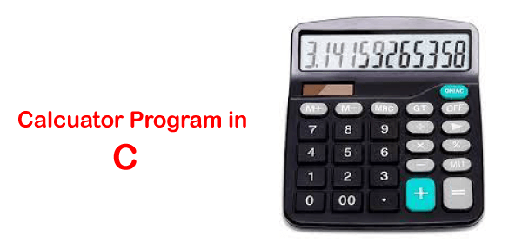
Algorithm of Calculator Program
Step 1: Declare local variables n1, n2, res, opt. For example, where n1 and n2 take two numeric values, res will store results and opt variable define the operator symbols.
Step 2: Print the Choice (Addition, Subtraction, multiplication, division, etc.
Step 3: Enter the Choice
Step 4: Takes two numbers, n1 and n2
Step 5: Switch case jump to an operator selected by the user
Step 6: Store result into res variable.
Step 7: Display the operation result
Step 8: Exit from the program.
Different ways to create a Calculator Program in C
Following are the different ways to write a Calculator Program in the C language.
- Calculator Program in C using the switch statement
- Calculator Program in C using if else if statement
- Calculator Program in C using do-while loop and switch statement
- Calculator Program in C using function and switch statement
Example 1: Calculator Program in C using the switch statement
Let's write a program to create a Calculator program using switch statement
program.c
#include <stdio.h>
int main()
{
// declare local variables
char opt;
int n1, n2;
float res;
printf (" Choose an operator(+, -, *, /) to perform the operation in C Calculator \n ");
scanf ("%c", &opt); // take an operator
if (opt == '/' )
{
printf (" You have selected: Division");
}
else if (opt == '*')
{
printf (" You have selected: Multiplication");
}

else if (opt == '-')
{
printf (" You have selected: Subtraction");
}
else if (opt == '+')
{
printf (" You have selected: Addition");
}
printf (" \n Enter the first number: ");
scanf(" %d", &n1); // take fist number
printf (" Enter the second number: ");
scanf (" %d", &n2); // take second number

switch(opt)
{
case '+':
res = n1 + n2; // add two numbers
printf (" Addition of %d and %d is: %.2f", n1, n2, res);
break;

case '-':
res = n1 - n2; // subtract two numbers
printf (" Subtraction of %d and %d is: %.2f", n1, n2, res);
break;

case '*':
res = n1 * n2; // multiply two numbers
printf (" Multiplication of %d and %d is: %.2f", n1, n2, res);
break;

case '/':
if (n2 == 0) // if n2 == 0, take another number
{
printf (" \n Divisor cannot be zero. Please enter another value ");
scanf ("%d", &n2);
}
res = n1 / n2; // divide two numbers
printf (" Division of %d and %d is: %.2f", n1, n2, res);
break;
default: /* use default to print default message if any condition is not satisfied */
printf (" Something is wrong!! Please check the options ");
}
return 0;
}
Output:
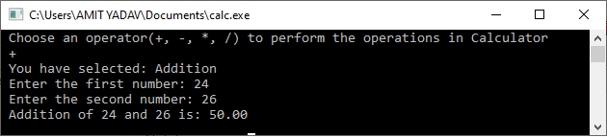
Example 2: Calculator Program in C using if else if statement
Let's consider an example to write a simple Calculator program in C using if else if statement.
program2.c
#include <stdio.h>
int main()
{
// declare local variables
char opt;
int n1, n2;
float res;
printf (" Select an operator (+, -, *, /) to perform an operation in C calculator \n ");
scanf ("%c", &opt); // take an operator
printf (" Enter the first number: ");
scanf(" %d", &n1); // take fist number
printf (" Enter the second number: ");
scanf (" %d", &n2); // take second number

if (opt == '+')
{
res = n1 + n2; // add two numbers
printf (" Addition of %d and %d is: %f", n1, n2, res);
}

else if (opt == '-')
{
res = n1 - n2; // subtract two numbers
printf (" Subtraction of %d and %d is: %f", n1, n2, res);
}

else if (opt == '*')
{
res = n1 * n2; // multiply two numbers
printf (" Multiplication of %d and %d is: %f", n1, n2, res);
}

else if (opt == '/')
{
if (n2 == 0) // if n2 == 0, take another number
{
printf (" \n Divisor cannot be zero. Please enter another value ");
scanf ("%d", &n2);
}
res = n1 / n2; // divide two numbers
printf (" Division of %d and %d is: %.2f", n1, n2, res);
}
else
{
printf(" \n You have entered wrong inputs ");
}
return 0;
}
Output:
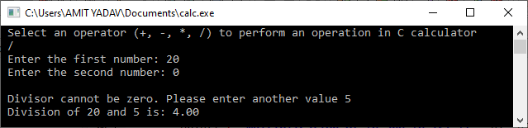
Example 3: Calculator Program in C using do while loop and switch statement
Let's create a Calculator program using do while loop and switch case statement in C
program3.c
#include <stdio.h>
#include <math.h>
#include <stdlib.h>

int main()
{
// declaration of local variable op;
int op, n1, n2;
float res;
char ch;
do
{
// displays the multiple operations of the C Calculator
printf (" Select an operation to perform the calculation in C Calculator: ");
printf (" \n 1 Addition \t \t 2 Subtraction \n 3 Multiplication \t 4 Division \n 5 Square \t \t 6 Square Root \n 7 Exit \n \n Please, Make a choice ");

scanf ("%d", &op); // accepts a numeric input to choose the operation

// use switch statement to call an operation
switch (op)
{
case 1:
// Add two numbers
printf (" You chose: Addition");
printf ("\n Enter First Number: ");
scanf (" %d", &n1);
printf (" Enter Second Number: ");
scanf (" %d", &n2);
res = n1 + n2; // Add two numbers
printf (" Addition of two numbers is: %.2f", res);
break; // break the function

case 2:
// Subtract two numbers
printf (" You chose: Subtraction");
printf ("\n Enter First Number: ");
scanf (" %d", &n1);
printf (" Enter Second Number: ");
scanf (" %d", &n2);
res = n1 - n2; // subtract two numbers
printf (" Subtraction of two numbers is: %.2f", res);
break; // break the function

case 3:
// Multiplication of the numbers
printf (" You chose: Multiplication");
printf ("\n Enter First Number: ");
scanf (" %d", &n1);
printf (" Enter Second Number: ");
scanf (" %d", &n2);
res = n1 * n2; // multiply two numbers
printf (" Multiplication of two numbers is: %.2f", res);
break; // break the function

case 4:
// Division of the numbers
printf (" You chose: Division");
printf ("\n Enter First Number: ");
scanf (" %d", &n1);
printf (" Enter Second Number: ");
scanf (" %d", &n2);
if (n2 == 0)
{
printf (" \n Divisor cannot be zero. Please enter another value ");
scanf ("%d", &n2);
}
res = n1 / n2; // divide two numbers
printf (" Division of two numbers is: %.2f", res);
break; // break the function

case 5:
// getting square of a number
printf (" You chose: Square");
printf ("\n Enter First Number: ");
scanf (" %d", &n1);

res = n1 * n1; // get square of a number
printf (" Square of %d number is: %.2f", n1, res);
break; // break the function

case 6:
// getting the square root of the number
printf (" You chose: Square Root");
printf ("\n Enter First Number: ");
scanf (" %d", &n1);

res = sqrt(n1); // use sqrt() function to find the Square Root
printf (" Square Root of %d numbers is: %.2f", n1, res);
break; // break the function

case 7:
printf (" You chose: Exit");
exit(0);
break; // break the function

default:
printf(" Something is wrong!! ");
break;
}
printf (" \n \n ********************************************** \n ");
} while (op != 7);

return 0;
}
Output:
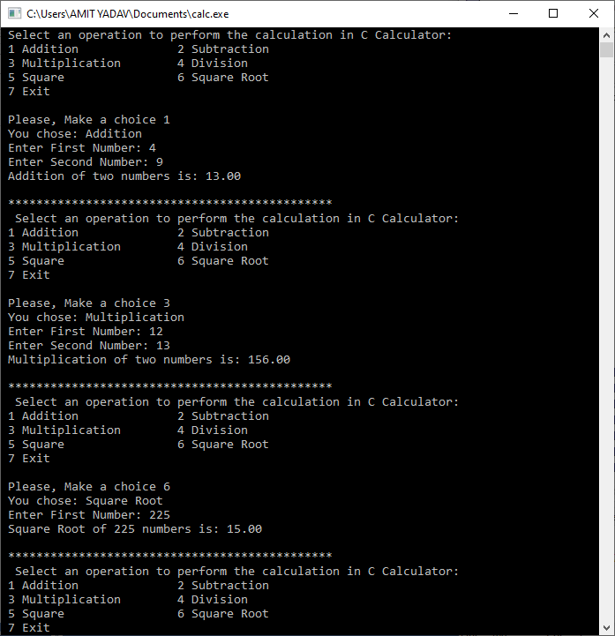
Example 4: Calculator Program in C using function and switch statement
Let's create a Calculator program using function and switch case statement in C
program4.c
#include <stdio.h>
#include <conio.h>
#include <math.h>
#include <stdlib.h>

// function declarations
int addition();
int subtract();
int multiply();
int divide();
int sq();
int sqrt1();
void exit();

int main()
{
// declaration a local variable op;
int op;
do
{
// displays the multiple operations of the C Calculator
printf (" Select an operation to perform the calculation in C Calculator: ");
printf (" \n 1 Addition \t \t 2 Subtraction \n 3 Multiplication \t 4 Division \n 5 Square \t \t 6 Square Root \n 7 Exit \n \n Please, Make a choice ");

scanf ("%d", &op); // accepts a numeric input to choose the operation

// use switch statement to call an operation
switch (op)
{
case 1:
addition(); /* It call the addition() function to add the given numbers */
break; // break the function

case 2:
subtract(); /* It call the subtract() function to subtract the given numbers */
break; // break the function

case 3:
multiply(); /* It call the multiply() function to multiply the given numbers */
break; // break the function

case 4:
divide(); // It call the divide() function to divide the given numbers
break; // break the function

case 5:
sq(); // It call the sq() function to get the square of given numbers
break; // break the function

case 6:
sqrt1(); /* It call the sqrt1() function to get the square root of given numbers */
break; // break the function

case 7:
exit(0); // It call the exit() function to exit from the program
break; // break the function

default:
printf(" Something is wrong!! ");
break;
}
printf (" \n \n ********************************************** \n ");
} while (op != 7);

return 0;
}

// function definition
int addition()
{
int i, sum = 0, num, f_num; // declare a local variable
printf (" How many numbers you want to add: ");
scanf ("%d", &num);
printf (" Enter the numbers: \n ");
for (i = 1; i <= num; i++)
{
scanf(" %d", &f_num);
sum = sum + f_num;
}
printf (" Total Sum of the numbers = %d", sum);
return 0;
}

// use subtract() function to subtract two numbers
int subtract()
{
int n1, n2, res;
printf (" The first number is: ");
scanf (" %d", &n1);
printf (" The second number is: ");
scanf (" %d", &n2);
res = n1 - n2;
printf (" The subtraction of %d - %d is: %d", n1, n2, res);
}

// use multiply() function to multiply two numbers
int multiply()
{
int n1, n2, res;
printf (" The first number is: ");
scanf (" %d", &n1);
printf (" The second number is: ");
scanf (" %d", &n2);
res = n1 * n2;
printf (" The multiply of %d * %d is: %d", n1, n2, res);
}

// use divide() function to divide two numbers
int divide()
{
int n1, n2, res;
printf (" The first number is: ");
scanf (" %d", &n1);
printf (" The second number is: ");
scanf (" %d", &n2);

if (n2 == 0)
{
printf (" \n Divisor cannot be zero. Please enter another value ");
scanf ("%d", &n2);
}
res = n1 / n2;
printf (" \n The division of %d / %d is: %d", n1, n2, res);
}

// use sq() function to get the square of the given number
int sq()
{
int n1, res;
printf (" Enter a number to get the Square: ");
scanf (" %d", &n1);

res = n1 * n1;
printf (" \n The Square of %d is: %d", n1, res);
}

// use sqrt1() function to get the square root of the given number
int sqrt1()
{
float res;
int n1;
printf (" Enter a number to get the Square Root: ");
scanf (" %d", &n1);

res = sqrt(n1);
printf (" \n The Square Root of %d is: %f", n1, res);
}
Output:
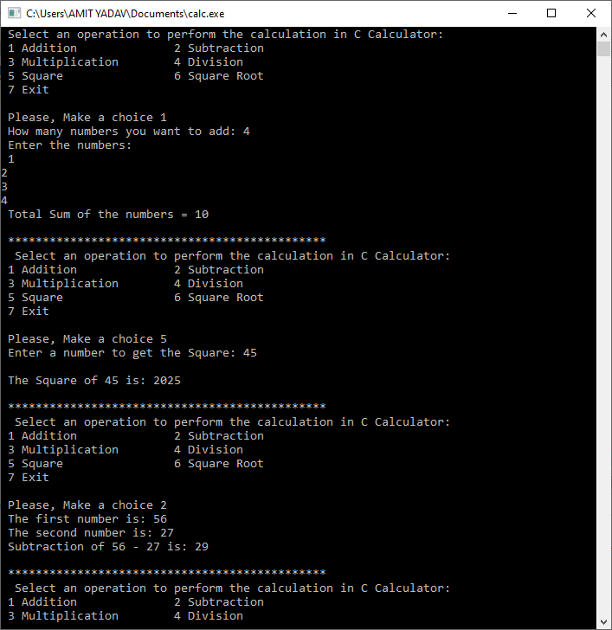

Calloc in C
This topic will discuss how to create dynamic memory allocation using the calloc() function in the C programming language. Before going through the concepts, let's discuss the dynamic memory allocation in C. Dynamic memory is a structure programming procedure that allows users to allocate the memory at the run time of a program. Using dynamic memory allocation, we can increase or decrease the memory during the execution of a program. In this way, it avoids the wastage of computer memory. A memory allocation is divided into two parts are malloc() and calloc() function.

A calloc() function is a predefined library function that stands for contiguous memory allocation. A calloc() function is used to create multiple blocks at the run time of a program having the same size in the memory. A calloc function is defined inside the stdlib.h header file. It has two parameters, no. of blocks and the size of each block. When the dynamic memory is allocated using the calloc() function, it returns the base address of the first block, and each block is initialized with 0. And if memory is not created, it returns a NULL pointer.
For example, suppose we want to create three blocks of memory using the calloc() function, we need to pass two parameters, a number of blocks (3) and the size of each block (int, char, float, etc.) in the byte. In this way, it creates three blocks whose size is the same inside the computer memory.
Syntax
ptr = (cast_type *) calloc ( number_of_blocks, size_of_block);
In the above syntax, the calloc() function has two parameters. The first parameter defines the number of blocks and the second parameter defines the size of each block in memory. The size of the blocks and cast_type can be in int, char, float, etc.
Return: It returns the base address of the first block to the ptr variable.
Program to check dynamic memory is allocated using calloc() function
Let's write a simple program to check whether the dynamic memory is allocated in C.
program.c
#include <stdio.h>
#include <stdlib.h>
int main()
{
int *ptr;
/* use calloc() function to define the no. of blocks and size of each blocks. */
ptr = calloc (4, sizeof(int)); // here 4 is the no. of block and int is the size of block
if (ptr != NULL)
{
printf (" Memory is created successfully \n");
}
else
printf (" Memory is not created ");
return 0;
}
Output:
Memory is created successfully
Program to demonstrate the use of the calloc() function
Let's consider creating dynamic memory allocation using calloc() function and storing data into the memory blocks.
Program2.c
#include <stdio.h>
#include <conio.h>
#include <stdlib.h>

void main()
{
int n, *ptr, *p, i, sum = 0;
/* n = number of elements, *ptr = store base address of the dynamic memory,
*p store temporary address of the *ptr */
printf (" Enter the number of elements: ");
scanf (" %d", &n); // it takes number of elements

// use calloc syntax to create memory block of int data type
ptr = (int *) calloc (n, sizeof(int));
p = ptr; // assign the address of ptr
if (ptr == NULL) // it checks whether the memory is allocated
{
printf (" Memory is not allocated. ");
exit(0); // exit from the program
}
printf (" Enter %d numbers \n", n);
for ( i = 1; i <= n; i++)
{
scanf ( "%d", ptr);
sum = sum + *ptr;
ptr++;
}

printf (" Elements are: ");
for (i = 1; i <= n; i++)
{
printf (" %d", *p);
p++;
}
printf (" \n The addition of the elements is: %d ", sum);
getch();
}
Output:
Enter the number of elements: 5
Enter 5 numbers
1
2
3
4
5
Elements are: 1 2 3 4 5
The addition of the elements is: 15
Program to release dynamic memory allocation using free() function
free() function: A free() function is used to release the dynamic memory which is created either calloc() or malloc() function. These allocated memories cannot be freed to their own, and they will exist till the end of the program. So, it is our responsibility to release that memory that can be reused, and hence we explicitly use the free() function to release the memory.
Syntax
free (ptr);
Here free() is a function that releases the allocated memory using the pointer ptr variable.
Let's consider creating dynamic memory allocation using the calloc() function and then releasing occupied space using the free() function in the C program.
Release.c
#include <stdio.h>
#include <conio.h>
#include <stdlib.h>

void main()
{
int n, *ptr, *p, i, sum = 0;
printf (" Define the number of elements to be entered: ");
scanf (" %d", &n);

// use calloc syntax to create memory block of int data type
ptr = (int *) calloc (n, sizeof(int));
p = ptr; // store the base address in p
if (ptr == NULL)
{
printf (" Out of memory ");
exit(0);
}
printf (" Enter the elements \n", n);
for ( i = 1; i <= n; i++)
{
scanf ( "%d", ptr);
sum = sum + *ptr;
ptr++;
}

printf (" Elements are: ");
for (i = 1; i <= n; i++)
{
printf (" %d", *p);
p++;
}
printf (" \n The addition of the elements is: %d ", sum);
free(ptr); /* Use free() function to release the dynamic memory allocation */
getch();
}
Output:
Define the number of elements to be entered: 6
Enter the elements
2
4
6
8
10
12
Elements are: 2 4 6 8 10 12
The addition of the elements is: 42

Difference between the user-defined and the library function in C
This topic will discuss the difference between the user-defined and the library function in the C programming language. Before going to the topic, let's understand the function in the C language. A function is a self-contained group of subprograms used to perform some specific, well-defined task. The functions are divided into two parts: the user-defined and the library function.
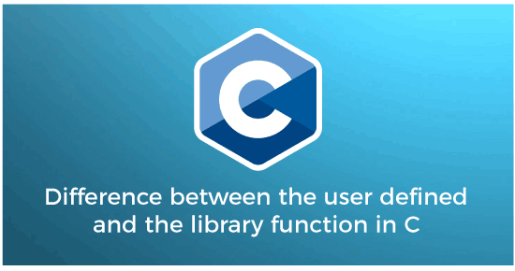
User- defined Function
As the name suggests, a user-defined function is a function written by the user to write any program code and execute specific actions. These user-defined functions can be modified and execute according to the requirement of the programmer. A programmer can change the user-defined function, but these functions are not defined in the C header files. A user-defined function is made up using the function declaration, function definition, and the function call.
Function Definition
The function definition defines the actual body of the function that perform some specific tasks in a program.
Syntax:
return_type function_name ( data_type arg1, data_type arg2, ... ) {
// define the variables
statement to be executed;
return (expr);
}
Here return type represents the function that can return any defined data type values. The return type value can be int, float, char, double, etc., where the function_name represents the name of a function that contains more than one argument in it.
Function Calling
After defining the function definition, we need to call the defined function in a program to execute its tasks. However, a function can be called multiple times by writing the function name followed by arguments lists.
Syntax:
function_name(arg1, arg2, ...)
Here, arg1, arg2 are the actual arguments passed to the function_name.
Function Declaration
The function declaration defines the function name, return type and the passed arguments in it. A function definition is always defined outside of the main() function in any C program.
Syntax:
return_type function_name ( data_type arg1, data_type arg2, ..) ;
Program to calculate the area of circle using user-defined function in C
Area.c
#include <stdio.h>
int func(int rad);
int main()
{
int r, result;

printf(" Enter the radius of a circle ");
scanf("%d", &r);
result = func(r);
printf (" The area of a circle is: %d", result);
return 0;
}
int func(int rad)
{
int area;
float pi = 3.14;
area = pi * rad * rad;
return area;
}
Output:
Enter the radius of a circle: 5
The area of a circle is: 78
Program to sum two numbers using user defined function in C
Add.c
#include <stdio.h>
int sum_numbers(int x, int y); // function prototype
int main()
{

int sum; // store the result
int num1, num2; // declare variables
printf(" Enter two numbers \n");
scanf("%d %d", &num1, &num2);

sum = sum_numbers(num1, num2); // function call
printf( " The addition of two numbers is %d", sum);
return 0;
}
int sum_numbers(int x, int y) // pass x and y as the parameters
{
int result;
result = x + y; //add two numbers
return result;
}
Output:
Enter two numbers
5
6
The addition of two numbers is 11
Library Function
C programming language provides some library functions to perform some predefined tasks. These functions are also called the built-in or predefined function in the C header files whose meaning cannot change. When we use these functions on any program, we call the function name with appropriate header files because these functions are defined inside the header files. In other words, we did not require to write the complete code to perform a specific task; instead, we can directly call the function in our program whenever it is required. For example: printf(), scanf(), getch(), etc., are the predefined library functions.
Program to demonstrate the library function in C
Built.c
#include <stdio.h>
#include <conio.h>
void main()
{
// use printf() function to print the statement
printf (" Welcome to the JavaTpoint ");
printf (" \n It is a library function in the C program. ");
getch(); // It holds the console screen
}
Output:
Welcome to the JavaTpoint
It is a library function in the C program
In the above program, we use a printf() and getch() built-in function whose meaning or tasks are already defined in the C compiler. Therefore, we did not require to write complete code to use the printf() and getch() function in the C program.
Difference between the user-defined and the library function in C
S.No | User defined Function | Library function
1. | A programmer creates a function according to the requirement of a program, which is called a user-defined function. | A function whose prototypes are already defined in the C library is called the library function.
2. | A user-defined function is required to write the complete code before using the function in a program. | We don't require writing a complete code to use the library function in a program.
3. | The name of any user-defined function can change easily. | We can't change or modify the name of the library function because the functionality of these functions is already defined in the compiler.
4. | A user defined function is not compulsory to use in any C program. | We need to use the library function in every C program.
5. | A user-defined function does not require writing any code inside the header files.  For example: swap() function does not require any header file. | All the library functions are predefined inside the header files.  For example: printf(), and scanf() function are defined in the stdio.h header file. And the strpcy(), strcmp() function are defined in the string.h header file.
6. | A user-defined function is part of a program. | Library functions are part of the C header file.
7. | The programmer or user define the function at the time of writing the code. | The developer in the C compiler predefines the library function.
8. | Example: multiply(), sum() divide(), etc. are the user defined or user created function in a program. | Example: printf(), sqrt(), strcpy(), etc.

Memset C
More than a third word of the alphabet, C is a strictly compiled programming language that forms the base of all other languages in the programming world today. In other words, the programs written in C run only after being compiled. C is constrained to certain parameters or functions but contains some different functions that serve some specific purpose. In this article, you would be learning about memset() in C and other factors and use cases associated with it.
What is memset()?
The function memset("memory setter") is a standard library function in C language that sets or fills a memory block semantically with a value.
For instance, consider that you have an array of 8 characters consuming 8 bytes of memory when this array is declared, your computer chunks off 8 bytes of memory on the heap available in your system. This memory allocation is not random. Randomization occurs only when the process like Address Space Layout Randomization occurs for some exemplary purposes or, hexadecimal allocation of address in the range of 0x00 to 0x07. Consider you declare an array of array of 8 characters as shown.
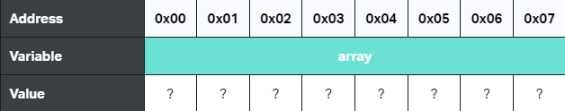
char array[8];

Initially, you are completely unaware of the contents of this block memory taken by the array without initializing the array. Although it can be nothing but can be an old value that you might have used in the previous programs, or the block in the memory might be undefined.
In general, and to keep up with good practices while working with C, it is best to gain full control over any memory used in any given program. Therefore, instead of leaving these 8 bytes of memory vacant, you must always set or fill the memory with a known or given value along with a null byte (\0). In this way, you can ensure full control of the memory block consumed by the array defined by you. See the image below to get a visual of what is being discussed.
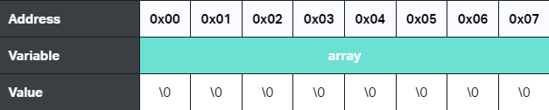
In other words, all you want is to memset the functional blocks of memory. The memset() takes the following parameters. The function accepts three parameters, a pointer to the block of memory and an integer followed by a size_t which is nothing but an unsigned integer variable designed to hold any index of an array.
void *s, int c, size_t
The first parameter represents a pointer of type void since the memory block is initially empty or about to be filled. The type void signifies the pointer can reference the memory regardless of type.
The second parameter is the integer to fill with the pointer allocation. Note that this parameter is received as an integer argument that later gets converted to the character when memory filling is required. This conversion ensures that functions keep only 8 bits needed from the integer parameter. Else it might consume more memory than needed.
The third parameter represents the given size of the memory block that has to be filled. When the pointer references the memory location to fill this space, it tells nothing about how much memory it should fill. Therefore, the main purpose of passing this parameter is to ensure proper and positive size so that memory allocation doesn't suffer memory loss.
Return value of memset()
The default return value of memset() is void * (pointer with no return type). You might receive nothing back from the memset() if you expect to get what you gave to these functions. You might only expect to get some output after the function turns around and returns a pointer with the same memory address passed when you try to call the memset function.
How to use memset()?
To use memset() in your program, the first thing you need to do is to include the string header file in your program, as shown below.
#include <string.h>
Once the string library of C is included in your program, you need nothing more. You can easily access the memset function directly. To make it clearer and easy, consider the below code snippet containing two other libraries like <stdio.h> and <stdlib.h> (for the usage of exit and printf purposes).
#include <stdio.h>
#include <stdlib.h>
#include <string.h>

int main(void)
{
char memory[8];

/* Fill the memory block with null bytes */
memset(memory, '\0', 8);
printf("%s\
", memory);

/* Fill the memory block with hashes */
memset(memory, '#', 8);
printf("%s\
", memory);

/* Fill the memory block with dollar signs */
memset(memory, '$', 8);
printf("%s\
", memory);

return (EXIT_SUCCESS);
}
When is memset() used?
As previously discussed, while programming in C, it is always a best practice to have tight control and maintenance of memory while allocating memory and initializing it. In case you don't initialize immediately, other dedicated functions like strcpy might come into use. Proper usage of strcpy involves a new block memory allocation method where a copy of a string is kept aside before actually using it. Since it is not initialized, it might need to be declared first before actually using strcpy. In such cases, memset() is very suitable to fill the block or clear them out initially. Consider the example given below to understand why is memset() used.
#include <stdio.h>
#include <stdlib.h>
#include <string.h>

int main(void)
{
char src[7] = "Source";
char dest[7];

/* Initialize dest with null bytes for good practice */
memset(dest, '\0', sizeof(dest));

/* Before copying */
printf("String src before copy: %s\
", src);
printf("String dest before copy: %s\
", dest);

/* Copy src into dest */
strcpy(dest, src);

/* After copying */
printf("String src after copy: %s\
", src);
printf("String dest after copy: %s\
", dest);

return (EXIT_SUCCESS);
}
In general, memset() is a great tool to be considered while working with C and memory allocation methods. In simple words, if you can't initialize it, memset it.
Applications of memset()
So far, you have to see all the relevant examples and use cases for a particular memset() instance. But, to understand better, you need to look at multiple examples that will be discussed as an application of memset. Consider the below examples that describes its applications.
Example 1
#include <stdio.h>
#include <string.h>

int main() {
char a[] = {"Hello from JournalDev"};

printf("a = %s\n", a);

printf("Filling the first 5 characters a with 'H' using memset\n");

memset(a, 'H', 5 * sizeof(char));

printf("After memset, a = %s\n", a);

return 0;
}
Output:
a = Hello from JournalDev
Filling the first five characters a with 'H' using memset
After memset, a = HHHHH from JournalDev
It is quite clear from the previous as well as this example how memset() handles initialization. In the code given above, you can see how memset acts with the variable defining the size of the character array or string. After using the memset() function, you see five repeated characters of H from the given string.
Example 2
#include <stdio.h>
#include <string.h>

int main() {
char a[] = {"Hello from JournalDev"};

printf("a = %s\n", a);

printf("Filling the last 5 characters a with 'H' using memset\n");

size_t a_len = strlen(a);

//Using an offset of (a + a_len - 5), so that we can
//fill the last 5 characters
memset(a + (a_len - 5), 'H', 5 * sizeof(char));

printf("After memset, a = %s\n", a);

return 0;
}
Output:
a = Hello from JournalDev
Filling the last five characters a with 'H' using memset
After memset, a = Hello from JournHHHHH
This example is similar to the previous one with a catchy hook. It is important to understand the variations of the same programs with different usage techniques of memset(). In the above example, you can see that only the offset location is being filled. In this example, the only difference is the last five characters filled with H since you can see that the memory location or initialization of address has already been done.
Memset() vs calloc() vs naive iteration
There are times when you can opt to use memset() to zero for array initialization. Often, there exists some performance issues of other functions like naive approaches or using calloc() function. There are also some speed issues and memory allocation techniques that are hard to understand and implement. To understand how memset solves these kinds of problems, see the below example code to find why memset() is beneficial to use and how both memset() and calloc() can run on a Linux machine using the <time.h> header file.
#include <stdio.h>
#include <stdlib.h>
#include <string.h>
#include <time.h>

void* init_with_memset(int* arr, size_t num_locations) {
// Perform zero initialization with memset
// on an integer array
return memset(arr, 0, num_locations * sizeof(int));
}

void* init_with_calloc(int* arr, size_t num_locations) {
arr = calloc(num_locations, sizeof(int));
return arr;
}

void* init_with_iteration(int* arr, size_t num_locations) {
// Naive unoptimized iteration using array indexing
for (int i=0; i<num_locations; i++) {
arr[i] = 0;
}
return arr;
}

int main() {
// Set the array to -1 initially
int arr[2560];
for (int i=0; i<2560; i++)
arr[i] = -1;

clock_t start_time, end_time;
double total_time;

start_time = clock();
// 1000 locations
init_with_memset(arr, 1000);
end_time = clock();
total_time = (double) (end_time - start_time);
total_time = total_time / CLOCKS_PER_SEC;
printf("Time for memset() = %.6f seconds\n", total_time);

start_time = clock();
// 1000 locations
init_with_calloc(arr, 1000);
end_time = clock();
total_time = (double) (end_time - start_time);
total_time = total_time / CLOCKS_PER_SEC;
printf("Time for calloc() = %.6f seconds\n", total_time);

start_time = clock();
// 1000 locations
init_with_iteration(arr, 1000);
end_time = clock();
total_time = (double) (end_time - start_time);
total_time = total_time / CLOCKS_PER_SEC;
printf("Time for naive iteration = %.6f seconds\n", total_time);

return 0;
}
Output:
Time for memset() = 0.000002 seconds
Time for calloc() = 0.000005 seconds
Time for naive iteration = 0.000006 seconds
In the above example, you can easily observe and understand that memset() is thrice as fast as both the native iteration and calloc(). It is so fast because it is already optimized based on the architecture provided by the C compiler, the speed is automatically enhanced.
Conclusion
As popularly said, when you don't initialize, memset it. This proverb usually talks about the advantage of memset over other approaches like calloc() or native iteration. In this article, you saw how to deal with such issues while initializing an array when the space is vacant or unused. The problems and solutions you find in this article tell you how memset can be an important aspect while dealing with memory allocation with a programming language like C.

ASCII Table in C
This topic will discuss the ASCII codes and how to write a program to print an ASCII table in the C programming language. ASCII stands for American Standard Code for Information Interchange. ASCII code is a character encoding scheme used to define the value of basic character elements for exchanging information in computers and other electronic devices.

Furthermore, the ASCII code is a collection of 255 symbols in the character set, divided into two parts, the standard ASCII code, and the extended ASCII code. The standard ASCII code ranges from 0 to 127, 7 bits long, and the extended ASCII code from 128 to 255 is 8 bits long. These characters are a combination of symbol letters (uppercase and lowercase (a-z, AZ), digits (0-9), special characters (!, @, #, $, etc.), punctuation marks, and control characters. Hence, we can say, each character has its own ASCII value.
For example, when we enter a string as "HELLO", the computer machine does not directly store the string we entered. Instead, the system stores the strings in their equivalent ASCII value, such as '7269767679'. The ASCII value of H is 72, E is 69, L is 76, and O is 79.
Program to get the ASCII value of the capital letters
Program.c
#include <stdio.h>
int main()
{
// declare local variable
int caps;
// use for loop to print the capital letter from A to Z
for ( caps = 65; caps < 91; caps++)
{
printf (" \n The ASCII value of %c is %d ", caps, caps);
}
return 0;
}
Output
The ASCII value of A is 65
The ASCII value of B is 66
The ASCII value of C is 67
The ASCII value of D is 68
The ASCII value of E is 69
The ASCII value of F is 70
The ASCII value of G is 71
The ASCII value of H is 72
The ASCII value of I is 73
The ASCII value of J is 74
The ASCII value of K is 75
The ASCII value of L is 76
The ASCII value of M is 77
The ASCII value of N is 78
The ASCII value of O is 79
The ASCII value of P is 80
The ASCII value of Q is 81
The ASCII value of R is 82
The ASCII value of S is 83
The ASCII value of T is 84
The ASCII value of U is 85
The ASCII value of V is 86
The ASCII value of W is 87
The ASCII value of X is 88
The ASCII value of Y is 89
The ASCII value of Z is 90
Program to get the ASCII value of the small letters
Program2.c
#include <stdio.h>
int main()
{
// declare local variable
int small;
// use for loop to print the small alphabets letter from a to z
for ( small = 97; small < 123; small++)
{
// display ASCII values to its equivalent characters
printf (" \n The ASCII value of %c is %d ", small, small);
}
return 0;
}
Output
The ASCII value of a is 97
The ASCII value of b is 98
The ASCII value of c is 99
The ASCII value of d is 100
The ASCII value of e is 101
The ASCII value of f is 102
The ASCII value of g is 103
The ASCII value of h is 104
The ASCII value of i is 105
The ASCII value of j is 106
The ASCII value of k is 107
The ASCII value of l is 108
The ASCII value of m is 109
The ASCII value of n is 110
The ASCII value of o is 111
The ASCII value of p is 112
The ASCII value of q is 113
The ASCII value of r is 114
The ASCII value of s is 115
The ASCII value of t is 116
The ASCII value of u is 117
The ASCII value of v is 118
The ASCII value of w is 119
The ASCII value of x is 120
The ASCII value of y is 121
The ASCII value of z is 122
Program to get the ASCII value of the given characters
Program3.c
#include <stdio.h>
int main()
{

char arr[30]; // declare the size of character array
int count = 0; // declare a count variable

// enter any name to get the ascii codes
printf (" \n Enter the name to get the ASCII codes: ");
scanf (" %s", &arr);

// use while loop to sequentially iterate every characters of the array
while (arr[count] != '\0')
{
// display the character name one by one
printf (" \n The ascii code of the character %c is %d ", arr[count], arr[count]);
count++; // increment one by one
}
return 0;
}
Output
Enter the name to get the ASCII codes: JAVATPOINT

The ASCII code of the character J is 74
The ASCII code of the character A is 65
The ASCII code of the character V is 86
The ASCII code of the character A is 65
The ASCII code of the character T is 84
The ASCII code of the character P is 80
The ASCII code of the character O is 79
The ASCII code of the character I is 73
The ASCII code of the character N is 78
The ASCII code of the character T is 84
Program to get the ASCII value of the special characters
Program4.c
#include <stdio.h>
int main()
{
// declare a variable
int specialCh;

for (specialCh = 33; specialCh < 48; specialCh++)
{
printf (" \n The ASCII value of '%c' special character is: %d", specialCh, specialCh);

}

for (specialCh = 58; specialCh < 65; specialCh++)
{
printf (" \n The ASCII value of '%c' special character is: %d", specialCh, specialCh);

}

for (specialCh = 123; specialCh < 127; specialCh++)
{
printf (" \n The ASCII value of '%c' special character is: %d", specialCh, specialCh);

}
return 0;
}
Output
The ASCII value of '!' special character is: 33
The ASCII value of '"' special character is: 34
The ASCII value of '#' special character is: 35
The ASCII value of '$' special character is: 36
The ASCII value of '%' special character is: 37
The ASCII value of '&' special character is: 38
The ASCII value of ''' special character is: 39
The ASCII value of '(' special character is: 40
The ASCII value of ')' special character is: 41
The ASCII value of '*' special character is: 42
The ASCII value of '+' special character is: 43
The ASCII value of ',' special character is: 44
The ASCII value of '-' special character is: 45
The ASCII value of '.' special character is: 46
The ASCII value of '/' special character is: 47
The ASCII value of ':' special character is: 58
The ASCII value of ';' special character is: 59
The ASCII value of '<' special character is: 60
The ASCII value of '=' special character is: 61
The ASCII value of '>' special character is: 62
The ASCII value of '?' special character is: 63
The ASCII value of '@' special character is: 64
The ASCII value of '{' special character is: 123
The ASCII value of '|' special character is: 124
The ASCII value of '}' special character is: 125
The ASCII value of '~' special character is: 126
Program to print the complete ASCII tables in C
Program6.c
#include <stdio.h>
int main()
{
// declare a variable
int asciTable;
printf (" The complete ASCII table of the characters in the C ");
for (asciTable = 0; asciTable < 255; asciTable++)
{
printf (" \n The value of '%c' character is: %d", asciTable, asciTable);

}
return 0;
}
Output
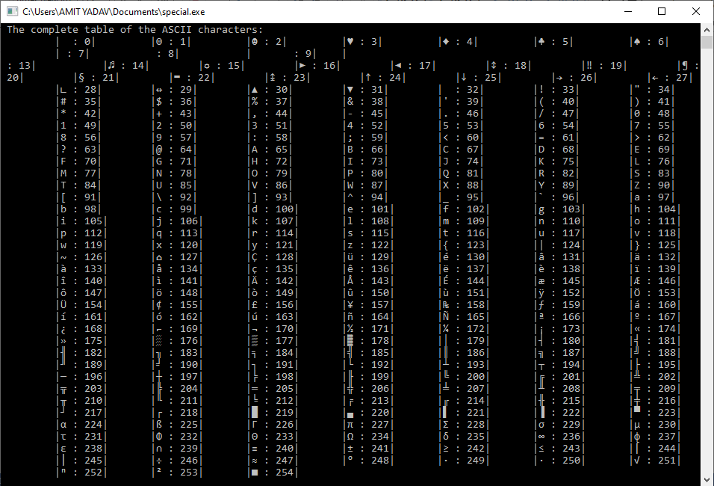

Static function in C
In this topic, we will discuss the static function in the C programming language. By default, every function is declared as global that can be accessed anywhere inside a program. The static keyword is used before the function's name to make any function as the static function. And the scope of the static function in C is limited to its object files or only a program. It means that the static function is only visible to its program files and restricts other files or programs from accessing the static function.
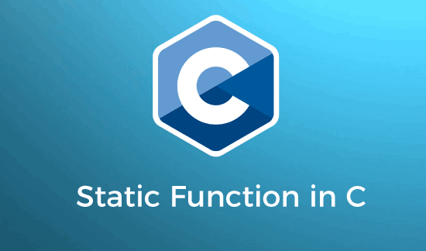
Syntax
<function data_type> static <function_ name> ( ){}
or
static int function_name ()
{
// define the statement to be executed
}
Here, we use a static keyword before the function_name to make the given function th static.
Some important points of static function
- A static keyword can be used before the name of a function to make it static.
- However, the scope of the static function is throughout the program only. It means the static function can be called inside the same program or file.
- If we try to access the static function from another file, it throws an error.
- We can make a global function as the static by adding the static before the function name of a program.
Program to call a global function inside another file
In this program, we need to create two files, file1.c and file2.c. Now, we create a global function inside the file1.c, as shown below.
File1.c
int add(int x, int y) // this function is called to the file2.c
{
int sum; // declare the sum variable
sum = x + y; // store the sum of two number in sum
return sum;
}
After defining the global function in the file1.c file, now we create another file file2.c and then call the global function add() in it.
File2.c
#include <stdio.h>
#include <stdlib.h>
#include "file1.c" // file1.c is use as a refernce file
int add(int x, int y); // define the global function
int main()
{
int n1, n2, res; // define local variables
printf (" Enter any two numbers: ");
scanf ("%d %d", &n1, &n2); // accepts two numbers

res = add(n1, n2); // call global function from "file1.c"
printf (" The sum of the two numbers is: %d", res);
return 0;
}
Output
Enter any two numbers: 5
20
The sum of the two numbers is: 25
As we can see in the above program, we create two files, file1.c and file2.c. In file1.c, we define a global function add() that is called inside the file2.c. And in file2.c, file1.c will be treated as the reference file that contains the definition of the global function and is called inside the main() function to return the sum of two integer numbers.
Program to call a static function inside another file
Let's create a program to make a global function as a static function by adding the static keyword before the function and then call in file2.c.
File1.c
static void add(void) // It is a static function
{
printf (" I am a static function");
}
Now we create another file with name file2.c and call the static function to check its scope.
File2.c
#include <stdio.h>
#include <stdlib.h>

int main()
{
printf(" I am a main() function.");
myFun(); // call static function
return 0;
}
Output
Undefined reference to myFun() function.
When we compiled the above program, it throws an error as "undefined reference to myFun(). Because of the static function myFun(), its object files can only access, and it does not allow other functions to access the static function.
Program to call a static function in same object file or function
Let's create a program to demonstrate the use of the static function in C.
File1.c
#include <stdio.h>
#include <stdlib.h>

// define the static function
static int mySqr( int num)
{
return num * num;
}

int main()
{
int n1, res;
printf (" Enter an integer number: ");
scanf ("%d", &n1);
res = mySqr(n1); // call static function
printf(" The square of the %d is %d.", n1, res);
return 0;
}
Output
Enter an integer number: 25
The square of the 25 is 625
In the above program, we create a static function inside the same object file File1.c. In File1.c, the main() function calls the static function mySqr() to return the square of the given number. The static function works correctly as the scope of the static function is only within its object file or program.
Program to call multiple static function in same file
Let's create a program to create multiple static function and call inside the main() function.
Program.c
#include <stdio.h>
#include <stdlib.h>
#include <math.h>

// define the static function
static int mySqr( int num)
{
return num * num;
}

static void myfun2(void)
{
printf ("\n I am inside the static function.");
}

static int myFun3(int num2)
{
return sqrt(num2);
}
int main()
{
int n1, res;
printf (" Enter an integer number: ");
scanf ("%d", &n1);
res = mySqr(n1); // call static function
printf(" The square of the %d is %d", n1, res);
myfun2(); // call static function
res = myFun3(n1);
printf(" \n The square root of the %d is %d", n1, res);
return 0;
}
Output
Enter an integer number: 36
The square of the 36 is 1296
I am inside the static function.
The square root of the 36 is 6
In the above program, we create multiple static functions in the same object file, and each static function is called inside the main() function to return the value.

Reverse a String in C
This topic will discuss several ways to reverse a string in the C programming language. Reversing a string is the technique that reverses or changes the order of a given string so that the last character of the string becomes the first character of the string and so on. Furthermore, we can also check the Palindrome of the given string by reversing the original string.
For example, we enter a string "APPLE", and then use the reverse algorithm. The reverse algorithm returns the string "ELPPA" which is completely reverse of the original string.
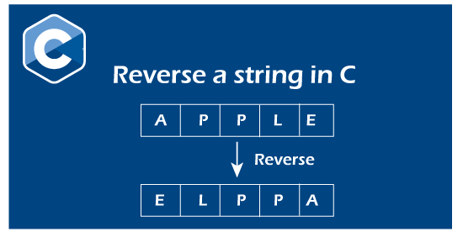
Different ways to find the reverse of a string in the C
Following are the various ways to find the reverse of a string in the C programming language:
- Reverse a string using the strrev() function
- Reverse a string without using the library function
- Reverse a string using the recursion function
- Reverse a string using for loop
- Reverse a string using while loop
- Reverse a string using pointers
- Reverse a string to check for Palindrome

Program 1: Print the reverse of a string using strrev() function
Let's consider an example to print the reverse of a string using the strrev() function.
Program1.c
#include <stdio.h>
#include <string.h>
int main()
{
char str[40]; // declare the size of character string
printf (" \n Enter a string to be reversed: ");
scanf ("%s", str);

// use strrev() function to reverse a string
printf (" \n After the reverse of a string: %s ", strrev(str));
return 0;
}
Output
Enter a string to be reversed: AMBULANCE
After the reverse of a string: ECNALUBMA
Program 2: Print the reverse of a string without using the library function
Let's consider an example to print the reverse of a string using user defined function.
Program2.c
#include <stdio.h>
#include <string.h>

// function definition of the revstr()
void revstr(char *str1)
{
// declare variable
int i, len, temp;
len = strlen(str1); // use strlen() to get the length of str string

// use for loop to iterate the string
for (i = 0; i < len/2; i++)
{
// temp variable use to temporary hold the string
temp = str1[i];
str1[i] = str1[len - i - 1];
str1[len - i - 1] = temp;
}
}

int main()
{
char str[50]; // size of char string
printf (" Enter the string: ");
gets(str); // use gets() function to take string

printf (" \n Before reversing the string: %s \n", str);

// call revstr() function
revstr(str);
printf (" After reversing the string: %s", str);
}
Output
Enter the string: Welcome Friends

Before reversing the string: Welcome Friends
After reversing the string: sdneirF emocleW
Program 3: Print the reverse of a string using the recursion function
Let's consider an example to print the reverse of a string using the recursion function.
Recursion function: A recursion function is a function that continuously calls the same function without using a looping statement.
Program3.c
#include <stdio.h>
#include <string.h>

// use recursion function
void revstr(char *str1)
{
// declare static variable
static int i, len, temp;
len = strlen(str1); // use strlen() to get the length of str string

if (i < len/2){
// temp variable use to temporary hold the string
temp = str1[i];
str1[i] = str1[len - i - 1];
str1[len - i - 1] = temp;
i++;
revstr(str1); // recusively calls the revstr() function
}
}

int main()
{
char str1[50]; // size of char string
printf (" Enter the string: ");
gets(str1); // use gets() function to take string

printf (" \n Before reversing the string: %s \n", str1);

// call revstr() function
revstr(str1);
printf (" After reversing the string: %s", str1);
}
Output
Enter the string: LIFE INSURANCE

Before reversing the string: LIFE INSURANCE
After reversing the string: ECNARUSNI EFIL
Program 4: Print the reverse of a string using for loop
Let's consider an example to print the reverse of a string using for loop in C programming language.
Program4.c
#include <stdio.h>
#include <conio.h>
#include <string.h>
void main()
{
char str[50], temp; // define the size of str[] array
int i, left, right, len;
printf (" \n Display a reverse string in the C: \n");
printf (" ----------------------- ");
printf (" \n Enter a string to reverse order: ");
scanf( "%s", &str);
len = strlen(str); // get the length of the string
left = 0; // set left index at 0
right = len - 1; // set right index len - 1
// use for loop to store the reverse string
for (i = left; i <right; i++)
{
temp = str[i];
str[i] = str[right];
str[right] = temp;
right--;
}
printf (" The reverse of the original string is: %s ", str);
getch();
}
Output
Display a reverse string in the C:
-----------------------
Enter a string to reverse order: APPLE
The reverse of the original string is: ELPPA
Program 5: Print the reverse of a string using while loop
Let's consider an example to print the reverse of a string using while loop in C programming language.
Program5.c
#include <stdio.h>
#include <string.h>
int main()
{
char str1[50], temp; // declare and initialize the size of string array.
int i = 0, j =0;
printf (" Enter a string to be reversed: ");
scanf( "%s", str1);
j = strlen (str1) - 1; // get the length of the string
// use while loop to define the condition
while ( i < j)
{
// use temp variable to store the characters of str1
temp = str1[j];
str1[j] = str1[i];
str1[i] = temp;
i++; // i incremented by 1
j--; // j is decremented by 1
}
printf (" The reversed of the string: %s", str1);
return 0;
}
Output
Enter a string to be reversed: JAVATPOINT
The reversed of the string: TNIOPTAVAJ
Program 6: Print the reverse of a string using pointers
Let's consider an example to print the reverse of a string using pointers in the C programming language.
Program6.c
#include <stdio.h>
#include <string.h>

int str_len( char *st);
void revstr( char *st);
int main()
{
char st[50];
printf (" Enter a string to be reversed: ");
scanf( "%s", st);

revstr(st);

printf (" The reverse string is: %s", st);
return 0;
}

void revstr (char *st)
{
int len, i;
char *start, *end, temp;

len = str_len (st);
start = st;
end = st;

for (i = 0; i < len - 1; i++)
end++;

for (i = 0; i < len/2; i++)
{
temp = *end;
*end = *start;
*start = temp;

start++;
end--;
}
}

int str_len (char *ptr)
{
int i = 0;
while ( *(ptr + i) != '\0')
i++;
return i;
}
Output
Enter a string to be reversed: JAVATPOINT
The reverse string is: TNIOPTAVAJ
Program 7: Program to check whether the reverse string is a Palindrome
Consider a program to check whether the given string is a palindrome or not in the C programming language.
Program7.c
#include <stdio.h>
#include <string.h>
int main ()
{
// declare variables
char str1[30];
int i, len, flag = 0;

printf (" Enter a string: ");
scanf ("%s", str1);
len = strlen( str1 ); // get the string length

for ( i = 0; i < len; i++)
{
// str1[i] is not equal to str1[len-i-1]
if (str1[i] != str1[len - i - 1])
{
flag = 1;
break; // exit from if statement
}
}
if (flag)
{
printf (" %s is not a palindrome string", str1);
}
else
{
printf (" %s is a palindrome", str1);
}
return 0;
}
Output
Enter a string: madam
madam is a palindrome string.

Twin Prime Numbers in C
This topic will discuss twin primes and how we can print twin primes in the C programming language. A twin prime is a pair of prime numbers representing the difference of two prime numbers always 2 and is therefore called a twin prime. In simple words, if the difference between two prime numbers is 2 and there is exactly one composite number between them, then the number is called twin prime numbers.
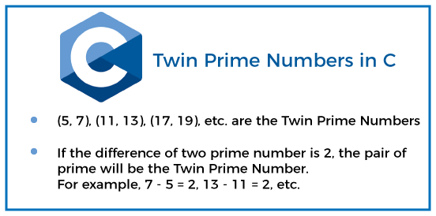
For example, (59, 61) and (71, 73) are twin prime pairs, and the difference between these numbers is 61 - 59 = 2, and 73 - 71 = 2.
Properties of the twin prime number
- (2, 3) are not considered twin primes because there is no composite number between them, and neither is the difference of two prime numbers (2, 3) is equal to 2.
- (3, 5) is a pair of twin primes because the difference of two primes (5 - 3 = 2) is 2 and hence (3, 5) is a twin prime.
- Every twin other than (3, 5) is in the form of a prime number (6n - 1, 6n + 1), where n defines the natural number.
- 5 is the only prime number in which the difference between both positive and negative primes is 5. So, 5 appears in two prime pairs (3, 5) and (5, 7).
- If we add two pairs of twin prime numbers, the result of twin primes will be divisible by 12, except for (3, 5) pairs of twin prime numbers.
Program to print twin primes from 2 to n using user defined function
Create a program in C programming language to generate twin prime number between 2 to n.
Program1.c
#include <stdio.h>
#include <conio.h>
int main ()
{
// declare variables
int i, num, count = 0;
printf (" Enter the last number: ");
scanf (" %d", &num); // get the last number

for (i = 2; i <= num; i++)
{
if (twinprime (i) && twinprime (i+2))
{
printf (" \n The twin prime number is: (%d, %d) ", i, i+2);
count++; // counter increment by 1
}
}
printf (" \n \n Total number of twin prime pairs: %d", count);
return 0;
}
// function definition
int twinprime( int n)
{
int i = 2;
// use for loop to find the twin prime
for (i = 2; i <= n/2; i++)
{
// if n is completely divisible by 1 without leaving any remainder, it returns 0
if (n%i == 0)
return 0;
}
// otherwise it returns 1
if (i > n / 2)
return 1;
}
Output
Enter the last number: 100
The twin prime number is: (3, 5)
The twin prime number is: (5, 7)
The twin prime number is: (11, 13)
The twin prime number is: (17, 19)
The twin prime number is: (29, 31)
The twin prime number is: (41, 43)
The twin prime number is: (59, 61)
The twin prime number is: (71, 73)
Total number of twin prime pairs: 8
In the above program, a for loop that iterates over the numbers between the specified range of 2 to 100. After that, we create a twinprime() as a user-defined function called inside the for loop to check the primes of the 'i' and 'i+2' index. And if the condition is met, it prints the total pair of twin prime and the twin prime numbers.
Program to print twin primes using the Sieve of Eratosthenes algorithm
The Sieve of Eratosthenes is an approach to get a list of all prime numbers that are less than or equal to a given number (n). It iterates the prime number up to n consecutive number and checks that both the i^{th} and (i + 2) numbers are prime, and then it prints the prime number; otherwise, it moves to the next number to get the twin primes. Here, (3, 5), (5, 7), (11, 13) are examples of the Sieve of Eratosthenes algorithm.
Let's consider an example to get the twin primes using the Sieve of Eratosthenes algorithm.
Program2.c
#include <stdio.h>
#include <string.h>
int main()
{
// declare an integer variable
int num;
printf (" Enter the last number to get twin prime numbers: ");
scanf (" %d", &num);
// call twinprime() function
twinprime( num); // pass num as an argument
return 0;
}
void twinprime (int n)
{
int j;
/* here we create a unsigned char array 'prime[]' and initialize all its entries as true. */
unsigned char prime[n + 1]; // declaration of the unsigned char prime[] array
memset (prime, 1, sizeof(prime));
// use for loop to iterate over a certain range
for ( j = 2; (j * j) <= n; j++)
{
// if the condition of prime[j] remains true, it is a prime
if (prime [j] == 1)
{
int i = 0;
// update the multiples of j
for (i = (j * 2); i <= n; i += j)
prime[i] = 0;
}
}
// now check for twin prime numbers and print the twin primes
for ( j = 2; j <= (n - 2); j++)
{
if (prime[j] && prime[j + 2])
printf (" \n The twin prime numbers: (%d, %d) ", j, j +2);
}
}
Output
Enter the last number to get twin prime numbers: 200
The twin prime numbers: (3, 5)
The twin prime numbers: (5, 7)
The twin prime numbers: (11, 13)
The twin prime numbers: (17, 19)
The twin prime numbers: (29, 31)
The twin prime numbers: (41, 43)
The twin prime numbers: (59, 61)
The twin prime numbers: (71, 73)
The twin prime numbers: (101, 103)
The twin prime numbers: (107, 109)
The twin prime numbers: (137, 139)
The twin prime numbers: (149, 151)
The twin prime numbers: (179, 181)
The twin prime numbers: (191, 193)
The twin prime numbers: (197, 199)
Program to check whether a given number is a twin prime or not
Let us consider an example of whether a given number is twin prime or not in the C programming language.
Program3.c
#include <stdio.h>
#include <string.h>
// function definition of the checktwin()
void checktwin(num1, num2)
{
// declare integer variables
int i;
// declare and initialize isprime
unsigned char isprime = 1;
// use for loop to check the prime number for the first number
for ( i = 2; i <= (num1 / 2); i++ )
{
// if num1 is completely divisible by i, the if block is executed
if (num1 % i == 0)
{
isprime = 0;
break;
}
}
/* here isprime is called and abs() function get the absolute result of num1 and num2 */
if (isprime && abs(num1 - num2) == 2)
{
// declare isprime2 as unsigned char and initialize as 1 that represents true.
unsigned char isprime2 = 1;
// use for loop to check the second number is a prime number
for ( i = 2; i <= num2 / 2; i++)
{
// it checks num2 is completely divisible by i and return 0
if (num2 % i == 0)
{
// isprime2 initialize by 0
isprime2 = 0;
break;
}
}
// check the isprime2 condition
if (isprime2)
{
printf (" %d and %d are twin prime", num1, num2);
}
else
printf (" %d and %d are not twin prime", num1, num2);
}
else
printf (" %d and %d are not twin prime number", num1, num2);
}
int main()
{
int num1, num2;
printf (" Enter the first number: ");
scanf ("%d", &num1); // get first number
printf (" Enter the second number: ");
scanf (" %d", &num2); // get second number
checktwin(num1, num2); /* call the checktwin() function and pass num1 and num2 as parameters. */
return 0;
}
Output
Enter the first number: 71
Enter the second number: 73
71 and 73 are twin prime
2nd execution:
Enter the first number: 15
Enter the second number: 17
15 and 17 are not twin prime
In the above program, we take two numbers from the user to check whether the given number is twin prime or not. Here we take 5 and 7 as the prime number, and the function returns 5 and 7 are twin prime. Similarly, we take the numbers 15 and 17, and the function returns numbers, not twin primes.

strchr() function in C
This section will discuss the strchr() function of string headers in the C programming language. An strchr() function is used to find the first occurrence of a specified character within the original string. In other words, an strchr() function checks whether the original string contains defined characters. If the character is found inside the string, it returns a pointer value; otherwise, it returns a null pointer. While using the strchr() function in the C programming language, we need to import the <string.h> header file in the program.
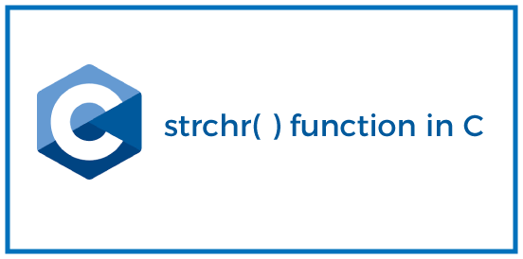
Syntax
char *strchr (const char *str, int c);
In the above syntax, an strchr() function has two parameters: str and ch.
str: A str represents the original string in which the character is to be searched.
ch: A ch is a character type variable representing a character searched in the string str.
Return value: It returns a pointer value containing the first occurrence of the character in the given string.
Program to demonstrate the use of a strchr() function
Let's consider an example to check the occurrence of a character in the given string.
Program1.c
#include <stdio.h>
#include <string.h>
int main ()
{
const char str[] = "Use strchr() function in C.";
const char ch = 's'; // it is searched in str[] array
char *ptr; // declare character pointer ptr

printf (" Original string is: %s \n", str);
// use strchr() function and pass str in which ch is to be searched
ptr = strchr( str, ch);
printf (" The first occurrence of the '%c' in '%s' string is: '%s' ", ch, str, ptr);
return 0;
}
Output
Original string is: Use strchr() function in C.
The first occurrence of the 's' in 'Use strchr() function in C.' string is: 'e strchr() function in C.'
In the above program, we pass an str parameter to the strchr() function to search for character 's', and when a character is found, it returns a pointer ptr value. A ptr variable contains a value from the specified character of the original string until the ch variable does not get a null character in the string.
Program to search a character using the strchr() function and if-else statement
Let's consider an example to get the occurrence of the first character using the strchr() function and if-else statement in a given string of the C programming language.
Program1.c
#include <stdio.h>
#include <string.h> // use string.h header file

int main ()
{

const char *s = "javatpoint"; // initialization of the constant char pointer
char ch; // declare a ch variable

printf (" Original string: \"%s\" \n ", s); // print the string

// take a character from the user
printf ("Please enter a character you want to search in the string: ");
scanf (" %c", &ch);

// it checks whether the specified character exists in the string
if ( strchr (s, ch) != NULL )
{
printf (" \n '%c' is found in \"%s\" ", ch, s);
}
// if the character is not found, the below statement is executed
else
printf (" \n '%c' is not found in \"%s\" ", ch, s);

return 0;
}
Output
Original string: "javatpoint"
Please enter a character you want to search in the string: p

'p' is found in "javatpoint"
2nd execution:
Original string: "javatpoint"
Please enter a character you want to search in the string: b

'b' is not found in "javatpoint"
In the above program, we pass a string "javatpoint" to search for a specified character. Here we take the 'p' character as input from the user and search in the string. After that, the if statement checks for the occurrence of the character using the strchr() function and prints the specified character if it exists. Otherwise, it indicates that the character is not found in the string.
Program to get the occurrence of each character in a given string
Let's consider an example to print the occurrence of each character in a given string with strchr() function and while loop of C programming language.
Program3.c
#include <stdio.h>
#include <string.h>
int main ()
{
// initialize a string
char str[] = " Welcome to the JavaTpoint site";
char *ptr; // declare a pointer variable
int i = 1; // declare and initialize i

// use strchr() function to check the occurrence of the character
ptr = strchr (str, 'e' );

// use while loop to checks ptr until it becomes null
while (ptr != NULL)
{
printf (" Given character 'e' found at position %d \n", (ptr - str + 1));
printf (" Occurrence of the character 'e' : %d \n", i);
printf (" The occurrence of the character 'e' in the string \"%s\" is \"%s\" \n \n", str, ptr);

// use strchr() function to update the position of the string
ptr = strchr (ptr + 1, 'e');
i++;
}
return 0;
}
Output
Given character 'e' found at position 3
Occurrence of the character 'e' : 1
The occurrence of the character 'e' in the string " Welcome to the JavaTpoint site" is "elcome to the JavaTpoint site"

Given character 'e' found at position 8
Occurrence of the character 'e' : 2
The occurrence of the character 'e' in the string " Welcome to the JavaTpoint site" is "e to the JavaTpoint site"

Given character 'e' found at position 15
Occurrence of the character 'e' : 3
The occurrence of the character 'e' in the string " Welcome to the JavaTpoint site" is "e JavaTpoint site"

Given character 'e' found at position 31
Occurrence of the character 'e' : 4
The occurrence of the character 'e' in the string " Welcome to the JavaTpoint site" is "e"

Structure of a C program
The structure of a C program means the specific structure to start the programming in the C language. Without a proper structure, it becomes difficult to analyze the problem and the solution. It also gives us a reference to write more complex programs.
Let's first discuss about C programming.
C programming
C language combines the power of a low-level language and a high-level language. The low-level languages are used for system programming, while the high-level languages are used for application programming. It is because such languages are flexible and easy to use. Hence, C language is a widely used computer language.
It supports various operators, constructors, data structures, and loop constructs. The features of C programming make it possible to use the language for system programming, development of interpreters, compilers, operating systems, graphics, general utilities, etc. C is also used to write other applications, such as databases, compilers, word processors, and spreadsheets.
The essential features of a C program are as follows:
Pointers: it allows reference to a memory location by the name assigned to it in a program.
Memory allocation: At the time of definition, memory is assigned to a variable name, allowing dynamic allocation of the memory. It means that the program itself can request the operating system to release memory for use at the execution time.
Recursion: When a function calls itself, it is known as recursion.
Bit-manipulation: It refers to the manipulation of data in its lowest form. It is also known as bits. The computer stores the information in binary format (0 and 1).
Let's start with the importance of specifying the structure of a C program.
Importance of structure of a C program
Sometimes, when we begin with a new programming language, we are not aware about the basic structure of a program. The sections of a program usually get shuffled and the chance of omission of error rises. The structure of a language gives us a basic idea of the order of the sections in a program. We get to know when and where to use a particular statement, variable, function, curly braces, parentheses, etc. It also increases our interest in that programming language.
Thus, the structure helps us analyze the format to write a program for the least errors. It gives better clarity and the concept of a program.
Here, we will discuss the sections of a C program, some practical examples with explanations, steps to compile and execute a C program.
Let's start.
Sections of a C program
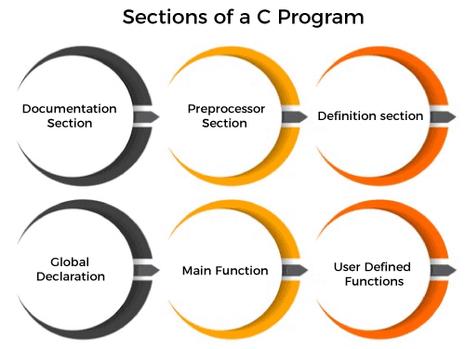
The sections of a C program are listed below:
- Documentation section
- Preprocessor section
- Definition section
- Global declaration
- Main function
- User defined functions
Let's discuss it in detail.
Documentation section
It includes the statement specified at the beginning of a program, such as a program's name, date, description, and title. It is represented as:
//name of a program
Or
/*
Overview of the code
.
*/
Both methods work as the document section in a program. It provides an overview of the program. Anything written inside will be considered a part of the documentation section and will not interfere with the specified code.
Preprocessor section
The preprocessor section contains all the header files used in a program. It informs the system to link the header files to the system libraries. It is given by:
#include<stdio.h>
#include<conio.h>
The #include statement includes the specific file as a part of a function at the time of the compilation. Thus, the contents of the included file are compiled along with the function being compiled. The #include<stdio.h> consists of the contents of the standard input output files, which contains the definition of stdin, stdout, and stderr. Whenever the definitions stdin, stdout, and stderr are used in a function, the statement #include<stdio.h> need to be used.
There are various header files available for different purposes. For example, # include <math.h>. It is used for mathematic functions in a program.
Define section
The define section comprises of different constants declared using the define keyword. It is given by:
#define a = 2
Global declaration
The global section comprises of all the global declarations in the program. It is given by:
float num = 2.54;
int a = 5;
char ch ='z';
The size of the above global variables is listed as follows:
char = 1 byte
float = 4 bytes
int = 4 bytes
We can also declare user defined functions in the global variable section.
Main function
main() is the first function to be executed by the computer. It is necessary for a code to include the main(). It is like any other function available in the C library. Parenthesis () are used for passing parameters (if any) to a function.
The main function is declared as:
main()
We can also use int or main with the main (). The void main() specifies that the program will not return any value. The int main() specifies that the program can return integer type data.
int main()
Or
void main()
Main function is further categorized into local declarations, statements, and expressions.
Local declarations
The variable that is declared inside a given function or block refers to as local declarations.
main()
{
int i = 2;
i++;
}
Statements
The statements refers to if, else, while, do, for, etc. used in a program within the main function.
Expressions
An expression is a type of formula where operands are linked with each other by the use of operators. It is given by:
a - b;
a +b;
User defined functions
The user defined functions specified the functions specified as per the requirements of the user. For example, color(), sum(), division(), etc.
The program (basic or advance) follows the same sections as listed above.
Return function is generally the last section of a code. But, it is not necessary to include. It is used when we want to return a value. The return function returns a value when the return type other than the void is specified with the function.
Return type ends the execution of the function. It further returns control to the specified calling function. It is given by:
return;
Or
return expression ;
For example,
return 0;
Examples
Let's begin with a simple program in C language.
Example 1: To find the sum of two numbers given by the user
It is given by:
/* Sum of two numbers */
#include<stdio.h>
int main()
{
int a, b, sum;
printf("Enter two numbers to be added ");
scanf("%d %d", &a, &b);
// calculating sum
sum = a + b;
printf("%d + %d = %d", a, b, sum);
return 0; // return the integer value in the sum
}
Output
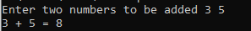
The detailed explanation of each part of a code is as follows:
/* Sum of the two numbers */ | It is the comment section. Any statement described in it is not considered as a code. It is a part of the description section in a code.  The comment line is optional. It can be in a separate line or part of an executable line.
#include<stdio.h> | It is the standard input-output header file. It is a command of the preprocessor section.
int main() | main() is the first function to be executed in every program. We have used int with the main() in order to return an integer value.
{…  } | The curly braces mark the beginning and end of a function. It is mandatory in all the functions.
printf() | The printf() prints text on the screen. It is a function for displaying constant or variables data. Here, 'Enter two numbers to be added' is the parameter passed to it.
scanf() | It reads data from the standard input stream and writes the result into the specified arguments.
sum = a + b | The addition of the specified two numbers will be passed to the sum parameter in the output.
return 0 | A program can also run without a return 0 function. It simply states that a program is free from error and can be successfully exited.

Example 2: To draw a box by accepting a number from the user
It is given by:
/* a simple code to draw a box by accepting a number from the user */

#include<stdio.h> // preprocessor section that contains header files
#include<conio.h>
void main() // main section
{
char num; //local statements
puts(" Enter number of lines of a box (1 to 3) \n");
/* puts accepts, as parameter, a string constant, or a variable enclosed within the double quotes for display on the standard output*/

num = getchar(); // getchar() is also equal to getc(stdin) in C programming.
/* It accepts a parameter and allows the character to be read during the program execution. */
fflush(stdin); // clears the buffer
if(num=='1') // beginning of if-else condition
{
puts("-----------");
puts("| |");
puts("-----------");
}
else if(num=='2') /*if-else performs two different operations depending on the true or false condition of the expression.*/
{
puts("-----------");
puts("| |");
puts("| |");
puts("-----------");
}
else if(num=='3')
{
puts("-----------");
puts("| |");
puts("| |");
puts("| |");
puts("-----------");
}
else
{
puts("Invalid input");
}
}
We have saved the file with the name boxexample.c. Let's compile and execute the code with the help of the command prompt. The file was created in the Notepad.
Output
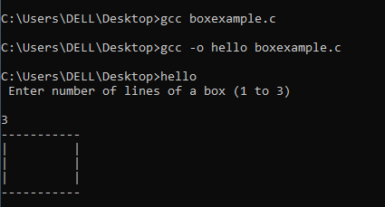

The steps to create, compile, and execute the code from the beginning have been explained later in the topic. It will help us compile any type of C code with the help of text editor (Notepad here) and cmd (Command Prompt).
We can collectively say that the program includes preprocessor commands, variables, functions, statements, expressions, and comments.
Compile and execution of a C program
Here, we will discuss the method to compile and run the C program with the help of the command prompt.
The steps involved in a complete program execution are as follows:
- Create a program
- Compile a program
- Run or execute a program
- Output of the program
Create a program
It refers to the code created in any text editor. We can also compile and run the C code in any software, such as Visual studio.
Compile a program
If refers to the process of checking the errors in the code. The computer displays all the errors (if any) found in our specified C code. We can make further changes to correct those errors.
Run or execute a program
The next step is the run or execution part. A program is assembled and linked without any error. The computer performs different operations, such as decoding, ALU operations to run a program.
Output of the program
It is the last part of the program where the output of the specified code is produced as the result.
But, where to write a program and how to open a command prompt to run that program. Do not worry; it is very easy to do all these steps. Let's start with the step to compile and run a C program.
Step to compile and run a C program
We need first to ensure that the gcc compiler is already present on our PC or not. If it is not installed, we need first to install the gcc compiler. We can also try other methods to run a C program. But here, we have used the gcc compiler.
Step: 1 - gcc complier installation
We can directly install the latest gcc complier through the link: https://jmeubank.github.io/tdm-gcc/
Complete all the steps during the installation till the process gets completed.

Step: 2 - creating a C program
Create a C program using the simple text editor. Here, we have used notepad. It is shown below:
#include<stdio.h>
main()
{
printf("Hello, Welcome to the C programming \n");
return;
}
Now, save the file in any directory with the extension (.c). For example, we have saved the file with the name 'welcome.c' on the desktop.
Step: 3 - Opening the command prompt
Open the cmd or command prompt on our computer. We can simply type cmd on the search or the run option. The Command prompt will appear.
Step: 4 - rechecking the gcc complier
After the command prompt opens, type 'gcc -v' and press Enter. It will appear as the image shown below:
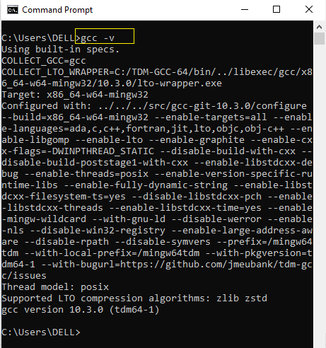
It shows that gcc is successfully installed on our PC.
Step: 5 - go to the source directory
We now need to specify the source directory on the cmd. Type 'cd space source directory' and press Enter. Since, we have saved our text editor file on the desktop, so we will specify the source directory as desktop. It is given by:
- cd desktop
Step: 6 - compile the source code
Run the command 'gcc space full name of the file saved with the extension (.c)' and press Enter, as shown below:
- gcc welcome.c
If there is any error in our file, it will appear. Otherwise, move on to the step 7.
Step: 7 - Compile the source code
The executable file is not yet named because we have not told the compiler to perform any such task. So, we will first name the executable file by running the command 'gcc space -o space (name of executable file) space (name of the original file with the extension)' and press Enter. It is given by:
gcc -o hello welcome.c
Here, we have given the executable name as hello. We can define the name as per our convenience.
Step: 8 - Run the program
It is the last step to run a program. We will run the program in the command prompt only. Here, we will type the name of the executable file without any extension. The executable name will be the same as specified in step 7. It is given by:
hello
Press Enter. The output will appear on the command prompt, as shown below:
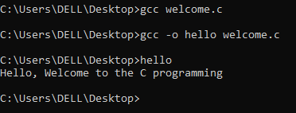
Similarly, we can run multiple C programs using the same steps, as discussed above.

Power Function in C
This article will discuss the power function and its various examples in the C language. The power function is used to find the power of any given number. The power function is a predefined library function of the math.h header file, and we need to import the math.h header file in our program while using the pow() function. In other words, a pow() function is used to calculate the power of the base number (x) by raising the power of (y) as (x^{y}).
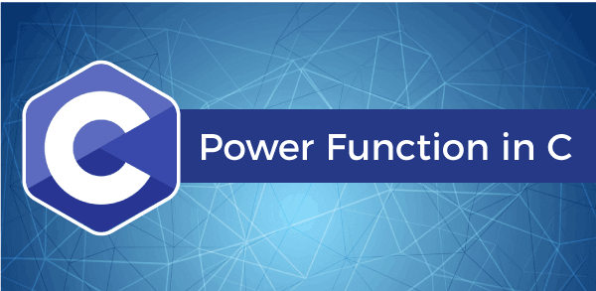
For example, we take base as 2 and power as 5, the power of a number using the pow(2, 5) function to return a value as the 32. Similarly, we pass 3 as the base and 4 as the exponent number to raise the power of the base number using the pow(3, 4), which returns results as 81.

Syntax
int pow (int x, int y);
The pow() function has two integer arguments for raising the power of base value (x) by the exponent (y).
Parameters:
- x: The x variable represents the base value, whose power is to be calculated.
- y: The y variable represents the power or exponent value.
Program to find the power of an integer number using the pow() function
Let's consider an example to get the power of an integer number using the pow() function in the C programming language.
Program2.c
#include <stdio.h>
#include <math.h>
int main ()
{
// declare base and exp variable
int base, exp;
int result; // store the result
printf (" Enter the base value from the user: ");
scanf (" %d", &base); // get base from user
printf (" Enter the power value for raising the power of base: ");
scanf (" %d", &exp); // get exponent from user

// use pow() function to pass the base and the exp value as arguments
result = pow ( base, exp);
printf (" %d to the power of %d is = %d ", base, exp, result);
return 0;
}
Output
Enter the base value from the user: 7
Enter the power value for raising the power of base: 5
7 to the power of 5 is = 16807
Program to calculate the power of double data value using the pow() function
Let's consider an example to demonstrate the pow() function using the double data values in the C programming language.
Program2.c
#include <stdio.h>
#include <math.h>
int main ()
{
// declare base and exp variable
double base, exp;
double result; // store the result
printf (" Enter the base value: ");
scanf (" %lf", &base); // get base from user
printf (" Enter the power value: ");
scanf (" %lf", &exp); // get exponent from user

// use pow() function to pass the base and the exp value as arguments
result = pow ( base, exp);
printf (" %.1lf to the power of %.1lf is = %.2lf ", base, exp, result);
return 0;
}
Output
Enter the base value from the user: 2.9
Enter the power value for raising the power of base: 8.3
2.9 to the power of 8.3 is = 6884.99
Program to get the power of a number using a user-defined function
Let's consider an example to create a user-defined function to get the power of a number in the C programming language.
Program1.c
#include <stdio.h>
#include <math.h>
int main ()
{
// declare local variable
long int base, exp;
printf (" Enter the base value: ");
scanf (" %d", &base); // take a number from user

printf (" Enter the power value: ");
scanf (" %d", &exp); // take a number from user

// use pow() function to pass the base and exp variable
printf (" %d to the power %d is = %d ", base, exp, pow_num (base, exp));
}

// definition of the function
int pow_num (int x, int y)
{
int power = 1, i; // declare variables
for (i = 1; i <= y; ++i)
{
power = power * x;

}
return power;
}
Output
Enter the base value: 25
Enter the power value: 6
25 to the power 6 is = 244140625
Program to get the power of a number using the recursion function and pow() function
Let's consider an example to find the power of a number using the recursion function and pow() function in the C programming language.
Program.c
#include <stdio.h>
#include <math.h>
int main ()
{
// declare local variable
long int base, exp;
printf (" Enter the base value from the user ");
scanf (" %d", &base); // take a number from user

printf (" Enter the power value from the user ");
scanf (" %d", &exp); // take a number from user

// use pow() function to pass the base and exp variable
printf (" %d to the power of %d is = %d ", base, exp, pow_num (base, exp));
}

// definition of the function
int pow_num (int x, int y)
{
if ( y == 0)
{
return 1;
}
else
return pow_num (x, y - 1) * x;
}
Output
Enter the base value from the user 5
Enter the power value from the user 6
5 to the power of 6 is = 15625
Conclusion
A power function is used to find the power of any numeric data (int, float, double) using the pow() function. A power function has two arguments: the base number and the exponent number. The base number represents the power to be calculated, and the exponent defines the power of the base value.

Malloc in C
This section will discuss the allocation of the Dynamic memory using the malloc in the C programming language. The malloc is a predefined library function that stands for memory allocation. A malloc is used to allocate a specified size of memory block at the run time of a program. It means it creates a dynamic memory allocation at the run time when the user/programmer does not know the amount of memory space is needed in the program.
Therefore, it inputs the memory size (in bytes) at the run time to reserve a contiguous memory block that returns a pointer of type void, which is cast into a pointer of any form. The dynamic memory is created using the malloc does not initialize the memory at execution time, and hence the memory block contains some default garbage value. The malloc function is defined inside the stdlib.h header file. So, we need to use <stdlib.h> header file while using the malloc function in our program.

Syntax
ptr = ( cast_ type *) malloc (byte_size);
In the above syntax, the byte_size is an argument that specifies the size of the memory block (in byte), which is passed into the malloc function to reserve the contiguous memory. A malloc() function returns a type void pointer that can be cast into pointers of any defined form.
Program to check memory is created using the malloc function
Let's consider an example to check memory is created using the malloc function in the C programming language.
Program1.c
#include <stdio.h>
#include <stdlib.h> // use stdlib.h header file to malloc() function
int main ()
{
int *pt; // declare a pointer of type int
// use malloc() function to define the size of block in bytes
pt = malloc (sizeof(int));

// use if condition that defines ptr is not equal to null
if (pt != NULL)
{
printf (" Memory is created using the malloc() function ");
}
else
printf (" memory is not created ");
return 0;
}
Output
Memory is created using the malloc() function
In the above program, we create an integer type dynamic memory using the malloc() function that returns an integer pointer to point to the base address. And if the statement checks whether the ptr is equal to NULL pointer and if the statement is true, it means the memory is not created. Else the memory is successfully created through the malloc() function.
Program to create a dynamic memory using the malloc() function
Let's consider an example of taking the size as an input from the user and then entering data at the run time using the malloc () function in the C programming language.
Program2.c
#include <stdio.h>
#include <stdlib.h>
int main ()
{
// declare the local variables
int *ptr, size, i;

printf (" Enter the allocated size of memory ");
scanf (" %d", &size); // get the size of a memory
// use malloc() function to define the size of block in bytes
ptr = malloc (size * sizeof(int));
// use if condition that defines ptr is not equal to null
if (ptr != NULL)
{
// get an input from the user and print it
printf (" Enter numbers from the user: ");
for ( i = 0; i < size; i++)
{
scanf (" %d", ptr + i); // stores the numbers from base address of memory
}
printf (" Numbers are stores in contiguous memory: \n ");
for ( i = 0; i < size; i++)
{
printf (" \n The number is: %d", *(ptr + i)); // here *(ptr + i) is same as ptr[i]
}
printf (" \n Memory is created using the malloc() function ");
return 0;
}
else
printf (" memory is not created ");
return 0;
}
Output
Enter the allocated size of memory 10
Enter numbers from the user: 25
40
20
13
56
78
67
24
10
7
Numbers are stores in contiguous memory:
The number is: 25
The number is: 40
The number is: 20
The number is: 13
The number is: 56
The number is: 78
The number is: 67
The number is: 24
The number is: 10
The number is: 7
Memory is created using the malloc() function
Release memory space using the free() function
A free() function releases the dynamic memory allocation created through the malloc() function. The dynamic memory could not free the occupied memory itself, and the existing space remains even program end. Therefore, we need to free the reserved memory so that other programs can reuse it.
Syntax
free (ptr);
In the above syntax, we pass ptr inside the free() function that acts as the reference or base address of the dynamic memory to points to the memory block.
Program3.c
#include <stdio.h>
#include <stdlib.h>
void main()
{
int num, i, sum = 0;
int *ptr, *p;
printf (" The number of elements to be entered: \n ");
scanf (" %d", &num); // define the no. of element to be entered
// use malloc() function to define the size of memory block
ptr = (int *) malloc (num);
p = ptr; // store the base address of ptr in p
// validate the string is full or not
if (ptr == NULL)
{
printf (" Memory is not allocated ");
exit(0); // exit from program
}
else
{
printf (" Memory is created using the malloc() function ");
}
printf ("\n Enter the elements in allocated space: ");
for (i = 1; i <= num; i++)
{
scanf (" %d", ptr);
sum = sum + *ptr;
ptr++;
}
// print the entered number
printf (" Elements are: ");
for (i = 1; i <= num; i++)
{
printf (" \n %d", *p);
p++;
}
printf (" \n The addition of stored elements is: %d ", sum);
free (ptr); // use free() function to release the occupy space using malloc() function
getch();
}
Output
The number of elements to be entered:
10
Memory is created using the malloc() function
Enter the elements in allocated space: 45
12
67
89
34
56
25
25
67
34
Elements are:
45
12
67
89
34
56
25
25
67
34
The addition of stored elements is: 454

Table Program in C
This article will write the table programs using loops (for, do-while, and while loop) and functions (user-defined and recursion function) in the C programming language.
A table (or multiplication table) of numbers is generated by multiplying a constant number with an iterative number from 1 to 10 to get the table. In other words, we can get the table of a number by multiplying the given number with counting from 1, 2, 3, 4, 5, ..., 9, 10. And on each iteration, the value of counting is incremented by 1, which goes up to 10, to print a complete table.
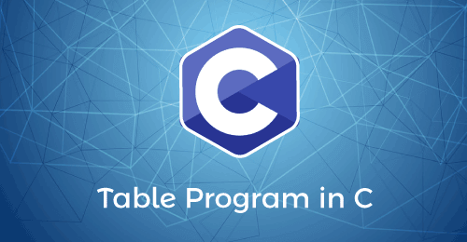
For example, suppose we want to write the table of 5 in C language. So, first, we take 5 as input from the user, and then, we use a loop or function that multiplies the number 5 by 1 (5 * 1), and then (5 * 2), (5 * 3), to the last (5 * 10) number, to get the complete table of the given numbers.

Different ways to generate the table program
Following are the various ways to generate the table program in the C programming language.
- Using for loop
- Using while loop
- Using do-while loop
- Using user-defined function
- Using recursion function
- Using if and goto statement
- Using for loop and pointer
- Using nested for loop
Program to generate the table of a given number using for loop
Let's consider an example to print the table of the specific number using for loop in the C programming language.
Program1.c
#include <stdio.h>
int main()
{
int num, i; // declare a variable
printf (" Enter a number to generate the table in C: ");
scanf (" %d", &num); // take a positive number from the user

printf ("\n Table of %d", num);
// use for loop to iterate the number from 1 to 10
for ( i = 1; i <= 10; i++)
{
printf ("\n %d * %d = %d", num, i, (num*i));
}
return 0;
}
Output
Enter a number to generate the table in C: 7
Table of 7
7 * 1 = 7
7 * 2 = 14
7 * 3 = 21
7 * 4 = 28
7 * 5 = 35
7 * 6 = 42
7 * 7 = 49
7 * 8 = 56
7 * 9 = 63
7 * 10 = 70
In the above code, for loop executes from 1 to 10, the given number is multiplied by 1, and the next iteration is multiplied by 2, and the process continues until it multiplies the number to 10. Finally, it prints the table on the screen.
Program to generate the table of a number using while loop
Let's consider an example to print the table for a number using a while loop in the C programming language.
Program2.c
#include <stdio.h>
int main()
{
int num, i = 1; // declare a variable
printf (" Enter a number to generate the table in C: ");
scanf (" %d", &num); // take a positive number from the user

printf ("\n Table of %d \n ", num);

// use while loop to evaluate the condition
while (i <= 10)
{
// print the table
printf (" %d x %d = %d \n", num, i, (num * i));
i++; // incremented by 1
}
return 0;
}
Output
Enter a number to generate the table in C: 8
Table of 8
8 x 1 = 8
8 x 2 = 16
8 x 3 = 24
8 x 4 = 32
8 x 5 = 40
8 x 6 = 48
8 x 7 = 56
8 x 8 = 64
8 x 9 = 72
8 x 10 = 80
Program to generate the table of a number using do-while loop
Let's consider an example to print the number table using a do-while loop in the C programming language.
Program3.c
#include <stdio.h>
int main()
{
int num, i = 1; // declare a variable
printf (" Enter a number to generate the table in C: ");
scanf (" %d", &num); // take a positive number from the user

printf ("\n Table of %d \n", num);

// use do-while loop to evaluate the condition
do
{
// print the table
printf (" %d x %d = %d \n", num, i, (num * i));
i++; // incremented by 1
} while (i <= 10); // check condition

return 0;
}
Output
Enter a number to generate the table in C: 3
Table of 3
3 x 1 = 3
3 x 2 = 6
3 x 3 = 9
3 x 4 = 12
3 x 5 = 15
3 x 6 = 18
3 x 7 = 21
3 x 8 = 24
3 x 9 = 27
3 x 10 = 30
Program to generate the table using for loop and user-defined function
Let's consider an example to print the table of the specific number using user-defined function and for loop in the C programming language.
Program4.c
#include <stdio.h>
void tab_num (int x);
int main ()
{
int number;
printf (" Enter a number to get the table: ");
scanf (" %d", &number); // accept a number

printf ("\n The multiplication table of %d \n", number);
tab_num (number); // call tab_num function
return 0;
}
void tab_num (int number)
{
int i; // declare variable
// use for loop to iterate the number from 1 to 10
for ( i = 1; i <= 10; i++)
{
printf (" %d x %d = %d \n", number, i, number * i);
}
}
Output
Enter a number to get the table: 23
The multiplication table of 23
23 x 1 = 23
23 x 2 = 46
23 x 3 = 69
23 x 4 = 92
23 x 5 = 115
23 x 6 = 138
23 x 7 = 161
23 x 8 = 184
23 x 9 = 207
23 x 10 = 230
Program to generate the table of a number using recursion function
Let's write an example to print the number table using the recursion function in the C programming language.
Program5.c
#include <stdio.h>
int main()
{
int num, i = 0; // declare a variable
printf (" Enter a number to generate the table in C: ");
scanf (" %d", &num); // take a positive number from the user

printf ("\n Table of %d", num);
Multiply_tab (num, 1); // call function
}
// definition of Multiply_tab()
void Multiply_tab (int num, int i)
{
printf (" \n");
printf (" %d x %d = %d ", num, i, (num * i));

// If block checks the condition
if (i < 10)
return Multiply_tab (num, i + 1);
}
Output
Enter a number to generate the table in C: 9
Table of 9
9 x 1 = 9
9 x 2 = 18
9 x 3 = 27
9 x 4 = 36
9 x 5 = 45
9 x 6 = 54
9 x 7 = 63
9 x 8 = 72
9 x 9 = 81
9 x 10 = 90
Program to generate the table of a number using goto statement
Let's consider an example to print the number table using a goto statement in the C programming language.
Program6.c
#include <stdio.h>
int main ()
{
int n, i = 1; // declare variable
printf (" Enter a number to get the table: ");
scanf (" %d", &n); // take a positive number
table: // It is a label
// display table
printf (" %d * %d = %d \n", n, i, (n * i));
i++; // incremented by 1
/* if statement check the value of i should not be greater than 10. */
if ( i <= 10)
goto table; // use goto statement to jump to the table label
}
Output
Enter a number to get the table: 5
5 * 1 = 5
5 * 2 = 10
5 * 3 = 15
5 * 4 = 20
5 * 5 = 25
5 * 6 = 30
5 * 7 = 35
5 * 8 = 40
5 * 9 = 45
5 * 10 = 50
Program to generate the table of a number using pointer
Let's consider an example to print the number table using a pointer in the C programming language.
Program7.c
#include <stdio.h>
int main ()
{
int n, i; // declare integer variables
int *ptr; // integer pointer variable
printf (" Enter a number to print the table: ");
scanf (" %d", &n); // take a number
ptr = &n; // store the address of n to ptr
printf (" \n Table of %d: \n", n);
for ( i = 1; i <= 10; i++)
{
printf (" %d * %d = %d \n", n, i, (n*i));
}
return 0;
}
Output
Enter a number to print the table: 17
Table of 17:
17 * 1 = 17
17 * 2 = 34
17 * 3 = 51
17 * 4 = 68
17 * 5 = 85
17 * 6 = 102
17 * 7 = 119
17 * 8 = 136
17 * 9 = 153
17 * 10 = 170
Program to generate the table from 2 to 10 using nested for loop
Let's consider an example to print the table from 2 to 10 using nested for loop in the C programming language.
Program8.c
#include <stdio.h>
int main ()
{
int i, j; /* Here, the i variable is used for the outer loop, and j is used for the inner loop. */
int num1, num2;
printf (" Enter the first number from to get the table: ");
scanf (" %d", &num1);
printf (" Enter the last number: ");
scanf (" %d", &num2);
// use for loop to iterate the value of 1 up to 10
for (i = num1; i <= num2; i++)
{
num1 = i; /* Here the value of i is incremented by 1 and assigned to num variable on completion of each table. */
// inner for loop
printf (" Table of %d => ", num1);
for (j = 1; j <=10; j++)
{
printf(" | %3d |", num1 * j);
}
printf (" \n");
}
return 0;

}
Output
Enter the first number from to get the table: 2
Enter the last number: 10
Table of 2 => | 2 | | 4 | | 6 | | 8 | | 10 | | 12 | | 14 | | 16 | | 18 | | 20 |
Table of 3 => | 3 | | 6 | | 9 | | 12 | | 15 | | 18 | | 21 | | 24 | | 27 | | 30 |
Table of 4 => | 4 | | 8 | | 12 | | 16 | | 20 | | 24 | | 28 | | 32 | | 36 | | 40 |
Table of 5 => | 5 | | 10 | | 15 | | 20 | | 25 | | 30 | | 35 | | 40 | | 45 | | 50 |
Table of 6 => | 6 | | 12 | | 18 | | 24 | | 30 | | 36 | | 42 | | 48 | | 54 | | 60 |
Table of 7 => | 7 | | 14 | | 21 | | 28 | | 35 | | 42 | | 49 | | 56 | | 63 | | 70 |
Table of 8 => | 8 | | 16 | | 24 | | 32 | | 40 | | 48 | | 56 | | 64 | | 72 | | 80 |
Table of 9 => | 9 | | 18 | | 27 | | 36 | | 45 | | 54 | | 63 | | 72 | | 81 | | 90 |
Table of 10 => | 10 | | 20 | | 30 | | 40 | | 50 | | 60 | | 70 | | 80 | | 90 | | 100 |

Types of Recursion in C
This section will discuss the different types of recursion in the C programming language. Recursion is the process in which a function calls itself up to n-number of times. If a program allows the user to call a function inside the same function recursively, the procedure is called a recursive call of the function. Furthermore, a recursive function can call itself directly or indirectly in the same program.
Syntax of the Recursion function
void recursion ()
{
recursion(); // The recursive function calls itself inside the same function
}
int main ()
{
recursion (); // function call
}
In the above syntax, the main() function calls the recursion function only once. After that, the recursion function calls itself up to the defined condition, and if the user doesn't define the condition, it calls the same function infinite times.

Different types of the recursion
Following are the types of the recursion in C programming language, as follows:
- Direct Recursion
- Indirect Recursion
- Tail Recursion
- No Tail/ Head Recursion
- Linear recursion
- Tree Recursion
Direct Recursion
When a function calls itself within the same function repeatedly, it is called the direct recursion.
Structure of the direct recursion
fun()
{
// write some code
fun();
// some code
}
In the above structure of the direct recursion, the outer fun() function recursively calls the inner fun() function, and this type of recursion is called the direct recursion.
Let's write a program to demonstrate the direct recursion in C programming language.
Program2.c
#include<stdio.h>
int fibo_num (int i)
{
// if the num i is equal to 0, return 0;
if ( i == 0)
{
return 0;
}
if ( i == 1)
{
return 1;
}
return fibo_num (i - 1) + fibonacci (i -2);
}
int main ()
{
int i;
// use for loop to get the first 10 fibonacci series
for ( i = 0; i < 10; i++)
{
printf (" %d \t ", fibo_num (i));
}
return 0;
}
Output
0 1 1 2 3 5 8 13 21 34
Indirect Recursion
When a function is mutually called by another function in a circular manner, the function is called an indirect recursion function.
Structure of the indirect recursion
fun1()
{
// write some code
fun2()
}
fun2()
{
// write some code
fun3()
// write some code
}
fun3()
{
// write some code
fun1()
}
In this structure, there are four functions, fun1(), fun2(), fun3() and fun4(). When the fun1() function is executed, it calls the fun2() for its execution. And then, the fun2() function starts its execution calls the fun3() function. In this way, each function leads to another function to makes their execution circularly. And this type of approach is called indirect recursion.
Let's write a program to demonstrate the indirect recursion in C programming language.
Program3.c
#include <stdio.h>
// declaration of the odd and even() function
void odd(); // Add 1 when the function is odd()
void even(); // Subtract 1 when the function is even
int num = 1; // global variable
void odd ()
{
// if statement check and execute the block till n is less than equal to 10
if (num <= 10)
{
printf (" %d ", num + 1); // print a number by adding 1
num++; // increment by 1
even(); // invoke the even function
}
return;
}
void even ()
{
// if block check the condition that n is less than equal to 10
if ( num <= 10)
{
printf (" %d ", num - 1); // print a number by subtracting 1
num++;
odd(); // call the odd() function
}
return;
}
int main ()
{
odd(); // main call the odd() function at once
return 0;
}
Output
2 1 4 3 6 5 8 7 10 9
Tail Recursion
A recursive function is called the tail-recursive if the function makes recursive calling itself, and that recursive call is the last statement executes by the function. After that, there is no function or statement is left to call the recursive function.
Let's write a program to demonstrate the tail recursion in C programming language.
Program4.c
#include <stdio.h>
// function definition
void fun1( int num)
{
// if block check the condition
if (num == 0)
return;
else
printf ("\n Number is: %d", num); // print the number
return fun1 (num - 1); // recursive call at the end in the fun() function
}
int main ()
{
fun1(7); // pass 7 as integer argument
return 0;
}
Output
Number is: 7
Number is: 6
Number is: 5
Number is: 4
Number is: 3
Number is: 2
Number is: 1
Non-Tail / Head Recursion
A function is called the non-tail or head recursive if a function makes a recursive call itself, the recursive call will be the first statement in the function. It means there should be no statement or operation is called before the recursive calls. Furthermore, the head recursive does not perform any operation at the time of recursive calling. Instead, all operations are done at the return time.
Let's write a program to demonstrate the Head/Non-Tail recursion in C programming language.
Program5.c
#include <stdio.h>
void head_fun (int num)
{
if ( num > 0 )
{
// Here the head_fun() is the first statement to be called
head_fun (num -1);
printf (" %d", num);
}
}
int main ()
{
int a = 5;
printf (" Use of Non-Tail/Head Recursive function \n");
head_fun (a); // function calling
return 0;
}
Output
Use of Non-Tail/Head Recursive function
1 2 3 4 5
Linear Recursion
A function is called the linear recursive if the function makes a single call to itself at each time the function runs and grows linearly in proportion to the size of the problem.
Let's write a program to demonstrate the linear Recursion in C programming language.
Program6.c
#include <stdio.h>
#define NUM 7
int rec_num( int *arr, int n)
{
if (n == 1)
{
return arr[0];
}
return Max_num (rec_num (arr, n-1), arr[n-1]);
}
// get the maximum number
int Max_num (int n, int m)
{
if (n > m)
return n;
return m;
}
int main ()
{
// declare and initialize an array
int arr[NUM] = { 4, 8, 23, 19, 5, 35, 2};
int max = rec_num(arr, NUM); // call function
printf (" The maximum number is: %d\n", max); // print the largest number
}
Output
The maximum number is: 35
Tree Recursion
A function is called the tree recursion, in which the function makes more than one call to itself within the recursive function.
Let's write a program to demonstrate the tree recursion in C programming language.
Program7.c
#include <stdio.h>
// It is called multiple times inside the fibo_num function
int fibo_num (int num)
{
if (num <= 1)
return num;
return fibo_num (num - 1 ) + fibo_num(num - 2);
}
void main()
{
int num = 7;
printf (" Use of Tree Recursion: \n");
// print the number
printf (" The Fibonacci number is: %d", fibo_num(7));
}
Output
Use of Tree Recursion:
The Fibonacci number is: 13

Convert Uppercase to Lowercase in C
This section will discuss the different programs to convert the uppercase letters (character or strings) into lowercase in the C programming language. The uppercase letter is the capital letter of the alphabet. For example, capital letters are A, B, C, D, …, X, Y, Z. Similarly, a lowercase letter is represented by the small letter of the alphabet. For example, small letters are a, b, c, d, e…., w, x, y, z.
When we convert the capital letters or strings into lowercase using the ASCII codes, the process converts the uppercase to the lowercase letters in C programming. The ASCII value of the uppercase letter (A -Z) is ranging from 65 to 90, and the ASCII value of the lowercase letter (a -z) is ranging from 97 to 122.

For example, we have the capital letter 'A' and want to convert it into lowercase letter 'a', we need to add 32 to the ASCII value of A (65) that returns character 'a' whose ASCII value is 97 (65 + 32). Similarly, we can convert the uppercase string 'HELLO' into the lowercase string 'hello'.

Program to convert the uppercase character into lowercase
Let's write a program to convert the uppercase character into lowercase character in C programming language.
Program1.c
#include <stdio.h>
#include <conio.h>
int main ()
{
char upr, lwr; // declare variables
int ascii;

// convert in lower case
printf (" Enter the Upper Case Character: ");
scanf (" %c", &upr);
ascii = upr + 32;
printf (" %c character in Lower case is: %c", upr, ascii);

// convert in upper case
printf (" \n Enter the Lower Case Character: ");
scanf (" %c", &lwr);
ascii = lwr - 32;
printf (" %c character in the Upper case is: %c", lwr, ascii);

return 0;
}
Output
Enter the Upper Case Character: A
A character in Lower case is: a
Enter the Lower Case Character: z
z character in the Upper case is: Z
Program to convert the uppercase string into lower case using for loop
Let's write a simple program to convert the uppercase string into lowercase using for loop in the C Programming.
Program2.c
#include <stdio.h>
#include <conio.h>
int main ()
{
char str[30];
int i;
printf (" Enter the string: ");
scanf (" %s", &str); // take a string

// use for loop to change string from upper case to lower case
for ( i = 0; i <= strlen (str); i++)
{
// The ASCII value of A is 65 and Z is 90
if (str[i] >= 65 && str[i] <= 90)
str[i] = str[i] + 32; /* add 32 to string character to convert into lower case. */
}
printf (" \n Upper Case to Lower case string is: %s", str);
return 0;
}
Output
Enter the string: WELCOME

Upper Case to Lower case string is: welcome
Program to convert the uppercase string into lower case using while loop
Let's consider an example to print the lowercase string from uppercase using while loop in C programming.
Program3.c
#include <stdio.h>
#include <conio.h>
int main ()
{
char upr[50], lwr[50]; // declare character array
int i = 0;

printf (" Enter an upper case string: ");
gets (upr); // use gets() function to take string

/* use while loop to iterate the character array string until '\0' not occur. */
while (upr [i] != '\0')
{
lwr [i] = upr[i] + 32; // Add 32 to string character to convert into lower case. i++;
}

printf (" \n The lowercase string is: %s", lwr);

return 0;

}
Output
Enter an upper case string: CPROGRAMMING

The lowercase string is: cprogramming
Program to convert the uppercase string into lowercase using the strlwr() function
Strlwr() function: The strlwr() function is a predefined function of the string library used to convert the uppercase string into the lowercase by passing the given string as an argument to return the lowercase string.
Syntax
strlwr (upr);
The strlwr() function has a upr argument representing the uppercase string, and the strlwr() function takes upr argument to return a lowercase string.
Let's create a program to convert the uppercase string into the lowercase using the built-in strlwr() function in C programming.
Program4.c
#include <stdio.h>
#include <conio.h>
int main ()
{
char upr[50]; // declare character array

printf (" Enter the upper case string: ");
gets (upr); // use gets() function to take string

// use strlwr() function to change upper case into lower string
printf (" \n The lowercase string is: %s", strlwr(upr));

return 0;
}
Output
Enter the upper case string: GOOD BYE

The lowercase string is: good bye
Program to convert the uppercase string into lowercase using the user-defined function
Let's consider an example to convert the uppercase string into lowercase using the user-defined function in C programming.
Program5.c
#include <stdio.h>
#include <conio.h>

// create a function
void upr_lwr (char *str)
{
int i;
// use for loop to iterate the length of the string
for ( i = 0; str[i]; i++)
{
if ( str [i] >= 65 && str [i] <= 90)
str[i] = str[i] + 32; /* add 32 to string character to change into lowercase */
}
}
int main ()
{
char str[100]; // declare the size of character array

printf (" Enter the upper case string: ");
gets (str); // use gets() function to take string

// call upr_lwr() function
upr_lwr (str);

printf (" \n The lowercase string is: %s", str);

return 0;

}
Output
Enter the upper case string: JAVATPOINT

The lowercase string is: javatpoint
Program to convert the uppercase string into lowercase using the recursion function
Let's consider an example to print the lowercase string from uppercase using the recursion function in the C programming.
Program6.c
#include <stdio.h>
#include <conio.h>
#include <string.h>

int upr_lwr (char *str)
{
static int i = 0;
if (str[i])
{

/* If statement check the enter character's ASCII value is more than 65 and less than equal to 90. */
if ( str[i] >= 65 && str[i] <= 90)
str[i] = str[i] + 32; // add 32 to string character to change into lowercase
i++;
upr_lwr(str);
}
}
int main ()
{
char str[100]; // declare the size of character array

printf (" Enter the upper case string: ");
gets (str); // use gets() function to take string

// call upr_lwr() function
upr_lwr (str);

printf (" \n The lowercase string is: %s", str);
}
Output
Enter the upper case string: C PROGRAMMING LANGUAGE

The lowercase string is: c programming language

Unary Operator in C
In this section, we will discuss the unary operator in the C programming language. Operators are the special symbols used to perform mathematical and logical operations to the given numbers or operands and returns results based on passed operator between the operands.

A unary operator is an operator used to operate on a single operand to return a new value. In other words, it is an operator that updates the value of an operand or expression's value by using the appropriate unary operators. In Unary Operator, operators have equal priority from right to left side associativity.

Types of the Unary Operator
Following are the types of the unary operators in the C programming language.
- Unary Minus (-)
- Unary Plus (+)
- Increment (++)
- Decrement (--)
- Logical Negation (!)
- Address Operator (&)
- Sizeof() operator
Unary Minus (-)
The Unary Minus operator is represented using the symbol (-). The unary operator is used to change the sign of any positive value to a negative value. It means it changes the positive number to the negative, and a negative number becomes the positive number using the unary minus operator.
Syntax
int a = 2;
int b = -(a);
Example 1:
#include <stdio.h>
#include <conio.h>
int main ()
{
int a = 5; // positive value of a.
int b = -(a); // use unary minus operator to change the value

int n1 = 20;
int n2 = -30;

printf (" The value of a: %d \n", a);
printf (" The value of b: %d \n", b);

printf (" The value of -n1: %d \n", -n1);
printf (" The value of -n2: %d ", -n2);

return 0;
}
Output
The value of a: 5
The value of b: -5
The value of -n1: -20
The value of -n2: 30
Unary plus (+)
The unary plus operator is represented as the "+" symbol, and it does not change to the operand value.
Example 2:
#include <stdio.h>
#include <conio.h>
int main ()
{
int a = 10; // use unary plus operator
int b = (-10); // It does not change the operand value
printf (" The value of a: %d \n", a);
printf (" The value of b: %d \n", b);
return 0;
}
Output
The value of a: 10
The value of b: -10
Unary Increment Operator (++)
It is the unary increment operator, which is denoted by the "++" symbol. The "++" symbol represents the operand's value is increased by 1. It can be used in two ways, as the post-increment and the pre-increment.
Pre Increment: The pre-increment operator is represented as (++a), which means the value of variable 'a' is increment by 1 before using operand to the expression.
Example:
x = 10;
A = ++x;
The initial value of x is 10, and using the pre-increment operator (++x) increases the operand value by 1 before assigning it to the variable 'A'.
Post Increment: The (a++) symbol represents the post-increment operator, which means the value of 'a' is incremented by 1 after assigning the original value to the expression or another variable.
Example:
x = 10;
A = x++;
Here the initial value of the x variable is 10 and using the post-increment operator (x++) to assign increment value of the 'x' to the variable 'A'.
Example 3:
#include <stdio.h>
#include <conio.h>
int main ()
{
int x, y, a, b; // declare local variable
a = 10;
x = ++a; // It shows pre increment operator

printf (" Pre Increment Operator");
// Here the value of x is increased by 1.
printf (" \n The value of x is %d.", x);

printf (" \n The value of a is %d.", a);

b = 20;
y = b++; // It shows the post increment operator
printf (" \n\n Post Increment Operator");
printf (" \n The value of y is %d.", y);
// get updated value of b
printf (" \n The value of b is %d.", b);

return 0;
}
Output
Pre Increment Operator
The value of x is 11.
The value of a is 11.

Post Increment Operator
The value of y is 20.
The value of b is 21.
Unary Decrement Operator (--)
The unary decrement operator is opposite to the unary increment operator. The Unary decrement operator is represented by the double minus (--) symbol, and it is used to decrease the operand value by 1 according to the decrement's types. The Unary decrement operator is of two types: the Pre decrement operator and the Post Decrement operator.
Pre Decrement: The pre decrement operator is denoted as (--a) symbol, meaning the operand value is decreased by 1 before assigning to another variable or expression.
Syntax
int pre = --a;
Post Decrement: The Post decrement operator is denoted as (a--) symbol, which means the original value is decreased by 1 after assigning to another variable or expression.
Syntax
int post = a--;
Example 4:
#include <stdio.h>
#include <conio.h>
int main ()
{
int x, y, a, b; // declare local variable
a = 10;
x = --a; // It shows pre decrement operator

printf (" Pre Decrement Operator");
// Here the value of x is decreased by 1.
printf (" \n The value of x is %d.", x);

printf (" \n The value of a is %d.", a);

b = 20;
y = b--; // It shows the post decrement operator
printf (" \n\n Post Decrement Operator");
printf (" \n The value of y is %d.", y);
// get updated value of b
printf (" \n The value of b is %d.", b);

return 0;
}
Output
Pre Decrement Operator
The value of x is 9.
The value of a is 9.

Post Decrement Operator
The value of y is 20.
The value of b is 19.
Unary Sizeof() Operator
The sizeof is a keyword used to find the size of different data types or operands like int, float, char, double, etc.
Syntax
sizeof(data_variable);
Example 5:
#include <stdio.h>
#include <conio.h>
int main ()
{
// declaration of different types of data variables
int x;
float y;
char ch;
double z;

// use sizeof() operator and pass the different data type variable to get their size.
printf (" The size of the int (x) variable is: %d", sizeof(x));
printf (" \n The size of the float (y) variable is: %d", sizeof(y));
printf (" \n The size of the char (ch) variable is: %d", sizeof(ch));
printf (" \n The size of the double (z) variable is: %d", sizeof(z));
return 0;
}
Output
The size of the int (x) variable is: 4
The size of the float (y) variable is: 4
The size of the char (ch) variable is: 1
The size of the double (z) variable is: 8
Logical Not (!) Operator
The logical not operator is used to reverse the given condition. For example, if the operand is true, the logical not operator (!) reverses and return false; if the operand is false, the logical operator returns true.
Syntax
bool a = true;
bool b = !a; // It reverse the condition of variable b
Example 6:
#include <stdio.h>
#include <stdbool.h>
int main ()
{
// declare variables
bool a = true;
bool b;
b = !a; // use logical operator to reverse the condition
printf (" The Boolean value of a is: %d", a);
printf (" \n The Boolean value of b is: %d", b);

bool c = 0;
bool d = !c;
printf (" \n The Boolean value of c is: %d", c);
printf (" \n The Boolean value of d is: %d", d);
return 0;
}
Output
The Boolean value of a is: 1
The Boolean value of b is: 0
The Boolean value of c is: 0
The Boolean value of d is: 1
AddressOf Operator (&)
The Unary AddressOf Operator is denoted as ampersand (&) symbol, which is used to find the address of a variable defined in computer memory.
Syntax
int a = 5;
int b = &a; // variable b hold the address of variable a
Example 7:
#include <stdio.h>
#include <conio.h>
int main ()
{
// declare variables
int a = 10;
int b;

// use addressof (&) operator to assign the address
b = &a;
printf (" The value of variable a is: %d", a);
printf (" \n The address of variable b is: %d", b);
return 0;
}
Output
The value of variable a is: 10
The address of variable b is: 6487704

Arithmetic Operator in C
Operators are the special symbols in the C programming language, which is used to perform various mathematical and logical operations on the given operands to return the appropriate results. There are various operators in the C programming language such as Arithmetic Operators, Relational Operators, Shift Operators, Logical Operators, Bitwise Operators, Ternary or Conditional Operators, and Assignment Operators. But here, we will understand only the Arithmetic Operator in the C programming language.
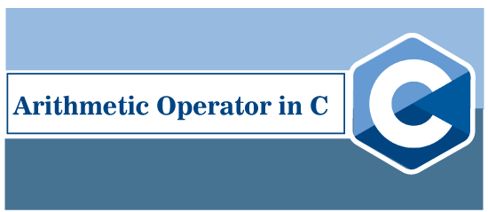
Arithmetic Operator is used to performing mathematical operations such as addition, subtraction, multiplication, division, modulus, etc., on the given operands.
For example: 5 + 3 = 8, 5 - 3 = 2, 2 * 4 = 8, etc. are the examples of arithmetic operators. Let's discuss the different types of Arithmetic Operators in the C programming.
Plus Operator
It is a simple Plus (+) Operator used to add two given operands. We can use Plus Operator with different data types such as integer, float, long, double, enumerated and string type data to add the given operand.
Syntax
C = A + B;
For example, there are two operands, 5 and 6, and we want to get the sum of these numbers. Therefore, we use the '+' Operator between the given numbers that return integer data 11.
Program1.c
#include <stdio.h>
#include <conio.h>
int main ()
{
// declare integer variables
int num1, num2, res;
// declare float data type number
float f1, f2, res1;
// declare double variables
double d1, d2, res2;
printf (" Enter two integer numbers: ");
scanf ("%d %d", &num1, &num2);
res = num1 + num2; // use + operator

printf (" Enter two float numbers: \n ");
scanf ("%f %f", &f1, &f2);
res1 = f1 + f2; // use + operator

printf (" Enter two double data type numbers: \n ");
scanf ("%lf %lf", &d1, &d2);
res2 = d1 + d2; // use + operator
printf (" The sum of two integer numbers: %d \n", res);
printf (" The sum of two float numbers: %f \n ", res1);
printf (" The sum of two double numbers: %lf", res2);
return 0;
}
Output
Enter two integer numbers: 25
35
Enter two float numbers:
79.21
67.79
Enter two double data type numbers:
234.123
345.341
The sum of two integer numbers: 60
The sum of two float numbers: 147.000000
The sum of two double numbers: 579.464000
Minus Operator
The minus operator is denoted by the minus (-) symbol. It is used to return the subtraction of the first number from the second number. The data type of the given number can be different types, such as int, float, double, long double, etc., in the programing language.
Syntax
C = A - B;
For example, there are two operands, 15 and 6, and we want their subtraction result. So, we use the '-' Operator between the given numbers that return data 9.
Program2.c
/* program to subtract the two numbers using minus operator */
#include <stdio.h>
#include <conio.h>
int main ()
{
// declare integer variables
int num1, num2, res;
// declare float data type number
float f1, f2, res1;
// declare double variables
double d1, d2, res2;
printf (" Enter two integer numbers: ");
scanf ("%d %d", &num1, &num2);
res = num1 - num2; // use + operator

printf (" Enter two float numbers: \n ");
scanf ("%f %f", &f1, &f2);
res1 = f1 - f2; // use + operator

printf (" Enter two double data type numbers: \n ");
scanf ("%lf %lf", &d1, &d2);
res2 = d1 - d2; // use + operator
printf (" The subtraction of two integer numbers: %d \n", res);
printf (" The subtraction of two float numbers: %f \n ", res1);
printf (" The subtraction of two double numbers: %lf", res2);
return 0;
}
Output
Enter two integer numbers: 56
11
Enter two float numbers:
78.98
56.45
Enter two double data type numbers:
47789.7149
1234.7987
The subtraction of two integer numbers: 45
The subtraction of two float numbers: 22.530003
The subtraction of two double numbers: 46554.916200
Multiplication Operator
The multiplication operator is represented as an asterisk (*) symbol, and it is used to return the product of n1 and n2 numbers. The data type of the given number can be different types such as int, float, and double in the C programing language.
Syntax
C = A * B;
For example, there are two operands 15 and 6, and we want to get their product. So, we can use the '*' Operator between the given numbers that return int data 90.
Program3.c
/* program to multiply two numbers using astrisk (*) operator. */
#include <stdio.h>
#include <conio.h>
int main ()
{
// declare integer variables
int num1, num2, res;
// declare float data type number
float f1, f2, res1;
// declare double variables
double d1, d2, res2;
printf (" Enter two integer numbers: ");
scanf ("%d %d", &num1, &num2);
res = num1 * num2; // use * operator

printf (" Enter two float numbers: \n ");
scanf ("%f %f", &f1, &f2);
res1 = f1 * f2; // use * operator

printf (" Enter two double data type numbers: \n ");
scanf ("%lf %lf", &d1, &d2);
res2 = d1 * d2; // use * operator
printf (" The multiplication of two integer numbers: %d \n", res);
printf (" The multiplication of two float numbers: %f \n ", res1);
printf (" The multiplication of two double numbers: %lf", res2);
return 0;
}
Output
Enter two integer numbers: 15
12
Enter two float numbers:
2.5
3.5
Enter two double data type numbers:
234.324
798.124
The multiplication of two integer numbers: 180
The multiplication of two float numbers: 8.750000
The multiplication of two double numbers: 187019.608176
Division Operator
The division operator is an arithmetic operator that divides the first (n1) by the second (n2) number. Using division operator (/), we can divide the int, float, double and long data types variables.
Syntax
C = A / B;
For example, there are two operands, 25.5 and 5.0, and we want to get their division result. So, we use the '/' Operator between the given numbers that return float data 5.1.
Program4.c
/* program to divide the first number by second number using division (/) operator. */
#include <stdio.h>
#include <conio.h>
int main ()
{
// declare integer variables
int num1, num2, res;
// declare float data type number
float f1, f2, res1;
// declare double variables
double d1, d2, res2;
printf (" Enter two integer numbers: ");
scanf ("%d %d", &num1, &num2);
res = num1 / num2; // use / operator

printf (" Enter two float numbers: \n ");
scanf ("%f %f", &f1, &f2);
res1 = f1 / f2; // use / operator

printf (" Enter two double data type numbers: \n ");
scanf ("%lf %lf", &d1, &d2);
res2 = d1 / d2; // use / operator
printf (" The division of two integer numbers: %d \n", res);
printf (" The division of two float numbers: %f \n ", res1);
printf (" The division of two double numbers: %lf", res2);
return 0;
}
Output
Enter two integer numbers: 125
15
Enter two float numbers:
214.32
248.56
Enter two double data type numbers:
4243.7691
687.434
The division of two integer numbers: 8
The division of two float numbers: 0.862247
The division of two double numbers: 6.173348
Modulus Operator
The modulus operator is represented by the percentage sign (%), and it is used to return the remainder by dividing the first number by the second number.
Syntax
C = A % B;
For example, there are two operands 25 and 4, and we want to get their modulus result. So, we use the '%' operator in between the given numbers that return remainder 1.
Program5.c
/* program to return the remainder of two numbers using modulus (%) operator. */
#include <stdio.h>
#include <conio.h>
int main ()
{
// declare integer variables
int num1, num2, res;

printf (" Enter two integer numbers: ");
scanf ("%d %d", &num1, &num2);
res = num1 % num2; // use % operator

printf (" The modulus of two integer numbers: %d \n", res);

return 0;
}
Output
Enter two integer numbers: 35
3
The modulus of two integer numbers: 2
Increment Operator
Increment Operator is the type of Arithmetic operator, which is denoted by double plus (++) operator. It is used to increase the integer value by 1.
Syntax
B = A++;
For example, suppose the integer value of A is 10, the increment operator increases the operand value by 1, which returns 11.
Program6.c
/* program to demonstrate the increment (++) operator. */
#include <stdio.h>
#include <conio.h>
int main ()
{
// declare integer variables
int num1, res;

printf (" Enter the positive number: ");
scanf ("%d", &num1);
res = num1++; // use increment operator

printf (" The incremented value is: %d ", num1);
return 0;
}
Output
Enter the positive number: 10
The incremented value is: 11
Decrement Operator
Decrement Operator is denoted by the double minus (--) symbol, which decreases the operand value by 1.
Syntax
B = A--;
For example, suppose the integer value of A is 10, the decrement operator decreases the operand value by 1 that returns 9.
Program7.c
/* program to demonstrate the decrement operator (--) in the Arithmetic Operator. */
#include <stdio.h>
#include <conio.h>
int main ()
{
// declare integer variables
int num1, res;

printf (" Enter the positive number: ");
scanf ("%d", &num1);
res = num1--; // use decrement operator

printf (" The decremented value is: %d ", num1);
return 0;
}
Output
Enter the positive number: 10
The decremented value is: 9

Ceil Function in C

This section will discuss the Ceil function in the C programming language. Ceil function is a predefined function of math.h header file. It returns the nearest integer number, which is greater than or equal to the number passed as an argument in it. For example, we pass the float number 3.4, and the ceil() function returns the greatest number 4.

Syntax
double ceil ( double x);
Parameters
Here, x is an argument of the ceil function.
Returns
The ceil() function returns the smallest possible integer value to round up the passed number x.
Properties of the ceil function
- It is a built-in method of math.h header file.
- Using the ceil() function to return the smallest number greater than or equal to the parametric number.
- If the passed number is 0, the ceil() function returns the 0.
- If the number is equal to the mathematical integer, the result generated by the ceil() function will be the same as the specified number.
- If a number is less than 0 but greater than -1.0, the result will be zero.

Note: The ceil() function can only be used with floating-point positive and negative numbers to round off the given number. If the passed positive and negative number is an integer, the function returns the same number without ceiling or round off the nearest given number.
Example 1: Program to ceil a number using the ceil() function
#include <stdio.h>
#include <math.h>
int main ()
{
// declare local variables
double num = 9.37;
int result;

// use ceil () function to round up the nearest value.
result = ceil (num);

printf ( " \n The ceiling integer of %.2f = %d ", num, result);
return 0;
}
Output
The ceiling integer of 9.37 = 10
As shown in the program, the value of variable num 9.37 is passed to the ceil() function returns the round off to its nearest integer value 10.
Example 2: Program to ceil the floating number using the ceil() function
#include <stdio.h>
#include <math.h>
int main ()
{
// declare local variables
float f1, f2, f3, f4, f5;
f1 = 2.3;
f2 = -2.7;
f3 = 5.1;
f4 = 56.4;
f5 = 2.8;

// use ceil() function to return the nearest number
printf (" The ceiling value of %.2f is %.2f \n ", f1, ceil (f1));
printf (" The ceiling value of %.2f is %.2f \n ", f2, ceil (f2));
printf (" The ceiling value of %.2f is %.2f \n ", f3, ceil (f3));
printf (" The ceiling value of %.2f is %.2f \n ", f4, ceil (f4));
printf (" The ceiling value of %.2f is %.2f \n ", f5, ceil (f5));
return 0;
}
Output
The ceiling value of 2.30 is 3.00
The ceiling value of -2.70 is -2.00
The ceiling value of 5.10 is 6.00
The ceiling value of 56.40 is 57.00
The ceiling value of 2.80 is 3.00
Example 3: Program to round up the floating number using the ceil() function
#include <stdio.h>
#include <math.h>
int main ()
{
// declare local variables
float num;
float result;

printf (" Enter the float number: ");
scanf ( "%f", &num);

// use ceil () function
result = ceil (num);

printf ( " The ceil of %.2f is %f ", num, result);
return 0;
}
Output
Enter the float number: 55.6
The ceil of 55.60 is 56.000000
Example 4: Program to round up the positive and negative numbers using the ceil() function
#include <stdio.h>
#include <math.h>
int main ()
{

int num, result, num2, result2;

printf (" Enter the positive integer: ");
scanf (" %d", &num);

printf (" Enter the negative integer: ");
scanf (" %d", &num2);

// use ceil () function to round up the nearest value of the given number. */
result = ceil (num);
result2 = ceil (num2);

printf ( " \n The ceiling integer of %d = %d ", num, result);
printf ( " \n The ceiling integer of %d = %d ", num2, result2);
return 0;
}
Output
Enter the positive integer: 56
Enter the negative integer: -24

The ceiling integer of 56 = 56
The ceiling integer of -24 = -24

Relational Operator in C
Operators are the special symbols used to perform mathematical and logical operations to the given operands. There are various types of operators in C, such as arithmetic, logical, bitwise, relational, conditional or ternary, etc.
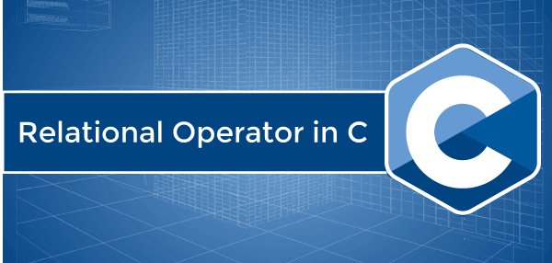
Relational Operators are the operators used to create a relationship and compare the values of two operands.
For example, there are two numbers, 5 and 15, and we can get the greatest number using the greater than operator (>) that returns 15 as the greatest or larger number to the 5.
Types of Relational Operators
Following are the various types of relational operators in C.
Equal To Operator (==)
It is used to compare both operands and returns 1 if both are equal or the same, and 0 represents the operands that are not equal.
Syntax
Opr1 == Opr2
Let's create a program to use the double equal to operator (==) for comparing the operands value in C.
Program1.c
#include <stdio.h>
#include <math.h>
int main ()
{
int a = 5;
int b = 10;

// Use Equal To Operator
printf (" a == b : %d", (a == b));
if (a == b)
printf ("\n %d is equal to %d", a, b);
else
printf (" \n %d is not equal to %d", a, b);

int x = 5;
int y = 5;

// Use Equal To Operator
printf (" \n x == y : %d", (x == y));
if (a == b)
printf (" \n %d is equal to %d", x, y);
else
printf ("\n %d is not equal to %d", x, y);
return 0;
}
Output
a == b : 0
5 is not equal to 10
x == y : 1
5 is not equal to 5
Not Equal To Operator (!=)
The Not Equal To Operator is the opposite of the Equal To Operator and is represented as the (!=) operator. The Not Equal To Operator compares two operands and returns 1 if both operands are not the same; otherwise, it returns 0.
Syntax:
Opr1 != Opr2;
Let's create a simple program to use the Not equal to (!=) operator for comparing the values of variable in C.
Program2.c
#include <stdio.h>
#include <math.h>
int main ()
{
int a = 5;
int b = 10;

// Use Not Equal To (!=) Operator
printf (" a != b : %d", (a != b));
if (a != b)
printf ("\n %d is equal to %d", a, b);
else
printf (" \n %d is not equal to %d", a, b);

int x = 5;
int y = 5;

// Use Not Equal To (!=) Operator
printf (" \n x != y : %d", (x != y));
if (a != b)
printf (" \n %d is equal to %d", x, y);
else
printf ("\n %d is not equal to %d", x, y);
return 0;
}
Output
a != b : 1
5 is equal to 10
x != y : 0
5 is equal to 5
Less than Operator (<)
It is used to check whether the value of the left operand is less than the right operand, and if the statement is true, the operator is known as the Less than Operator.
Syntax:
A < B;
Here the operand A is less than operand B.
Let's create a program to use the less-than operator (<) to compare the operand value in C.
Program3.c
#include <stdio.h>

int main ()
{
int num1, num2;
printf (" Enter the value of num1: ");
scanf (" %d", &num1);

printf (" \n Enter the value of num2: ");
scanf (" %d", &num2);

// use less than operator (<)
if (num1 < num2)
{
printf (" \n The value of num1 is less than num2.");
}
else
{
printf (" \n The value of num2 is less than num1.");
}
return 0;
}
Output
Enter the value of num1: 45

Enter the value of num2: 89

The value of num1 is less than num2.
Greater than Operator (>)
The operator checks the value of the left operand is greater than the right operand, and if the statement is true, the operator is said to be the Greater Than Operator.
Syntax:
A > B;
Here, operand A is greater than operand B.
Let's create a program to use the greater than operator (>) to compare the operand value in C.
Program4.c
#include <stdio.h>

int main ()
{
int num1, num2;
printf (" Enter the value of num1: ");
scanf (" %d", &num1);

printf (" \n Enter the value of num2: ");
scanf (" %d", &num2);

// use greater than operator (>)
if (num1 > num2)
{
printf (" \n The value of num1 is greater than num2.");
}
else
{
printf (" \n The value of num2 is greater than num1.");
}
return 0;
}
Output
Enter the value of num1: 20

Enter the value of num2: 30

The value of num2 is greater than num1.
Less than Equal To Operator (<=)
The operator checks whether the value of the left operand is less than or equal to the right operand, and if the statement is true, the operator is said to be the Less than Equal To Operator.
Syntax:
A <= B;
Here, operand A is less than or equal to operand B. So, it is a Less than Equal to Operator.
Let's create a program to use the Less than Equal to operator (<=) to compare the operand value in C.
Program5.c
#include <stdio.h>

int main ()
{
int num1, num2;
printf (" Enter the value of num1: ");
scanf (" %d", &num1);

printf (" \n Enter the value of num2: ");
scanf (" %d", &num2);

// use less than equal to operator (<=)
if (num1 < num2)
{
printf (" \n The value of num1 is less than num2.");
}
else if (num1 <= num2 )
{
printf (" \n The value of num1 is equal to num2.");
}
else
{
printf (" \n The value of num2 is less than num1.");
}
return 0;
}
Output
Enter the value of num1: 45

Enter the value of num2: 45

The value of num1 is equal to num2.
Greater than Equal To Operator (>=)
The operator checks whether the left operand's value is greater than or equal to the right operand. If the statement is true, the operator is said to be the Greater than Equal to Operator.
Syntax:
A >= B;
Here, operand A is greater than equal to the right operand B. So, it is the Greater than Equal To operator.
Let's create a program to use the Greater than Equal To operator to compare the operand value in C.
Program6.c
#include <stdio.h>

int main ()
{
int num1, num2;
printf (" Enter the value of num1: ");
scanf (" %d", &num1);

printf (" \n Enter the value of num2: ");
scanf (" %d", &num2);

// use greater than equal to operator (>=)
if (num1 > num2)
{
printf (" \n The value of num1 is greater than num2.");
}
else if (num1 >= num2 ) // greater than operator (>=)
{
printf (" \n The value of num1 is equal to num2.");
}
else
{
printf (" \n The value of num2 is greater than num1.");
}
return 0;
}
Output
Enter the value of num1: 28

Enter the value of num2: 79

The value of num2 is greater than num1.

Assignment Operator in C
There are different kinds of the operators, such as arithmetic, relational, bitwise, assignment, etc., in the C programming language. The assignment operator is used to assign the value, variable and function to another variable. Let's discuss the various types of the assignment operators such as =, +=, -=, /=, *= and %=.
Example of the Assignment Operators:
A = 5; // use Assignment symbol to assign 5 to the operand A
B = A; // Assign operand A to the B
B = &A; // Assign the address of operand A to the variable B

A = 20 \ 10 * 2 + 5; // assign equation to the variable A

Simple Assignment Operator (=):
It is the operator used to assign the right side operand or variable to the left side variable.
Syntax
int a = 5;
or int b = a;
ch = 'a';
Let's create a program to use the simple assignment operator in C.
Program1.c
#include <stdio.h>
#include <conio.h>
int main ()
{
// initialize variables
int n1, n2, c, x, y;
n1 = 5;
n2 = n1;
c = n1 + n2;
x = 20 / 4 * 2 + 5;
printf (" \n The value of n1: %d", n1);
printf (" \n The value of n2: %d", n2);
printf (" \n The value of c: %d", c);
printf (" \n The value of x: %d", x);
return 0;
}
Output
The value of n1: 5
The value of n2: 5
The value of c: 10
The value of x: 15
Plus and Assign Operator (+=):
The operator is used to add the left side operand to the left operand and then assign results to the left operand.
Syntax
A += B;
Or
A = A + B;
Let's create a program to use the Plus and assign operator in C.
Program2.c
#include <stdio.h>
#include <conio.h>
int main ()
{
// initialize variables
int n1, n2, c;
n1 = 5;
n2 = 10;
n2 += n1;
printf (" \n The value of n1: %d", n1);
printf (" \n The value of n2: %d", n2);

return 0;
}
Output
The value of a: 5
The value of b: 15
Subtract and Assign Operator (-=):
The operator is used to subtract the left operand with the right operand and then assigns the result to the left operand.
Syntax
A -= B;
Or
A = A - B;
Let's create a program to use the Subtract and Assign (-=) operator in C.
Program3.c
#include <stdio.h>
#include <conio.h>
int main ()
{
// initialize variables
int n1, n2, c;
n1 = 5;
n2 = 10;
n2 -= n1; // Use Subtract and Equal operator (b = b - a)
printf (" \n The value of n1: %d", n1);
printf (" \n The value of n2: %d", n2);

return 0;
}
Output
The value of n1: 5
The value of n2: 5
Multiply and Assign Operator (*=)
The operator is used to multiply the left operand with the right operand and then assign result to the left operand.
Syntax
A *= B;
Or
A = A * B;
Let's create a program to use the multiply and assign operator (*=) in C.
Program4.c
#include <stdio.h>
#include <conio.h>
int main ()
{
// initialize variables
int n1, n2, c;
n1 = 5;
n2 = 10;
n2 *= n1; // Use Multiply and Equal operator (b = b * a)
printf (" \n The value of n1: %d", n1);
printf (" \n The value of n2: %d", n2);

return 0;
}
Output
The value of n1: 5
The value of n2: 50
Divide and Assign Operator (/=):
An operator is used between the left and right operands, which divides the first number by the second number to return the result in the left operand.
Syntax
A /= B;
Or
A = A / B;
Let's create a program to use the divide and assign operator (/=) in C.
Program5.c
#include <stdio.h>
#include <conio.h>
int main ()
{
// initialize variables
int n1, n2, c;
n1 = 5;
n2 = 10;
n2 /= n1; // Use divide and Equal operator (b = b / a)
printf (" \n The value of n1: %d", n1);
printf (" \n The value of n2: %d", n2);

return 0;
}
Output
The value of n1: 5
The value of n2: 2
Modulus and Assign Operator (%=):
An operator used between the left operand and the right operand divides the first number (n1) by the second number (n2) and returns the remainder in the left operand.
Syntax
A %= B;
Or
A = A % B;
Let's create a program to use the divide and assign operator (%=) in C.
Program6.c
#include <stdio.h>
#include <conio.h>
int main ()
{
// initialize variables
int n1, n2, c;

printf (" Enter the value of n1: ");
scanf ("%d", &n1);

printf (" \n Enter the value of n2: ");
scanf ("%d", &n2);
n1 %= n2; // Use modulus and Equal operator (a = a % b)
printf (" \n The modulus value of n1: %d", n1);

return 0;
}
Output
Enter the value of n1: 23

Enter the value of n2: 5

The modulus value of n2: 3

Pre-increment and Post-increment Operator in C
Increment operators are the operator of the C programming language used to increase the given variable's value by 1. The increment operator can increase the given value by 1 before assigning it to the variable. On the other hand, the increment operator can increase the given value by 1 after assigning the variable. The increment operator is represented as the double plus (++) symbol, which means the value is incremented by 1.
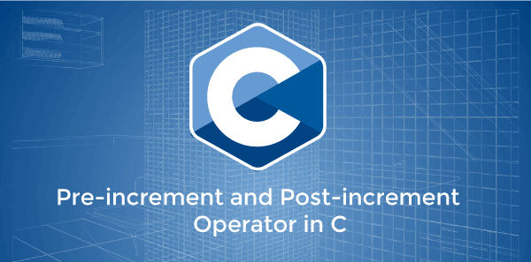
Properties of the Increment operator
There are some properties of the increment operator, as follows:
- The increment operator is used to increase the current value of the variable by 1.
- We can only use these operators with variables.
- It is the operator represented by the double plus (++) symbol.
There are two types of the increment operators
- Pre-increment operator
- Post-increment operator
Pre-increment operator
The pre-increment operator is represented as the double plus (++a) symbol, appended before the variable's name. The pre-increment operator is used to increment the value of an operand by 1 before using it in the mathematical expression. In other words, the value of a variable is first incremented, and then the updated value is used in the expression.
Syntax
x = ++a;
In the above syntax, the value of variable 'a' is first incremented by 1 before using in the expression.
Example 1: Let's create a simple program to use the pre-increment operator in C programming language.
Program1.c
#include <stdio.h>
#include <conio.h>
int main ()
{
// declaration of the variables
int a = 7;
int b = 2

// print the value of the increment operator
printf (" Use the pre-increment operator " );
printf (" The value of a is %d ", a);
printf (" The value of b is %d ", b);
// use pre-increment operator
b = ++a;
printf (" After using the pre-increment operator ");
printf (" The value of a is %d ", a);
printf (" The value of b is %d ", b);
return 0;
}
Output
Use the pre-increment operator
The value of a is 7
The value of b is 2
After using the pre-increment operator
The value of a is 8
The value of b is 10
Example 2: Let's create another program to use the pre-increment operator in mathematical expression.
Program2.c
#include <stdio.h>
#include <conio.h>
int main ()
{
// declare integer variables
int a, b, c, d, x;

// initialization of the variables
a = 5;
b = 7;
c = 12;
d = 15;

// use pre-increment operator in the mathematical expression
x = ++a + ++b + ++c + ++d;
printf ( " The value of x is: %d ", x);

// print the updated value of a, b, c, and d
printf (" \n The updated value of a = %d, b = %d, c = %d and d = %d ", a, b, c, d);
return 0;
}
Output
The value of x is: 43
The updated value of a = 6, b = 8, c = 13 and d = 16
Post-increment Operator
Post-increment is an increment operator, represented as the double plus (a++) symbol followed by an operator 'a'. It increments the value of the operand by 1 after using it in the mathematical expression. In other words, the variable's original value is used in the expression first, and then the post-increment operator updates the operand value by 1.
Syntax
x = a++;
In the above syntax, the operand 'a' value is assigned to the variable x, and then the post increment operator increases or updates the value of 'a' by 1.
Example 1: Let's create a simple program to use the post-increment operator in C programming language.
Program1.c
#include <stdio.h>
#include <conio.h>
int main ()
{
// declaration of the variables
int a = 7;
int b = 0;

// print the value of the increment operator
printf (" Before using the post-increment operator " );
printf (" \n The value of a is %d ", a);
printf (" \n The value of b is %d ", b);
// use post increment operator
b = a++;
printf (" \n\n After using the post-increment operator ");
printf (" \n The value of a is %d ", a);
printf (" \n The value of b is %d ", b);
return 0;
}
Output
Before using the post-increment operator
The value of a is 7
The value of b is 0

After using the post-increment operator
The value of a is 8
The value of b is 7
Example 2: Let's create another program to use the post-increment operator in mathematical expression.
Program2.c
#include <stdio.h>
#include <conio.h>
int main ()
{
// declare integer variables
int a, b, c, d, x;

// initialization of the variables
a = 5;
b = 7;
c = 12;
d = 15;

// use post-increment operator in the mathematical expression
x = a++ + b++ + c++ + d++;
printf ( " The value of x is: %d ", x);

// print the updated value of a, b, c, and d
printf (" \n The updated value of a = %d, b = %d, c = %d and d = %d ", a, b, c, d);
return 0;

}
Output
The value of x is: 39
The updated value of a = 6, b = 8, c = 13 and d = 16
Program to use the Pre-increment and Post-increment Operator
Let's create a simple program to use the pre-increment and post-increment operator in the C programming language.
Program3.c
#include <stdio.h>
#include <conio.h>
int main ()
{
int x, y, z, exp;

printf (" Enter the value of x: ");
scanf (" %d", &x);
printf (" \n Enter the value of y: ");
scanf (" %d", &y);
printf (" \n Enter the value of z: ");
scanf (" %d", &z);

printf (" \n Before using the increment operator: ");
printf (" \n The original value of x: %d", x);
printf (" \n The original value of x: %d", y);
printf (" \n The original value of x: %d", z);

// use pre-increment and post-increment operator
exp = x++ + ++x + ++y + y++ + ++z;
printf (" \n\n After using the increment operator: ");
printf (" \n The result of the expression is: %d", exp);
printf (" \n The updated value of x: %d", x);
printf (" \n The updated value of y: %d", y);
printf (" \n The updated value of z: %d", z);
return 0;

}
Output
Enter the value of x: 7

Enter the value of y: 12

Enter the value of z: 15

Before using the increment operator:
The original value of x: 7
The original value of x: 12
The original value of x: 15

After using the increment operator:
The result of the expression is: 58
The updated value of x: 9
The updated value of y: 14
The updated value of z: 16

Pointer vs array in C
Generally, in most cases, users assume that the pointer and array are both the same thing. However, it is not that simple because we will find some distinct differences if we look deeply at both. Therefore in this article, we will see whether the pointer and array are really the same or not.
Definition of array
Arrays are generally used for storing the same types of data items or values that are same in the nature. Although arrays cannot be used to store the data items or values that are not same in the nature, it is also considered a significant disadvantage of the arrays.
Syntax:
int mark[5] = {19, 10, 8, 17, 9};
Definition of the pointers
Apart from the arrays, if we talk about the pointer, they are generally used for storing the memory address of the other variable instead of storing the actual value of the variable. However, we can also use the pointer to access the whole array by using the pointer arithmetic. In addition, it also even makes the accessing array process much faster.
Syntax:
The pointer variable can be as declared as shown below:
//Declaration in C++
type * name;
What are the main differences between pointers and arrays?
Apart from what we have discussed above, the key differences can be found while implementing the pointer and array. For example, when the arrays are implemented, the fixed size of the memory block is allocated. On the other hand, where the pointers are implemented, the memory is dynamically allocated. Thus, allocating the memory in both the pointers and arrays can be considered the key difference. However, it is not the only difference that lies between the arrays and pointer because some other differences also do exist that are as follows:
- An array usually stores the variables ofsimilar data types, and the data types of the variables must match the type of array. However, the pointer variable stores the address of a variable of a type similar to a type of pointer variable type.
- We can generate an array of pointers, i.e. array whose variables are the pointer variables. On the other hand, we can also create a pointer that points to an array.
- In general, arrays are static, which means once the size of the array is declared, it cannot be resized according to users requirements. While on the other hand, pointers are dynamic, which means the memory allocated can be resized later at any point in time.
- Arrays are allocated at compile-time, while pointers are allocated at runtime
- If we talk about the size of an array, it usually depends on the number of variables are stored in it. While in the case of the pointer variable, it stores the address of the variable only. To understand it more clearly, you can consider the following given examples:
- The "sizeof" operator
If we use the "sizeof(array)", it will return the amount of memory used by all elements stored in the array. However, if we use the it for the pointer, e.g. "sizeof(pointer)", it only returns the amount of memory used by the pointer variable itself.
Comparison Chart
Lets us see the quick comparison chart to understand the difference between both arrays and pointers in an easier manner:
Basis for Comparison | Pointer | Array
Declaration | //In C++type * var_name; | //In C++type var_name[size];//In Java.type var-name[ ];var_name = new type[size];
Working | It generally stores the address of another variable of the same data type as the pointer variable's datatype. | Array usually stores the value of the variable of the same datatype.
Generation | A pointer to an array can be generated. | An array of pointers can be generated.
Storage | Pointers are specially designed to store the address of variables. | A normal array stores values of variables, and pointer array stores the address of variables.
Capacity | Usually, arrays can store the number of elements the same size as the size of the array variable. | A pointer variable can store the address of only one variable at a time.

Conclusion
In this article, we have explained the key differences between Array and Pointers. Therefore, after reading this article, we hope that your confusion about pointer and array will be cleared forever.

Restrict keyword in C
In this article, we will learn what is restrict keyword in C and how to use it in C programs. However, it was first introduced in the C99 version of the C language. So, let us see what exactly this restricted keyword is.
Introduction
Generally, the restrict keyword is mainly used for deceleration of pointer as a type of quantifier of the pointers. However, this keyword does not add any type of new functionalities or any new features to it, so what is the reason behind using it. The answer is quite straightforward because programmers can inform the compiler to optimize what can be optimized using this keyword.
In other words, we can say that whenever the "restrict" keyword is used with a pointer such as ptr, it informs the compiler that ptr is the only way to access the object pointed by it. Although, the compiler does not add and performs any additional checks. In short, there should be no other pointer which points to that particular object. However, if any user somehow violates this condition, it is quite possible that the user will get undefined results, or his program may behave abnormally.

Note: C++ does not support the restrict keyword, and it's only a keyword of the C programming language.
To understand the use of "restrict" keywords in more detail, you can consider the following given examples in which we have used the "restrict" keywords in as simple ways as possible.
Example 1
#include <stdio.h>
/* In this function we are adding the value of variable c to other variables a and y */
void function(int* a, int* b, int* restrict c)
{
*a += *c;
/* Updating value of variable a by adding the value of variables a and c */
*b += *c;
/* Updating value of variable b by adding the value of variables b and c. Since c is restrict, compiler will not reload value at address c in its assembly code. Therefore generated assembly code will be optimized */
}
int main(void)
{
int a = 50 , b = 100 , c = 150 ;
function(&a, &b, &c);
printf("%d %d %d", a, b, c);
}
Output
200 250 150
Example 2
#include <stdio.h>
void my_function(int* x, int* y, int* restrict z) {
*x += *z;
*y += *z;
}
main(void) {
int x = 10, y = 20, z = 30;
my_function(&x, &y, &z);
printf("%d %d %d", x, y, z);
}
Output
40 50 30
Q1. Where can you use a restrict keyword?
A. To a pointer
Syntax:
int* restrict p;
Q2. What'll compiler assume if you add a 'restrict' keyword to the pointer?
A. It'll assume that memory pointed by 'p', will be exclusively pointed by only 'p'.
Q3. How does the compiler's optimization help?
A. In general a data pointed by a pointer can be modified by any other pointer as well. In general, for every instruction you execute that involves reading a pointer - you need to reload the stored value in the pointer(value pointed by) to the CPU register. But once you know it has only one pointer, you can skip reloading again in some cases.
Conclusion
In this article, we have explained restrict keyword of the C language, and we have tried to keep things as simple as possible. In addition, answered some basic questions that are generally asked related to the "restrict" keyword.

The exit() function in C
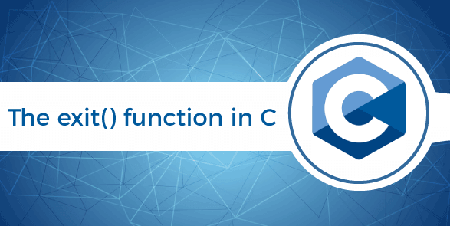
The exit() function is used to terminate a process or function calling immediately in the program. It means any open file or function belonging to the process is closed immediately as the exit() function occurred in the program. The exit() function is the standard library function of the C, which is defined in the stdlib.h header file. So, we can say it is the function that forcefully terminates the current program and transfers the control to the operating system to exit the program. The exit(0) function determines the program terminates without any error message, and then the exit(1) function determines the program forcefully terminates the execution process.
Important points of the exit() function
Following are the main points of the exit function in C programming as follows:
- We must include the stdlib.h header file while using the exit () function.
- It is used to terminate the normal execution of the program while encountered the exit () function.
- The exit () function calls the registered atexit() function in the reverse order of their registration.
- We can use the exit() function to flush or clean all open stream data like read or write with unwritten buffered data.
- It closed all opened files linked with a parent or another function or file and can remove all files created by the tmpfile function.
- The program's behaviour is undefined if the user calls the exit function more than one time or calls the exit and quick_exit function.
- The exit function is categorized into two parts: exit(0) and exit(1).
Syntax of the exit() function
void exit ( int status);
The exit() function has no return type.
int status: It represents the status value of the exit function returned to the parent process.
Example 1: Program to use the exit() function in the for loop
Let's create a program to demonstrate the exit (0) function for normal terminating the process in the C programming language.
#include <stdio.h>
#include <stdlib.h>
int main ()
{
// declaration of the variables
int i, num;
printf ( " Enter the last number: ");
scanf ( " %d", &num);
for ( i = 1; i<num; i++)
{
// use if statement to check the condition
if ( i == 6 )

/* use exit () statement with passing 0 argument to show termination of the program without any error message. */
exit(0);

else

printf (" \n Number is %d", i);
}
return 0;
}
Output
Enter the last number: 10

Number is 1
Number is 2
Number is 3
Number is 4
Number is 5
There are two types of exit status in C
Following are the types of the exit function in the C programming language, as follows:
- EXIT_ SUCCESS
- EXIT_FAILURE
EXIT_SUCCESS: The EXIT_ SUCCESS is the exit() function type, which is represented by the exit(0) statement. Where the '0' represents the successful termination of the program without any error, or programming failure occurs during the program's execution.
Syntax of the EXIT SUCCESS
exit (EXIT_SUCCESS);
Example 1: Program to demonstrate the usage of the EXIT_SUCCESS or exit(0) function
Let's create a simple program to demonstrate the working of the exit(0) function in C programming.
#include <stdio.h>
#include <stdlib.>
int main ()
{
printf ( " Start the execution of the program. \n");
printf (" Exit from the program. \n ");
// use exit (0) function to successfully execute the program
exit (0);
printf ( "Terminate the execution of the program.\n ");
return 0;
}
Output
Start the execution of the program.
Exit from the program.
Example 2: Program to use the EXIT_SUCCESS macro in the exit() function
Let's create a C program to validate the whether the character is presents or not.
#include <stdio.h>
#include <stdlib.h>
int main ()
{
// declaration of the character type variable
char ch;
printf(" Enter the character: ");
scanf (" %c", &ch);

// use if statement to check the condition
if ( ch == 'Y')
{
printf(" Great, you did it. ");
exit(EXIT_SUCCESS); // use exit() function to terminate the execution of a program
}
else
{
printf (" You entered wrong character!! ");
}
return 0;
}
Output
Enter the character: Y
Great, you did it.
EXIT_FAILURE: The EXIT_FAILURE is the macro of the exit() function to abnormally execute and terminate the program. The EXIT_FAILURE is also represented as the exit(1) function. Whether the '1' represents the abnormally terminates the program and transfer the control to the operating system.
Syntax of the EXIT_FAILURE
exit (EXIT_FAILURE);
Example 1: Let's create a program to use the EXIT_FAILURE or exit(1) function
#include <stdio.h>
#include <stdlib.h>
int main ()
{
int num1, num2;
printf (" Enter the num1: ");
scanf ("%d", &num1);

printf (" \n Enter the num2: ");
scanf ("%d", &num2);

if (num2 == 0)
{
printf (" \n Dividend cannot be zero. ");

// use EXIT_FAILURE
exit(1);
}

float num3 = (float)num1 / (float)num2;
printf (" %d / %d : %f", num1, num2, num3);

// use the EXIT_SUCCESS
exit(0);
}
Output
Enter the num1: 20
Enter the num2: 6
20 / 6 : 3.333333

2nd Run
Enter the num1: 20
Enter the num2: 6
Dividend cannot be zero
Example 2: Let's create another program to use the EXIT_FAILURE to terminate the C program.
#include <stdio.h>
#include <stdlib.h>
int main ()
{

// declare the data type of a file
FILE *fptr = fopen ( "javatpoint.txt", "r" );
// use if statement to check whether the fptr is null or not.
if ( fptr == NULL)
{
fprintf ( stderr, "Unable to open the defined file \n" );
exit ( EXIT_FAILURE); // use exit function to check termination
}
// use fclose function to close the file pointer
fclose (fptr);
printf ( " Normal termination of the program. ");
return 0;
}
Output
Unable to open the defined file.

Const Qualifier in C
In general, the const qualifier is used to declare a variable as constant, meaning its value cannot change once the variable has been initialized. However, there are several benefits of using const, such as if we have a constant value of the PI, we wouldn't like any part of the program to modify that value. Therefore we can declare it as a const using the const qualifier. But it has a little twist as usual because sometimes we are able to change the values of variables that are declared with const qualifiers. However, this is not always possible as it depends on where the const variables are stored in memory.
Syntax of const variable
const Data_Type Identifier = Value;
In General, the const qualifier only gives only an indication to the compiler that the value of qualify object cannot be changed. In other words, we can say that the const means not modifiable (cannot assign any value to the object at the run time).
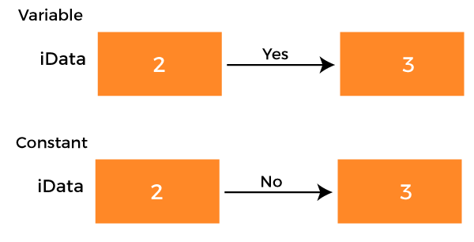
However, when we declare an identifier as constant using the const qualifier, it depends on the implementation (or on the compiler) where the "constant variable" will go or stored in the process control block. Thus several machines store the constant and jump tables in the text section, which only reads and contains all other executable instructions.
Rules
There are few rules that can help us decide when to use a const in the C program:
- We can use it when we don't want to change the variable's value after the initialization.
- In the case of call by reference, when we don't want to change the value of the passed variable. For e.g.,
- int Display ( const char *pcMessage)
- We can also use it while mapping the I/O register with the help of pointers in C.
Now, let us see some examples in which we will use the const qualifier in our program with a pointer:
1. Pointer to constant
Syntax
const int *xData;
or
int const *xData;
As you can see in the above declaration that "xData" is pointing to a constant integer variable. Therefore we cannot change the value of the pointed integer variable using the pointer (*xData), but we can change the pointer to point to any other integer variable. So now it is possible that, the pointer can point to any other variable because it is usually stored in the R&W area (or read and write memory). So lets us see an example of how we can implement it with the help of following the given examples.
Example 1
In this example, we will try to change the value of the integer variable using the pointer to constant (piIndex). However, If a user tries to change the value of the variable (iIndexData1) using the *piData, he will get the compiler error.
Program
#include <stdio.h>
int main(void)
{
/*Integer variable*/
int iIndexData1 = 2;
/*pointer to const int*/
const int *piIndex = NULL;
/*Assign the address of iIndexData to a pointer to const,here integer variable qualify to const integer its called up qualification which is valid in c*/
piIndex = &iIndexData1;
*piIndex = 3; /*Try to change value constant object*/
printf("Data is %d",*piIndex);
return 0;
}
Output
In function 'main':error: assignment of read-only location '*piIndex'
*piIndex = 3;
Example 2
Now, we will try to change the pointing variable in this example.
Program
#include <stdio.h>
int main(void)
{
/*Integer variable1*/
int iIndexData1 = 2;
/*Integer variable2*/
int iIndexData2 = 4;
/*Assign address of iIndexData to pointer to const,
here integer variable qualify to const integer*/
const int* piIndex = &iIndexData1;
printf("*piIndex is %d\n",*piIndex);
/*It's invalid because pointer is constant*/
piIndex = &iIndexData2;
printf("*piIndex is %d\n",*piIndex);
return 0;
}
Output
*piIndex is 2
*piIndex is 4
You can see that the above give code works perfectly, and we have successfully changed the pointing variable:
2. Constant pointer to a constant:
Syntax
const int *const piData;
As you can see in the above declaration, it is described that the constant pointer is pointing to a constant integer variable. This means we cannot change the value pointed by the pointer, and we can also not point the pointer to other integer variables.
Example 1
In this example, we will use the concept of a constant pointer to a constant.
Program
#include <stdio.h>
int main(void)
{
//Integer variable1
int Data = 2;
//const pointer to const int
const int *const piData = &Data;
printf("*piData is %d\n",*piData);
return 0;
}
Output
*piData is 2
As you can see that everything is working fine if we don't try to change the value of piData and *piData.
Example 2
In this example, we will try to change the value of *piData. However, according to the concept, we will get the compiler error because *piData qualify to constant. Now let's see what happens:
Program
#include <stdio.h>
int main(void)
{
//Integer variable
int Data = 2;
//const pointer to const int
const int *const piData = &Data;
//changing the value
*piData = 3;
printf("*piData is %d\n",*piData);
return 0;
}
Output
Error: assignment of read-only location '*piData'
As you can see in the Output, we cannot change the value of "*pidata".
Example 2
Here we will see that can we can point another integer variable to the pointer. Lets us see what happens:
Program
#include <stdio.h>
int main(void)
{
/*Integer variable1*/
int Data1 = 2;
/*Integer variable2*/
int Data2 = 4;
const int* const piData = &Data1;
//Display data
printf("*piData is %d\n",*piData);
/*It's invalid because pointer is constant*/
piData = &Data2;
printf("*piData is %d\n",*piData);
return 0;
}
Output
Error: assignment of read-only variable 'piData'
In the Output of both above given programs, you can see that in case of constant pointer to constant, we cannot change the constant value and neither we can point the constant pointer to another variable.

Sequence Points in C
In this article, we will learn what are Sequence Points in C Programming Language are. Furthermore, to understand them more easily, we will also discuss some examples of sequence points along with their practical implementation.
Introduction
In general, we can consider the sequence point as it defines any point in the execution of a computer program at which it guarantees or ensures that all the side effects of the previous evaluation of the program's code are done or successfully performed. However, it also ensures that none of the alterations or side effects of the subsequent evaluations is yet performed at all. In other words, we can say that in imperative programming, a sequence point defines any point in the execution of a computer program at which it is guaranteed that all the side effects of the previous evaluation would have been done. In addition, No side effects from the subsequent evaluation have been performed yet. It's quite possible that the word "side effect" may be confusing to you here. However, if it does, then let us see what exactly is the "side effect" is.
Side Effect
The term "Side Effect" is nothing but the side effect or changes done by any sort of function or expression where the state of something gets changes.
To understand the sequence point more detail, you can consider the following given examples:
Example 1
#include <stdio.h>
int f1() { printf ("hi,there"); return 1;}
int f2() { printf ("hello, there"); return 1;}
int main()
{
int p = f1() + f2();
return 0;
}
The output of the above-given program is undefined or non-predictive because the output of the above program will differ on the different machine or compiler because it is like asking for the value of an undefined automatic variable. The main reason behind the undefined behaviour of the above program is that the "+" operator does not have any defined standard order of evaluation for its operand. Therefore, we can not predict which function "f1" or "f2" will execute first. However, several other operators are available similar to the "+" operator such as '-', '/', '*', Bitwise AND &, Bitwise OR |, .. etc.
Example 2
#include <stdio.h>
int x = 20;
int f1() { x = x+10; return x;}
int f2() { x = x-5; return x;}
int main()
{
int p = f1() + f2();
printf ("p = %d", p);
return 0;
}
The output of the above program is also undefined because even evaluation of the expression can also cause side effects. For example, in the above program, the final value of p is ambiguous because it totally depends on the order of expression evaluation. Therefore, if the function "f1();" executes first, the value of p will be 55; otherwise 40.
Sequence points
These are some of the basic sequence points available in C Language
- logical AND &&
- logical OR ||
- conditional ?
- comma ,
1. logical AND &&
In case of the logical AND && operator, its left operand will be completly executed first, and it's all side effects before continuing. However, if the left operand evaluates to false, the execution process will stop, and the other operand will not execute at all.
2. logical OR ||
In the case of logical OR ||, its left operand has to be completely executed first and all its side effects before continuing. However, if the left operand evaluates to false (or nonzero), the other operand would not be executed at all.
3. Conditional?
In the case of the conditional operator, The first operand of the conditional operator will be evaluated first, and all its side effects are completed before continuing.
4. comma,
The left operand of the comma operator has to be completely evaluated first, and all its side effects have to be taken place before continuing. However, both operands of the comma operator are always evaluated.

Note: The comma operator in a function call does not guarantee the order of evaluation.

Anagram in C
This section will discuss the anagram and its program to check whether the given string is the Anagram or not. An anagram of a string is a string that contains the same characters in both the strings, except the order of characters can be different in the strings. In other words, anagrams are a technique of C programming that checks whether a given string contains the same number of characters, except that the sequence of characters can be changed in both strings.

For example, suppose we have two strings: "CAB" and "ABC". Both contain the same characters in these strings, but the arrangements of the first strings' characters are different from the second strings, and the process is termed the anagram of strings.

Algorithm of the Anagram string
Following are the algorithms of the anagram string in C, as follows:
- Input two strings from the user.
- Check the length of each string. If the length of the first string is not equal to the second string, the strings are not an anagram.
- If the length of both strings is equal, convert the string's characters into lower case letters that make the comparison of the string easier.
- After this, sort the characters of the strings using the built-in function of the C library to sort the strings. And if there is no built-in function, we convert the string to a character array.
- We must sort the converted string into a character array.
- And last, we check for the equality of the strings.
Example 1: Program to check the anagram of the string using user-defined function
#include <stdio.h>

// function definition
int get_anagrm (char [],char []);

int main ()
{
// declaration of the array
char arr1 [50], arr2 [50];
int count;

printf (" Enter the first string: \n ");
scanf (" %s", arr1);

printf (" Enter the second string: \n ");
scanf (" %s", arr2);

// call function
count = get_anagrm (arr1, arr2);

// use if-else statement to validate both strings are anagram or not.

if (count == 1)
{
printf (" %s and %s strings are an anagram of each other. \n", arr1, arr2);
}
else
{
printf (" %s and %s strings are not an anagram of each other. \n", arr1, arr2);
}

return 0;
}

// function defnition
int get_anagrm (char arr1[], char arr2[])
{
// create two num arrays and initialize their value as 0
int num1[20] = {0}, num2[20] = {0}, i = 0;

// use while loop to check arr1 is not null
while (arr1[i] != '\0')
{
num1[arr1[i] -'a']++;
i++;
}

i = 0;

// use while loop to check arr2 is not null
while (arr2[i] != '\0')
{
num2[arr2[i] -'a']++;
i++;
}

for ( i = 0;i <20; i++)
{
if ( num1[i] != num2[i])
return 0;
}
return 1;
}
Output
Enter the first string:
pine
Enter the second string
nipe
pine and nipe strings are an anagram of each other.

2nd time run:
Enter the first string:
pine
Enter the second string
nip
pine and nip strings are not an anagram of each other.
Example 2: Program to check the anagram of the string using nested for loop
#include <stdio.h>
#include <stdbool.h>
#include <string.h>

// define the no. of characters
#define No_Character 30

// use bool function to check the strings are anagrams
bool strAna (char *st1, char *st2)
{
// create two arrays and initialized with 0
int arr1[No_Character] = {0};
int arr2[No_Character] = {0};

int n = 0;
// check the length of each string
if (strlen (st1) != strlen (st2))
return false;

// use for loopto incremnet the array index
for ( n = 0; st1[n] && st2[n]; n++)
{
// increment the string character
// ascii value of a is 97
arr1[st1[n]-97]++;
arr2[st2[n]-97]++;
}

// arr1 is compared using the assigned value
for (n = 0; n < No_Character; n++)
{
if (arr1[n] != arr2[n])
return false;
return true;
}
}

int main ()
{
char st1[50], st2[50];

printf (" Input the first string: ");
gets(st1);

printf (" Input the second string: ");
gets(st2);
// call strAna function to check the anagram of the string
if (strAna (st1, st2))
{
printf (" \n The first string is an anagram of the second string. ");
}
else
{
printf (" \n The first string is not an anagram of the second string. ");
}
return 0;
}
Output
Input the first string: triangle
Input the second string: agtrinle
The first string is an anagram of the second string.
Example 3: Program to check the anagram of the string using the for and if statement
#include <stdio.h>
#include <string.h>
int main ()
{
// declare the character type array
char arr1[30], arr2[30];
int len1, len2, num, i, j, found = 0, not_found = 0;

printf (" Input the first string: ");
scanf ("%s", arr1);

printf (" Input the second string: ");
scanf ("%s", arr2);

// get the length of the strings
len1 = strlen (arr1);
len2 = strlen (arr2);

// use if statement to check the length is equal or not
if (len1 == len2)
{
num = len1; // assign the length to num variable
for ( i = 0; i < num; i++)
{
found = 0;
for ( j = 0; j < num; j++)
{
// check string is equal or not
if (arr1[i] == arr2[j])
{
found = 1;
break;
}
}

if (found == 0)
{
not_found = 1; // assign 1 to not_found
break;
}
}
if (not_found == 1)
printf (" \n The first string is not an anagram of the second string. ");
else
printf (" \n The first string is an anagram of the second string. ");
}
else
printf (" \n Both string must contains same number of character to be the anagram of string. ");

return 0;
}
Output
Input the first string: SILENCE
Input the second string: LENSICE
The first string is an anagram of the second string.
Example 4: Program to sort the string and check the anagram of the strings
#include <stdio.h>
#include <conio.h>
#include <string.h>

// declaration of the functions
void cnvt_to_lwr (char []);
void sortArr (char []);

int main ()
{
char str1[] = "course", str2[] = "source";
int x, y = 0;

// check the length of each string
if (strlen (str1) != strlen (str2))
{
printf(" The given strings are not anagram of each other. ");
return 0;
}

else
{
// convert string into lowercase
cnvt_to_lwr (str1);
cnvt_to_lwr (str2);

// call sortArr() function to sort the arrays
sortArr (str1);
sortArr (str2);
for (x = 0; x < strlen (str1); x++)
{
// check string is equal or not
if (str1[x] != str2[x])
{
printf (" The given strings are not an anagram of each other.");
return 0;
}
}
printf ( " Both strings are an anagram of each other. ");
}
return 0;

}

// function definition here
void cnvt_to_lwr (char a1[])
{
int num;
for ( num = 0; num < strlen(a1) -1; num++)
{
a1[num] = a1[num] + 32;
}
}

// sorting here
void sortArr (char a1[])
{
int temp = 0, i, l;

for (i = 0; i <strlen(a1) - 1; i++)
{
for ( l = i+1; l < strlen (a1); l++)
{
if (a1[i] > a1[l])
{
temp = a1[i];
a1[i] = a1[l];
a1[l] = temp;

}
}
}

}
Output
Both strings are an anagram of each other.

Increment and Decrement Operators in C
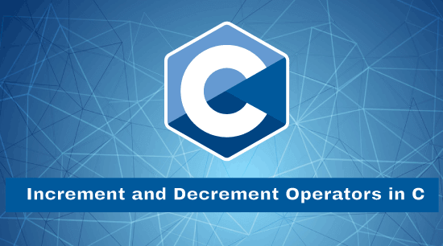
Operators are the predefined symbols of the C/C++ library, and it is used to perform logical as well as mathematical operations to the operands. There are various types of operators in the C programming language, such as arithmetic, logical, bitwise, increment or decrement operators, etc.

Increment Operator
Increment Operators are the unary operators used to increment or add 1 to the operand value. The Increment operand is denoted by the double plus symbol (++). It has two types, Pre Increment and Post Increment Operators.
Pre-increment Operator
The pre-increment operator is used to increase the original value of the operand by 1 before assigning it to the expression.
Syntax
X = ++A;
In the above syntax, the value of operand 'A' is increased by 1, and then a new value is assigned to the variable 'B'.
Example 1: Program to use the pre-increment operator in C
#include <stdio.h>
#include <conio.h>
int main ()
{
// declare integer variables
int x, y, z;
printf (" Input the value of X: ");
scanf (" %d", &x);
printf (" Input the value of Y: ");
scanf (" %d", &y);
printf (" Input the value of Z: ");
scanf (" %d", &z);
// use pre increment operator to update the value by 1
++x;
++y;
++z;

printf (" \n The updated value of the X: %d ", x);
printf (" \n The updated value of the Y: %d ", y);
printf (" \n The updated value of the Z: %d ", z);
return 0;
}
Output
Input the value of X: 10
Input the value of Y: 15
Input the value of Z: 20

The updated value of the X: 11
The updated value of the Y: 16
The updated value of the Z: 21
Post increment Operator
The post-increment operator is used to increment the original value of the operand by 1 after assigning it to the expression.
Syntax
X = A++;
In the above syntax, the value of operand 'A' is assigned to the variable 'X'. After that, the value of variable 'A' is incremented by 1.
Example 2: Program to use the post-increment operator in C
#include <stdio.h>
#include <conio.h>
int main ()
{
// declare integer variables
int x, y, z, a, b, c;
printf (" Input the value of X: ");
scanf (" %d", &x);
printf (" Input the value of Y: ");
scanf (" %d", &y);
printf (" Input the value of Z: ");
scanf (" %d", &z);
// use post-increment operator to update the value by 1
a = x++;
b = y++;
c = z++;

printf (" \n The original value of a: %d", a);
printf (" \n The original value of b: %d", b);
printf (" \n The original value of c: %d", c);

printf (" \n\n The updated value of the X: %d ", x);
printf (" \n The updated value of the Y: %d ", y);
printf (" \n The updated value of the Z: %d ", z);
return 0;
}
Output
Input the value of X: 10
Input the value of Y: 15
Input the value of Z: 20

The original value of a: 10
The original value of b: 15
The original value of c: 20

The updated value of the X: 11
The updated value of the Y: 16
The updated value of the Z: 21
Decrement Operator
Decrement Operator is the unary operator, which is used to decrease the original value of the operand by 1. The decrement operator is represented as the double minus symbol (--). It has two types, Pre Decrement and Post Decrement operators.
Pre Decrement Operator
The Pre Decrement Operator decreases the operand value by 1 before assigning it to the mathematical expression. In other words, the original value of the operand is first decreases, and then a new value is assigned to the other variable.
Syntax
B = --A;
In the above syntax, the value of operand 'A' is decreased by 1, and then a new value is assigned to the variable 'B'.
Example 3: Program to demonstrate the pre decrement operator in C
#include <stdio.h>
#include <conio.h>
int main ()
{
// declare integer variables
int x, y, z;
printf (" Input the value of X: ");
scanf (" %d", &x);
printf (" \n Input the value of Y: ");
scanf (" %d", &y);
printf ("n Input the value of Z: ");
scanf (" %d", &z);
// use pre decrement operator to update the value by 1
--x;
--y;
--z;

printf (" \n The updated value of the X: %d ", x);
printf (" \n The updated value of the Y: %d ", y);
printf (" \n The updated value of the Z: %d ", z);
return 0;
}
Output
Input the value of X: 5
Input the value of Y: 6
Input the value of Z: 7

The updated value of the X: 6
The updated value of the Y: 7
The updated value of the Z: 8
Post decrement Operator:
Post decrement operator is used to decrease the original value of the operand by 1 after assigning to the expression.
Syntax
B = A--;
In the above syntax, the value of operand 'A' is assigned to the variable 'B', and then the value of A is decreased by 1.
Example 4: Program to use the post decrement operator in C
#include <stdio.h>
#include <conio.h>
int main ()
{
// declare integer variables
int x, y, z, a, b, c;
printf (" Input the value of X: ");
scanf (" %d", &x);
printf (" Input the value of Y: ");
scanf (" %d", &y);
printf (" Input the value of Z: ");
scanf (" %d", &z);
// use post-decrement operator to update the value by 1
a = x--;
b = y--;
c = z--;

printf (" \n The original value of a: %d", a);
printf (" \n The original value of b: %d", b);
printf (" \n The original value of c: %d", c);

printf (" \n\n The updated value of the X: %d ", x);
printf (" \n The updated value of the Y: %d ", y);
printf (" \n The updated value of the Z: %d ", z);
return 0;
}
Output
Input the value of X: 6
Input the value of Y: 12
Input the value of Z: 18

The original value of a: 6
The original value of b: 12
The original value of c: 18

The updated value of the X: 5
The updated value of the Y: 11
The updated value of the Z: 17
Example 5: Program to perform the pre increment and pre decrement operator
#include <stdio.h>
#include <conio.h>
int main ()
{
// declare integer data type variable
int i, j, x, y;
printf (" Enter the value of i " );
scanf (" %d", &i);
printf (" Enter the value of j " );
scanf (" %d", &j);

// use pre increment operator to update original value by 1
x = ++i;
printf (" After using the pre-incrementing, the value of i is %d \n", i);
printf (" The value of x is %d \n", x);

// use pre decrement operator to decrease original value by 1
y = --j;
printf (" After using the pre-decrementing, the value of j is %d \n", j);
printf (" The value of y is %d \n", y);
return 0;
}
Output
Enter the value of i
5
Enter the value of j
10
After using the pre-incrementing, the value of i is 6
The value of x is 6
After using the pre-decrementing, the value of j is 9
The value of y is 9
Example 6: Program to print the post increment and post decrement operator
#include <stdio.h>
#include <conio.h>
int main ()
{
// declare integer data type variable
int i, j, x, y;
printf (" Enter the value of i " );
scanf (" %d", &i);
printf (" Enter the value of j " );
scanf (" %d", &j);

// use post increment operator to update original value by 1
x = i++;
printf (" After using the post-incrementing, the value of i is %d \n", i);
printf (" The value of x is %d \n", x);

// use post decrement operator to decrease original value by 1
y = j--;
printf (" After using the post-decrementing, the value of j is %d \n", j);
printf (" The value of y is %d \n", y);
return 0;
}
Output
Enter the value of i 10
Enter the value of j 20
After using the post-incrementing, the value of i is 11
The value of x is 10
After using the post-decrementing, the value of j is 19
The value of y is 20
Difference between the Increment and Decrement Operator in C
Increment Operator | Decrement Operator
It is used to increment the value of a variable by 1. | It is used to decrease the operand values by 1.
The increment operator is represented as the double plus (++) symbol. | The decrement operator is represented as the double minus (--) symbol.
It has two types: pre-increment operator and post-increment operator. | Similarly, it has two types: the pre-decrement operator and the post-decrement operator.
Pre increment operator means the value of the operator is incremented first and then used in the expression.  The post-increment operator means the operand is first used in the expression and then performs the increment operation to the original value by 1. | Pre decrement means the value of the operator is decremented first and then assigned in the expression.  Whereas the post decrement operator means the operand is first used in the expression and then performs the decrement operation to the operand's original value by 1.
Syntax for the pre increment operator: X = ++a;  Syntax for the post increment operator: X = a++; | Syntax for the pre decrement operator: X = --a;  Syntax for the post decrement operator: X = a--;
Both operators' works only to the single operand, not values. | Both operators' works only to the single operand, not values.

Logical AND Operator in C
Logical operators perform logical operations on a given expression by joining two or more expressions or conditions. It can be used in various relational and conditional expressions. This operator is based on Boolean values to logically check the condition, and if the conditions are true, it returns 1. Otherwise, it returns 0 (False). In C programming, logical operators are classified into three types such as the logical AND (&&) operator, the logical OR operator (||), and the logical NOT (!) operator. Here, we learn about the Logical AND operator and its various examples in the C programming language.

Logical AND Operator
The logical AND operator is represented as the '&&' double ampersand symbol. It checks the condition of two or more operands by combining in an expression, and if all the conditions are true, the logical AND operator returns the Boolean value true or 1. Else it returns false or 0.

Note: If the value of both is non-zero, the condition will remain true. Otherwise, the logical AND (&&) operator returns 0 (false).
Syntax
(condition1 && condition2)
There are two conditions in the above syntax, condition1 and condition2, and in between the double (&&) ampersand symbol. If both the conditions are true, the logical AND operator returns Boolean value 1 or true. Otherwise, it returns false.
Truth table of the Logical AND (&&) operator
A | B | A && B
1 | 1 | 1
1 | 0 | 0
0 | 1 | 0
0 | 0 | 0

Example 1: Program to demonstrate the Logical AND Operator in C
#include <stdio.h>
#include <conio.h>

int main ()
{
// declare variable
int n = 20;

// use Logical AND (&&) operator to check the condition
printf (" %d \n", (n == 20 && n >= 8)); // condition is true, therefore it returns 1
printf (" %d \n", (n >= 1 && n >= 20));
printf (" %d \n", (n == 10 && n >= 0));
printf (" %d \n", (n >= 20 && n <= 40));

return 0;
}
Output
1
1
0
1
Example 2: Program to find the largest number using the Logical AND operator
#include <stdio.h>
#include <conio.h>
int main ()
{
// declare integer type variable
int x, y, z;
printf (" Enter the first number: ");
scanf ("%d", &x);
printf (" Enter the second number: ");
scanf ("%d", &y);
printf (" Enter the third number: ");
scanf ("%d", &z);

// use logical AND operator to validate the condition
if ( x >= y && x >= z )
{
printf (" %d is the largest number of all. ", x);
}
else if ( y >= x && y >= z)
{
printf (" %d is the largest number of all. ", y);
}
else
{
printf ( " %d is the largest number of all. ", z);
}
return 0;
}
Output
Enter the first number: 20
Enter the second number: 10
Enter the third number: 50
50 is the largest number of all
Example 3: Program to use the Logical AND (&&) operator to check whether the user is teenager or not.
#include <stdio.h>
#include <conio.h>

int main ()
{
// declare variable
int age;

printf (" Enter the age: ");
scanf (" %d", &age); // get age

// use logical AND operator to check more than one condition
if ( age >= 13 && age <= 19)
{
printf (" %d is a teenager age. ", age);
}
else
{
printf (" %d is not a teenager age. ", age);
}

return 0;
}
Output
Enter the age: 17
17 is a teenager age.

2nd execution:
Enter the age: 10
10 is not a teenager age.
Example 4: Program to validate whether the entered number is in the defined range or not.
#include <stdio.h>

int main ()
{
int num;
printf (" Enter a number between 1 to 50: ");
scanf (" %d", &num); //get the number

// use logical AND operator to check condition
if ( (num > 0 ) && (num <= 50))
{
printf (" The entered number is in the range 0 and 50. ");
}
else if ( ( num > 50 ) && ( num <= 100))
{
printf (" The entered number is in the range 50 and 100. ");
}
else
{
printf (" Please enter the number is in the defined range. ");
}
return 0;

}
Output
Enter a number between 1 to 50: 19
The entered number is in the range 0 and 50.

2nd Run
Enter a number between 1 to 50:
51
The entered number is in the range 50 and 100.

3rd execution:
Enter a number between 1 to 50:
0
Please enter the number is in the defined range.
Example 5: Program to validate the username and password entered by the user is correct or not using the predefined username and password.
#include <stdio.h>
#include <string.h>

// use #define macro to define the values for UserName and Password
#define UserName "system"
#define Password "admin@123"

int main ()
{
// declare character type array
char un[50], pass[50];
// take UserName and Password from user
printf ( " Enter the username: " );
scanf (" %s", un);
printf ( " Enter the password: " );
scanf (" %s", pass);

// use if statement and Logical AND operator to validate the condition
if (strcmp (UserName, un) == 0 && strcmp (Password, pass) == 0)
{
printf (" \n The user's credentials are correct. ");
}
else
{
printf ( " \n The user's credentials are incorrect. ");
}
return 0;
}
Output
Enter the username: system
Enter the password: admin@123

The user's credentials are correct.

2nd execution
Enter the username: system
Enter the password: admin@1234

The user's credentials are incorrect.

Shift Operators in C

This section will discuss the Bitwise shift operators in the c programming language. Bitwise shift operator is used to shift the binary bits either in the left direction or right direction according to the program's requirement.

Shift operators are classified into two types based on the shifting position of the bits.
- Left Shift Operator
- Right Shift Operator
Left Shift Operator
The left shift operator is a type of Bitwise shift operator, which performs operations on the binary bits. It is a binary operator that requires two operands to shift or move the position of the bits to the left side and add zeroes to the empty space created at the right side after shifting the bits.
Syntax
var_name << no_of_position
In the above syntax, var_name represents the integer variable name on which the left shift (<<) operation is to be performed to shift the binary bits at the left side. And the no_of_position variable represents the number of bits to be placed or shifted at the left side. In other words, the left shift operator shifts the binary bits of the first operand on the left side by the defined number of bits to the second operand.
For example, the value of the integer variable num is 22, and its binary form is 10110. Now we use the left shift operator to shift the binary bits 2, the num = num << 2 equal to the num = num * (2^2). And the new value of num is 22* (2 ^ 2) = 88, which is equal to the binary form 1011000.
Example 1: Program to demonstrate the use of the Left Shift operator in C
#include <stdio.h>
int main ()
{
// declare local variable
int num;
printf (" Enter a positive number: ");
scanf (" %d", &num);
// use left shift operator to shift the bits
num = (num << 2); // It shifts two bits at the left side
printf (" \n After shifting the binary bits to the left side. ");
printf (" \n The new value of the variable num = %d", num);
return 0;
}
Output
Enter a positive number: 25
After shifting the binary bits to the left side.
The new value of the variable num = 100
Example 2: Program to use the Left Shift operator in the unsigned int data of the C
#include <stdio.h>
int main ()
{
// declare local variable
unsigned int num = 0xff;
// use left shift operator to shift the bits
num = (num << 2);
printf (" \n After shifting the binary bits to the left side. ");
printf (" \n The new value of the unsigned variable num = %d", num);
return 0;
}
Output
After shifting the binary bits to the left side.
The new value of the unsigned variable num = 1020
Example 3: Program to input the positive number from the user to perform the Left shift operator
#include <stdio.h>
int main ()
{
// declare local variable
int num, bit;
printf (" Enter a positive number: ");
scanf (" %d", &num);

printf (" No. of binary bits shifted to the left side: ");
scanf (" %d", &bit);
// use left shift operator to shift the bits
num = (num << bit);
printf (" \n After shifting the bits to the left side. ");
printf (" \n The new value of the num = %d", num);
return 0;
}
Output
Enter a positive number: 40
No. of binary bits shifted to the left side: 4
After shifting the bits to the left side.
The new value of the num = 640
In the above example, the binary bit of the user-defined positive number 40 is 101000. After that, we take 4 as the number to shift the binary bits on the left side. And then, the left-shifts operator shift 4 binary bits at the left side, and then space is created at the right side, which is filled or added by 4 zeroes to the right side that returns the binary value 1010000000, which is equivalent to the decimal number 640.
Right shift operator
The right shift operator is a type of bitwise shift operator used to move the bits at the right side, and it is represented as the double (>>) arrow symbol. Like the Left shift operator, the Right shift operator also requires two operands to shift the bits at the right side and then insert the zeroes at the empty space created at the left side after shifting the bits.
Syntax
var_name >> no_of_position
In the above syntax, var_name represents the integer variable on which the right shift (>>) operation is to be performed to shift the binary bits at the right side. And the no_of_position variable represents the number of bits to be placed or shifted to the right side. In other words, the right shift operator shifts the binary bits of the first operand at the right side by defining the total number of bits to the second operand.
Example 1: Program to demonstrate the use of the Right Shift operator in C
#include <stdio.h>
int main ()
{
// declare local variable
int num;
printf (" Enter a positive number: ");
scanf (" %d", &num);
// use right shift operator to shift the bits
num = (num >> 2); // It shifts two bits at the right side
printf (" \n After shifting the binary bits to the right side. ");
printf (" \n The new value of the variable num = %d", num);
return 0;
}
Output
Enter a positive number: 25

After shifting the binary bits to the right side.
The new value of the variable num = 6
Example 2: Program to use the Right Shift operator in the unsigned int data of the C
#include <stdio.h>
int main ()
{
// declare local variable
unsigned int num = 0xff;
// use right shift operator to shift the bits
num = (num >> 2);
printf (" \n After shifting the binary bits to the right side. ");
printf (" \n The new value of the unsigned variable num = %d", num);
return 0;
}
Output
After shifting the binary bits to the right side.
The new value of the unsigned variable num = 63
Example 3: Program to input the positive number from the user to perform the Right shift operator
#include <stdio.h>
int main ()
{
// declare local variable
int num, bit;
printf (" Enter a positive number: ");
scanf (" %d", &num);

printf (" No. of binary bits shifted to the right side: ");
scanf (" %d", &bit);
// use right shift operator to shift the bits
num = (num >> bit);
printf (" \n After using the right shift operator to shift the bits at the right side. ");
printf (" \n New value of the num = %d", num);
return 0;
}
Output
Enter a positive number: 40
No. of binary bits shifted to the right side: 4
After using the right shift operator to shift the bits to the right.
The new value of the num = 2

Near, Far, and Huge pointers in C
In this article, we learn some of the old concepts that were usually used and implemented in the 16 bit Intel architectures in the earlier days of Ms-Dos, but they are not used much nowadays. Still, these concepts are very important because they are like the building block of current technology. However, on the basis of the Memory model and segment, pointers can be classified into three types, which are as follows:
- Near pointer
- Far pointer
- Huge pointer
Near pointer
In general, we can consider the near point as it is used to store the address, which has a maximum size of 16 bits only. Using the near pointer, we can not store the address with a size greater than 16 bits. However, we can store all other smaller addresses that are within the 16 bits limit. You may think that the 16 bits are a little small because we can only access 64kb of data at a time. Thus, it is considered one of the major disadvantages of the near pointer, which is why it is no longer commonly used. Lets us see some other important key points that can help us to understand the near pointer.
Syntax
The syntax is as follows -
<data type> near <pointer definition>
The following statement declares a near pointer for the variables
char near *string;
Lets us see some important key points that can help us to understand the "Near" pointer.
- Near pointer cannot access beyond the data segment like graphics video memory, text video memory, etc. The size of the near pointer is two bytes. With the help of keyword near, we can make any pointer a near pointer.
- It is a pointer that works within the range of the 64Kb data segment of memory.
- It cannot access addresses beyond the given data segment.
- A near pointer can be incremented or decremented in the address range by using an arithmetic operator.
To understand the "Near" pointer in more detail lets us see an example:
Example
#include<stdio.h>

int main()
{
int x=25;
int near* ptr;
ptr=&x;
printf("%d",sizeof ptr);
return 0;
}
Output
2
Far Pointer
In general, Far pointer is typically considered as a pointer of 32 bits size. However, it can also access the information stored outside the computer's memory from the current segment. Although to use this type of pointer, we usually need to allocate the sector register to store the data address in the current segment. In addition, we also need to allocate another register to store offset within the current segment.
Syntax
The syntax is given below:
<data type> far <pointer definition>
The following statements declares a far pointer for the variable s
char far *s;
Lets us see some other important key points that can help us to understand the Far pointer.
- When the pointer is incremented or decremented, only the offset part is changed.
- It is such a type of pointer that stores both offset and segment address to which the pointer is differencing.
- A far pointer address ranges from 0 to 1MB.
- It can access all 16 segments.
Example
#include<stdio.h>
int main(){
int number=50;
int far *p;
p=&number;
printf("%d",sizeof number);
return 0;
}
Output
4
Huge pointers
Like the far pointer, the huge pointer also has the same size as 32 bits, but it can even access the bits stored or located outside the segment. However, the far pointer is quite similar to the Huge pointer, but it still has some advantages over the far pointer. For example, the Far Pointer which is fixed; thus, that part of the sector in which they are stored or located can not be changed or modified in any way. However, it is not the case with the Huge pointer because the Huge Pointer has the elasticity which allows it to do that.
Lets us see some other important key points that can help us to understand the "Huge" pointer.
- A pointer that can point to any segment in the memory is known as a huge pointer. A huge pointer has a size of 4 bytes or 32-bits, and it can access up to 64K size in memory.
- The huge pointer can be incremented without suffering with segment work round.
The following-given example shows the usage of the huge pointer.
Example:
#include<stdio.h>
int main()
{
char huge * far *p;
printf("%d %d %d",sizeof(p),sizeof(*p),sizeof(**p));
return 0;
}
Output
4 4 1
In the given program, p is the huge pointer, *p is the far pointer, and **p is the char type data variable.
What is the difference between near, far, and huge pointers?
In general, a virtual address is made up of a selector and an offset. A near-pointer does not have an explicit selector, while huge pointers have an explicit selector. When we perform pointer arithmetic on a far pointer, the selector is not modified, but it can be modified in the case of a huge pointer.

Note: These are non-standard keywords, also implementation-specific, and are irrelevant in modern platforms.

Magic Number in C
In this section, we will discuss magic numbers in C programming language along with their various examples. When the sum of all the given digits of a number and the reverse of that sum is multiplied, which is equal to the original number, and then the number is called a magic number.
For example, suppose we have a 1729 number and we need to validate whether the number is a magic number or not. So, first we need to get the sum of all digits of the number which is 19 (1 + 7 + 2 + 9 = 19). Reverse the sum of the number is 91, and then get the product of the sum of original digits with the reverse of that sum as 19 * 91 = 1729. So, it is the magic number.
Steps to find the Magic number in C
Step 1: Declare an integer type variable and input a number from the user to store it in N.
Step 2: Get the sum of all digits of the original number and store it another variable A.
Step 3: Reverse the number of variable A and store into B.
Step 4: After that, multiply the values of variable A and B and store into C.
Step 5: Check whether C == N, then the number is a Magic Number. Else, the Number is not a Magic number.
Example 1: Program to check whether the number is a Magic number in C
Let's create a program to take a number from the user and validate whether the entered number is a magic number or not in the C programming language.
#include <stdio.h>
#include <conio.h>

int main ()
{
// declare integer variables
int n, temp, rev = 0, digit, sum_of_digits = 0;

printf (" Enter a Number: \n");
scanf (" %d", &n); // get the number

temp = n; // assign the number to temp variable

// use while loop to calculate the sum of digits
while ( temp > 0)
{
// extract digit one by one and store into the sum_of_digits
sum_of_digits = sum_of_digits + temp % 10; /* use modulus symbol to get the remainder of each iteration by temp % 10 */
temp = temp / 10;
}

temp = sum_of_digits; // assign the sum_of_digits to temp variable
printf (" \n The sum of the digits = %d", temp);

// get the reverse sum of given digits
while ( temp > 0)
{
rev = rev * 10 + temp % 10;
temp = temp / 10;
}

printf (" \n The reverse of the digits = %d", rev);

printf (" \n The product of %d * %d = %d", sum_of_digits, rev, rev * sum_of_digits);
// use if else statement to check the magic number
if ( rev * sum_of_digits == n)
{
printf (" \n %d is a Magic Number. ", n);
}
else
{
printf (" \n %d is not a Magic Number. ", n);
}
return 0;

}
When we execute the above program in the C compiler, it produces the below output in the console screen.
Enter a number
1729
The sum of the digits = 19
The reverse of the digits = 91
The product of 19 * 91 = 1729
1729 is a Magic Number.
In the above program, we take 1729 from the user and assign the number to the temp variable. After that, use a while loop to extract the sum of the original digits (n) into sum_of_digits one by one and assign the result to the temp. Use the loop again to reverse the sum of the digits and print the reverse number. And finally compare the original digit (N) with the multiplication of sum_of_digits and rev variable that return the same result to show a magic number.
Example 2: Program to check whether the number is a Magic number using the user-defined function
Let's create an example to take a number from the user and validate whether the entered number is a magic number or not in the C programming language.
/* program to check the magic number using the user-defined function in c programming. */
#include <stdio.h>
#include <conio.h>

// create getReverse () function to get the reverse of the given number
int getReverse (int num)
{
int revNum = 0;

//use while loop to get the reverse of original nummber (n)
while ( num > 0)
{
revNum = (revNum * 10) + (num % 10);
num = num / 10;
}
printf (" \n The reverse of the number = %d", revNum);
return revNum;
}

// create getSum() function to get the sum of each digits of the given number
int getSum ( int num)
{
int sum = 0; // initialize the sum variable with 0
while ( num > 0)
{
sum = sum + ( num % 10);
num = num / 10;
}
printf ( " \n The sum of the given number = %d", sum);
return sum;
}

int main ()
{
// declare variable
int num, sum, revNum;
printf (" Enter the number: ");
scanf (" %d", &num);

sum = getSum (num); // call getSum () function
revNum = getReverse (sum); // callgetReverse () function and argument sum

int result = sum * revNum;
printf (" \n The product of %d and %d = %d ", sum, revNum, result);

// use if else to check condition
if (sum * revNum == num)
{
printf (" \n %d is a magic number. ", num);
}
else
{
printf ( " \n %d is not a magic number. ", num);
}
}
When we execute the above program in the C compiler, it produces the below output in your computer screen.
Enter the number: 1729
The sum of the given number = 19
The reverse of the number = 91
The product of 19 and 91 = 1729
1729 is a Magic Number.
2nd execution:
Enter the number: 5189
The sum of the given number = 23
The reverse of the number = 32
The product of 23 and 32 = 736
5189 is not a magic number.
In the above program, we take 5189 from the user and create two user defined function getSum() and getRevere(). Where the getSum() function is used to calculate the sum of the given number, and the getReverse() function to reverse sum of the getSum() function. If the multiplication of the getSum() and getReverse()function is equal to the num, the number is a magic number.
Method 2: Recursive Method to check the Magic number in C
A number is said to be a magic number, if the sum of the digits is recursively calculated till a single digit which is equal to 1. Otherwise the number is not a magic number
Example 1: Program to find the Magic number using recursive Method
Let's create a program to input the integer data from the user and validate whether the number is a magic number or not in the C programming language.
/* create a program to get the magic number by dividing the given number by 9. */
#include <stdio.h>
#include <conio.h>
int main ()
{
// declare integer variable
int num;
printf ( " Enter the number: ");
scanf (" %d", &num);

// get the modulus of the input number by 9 to check magic number
if ( num % 9 == 1)
{
printf ( " It is a Magic Number. ");
}
else
{
printf ( " it is not a Magic Number. ");
}
return 0;
}
When we execute the above program in the C compiler, it produces the below output in the console screen.
Enter the number: 1789
It is a Magic Number.
2nd execution:
Enter the number: 55057
It is not a Magic Number.

Remove Duplicate Elements from an Array in C
This section will discuss the removing or deletion of the duplicate elements from an array in the C programming language. When the same number of elements occurs in sorted or unsorted array, then the elements of the array is called the duplicate elements. And we need to delete these duplicate elements or same number from an array to make the resultant array consists of unique elements.
For example, there is an integer type array arr[10] that contains { 5, 8, 3, 3, 5, 9} elements. In this array, 3 and 5 occurs two times. Hence, these elements are duplicate elements. So, after deleting the duplicate elements from an array arr[], we get 5, 8, 3,9 elements.
Steps to delete the duplicate elements from unsorted array
Step 1: Input the size of an array from the user and store into the size variable.
Step 2: Use for loop to read the elements of an array and store in arr[i] variable.
Step 3: To get the duplicate elements from an array we need to use two for loops. Where the first loop start from 0 to size. And the structure of the loop is: for (i = 0; i < size; i++).
Another loop selects each element of the array and compare with the corresponding element to get the duplicate elements. And the structure of the inner loop is: for (j = i + 1; j < size; j++) and the code to find the subsequent same element is: if (arr[i] == arr[j]).
Step 4: If any duplicate element is encountered, delete the duplicate element from an array and the size of array is decrement by 1 such that, size = size - 1.
Step 5: After that, print the unique elements of an array and the code is:
for (i = 0; i < size; i++)
{
printf ("%d \t" , arr[i]);
}
Example 1: Program to remove the duplicate elements from an array
Let's consider an example to delete the same number or duplicate elements from an array in the C programming language.
#include <stdio.h>
#include <conio.h>
int main ()
{
// declare local variables
int arr[20], i, j, k, size;

printf (" Define the number of elements in an array: ");
scanf (" %d", &size);

printf (" \n Enter %d elements of an array: \n ", size);
// use for loop to enter the elements one by one in an array
for ( i = 0; i < size; i++)
{
scanf (" %d", &arr[i]);
}

// use nested for loop to find the duplicate elements in array
for ( i = 0; i < size; i ++)
{
for ( j = i + 1; j < size; j++)
{
// use if statement to check duplicate element
if ( arr[i] == arr[j])
{
// delete the current position of the duplicate element
for ( k = j; k < size - 1; k++)
{
arr[k] = arr [k + 1];
}
// decrease the size of array after removing duplicate element
size--;

// if the position of the elements is changes, don't increase the index j
j--;
}
}
}

/* display an array after deletion or removing of the duplicate elements */
printf (" \n Array elements after deletion of the duplicate elements: ");

// for loop to print the array
for ( i = 0; i < size; i++)
{
printf (" %d \t", arr[i]);
}
return 0;
}
When we execute the above program in C compiler, it produces the given below output in the console screen.
Define the number of elements in an array: 10

Enter 10 elements of an array:
57
12
89
32
62
12
89
35
67
75

Array elements after deletion of the duplicate elements: 57 12 89 32 62 35 67 75
Remove the Duplicate Elements from Sorted Array
Suppose we have a given sorted array and the task is to remove the same number of elements from the array. For example, there is an integer type array whose size is 5 and contains arr[] = {2, 2, 3, 3, 5} elements. In this sorted array, 2 and 3 numbers occurs two times. Hence, these elements are duplicate elements. So, after deleting the duplicate elements from an array arr[], we get 2, 3, 5 elements and the new size of array is 3.
Algorithm to delete the duplicate elements from sorted array
Following is the algorithm to delete the duplicate array's elements from the sorted array in the C programming language.
- Define the size of elements of the array.
- Read the array elements from the user.
- Repeat from i = 1 to num.
  - if (arr[i] != arr [i + 1]
  - temp [j++] = arr[i]
  - temp [j++] = arr[n- 1]
  - Repeat from i = 1 to j
  - arr[i] = temp[i]
  - arr [i] = temp [i]
  - Return j.
- Print unique elements of the array.
Example 2: Program to remove the duplicate elements from sorted array using the user-defined function
Let's consider an example to delete the same number or duplicate elements from sorted array in the C programming language.
/* program to delete the duplicate elements from sorted array in C. */
#include <stdio.h>

int duplicate_element ( int arr[], int num)
{
// check num is equal to 0 and num == 1
if (num == 0 || num == 1)
return num;

// create temp array to store same number
int temp [num];

// declare variable
int i, j = 0;

// use for loop to check duplicate element
for (i = 0; i < num - 1; i++)
{
// check the element of i is not equal to (i + 1) next element
if (arr [i] != arr[i + 1])
temp[j++] = arr[i];
}
temp[j++] = arr[ num - 1];

// check the original array's elements with temporary array's elements
for (i = 0; i < j; i++)
{
arr[i] = temp[i];
}

return j;
}

int main ()
{
int num;
printf (" Define the no. of elements of the array: ");
scanf (" %d", &num);

int arr[num], i;

printf (" Enter the elements: ");
// use loop to read elements one by one
for ( i = 0; i < num; i++)
{
scanf (" %d", &arr[i]);
}

printf (" \n Elements before removing duplicates: ");
for ( i = 0; i < num; i++)
{
printf (" %d", arr[i]);
}

num = duplicate_element (arr, num);

// print array after removing duplicates elements
printf (" \n Display array's elements after removing duplicates: ");
for ( i = 0; i < num; i++)
{
printf (" %d", arr[i]);
}

return 0;

}
When we execute the above program in C compiler, it produces the given below output in the console screen.
Define the no. of elements of the array: 10
Enter the elements: 5
6
6
7
8
8
9
10
11
11

Elements before removing duplicates: 5 6 6 7 8 8 9 10 11 11
Display array's elements after removing duplicates: 5 6 7 8 9 10 11
Example 3: Program to remove the duplicate array elements using pointer
Let's consider an example to print the unique array elements by removing the duplicate element using the pointers in the C programming language.
- /* program to delete the duplicate elements from sorted array using pointers in C. */
- #include <stdio.h>
- #include <stdlib.h>

- // declare variable
- int i, j;

- // definition of the function
- int remove_element ( int *ptr, int num)
- {
- int temp;

- // use for loop

- for ( i = 0; i < num-1; i++)
- {
- for (j = i + 1; j < num; j++)
- {
- // if statement to check the same number int sorted array
- if ( *(ptr+i) == *(ptr+j))
- {
- temp = *(ptr + j);
- *(ptr + j) = *(ptr + num - 1);
- *(ptr + num - 1) = temp;
- num--;
- }
- }
- }

- printf (" After removing the duplicate elements: ");
- for ( i = 0; i < num; i++)
- {
- printf (" %d \t", *(ptr+i));
- }
- return 0;
- }

- int main ()
- {
- // declare local variable
- int num, *ptr;
- printf (" Define the size of the array element: ");
- scanf (" %d", &num);

- ptr = (int *) malloc (num * sizeof(int));

- printf (" \n Enter the elements of the array: \n");
- // use for loop to read elements
- for ( i = 0; i < num; i++)
- {
- scanf (" %d", (ptr+i));
- }

- // call function to print the unique elements
- remove_element (ptr, num);
- return 0;
- }
When we execute the above program in C compiler, it produces the given below output in the console screen.
Define the size of the array element: 10

Enter the elements of the array:
5
5
6
7
7
8
8
9
10
11
After removing the duplicate elements: 5 11 6 7 10 8 9
Example 4: Delete Duplicate Elements from a sorted array by creating separate index for same elements
Let's consider an example to display the unique elements from a sorted array by creating extra space for same number of element/ index in the C programming language.
#include <stdio.h>
#include <conio.h>

/* deleteDuplicate() function to remove same elements
and return new array size. */
int deleteDuplicate (int arr[], int num)
{

if (num == 0 || num == 1)
return num;

// store index of next unique element
int i, j = 0;

// use for loop to find and remove the duplicate elements
for (i = 0; i < num - 1; i++)
{
if ( arr[i] != arr[i+1])
{
arr[j++] = arr[i];
}

}
arr[j++] = arr[num -1];
return j;
}

int main ()
{
int i;
// initialize sorted array
int arr[] = {5, 10, 10, 15, 15, 20, 25, 25, 30, 30};

// get the size of the array
int num = sizeof(arr) / sizeof(arr[0]);

/* call deleteDuplicate() function to
delete duplicate element and return new size. */
num = deleteDuplicate(arr, num);

printf (" Display the unique elements from the sorted array: \n ");
// display the updated element of the sorted array
for ( i = 0; i < num; i++)
{
printf (" %d \t", arr[i]);
}
return 0;
}
When we execute the above program in C compiler, it produces the given below output in the console screen.
Display the unique elements from the sorted array:
5 10 15 20 25 30

Generic Linked list in C
A linked list is a linear collection of data elements for whom the order is determined by one's physical location in memory rather than by their physical order. Rather, each element serves as a stepping stone to the next. It's a data structure made up of nodes that symbolize a sequence. So every node contains data and a reference (a link) to the next node in the sequence in its most basic form. During iteration, this structure enables efficient insertion and removal of elements from any position in the sequence. More complex variants include extra links, allowing for more efficient insertion and removal of nodes at arbitrary positions.
One disadvantage of linked lists is that access time is linear and difficult to the pipeline. It is not possible to provide faster access, such as random access. When compared to linked lists, arrays have better cache locality.
Linked lists are one of the most basic and widely used data structures. They can be used to incorporate a variety of other popular abstract data types, such as lists, stacks, queues, associative arrays, and S-expressions; however, it is not rare to incorporate those data structures directly without using a linked list as the foundation or underlying data structure.
The primary advantage of a linked list over a traditional array is that the list elements can be easily inserted or removed without requiring reallocation or reorganization of the entire structure because the data items do not need to be stored contiguously in memory or on disc, whereas restructuring an array at run-time is a much more costly operation. Linked lists allow the addition and removal of nodes at any point in the list with a constant number of operations by keeping the link preceding the link being added or removed in memory during list traversal. However, because simple linked lists do not support random access to data or efficient indexing, many basic operations, such as obtaining the last node of the list, locating a node that contains a given datum, or locating the location where a new node should be inserted, may necessitate iterating through most or all of the list elements. The benefits and drawbacks of using linked lists are listed below.
A dynamic array is a data structure that allocates all elements in memory in a contiguous manner and keeps track of the current number of elements. If the dynamic array's allocated space is exceeded, it is reallocated and (possibly) copied, which is an expensive operation. There are several advantages to using linked lists over dynamic arrays. Insertion or deletion of an element at a specific point of a list is a constant-time operation (unless we have already indexed a pointer to the node (before the one to be removed or before the insertion point). In contrast, insertion in a dynamic array at random locations will require moving half of the elements on average and all of the elements in the worst case. While it is possible to "delete" an element from an array in constant time by marking its slot as "vacant," this causes fragmentation that impedes iteration performance.
Depending upon the type of pointer, the nodes of a linked list have the direction of the pointers of the linked list nodes.
Types of Linked list
There are different types of linked lists, and some of the major types of linked lists are:
- Singly Linked list
- Doubly Linked list
- Circular Linked list
- Doubly Circular Linked list
Singly Linked list
In a singly linked list, the node of the singly linked list points to the address of the memory location where the next node is stored. Similarly, in this way, all the nodes are storing the address of their respective next nodes. Other than the last node, the address in the pointer of the last node is NULL representing it is the last node of the linked list.
Code
Now let's see a sample code to create a singly linked list, add elements in the list, and then traverse the singly linked list in the C programming language.
/* A sample C code to perform the following functions on Singly Linked list Insert, Delete, Display and Count Operations */
/* All Operations Example Program Using Functions in C*/
// stdio library is included to use the input output functionalities in the program
#include <stdio.h>
// the malloc library is included to dynamically allocate memory to the nodes of the Singly Linked list
#include <malloc.h>
#include <stdlib.h>
// a struct named node is defined that will represent the node of the Singly Linked list
// the struct object has two variables in it named value and next
struct node {
// the value variable is of integer type and will be used to store the value associated with that particular node of the Singly Linked list
int value;
// the next variable is of struct node* type and will be used to store the address of the next node of the Singly Linked list
struct node *next;
};
void insert();
void display();
void delete();
int count();
// the struct object named node is typedef with DATA_NODE for easier interpretation
typedef struct node DATA_NODE;
// An object of the DATA_NODE (which is struct node) named head_node is created and initialized with 0 that acts as the head node of the Singly Linked list.
DATA_NODE *head_node = 0;
// An object of the DATA_NODE (struct node) named first_node is created and initialized with 0, which acts as the first node of the Singly Linked list.
DATA_NODE *first_node = 0;
// An object of the DATA_NODE (which is struct node) named temp_node is created and initialized with 0 that will be used to store the node of the Singly Linked list temporarily.
DATA_NODE *temp_node = 0;
// An object of the DATA_NODE (which is struct node) named next_node,prev_node is created that will be used to temproray store the node of Singly Linked list.
DATA_NODE *prev_node;
DATA_NODE next_node;
// a variable named data of integer type is created to store the value associated with that particular node of the Singly Linked list
int data;
// A function named insert is written to add a new node to the Singly Linked list
void insert() {
// Data to be associate with that particular node of the Singly Linked list is taken as input from the user
printf("\nEnter Element for Insert Linked list : \n");
// the data enetred by the user is stored in the data variable
scanf("%d", &data);
// a temporary node is created with the added new data by the user, and this new temporary node is allocated memory by using the malloc function
temp_node = (DATA_NODE *) malloc(sizeof (DATA_NODE));
// now the data added by the user is associated with this particular new temproray node
temp_node->value = data;
// while inserting a new node to the Singly linked list, it is checked whether the first_node is zero or not,
// if first_node is zero, that means there are no nodes present in the Singly Linked list at that time, so that
// new node is added at the start of the Singly Linked list, which will act as the head of the Linked list
// if the first_node is not zero, then the new node is added after that already existing node
// this if condition will check the value of first_node varible
if (first_node == 0) {
// if value of first_node varible is zero then it will become the head of the Singly Linked list
first_node = temp_node;
} else {
// if the value is not zero, then the address of this new node will be added to the pointer of the already last existing node in the Singly Linked list
head_node->next = temp_node;
}
// and the address that is stored in the newly added node is 0 representing it to be the last node of the Singly Linked list
temp_node->next = 0;
head_node = temp_node;
fflush(stdin);
}//end of the insert function
// A function named delete was written to delete a node from the Singly Linked list
void delete() {
int countvalue = 0;
int pos = 0;
int i = 0;
countvalue = count();
temp_node = first_node;
printf("\nDisplay Linked list : \n");
// The position of the node that we want to delete from the Singly Linked list is taken as input from the user
printf("\nEnter Position for Delete Element : \n");
// The position of the node that we want to delete from the Singly Linked list entered by the user is stored in the pos variable
scanf("%d", &pos);
// Now, for deleting a node from the Singly Linked list, first we need to traverse to that position and then delete that node from the Singly Linked list
// By deleting, we mean to add the pointer of the previous node to the next node of the node whose position is entered by the user.
if (pos > 0 && pos <= countvalue) {
// this is the case when the user wants to delete the head node of the Singly Linked list
if (pos == 1) {
temp_node = temp_node -> next;
first_node = temp_node;
// Once the node is deleted a message is displayed to the user
printf("\nDeleted Successfully \n\n");
} else {
while (temp_node != 0) {
if (i == (pos - 1)) {
prev_node->next = temp_node->next;
if(i == (countvalue - 1))
{
head_node = prev_node;
}
// Once the node is deleted a message is displayed to the user
printf("\nDeleted Successfully \n\n");
break;
} else {
i++;
prev_node = temp_node;
temp_node = temp_node -> next;
}
}
}
// if the position that is entered by the user is out of the range of the length of the Singly Linked list then an error message saying Invalid position is displayed
} else
printf("\nInvalid Position \n\n");
}// end of delete function
// A function named display is written to print the data in the nodes of the Singly Linked list
void display() {
//an integer variable named count is initialized with zero that will keep the total count of the number of nodes in the Singly Linked list
int count = 0;
// the temp_node variable is initialized with the first_node variable, which is the first node of the Singly Linked list
temp_node = first_node;
printf("\nDisplay Linked list : \n");
// The Singly Linked list is traversed untill the last element of the Singly Linked list is encountered
while (temp_node != 0) {
// while traversing the Singly Linked list the data present in the each node of the Singly Linked list is printed
printf("# %d # ", temp_node->value);
// the count variable is incremented after traversing each node of the Singly Linked list
count++;
temp_node = temp_node -> next;
}
// after traversing each node of the Singly Linked list, the total count of the number of nodes in the Singly Linked list is printed
printf("\nNo Of Items In Linked list : %d\n", count);
}// end of display function
// A function named count is written to count the total number of nodes in the Singly Linked list
int count() {
//an integer variable named count is initialized with zero that will keep the total count of the number of nodes in the Singly Linked list
int count = 0;
// the temp_node variable is initialized with the first_node variable, which is the first node of the Singly Linked list
temp_node = first_node;
// The Singly Linked list is traversed until the last element of the Singly Linked list is encountered
while (temp_node != 0) {
// the count varible is incremented after traversing each node of the Singly Linked list
count++;
temp_node = temp_node -> next;
}
// after traversing each node of the Singly Linked list, the total count of the number of nodes in the Singly Linked list is printed
printf("\nNo Of Items In Linked list : %d\n", count);
return count;
}// end of count function
// main function is written to call all the functionalities functions of the Singly Linked list written above
int main() {
char ch;
// Do-while loop
// Do part for performing actions
do
// Menu is displayed
// Users enter 'y' to continue 'n' if
// entered by user , the program terminates
{
// Menu
// Display messages
printf("Please Choose one of the Operations::\n");
printf("1. To Insert Data in the Singly Linked list.\n");
printf("2. To Delete Data from the Singly Linked list.\n");
printf("3. To Display Data present in the Singly Linked list.\n");
printf("4. To Display the count of nodes in the Singly Linked list.\n");
printf("\n");
int choice;
scanf("%d",&choice);
// Switch case
switch (choice) {
// Case 1
case 1:
insert();
// Display message
printf("Data Added Sucessfully.\n");
// Break statement to terminate a case
break;
// Case 2
case 2:
// Display message
delete();
// Break statement to terminate a case
break;
// Case 3
case 3:
// Display message
display();
// Break statement to terminate a case
break;
// Case 2
case 4 :
// Display message
count();
// Break statement to terminate a case
break;
default:
// Print statement
printf("Please enter a valid option from the menu to proceed further.\n \n");
// Break statement
break;
}
printf("\nType [N or n] to terminate the program.\nType [Y or y] to continue the program.\n");
scanf(" %c",&ch);
} while (!(ch == 'N' || ch == 'n'));
return 0;
}// end of main function
Output:
The above code gives the following output:
Please Choose one of the Operations::
1. To Insert Data in the Singly Linked list.
2. To Delete Data from the Singly Linked list.
3. To Display Data present in the Singly Linked list.
4. To Display the count of nodes in the Singly Linked list.
1
Enter Element for Insert Linked list:
2
Data Added Successfully.
Type [N or n] to terminate the program.
Type [Y or y] to continue the program.
y
Please Choose one of the Operations::
1. To Insert Data in the Singly Linked list.
2. To Delete Data from the Singly Linked list.
3. To Display Data present in the Singly Linked list.
4. To Display the count of nodes in the Singly Linked list.
1
Enter Element for Insert Linked list:
3
Data Added Successfully.
Type [N or n] to terminate the program.
Type [Y or y] to continue the program.
y
Please Choose one of the Operations::
1. To Insert Data in the Singly Linked list.
2. To Delete Data from the Singly Linked list.
3. To Display Data present in the Singly Linked list.
4. To Display the count of nodes in the Singly Linked list.
1
Enter Element for Insert Linked list:
6
Data Added Successfully.
Type [N or n] to terminate the program.
Type [Y or y] to continue the program.
y
Please Choose one of the Operations::
1. To Insert Data in the Singly Linked list.
2. To Delete Data from the Singly Linked list.
3. To Display Data present in the Singly Linked list.
4. To Display the count of nodes in the Singly Linked list.
1
Enter Element for Insert Linked list:
89
Data Added Successfully.
Type [N or n] to terminate the program.
Type [Y or y] to continue the program.
y
Please Choose one of the Operations::
1. To Insert Data in the Singly Linked list.
2. To Delete Data from the Singly Linked list.
3. To Display Data present in the Singly Linked list.
4. To Display the count of nodes in the Singly Linked list.
1
Enter Element for Insert Linked list:
56
Data Added Successfully.
Type [N or n] to terminate the program.
Type [Y or y] to continue the program.
y
Please Choose one of the Operations::
1. To Insert Data in the Singly Linked list.
2. To Delete Data from the Singly Linked list.
3. To Display Data present in the Singly Linked list.
4. To Display the count of nodes in the Singly Linked list.
1
Enter Element for Insert Linked list:
31
Data Added Successfully.
Type [N or n] to terminate the program.
Type [Y or y] to continue the program.
y
Please Choose one of the Operations::
1. To Insert Data in the Singly Linked list.
2. To Delete Data from the Singly Linked list.
3. To Display Data present in the Singly Linked list.
4. To Display the count of nodes in the Singly Linked list.
1
Enter Element for Insert Linked list:
78
Data Added Successfully.
Type [N or n] to terminate the program.
Type [Y or y] to continue the program.
y
Please Choose one of the Operations::
1. To Insert Data in the Singly Linked list.
2. To Delete Data from the Singly Linked list.
3. To Display Data present in the Singly Linked list.
4. To Display the count of nodes in the Singly Linked list.
3
Display Linked list:
# 2 # # 3 # # 6 # # 89 # # 56 # # 31 # # 78 #
No Of Items In Linked list: 7
Type [N or n] to terminate the program.
Type [Y or y] to continue the program.
y
Please Choose one of the Operations::
1. To Insert Data in the Singly Linked list.
2. To Delete Data from the Singly Linked list.
3. To Display Data present in the Singly Linked list.
4. To Display the count of nodes in the Singly Linked list.
2
No of Items In Linked list: 7
Display Linked list:
Enter Position for Delete Element:
4
Deleted Successfully
Type [N or n] to terminate the program.
Type [Y or y] to continue the program.
y
Please Choose one of the Operations::
1. To Insert Data in the Singly Linked list.
2. To Delete Data from the Singly Linked list.
3. To Display Data present in the Singly Linked list.
4. To Display the count of nodes in the Singly Linked list.
3
Display Linked list:
# 2 # # 3 # # 6 # # 56 # # 31 # # 78 #
No Of Items In Linked list: 6
Type [N or n] to terminate the program.
Type [Y or y] to continue the program.
y
Please Choose one of the Operations::
1. To Insert Data in the Singly Linked list.
2. To Delete Data from the Singly Linked list.
3. To Display Data present in the Singly Linked list.
4. To Display the count of nodes in the Singly Linked list.
4
No of Items in Linked list: 6
Type [N or n] to terminate the program.
Type [Y or y] to continue the program.
n
In the above code, we created different functions for different functionalities of the linked list like inserting a new node to the linked list, displaying the data present in all the nodes of the linked list, deleting a particular node present at a specific position in the linked list and counting the total number of nodes in the linked list.
While inserting a new node to the singly linked list, it is checked whether the first node is zero or not,
- If the first node is zero, there are no nodes present in the singly linked list at that time, so that a new node is added at the start of the singly linked list, which will act as the head of the linked list.
- If the first node is not zero, then the new node is added. After that already the last existing node is present in the linked list. For deleting a node from the linked list, first, we need to take the index of that node from the user. Once we have the position of that node next step is to traverse to that node, and after reaching that node, the previous node of the node that we want to delete is holding the address of this node so but we need to change it to the node of the next of that position. And for the printing of the data present in all the nodes, we need to traverse the whole list beginning from the head (first) node all up to the last node, and while traversing each node, the data present in that node is displayed. A similar approach is followed for printing the total count of the nodes in the linked list.

isalnum() function in C
This section will discuss the isalnum() function in the C programming language to check whether the passed character as the argument is a valid alphanumeric character or not. The isalnum() function is declared in the ctype.h header file. The isalnum() function takes one argument and tests for both digits and the character of the alphabet. If the given character is either the digits (0 - 9) or alphabets (a - z or A to Z), it returns a true or non-zero value. Otherwise, it returns false or zero.
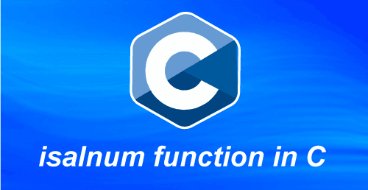
For example, if the given character is 'a', the isalnum() function returns a non-zero value. Similarly, we enter 5 as the numeric to the isalnum() function that returns a non-zero value. If the given number is neither the alphabets (a to z or A to Z) letter nor the digits from 0 to 9, it returns zero.

Syntax of the isalnum() function
Following is the syntax of the isalnum() function in the C programming languages, as follows:
int isalnum (int ch);
Here, the isalnum function takes ch as the argument to check the given argument is alphanumeric or not.
Parameters:
ch: It represents the alphabets or numeric numbers to be checked.
Return Value:
It returns a non-zero value when the passed 'ch' character is a digit or a letter. Otherwise, it shows 0.
Example 1: Program to demonstrate the usage of the isalnum() function in C
Let's consider an example to check the given character is an alphanumeric in the C programming language.
/* get the alphanumeric number using the isalnum() function in C. */
#include <stdio.h>
#include <conio.h>
int main ()
{
// declaration of the variables
int ch1 = 'A';
int ch2 = 'e';
int ch3 = '$';
int ch4 = '7';
int ch5 = ' ';
int ch6 = '0';

/* use isalnum () function to check the given number is alphanumeric. */
if ( isalnum (ch1) )
{
printf (" '%c' is an alphanumeric character. \n", ch1);
}
else
{
printf ("'%c' is not an alphabetic or numeric character. \n", ch1);
}

if ( isalnum (ch2) )
{
printf (" '%c' is an alphanumeric character. \n", ch2);
}
else
{
printf ("'%c' is not an alphabetic or numeric character. \n", ch2);
}

if ( isalnum (ch3) )
{
printf (" '%c' is an alphanumeric character. \n", ch3);
}
else
{
printf ("'%c' is not an alphabetic or numeric character. \n", ch3);
}

if ( isalnum (ch4) )
{
printf (" '%c' is an alphanumeric character. \n", ch4);
}
else
{
printf (" '%c' is not an alphabetic or numeric character. \n", ch4);
}

if ( isalnum (ch5) )
{
printf (" '%c' is an alphanumeric character. \n", ch5);
}
else
{
printf (" '%c' is not an alphabetic or numeric character. \n", ch5);
}

if ( isalnum (ch6) )
{
printf (" '%c' is an alphanumeric character. \n", ch6);
}
else
{
printf (" '%c' is not an alphabetic or numeric character. \n", ch6);
}

return 0;
}
Output:
'A' is an alphanumeric character.
'e' is an alphanumeric character.
'$' is not an alphabetic or numeric character.
'7' is an alphanumeric character.
' ' is not an alphabetic or numeric character.
'0' is an alphanumeric character.
In the above program, the isalnum() function checks each variables' values whether the passed character is an alphanumeric value or not. If the given character is alphanumeric, it returns the %c is an alphanumeric character; else, it shows the %c is not an alphanumeric character.
Example 2: Program to input a character and check the alphanumeric using the isalnum() function
Let's consider an example to input the character from the user and check whether the given character is alphanumeric in the C programming language.
#include <stdio.h>
#include <ctype.h>

int main ()
{
// declare char data type variable
char ch;

printf (" \n Enter a valid character: ");
scanf (" %c", &ch);

/* use isalnum() function to check the valid alphabets (a to z or A to Z) or numeric (0 to 9) character */
if (isalnum (ch))
{
printf (" \n '%c' is a valid alphanumeric character. ", ch);
}
else
{
printf (" \n %c is not an alphanumeric character. ", ch);
printf (" \n Please, enter a valid alphanumeric character ('a' to 'z' or 'A' to 'Z' and (0 to 9)). " );
}
return 0;
}
Output:
Enter a valid character: t
't' is a valid alphanumeric character.
Here, we input the 't' character from the user and then use the isalnum() function to check the given character is alphanumeric.
2nd execution:
Enter a valid character: 7
'7' is a valid alphanumeric character.
Similarly, we input 7 from the user and check the given number is numeric or not. If the number contains 0 to 9 digits, the isalnum () function returns that the given number is numeric.
3rd execution:
Enter a valid character: +
'+' is not an alphanumeric character.
Please, enter a valid alphanumeric character ('a' to 'z' or 'A' to 'Z' and (0 to 9)).
Here, we input the '+" character and use the isalnum() function to check the alphanumeric character. And we get the given character is not alphanumeric means neither the character is alphabets nor digits from 0 to 9.
Example 3: Program to return non-zeroes values for alphanumeric characters in C
Let's consider an example to validate the alphanumeric character and returns a non-zero values using the isalnum() function in the C programming language.
#include <stdio.h>
#include <ctype.h>

int main ()
{
// declare character type variable
char ch;

ch = 'C';
// use isalnum() function to check uppercase alphabet
printf (" \n The result of valid uppercase alphanumeric is passed: %d ", isalnum (ch));

ch = 'h';
// use isalnum() function to check lowercase alphabet
printf (" \n The result of valid lowercase alphanumeric is passed: %d ", isalnum (ch));

ch = '05';
// use isalnum() function to check alphanumeric character
printf (" \n The result of valid alphanumeric character is passed: %d ", isalnum (ch));

ch = '91';
// use isalnum() function to check uppercase alphabet
printf (" \n The result of valid alphanumeric character is passed: %d ", isalnum (ch));

ch = '&';
// use isalnum() function to check alphanumeric character
printf (" \n The result of non-alphanumeric character is passed: %d ", isalnum (ch));

return 0;
}
Output:
The result of valid uppercase alphanumeric is passed: 1
The result of valid lowercase alphanumeric is passed: 2
The result of valid alphanumeric character is passed: 4
The result of valid alphanumeric character is passed: 4
The result of non-alphanumeric character is passed: 0
Example 4: Program to check all alphanumeric character of the array using the isalnum() function
Let's consider an example to check all array character is alphanumeric or not using the isalnum() function in the C programming language
#include<stdio.h>
#include<stdlib.h>
#include <ctype.h>
int main()
{
// declaration of the character type array
char str[7] = {'#','&','@','9','Z','o', '!'};
// place 0 as the return values of all character stored in str array.
int arr[7] = {0, 0, 0, 0, 0, 0, 0};
int i;

// use for loop to assign the result of the isalnum() function
for (i = 0; i < 7; i++)
{
arr[i] = isalnum (str[i]);
}
for (i = 0; i < 7; i++)
{
printf( "\n '%c'", str[i]); // print character

// check array element is not equal to 0
if (arr[i] != 0)
{
printf( " is an Alphanumeric character. ");
}
else
{
printf( " is NOT an alphabet or numeric character. ");
}
}
return 0;
}
Output:
'#' is NOT an alphabet or numeric character.
'&' is NOT an alphabet or numeric character.
'@' is NOT an alphabet or numeric character.
'9' is an Alphanumeric character.
'Z' is an Alphanumeric character.
'0' is an Alphanumeric character.
'!' is NOT an alphabet or numeric character.

isalpha() function in C
This section will discuss the isalpha() function of the C programming language. The islpha() function is a predefined library function of the ctype.h header file that takes an argument as the character type and validates for valid alphabets. If the given character is alphabets (a - z or A to Z), it returns a non-zero value; else, it returns 0.
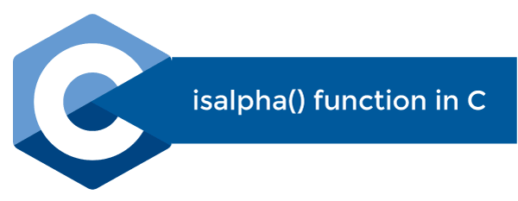

Note: While using the islpha() function, we must add the ctype.h header file in our program.
For example, if the given character is from 'a' to 'z' and 'A' to 'Z', the isalpha() function returns a non-zero value. And if the given character is not the letters of the alphabets, it returns zeroes for other characters ( '@', '$', '&', etc.).
Input character: 'b'
Function returns 1

Input character: '&'
Function returns 0
Syntax of the isalpha function
Following is the syntax for the isalpha() function in C programming, as follows.
int isalpha (char Ch);
Here, the isalpha() function takes ch as the character type argument to check the alphabetic letters.
Parameters:
Ch: It represents the character type variable to be checked.
Return Value:
The isalpha() function returns a non zero value when the 'ch' character is an alphabetic. Else, it shows the zero.
Example 1: Program to check the alphabetic character using the islpha() function
Let's consider an example to check whether the given character is alphabet using the islpha() function in the C programming.
#include <stdio.h>
#include <ctype.h> // use ctype.h header file

int main (int argc, const char *argv [])
{
// define unsigned variable
unsigned char ch;

// assign character to the ch
ch = 'a';

/* use isalpha () function to check the alphabet character */
if (isalpha (ch) != 0)
{
printf (" \n '%c' is a valid alphabetic character. ", ch);
}
else
{
printf (" '%c' is not the valid alphabetic character. ", ch);
}

// assign a non alphabetic character to the ch variable
ch = '&';

/* use isalpha () function to check the alphabet character */
if (isalpha (ch) != 0)
{
printf (" \n '%c' is a valid alphabetic character. ", ch);
}
else
{
printf (" \n '%c' is not a valid alphabetic character. ", ch);
}

return 0;
}
Output:
'a' is a valid alphabetic character.
'&' is not a valid alphabetic character.
Example 2: Program to validate the given character using the isalpha() function
Let's consider a example to use the isalpha() function and check whether the various given character is alphabets or not in the C programming.
#include <stdio.h>
#include <ctype.h> // use ctype.h header file

int main ()
{

// check character 'e'
/* use isalpha () function to check the alphabet character */
if (isalpha ( 'e') == 0)
{
printf (" \n 'e' is not an alphabetic character. ");
}
else
{
printf ("\n 'e' is an alphabetic character. ");
}

// check character 'Z'
if (isalpha ('Z') == 0)
{
printf (" \n 'Z' is not an alphabetic character. ");
}
else
{
printf (" \n 'Z' is an alphabetic character. ");
}

// check character '@'
if (isalpha ('@') == 0)
{
printf (" \n '@' is not an alphabetic character. ");
}
else
{
printf (" \n '@' is an alphabetic character. ");
}

// check character '5'
if (isalpha ('5') == 0)
{
printf (" \n '5' is not an alphabetic character. ");
}
else
{
printf (" \n '5' is an alphabetic character. ");
}

return 0;
}
Output:
'e' is an alphabetic character.
'Z' is an alphabetic character.
'@' is not an alphabetic character.
'5' is not an alphabetic character.
Example 3: Program to get a character from user and check whether the character is valid character
Let's consider an example to check valid characters using the isalpha function in C programming language.
#include <stdio.h>
#include <ctype.h>

int main ()
{
// declare character type variable
char ch;

printf (" \n Enter a valid character: ");
scanf (" %c", &ch);

// use isalpha() function to check the valid character
if (isalpha (ch))
{
printf (" \n You entered a valid alphabet. ");
}
else
{
printf (" \n %c is not an alphabet. ");
printf (" \n Please, enter a valid alphabet character ('a' to 'z' or 'A' to 'Z'). " );
}
return 0;
}
Output:
Enter a valid character: g
You entered a valid alphabet.
In the above program, we take the 'g' character from the user and then use the isalpha() function to check whether the input character is an alphabet or not. If the character is an alphabet, it prints "You entered a valid character".
2nd execution:
Enter a valid character: $
$ is not an alphabet.
Please, enter a valid alphabet character ('a' to 'z' or 'A' to 'Z').
In the second execution, we input the '$' character and use the isalpha() function to check the character is an alphabet or not. Here '$' character is not an alphabet. So, it returns the "$ is not an alphabet. Please, enter a valid alphabet character ('a' to 'z' or 'A' to 'Z')".
Example 4: Program to return a non zeroes values for alphabetic character using the isalpha() function
Let's consider an example to validate the alphabetic character and returns a non zero values using the isalpha() function in the C programming language.
#include <stdio.h>
#include <ctype.h>

int main ()
{
// declare character type
char ch;

ch = 'C';
// use isalpha() function to check uppercase alphabet
printf (" \n The result of valid uppercase alphabetic character is passed: %d ", isalpha (ch));

ch = 'h';
// use isalpha() function to check lowercase alphabet
printf (" \n The result of valid lowercase alphabetic character is passed: %d ", isalpha (ch));

ch = '+';
// use isalpha() function to check non-alphabetic character
printf (" \n The result of non-alphabetic character is passed: %d ", isalpha (ch));

return 0;
}
Output:
The result of valid uppercase alphabetic character is passed: 1
The result of valid lowercase alphabetic character is passed: 2
The result of non-alphabetic character is passed: 0
In the above program, we get different non-zero values when the alphabetic character is passed to the isalpha() function. But, when we pass the non-alphabetic character to the isalpha() function, it always returns 0.
Example 5: Program to check all valid characters of the array using the isalpha() function
Let's create an example to use the isalpha function to check the array character in C programming language.
#include<stdio.h>
#include<stdlib.h>
#include <ctype.h>

int main()
{

// declaration of the character type array
char str[7] = {'*','$','@','7','Z','p', '!'};

// insert 0 as the return values to all character type array in str .
int arr[7] = {0, 0, 0, 0, 0, 0, 0};

int i;

// use for loop to assign the result of the isalpha() function
for (i = 0; i < 7; i++)
{
arr[i] = isalpha (str[i]);
}

for (i = 0; i < 7; i++)
{
printf( " \n '%c'", str[i]); // print character

// check array element is not equal to 0
if (arr[i] != 0)
{
printf( " is an Alphabetic character. ");
}

else
{
printf( " is NOT an Alphabetic character. ");
}
}
return 0;
}
Output:
'*' is NOT an Alphabetic character.
'$' is NOT an Alphabetic character.
'@' is NOT an Alphabetic character.
'7' is NOT an Alphabetic character.
'Z' is an Alphabetic character.
'p' is an Alphabetic character.
'!' is NOT an Alphabetic character.

Bisection Method in C
This section will discuss the bisection method in the C programming language. The bisection method is a simple and convergence method used to get the real roots of non-linear equations. The Bisection method repeatedly bisects or separates the interval and selects a subinterval in which the root of the given equation is found.
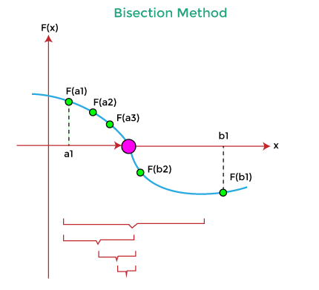
It means if a function f(x) is continuous in the closed interval [a, b] and the f(a) and f(b) are two real numbers of opposite signs that contain at least one real root of f(x)= 0, between a and b. This method is also known as the Bolzano or Half Interval or Binary search method.

Bisection Method Algorithm:
Following is the algorithm of the Bisection Method in C.
- Start the program.
- Input two initial guesses x1 and x2. The 'e' is the absolute error to get the desired degree of accuracy.
- Compute the function value: f1 = f(x1) and f2 = f(x2)
- Now compare the product of f1 and f2 with 0, as
If (f1 * f2) > 0, it displays the initial guesses are wrong and transfer control to step 11.
- Get the mid value: x = (x1 + x2) / 2
- If ( [ (x1 - x2) / x] < e), then print the value x and jump to (11).
- Else, it shows: f = f(x)
- If (( f * f1) > 0), then assign x1 = x and f1 = f.
- Else, assign x2 = x and f2 = f.
- Jump to 5. And the loop continues with new values.
- Terminate the program.
Example 1: Program to find the root of the given equation using the Bisection method
Let's consider an example to get the approximation root of an equation using the Bisection method and for loop in the C programming language.
/* program to demonstrate the usage of the bisection method in C. */
#include <stdio.h>

// funciton definition
void bisect (float *mid_pt, float int_st, float int_end, int *iter_cnt);
double get_fun (double res);

int main ()
{
// declaration of the variables
int iter_cnt, mx_iter_cnt;
float mid_pt, int_st, int_end, err_all, root;

printf (" \n Enter the first starting point: ");
scanf (" %f", &int_st);
printf (" \n Enter the second ending point: ");
scanf (" %f", &int_end);

// declare no. of iteration to be allowed
printf (" \n Enter the maximum iteration to be allowed: ");
scanf (" %d", &mx_iter_cnt);

// allow no. of error point
printf (" Input the no. of allowed error point: ");
scanf (" %f", &err_all);

// call bisect() function
bisect (&mid_pt, int_st, int_end, &iter_cnt);

// use for loop to print the max iteration
for (iter_cnt = 0; iter_cnt < mx_iter_cnt; mid_pt = root)
{

// chcck initial num * mid_pt is less than 0
if ( get_fun (int_st) * get_fun (mid_pt) < 0)
{
int_end = mid_pt; // assign the mid_pt to int_end
}
else
{
int_st = mid_pt; // else it assign the mid_pt to int_st
}

bisect ( &root, int_st, int_end, &iter_cnt); // get the address
if ( fabs (root - mid_pt) < err_all)
{
printf (" \n The approximation root is: %f \n", root);
return 0;
}
}

// print insufficient
printf (" The iterations are insufficient: ");
return 0;
}

// function definition
void bisect (float *mid_pt, float int_st, float int_end, int *iter_cnt)
{
*mid_pt = (int_st + int_end) / 2; // get the middle value
++(*iter_cnt); // increment the iteration value
printf ( " Iteration \t %d: \t %f \n", *iter_cnt, *mid_pt);
}

double get_fun (double res)
{
return (res * res * res - 4 * res - 9);
}
Output:
Enter the first starting point: 5
Enter the second ending point: 9
Enter the maximum iteration to be allowed: 8
Input the no. of allowed error point: 0.02
Iteration 1: 7.000000
Iteration 1: 8.000000
Iteration 2: 8.500000
Iteration 3: 8.750000
Iteration 4: 8.875000
Iteration 5: 8.937500
Iteration 6: 8.968750
Iteration 7: 8.984375

The approximation root is: 8.984375
Example 2: Program to find the real root of the (x3 + 3x - 5 = 0) equation using the Bisection method
Let's consider an example to print the real roots using the Bisection method in the C programming language.
#include <stdio.h>
#include <conio.h>

// create a function
double bisect ( double num)
{
// it returns the value of the function
return ( pow (num, 3) + 3 * num - 5);
}

int main ()
{
printf ( " \n Display the real roots of the given equation using the Bisection method: ");
printf ( " \n x ^ 3 + 3 * x - 5 = 0 \n ");
double x0, x1;

printf ( " \n Enter the first approximation of the root: ");
scanf (" %lf", &x0);

printf ( " \n Enter the second approximation of the root: ");
scanf (" %lf", &x1);

int iterate;
printf (" \n Input the number of iteration you want to perform: ");
scanf (" %d", &iterate);

int count = 1;
double l1 = x0;
double l2 = x1;
double r, f1, f2, f3;

// now check whether the initial approximation are the real root
if (bisect (l1) == 0) // it is a root
{
r = l1;
}
else if ( bisect (l2) == 0)
{
r = l2;
}

// if the above two values are not the root of the given equation
else
{
while (count <= iterate) // here count is initialized with 1
{
f1 = bisect (l1);
r = (l1 + l2) / 2.0; // get the mid value of the interval l1 and l2
f2 = bisect (r);
f3 = bisect (l2);

// check f2 is equal to 0
if (f2 == 0)
{
r = f2;
break; // break the execution from the while loop statement
}

printf (" \n The root after %d iterations is %lf. \n", count, r);

// check multiplication of f1 * f2 not less than 0
if ( f1 * f2 < 0)
{
l2 = r;
}
else if (f2 * f3 < 0)
{
l1 = r;
}
count++;
}
}
// return final value after mentioned the iteration
printf (" \n The approximation of the root is: %lf \n ", r);
return 0;
}
Output:
Display the real roots of the given equation using the Bisection method:
X ^ 3 + 3 * x - 5 = 0
Enter the first approximation of the root: 1
Enter the second approximation of the root: 5
Input the number of iteration you want to perform: 7
The root after 1 iterations is 3.000000
The root after 2 iterations is 2.000000.
The root after 3 iterations is 1.500000.
The root after 4 iterations is 1.250000.
The root after 5 iterations is 1.125000.
The root after 6 iterations is 1.187500.
The root after 7 iterations is 1.156250.
The approximation root is 1.156250
Example 3: Program to find the approximation root of the non-algebraic function using the Bisection method
Let's create a simple program to calculate the approximation root using the Bisection method and do while loop in C programming language.
/* program to get the roots of the given equation using the do while loop in C. */
#include <stdio.h>
#include <conio.h>
#include <stdlib.h>
#include <math.h>
// define function whose root to be determined
double f (double a)
{
return 3 * a + sin (a) - exp (a);
}

int main ()
{
// declare double data type variable
double x, y, z, eps;
int count; // integer data type

x:printf (" \n Input the initial approximation for x: \n ");
scanf (" %lf", &x);

printf (" Input the initial approximation for y: \n ");
scanf (" %lf", &y);

printf (" Define the input accuracy: \n ");
scanf (" %lf", &eps);

printf (" Input the maximum number of iteration: \n ");
scanf (" %d", &count);

// use if statement to check the product of f(a) and f(b) is not less than 0
if (f(x) * f(y) <= 0)
{
int iter = 1; // initialize iter to 1
// execution of the bisection method starts here

printf (" Iteration \t x \t \ty \t\tz \t\tf(z) \t |x - y| \n ");

// use do while loop
do {
z = (x + y) / 2; // get the mid value for z
printf (" %d \t %lf \t %lf \t %lf \t %lf \t %lf \n", iter, x, y, z, f(z), fabs(x - y));
if (f(x) * f(z) > 0)
{
x = z; // assign the value of z to x
}
else if (f(x) * f(z) < 0)
{
y = z; // assign the value of z to y
}
iter++; // increment counter by 1
}
while (fabs (x - y) >= eps && iter <= count);
printf (" \nThe root of the given equation is: %lf", z);
}
else
{
printf (" \n The root doesn't exist in the given interval. ");
goto x;
}

}
Output:
Input the initial approximation for x:
1
Input the initial approximation for y:
3
Define the input accuracy:
.002
Input the maximum number of iteration:
10
Iteration x y z f(z) |x - y|
1 1.000000 3.000000 2.000000 -0.479759 2.000000
2 1.000000 2.000000 1.500000 1.015806 1.000000
3 1.500000 2.000000 1.750000 0.479383 0.500000
4 1.750000 2.000000 1.875000 0.058267 0.250000
5 1.875000 2.000000 1.937500 -0.195362 0.125000
6 1.875000 1.937500 1.906250 -0.064801 0.062500
7 1.875000 1.906250 1.890625 -0.002343 0.031250
8 1.875000 1.890625 1.882812 0.028192 0.015625
9 1.882812 1.890625 1.886719 0.012982 0.007812
10 1.886719 1.890625 1.888672 0.005334 0.003906

The root of the given equation is: 1.888672
Advantages of the Bisection Method:
- The Bisection method is guaranteed to the convergence of real roots.
- It reduces the chances of error in the non-linear equation.
- It evaluates one function at each iteration.
- It usually convergence in a linear fashion.
- We can control the error by increasing the number of iterations that return a more accurate root in the bisection method.
- It does not involve complex calculations to get the root.
- The bisection method is faster in the case of multiple roots.
Disadvantages of the Bisection Method
- In the Bisection method, the convergence is very slow as compared to other iterative methods.
- The rate of approximation of convergence in the bisection method is 0.5.
- It is a linear rate of convergence.
- It fails to get the complex root.
- It cannot be applied if there are any discontinuity occurrs in the guess interval.
- It is unable to find the root for some equations. For example, f(x) = x² as there are no bracketing or bisect values.
- It cannot be used over an interval when the function takes the same sign values.

snprintf() function in C
In this section, we will discuss the snprintf() function in the C programming language. The snprintf is a predefined library function of the stdio.h header file, which redirects the output of the standard printf() function to other buffers.
The snprint() function is used to format the given strings into a series of characters or values in the buffer area. The snprintf() function contains an 'n' argument representing the maximum number of characters, including the null character, stored in the buffer area.
The snprintf function also returns the number of characters that are inserted or written to the buffer. However, these characters are returned or displayed by the printf() function in the print statement or characters in the stdout header file.


Note: The snprintf() function inserts a null character to the end of the resulting output that is also counted as the size of the buffer. Furthermore, the buffer is an array that stores only character type elements, not in the string type.
Syntax of the snprintf() function in C
Following is the syntax of the snprintf() function in the c programming language.
int snprintf (char *str, size_t size, const char *format, ?);
Parameters:
str: It is a character type array buffer.
size: it defines the maximum number of characters that can store in the buffer.
format: In C language, the string defines a format that contains the same type of specifications as the printf() function defines in the stdio.h header file.
…: It is an optional (…) parameter or argument.
Return Values:
The snprintf() function returns the number of characters or values that have been written or stored for a sufficiently large buffer without including the null terminating character. And if the written characters are larger than the buffer size, it returns a negative value. And if the buffer size is too small, the given string will be truncated or reduced to the buffer size.
Example 1: Program to demonstrate the snprintf() function in C
Let's create a program to check the buffer size and return the number of character enter to the buffer using the snprintf() function in C.
/* create an example to use the snprintf function in c. */
#include <stdio.h>
#include <conio.h>

int main ()
{
// declare and initialize the char variable
char *r = "Javatpoint.com";
char buf[100]; // define the size of character type buffer

/* use the snprintf() function to return the no. of character founded in the buffer area */
int n = snprintf (buf, 34, "%s \n", r); // 34 represents the size of buffer to store max characters

// display the string stored in the buffer and count each character of the buffer area.
printf (" The given string is: %s \n Count the stored character: %d \n", buf, n);

return 0;
}
When we execute the above program, it produces the given output on the console screen.
The given string is: Javatpoint.com

Count the stored character: 16
2nd execution
The given string is: Javatpoint.com
Count the stored character: -1
Now we reduce the max input character from 34 to 14, and this time, it returns a negative number, indicating the buffer size is less than the given string.
Example 2: Program to use the snprintf() function in C
Let's create an example to insert the character to the buffer and return from the same using the snprintf() function in C programming language.
#include <stdio.h>
#include <conio.h>

int main ()
{
char buf[200]; // define the size of character type buffer

int ret_val, buf_size = 55;
char name[] = "David"; // define string
int age = 19;

// use the snprintf() function to return the no. of character found in buffer area
ret_val = snprintf (buf, buf_size, "Hello friend, My name is %s, and I am %d years old.", name, age);

/* check ret_value should be greater than 0 and less than the size of the buffer (buf_size). */
if ( ret_val > 0 && ret_val < buf_size)
{
printf (" Buffer is written successfully! \n ");
printf (" %s\n", buf);
printf (" No. of characters read: %d", ret_val);
}
else
{
printf (" Buffer is not completely filled or written. \n ");
printf (" %s \n", buf);
printf (" The return value: %d", ret_val);
}

return 0;

}
When we execute the above program, it produces the given output on the console screen.
Buffer is written successfully!
Hello friend, My name is David, and I am 19 years old.
No. of characters read: 53
In the above program, we declared the character type buffer buf[200], and the buf_size variable can insert the maximum characters is 55. If the given statement is in the defined range, the snprintf() function returns the total no. of characters read from the buffer.
2nd execution
Buffer is not completely filled or written.
Hello friend, My name is David and
The return value: -1
When we define the buf_size as 35, the given statement is automatically truncated by the snprintf() function that returns a negative number (-1) and displays "Buffer is not completely filled or written".

Remove an element from an array in C
In this topic, we will learn how to delete or remove a particular element from an array in the C programming language. An array is the collection of the same data type elements or items stored in a contiguous memory block. In C programming, an array is derived data that stores primitive data type values like int, char, float, etc.
To delete a specific element from an array, a user must define the position from which the array's element should be removed. The deletion of the element does not affect the size of an array. Furthermore, we should also check whether the deletion is possible or not in an array.
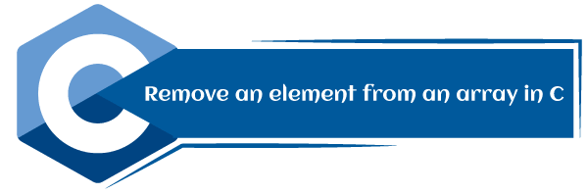
For example, suppose an array contains seven elements, arr[] = {10, 25, 14, 8, 12, 15, 5); and the user want to delete element 8. So, first, the user must define the position of the 8th element, which is the 4th, and then check whether the deletion is possible or not. The position of the particular element should not be more than the total elements of an array. Here, we have 7 elements in an array, and the user wants to delete the 8th position element, which is impossible.
Steps to remove an element from an array
Following is the steps to remove a particular element from an array in C programming.
Step 1: Input the size of the array arr[] using num, and then declare the pos variable to define the position, and i represent the counter value.
Step 2: Use a loop to insert the elements in an array until (i < num) is satisfied.
Step 3: Now, input the position of the particular element that the user or programmer wants to delete from an array.
Step 4: Compare the position of an element (pos) from the total no. of elements (num+1). If the pos is greater than the num+1, the deletion of the element is not possible and jump to step 7.
Step 5: Else removes the particular element and shift the rest elements' position to the left side in an array.
Step 6: Display the resultant array after deletion or removal of the element from an array.
Step 7: Terminate or exit from the program.
Example 1: Program to remove an element from an array using for loop
Let's create a program to delete an element from an array using for loop in the C programming language.
/* program to remove the specific elements from an array in C. */
#include <stdio.h>
#include <conio.h>

int main ()
{
// declaration of the int type variable
int arr[50];
int pos, i, num; // declare int type variable
printf (" \n Enter the number of elements in an array: \n ");
scanf (" %d", &num);

printf (" \n Enter %d elements in array: \n ", num);

// use for loop to insert elements one by one in array
for (i = 0; i < num; i++ )
{ printf (" arr[%d] = ", i);
scanf (" %d", &arr[i]);
}

// enter the position of the element to be deleted
printf( " Define the position of the array element where you want to delete: \n ");
scanf (" %d", &pos);

// check whether the deletion is possible or not
if (pos >= num+1)
{
printf (" \n Deletion is not possible in the array.");
}
else
{
// use for loop to delete the element and update the index
for (i = pos - 1; i < num -1; i++)
{
arr[i] = arr[i+1]; // assign arr[i+1] to arr[i]
}

printf (" \n The resultant array is: \n");

// display the final array
for (i = 0; i< num - 1; i++)
{
printf (" arr[%d] = ", i);
printf (" %d \n", arr[i]);
}
}
return 0;
}
Output:
Enter the number of elements in an array:
8

Enter 8 elements in array:
arr[0] = 3
arr[1] = 6
arr[2] = 2
arr[3] = 15
arr[4] = 10
arr[5] = 5
arr[6] = 8
arr[7] = 12
Define the position of the array element where you want to delete:
5

The resultant array is:
arr[0] = 3
arr[1] = 6
arr[2] = 2
arr[3] = 15
arr[4] = 5
arr[5] = 8
arr[6] = 12
In the above program, we input 8 elements for an array arr[] from the user. After that, the user enters the position of the particular element is 5. And then, we checked the defined position by the If statement (if (pos > num + 1)); Here, 5 is less than the (num+1). So the condition is false, and it executes the else block to remove the 5th position of the element is 10 using for loop and then prints the resultant array.
Example 2: Program to remove the specific character from an array using for loop
Let's consider an example to delete the particular position of the defined character from an array using for loop in the C programming language.
/* program to remove the specific elements from an array in C. */
#include <stdio.h>
#include <conio.h>

int main ()
{
// declaration of the int type variable
int arr[50];
int pos, i, num; // declare int type variable
printf (" \n Enter the number of elements in an array: \n ");
scanf (" %d", &num);

printf (" \n Enter %d elements in array: \n ", num);

// use for loop to insert elements one by one in array
for (i = 0; i < num; i++ )
{ printf (" arr[%d] = ", i);
scanf (" %c", &arr[i]);
}

// enter the position of the element to be deleted
printf( " Define the position of the array element where you want to delete: \n ");
scanf (" %d", &pos);

// check whether the deletion is possible or not
if (pos >= num+1)
{
printf (" \n Deletion is not possible in the array.");
}
else
{
// use for loop to delete the element and update the index
for (i = pos - 1; i < num -1; i++)
{
arr[i] = arr[i+1]; // assign arr[i+1] to arr[i]
}

printf (" \n The resultant array is: \n");

// display the final array
for (i = 0; i< num - 1; i++)
{
printf (" arr[%d] = ", i);
printf (" %c \n", arr[i]);
}
}
return 0;
}
Output:
Enter the number of elements in an array:
8
Enter 8 elements in array:
arr[0] = a
arr[1] = b
arr[2] = f
arr[3] = h
arr[4] = e
arr[5] = k
arr[6] = w
arr[7] = p
Define the position of the array element where you want to delete:
4

The resultant array is:
arr[0] = a
arr[1] = b
arr[2] = f
arr[3] = e
arr[4] = k
arr[5] = w
arr[6] = p
Example 3: Program to delete a particular element from an array using the user-defined function
Let's consider an example to demonstrate the deletion of the particular element using the user defined function in the C programming language.
/* program to delete a particular element from an array using user defined function in c. */
#include <stdio.h>
#include <conio.h>

// create user defined function update elements
addElement (int *arr, int num, int pos)
{
int i;
// use for loop to update the index
for (i = pos-1; i < num - 1; i++)
{
arr[i] = arr[i+1]; //
}
}

// create disp() function to print the input array elements
disp( int arr[], int num)
{
int i;
// use for loop to print the resultant array
for ( i = 0; i < num; i++)
{
printf( "\n arr[%d] = %d", i, arr[i]);
}
}

int main ()
{
// declaration of the array
int arr[100];
int i, num, pos, result;

printf (" Enter the size of the array: ");
scanf (" %d", &num);

printf (" \n Enter the %d elements in an array: \n", num);
// use for loop to input the elements one by one
for (i = 0; i < num; i++)
{
printf (" arr[%d] = ", i);
scanf (" %d", &arr[i]);
}

// define the position of the element to be deleted from an array
printf (" Enter the position of the element you want to delete from an array: ");
scanf (" %d", &pos);

// check whether thr defined pos is less than equal to size of array (num) and larger than 0
if (pos <= num && pos > 0)
{
printf (" Array before deletion: \n");

// call disp() function print the array
disp (arr, num);
// call addElement() function
addElement(arr, num, pos);

printf (" \n Array after deletion: \n");
// disp() function to print the updated array
disp( arr, num-1);
}
return 0;
}
Output:
Enter the size of the array: 8
Enter the 8 elements in an array:
arr[0] = 2
arr[1] = 4
arr[2] = 6
arr[3] = 8
arr[4] = 10
arr[5] = 3
arr[6] = 9
arr[7] = 12
Enter the position of the element you want to delete from an array: 4
Array before deletion:

arr[0] = 2
arr[1] = 4
arr[2] = 6
arr[3] = 8
arr[4] = 10
arr[5] = 3
arr[6] = 9
arr[7] = 12
Array after deletion:

arr[0] = 2
arr[1] = 4
arr[2] = 6
arr[3] = 10
arr[4] = 3
arr[5] = 9
arr[6] = 12
Example 4: Program to remove the specific element from an array using the pointers
Let's consider an example of deleting the particular element from an array using the pointers and the user defined function in the C programming language.
/* create a program to delete a specific element from an array using pointers in C. */
#include <stdio.h>
#include <conio.h>

// create a function to delete the specific element
void del (int num, int *arr, int index);

int main ()
{
// declaration of the variables
int *arr, num, i, index;
printf (" Define the size of the array: ");
scanf (" %d", &num);

// use malloc function to dynamic create space for an array
arr = (int *) malloc (sizeof(int) *num);

printf (" \n Enter %d elements in an array: ", num);
// use for loop to insert element one by one
for (i = 0; i < num; i++)
{
printf (" \n arr[%d] = ", i);
scanf (" %d", (arr + i));
}

// position of the element to be deleted
printf (" Enter the position of the element to be deleted from an array: ");
scanf (" %d", &index);
del (num, arr, index); /* call delete function to delete the position of element and print the resultant array. */
return 0;
}

// function definition
void del (int num, int *arr, int index)
{
int i, j;
// check position of the index
if (index <= num)
{
// use for loop to delete the position of the defined index
for (i = index - 1; i < num; i++)
{
j = i + 1; // assign the elments to j
*(arr + i) = *(arr + j);
}

// display the resultant array after deletion of the specific element
printf (" \n The resultant array after deletion of the array elements are: \n");
for (i = 0; i < num - 1; i++)
{
printf (" arr[%d] = %d \n", i, ( *(arr + i)));
}
}
else
{
printf (" \n Please enter correct position.");
}
}
Output:
Define the size of the array: 8
Enter 8 elements in an array:
arr[0] = 5
arr[1] = 10
arr[2] = 15
arr[3] = 20
arr[4] = 25
arr[5] = 30
arr[6] = 35
arr[7] = 40
Enter the position of the element to be deleted from an array: 4
The resultant array after deletion of the array elements are:
arr[0] = 5
arr[1] = 10
arr[2] = 15
arr[3] = 25
arr[4] = 30
arr[5] = 35
arr[6] = 40

Square Root in C

This section will discuss finding the square root of a given number using the sqrt() function in the C programming language. In mathematics, the square root of a number is just the reverse of squaring of that number. It means when the same is multiplied by itself to return the square of a number. And the single number multiplied by itself is called the square root of a number. For example, suppose we want to get the square of any number is 3, the number 3 is multiplied by itself as 3 * 3 to return the square 9. And the same number 3 is called the square root of the number 9. Similarly, we have a number 81, and the square root of that number is 9 (9 * 9 = 81).

In C programming, the sqrt() function is a pre-defined library function used to calculate the square root of a number. The sqrt() function is defined in the math.h header file. So, we need to write the <math.h> header file while using the sqrt() function in C. Furthermore, we can find the square root of the given number without using the sqrt function.
Syntax of the sqrt() function
double sqrt( double arg);
In the above syntax, the sqrt() function takes a single argument as double to return its square root in double data types.
arg: It is a double data type argument of the sqrt() function.
Return value: The sqrt function returns a square root of the given number in a defined double data type.

Note: We can find the square root of the int, float, double or long double data type number by explicitly converting the given data type to another.
Algorithm to find the Square Root
- Declare an integer variable, as num.
- Use the sqrt() function to pass the num variable as an argument to find the square root.
- Print the result.
- Exit or terminate the program.
Example 1: Program to get the square root of a number using the sqrt() function
Let's consider an example to calculate the square root of the given number using the sqrt() function in C.
#include <stdio.h>
#include <conio.h>
#include <math.h>

int main ()
{
// declaration of the int, float and double variables
int x, res;
float y, res1;
double z, res2;

x = 289;
// use the sqrt() function to return integer values
res = sqrt(x);
printf (" The square root of %d is: %d", x, res);

// square root of float variable
y = 12.25;
// use the sqrt() function to return float values
res1 = sqrt(y);
printf (" \n The square root of %.2f is: %.2f", y, res1);

// square root of double variable
z = 144.00;
// use the sqrt() function to return double values
res2 = sqrt(z);
printf (" \n The square root of %.2lf is: %.2lf", z, res2);

return 0;
}
Output:
The square root of 289 is: 17
The square root of 12.25 is: 3.50
The square root of 144.00 is: 12.00
Example 2: Program to take a number from user and to get the square root
Let's consider an example to print the square root of a number by taking an input from the user and then use the sqrt() function in C.
#include <stdio.h>
#include <conio.h>
#include <math.h>

int main ()
{
// declare an integer variable
int x;
double res;
printf (" Enter any number to get the square root: ");
scanf (" %d", &x);
// use the sqrt() function to return integer values
res = sqrt(x);
printf (" \n The square root of %d is: %.2lf", x, res);

return 0;
}
Output:
Enter any number to get the square root: 625
The square root of 625 is: 25.00
Example 3: Program to find the square root using user defined function
Let's create a program to get the square root of the given number using the user defined function in the C programming language.
#include <stdio.h>
#include <conio.h>
#include <math.h>

// function declaration
double getSqr (int num);

int main ()
{
// declare an integer variable
int x;
double res;
printf (" Enter any number to get the square root: ");
scanf (" %d", &x);

res = getSqr(x); // call the function
printf (" \n The square root of %d is: %.2lf", x, res);

return 0;
}

// function definition
double getSqr ( int num)
{
double getRes;
// use sqrt() function to print the square root
getRes = sqrt (num);
return getRes;
}
Output:
Enter any number to get the square root: 87
The square root of 87 is: 9.33
pow() function
The pow() is a pre-defined function of math.h header file for calculating the power of a given number.
Syntax of the pow() function
int pow( arg, 0.5);
The pow() function takes two arguments: the first argument defines a variable to obtain the power, or the square root of the given number, and 0.5 is a default argument that is equal to ½ or 1 / 2 = 0.5.
Example 4: Program to get the square root of a number using the pow() function
Let's consider an example to print the square root of a number using the pow() function in C.
#include <stdio.h>
#include <conio.h>
#include <math.h>

int main ()
{
// declare an integer variable
int x;
double res;
printf (" Enter any number to get the square root: ");
scanf (" %d", &x);
// use the pow() function to return the square root
res = pow(x, 0.5); //it takes two argument: input variable and 0.5 is default value
printf (" \n The square root of %d is: %.2lf", x, res);

return 0;
}
Output:
Enter any number to get the square root: 1225
The square root of 1225 is: 35.00
In the above program, we take the integer value of variable x is 1225 from the user and pass x as an argument to the pow() function to return the power or square root of the given number.
Example 5: Program to get the square root of a number without using the sqrt() function
Let's consider an example to print the square root of a number without using the pre-defined sqrt() function in C.
/* Display the square root of a number without using the sqrt() function in C. */
#include <stdio.h>
#include <conio.h>
int main()
{
// declaration of the variables
int num;
float sqrt, temp;

printf (" Enter a number to get the square root: ");
scanf (" %d", &num);

// divide the given number by 2 and store into sqrt
sqrt = num / 2;
temp = 0;

// use while loop to continuously checks the sqrt is not equal to the temp
while (sqrt != temp) // Initially temp is 0 and sqrt = num
{
temp = sqrt; // assign sqrt to temp

sqrt = ( num / temp + temp) / 2;
}

printf (" \n The square root of %d is %f", num, sqrt);
return 0;
}
Output:
Enter a number to get the square root: 2
The square root of 2 is 1.414214
In the above program, we input a number from the user which we find the square root. So, first, we divide the given number by 2 and store it in the sqrt variable. After that, we initialize temp with 0. And then use the while loop that continuously iterates and checks sqrt is not equal to the temp, and on each iteration, it assigns the sqrt value to temp, and the sqrt gets a new value by solving the logic (num/temp + temp) /2; And then prints the square root of 2 is 1.414214.

isprint() function in C
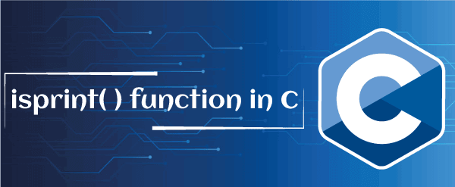
This section will discuss the isprint() function in the C programming language. The isprint() function is a predefined library function of the C language, which is used to check whether the input character is a printable character on the screen (including the space character) or not. It is defined in the ctype.h header file. So, we must add the ctype.h header file while writing a program in the C language.

This function takes a character type argument from the user and validates whether the character is printable. If the passed character is printable, the function returns a positive non-zero value; else, it shows zero (0).
For example, suppose the user enters the 'g' character as an argument to the isprint() function; the function checks the input character is printable or not. And if yes, it returns a non-zero value. Similarly, if we input a new line (\n) or tab (\t) character to the isprint function, it returns zero because it is not a printable character.
Syntax of the isprint() function
Following is the syntax of the isprint() function in the C language, as follows:
int isprint (char c);
Parameter:
c: It indicates the character type value is passed to the isprint() function.
Return Value:
The isprint() function checks the passed argument, and if the character is printable, it returns a non-zero value. Otherwise, it returns zeroes.
Example 1: Program to find the printable character using the isprint() function
Let's write a simple program to find the printable character on the screen using the isprint() function in the C language.
/* program to check the printable character using the isprint() function in C. */
#include <stdio.h>
#include <conio.h>
#include <ctype.h>
int main ()
{
// declaration of the character type variables
int ch1 = 'b';
int ch2 = '@';
int ch3 = ' ';
int ch4 = '%';
int ch5 = '\n';
int ch6 = '\t';

/* use isprint () function to check the printable character. */
if ( isprint (ch1) )
{
printf (" '%c' is a printable character. \n", ch1);
}
else
{
printf ("'%c' is not a printable character. \n", ch1);
}

if ( isprint (ch2) )
{
printf (" '%c' is a printable character. \n", ch2);
}
else
{
printf ("'%c' is not a printable character. \n", ch2);
}

if ( isprint (ch3) )
{
printf (" '%c' is a printable character. \n", ch3);
}
else
{
printf ("'%c' is not a printable character. \n", ch3);
}

if ( isprint (ch4) )
{
printf (" '%c' is a printable character. \n", ch4);
}
else
{
printf ("'%c' is not a printable character. \n", ch4);
}

if ( isprint (ch5) )
{
printf (" '%c' is a printable character. \n", ch5);
}
else
{
printf ("'%c' is not a printable character. \n", ch5);
}

if ( isprint (ch6) )
{
printf (" '%c' is a printable character. \n", ch6);
}
else
{
printf ("'%c' is not a printable character. \n", ch6);
}

return 0;
}
Output:
'b' is a printable character.
'@' is a printable character.
' ' is a printable character.
'%' is a printable character.
' ' is not a printable character.
' ' is not a printable character.
In the above program, we have defined various characters ('b', '@', ' ', '%', the new line (\n), and the '\t' (tab space)) to check the printable character. And then, the isprint() function check and print the only printable character, and if any character is not printable, it returns "%c is not printable character".
Example 2: Program to take a character from user and check whether the character is printable or not
Let's write a program to get a character from the user and display it using the isprint() function in the C language.
#include <stdio.h>
#include <ctype.h>

int main ()
{
// declaration of the variables
char c;

printf (" \n Input a printable character: ");
scanf (" %c", &c); // get a character

/* use the isprint() function to print only printable character */
if (isprint (c))
{
printf (" \n '%c' is a correct printable character. ", c);
}
else
{
printf (" \n '%c' is not a printable character. ", c);
printf (" \n Input only printable character. " );
}
return 0;
}
Output:
Input a printable character: j
'j' is a correct printable character.
In the above program, we input character 'j' from the user and then use the isprint() function to validate the printable character that returns 'j' is a correct printable character.
2nd execution:
Input a printable character: 8
'8' is a correct printable character.
Similarly, we take another character or digit '8' from the user, and then the isprint() function checks the given printable character. After that, the isprint() function print '8' is a correct printable character. And if enter new line (\n) or \t, the isprint() function returns %c is not a printable character.
Example 3: Program to check the printable string using the isprint() function and while loop
Let's write an example to print the printable string characters using the while loop and isprint() function in C.
#include <stdio.h>
#include <ctype.h>

int main ()
{
// declare a character type string
char str[] = "Zb. \n2 \t*.";
int i = 0;

// use while loop to iterate string character one by one
while (str[i] != '\0')
{
/* use the isprint() function to check the valid printable string character */
if (isprint (str[i]))
{
printf (" \n '%c' is a printable character. ", str[i]);
}
else
{
printf (" \n %c is not a printable character. ", str[i]);
}
i++;
}
return 0;
}
Output:
'Z' is a printable character.
'b' is a printable character.
'.' is a printable character.

is not a printable character.
'2' is a printable character.
' ' is a printable character.
is not a printable character.
'*' is a printable character.
'.' is a printable character.
In the above program, we declare a character string "Ab. \n2 \t*." and then check whether the given string is printable or not using the isprint() function. So, first, we use a while loop that iterates each character of the string till the string is not equal to null. Inside the while loop, condition check and print each valid character using the isprint() function, including the white space. And if the character is not printable, it prints " It is not a printable character.".
Example 4: Program to find all printable characters in C using the isprint() function
Let's create a program to find the complete lists of printable characters in the C programming language.
#include <stdio.h>
#include <ctype.h>
#include <conio.h>
int main ()
{
// declaration of the variables
int i = 0;
int count = 0; // count printable characters

// use while loop to iterate till defined condition
while ( i < 256)
{
/// use isprint() function to check printable character
if ( isprint(i) != 0)
{
printf (" %c", i); // it prints only printable character
++count; // count total printable character and update the count by 1
}
++i;
}
printf (" \n There are total %d printable characters. \n", count);

getch();
}
Output:
! " # $ % & ' ( ) * + , - . / 0 1 2 3 4 5 6 7 8 9 : ; < = > ? @ A B C D E F G H I J K L M N O P Q R S T U V W X Y Z [ \ ] ^ _ ` a b c d e f g h i j k l m n o p q r s t u v w x y z { | } ~
There are total 95 printable characters.
Example 5: Program to print all printable characters of the array using the isprint() function
Let's create a program to print all character type array elements using the isprint() function in the C programming language.
#include <stdio.h>
#include <stdlib.h>
#include <ctype.h>
int main()
{
// declare a character type array
char str[8] = {'G', '&', ' ', '6', '\n', 'e', '!', '\t'};

// It includes 0 as the return values of all defined character in str array.
int arr[8] = {0, 0, 0, 0, 0, 0, 0};
int i; // declare 'i' as int type variable

// iterate all elements of the array using the for loop
for (i = 0; i < 8; i++)
{
arr[i] = isprint (str[i]); /* the isprint() function check printable character and assign character to arr[i] */
}

// iterate to display characters
for (i = 0; i < 8; i++)
{
printf( "\n '%c'", str[i]);

// if statement checks all the characters of the array that is not equal to 0.
if (arr[i] != 0)
{
printf( " is a printable character. ");
}
else
{
printf( " is NOT a printable character. ");
}
}
return 0;
}
Output:
'G' is a printable character.
'&' is a printable character.
' ' is a printable character.
'6' is a printable character.
'
' is NOT a printable character.
'e' is a printable character.
'!' is a printable character.
' ' is NOT a printable character.

isdigit() function in C
This topic will discuss the isdigit() function in the C language. The isdigit() function is a predefined function of the C library, which is used to check whether the character is a numeric character from 0 to 9 or not. And if the given character is a numeric number or digit, it returns a true Boolean value or non-zero; else, it returns zero or false value. The isdigit function is declared inside the ctype.h header file, so we must add to the C program.
For example, suppose we enter character 'h' to the isdigit() function; the function checks whether the input character is a digit or not. Here the character is not a digit. So the isdigit() function returns zero (0) or false value. Similarly, we again enter numeric character '5' to the isdigit() function. This time, the function returns a true or non-zero value because '5' is a numeric characte from 0 to 9 digits.
Syntax of the isdigit() function
Following is the syntax of the isdigit() function in the C language.
int isdigit (int ch);
Parameters:
Ch - It defines the numeric character to be passed in the isdigit() function.
Return Value:
The isdigit() function checks the 'ch' argument, and if the passed character is a digit, it returns a non-zero value. Otherwise, it shows a zero or false Boolean value.
Example 1: Program to check whether the given character is digit or not
Let's create a program to check the given characters are digit or not using the isdigit() function in the C programming.
/* Check whether the given characters are digits or not in C. */
#include <stdio.h>
#include <ctype.h>

int main ()
{

// Use the isdigit() function to check the character is digit or not. */
if (isdigit ( 'P' ) == 0) //check 'P' is digit
{
printf (" \n The given character 'P' is not digit'. ");
}
else
{
printf ("\n The given character 'P' is a digit. ");
}

if (isdigit ( '3' ) == 0) //check for '3'
{
printf (" \n The given character '3' is not digit'. ");
}
else
{
printf ("\n The given character '3' is a digit. ");
}

if (isdigit ( '!' ) == 0) //check for '!' character
{
printf (" \n The given character '!' is not digit'. ");
}
else
{
printf ("\n The given character '!' is a digit. ");
}

if (isdigit ( '$4' ) == 0) //check for '44'
{
printf (" \n The given character '$4' is not digit'. ");
}
else
{
printf ("\n The given character '$4' is a digit. ");
}

if (isdigit ( '0' ) == 0) //check for '0'
{
printf (" \n The given character '0' is not a digit. ");
}
else
{
printf ("\n The given character '0' is a digit. ");
}

return 0;
}
Output:
The given character 'P' is not a digit.
The given character '3' is a digit.
The given character '!' is not a digit.
The given character '$4' is not a digit.
The given character '0' is not a digit.
In the above program, we defined different characters like 'P', '3', '!', '$4', 0 to check whether these are valid characters or not using the isdigit() function. And then, we use the isdigit() function that checks and returns the characters 'P', '1', $4 are not digits.
Example 2: Program to check whether the character entered by the user is a digit or not
Let's write a program to find whether the input character is valid or not using the isdigit() function in C.
/* Check whether the given characters are digits or not in C. */
#include <stdio.h>
#include <ctype.h>

int main ()
{

char n; // declare an integer type variable n

printf (" Enter a number to check for valid digits: ");
scanf ("%c", &n);

// use the isdigit() function to check the digit
if (isdigit (n))
{
printf (" \n It is a digit. ");
}
else
{
printf (" \n It is not a digit. ");
}
return 0;
}
Output:
Enter a number to check for valid digits: 5
It is a digit.
In the above program, we input the '5' character from the user and then use the isdigit function to check whether the passed argument is a digit. Here, the passed character is a digit, so the isdigit() function returns the statement "It is a digit."
2nd execution
Enter a number to check for valid digits: A
It is not a digit.
Similarly, when we enter character 'A' to the isdigit() function, the function checks for the valid character, and we can see character 'A' is not a digit. So, the function returns the statement 'It is not a digit.'
Example 3: Program to print zero and non-zero numbers for passed character in C
Let's write a program to check all given characters and returns zeroes and non-zeroes values based on the passed characters to the isdigit() function in C.
/* create a simple program to return zeroes and non-zeroes values based on the given characters. */
#include <stdio.h>
#include <ctype.h>

int main ()
{
char num; // declare num as the character type variable

num = '0';
// check character 0 using the isdigit() function
printf (" \n The isdigit() function returns result based on character (0) passed: %d ", isdigit (num));

num = 'o';
// check character o using the isdigit() function
printf (" \n The isdigit() function returns result based on character (o) passed: %d ", isdigit (num));

num = '08';
// check character 08 using the isdigit() function
printf (" \n The isdigit() function returns result based on character (08) passed: %d ", isdigit (num));

num = '+';
// check character + using the isdigit() function
printf (" \n The isdigit() function returns result based on character (+) passed: %d ", isdigit (num));

num = '%';
// check character % using the isdigit() function
printf (" \n The isdigit() function returns result based on character ('%') passed: %d ", isdigit (num));

return 0;
}
Output:
The isdigit() function returns result based on character (0) passed: 1
The isdigit() function returns result based on character (o) passed: 0
The isdigit() function returns result based on character (08) passed: 1
The isdigit() function returns result based on character (+) passed: 0
The isdigit() function returns result based on character (%) passed: 0
In the above program, we tests for valid given digit characters using the isdigit() function. The isdigit() function returns 1 to the numeric characters and 0 to the alphabetic or special symbols defined in the program that are not digits.
Example 4: Program to check all the array elements using the isdigit() function
Let's write a program to find all the valid digits of the array element using the isdigit() function in C.
#include <stdio.h>
#include <conio.h>
#include <ctype.h>

int main ()
{
int i;
// declare and initialize the character type array
char arr[8] = {'E', '08', '@', '-', '3', '/', '007', '$'};

int arr2[8] = {0, 0, 0, 0, 0, 0, 0, 0}; // initialize arr2 with containing all zeroes element

// use for loop to iterate all elements
for (i = 0; i < 8; i++)
{
// check and assign digits to the arr2[i] using the isdigit() function
arr2[i] = isdigit (arr[i]);
}

for (i = 0; i < 8; i++)
{
// display array characters
printf (" \n '%c'", arr[i]);

// check array elements
if (arr2[i] != 0)
{
printf (" is a digit character. ");
}
else
{
printf (" is not a valid digit character. ");
}
}
return 0;
}
Output:
'E' is not a valid digit character.
'8' is a digit character.
'@' is not a valid digit character.
'-' is not a valid digit character.
'3' is a digit character.
'/' is not a valid digit character.
'7' is a digit character.
'$' is not a valid digit character.
We declared and initialized the arr[] variable with some elements in the above program. And then, we create another array arr2[] that contains zero (0) to assign the result to those elements that are not valid digits. The isdigit() function checks all the arr[] array elements and returns non-zero values to the valid digit elements. Else it returns zeroes (0) to non-digit elements.

isgraph() function in C
This topic will discuss the isgraph() function in the C programming language. The isgraph() function in C programming is used to check whether a character is a graphic character or not.

The graphic characters are those graphical representation characters used to display or print characters on the screen. It means the graphical character prints passed characters without displaying whitespace, newline, and new tab characters like (' '), '\n', '\t', which is not considered as the isgraph() characters.
The isgraph() function is declared in the ctype.h header file. If the passed character is a graphical character, the isgraph() function returns a non-zero value. And if the given character is not the graphical or printable character, the function returns a zero value.
For example, suppose we enter characters 'u', 6, / to the isgraph function and then function check whether the input character is graphical or not. Here we pass different characters that return a non-zero value. Similarly, we passed the white space (' ') character to the isgraph() function that returns zero value.
Syntax of the isgraph() function
The following is the syntax of the isgraph() function in C.
int isgraph( int c);
Here, the isgraph() function contains one argument to check valid graphical characters.
Parameter:
C - The 'c' variable represents the character passed in the isdigit() function.
Return Value:
The isgraph() function determines whether the passed character is a graphic character and if yes, the function returns a non-zero value or returns zero value.
Example 1: Program to check whether the passed character is the graphical characters
Let's write a simple program to check whether the given characters are the graphical characters in the C language.
#include <stdio.h>
#include <conio.h>
#include <ctype.h>

int main ()
{
// declare character type variable

/* use the isgraph () function to check the graphical character. */
if ( isgraph ('@') )
{
printf (" It is a graphical character. \n" );
}
else
{
printf (" It is not a graphical character. \n");
}

// check for new line
if ( isgraph ('\n' ))
{
printf (" It is a graphical character. \n" );
}
else
{
printf (" It is not a graphical character. \n");
}

// check for 'ch character
if ( isgraph ('Ch') )
{
printf (" It is a graphical character. \n" );
}
else
{
printf (" It is not a graphical character. \n");
}

// check for new '\t' tab

if ( isgraph ('\t' ))
{
printf (" It is a graphical character. \n" );
}
else
{
printf (" It is not a graphical character. \n");
}

// check for '#' symbol
if ( isgraph ('#') )
{
printf (" It is a graphical character. \n" );
}
else
{
printf (" It is not a graphical character. \n");
}

// check for white space
if ( isgraph ( ' ') )
{
printf (" It is a graphical character. \n" );
}
else
{
printf (" It is not a graphical character. \n");
}

return 0;
}
Output:
It is a graphical character.
It is not a graphical character.
It is a graphical character.
It is not a graphical character.
It is a graphical character.
It is not a graphical character.
Example 2: Program to take an input from the user to validate the graphical character
Let's write the C program to input and validate the graphical character using the isgraph() function.
/* input a number from the user to display graphical characters. */
#include <stdio.h>
#include <ctype.h>

int main ()
{
// declaration of char variables
char c;

printf (" \n Enter the graphical character: ");
scanf (" %c", &c); // get a graphical character

/* use the isgraph() function to check graphical characters */
if (isgraph (c))
{
printf (" \n '%c' is a graphical character. ", c);
}
else
{
printf (" \n '%c' is not the graphical character. ", c);
printf (" \n Please, enter only graphical character. " );
}
return 0;
}
Output:
Enter the graphical character: 5
'5' is a graphical character.
In the above program, we input 5 from the user to check whether the passed character is a graphical character. If the 5 is a graphical character, it displays '5 is a graphical character'. So, we use the isgraph() function takes 5 as an argument to validate the graphical character.
2nd execution:
Enter the graphical character: *
'*' is a graphical character.
Here, the character '*' is passed as an argument to the isgraph() function for printing the graphical character. And if the given character is a graphical character, the function shows "* is a graphical character".
Similarly, when we pass the white space ('') or newline (\n) character to the isgraph() function for validating the graphical character. Here, the '' white space or new line is not a graphical function, so the isgraph() returns "It is not a graphical character".
Example 3: Program to print all graphical characters in C
Let's write a simple program to check and display all the existing graphical characters in the C programming language.
#include <stdio.h>
#include <ctype.h>
#include <conio.h>
int main ()
{
// declare and initialize the variables
int i = 0;
int count = 0; // it counts the total graphical characters

// This loop continuously iterates till condition is satisfied
while ( i < 256)
{
/// use isgraph() function to validate the graphical character
if ( isgraph(i) != 0)
{
printf (" %c", i); // It only print the graphical characters
++count; // update the count by 1
}
++i; // increment i by 1
}
printf (" \n There are total %d valid graphical characters. \n", count);

getch();
}
Output:
! " # $ % & ' ( ) * + , - . / 0 1 2 3 4 5 6 7 8 9 : ; < = > ? @ A B C D E F G H I J K L M N O P Q R S T U V W X Y Z [ \ ] ^ _ ` a b c d e f g h i j k l m n o p q r s t u v w x y z { | } ~
There are total 94 valid graphical characters.
In the above program, we use the isgraph() function to print all the graphical characters available in the C library. So, we declared and initialized the integer variables 'i' and 'count' with 0 to print and count the valid graphical characters in C. The while loop continuously iterates and prints the graphical character till (i < 257) condition is satisfied. And finally, it prints the total valid graphical characters.

Logical NOT (!) Operator in C

This section will discuss the logical NOT (!) operator in the C programming language. As we already know, the logical operator is used to perform the logical operation by combining two or more conditions on the given expressions. If the logical conditions of the operands are true, the operator returns true Boolean values or 1. Otherwise, it returns a false Boolean value or 0. The logical operators are classified into three parts: Logical AND, Logical OR, and Logical NOT operators.

The logical AND operator is used to check the conditions of two or more operands that remain are true in a given expression; the AND operator returns a true or non-zero (1) value. Else, it returns a false or 0 value. So, we can say the logical AND operator can perform only in an expression when conditions of both operands are true, and if any condition is not true, it returns 0. The logical AND operator is represented as the double ampersand '&&' symbol.
Syntax:
(A > b && b > c)
The logical OR operator is used to check both operands (A & B) conditions, and if one of the operands or expressions is true, the operator returns a true Boolean value. Similarly, if none of the expressions are true, it returns a false or zero value. The logical OR operator is denoted as the double pipe '||' symbol.
Syntax:
(A > B) || (A < C)
Logical NOT operator
The logical NOT operator is represented as the '!' symbol, which is used to reverse the result of any given expression or condition. If the result of an expression is non-zero or true, the result will be reversed as zero or false value. Similarly, if the condition's result is false or 0, the NOT operator reverses the result and returns 1 or true.
For example, suppose the user enters a non-zero value is 5, the logical NOT (!) operator returns the 0 or false Boolean value. And if the user enters a zero (0) value, the operator returns the true Boolean value or 1.
Syntax of the logical NOT operator
! (condition); // It '!' represents the NOT operator
Here, the '!' symbol represents the logical NOT operator, which inverses the result of the given condition.
The truth table of the logical NOT operator:
Following is the truth table of the logical not operator in C
condition !(condition)
1 0
0 1
Example 1: Program to use the logical NOT operator in C
Let's create a simple program to reverse the given condition of the operands in the C programming language.
/* demonstration the use of the logical not operator in C. */
#include <stdio.h>
#include <conio.h>
int main ()
{
// declare an initialize x variable
int x = 5;

// display the result generated using the NOT (!) operator
printf (" The return value = %d \n", ! (x == 5));
printf (" The return value = %d \n", ! (x != 5));
printf (" The return value = %d \n", ! (x >= 3));
printf (" The return value = %d \n", ! (x < 3));

return 0;
}
Output:
The return value = 0
The return value = 1
The return value = 0
The return value = 1
In the above program, we use the NOT (!) operator to reverse the result of the various expression, such as the condition of the variable x is equal to 5, which is true. Still, the NOT operator reverses the result and returns 0. Similarly, we defined the condition (x!=5), but the logical operator changed its result and returned 1 and so on.
Example 2: Program to input a number to perform the logical NOT operator
Let's create a simple program to get the reverse result of an integer number using the logical NOT (!) operator in the C programming language.
/* demonstration the use of the logical not operator in C. */
#include <stdio.h>
#include <conio.h>
int main ()
{
// declare an initialize x variable
int x, n;
printf (" Enter the number: ");
scanf ("%d", &x);

n = !x; // use logical not operator to reverse the condition
printf (" The result of x: %d", n); // display the result

return 0;
}
Output:
Enter the number: 7
The result of x: 0
In the above program, we input an integer number 7 from the user and store it into x variable. After that, the logical NOT (!) operator reverses the value of x (non-zero) and returns zero (0) to print the result of x.
2nd execution:
Enter the number: 0
The result of x: 1
Similarly, we input zero (0) from the user and use the logical NOT (!) operator to reverse the value of x to a non-zero value, which is 1.
Example 3: Program to find the leap year using the logical AND (&&), OR (||), and NOT (!) operator
Let's write a simple program to check whether the given year is a leap or not using the logical AND (&&), logical OR (||), and the logical NOT (!) operator in the C language.
#include <stdio.h>
#include <conio.h>

int main ()
{
int yr; // declare int type variable

printf (" Enter the year: ");
scanf ("%d", &yr);

// use the if..else statement to check the condition
/* '&&' (AND) operator to validate both operand, '||' (OR) operator check ny given expressions are true,
'!' (NOT) check the result of (yr % 100 != 0). */
if ( (yr % 400 == 0) || (yr % 4 == 0 && yr % 100 != 0))
{
printf (" %d is a leap year. \n", yr);
}
else
{
printf (" %d is not a leap year. \n", yr);
}
return 0;
}
Output:
Enter the year: 2020
2020 is a leap year.
In the above program, we enter 2020 and then check the given year by defining the if...else statement. In this statement, we defined two conditions;
- The given year is divided by 400, which is equal to 0. And then, we use the logical OR operator to check whether the left or right operand condition is true.
- In the second condition, the given year is divided by 4 and 100. But when we divide 2020 with 4, which is equal to 0. Similarly, we divide the year 2020 by 100, which is also not equal to 0. So, both the conditions are true that display the "2020 is a leap year".
- But when we enter the year 2021, it prints the given result "2021 is not a leap year".
2nd execution:
Enter the year: 2021
2021 is not a leap year.
Example 4: Program to check different conditions using the AND, OR, and the NOT logical operator
Let's write a program to demonstrate the multiple conditions of the given operands using the AND, OR, and the NOT logical operator in C.
/* program to check the various condition using the logical NOT operator in c. */
#include <stdio.h>
#include <conio.h>

int main ()
{
// declare and initialize variables
int a = 20, b = 15;
int n1 = 15, n2 = 17;

// use logical 'AND' and logical 'NOT' operator
if (a > b && a != 0)
{
printf (" The AND (&&) operator said: Both conditions are true. \n ");
}

// use logical 'OR' and logical 'NOT' operator
if (n1 > n2 || n2 != 15)
{
printf (" The OR (||) operator said: Only one condition is true. \n ");
}

if ( ! (a > b && a != 0 ))
{
printf (" The NOT (!) operator: Here both conditions are true. \n ");
}
else
{
printf (" The NOT (!) operator: Here, both conditions are true. "
" But, the status of the condition is reversed as false. \n");
}
return 0;
}
Output:
The AND (&&) operator is said: Both conditions are true.
The OR (||) operator is said: Only one condition is true.
The NOT (!) operator: Here, both conditions are true. But, the status of the condition is reversed as false.

Self-referential structure
The self-referential structure is a structure that points to the same type of structure. It contains one or more pointers that ultimately point to the same structure.
- Structures are a user-defined data structure type in C and C++.
- The main benefit of creating structure is that it can hold the different predefined data types.
- It is initialized with the struct keyword and the structure's name followed by this struct keyword.
- We can easily take the different data types like integer value, float, char, and others within the same structure.
- It reduces the complexity of the program.
- Using a single structure can hold the values and data set in a single place.
- In the C++ programming language, placing struct keywords is optional or not mandatory, but it is mandatory in the C programming language.
- Self-referential structure plays a very important role in creating other data structures like Linked list.
- In this type of structure, the object of the same structure points to the same data structure and refers to the data types of the same structure.
- It can have one or more pointers pointing to the same type of structure as their member.
- The self-referential structure is widely used in dynamic data structures such as trees, linked lists, etc.
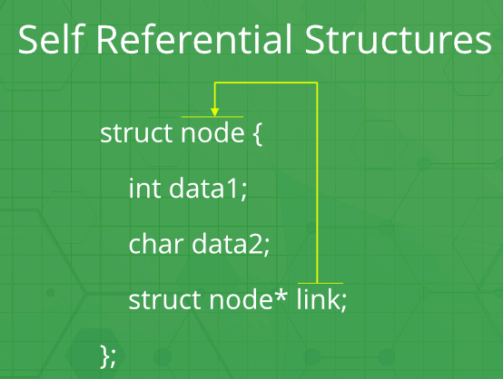
Why do we require a Self-referential structure?
Self-referential structure plays a vital role in the linked list, trees, graphs, and many more data structures. By using the structure, we can easily implement these data structures efficiently. For defining a particular node, the structure plays a very important role. In a linked list, the structure is used to store the data information and the address of the next node in the given linked list. Mainly the data part is of integer type, and the link address part is of pointer type, which holds the address of the next node, so that it can for the Link ultimately.
As we all know, the role of a linked list is used to store the data elements of the same type, in which address locations are not at the consecutive difference. In this linear linked list, the current node holds the address of the next node so that it ultimately forms the Link between the current node and the next node.
Here in the linked list, we will define a common structure, which contains the data and address pointer to carry the address of the next node, so to form the multiple nodes, we from each node using the node structure.
Unlike a static data structure such as an array where the size of the array limits the number of elements that can easily to inserted into the array, a self-referential structure can dynamically be expanded or contracted.
Operations like the insertion or deletion of nodes in a self-referential structure involve straightforward alteration of pointers.
Linked list
- A linked list is a useful data storage method, and it is very easy to implement it in C programming Language.
- Several kinds of linked lists, including single linked lists, double linked lists, and binary trees.
- Each type is suited for certain types of data storage.
- The one thing that these lists have in common is that the links between data items are defined by the information contained in the items themselves, in the form of pointers.
- The linked list is distinctly different from arrays, in which the links between data items result from the layout and storage of the array.
Here, we will discuss the self-referential structure in more detail using the linked list concepts.
Let's understand the concept of self-referential structure in more detail using the example mentioned below:
Example 1: Creating a random self-referential structure in the C programming language.
// Dummy Self-referential structure in C language
struct node // Creating a node of structure type contains data
// part of integer type and a pointer of structure type to
// hold the address of the next node
{
int d1 ; // data 1 of integer type
int d2 ; // data 2 of integer type
struct node * link ; // Self referential structure link is pointing the same
// structure of the type node
} ;
Int main()
{
Struct node obj; // Creating an object of the node type, this object is // consists of three parts one is data 1 and
// second is of data 2, and third is of link type pointer
// carries the address of the next node.
Return 0 ;
}
Example 2: Creating a random self-referential structure in a python programming language.
# Dummy Self-referential structure in python language
class node: # Creating a node that contains data
# part of and a pointer of node type to
# hold the address of the next node
def __init__(self):
self.data1=0
self.data2=' '
self.link=None # Self-referential structure link is pointing the same
# structure of the type node

if __name__ == '__main__':
ob=node()
# Creating a object of node type, this object is
# consists of three parts one is data 1 and
# second is of data 2 and third is of link type pointer
# carries the address of the next node
Types of self-referential structure
- Single Link self-referential structure
- Multiple Link self-referential structures
Single Link self-referential structure
As the name suggests, we can easily predict that these structures consist of a single Link, mainly the only one pointer link of structure type pointing to the same structure. To better understand it, we can connect this concept with the singly linked list.
In a singly linked list, there is only a single pointer that carries the address of the next node, and that pointer variable is of the structure node type itself. It is mainly used when we want to store the different data items by fetching out them from various addresses and connecting all of them by storing the address of one data item into the linked part of the other node. In this way, we can easily connect all the data items by using these connecting links.
Let's look at the working of single link self-referential structure with the help of an example:
// Single link self-referential structure implementation in C language
#include<stdio.h>
#include<stdlib.h>
struct node
{
int info ;
struct node *link ; // Self-referential structure link is pointing the same
// structure of the type node
};

struct node *START = NULL ; // start pointer to control the linked list //
struct node* createnode() ;
void insertatlast() ; // insert node at last //
void deleteatfirst() ; // delete node at first //
void viewlist() ;
void insertatfirst() ;
int getlength() ;
int menu() ;
void insertafteranynode() ;
void deleteatlast() ;
void deleteatposition() ;

struct node* createnode() // create node dynamically //
{
struct node *n ;
n = malloc( sizeof(struct node) ) ;
return ( n ) ;
}
void insertatlast()
{
struct node *temp ,*t ;
temp = createnode() ;
printf( "Enter the data in node \n " ) ;
scanf( " %d" , &temp->info ) ;
temp->link = NULL ;
if ( START == NULL )
START = temp ;
else
{
t = START ;
while ( t->link != NULL )
{
t = t->link ;
}
t->link = temp ;
}
}
void deleteatfirst() // delete node at first //
{
if ( START == NULL )
printf ( "List is empty \n " ) ;
else
{
struct node *q ;
q = START ;
START = START->link ;
free( q ) ;
}
}
void viewlist()
{ struct node* t ;
if ( START == NULL )
{
printf ( "No List \n " ) ;
}
else
{
t = START ;
while ( t != NULL )
{
printf ( " %d" , t->info ) ;
t = t->link ;
}
}
}
void insertatfirst()
{ struct node*New ;
New = createnode() ;
printf ( "Enter the data in node \n " ) ;
scanf ( " %d" , &New->info ) ;

if ( START == NULL )
START = New ;
else
{
New->link = START ;
START = New ;
}
}
int getlength()
{
int count = 0 ;
struct node* t ;
if ( START == NULL )
printf ( "List is empty \n " ) ;
else
{
t =START ;
while ( t != NULL )
{
count = count + 1 ;
t = t->link ;
}
}
return count ;
}
void insertafteranynode()
{
int position ;
struct node* newnode ,*t ;
if ( START == NULL )
printf ( "List is empty \n " ) ;
else
{
printf ( "Enter position after which you want to add: \n " ) ;
scanf ( " %d" , &position ) ;
if ( position > getlength() )
{
printf ( "Wrong position \n " ) ;
insertafteranynode() ; // recursion //

}
else
{
int i = 1 ;
newnode = createnode() ;
printf ( "Enter Data \n " ) ;
scanf ( " %d" , &newnode->info ) ;
newnode->link = NULL ;
if ( START == NULL )
START = newnode ;
else
{
t = START ;
while ( i < position )
{
t = t->link ;
i++ ;
}
newnode->link = t->link ;
t->link = newnode ;
}
}
}
}
void deleteatlast()
{
struct node* t , *q ;
if ( START == NULL )
{
printf ( "List is empty \n " ) ;
}
else
{
t = START ;
q = START ;
while ( t->link != NULL )
{
q = t ;
t = t->link ;
}
if ( t == START )
{
START == NULL ;
}
else
{
q->link = NULL ;
free( t ) ;
}
}
}
void deleteatposition()
{
struct node *t , *q ;
int position , i = 1 ;
t = START ;
if ( START == NULL)
{
printf ( "List is empty \n " ) ;
}
else
{
printf ( "Enter position after which you want to delete: \n " ) ;
scanf ( " %d" , &position ) ;
if ( position > getlength() )
{
printf ( "Wrong position \n " ) ;
deleteatposition() ; // recursion //

}
else
{
while ( i < position )
{
q = t ;
t = t->link ;
i++ ;
}
if ( t == START )
{
START == NULL ;
}
else
{
q->link = t->link ;
free( t ) ;
}
}
}
}
int menu()
{
int ch ;
printf ( " \t \t \t 1.ADD NODE LAST IN LINK \n " ) ;
printf ( " \t \t \t 2.ADD NODE AT FIRST IN LINK \n " ) ;
printf ( " \t \t \t 3.VIEW LIST IN LINK \n " ) ;
printf ( " \t \t \t 4.DELETE NODE AT FIRST IN LINK \n " ) ;
printf( " \t \t \t 5. TO SEE THE LENGTH OF LIST \n " ) ;
printf ( " \t \t \t 6. INSERT NODE IN BETWEEN \n " ) ;
printf ( " \t \t \t 7.DELETE NODE AT LAST IN LINK \n " ) ;
printf ( " \t \t \t 8.DELETE NODE AT SPECIFIC POSITION IN LINK \n " ) ;
printf ( " \t \t \t 9.EXIT \n " ) ;
printf ( "ENTER THE CHOICE \n " ) ;
scanf ( " %d" , &ch ) ;
return( ch ) ;
}
void main()
{ int k ;
while ( 1 )
{
switch ( menu() )
{
case 1 :
insertatlast() ;
break ;
case 2 :
insertatfirst() ;
break ;
case 3 :
viewlist() ;
break ;
case 4 :
deleteatfirst() ;
break ;
case 5 :
k = getlength() ;
printf ( "THE LENGTH OF THE LIST IS %d \n " , k ) ;
break ;
case 6 :
insertafteranynode() ;
break ;
case 7 :
deleteatlast() ;
break ;
case 8 :
deleteatposition() ;
break ;
case 9 :
exit( 0 ) ;
break ;
default :
printf ( " Not available \n " ) ;
}
}
}
The output of the above program is:
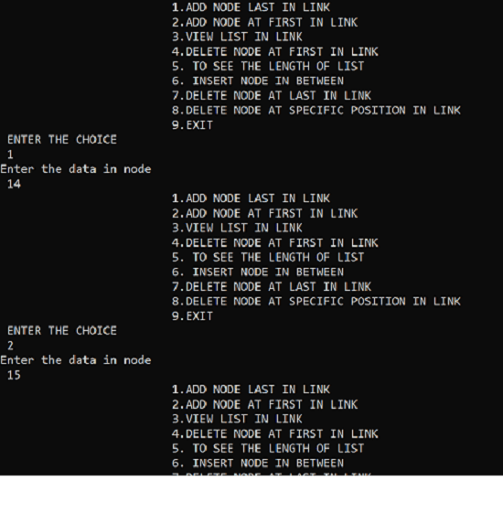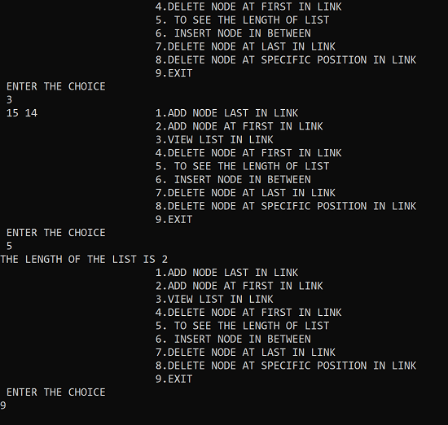

# Single link self-referential structure implementation in Python language
class node:
def __init__(self):
self.d1=0
self.d2=0
self.link=None

if __name__ == '__main__':
obj1=node() # Node1

# Initialization
obj1.link = None
obj1.d1 = 17
obj1.d2 = 14

obj2=node() # Node2

# Initialization
obj2.link = None
obj2.d1 = 36
obj2.d2 = 24

# Linking obj1 and obj2
obj1.link = obj2

# Accessing data members of obj2 using obj1
print(obj1.link.d1)
print(obj1.link.d2)
The output of the above program is:
36

24
Multiple Link self-referential structures
As the name suggests, we can easily predict that these types of the structure consist of multiple Link, here we will make use of two pointer links of structure type which is pointing to the same structure, to understand it better, we can connect this concept with a doubly-linked list.
In a doubly-linked list, two single pointers carry the address of the next node and the previous node, and that pointer variable is of the structure node type itself. It is mainly used when we want to store the different data items by fetching out them from various addresses and connecting all of them by storing the address of one data item into the linked part of the other node; in this way, we can easily connect all the data items by using these connecting links.
Let us look at the working of, multiple link self-referential structure with the help of an example:
// Multiple link self-referential structure implementation in C language
#include<stdio.h>
#include<stdlib.h>
struct node
{
int info ;
struct node *prev ; // Self-referential structure link is pointing the same
// structure of the type node but to the previous node

struct node *next; // Self-referential structure link is pointing the same
// structure of the type node but to the next node

} ;

struct node * START = NULL ; // Start pointer of the list and initially it must be null, // represents that no node is present
void insertnodeatfirst() ;
void deleteatfirst() ;
void viewlist() ;
int menu() ;
void insertnodeatfirst() // Inserting the node at first
{
struct node * newnode ;
newnode = malloc( sizeof( struct node ) ) ;
printf ( "Enter Data: \n " ) ;
scanf ( " %d" , &newnode->info ) ;
newnode->prev = NULL ;
newnode->next = NULL ;
if ( START == NULL )
START = newnode ;
else
{
START->prev = newnode ;
newnode->next = START ;
START = newnode ;
}
}
void deleteatfirst() // deleting the first node
{
struct node * temp ;
if ( START == NULL )
printf ( "List is empty \n " ) ;
else
{
temp = START ;
START = START->next ;
START->prev = NULL ;
free( temp ) ;
}
}
void viewlist() // displaying all the nodes in the list
{
struct node * t ;
if ( START == NULL )
printf ( "List is empty \n " ) ;
else
{
t = START ;
while ( t != NULL )
{
printf ( " %d \n " , t->info ) ;
t = t->next ;
}
}
}
int menu()
{ int n ;
printf ( " \t \t \t 1. VIEW LIST \n " ) ;
printf ( " \t \t \t 2. INSERT AT FIRST IN LIST \n " ) ;
printf ( " \t \t \t 3. DELETE AT FIRST IN LIST \n " ) ;
printf ( " \t \t \t 4. EXIT \n " ) ;
printf ( "ENTER YOUR CHOICE \n " ) ;
scanf ( " %d" , &n ) ;
return ( n ) ;
}
int main()
{
while ( 1 )
{
switch ( menu() )
{
case 1 :
viewlist() ;
break ;
case 2 :
insertnodeatfirst() ;
break ;
case 3 :
deleteatfirst() ;
break ;
case 4 :
exit ( 1 ) ;
break ;
default :
printf ( " NOT AVAILABLE \n " ) ;
}
}
}
The output of the above program is:
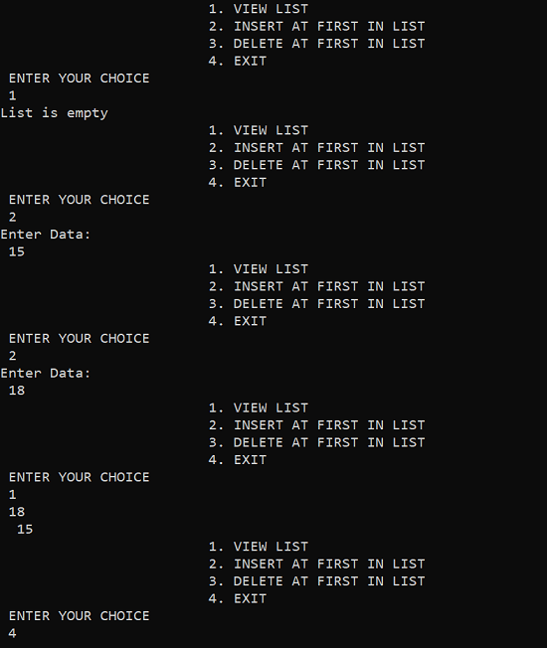
# Multiple link self-referential structure implementation in Python language
class node:
def __init__(self):
self.data = 0
self.prev = None
self.next = None

if __name__ == '__main__':
obj1=node() # Node1

# Initialization
obj1.prev = None
obj1.next = None
obj1.data = 15

obj2=node() # Node2

# Initialization
obj2.prev = None
obj2.next = None
obj2.data = 20

obj3 = node() # Node3

# Initialization
obj3.prev = None
obj3.next = None
obj3.data = 25

# Forward links
obj1.next = obj2
obj2.next = obj3

# Backward links
obj2.prev = obj1
obj3.prev = obj2

# Accessing data of obj1, obj2 and obj3 by obj1
print(obj1.data , end='\t')
print(obj1.next.data , end='\t')
print(obj1.next.next.data)

# Accessing data of obj1, obj2 and obj3 by obj2
print(obj2.prev.data , end='\t')
print(obj2.data , end='\t')
print(obj2.next.data)

# Accessing data of obj1, obj2 and obj3 by obj3
print(obj3.prev.prev.data , end='\t')
print(obj3.prev.data , end='\t')
print(obj3.data)
The output of the above program is:
15 20 25
15 20 25
15 20 25

Break Vs. Continue in C
Understanding the Difference Between a Break and a Continue Statement
Both statements are of the same type, and they allow a user to change or alter the flow of a programme. They are, however, distinct. The main difference between the break and continue statements in C is that the break statement causes the innermost switch or enclosing loop to exit immediately. The continue statement, on the other hand, starts the next iteration of the while, for, or do loop. The continue statement immediately takes control of the test condition in while and do loops. In the case of a for loop, it also takes control of the loop's increment step.
The continue statement can only be used on loops and not on switches. When a continue is present inside a switch (or further inside a loop), the next loop is iterated.
If we want to exit after the execution of a specific case, we can use a break in the switch. In the case of a loop, the break is also useful when we want to exit the loop after a certain condition occurs. For example, if you reach the end of your data or an error condition too soon. We only use the continue statement when we want to skip a statement (or multiple statements) in the body of a loop and pass control to the next iteration.

Break is defined as
Break has only two uses in C++, the first of which is to "end the execution of a case in a switch statement." The second step is to "end the loop and resume control to the next statement after the loop."
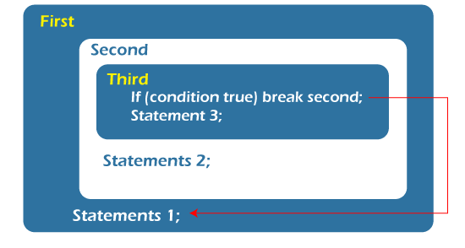
In C++, the break statement is used.
Let's take a closer look at each use of the 'break' statement. To begin, use to end the case execution in a switch. Only the switch that surrounds it is affected by the 'break' in the switch. It has no effect on the switch's enclosing loop.
//In context to C++.

//using break in switch in context of C++.

switch( integer expression)
{
case 1:
. . . . .
. . . . .
break;
case 2:
. . . . .
. . . . .
break;
case 3:
. . . . .
. . . . .
break;
default:
. . . . . . .
. . . . . . .
}
Continue is defined as
Breaking the loop terminates the remaining iterations and allows the control to exit the loop. Continue working in this manner as a break. The continue statement halts the execution of any remaining code in the loop for the current iteration and returns control to the loop's next iteration.
The continue statement skips the current iteration's code and passes control to the loop's next iteration.
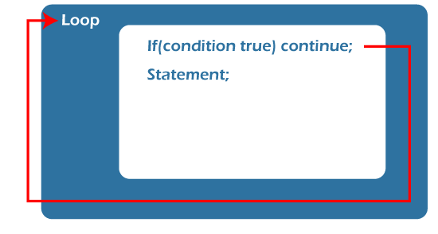
C++ Continue Statement
Let's look at an example of how to use the 'continue' statement in C++.
// using continue in context to C++
summation=0;
cin>>number;
while (cin)
{
if (num<0)
cout<<"Negative number found in the data"<<endl;
cin>>num;
continue;
}
summation = summation + number;
cin>>number;
}
With a 'for' loop, the effect of the continue statement is enhanced. While the continue statement is likely to execute the update statement in the case of while and do...while, this is not guaranteed.
In C, what is the difference between a break and a continue statement?
Parameters | Break Statement | Continue Statement
Construct a loop. | This statement allows a user to exit a loop's overall structure. | It does not allow a user to exit an overall loop structure.
Statements that switch and loop | The break statement can be used in conjunction with the switch statement. It can also be used inside the while loop, do-while loop, and for loop. It means that both the loop and the switch can easily break. | The switch statement and the continue statement are incompatible. You can still use it in for loops, do-while loops, and while loops. This means that continue can only happen in a loop, not in a switch.
Control | When the control reaches the break statement in a loop construct, it exits immediately. | The control passes from the beginning of a loop statement to the continue statement as soon as it encounters it.
Function | The break statement causes a loop or a switch to stop running in the middle of a case's execution. It means that if a switch or a loop encounters a break, it will end abruptly. | The continue statement does not end the loop, but rather leads it to the next iteration. It means that if a loop encounters a continue statement, it will complete all of its iterations. The continue statement is used to skip the statements that follow the continue in a loop.
Syntax | It can be written as:  break; | It can be written as:  continue;

The Key Differences Between Break and Continue
- In a nutshell, the break keyword ends the loop's remaining iterations. The continue keyword, on the other hand, only ends the loop's current iteration.
- When the break keyword is used, the program's control exits the loop and moves on to the next statement after the loop. The control of the programme resumes to the next iteration of the loop if the continue keyword is used.
- As the preceding step concludes, when the break control of the programme is executed, the programme exits the loop. It is clear that break causes any loop to terminate early. Continue, on the other hand, only terminates the current iteration and resumes the loop's next iteration, so we can say that continue causes the loop's next iteration to be executed sooner.
- After it is executed, the break keyword terminates all remaining iterations, effectively stopping the loop from continuing. The continue keyword, on the other hand, keeps the loop running.
- The break keyword can be used with both "switch" and "label" statements. The continue keyword, on the other hand, cannot be used with "switch" or "label."
Conclusion
Both the break and continue statements are jump statements that move control to another section of the programme. Whereas the break statement allowed the control to exit the loop, the continue statement allowed the control to enter the loop's next iteration.

For vs. While loop in C
Understanding the Difference Between a for loop and a while loop
The iteration statements in C++, such as for loop, while loop, and do-while loop, allow a set of instructions to be executed repeatedly until the condition is true, and then terminate when the condition is false. Iteration statements can have predefined conditions, such as in a for loop, or open-ended conditions, such as in a while loop.
In C++, a variety of 'for' loop variations are implied to increase the language's applicability, power, and flexibility. For example, the for loop allows us to control the loop by using multiple variables inside it, as well as the use of the converge function with the 'for' loop. In contrast, we cannot use many variations with the while loop; it must be used with the standard syntax.
There are some significant differences between the for and while loops, which are further explained using a comparison chart.
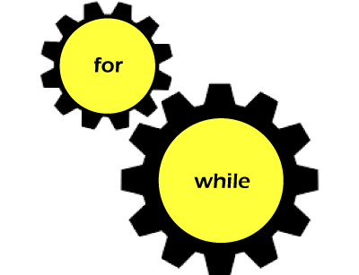
For Loop is defined as
There are two types of for loops in Java. The first is the "traditional" form, while the second is the "for-each" form.
The most general form of a for loop statement.
for (initialization; condition; iteration)
{
//body of for loop
}
Initialization: The for loop's loop controlling variable is only initialised once, during the first iteration of the loop. The loop controlling variable is initialised here; if the loop variable is never used again in the programme and is only used as the loop's controlling variable, it is both declared and initialised in the 'for' loop.
Condition: The 'for' loop's condition is executed each time the loop is iterated.
The iteration statement is an expression that increments or decrements the loop controlling variable.
When the loop is executed, the initialization condition is executed first, followed by the condition check. If the condition is met, the body of the loop is executed, followed by the iteration statement. The condition is then checked again to determine whether the loop will iterate further or terminate.
In Java, the initialization and iteration statements can both contain multiple statements. A comma separates each statement; in Java, a comma is a separator; in C++, a comma is an operator that can be used in any valid expression.
The syntax of the for-each loop
The "for-each" form is a more advanced version of the for loop. The for-each loop takes the following general form.
for(type iter_variable: collection) statement-block
The "type" parameter specifies the type of iteration variable, which is followed by the iteration variable. The element from the collection variable will be passed to the iteration variable. The type must match the type of elements in the collection variable. The for-each form of the for loop automates the loop's iteration from beginning to end, accessing the values in sequential order.
Example
There are various types of collections that can be used with a for loop. Let's talk about it using an array as a collection.
public class Main
{
public static void main(String[] args)
{
int array[]={10, 20, 30, 40, 50, 60};
int add=0;
for( int c: array)
{
System.out.println( "value in c " + c);
add = add+c;
}
System.out.println("additon of array elements is " +add);
}
}
Output:
value in c 10
value in c 20
value in c 30
value in c 40
value in c 50
value in c 60
additon of array elements is 210
'c' is an iteration variable in this case; it receives the values from array[], one by one, from the lowest to the highest index in the array. The loop iterates until all of the array's elements are examined. The loop can be broken in the middle by using "break." The change in the iteration variable, on the other hand, has no effect on the array because it is a read-only variable.
While loop is defined as
The while loop is the most basic loop in both C++ and Java. A while loop's operation is similar in C++ and Java.
Syntax
The following is the while loop declaration:
while ( condition)
{
statements; //body of loop
}
The while loop first checks the condition and then executes the statements until the condition in the while loop is true. In a while loop, the condition can be any boolean expression. When an expression returns a non-zero value, the condition is true; when it returns a zero value, the condition is false.
If the condition is true, the loop iterates itself; if the condition is false, control is passed to the line of code immediately following the loop. The body loop or statements can be an empty statement, a single statement, or a block of statements.
Example
Let's look at how a while loop works. The code in the example below will print from 1 to 10.
public class Main
{
public static void main (String args[])
{
int n=0;
while(n<10)
{
n++;
System.out.println("n=" +n);
}
}
}
Output:
n=1
n=2
n=3
n=4
n=5
n=6
n=7
n=8
n=9
n=10
The initial value of 'n' in this case is 0, which makes the condition in the while loop true. The control then enters the while loop's body, where the value of 'n' is incremented in accordance with the first statement.
The value of 'n' is printed, then control returns to the condition in a while loop, where the value of 'n' is now 1, satisfying the condition once more, and the body of the loop is executed once more. This continues until the condition becomes false, at which point the loop is terminated.
The 'while' loop, like the 'for' loop, can initialise the control variable at the beginning of the loop, i.e. during condition checking.
//for example
while((ch = getchar( ) ) != 'A')
{
System.out.println(" The input alphabet " +ch);
}
At the top of the loop, the control variable 'ch' is initialised, and the loop's condition is verified.

Note: If there is only one statement in the body of the loop, whether it is a for loop or a while loop, the curly braces are not required.
In C, what is the difference between a for loop and a while?
Parameters | For Loop | While Loop
Declaration | for(initialization ; condition ; iteration ) {  //body of 'for' loop  } | initialization  while ( condition ) {  statements;  //body of loop  }
Format. | At the top of the loop, initialization, condition checking, and iteration statements are written. | At the top of the loop, only initialization and condition checking are performed.
Use. | The 'for' loop was only used when the number of iterations was already known. | When the number of iterations is unknown, the 'while' loop is used.
Condition. | If the condition is not included in the 'for' loop, the loop iterates indefinitely. | If the condition is not included in the 'while' loop, a compilation error occurs.
Initialization | The initialization is never repeated in a 'for' loop. | If initialization is performed during condition checking in a while loop, initialization is performed each time the loop iterates.
Iteration assertion | Because the iteration statement in the 'for' loop is written at the top, it executes only after all statements in the loop have been executed. | The iteration statement in a 'while' loop can be written anywhere in the loop.

The Key Differences Between for and while loop
- Initialization, condition checking, and increment or decrement of iteration variables are all done explicitly in the loop syntax only. In contrast, in the while loop, we can only initialise and check the condition in the loop syntax.
- When we know the number of iterations that must occur in a loop execution, we use the for loop. On the other hand, if we do not know how many iterations must occur in a loop, we use a while loop.
- If you do not include a condition statement in the for loop, the loop will loop indefinitely. In contrast, failing to include a condition statement in the while loop will result in a compilation error.
- The initialization statement in the for loop syntax is only executed once at the beginning of the loop. If the while loop's syntax includes an initialization statement, the initialization statement will be executed each time the loop iterates.
- The iteration statement in the for loop will run after the body of the for loop. On the contrary, because the iteration statement can be written anywhere in the body of the while loop, there may be some statements that execute after the iteration statement in the body of the while loop is executed.
Conclusion
Loops are thus a collection of commands that must be used in a specific order. If the loop structure is incorrect, the programming will display the syntax error. Loops run to obtain a result or to satisfy a condition or set of conditions. It is the foundation of all programming languages.
During execution, the loop structure asks a question and executes until the answer is satisfactory. The same question is asked again and again until the new statement is applied. The looping process continues indefinitely until the programme reaches a breakpoint. In the event that the breaking point is not reached, the programme will crash.
The for and while loops are both conditional statements. A for loop is a single-line command that will be executed repeatedly. While loops can be single-lined or contain multiple commands for a single condition.
Both the for loop and the while loop are important in computer languages for obtaining results. The condition is met if the command syntax is correct.
Both the for loop and the while loop are iteration statements, but they have distinct characteristics. The for loop declares everything (initialization, condition, iteration) at the top of the loop body. In contrast, only initialization and condition are at the top of the body of the loop in a while loop, and iteration can be written anywhere in the body of the loop.

Abort() Function in C Programming
The abort() function is a function in the C library that bring you out from the program from where this function is called in the program.
It initiates a SIGABRT signal. The signal leads to the termination of the program that is being currently executed. It relieves all the buffers and ensures that all the files are closed.
The program may even have a handler. The responsibility of the handler includes intercepting the SIGABRT signal. It returns the control to the host environment. If the handler does not catch the signal, then an abnormal shutdown of the program occurs.

Note: When the program's termination is not normal, the user will be unable to use atexit() functions.
The user can also use a handler using the abort() function. The handler is used to handle the SIGABRT signal after it is initiated. The signal is generated again when the programs return the handler for any default action is returned. The code comes across the handle only once, even when resetting the handler.
The same is the case with the signal, once the handler ignores it. It will lead to the termination of the program.
The program's termination can be stopped even after executing the abort() function if the SIGABRT signal is caught by the handler or if it is ignored. You can use several methods in your program to avoid a return from the handler. One is you can get directly out of the handler.
Use the following functions to jump out of the handler:
- setjmp()
- longjmp()
Declaring the abort() function
The syntax of declaring abort() is similar to any other function. It begins with the return type, then followed by the function name that is abort(). And the parameter inside the brackets.
Thus, the function does not require any parameter and also it does not return any
value. So for both, we use the datatype void.
Implementing abort() in C:
Let us discuss an example to implement the abort() function:
#include <stdio.h>
#include <stdlib.h>
int main ()
{
FILE *fileptr;

printf("The program will open the thisfile.txt\n");
fileptr = fopen( "thisfile.txt","r" );
if(fileptr == NULL) {
printf("If this condition is met, user would abort the program\n");
abort();
}
printf("Once the file is used close thisfile.txt\n");
fclose(fileptr);

return(0);
}
Output:
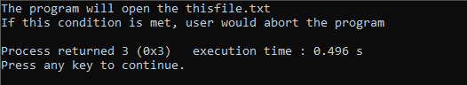
Given above is the output after the compilation and execution of the program. The result of the program will be as follows:
The program will try opening the thisfile.txt file, but no file exists with this name. So, when the code tries to open the file, it fails, and the code is aborted.
The steps are as follows:
- Open the thisfile.txt
- Abort the program
- Dump the core.
Difference between abort() and exit()
The exit() function ensures that the program is terminated properly. It closes all the files that were opened during the execution of the function. It clears the buffer and calls the functions listed in atexit().
When using the abort(), it initiates a SIGABRT signal that terminates the program if not caught by the handler in the program. But if the handler intercepts the signal, it may prevent the termination. The termination is unusual in this case. It may not close the file or not erase the temporary files that were created during the execution.
On using exit(), the functions that are registered with atexit() cannot be implemented. If the user wants to clear the stream buffer, it is better to use the exit() function, or the programmer should include a handler for SIGABRT in the code.

Assert in C Programming
Asserts are used in programs if the developer wishes to assert or make assumptions. An example where we can use assert is to check whether the pointer that is returned by malloc() is a NULL value or not. It is a diagnostic tool.
The Syntax for assert() function in C Programming
void assert( int expression);
It takes an expression for the parameter in the function. The parameter is evaluated. If the value returned after evaluation of the expression is 0 or FALSE, it returns the expression along with the file name and line of execution as an error. If the errors occur, the program calls the abort() function. The assert function does not do anything if the expression is evaluated TRUE.
Implementing assert() in a Program
To implement the assert() function in your program, you must include assert.h header file in your program.
#include <stdio.h>
#include <assert.h>
int main()
{int constt = 100;
// The portion contains multiple lines of code
// Assuming that some operations have been performed in the code
// that have changed the value of constt from 100 to 10.
constt = 10;
// the programmer is unaware of these changes
// and assumed that the value of constt is still 100.
assert(constt==100);
//code after assertion.
return 0;
}
Output:
In the program below, an assertion is made since the condition is false. The assertions fail.
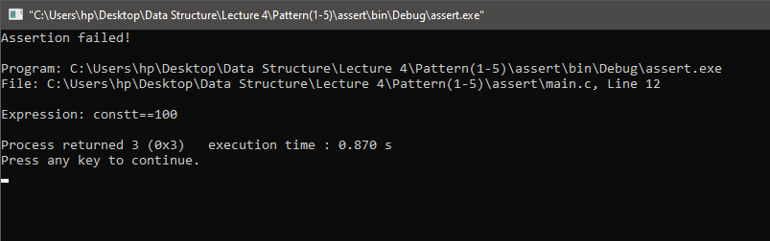
Assert vs Error Handling in C Programming
The programmer uses assertions to check the logically incorrect conditions. It is used in those scenarios where the programmers want to ensure the state of the code before running or completing the execution of the program. Such situations can't happen logically.
Error handling is performed during the runtime, whereas the asserts statement does not run during the run time. It is advised to not use the assert() statement in your program while execution as it may cause side effects during the execution.
Ignore the Assertions in your Program
As discussed, the assert statement may cause side effects during the compile time of the program and removing all the assertions from the code is a very tedious and difficult process.
In C programming language, there is an easier method that completely removes all the assert statements from your code during the execution.
It is done using the preprocessor NDEBUG.
Below is the code implementing assert while using the NDEBUG.
// The program return below will not through any error because we have //defined the pre-processor NDEBUG in it.
#define NDEBUG
# include <assert.h>
int main()
{
int constant = 10;
assert (constant==1);
return 0;
}
Output:
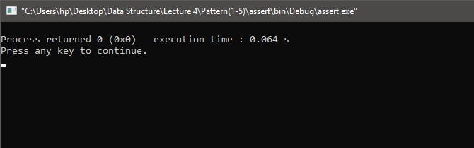

Floor() Function in C Programming
floor() in Mathematics
The floor() function in mathematics requires a real number, and it computes the greatest integer that can either be less than or equals to the value of x.
floor() in C Programming
It is a function that is defined in math.h header file and other similar functions enable the user to perform certain mathematical operations so easy further computations.
The floor() function takes a value from the user and returns the double value that is less than or equal to the value of x.
Syntax for using floor()
The function's return type is double, which takes a numerical argument. It can also be int, float, or any other datatype that can hold numerical value. Thus, the syntax is as follows:
double floor(double arg);
Implementing floor() in a C Program
Below is the code for implementing the floor() function in C language:
#include <stdio.h>
#include <math.h>
int main () {
// initializing the variables in the program
// here we have taken five floating pt numbers
float realno1, realno2, realno3, realno4, realno5, realno6;
float answer, answer1;
// assigning values to the initialized variables
realno1 = 3.1;
realno2 = 9.8;
realno3 = 11.9;
realno4 = 12.1;
realno5 = 16.5;
realno6 = 11.1;
//Computing and printing the floor value of the integers
printf("floor value of realno1 is = %.1lf\n", floor(realno1));
printf("floor value of realno2 is = %.1lf\n", floor(realno2));
printf("floor value of realno3 is = %.1lf\n", floor(realno3));
printf("floor value of realno4 is = %.1lf\n", floor(realno4));
printf("floor value of realno5 is = %.1lf\n", floor(realno5));
//You can either directly call the floor() function in the print statement
// or you can use it as any other function and call it outside the print and store the result in other variable
answer = floor(realno6);
printf("floor value of realno6 is = %.1f\n", answer);
//You can directly use a numerical value too
answer1 = floor(9.99);
printf("floor value of value is = %.1f\n", answer1);
return(0);
}
Output:
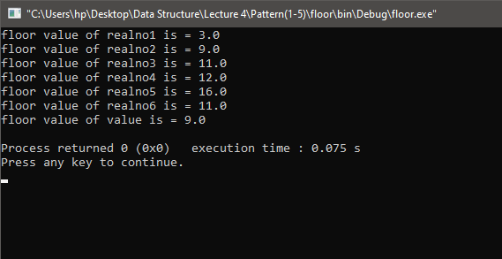
Explanation:
We have used the function in three different ways in the above program.
We have first directly printed the floor value using the printf() statement without storing the computed value in any variable.
In the second method we have storing the value computed using the variable floor. Then we used the value stored in the variable to print the output.
In the last method, we have directly used a numerical value as the input parameter in the function and have stored the value in the variable, which is to be printed.

memcmp() in C
Description of memcmp()
The memcmp() function allows the user to make a comparison between the bytes of the two mentioned characters. Depending upon the result after the comparison, it can return a positive or negative integer value. The function can also return 0.
The function is represented as int memcmp(const void *strng1, const void *strng2, size_t n). In this function, the computer will checks that the size of the initial elements of the object strng1 is either less, more or equal to the size of the initial n elements of the object strng2. The function is defined in the string.h header file. So, it is necessary to import the header file in your program to use the function in your code.
Declaring the memcmp() Function
The syntax for declaring the function is as follows:
int memcmp(const void *strng1, const void *strng2, size_t n);
Parameters inside the function
strng1: The pointer declared inside the function will point to the location of the first object that will be compared to the second object.
Strng2: This pointer points to the second object's memory block.
n: It determines the number of bytes of data that are required to be compared.
Returning Value after Computation
The function can return three possible ranges of values after comparing the size of two bytes.
Return Value is a Positive Integer: This means that the size of memory block 1 is greater than that of memory block 2.
Return Value is a Negative Integer: This means that the size of memory block 1 is less than that of memory block 2.
It returns 0: This means that the size of memory block 1 equals the size of memory block 2.
Implementing memcmp() function in C Program
Below is the code depicting the use of memcmp(). In the code below, we will compare the two arrays.
#include <stdio.h>
#include <string.h>
#define SIZE 20
int main ()
{
// initializing a variable result
//store the result of comparison
int result = 0;
//define both objects that is to be compared
char strng1[SIZE] = "memoryblock1";
char strng2[SIZE] = "sizeofthememoryblock2";
result = memcmp(strng1, strng2, 8);
if(result > 0)
{
printf("The size of strng1 is more than the size of strng2");
}
else if(result < 0)
{
printf("The size of strng1 is less than the size of strng2");
}
else
{
printf("The size of strng1 is equal to the size of strng2");
}
return 0;
}
Output:
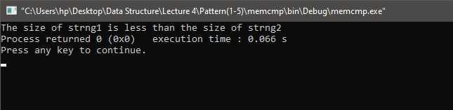
Explanation:
The value returned by the memcmp() will be negative. In the above example, we have stored "memoryblock1" in the first block, and in the second block, we have saved the "sizeofthememoryblock2". The first set of different characters is 'm' and 's'. The value of s is greater than the value of m; therefore, it will return a negative integer.
Important Facts Related to the memcmp() Function in C Programming
- It is necessary to include the h header file in your code to use the memcmp() function.
- The parameter in memcmp() function includes pointers which points to the objects and an integer 'n'. The n specifies the characters counting from the beginning until the comparison is made.
- If the initial characters in both the object are equal, then the function will move to the second character of the object. The step will be repeated until it finds any non-identical character in the block or compares to the nth element.
- If all the elements in the memory block are identical when compared, then the memcmp() functions 0.
Let us code to see the implementation of the above scenario
#include <stdio.h>
#include <string.h>
int main ()
{
int result = 0;
int ary1[] = {5,6,7};
int ary2[] = {5,6,7};
result = memcmp(ary1, ary2, 6);
if(result > 0)
{
printf("The size of ary1 is more than the size of ary2");
}
else if(result < 0)
{
printf("The size of ary1 is less than the size of ary2");
}
else
{
printf("The size of ary1 is equal to the size of ary2");
}
return 0;
}
Output:
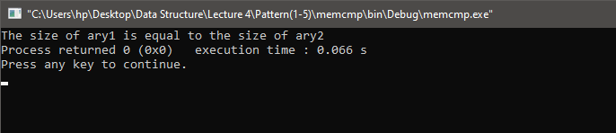
Explanation:
In the above examples, both arrays are equal. So, the memcmp() will return 0, which will be stored in the variable.
The function will return a positive integer whenever the first characters are different in both the arrays and the value of the character of the first array are greater than the value of the second array.
Let us implement a code where the value of the first object is more than the second object.
#include <stdio.h>
#include <string.h>
int main ()
{
int result = 0;
//for the first array 9 is greater than 5
// once it has evaluated unmatching characters, it wont compare further.
int ary1[] = {5,9,7,11};
int ary2[] = {5,5,7,12};
result = memcmp(ary1, ary2,20);
if(result > 0)
{
printf("The size of ary1 is more than the size of ary2");
}
else if(result < 0)
{
printf("The size of ary1 is less than the size of ary2");
}
else
{
printf("The size of ary1 is equal to the size of ary2");
}
return 0;
}
Output:
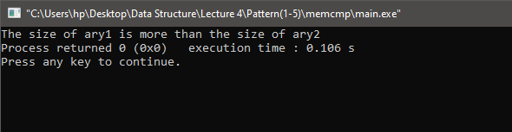
Explanation:
The second element in the arrays is different. So, the memcmp() will evaluate which element is greater. In this case element in the first array that is 9 is greater than the element in the second array that is 5. Thus, it will return a positive value for the result.
Suppose the initial non-identical character of the first object is less than the corresponding character of the second object. In this case, the value of the result will be a negative integer.
Let us see an example where the value returned by the memcmp() will be negative.
#include <stdio.h>
#include <string.h>
int main ()
{
int result = 0;
//for the first array 4 is less than 5
// once it has evaluated unmatching characters, it wont compare further.
int ary1[] = {4,9,7,11};
int ary2[] = {5,5,7,12};
result = memcmp(ary1, ary2,20);
if(result > 0)
{
printf("The size of ary1 is more than the size of ary2");
}
else if(result < 0)
{
printf("The size of ary1 is less than the size of ary2");
}
else
{
printf("The size of ary1 is equal to the size of ary2");
}
return 0;
}
Output:
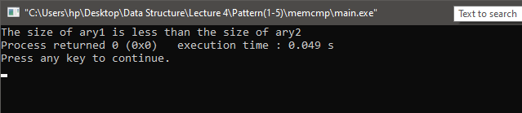
Explanation:
The very first element in the arrays is different. So, the memcmp() will evaluate which element is less. In this case element in the first array that is 4 is less than the element in the second array that is 5. Thus, it will return a negative value for the result.
The programmer needs to choose the number of characters or bytes for which he wants to perform the comparison. It can affect the result, so the programmer must ensure that a valid value is assigned to n.
The programmer should ensure that the number of bytes he enters should always be less than the size of both objects. Otherwise, it may return the wrong result.
#include <stdio.h>
#include <string.h>
int main ()
{
int result = 0;
//both the arrays are equal
int ary1[] = {5,5,7,12};
int ary2[] = {5,5,7,12};
//here the value of n is greater than size of both arr1 and arr2
result = memcmp(ary1, ary2,1300);
if(result > 0)
{
printf("The size of ary1 is more than the size of ary2");
}
else if(result < 0)
{
printf("The size of ary1 is less than the size of ary2");
}
else
{
printf("The size of ary1 is equal to the size of ary2");
}
return 0;
}
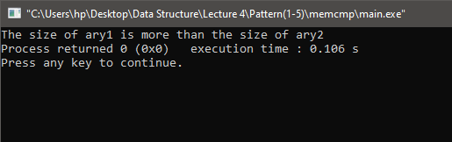
Output:

Explanation:
In the above program, both the arrays are exactly the same. That is equal, and the size of n is greater than the size of both arrays. Thus, the program is returning the wrong result.

Note: You should not use the memcmp() function to make the comparison between structures as it may return erroneous results and is not safe because there is always a chance of a garbage value in the padding bytes.
Implementing Your Own memcmp() Function
The memcmp() function is already defined in the C library and can be easily used after including the string.h header file in your program. The functions defined in the library are the most efficient and effective to use. So, defining or creating your memcmp() function is not required.
If there are certain conditions or scenarios that you are aware of, that can reduce the complexity of performing the comparison between the objects. In that case, you can define your memcmp() function to increase the program's simplicity.
Below is the function definition of a user-defined memcmp() function. Many scenarios are not taken into account in this function. So, if you want to add more conditions, you can change the code accordingly or use the library function to perform the comparison.
int user_def_memcmp(const void *strng1, const void *strng2, int length)
{
unsigned char *x = strng1;
unsigned char *y = strng2;
int comparisoncheck = 0;
//To check that pointers are pointing to same blocks.
if (strng1 == strng2)
{
return comparisoncheck;
}
while (length > 0)
{
if (*x != *y)
{ //Comparison between un matching charachters
comparisoncheck = (*x >*y)?1:-1;
break;
}
length--;
x++;
y++;
}
return comparisoncheck;
}

Find Day from Day in C without Using Function
Some Calendar Information
The time it takes for Earth to complete one orbit of the Sun is one year. It comes close to being 365.25 days. Therefore, if 365 days are regarded as a year, 4 years total have 1 day remaining. This results in a leap year, which has 366 days and happens once every four years. Every four-digit year, such as 0004, 0008, and so on, is a leap year starting with the year 0001. However, 365.25 is also an approximation. These results in anomalies occurring every 100 or 400 years, i.e., the years 0100, 0200, and 0300 are not leap years, but the year 0400 is.
An whole year has 12 months. They have the following lengths (Number of Days):
February 28 (if it's a non-leap year) and March 29 (Leap Year)
March 31 through April 30 through May 31 through June 30 through August 31 through September 30 through December 31
The TOTAL is thus 365 (Non-Leap Year) and 366. (Leap Year).
We discovered a truth that is 01-01-0001 by moving backward. i.e., Monday, January 1st, 0001. This serves as the program's foundation. Additionally, we employ a variable named day value, whose values are 0, 1, 2, 3, 4, or 6 for Monday, Tuesday, Thursday, Friday, Saturday, and Sunday, respectively.
# include < stdio . h >
# include < conio . h >
void main ( )
{
int month [ 12 ] = { 31 , 28 , 31 , 30 , 31 , 30 , 31 , 31 , 30 , 31 , 30 , 31 } ;
char week [ 7 ] [ 10 ] ;
int date , mon , year , i , r , s = 0 ;
clrscr ( ) ;
strcpy ( week [ 0 ] , " Sunday " ) ;
strcpy ( week [ 1 ] , " Monday " ) ;
strcpy ( week [ 2 ] , " Tuesday " ) ;
strcpy ( week [ 3 ] , " Wednesday " ) ;
strcpy ( week [ 4 ] , " Thursday " ) ;
strcpy ( week [ 5 ] , " Friday " ) ;
strcpy ( week [ 6 ] , " Saturday " ) ;
printf ( " ?nter a valid date ( dd / mm / yyyy ) : " ) ;
scanf ( " % d / % d / % d " , & date , & mon , & year ) ;
if ( ( year % 400 = = 0 ) | | ( ( year % 4 = = 0 ) & & ( year % 100 ! = 0 ) ) )
month [ 1 ] = 29 ;
for ( i = 0 ; i < mon - 1 ; i + + )
s = s + month [ i ] ;
s = s + ( date + year + ( year / 4 ) - 2 ) ;
s = s % 7 ;
printf ( " \ n The day is : % s " , week [ s ] ) ;
getch ( ) ;
}
Output:
?nter a valid date ( dd / mm / yyyy ) : 05/07/2022

The day is : Tuesday
..................................................
Process executed in 1.22 seconds
Press any key to continue.
Explanation
A total of 12 distinct integers can be kept in the array month[12], which is of the type integer. Additionally initialized at declaration time is this array. Each value in this array indicates how many days there are in a specific month, for example, the first value, 31, indicates that January has 31 days. Char [7] [10] - This is a different array from the month [12] array mentioned before since it is a multidimensional array of the type character. This array can hold up to seven items, and each value's length must be between nine and ten. The days, such as Sunday, Monday, and so on, are represented by this array. These integers are used to record the day, month, and year that the user has supplied. Other integers used for intermediate computations include I, r, and s. Here, we're using the string copy function strcpy from the C language, rather than initializing the char[7][10] array at the time of declaration like we did with the month[12] array ().
The strcpy() method is used to initialize week[7][10]. Now, we request preformatted input from the user. When the user inputs the date in the format dd/mm/yyyy, all three values are immediately stored in their respective variables since we separated each integer within scanf() by a "/".
Then if statement then determines whether or not the year the user supplied is a leap year. The number of days in the month of February is set to 29 if the year is a leap year by month [1] = 29;

Find Median of 1D Array Using Functions in C
The midway value that splits the items into two portions with an equal number of items on either side is known as the median if the list's contents are ordered in order. Even numbers of things have two middle values, while odd numbers of items have just one. Therefore, the median is defined as the average of the two middle values when there are even numbers of elements.
Algorithm
To determine the median, use the procedure below.
- First, read the items into an array while maintaining an item count.
- The objects are sorted in step two by increasing value.
- Calculate the median.
Following is the reasoning behind sorting the data before determining a median:-
for(i=1 ; i <= n-1 ; i++) {
for (j=1 ; j <= n-i ; j++) {
if ( a[j] <= a [j+1] ) {
t = a[j];
a[j] = a[j+1];
a[j+1] = t;
} else
continue;
}
}
The following reasoning was used to determine the list's median:-
if ( n % 2 = = 0 )
median = ( a [ n / 2 ] + a [ n / 2 + 1 ] ) / 2 . 0 ;
else
median = a [ n / 2 + 1 ] ;
Example: C program to determine the median of supplied integers is provided below.
#include < stdio.h >
#include < conio.h >
#include < sdtlib >
#define N 10
main ( ) {
int i , j , n ;
float median , a [ N ] , t ;
printf ( " ?nter the number of items \ n " ) ;
scanf ( " % d " , & n ) ;
/* Reading items into array a */
printf ( " Input % d values \ n " , n ) ;
for ( i = 1 ; i < = n ; i + + )
scanf ( " % f " , & a [ i ] ) ;
/* Sorting begins */
for ( i = 1 ; i < = n - 1 ; i + + ) { / * Trip - i begins * /
for ( j = 1 ; j < = n - i ; j + + ) {
if ( a [ j ] < = a [ j + 1 ] ) { / * Interchanging values * /
t = a [ j ] ;
a [ j ] = a [ j + 1 ] ;
a [ j + 1 ] = t ;
}
else
continue ;
}
} / * sorting ends * /
/ * calculation of median * /
if ( n % 2 = = 0 )
median = ( a [ n / 2 ] + a [ n / 2 + 1 ] ) / 2.0 ;
else
median = a [ n / 2 + 1 ] ;
/ * Printing * /
for ( i = 1 ; i < = n ; i + + )
printf ( " % f " , a [ i ] ) ;
printf ( " \ n \ n Median is % f \ n " , median ) ;
}
Output:
?nter the number of items
5
Input 5 values
2.3
1.2
3.8
4.6
8.9
8.900000 4.600000 3.800000 2.300000 1.200000
Median is 3.800000
.......................................................
Process executed in 1.22 seconds
Press any Key to continue.
Explanation
In the above example of a program in C++, we have demonstrated how we can find the median of the supplied intergers.
Another Example:
#include < stdio.h >
void swap ( int * p , int * q ) {
int t ;
t = * p ;
* p = * q ;
* q = t ;
}
void sort ( int a [ ] , int n ) {
int i , j , temp ;
for ( i = 0 ; i < n - 1 ; i + + ) {
for ( j = 0 ; j < n - i - 1 ; j + + ) {
if ( a [ j ] > a [ j + 1 ] )
swap ( & a [ j ] , & a [ j + 1 ] ) ;
}
}
}
int main ( ) {
int a [ ] = { 6 , 3 , 8 , 5 , 1 } ;
int n = 5 ;
int sum , i ;
sort ( a , n ) ;
n = ( n + 1 ) / 2 - 1 ; // -1 as array indexing in C starts from 0
printf ( " Median = % d " , a [ n ] ) ;
return 0 ;
}
Output:
Median = 5
..................................
Process executed in 1.11 seconds
Press any key to continue.
Explanation
In the above example of a program in C, Take the list 3, 5, 2, 7, 3 as an example for our input list. First, we reorder it as 2, 3, 3, 5, 7 to determine the median and we discover that ((5+1)/2) is 3 at position 3. Therefore, the median value in this list is 3.

Find Reverse of an Array in C Using Functions
This article will demonstrate how to create a C program that uses a function to reverse an array. For instance, if "arr" is an array of three numbers like in:
arr [ 0 ] = 1
arr [ 1 ] = 2
arr [ 2 ] = 3
Then, by reversing the array we will have:
arr [ 0 ] = 3
arr [ 1 ] = 2
arr [ 2 ] = 1
In C, you may reverse an array in four different ways: with a for loop, pointers, recursion, or by writing a function.
Example:
#include < stdio.h >
#include < stdlib >
#include < conio.h >
#include < math >
// function to reverse an Array
void reverse ( int arr [ 10 ] , int n )
{
int i , tmp ;
for( i = 0 ; i < n / 2 ; i + + )
{
tmp = arr [ i ] ;
arr [ i ] = arr [ n - 1 - i ] ;
arr [ n - 1 - i ] = tmp ;
}
}
int main ( )
{
int arr [ 100 ] , i , size ;
printf ( " ?nter size of array : " ) ;
scanf ( " % d " , & size ) ;
printf ( " ?nter the elements of the array : " ) ;
for ( i = 0 ; i < size ; i + + )
scanf ( " % d " , & arr [ i ] ) ;
// call reverse function
reverse ( arr , size ) ;
// display reversed array
printf ( " After reversing the array : " ) ;
for ( i = 0 ; i < size ; i + + )
{
printf ( " % d " , arr [ i ] ) ;
}
return 0 ;
}
Output:
?nter size of array: 3
?nter the elements of the array: 1 2 3
After reversing the array: 3 2 1
....................................
Process executed in 1.22 seconds
Press any key to continue.
Explanation
In the above example of a program in C, we have demonstrated how we can use function to reverse an array. We have created a user defined function reverse which takes the array and the size of the array as parameter and creates a tmp variable to swap the numbers.
In-Place Implementation
#include < stdio.h >
#include < stdlib >
#include < conio.h >
#include < math >
// Function to print contents of an array
void print ( int arr [ ] , int n )
{
for ( int i = 0 ; i < n ; i + + ) {
printf ( " % d " , arr [ i ] ) ;
}
}
// Function to reverse elements of an array
void reverse ( int arr [ ] , int n )
{
for ( int low = 0 , high = n - 1 ; low < high ; low + + , high - - )
{
int temp = arr [ low ] ;
arr [ low ] = arr [ high ] ;
arr [ high ] = temp ;
}
}
int main ( void )
{
int arr [ ] = { 1 , 2 , 3 , 4 , 5 } ;
int n = sizeof ( arr ) / sizeof ( arr [ 0 ] ) ;
reverse ( arr , n ) ;
print ( arr , n ) ;
return 0 ;
}
Output:
5 4 3 2 1
.............
Process executed in 2.12 seconds
Press any key to continue.
Explanation
In the above example of a program in C, reading the items from both ends of the array and swapping them can be used to build a linear in-place algorithm, as shown in the example.
Another Example:
#include <stdio.h>
// Function to print contents of an array
void print(int arr[], int n)
{
for (int i = 0; i < n; i++) {
printf("%d ", arr[i]);
}
}
// Function to reverse elements of an array
void reverse(int arr[], int i, int n)
{
// base case: end of an array is reached or array index out-of-bounds
if (i >= n) {
return;
}
// store the next array element
int value = arr[i];
// reach the end of the array using recursion
reverse(arr, i + 1, n);
// put elements in the call stack back into the array
// in the correct order
arr[n - i - 1] = value;
}
int main(void)
{
int arr[] = { 1, 2, 3, 4, 5 };
int n = sizeof(arr)/sizeof(arr[0]);
reverse(arr, 0, n);
print(arr, n);
return 0;
}
Output:
5 4 3 2 1
....................
Process executed in 1.22 seconds
Press any key to continue.
Explanation
Another is a recurring system that puts the elements in a call stack before returning them to the same members in the correct order at the end of the repetition.

Find Occurrence of Substring in C using Function
This software counts the number of times a substring appears in a string after receiving a string and a substring as input. Let us look at an example:
Solution would be:
- Take as input a string and a substring.
- Look first in the string for the substring.
- Count the instances where it is present if it is there.
Here is the C program's source code for counting the occurrences of a substring within a string. On a Linux machine, the C program is successfully built and executed. Also given below is the output of the application.
Example:
/*
* C Program To Count the Occurrence of a Substring in String
*/
# include < stdio . h >
# include < string . h >
# include < stdlib >
# include < conio . h >
char str [ 100 ] , sub [ 100 ] ;
int count = 0 , count1 = 0 ;
void main()
{
int i , j , l , l1 , l2 ;
printf ( " \ n enter a string : " ) ;
scanf ( " % [ ^ \ n ] s " , str ) ;
l1 = strlen ( str ) ;
printf ( " \ n enter a substring : " ) ;
scanf ( " % [ ^ \ n ] s " , sub ) ;
l2 = strlen ( sub ) ;
for ( i = 0 ; i < l1 ; )
{
j = 0 ;
count = 0 ;
while ( ( str [ i ] = = sub [ j ] ) )
{
count + + ;
i + + ;
j + + ;
}
if ( count = = l2 )
{
count1 + + ;
count = 0 ;
}
else
i + + ;
}
printf ( " % s occurs % d times in % s " , sub , count1 , str ) ;
}
Output:
enter a string : prrrogram c prrrogramming
enter a substring : rr
rr occurs 2 times in prrrogram c prrrogramming
..............................................
Process executed in 2.22 seconds
Press any key to continue.
Explanation
- Take a string and a substring as input and place them in the corresponding str and sub fields.
- Use the strlen function to determine the length of both strings.
- Determine if a substring is present or not using a for loop. If so, use the count variable to count how many times it is present.
- Print the number of variables as output.
Using Function:
/*
* C Program To Count the Occurrence of a Substring in String
*/
# include < stdio . h >
# include < string . h >
# include < stdlib >
# include < conio . h >
int substring_count ( char * string , char * substring ) {
int i , j , l1 , l2 ;
int count = 0 ;
l1 = strlen ( string ) ;
l2 = strlen ( substring ) ;

for ( i = 0 ; i < l1 - l2 + 1 ; i + + ) {
if ( strstr ( string + i , substring ) = = string + i ) {
count + + ;
i = i + l2 - 1 ;
}
}
return count ;
}
Output:
enter a string : If life were predictable it would cease to be life and be without flavor
enter substring : be
Substring occurrence count is : 2
..............................................
Process executed in 1.22 seconds
Press any key to continue.
Explanation
We utilized the strstr() method rather than creating our own inner loop to determine whether the substring matches from a certain location in the outer loop. The first matching character's pointer is returned by the strstr() method. The counter is increased if the pointer is equal to the pointer for the outer loop's initial character. With the help of the strcmp() method, we can accomplish the same goal. The strchr function gives the string's first instance of each character.
The strrchr function returns the character that last appeared in a string. If the character is not detected, they return a NULL pointer instead of a character pointer. Let's create a program that outputs the first and last index of every lower-case character in a string using these functions.
A pointer to the character where the occurrence of the desired character is detected is returned by both strchr and strrchr. Let's say the character to be searched for is "b" and the string to be searched is "abcd." A pointer to character "b" in the string is then given back. In the absence of the character, NULL is returned.

Find out Power without Using POW Function in C
The function pow() is used to calculate the power of a given integer. Now in this article we will going to understand with a help of a program how to calculate the power of a integer without using the function pow() in C.
Using for loop for Determining the Power of Given Integer
Imagine you need to locate a ^ b. The easiest method is to multiply a by b times using a loop.
- Let a ^ b be the input. The base is a, while the exponent is b.
- Start with a power of 1.
- Using a loop, execute the following instructions b times
- power = power * a
- The power system has the final solution, a ^ b.
Let's understand the above approach better with an example of a program in C:
# include < stdio . h >
# include < string . h >
# include < conio . h >
# include < math >
# include < stdlib >
int Pow ( int a , int b ) {
int power = 1 , i ;
for ( i = 1 ; i < = b ; + + i ) {
power = power * a ;
}
return power ;
}
int main ( ) {
long long int base , exponent ;

printf ( " enter Base : " ) ;
scanf ( " % d " , & base ) ;

printf ( " enter Power : " ) ;
scanf ( " % d " , & exponent ) ;

printf ( " % d ^ % d = % d " , base , exponent , Pow ( base , exponent ) ) ;
}
Output:
Enter Base: 5
Enter Power: 3
5 ^ 3 = 125
..........................
Process executed in 3.22 seconds
Press any key to continue.
Explanation
The code above has an O (N) time complexity, where N is the exponent. O is the space complexity (1).
Using While loop:
# include < stdio . h >
# include < string . h >
# include < conio . h >
# include < math >
# include < stdlib >
int main ( )
{
int n , exp , exp1 ;
long long int value = 1 ;
printf ( " enter the number and its exponential : \ n \ n " ) ;
scanf ( " % d % d " , & n , & exp ) ;
exp1 = exp ; // storing original value for future use
// same as while ( ( - - exp ) ! = - 1 )
while ( exp - - > 0 )
{
value * = n ; // multiply n to itself exp times
}
printf ( " \ n \ n % d ^ % d = % l l d \ n \ n " , n , exp1 , value ) ;
return 0;
}
Output:
enter the number and its exponential :
5
4
5 ^ 6 = 625
..........................
Process executed in 0.11 seconds
Press any key to continue.
Explanation
Long Long Int is twice as large as Long Int. The format specifier for long long int is percent lld.
Using Recursion to find the Power of Given Integer
Assume that a ^ b is the input. The power of 'a' will increase by one with each recursive call. To obtain a ^ b, we call the recursive function b twice.
- Let Pow ( a, b ) be the recursive function used to calculate a ^ b.
- Simply return 1 if b == 0; else, return Pow (a, b -1) * a.
Let's understand the above approach better with an example of a program in C:
# include < stdio . h >
# include < string . h >
# include < conio . h >
# include < math >
# include < stdlib >
int Pow ( int a , int b ) {
if ( b = = 0 )
return 1 ;
else
return Pow ( a , b - 1 ) * X ;
}
int main ( ) {
long long int base , exponent ;
printf ( " enter Base : " ) ;
scanf ( " % d " , & base ) ;
printf ( " enter Power : " ) ;
scanf ( " % d " , & exponent ) ;
printf ( " % d ^ % d = % d " , base , exponent , Pow ( base , exponent ) ) ;
return 0;
}
Output:
Enter Base: 5
Enter Power: 4
5 ^ 4 = 625
..........................
Process executed in 1.22 seconds
Press any key to continue.
Explanation:
In the above example of a code in C, time complexity would be exponent N, O(N) & O(N) space complexity, internal stack.

Exponential() in C
Exponential in mathematics
It can be described as the function that computes the power of any constant. It can be represented as a^x where a is a constant value. Usually, the constant value is e.
Exponential in C Programming
In C programming, we compute the exponential value of the constant e., e stands for Euler's number. The value of e is approximately 2.71828. The exp() function is defined in maths.h header file. So, if the
Syntax of exp() function in C Programming
Double exp(double parameter);
Parameter for exp() function
The function only requires one parameter. The parameter stores the value by which the e is to be raised. Since the value for which the exponent is to be computed is constant.
Return Type for exp() function
The return type for the exp() function is double. It can be float or any other data type that can hold the numerical value.
Implementing exp() function in C Program
Below is the code to implement the exp() function in C Program.
//Include the maths header file in the program.
#include <stdio.h>
#include <math.h>

int main()
{// Use the exp() function to compute the exponential value for e.
printf("The value for e raised to power 0 is = %.6f \n", exp(0));
printf("The value for e raised to power 2 is = %.6f \n", exp(2));
printf("The value for e raised to power 13 is = %.6f \n", exp(13));
printf("The value for e raised to power 12.01 is = %.6f \n", exp(12.01));
printf("The value for e raised to power -1 is = %.6f \n", exp(-1));
printf("The value for e raised to power -3.73 is = %.6f \n", exp(-3.73));
// Using .6f to print the result will return the answer up to 6th decimal place.
return 0;
}
Output:
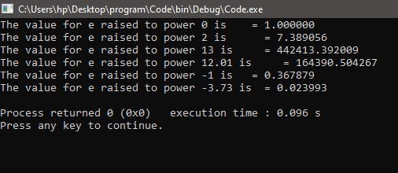
User Input for Computing the Exponential Value
//The C Program for raising the power of e by user input
//exp() is defined in math.h header file
#include <stdio.h>
#include <math.h>
int main()
{
float power, result;
printf(" Please input the value to raise e : \n");
//take user input
scanf("%f", &power);
//Store answer
result = exp(power);
printf("\n The value for e raised to the power %.4f is = %.6f \n", power, result);
return 0;
}
Output:
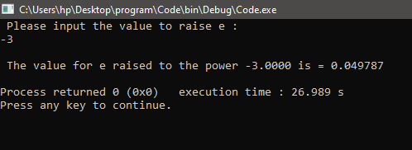
In the above example, we have taken the input from the user. It can be any float value once the user enters the value. It will be used to compute the exponential in the program, and it will be stored in the variable result. In the last statement, we will print the result. The answer will be displayed up to the sixth decimal place.

Float in C
Float is a data type that enables the user to declare variables and assign floating point values to the variable.
The syntax for declaring float variable
The data type is used to declare the numbers with decimal points. Its syntax is as follows:
float variable_name= value;
You can also use the float keyword once to declare multiple floating point variables at once.
float var1=value, var2=val, var3=val,….varn=valn;
Parameters or Arguments
- var1: It states the name of the first variable declared by the user.
- val1: It is not necessary to assign the value to the variable while declaring it. This parameter is optional to use. The user can also take user input to assign value to the variable.
- varn: It is the name for the nth variable.
- valn: It is optional. It will assign the value to the nth variable.
For Example:
float rateofinterest=10.00;
float roi;
Now let us see examples to learn how to use the float in your C program.
Example 1: Declare the Variable
In the code below, we have used the float keyword to declare the roi variable in the program.
#include <stdio.h>
int main()
{
float roi;
roi = 10.00;
//it will print 6 digit decimal number after the decimal points.
printf("The rate of interest for the investment is %f \n", roi);
return 0;
}
Output:
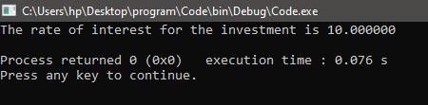
Example 2: Declare the Variable and assign the value to the variable
In the code below, we have declared the variable and assigned the value to the variable in a single statement. This reduces unnecessary lines of code.
#include <stdio.h>
int main()
{ // we have used a single line to
//i) declare the variable
//ii) assign the value to the declared variable
float secondinterest=12.00;

//it will print 6 digit decimal number after the decimal points.
printf("The rate of interest for the second investment is %f \n", secondinterest);
return 0;
}
Output:
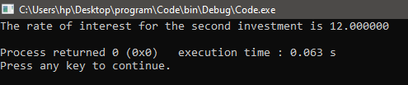
Example 3: Declare Multiple Floating Point Variable in a single line
The user can also declare multiple variables in a single line using the datatype only once. To declare multiple variables in a single statement, the user must separate the variable names by commas (,).
Let us see an example to implement the statement in your code.
#include <stdio.h>
int main()
{ // we have used a single line to
//declare multiple variables
float firstinterest, secondinterest;
firstinterest=9.00;
secondinterest=13.00;

//it will print 6 digit decimal number after the decimal points.
printf("The rate of interest for the first investment is %f \n", firstinterest);
printf("The rate of interest for the second investment is %f \n", secondinterest);
return 0;
}
Output:
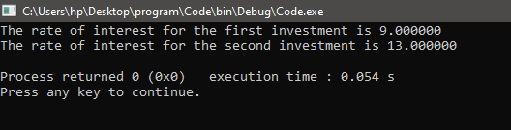
Example 4: Declaring multiple floating point variables and assigning the values to the variable in the same statement.
It is possible to declare different variables simultaneously until they have the same datatype. To declare floating point variables and assign the values to the variable, use the float keyword, followed by key=value pairs of the variable name and value, each separated by a comma (,).
#include <stdio.h>
int main()
{ // we have used a single line to
//i) declare multiple variables
//ii)assign different values to the multiple variables
float firstinterest=8.15, secondinterest=15.5;

//it will print 6 digit decimal number after the decimal points.
printf("The rate of interest for the first investment is %f \n", firstinterest);
printf("The rate of interest for the second investment is %f \n", secondinterest);
return 0;
}
Output:
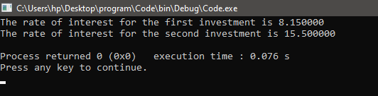
Differentiate between float and double datatype in C Programming
There are two data types in C and C++ that allow users to take and return decimal point values in the system. These data types are float and double, and the user can use both these data types to represent such numbers.
Now the question arises why use two different data types for representing the same type of data and what is the difference between these two data types?
- The major difference between float and double is based on their precision. The precision determines the degree of accuracy of the variable value. The precision for the double time is 2 times more than the precision of the float data type. In simpler terms, it means that the variable that is initialized uses double, double precision rather than the variables initialized using the float data type.
- The number of precision of a variable that is initialized using double is 64-bit precision for a decimal point number. The 62 bits are divided into several parts, each with its own role. The first bit is used for storing the sign, and the next 11 bits are used for storing the exponent value. The remaining 52 bits are used for storing the actual variable of the value. The double can store 15 decimals.
- In contrast, the precision of a variable that is initialized using float is 32-bit for a decimal point number. The next 8 bits are used for storing the exponent value. The rest of the 23 bits are used for storing the actual variable of the value. The float can have 7 decimal digits of precision.
- The precision of a double data type is more than the float; therefore, it requires double the amount of space required to store a float variable. So, it is only preferred to use where the accuracy of the value holds more importance than the space complexity of the program.

islower() in C
The islower() function is used to check whether the entered character passed inside the function is a lowercase character. The lowercase character includes (a-z).
Syntax of islower() In C Programming
int islower( int arg);
Parameters Passed in islower() Function
c: It requires only one parameter. The c represents a character that is required to be checked.
Return Value
Two possible values can be returned after using the islower() function. They can be
Non-zero value: It returns a non-zero value when the character passed to the islower() function is a lowercase character.
0: The function returns a zero (0) if the character is not lowercase.
Implementation of islower() function in C Programming
The islower() function in C Program checks that a character is typed in lowercase and not uppercase. It only returns a number other than zero if the character is one of them: a b c d e f g h i j k l m n o p q r s t u v w x y z.
The islower() function is declared in the ctype.h header file. It is necessary to include this header file to use this function as the function definition is in this file.
For any character the islower() function returns a non-zero value. The functions such as iscntrl, isdigit, ispunct and isspace will return zero for the same character.
For example:
Input value: z
Output: Non-zero value
Input value: U
Output: 0
Input value: $
Output: 0
Input value: c
Output: Non-zero value
Implement a C Program to Check Whether a Character is a lowercase character or not
#include <stdio.h>
// including ctype to use the islower() function in your code
#include <ctype.h>
int main()
{
//take the character as an integer value.
int character; //Ascii value of the character
printf("Enter a character from the keyboard ");
character = fgetc(stdin);
//using the function for checking character is between(a-z)
//if it is (a-z) then it will return 0
if (islower(character) == 0)
{
printf("%c is not a lowercase character.", character);
}
// in every other case else statement will be executed.
else
{
printf("%c is a lowercase character.", character);
}
return 0;
}
Output:
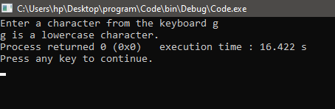
The user can input any valid character from the keyboard. The program will pass that character into the islower() function, determining whether the character is in lowercase.
Using the islower() Function to write more complex programs
There are multiple applications of the islower() function. Some of these applications are implemented below:
Count the lowercase characters in a given string
Algorithm
To find out the number of lowercase characters in the string, we are required to follow these steps:
- Initialize a counter variable to zero.
- First, transverse the string character by character.
- Ensure that each character of the string is passed into the islower() function.
- Increment the value of the counter value by 1 whenever a non-zero value is returned by the islower() function.
- Use the break() statement to come out of the loop when the conditions have encountered the null character. The only drawback with this method is that the string should have only one null character at the end.
- Return the value of the counter value, representing the number of lowercase characters in the string. Print the value in your main function.
//Include all the necessary libraries
#include <ctype.h>
#include<string.h>
#include <stdio.h>
unsigned int TotalLowercase(char *strng)
{
unsigned int counter = 0;
//check if string is valid or not
if (strng != NULL)
{
//count the occurrence of lowercase characters
//increment whenever a lowercase character is encountered
for(int i=0;strng[i]!=0;i++)
{
if (islower((unsigned char)strng[i]))
{++counter;
}
}
}
// return the value of counter once null character is reached in the given string.
return (counter);
}
int main()
{
char strng[] = "This is the Content for JavaTpoint";
unsigned int counter = TotalLowercase(strng);
printf("The count of characters in the given string is %u\n\n", strlen(strng));
printf("\nThe number of lowercase characters in the given input stream is : %u\n\n", counter);
return 0;
}
Output:
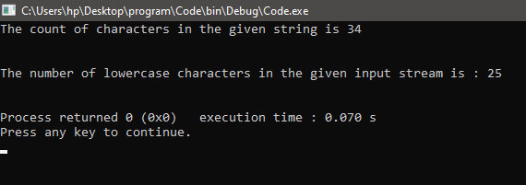
Print the Characters of the String Until you have encountered a Lowercase Character in the string
This is also a popular coding question. The aim is to print a string till you encounter the first lowercase character in the string. It is easy to code this problem by simply using the islower() function in the C Programming language.
Algorithm
- The first step is to transverse the string characters by character. Each character is once passed into the islower() function.
- The function returns a zero a character that is not in lowercase is passed into it. Use a loop to perform iteration. The condition for execution of the loop is that the islower() function should return Zero. So, if a non-lowercase character is passed in the function, it will return a non-zero value, the loop will execute, and the character will be printed.
- The loop will terminate itself once it encounters a lowercase character as it will break, resulting in coming out of the loop.
Let us code the actual program using the above algorithm.
//Include all the necessary libraries
#include <ctype.h>
#include<string.h>
#include <stdio.h>
int main()
{
char str[] = "THIS IS THE STRING PRINTeD TILL FIRST lowercase character";
unsigned int i = 0;
//Print the String until the first character
//loop executes till the condition is false
while (!islower((unsigned char)str[i]))
{
putchar(str[i]);
i++;
}
return 0;
}
Output:
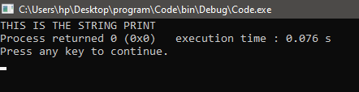
Print the First Lowercase Character in the given string
Another application of the islower() function in C Programming is that we can easily determine the first lowercase character present in the string. Let us discuss two different approaches to solving this problem. One method to solve this is by performing iterations. The other method is by solving the problem using recursion in your code.
Iterative Approach
It is quite simple and straightforward. We will perform a linear search on the string. The difference is that here we will use the searching algorithm with the islower() function to find the very first lowercase character in the string.
#include <ctype.h>
#include<string.h>
#include <stdio.h>
char firstLowerCharacter(char *strng)
{
unsigned int i = 0;
char firstLowercaseCharacter = 0;
//Check if the string is valid or not
if (strng != NULL)
{
//
// find first lowercase char
while (strng[i] != '\0')
{
if (islower((unsigned char)strng[i]))
{
//break as the first lowercase character will be encountered
firstLowercaseCharacter = strng[i];
break;
}
++i;
}
}
//it will return the first lowercase character in the string
return (firstLowercaseCharacter);
}
int main()
{
//String must have only one null char (terminating null)
char strng[] = "LET US CHECK FOR THE fIRST LOWERCASE CHARACTER.";
unsigned int firstLowercaseCharacter = firstLowerCharacter(strng);
if(firstLowercaseCharacter != 0)
{
printf("The number of characters in the string are: %u\n\n", strlen(strng));
printf("\nThe first lowercase character typed in the string is: %c \n\n", firstLowercaseCharacter);
}
else
printf("There is no lowercase character in the string.");
return 0;
}
Output:
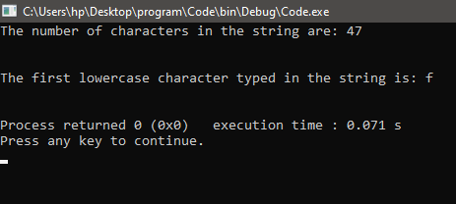
Recursive Approach
#include <ctype.h>
#include<string.h>
#include <stdio.h>
char firstLowerCharacter(char * strng, int i)
{
if (strng != NULL)
{
if (strng[i] == '\0')
{
return 0;
}
if (islower(strng[i]))
{
return strng[i];
}
}
return firstLowerCharacter(strng, i+1);
}
int main()
{
//The string should only have one null character in it
//that is in the end of the string marking the end of the string
char strng[] = "LET US CHECK FOR THE FIRST lowerCASE CHARACTER";
unsigned int firstLowerCaseChar = firstLowerCharacter(strng, 0);
if(firstLowerCaseChar != 0)
{
printf("The number of characters in the string are: %u\n\n", strlen(strng));
printf("\nThe first lowercase character typed in the string is: %c \n\n", firstLowerCaseChar);
}
else
printf("There is no lowercase character in the string.");
return 0;
}
Output:
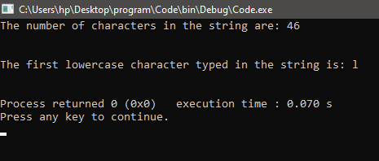

memcpy() in C
The memcpy() function is also called the Copy Memory Block function. It is used to make a copy of a specified range of characters. The function is only able to copy the objects from one memory block to another memory block if they both don't overlap at any point.
Syntax
The syntax for memcpy() function in C language is as follows:
void *memcpy(void *arr1, const void *arr2, size_t n);
The memcpy() function will copy the n specified character from the source array or location. In this case, it is arr1 to the destination location that is arr2. Both arr1 and arr2 are the pointers that point to the source and destination location, respectively.
Parameter or Arguments passed in memcpy()
- arr1: it is the first parameter in the function that specifies the location of the source memory block. It represents the array that will be copied to the destination.
- arr2: The second parameter in the function specifies the location of the destination memory block. It represents the array where the memory block will be copied.
- n: It specifies the number of characters copied from source to destination.
Return
It returns a pointer that is the arr1.
Header file
Since the memcpy() function is defined in the string.h header file, it is necessary to include it in the code to implement the function.
#include<string.h>
Let us see how to implement the memcpy() function in C program.
//Implementation of memcpy() in C Programming
#include <stdio.h>
#include <string.h>
int main(int argc, const char * argv[])
{
//initializing a variable that will hold the result./* Create a place to store our results */
int res;
//declare the arrays for which you want to copy the data and
//in which you want to copy it
char orgnl[50];
char copy[50];
//Entering a string the orgnl array
strcpy(orgnl, "This is the program for implementing the memcpy() in C Program");
//use the memcpy() function to copy the characters from the source to destination.
res = memcpy(copy, orgnl, 27);
// we have specified n as 27 this means it will copy the first 27 character of
//orgnl array to copy array
//set the value for last index in the copy as 0
copy[27] = 0;
//display the copied content
printf("%s\n", copy);
return 0;
}

Note: It is necessary to set the last index as null in the copied array as the function only copies the data and does not initialize the memory itself. The string expects a null value to terminate the string.
Important Facts to be Accounted before implementing memcpy() in C Programming:
- The memcpy() function is declared in the string.h header file. So the programmer needs to ensure to include the file in the code.
- The size of the buffer in which the content is to be copied must be greater than the number of bytes to be copied into the buffer.
- It does not work when the objects overlap. The behavior is undefined if we try to perform the function on the objects that overlap.
- It is necessary to add a null character when using the strings as it does not check for the terminating null characters in the strings.
- The function behavior will not be defined if the function will access the buffer beyond its size of it. It is better to check the buffer size using the sizeof() function.
- It does not ensure that the destination memory block is valid in the memory of the system or not.
#include <stdio.h>
#include <string.h>
int main ()
{
//The first step is to initialize the source and destination array.

char* new;
char orgnl[30] = "Movetheobject";

//Print the contents before performing memcpy() function.

printf("Before implementing memcpy() destination and source memory block respt is\n new = %s\n orgnl = %s\n", new, orgnl);
memcpy(new, orgnl, sizeof(orgnl));

//Display the content in both new and orgnl array after implementing memcpy.

printf("After memcpy >> new = %s\n orgnl = %s\n", new, orgnl);
return 0;
}
Output:
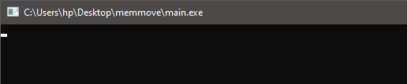
The behavior of the code is not defined because the new pointer is not pointing to any valid location. Hence, the program will not function properly. In some compilers, it may also return an error. The destination pointer in the above case is invalid.
- The memcpy() function also does not perform the validation of the source buffer.
#include <stdio.h>
#include <string.h>
int main ()
{
//The first step is to initialize the source and destination array.

char new[10]= {1};
char *orgnl;

//Print the contents before performing memcpy() function.

printf("Before implementing memcpy() destination and source memory block respt is\n new = %s\n orgnl = %s\n", new, orgnl);
memcpy(new, orgnl, sizeof(orgnl));

//Display the content in both new and orgnl array after implementing memcpy.

printf("After memcpy >> new = %s\n orgnl = %s\n", new, orgnl);
return 0;
}
Output:
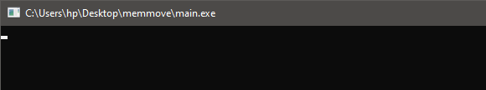
The output, in this case, is also similar to that in the above case, where the destination was not specified. The only difference here is it would not return any compilation error. It will just show undefined behavior as the source pointer is not pointing to any defined location.
- The memcpy() functions work on the byte level of the data. Therefore the value of n should always be in bytes for desired results.
- In the syntax for the memcpy() function, the pointers are declared void * for both the source and the destination memory block, which means that they can be used to point toward any type of data.
Let us see some examples implementing the memcpy() function for different datatype of data.
Implementing the memcpy() function with char type data
#include <stdio.h>
#include <string.h>
int main()
{
//initialize the source array,
//the data will be copied from source to destination/
char sourcearr[30] = "This content is to be copied.";
//this is the destination array
//data will be copied at this location.
char destarr[30] = {0};
//copy the data stored in the sourcearr buffer into destarr buffer
memcpy(destarr,sourcearr,sizeof(sourcearr));
//print the data copied into destarr
printf("destination array content is now changed to\n = %s\n", destarr);
return 0;
}
Output:
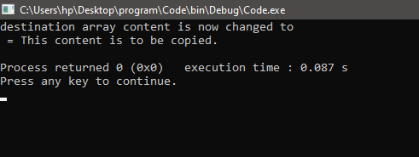
Here we have initialized two arrays of size 30. The sourcearr[] contains the data to be copied into the destarr. We used the memcpy() function to store the data in destarr[].
Implementing memcpy(0 function with integer type data
#include <stdio.h>
#include <string.h>
int main()
{
//initialize the source array,
//the data will be copied from source to destination/
int sourcearr[100] = {1,2,3,4,5};
//this is the destination array
//data will be copied at this location.
int destarr[100] = {0};
//copy the data stored in the sourcearr buffer into destarr buffer
memcpy(destarr,sourcearr,sizeof(sourcearr));
//print the data copied into destarr
printf("destination array content is now changed to\n");
for(int i=0;i<5;i++){
printf("%d", destarr[i]);
}return 0;}
Output:
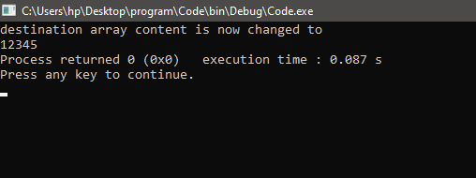
In this code, we have stored the integers in the array. Both the arrays can store int datatype. We have used the indexes to print the elements of the destarr after copying the elements of the sourcearr into destarr.
Implementing the memcpy() function with struct datatype
#include <stdio.h>
#include <string.h>
struct
{
char name[40];
int age;
} prsn1, prsn2;
int main()
{
//
char firstname[]="Ashwin";
//Using the memcpy() function to copy the data from
//firstname to the struct
//add it is as prsn1 name
memcpy ( prsn1.name, firstname, strlen(firstname)+1 );
//initialize the age of the prsn1
prsn1.age=20;
//using the memcpy() function to copy one person to another
//the data will be copied from prsn1 to prsn2
memcpy ( &prsn2, &prsn1, sizeof(prsn1) );
//print the stored data
//display the value stored after copying the data
//from prsn1 to prsn2
printf ("person2: %s, %d \n", prsn2.name, prsn2.age );
return 0;
}
Output:
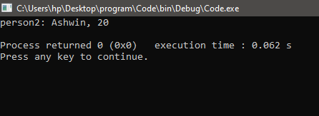
In the above code, we have defined the structure. We have used the memcpy() function twice. The first time we used it to copy the string into prsn1, we used it the second time to copy the data from the prsn1 to prsn2.
Define your memcpy() function in C Programming Language
Implementing the memcpy() function in the C Programming language is comparatively easy. The logic is quite simple behind the memcpy() function. To implement the memcpy() function, you must typecast the source address and the destination address to char*(1 byte). Once the typecasting is performed, now copy the contents from the source array to the destination address. We have to share the data byte by byte. Repeat this step until you have completed n units, where n is the specified bytes of the data to be copied.
Let us code our own memcpy() function:

Note: The function below works similarly to the actual memcpy() function, but many cases are still not accounted for in this user-defined function. Using your memcpy() function, you can decide specific conditions to be included in the function. But if the conditions are not specified, it is preferred to use the memcpy() function defined in the library function.
//this is just the function definition for the user defined memcpy() function.
void * MemCpy(void* destinatn, const void* source, unsigned int cn)
{
char *pntDest = (char *)destinatn;
const char *pntSource =( const char*)source;
if((pntDest!= NULL) && (pntSource!= NULL))
{
while(cn) //till cn the loop will be executed
{
//copy the contents from source to dest
//the data should be copied byte by byte
*(pntDest++)= *(pntSource++);
//decrement the value of cn
--cn;
}
}
return destinatn;
}
Let us write a driver code to check that above code is working properly on not.
Driver Code to test MemCpy() Function
In the code below we will use the arr1 to copy the data into the arr2 by using MemCpy() function.
void * MemCpy(void* destinatn, const void* source, unsigned int cn)
{
char *pntDest = (char *)destinatn;
const char *pntSource =( const char*)source;
if((pntDest!= NULL) && (pntSource!= NULL))
{
while(cn) //till cn the loop will be executed
{
//copy the contents from source to dest
//the data should be copied byte by byte
*(pntDest++)= *(pntSource++);
//decrement the value of cn
--cn;
}
}
return destinatn;
}
int main()
{
char src[20] = "How Are you ?"; //Source String
char dst[20] = {0}; //dst buffer
//copy source buffer int dst
MemCpy(dst,src,sizeof(src));
printf("dst = %s\n", dst);
return 0;
}
Output:
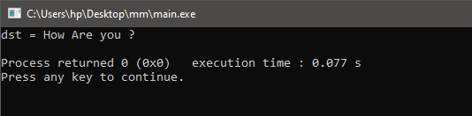

memmove() in C
The memmove() function transfers the memory block from one location to another. The function is declared in the string.h file.
Syntax
The syntax for the memmove function is as follows:
void *memmove(void *strng1, const void *strng2, size_t n);
Parameters Passed inside the Function
- strng1: It is the pointer to the memory block where you wish to copy the contents of the source memory block. The datatype for the pointer is *void.
- strng2: It is the pointer to the memory block from where you want to copy the contents to the destination memory block. The datatype for the pointer is *void.
- n: It is the number of bytes of data to be moved from one location to another.
Return
It returns a pointer pointing to the destination of the memory block, which according to the syntax, is strng1.
Implementation of memmove() function in C Programming
Let us implement the memmove() function. In this function, we will move the contents of the orgnl array to the new array.
#include <stdio.h>
#include <string.h>
int main ()
{
//The first step is to initialize the source and destination array.

char new[] = "The content will be loaded soon.\n";
char orgnl[] = "The content is to be transferred to a new location.\n";

//Print the contents before performing memmove function.

printf("Before implementing memmove destination and source memory block respt is\n >> new = %s\n orgnl = %s\n", new, orgnl);
memmove(new, orgnl, sizeof(orgnl));

//Display the content in both new and orgnl array after implementing memmove.

printf("After memmove >> new = %s\n orgnl = %s\n", new, orgnl);
return 0;
}
Output:
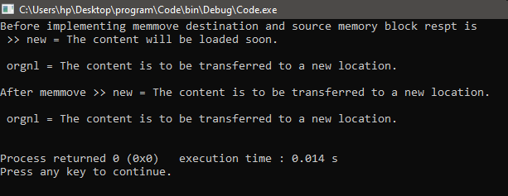
Some Facts related to the memmove() function in C programming:
Using examples, let us discuss some important facts related to the memmove() function.
- As discussed earlier, the memmove() function in C Programming can move the content from the source location to the destination buffer even if both buffers overlap. If it is given that the source and destination are not overlapping with each other, then it is advised to use memcpy() instead of the memmove() function. But if they are overlapping, then the function will show undefined behavior. In that case, you should use the memmove() function.
Let us discuss the example:
#include <string.h>
#include <stdio.h>
int main()
{
char strng1[1000] = "This string will be used to implement the memmove() function.";
char strng2[1000] = "This string will be used to implement the memcpy() function.";
//Use of memmove
printf( "Function:\tUsing the memmove() function while the src and dest overlap\n\n" );
printf( "Orignal content of the first string:\t%s\n",strng1);
//the source content will replace
printf( "Source for copying the content:\t%s\n",strng1 + 5 );
//the destination content will be repl
printf( "Destination to copy the content:\t%s\n\n",strng1 + 11 );
memmove( strng1 + 11, strng1 + 5, 29 );
printf( "Result after implementing the memmove()function:\t%s\n",strng1 );
printf( "Length of the strng1:\t%d characters\n\n", strlen( strng1 ) );
//Use of memcpy
printf( "Function:\tUsing the memcpy() function while the src and dest overlap\n\n" );
printf( "Orignal content of the second string::\t%s\n",strng2);
//the source content will replace
printf( "Source for copying the content:\t%s\n",strng2 + 5 );
//the destination content will be replaced
printf( "Destination to copy the content:\t%s\n\n",strng2 + 11 );
memcpy( strng2 + 11, strng2 + 5, 29 );
printf( "Result after implementing the memcpy()function:\t%s\n",strng2 );
printf( "Length of the strng2:\t%d characters\n\n", strlen( strng2 ) );
return 0;
}
Output:
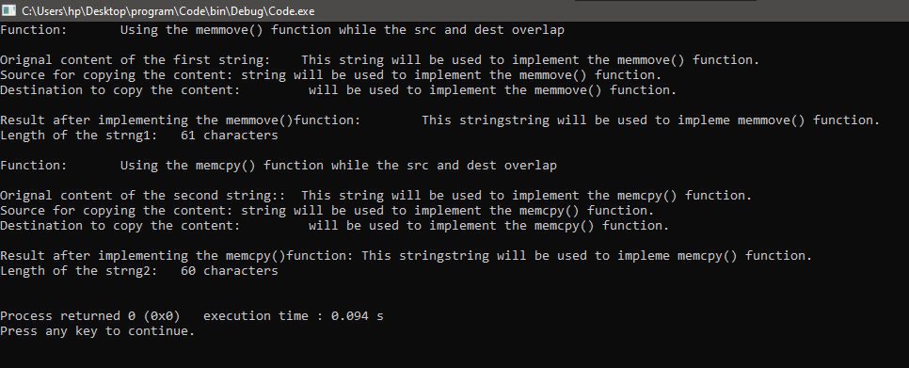
- The execution time for both the functions that is memcpy() and memmove() is almost equal though it may differ with the platform or compiler. The memcpy() function can be slower or faster than the memmove(), but the difference is very small.
//include all the necessary header files
#include <string.h>
#include <stdio.h>
//clock() function is defined in time.h header file.
#include <time.h>
//define the size of the buffer
#define BUFFERSIZE (100 * 1024) //It is equal to 100kb
#define LOOP 10000
int main()
{
char destn[BUFFERSIZE] = {0};
char source[BUFFERSIZE] = {0};
int i = 0;
double t_spent;
clock_t start, end;
//Execute the memmove() function
//Start the clock as the execution begins
start = clock();
for ( i = 0; i < LOOP; i++)
{
memmove(destn,source,BUFFERSIZE);
}
// Store the last time recorded by the clock on completion of the execution of the function
end = clock();
// Determine the total time taken from the beginning to the end of execution of the program.
t_spent = (double)(end - start) / CLOCKS_PER_SEC;
printf("memmove() took %f seconds to complete\n", t_spent);
//Execute the memcpy() function
//Start the clock as the execution begins
start = clock();
for ( i = 0; i < LOOP; i++)
{
memcpy(destn,source,BUFFERSIZE);
}
// Store the last time recorded by the clock on completion of the execution of the function
end = clock();
// Determine the total time taken from the beginning to the end of execution of the program.
t_spent = (double)(end - start) / CLOCKS_PER_SEC;
printf("memcpy() took %f seconds to complete\n", t_spent);
return 0;
}
Output:
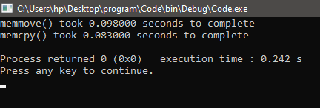
- The main difference between the working of the memmove() and memcpy() function is that the memmove() function is bidirectional while the memcpy() function is unidirectional. Memmove can also move the bytes in the forward and backward direction, while the memcpy can only move in the forward direction.
Implementing your memmove() function in C Programming
The standard function is defined in string.h header file is very efficient and accounts for all the possible cases the developer may face while moving the data from one location to another. So, if it is not necessary to define your memmove() function, the user should refrain from doing so.
Implementing the memmove() function is just like the memcpy function, but here we must take overlapping into account too. This makes the program more complex than the memcpy() function.
This also increases the space complexity of the program as we would require initializing a temporary array. The temporary array will be used to manage the overlapping scenario.
All the characters that are to be moved will be first stored in this temporary array then these characters stored in the temporary array will be moved to the destination location.
void * my_memmove(void* destn, const void* src, unsigned int n)
{
char *pDest = (char *)destn;
const char *pSrc =( const char*)src;
//allocation of the memory block for the temp array
char *temp = (char *)malloc(sizeof(char ) * n);
if(NULL == temp)
{
return NULL;
}
else
{
unsigned int i = 0;
//Copy the content from the src array to temp array first
for(i =0; i < n ; ++i)
{
*(temp + i) = *(pSrc + i);
}
//copy the content from the temp array to the destination array
for(i =0 ; i < n ; ++i)
{
*(pDest + i) = *(temp + i);
}
free(temp); //free allocated memory
}
return destn;
}
Let us code a driver program to ensure that the function built by us is working properly.
#include <iostream>
//to use the malloc function in your code ensure to
//include cstdlib
#include <cstdlib>
void * my_memove(void* destn, const void* source, unsigned int n)
{
char *pDest = (char *)destn;
const char *pSrc =( const char*)source;
//allocate memory for tmp array
char *temp = (char *)malloc(sizeof(char ) * n);
if(NULL == temp)
{
return NULL;
}
else
{
unsigned int i = 0;
// Begin with copying the contents
//from source to the temp
for(i =0; i < n ; ++i)
{
*(temp + i) = *(pSrc + i);
}
//Use the copied content in temp to move the contents in the destn
for(i =0 ; i < n ; ++i)
{
*(pDest + i) = *(temp + i);
}
free(temp); //free the resources allocated to the temp
}
return destn;
}
int main()
{
char Src[] = "This is the content to be copied.";
// The destination string size is 14.
char Dest[16] = {0};
// Lets begin with copying the content that is stored in Src into the Dest
//Use your own my_memove function
my_memove(Dest, Src, 12);
printf("String after copying the n bytes: %s\n", Dest);
int dSrc[] = {20, 100, 30, 50, 70};
int n = sizeof(dSrc)/sizeof(dSrc[0]);
int dDestn[n], index = 0;
// Lets begin with copying the content that is stored in dSrc into the dDest
//Use your own my_memove function
my_memove(dDestn, dSrc, sizeof(dSrc));
printf("\nNow after copying the array it is: ");
for (index=0; index<n; index++)
{
printf("%d ", dDestn[index]);
}
return 0;
}
Output:
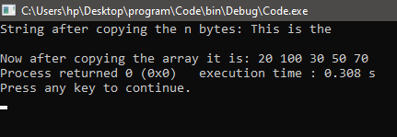
In the above code, we have used the driver code. We have copied a string and array using the my_memove() function defined above. We have used a temporary array to ensure that overlapping is accounted for. Thus the string and array were copied, and our function worked perfectly.

Matrix Calculator in C
Matrix-based issue solving requires extensive computation labor, and if even one error is made, the user will not be able to obtain the desired answer. For each row and column, you must input the required components. It is not enough to just enter data for each individual index to fix the issue. It takes a lot of effort to acquire the output and perform the processing steps necessary to reach the desired outcome. By removing the values from other indices, you may get the centre value.
Each member of the second matrix must be multiplied by every other element when performing multiplication. Each row element of the first matrix is multiplied by each column member of the second matrix as part of the processing activity.
It will take some time to manually solve this problem, and the amount of time will also depend on the type of matrix. It is simple to solve the problem within five minutes if the matrix size is 2x2, but more challenging if the index size is larger than 3 or the matrix indexes differ. Therefore, to save time, you can use this method to match your solutions by just providing a few parameters regarding the type of matrix and its components.
Current Scenario
Although the current system also offers computer-oriented approaches to obtain the results of matrix multiplications, the current method cannot be used to varied sizes. This system can only be used for matrix whose index sizes are of two dimensions, and it cannot be used for matrix whose index sizes vary. Additionally, you will be able to compute the multiplication of two 2x2 matrix matrices. However, you won't be able to verify your findings simultaneously since matrices larger than 2 cannot be used to generate results. In order to allow users to double-check their submitted data, the current system is also unable to show the entered elements while presenting the final results.
Problem this project will solve
Any required matrix size may be produced using the existing matrix multiplication technology. Before inputting the element values for a given matrix, users will additionally have the option of selecting the matrix size. You only need to enter the elements for each matrix after the matrix sizes for both matrices have been entered. With this technique, you won't need to put in any further effort because the login listed on the screen's reverse side will handle the remaining tasks. It will be able to show both the final results and specifics from each matrix.
Program Breakdown
void readMatrix(int array[10][10], int rows, int colums);
void printMatrix(int array[10][10], int rows, int colums);
void matrixAddSub(int arrayone[10][10], int arraytwo[10][10], int rows, int colums, int mul);
void matrixScalarMultiply(int array[10][10], int scalar, int rows, int colums);
void matrixMultiply(int arrayone[10][10], int arraytwo[10][10], int rowsA, int columsA, int columsB);
In our Program we are declaring user defined functions like to read the matrix we have read matrix function, to prirnt matrix we have printMatrix function, to add and subtract the matrix we have matrixAddSub function, to multiply we have matrixScalarMultipy function.
printf("\nOperation Menu\n");
printf("\t1. to Add\n");
printf("\t2. to Subtract\n");
printf("\t3. to Scalar Multiply\n");
printf("\t4. to Multiply two matrices\n");
printf("Enter your choice: ");
scanf(" %d", &operation);
In the main function of our program we have different options for user to perform like to add, to subtract, to scalar multiply, to multiply two matrices.
case 1:
printf("\nEnter the #rows and #cols for matrix A: ");
scanf("%d%d", &rowA, &colA);

printf("Enter the #rows and #cols for matrix B: ");
scanf("%d%d", &rowB, &colB);

while ((rowA != rowB) && (colA != colB)){
printf("\nMatrices must be the same size\n");
printf("\nEnter the #rows and #cols for matrix A: ");
scanf("%d%d", &rowA, &colA);

printf("Enter the #rows and #cols for matrix B: ");
scanf("%d%d", &rowB, &colB);

}

printf("\n\tEnter elements of Matrix A a %d x %d matrix.\n", rowA, colA); // with the %d we remember the user the dimensions of the array
readMatrix(matrixA, rowA, colA);
printf("\n\t\tMatrix A\n\n");
printMatrix(matrixA, rowA, colA);

printf("\n\tEnter elements of Matrix B a %d x %d matrix.\n", rowB, colB); // with the %d we remember the user the dimensions of the array
readMatrix(matrixB, rowB, colB);
printf("\n\t\tMatrix B\n\n");
printMatrix(matrixB, rowB, colB);

printf("\nThe Sum of matrixA + matrixB is : \n");
matrixAddSub(matrixA, matrixB, rowA, colA, add);

break;
If the user has chosen any option then the system will ask to add the elements of the 2 matrices to be added in all cases.
void readMatrix(int array[10][10], int rows, int colums){
int i, j;
for (i = 0; i < rows; i++){
printf("\t%d entries for row %d: ", colums, i + 1);
for (j = 0; j < colums; j++){
scanf("%d", &array[i][j]);
}
}
return;
}
The above function readMatrix will read the matrix elements entered by the user.
void printMatrix(int array[10][10], int rows, int colums){
int i, j;

for (i = 0; i < rows; i++) {
for (j = 0; j < colums; j++){
printf("\t%d", array[i][j]);
}
printf("\n");
}
}
The above function will print the matrix entered by the user.
void matrixAddSub(int arrayone[10][10], int arraytwo[10][10], int rows, int colums, int mul){
int i, j;
int sumM[10][10];
int scaM[10][10];
for (i = 0; i < rows; i++){
for (j = 0; j < colums; j++){
scaM[i][j] = mul * arraytwo[i][j];
}
}
for (i = 0; i < rows; i++){
for (j = 0; j < colums; j++){
sumM[i][j] = arrayone[i][j] + scaM[i][j];
printf("\t%d", sumM[i][j]);
}
printf("\n");
}
If the user has selected the option to add then the above function will come in action and add the elements of the 2 matrices.
void matrixScalarMultiply(int array[10][10], int scalar, int rows, int colums){
int i, j;
int scaM[10][10];
for (i = 0; i < rows; i++){
for (j = 0; j < colums; j++){
scaM[i][j] = scalar * array[i][j];
printf("%d\t", scaM[i][j]);
}
printf("\n");
}

}
If the user has selected the option to scalar multiply then the above function will come in action.
void matrixMultiply(int arrayone[10][10], int arraytwo[10][10], int rowsA, int columsA,int columsB){
int i, j, k;
int mulM[10][10];

// Initializing all elements of result matrix to 0
for (i = 0; i<rowsA; ++i)
for (j = 0; j<columsB; ++j)
{
mulM[i][j] = 0;
}

// Multiplying matrices a and b and
// storing result in result matrix
for (i = 0; i<rowsA; ++i)
for (j = 0; j<columsB; ++j)
for (k = 0; k<columsA; ++k)
{
mulM[i][j] += arrayone[i][k] * arraytwo[k][j];
}
printf("\nOutput Matrix:\n");
for (i = 0; i<rowsA; ++i)
for (j = 0; j<columsB; ++j)
{
printf("\t%d ", mulM[i][j]);
if (j == columsB - 1)
printf("\n\n");
}
}
If the user has selected the option to multiply then the above function will come in action and multiply the elements of the 2 matrices and print the result.
Program for Matrix Calculator in C++
#include <stdio.h>
//User Defined Function Declaration
void readMatrix(int array[10][10], int rows, int colums);
void printMatrix(int array[10][10], int rows, int colums);
void matrixAddSub(int arrayone[10][10], int arraytwo[10][10], int rows, int colums, int mul);
void matrixScalarMultiply(int array[10][10], int scalar, int rows, int colums);
void matrixMultiply(int arrayone[10][10], int arraytwo[10][10], int rowsA, int columsA, int columsB);
int main(void){

int i, j, k; //used in for loops

int matrixA[10][10]; // initialized at 10 just to have it initialized
int matrixB[10][10];
int rowA, colA;
int rowB, colB;
int operation;//used in swtich statements
char again = 'Y';
int scalar = 0;
int add = 1;
int sub = -1;

while (again == 'Y'){

//this is the operation menu just type A, B, C or D to calculate
printf("\nOperation Menu\n");
printf("\t1. to Add\n");
printf("\t2. to Subtract\n");
printf("\t3. to Scalar Multiply\n");
printf("\t4. to Multiply two matrices\n");
printf("Enter your choice: ");
scanf(" %d", &operation);

switch (operation){

case 1:
printf("\nEnter the #rows and #cols for matrix A: ");
scanf("%d%d", &rowA, &colA);

printf("Enter the #rows and #cols for matrix B: ");
scanf("%d%d", &rowB, &colB);

while ((rowA != rowB) && (colA != colB)){
printf("\nMatrices must be the same size\n");
printf("\nEnter the #rows and #cols for matrix A: ");
scanf("%d%d", &rowA, &colA);

printf("Enter the #rows and #cols for matrix B: ");
scanf("%d%d", &rowB, &colB);

}

printf("\n\tEnter elements of Matrix A a %d x %d matrix.\n", rowA, colA); // with the %d we remember the user the dimensions of the array
readMatrix(matrixA, rowA, colA);
printf("\n\t\tMatrix A\n\n");
printMatrix(matrixA, rowA, colA);

printf("\n\tEnter elements of Matrix B a %d x %d matrix.\n", rowB, colB); // with the %d we remember the user the dimensions of the array
readMatrix(matrixB, rowB, colB);
printf("\n\t\tMatrix B\n\n");
printMatrix(matrixB, rowB, colB);

printf("\nThe Sum of matrixA + matrixB is : \n");
matrixAddSub(matrixA, matrixB, rowA, colA, add);

break;

case 2:

printf("\nEnter the #rows and #cols for matrix A: ");
scanf("%d%d", &rowA, &colA);

printf("Enter the #rows and #cols for matrix B: ");
scanf("%d%d", &rowB, &colB);

while ((rowA != rowB) && (colA != colB)){
printf("\nMatrices must be the same size\n");
printf("\nEnter the #rows and #cols for matrix A: ");
scanf("%d%d", &rowA, &colA);

printf("Enter the #rows and #cols for matrix B: ");
scanf("%d%d", &rowB, &colB);
}

printf("\n\tEnter elements of Matrix A a %d x %d matrix.\n", rowA, colA); // with the %d we remember the user the dimensions of the array
readMatrix(matrixA, rowA, colA);
printf("\n\t\tMatrix A\n\n");
printMatrix(matrixA, rowA, colA);

printf("\n\tEnter elements of Matrix B a %d x %d matrix.\n", rowB, colB); // with the %d we remember the user the dimensions of the array
readMatrix(matrixB, rowB, colB);
printf("\n\t\tMatrix B\n\n");
printMatrix(matrixB, rowB, colB);

printf("\nThe difference between matrixA - matrixB is : \n");
matrixAddSub(matrixA, matrixB, rowA, colA, sub);
break;

case 3:

printf("\nEnter the scalar: ");
scanf("%d", &scalar);
printf("\nThe scalar is: %d ", scalar);

printf("\nEnter the #rows and #cols for matrix A: ");
scanf("%d%d", &rowA, &colA);

printf("\n\tEnter elements of Matrix A a %d x %d matrix.\n", rowA, colA); // with the %d we remember the user the dimensions of the array
readMatrix(matrixA, rowA, colA);
printf("\n\t\tMatrix A\n\n");
printMatrix(matrixA, rowA, colA);

printf("\nThe scalar multiplication between matrixA * %d is: \n", scalar);
matrixScalarMultiply(matrixA, scalar, rowA, colA);

break;

case 4:
//when multiplying arrays matrixA column # has to equal matrixB row #
printf("\nEnter the #rows and #cols for matrix A: ");
scanf("%d%d", &rowA, &colA);

printf("Enter the #rows and #cols for matrix B: ");
scanf("%d%d", &rowB, &colB);

// Column of first matrix should be equal to column of second matrix and
while (colA != rowB)
{
printf("\n\nError! column of first matrix not equal to row of second.\n\n");
printf("\nEnter the #rows and #cols for matrix A: ");
scanf("%d%d", &rowA, &colA);

printf("Enter the #rows and #cols for matrix B: ");
scanf("%d%d", &rowB, &colB);
}

// Storing elements of first matrix.
printf("\n\tEnter elements of Matrix A a %d x %d matrix.\n", rowA, colA); // with the %d we remember the user the dimensions of the array
readMatrix(matrixA, rowA, colA);
printf("\n\t\tMatrix A\n\n");
printMatrix(matrixA, rowA, colA);

// Storing elements of second matrix.
printf("\n\tEnter elements of Matrix B a %d x %d matrix.\n", rowB, colB); // with the %d we remember the user the dimensions of the array
readMatrix(matrixB, rowB, colB);
printf("\n\t\tMatrix A\n\n");
printMatrix(matrixB, rowB, colB);

//multiplyng arrays
matrixMultiply(matrixA, matrixB, rowA, colA, colB);

break;

default:
printf("\nIncorrect option! Please choose a number 1-4.");
break;
}

printf("\n\nDo you want to calculate again? Y/N\n");
scanf(" %c", &again);
again = toupper(again);
}
printf("\n\nGoodbye!\n\n");

return 0;
}

//User Defined Function Definition
void readMatrix(int array[10][10], int rows, int colums){
int i, j;
for (i = 0; i < rows; i++){
printf("\t%d entries for row %d: ", colums, i + 1);
for (j = 0; j < colums; j++){
scanf("%d", &array[i][j]);
}
}

return;
}

void printMatrix(int array[10][10], int rows, int colums){
int i, j;

for (i = 0; i < rows; i++) {
for (j = 0; j < colums; j++){
printf("\t%d", array[i][j]);
}
printf("\n");
}
}

void matrixAddSub(int arrayone[10][10], int arraytwo[10][10], int rows, int colums, int mul){
int i, j;
int sumM[10][10];
int scaM[10][10];
for (i = 0; i < rows; i++){
for (j = 0; j < colums; j++){
scaM[i][j] = mul * arraytwo[i][j];
}
}

for (i = 0; i < rows; i++){
for (j = 0; j < colums; j++){
sumM[i][j] = arrayone[i][j] + scaM[i][j];
printf("\t%d", sumM[i][j]);
}
printf("\n");
}
}

void matrixScalarMultiply(int array[10][10], int scalar, int rows, int colums){
int i, j;
int scaM[10][10];
for (i = 0; i < rows; i++){
for (j = 0; j < colums; j++){
scaM[i][j] = scalar * array[i][j];
printf("%d\t", scaM[i][j]);
}
printf("\n");
}

}

void matrixMultiply(int arrayone[10][10], int arraytwo[10][10], int rowsA, int columsA,int columsB){
int i, j, k;
int mulM[10][10];

// Initializing all elements of result matrix to 0
for (i = 0; i<rowsA; ++i)
for (j = 0; j<columsB; ++j)
{
mulM[i][j] = 0;
}

// Multiplying matrices a and b and
// storing result in result matrix
for (i = 0; i<rowsA; ++i)
for (j = 0; j<columsB; ++j)
for (k = 0; k<columsA; ++k)
{
mulM[i][j] += arrayone[i][k] * arraytwo[k][j];
}
printf("\nOutput Matrix:\n");
for (i = 0; i<rowsA; ++i)
for (j = 0; j<columsB; ++j)
{
printf("\t%d ", mulM[i][j]);
if (j == columsB - 1)
printf("\n\n");
}
}
Output:
Operation Menu
1. to Add
2. to Subtract
3. to Scalar Multiply
4. to Multiply two matrices
Enter your choice: 1

Enter the #rows and #cols for matrix A: 2 2
Enter the #rows and #cols for matrix B: 2 2

Enter elements of Matrix A a 2 x 2 matrix.
2 entries for row 1: 1 2
2 entries for row 2: 3 4
Matrix A

1 2
3 4

Enter elements of Matrix B a 2 x 2 matrix.
2 entries for row 1: 5 6
2 entries for row 2: 7 8
Matrix B

5 6
7 8

The Sum of matrixA + matrixB is :
6 8
10 12
Do you want to calculate again? Y/N
Y
Enter your choice: 2

Enter the #rows and #cols for matrix A: 2 2
Enter the #rows and #cols for matrix B: 2 2

Enter elements of Matrix A a 2 x 2 matrix.
2 entries for row 1: 1 2
2 entries for row 2: 3 4

Matrix A

1 2
3 4

Enter elements of Matrix B a 2 x 2 matrix.
2 entries for row 1: 5 6
2 entries for row 2: 7 8

Matrix B

5 6
7 8

The difference between matrixA - matrixB is :
-4 -4
-4 -4
Do you want to calculate again? Y/N
Y
Enter your choice: 3

Enter the scalar: 2

The scalar is: 2
Enter the #rows and #cols for matrix A: 2 2

Enter elements of Matrix A a 2 x 2 matrix.
2 entries for row 1: 1 2
2 entries for row 2: 3 4

Matrix A

1 2
3 4

The scalar multiplication between matrixA * 2 is:
2 4
6 8
Enter your choice: 4

Enter the #rows and #cols for matrix A: 2 2
Enter the #rows and #cols for matrix B: 1 2

Error! column of first matrix not equal to row of second.
Enter the #rows and #cols for matrix A: 1 2
Enter the #rows and #cols for matrix B: 3 4
Error! column of first matrix not equal to row of second.

Bank Account Management System
As of now, C program operations are performed on a prompt or terminal that is not saved anywhere. But in the software sector, the majority of applications are created to store the data they get. Keeping the information that was retrieved in a file is one such method. On a file, many operations can be carried out, including:
- Making a new file (using the fopen command with the "a" or "a+" or "w" or "w+" attributes)
- launching a current file (fopen)
- examining a file (fscanf or fgets)
- creating a file (fprintf or fputs)
- Accessing a particular spot in a file (fseek, rewind)
- filing a closure (fclose)
Our Approach
Let's go through the strategy in depth, going over each function and a detailed description of each. In the main function, construct a Menu and several functions that will be invoked using switch case statements. There are four distinct purposes:
- account()- This function is used to create a new account.
- transfermoney()- This function is used to transfer money to the account
- checkbalance()- This function is used to check the balance in the account.
- login()- This function is used to login into the account.
Create an account for our user by executing the account() method first, and then utilize file handling functions to put all the data in a file. The user may then use the transfermoney() method to send money to other users, and the checkbalance() function can be used to check the account's current balance.
In order to save user data and read it all later, concepts of file handling will be employed. Because file structures are simple to write and read, they will be used to store user data.
Program Breakdown
# include < conio . h >
# include < stdio . h >
# include < stdlib . h >
# include < string . h >
# include < windows . h >
We will include all the necessary files to avoid any kind of error in our bank account management system program.
void account ( void )
{
char password [ 20 ] ;
int passwordlength , i , seek = 0 ;
char ch ;
FILE * fp , * fu ;
struct pass u1 ;
struct userpass p1 ;

struct userpass u2 ;

// Opening file to
// write data of a user
fp = fopen ( " username.txt " , " ab " ) ;

// Inputs
system ( " cls " ) ;
printf (" \ n \ n !!!!! CREATE ACCOUNT !!!!! " ) ;

printf ( " \ n \ n FIRST NAME.. " ) ;
scanf ( " % s " , &u1.fname ) ;

printf ( " \ n \ n \ n LAST NAME.." ) ;
scanf ( " % s " , &u1.lname ) ;

printf ( " \ n \ n FATHER's NAME.. " ) ;
scanf ( " % s " , &u1.fathname ) ;

printf ( " \ n \ n MOTHER's NAME.. " ) ;
scanf ( " % s " , &u1.mothname ) ;

printf ( " \ n \ n ADDRESS.. " ) ;
scanf ( " % s " , &u1.address ) ;

printf ( " \ n \ n ACCOUNT TYPE " ) ;
scanf ( " % s " , &u1.typeaccount ) ;

printf ( " \ n \ n DATE OF BIRTH.. " ) ;
printf ( " \ n DATE - " ) ;
scanf ( " % d " , &u1.date ) ;
printf ( " \ n MONTH - " ) ;
scanf ( " % d " , &u1.month ) ;
printf ( " \ n YEAR - " ) ;
scanf ( " % d " , &u1.year ) ;

printf ( " \ n \ n ADHAR NUMBER " ) ;
scanf ( " % s " , u1.adharnum ) ;

printf ( " \ n \ n PHONE NUMBER " ) ;
scanf ( " % s " , u1.pnumber ) ;

printf ( " \ n \ n USERNAME.. " ) ;
scanf ( " % s " , &u1.username ) ;

printf ( " \ n \ n PASSWORD.. " ) ;

// Taking password in the
// form of stars
for ( i = 0 ; i < 50 ; i++ )
{
ch = getch ( ) ;
if ( ch ! = 13 )
{
password [ i ] = ch ;
ch = ' * ' ;
printf ( " % c " , ch ) ;
}
else
break ;
}

// Writing to the file
fwrite ( &u1 , sizeof ( u1 ) , 1 , fp ) ;

// Closing file
fclose ( fp ) ;

// Calling another function
// after successful creation
// of account
accountcreated ( ) ;
}
Create a structure using all of the user's input so that the data may be stored in a file.
// Function to transfer
// money from one user to
// another
void transfermoney ( void )
{
int i , j ;
FILE * fm , * fp ;
struct pass u1 ;
struct money m1 ;
char usernamet [ 20 ] ;
char usernamep [ 20 ] ;
system("cls");

// Opening file in read mode to
// read user's username
fp = fopen ( " username.txt " , " rb " ) ;

// Creating a another file
// to write amount along with
// username to which amount
// is going to be transferred
fm = fopen ( " mon.txt " , " ab " ) ;

gotoxy ( 33 , 4 ) ;
printf ( " ---- TRANSFER MONEY ---- " ) ;
gotoxy ( 33 , 5 ) ;
printf ( " ======================== " ) ;

gotoxy ( 33 , 11 ) ;
printf ( " FROM ( your username ) .. " ) ;
scanf ( " % s " , &usernamet ) ;

gotoxy ( 33 , 13 ) ;
printf ( " TO ( username of person ) .. " ) ;
scanf ( " % s " , &usernamep ) ;

// Checking for username if it
// is present in file or not
while ( fread ( &u1 , sizeof ( u1 ) , 1 , fp ) )

{
if ( strcmp ( usernamep ,
u1.username ) = = 0 )
{
strcpy ( m1.usernameto ,
u1.username ) ;
strcpy ( m1.userpersonfrom ,
usernamet ) ;
}
}
gotoxy ( 33 , 16 ) ;

// Taking amount input
printf ( " ENTER THE AMOUNT TO BE TRANSFERRED .. " ) ;
scanf ( " % d " , &m1.money1 ) ;

// Writing to the file
fwrite ( &m1 , sizeof ( m1 ) , 1 , fm ) ;

gotoxy ( 0 , 26 ) ;
printf (
" -------------------------------------------------- "
" -------------------------------------------- " ) ;

gotoxy ( 0 , 28 ) ;
printf (
" -------------------------------------------------- "
" -------------------------------------------- " ) ;

gotoxy ( 0 , 29 ) ;
printf ( " transfering amount , Please wait .. " ) ;

gotoxy ( 10 , 27 ) ;
for ( i = 0 ; i < 70 ; i + + )
{
for ( j = 0 ; j < 1200000 ; j + + )
{
j + + ;
j - - ;
}
printf ( " * " ) ;
}

gotoxy ( 33 , 40 ) ;
printf ( " AMOUNT SUCCESSFULLY TRANSFERRED .... " ) ;
getch ( ) ;

// Close the files
fclose ( fp ) ;
fclose ( fm ) ;

// Function to return
// to the home screen
display ( usernamet ) ;
}
Open the file with the username of the user to whom the money should be transferred, enter the amount, and then close the file.
// Function to check balance
// in users account
void checkbalance ( char username2 [ ] )
{
system ( " cls " ) ;
FILE * fm ;
struct money m1 ;
char ch ;
int i = 1 , summoney = 0 ;

// Opening amount file record
fm = fopen ( " mon.txt " , " rb " ) ;

int k = 5 , l = 10 ;
int m = 30 , n = 10 ;
int u = 60 , v = 10 ;

gotoxy ( 30 , 2 ) ;
printf ( " ==== BALANCE DASHBOARD ==== " ) ;
gotoxy ( 30 , 3 ) ;
printf ( " *************************** " ) ;
gotoxy ( k , l ) ;
printf ( " S no." ) ;
gotoxy ( m , n ) ;
printf ( " TRANSACTION ID " ) ;
gotoxy ( u , v ) ;
printf ( " AMOUNT " ) ;

// Reading username to
// fetch the correct record
while ( fread ( &m1 , sizeof ( m1 ) , 1 , fm ) )
{
if ( strcmp ( username2 ,
m1.usernameto ) = = 0 )
{
gotoxy ( k , + + l ) ;
printf ( " % d " , i ) ;
i + + ;
gotoxy ( m , + + n ) ;
printf ( " % s " , m1.userpersonfrom ) ;

gotoxy ( u , + + v ) ;
printf ( " % d " , m1.money1 ) ;
// adding and
// finding total money
summoney = summoney + m1.money1 ;
}
}

gotoxy ( 80 , 10 ) ;
printf ( " TOTAL AMOUNT " ) ;

gotoxy ( 80 , 12 ) ;
printf ( " % d " , summoney ) ;

getch ( ) ;

// Closing file after
// reading it
fclose ( fm ) ;
display ( username2 ) ;
}
Opening a file containing all the transfer records, reading them one at a time, and comparing them to the username supplied to the function to retrieve the appropriate transfer records.
// Login function to check
// the username of the user
void login ( void )
{
system ( " cls " ) ;
char username [ 50 ] ;
char password [ 50 ] ;
int i , j , k ;
char ch ;
FILE * fp , * fu ;
struct pass u1 ;
struct userpass u2 ;
// Opening file of
// user data
fp = fopen ( " username.txt " , " rb " ) ;
if ( fp == NULL )
{
printf ( " ERROR IN OPENING FILE " ) ;
}
gotoxy ( 34 , 2 ) ;
printf ( " ACCOUNT LOGIN " ) ;
gotoxy ( 7 , 5 ) ;
printf ( " ***********************************************"
" ******************************** " ) ;

gotoxy ( 35 , 10 ) ;
printf ( " ==== LOG IN ==== " ) ;

// Take input
gotoxy ( 35 , 12 ) ;
printf ( " USERNAME .. " ) ;
scanf ( " % s " , &username ) ;

gotoxy ( 35 , 14 ) ;
printf ( " PASSWORD .. " ) ;
// Input the password
for ( i = 0 ; i < 50 ; i + + )
{
ch = getch ( ) ;
if ( ch ! = 13 )
{
password [ i ] = ch ;
ch = ' * ' ;
printf ( " % c " , ch ) ;
}

else
break ;
}

// Checking if username
// exists in the file or not
while ( fread ( & u1 ,
sizeof ( u1 ) , 1 , fp ) )
{
if ( strcmp ( username ,
u1.username ) == 0 )
{
loginsu ( ) ;
display ( username ) ;
}
}

// Closing the file
fclose ( fp ) ;
}

// Screen is shown after
// successful login
void loginsu ( void )
{
int i ;
FILE * fp ;
struct pass u1 ;
system ( " cls " ) ;
printf ( " Fetching account details ..... \ n " ) ;
for ( i = 0 ; i < 20000 ; i + + )
{
i + + ;
i - - ;
}
gotoxy ( 30 , 10 ) ;
printf ( " LOGIN SUCCESSFUL .... " ) ;
gotoxy ( 0 , 20 ) ;
printf ( " Press enter to continue " ) ;

getch ( ) ;
}
In order to provide login capability, we open the file, compare the username entered by the user during registration, and, if the username is accurate and matches the record already in our file, log the user in.
Program for Bank Account Management system in C
// C program to implement
// the above approach
#include <conio.h>
#include <stdio.h>
#include <stdlib.h>
#include <string.h>
#include <windows.h>

// Declaring all the functions
void checkbalance(char*);
void transfermoney(void);
void display(char*);
void person(char*);
void login(void);
void loginsu(void);
void account(void);
void accountcreated(void);
void afterlogin(void);
void logout(void);

// Declaring gotoxy
// function for setting
// cursor position
void gotoxy(int x, int y)
{
COORD c;
c.X = x;
c.Y = y;

SetConsoleCursorPosition(
GetStdHandle(STD_OUTPUT_HANDLE), c);
}

// Creating a structure to store
// data of the user
struct pass {
char username[50];
int date, month, year;
char pnumber[15];
char adharnum[20];
char fname[20];
char lname[20];
char fathname[20];
char mothname[20];
char address[50];
char typeaccount[20];
};

// Structure to keep track
// of amount transfer
struct money {
char usernameto[50];
char userpersonfrom[50];
long int money1;
};

struct userpass {
char password[50];
};

// Driver Code
int main()
{
int i, a, b, choice;
int passwordlength;

gotoxy(20, 3);

// Creating a Main
// menu for the user
printf("WELCOME TO BANK ACCOUNT SYSTEM\n\n");
gotoxy(18, 5);

printf("**********************************");
gotoxy(25, 7);

printf("DEVELOPER-Prateek");

gotoxy(20, 10);
printf("1.... CREATE A BANK ACCOUNT");

gotoxy(20, 12);
printf("2.... ALREADY A USER? SIGN IN");
gotoxy(20, 14);
printf("3.... EXIT\n\n");

printf("\n\nENTER YOUR CHOICE..");

scanf("%d", &choice);

switch (choice) {
case 1:
system("cls");
printf("\n\n USERNAME 50 CHARACTERS MAX!!");
printf("\n\n PASSWORD 50 CHARACTERS MAX!!");
account();
break;

case 2:
login();
break;

case 3:
exit(0);
break;

getch();
}
}

// Function to create accounts
// of users
void account(void)
{
char password[20];
int passwordlength, i, seek = 0;
char ch;
FILE *fp, *fu;
struct pass u1;
struct userpass p1;

struct userpass u2;

// Opening file to
// write data of a user
fp = fopen("username.txt", "ab");

// Inputs
system("cls");
printf("\n\n!!!!!CREATE ACCOUNT!!!!!");

printf("\n\nFIRST NAME..");
scanf("%s", &u1.fname);

printf("\n\n\nLAST NAME..");
scanf("%s", &u1.lname);

printf("\n\nFATHER's NAME..");
scanf("%s", &u1.fathname);

printf("\n\nMOTHER's NAME..");
scanf("%s", &u1.mothname);

printf("\n\nADDRESS..");
scanf("%s", &u1.address);

printf("\n\nACCOUNT TYPE");
scanf("%s", &u1.typeaccount);

printf("\n\nDATE OF BIRTH..");
printf("\nDATE-");
scanf("%d", &u1.date);
printf("\nMONTH-");
scanf("%d", &u1.month);
printf("\nYEAR-");
scanf("%d", &u1.year);

printf("\n\nADHAR NUMBER");
scanf("%s", u1.adharnum);

printf("\n\nPHONE NUMBER");
scanf("%s", u1.pnumber);

printf("\n\nUSERNAME.. ");
scanf("%s", &u1.username);

printf("\n\nPASSWORD..");

// Taking password in the form of
// stars
for (i = 0; i < 50; i++) {
ch = getch();
if (ch != 13) {
password[i] = ch;
ch = '*';
printf("%c", ch);
}
else
break;
}

// Writing to the file
fwrite(&u1, sizeof(u1),
1, fp);

// Closing file
fclose(fp);

// Calling another function
// after successful creation
// of account
accountcreated();
}

// Successful account creation
void accountcreated(void)
{
int i;
char ch;
system("cls");
printf(
"PLEASE WAIT....\n\nYOUR DATA IS PROCESSING....");
for (i = 0; i < 200000000; i++) {
i++;
i--;
}

gotoxy(30, 10);

printf("ACCOUNT CREATED SUCCESSFULLY....");
gotoxy(0, 20);

printf("Press enter to login");

getch();
login();
}

// Login function to check
// the username of the user
void login(void)
{
system("cls");

char username[50];
char password[50];

int i, j, k;
char ch;
FILE *fp, *fu;
struct pass u1;
struct userpass u2;

// Opening file of
// user data
fp = fopen("username.txt",
"rb");

if (fp == NULL) {
printf("ERROR IN OPENING FILE");
}
gotoxy(34, 2);
printf(" ACCOUNT LOGIN ");
gotoxy(7, 5);
printf("***********************************************"
"********************************");

gotoxy(35, 10);
printf("==== LOG IN ====");

// Take input
gotoxy(35, 12);
printf("USERNAME.. ");
scanf("%s", &username);

gotoxy(35, 14);
printf("PASSWORD..");

// Input the password
for (i = 0; i < 50; i++) {
ch = getch();
if (ch != 13) {
password[i] = ch;
ch = '*';
printf("%c", ch);
}

else
break;
}

// Checking if username
// exists in the file or not
while (fread(&u1, sizeof(u1),
1, fp)) {
if (strcmp(username,
u1.username)
== 0) {
loginsu();
display(username);
}
}

// Closing the file
fclose(fp);
}

// Redirect after
// successful login
void loginsu(void)
{
int i;
FILE* fp;
struct pass u1;
system("cls");
printf("Fetching account details.....\n");
for (i = 0; i < 20000; i++) {
i++;
i--;
}

gotoxy(30, 10);
printf("LOGIN SUCCESSFUL....");
gotoxy(0, 20);
printf("Press enter to continue");

getch();
}

// Display function to show the
// data of the user on screen
void display(char username1[])
{
system("cls");
FILE* fp;
int choice, i;
fp = fopen("username.txt", "rb");
struct pass u1;

if (fp == NULL) {
printf("error in opening file");
}

while (fread(&u1, sizeof(u1),
1, fp)) {
if (strcmp(username1,
u1.username)
== 0) {
gotoxy(30, 1);
printf("WELCOME, %s %s",
u1.fname, u1.lname);
gotoxy(28, 2);
printf("..........................");
gotoxy(55, 6);
printf("==== YOUR ACCOUNT INFO ====");
gotoxy(55, 8);
printf("***************************");
gotoxy(55, 10);
printf("NAME..%s %s", u1.fname,
u1.lname);

gotoxy(55, 12);
printf("FATHER's NAME..%s %s",
u1.fathname,
u1.lname);

gotoxy(55, 14);
printf("MOTHER's NAME..%s",
u1.mothname);

gotoxy(55, 16);
printf("ADHAR CARD NUMBER..%s",
u1.adharnum);

gotoxy(55, 18);
printf("MOBILE NUMBER..%s",
u1.pnumber);

gotoxy(55, 20);
printf("DATE OF BIRTH.. %d-%d-%d",
u1.date, u1.month, u1.year);

gotoxy(55, 22);
printf("ADDRESS..%s", u1.address);

gotoxy(55, 24);
printf("ACCOUNT TYPE..%s",
u1.typeaccount);
}
}

fclose(fp);

gotoxy(0, 6);

// Menu to perform different
// actions by user
printf(" HOME ");
gotoxy(0, 7);
printf("******");
gotoxy(0, 9);
printf(" 1....CHECK BALANCE");
gotoxy(0, 11);
printf(" 2....TRANSFER MONEY");
gotoxy(0, 13);
printf(" 3....LOG OUT\n\n");
gotoxy(0, 15);
printf(" 4....EXIT\n\n");

printf(" ENTER YOUR CHOICES..");
scanf("%d", &choice);

switch (choice) {
case 1:
checkbalance(username1);
break;

case 2:
transfermoney();
break;

case 3:
logout();
login();
break;

case 4:
exit(0);
break;
}
}

// Function to transfer
// money from one user to
// another
void transfermoney(void)
{
int i, j;
FILE *fm, *fp;
struct pass u1;
struct money m1;
char usernamet[20];
char usernamep[20];
system("cls");

// Opening file in read mode to
// read user's username
fp = fopen("username.txt", "rb");

// Creating a another file
// to write amount along with
// username to which amount
// is going to be transferred
fm = fopen("mon.txt", "ab");

gotoxy(33, 4);
printf("---- TRANSFER MONEY ----");
gotoxy(33, 5);
printf("========================");

gotoxy(33, 11);
printf("FROM (your username).. ");
scanf("%s", &usernamet);

gotoxy(33, 13);
printf(" TO (username of person)..");
scanf("%s", &usernamep);

// Checking for username if it
// is present in file or not
while (fread(&u1, sizeof(u1),
1, fp))

{
if (strcmp(usernamep,
u1.username)
== 0) {
strcpy(m1.usernameto,
u1.username);
strcpy(m1.userpersonfrom,
usernamet);
}
}
gotoxy(33, 16);

// Taking amount input
printf("ENTER THE AMOUNT TO BE TRANSFERRED..");
scanf("%d", &m1.money1);

// Writing to the file
fwrite(&m1, sizeof(m1),
1, fm);

gotoxy(0, 26);
printf(
"--------------------------------------------------"
"--------------------------------------------");

gotoxy(0, 28);
printf(
"--------------------------------------------------"
"--------------------------------------------");

gotoxy(0, 29);
printf("transfering amount, Please wait..");

gotoxy(10, 27);
for (i = 0; i < 70; i++) {
for (j = 0; j < 1200000; j++) {
j++;
j--;
}
printf("*");
}

gotoxy(33, 40);
printf("AMOUNT SUCCESSFULLY TRANSFERRED....");
getch();

// Close the files
fclose(fp);
fclose(fm);

// Function to return
// to the home screen
display(usernamet);
}

// Function to check balance
// in users account
void checkbalance(char username2[])
{
system("cls");
FILE* fm;
struct money m1;
char ch;
int i = 1, summoney = 0;

// Opening amount file record
fm = fopen("mon.txt", "rb");

int k = 5, l = 10;
int m = 30, n = 10;
int u = 60, v = 10;

gotoxy(30, 2);
printf("==== BALANCE DASHBOARD ====");
gotoxy(30, 3);
printf("***************************");
gotoxy(k, l);
printf("S no.");
gotoxy(m, n);
printf("TRANSACTION ID");
gotoxy(u, v);
printf("AMOUNT");

// Reading username to
// fetch the correct record
while (fread(&m1, sizeof(m1),
1, fm)) {
if (strcmp(username2,
m1.usernameto)
== 0) {
gotoxy(k, ++l);
printf("%d", i);
i++;
gotoxy(m, ++n);
printf("%s", m1.userpersonfrom);

gotoxy(u, ++v);
printf("%d", m1.money1);
// Adding and
// finding total money
summoney = summoney + m1.money1;
}
}

gotoxy(80, 10);
printf("TOTAL AMOUNT");

gotoxy(80, 12);
printf("%d", summoney);

getch();

// Closing file after
// reading it
fclose(fm);
display(username2);
}

// Logout function to bring
// user to the login screen
void logout(void)
{
int i, j;
system("cls");
printf("please wait, logging out");

for (i = 0; i < 10; i++) {
for (j = 0; j < 25000000; j++) {
i++;
i--;
}
printf(".");
}

gotoxy(30, 10);
printf("Sign out successfully..\n");

gotoxy(0, 20);
printf("press any key to continue..");

getch();
}
Output:
WELCOME TO BANK ACCOUNT SYSTEM

**********************************

DEVELOPER-Prateek Tomar

1.... CREATE A BANK ACCOUNT

2.... ALREADY A USER? SIGN IN

3.... EXIT
!!!!!CREATE ACCOUNT!!!!!

FIRST NAME..First_name
LAST NAME..Last_name
FIRST NAME..First_name

LAST NAME..Last_name
FATHER's NAME..Mr Father
MOTHER's NAME.. Mrs Mother
ADDRESS..Addres/2 block A
ACCOUNT TYPE
DATE OF BIRTH..00-00-000
DATE- 00
MONTH- 00
YEAR- 00
ADHAR NUMBER 51235123512
PHONE NUMBER 71223124
PLEASE WAIT....
YOUR DATA IS PROCESSING....
ACCOUNT CREATED SUCCESSFULLY....Press enter to login
ACCOUNT LOGIN

* * * * * * * * * * * * * * * * * * * * * * * * * * * * * * * * * * * * * * * * * * * * * * * * * *
==== LOG IN ====USERNAME.. 12345
PASSWORD..***
//logged in

Library Management System in C
In this article, you will learn about the Library Management System in C. This is a project demonstrating the storage of data related to books. You will also learn its usage and applications in detail.
What is Library Management System, and why should we use it?
The concept of storing or recording the details of books embedded within the user's system is known as Library Management System. It details the type of books, the list of books, etc. Only a person with the login credentials can access the Library Management System. That person can perform many operations like adding the book details, removing the book details, displaying the book details, modifying the book details, etc.
We must use the Library Management System in order to have secured storage of book details contained within the Library ( probably ). This feature is generally enabled in order to protect the data, which is highly confidential. This is one of the simplest Management systems built within the system using the C programming language.
The Library Management System overviews the concept of storing and generating all the data or records of the book contained within the library. This can be known as a general database which stores the data of the book details. It helps in searching the details by reducing time consumption. Not only protects the details of the books in the library but also saves all the data up to date without missing any. This is the major benefit of the Library Management System.
Let us construct a C program to perform the operations such as " Adding the book details ", " Displaying the book details ", and " Finding the total number of books in the library ".
A program that demonstrates the project of Library Management System in C language:
// block 1
// to import standard input and output
#include <stdio.h>
// to import clear statements, etc. ( if any )
#include <conio.h>
// to import standard libraries
#include <stdlib.h>
// to import strings and use strings
#include <string.h>

// block 2

// declare all variables which store their respective
// data using structure ' library '
struct library
{
// to store the name of the book
char book_name[100];
// to store the name of the author of the book
char author_name[100];
// to store the cost of the book
float cost;
// to store the number of pages of the book
int no_of_pages;
};

// block 3

// main function
int main()
{
// using the strut library again.'
// in order to perform operations
struct library lib[100];
char book_name[100];
int i, j, count;
i = 0;
j = 0;
count = 0;

// block 3.1

while(j!=6)
{
printf(" \n\n1. Add Book details\n ");
printf(" 2. Display the list of books and its details\n ");
printf(" 3. Display the total no. of books in the library\n ");
printf(" 4. Exit\n\n");
printf(" Enter the number: ");
scanf(" %d", &j);

// block 3.1.1

switch(j)
{
// in order to add the book details
case 1:
printf(" \nYou can add the details of the book ");
printf(" \nEnter the book name: ");
scanf(" %s", lib[i].book_name);
printf(" \nEnter the author name: ");
scanf(" %s", lib[i].author_name);
printf(" \nEnter the number of pages: ");
scanf(" %d", &lib[i].no_of_pages);
printf(" \nEnter the cost of the book: ");
scanf(" %f", &lib[i].cost);
count = count + 1;
i = i + 1;
break;

case 2:
// if there are no books registered previously
if (count==0)
{
printf(" \nThere are no books stored!!\n\n ");
}
else
{
// to view the list of the books
printf(" \nYou can view the list of books ");
printf(" \nThe list of books are: ");
for(i=0; i < count; i++)
{
printf(" \nThe name of the book is: %s ", lib[i].book_name);
printf(" \nThe name of the author is: %s ", lib[i].author_name);
printf(" \nThe number of pages are: %d ", lib[i].no_of_pages);
printf(" \nThe cost of the book is: %f\n\n ", lib[i].cost);
}
}
break;

case 3:
// to view the total number of books
printf(" \nTotal number of books in the library are: %d\n\n ", count);
break;

case 4:
// to exit from the program
exit(0);

default:
// if any number other than 1, 2, 3, 4 is entered
printf(" \nInvalid number entered\n\n ");
}

}

}
An explanation for the program:
As we have classified the entire program into 5 blocks, let us discuss each block one by one.
Block 1:
// to import standard input and output
#include <stdio.h>
// to import clear statements, etc. ( if any )
#include <conio.h>
// to import standard libraries
#include <stdlib.h>
// to import strings and use strings
#include <string.h>
In this block, we have included or imported all the pre-processors that are necessary for the program, which tells the C compiler to perform specific operations before compiling accordingly. This step, i.e., " Pre-processors ", is one of the main steps in the " Structure of C program ". Without using specific pre-processors, we cannot perform any required task within the program.
Block 2:
// declare all variables which store their respective
// data using structure ' library '
struct library
{
// to store the name of the book
char book_name[100];
// to store the name of the author of the book
char author_name[100];
// to store the cost of the book
float cost;
// to store the number of pages of the book
int no_of_pages;
};
<
This block deals with the structure " library ", which involves the mandatory variables. Generally, the Structures in C language are used to group several variables within a single place. These variables are declared and initiated within this block in order to use those whenever needed throughout the program. In the same way, the structure " library " is also used in this program. It is used in order to declare the variables like " book_name ", " author_name ", " cost ", and " no_of_pages ", which possess different data types.
Block 3:
// main function
int main()
{
// using the strut library again.'
// in order to perform operations
struct library lib[100];
char book_name[100];
int i, j, count;
i = 0;
j = 0;
count = 0;

// block 3.1

while(j!=6)
{
// statements regarding the choice

// block 3.1.1

switch(j)
{
// switch cases depending on the option chosen
}

}
In this block, the main section is initiated. We have considered " int main " directly. In the main section, we reconsidered the structure " library " that has been declared previously in order to access its members. The name of the book using a variable " book_name " can be declared again to have a specific nature and difference between the one declared in the structure, and the other declared in the main section.
The variables like " book_name ", " i ", " j " and " count " are declared in which the variable " book_name " defines the name of the book entered, " i " and " j " defines the use for iteration, and " count " defines the number of books present in the library. After declaring the required variables according to their data types, we considered a while loop and a switch case. Let us discuss everything about while loop and switch cases in the upcoming statements.
Block 3.1:
while(j!=6)
{
printf(" \n\n1. Add Book details\n ");
printf(" 2. Display the list of books and its details\n ");
printf(" 3. Display the total no. of books in the library\n ");
printf(" 4. Exit\n\n");
printf(" Enter the number: ");
scanf(" %d", &j);

// block 3.1.1
switch(j)
{
// switch cases depending on the option chosen
}

}
In this block, the iteration is implemented using a while loop. We need to initiate the iteration in order to have multiple inputs and give out their corresponding outputs. In other words, we can say that we use a while loop for iterating many times when we want to give input many times, one after another, so that all the information of the books present in the library can be somehow known.
A variable " j ", which is initiated as 0, is considered, and a base condition " j ! = 6 " is given. In the while loop, the condition " j ! = 6 " ensures that the serial number or the choice among the statements " Add Book details ", " Display the list of books and its details ", " Display the total no. of books in the library " and " Exit " is not exceeded. When a number 5 is given, then it is considered to be the default and then quits the loop, which further prints the " Invalid Input " statement.
There is a " switch case " introduced, which compares the scanned value of j previously and then checks the case according to the number scanned. Let us discuss everything about the switch case block in the upcoming statements.
Block 3.1.1:
switch(j)
{
// in order to add the book details
case 1:
printf(" \nYou can add the details of the book ");
printf(" \nEnter the book name: ");
scanf(" %s", lib[i].book_name);
printf(" \nEnter the author name: ");
scanf(" %s", lib[i].author_name);
printf(" \nEnter the number of pages: ");
scanf(" %d", &lib[i].no_of_pages);
printf(" \nEnter the cost of the book: ");
scanf(" %f", &lib[i].cost);
count = count + 1;
i = i + 1;
break;

case 2:
// if there are no books registered previously
if (count==0)
{
printf(" \nThere are no books stored!!\n\n ");
}
else
{
// to view the list of the books
printf(" \nYou can view the list of books ");
printf(" \nThe list of books are: ");
for(i=0; i < count; i++)
{
printf(" \nThe name of the book is: %s ", lib[i].book_name);
printf(" \nThe name of the author is: %s ", lib[i].author_name);
printf(" \nThe number of pages are: %d ", lib[i].no_of_pages);
printf(" \nThe cost of the book is: %f\n\n ", lib[i].cost);
}
}
break;

case 3:
// to view the total number of books
printf(" \nTotal number of books in the library are: %d\n\n ", count);
break;

case 4:
// to exit from the program
exit(0);

default:
// if any number other than 1, 2, 3, 4 is entered
printf(" \nInvalid number entered\n\n ");
}
In this block of code, every case is considered, and its corresponding output is given accordingly. For example, if the number entered is 2 out of 1, 2, 3, 4, the output of the list of books will be given as the serial number 2 denotes the " display the list of books in the library " statement. In the same way, when the input number is given as 1, it takes the information of the new book as the serial number 1 denotes " Add book details ". When a default number, i.e., a number which is not 1, 2, 3, or 4, is entered, it returns the default case and then prints " Invalid number entered " as there is no statement confession to the respective numbers other than 1, 2, 3, and 4.
Input and output for the above program:
Add Book details
Display the list of books and its details
Display the total no. of books in the library
Exit

Enter the number: 1

You can add the details of the book
Enter the book name: Nikki's_life

Enter the author name: Nikhitha

Enter the number of pages: 306

Enter the cost of the book: 500.00

1. Add Book details
2. Display the list of books and its details
3. Display the total no. of books in the library
4. Exit

Enter the number: 1

You can add the details of the book
Enter the book name: Nikki_schooling

Enter the author name: Nikhitha

Enter the number of pages: 490

Enter the cost of the book: 1000

1. Add Book details
2. Display the list of books and its details
3. Display the total no. of books in the library
4. Exit

Enter the number: 1

You can add the details of the book
Enter the book name: Sathwik_journey

Enter the author name: Sathwik

Enter the number of pages: 1048

Enter the cost of the book: 2500

1. Add Book details
2. Display the list of books and its details
3. Display the total no. of books in the library
4. Exit

Enter the number: 2

You can view the list of books
The list of books are:
The name of the book is: Nikki's_life
The name of the author is: Nikhitha
The number of pages are: 306
The cost of the book is: 500.000000

The name of the book is: Nikki_schooling
The name of the author is: Nikhitha
The number of pages are: 490
The cost of the book is: 1000.000000

The name of the book is: Sathwik_journey
The name of the author is: Sathwik
The number of pages are: 1048
The cost of the book is: 2500.000000
In this way, the program of the Library Management System is designed using simple blocks of code. This is one of the best ways to store the data (mainly the data related to books in the library).

Calendar Application in C
The Calendar in C Programming is a Calendar Project In C that helps you find the date and day you need by being built in the C programming language. It also does a few other tasks. A C-written calendar application may offer information going back to the late 1600s. By just entering the values, you may also get the results for the day. Another choice is to include notes. The note area can include a maximum of 50 characters.
Describe the Calendar
It is a day-planning technique. This is done by giving names to certain time periods, most frequently days, weeks, months, and years. A date in such a system designates a single, particular day. A calendar is a tangible representation of such a system (typically made of paper). A calendar can also refer to a list of forthcoming occasions, such as a court calendar, or a collection of documents that are largely or entirely chronological, such as a wills calendar.
Program Breakdown
struct Date {
int dd ;
int mm ;
int yy ;
} ;
We are creating a class for date having private data members as date month and year.
struct Remainder {
int dd ;
int mm ;
char note [ 50 ] ;
} ;
We are creating a class for remainder having private data members as date, mounth and a character array note.
void SetColor ( int ForgC )
{
WORD wColor ;
//We will need this handle to get the current background attribute
HANDLE hStdOut = GetStdHandle ( STD_OUTPUT_HANDLE ) ;
CONSOLE_SCREEN_BUFFER_INFO csbi ;

//We use csbi for the wAttributes word.
if ( GetConsoleScreenBufferInfo ( hStdOut , & csbi ) )
{
//Mask out all but the background attribute, and add in the forgournd color
wColor = ( csbi.wAttributes & 0xF0 ) + (ForgC & 0x0F ) ;
SetConsoleTextAttribute ( hStdOut , wColor ) ;
}
return ;
}
This will set the forground color for printing in a console window.
void ClearConsoleToColors ( int ForgC , int BackC )
{
WORD wColor = ( ( BackC & 0x0F ) < < 4 ) + ( ForgC & 0x0F ) ;
//Get the handle to the current output buffer ...
HANDLE hStdOut = GetStdHandle ( STD_OUTPUT_HANDLE ) ;
//This is used to reset the carat/cursor to the top left.
COORD coord = { 0 , 0 } ;
//A return value ... indicating how many chars were written
// not used but we need to capture this since it will be
// written anyway ( passing NULL causes an access violation ).
DWORD count ;
//This is a structure containing all of the console info
// it is used here to find the size of the console.
CONSOLE_SCREEN_BUFFER_INFO csbi ;
//Here we will set the current color
SetConsoleTextAttribute ( hStdOut , wColor ) ;
if ( GetConsoleScreenBufferInfo ( hStdOut , & csbi ) )
{
//This fills the buffer with a given character (in this case 32=space).
FillConsoleOutputCharacter ( hStdOut , ( TCHAR ) 32 , csbi . dwSize . X * csbi.dwSize.Y , coord , &count ) ;
FillConsoleOutputAttribute ( hStdOut , csbi . wAttributes , csbi . dwSize . X * csbi . dwSize . Y , coord , & count ) ;
//This will set our cursor position for the next print statement.
SetConsoleCursorPosition ( hStdOut , coord ) ;
}
return ;
}
This is a structure containing all of the console info it is used here to find the size of the console.
void SetColorAndBackground ( int ForgC , int BackC )
{
WORD wColor = ( ( BackC & 0x0F ) < < 4 ) + ( ForgC & 0x0F ) ;
SetConsoleTextAttribute ( GetStdHandle ( STD_OUTPUT_HANDLE ) , wColor ) ;
return ;
}
The above function is used to set the background color of the console.
int check_leapYear ( int year ) { //checks whether the year passed is leap year or not
if ( year % 400 = = 0 || ( year % 100 ! = 0 & & year % 4 = =0 ) )
return 1 ;
return 0 ;
}
The above peace of code is used to check if the user entered the year is a leap year or not.
int getNumberOfDays ( int month , int year ){ //returns the number of days in given month
switch ( month ) { //and year
case 1 : return ( 31 ) ;
case 2 : if ( check_leapYear ( year ) = = 1 )
return ( 29 ) ;
else
return ( 28 ) ;
case 3 : return ( 31 ) ;
case 4 : return ( 30 ) ;
case 5 : return ( 31 ) ;
case 6 : return ( 30 ) ;
case 7 : return ( 31 ) ;
case 8 : return ( 31 ) ;
case 9 : return ( 30 ) ;
case 10 : return ( 31 ) ;
case 11 : return ( 30 ) ;
case 12 : return ( 31 ) ;
default : return ( -1 ) ;
}
}
The above function will return the number of days in the month.
char * getName ( int day ) { //returns the name of the day
switch ( day ) {
case 0 : return ( " Sunday " ) ;
case 1 : return ( " Monday " ) ;
case 2 : return ( " Tuesday " ) ;
case 3 : return ( " Wednesday " ) ;
case 4 : return ( " Thursday " ) ;
case 5 : return ( " Friday " ) ;
case 6 : return ( " Saturday " ) ;
default : return ( " Error in getName ( ) module.Invalid argument passed " ) ;
}
}
The above function is responsible to return the name of the day.
void AddNote ( ) {
FILE * fp ;
fp = fopen ( " note.dat " , " ab+ " ) ;
system ( " cls " ) ;
gotoxy ( 5 ,7 ) ;
printf ( " Enter the date ( DD / MM ) : " ) ;
scanf ( " % d % d " , & R . dd , & R . mm ) ;
gotoxy ( 5 , 8 ) ;
printf ( " Enter the Note ( 50 character max ) : " ) ;
fflush ( stdin ) ;
scanf ( " % [ ^ \ n ] " , R.note ) ;
if ( fwrite ( & R , sizeof ( R ) , 1 , fp ) ) {
gotoxy ( 5 , 12 ) ;
puts ( " Note is saved sucessfully " ) ;
fclose ( fp ) ;
}else {
gotoxy ( 5 , 12 ) ;
SetColor ( 12 ) ;
puts ( " \ a Fail to save!! \ a " ) ;
ClearColor ( ) ;
}
gotoxy ( 5 , 15 ) ;
printf ( " Press any key............" ) ;
getch ( ) ;
fclose ( fp ) ;
}
If a user wants to add a note at some particular date then it will be done by the above mentioned function.
void showNote ( int mm ) {
FILE * fp ;
int i = 0 , isFound = 0 ;
system ( " cls " ) ;
fp = fopen ( " note . dat " , " rb " ) ;
if ( fp = = NULL ) {
printf ( " Error in opening the file " ) ;
}
while ( fread ( &R , sizeof ( R ) , 1 , fp ) = = 1 ) {
if ( R.mm = = mm ) {
gotoxy ( 10 , 5 + i ) ;
printf ( " Note % d Day = % d : % s " , i + 1 , R . dd , R . note ) ;
isFound = 1 ;
i + + ;
}
}
if ( isFound = = 0 ) {
gotoxy ( 10 ,5 ) ;
printf ( " This Month contains no note " ) ;
}
gotoxy ( 10 , 7 + i ) ;
printf ( " Press any key to back....... " ) ;
getch ( ) ;

}
The above function is used to show the note added by the user.
Program for Calendar Application in C
#include<stdio.h>
#include<conio.h>
#include<windows.h>

/* * * * * * * * * * * * * * * * * * * * * * * * * * * * * * * * * * * * * * * * * * * * * * *
* * * * * * * * * * * * * * * * * * * * * * * * * * * * * * * * * * * * * * * * * * * * * * */
struct Date{
int dd;
int mm;
int yy;
};
struct Date date;

struct Remainder{
int dd;
int mm;
char note[50];
};
struct Remainder R;

COORD xy = {0, 0};

void gotoxy (int x, int y)
{
xy.X = x; xy.Y = y; // X and Y coordinates
SetConsoleCursorPosition(GetStdHandle(STD_OUTPUT_HANDLE), xy);
}
//This will set the forground color for printing in a console window.
void SetColor(int ForgC)
{
WORD wColor;
//We will need this handle to get the current background attribute
HANDLE hStdOut = GetStdHandle(STD_OUTPUT_HANDLE);
CONSOLE_SCREEN_BUFFER_INFO csbi;

//We use csbi for the wAttributes word.
if(GetConsoleScreenBufferInfo(hStdOut, &csbi))
{
//Mask out all but the background attribute, and add in the forgournd color
wColor = (csbi.wAttributes & 0xF0) + (ForgC & 0x0F);
SetConsoleTextAttribute(hStdOut, wColor);
}
return;
}

void ClearColor(){
SetColor(15);
}

void ClearConsoleToColors(int ForgC, int BackC)
{
WORD wColor = ((BackC & 0x0F) << 4) + (ForgC & 0x0F);
//Get the handle to the current output buffer...
HANDLE hStdOut = GetStdHandle(STD_OUTPUT_HANDLE);
//This is used to reset the carat/cursor to the top left.
COORD coord = {0, 0};
//A return value... indicating how many chars were written
// not used but we need to capture this since it will be
// written anyway (passing NULL causes an access violation).
DWORD count;

//This is a structure containing all of the console info
// it is used here to find the size of the console.
CONSOLE_SCREEN_BUFFER_INFO csbi;
//Here we will set the current color
SetConsoleTextAttribute(hStdOut, wColor);
if(GetConsoleScreenBufferInfo(hStdOut, &csbi))
{
//This fills the buffer with a given character (in this case 32=space).
FillConsoleOutputCharacter(hStdOut, (TCHAR) 32, csbi.dwSize.X * csbi.dwSize.Y, coord, &count);

FillConsoleOutputAttribute(hStdOut, csbi.wAttributes, csbi.dwSize.X * csbi.dwSize.Y, coord, &count );
//This will set our cursor position for the next print statement.
SetConsoleCursorPosition(hStdOut, coord);
}
return;
}

void SetColorAndBackground(int ForgC, int BackC)
{
WORD wColor = ((BackC & 0x0F) << 4) + (ForgC & 0x0F);;
SetConsoleTextAttribute(GetStdHandle(STD_OUTPUT_HANDLE), wColor);
return;
}
int check_leapYear(int year){ //checks whether the year passed is leap year or not
if(year % 400 == 0 || (year % 100!=0 && year % 4 ==0))
return 1;
return 0;
}
void increase_month(int *mm, int *yy){ //increase the month by one
++*mm;
if(*mm > 12){
++*yy;
*mm = *mm - 12;
}
}

void decrease_month(int *mm, int *yy){ //decrease the month by one
--*mm;
if(*mm < 1){
--*yy;
if(*yy<1600){
printf("No record available");
return;
}
*mm = *mm + 12;
}
}

int getNumberOfDays(int month,int year){ //returns the number of days in given month
switch(month){ //and year
case 1 : return(31);
case 2 : if(check_leapYear(year)==1)
return(29);
else
return(28);
case 3 : return(31);
case 4 : return(30);
case 5 : return(31);
case 6 : return(30);
case 7 : return(31);
case 8 : return(31);
case 9 : return(30);
case 10: return(31);
case 11: return(30);
case 12: return(31);
default: return(-1);
}
}

char *getName(int day){ //returns the name of the day
switch(day){
case 0 :return("Sunday");
case 1 :return("Monday");
case 2 :return("Tuesday");
case 3 :return("Wednesday");
case 4 :return("Thursday");
case 5 :return("Friday");
case 6 :return("Saturday");
default:return("Error in getName() module.Invalid argument passed");
}
}

void print_date(int mm, int yy){ //prints the name of month and year
printf("---------------------------\n");
gotoxy(25,6);
switch(mm){
case 1: printf("January"); break;
case 2: printf("February"); break;
case 3: printf("March"); break;
case 4: printf("April"); break;
case 5: printf("May"); break;
case 6: printf("June"); break;
case 7: printf("July"); break;
case 8: printf("August"); break;
case 9: printf("September"); break;
case 10: printf("October"); break;
case 11: printf("November"); break;
case 12: printf("December"); break;
}
printf(" , %d", yy);
gotoxy(20,7);
printf("---------------------------");
}
int getDayNumber(int day,int mon,int year){ //retuns the day number
int res = 0, t1, t2, y = year;
year = year - 1600;
while(year >= 100){
res = res + 5;
year = year - 100;
}
res = (res % 7);
t1 = ((year - 1) / 4);
t2 = (year-1)-t1;
t1 = (t1*2)+t2;
t1 = (t1%7);
res = res + t1;
res = res%7;
t2 = 0;
for(t1 = 1;t1 < mon; t1++){
t2 += getNumberOfDays(t1,y);
}
t2 = t2 + day;
t2 = t2 % 7;
res = res + t2;
res = res % 7;
if(y > 2000)
res = res + 1;
res = res % 7;
return res;
}

char *getDay(int dd,int mm,int yy){
int day;
if(!(mm>=1 && mm<=12)){
return("Invalid month value");
}
if(!(dd>=1 && dd<=getNumberOfDays(mm,yy))){
return("Invalid date");
}
if(yy>=1600){
day = getDayNumber(dd,mm,yy);
day = day%7;
return(getName(day));
}else{
return("Please give year more than 1600");
}
}

int checkNote(int dd, int mm){
FILE *fp;
fp = fopen("note.dat","rb");
if(fp == NULL){
printf("Error in Opening the file");
}
while(fread(&R,sizeof(R),1,fp) == 1){
if(R.dd == dd && R.mm == mm){
fclose(fp);
return 1;
}
}
fclose(fp);
return 0;
}

void printMonth(int mon,int year,int x,int y){ //prints the month with all days
int nod, day, cnt, d = 1, x1 = x, y1 = y, isNote = 0;
if(!(mon>=1 && mon<=12)){
printf("INVALID MONTH");
getch();
return;
}
if(!(year>=1600)){
printf("INVALID YEAR");
getch();
return;
}
gotoxy(20,y);
print_date(mon,year);
y += 3;
gotoxy(x,y);
printf("S M T W T F S ");
y++;
nod = getNumberOfDays(mon,year);
day = getDayNumber(d,mon,year);
switch(day){ //locates the starting day in calender
case 0 :
x=x;
cnt=1;
break;
case 1 :
x=x+4;
cnt=2;
break;
case 2 :
x=x+8;
cnt=3;
break;
case 3 :
x=x+12;
cnt=4;
break;
case 4 :
x=x+16;
cnt=5;
break;
case 5 :
x=x+20;
cnt=6;
break;
case 6 :
x=x+24;
cnt=7;
break;
default :
printf("INVALID DATA FROM THE getOddNumber()MODULE");
return;
}
gotoxy(x,y);
if(cnt == 1){
SetColor(12);
}
if(checkNote(d,mon)==1){
SetColorAndBackground(15,12);
}
printf("%02d",d);
SetColorAndBackground(15,1);
for(d=2;d<=nod;d++){
if(cnt%7==0){
y++;
cnt=0;
x=x1-4;
}
x = x+4;
cnt++;
gotoxy(x,y);
if(cnt==1){
SetColor(12);
}else{
ClearColor();
}
if(checkNote(d,mon)==1){
SetColorAndBackground(15,12);
}
printf("%02d",d);
SetColorAndBackground(15,1);
}
gotoxy(8, y+2);
SetColor(14);
printf("Press 'n' to Next, Press 'p' to Previous and 'q' to Quit");
gotoxy(8,y+3);
printf("Red Background indicates the NOTE, Press 's' to see note: ");
ClearColor();
}

void AddNote(){
FILE *fp;
fp = fopen("note.dat","ab+");
system("cls");
gotoxy(5,7);
printf("Enter the date(DD/MM): ");
scanf("%d%d",&R.dd, &R.mm);
gotoxy(5,8);
printf("Enter the Note(50 character max): ");
fflush(stdin);
scanf("%[^\n]",R.note);
if(fwrite(&R,sizeof(R),1,fp)){
gotoxy(5,12);
puts("Note is saved sucessfully");
fclose(fp);
}else{
gotoxy(5,12);
SetColor(12);
puts("\aFail to save!!\a");
ClearColor();
}
gotoxy(5,15);
printf("Press any key............");
getch();
fclose(fp);
}

void showNote(int mm){
FILE *fp;
int i = 0, isFound = 0;
system("cls");
fp = fopen("note.dat","rb");
if(fp == NULL){
printf("Error in opening the file");
}
while(fread(&R,sizeof(R),1,fp) == 1){
if(R.mm == mm){
gotoxy(10,5+i);
printf("Note %d Day = %d: %s", i+1, R.dd, R.note);
isFound = 1;
i++;
}
}
if(isFound == 0){
gotoxy(10,5);
printf("This Month contains no note");
}
gotoxy(10,7+i);
printf("Press any key to back.......");
getch();

}

int main(){
ClearConsoleToColors(15, 5);
SetConsoleTitle("Calender Project - ITSOURCECODE.COM");
int choice;
char ch = 'a';
while(1){
system("cls");
printf("1. Find Out the Day\n");
printf("2. Print all the day of month\n");
printf("3. Add Note\n");
printf("4. EXIT\n");
printf("ENTER YOUR CHOICE : ");
scanf("%d",&choice);
system("cls");
switch(choice){
case 1:
printf("Enter date (DD MM YYYY) : ");
scanf("%d %d %d",&date.dd,&date.mm,&date.yy);
printf("Day is : %s",getDay(date.dd,date.mm,date.yy));
printf("\nPress any key to continue......");
getch();
break;
case 2 :
printf("Enter month and year (MM YYYY) : ");
scanf("%d %d",&date.mm,&date.yy);
system("cls");
while(ch!='q'){
printMonth(date.mm,date.yy,20,5);
ch = getch();
if(ch == 'n'){
increase_month(&date.mm,&date.yy);
system("cls");
printMonth(date.mm,date.yy,20,5);
}else if(ch == 'p'){
decrease_month(&date.mm,&date.yy);
system("cls");
printMonth(date.mm,date.yy,20,5);
}else if(ch == 's'){
showNote(date.mm);
system("cls");
}
}
break;
case 3:
AddNote();
break;
case 4 :
exit(0);
}
}
return 0;
}
Output:
1. Find Out the Day
2. Print all the day of month
3. Add Note
4. EXIT
ENTER YOUR CHOICE :1
Enter date (DD MM YYYY) : 22 08 2022
ENTER YOUR CHOICE :2
---------------------------
August , 2022
---------------------------
S M T W T F S
01 02 03 04 05 06
07 08 09 10 11 12 13
14 15 16 17 18 19 20
21 22 23 24 25 26 27
28 29 30 31

Press 'n' to Next, Press 'p' to Previous and 'q' to Quit
Red Background indicates the NOTE, Press 's' to see note:
ENTER YOUR CHOICE: 3
Enter the date(DD/MM): 22 08
Enter the Note(50 character max): All you need is JavaTpoint
Note is saved sucessfully
Press any key............
--------------------------------
Process exited after 393.4 seconds with return value 0
Press any key to continue . . .

va_start() in C programming
The va_start is a macro defined in the stdarg header file in the C Programming languages. The va_start() function is used to initialize the argument list.
The argument list is referred to by ap. Initializing the argument list is necessary before using the va_arg() and va_end() functions in the program. The second argument passed in the va_start() function is the last_arg. This argument is also called the fixed argument. This argument is passed in the function that is the argument before the ellipsis.
The macros are called in the program before calling the va_arg and va_end in the function.
Syntax for using va_start() function
The declaration for va-start() macro in your program:
void va_start( va_list ap, last_arg);
Return Type in va_start() function
void: Since the function does not return any value, the return type used when declaring the va_start() function is void.
Parameters Passed in va_start() function
- ap - This parameter refers to the variable list. It is an object that is specifically created for the va_list. This object is used for storing the information that the user requires to find the additional arguments using the va_arg() function.
- last_arg - This is the last argument entered in the va_start() function. It is a fixed-length argument to be passed in it just before the ellipsis.
Header file:
Since this macro is defined in the stdarg library, thus, it is necessary to include the header file in your program
#include<stdarg.h>
Implementation of va_start() function in C Program:
#include <stdio.h>
#include <stdarg.h>
//let us define a function that will be used to perform addition
//here we have not defined the total parameters that can be passed in the function
int addition(int n, ...)
{
// initialize a temporary variable that can be used
// to store the parameters passed in the functions
// so that we can add them
va_list numtoadd;
int totalsum;

// Initialize a variable to store
// the sum of all the parameters in the function.
totalsum = 0;

// Use the va_start() function
// define the variable part of the function and
// then define the end of the argument lists
va_start(numtoadd, n);

// use the loop to add each argument
// and add all the arguments in the totalsum variable
for (int i=0; i < n; i++)
totalsum = totalsum + va_arg(numtoadd, int);

// now once you have used the list
// clear the memory
va_end(numtoadd);

// now the addition is performed and stored in totalsum
// return the totalsum
return totalsum;
}

int main(int argc, const char * argv[])
{
// Define variables to store the value required for addition
int val1, val2, val3;
int res;

val1 = 3;
val2 = 4;
val3 = 5;

/* Calling the addition function */
res = addition(3, val1, val2, val3);

// Print the answers after performing the addition
printf("The sum of %d, %d and %d is %d\n", val1, val2, val3, res);

return 0;
}
Output:
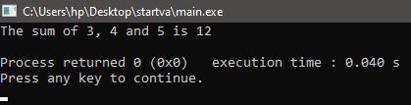
Let us discuss another example of printing the product of a list of numbers.
#include <stdio.h>
#include <stdarg.h>
//let us define a function that will be used to perform multiplication
//here we have not defined the total parameters that can be passed in the function
int product(int n, ...)
{
// initialize a temporary variable that can be used
// to store the parameters passed in the functions
// that we have to multiply
va_list numtomul;
int totalproduct;

// Initialize a variable to store
// the product of all the parameters in the function.
totalproduct = 1;

// Use the va_start() function
// define the variable part of the function and
// then define the end of the argument lists
va_start(numtomul, n);

// use the loop to add each argument
// and add all the arguments in the totalsum variable
for (int i=0; i < n; i++)
totalproduct = totalproduct * va_arg(numtomul, int);

// now once you have used the list
// clear the memory
va_end(numtomul);

// now the multiplication is performed and stored in totalproduct
// return the totalsum
return totalproduct;
}

int main(int argc, const char * argv[])
{
// Define variables to store the value required for performing multiplication
int val1, val2, val3;
int res;

val1 = 3;
val2 = 4;
val3 = 5;

/* Calling the product function */
res = product(3, val1, val2, val3);

// Print the answers after computing product
printf("The product of %d, %d and %d is %d\n", val1, val2, val3, res);

return 0;
}
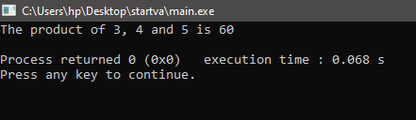
Output:

Conclusion: Before implementing the va_arg() function in the your program, it is necessary to implement the va_start() function in your code and end it with va_end() function.

Ascii vs Unicode
The two-character encoding schemes that are currently most widely utilized around the world are Unicode and ASCII. As opposed to ASCII, which is used to represent text in computers as symbols, characters, and numbers, Unicode is a character encoding that may be used to process, store, and exchange text data in any language.
What is ASCII?
- For electronic communication, it is a standard for character encoding. The American Standard Code for Information Interchange (ASCII) was first published in 1963. ASCII codes are used to represent text in computers and other electronic devices.
- Each letter is given a distinct value between 0 and 127 in the ASCII code, which is used to represent 128 English characters. For instance, uppercase A has the ASCII value 65, uppercase B has the code 66, and so on. For other examples, see the table below.
- The majority of computers encode text using ASCII encoding, which makes moving data between devices much simpler.
For Example:
Name | Symbol / Char | ASCII Value | Hexadecimal Code
Dollar | $ | 36 | 24
The ampersand | & | 38 | 26
Asterisk | * | 42 | 2A
Minus Sign / Hyphen | - | 45 | 2D
Decimal Point | . | 46 | 2E

What is UNICODE?
- Every character in every language spoken today can be defined uniquely thanks to Unicode by being given a different number. The Unicode Consortium maintains the Unicode standard, which includes emojis and more than 1,40,000 characters from more than 150 present and historical scripts.
- Different character encodings, such as UTF-8, UTF-16, and UTF-32, can be used to define Unicode. Over 90% of websites on the World Wide Web and the majority of contemporary operating systems, including Windows, employ UTF-8, making it the most widely used of them.
ASCII VS UNICODE
Let us now see some of the main differences between ASCII and UNICODE:
UNICODE | ASCII
A wider range of characters than ASCII is represented by Unicode, including letters from languages like English, Arabic, Greek, and others, mathematical symbols, historical scripts, and emoji. | Lowercase letters (a-z), uppercase letters (A-Z), numerals (0-9), and symbols like parenthesis, dollars, the ampersand, and others are represented by the ASCII code.
Unicode encrypts 154 written scripts. | Only 128 different characters can be encoded using ASCII using a 7-bit range.
UNICODE is a superset of ASCII. | ASCII is a proper subset of UNICODE

We can conclude that the text encoding systems, Unicode and ASCII, are of the highest importance in contemporary communications. Both have advantages and downsides, but a more universal encoding technique will always make communication easier in the long run.

