CSS Background
CSS background property is used to define the background effects on element. There are 5 CSS background properties that affects the HTML elements:
- background-color
- background-image
- background-repeat
- background-attachment
- background-position

1) CSS background-color
The background-color property is used to specify the background color of the element.
You can set the background color like this:
- <!DOCTYPE html>
- <html>
- <head>
- <style>
- h2,p{
- background-color: #b0d4de;
- }
- </style>
- </head>
- <body>
- <h2>My first CSS page.</h2>
- <p>Hello Javatpoint. This is an example of CSS background-color.</p>
- </body>
- </html>
Output:

My first CSS page.
Hello Javatpoint. This is an example of CSS background-color.

2) CSS background-image
The background-image property is used to set an image as a background of an element. By default the image covers the entire element. You can set the background image for a page like this.
- <!DOCTYPE html>
- <html>
- <head>
- <style>
- body {
- background-image: url("paper1.gif");
- margin-left:100px;
- }
- </style>
- </head>
- <body>
- <h1>Hello Javatpoint.com</h1>
- </body>
- </html>
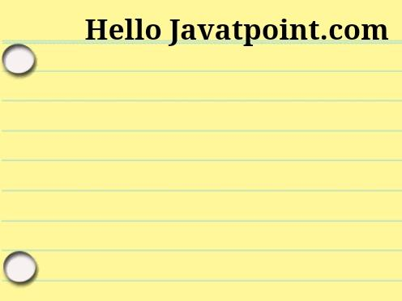
Output
Note: The background image should be chosen according to text color. The bad combination of text and background image may be a cause of poor designed and not readable webpage.

3) CSS background-repeat
By default, the background-image property repeats the background image horizontally and vertically. Some images are repeated only horizontally or vertically.
The background looks better if the image repeated horizontally only.
background-repeat: repeat-x;
- <!DOCTYPE html>
- <html>
- <head>
- <style>
- body {
- background-image: url("gradient_bg.png");
- background-repeat: repeat-x;
- }
- </style>
- </head>
- <body>
- <h1>Hello Javatpoint.com</h1>
- </body>
- </html>

background-repeat: repeat-y;
- <!DOCTYPE html>
- <html>
- <head>
- <style>
- body {
- background-image: url("gradient_bg.png");
- background-repeat: repeat-y;
- }
- </style>
- </head>
- <body>
- <h1>Hello Javatpoint.com</h1>
- </body>
- </html>
Output:


4) CSS background-attachment
The background-attachment property is used to specify if the background image is fixed or scroll with the rest of the page in browser window. If you set fixed the background image then the image will not move during scrolling in the browser. Let?s take an example with fixed background image.
- background: white url('bbb.gif');
- background-repeat: no-repeat;
- background-attachment: fixed;
Output:
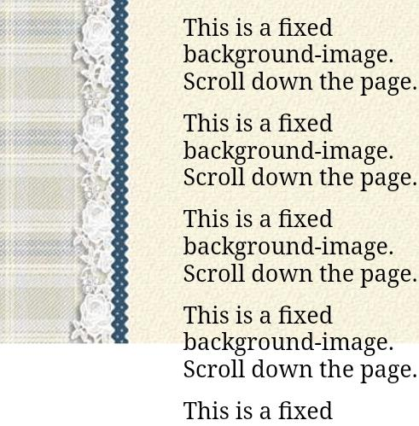

5) CSS background-position
The background-position property is used to define the initial position of the background image. By default, the background image is placed on the top-left of the webpage.
You can set the following positions:
- center
- top
- bottom
- left
- right

- background: white url('good-morning.jpg');
- background-repeat: no-repeat;
- background-attachment: fixed;
- background-position: center;
Output:
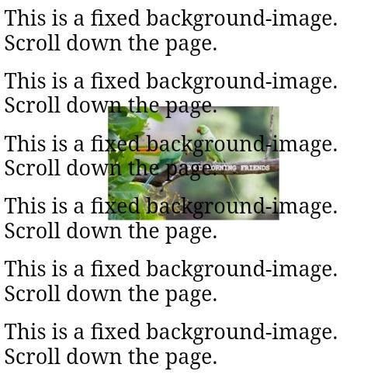

CSS Border
The CSS border is a shorthand property used to set the border on an element.
The CSS border properties are use to specify the style, color and size of the border of an element. The CSS border properties are given below
- border-style
- border-color
- border-width
- border-radius

1) CSS border-style
The Border style property is used to specify the border type which you want to display on the web page.
There are some border style values which are used with border-style property to define a border.
Value | Description
none | It doesn't define any border.
dotted | It is used to define a dotted border.
dashed | It is used to define a dashed border.
solid | It is used to define a solid border.
double | It defines two borders wIth the same border-width value.
groove | It defines a 3d grooved border. effect is generated according to border-color value.
ridge | It defines a 3d ridged border. effect is generated according to border-color value.
inset | It defines a 3d inset border. effect is generated according to border-color value.
outset | It defines a 3d outset border. effect is generated according to border-color value.
- <!DOCTYPE html>
- <html>
- <head>
- <style>
- p.none {border-style: none;}
- p.dotted {border-style: dotted;}
- p.dashed {border-style: dashed;}
- p.solid {border-style: solid;}
- p.double {border-style: double;}
- p.groove {border-style: groove;}
- p.ridge {border-style: ridge;}
- p.inset {border-style: inset;}
- p.outset {border-style: outset;}
- p.hidden {border-style: hidden;}
- </style>
- </head>
- <body>
- <p class="none">No border.</p>
- <p class="dotted">A dotted border.</p>
- <p class="dashed">A dashed border.</p>
- <p class="solid">A solid border.</p>
- <p class="double">A double border.</p>
- <p class="groove">A groove border.</p>
- <p class="ridge">A ridge border.</p>
- <p class="inset">An inset border.</p>
- <p class="outset">An outset border.</p>
- <p class="hidden">A hidden border.</p>
- </body>
- </html>
Output:
No border.
A dotted border.
A dashed border.
A solid border.
A double border.
A groove border.
A ridge border.
An inset border.
An outset border.
A hidden border.

2) CSS border-width
The border-width property is used to set the border's width. It is set in pixels. You can also use the one of the three pre-defined values, thin, medium or thick to set the width of the border.

Note: The border-width property is not used alone. It is always used with other border properties like "border-style" property to set the border first otherwise it will not work.
- <!DOCTYPE html>
- <html>
- <head>
- <style>
- p.one {
- border-style: solid;
- border-width: 5px;
- }
- p.two {
- border-style: solid;
- border-width: medium;
- }
- p.three {
- border-style: solid;
- border-width: 1px;
- }
- </style>
- </head>
- <body>
- <p class="one">Write your text here.</p>
- <p class="two">Write your text here.</p>
- <p class="three">Write your text here.</p>
- </body>
- </html>
Output:

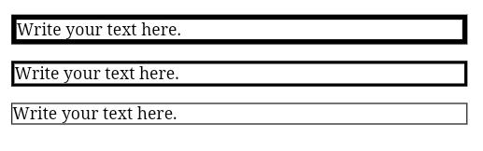
3) CSS border-color
There are three methods to set the color of the border.
- Name: It specifies the color name. For example: "red".
- RGB: It specifies the RGB value of the color. For example: "rgb(255,0,0)".
- Hex: It specifies the hex value of the color. For example: "#ff0000".
There is also a border color named "transparent". If the border color is not set it is inherited from the color property of the element.

Note: The border-color property is not used alone. It is always used with other border properties like "border-style" property to set the border first otherwise it will not work.
- <!DOCTYPE html>
- <html>
- <head>
- <style>
- p.one {
- border-style: solid;
- border-color: red;
- }
- p.two {
- border-style: solid;
- border-color: #98bf21;
- }
- </style>
- </head>
- <body>
- <p class="one">This is a solid red border</p>
- <p class="two">This is a solid green border</p>
- </body>
- </html>
Output:
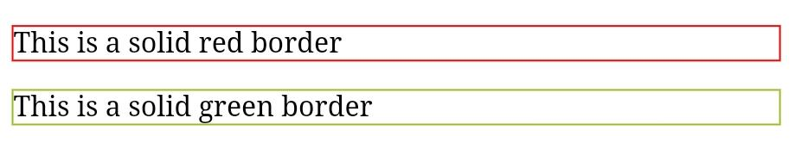

CSS border-radius property
This CSS property sets the rounded borders and provides the rounded corners around an element, tags, or div. It defines the radius of the corners of an element.
It is shorthand for border top-left-radius, border-top-right-radius, border-bottom-right-radius and border-bottom-left-radius. It gives the rounded shape to the corners of the border of an element. We can specify the border for all four corners of the box in a single declaration using the border-radius. The values of this property can be defined in percentage or length units.
This CSS property includes the properties that are tabulated as follows:
Property | Description
border-top-left-radius | It is used to set the border-radius for the top-left corner
border-top-right-radius | It is used to set the border-radius for the top-right corner
border-bottom-right-radius | It is used to set the border-radius for the bottom-right corner
border-bottom-left-radius | It is used to set the border-radius for the bottom-left corner
If the bottom-left value is omitted, then it will be same as the top-right. If the value of bottom-right is eliminated, then it will be same as the top-left. Similarly, if top-right is eliminated, then it will be the same as top-left.
Let's see what happens when we provide a single value, two values, three values, and four values to this property.
- If we provide a single value (such as border-radius: 30px;) to this property, it will set all corners to the same value.
- When we specify two values (such as border-radius: 20% 10% ;), then the first value will be used for the top-left and bottom-right corners, and the second value will be used for the top-right and bottom-left corners.
- When we use three values (such as border-radius: 10% 30% 20%;) then the first value will be used for the top-left corner, the second value will be applied on top-right, and bottom-left corners and the third value will be applied to the bottom-right corner.
- Similarly, when this property has four values (border-radius: 10% 30% 20% 40%;) then the first value will be the radius of top-left, the second value will be used for the top-right, the third value will be applied on bottom-right, and the fourth value is used for bottom-left.

Syntax
- border-radius: 1-4 length | % / 1-4 length | % | inherit | initial;

Property values
length: It defines the shape of the corners. It denotes the size of the radius using length values. Its default value is 0. It does not allow negative values.
percentage: It denotes the size of the radius in percentage. It also does not allow negative values.

Example
- <!DOCTYPE html>
- <html>

- <head>
- <title> CSS border-radius </title>
- <style>
- div {
- padding: 50px;
- margin: 20px;
- border: 6px ridge red;
- width: 300px;
- float: left;
- height: 150px;
- }
- p{
- font-size: 25px;
- }
- #one {
- border-radius: 90px;
- background: lightgreen;
- }
- #two {
- border-radius: 25% 10%;
- background: orange;
- }
- #three {
- border-radius: 35px 10em 10%;
- background: cyan;
- }
- #four {
- border-radius: 50px 50% 50cm 50em;
- background: lightblue;
- }

- </style>
- </head>

- <body>
- <div id = "one">
- <h2> Welcome to the javaTpoint.com </h2>
- <p> border-radius: 90px; </p>
- </div>
- <div id = "two">
- <h2> Welcome to the javaTpoint.com </h2>
- <p> border-radius: 25% 10%; </p>
- </div>
- <div id = "three">
- <h2> Welcome to the javaTpoint.com </h2>
- <p> border-radius: 35px 10em 10%; </p>
- </div>
- <div id = "four">
- <h2>Welcome to the javaTpoint.com</h2>
- <p>border-radius: 50px 50% 50cm 50em;</p>
- </div>
- </body>
- </html>
Output
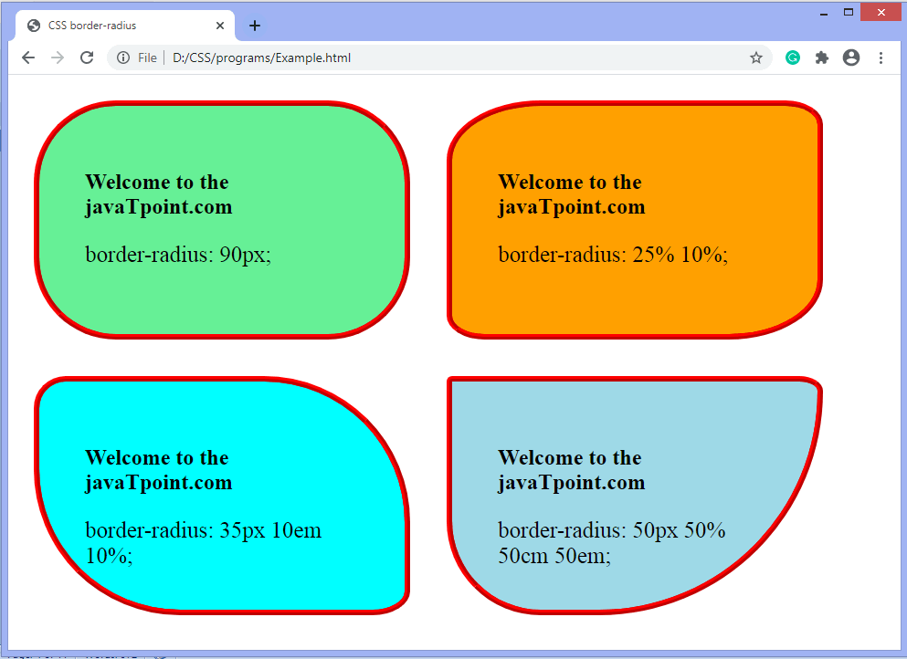
Now, let's see the border-radius for specific corners.

Example- border-top-left-radius
It sets the border radius for the top-left corner.
- <!DOCTYPE html>
- <html>

- <head>
- <title> CSS border-radius </title>
- <style>
- #left {
- border-top-left-radius: 250px;
- background: lightgreen;
- padding: 50px;
- border: 6px ridge red;
- width: 300px;
- height: 200px;
- font-size: 25px;
- }
- </style>
- </head>

- <body>
- <center>
- <div id = "left">
- <h2>Welcome to the javaTpoint.com</h2>
- <p>border-top-left-radius: 250px;</p>
- </div>
- </center>
- </body>
- </html>
Output
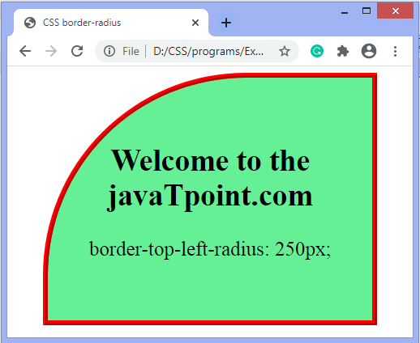

Example- border-top-right-radius
It sets the border-radius for the top-right corner
- <!DOCTYPE html>
- <html>
- <head>
- <style>
- #left {
- border-top-right-radius: 50%;
- background: lightgreen;
- padding: 50px;
- border: 6px ridge red;
- width: 300px;
- height: 200px;
- font-size: 25px;
- }
- </style>
- </head>

- <body>
- <center>
- <div id = "left">
- <h2>Welcome to the javaTpoint.com</h2>
- <p>border-top-right-radius: 50%;</p>
- </div>
- </center>
- </body>
- </html>
Output
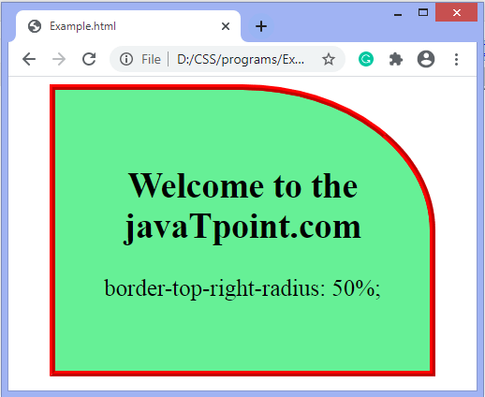

Example- border-bottom-right-radius
It sets the border-radius for the bottom-right corner
- <!DOCTYPE html>
- <html>
- <head>
- <style>
- #left {
- border-bottom-right-radius: 50%;
- background: lightgreen;
- padding: 50px;
- border: 6px ridge red;
- width: 300px;
- height: 200px;
- font-size: 25px;
- }
- </style>
- </head>

- <body>
- <center>
- <div id = "left">
- <h2>Welcome to the javaTpoint.com</h2>
- <p>border-bottom-right-radius: 50%;</p>
- </div>
- </center>
- </body>
- </html>
Output
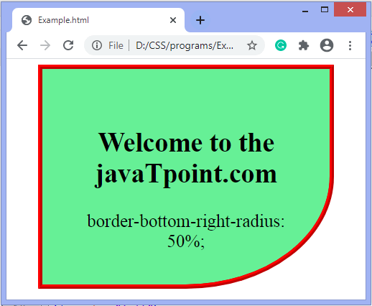

Example- border-bottom-left-radius
It sets the border-radius for the bottom-left corner
- <!DOCTYPE html>
- <html>
- <head>
- <style>
- #left {
- border-bottom-left-radius: 50%;
- background: lightgreen;
- padding: 50px;
- border: 6px ridge red;
- width: 300px;
- height: 200px;
- font-size: 25px;
- }
- </style>
- </head>

- <body>
- <center>
- <div id = "left">
- <h2>Welcome to the javaTpoint.com</h2>
- <p>border-bottom-left-radius: 50%;</p>
- </div>
- </center>
- </body>
- </html>
Output
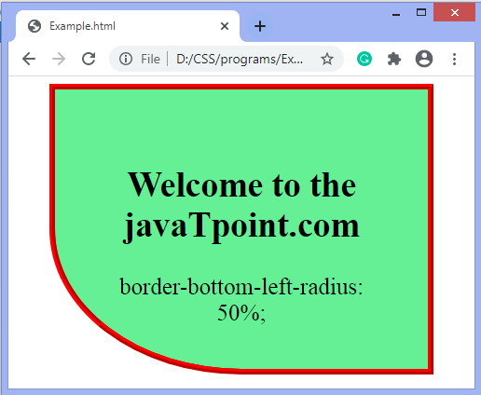
We can specify separate horizontal and vertical values by using the slash (/) symbol. The values before the slash (/) is used for the horizontal radius and the values after the slash (/) are for the vertical radius.
There is an example given below using the slash (/) symbol.

Example
- <!DOCTYPE html>
- <html>
- <head>
- <style>
- div{
- padding: 50px;
- border: 6px ridge red;
- width: 300px;
- margin: 20px;
- font-weight: bold;
- height: 175px;
- float: left;
- font-size: 25px;
- }
- #one {
- border-radius: 10% / 50%;
- background: lightgreen;
- }
- #two {
- border-radius: 120px / 100px 10px;
- background: lightblue;
- }
- #three {
- border-radius: 50% 10em / 10% 20em;
- background: lightpink;
- }
- #four {
- border-radius: 100px 10em 120px / 30%;
- background: cyan;
- }
- </style>
- </head>

- <body>
- <center>
- <div id = "one">
- <h2>Welcome to the javaTpoint.com</h2>
- <p>border-radius: 10% / 50%; </p>
- </div>
- <div id = "two">
- <h2>Welcome to the javaTpoint.com</h2>
- <p>border-radius: 120px / 100px 10px; </p>
- </div>
- <div id = "three">
- <h2>Welcome to the javaTpoint.com</h2>
- <p>border-radius: 50% 10em / 10% 20em; </p>
- </div>
- <div id = "four">
- <h2>Welcome to the javaTpoint.com</h2>
- <p>border-radius: 100px 10em 120px / 30%; </p>
- </div>
- </center>
- </body>
- </html>
Output
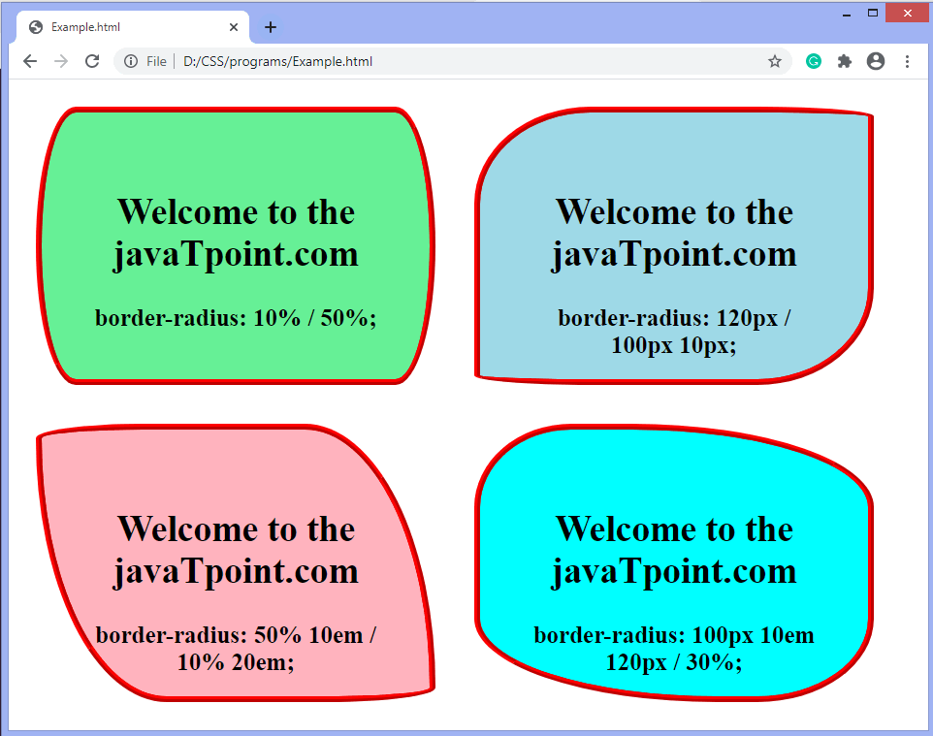

CSS border-collapse property
This CSS property is used to set the border of the table cells and specifies whether the table cells share the separate or common border.
This property has two main values that are separate and collapse. When it is set to the value separate, the distance between the cells can be defined using the border-spacing property. When the border-collapse is set to the value collapse, then the inset value of border-style property behaves like groove, and the outset value behaves like ridge.

Syntax
- border-collapse: separate | collapse | initial | inherit;
The values of this CSS property are defined as follows.

Property Values
separate: It is the default value that separates the border of the table cell. Using this value, each cell will display its own border.
collapse: This value is used to collapse the borders into a single border. Using this, two adjacent table cells will share a border. When this value is applied, the border-spacing property does not affect.
initial: It sets the property to its default value.
inherit: It inherits the property from its parent element.
Now, let's understand this CSS property by using some examples. In the first example, we are using the separate value of the border-collapse property. In the second example, we are using the collapse value of the border-collapse property.

Example - Using separate value
With this value, we can use the border-spacing property to set the distance between the adjacent table cells.
- <!DOCTYPE html>
- <html>

- <head>
- <title> border-collapse property </title>
- <style>
- table{
- border: 2px solid blue;
- text-align: center;
- font-size: 20px;
- width: 80%;
- height: 50%;
- }
- th{
- border: 5px solid red;
- background-color: yellow;
- }
- td{
- border: 5px solid violet;
- background-color: cyan;
- }
- #t1 {
- border-collapse: separate;
- }
- </style>
- </head>

- <body>

- <h1> The border-collapse Property </h1>
- <h2> border-collapse: separate; </h2>
- <table id = "t1">
- <tr>
- <th> First_Name </th>
- <th> Last_Name </th>
- <th> Subject </th>
- <th> Marks </th>
- </tr>
- <tr>
- <td> James </td>
- <td> Gosling </td>
- <td> Maths </td>
- <td> 92 </td>
- </tr>
- <tr>
- <td> Alan </td>
- <td> Rickman </td>
- <td> Maths </td>
- <td> 89 </td>
- </tr>
- <tr>
- <td> Sam </td>
- <td> Mendes </td>
- <td> Maths </td>
- <td> 82 </td>
- </tr>
- </table>
- </body>

- </html>
Output
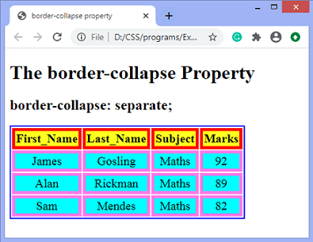

Example - Using collapse property
The border-spacing and border-radius properties cannot be used with this value.
- <!DOCTYPE html>
- <html>

- <head>
- <title> border-collapse property </title>
- <style>
- table{
- border: 2px solid blue;
- text-align: center;
- font-size: 20px;
- width: 80%;
- height: 50%;
- }
- th{
- border: 5px solid red;
- background-color: yellow;
- }
- td{
- border: 5px solid violet;
- background-color: cyan;
- }
- #t1{
- border-collapse: collapse;
- }
- </style>
- </head>

- <body>

- <h1> The border-collapse Property </h1>
- <h2> border-collapse: collapse; </h2>
- <table id = "t1">
- <tr>
- <th> First_Name </th>
- <th> Last_Name </th>
- <th> Subject </th>
- <th> Marks </th>
- </tr>
- <tr>
- <td> James </td>
- <td> Gosling </td>
- <td> Maths </td>
- <td> 92 </td>
- </tr>
- <tr>
- <td> Alan </td>
- <td> Rickman </td>
- <td> Maths </td>
- <td> 89 </td>
- </tr>
- <tr>
- <td> Sam </td>
- <td> Mendes </td>
- <td> Maths </td>
- <td> 82 </td>
- </tr>
- </table>
- </body>
- </html>
Output
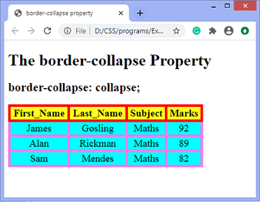

CSS border-spacing property
This CSS property is used to set the distance between the borders of the adjacent cells in the table. It applies only when the border-collapse property is set to separate. There will not be any space between the borders if the border-collapse is set to collapse.
It can be defined as one or two values for determining the vertical and horizontal spacing.
- When only one value is specified, then it sets both horizontal and vertical spacing.
- When we use the two-value syntax, then the first one is used to set the horizontal spacing (i.e., the space between the adjacent columns), and the second value sets the vertical spacing (i.e., the space between the adjacent rows).

Syntax
- border-spacing: length | initial | inherit;

Property Values
The values of this CSS property are defined as follows.
length: This value sets the distance between the borders of the adjacent table cells in px, cm, pt, etc. Negative values are not allowed.
initial: It sets the property to its default value.
inherit: It inherits the property from its parent element.
Let's understand this CSS property by using some examples. In the first example, we are using the single value of the border-spacing property, and in the second example, we are using two values of the border-spacing property.

Example
Here, we are using the single value of the border-spacing property. The border-collapse property is set to separate, and the value of the border-spacing is set to 45px.
- <!DOCTYPE html>
- <html>

- <head>
- <title> border-spacing property </title>
- <style>
- table{
- border: 2px solid blue;
- text-align: center;
- font-size: 20px;
- background-color: lightgreen;
- }
- th{
- border: 5px solid red;
- background-color: yellow;
- }
- td{
- border: 5px solid violet;
- background-color: cyan;
- }
- #space{
- border-collapse: separate;
- border-spacing: 45px;
- }
- </style>
- </head>

- <body>

- <h1> The border-spacing Property </h1>
- <h2> border-spacing: 45px; </h2>
- <table id = "space">
- <tr>
- <th> First_Name </th>
- <th> Last_Name </th>
- <th> Subject </th>
- <th> Marks </th>
- </tr>
- <tr>
- <td> James </td>
- <td> Gosling </td>
- <td> Maths </td>
- <td> 92 </td>
- </tr>
- <tr>
- <td> Alan </td>
- <td> Rickman </td>
- <td> Maths </td>
- <td> 89 </td>
- </tr>
- <tr>
- <td> Sam </td>
- <td> Mendes </td>
- <td> Maths </td>
- <td> 82 </td>
- </tr>
- </table>
- </body>

- </html>
Output
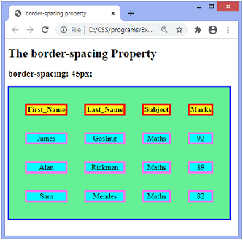

Example
Here, we are using two values of the border-spacing property. The border-collapse property is set to separate, and the value of the border-spacing is set to 20pt 1em. The first value, i.e., 20pt sets the horizontal spacing, and the value 1em set the vertical spacing.
- <!DOCTYPE html>
- <html>

- <head>
- <title> border-spacing property </title>
- <style>
- table{
- border: 2px solid blue;
- text-align: center;
- font-size: 20px;
- background-color: lightgreen;
- }
- th{
- border: 5px solid red;
- background-color: yellow;
- }
- td{
- border: 5px solid violet;
- background-color: cyan;
- }
- #space{
- border-collapse: separate;
- border-spacing: 20pt 1em;
- }
- </style>
- </head>

- <body>

- <h1> The border-spacing Property </h1>
- <h2> border-spacing: 20pt 1em; </h2>
- <table id = "space">
- <tr>
- <th> First_Name </th>
- <th> Last_Name </th>
- <th> Subject </th>
- <th> Marks </th>
- </tr>
- <tr>
- <td> James </td>
- <td> Gosling </td>
- <td> Maths </td>
- <td> 92 </td>
- </tr>
- <tr>
- <td> Alan </td>
- <td> Rickman </td>
- <td> Maths </td>
- <td> 89 </td>
- </tr>
- <tr>
- <td> Sam </td>
- <td> Mendes </td>
- <td> Maths </td>
- <td> 82 </td>
- </tr>
- </table>
- </body>

- </html>
Output
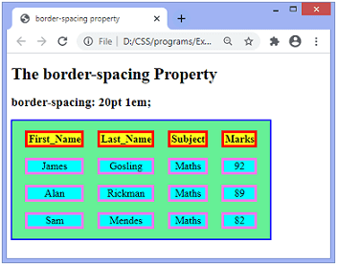

CSS Display
CSS display is the most important property of CSS which is used to control the layout of the element. It specifies how the element is displayed.
Every element has a default display value according to its nature. Every element on the webpage is a rectangular box and the CSS property defines the behavior of that rectangular box.

CSS Display default properties
default value | inline
inherited | no
animation supporting | no
version | css1
javascript syntax | object.style.display="none"

Syntax
- display:value;

CSS display values
There are following CSS display values which are commonly used.
- display: inline;
- display: inline-block;
- display: block;
- display: run-in;
- display: none;

1) CSS display inline
The inline element takes the required width only. It doesn't force the line break so the flow of text doesn't break in inline example.
The inline elements are:
- <span>
- <a>
- <em>
- <b> etc.
Let's see an example of CSS display inline.
- <!DOCTYPE html>
- <html>
- <head>
- <style>
- p {
- display: inline;
- }
- </style>
- </head>
- <body>
- <p>Hello Javatpoint.com</p>
- <p>Java Tutorial.</p>
- <p>SQL Tutorial.</p>
- <p>HTML Tutorial.</p>
- <p>CSS Tutorial.</p>
- </body>
- </html>
Output:
Hello Javatpoint.com Java Tutorial. SQL Tutorial. HTML Tutorial. CSS Tutorial.

2) CSS display inline-block
The CSS display inline-block element is very similar to inline element but the difference is that you are able to set the width and height.
- <!DOCTYPE html>
- <html>
- <head>
- <style>
- p {
- display: inline-block;
- }
- </style>
- </head>
- <body>
- <p>Hello Javatpoint.com</p>
- <p>Java Tutorial.</p>
- <p>SQL Tutorial.</p>
- <p>HTML Tutorial.</p>
- <p>CSS Tutorial.</p>
- </body>
- </html>
Output:
Hello Javatpoint.com Java Tutorial. SQL Tutorial. HTML Tutorial. CSS Tutorial.

3) CSS display block
The CSS display block element takes as much as horizontal space as they can. Means the block element takes the full available width. They make a line break before and after them.
- <!DOCTYPE html>
- <html>
- <head>
- <style>
- p {
- display: block;
- }
- </style>
- </head>
- <body>
- <p>Hello Javatpoint.com</p>
- <p>Java Tutorial.</p>
- <p>SQL Tutorial.</p>
- <p>HTML Tutorial.</p>
- <p>CSS Tutorial.</p>
- </body>
- </html>
Output:
Hello Javatpoint.com
Java Tutorial.
SQL Tutorial.
HTML Tutorial.
CSS Tutorial.

4) CSS display run-in
This property doesn't work in Mozilla Firefox. These elements don't produce a specific box by themselves.
- If the run-in box contains a bock box, it will be same as block.
- If the block box follows the run-in box, the run-in box becomes the first inline box of the block box.
- If the inline box follows the run-in box, the run-in box becomes a block box.

- <!DOCTYPE html>
- <html>
- <head>
- <style>
- p {
- display: run-in;
- }
- </style>
- </head>
- <body>
- <p>Hello Javatpoint.com</p>
- <p>Java Tutorial.</p>
- <p>SQL Tutorial.</p>
- <p>HTML Tutorial.</p>
- <p>CSS Tutorial.</p>
- </body>
- </html>
Output:
Hello Javatpoint.com
Java Tutorial.
SQL Tutorial.
HTML Tutorial.
CSS Tutorial.

5) CSS display none
The "none" value totally removes the element from the page. It will not take any space.
- <!DOCTYPE html>
- <html>
- <head>
- <style>
- h1.hidden {
- display: none;
- }
- </style>
- </head>
- <body>
- <h1>This heading is visible.</h1>
- <h1 class="hidden">This is not visible.</h1>
- <p>You can see that the hidden heading does not contain any space.</p>
- </body>
- </html>
Output:

This heading is visible.
You can see that the hidden heading does not contain any space.

Other CSS display values
Property-value | Description
flex | It is used to display an element as an block-level flex container. It is new in css3.
inline-flex | It is used to display an element as an inline-level flex container. It is new in css3.
inline-table | It displays an element as an inline-level table.
list-Item | It makes the element behave like a <li> element.
table | It makes the element behave like a <table> element.
table-caption | It makes the element behave like a <caption> element.
table-column-group | It makes the element behave like a <colgroup> element.
table-header-group | It makes the element behave like a <thead> element.
table-footer-group | It makes the element behave like a <tfoot> element.
table-row-group | It makes the element behave like a <tbody> element.
table-cell | It makes the element behave like a <td> element.
table-row | It makes the element behave like a <tr> element.
table-column | It makes the element behave like a <col> element.

CSS Cursor
It is used to define the type of mouse cursor when the mouse pointer is on the element. It allows us to specify the cursor type, which will be displayed to the user. When a user hovers on the link, then by default, the cursor transforms into the hand from a pointer.
Let's understand the property values of the cursor.
Values | Usage
alias | It is used to display the indication of the cursor of something that is to be created.
auto | It is the default property in which the browser sets the cursor.
all-scroll | It indicates the scrolling.
col-resize | Using it, the cursor will represent that the column can be horizontally resized.
cell | The cursor will represent that a cell or the collection of cells is selected.
context-menu | It indicates the availability of the context menu.
default | It indicates an arrow, which is the default cursor.
copy | It is used to indicate that something is copied.
crosshair | In it, the cursor changes to the crosshair or the plus sign.
e-resize | It represents the east direction and indicates that the edge of the box is to be shifted towards right.
ew-resize | It represents the east/west direction and indicates a bidirectional resize cursor.
n-resize | It represents the north direction that indicates that the edge of the box is to be shifted to up.
ne-resize | It represents the north/east direction and indicates that the edge of the box is to be shifted towards up and right.
move | It indicates that something is to be shifted.
help | It is in the form of a question mark or ballon, which represents that help is available.
None | It is used to indicate that no cursor is rendered for the element.
No-drop | It is used to represent that the dragged item cannot be dropped here.
s-resize | It indicates an edge box is to be moved down. It indicates the south direction.
Row-resize | It is used to indicate that the row can be vertically resized.
Se-resize | It represents the south/east direction, which indicates that an edge box is to be moved down and right.
Sw-resize | It represents south/west direction and indicates that an edge of the box is to be shifted towards down and left.
Wait | It represents an hourglass.
<url> | It indicates the source of the cursor image file.
w-resize | It indicates the west direction and represents that the edge of the box is to be shifted left.
Zoom-in | It is used to indicate that something can be zoomed in.
Zoom-out | It is used to indicate that something can be zoomed out.
The illustration of using the above values of cursor property is given below:
Example
- <html>
- <head>
- </head>
- <style>
- body{
- background-color: lightblue;
- color:green;
- text-align: center;
- font-size: 20px;
- }

- </style>

- <body>
- <p>Move your mouse over the below words for the cursor change.</p>
- <div style = "cursor:alias">alias Value</div>
- <div style = "cursor:auto">auto Value</div>
- <div style = "cursor:all-scroll">all-scroll value</div>
- <div style = "cursor:col-resize">col-resize value</div>
- <div style = "cursor:crosshair">Crosshair</div>
- <div style = "cursor:default">Default value</div>
- <div style = "cursor:copy">copy value</div>
- <div style = "cursor:pointer">Pointer</div>
- <div style = "cursor:move">Move</div>
- <div style = "cursor:e-resize">e-resize</div>
- <div style = "cursor:ew-resize">ew-resize</div>
- <div style = "cursor:ne-resize">ne-resize</div>
- <div style = "cursor:nw-resize">nw-resize</div>
- <div style = "cursor:n-resize">n-resize</div>
- <div style = "cursor:se-resize">se-resize</div>
- <div style = "cursor:sw-resize">sw-resize</div>
- <div style = "cursor:s-resize">s-resize</div>
- <div style = "cursor:w-resize">w-resize</div>
- <div style = "cursor:text">text</div>
- <div style = "cursor:wait">wait</div>
- <div style = "cursor:help">help</div>
- <div style = "cursor:progress">Progress</div>
- <div style = "cursor:no-drop">no-drop</div>
- <div style = "cursor:not-allowed">not-allowed</div>
- <div style = "cursor:vertical-text">vertical-text</div>
- <div style = "cursor:zoom-in">Zoom-in</div>
- <div style = "cursor:zoom-out">Zoom-out</div>
- </body>
- </html>
Output:
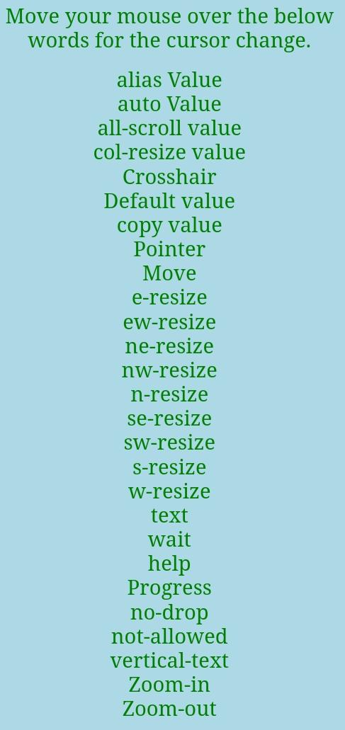

CSS Buttons
In HTML, we use the button tag to create a button, but by using CSS properties, we can style the buttons. Buttons help us to create user interaction and event processing. They are one of the widely used elements of web pages.
During the form submission, to view or to get some information, we generally use buttons.
Let's see the basic styling in buttons.

Basic styling in Buttons
There are multiple properties available that are used to style the button element. Let's discuss them one by one.

background-color
As we have discussed earlier, this property is used for setting the background color of the button element.
Syntax
- element {
- // background-color style
- }
Example
- <!DOCTYPE html>
- <html>

- <head>
- <title>
- button background Color
- </title>

- <style>
- body{
- text-align: center;
- }
- button {
- color:lightgoldenrodyellow;
- font-size: 30px;
- }
- .b1 {
- background-color: red;
- }
- .b2 {
- background-color: blue;
- }
- .b3 {
- background-color: violet;
- }
- </style>
- </head>

- <body>
- <h1>The background-color property.</h1>
- <button class="b1">Red color button</button>
- <button class="b2">Blue color button</button>
- <button class="b3">Violet color button</button>
- </body>
- </html>
Output

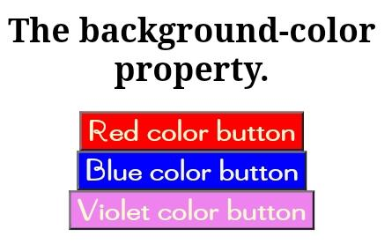
border
It is used to set the border of the button. It is the shorthand property for border-width, border-color, and border-style.
Syntax
- element {
- // border style
- }
Example
- <!DOCTYPE html>
- <html>

- <head>
- <title>
- button background Color
- </title>

- <style>
- body{
- text-align: center;
- }
- button {
- color:lightgoldenrodyellow;
- font-size: 30px;
- }
- .b1 {
- background-color: red;
- border:none;
- }
- .b2 {
- background-color: blue;
- border:5px brown solid;
- }
- .b3 {
- background-color: yellow;
- color:black;
- border:5px red groove;
- }
- .b4{
- background-color:orange;
- border: 5px red dashed;
- }
- .b5{
- background-color: gray;
- border: 5px black dotted;
- }
- .b6{
- background-color: lightblue;
- border:5px blue double;
- }
- </style>
- </head>

- <body>
- <h1>The border property</h1>
- <button class="b1">none</button>
- <button class="b2">solid</button>
- <button class="b3">groove</button>
- <button class="b4">dashed</button>
- <button class="b5">dotted</button>
- <button class="b6">double</button>

- </body>
- </html>
Output

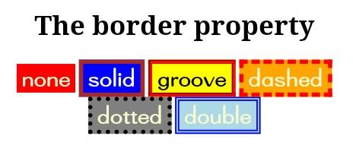
border-radius
It is used to make the rounded corners of the button. It sets the border radius of the button.
Syntax
- element {
- // border-radius property
- }
Example
- <!DOCTYPE html>
- <html>

- <head>
- <title>
- button background Color
- </title>

- <style>
- body{
- text-align: center;
- }
- button {
- color:lightgoldenrodyellow;
- font-size: 30px;
- }
- .b1 {
- background-color: red;
- border:none;
- }
- .b2 {
- background-color: blue;
- border:5px brown solid;
- border-radius: 7px;
- }
- .b3 {
- background-color: yellow;
- color:black;
- border:5px red groove;
- border-radius: 10px;
- }
- .b4{
- background-color:orange;
- border: 5px red dashed;
- border-radius: 20px;
- }
- .b5{
- background-color: gray;
- border: 5px black dotted;
- border-radius: 30px;
- }
- .b6{
- background-color: lightblue;
- border:5px blue double;
- border-radius: 25px;
- }
- </style>
- </head>

- <body>
- <h1>The border-radius property</h1>
- <h2>Below there is the border name and border-radius</h2>
- <button class="b1">none</button>
- <button class="b2">solid 7px</button>
- <button class="b3">groove 10px</button>
- <button class="b4">dashed 20px</button>
- <button class="b5">dotted 30px</button>
- <button class="b6">double 25px</button>

- </body>
- </html>
Output

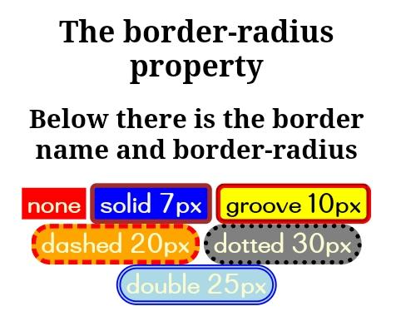
box-shadow
As its name implies, it is used to create the shadow of the button box. It is used to add the shadow to the button. We can also create a shadow during the hover on the button.
Syntax
- box-shadow: [horizontal offset] [vertical offset] [blur radius]
- [optional spread radius] [color];
Example
- <!DOCTYPE html>
- <html>

- <head>
- <title>
- button background Color
- </title>

- <style>
- body{
- text-align: center;
- }
- button {
- color:lightgoldenrodyellow;
- font-size: 30px;
- }
- .b1{
- background-color: lightblue;
- border:5px red double;
- border-radius: 25px;
- color:black;
- box-shadow : 0 8px 16px 0 black,
- 0 6px 20px 0 rgba(0, 0, 0, 0.19);
- }
- .b2{
- background-color: lightblue;
- border:5px red dotted;
- color:black;
- border-radius: 25px;
- }
- .b2:hover{
- box-shadow : 0 8px 16px 0 black,
- 0 6px 20px 0 rgba(0, 0, 0, 0.19);
- }
- </style>
- </head>

- <body>
- <button class="b1">Shadow on button</button>
- <button class="b2">Box-shadow on hover</button>
- </body>
- </html>
Output

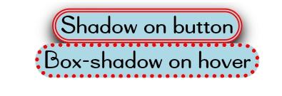
padding
It is used to set the button padding.
Syntax
- element {
- // padding style
- }
Let's understand it using an illustration.
Example
- <!DOCTYPE html>
- <html>

- <head>
- <title>
- button background Color
- </title>

- <style>
- body{
- text-align: center;
- }
- button {
- color:lightgoldenrodyellow;
- font-size: 30px;
- }
- .b1 {
- background-color: red;
- border:none;
- padding: 16px;
- }
- .b2 {
- background-color: blue;
- border:5px brown solid;
- padding:15px 30px 25px 40px;
- }
- .b3 {
- background-color: yellow;
- color:black;
- border:5px red groove;
- padding-top:30px;
- }
- .b4{
- background-color:orange;
- border: 5px red dashed;
- padding-bottom:40px;
- }
- .b5{
- background-color: gray;
- border: 5px black dotted;
- padding-left: 40px;
- }
- .b6{
- background-color: lightblue;
- border:5px blue double;
- padding-right: 40px;;
- }
- </style>
- </head>

- <body>
- <h1>The padding property</h1>
- <button class="b1">none</button>
- <button class="b2">solid</button>
- <button class="b3">groove</button>
- <button class="b4">dashed</button>
- <button class="b5">dotted</button>
- <button class="b6">double</button>

- </body>
- </html>
Output
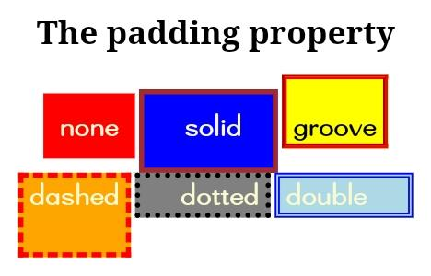

CSS Float
The CSS float property is a positioning property. It is used to push an element to the left or right, allowing other element to wrap around it. It is generally used with images and layouts.
To understand its purpose and origin, let's take a look to its print display. In the print display, image is set into the page such that text wraps around it as needed.
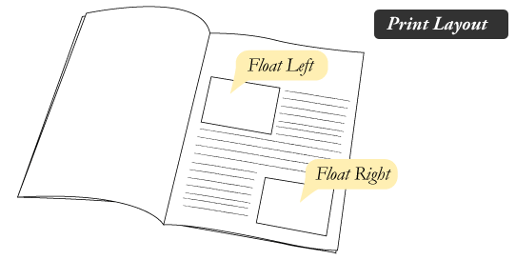
Its web layout is also just similar to print layout.
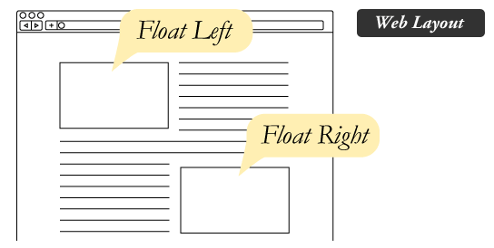

How it works
Elements are floated only horizontally. So it is possible only to float elements left or right, not up or down.
- A floated element may be moved as far to the left or the right as possible. Simply, it means that a floated element can display at extreme left or extreme right.
- The elements after the floating element will flow around it.
- The elements before the floating element will not be affected.
- If the image floated to the right, the texts flow around it, to the left and if the image floated to the left, the text flows around it, to the right.

CSS Float Properties
Property | Description | Values
clear | The clear property is used to avoid elements after the floating elements which flow around it. | left, right, both, none, inherit
float | It specifies whether the box should float or not. | left, right, none, inherit

CSS Float Property Values
Value | Description
none | It specifies that the element is not floated, and will be displayed just where it occurs in the text. this is a default value.
left | It is used to float the element to the left.
right | It is used to float the element to the right.
initial | It sets the property to its initial value.
inherit | It is used to inherit this property from its parent element.

CSS Float Property Example
Let's see a simple example to understand the CSS float property.
- <!DOCTYPE html>
- <html>
- <head>
- <style>
- img {
- float: right;
- }
- </style>
- </head>
- <body>
- <p>The following paragraph contains an image with style
- <b>float:right</b>. The result is that the image will float to the right in the paragraph.</p>
- <img src="good-morning.jpg" alt="Good Morning Friends"/>
- This is some text. This is some text. This is some text.
- This is some text. This is some text. This is some text.
- This is some text. This is some text. This is some text.
- This is some text. This is some text. This is some text.
- This is some text. This is some text. This is some text.
- This is some text. This is some text. This is some text.
- This is some text. This is some text. This is some text.
- This is some text. This is some text. This is some text.
- This is some text. This is some text. This is some text.
- This is some text. This is some text. This is some text.
- This is some text. This is some text. This is some text.
- This is some text. This is some text. This is some text.
- This is some text. This is some text. This is some text.
- </p>
- </body>
- </html>
Output
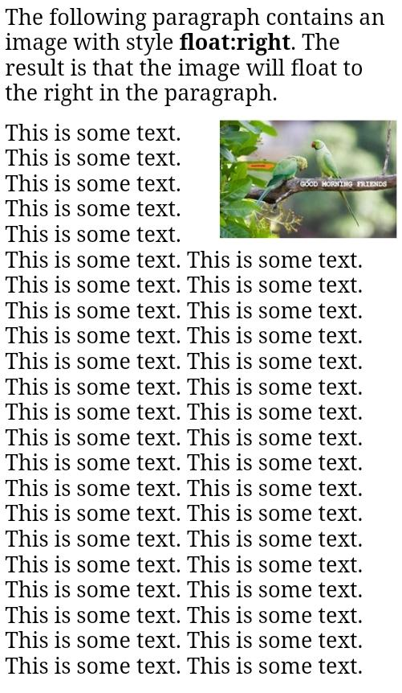

CSS Font
CSS Font property is used to control the look of texts. By the use of CSS font property you can change the text size, color, style and more. You have already studied how to make text bold or underlined. Here, you will also know how to resize your font using percentage.
These are some important font attributes:
- CSS Font color: This property is used to change the color of the text. (standalone attribute)
- CSS Font family: This property is used to change the face of the font.
- CSS Font size: This property is used to increase or decrease the size of the font.
- CSS Font style: This property is used to make the font bold, italic or oblique.
- CSS Font variant: This property creates a small-caps effect.
- CSS Font weight: This property is used to increase or decrease the boldness and lightness of the font.

1) CSS Font Color
CSS font color is a standalone attribute in CSS although it seems that it is a part of CSS fonts. It is used to change the color of the text.
There are three different formats to define a color:
- By a color name
- By hexadecimal value
- By RGB
In the above example, we have defined all these formats.
- <!DOCTYPE html>
- <html>
- <head>
- <style>
- body {
- font-size: 100%;
- }
- h1 { color: red; }
- h2 { color: #9000A1; }
- p { color:rgb(0, 220, 98); }
- }
- </style>
- </head>
- <body>
- <h1>This is heading 1</h1>
- <h2>This is heading 2</h2>
- <p>This is a paragraph.</p>
- </body>
- </html>
Output:

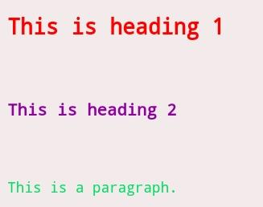
2) CSS Font Family
CSS font family can be divided in two types:
- Generic family: It includes Serif, Sans-serif, and Monospace.
- Font family: It specifies the font family name like Arial, New Times Roman etc.
Serif: Serif fonts include small lines at the end of characters. Example of serif: Times new roman, Georgia etc.
Sans-serif: A sans-serif font doesn't include the small lines at the end of characters. Example of Sans-serif: Arial, Verdana etc.
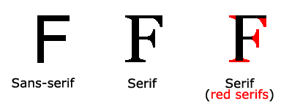
- <!DOCTYPE html>
- <html>
- <head>
- <style>
- body {
- font-size: 100%;
- }
- h1 { font-family: sans-serif; }
- h2 { font-family: serif; }
- p { font-family: monospace; }
- }
- </style>
- </head>
- <body>
- <h1>This heading is shown in sans-serif.</h1>
- <h2>This heading is shown in serif.</h2>
- <p>This paragraph is written in monospace.</p>
- </body>
- </html>
Output:

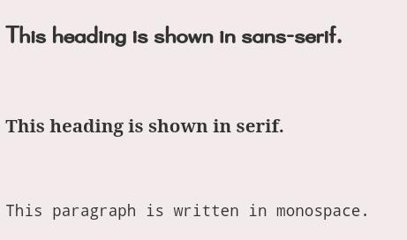
3) CSS Font Size
CSS font size property is used to change the size of the font.
These are the possible values that can be used to set the font size:
Font Size Value | Description
xx-small | used to display the extremely small text size.
x-small | used to display the extra small text size.
small | used to display small text size.
medium | used to display medium text size.
large | used to display large text size.
x-large | used to display extra large text size.
xx-large | used to display extremely large text size.
smaller | used to display comparatively smaller text size.
larger | used to display comparatively larger text size.
size in pixels or % | used to set value in percentage or in pixels.
- <html>
- <head>
- <title>Practice CSS font-size property</title>
- </head>
- <body>
- <p style="font-size:xx-small;"> This font size is extremely small.</p>
- <p style="font-size:x-small;"> This font size is extra small</p>
- <p style="font-size:small;"> This font size is small</p>
- <p style="font-size:medium;"> This font size is medium. </p>
- <p style="font-size:large;"> This font size is large. </p>
- <p style="font-size:x-large;"> This font size is extra large. </p>
- <p style="font-size:xx-large;"> This font size is extremely large. </p>
- <p style="font-size:smaller;"> This font size is smaller. </p>
- <p style="font-size:larger;"> This font size is larger. </p>
- <p style="font-size:200%;"> This font size is set on 200%. </p>
- <p style="font-size:20px;"> This font size is 20 pixels. </p>
- </body>
- </html>
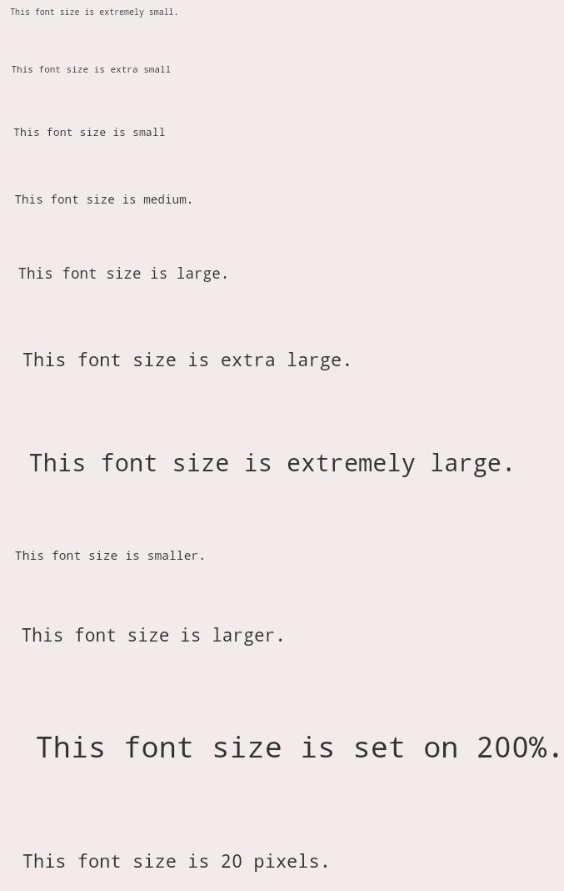
Output:

4) CSS Font Style
CSS Font style property defines what type of font you want to display. It may be italic, oblique, or normal.
- <!DOCTYPE html>
- <html>
- <head>
- <style>
- body {
- font-size: 100%;
- }
- h2 { font-style: italic; }
- h3 { font-style: oblique; }
- h4 { font-style: normal; }
- }
- </style>
- </head>
- <body>
- <h2>This heading is shown in italic font.</h2>
- <h3>This heading is shown in oblique font.</h3>
- <h4>This heading is shown in normal font.</h4>
- </body>
- </html>
Output:

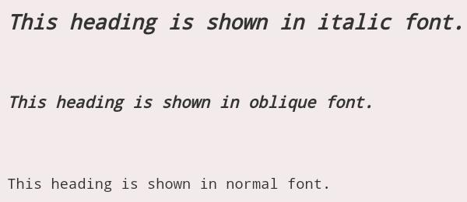
5) CSS Font Variant
CSS font variant property specifies how to set font variant of an element. It may be normal and small-caps.
- <!DOCTYPE html>
- <html>
- <head>
- <style>
- p { font-variant: small-caps; }
- h3 { font-variant: normal; }
- </style>
- </head>
- <body>
- <h3>This heading is shown in normal font.</h3>
- <p>This paragraph is shown in small font.</p>
- </body>
- </html>
Output:

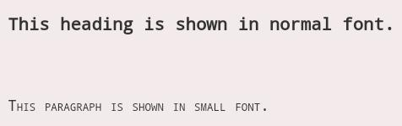
6) CSS Font Weight
CSS font weight property defines the weight of the font and specify that how bold a font is. The possible values of font weight may be normal, bold, bolder, lighter or number (100, 200..... upto 900).
- <!DOCTYPE html>
- <html>
- <body>
- <p style="font-weight:bold;">This font is bold.</p>
- <p style="font-weight:bolder;">This font is bolder.</p>
- <p style="font-weight:lighter;">This font is lighter.</p>
- <p style="font-weight:100;">This font is 100 weight.</p>
- <p style="font-weight:200;">This font is 200 weight.</p>
- <p style="font-weight:300;">This font is 300 weight.</p>
- <p style="font-weight:400;">This font is 400 weight.</p>
- <p style="font-weight:500;">This font is 500 weight.</p>
- <p style="font-weight:600;">This font is 600 weight.</p>
- <p style="font-weight:700;">This font is 700 weight.</p>
- <p style="font-weight:800;">This font is 800 weight.</p>
- <p style="font-weight:900;">This font is 900 weight.</p>
- </body>
- </html>
Output:
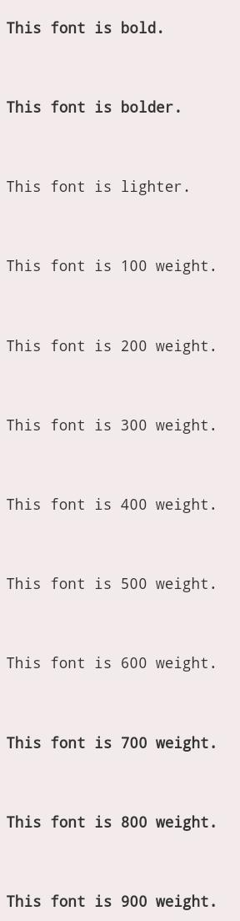

CSS Font-size
The font-size property in CSS is used to specify the height and size of the font. It affects the size of the text of an element. Its default value is medium and can be applied to every element. The values of this property include xx-small, small, x-small, etc.

Syntax
- font-size: medium|large|x-large|xx-large|xx-small|x-small|small|;
The font-size can be relative or absolute.

Absolute-size
It is used to set the text to a definite size. Using absolute-size, it is not possible to change the size of the text in all browsers. It is advantageous when we know the physical size of the output.

Relative-size
It is used to set the size of the text relative to its neighboring elements. With relative-size, it is possible to change the size of the text in browsers.

NOTE: If we do not define a font-size, then for the normal text such as paragraphs, the default size is 16px, which is equal to 1em.

Font-size with pixels
When we set the size of text with pixels, then it provides us the full control over the size of the text.

Example
- <!DOCTYPE html>
- <html>
- <head>
- <style>

- #first {
- font-size: 40px;
- }
- #second {
- font-size: 20px;
- }
- </style>
- </head>
- <body>

- <p id="first">This is a paragraph having size 40px.</p>
- <p id="second">This is another paragraph having size 20px.</p>

- </body>
- </html>
Output

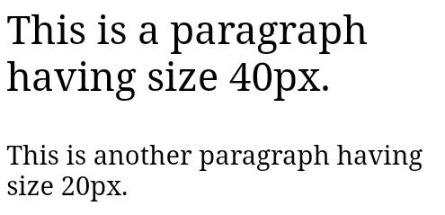
Font-size with em
It is used to resize the text. Most of the developers prefer em instead of pixels. It is recommended by the world wide web consortium (W3C). As stated above, the default text size in browsers is 16px. So, we can say that the default size of 1em is 16px.
The formula for calculating the size from pixels to em is em = pixels/16.

Example
- <!DOCTYPE html>
- <html>
- <head>
- <style>
- #first {
- font-size: 2.5em; /* 40px/16=2.5em */
- }

- #second {
- font-size: 1.875em; /* 30px/116=1.875em */
- }

- #third {
- font-size: 0.875em; /* 14px/16=0.875em */
- }
- </style>
- </head>
- <body>

- <p id='first'>First paragraph.</p>
- <p id='second'>Second paragraph</p>
- <p id='third'>Third Paragraph.</p>
- </body>
- </html>
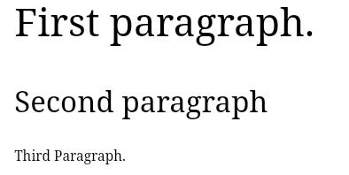
Output

Responsive font size
We can set the size of the text by using a vw unit, which stands for the 'viewport width'. The viewport is the size of the browser window.
1vw = 1% of viewport width.
If the width of the viewport is 50cm, then the 1vw is equal to 0.5 cm.

Example
- <!DOCTYPE html>
- <html>
- <meta name="viewport" content="width=device-width, initial-scale=1.0">
- <body>

- <p style="font-size:5vw;">First paragraph having the width of 5vw.</p>
- <p style="font-size:10vw;">Second paragraph having the width of 10vw.</p>

- </body>
- </html>
Output

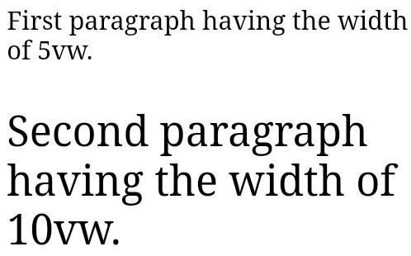
Font-size with the length property
It is used to set the size of the font in length. The length can be in cm, px, pt, etc. Negative values of length property are not allowed in font-size.

Syntax
- font-size: length;

Example
- <!DOCTYPE html>
- <html>
- <head>
- <style>
- .length {
- color:red;
- font-size: 5cm;
- }
- </style>
- </head>

- <body>
- <h1>font-size property</h1>

- <p class = "length">A paragraph having length 5cm.</p>
- </body>
- </html>

CSS font-family
This CSS property is used to provide a comma-separated list of font families. It sets the font-face for the text content of an element. This property can hold multiple font names as a fallback system, i.e., if one font is unsupported in the browser, then others can be used. The different font-family is used for making attractive web pages.
There are two types of font-family names in CSS, which are defined below:
- family-name: It is the name of the font-family such as "Courier", "Arial", "Times", etc.
- generic-family: It is the name of the generic family that includes five categories, which are "serif", "sans-serif", "cursive", "fantasy", and "monospace". It should be placed at last in the list of the font family names.
Let's define the generic-family categories.
serif: It is mainly used when we are writing the text for printing, such as books, magazines, newspapers, etc. It includes the font-family such as Georgia, Garamond, Times New Roman, Minion, and many more.
sans-serif: It is a modern, formal, and simple style. It is widely used but most often in the digital form of text. It includes the font-family that are Arial, Calibri, Verdana, Futura, Lato, and many more.
cursive: It is mainly used for writing the invitation letter, informal messages, etc. It is like a handwritten text which is written by a pen or a brush. The font-family that it includes is Insolente, Corsiva, Flanella, Belluccia, Zapfino, and many more.
monospace: It is for instructions, mailing address, typewritten text, etc. It includes the font-family that is Monaco, SimSun, Courier, Consolas, Inconsolata, and many more.
fantasy: It makes the text expressive, decorative, and impactful. It includes the font-family that is Impact, Copperplate, Cracked, Critter, and many more.
Syntax
- font-family: family-name|generic-family|initial|inherit;
Values
Let's see the values of the font-family property.
family-name/generic-family: It is the list of font-family names and the generic family names.
initial: It is used to set the property to its default value.
inherit: It is used to inherit the property from its parent element.
Let's understand it by using an illustration.
Example
- <!DOCTYPE html>
- <html>
- <head>
- <style>
- body{
- text-align:center;
- }
- h1.a {
- font-family: "Times New Roman", Times, serif;
- color:Red;
- }

- h2.b {
- font-family: Arial, Helvetica, sans-serif;
- color:blue;
- }
- </style>
- </head>
- <body>
- <h1>The font-family Property</h1>

- <h1 class="a">Hello World :) :)</h1>

- <h2 class="b">Welcome to the javaTpoint.com</h2>

- </body>
- </html>
Output
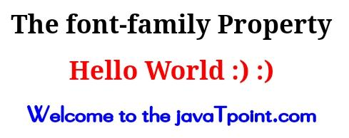

CSS font-weight
This property is used for setting the thickness and boldness of the font. It is used to define the weight of the text. The available weight depends on the font-family, which is used by the browser.
Syntax
- font-weight: normal | lighter | bolder | bold | number | inherit |initial | unset;
Property Values
normal: It is the default font-weight whose numeric value is 400.
lighter: It considers the existing font-weight of the font-family and makes the font-weight lighter compare to the parent element.
bolder: It considers the existing font-weight of the font-family and makes the font-weight heavier compare to the parent element.
bold: As its name implies, it is used to define the bold font-weight, and its numeric value is 700.
number: It is used to set the font-weight based on the specified number. Its range can be between 1 to 1000.
initial: It is used to set the font-weight to its default value.
Let's see an example of this property.
Example
- <!DOCTYPE html>

- <html>
- <head>
- <title> font-weight property </title>

- <style>
- body{
- font-family: sans-serif;
- }
- p.one{
- font-weight: normal;
- }
- p.two{
- font-weight: lighter;
- }

- p.three{
- font-weight: bolder;
- }

- p.four{
- font-weight: bold;
- }

- p.five{
- font-weight: 1000;
- }

- p.six{
- font-weight: initial;
- }
- p.seven{
- font-weight: inherit;
- }
- p.eight{
- font-weight: unset;
- }

- </style>
- </head>

- <body>
- <p class="one">
- normal property value
- </p>

- <p class="two">
- lighter property value
- </p>

- <p class="three">
- bolder property value
- </p>
- <p class="four">
- bold property value
- </p>
- <p class="five">
- number property value
- </p>

- <p class="six">
- initial property value
- </p>
- <p class="seven">
- inherit property value
- </p>
- <p class="eight">
- unset property value
- </p>
- </body>
- </html>
Output
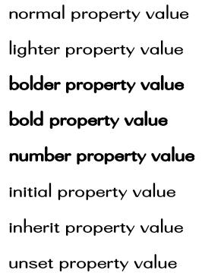

CSS font-stretch property
The font-stretch property in CSS allows us to select a normal, expanded, or condensed face from the font's family. This property sets the text wider or narrower compare to the default width of the font. It will not work on any font but only works on the font-family that has a width-variant face.
This CSS property only works for the fonts with additional faces like expanded and condensed faces; otherwise, it will be affectless for the fonts that don't have condensed or expanded faces.
The nine keyword values for choosing the width of the font-face are given in the following syntax.

Syntax
- font-stretch: normal | semi-condensed | condensed | extra-condensed | ultra-condensed | semi-expanded | expanded | extra-expanded | ultra-expanded

Property Values
The property values of this CSS property are tabulated as follows:
Keyword | Description
normal | This is the default value, which does not stretch any font.
semi-condensed | It slightly condensed the text characters of the element. This value makes the text narrower than normal but not narrower than condensed.
condensed | This value makes the text narrower than semi-condensed but not narrower than extra-condensed.
extra-condensed | This value makes the text narrower than condensed but not narrower than ultra-condensed.
ultra-condensed | This value makes the text extremely narrowed.
semi-expanded | It slightly widened the text characters of the element. This value makes the text wider than normal but not wider than expanded.
expanded | This value makes the text wider than semi-expanded but not wider than extra-expanded.
extra-expanded | This value makes the text wider than expanded but not wider than ultra-expanded.
ultra-expanded | This value makes the text extremely wider.
Let's understand the above property values by using an example.

Example
- <!DOCTYPE html>
- <html>
- <head>
- <title>
- CSS font-stretch Property
- </title>

- <style>
- body{
- text-align: center;
- }
- div{
- font-family: Arial, Helvetica, sans-serif;
- font-size: 20px;
- color: blue;
- }
- .normal {
- font-stretch: normal;
- }
- .semi-condensed {
- font-stretch: semi-condensed;
- }
- .condensed {
- font-stretch: condensed;
- }
- .extra-condensed {
- font-stretch: extra-condensed;
- }
- .ultra-condensed {
- font-stretch: ultra-condensed;
- }

- .semi-expanded {
- font-stretch: semi-expanded;
- }

- .expanded {
- font-stretch: expanded;
- }
- .extra-expanded {
- font-stretch: extra-expanded;
- }

- .ultra-expanded {
- font-stretch: ultra-expanded;
- }
- </style>
- </head>

- <body>
- <h1> Example of the font-stretch property </h1>
- <div class = "normal">
- normal
- </div>

- <div class = "semi-condensed">
- semi-condensed
- </div>
- <div class = "condensed">
- condensed
- </div>

- <div class = "extra-condensed">
- extra-condensed
- </div>

- <div class = "ultra-condensed">
- ultra-condensed
- </div>
- <div class = "semi-expanded">
- semi-expanded
- </div>

- <div class = "expanded">
- expanded
- </div>

- <div class = "extra-expanded">
- extra-expanded
- </div>

- <div class = "ultra-expanded">
- ultra-expanded
- </div>
- </body>

- </html>
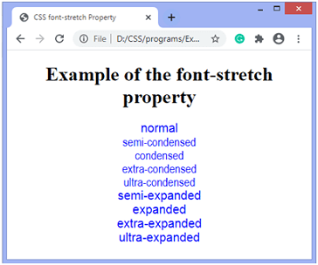
Output

