CSS Colors
The color property in CSS is used to set the color of HTML elements. Typically, this property is used to set the background color or the font color of an element.
In CSS, we use color values for specifying the color. We can also use this property for the border-color and other decorative effects.
We can define the color of an element by using the following ways:
- RGB format.
- RGBA format.
- Hexadecimal notation.
- HSL.
- HSLA.
- Built-in color.
Let's understand the syntax and description of the above ways in detail.

RGB Format
RGB format is the short form of 'RED GREEN and BLUE' that is used for defining the color of an HTML element simply by specifying the values of R, G, B that are in the range of 0 to 255.
The color values in this format are specified by using the rgb() property. This property allows three values that can either be in percentage or integer (range from 0 to 255).
This property is not supported in all browsers; that's why it is not recommended to use it.
Syntax
- color: rgb(R, G, B);

RGBA Format
It is almost similar to RGB format except that RGBA contains A (Alpha) that specifies the element's transparency. The value of alpha is in the range 0.0 to 1.0, in which 0.0 is for fully transparent, and 1.0 is for not transparent.
Syntax
- color:rgba(R, G, B, A);

Hexadecimal notation
Hexadecimal can be defined as a six-digit color representation. This notation starts with the # symbol followed by six characters ranges from 0 to F. In hexadecimal notation, the first two digits represent the red (RR) color value, the next two digits represent the green (GG) color value, and the last two digits represent the blue (BB) color value.
The black color notation in hexadecimal is #000000, and the white color notation in hexadecimal is #FFFFFF. Some of the codes in hexadecimal notation are #FF0000, #00FF00, #0000FF, #FFFF00, and many more.
Syntax
- color:#(0-F)(0-F)(0-F)(0-F)(0-F)(0-F);

Short Hex codes
It is a short form of hexadecimal notation in which every digit is recreated to arrive at an equivalent hexadecimal value.
For example, #7B6 becomes #77BB66 in hexadecimal.
The black color notation in short hex is #000, and the white color notation in short hex is #FFF. Some of the codes in short hex are #F00, #0F0, #0FF, #FF0, and many more.

HSL
It is a short form of Hue, Saturation, and Lightness. Let's understand them individually.
Hue: It can be defined as the degree on the color wheel from 0 to 360. 0 represents red, 120 represents green, 240 represents blue.
Saturation: It takes value in percentage in which 100% represents fully saturated, i.e., no shades of gray, 50% represent 50% gray, but the color is still visible, and 0% represents fully unsaturated, i.e., completely gray, and the color is invisible.
Lightness: The lightness of the color can be defined as the light that we want to provide the color in which 0% represents black (there is no light), 50% represents neither dark nor light, and 100% represents white (full lightness).
Let's see the syntax of HSL in color property.
Syntax
- color:hsl(H, S, L);

HSLA
It is entirely similar to HSL property, except that it contains A (alpha) that specifies the element's transparency. The value of alpha is in the range 0.0 to 1.0, in which 0.0 indicates fully transparent, and 1.0 indicates not transparent.
Syntax
- color:hsla(H, S, L, A);

Built-in Color
As its name implies, built-in color means the collection of previously defined colors that are used by using a name such as red, blue, green, etc.
Syntax
- color: color-name;
Let's see the list of built-in colors along with their decimal and hexadecimal values.
S.no. | Color name | Hexadecimal Value | Decimal Value or rgb() value
1. | Red | #FF0000 | rgb(255,0,0)
2. | Orange | #FFA500 | rgb(255,165,0)
3. | Yellow | #FFFF00 | rgb(255,255,0)
4. | Pink | #FFC0CB | rgb(255,192,203)
5. | Green | #008000 | rgb(0,128,0)
6. | Violet | #EE82EE | rgb(238,130,238)
7. | Blue | #0000FF | rgb(0,0,255)
8. | Aqua | #00FFFF | rgb(0,255,255)
9. | Brown | #A52A2A | rgb(165,42,42)
10. | White | #FFFFFF | rgb(255,255,255)
11. | Gray | #808080 | rgb(128,128,128)
12. | Black | #000000 | rgb(0,0,0)
The illustration of CSS colors, which includes the above properties, is given below.

Example
- <html>
- <head>
- <title>CSS hsl color property</title>
- <style>
- h1{
- text-align:center;
- }
- #rgb{
- color:rgb(255,0,0);
- }
- #rgba{
- color:rgba(255,0,0,0.5);
- }
- #hex{
- color:#EE82EE;
- }
- #short{
- color: #E8E;
- }
- #hsl{
- color:hsl(0,50%,50%);
- }
- #hsla{
- color:hsla(0,50%,50%,0.5);
- }
- #built{
- color:green;
- }
- </style>
- </head>
- <body>
- <h1 id="rgb">
- Hello World. This is RGB format.
- </h1>
- <h1 id="rgba">
- Hello World. This is RGBA format.
- </h1>
- <h1 id="hex">
- Hello World. This is Hexadecimal format.
- </h1>
- <h1 id="short">
- Hello World. This is Short-hexadecimal format.
- </h1>
- <h1 id="hsl">
- Hello World. This is HSL format.
- </h1>
- <h1 id="hsla">
- Hello World. This is HSLA format.
- </h1>
- <h1 id="built">
- Hello World. This is Built-in color format.
- </h1>
- </body>
- </html>
Output
- <html>
- <head>
- <title>CSS hsl color property</title>
- <style>
- h1{
- text-align:center;
- }
- #rgb{
- color:rgb(255,0,0);
- }
- #rgba{
- color:rgba(255,0,0,0.5);
- }
- #hex{
- color:#EE82EE;
- }
- #short{
- color: #E8E;
- }
- #hsl{
- color:hsl(0,50%,50%);
- }
- #hsla{
- color:hsla(0,50%,50%,0.5);
- }
- #built{
- color:green;
- }
- </style>
- </head>
- <body>
- <h1 id="rgb">
- Hello World. This is RGB format.
- </h1>
- <h1 id="rgba">
- Hello World. This is RGBA format.
- </h1>
- <h1 id="hex">
- Hello World. This is Hexadecimal format.
- </h1>
- <h1 id="short">
- Hello World. This is Short-hexadecimal format.
- </h1>
- <h1 id="hsl">
- Hello World. This is HSL format.
- </h1>
- <h1 id="hsla">
- Hello World. This is HSLA format.
- </h1>
- <h1 id="built">
- Hello World. This is Built-in color format.
- </h1>
- </body>
- </html>
Output
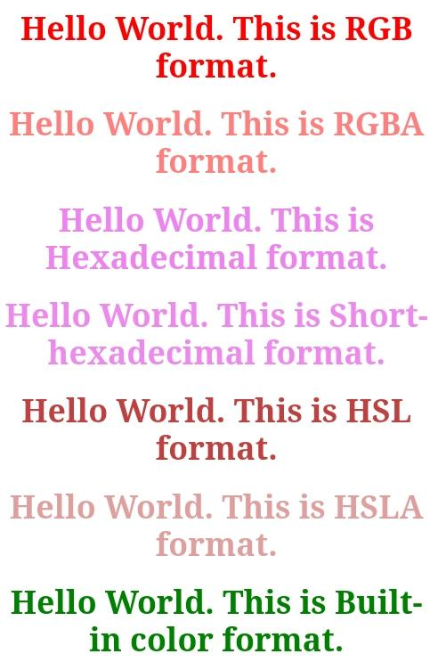

CSS hover
The :hover selector is for selecting the elements when we move the mouse on them. It is not only limited to the links. We can use it on almost every HTML element. To style the link to unvisited pages, we can use the :link selector. To style the link for visited pages, we can use the :visited selector and to style the active links we can use the :active selector.
It is introduced in CSS1. The hover can be used to highlight the web pages as per the preference of users in an effective web-designing program.
The hover feature includes the following effects:
- Change the color of the background and font.
- Modify the opacity of the image.
- Text embedding.
- Create image rollover effects.
- Swapping of images.

NOTE: To make the hover effective, we must have to declare it after the :link and :visited selectors if they are present in the CSS definition.
Basically, the hover effect modifies the element's property value to enable the animate changes on a stated image/text or the corresponding elements. Embedding of the hover elements in the web pages makes them interactive and functional.
Generally, the hover feature is compatible with all of the main browsers. But, it will be a challenging task to implement it on touch devices. It is observed that an active hover function gets stuck on the non-supportive device.

Syntax
- :hover {
- css declarations;
- }
Let's understand it by using some illustrations.
Example 1: Changing the link color on hover by using CSS
Let's see how the color of the link gets changed when we place the cursor on it. It will create a stylish effect, and its implementation is easy when we are using CSS.
- <html>
- <head>

- <style>
- body{
- text-align:center;
- }
- a
- {
- color: red;
- }
- a:hover
- {
- color: green;
- }
- a:active
- {
- color: cyan;
- }
- </style>
- </head>
- <body>
- <h1>Move your mouse on the below link to see the hover effect.</h1>
- <a class = "link" href = https://www.javatpoint.com/css-grid>CSS Grid</a>
- </body>
- </html>
Example 2: Apply hover on paragraph, heading and link
- <html>
- <head>
- <style>
- body{
- text-align:center;
- }
- p:hover, h1:hover, a:hover{
- background-color: yellow;
- }
- </style>
- </head>
- <body>
- <h1>Hello World</h1>
- <p>Welcome to the javaTpoint.</p>
- <a href='https://www.javatpoint.com/css-grid'>CSS Grid</a>
- </body>
- </html>
Example 3- Text overlay on image hover
This CSS code displays the text on the image during mouse hover. Let's see the image overlay effect during mouse hover.
- <!DOCTYPE html>
- <html>
- <head>
- <meta name="viewport" content="width=device-width, initial-scale=1">
- <style>
- body{
- text-align:center;
- }
- * {box-sizing: border-box;}

- .container {
- position: relative;
- width: 50%;
- max-width: 300px;
- }

- .image {
- display: block;
- width: 100%;
- height: auto;
- }

- .overlay {
- position: absolute;
- bottom: 0;
- background: rgba(0, 0, 0, 0.2);
- width: 100%;
- opacity:0;
- transition: .9s ease;
- font-size: 25px;
- padding: 20px;
- }

- .container:hover .overlay {
- opacity: 1.5;
- }
- </style>
- </head>
- <body>

- <h1>Image Overlay Title Effect</h1>
- <h2>Move your mouse over the image to see the effect.</h2>

- <center>
- <div class="container">
- <img src="jtp.png" class="image">
- <div class="overlay">Welcome to javaTpoint.com</div>
- </div> </center>

- </body>
- </html>

CSS Important
This property in CSS is used to give more importance compare to normal property. The !important means 'this is important'. This rule provides a way of making the Cascade in CSS.
If we apply this property to the text, then the priority of that text is higher than other priorities. It is to be recommended not to use this CSS property into your program until it is highly required. It is because the more use of this property will cause a lot of unexpected behavior.
If a rule is defined with this attribute, it will reject the normal concern in which the later used rule overrides the previous ones. If we use more than one declaration marked !important, then the normal cascade takes it over again. That means the new marked !important will replace the previous one.
It increases the priority of the CSS property and ignores the overriding properties.

Syntax
- element {
- font-size: 14px !important;
- color: blue !important;
- ...
- }

Example
- Example
- <!DOCTYPE html>
- <html>
- <head>
- <style>
- h1 {
- color: white ;
- }
- H1 {
- color:blue !important;
- }
- body {
- background-color:lightblue !important;
- text-align:center;
- background-color:yellow;
- }
- </style>
- </head>
- <body>
- <h1>Hello World.</h1>
- <h1>Welcome to the javaTpoint.com. This is an example of <i>!important</i> property.</h1>
- <p></p>
- </body>
- </html>
Output

In the above example, we can see that instead of pink, the background color of the body is light blue because, in the body tag, the !important is applied after the light blue background color.
Let's take another example of this property to understand it more clearly.

Example
In this example, we are applying the !important attribute on the border of the text. The color of the border of h1 heading will remain red despite of other declarations. The color and border-color of heading h2 will remain green and violet despite of other declarations.
- <!DOCTYPE html>
- <html>
- <head>
- <meta name="viewport" content="width=device-width, initial-scale=1">
- <style>
- body{
- text-align: center;
- }
- h1 {
- border-color: red !important;
- border: 5px green solid;
- border-color: black;
- }
- h2{
- color: green !important;
- color: red;
- border-color:violet !important;
- border: 5px green solid;
- }
- </style>
- </head>
- <body>

- <h1>Hello World :) :)</h1>
- <h2>Welcome to the javaTpoint.com</h2>

- </body>
- </html>
Output
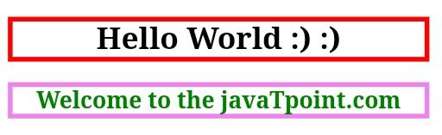

CSS Background-color
This property is used to set the background color of an element. The background of an element covers the total size, including the padding and border and excluding margin. It can be applied to all HTML elements.

Syntax
- element {
- background-color: color_name|transparent|initial|inherit;
- }
Let's discuss the possible values of this property.
- color_name: It is used for defining the background color value or the color codes. It can be given by using the color name, hexadecimal value, or rgb() value.
- transparent: It is the default value of this property, which is used to specify the transparent background-color.
- initial: It is not used to set the background color. It sets the default value.
- Inherit: It is used to inherit the background-color from its parent.
Let's see an illustration of this property.

Example
- <!DOCTYPE html>
- <html>
- <head>
- <title>background-color property</title>
- <style>
- body {
- text-align:center;
- background-color: lightblue;
- }
- h1{
- color: blue;
- }
- </style>
- </head>
- <body>
- <h1>Hello World.</h1>
- <h1>Welcome to the javaTpoint.com</h1>
- </body>
- </html>
Output


CSS background-attachment property
The background-attachment property is used to specify that the background image is fixed or scroll with the rest of the page in the browser window.
This property has three values scroll, fixed, and local. Its default value is scroll, which causes the element to not scroll with its content. The local value of this property causes the element to scroll with the content. If we set the value to fixed, the background image will not move during scrolling in the browser.
This CSS property can support multiple background images. We can specify a different value of the background-attachment property for each background-image, separated by commas. Every image will match with the corresponding value of this property.

Syntax
- background-attachment: scroll | fixed | local | initial | inherit;
The values of this property are defined as follows.

Property Values
scroll: It is the default value that prevents the element from scrolling with the contents, but scrolls with the page.
fixed: Using this value, the background image doesn't move with the element, even the element has a scrolling mechanism. It causes the image to be locked in one place, even the rest of the document scrolls.
local: Using this value, if the element has a scrolling mechanism, the background image scrolls with the content of the element.
initial: It sets the property to its default value.
inherit: It inherits the property from its parent element.
Let's understand this property by using some illustrations.

Example
In this example, we are using the scroll value of the background-attachment property, which is the default behavior. So when the page is scrolled, the background scrolls with it.
- <!DOCTYPE html>
- <html>
- <head>
- <title>
- background-attachment property
- </title>

- <style>
- #example {
- background-image: url("lion.png");
- font-size: 35px;
- border: 4px solid red;
- color: white;
- background-position: center;
- background-color: green;
- background-repeat: no-repeat;
- background-attachment: scroll;
- }

- </style>
- </head>

- <body>
- <h1> background-attachment: scroll;</h1>
- <p> If there is no scrollbar on your screen, then try to resize the browser's window to see the effect. </p>
- <div id="example">
- <p>
- Hi, Welcome to the javaTpoint.com. This site is developed so that students may learn computer science related technologies easily. The javaTpoint.com is always providing an easy and in-depth tutorial on various technologies. No one is perfect in this world, and nothing is eternally best. But we can try to be better.
- </p>
- </div>

- </body>
- </html>
Output
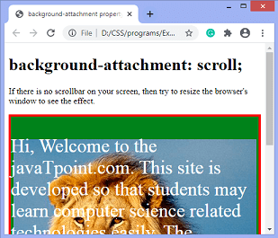

Example - Using fixed value
In this example, we are using the fixed value of the background-attachment property. This value fixed the background image, and the image will not move even the rest of the document scrolls.
- <!DOCTYPE html>
- <html>
- <head>
- <title>
- background-attachment property
- </title>

- <style>
- #example {
- background-image: url("lion.png");
- font-size: 35px;
- border: 4px solid red;
- color: white;
- background-position: center;
- background-color: green;
- background-repeat: no-repeat;
- background-attachment: fixed;
- }

- </style>
- </head>

- <body>
- <h1> background-attachment: fixed;</h1>
- <p> If there is no scrollbar on your screen, then try to resize the browser's window to see the effect. </p>
- <div id="example">
- <p>
- Hi, Welcome to the javaTpoint.com. This site is developed so that students may learn computer science related technologies easily. The javaTpoint.com is always providing an easy and in-depth tutorial on various technologies. No one is perfect in this world, and nothing is eternally best. But we can try to be better.
- </p>
- </div>

- </body>
- </html>
Output
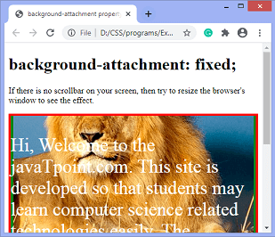

Example - Using local value
In this example, we are using the local value of the background-attachment property. Here, the background-image will scroll with the scrolling of the element's content.
- <!DOCTYPE html>
- <html>
- <head>
- <title>
- background-attachment property
- </title>

- <style>
- #example {
- background-image: url("lion.png");
- font-size: 35px;
- border: 4px solid red;
- color: white;
- background-position: center;
- background-color: green;
- background-repeat: no-repeat;
- background-attachment: local;
- }

- </style>
- </head>

- <body>
- <h1> background-attachment: local;</h1>
- <p> If there is no scrollbar on your screen, then try to resize the browser's window to see the effect. </p>
- <div id="example">
- <p>
- Hi, Welcome to the javaTpoint.com. This site is developed so that students may learn computer science related technologies easily. The javaTpoint.com is always providing an easy and in-depth tutorial on various technologies. No one is perfect in this world, and nothing is eternally best. But we can try to be better.
- </p>
- </div>

- </body>
- </html>
Output
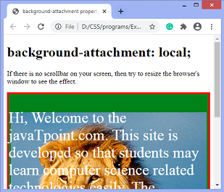
Now, let's see another example in which we are using more than one background image for an element.

Example
Here, there are two background images on which we are applying the background-attachment property. The attachment for the first image is set to fixed, whereas the attachment for the second image is set to scroll.
- <!DOCTYPE html>
- <html>
- <head>
- <title>
- background-attachment property
- </title>

- <style>
- #example {
- background-image: url("jtp.png"), url("forest.jpg");
- height: 500px;
- border: 4px solid red;
- background-position: center;
- background-repeat: no-repeat;
- background-attachment: fixed, scroll;
- }

- </style>
- </head>

- <body>
- <h1> background-attachment: scroll;</h1>
- <p> If there is no scrollbar on your screen, then try to resize the browser's window to see the effect. </p>
- <div id="example">
- </div>
- </body>
- </html>
Output
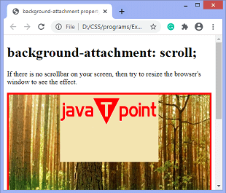

CSS background-size property
The background-size CSS property is used to set the size of a background image of an element. The background image can be stretched or constrained to fit into the existing space. It allows us to control the scaling of the background image.
This property can be defined using length, percentage, or keyword values. It has two possible keyword values that are contain and cover. Its single-value syntax defines the width of the image (in this case, the height sets to auto), whereas the double values define the value of both height and width in which the first value sets the width and second sets the height.
If an element has multiple background images, we can define the comma-separated values to define the different sizes of each one.
The cover value of the background-size property is used to cover the entire background area of the element. In contrast, the contain value of this property scales the image as much as possible without clipping the image.

Syntax
- background-size: auto | length | cover | contain | initial | inherit;
The values of this property are defined as follows.

Property Values
auto: This is the default value, which displays the background image in its original size.
length: It is used to set the width and height of the background image. This value stretches the image in the corresponding dimension of the given length. Its single value specifies the width of the image, and the height sets to auto. If two values are given, the first value sets the width, and the second value sets the height. It does not allow negative values.
percentage: This value defines the width and height of the background image to the percentage (%) of the background positioning area. Negative values are not allowed.
cover: This value is used to resize the background image to cover the entire container. Sometimes, it crops the little bit off one of the edges or stretches the image. It resizes the image to ensure the element is completely covered.
contain: Without stretching or cropping, it resizes the background image to ensure the image is completely visible.
initial: It sets the property to its default value.
inherit: It inherits the property from its parent element.
Let's understand this CSS property by using some illustrations.

Example
In this example, there are three div elements with a width of 300px and a height of 200px. Every div element has a background-image on which we are applying the background-size property.
Here we are using the length and percentage values to set the background-size of div element. The background-size of first div element set to auto, second div element is set to 150px 150px, and the background-size of third div element is set to 30%.
- <!DOCTYPE html>
- <html>
- <head>
- <title>
- background-size property
- </title>
- <style>
- div {
- width: 300px;
- height: 200px;
- border: 2px solid red;
- }
- #div1{
- background-image: url('lion.png');
- background-size: auto;
- }
- #div2{
- background-image: url('lion.png');
- background-size: 150px 150px;
- }
- #div3{
- background-image: url('lion.png');
- background-size: 30%;
- }
- </style>
- </head>

- <body>
- <h2> background-size: auto; </h2>
- <div id = "div1"></div>
- <h2> background-size: 150px 150px; </h2>
- <div id = "div2"></div>
- <h2> background-size: 30%; </h2>
- <div id = "div3"></div>
- </body>
- </html>
Output
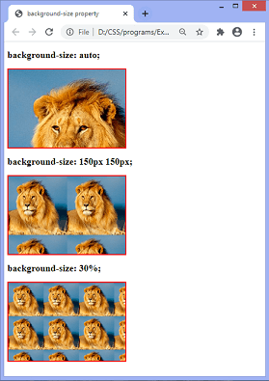
Now, in the next example, we are using the cover, contain, and initial values of the background-size property.

Example
- <!DOCTYPE html>
- <html>
- <head>
- <title>
- background-size property
- </title>
- <style>
- div {
- width: 300px;
- height: 250px;
- border: 2px solid red;
- background-repeat: no-repeat;
- }
- #div1{
- background-image: url('lion.png');
- background-size: contain;
- }
- #div2{
- background-image: url('lion.png');
- background-size: cover;
- }
- #div3{
- background-image: url('lion.png');
- background-size: initial;
- }
- </style>
- </head>

- <body>
- <h2> background-size: contain; </h2>
- <div id = "div1"></div>
- <h2> background-size: cover; </h2>
- <div id = "div2"></div>
- <h2> background-size: initial; </h2>
- <div id = "div3"></div>
- </body>
- </html>
Output
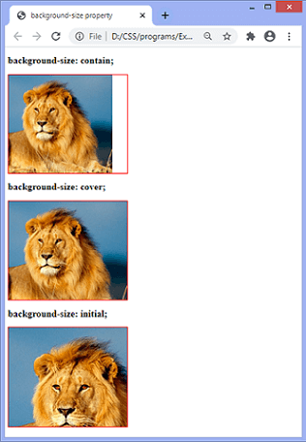

Example - Combining multiple images
We can also combine the values of this property and can apply them to multiple images. It can be done by comma-separated syntax.
In this example, there are three div elements, each having two background-images. Now, we are applying the background-size property on both images.
- <!DOCTYPE html>
- <html>
- <head>
- <title>
- background-size property
- </title>
- <style>
- div {
- width: 250px;
- height: 250px;
- border: 2px solid red;
- background-repeat: no-repeat;
- background-position: center;
- }
- #div1{
- background-image: url('lion.png'), url('forest.jpg');
- background-size: 300px 150px, cover;
- }
- #div2{
- background-image: url('lion.png'), url('forest.jpg');
- background-size: 200px 150px, 300px 200px;
- }
- #div3{
- background-image: url('lion.png'), url('forest.jpg');
- background-size: 150px 175px, contain;
- }
- </style>
- </head>

- <body>
- <h2> background-size: 300px 150px, cover; </h2>
- <div id = "div1"></div>
- <h2> background-size: 200px 150px, 300px 200px; </h2>
- <div id = "div2"></div>
- <h2> background-size: 150px 175px, contain; </h2>
- <div id = "div3"></div>

- </body>
- </html>
Output
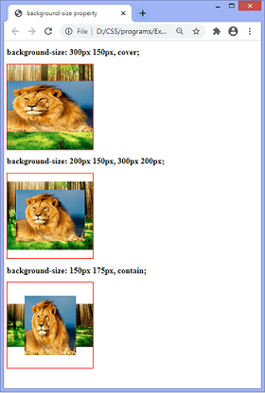

CSS Line Height
The CSS line height property is used to define the minimal height of line boxes within the element. It sets the differences between two lines of your content.
It defines the amount of space above and below inline elements. It allows you to set the height of a line of independently from the font size.

CSS line-height values
There are some property values which are used with CSS line-height property.
value | description
normal | This is a default value. it specifies a normal line height.
number | It specifies a number that is multiplied with the current font size to set the line height.
length | It is used to set the line height in px, pt,cm,etc.
% | It specifies the line height in percent of the current font.
initial | It sets this property to its default value.
inherit | It inherits this property from its parent element.

CSS line-height example
- <!DOCTYPE html>
- <html>
- <head>
- <style>
- h3.small {
- line-height: 70%;
- }
- h3.big {
- line-height: 200%;
- }
- </style>
- </head>
- <body>
- <h3>
- This is a heading with a standard line-height.<br>
- This is a heading with a standard line-height.<br>
- The default line height in most browsers is about 110% to 120%.<br>
- </h3>
- <h3 class="small">
- This is a heading with a smaller line-height.<br>
- This is a heading with a smaller line-height.<br>
- This is a heading with a smaller line-height.<br>
- This is a heading with a smaller line-height.<br>
- </h3>
- <h3 class="big">
- This is a heading with a bigger line-height.<br>
- This is a heading with a bigger line-height.<br>
- This is a heading with a bigger line-height.<br>
- This is a heading with a bigger line-height.<br>
- </h3>
- </body>
- </html>
Output
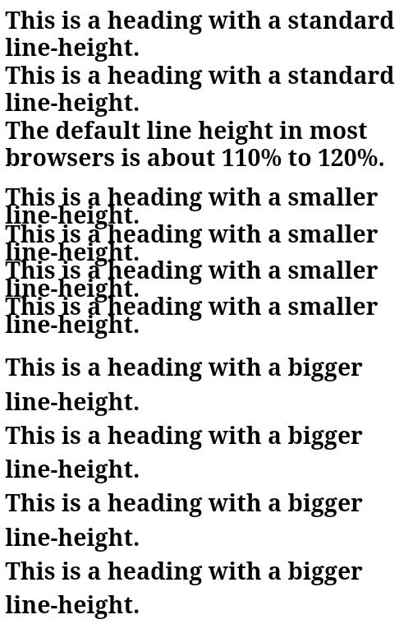

CSS Margin
CSS Margin property is used to define the space around elements. It is completely transparent and doesn't have any background color. It clears an area around the element.
Top, bottom, left and right margin can be changed independently using separate properties. You can also change all properties at once by using shorthand margin property.
There are following CSS margin properties:

CSS Margin Properties
Property | Description
margin | This property is used to set all the properties in one declaration.
margin-left | it is used to set left margin of an element.
margin-right | It is used to set right margin of an element.
margin-top | It is used to set top margin of an element.
margin-bottom | It is used to set bottom margin of an element.

CSS Margin Values
These are some possible values for margin property.
Value | Description
auto | This is used to let the browser calculate a margin.
length | It is used to specify a margin pt, px, cm, etc. its default value is 0px.
% | It is used to define a margin in percent of the width of containing element.
inherit | It is used to inherit margin from parent element.

Note: You can also use negative values to overlap content.

CSS margin Example
You can define different margin for different sides for an element.
- <!DOCTYPE html>
- <html>
- <head>
- <style>
- p {
- background-color: pink;
- }
- p.ex {
- margin-top: 50px;
- margin-bottom: 50px;
- margin-right: 100px;
- margin-left: 100px;
- }
- </style>
- </head>
- <body>
- <p>This paragraph is not displayed with specified margin. </p>
- <p class="ex">This paragraph is displayed with specified margin.</p>
- </body>
- </html>
Output:
This paragraph is not displayed with specified margin.
This paragraph is displayed with specified margin.

Margin: Shorthand Property
CSS shorthand property is used to shorten the code. It specifies all the margin properties in one property.
There are four types to specify the margin property. You can use one of them.
- margin: 50px 100px 150px 200px;
- margin: 50px 100px 150px;
- margin: 50px 100px;
- margin 50px;

1) margin: 50px 100px 150px 200px;
It identifies that:
top margin value is 50px
right margin value is 100px
bottom margin value is 150px
left margin value is 200px
- <!DOCTYPE html>
- <html>
- <head>
- <style>
- p {
- background-color: pink;
- }
- p.ex {
- margin: 50px 100px 150px 200px;
- }
- </style>
- </head>
- <body>
- <p>This paragraph is not displayed with specified margin. </p>
- <p class="ex">This paragraph is displayed with specified margin.</p>
- </body>
- </html>
Output:
This paragraph is not displayed with specified margin.
This paragraph is displayed with specified margin.

2) margin: 50px 100px 150px;
It identifies that:
top margin value is 50px
left and right margin values are 100px
bottom margin value is 150px
- <!DOCTYPE html>
- <html>
- <head>
- <style>
- p {
- background-color: pink;
- }
- p.ex {
- margin: 50px 100px 150px;
- }
- </style>
- </head>
- <body>
- <p>This paragraph is not displayed with specified margin. </p>
- <p class="ex">This paragraph is displayed with specified margin.</p>
- </body>
- </html>
Output:
This paragraph is not displayed with specified margin.
This paragraph is displayed with specified margin.

3) margin: 50px 100px;
It identifies that:
top and bottom margin values are 50px
left and right margin values are 100px
- <!DOCTYPE html>
- <html>
- <head>
- <style>
- p {
- background-color: pink;
- }
- p.ex {
- margin: 50px 100px;
- }
- </style>
- </head>
- <body>
- <p>This paragraph is not displayed with specified margin. </p>
- <p class="ex">This paragraph is displayed with specified margin.</p>
- </body>
- </html>
Output:
This paragraph is not displayed with specified margin.
This paragraph is displayed with specified margin.

4) margin: 50px;
It identifies that:
top right bottom and left margin values are 50px
- <!DOCTYPE html>
- <html>
- <head>
- <style>
- p {
- background-color: pink;
- }
- p.ex {
- margin: 50px;
- }
- </style>
- </head>
- <body>
- <p>This paragraph is not displayed with specified margin. </p>
- <p class="ex">This paragraph is displayed with specified margin.</p>
- </body>
- </html>
Output:
This paragraph is not displayed with specified margin.
This paragraph is displayed with specified margin.

CSS Opacity
The CSS opacity property is used to specify the transparency of an element. In simple word, you can say that it specifies the clarity of the image.
In technical terms, Opacity is defined as degree in which light is allowed to travel through an object.

How to apply CSS opacity setting
Opacity setting is applied uniformly across the entire object and the opacity value is defined in term of digital value less than 1. The lesser opacity value displays the greater opacity. Opacity is not inherited.

CSS Opacity Example: transparent image
Let's see a simple CSS opacity example of image transparency.
- <!DOCTYPE html>
- <html>
- <head>
- <style>
- img.trans {
- opacity: 0.4;
- filter: alpha(opacity=40); /* For IE8 and earlier */
- }
- </style>
- </head>
- <body>
- <p>Normal Image</p>
- <img src="rose.jpg" alt="normal rose">
- <p>Transparent Image</p>
- <img class="trans" src="rose.jpg" alt="transparent rose">
- </body>
- </html>
Output:

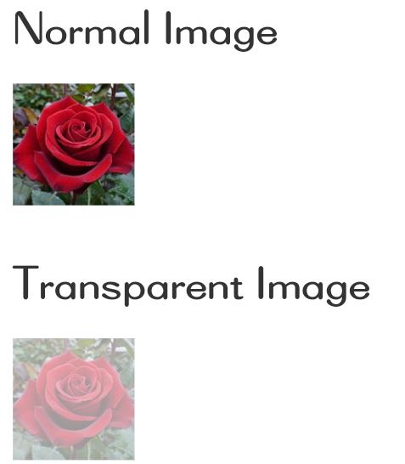
Note 1: Chrome, Firefox, Opera, Safari, and IE9 use the opacity property for transparency. The opacity value ranges from 0.1 to 1.0. Lower value produces the greater opacity.

Note 2: The older versions of IE use filter: alpha(opacity=x). Here x value varies from 0 to 100. Lower value produces the greater opacity.

CSS filter
CSS filters are used to set visual effects to text, images, and other aspects of a webpage. The CSS filter property allows us to access the effects such as color or blur, shifting on the rendering of an element before the element gets displayed.
The syntax of CSS filter property is given below.
Syntax
- filter: none | invert() | drop-shadow() | brightness() | saturate() | blur() | hue-rotate() | contrast() | opacity() | grayscale() | sepia() | url();
Let's discuss the property values along with an example.

brightness()
As its name implies, it is used to set the brightness of an element. If the brightness is 0%, then it represents completely black, whereas 100% brightness represents the original one. It can also accept values above 100% that provide brighter results.
We can understand it by using the following illustration.
Example
- <!DOCTYPE html>
- <html>

- <head>
- <title>CSS filter property</title>
- <style>
- body{
- text-align:center;
- }
- #img1 {
- filter: brightness(130%);
- }
- </style>
- </head>
- <body>
- <img src = "tiger.png" > <h2>Original Image </h2>
- <img src = "tiger.png" id = "img1"> <h2>brightness(130%)</h2>
- </body>

- </html>

blur()
It is used to apply the blur effect to the element. If the blur value is not specified, then the value 0 is used as a default value. The parameter in blur() property does not accept the percentage values. A larger value of it creates more blur.
Example
- <!DOCTYPE html>
- <html>

- <head>
- <title>CSS filter property</title>
- <style>
- body{
- text-align:center;
- }
- #img1 {
- filter: blur(2px);
- }
- </style>
- </head>
- <body>
- <img src = "tiger.png" > <h2>Original Image </h2>
- <img src = "tiger.png" id = "img1"> <h2>blur(2px)</h2>
- </body>

- </html>

invert()
It is used to invert the samples in the input image. Its 100% value represents completely inverted, and 0% values leave the unchanged input. Negative values are not allowed in it.
Example
- <!DOCTYPE html>
- <html>

- <head>
- <title>CSS filter property</title>
- <style>
- body{
- text-align:center;
- }
- #img1 {
- filter: invert(60);
- }
- </style>
- </head>
- <body>
- <img src = "tiger.png" > <h2>Original Image </h2>
- <img src = "tiger.png" id = "img1"> <h2>invert(60)</h2>
- </body>

- </html>

saturate()
It sets the saturation of an element. The 0% saturation represents the completely unsaturated element, whereas the 100% saturation represents the original one. The values greater than 100% are allowed that provides super-saturated results. We cannot use negative values with this property.
Example
- <!DOCTYPE html>
- <html>

- <head>
- <title>CSS filter property</title>
- <style>
- body{
- text-align:center;
- }
- #img1 {
- filter: saturate(40);
- }
- </style>
- </head>
- <body>
- <img src = "tiger.png" > <h2>Original Image </h2>
- <img src = "tiger.png" id = "img1"> <h2>saturate(40)</h2>
- </body>

- </html>

drop-shadow()
It applies the drop-shadow effect to the input image. The values it accepts are h-shadow, v-shadow, blur, spread, and color.
Example
- <!DOCTYPE html>
- <html>

- <head>
- <title>CSS filter property</title>
- <style>
- body{
- text-align:center;
- }
- #img1 {
- filter: drop-shadow(10px 20px 30px yellow);
- }
- </style>
- </head>
- <body>
- <img src = "tiger.png" > <h2>Original Image </h2>
- <img src = "tiger.png" id = "img1"> <h2> drop-shadow(10px 20px 30px yellow);</h2>
- </body>

- </html>

contrast()
It adjusts the contrast of the input. Its 0% value will create a completely black image, whereas the 100% values leave the unchanged input, i.e., represents the original one. Values greater than 100% are allowed that provides results with less contrast.
Example
- <!DOCTYPE html>
- <html>

- <head>
- <title>CSS filter property</title>
- <style>
- body{
- text-align:center;
- }
- #img1 {
- filter: contrast(50%);
- }
- </style>
- </head>
- <body>
- <img src = "tiger.png" > <h2>Original Image </h2>
- <img src = "tiger.png" id = "img1"> <h2> contrast(50%)</h2>
- </body>

- </html>

opacity()
It is used to apply transparency to the input image. Its 0% value indicates completely transparent, whereas the 100% value represents the original image, i.e., fully opaque.
Let's understand it by an illustration.
Example
- <!DOCTYPE html>
- <html>

- <head>
- <title>CSS filter property</title>
- <style>
- body{
- text-align:center;
- }
- #img1 {
- filter: opacity(40%);
- }
- </style>
- </head>
- <body>
- <img src = "tiger.png" > <h2>Original Image </h2>
- <img src = "tiger.png" id = "img1"> <h2> opacity(40%)</h2>
- </body>

- </html>

hue-rotate()
It applies a hue-rotation on the input image. Its perimeter value defines the number of degrees around the color circle; the image will be adjusted. Its default value is 0 degree, which represents the original image. Its maximum value is 360 degrees.
Let's understand it by an illustration.
Example
- <!DOCTYPE html>
- <html>

- <head>
- <title>CSS filter property</title>
- <style>
- body{
- text-align:center;
- }
- #img1 {
- filter: hue-rotate(240deg);
- }
- </style>
- </head>
- <body>
- <img src = "tiger.png" > <h2>Original Image </h2>
- <img src = "tiger.png" id = "img1"> <h2> hue-rotate(240deg)</h2>
- </body>

- </html>

grayscale()
It converts the input image into black and white. 0% grayscale represents the original one, whereas 100% represents completely grayscale. It converts the object colors into 256 shades of gray.
Example
- <!DOCTYPE html>
- <html>

- <head>
- <title>CSS filter property</title>
- <style>
- body{
- text-align:center;
- }
- #img1 {
- filter: grayscale(80%);
- }
- </style>
- </head>
- <body>
- <img src = "tiger.png" > <h2>Original Image </h2>
- <img src = "tiger.png" id = "img1"> <h2> grayscale(80%)</h2>
- </body>

- </html>

sepia()
It is used to transform the image into a sepia image. 0% value represents the original image, whereas the 100% value indicates the completely sepia.
Example
- <!DOCTYPE html>
- <html>

- <head>
- <title>CSS filter property</title>
- <style>
- body{
- text-align:center;
- }
- #img1 {
- filter: sepia(90%);
- }
- </style>
- </head>
- <body>
- <img src = "tiger.png" > <h2>Original Image </h2>
- <img src = "tiger.png" id = "img1"> <h2> sepia(90%)</h2>
- </body>

- </html>

CSS Images
Images are an important part of any web application. Including a lot of images in a web application is generally not recommended, but it is important to use the images wherever they required. CSS helps us to control the display of images in web applications.
The styling of an image in CSS is similar to the styling of an element by using the borders and margins. There are multiple CSS properties such as border property, height property, width property, etc. that helps us to style an image.
Let's discuss the styling of images in CSS by using some illustrations.

Thumbnail Image
The border property is used to make a thumbnail image.
Example
- <!DOCTYPE html>
- <html>
- <head>
- <style>
- img{
- border: 2px solid red;
- border-radius:5px;
- padding:10px;
- }
- h2{
- color:red;
- }
- </style>
- </head>

- <body>
- <h1>Thumbnail Image</h1>
- <img src="jtp.png"></img>
- <h2>Welcome to javaTpoint</h2>
- </body>
- </html>

Transparent image
To make an image transparent, we have to use the opacity property. The value of this property lies between 0.0 to 1.0, respectively.
Example
- <!DOCTYPE html>
- <html>
- <head>
- <style>
- img{
- border: 2px solid red;
- border-radius:5px;
- padding:10px;
- opacity:0.3;
- }
- h2{
- color:red;
- }
- </style>
- </head>

- <body>
- <h1>Transparent Image</h1>
- <img src="jtp.png"></img>
- <h2>Welcome to javaTpoint</h2>
- </body>
- </html>

Rounded image
The border-radius property sets the radius of the bordered image. It is used to create the rounded images. The possible values for the rounded corners are given as follows:
- border-radius: It sets all of the four border-radius property.
- border-top-right-radius: It sets the border of the top-right corner.
- border-top-left-radius: It sets the border of the top-left corner.
- border-bottom-right-radius: It sets the border of the bottom-right corner.
- border-bottom-left-radius: It sets the border of the bottom-left corner.
Example
- <!DOCTYPE html>
- <html>
- <head>
- <style>
- #img1{
- border: 2px solid green;
- border-radius:10px;
- padding:5px;
- }
- #img2{
- border: 2px solid green;
- border-radius:50%;
- padding:5px;
- }

- h2{
- color:red;
- }
- </style>
- </head>

- <body>
- <h1>Rounded Image</h1>
- <img src="jtp.png" id="img1"></img>
- <h2>Welcome to javaTpoint</h2>

- <h1>Circle Image</h1>
- <img src="jtp.png" id="img2"></img>
- <h2>Welcome to javaTpoint</h2>
- </body>
- </html>

Responsive Image
It automatically adjusts to fit on the screen size. It is used to adjust the image to the specified box automatically.
Example
- <!DOCTYPE html>
- <html>
- <head>
- <style>
- #img1{
- max-width:100%;
- height:auto;
- }
- h2{
- color:red;
- }
- </style>
- </head>

- <body>
- <h1>Responsive image</h1>
- <h2>You can resize the browser to see the effect</h2>
- <img src="jtp.png" id="img1" width="1000" height="300"></img>
- <h2>Welcome to javaTpoint</h2>
- </body>
- </html>

Center an Image
We can center an image by using the left-margin and right-margin property. We have to set these properties to auto in order to make a block element.
Example
- <!DOCTYPE html>
- <html>
- <head>
- <style>
- #img1{
- margin-left:auto;
- margin-right:auto;
- display:block;
- }
- h1,h2{
- text-align:center;
- }
- </style>
- </head>

- <body>
- <h1>Center image</h1>
- <img src="jtp.png" id="img1"></img>
- <h2>Welcome to javaTpoint</h2>
- </body>
- </html>

CSS Overflow
The CSS overflow property specifies how to handle the content when it overflows its block level container.
We know that every single element on a page is a rectangular box and the size, positioning and behavior of these boxes are controlled via CSS.
Let's take an example: If you don't set the height of the box, it will grow as large as the content. But if you set a specific height or width of the box and the content inside cannot fit then what will happen. The CSS overflow property is used to overcome this problem. It specifies whether to clip content, render scroll bars, or just display content.

CSS Overflow property values
Value | Description
visible | It specifies that overflow is not clipped. it renders outside the element's box.this is a default value.
hidden | It specifies that the overflow is clipped, and rest of the content will be invisible.
scroll | It specifies that the overflow is clipped, and a scroll bar is used to see the rest of the content.
auto | It specifies that if overflow is clipped, a scroll bar is needed to see the rest of the content.
inherit | It inherits the property from its parent element.
initial | It is used to set the property to its initial value.

CSS Overflow Example
Let's see a simple CSS overflow property.
- <!DOCTYPE html>
- <html>
- <head>
- <style>
- div.scroll {
- background-color: #00ffff;
- width: 100px;
- height: 100px;
- overflow: scroll;
- }

- div.hidden {
- background-color: #00FF00;
- width: 100px;
- height: 170px;
- overflow: hidden;
- }
- </style>
- </head>
- <body>
- <p>The overflow property specifies what to do if the content of an element exceeds the size of the element's box.</p>
- <p>overflow:scroll</p>
- <div class="scroll">You can use the overflow property when you want to have better control of the layout.
- The default value is visible.</div>
- <p>overflow:hidden</p>
- <div class="hidden">You can use the overflow property when you want to have better control of the layout.
- The default value is visible.</div>
- </body>
- </html>
Output:
The overflow property specifies what to do if the content of an element exceeds the size of the element's box.
overflow:scroll
You can use the overflow property when you want to have better control of the layout. The default value is visible.
overflow:hidden
You can use the overflow property when you want to have better control of the layout. The default value is visible.

