CSS Padding
CSS Padding property is used to define the space between the element content and the element border.
It is different from CSS margin in the way that CSS margin defines the space around elements. CSS padding is affected by the background colors. It clears an area around the content.
Top, bottom, left and right padding can be changed independently using separate properties. You can also change all properties at once by using shorthand padding property.

CSS Padding Properties
Property | Description
padding | It is used to set all the padding properties in one declaration.
padding-left | It is used to set left padding of an element.
padding-right | It is used to set right padding of an element.
padding-top | It is used to set top padding of an element.
padding-bottom | It is used to set bottom padding of an element.

CSS Padding Values
Value | Description
length | It is used to define fixed padding in pt, px, em etc.
% | It defines padding in % of containing element.

CSS Padding Example
- <!DOCTYPE html>
- <html>
- <head>
- <style>
- p {
- background-color: pink;
- }
- p.padding {
- padding-top: 50px;
- padding-right: 100px;
- padding-bottom: 150px;
- padding-left: 200px;
- }
- </style>
- </head>
- <body>
- <p>This is a paragraph with no specified padding.</p>
- <p class="padding">This is a paragraph with specified paddings.</p>
- </body>
- </html>
Output:
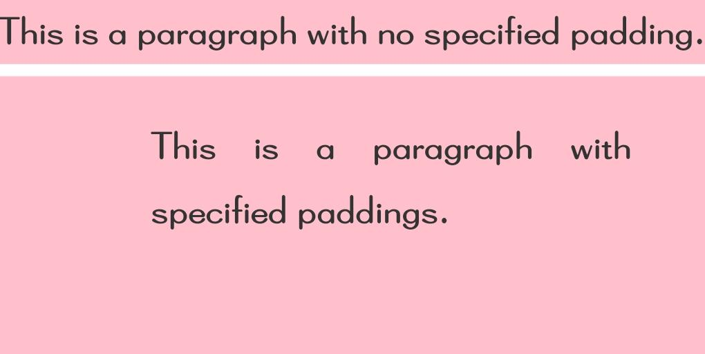

CSS Position
The CSS position property is used to set position for an element. it is also used to place an element behind another and also useful for scripted animation effect.
You can position an element using the top, bottom, left and right properties. These properties can be used only after position property is set first. A position element's computed position property is relative, absolute, fixed or sticky.
Let's have a look at following CSS positioning:
- CSS Static Positioning
- CSS Fixed Positioning
- CSS Relative Positioning
- CSS Absolute Positioning

1) CSS Static Positioning
This is a by default position for HTML elements. It always positions an element according to the normal flow of the page. It is not affected by the top, bottom, left and right properties.

2) CSS Fixed Positioning
The fixed positioning property helps to put the text fixed on the browser. This fixed test is positioned relative to the browser window, and doesn't move even you scroll the window.
- <!DOCTYPE html>
- <html>
- <head>
- <style>
- p.pos_fixed {
- position: fixed;
- top: 50px;
- right: 5px;
- color: blue;
- }
- </style>
- </head>
- <body>

- <p>Some text...</p><p>Some text...</p><p>Some text...</p><p>........</p><p>.... ...</p
- ><p>........</p><p>........</p><p>........</p><p>........</p>
- <p>........ </p><p>........</p><p>........</p><p>........</p><p>........</p>
- <p>........</p><p>........</p><p>Some text...</p><p>Some text...</p><p>Some text...</p>
- <p class="pos_fixed">This is the fix positioned text.</p>
- </body>
- </html>

3) CSS Relative Positioning
The relative positioning property is used to set the element relative to its normal position.
- <!DOCTYPE html>
- <html>
- <head>
- <style>
- h2.pos_left {
- position: relative;
- left: -30px;
- }
- h2.pos_right {
- position: relative;
- left: 30px;
- }
- </style>
- </head>
- <body>
- <h2>This is a heading with no position</h2>
- <h2 class="pos_left">This heading is positioned left according to its normal position</h2>
- <h2 class="pos_right">This heading is positioned right according to its normal position</h2>
- <p>The style "left:-30px" subtracts 30 pixels from the element's original left position.</p>
- <p>The style "left:30px" adds 30 pixels to the element's original left position.</p>
- </body>
- </html>

4) CSS Absolute Positioning
The absolute positioning is used to position an element relative to the first parent element that has a position other than static. If no such element is found, the containing block is HTML.
With the absolute positioning, you can place an element anywhere on a page.
- <!DOCTYPE html>
- <html>
- <head>
- <style>
- h2 {
- position: absolute;
- left: 150px;
- top: 250px;
- }
- </style>
- </head>
- <body>
- <h2>This heading has an absolute position</h2>
- <p> The heading below is placed 150px from the left and 250px from the top of the page.</p>
- </body>
- </html>

All CSS Position Properties
No. | property | description | values
1) | bottom | It is used to set the bottom margin edge for a positioned box. | auto, length, %, inherit
2) | clip | It is used to clip an absolutely positioned element. | shape, auto, inherit
3) | cursor | It is used to specify the type of cursors to be displayed. | url, auto, crosshair, default, pointer, move, e-resize, ne-resize, nw-resize, n-resize, se-resize, sw-resize, s-resize, w-resize, text, wait, help
4) | left | It sets a left margin edge for a positioned box. | auto, length, %, inherit
5) | overflow | This property is used to define what happens if content overflow an element's box. | auto, hidden, scroll, visible, inherit
6) | position | It is used to specify the type of positioning for an element. | absolute, fixed, relative, static, inherit
7) | right | It is used to set a right margin edge for a positioned box. | auto, length, %, inherit
8) | top | It is used to set a top margin edge for a positioned box. | auto, length, %, inherit
9) | z-index | It is used to set stack order of an element. | number, auto, inherit

CSS Vertical Align
The CSS vertical align property is used to define the vertical alignment of an inline or table-cell box. It is the one of the self-explanatory property of CSS. It is not very easy property for beginners.

What it does
- It is applied to inline or inline-block elements.
- It affects the alignment of the element, not its content. (except table cells)
- When it applied to the table cells, it affect the cell contents, not the cell itself.

CSS Vertical Align Values
value | description
baseline | It aligns the baseline of element with the baseline of parent element. This is a default value.
length | It is used to increase or decrease length of the element by the specified length. negative values are also allowed.
% | It is used to increase or decrease the element in a percent of the "line-height" property. negative values are allowed.
sub | It aligns the element as if it was subscript.
super | It aligns the element as if it was superscript.
top | It aligns the top of the element with the top of the tallest element on the line.
bottom | It aligns the bottom of the element with the lowest element on the line.
text-top | the top of the element is aligned with the top of the parent element's font.
middle | the element is placed in the middle of the parent element.
text-bottom | the bottom of the element is aligned with the bottom of the parent element's font.
initial | It sets this property to Its default value.
inherit | inherits this property from Its parent element.

CSS Vertical Align Example
- <!DOCTYPE html>
- <html>
- <head>
- <style>
- img.top {
- vertical-align: text-top;
- }
- img.bottom {
- vertical-align: text-bottom;
- }
- </style>
- </head>
- <body>
- <p><img src="good-morning.jpg" alt="Good Morning Friends"/> This is an image with a default alignment.</p>
- <p><img src="good-morning.jpg" class="top" alt="Good Morning Friends"/> This is an image with a text-top alignment.</p>
- <p><img src="good-morning.jpg" class="bottom" alt="Good Morning Friends"/> This is an image with a text-bottom alignment.</p>
- </body>
- </html>
Output
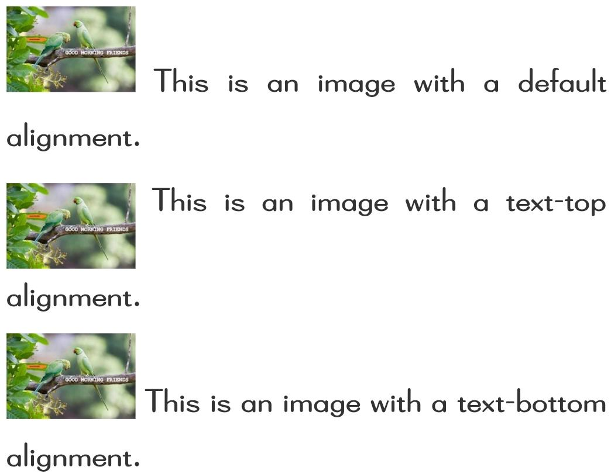

CSS White Space
The CSS white space property is used to specify how to display the content within an element. It is used to handle the white spaces inside an element.

CSS White Space values
There are many white space values that can be used to display the content inside an element.
Value | Description
normal | This is a default value. in this value, text is wrapped when necessary. sequences of white space will collapse into a single whitespace.
nowrap | Sequences of white space will collapse into a single whitespace. in this value, text will never wrap to the next line and only break when <br> tag is used.
pre | Whitespace is preserved by the browser. it is act like html <pre> tag. text will only wrap on line breaks.
pre-line | Sequences of white space will collapse into a single whitespace. texts are wrapped when necessary, and on line break.
pre-wrap | Whitespace is preserved by the browser. texts are wrapped when necessary, and on line break.
initial | It sets this property to its default value.
inherit | It inherits this property from its parent element.

CSS White Space Example
- <!DOCTYPE html>
- <html>
- <head>
- <style>
- p {
- white-space: nowrap;
- }
- </style>
- </head>
- <body>
- <p>
- Write some text..Write some text..Write some text..
- Write some text..Write some text..Write some text..
- Write some text..Write some text..Write some text..
- Write some text..Write some text..Write some text..
- Write some text..Write some text..Write some text..
- </p>
- </body>
- </html>

CSS Width
The CSS width property is used to set the width of the content area of an element.
It does not include padding borders or margins. It sets width of the area inside the padding, border, and margin of the element.

CSS width values
Value | Description
auto | It is a default value. it is used to calculate the width.
length | It is used to define the width in px, cm etc.
% | It defines the width of the containing block in %.
initial | It is used to set the property to its default value.
inherit | It is used to inherit the property from its parent element.

CSS Width Example: width in px
- <!DOCTYPE html>
- <html>
- <head>
- <style>
- img.normal {
- width: auto;
- }
- img.big {
- width: 150px;
- }
- p.ex {
- height: 150px;
- width: 150px;
- }
- </style>
- </head>
- <body>
- <img class="normal" src="good-morning.jpg" width="95" height="84"><br>
- <img class="big" src="good-morning.jpg" width="95" height="84">
- <p class="ex">The height and width of this paragraph is 150px.</p>
- <p>This is a paragraph.</p>
- </body>
- </html>
Output:

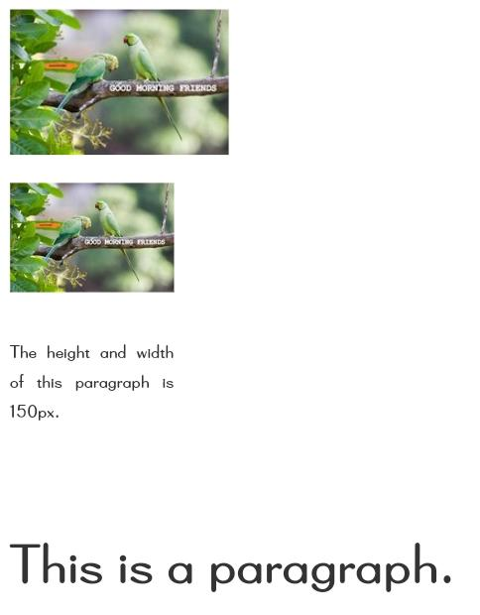
CSS Width Example: width in %
The percent width is a measurement unit for the containing block. It is great for images.
- <!DOCTYPE html>
- <html>
- <head>
- <style>
- img.normal {
- width: auto;
- }
- img.big {
- width: 50%;
- }
- img.small {
- width: 10%;
- }
- </style>
- </head>
- <body>
- <img class="normal" src="good-morning.jpg" width="95" height="84"><br>
- <img class="big" src="good-morning.jpg" width="95" height="84"><br>
- <img class="small" src="good-morning.jpg" width="95" height="84">
- </body>
- </html>
Output

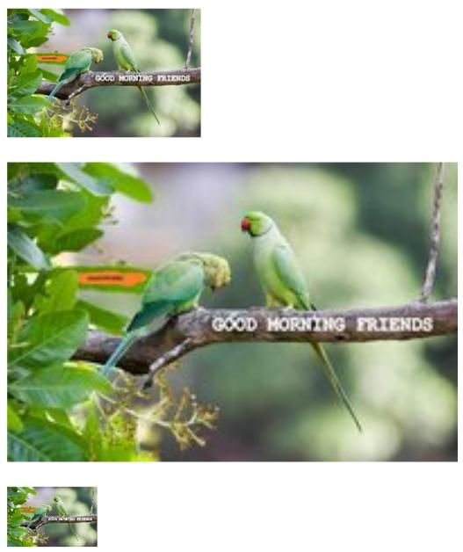
Note: You can also use the "min-width" and "max-width" property to control the size of image.

CSS height property
This CSS property sets the height of an element. It is used to set the height of content area of an element.
It does not include padding borders or margins, whereas it sets the height of the area inside the padding, border, and margin of the element. It can accept the length and percentage values. But it does not allow negative values.
If we set the height to a numeric value (like in px, %, etc.), the content can be overflow if it does not fit in the given height. We can manage the overflowing content by defining the overflow property.
If the height of the container is not explicitly defined, and the element is not absolutely positioned (i.e., position: absolute;), the value of height property is set to auto. The min-height and max-height properties can also be used to control the size.

Syntax
- height: auto | length | initial | inherit;

Property Values
The values of this property are tabulated as follows.
Value | Description
auto | It is a default value. Using this value browser is responsible for calculating the height of the element. Negative values are not allowed.
length | It specifies the height of an element using the length units such as px, cm, pt, etc. Negative values are not allowed.
% | It defines the height of the container in %. Negative values are not allowed.
initial | It is used to set the property to its default value.
inherit | It is used to inherit the property from its parent element.
Now, we will see some of the examples to understand this property more clearly.

Example
Here, we are using the keyword value auto and the length values of height property in px and em.
- <!DOCTYPE html>
- <html>
- <head>
- <style>
- #auto{
- height: auto;
- width: 275px;
- border: 2px solid blue;
- }
- #px{
- height: 320px;
- width: 275px;
- border: 2px solid blue;
- }
- #em{
- height: 16em;
- width: 275px;
- border: 2px solid blue;
- }
- p{
- font-size: 20px;
- }
- </style>
- </head>
- <body>
- <h2> height: auto; </h2>
- <div id ="auto">
- <img src="jtp.png">
- <p> Welcome to the javaTpoint.com </p>
- <p> The height this div element is set to auto. </p>
- </div>
- <h2> height: 320px; </h2>
- <div id ="px">
- <img src="jtp.png">
- <p> Welcome to the javaTpoint.com </p>
- <p> The height this div element is set to 320px. </p>
- </div><br>
- <h2> height: 16em; </h2>
- <div id ="em">
- <img src="jtp.png">
- <p> Welcome to the javaTpoint.com </p>
- <p> The height this div element is set to 16em. </p>
- </div>
- </body>
- </html>
Output
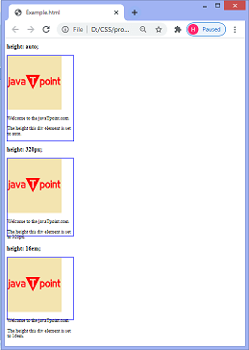

Example
Here, we are specifying the value of height property in percentage.
- <!DOCTYPE html>
- <html>
- <head>
- <style>
- #per{
- position: absolute;
- width: auto;
- height: 65%;
- border: 2px solid blue;
- }

- p{
- font-size: 20px;
- }

- </style>
- </head>
- <body>

- <h2> height: 65%; </h2>
- <div id ="per">
- <img src="jtp.png">
- <p> Welcome to the javaTpoint.com </p>
- <p> The height this div element is set to 65%. </p>
- </div>
- </body>
- </html>
Output
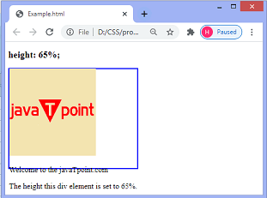

CSS Word Wrap
CSS word wrap property is used to break the long words and wrap onto the next line. This property is used to prevent overflow when an unbreakable string is too long to fit in the containing box.

CSS Word Wrap Values
Value | Description
normal | This property is used to break words only at allowed break points.
break-word | It is used to break unbreakable words.
initial | It is used to set this property to its default value.
inherit | It inherits this property from its parent element.

CSS Word Wrap Example
- <!DOCTYPE html>
- <html>
- <head>
- <style>
- p.test {
- width: 11em;
- background-color: #00ffff;
- border: 1px solid #000000;
- padding:10px;
- word-wrap: break-word;
- }
- </style>
- </head>
- <body>
- <p class="test"> In this paragraph, there is a very long word:
- iamsooooooooooooooooooooooooooooooolongggggggggggggggg.The long word will break and wrap to the next line.</p>
- </body>
- </html>
Output:
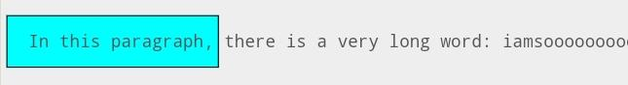

Box-shadow CSS
It is used to add shadow-like effects around the frame of an element.

Syntax
- box-shadow: h-offset v-offset blur spread color |inset|inherit|initial|none;
Let's understand property values.
h-offset: It horizontally sets the shadow position. Its positive value will set the shadow to the right side of the box. Its negative value is used to set the shadow on the left side of the box.
v-offset: Unlike the h-offset, it is used to set the shadow position vertically. The positive value in it sets the shadow below the box, and the negative value sets the shadow above of the box.
blur: As its name implies, it is used to blur the box-shadow. This attribute is optional.
spread: It sets the shadow size. The spread size depends upon the spread value.
color: As its name implies, this attribute is used to set the color of the shadow. It is an optional attribute.
inset: Normally, the shadow generates outside of the box, but by using inset, the shadow can be created within the box.
initial: It is used to set the property of the box-shadow to its default value.
inherit: it is inherited from its parent.
none: It is the default value that does not include any shadow property.
Let's understand the above attributes by using an illustration.

Example
- <!DOCTYPE html>
- <html>
- <head>
- <title>CSS box-shadow Property</title>

- <style>
- div
- {
- border: 1px solid;
- padding: 10px;
- }
- #hvb
- {
- /* box-shadow: h-offset v-offset blur */
- box-shadow: 5px 10px 10px;
- }
- #spr
- {
- /* box-shadow: h-offset v-offset blur spread */
- box-shadow: 5px 10px 10px 10px;
- }
- #col
- {
- /* box-shadow: h-offset v-offset blur spread color */
- box-shadow: 5px 10px 10px 10px orange;
- }
- #ins
- {
- /* box-shadow: h-offset v-offset blur spread color inset */
- box-shadow: 5px 10px 10px 10px orange inset;
- }
- #init
- {
- /* box-shadow: initial */
- box-shadow: initial;

- }
- #non
- {
- /* box-shadow: none */
- box-shadow: none;
- }
- </style>
- </head>

- <body>
- <div id = "hvb">
- <h1>It is a shadow box that has h-offset, v-offset and blur attributes.</h1>
- </div>
- <br><br>
- <div id = "spr">
- <h1>It is a box that includes the spread attribute.</h1>
- </div>
- <br><br>
- <div id = "col">
- <h1>It is a box that includes the color attribute.</h1>
- </div>
- <br><br>
- <div id = "ins">
- <h1>It is a box that includes the inset attribute.</h1>
- </div>
- <br><br>
- <div id = "init">
- <h1>It is a box that includes the initial attribute.</h1>
- </div>
- <br><br>
- <div id = "non">
- <h1>It is a box that includes the default attribute i.e. none.</h1>
- </div>
- </body>
- </html>
Output
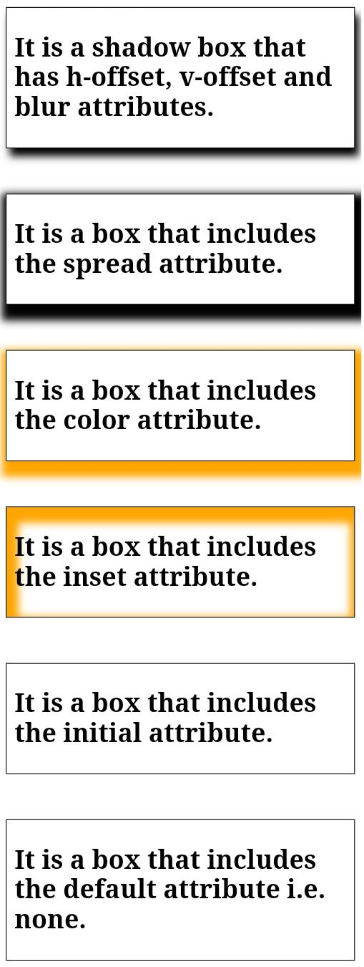

CSS Text-shadow
As its name implies, this CSS property adds shadows to the text. It accepts the comma-separated list of shadows that applied to the text. It's default property is none. It applies one or more than one text-shadow effect on the element's text content.
Let's see the syntax of text-shadow property.
Syntax
- text-shadow: h-shadow v-shadow blur-radius color| none | initial | inherit;
Values
h-shadow: It is the required value. It specifies the position of the horizontal shadow and allows negative values.
v-shadow: It is also the required value that specifies the position of the vertical shadow. It does not allow negative values.
blur-radius: It is the blur-radius, which is an optional value. Its default value is 0.
color: It is the color of the shadow and also an optional value.
none: It is the default value, which means no shadow.
initial: It is used to set the property to its default value.
inherit: It simply inherits the property from its parent element.
Let's understand it by using some illustrations.

Example- Simple shadow
- <!DOCTYPE html>

- <html>
- <head>
- <title> font-weight property </title>
- <style>
- p.simple{
- text-shadow: 3px 3px red;
- }
- </style>
- </head>

- <body>
- <p class="simple">
- Simple Shadow
- </p>

- </body>
- </html>
Output


Example- Fuzzy shadow
- <!DOCTYPE html>

- <html>
- <head>
- <title> font-weight property </title>
- <style>
- p.fuzzy{
- text-shadow: 3px 3px 3px violet;
- font-size:30px;
- text-align:center;
- }
- </style>
- </head>

- <body>
- <p class="fuzzy">
- Fuzzy Shadow
- </p>

- </body>
- </html>
Output

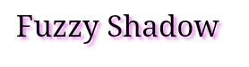
Example- Multiple Shadows
- <!DOCTYPE html>

- <html>
- <head>
- <title> font-weight property </title>
- <style>
- p.multi{
- text-shadow: -3px -3px 3px blue, 3px 3px 3px red;
- font-size:30px;
- text-align:center;
- }
- </style>
- </head>

- <body>
- <p class="multi">
- Multiple Shadows
- </p>

- </body>
- </html>
Output

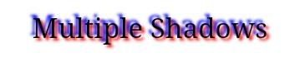
Example- Glow Effect
- <!DOCTYPE html>

- <html>
- <head>
- <title> font-weight property </title>
- <style>
- .multi{
- text-shadow: 0 0 .1em cyan;
- background-color: black;
- font-size:50px;
- text-align:center;
- }
- </style>
- </head>

- <body>
- <div class="multi">
- Glow Effect
- </div>

- </body>
- </html>
Output
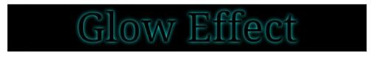

CSS text-transform
This CSS property allows us to change the case of the text. It is used to control the text capitalization. This CSS property can be used to make the appearance of text in all-lowercase or all-uppercase or can convert the first character of each word to uppercase.
Syntax
- text-transform: capitalize| uppercase | lowercase | none | initial | inherit;
Let's discuss its property values along with an example.

capitalize
It transforms the first character of each word to uppercase. It will not capitalize the first letter after the number. It only affects the first letters of the words instead of changing the rest of the letters in the word.
If we apply the capitalize property on a word that already has capital letters, then the letters of that word will not switch to lowercase.
The illustration of this property is given below.
Syntax
- text-transform: capitalize;
Example
- <!DOCTYPE html>
- <html>

- <head>
- <title>
- CSS text-transform Property
- </title>
- <style>
- body{
- text-align:center;
- }
- h1 {
- color: blue;
- }

- p{
- text-transform: capitalize;
- }
- </style>
- </head>

- <body>
- <center>
- <h1>CSS text-transform property</h1>

- <h2>text-transform: capitalize</h2>
- <p>hello world</p>
- <p>WELCOME to the javaTpoint</p>

- </body>

- </html>

uppercase
As its name implies, it transforms all characters of the word into uppercase.
Syntax
- text-transform: uppercase;
Example
- <!DOCTYPE html>
- <html>

- <head>
- <title>
- CSS text-transform Property
- </title>
- <style>
- body{
- text-align:center;
- }
- h1 {
- color: blue;
- }

- p{
- text-transform: uppercase;
- }
- </style>
- </head>

- <body>
- <center>
- <h1>CSS text-transform property</h1>

- <h2>text-transform: uppercase</h2>
- <p>hello world</p>
- <p>WELCOME to the javaTpoint</p>

- </body>

- </html>

lowercase
It transforms all characters of the word into lowercase.
Syntax
- text-transform: lowercase;
Example
- <!DOCTYPE html>
- <html>

- <head>
- <title>
- CSS text-transform Property
- </title>
- <style>
- body{
- text-align:center;
- }
- h1 {
- color: blue;
- }

- p{
- text-transform: lowercase;
- }
- </style>
- </head>

- <body>
- <center>
- <h1>CSS text-transform property</h1>

- <h2>text-transform: lowercase</h2>
- <p>HELLO WORLD</p>
- <p>WELCOME TO THE JAVATPOINT</p>

- </body>

- </html>

none
It is the default value that has no capitalization. It renders the text as it is.
Syntax
- text-transform: none;
Example
- <!DOCTYPE html>
- <html>

- <head>
- <title>
- CSS text-transform Property
- </title>
- <style>
- body{
- text-align:center;
- }
- h1 {
- color: blue;
- }

- p{
- text-transform: none;
- }
- </style>
- </head>

- <body>
- <center>
- <h1>CSS text-transform property</h1>

- <h2>text-transform: none</h2>
- <p>Hello World</p>
- <p>Welcome to the javaTpoint.</p>

- </body>

- </html>

CSS Outline
CSS outline is just like CSS border property. It facilitates you to draw an extra border around an element to get visual attention.
It is as easy as to apply as a border.
See this example:
- <!DOCTYPE html>
- <html>
- <style type="text/css">
- .box {
- background-color: #eee;
- outline: 3px solid red;
- border: 3px solid lightgreen;
- padding: 5px 10px;
- }
- </style>
- <div class="box">Welcome to JavaTpoint</div>
- </body>
- </html>
Output

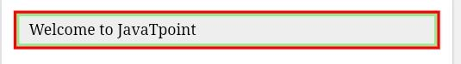
Difference between Border and Outline
At first glance, border and outline look similar, but there are some very important differences between them:
- It is not possible to apply a different outline width, style and color for the four sides of an element while in border; you can apply the provided value for all four sides of an element.
- The border is a part of element's dimension while the outline is not the part of element's dimension. Means, it doesn't matter how thick an outline you apply to the element, the dimensions of it won't change.
The outline property is a shorthand property. It can be divided into outline-width, outline-style and outline-color properties. It facilitates you to use any of the property alone, if you need it.
See this example:
- <!DOCTYPE html>
- <html>
- <style type="text/css">
- .box {
- background-color: #eee;
- border: 3px solid Lightgreen;
- padding: 5px 10px;
- outline-width: 3px;
- outline-style: solid;
- outline-color: red;
- }
- </style>
- <div class="box">Welcome to JavaTpoint</div>
- </body>
- </html>
Output
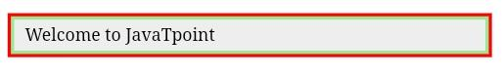
In the above example, you can see the three outline properties:
Outline-width:It is similar to margin and padding. It can be either an absolute value or a relative value or one of the predefined outline width values i.e. thin, medium or thick. It is preferred to use either an absolute value or a relative value because different browsers interpret differently while using predefined outline width values like thin, medium or thick.
Outline-color:It specifies the color that you use for the outline. It supports all the colors available in HTML and CSS.
Outline-style:In the above example, we have used only solid outline style while there are a lot of outline style i.e. hidden, dotted, dashed, solid, double, groove, ridge, inset and outset.
Let's take an example to demonstrate the usage of different outline-styles.
See this example:
- <!DOCTYPE html>
- <html>
- <style type="text/css">
- .box {
- outline-color: red;
- outline-width: 4px;
- margin: 10px;
- float: left;
- border: 2px solid lightgreen;
- padding: 5px 10px;
- }
- </style>
- <div class="box" style="outline-style: dashed;">This is dashed outline.</div>
- <div class="box" style="outline-style: dotted;">This is dotted outline.</div>
- <div class="box" style="outline-style: double;">This is double outline.</div>
- <div class="box" style="outline-style: groove;">This is groove outline.</div>
- <div class="box" style="outline-style: inset;">This is inset outline.</div>
- <div class="box" style="outline-style: outset;">This is outset outline.</div>
- <div class="box" style="outline-style: ridge;">This is ridge outline.</div>
- <div class="box" style="outline-style: solid;">This is solid outline.</div>
- </body>
- </html>
Output

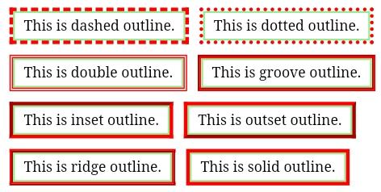
Outline offset
The outline offset is used to create a distance between outline and border.
It takes a CSS length unit and the empty space between the border and the outline will be transparent and then it takes the background color of the parent element. So you can see a visible difference between outline and border.
Let's take an example to see the difference between outline and border.
See this example:
- <!DOCTYPE html>
- <html>
- <style type="text/css">
- .box {
- background-color: #eee;
- outline: 3px solid red;
- outline-offset: 6px;
- border: 3px solid Lightgreen;
- padding: 5px 10px;
- }
- </style>
- <div class="box">Welcome to JavaTpoint</div>
- </body>
- </html>
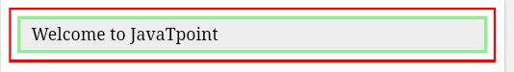
Output

CSS Visibility
The CSS visibility property is used to specify whether an element is visible or not.
Note: An invisible element also take up the space on the page. By using display property you can create invisible elements that don't take up space.
Syntax:
- visibility: visible|hidden|collapse|initial|inherit;

CSS Visibility Parameters
visible:It is the by default value. It specifies that the element is visible.
hidden:It specifies that the element is invisible (but still takes up space).
collapse:It is used only for table elements. It is used to remove a row or column, but it does not affect the table layout.
The space taken up by the row or column will be available for other content.
If collapse is used on other elements, it renders as "hidden"
initial:It is used to set this property to its default value.
inherit:It is used to inherit this property from its parent element.

CSS Visibility Example
- <!DOCTYPE html>
- <html>
- <head>
- <style>
- h1.visible {
- visibility: visible
- }
- h1.hidden {
- visibility: hidden
- }
- </style>
- </head>
- <body>
- <h1 class="visible">I am visible</h1>
- <h1 class="hidden">I am invisible</h1>
- <p><strong>Note:</strong> An invisible element also take up the space on the page.
- By using display property you can create invisible elements that don't
- take space.</p>
- </body>
- </html>

JavaScript Syntax:
- object.style.visibility="hidden"
See the JavaScript example:
- <!DOCTYPE html>
- <html>
- <head>
- <style>
- #myDIV {
- margin: auto;
- width: 400px;
- height: 200px;
- background-color: lightpink;
- border: 1px solid black;
- }
- </style>
- </head>
- <body>
- <p>Click the "Try it" button to set the visibility property and hide the div element.</p>
- <button onclick="myFunction()">Try it</button>
- <div id="myDIV">This is my DIV element.</div>
- <p><strong>Note:</strong> An invisible element also take up the space on the page. </p>
- <script>
- function myFunction() {
- document.getElementById("myDIV").style.visibility = "hidden";
- }
- </script>
- </body>
- </html>

CSS Counters
CSS counters are similar to variables. These are maintained by CSS and those values can be incremented by CSS rules to track how many times they are used.
CSS counters facilitate simple CSS based incrementing and display of a number for generated content.

CSS Counter Properties
Following is a list of properties that are used with CSS counter:
- counter-reset: It is used to create or reset a counter.
- counter-increment: It is used to increment the counter value.
- content: It is used to insert generated content.
- counter() or counters() function: It is used to add the value of a counter to an element.

Note: Before using a CSS counter, it must be created with counter-reset.

CSS Counter Example
Let's take an example to create a counter for a page and increment the counter value for each next element.
See this example:
- <!DOCTYPE html>
- <html>
- <head>
- <style>
- body {
- counter-reset: section;
- }
- h2::before {
- counter-increment: section;
- content: "Section " counter(section) ": ";
- }
- </style>
- </head>
- <body>
- <h1>Example of CSS Counters:</h1>
- <h2>Java Tutorial</h2>
- <h2>HTML Tutorial</h2>
- <h2>CSS Tutorial</h2>
- <h2>Oracle Tutorial</h2>
- <p><strong>Note:</strong> IE8 supports these properties only if a !DOCTYPE is specified.</p>
- </body>
- </html>
Output

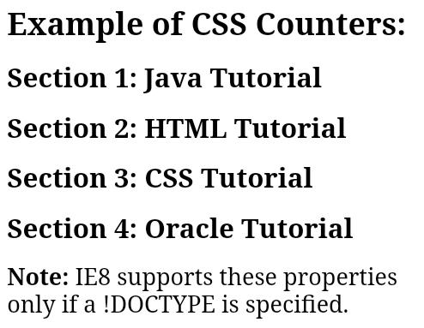
Note: In the above example you can see that a counter is created for the page in the body selector and it increments the counter value for each <h2> element and adds "Section <value of the counter>:" to the beginning of each <h2> element.

CSS Nesting Counters
You can also create counters within the counter. It is called nesting of a counter. Let's take an example to demonstrate nesting counter.
See this example:
- <!DOCTYPE html>
- <html>
- <head>
- <style>
- body {
- counter-reset: section;
- }
- h1 {
- counter-reset: subsection;
- }
- h1::before {
- counter-increment: section;
- content: "Section " counter(section) ". ";
- }
- h2::before {
- counter-increment: subsection;
- content: counter(section) "." counter(subsection) " ";
- }
- </style>
- </head>
- <body>
- <h1>Java tutorials:</h1>
- <h2>Core Java tutorial</h2>
- <h2>Servlet tutorial</h2>
- <h2>JSP tutorial</h2>
- <h2>Spring tutorial</h2>
- <h2>Hibernate tutorial</h2>

- <h1>Web technology tutorials:</h1>
- <h2>HTML tutorial</h2>
- <h2>CSS tutorial</h2>
- <h2>jQuery tutorial</h2>
- <h2>Bootstrap tutorial</h2>

- <h1>Database tutorials:</h1>
- <h2>SQL tutorial</h2>
- <h2>MySQL tutorial</h2>
- <h2>PL/SQL tutorial</h2>
- <h2>Oracle tutorial</h2>
- <p><strong>Note:</strong> IE8 supports these properties only if a !DOCTYPE is specified.</p>
- </body>
- </html>
Output

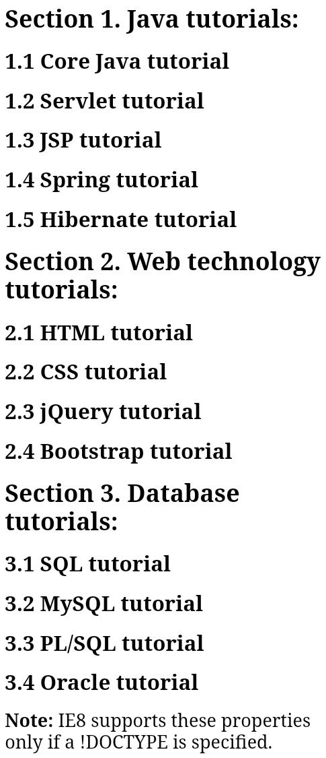
Note: In the above example you can see that a counter is created for the section and another nesting counter named subsection is created within section.

Different level of nesting counters
You can create outlined lists by using nesting counters. It facilitates you to insert a string between different levels of nested counters.
See this example:
- <!DOCTYPE html>
- <html>
- <head>
- <style>
- ol {
- counter-reset: section;
- list-style-type: none;
- }

- li::before {
- counter-increment: section;
- content: counters(section,".") " ";
- }
- </style>
- </head>
- <body>
- <h2>Different level of Nesting counters</h2>
- <ol>
- <li>item</li>
- <li>item
- <ol>
- <li>item</li>
- <li>item</li>
- <li>item
- <ol>
- <li>item</li>
- <li>item</li>
- <li>item</li>
- </ol>
- </li>
- <li>item</li>
- </ol>
- </li>
- <li>item</li>
- <li>item</li>
- </ol>
- <p><b>Note:</b> IE8 supports these properties only if a !DOCTYPE is specified.</p>
- </body>
- </html>
Output
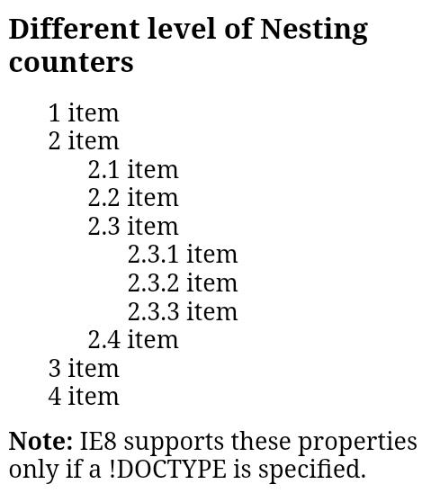

CSS clearfix
A clear float (or clearfix) is a way for an element to fix or clear the child elements so that we do not require to add additional markup. It resolves the error which occurs when more than one floated elements are stacked next to each other.
Suppose if we set the position of a sidebar to the left of the main content block, but we get the elements collapse and overlap on each other. We can understand it as if a child element is floated and taller than its parent element; it will overflow outside of its container.
To overcome this, we can use the overflow: auto; property to the containing element.
Let us try to understand it by using an example.

Example
In this example, the image is floated and taller than the element containing it, so that it overflows outside of its container.
Now, we are creating a class jtp and add the overflow: auto; property to the corresponding element.
- <!DOCTYPE html>
- <html>
- <head>
- <style>
- div {
- border: 3px solid red;
- padding: 5px;
- background-color:pink;
- font-size:20px;
- }

- img{
- float: right;
- border: 3px solid blue;

- }
- p{
- font-size:20px;
- clear:right;
- }
- .jtp{
- overflow: auto;
- }
- </style>
- </head>
- <body>

- <h1>Without Clearfix</h1>
- <div>
- <img class="img1" src="jtp.png">
- Welcome to the javaTpoint.com. Here, you can find the best tutorials that are easy to read and help you to clear your concepts.
- </div>
- <p>Use the overflow:auto; CSS property</p>
- <h1>With Clearfix</h1>
- <div class="jtp">
- <img class="img2" src="jtp.png">
- Welcome to the javaTpoint.com. Here, you can find the best tutorials that are easy to read and help you to clear your concepts.
- </div>

- </body>
- </html>
The above clearfix method works well as long as we manage the paddings and margins. But a modern way to clearfix is safer to use.
Let's see another method of clearfix.

Example
In this example, we set the clear property to 'both', which stands that the floating elements will not allow on both the left and right sides. We set the display property to 'table', which makes the element behave like <table> element of HTML. And we also have to leave the content empty.
- <!DOCTYPE html>
- <html>
- <head>
- <style>
- div {
- border: 3px solid red;
- padding: 5px;
- background-color:pink;
- font-size:20px;
- }

- img{
- float: right;
- border: 3px solid blue;
- }
- p{
- font-size:20px;
- clear:right;
- }
- .jtp:after{
- content:'.';
- clear:both;
- display: table;
- }
- </style>
- </head>
- <body>

- <h1>Without Clearfix</h1>
- <div>
- <img src="jtp.png">
- Welcome to the javaTpoint.com. Here, you can find the best tutorials that are easy to read and help you to clear your concepts.
- </div>
- <p>Another clearfix method</p>
- <h1>With Clearfix</h1>
- <div class="jtp">
- <img src="jtp.png">
- Welcome to the javaTpoint.com. Here, you can find the best tutorials that are easy to read and help you to clear your concepts.
- </div>

- </body>
- </html>

CSS icons
Icons can be defined as the images or symbols used in any computer interface refer to an element. It is a graphical representation of a file or program that helps the user to identify about the type of file quickly.
Using the icon library is the easiest way to add icons to our HTML page. It is possible to format the library icons by using CSS. We can customize the icons according to their color, shadow, size, etc.
There are given some of the icon libraries such as Bootstrap icons, Font Awesome icons, and Google icons that can be used in CSS easily. There is no need to install or download the libraries mentioned above.
Let's discuss the above-mentioned libraries of icons.

Font Awesome icons
To use this library in our HTML page, we need to add the following link within the <head></head> section.
- <link rel="stylesheet" href="https://cdnjs.cloudflare.com/ajax/libs/font-awesome/4.7.0/css/font-awesome.min.css">
Let's understand it with an illustration.

Example
- <!DOCTYPE html>
- <html>

- <head>
- <title>CSS Icons</title>
- <link rel="stylesheet" href="https://cdnjs.cloudflare.com/ajax/libs/font-awesome/4.7.0/css/font-awesome.min.css">
- <style>
- body{
- text-align:center;
- background-color:lightblue;
- }
- .fa{
- color:red;
- font-size:50px;
- margin:10px;
- }
- </style>
- </head>
- <body style="text-align:center">
- <h1>Font Awesome Library</h1>
- <i class="fa fa-cloud"></i>
- <i class="fa fa-file"></i>
- <i class="fa fa-heart"></i>
- <i class="fa fa-bars"></i>
- <i class="fa fa-car"</i>
- </body>
- </html>
Output

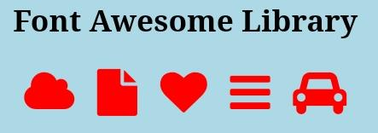
Bootstrap icons
As similar to the font awesome library, we can add the bootstrap icons in our HTML page using the link given below in the <head></head> section.
- <link rel="stylesheet"
- href="https://maxcdn.bootstrapcdn.com/bootstrap/3.3.7/css/bootstrap.min.css">

Example
- <!DOCTYPE html>
- <html>

- <head>
- <title>CSS Icons</title>
- <link rel="stylesheet"
- href="https://maxcdn.bootstrapcdn.com/bootstrap/3.3.7/css/bootstrap.min.css">
- <style>
- body{
- text-align:center;
- background-color:lightblue;
- }
- .glyphicon{
- color:red;
- font-size:50px;
- margin:10px;
- }
- </style>
- </head>
- <body style="text-align:center">
- <h1>Bootstrap icons</h1>
- <i class="glyphicon glyphicon-cloud"></i>
- <i class="glyphicon glyphicon-file"></i>
- <i class="glyphicon glyphicon-heart"></i>
- <i class="glyphicon glyphicon-user"></i>
- <i class="glyphicon glyphicon-thumbs-up"></i>
- <i class="glyphicon glyphicon-remove"></i>
- <i class="glyphicon glyphicon-envelope"></i>
- </body>
- </html>
Output

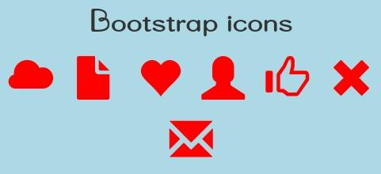
Google icons
As similar to the above libraries, we can add it in our HTML page simply by adding the link given below in the <head></head> section.

Example
- <link rel="stylesheet" href="https://fonts.googleapis.com/icon?family=Material+Icons">

Example
- <!DOCTYPE html>
- <html>

- <head>
- <title>CSS Icons</title>
- <link rel="stylesheet" href="https://fonts.googleapis.com/icon?family=Material+Icons">
- <style>
- body{
- text-align:center;
- background-color:lightblue;
- }
- .material-icons{
- color:red;
- font-size:50px;
- margin:10px;
- }
- </style>
- </head>
- <body style="text-align:center">
- <h1>Google icons</h1>
- <i class="material-icons">cloud</i>
- <i class="material-icons">attachment</i>
- <i class="material-icons">computer</i>
- <i class="material-icons">favorite</i>
- <i class="material-icons">traffic</i>
- </body>
- </html>
Output
