CSS justify-content
This CSS property is used to align the items of the flexible box container when the items do not use all available space on the main-axis (horizontally). It defines how the browser distributes the space around and between the content items.
This CSS property can't be used to describe containers or items along the vertical axis. To align the items vertically, we have to use the align-items property.

Syntax
- justify-content: center | flex-start | flex-end | space-around | space-evenly | space-between | initial | inherit;
The default value of this property is flex-start. Let's understand its property values in detail.

Property values
- center: As its name implies, it set the position of items at the center of the container.
- flex-start: It is the default value that positioned the items at the beginning of the container.
- flex-end: It set the position of items at the end of the container.
- space-around: It positioned the items with equal spacing from each other. It evenly distributes the items in the line along with the same space around them.
- space-between: Items are evenly spaced in which the first item is at the beginning, and the last item is at the end.
- space-evenly: It also positioned the items with equal space, but the spacing from the corners differs.
Let's understand the above values by using an illustration.

Example
- <!DOCTYPE html>
- <html>

- <head>
- <title>CSS filter property</title>
- <style>

- #flexstart{
- display:flex;
- justify-content: flex-start;
- }
- #flexend{
- display:flex;
- justify-content: flex-end;
- }

- #cent{
- display:flex;
- justify-content: center;
- }
- #evenly{
- display:flex;
- justify-content: space-evenly;
- }
- #around{
- display:flex;
- justify-content: space-around;
- }
- #between{
- display:flex;
- justify-content: space-between;
- }
- .flex-item{
- width:50px;
- height:50px;
- margin:5px;
- padding:5px;
- color:white;
- font-size:2em;
- font-weight:bold;
- text-align:center;
- border: 1px solid black;
- background-color:blue;
- }
- </style>
- </head>
- <body>
- <div id="flexstart">
- <h1>flex-start</h1>
- <div class="flex-item">1</div>
- <div class="flex-item">2</div>
- <div class="flex-item">3</div>
- <div class="flex-item">4</div>
- <div class="flex-item">5</div>
- </div>
- <div id="flexend">
- <h1>flex-end</h1>
- <div class="flex-item">1</div>
- <div class="flex-item">2</div>
- <div class="flex-item">3</div>
- <div class="flex-item">4</div>
- <div class="flex-item">5</div>
- </div>

- <div id="cent">
- <h1>center</h1>
- <div class="flex-item">1</div>
- <div class="flex-item">2</div>
- <div class="flex-item">3</div>
- <div class="flex-item">4</div>
- <div class="flex-item">5</div>
- </div>
- <h1>space-evenly</h1>
- <div id="evenly">
- <div class="flex-item">1</div>
- <div class="flex-item">2</div>
- <div class="flex-item">3</div>
- <div class="flex-item">4</div>
- <div class="flex-item">5</div>
- </div>
- <h1>space-around</h1>
- <div id="around">
- <div class="flex-item">1</div>
- <div class="flex-item">2</div>
- <div class="flex-item">3</div>
- <div class="flex-item">4</div>
- <div class="flex-item">5</div>
- </div>
- <h1>space-between</h1>
- <div id="between">
- <div class="flex-item">1</div>
- <div class="flex-item">2</div>
- <div class="flex-item">3</div>
- <div class="flex-item">4</div>
- <div class="flex-item">5</div>
- </div>

- </body>
- </html>
Output
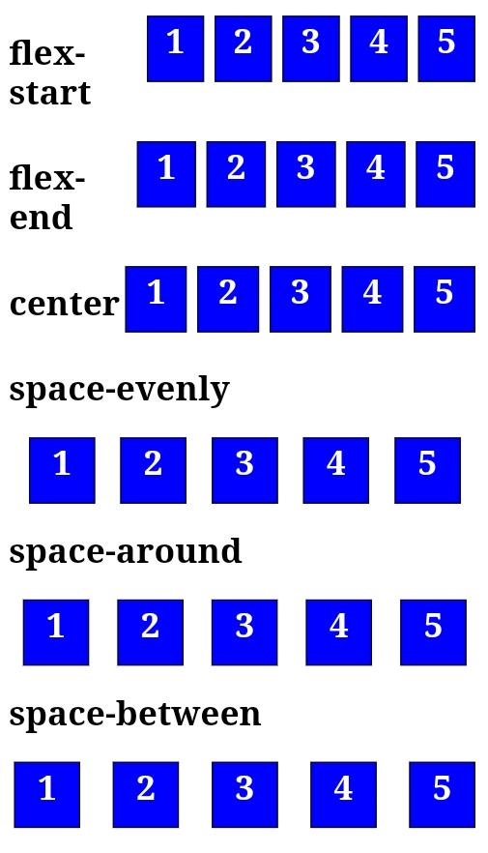

CSS text-decoration
It is a CSS property that decorates the content of the text. It adds lines under, above, and through the text. It sets the appearance of decorative lines on text. This CSS property decorates the text with several kinds of lines. This is shorthand for text-decoration-line, text-decoration-color, and text-decoration-style.
The syntax of this CSS property is given as follows-

Syntax
- text-decoration: text-decoration-line text-decoration-color text-decoration-style|initial|inherit;
Let's discuss its property values along with an example.

text-decoration-line
It sets the kind of text-decoration like overline, underline, or line-through. It can be used to add a combination of lines to the selected text.

Example
In this example, we are going to use the values underline, overline, and line-through. We will also see how to use these values simultaneously.
- <!DOCTYPE html>
- <html>
- <head>
- <title>text-decoration</title>
- <style>
- h1 {
- color: red;
- }
- h2{
- color: blue;
- }
- body {
- text-align: center;
- }
- p{
- font-size: 30px;
- }
- #p1 {
- text-decoration: underline;
- }
- #p2 {
- text-decoration: line-through;
- }
- #p3 {
- text-decoration: overline;
- }
- #p4 {
- text-decoration: overline underline line-through;
- }
- </style>
- </head>

- <body>
- <h1>Welcome to the javaTpoint.com</h1>
- <h2>text-decoration: text-decoration-line;</h2>
- <div>
- <p id="p1">This is underline</p>
- <p id="p2">This is line-through</p>
- <p id="p3">This is overline</p>
- <p id="p4">This is the combination of lines</p>
- </div>
- </body>
- </html>
Output

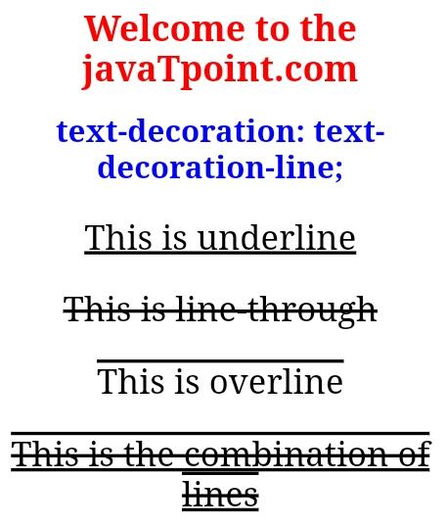
text-decoration-style
This property is used to set the style of the line. Its values are solid, dotted, wavy, double, and dashed.
The following example explains this property more clearly.

Example
- <!DOCTYPE html>
- <html>
- <head>
- <title>text-decoration</title>
- <style>
- h1 {
- color: red;
- }
- h2{
- color: blue;
- }
- body {
- text-align: center;
- }
- p{
- font-size: 30px;
- }
- #p1 {
- text-decoration: underline double;
- }
- #p2 {
- text-decoration: line-through dashed;
- }
- #p3 {
- text-decoration: dotted overline;
- }
- #p4 {
- text-decoration: lightblue wavy overline underline line-through;
- color:red;
- }
- </style>
- </head>

- <body>
- <h1>Welcome to the javaTpoint.com</h1>
- <h2>text-decoration: text-decoration-line text-decoration-style;</h2>
- <div>
- <p id="p1">This is double underline</p>
- <p id="p2">This is dashed line-through</p>
- <p id="p3">This is dotted overline</p>
- <p id="p4">This is the wavy combination of lines</p>
- </div>
- </body>

- </html>
Output

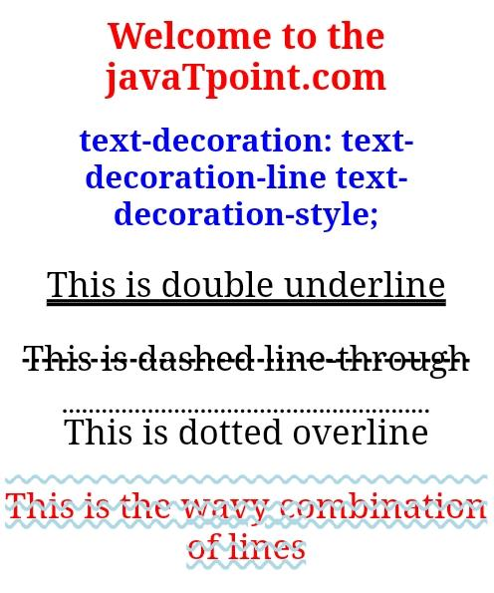
text-decoration-color
This property is used to provide color to the decoration. Its value is any color in a valid format.

Example
- <!DOCTYPE html>
- <html>
- <head>
- <title>text-decoration</title>
- <style>
- h1 {
- color: red;
- }
- h2{
- color: blue;
- }
- body {
- text-align: center;
- }
- p{
- font-size: 30px;
- }
- #p1 {
- text-decoration: underline double cyan;
- }
- #p2 {
- text-decoration: line-through dashed green;
- }
- #p3 {
- text-decoration: dotted overline blue;
- }
- #p4 {
- text-decoration: lightblue wavy overline underline line-through;
- color:red;
- }
- </style>
- </head>

- <body>
- <h1>Welcome to the javaTpoint.com</h1>
- <h2>text-decoration: text-decoration-line text-decoration-style;</h2>
- <div>
- <p id="p1">This is double underline</p>
- <p id="p2">This is dashed line-through</p>
- <p id="p3">This is dotted overline</p>
- <p id="p4">This is the wavy combination of lines</p>
- </div>
- </body>

- </html>
Output
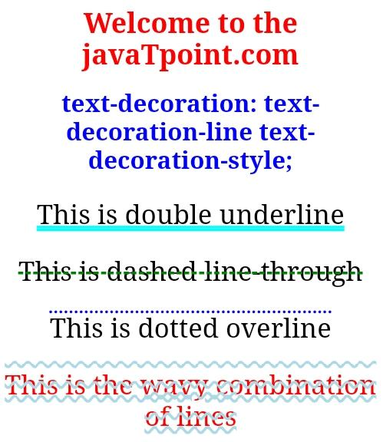

CSS Lists
There are various CSS properties that can be used to control lists. Lists can be classified as ordered lists and unordered lists. In ordered lists, marking of the list items is with alphabet and numbers, whereas in unordered lists, the list items are marked using bullets.
We can style the lists using CSS. CSS list properties allow us to:
- Set the distance between the text and the marker in the list.
- Specify an image for the marker instead of using the number or bullet point.
- Control the marker appearance and shape.
- Place the marker outside or inside the box that contains the list items.
- Set the background colors to list items and lists.
The CSS properties to style the lists are given as follows:
- list-style-type: This property is responsible for controlling the appearance and shape of the marker.
- list-style-image: It sets an image for the marker instead of the number or a bullet point.
- list-style-position: It specifies the position of the marker.
- list-style: It is the shorthand property of the above properties.
- marker-offset: It is used to specify the distance between the text and the marker. It is unsupported in IE6 or Netscape 7.
Let's understand the above properties in detail, along with an example of each.

The list-style-type property
It allows us to change the default list type of marker to any other type such as square, circle, roman numerals, Latin letters, and many more. By default, the ordered list items are numbered with Arabic numerals (1, 2, 3, etc.), and the items in an unordered list are marked with round bullets (•).
If we set its value to none, it will remove the markers/bullets.

Note: The list also includes the default padding and margin. To remove this, we need to add padding:0 and margin:0 to <ol> and <ul>.
The illustration of using this property is given as follows:

Example
- <!DOCTYPE html>
- <html>
- <head>
- <title>CSS Lists</title>
- <style>
- .num{
- list-style-type:decimal;
- }
- .alpha{
- list-style-type:lower-alpha;
- }
- .roman{
- list-style-type:lower-roman;
- }
- .circle{
- list-style-type:circle;
- }
- .square{
- list-style-type:square;
- }
- .disc{
- list-style-type:disc;
- }
- </style>
- </head>
- <body>
- <h1>
- Welcome to the javaTpoint.com
- </h1>
- <h2>
- Ordered Lists
- </h2>
- <ol class="num">
- <li>one</li>
- <li>two</li>
- <li>three</li>
- </ol>
- <ol class="alpha">
- <li>one</li>
- <li>two</li>
- <li>three</li>
- </ol>
- <ol class="roman">
- <li>one</li>
- <li>two</li>
- <li>three</li>
- </ol>
- <h2>
- Unordered lists
- </h2>
- <ul class="disc">
- <li>one</li>
- <li>two</li>
- <li>three</li>
- </ul>
- <ul class="circle">
- <li>one</li>
- <li>two</li>
- <li>three</li>
- </ul>
- <ul class="square">
- <li>one</li>
- <li>two</li>
- <li>three</li>
- </ul>

- </body>
- </html>

The list-style-position property
It represents whether the appearing of the marker is inside or outside of the box containing the bullet points. It includes two values.
inside: It means that the bullet points will be in the list item. In this, if the text goes on the second line, then the text will be wrap under the marker.
outside: It represents that the bullet points will be outside the list item. It is the default value.
The following example explains it more clearly.

Example
- <!DOCTYPE html>
- <html>
- <head>
- <title>CSS Lists</title>
- <style>
- .num{
- list-style-type:decimal;
- list-style-position:inside;
- }
- .roman{
- list-style-type:lower-roman;
- list-style-position:outside;
- }
- .circle{
- list-style-type:circle;
- list-style-position:inside;
- }
- .square{
- list-style-type:square;
- }
- .disc{
- list-style-type:disc;
- list-style-position:inside;
- }
- </style>
- </head>
- <body>
- <h1>
- Welcome to the javaTpoint.com
- </h1>
- <h2>
- Ordered Lists
- </h2>
- <ol class="num">
- <li>INSIDE</li>
- <li>two</li>
- <li>three</li>
- </ol>
- <ol class="roman">
- <li>OUTSIDE</li>
- <li>two</li>
- <li>three</li>
- </ol>
- <h2>
- Unordered lists
- </h2>
- <ul class="disc">
- <li>INSIDE</li>
- <li>two</li>
- <li>three</li>
- </ul>
- <ul class="circle">
- <li>INSIDE</li>
- <li>two</li>
- <li>three</li>
- </ul>
- <ul class="square">
- <li>DEFAULT</li>
- <li>two</li>
- <li>three</li>
- </ul>

- </body>
- </html>

The list-style-image property
It specifies an image as the marker. Using this property, we can set the image bullets. Its syntax is similar to the background-image property. If it does not find the corresponding image, the default bullets will be used.

Example
- <!DOCTYPE html>
- <html>
- <head>
- <title>CSS Lists</title>
- <style>
- .order{
- list-style-image: url(img.png);
- }
- .unorder{
- list-style-image: url(img.png);
- }

- </style>
- </head>
- <body>
- <h1>
- Welcome to the javaTpoint.com
- </h1>
- <h2>
- Ordered Lists
- </h2>
- <ol class="order">
- <li>one</li>
- <li>two</li>
- <li>three</li>
- </ol>
- <h2>
- Unordered lists
- </h2>
- <ul class="unorder">
- <li>one</li>
- <li>two</li>
- <li>three</li>
- </ul>

- </body>
- </html>

The list-style property
It is the shorthand property that is used to set all list properties in one expression. The order of the values of this property is type, position, and image. But if any property value is missing, then the default value will be inserted.

Example
- <!DOCTYPE html>
- <html>
- <head>
- <title>CSS Lists</title>
- <style>
- .order{
- list-style: lower-alpha inside url(img.png);
- }
- .unorder{
- list-style: disc outside;
- }

- </style>
- </head>
- <body>
- <h1>
- Welcome to the javaTpoint.com
- </h1>
- <h2>
- Ordered Lists
- </h2>
- <ol class="order">
- <li>one</li>
- <li>two</li>
- <li>three</li>
- </ol>
- <h2>
- Unordered lists
- </h2>
- <ul class="unorder">
- <li>one</li>
- <li>two</li>
- <li>three</li>
- </ul>

- </body>
- </html>

Styling Lists with colors
To make the lists more attractive and interesting, we can style lists with colors. The addition of anything to the <ul> or <ol> tag will affect the entire list, whereas the addition to the individual <li> tag will affect the items of the corresponding list.

Example
- <!DOCTYPE html>
- <html>
- <head>
- <title>CSS Lists</title>
- <style>
- .order{
- list-style: upper-alpha;
- background: pink;
- padding:20px;
- }
- .order li{
- background: lightblue;
- padding:10px;
- font-size:20px;
- margin:10px;
- }
- .unorder{
- list-style: square inside;
- background: cyan;
- padding:20px;
- }
- .unorder li{
- background: green;
- color:white;
- padding:10px;
- font-size:20px;
- margin:10px;
- }

- </style>
- </head>
- <body>
- <h1>
- Welcome to the javaTpoint.com
- </h1>
- <h2>
- Ordered Lists
- </h2>
- <ol class="order">
- <li>ONE</li>
- <li>TWO</li>
- <li>THREE</li>
- </ol>
- <h2>
- Unordered lists
- </h2>
- <ul class="unorder">
- <li>ONE</li>
- <li>TWO</li>
- <li>THREE</li>
- </ul>

- </body>
- </html>

CSS :nth-child(n) selector
This selector is used for matching the elements based on their position regardless of the type of its parent. The n can either be a keyword, formula, or a number. It is used to match the elements based on their position within a group of siblings. It matches each element, which is the nth-child.

Syntax
Following are the syntax of this selector:
- :nth-child(n) {
- //CSS Property
- }
The "n" in the parentheses is the argument that represents the pattern for matching elements. It can be a functional notation, even or odd.
Odd values represent the elements whose position is odd in series like 1, 3, 5, etc. Similarly, the even values represent the elements whose position is even in series like 2, 4, 6, etc.
Functional notation (An+B): Functional notation represents those elements whose siblings position match the An+B pattern, where A is the integer step size, n is any positive integer starting from 0, and B is the integer offset.
Let' see some illustrations.

Example1
In this example, we are using the functional notation 3n+4 that will represent the elements:
(3×0)+4 = 4, (3×1)+4 =7, and many more.
- <!DOCTYPE html>
- <html>
- <head>
- <title>CSS :nth-child Selector</title>
- <style>
- p:nth-child(3n+4) {
- background: yellow;
- color: black;
- font-size:30px;
- }
- </style>
- </head>
- <body style = "text-align:center">
- <h1>
- Hello World
- </h1>
- <h2>
- Welcome to the javaTpoint
- </h2>

- <p>It will not affected.</p>
- <p>It will be affected.</p>
- <p>Not affected.</p>
- <p>Not affected.</p>
- <p>It will be affected.</p>

- </body>
- </html>
Output

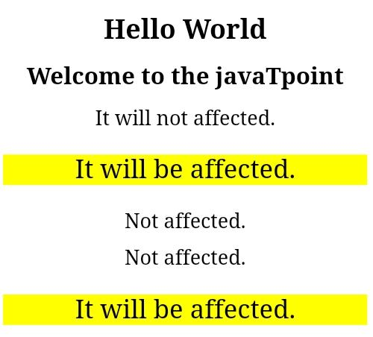
Example2
In this example, we are going to use odd and even keywords that match those elements whose index is odd or even. It is to be noted that the first child index is 1.
- <!DOCTYPE html>
- <html>
- <head>
- <title>CSS :nth-child Selector</title>
- <style>
- p:nth-child(even) {
- background: yellow;
- color: black;
- font-size:30px;
- }
- p:nth-child(odd) {
- background: blue;
- color: white;
- font-size:20px;
- </style>
- </head>
- <body style = "text-align:center">
- <h1>
- Hello World
- </h1>
- <h2>
- Welcome to the javaTpoint
- </h2>

- <p>Odd</p>
- <p>Even</p>
- <p>Odd</p>
- <p>Even</p>
- <p>Odd</p>

- </body>
- </html>
Output
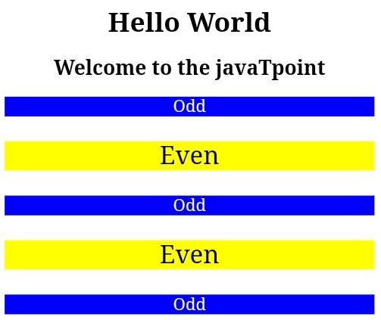

CSS sticky
The CSS position property is used to set the position for an element. It is also used to place an item behind another element and also useful for the scripted animation effect. The "position: sticky;" is used to position the element based on the scroll position of the user.
This CSS property allows the elements to stick when the scroll reaches to a certain point. Depends upon the scroll position, a sticky element toggles in between fixed and relative. The element will be positioned relative until the specified position of offset is met in the viewport. Then, similar to position: fixed, the element sticks in one place.
Let us try to understand this CSS property by using an illustration.

Example
- <!DOCTYPE html>
- <html>
- <head>
- <style>
- body{
- text-align:center;
- }
- .stick{
- position: sticky;
- top:50px;
- padding: 10px;
- font-size:20px;
- font-weight:bold;
- background-color: lightblue;
- border: 1px solid blue;
- }
- </style>
- </head>
- <body>
- <h1>Scroll and see the effect!</h1>
- <div class = "stick">Sticky Element</div>
- <div style = "padding-bottom:2000px">
- <h2>Hello World</h2>
- <h2>Welcome to javaTpoint.com</h2>
- </div>
- </body>
- </html>
Output
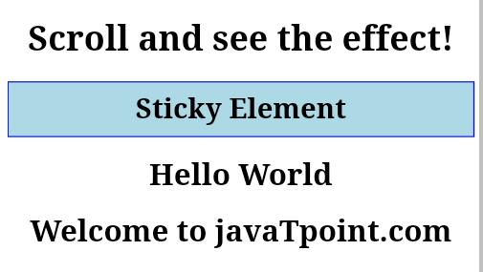

CSS background-clip
This CSS property specifies the painting area of the background. It limits the area in which the background color or image appears by applying a clipping box. Anything outside the box will be discarded and invisible.
It sets whether the background of an element extends under the border-box, padding-box, and content-box.

Syntax
- background-clip: border-box| padding-box| content-box| inherit;

Possible values
Let's understand the property values along with an example of each.

border-box
It is the default value. It means that the background image and color will be drawn inside the border-box. It sets the background color, which spreads over the entire division.

Example
- <!DOCTYPE html>
- <html>
- <head>
- <style>
- div {
- background-color: yellow;
- background-clip: border-box;
- text-align: center;
- border:5px dotted blue;
- }
- h1,h2{
- color: red;
- }
- </style>
- </head>

- <body>
- <div>
- <h1>
- Welcome to the javaTpoint.com
- </h1>
- <h2>
- background-clip: border-box;
- </h2>
- </div>
- </body>
- </html>
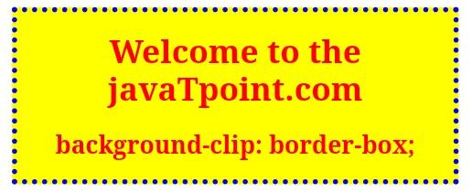
Output

padding-box
It sets the background within the border, i.e., the background image and color are drawn inside the padding-box.

Example
- <!DOCTYPE html>
- <html>
- <head>
- <style>
- div {
- background-color: yellow;
- background-clip: padding-box;
- padding: 25px;
- text-align: center;
- border:5px dashed blue;
- }
- h1,h2{
- color: red;
- }
- </style>
- </head>

- <body>
- <div>
- <h1>
- Welcome to the javaTpoint.com
- </h1>
- <h2>
- background-clip: padding-box;
- </h2>
- </div>
- </body>
- </html>
Output

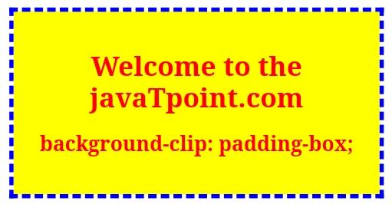
content-box
It sets the background-color up to the content only. The background is painted inside the content box, i.e., the background image and color will be drawn in the content box.

Example
- <!DOCTYPE html>
- <html>
- <head>
- <style>
- div {
- background-color: yellow;
- background-clip: content-box;
- padding: 15px;
- text-align: center;
- border:5px dashed blue;
- }
- h1,h2{
- color: red;
- }
- </style>
- </head>

- <body>
- <div>
- <h1>
- Welcome to the javaTpoint.com
- </h1>
- <h2>
- background-clip: content-box;
- </h2>
- </div>
- </body>
- </html>
Output
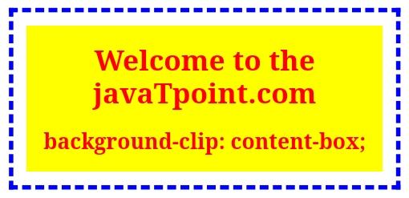

CSS checkbox style
The checkbox is an HTML element used to take input from the user. It is hard to style the checkbox, but pseudo-elements makes it easier to style a checkbox.
This HTML element is generally used on every website, but without styling them, they look similar on every website. So, styling them will make our site different and attractive. We have to hide the original checkbox in order to style the checkbox. Styling the checkboxes using CSS is an interesting and creative task, which will provide a new and attractive look to the default checkbox.
Styling of the checkbox will be clear by using some illustrations. Let's see some of the illustrations for the same.

Example1
In this example, we are using the '~' which is the sibling combinator. It selects all elements that are preceded by the previous selector. We have also used the pseudo-class :hover to style the checkbox when the user moves the cursor over it.
- <!DOCTYPE html>
- <html>
- <style>
- .container {
- display: block;
- position: relative;
- padding-left: 35px;
- margin-bottom: 20px;
- cursor: pointer;
- font-size: 25px;
- }

- /* Hide the default checkbox */
- .container input {
- visibility: hidden;
- cursor: pointer;
- }

- /* Create a custom checkbox */
- .mark {
- position: absolute;
- top: 0;
- left: 0;
- height: 25px;
- width: 25px;
- background-color: lightgray;
- }

- .container:hover input ~ .mark {
- background-color: gray;
- }

- .container input:checked ~ .mark {
- background-color: blue;
- }

- /* Create the mark/indicator (hidden when not checked) */
- .mark:after {
- content: "";
- position: absolute;
- display: none;
- }

- /* Show the mark when checked */
- .container input:checked ~ .mark:after {
- display: block;
- }

- /* Style the mark/indicator */
- .container .mark:after {
- left: 9px;
- top: 5px;
- width: 5px;
- height: 10px;
- border: solid white;
- border-width: 0 3px 3px 0;
- transform: rotate(45deg);
- }
- </style>
- <body>

- <h1>Qualification</h1>
- <label class="container">MCA
- <input type="checkbox">
- <span class="mark"></span>
- </label>
- <label class="container">BCA
- <input type="checkbox">
- <span class="mark"></span>
- </label>
- <label class="container">12th
- <input type="checkbox">
- <span class="mark"></span>
- </label>
- <label class="container">10th
- <input type="checkbox" checked="check">
- <span class="mark"></span>
- </label>

- </body>
- </html>
Output

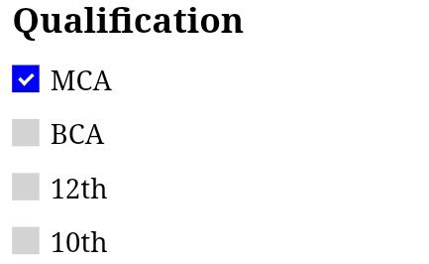
Example2
In this example, we are going to see the modified checkmark.
- <!DOCTYPE html>
- <html>

- <head>
- <style>
- .container {
- display: block;
- position: relative;
- padding-left: 45px;
- margin-bottom: 15px;
- cursor: pointer;
- font-size: 20px;
- }

- /* Hide the original checkbox */
- input[type=checkbox] {
- visibility: hidden;
- }

- /* creating a custom checkbox*/
- .mark {
- position: absolute;
- top: 0;
- left: 0;
- height: 25px;
- width: 25px;
- background-color: lightgray;
- }

- /*background color to be shown when hovering over checkbox */
- .container:hover input ~ .mark {
- background-color: gray;
- }

- /*background color to be shown when the checkbox is checked */
- .container input:checked ~ .mark {
- background-color: blue;
- }

- /* checkmark to be shown in checkbox */
- /* It will not be shown when unchecked */
- .mark:after {
- content: "";
- position: absolute;
- display: none;
- }

- /* display checkmark when checked */
- .container input:checked ~ .mark:after {
- display: block;
- }

- /* creating a square to be the sign of
- checkmark */
- .container .mark:after {
- left: 6px;
- bottom: 6px;
- width: 6px;
- height: 6px;
- border: solid white;
- border-width: 4px 4px 4px 4px;
- }
- </style>
- </head>

- <body>
- <h1>Qualification</h1>

- <label class="container">
- MCA
- <input type="checkbox">
- <span class="mark"></span>
- </label>

- <label class="container">
- BCA
- <input type="checkbox">
- <span class="mark"></span>
- </label>
- <label class="container">
- 12th
- <input type="checkbox">
- <span class="mark"></span>
- </label>
- <label class="container">
- 10th
- <input type="checkbox" checked="check">
- <span class="mark"></span>
- </label>
- </body>

- </html>
Output

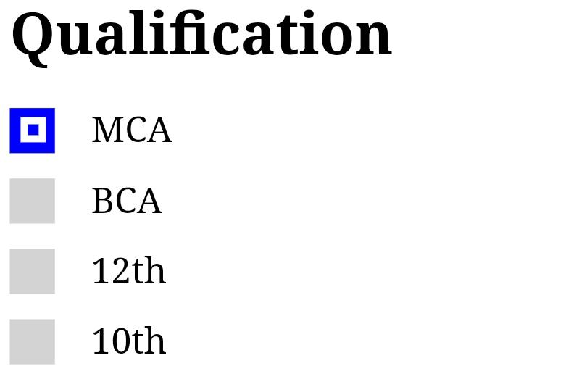
Example3
Now, we are going to see another example of styling the checkbox. In this example, we will see the ripple effect, which makes the checkbox more attractive. This effect gives a new look to the checkbox. Similar to the above example, we have also use the '~' sibling combinator, which will select all elements preceded by the former selector. There is also the use of some pseudo-classes such as :checked, :before, :after, etc.
See the following example to create the ripple effect in checkbox by using CSS.
- <html>
- <head>
- <style>
- body{
- text-align: center;
- }
- .check {
- width: 500px;
- margin: 50px auto;
- clear: both;
- display: block;
- background-color: #009BFF;
- border-radius: 4px;
- }
- .check::after {
- clear: both;
- display: block;
- content: "";
- }
- .check .checkbox-container {
- float: left;
- width: 50%;
- box-sizing: border-box;
- text-align:center;
- padding: 40px 0px;
- }

- /* Styling Checkbox Starts */
- .checkbox-label {
- color: white;
- display: block;
- position: relative;
- margin: auto;
- cursor: pointer;
- font-size: 22px;
- line-height: 24px;
- height: 50px;
- width: 24px;
- clear: both;
- }
- .checkbox-label input {
- position: absolute;
- opacity: 0;
- cursor: pointer;
- }

- .checkbox-label .mark {
- top:30px;
- position: absolute;
- height: 24px;
- width: 24px;
- background-color: transparent;
- border-radius: 5px;
- transition: all 0.3s ease-in;
- border: 2px solid white;
- }
- .checkbox-label input:checked ~ .mark {
- background-color: white;
- border-radius: 5px;
- transform: rotate(0deg) scale(1);
- opacity:1;
- border: 2px solid white;
- }
- .checkbox-label .mark::after {
- position: absolute;
- content: "";
- border-radius: 5px;
- }
- .checkbox-label input:checked ~ .mark::after {
- transform: rotate(45deg) scale(1);
- left: 8px;
- top: 3px;
- width: 6px;
- height: 12px;
- border: solid red;
- border-width: 0 2px 2px 0;
- border-radius: 0;
- }
- /* For Ripple Effect */
- .checkbox-label .mark::before {
- position: absolute;
- content: "";
- border-radius: 10px;
- border: 5px solid yellow;
- transform: scale(0);
- }

- .checkbox-label input:checked ~ .mark::before {
- left: -3px;
- top: -3px;
- width: 24px;
- height: 24px;
- border-radius: 5px;
- transform: scale(3);
- opacity:0;
- transition: all 0.3s ease-out;
- }

- </style>
- </head>
- <body>

- <h1>Qualification</h1>
- <div class="check">
- <div class="checkbox-container">
- <label class="checkbox-label">MCA
- <input type="checkbox">
- <span class="mark"></span>
- </label>
- </div>
- <div class="checkbox-container">
- <label class="checkbox-label">BCA
- <input type="checkbox">
- <span class="mark"></span>
- </label>
- </div>
- <div class="checkbox-container">
- <label class="checkbox-label">12th
- <input type="checkbox">
- <span class="mark"></span>
- </label>
- </div>
- <div class="checkbox-container">
- <label class="checkbox-label">10th
- <input type="checkbox" checked="check">
- <span class="mark"></span>
- </label>
- </div>
- </div>

- </body>
- </html>
Output
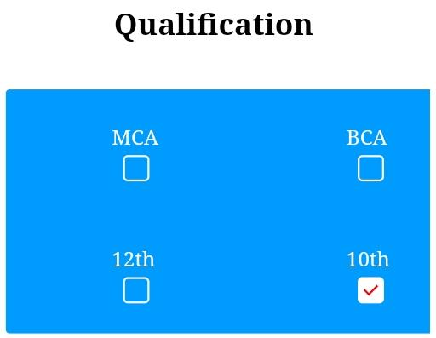

CSS letter-spacing
This CSS property used to control the space between every letter inside an element or the block of text. It sets the spacing behavior between the characters of the text. Using this property, we can increase or decrease the space between the characters of the text.
It modifies the space between the adjacent characters.

Syntax
- letter-spacing: normal | length | initial | inherit;

Possible values
normal: It is the default value that does not provide any space between the characters. It does not change the default spacing between the letters. It is similar to set the value to 0.
length: It is used to specify an additional space between the characters. It allows the negative values that tighten the text appearance instead of loosening it. The greater length implies the maximum space between the letters. This value supports the font-relative values (em, rem), absolute values (px).

Example
In this example, we are going to try different values of letter-spacing property in order to see the different results. We will also use the possible length values to see the spacing between the characters.
This example will illustrate the setting of space between the characters.
- <!DOCTYPE html>
- <html>
- <head>
- <title>CSS letter-spacing Property</title>
- </head>
- <body style = "text-align: center;">
- <h1 style = "color: blue;">
- Welcome to the javaTpoint.com
- </h1>

- <h2>
- This is an example of CSS letter-spacing Property
- </h2>
- <p style= "letter-spacing: normal;">
- This paragraph has letter-spacing: normal;
- </p>
- <p style= "letter-spacing: 7px;">
- This paragraph has letter-spacing: 7px;
- </p>
- <p style= "letter-spacing: 0.7em;">
- This paragraph has letter-spacing: 0.7em;
- </p>
- <p style= "letter-spacing: -1px;">
- This paragraph has letter-spacing: -1px;
- </p>

- </body>
- </html>
Output
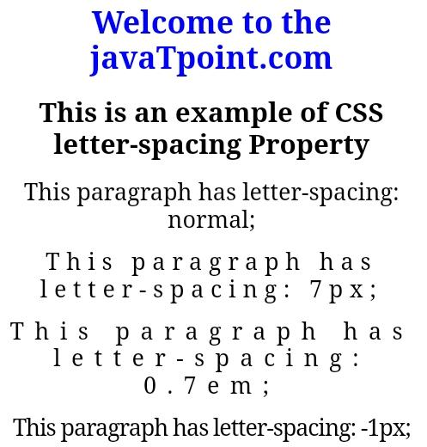
A large negative or positive value of letter-spacing will make the word unreadable. If we apply a very large positive value, it will cause the appearance of letters like a series of unconnected and individual letters. A very large negative value will overlap the letter to each other, which makes the word unrecognizable.

CSS Navigation bar
A Navigation bar or navigation system comes under GUI that helps the visitors in accessing information. It is the UI element on a webpage that includes links for the other sections of the website.
A navigation bar is mostly displayed on the top of the page in the form of a horizontal list of links. It can be placed below the logo or the header, but it should always be placed before the main content of the webpage.
It is important for a website to have easy-to-use navigation. It plays an important role in the website as it allows the visitors to visit any section quickly.
Let's discuss the horizontal navigational bar and vertical navigational bar in detail.

Horizontal Navigation Bar
The horizontal navigation bar is the horizontal list of links, which is generally on the top of the page.
Let's see how to create a horizontal navigation bar by using an example.

Example
In this example, we are adding the overflow: hidden property that prevents the li elements from going outside of the list, display: block property displays the links as the block elements and makes the entire link area clickable.
We are also adding the float: left property, which uses float for getting the block elements to slide them next to each other.
If we want the full-width background color then we have to add the background-color property to <ul> rather than the <a> element.
- <!DOCTYPE html>
- <html>
- <head>
- <style>
- ul {
- list-style-type: none;
- margin: 0;
- padding: 0px;
- overflow: hidden;
- background-color: lightgray;
- }

- li {
- float: left;
- }

- li a {
- display: block;
- color: blue;
- font-size:20px;
- text-align: center;
- padding: 10px 20px;
- text-decoration: none;
- }
- .active{
- background-color: gray;
- color: white;
- }
- li a:hover {
- background-color: orange;
- color: white;
- }
- </style>
- </head>
- <body>

- <ul>
- <li><a class="active" href="#home">Home</a></li>
- <li><a href="#">Java</a></li>
- <li><a href="#">HTML</a></li>
- <li><a href="#">CSS</a></li>
- </ul>

- </body>
- </html>
Output

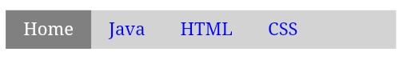
Border dividers
We can add the border between the links in the navigation bar by using the border-right property. The following example explains it more clearly.

Example
- <!DOCTYPE html>
- <html>
- <head>
- <style>
- ul {
- list-style-type: none;
- margin: 0;
- padding: 0px;
- overflow: hidden;
- background-color: lightgray;
- }

- li {
- float: left;
- border-right: 1px solid blue;
- }

- li a {
- display: block;
- color: blue;
- font-size:20px;
- text-align: center;
- padding: 10px 20px;
- text-decoration: none;
- }
- .active{
- background-color: gray;
- color: white;
- }
- li a:hover {
- background-color: orange;
- color: white;
- }
- </style>
- </head>
- <body>

- <ul>
- <li><a class="active" href="#home">Home</a></li>
- <li><a href="#">Java</a></li>
- <li><a href="#">HTML</a></li>
- <li><a href="#">CSS</a></li>
- </ul>

- </body>
- </html>
Output

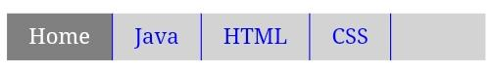
Fixed Navigation bars
When we scrolls the page, fixed navigation bars stay at the bottom or top of the page. See an example of the same.

Example
- <!DOCTYPE html>
- <html>
- <head>
- <style>
- ul {
- list-style-type: none;
- position: fixed;
- width:100%;
- top:0;
- margin: 0;
- padding: 0px;
- overflow: hidden;
- background-color: lightgray;
- }

- li {
- float: left;
- border-right: 1px solid blue;
- }

- li a {
- display: block;
- color: blue;
- font-size:20px;
- text-align: center;
- padding: 10px 20px;
- text-decoration: none;
- }
- .active{
- background-color: gray;
- color: white;
- }
- li a:hover {
- background-color: orange;
- color: white;
- }
- </style>
- </head>
- <body>
- <ul>
- <li><a class="active" href="#home">Home</a></li>
- <li><a href="#">Java</a></li>
- <li><a href="#">HTML</a></li>
- <li><a href="#">CSS</a></li>
- </ul>
- <h1 style="padding-top: 100px; text-align: center;">Hello World</h1>
- <h2 style="padding-bottom: 2000px; text-align: center;">Scroll down the page to see the fixed navigation bar</h2>

- </body>
- </html>
Output

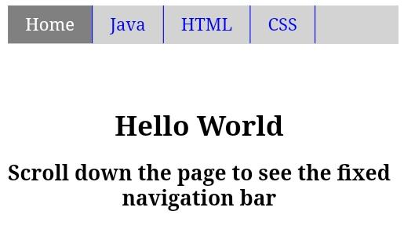
Sticky Navbar
The position: sticky; property is used to position the element based on the scroll position of the user.
This CSS property allows the elements to stick when the scroll reaches to a certain point. Depending upon the scroll position, a sticky element toggles in between fixed and relative property.

Example
- <!DOCTYPE html>
- <html>
- <head>
- <style>
- ul {
- list-style-type: none;
- position: sticky;
- width:100%;
- top:0;
- margin: 0;
- padding: 0px;
- overflow: hidden;
- background-color: lightgray;
- }

- li {
- float: left;
- border-right: 1px solid blue;
- }

- li a {
- display: block;
- color: blue;
- font-size:20px;
- text-align: center;
- padding: 10px 20px;
- text-decoration: none;
- }
- .active{
- background-color: gray;
- color: white;
- }
- li a:hover {
- background-color: orange;
- color: white;
- }
- </style>
- </head>
- <body>
- <h1> Example of sticky navigation bar</h1>
- <ul>
- <li><a class="active" href="#home">Home</a></li>
- <li><a href="#">Java</a></li>
- <li><a href="#">HTML</a></li>
- <li><a href="#">CSS</a></li>
- </ul>
- <h1 style="padding-top: 100px; text-align: center;">Hello World</h1>
- <h2 style="padding-bottom: 2000px; text-align: center;">Scroll down the page to see the sticky navigation bar</h2>

- </body>
- </html>
Output

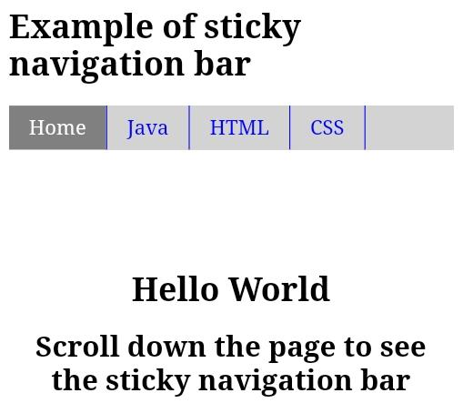
Dropdown Navbar
Following example explain how to create a dropdown menu inside a navigation bar.

Example
- <!DOCTYPE html>
- <html>
- <head>
- <style>

- ul {
- list-style-type: none;
- margin: 0;
- padding: 0;
- overflow: hidden;
- background-color: lightgray;
- }

- li {
- float: left;
- }

- li a, .dropbtn {
- display: inline-block;
- color: blue;
- font-size:20px;
- text-align: center;
- padding: 10px 20px;
- text-decoration: none;
- }
- .active{
- background-color: gray;
- color: white;
- }
- li a:hover , .dropdown:hover .dropbtn{
- background-color: orange;
- color: white;
- }

- .dropdown-content {
- display: none;
- position: absolute;
- background-color: lightblue;
- min-width: 160px;
- box-shadow: 5px 8px 10px 0px black;
- }

- .dropdown-content a {
- color: black;
- padding: 12px 16px;
- text-decoration: none;
- display: block;
- text-align: left;
- }

- .dropdown-content a:hover {
- background-color: gray;
- color:white;
- }

- .dropdown:hover .dropdown-content {
- display: block;
- }
- h1,h2,h3{
- text-align:center;
- color: green;
- }
- </style>
- </head>
- <body>
- <ul>
- <li><a class="active" href="#home">Home</a></li>
- <li><a href="#">Java</a></li>
- <li><a href="#">C</a></li>
- <li><a href="#">C++</a></li>
- <li class="dropdown">
- <a href="#" class="dropbtn">Web-designing</a>
- <div class="dropdown-content">
- <a href="#">HTML</a>
- <a href="#">CSS</a>
- <a href="#">Bootstrap</a>
- </div>
- </li>
- </ul>
- <h1>Welcome to the javaTpoint.com</h1>
- <h2>Example of Dropdown Menu inside a Navigation Bar</h2>
- <h3>Move your cursor on the "web-designing" to see the dropdown effect.</h3>

- </body>
- </html>

Vertical Navigation bar
In this example, we are going to see how to build a vertical navigation bar.

Example
- <!DOCTYPE html>
- <html>
- <head>
- <style>
- ul {
- list-style-type: none;
- margin: 0;
- padding: 0;
- width: 200px;
- background-color: lightblue;
- }

- li a {
- display: block;
- color: blue;
- font-size:20px;
- padding: 8px 16px;
- text-decoration: none;
- }
- .active{
- background-color: orange;
- color: white;
- }
- li a:hover {
- background-color: orange;
- color: white;
- }
- </style>
- </head>
- <body>

- <h2>Vertical Navigation Bar</h2>

- <ul>
- <li><a href="#" class = "active">Home</a></li>
- <li><a href = "#">Java</a></li>
- <li><a href = "#">CSS</a></li>
- <li><a href = "#">HTML</a></li>
- <li><a href = "#">Bootstrap</a></li>
- </ul>

- </body>
- </html>
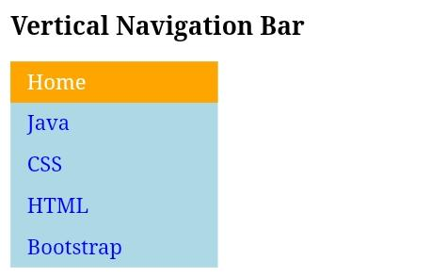
Output
We can align the links to the center and add borders between them. See an example of the same.

Example
In this example, we are adding the text-align: center; property to <li> and <a> to center the links and border property to <ul> to add the border. We will also add the border-bottom property to all <li> elements.
- <!DOCTYPE html>
- <html>
- <head>
- <style>
- ul {
- list-style-type: none;
- margin: 0;
- padding: 0;
- width: 200px;
- background-color: lightblue;
- border: 1px solid blue;
- }

- li a {
- display: block;
- color: blue;
- font-size:20px;
- padding: 10px 20px;
- text-decoration: none;
- border-bottom: 1px solid blue;
- }
- ul:last-child {
- border-bottom: none;
- }
- .active{
- background-color: orange;
- color: white;
- }
- li a:hover {
- background-color: orange;
- color: white;
- }
- </style>
- </head>
- <body>

- <h2>Vertical Navigation Bar</h2>

- <ul>
- <li><a href="#" class = "active">Home</a></li>
- <li><a href = "#">Java</a></li>
- <li><a href = "#">CSS</a></li>
- <li><a href = "#">HTML</a></li>
- <li><a href = "#">Bootstrap</a></li>
- </ul>

- </body>
- </html>

Full-height fixed Vertical Navbar
We can also create the fixed full-height side navigation bar by using the properties height: 100%; and postion: fixed;

Example
- <!DOCTYPE html>
- <html>
- <head>
- <style>
- body{
- background-color: pink;
- }
- ul {
- list-style-type: none;
- margin: 0;
- padding: 0;
- height:100%;
- top:0;
- width:150px;
- overflow: auto;
- background-color: lightblue;
- border: 1px solid blue;
- position: fixed;
- }
- li a {
- display: block;
- color: blue;
- font-size:20px;
- padding: 10px 20px;
- text-decoration: none;
- border-bottom: 1px solid blue;
- }
- .active{
- background-color: orange;
- color: white;
- }
- li a:hover {
- background-color: orange;
- color: white;
- }
- </style>
- </head>
- <body>

- <ul>
- <li><a href = "#" class = "active">Home</a></li>
- <li><a href = "#">Java</a></li>
- <li><a href = "#">CSS</a></li>
- <li><a href = "#">HTML</a></li>
- <li><a href = "#">Bootstrap</a></li>
- </ul>
- <div style="margin-left:20%;padding-bottom:2000px;color:blue;">
- <h1>Welcome to the javaTpoint.com</h1>
- <h2>Side navigation bar with height: 100%; and position: fixed;</h2>
- <h3>Scroll the page, and see how the sidenav sticks to the page</h3>

- </div>
- </body>
- </html>

