HTML 5 Tags
There is a list of newly included tags in HTML 5. These HTML 5 tags (elements) provide a better document structure. This list shows all HTML 5 tags in alphabetical order with description.

List of HTML 5 Tags
Tag | Description
<article> | This element is used to define an independent piece of content in a document, that may be a blog, a magazine or a newspaper article.
<aside> | It specifies that article is slightly related to the rest of the whole page.
<audio> | It is used to play audio file in HTML.
<bdi> | The bdi stands for bi-directional isolation. It isolates a part of text that is formatted in other direction from the outside text document.
<canvas> | It is used to draw canvas.
<data> | It provides machine readable version of its data.
<datalist> | It provides auto complete feature for textfield.
<details> | It specifies the additional information or controls required by user.
<dialog> | It defines a window or a dialog box.
<figcaption> | It is used to define a caption for a <figure> element.
<figure> | It defines a self-contained content like photos, diagrams etc.
<footer> | It defines a footer for a section.
<header> | It defines a header for a section.
<main> | It defines the main content of a document.
<mark> | It specifies the marked or highlighted content.
<menuitem> | It defines a command that the user can invoke from a popup menu.
<meter> | It is used to measure the scalar value within a given range.
<nav> | It is used to define the navigation link in the document.
<progress> | It specifies the progress of the task.
<rp> | It defines what to show in browser that don't support ruby annotation.
<rt> | It defines an explanation/pronunciation of characters.
<ruby> | It defines ruby annotation along with <rp> and <rt>.
<section> | It defines a section in the document.
<summary> | It specifies a visible heading for <detailed> element.
<svg> | It is used to display shapes.
<time> | It is used to define a date/time.
<video> | It is used to play video file in HTML.
<wbr> | It defines a possible line break.

HTML <!DOCTYPE> tag
On the HTML document you have often seen that there is a <!DOCTYPE html> declaration before the <html> tag. HTML <!DOCTYPE> tag is used to inform the browser about the version of HTML used in the document. It is called as the document type declaration (DTD).
Technically <!DOCTYPE > is not a tag/element, it just an instruction to the browser about the document type. It is a null element which does not contain the closing tag, and must not include any content within it.
Actually, there are many type of HTML e.g. HTML 4.01 Strict, HTML 4.01 Transitional, HTML 4.01 Frameset, XHTML 1.0 Strict, XHTML 1.0 Transitional, XHTML 1.0 Frameset, XHTML 1.1 etc.
The <!DOCTYPE> declaration refers Document Type Declaration (DTD) in HTML 4.01; because HTML 4.01 was based on SGML. But HTML 5 is not SGML based language.

DTD defines the rules for the markup languages so that the browsers recognize the content correctly.
The doctype declaration differs between HTML versions. The HTML 5 doctype declaration is given below.

Syntax
<!DOCTYPE html>
Following are some specifications about the HTML <!DOCTYPE>
Display | None
Start tag/End tag | Start tag only
Usage | Structural
Let's see an example of HTML document with doctype declaration.
- <!DOCTYPE html>
- <html>
- <head>
- <title>This is the title</title>
- </head>
- <body>
- This is the content of the document.
- </body>
- </html>

Note: It is always a good practice to add a declaration to your HTML documents to enable web browser to recognize that what type of document to expect.

Supporting Browsers
Element | Chrome | IE | Firefox | Opera | Safari
<!DOCTYPE> | Yes | Yes | Yes | Yes | Yes

Note: DOCTYPE declaration is not case sensitive.

HTML Anchor
The HTML anchor tag defines a hyperlink that links one page to another page. It can create hyperlink to other web page as well as files, location, or any URL. The "href" attribute is the most important attribute of the HTML a tag. and which links to destination page or URL.

href attribute of HTML anchor tag
The href attribute is used to define the address of the file to be linked. In other words, it points out the destination page.
The syntax of HTML anchor tag is given below.
<a href = "..........."> Link Text </a>
Let's see an example of HTML anchor tag.
- <a href="second.html">Click for Second Page</a>

Specify a location for Link using target attribute
If we want to open that link to another page then we can use target attribute of <a> tag. With the help of this link will be open in next page.

Example:
- <!DOCTYPE html>
- <html>
- <head>
- <title></title>
- </head>
- <body>
- <p>Click on <a href="https://www.javatpoint.com/" target="_blank"> this-link </a>to go on home page of JavaTpoint.</p>
- </body>
- </html>
Output:
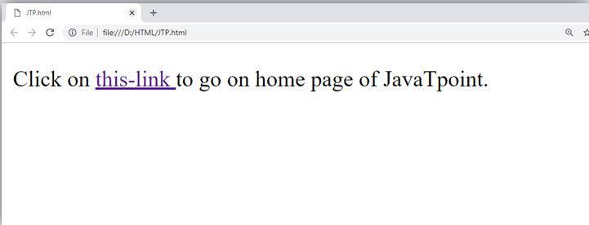
Note:
- The target attribute can only use with href attribute in anchor tag.
- If we will not use target attribute then link will open in same page.

Appearance of HTML anchor tag
An unvisited link is displayed underlined and blue.
A visited link displayed underlined and purple.
An active link is underlined and red.

Supporting Browsers
Element | Chrome | IE | Firefox | Opera | Safari
<a> | Yes | Yes | Yes | Yes | Yes

HTML <abbr> tag
HTML <abbr> tag is used to represent an acronym or abbreviation of a longer word or phrase, such as www, HTML, HTTP, etc. The content written between <abbr> tags renders with dotted underline in some browser.
This tag can be used with "title" attribute (optional), and the value of title attribute will be pop-up when the mouse hovers over the content written between <abbr> tag.

Syntax
- <abbr title="HyperText Markup language">HTML</abbr>
Following are some specifications about the HTML <abbr> tag
Display | Inline
Start tag/End tag | Both Start tag and End tag
Usage | Semantic/Textual

Example
With title Attribute:
- <!DOCTYPE html>
- <html>
- <head>
- <title>Abbreviation Tag</title>
- </head>
- <body>
- <h2>Abbreviation tag example</h2>
- <p><b>Hover mouse over the content and see the abbreviation</b></p>
- <abbr title="Hyper Text Transfer protocol">HTTP</abbr>
- </body>
- </html>

Example
Without title Attribute:
- <!DOCTYPE html>
- <html>
- <head>
- <title>Abbreviation tag</title>
- </head>
- <body>
- <h2>Abbreviation tag Example</h2>
- <p><abbr>CPU</abbr> is brain of a Computer</p>
- </body>
- </html>

Global attributes:
The <abbr> tag supports the global attributes.

Event Attributes:
The <abbr> tag supports the event attributes.

Supporting Browsers
Element | Chrome | IE | Firefox | Opera | Safari
<abbr> | Yes | Yes | Yes | Yes | Yes

HTML <acronym> tag (Not supported in HTML5)
HTML <acronym> tag is used with title attribute to contain a full explanation of an acronym content. When you hover the mouse on content, then it will show the explanation of word.

Note: The <acronym> tag has been depreciated in HTML5 and we can use <abbr> tag instead of <acronym>.

Syntax
- <acronym title="Indian Space Research Organisation">ISRO</acronym>
Following are some specifications about the HTML <acronym> tag
Display | Inline
Start tag/End tag | Both Start tag and End tag
Usage | Semantic/Textual

Example
- <!DOCTYPE html>
- <html>
- <head>
- <title>Acronym tag</title>
- </head>
- <body>
- <h2>Acronym tag Example</h2>
- <acronym title="Indian Space Research Organisation">ISRO</acronym>
- </body>
- </html>

Difference between <acronym> and <abbr> tag
Although <acronym> tag is not supported by HTML5 but instead of that we can use <abbr> tag and we will get the same result using both tag.

Example
- <!DOCTYPE html>
- <html>
- <head>
- </head>
- <body>
- <h2>Acronym and Abbreviation Example</h2>
- <acronym title="Indian Space Research Organisation">ISRO</acronym>
- <abbr title="National Aeronautics and Space Administration">NASA</abbr>
- </body>
- </html>

Supporting Browsers
Element | Chrome | IE | Firefox | Opera | Safari
<acronym> | Yes | Yes | Yes | Yes | Yes

HTML <address> tag
HTML <address> tag is used to specify the authorship information of the article or webpage. It can contain any type of information which is needed such as, URL, physical address, phone number, email, other links, etc.
The <address> tag is useful for various contexts such as business contact information in the header of the page, or author related contact information, etc.
The contact information written between <address> tags mostly renders in the italic form on the browser.

Note: To represent a random address use <p> tag instead of <address> tag, as it should contain the main contact information.

Syntax
- <address>Contact Author at:<br>
- <a href="mailto:example@gmail.com">Example@gmail.com</a></address>
If you want to specify the information of the author for an article, you must place the <address> tag inside the <article> element.
Following are the specifications of <address> tag:
Display | Block
Usage | Semantic
Tags | Start and end tag

Example
- <!DOCTYPE html>
- <html>
- <head>
- <title>Address Tag</title>
- </head>
- <body>
- <h2>Example of Address tag</h2>
- <address>The article is written by:<b>Harshita</b> <br>Contact Author at:
- <a href="mailto:example@gmail.com">Example@gmail.com</a><br>You can also visit our blog:
- <a href="http://javatpoint.blogspot.com/">javaTpoint blog</a>
- </address>
- </body>
- </html>

Attributes
The <address> tag does not contain any specific attribute for it.

Global Attribute:
The <address> tag supports the global attributes.

Event attribute:
The <address> tag supports all Events attributes.

Supporting Browsers
Element | Chrome | IE | Firefox | Opera | Safari
<address> | Yes | Yes | Yes | Yes | Yes

HTML <applet> tag (Not supported in HTML5)
HTML <applet> tag was used to embed the Java applet in an HTML document. This element has been deprecated in HTML 4.0 and instead of it we can use <object> and newly added element <embed>.
The use of Java applet is also deprecated, and most browsers do not support the use of plugins.

Note: The <applet> tag is deprecated in HTML4.0 and not supported in HTML5. So you can use <object> tag or <embed> tag instead of <applet>.

Syntax
- <applet code="URL" height="200" width="100">.............</applet>
Following are some specifications about <applet> tag
Display | Block
Start tag/End tag | Both Start tag and End tag
Usage | Embed Applets

Example
- <!DOCTYPE html>
- <html>
- <head>
- <title>Applet Tag</title>
- </head>
- <body>
- <p>Example of Applet Tag</p>
- <applet code="Shapes.class" align="right" height="200" width="300">
- <b>Sorry! you need Java to see this</b>
- </applet>
- </body>
- </html>

Attributes
Specific Attributes
Attribute name | Value | Description
code | URL | It specifies the URL of Java applet class file.
width | pixels | It specifies the display width of the applet panel.
height | pixels | It specifies the display height of applet panel
align | - left  - right  - top  - middle  - bottom | It specifies the position of applet application relative to surrounding content.
alt | text | It is used to display alternative text in case browser does not support Java.
archive | URL | This specifies the archived or compressed version of an applet application.
object | name | It specifies the URL or reference to a serialized representation of an applet.
codebase | URL | It specifies the exact or relative URL of applets .class file specified in the code attribute.
hspace | pixels | It specifies the horizontal space around the applet.
vspace | pixels | It specifies the vertical space around the applet.
name | name | It specifies the name for the applet

Global Attributes
The <applet> tag supports all Global Attributes in HTML

Event Attributes
The <applet> tag supports all Event Attributes in HTML

Supporting Browsers
Element | Chrome | IE | Firefox | Opera | Safari
<applet> | Not supported | Not Supported | Yes | Not Supported | Yes

HTML <area> tag

Description:
The <area> tag defines the clickable areas or active areas inside the image-map which are associated with the hyperlinks. If you click on those areas then it will perform some action such as open a new image, new URL, etc. This tag is always used with <map> element.
Inside an image map different areas can be hyperlinked to various locations using multiple <area> elements in a single <map> element.
The <area> element is defined with (required) attributes shape and coords. The shape attribute specifies the shape of the area such as rectangle, circle, square, and polygon. The coords attribute defines the coordinates of areas inside the image.

What is Image-map
An image-map is defined as a graphical image with active areas so that when user click on those area, it can link to different destinations. To define an image-map, we require the following things:
- An HTML <img> element with usemap attribute which defines a valid map name.
- HTML <map> element with name attribute whose value must be same as usemap
- One or more <area> elements inside a <map> element which create clickable areas in an image-map.

Syntax
- <area shape="" coords="" href="">
Following are some specifications about the HTML <area> tag
Display | Block
Start tag/End tag | Only start tag(End tag forbidden)
Usage | Image Map

Example
- <!DOCTYPE html>
- <html>
- <head>
- <title>HTML Area tag</title>
- <style>
- body{
- margin-left: 250px;}
- </style>
- </head>
- <body>
- <h2>Example of HTML Area tag</h2>
- <img src="image1.png" usemap="#web">
- <map name="web">
- <area shape="rect" coords="66,117,131,168" href="https://www.javatpoint.com/html-tutorial">
- <area shape="rect" coords="199,36,277,85" href="https://www.javatpoint.com/css-tutorial">
- <area shape="rect" coords="330,107,406,159" href="https://www.javatpoint.com/bootstrap-tutorial">
- <area shape="rect" coords="199,185,267,236" href="https://www.javatpoint.com/javascript-tutorial">
- </map>
- </body>
- </html>
Output:
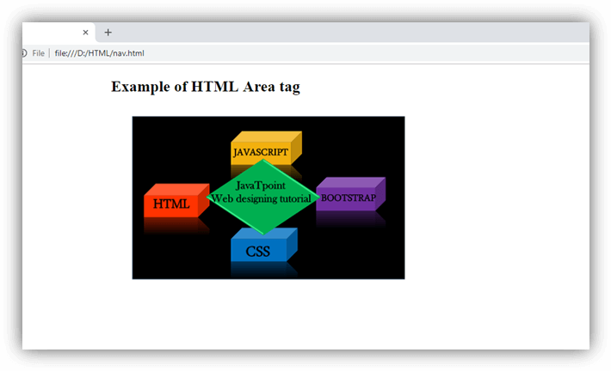

Attribute:

Tag-specific attributes:
Attribute | Value | Description
alt | text | An alternative text String to display on the browser if it does not display the image.
coords | x1,y1,x2,y2(rect) | Defines coordinates for the upper left and lower right of a rectangle.
coords | x,y, radius(circle) | Defines coordinates for the circle.
coords | x1,y1,x2,y2,x3,y3,..(polygon) | Defines the polygon vertices.
href | href | URL It determines the hyperlink destination for the active area.
target | _blank | Open link in a new window
target | _parent | Open link in the parent frame
target | _self | Open link in current window
target | _top | Open link with full width in the same window
target | frame_name | In the frame. (Not supported in HTML5)
shape | default | It defines the default area(rectangular).
shape | rect | It defines the rectangular area.
shape | circle | Defines the circular area.
shape | poly | Defines the polygonal.
download | filename | Defines that hyperlink, which is used for downloading the resource.
rel | alternate  author  bookmark  help  license  next  nofollow  noreferrer  prefetch  prev  search  tag | It defines the relationship between current and linked document.
hreflang | language_code | It specifies the language of the linked resource.
type | media_type | It specifies the MIME type of linked source.(Not supported in HTML5)

Global attribute:
The <area> tag supports the global attributes in HTML

Event attribute:
The <area> tag supports the event attributes in HTML.

Supporting Browsers
Element | Chrome | IE | Firefox | Opera | Safari
<area> | Yes | Yes | Yes | Yes | Yes

HTML Article Tag
The HTML <article> tag defines an independent self-contained content in a document, page, application or a site.
The article tag content makes sense on its own. It is independent and complete from other content shown on the page. This tag is generally used on Forum post, Blog post, News story, comment etc.

HTML article tag example
- <article>
- <h2>Narendra Modi</h2>
- <i>(Naam to suna hi hoga) </i>
- <p>Narendra DamodarDas Modi is the 15th and current Prime Minister of India,
- Modi, a leader of the Bharatiya Janata Party (BJP), previously served as the Chief Minister
- of Gujarat state from 2001 to 2014. He is currently the Member of Parliament (MP) from Varanasi. </p>
- </article>
Output:

Narendra Modi
(Naam to suna hi hoga)
Narendra DamodarDas Modi is the 15th and current Prime Minister of India, Modi, a leader of the Bharatiya Janata Party (BJP), previously served as the Chief Minister of Gujarat state from 2001 to 2014. He is currently the Member of Parliament (MP) from Varanasi.

HTML article tag also supports global and event attributes in HTML.

Supporting Browsers
Element | Chrome | IE | Firefox | Opera | Safari
<article> | Yes | Yes | Yes | Yes | Yes

HTML Aside Tag
The HTML <aside> tag provides information about the main content. According to W3C definition, the <aside> element represents content that forms the main textual flow of a document.
HTML aside is a new tag introduced in HTML5.

HTML aside tag example
- <p>I don't want to live in Ghaziabad, I wish; I could buy a flat in New Delhi.</p>
- <aside>
- <h3>New Delhi</h3>
- <p>New Delhi is the capital of India.</p>
- </aside>
Output:
I don't want to live in Ghaziabad, I wish; I could buy a flat in New Delhi.

New Delhi
New Delhi is the capital of India.

HTML aside tag also supports global and event attributes in HTML.

Supporting Browsers
Element | Chrome | IE | Firefox | Opera | Safari
<aside> | Yes | Yes | Yes | Yes | Yes

HTML Audio Tag
HTML audio tag is used to define sounds such as music and other audio clips. Currently there are three supported file format for HTML 5 audio tag.
- mp3
- wav
- ogg
HTML5 supports <video> and <audio> controls. The Flash, Silverlight and similar technologies are used to play the multimedia items.
This table defines that which web browser supports which audio file format.
Browser | mp3 | wav | ogg
Internet Explorer | yes | no | no
Google Chrome | yes | yes | yes
Mozilla Firefox | yes* | yes | yes
Opera | no | yes | yes
Apple Safari | yes | yes | no

HTML Audio Tag Example
Let's see the code to play mp3 file using HTML audio tag.
- <audio controls>
- <source src="koyal.mp3" type="audio/mpeg">
- Your browser does not support the html audio tag.
- </audio>
Output:

Let's see the example to play ogg file using HTML audio tag.
- <audio controls>
- <source src="koyal.ogg" type="audio/ogg">
- Your browser does not support the html audio tag.
- </audio>

Supporting Browsers
Element | Chrome | IE | Firefox | Opera | Safari
<audio> | Yes | Yes | Yes | Yes | Yes

Attributes of HTML Audio Tag
There is given a list of HTML audio tag.
Attribute | Description
controls | It defines the audio controls which is displayed with play/pause buttons.
autoplay | It specifies that the audio will start playing as soon as it is ready.
loop | It specifies that the audio file will start over again, every time when it is completed.
muted | It is used to mute the audio output.
preload | It specifies the author view to upload audio file when the page loads.
src | It specifies the source URL of the audio file.

HTML Audio Tag Attribute Example
Here we are going to use controls, autoplay, loop and src attributes of HTML audio tag.
- <audio controls autoplay loop>
- <source src="koyal.mp3" type="audio/mpeg"></audio>

MIME Types for HTML Audio format
The available MIME type HTML audio tag is given below.
Audio Format | MIME Type
mp3 | audio/mpeg
ogg | audio/ogg
wav | audio/wav

HTML bold tag
HTML bold tag is represented by <b> tag.
HTML <b> tag is used to display the written text in bold format. It is strictly a presentational element. If you want to show your text in bold letters and not have real semantic meaning, then put it within <b>.......</b> tag.

Difference between HTML <b> and <strong> tag
The b tag is explicit whereas strong tag is semantic.The <strong> tag adds extra semantic meaning to the HTML document.
It is recommended to use strong tag for bold format now.

HTML bold tag example
- <p> Hello guys, <b>this is the method to write bold text.</b></p>
Output:
Hello guys, this is the method to write bold text.

Note: According to HTML5 specification, b tag should be used only if no other tag is appropriate. For example: If you want to write a heading, you must use the header tag <h1> to <h6>. Important statement should be denoted within <strong>.....</strong> tag, and the text you want to mark or highlight, must be put within <mark>...</mark> tag.
There is also a CSS 'font-weight' property to set bold text.

Supporting Browsers
Element | Chrome | IE | Firefox | Opera | Safari
<b> | Yes | Yes | Yes | Yes | Yes

Note: HTML b tag also supports the global and event attribute in HTML.

HTML <base> tag
HTML <base> tag is used to specify a base URI or URL to use for all relative links contained within an HTML document.
Only one <base> element can be specified within a document, and it must be placed within <head> element. We can also specify how other links should open (in the same window, in another window, etc.) using the target attribute.

Syntax
- <base href="https://www.javatpoint.com">
In HTML <base> element does not contain closing tag but in XHTML end tag </base> is required.
Following are some specifications about the <base> tag
Display | None
Start tag/End tag | Only start-tag
Usage | Anchors and links

Example
Open in same window (by default)
- <!DOCTYPE html>
- <html>
- <head>
- <title>Base tag</title>
- <style>
- a{text-decoration: none;
- color:black;}
- a:hover{color: green;
- font-size: 18px;}
- </style>
- <base href="https://www.javatpoint.com">
- </head>
- <body>
- <h2 style="color: red; font-size: 30px; font-style: italic;">List of Web developement Tutorial</h2>
- <a href="/html-tutorial">HTML tutorial</a><br>
- <a href="/css-tutorial">CSS tutorial</a><br>
- <a href="/bootstrap-tutorial">Bootstrap tutorial</a><br>
- <a href="/javascript-tutorial">JavaScript tutorial</a><br>
- <a href="/jquery-tutorial">JavaScript tutorial</a>
- </body>
- </html>
In the above example we have used base URL =" https://www.javatpoint.com" which all other relative links will treat as starting URL. Here (/) defines the root URL of the current document.

Open in new window (using _blank in <base> tag):
- <!DOCTYPE html>
- <html>
- <head>
- <title>Base tag</title>
- <style>
- a{text-decoration: none;
- color:black;}
- a:hover{color: green;
- font-size: 18px;}
- </style>
- <base href="https://www.javatpoint.com" target="_blank">
- </head>
- <body>
- <h2 style="color: red; font-size: 30px; font-style: italic;">List of Web developement Tutorial</h2>
- <a href="/html-tutorial">HTML tutorial</a><br>
- <a href="/css-tutorial">CSS tutorial</a><br>
- <a href="/bootstrap-tutorial">Bootstrap tutorial</a><br>
- <a href="/javascript-tutorial">JavaScript tutorial</a><br>
- <a href="/jquery-tutorial">JavaScript tutorial</a>
- </body>
- </html>
In the above example we have used target="_blank" in only <base> tag but it is applied on whole document links.

Attribute
Tag Specific attributes:
Attribute | Value | Definition
href | URL | It specifies the base URL for all relative links.
target
target |  | _blank | Open the relative link in the new window
target |  | _self | Open the relative link in current window
target |  | _parent | Open the relative link in the parent frame
target |  | _top | Open the links in full width of the page

Global Attribute
The <base> tag supports all global attributes in HTML

Event Attribute
The <base> does not support the event attributes in HTML

Supporting Browsers
Element | Chrome | IE | Firefox | Opera | Safari
<base> | Yes | Yes | Yes | Yes | Yes

HTML <basefont> tag
(Not Supported in HTML5)
HTML <basefont> tag was used to specify the default value of font-size, color, and font-family for all content written within an HTML document.

Note: The <basefont> was deprecated in HTML 4 and completely removed from HTML5 so do not use this tag, instead of it you can use CSS to style the document.

Syntax
- <basefont color="blue" size="5" face="arial">
In HTML the closing tag </basefont> is not required but in XHTML the end tag is required.
Following are some specifications about the <base> tag
Display | None (empty tag)
Start tag/End tag | Only start-tag
Usage | Font styling

Example
- <!DOCTYPE html>
- <html>
- <head>
- <title>Basefont tag</title>
- <basefont color="blue" size="5" face="arial">
- </head>
- <body>
- <h2>Example of Basefont tag</h2>
- <p>The basefornt tag is not supported in HTML5 use CSS to style the document</p>
- </body>
- </html>

Right way is to Use CSS to set the base font:
- <!DOCTYPE html>
- <html>
- <head>
- <style>
- p{
- font-size: 20px;
- color: #67dfee;
- font-family: Helvetica;
- }
- </style>
- </head>
- <body>
- <h2>CSS to Style the document</h2>
- <p>This is Paragraph</p>
- </body>
- </html>

Attributes
Tag specific attributes:
Attribute | Value | Description
color | color | Specify the default color of all text within an HTML document. (Not Supported in HTML5)
face | font-family | Specify the default font face for the text in the document. (Not Supported in HTML5)
size | number | Specify the size of the text. (Not Supported in HTML5)

Supporting Browsers
Element | Chrome | IE | Firefox | Opera | Safari
<basefont> | No | No | No | No | No

HTML <bdi> tag
HTML <bdi> tag stands for Bidirectional Isolate Element. It is used to inform the browser to isolate the span of text which may be formatted in opposite directions than the surrounding text.
This tag is new in HTML5 and useful for languages such as Arabic or Hebrew, or if the browser dynamically inserts some text without knowing the directionality of text.

Note: The directionality of content inside <bdi> does not influence by the directionality of surrounding content.

Syntax
<bdi>Content</bdi>
Following are some specifications about the <bdi> tag
Display | Inline
Start tag/End tag | Both start and End tag
Usage | Semantic/textual

Example
- <!DOCTYPE html>
- <html>
- <head>
- <title>Bdi tag</title>
- <style>
- bdi{
- font-size: 25px;
- color: red; }
- </style>
- </head>
- <body>
- <h2>Example of HTML bdi tag</h2>
- <p>
- This <bdi> ???? ????? </bdi> Content is written in Arabic language
- </p>
- </body>
- </html>
Output:
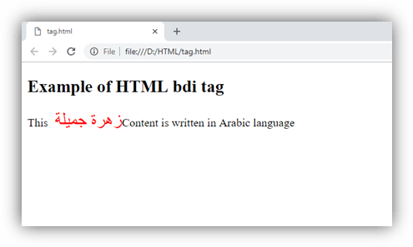

Attributes

Tag-specific attribute:
The <bdi> tag does not include any specific attribute

Global attribute:
The <bdi> tag supports all Global attribute

Event Attributes:
The <bdi> tag supports all Event Attributes

Difference between <bdi> and <bdo>
HTML <bdi> tag is new element of HTML5 and it is very similar to HTML <bdo> element. But the main difference in both the elements is that <bdi> tag isolates the content from its surrounding content but <bdo> tag reveres the direction. Sometimes <bdo> tag may cause some unexpected rendering errors so try to use <bdi> if required.

Supporting Browsers
Element | Chrome | IE | Firefox | Opera | Safari
<bdi> | Yes | No | Yes | Yes | Yes

HTML <bdo> tag
HTML <bdo> tag stands for "bidirectional override" which is used to overrides the current/default text direction. This tag sets the direction of content within it to render on browser from left to right or right to left.
The <bdo> tag is useful for the languages which are written from right to left such as Arabic and Hebrew.

Syntax
- <bdo dir=" "> Content......</bdo>
Following are some specifications about the <bdo> tag
Display | Inline
Start tag/End tag | Both start and End tag
Usage | textual

Example
- <!DOCTYPE html>
- <html>
- <head>
- <title>Bdo tag</title>
- </head>
- <body>
- <h2>Example of HTML bdo tag</h2>
- <p style="color:#ff4040">This is Normal Content with default directionality</p>
- <p>This is with left to right directionality:
- <bdo dir="ltr" style="color: #5f9ea0">A beautiful Flower</bdo>
- </p>
- <p>This is with right to left directionality:
- <bdo dir="rtl" style="color:#68228b">A beautiful Flower</bdo>
- </p>
- </body>
- </html>
Output:
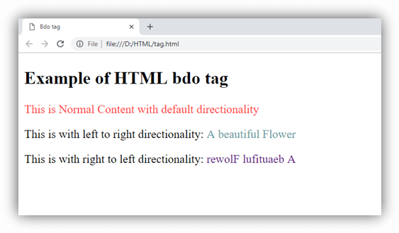

Attributes
Tag-specific attributes
Attribute | Value | Description
dir
dir |  | ltr | Defines the directionality from left to right.
dir |  | rtl | Defines the directionality from right to left.

Global Attributes
The <bdo> tag supports the Global attribute in HTML.

Event Attributes
The <bdo> tag supports the Event attribute in HTML.

Supporting Browsers
Element | Chrome | IE | Firefox | Opera | Safari
<bdo> | Yes | Yes | Yes | Yes | Yes

HTML <big> tag (Not supported in HTML5)
HTML <big> tag was used to increase the text font size one level bigger than the document's base font size or surrounding text size, such as small to medium, medium to large, etc.

NOTE: HTML <big> tag is no longer supported by HTML5, so you can use CSS to increase the font size.

Syntax
- <big>Content... </big>
Following are some specifications about the <big> tag
Display | Inline
Start tag/End tag | Both start and End tag
Usage | Fonts and Web Typography

Example
- <!DOCTYPE html>
- <html>
- <head>
- <title>Big tag</title>
- </head>
- <body>
- <h2>Example of HTML big tag</h2>
- <p style="color:#ff4040">This is paragraph with normal font size</p>
- <p style="color:#00bfff">
- <big>This is paragraph with font size greater than the previous content</big>
- </p>
- </body>
- </html>
Output:
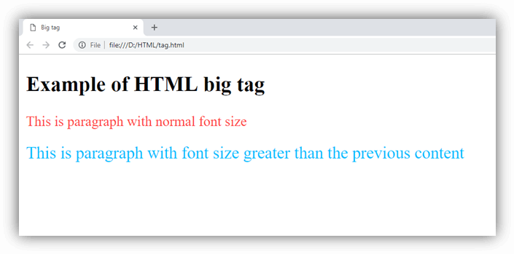

Increasing Font-size using CSS property:
- <!DOCTYPE html>
- <html>
- <head>
- <style>
- .fsize{
- font-size: 18px;
- color: red;
- }
- </style>
- </head>
- <body>
- <h2>Example to change font size using CSS</h2>
- <p>The paragraph content with default font size</p>
- <p class="fsize">The paragraph content with CSS to increase font size</p>
- </body>
- </html>
Output:
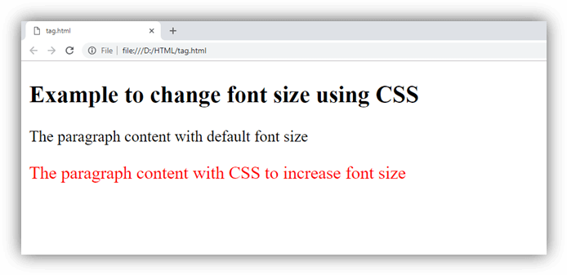

Attribute
Tag-specific Attribute:
The <big> element does not contain any specific attribute.

Global Attribute
The <big> element supports the Global Attribute in HTML.

Supporting Browsers
Element | Chrome | IE | Firefox | Opera | Safari
<big> | Yes | Yes | Yes | Yes | Yes

HTML <blockquote> tag
HTML <blockquote> tag is used to define a block of text which is quoted from another source. The Browser usually displays the content within <blockquote> tag as indented text.
If you want to insert a long quote then use <blockquote> and for short or inline quote use <q> tag.

Syntax
- <blockquote> quoted text......</blockquote>
Following are some specifications about the <blockquote> tag
Display | Block
Start tag/End tag | Both start and End tag
Usage | Semantic/textual

Example
- <!DOCTYPE html>
- <html>
- <head>
- <title>Blockquote tag</title>
- </head>
- <body>
- <h2>Example of blockquote tag</h2>
- <p>A Great Motivational Quote :</p>
- <blockquote cite="https://www.brainyquote.com/authors/erin_cummings">
- <p>
- At the end of the day, you are solely responsible for your success and your failure. And the sooner you realize that, you accept that, and integrate that into your work ethic, you will start being successful. As long as you blame others for the reason you aren't where you want to be, you will always be a failure.
- </p>
- </blockquote>
- <cite>Erin Cummings</cite>
- </body>
- </html>
Output:
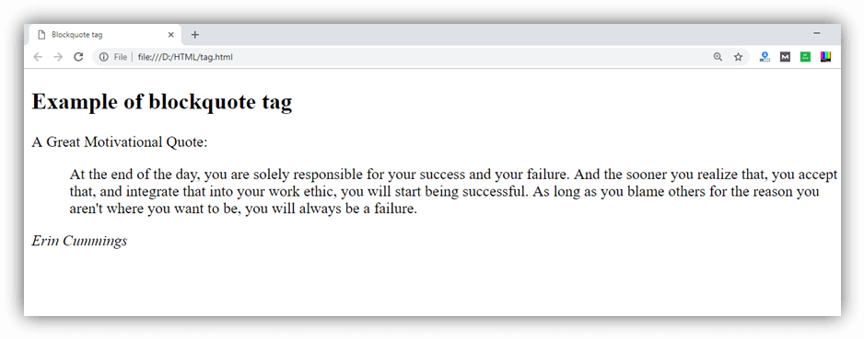

Styling <blockquote> tag
- <!DOCTYPE html>
- <html>
- <head>
- <title>Blockquote tag</title>
- <style>
- blockquote{
- text-align: justify;
- background-color: #F7EAE9;
- border-radius: 4px;
- margin-right: 25px;}
- cite{
- margin-left: 15px;}
- </style>
- </head>
- <body>
- <h2>Example of blockquote tag</h2>
- <p>A Great Motivational Quote:</p>
- <blockquote cite="https://www.brainyquote.com/authors/erin_cummings">
- <p>
- At the end of the day, you are solely responsible for your success and your failure. And the sooner you realize that, you accept that, and integrate that into your work ethic, you will start being successful. As long as you blame others for the reason you aren't where you want to be, you will always be a failure.
- </p>
- </blockquote>
- <cite>-Erin Cummings</cite>
- </body>
- </html>

Note: We have used CSS property margin-right: 25px to change the indentation applied to the text. You can also use margin-left or margin shorthand property.
Output:
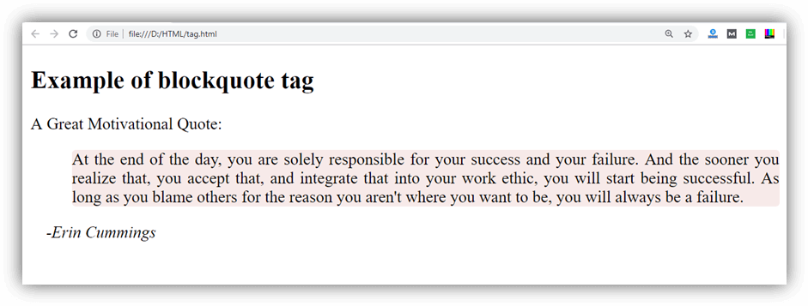

Attribute

Tag specific attribute
Attribute | value | Description
cite | URL | It is used to specify the URL of the source from where the quote is taken.

Global attributes
The <blockquote> tag supports all the global attributes in HTML.

Event attributes
The <blockquote> tag supports all events attributes in HTML.

Supporting Browsers
Element | Chrome | IE | Firefox | Opera | Safari
<blockquote> | Yes | Yes | Yes | Yes | Yes

HTML <body> tag
HTML <body> tag defines the main content of an HTML document which displays on the browser. It can contain text content, paragraphs, headings, images, tables, links, videos, etc.
The <body> must be the second element after the <head> tag or it should be placed between </head> and </html> tags. This tag is required for every HTML document and should only use once in the whole HTML document.

Syntax
- <body> Place your Content here........</body>
Following are some specifications about the <body> tag
Display | Inline
Start tag/End tag | Both start and End tag
Usage | Structural

Example
- <!DOCTYPE html>
- <html>
- <head>
- <title>Body Tag</title>
- </head>
- <body>
- <h2>Example of body tag</h2>
- <p>This paragraph is written between the body tag</p>
- </body>
- </html>
Output:
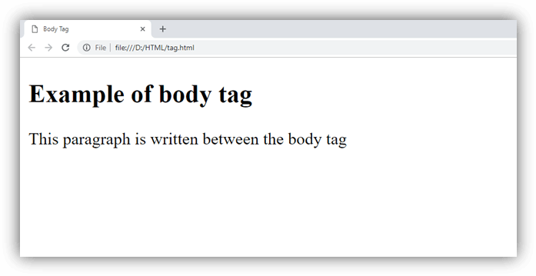

Attribute

Tag specific Attributes
Attribute | Value | Description
alink | color | It defines the color of the active link in a document. (Not supported in HTML5)
background | URL | It determines the background image for the document. (Not supported in HTML5)
bgcolor | color | It determines the background color of the content. (Not supported in HTML5)
link | color | It determines the color of the unvisited link. (Not supported in HTML5)
text | color | It determines the color of the text in the document. (Not supported in HTML5)
vlink | color | It determines the color of the visited link. (Not supported in HTML5)
onload |  | Function call on page loading
onunload |  | Function call when user leaves the page
onfocus |  | Function call when document receives focus by user.
onblur |  | Function call when document loses focus by user.

Global Attribute
The <body> attribute supports global attribute in HTML.

Event Attribute
The <body> attribute supports Event attributes in HTML.

Supporting Browsers
Element | Chrome | IE | Firefox | Opera | Safari
<body> | Yes | Yes | Yes | Yes | Yes

HTML <br> tag
The <br> tag in HTML document is used to create a line break in a text.
It is generally used in poem or address where the division of line is necessary. It is an empty tag, which means it does not need a company of end tag. If you place the <br> tag in the HTML code, then it works the same as pressing the enter key in a word processor.

Note: Don't use br tag for the margin between two paragraphs, use CSS margin property instead.

Syntax
- Text <br> Text

Difference between HTML <br> and <br/>
You can use HTML br tag two ways: <br> or <br/>. It is recommended to use closed br tag <br/> because it is supported in HTML and XHTML both.
Example 1:
- <!DOCTYPE HTML>
- <html>
- <head>
- <title>
- Example of BR tag
- </title>
- </head>
- <body>
- <p>If you want to break a line <br> in a paragraph, <br> use the BR element in <br> your HTML document. </p>
- </body>
- </html>
Output:
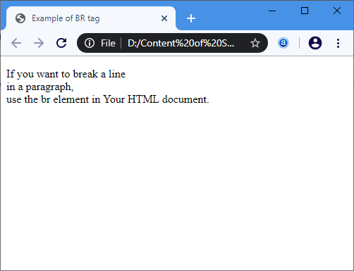
Example 2: The following example uses the <br> tag in the address:
- <!DOCTYPE HTML>
- <html>
- <head>
- <title>
- Example of BR tag in Address
- </title>
- </head>
- <body> <font color="green"> <!-The color attribute displays the color of following address in green -->
- <p>Central park <br>
- D.M Road, <br>
- New Delhi, <br>
- India <br>
- </body>
- </html>
Output:
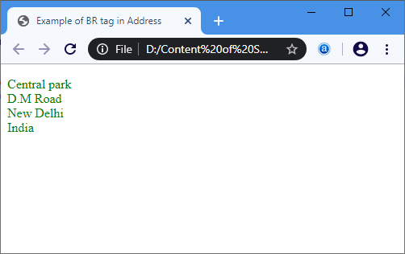
Example 3: The following example uses the <br> tag in the poem:
- <!DOCTYPE HTML>
- <html>
- <head>
- <title>
- Example of BR tag in Poem
- </title>
- </head>
- <body> <font color="green">
- <center> Dreams

- </center>
- Hold fast to dreams <br>

- For if dreams die <br>

- Life is a broken-winged bird <br>

- That cannot fly. <br>

- Hold fast to dreams <br>

- For when dreams go <br>

- Life is a barren field <br>

- Frozen with snow. <br>
- </body>
- </html>
Output:
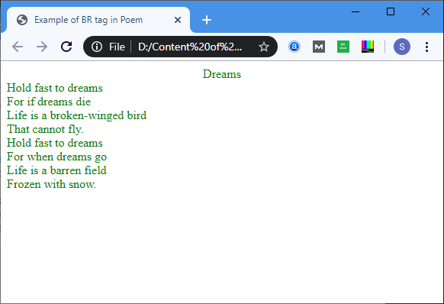

Browser Support
Element | Chrome | IE | Firefox | Opera | Safari
<br> | Yes | Yes | Yes | Yes | Yes

HTML Button Tag
The <button> tag is used to create a clickable button within HTML form on your webpage. You can put content like text or image within the <button>........</button> tag.
You should always specify the type attribute for a <button> tag. Different browsers use different default type for the button element.
HTML Button tag can be used inside and outside the form.
If you use it inside the form, it works as the submit button. You can also use it as reset button.
If you use it outside the form, you can call JavaScript function on it.

HTML Button Tag Example
Let's see the code to display the button.
- <button name="button" type="button">Click Here</button>
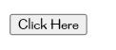
Output:

HTML Button Example: Calling JavaScript Function
Let's see the code to call JavaScript function on button click.
- <button name="button" value="OK" type="button" onclick="hello()">Click Here</button>
- <script>
- function hello(){
- alert("hello javatpoint user");
- }
- </script>

HTML Button Example: Submit Form
Let's see the code to submit form on button click.
- <form>
- Enter Name:<input type="text" name="name"/><br/>
- <button>Submit</button>
- </form>

HTML Button Example: Reset Form
Let's see the code to submit form on button click.
- <form>
- Enter Name:<input type="text" name="name"/><br/>
- <button type="reset">reset</button>
- </form>

Attributes of HTML Button Tag
<button> tag supports all global attributes and some specific additional attributes.
There is given a list of HTML button tag attributes.
Attribute | Description
autofocus | It specifies that a button should automatically get focus while the loading of the page.
disabled | It specifies that a button shuld be disabled.
form | It specifies one or more forms that the button belongs to.
formaction | It is used for submit type. It specifies where to send the form data when form is submitted.
formmethod | It specifies how to send form-data.
formenctype | It specifies how form-data should be encoded before sending it to server.
formnovalidate | It specifies that the form data should not be validated on submission.
formtarget | It specifies that where to display the response after submitting the form.
name | It specifies the name of the button.
type | It specifies the type of the button.
value | It specifies the value of the button.

Supporting Browsers
Element | Chrome | IE | Firefox | Opera | Safari
<button> | Yes | Yes | Yes | Yes | Yes

HTML button tag also supports the global and event attributes in HTML.

HTML Canvas Tag
The HTML canvas element provides HTML a bitmapped surface to work with. It is used to draw graphics on the web page.
The HTML 5 <canvas> tag is used to draw graphics using scripting language like JavaScript.
The <canvas> element is only a container for graphics, you must need a scripting language to draw the graphics. The <canvas> element allows for dynamic and scriptable rendering of 2D shapes and bitmap images.
It is a low level, procedural model that updates a bitmap and does not have a built-in scene. There are several methods in canvas to draw paths, boxes, circles, text and add images.

How to create a HTML canvas?
A canvas is a rectangle like area on an HTML page. It is specified with canvas element. By default, the <canvas> element has no border and no content, it is like a container.
- <canvas id = "mycanvas" width ="200" height ="100"> </canvas>

HTML 5 Canvas Tag Example
- <canvas id="myCanvas1" width="300" height="100" style="border:2px solid;">
- Your browser does not support the HTML5 canvas tag.
- </canvas>
Output:
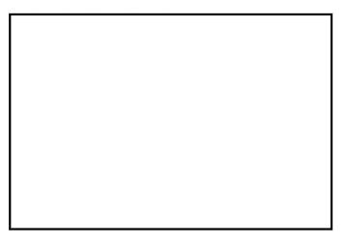

Note: It is always necessary to specify the id attribute and the height & width attribute to define the size of the canvas. You can have multiple canvas elements on one HTML page.

Supporting Browsers
Element | Chrome | IE | Firefox | Opera | Safari
<canvas> | Yes | Yes | Yes | Yes | Yes

HTML Canvas Tag with JavaScript
A canvas is a two dimensional grid.
Coordinates (0,0) defines the upper left corner of the canvas. The parameters (0,0,200,100) is used for fillRect() method. This parameter will fill the rectangle start with the upper-left corner (0,0) and draw a 200 * 100 rectangle.
- <canvas id="myCanvas" width="250" height="150" style="border:1px solid #c3c3c3;">
- Your browser does not support the HTML5 canvas tag.
- </canvas>
- <script>
- var c = document.getElementById("myCanvas");
- var cctx = c.getContext("2d");
- ctx.fillStyle = "#FF0000";
- ctx.fillRect(0,0,200,100);
- </script>
Output:

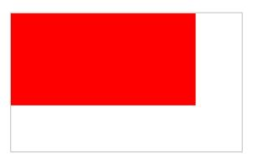
Drawing Line on Canvas
If you want to draw a straight line on the canvas, you can use the following two methods.
moveTo(x,y): It is used to define the starting point of the line.
lineTo(x,y): It is used to define the ending point of the line.
If you draw a line which starting point is (0,0) and the end point is (200,100), use the stroke method to draw the line.
- <canvas id="myCanvasLine" width="200" height="100" style="border:1px solid #d3d3d3;">
- Your browser does not support the HTML5 canvas tag.</canvas>
- <script>
- var c = document.getElementById("myCanvasLine");
- var cctx = c.getContext("2d");
- ctx.moveTo(0,0);
- ctx.lineTo(200,100);
- ctx.stroke();
- </script>
Output:

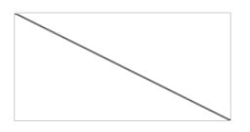
Drawing Circle on Canvas
If you want to draw a circle on the canvas, you can use the arc() method:
- arc(x, y, r, start, stop)
To sketch circle on HTML canvas, use one of the ink() methods, like stroke() or fill().
- <canvas id="myCanvasCircle" width="200" height="100" style="border:1px solid #d3d3d3;">
- Your browser does not support the HTML5 canvas tag.</canvas>
- <script>
- var c = document.getElementById("myCanvasCircle");
- var cctx = c.getContext("2d");
- ctx.beginPath();
- ctx.arc(95,50,40,0,2*Math.PI);
- ctx.stroke();
- </script>
Output:

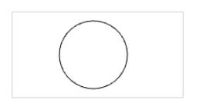
Drawing text on canvas
There are property and methods used for drawing text on the canvas.
font property: It is used to define the font property for the text.
fillText(text,x,y) method: It is used to draw filled text on the canvas. It looks like bold font.
strokeText(text,x,y) method: It is also used to draw text on the canvas, but the text is unfilled.
Let's see fillText() method example.
- <canvas id="myCanvasText1" width="300" height="100" style="border:1px solid #d3d3d3;">
- Sorry! Your browser does not support the HTML5 canvas tag.</canvas>
- <script>
- var c = document.getElementById("myCanvasText1");
- var cctx = c.getContext("2d");
- ctx.font = "30px Arial";
- ctx.fillText("Hello JavaTpoint",10,50);
- </script>
Output:

Let's see strokeText() method example.
- <canvas id="myCanvasText2" width="300" height="100" style="border:1px solid #d3d3d3;">
- Sorry!Upgrade your browser. It does not support the HTML5 canvas tag.</canvas>
- <script>
- var c = document.getElementById("myCanvasText2");
- var cctx = c.getContext("2d");
- ctx.font = "30px Arial";
- ctx.strokeText("Hello JavaTpoint",10,50);
- </script>
Output:
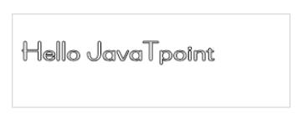

HTML <caption> tag
HTML <caption> tag is used to add a caption or title of an HTML table. It should be used inside the <table> element and just after the <table> start tag. A table may contain only one <caption> element.

Syntax
- <caption>Table title...</caption>
Following are some specifications about the <caption> tag
Display | Inline
Start tag/End tag | Both start and End tag
Usage | textual

Example 1
- <!DOCTYPE html>
- <html>
- <head>
- <title>Caption Tag</title>
- <style>
- table, td, th {
- border: 3px solid gray;
- border-collapse: collapse;}
- </style>
- </head>
- <body>
- <h2>Example of Caption tag</h2>
- <table width="800">
- <caption>Employee Details</caption>
- <thead>
- <tr>
- <th>Sr. No.</th>
- <th>Name</th>
- <th>Email</th>
- </tr>
- </thead>
- <tbody>
- <tr>
- <td>1.</td>
- <td>Ankit Pandey</td>
- <td>ankit2@gmail.com</td>
- </tr>
- <tr>
- <td>2.</td>
- <td>Ashvini Kumar</td>
- <td>ashvini@gmail.com</td>
- </tr>
- <tr>
- <td>3.</td>
- <td>Swati Sharma</td>
- <td>swati8@gmail.com</td>
- </tr>
- </tbody>
- </table>
- </body>
- </html>
Output:
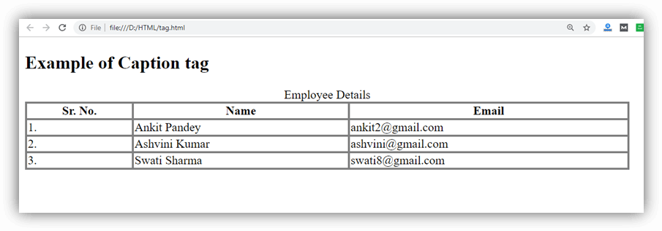

Attribute

Tag-specific Attributes
Attribute | Value | Description
align | - top  - bottom  - left  - right | It aligns the caption with respect to table

Global Attributes
The <caption> tag supports the Global attributes

Event Attributes
The <caption> tag supports the event attributes.

Supporting Browsers
Element | Chrome | IE | Firefox | Opera | Safari
<caption> | Yes | Yes | Yes | Yes | Yes

HTML <center> tag (Not Supported in HTML5)
The HTML <center> is a block level element which contains both block level and inline contents within it. The content written between the <center> elements will be displayed at the middle of the page.
The <center> tag has been deprecated in HTML 4 and obsolete in HTML5.

NOTE: The <center> tag is deprecated now so instead of that you can use CSS property text-align: center; to achieve the same result.

Syntax
- <center>Add Content Here....</center>
Following are some specifications about the <center> tag
Display | Inline
Start tag/End tag | Both start and End tag
Usage | textual

Example
Using <center> tag
- <!DOCTYPE html>
- <html>
- <head>
- <title>Center tag</title>
- </head>
- <body>
- <h2>Example of center tag</h2>
- <center>This content is displayed in the middle of page, but try to use CSS property to align the content as this tag is deprecated now.</center>
- </body>
- </html>
Using CSS
- <!DOCTYPE html>
- <html>
- <head>
- <title>Center tag</title>
- <style >
- h2{
- text-align: center;}
- </style>
- </head>
- <body>
- <h2>Example of center tag</h2>
- <p>This content is align centered using CSS property</p>
- </body>
- </html>
Output:
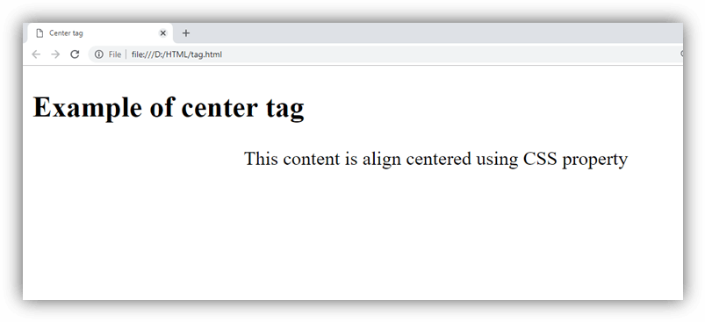

Attribute
HTML <center> tag does not contain any specific attribute in HTML but it supports the Global Attribute (till <center> tag is not removed completely).

Supporting Browsers
Element | Chrome | IE | Firefox | Opera | Safari
<center> | Yes | Yes | Yes | Yes | Yes

HTML <cite> tag
HTML <cite> tag specifies a citation, it provides reference or title to a creative work, quoted content, books, websites, a research paper, a blog-spot, painting, etc.
The main purpose of adding <cite> element is to provide or identify the source of the quote or any content.
The content written between <cite> tag renders in the italic form on the browser, and it can be overridden using CSS in your HTML document.

Syntax
- <cite>Cited Content.......</cite>
Following are some specifications about the <cite> tag
Display | Inline
Start tag/End tag | Both start and End tag
Usage | textual

Example:
- <!DOCTYPE html>
- <html>
- <head>
- <title>Cite Tag</title>
- </head>
- <body>
- <h2>Example of cite tag</h2>
- <img src="https://static.javatpoint.com/htmlpages/images/book.jpg" height="150" width="120">
- <p>A famous book:
- <cite> Learning Web Design</cite> written by Jennifer Niederst Robbins
- </p>
- </body>
- </html>
Output:
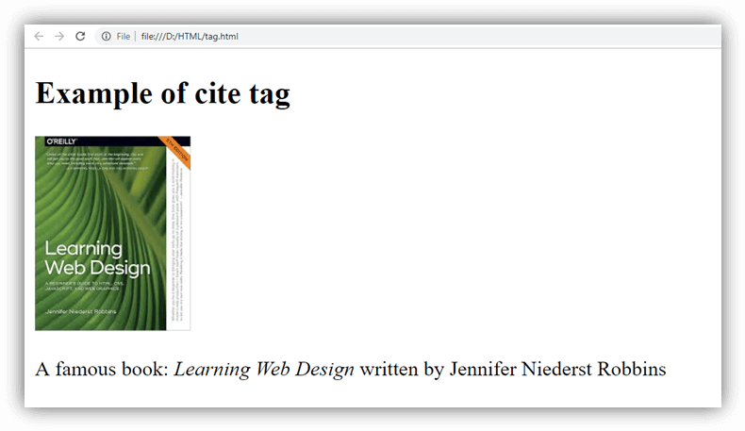

Attribute

Tag-specific attribute
HTML <cite> tag does not contain any specific attribute.

Global Attribute
HTML <cite> tag supports all Global attributes in HTML

Event Attribute
HTML <cite> tag supports all Event attributes in HTML.

Supporting Browsers
Element | Chrome | IE | Firefox | Opera | Safari
<cite> | Yes | Yes | Yes | Yes | Yes

HTML code tag
HTML <code> tag is used to represent computer code. It is a phrase tag which defines a piece of computer code. By default, it is displayed in the browser's default monospace font (also known as fixed-width font).

List of HTML phrase tags
Tag | Description
<em> | displays emphasized text
<strong> | displays important text
<dfn> | defines a definition term
<code> | defines a piece of computer code
<samp> | specifies a sample output from a computer program
<kbd> | defines keyboard input
<var> | defines a variable

HTML phrase tags example including code tag
- <em>It is inside em tag.</em><br>
- <strong>It is inside strong tag.</strong><br>
- <dfn>It is inside dfn tag.</dfn><br>
- <code>It is inside code tag.</code><br>
- <samp>It is inside samp tag.</samp><br>
- <kbd>It is inside kbd tag.</kbd><br>
- <var>It is inside var tag.</var>
Output:
It is inside em tag.
It is inside strong tag.
It is inside dfn tag.
It is inside code tag.
It is inside samp tag.
It is inside kbd tag.
It is inside var tag.

Supporting Browsers
Element | Chrome | IE | Firefox | Opera | Safari
<code> | Yes | Yes | Yes | Yes | Yes

HTML <col> tag
HTML <col> tag is used to specify common column properties for each column within <colgroup> element in an HTML table.
The <col> tag is useful when it requires to apply common style rules for each column cell rather than applying individually.

Syntax
- <col span=" " style=" ">

Note: In HTML <col> tag does not require a closing tag but in XHTML it require a closing </col> tag.
Following are some specifications about the HTML <col> tag
Display | Inline
Start tag/End tag | Start tag(Empty tag)
Usage | HTML tables

Example 1
- <!DOCTYPE html>
- <html>
- <head>
- <title>Col tag</title>
- </head>
- <body>
- <h2>Example of Col Tag</h2>
- <table border="1">
- <colgroup>
- <col span="2" style="background-color: #7fffd4">
- <col span="2" style="background-color: #98f5ff">
- </colgroup>
- <tr>
- <th>Roll No.</th>
- <th>Name</th>
- <th>Maths</th>
- <th>Science</th>
- </tr>
- <tr>
- <td>1</td>
- <td>Avinash</td>
- <td>68</td>
- <td>54</td>
- </tr>
- <tr>
- <td>2</td>
- <td>Neha</td>
- <td>65</td>
- <td>61</td>
- </tr>
- <tr>
- <td>3</td>
- <td>Jenny</td>
- <td>55</td>
- <td>78</td>
- </tr>
- <tr>
- <td>4</td>
- <td>Vivek</td>
- <td>75</td>
- <td>52</td>
- </tr>
- </table>
- </body>
- </html>
Output:
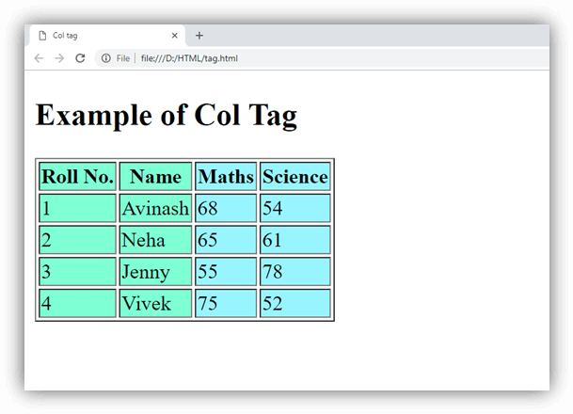

Attribute:
Tag-specific Attribute
element should contain. The default value of span attribute is 1.
Attribute | Value | Description
align | - left  - center  - right  - justify  - char | It specifies the horizontal alignment of each column cell.  (Not supported in HTML5).
char | character | It specifies the alignment of content based on Characters in a column. It will be ignored if align is not set to char. (Not supported in HTML5).
charoff | number | It sets the number of characters to offset the column data from the alignment character specified by the char attribute. (Not supported in HTML5).
span | number | It specifies the number of the columns which a
valign | - top  - middle  - bottom  - baseline | It specifies the vertical alignment of the columns.  (Not supported in HTML5).
width | - %  - Pixels  - relative_length | It specifies the width of the column.  (Not supported in HTML5).

Global Attribute
HTML <col> tag supports all Global attributes in HTML.

Event Attribute
HTML <col> tag supports all event attributes in HTML.

Supporting Browsers
Element | Chrome | IE | Firefox | Opera | Safari
<col> | Yes | Yes | Yes | Yes | Yes

HTML <colgroup> tag
HTML <colgroup> tag specifies group of column within an HTML table. It is used a parent container of one or more <col> elements to apply different properties in an HTML table.

NOTE: The <colgroup> tag must be used with <table> element after the <caption> and before <thead> or <tbody> elements.

Syntax
<colgroup>......</colgroup>
Following are some specifications about the HTML <colgroup> tag
Display | None
Start tag/End tag | Start tag and End Tag
Usage | HTML tables

Example
- <!DOCTYPE html>
- <html>
- <head>
- <title>Colgroup tag</title>
- </head>
- <body>
- <h2>Example of Colgroup Tag</h2>
- <table border="1">
- <colgroup>
- <col style="background-color: green" width="40">
- <col span="2" style="background-color: #ff7256" width="80">
- </colgroup>
- <tr>
- <th>Sr.No</th>
- <th>Product</th>
- <th>Price</th>
- </tr>
- <tr>
- <td>1</td>
- <td>Rice</td>
- <td>85</td>
- </tr>
- <tr>
- <td>2</td>
- <td>Butter</td>
- <td>260</td>
- </tr>
- <tr>
- <td>3</td>
- <td>Mango</td>
- <td>125</td>
- </tr>
- </table>
- </body>
- </html>
Output:
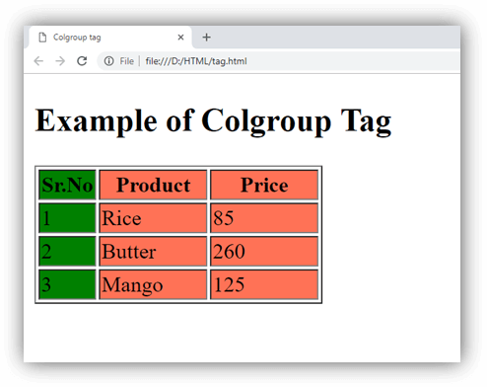

Attributes
Attribute | Value | Description
align | - left  - center  - right  - justify  - char | It specifies the alignment of the column content. (Not supported in HTML5).
char | character | It specifies the alignment of the content in a column group to the character. (Not supported in HTML5).
charoff | number | It sets the number of characters to offset the column data from the alignment character specified by the char attribute. (Not supported in HTML5).
span | number | It specifies the number of columns a colgroup should span.
valign | - top  - middle  - bottom  - baseline | It specifies the vertical alignment of the column group. (Not supported in HTML5).
width | - %  - Pixels  - relative_length | It specifies the width of the group of column. (Not supported in HTML5).

Global Attribute
HTML <colgroup> tag supports all Global attributes in HTML.

Event Attribute
HTML <colgroup> tag supports all event attributes in HTML.

Supporting Browsers
Element | Chrome | IE | Firefox | Opera | Safari
<colgroup> | Yes | Yes | Yes | Yes | Yes

HTML Data Tag
The HTML <data> tag is used to provide a machine readable version of its own contents. It displays the data in a special format. It is useful in the case where your data needs to be in a certain format because it may be processed by a script, but this might not be the format that you'd like your users to see.
Let's take a scenario to understand it well:
Suppose you have to represent some numbers to your users with letter (i.e. one, two, three and so on) but you have script that sorts the numbers in ascending or descending orders. So your script needs numbers in a format like 1, 2, 3... etc.
The <data> tag is here to solve your problem.
For the users: Write within the <data>....</data> tag.
For the script: Use value attribute.
- <data value="1">One </data>

HTML data tag attribute
There is only one required attribute. The data tag supports global and event attributes also.
Attribute | Description
value | It is required attribute. It is used to provide the machine-readable version of tag's content.

HTML data tag example
- <ul>
- <li><data value="101">Java Tutorial</data></li>
- <li><data value="111">SQL tutorial</data></li>
- <li><data value="121">HTML tutorial</data></li>
- </ul>
Output:
- Java Tutorial
- SQL tutorial
- HTML tutorial

Supporting Browsers
Element | Chrome | IE | Firefox | Opera | Safari
<data> | Yes | Yes | Yes | Yes | Yes

HTML Datalist Tag
The HTML <datalist> tag is is used to provide an auto complete feature on form element. It provides a list of predefined options to the users to select data.
The datalist tag is introduced in HTML5.
The <datalist> tag should be used with an <input< element that contains a "list" attribute. The value of "list" attribute is linked with the datalist id.

The HTML datalist tag supports global and event attributes also.

HTML datalist tag example
Let's see the simple example of HTML5 datalist tag. If you press A, it will show a list of cricketers starting with A letter.
- <label>
- Enter your favorite cricket player: Press any character<br />
- <input type="text" id="favCktPlayer" list="CktPlayers">
- <datalist id="CktPlayers">
- <option value="Sachin Tendulkar">
- <option value="Brian Lara">
- <option value="Jacques Kallis">
- <option value="Ricky Ponting">
- <option value="Rahul Dravid">
- <option value="Shane Warne">
- <option value="Rohit Sharma">
- <option value="Donald Bradman">
- <option value="Saurav Ganguly ">
- <option value="AB diVilliers">
- <option value="Mahendra Singh Dhoni">
- <option value="Adam Gilchrist">
- </datalist>
- </label>
Output:

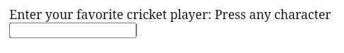
Supporting Browsers
Element | Chrome | IE | Firefox | Opera | Safari
<datalist> | Yes | Yes | Yes | Yes | Yes

HTML Description List | HTML Definition List
HTML Description List or Definition List displays elements in definition form like in dictionary. The <dl>, <dt> and <dd> tags are used to define description list.
The 3 HTML description list tags are given below:
- <dl> tag defines the description list.
- <dt> tag defines data term.
- <dd> tag defines data definition (description).

- <dl>
- <dt>HTML</dt>
- <dd>is a markup language</dd>
- <dt>Java</dt>
- <dd>is a programming language and platform</dd>
- <dt>JavaScript</dt>
- <dd>is a scripting language</dd>
- <dt>SQL</dt>
- <dd>is a query language</dd>
- </dl>
Output:
HTML
is a markup language
Java
is a programming language and platform
JavaScript
is a scripting language
SQL
is a query language

Supporting Browsers
Element | Chrome | IE | Firefox | Opera | Safari
<dl> | Yes | Yes | Yes | Yes | Yes

HTML <del> tag
HTML <del> tag is used to represent the range of text that has been deleted/removed from the document. It is used as a Markup for the deleted content. The browser generally renders it by strike a line through the deleted text, although this can be changed using the CSS property.

Note: To identify the deleted text and inserted text use <ins> tag with <del> which will display deleted and inserted text in a document.

Syntax
- <del> Content........</del>
Following are some specifications about the HTML <del> tag
Display | Inline
Start tag/End tag | Both Start and End tag
Usage | Textual

Example 1
- <!DOCTYPE html>
- <html>
- <head>
- <title>Del tag</title>
- </head>
- <body>
- <h2>Example of Del Tag</h2>
- <p>It represent the <del> deleted </del> text. </p>
- </body>
- </html>
Output:
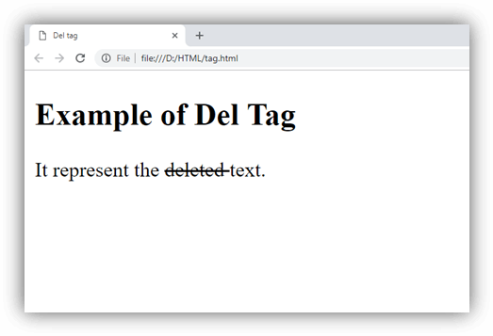

Example 2
Using CSS and <ins> tag
- <!DOCTYPE html>
- <html>
- <head>
- <title>Del tag</title>
- <style>
- del{
- color: red;
- background-color: #fde1e5;}
- ins{
- color:#16c39a;}
- </style>
- </head>
- <body>
- <h2>Example of Del Tag</h2>
- <p>Rishi came to Rahul's palce to <del>shock </del> <ins> surprise </ins> him</p>
- </body>
- </html>
Output:
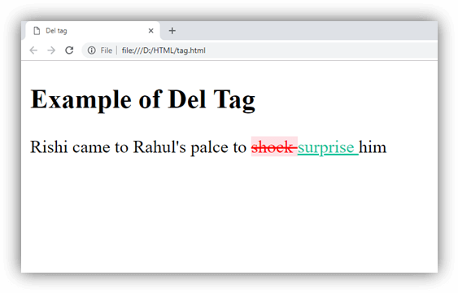

Attribute
Attribute | Value | Description
cite | URL | It specifies a URL of the resource which explains change or reason of deleting text.
datetime | YYYY-MM-DDThh:mm:ssTZD | It specifies the date and time when text is deleted.

Global Attribute
HTML <del> tag supports the Global attributes.

Event Attribute
HTML <del> tag supports the Event attributes.

Supporting Browsers
Element | Chrome | IE | Firefox | Opera | Safari
<del> | Yes | Yes | Yes | Yes | Yes

HTML Details Tag
HTML <details> tag is used to specify the additional details on the web page that the user can view or hide on demand.
According to W3C HTML specification, it is used as a disclosure widget from which user can retrieve additional information or control.
It is used together with a relevant tag known as <summary>. Technically, there is no need of summary tag, but if you ignore this then the browser will use some default text.
The <details> tag wraps all the content which you want to show or hide and the <summary> tag contains the summary and the title of the section.
HTML details is a new tag introduced in HTML5.
Let's take an example to understand this clearly.

HTML details tag attribute
HTML details tag also supports global and event attributes in HTML.
The details tag provides one specific attribute open.
Attribute | Description
open | It specifies that the details will be displayed (open) to the user.

HTML details tag example
- <details>
- <summary>Copyright 2011-2014.</summary>
- <p> - by JavaTpoint. All Rights Reserved.</p>
- <p>All content and graphics on this web site are the property of the javatpoint.com</p>
- </details>
- <p><b>Note:</b> The details tag is currently only supported in Opera, Chrome, and in Safari 6.</p>
Output:
Copyright 2011-2014.
- by JavaTpoint. All Rights Reserved.
All content and graphics on this web site are the property of the javatpoint.com
Note: The details tag is currently only supported in Opera, Chrome, and in Safari 6.

Supporting Browsers
Element | Chrome | IE | Firefox | Opera | Safari
<details> | Yes | No | No | Yes | Yes

HTML <dfn> tag
HTML <dfn> tag also called as HTML definition tag. It is used to represent the term which is defined within context of definition phrase or sentence in an HTML document. The defining instance term usually the first term in a document.
If a term is contained within the <dfn> element then browser understands that nearby text is the definition of the term.

Syntax
- <dfn>Content......... </dfn>
Following are some specifications about the HTML <dfn> tag
Display | Inline
Start tag/End tag | Both Start and End tag
Usage | Textual

Example
- <!DOCTYPE html>
- <html>
- <head>
- <title>Dfn tag</title>
- </head>
- <body>
- <h2>Example of dfn Tag</h2>
- <p><dfn>HTML</dfn> A markup language for Web designing</p>
- </body>
- </html>
Output:
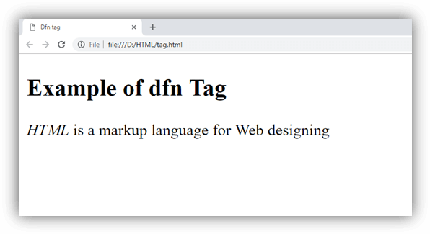

Using title attribute:
- <!DOCTYPE html>
- <html>
- <head>
- <title> Dfn tag</title>
- </head>
- <body>
- <h2>Example of dfn Tag</h2>
- <p> <dfn title="Transmission control protocol">TCP</dfn> is one of the main protocol of Internet protocols, used to interconnect network devices over the Internet</p>
- </body>
- </html>
Output:
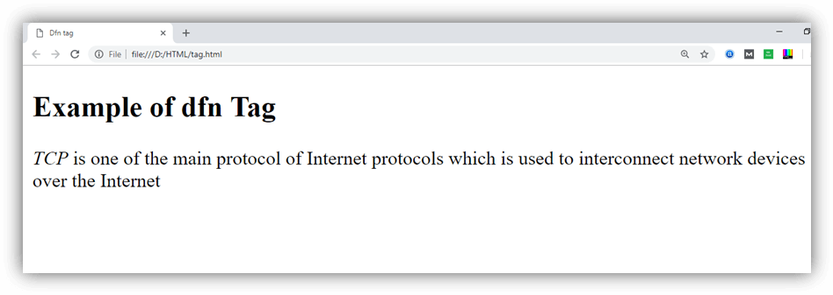

Attribute

Tag-specific attribute
Attribute | Value | Description
title |  | It specifies the definition of the term, and it shows when mouse hover on it.

Global attribute
HTML <dfn> tag supports the global attributes in HTML

Event attribute
HTML <dfn> tag supports the event attributes in HTML.

Supporting Browsers
Element | Chrome | IE | Firefox | Opera | Safari
<dfn> | Yes | Yes | Yes | Yes | Yes

HTML Dialog Tag
HTML <dialog> tag is used to create a new popup dialog on a web page. This tag represents a dialog box or other interactive component like window.
The <dialog> element uses a boolean attribute called open that activate element and facilitate user to interact with it.
HTML dialog is a new tag introduced in HTML5.

HTML dialog tag example
- <div>
- <dialog id="myFirstDialog" style="width:50%;background-color:#F4FFEF;border:1px dotted black;">
- <p><q>I am so clever that sometimes I don't understand a single word of what I am saying.
- </q> - <cite>Oscar Wilde</cite></p>
- <button id="hide">Close</button>
- </dialog>
- <button id="show">Show Dialog</button>
- </div>

- <!-- JavaScript to provide the "Show/Close" functionality -->
- <script type="text/JavaScript">
- (function() {
- var dialog = document.getElementById('myFirstDialog');
- document.getElementById('show').onclick = function() {
- dialog.show();
- };
- document.getElementById('hide').onclick = function() {
- dialog.close();
- };
- })();
- </script>
Output:
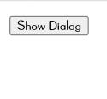
HTML dialog tag also supports global and event attributes in HTML.

Supporting Browsers
Element | Chrome | IE | Firefox | Opera | Safari
<dialog> | Yes | Yes | Yes | Yes | Yes

HTML <dir> tag (Not Supported in HTML5)
HTML <dir> tag was used as a container for the list of files/folders or content of the directory. The <dir> element is used with the <li> tags, and list of directories renders in bullets by default.

Note: Do not use HTML <dir> tag as it is deprecated now and not supported in HTML5. You can use <ul> tag and CSS property instead.

Syntax
- <dir>Directory list... </dir>
Following are some specifications about the HTML <dir> tag
Display | Block
Start tag/End tag | Both Start and End tag
Usage | HTML lists

Example 1
- <!DOCTYPE html>
- <html>
- <head>
- <title>Dir tag</title>
- <style>
- h2{
- color: #b22222;}
- p{
- color: green;}
- </style>
- </head>
- <body>
- <h2>Example of dir tag</h2>
- <p>List of javaTpoint popular Tutorials</p>
- <dir>
- <li>Java-tutorial</li>
- <li>DBMS-tutorial</li>
- <li>DataStructure-tutorial</li>
- <li>HTML-tutorial</li>
- </dir>
- </body>
- </html>
Output:
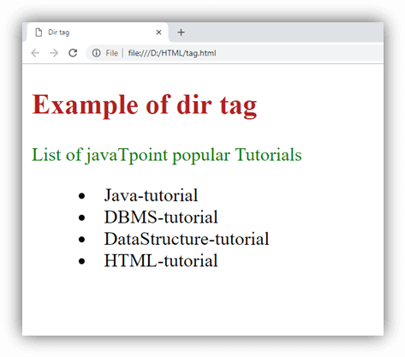

Attribute

Tag-specific Attribute
Attribute | Value | Description
compact | compact | It specifies that list should display smaller than normal. (Not supported in HTML5)

Global Attribute
HTML <dir> tag supports the Global attributes.

Event Attribute
HTML <dir> tag supports the Event attributes.

Supporting Browsers
Element | Chrome | IE | Firefox | Opera | Safari
<dir> | Yes | Yes | Yes | Yes | Yes

HTML Div Tag
The HTML <div> tag is used to group the large section of HTML elements together.
We know that every tag has a specific purpose e.g. p tag is used to specify paragraph, <h1> to <h6> tag are used to specify headings but the <div> tag is just like a container unit which is used to encapsulate other page elements and divides the HTML documents into sections.
The div tag is generally used by web developers to group HTML elements together and apply CSS styles to many elements at once. For example: If you wrap a set of paragraph elements into a div element so you can take the advantage of CSS styles and apply font style to all paragraphs at once instead of coding the same style for each paragraph element.
- <div style="border:1px solid pink;padding:20px;font-size:20px">
- <p>Welcome to Javatpoint.com, Here you get tutorials on latest technologies.</p>
- <p>This is second paragraph</p>
- </div>
Output:
Welcome to Javatpoint.com, Here you get tutorials on latest technologies.
This is second paragraph.

Difference between HTML div tag and span tag
div tag | span tag
HTML div is a block element. | HTML span is an inline element
HTML div element is used to wrap large sections of elements. | HTML span element is used to wrap small portion of texts, image etc.

HTML div example: Login Form
In this example, we are creating box using div tag. There is a login form inside the box. Let's see the CSS and HTML code.
CSS Code:
- .loginform{
- padding:10px;
- border:1px solid pink;
- border-radius:10px;
- float:right;
- margin-top:10px;
- }
- .formheading{
- background-color:red;
- color:white;
- padding:4px;
- text-align:center;
- }
- .sub{
- background-color:blue;
- padding: 7px 40px 7px 40px;
- color:white;
- font-weight:bold;
- margin-left:70px;
- border-radius:5px;
- }
HTML Code:
- <div class="loginform">
- <h3 class="formheading">Please Login</h3>
- <form action="LoginServlet" method="post">
- <table>
- <tr><td>Email:</td><td><input type="email" name="email"/></td></tr>
- <tr><td>Password:</td><td><input type="password" name="password"/></td></tr>
- <tr><td colspan="2" style="text-align:center"><input class="sub" type="submit" value="login"/></td></tr>
- </table>
- </form>
- </div>
Output:

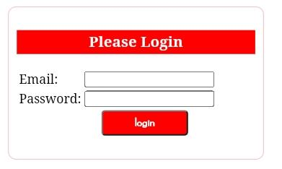
Supporting Browsers
Element | Chrome | IE | Firefox | Opera | Safari
<div> | Yes | Yes | Yes | Yes | Yes

HTML <em> tag
HTML <em> tag is used to stress emphasis the particular text within a sentence or phrase. It gives semantic meaning to the text contained within it and renders in the italic form on the browser.

Syntax
- <em>Write Important content here.....</em>
Following are some specifications about the HTML <em> tag
Display | Inline
Start tag/End tag | Both Start and End tag
Usage | Textual

Example
- <!DOCTYPE html>
- <html>
- <head>
- <title>Em Tag</title>
- <style>
- h2{
- color:#ff7f50;
- }
- </style>
- </head>
- <body>
- <h2>Example of em Tag</h2>
- <p>This is <em>HTML em tag</em> and it will emphasis the <em>important text</em> of the sentence</p>
- </body>
- </html>
Output:
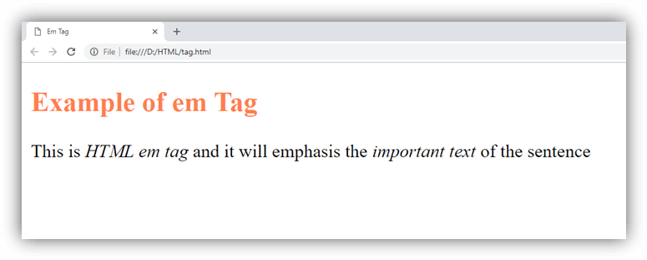

Attribute

Tag-specific attribute
The <em> tag does not contain any specific attribute in HTML.

Global attribute
The <em> tag supports the global attributes in HTML

Event attribute
The HTML <em> tag supports the event attributes in HTML.

Supporting Browsers
Element | Chrome | IE | Firefox | Opera | Safari
<em> | Yes | Yes | Yes | Yes | Yes

HTML <embed> tag
HTML <embed> tag is used to embed an external document in an HTML file which can be a third party application, multimedia, plugin(interactive content), etc. This element is new in HTML5.

Note: The <embed> element can be used to contain third party applications as well multimedia documents but in HTML5 the newly added <audio> and <video> elements are especially used to embed multimedia in HTML document.

Syntax
- <embed src=" " ></embed>
Following are some specifications about the HTML <embed> tag
Display | block
Start tag/End tag | Both Start and End tag
Usage | Embed third-party applications

Example 1
- <!DOCTYPE html>
- <html>
- <head>
- <title>Embed Tag</title>
- <style>
- h2{
- color: #cd5c5c;}
- p{
- color: #20b2aa;
- font-style: italic;}
- </style>
- </head>
- <body>
- <h2>Example of embed tag</h2>
- <p>The Dancing Penguin</p>
- <embed src="giphy.gif" height="200" width="300"></embed>
- </body>
- </html>
Output:
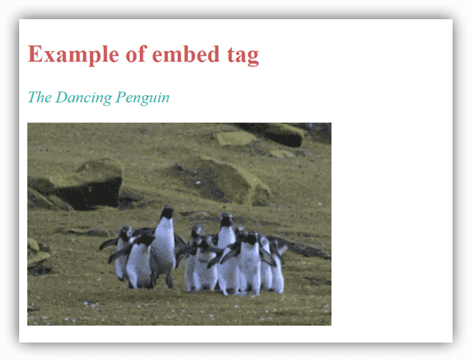

Attribute

Tag-specific attribute
Attribute | Value | Description
height | pixels | It specifies the height of the embedded content
src | URL | It defines the resource location of the embedded document.
type | media-type | It specifies the MIME type.
width | pixels | It determines the width of the embedded content.

Global attribute
The <embed> tag supports the global attributes in HTML

Event attribute
The <embed> tag supports the event attributes in HTML.

Supporting Browsers
Element | Chrome | IE | Firefox | Opera | Safari
<embed> | Yes | Yes | Yes | Yes | Yes

HTML <fieldset> tag
HTML <fieldset> tag is used to group the logically related fields/labels contained within an HTML form.
The use of this tag is optional while creating an HTML form but using <filedset>, it is easy to understand the purpose of grouped elements of form.
The <legend> tag is used with the <fieldset> element as a first child to define the caption for the grouped related fields.

Syntax
<fieldset>.....</fieldset>
Following are some specifications about the HTML <fieldset> tag
Display | Block
Start tag/End tag | Both Start and End tag
Usage | Structural (Within HTML Form)

Example 1
- <!DOCTYPE html>
- <html>
- <head>
- <title>fieldset Tag</title>
- <style>
- p{
- color: #db7093;
- margin-left: 440px;
- font-size: 40px;
- font-weight: bold;
- }
- form{
- color: white;
- width: 600px;
- height: 300px;
- margin: auto;
- margin-top: 30px;}
- div{
- background-color: #28455e;
- }
- .tx{
- margin-left: 20px;
- }
- </style>
- </head>
- <body>
- <h1>Example of fieldset Tag</h1>
- <p>User Feedback Form</p>
- <div>
- <form class="wd">
- <fieldset class="wd">
- <legend>User basic information:</legend>
- <label>First Name</label><br>
- <input type="text" name="fname"><br>
- <label>Last Name</label><br>
- <input type="text" name="lname"><br>
- <label>Enter Email</label><br>
- <input type="email" name="email"><br><br>
- </fieldset><br>
- <label class="tx">Enter your feedback:</label><br>
- <textarea class="tx" cols="30"></textarea><br><br>
- <input class="tx" type="Submit"><br>
- </form>
- </div>
- </body>
- </html>
Output:
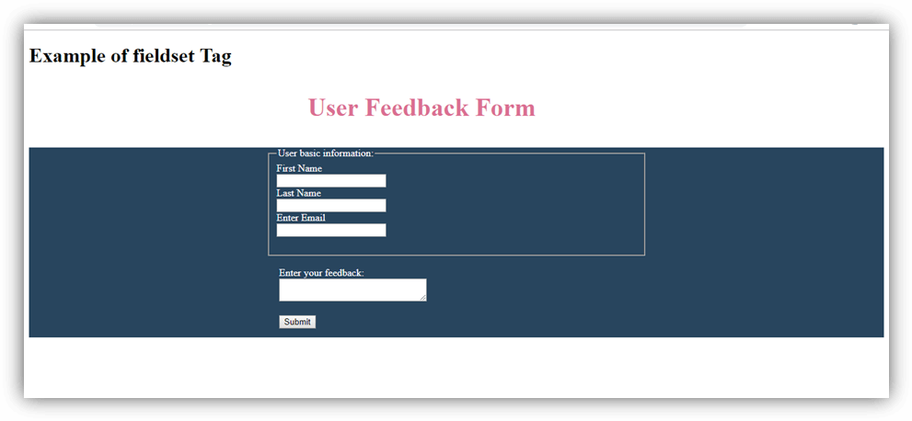

Attribute
= New in HTML5.

Tag-specific attribute
Attribute | Value | Description
disabled | disabled | It specifies that all form controls within the fieldset element are disabled.
form | form_id | It specifies the one or more form(s) to which fieldset controls belongs.
name | text | It specifies the name associated with fieldset. It will not display at the browser and useful with JS.

Global attribute
HTML < fieldset > tag supports the global attributes in HTML

Event attribute
HTML < fieldset > tag supports the event attributes in HTML.

Supporting Browsers
Element | Chrome | IE | Firefox | Opera | Safari
<fieldset> | Yes | Yes | Yes | Yes | Yes

HTML figcaption tag
The <figcaption> element is used to provide a caption to an image.
It is an optional tag and can appear before or after the content within the <figure> tag.
Only one <figcaption> element can be nested within a <figure> tag although the <figure> element itself may contain multiple other elements like <img> or <code>.
The <figcaption> element is used with <figure> element and it can be placed as the first or last child of the <figure> element.

HTML figure tag example
- <figure>
- <img src="https://static.javatpoint.com/htmlpages/images/tajmahal.jpg" alt="Taj Mahal"/>
- <figcaption>Fig.1.1 - A front view of the great Taj Mahal in Agra.</figcaption>
- </figure>
Output:

Fig.1.1 - A front view of the great Taj Mahal in Agra.

Supporting Browsers
Element | Chrome | IE | Firefox | Opera | Safari
<figcaption> | Yes | Yes | Yes | Yes | Yes

Note: HTML figcaption tag also supports the global and event attribute in HTML.

HTML figure tag
HTML <figure> tag is used to mark up a photo in the document on a web page.
As we know image tag is already available in HTML to display the pictures on web pages. But HTML 5 <figure> tag is used to handle the group of diagrams, photos, code listing etc. with some embedded content. You can also add a caption for the photo with the help of <figcaption> tag.
HTML figure is new a new tag introduced in HTML5.

HTML figure tag example
- <p>The Taj Mahal is widely recognized as "the jewel of Muslim art in India and
- one of the universally admired masterpieces of the world's heritage". It is regarded
- by many as the finest example of Mughal architecture, a style that combines elements
- from Islamic, Persian, Ottoman, Turkish and Indian architectural styles.</p>
- <figure>
- <img src="https://static.javatpoint.com/htmlpages/images/tajmahal.jpg" alt="Taj Mahal"/>
- </figure>
Output:
The Taj Mahal is widely recognized as "the jewel of Muslim art in India and one of the universally admired masterpieces of the world's heritage". It is regarded by many as the finest example of Mughal architecture, a style that combines elements from Islamic, Persian, Ottoman, Turkish and Indian architectural styles.

Note: The content you put within <figure>.......</figure> tag is related to the main flow, but its position is independent of the main flow and does not affect the flow the document when removed.

Supporting Browsers
Element | Chrome | IE | Firefox | Opera | Safari
<figure> | Yes | Yes | Yes | Yes | Yes

Note: HTML figure tag also supports the global and event attribute in HTML.

HTML <font> tag (Not Supported in HTML5)
HTML <font> tag is used to define the font style for the text contained within it. It defines the font size, color, and face or the text in an HTML document.

NOTE: Do not use HTML <font> tag as it is deprecated in HTML5, so you can use CSS properties to change the font size, face, color, etc.

Syntax
- <font size=" " color=" " face=" "> Content....</font>
Following are some specifications about the HTML <font> tag
Display | Inline
Start tag/End tag | Both Start and End tag
Usage | Font Style

Example 1
- <!DOCTYPE html>
- <html>
- <head>
- <title>Font Tag</title>
- </head>
- <body>
- <h2>Example of font tag</h2>
- <p>This is normal text without any font styling</p>
- <p>
- <font color="blue">Text with normal size and default face</font>
- </p>
- <p>
- <font size="5" color="green">Text with Increased size and default face</font>
- </p>
- <p>
- <font color="red" face="cursive">Text with Changed face</font>
- </p>
- </body>
- </html>
Output:
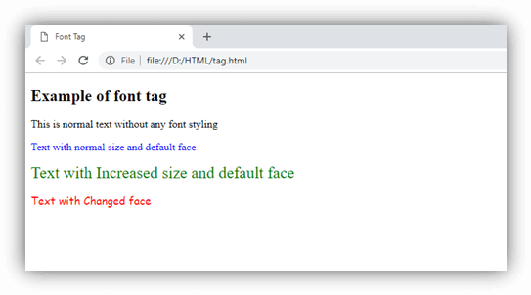

Using CSS
The same effect can be achieved using CSS properties as in below example:
- <!DOCTYPE html>
- <html>
- <head>
- <title>Font Tag</title>
- </head>
- <body>
- <h2>Change font using CSS</h2>
- <p>This is normal text without any font styling</p>
- <p style="color: blue;">Text with normal size and default face</p>
- <p style="font-size: 25px; color: green;">Text with Increased size and default face </p>
- <p style="font-family: cursive; color: red;">Text with Changed face</p>
- </body>
- </html>
Output:
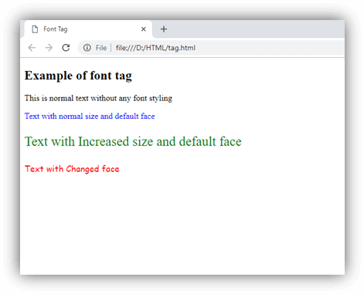

Attribute

Tag-specific attribute
Attribute | Value | Description
colod | rgb(X,X,X)  #xxxxx  color_name | It specifies the color of the content. (Not Supported in HTML5)
face | font_family | It specifies the typeface of the content. (Not Supported in HTML5)
size | number | It specifies the size of the content. (Not Supported in HTML5)

Supporting Browsers
Element | Chrome | IE | Firefox | Opera | Safari
<font> | Yes | Yes | Yes | Yes | Yes

HTML Footer Tag
HTML <footer> tag is used to define a footer for a document or a section. It is generally used in the last of the section (bottom of the page).
The footer tag is included in HTML5.
HTML <footer> tag contains information about its containing elements for example:
- author information
- contact information
- copyright information
- sitemap
- back to top links
- related documents etc.

Note: You can have one or many footer elements in one document.
If you want to put information like address, e-mail etc. about the author on your web page, all the relevant elements should be included into the footer element.

HTML Footer Tag Example
- <footer>
- <p>Posted by: Sonoo Jaiswal</p>
- <p>
- <address> JavaTpoint, plot no. 6, near MMX Mall,Mohan Nagar, Ghaziabad Pin no. 201007
- </address>
- </p>
- <p>Contact information:
- <a href="mailto:sonoojaiswal1987@gmail.com">sonoojaiswal1987@gmail.com</a>.
- </p>
- </footer>
Output:
Posted by: Sonoo Jaiswal
JavaTpoint, plot no. 6, near MMX Mall,Mohan Nagar, Ghaziabad Pin no. 201007
Contact information: sonoojaiswal1987@gmail.com.

Supporting Browsers
Element | Chrome | IE | Firefox | Opera | Safari
<footer> | Yes | Yes | Yes | Yes | Yes

HTML <frame> tag (Not supported in HTML5)
HTML <frame> tag define the particular area within an HTML file where another HTML web page can be displayed.
A <frame> tag is used with <frameset>, and it divides a webpage into multiple sections or frames, and each frame can contain different web pages.

Note: Do not use HTML <frame> tag as it is not supported in HTML5, instead you can use <iframe> or <div> with CSS to achieve similar effects in HTML.

Syntax
- < frame src = "URL" >
Following are some specifications about the HTML <frame> tag
Display | Block
Start tag/End tag | Start tag(required), End tag(forbidden)
Usage | Frames

Example 1

Create Vertical frames:
- <!DOCTYPE html>
- <html>
- <head>
- <title>Frame tag</title>
- </head>
- <frameset cols="25%,50%,25%">
- <frame src="frame1.html" >
- <frame src="frame2.html">
- <frame src="frame3.html">
- </frameset>
- </html>
Output:
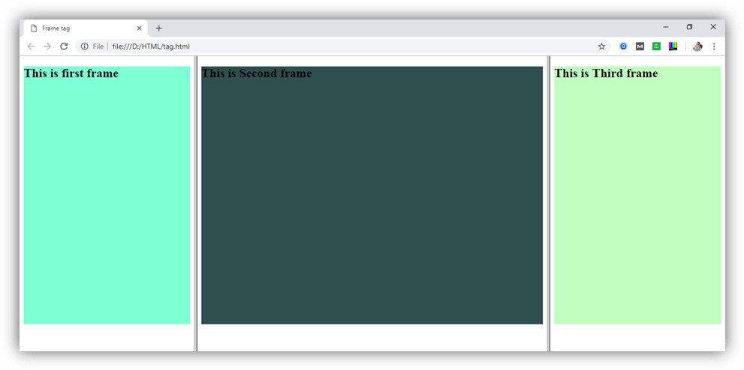
Frame1.html
- <!DOCTYPE html>
- <html>
- <head>
- <style>
- div{
- background-color: #7fffd4;
- height: 500px;
- }
- </style>
- </head>
- <body>
- <div>
- <h2>This is first frame</h2>
- </div>
- </body>
- </html>
Frame2.html
- <!DOCTYPE html>
- <html>
- <head>
- <style>
- div{
- background-color: #2f4f4f;
- height: 500px;

- }
- </style>
- </head>
- <body>
- <div>
- <h2>This is Second frame</h2>
- </div>
- </body>
- </html>
Frame3.html
- <!DOCTYPE html>
- <html>
- <head>
- <style>
- div{
- background-color: #c1ffc1;
- height: 500px;
- }
- </style>
- </head>
- <body>
- <div>
- <h2>This is Third frame</h2>
- </div>
- </body>
- </html>

Example 2:

Create Horizontal frames:
- <!DOCTYPE html>
- <html>
- <head>
- <title>Frame tag</title>
- </head>
- <frameset rows="30%, 40%, 30%">
- <frame name="top" src="frame1.html" >
- <frame name="main" src="frame2.html">
- <frame name="bottom" src="frame3.html">
- </frameset>
- </html>
Output:
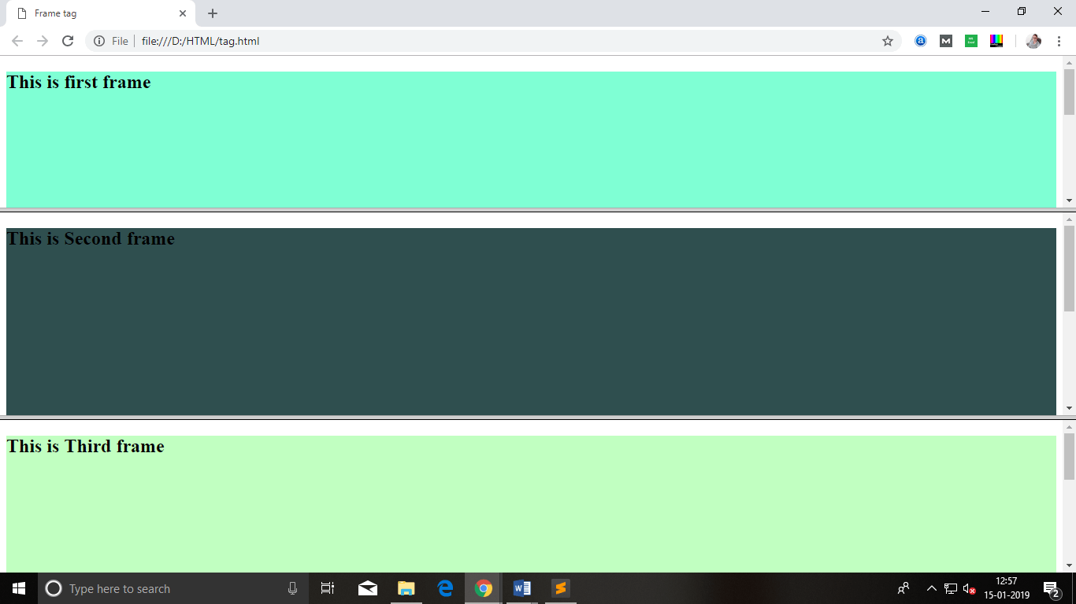

Attribute

Tag-specific attribute
Attribute | Value | Description
frameborder | 0  1 | It specifies whether to display a border around the frame or not, and its default value is 1
longdsec | URL | It specifies a page which contains the long description of the content of the frame.
marginheight | pixels | It specifies the top and bottom margins of the frame.
marginwidth | pixels | It defines the height of the margin between frames.
name | text | It is used to assign the name to the frame.
noresize | noresize | It is used to prevent resizing of the frame by the user.
scrolling | yes  no  auto | It specifies the existence of the scrollbar for overflowing content.
src | URL | It specifies the URL of the document which we want to display in a frame.

Supporting Browsers
Element | Chrome | IE | Firefox | Opera | Safari
<frame> | Yes | Yes | Yes | Yes | Yes

HTML <frameset> tag (Not supported in HTML5)
HTML <frameset> tag is used to contain the group of frames which can be controlled and styled as a unit. The <frameset> element also specifies the number of rows and columns in the frameset, and how much space they will occupy in a frame.

Note: Do not use HTML <frameset> element as it is deprecated and not supported by HTML5, but you can use <iframe> tag instead.

Syntax
- <frameset cols=" ">............</frameset>
Following are some specifications about the HTML <frameset> tag
Display | Block
Start tag/End tag | Both Start and End Tag
Usage | Frames

Example 1
- <!DOCTYPE html>
- <html>
- <head>
- <title>Frame tag</title>
- </head>
- <frameset cols="50%,50%">
- <frame src="https://www.javatpoint.com/html-table">
- <frame src="https://www.javatpoint.com/css-table">
- </frameset>
- </html>
Output:
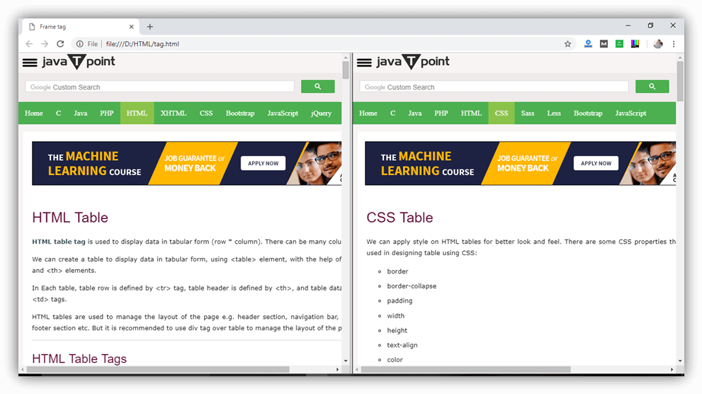

Attribute

Tag-specific attribute
Attribute | Value | Description
cols | Pixels  %  * | It specifies the number and size of column spaces in the frameset. (Not Supported in HTML5)
rows | Pixels  %  * | It specifies the number and size of the rows spaces in the frameset. (Not Supported in HTML5)

Supporting Browsers
Element | Chrome | IE | Firefox | Opera | Safari
<frameset> | Yes | Yes | Yes | Yes | Yes

HTML Header Tag
HTML <header> tag is used as a container of introductory content or navigation links. Generally a <header> element contains one or more heading elements, logo or icons or author's information.
You can use several <header> elements in one document, but a <header> element cannot be placed within a <footer>, <address> or another <header> element.

HTML Header Tag Example
- <header>
- <h2>ABCOnline.com</h2>
- <p> World's no.1 shopping website</p>
- </header>
Output:

ABCOnline.com
World's no.1 shopping website

Let's see another example of header tag with CSS code.
CSS Code:
- header{
- border: 1px solid pink;
- background-color:pink;
- padding:10px;
- border-radius:5px;
- }
HTML Code:
- <header>
- <h2>ABCOnline.com</h2>
- <p> World's no.1 shopping website</p>
- </header>
Output:

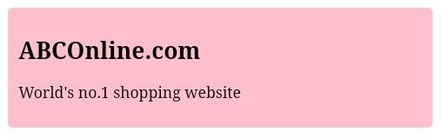
Supporting Browsers
Element | Chrome | IE | Firefox | Opera | Safari
<header> | Yes | Yes | Yes | Yes | Yes

HTML hr tag
HTML <hr> tag is used to specify a paragraph-level thematic break in HTML document. It is used when you abruptly change your topic in your HTML document. It draw a horizontal line between them. It is also called a Horizontal Rule in HTML.

HTML hr tag
- <h2>HTML</h2>
- <p>HTML is a language for describing web pages.</p>
- <hr/>
- <h2>HR Tag </h2>
- <p> HR tag is used to draw a horizontal line within the texts to sepate content.<p>
Output:

HTML
HTML is a language for describing web pages.

HR Tag
HR tag is used to draw a horizontal line within the texts to separate content.

HR tag in HTML 4.01 and HTML5?
In HTML 4.01, the <hr> tag represents a horizontal rule while in HTML 5, it defines a thematic break. CSS is used in HTML5 instead of layout attributes.

HR tag in HTML and XHTML
In HTML <hr> tag need not to be closed whereas <hr> tag must be properly closed in XHTML.

Supporting Browsers
Element | Chrome | IE | Firefox | Opera | Safari
<hr> | Yes | Yes | Yes | Yes | Yes

HTML <html> tag
The <html> tag represents root of an HTML document hence also called as root element. It is a container of all elements (except <!Doctype> ) such as <body>, <head> and each element which appears in an HTML document. It tells the browser that the document is an HTML document.
Before the <html> tag we can only use <!Doctype> declaration which gives information about the HTML version to the browser.

Syntax
<html>....</html>
Following are some specifications about the HTML <html> tag
Display | None
Start tag/End tag | Both Start and End tag
Usage | Structural

Example 1
- <!DOCTYPE html>
- <html>
- <head>
- <title>HTML tag</title>
- </head>
- <body>
- <h2>Example of HTML tag</h2>
- <p> Write your main Content within Body of the HTML document. </p>
- </body>
- </html>
Output:
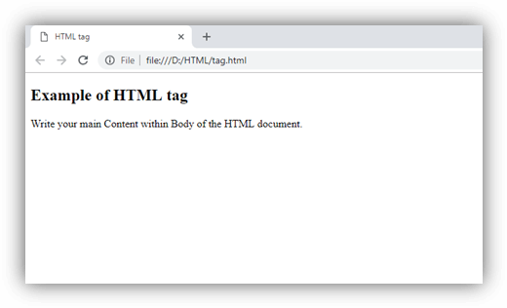

Attribute
Attribute | Value | Description
xmlns | http://www.w3.org/1999/xhtml | It specifies the XML namespace for the document(Not required)
manifest | URL | It specifies the URL of the resource manifest indicates resource which should be cached locally.

Global attribute
The <html> tag supports the global attributes in HTML

Event attribute
The <html> tag supports the event attributes in HTML.

Supporting Browsers
Element | Chrome | IE | Firefox | Opera | Safari
<html> | Yes | Yes | Yes | Yes | Yes

HTML <i> tag
HTML <i> tag is used to represent a part of text in a different voice from the surrounding text. The content within <i> tag usually renders in italic type on the browser. It can be useful to represent some technical terms, phrase, fictional character thoughts, etc.

NOTE: The <i> tag does not include any logical meaning to the content and if you want to represent some logically important part of the content then use <em> tag. (Both give same visual effect)

Syntax
- <i>Write your Content here....</i>
Following are some specifications about the HTML <i> tag
Display | Inline
Start tag/End tag | Both Start and End tag
Usage | Textual

Example 1
- <!DOCTYPE html>
- <html>
- <head>
- <title>HTML i Tag</title>
- <style>
- p{
- color: #e9967a;
- }
- i{
- color: green;
- }
- </style>
- </head>
- <body>
- <h2>Example of HTML i tag</h2>
- <p>John and his team is ready for his new gaming project <i>Marko Series 3</i> </p>
- </body>
- </html>
Output:
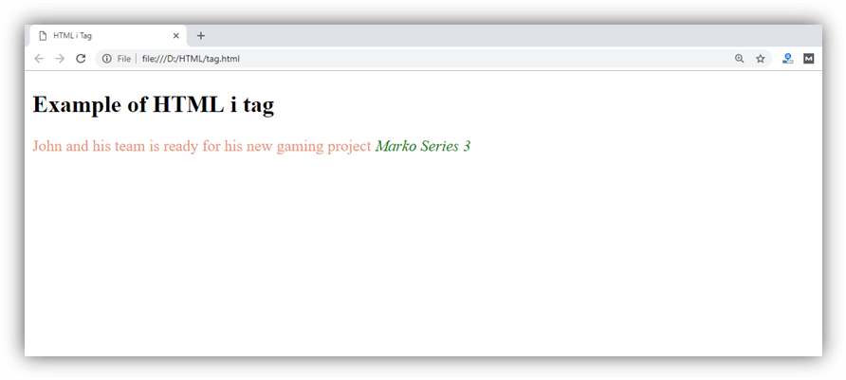

Attribute

Tag-specific attribute
HTML <i> tag does not contain any specific attribute.

Global attribute
HTML <i> tag supports the global attributes in HTML.

Event attribute
HTML <i> tag supports the event attributes in HTML.

Supporting Browsers
Element | Chrome | IE | Firefox | Opera | Safari
<i> | Yes | Yes | Yes | Yes | Yes

HTML Input Tag
The HTML <input> tag is used to represent a form input control in HTML document. This form input control facilitate user to input data and communicate with a website or application. Let's take an example of an HTML form with three input fields, two text fields and one button for submission.

HTML Input Tag Example
Let's see the example of HTML input tag.
- <form action="#">
- First name: <input type="text" name="FirstName" placeholder="enter firstname..."><br>
- Last name: <input type="text" name="LastName" placeholder="enter lastname..."><br>
- <input type="submit" value="Submit">
- </form>
Output:
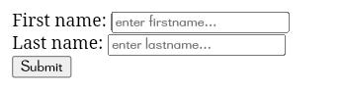
Click the "Submit" button for sending the form-data to a page on the server.

Points to remember
1) Use the input element within the form element to declare input control that allow user to enter data.
2) The input element is empty. It contains attributes only. There is no need of an end tag in HTML.
3) If you want to define labels for input element, use the label element with each input tag.

Difference between HTML4.01 and HTML5
HTML5 does not support "align" attribute. There are several new attributes for <input> tag in HTML5, and the type attribute has several new values.

Difference between HTML and XHTML
In HTML, <input> tag is used without an end tag. In XHTML, the <input> tag must be properly closed.

Supporting Browsers
Element | Chrome | IE | Firefox | Opera | Safari
<input> | Yes | Yes | Yes | Yes | Yes

HTML <ins> tag
HTML <ins> tag is used to represent the newly added text in an HTML document. It usually renders with an underline through the text, but it can be changed using CSS property.
The <ins> tag is more useful when it is used with the <del> element as it represents the part of the text that has been deleted and <ins> represent the part of the text that has been inserted to the document.

Syntax:
- <ins>Insert the text.......</ins>
Following are some specifications about the HTML <ins> tag
Display | Inline
Start tag/End tag | Both Start and End tag
Usage | Semantics

Example
- <!DOCTYPE html>
- <html>
- <head>
- <title>HTML ins Tag</title>
- </head>
- <body>
- <h2>Example of ins tag</h2>
- <p>
- If you will do <del>hard work </del> <ins>smart work</ins> then you will get success easily
- </p>
- </body>
- </html>
Output:
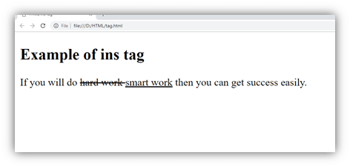

Attribute

Tag-specific attribute
Attribute | Value | Description
cite | URL | It specifies the URL of the resource which explains the reason for the change.
datetime | YYYYMMDD  HH:MM:SS | It specifies the date and time of change.

Global attribute
HTML <ins> tag supports the global attributes in HTML

Event attribute
HTML <ins> tag supports the event attributes in HTML.

Supporting Browsers
Element | Chrome | IE | Firefox | Opera | Safari
<ins> | Yes | Yes | Yes | Yes | Yes

HTML <isindex> tag (Not supported in HTML5)
HTML <isindex> tag is used to provide a single line text input in a page to query a document. If user sent input to the server then server returns the list of page matching with the query.
The <isindex> tag can be used anywhere in the document, but it would be preferable to use it within <head> tag.

Note: Do not use <isindex> tag as it is not supported by HTML5, instead of it you can use form <input> which will do the same work.

Syntax
- <isindex prompt = "Search your document here" />
Following are some specifications about the HTML <isindex> tag
Display | None
Start tag/End tag | Only Start tag (End tag forbidden)
An element of | Document Structure

Example
- <!DOCTYPE html>
- <html>
- <head>
- <isindex prompt = "Search your document here" />
- </head>
- </html>

Attribute

Tag-specific Attribute
Attribute | Value | Description
prompt | hint-text | It adds value as a label for the search text field.
action | URL | It is used to send the query to different URL instead of current document.

Global Attribute
HTML <isindex> tag supports the Global Attributes.

Event attribute
HTML <isindex> tag supports the Event Attributes.

Supporting Browsers
Element | Chrome | IE | Firefox | Opera | Safari
<isindex> | No | No | No | No | No

HTML <kbd> tag
HTML <kbd> tag indicates the part of inline text which represents the user keyboard input, voice input, or any other text entry device input.
The <kbd> text renders on the browser in default monospace font. It is used when a document needs to display the text which user should enter exactly from his keyboard.

Note: We can also use CSS properties to get the same display effect as <kbd> tag.

Syntax
- <kbd>Enter Keyboard input</kbd>
Following are some specifications about the HTML <kbd> tag
Display | Inline
Start tag/End tag | Both Start and End tag
Usage | Textual

Example
- <!DOCTYPE html>
- <html>
- <head>
- <title>Kbd Tag</title>
- <style>
- kbd { border: 1px solid blue;
- border-radius: 8px;
- padding: 3px 5px;
- margin: 2px;

- }
- </style>
- </head>
- <body>
- <h2>Example of Kbd tag</h2>
- <p>If you are using MS document then you can use shortcut <kbd>ctrl + s</kbd> to save your current document. </p>
- </body>
- </html>
Output:
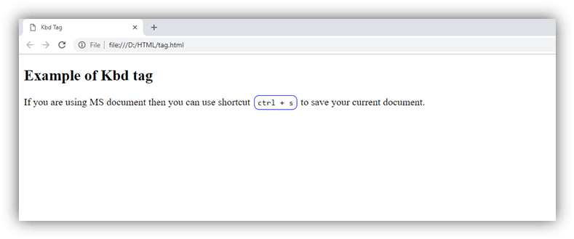

Attribute

Tag-specific attribute
The <kbd> tag does not include any specific attribute.

Global attribute
The <kbd> tag supports the global attributes in HTML

Event attribute
The <kbd> tag supports the event attributes in HTML

Supporting Browsers
Element | Chrome | IE | Firefox | Opera | Safari
<kbd> | Yes | Yes | Yes | Yes | Yes

HTML <label > Tag
The <label> tag is used to specify a label for an <input> element of a form. It adds a label to a form control such as text, email, password, textarea etc. It toggles the control when a user clicks on a text within the <label> element.

Syntax:
- <label> form_content... </label>
This tag can be used with the following two ways:
1. Set the id attribute inside the <input> element and specify its name for the for attribute inside the <label> tag.
Example: This example uses the for attribute with each label tag used in the form.
- <!DOCTYPE html>
- <html>
- <head>
- <meta name="viewport" content="width=device-width, initial-scale=1">
- <title>
- Example of Label tag
- </title>
- <style>
- /* The following tag selector body use the font-family and background-color properties for body of a page*/

- body {
- font-family: Calibri, Helvetica, sans-serif;
- background-color: pink;
- }
- /* Following container class used padding for generate space around it, and also use a background-color for specify the color lightblue as a background */
- .container {
- padding: 50px;
- background-color: lightblue;
- }
- /* The following tag selector input use the different properties for the text filed. */
- input[type=text] {
- width: 100%;
- padding: 15px;
- margin: 5px 0 22px 0;
- display: inline-block;
- border: none;
- background: #f1f1f1;
- }
- input[type=text]:focus {
- background-color: orange;
- outline: none;
- }
- div {
- padding: 10px 0;
- }
- hr {
- border: 1px solid #f1f1f1;
- margin-bottom: 25px;
- }
- /* The following tag selector button uses the different properties for the Button. */
- button {
- background-color: #4CAF50;
- color: white;
- margin: 8px 0;
- border: none;
- cursor: pointer;
- padding: 16px 20px;
- width: 100%;
- opacity: 0.9;
- }
- /* The following tag selector hover uses the opacity property for the Button which select button when you mouse over it. */
- button:hover {
- opacity: 1;
- }
- </style>
- </head>
- <body>
- <form>
- <div class="container">
- <center> <h1> Registration Form</h1> </center>
- <hr>
- <label for="firstname">
- Firstname
- </label>
- <input type="text" id="firstname" name="ftname" placeholder= "Firstname" size="15" required />
- <label for="middlename">
- Middlename:
- </label>
- <input type="text" id="middlename" name="mname" placeholder="Middlename" size="15" required />
- <label for="lastname">
- Lastname:
- </label>
- <input type="text" id="lastname" name="ltname" placeholder="Lastname" size="15"required />
- <div>
- <label for="gender">
- Gender :
- </label>
- <br>
- <input type="radio" id="gender" value="Male" name="gender" checked > Male
- <input type="radio" id="gender" value="Female" name="gender"> Female
- <input type="radio" id="gender" value="Other" name="gender"> Other

- </div>
- <label for="Phone">
- Phone:
- </label>
- <input type="text" name="country code" placeholder="Country Code" value="+91" size="2"/>
- <input type="text" id="Phone" name="phone" placeholder="phone no." size="10"/ required>
- <label for="email">
- Email
- </label>
- <input type="text" id="email" placeholder="Enter Email" name="email" required>
- <button type="submit" value="submit">Submit</button>
- <button type="reset" value="submit">Reset</button>
- </form>
- </body>
- </html>
Output:
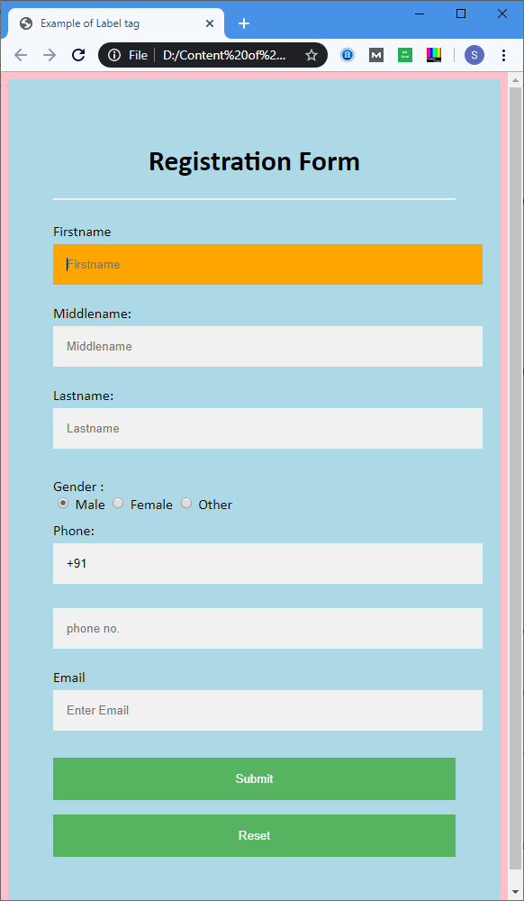
2.We can also use the <input> tag within the <label> element in a form.
Example: This example uses the <input> tag within the </label> element in a form.
- <!DOCTYPE html>
- <html>
- <head>
- <meta name="viewport" content="width=device-width, initial-scale=1">
- <style>
- /* The following tag selector body use the font-family and background-color properties for body of a page*/
- body{
- font-family: Calibri, Helvetica, sans-serif;
- background-color: pink;
- }
- /* Following container class used padding for generate space around it, and also use a background-color for specify the color lightblue as a background */
- .container {
- padding: 50px;
- background-color: lightblue;
- }
- /* The following tag selector input use the different properties for the text filed. */
- input[type=text] {
- width: 100%;
- padding: 15px;
- margin: 5px 0 22px 0;
- display: inline-block;
- border: none;
- background: #f1f1f1;
- }
- input[type=text]:focus {
- background-color: orange;
- outline: none;
- }
- div {
- padding: 10px 0;

- }

- hr {
- border: 1px solid #f1f1f1;
- margin-bottom: 25px;
- }
- /* The following tag selector button use the different properties for the Button. */
- button {
- background-color: #4CAF50;
- color: white;
- padding: 16px 20px;
- border: none;
- cursor: pointer;
- margin: 8px 0;
- width: 100%;
- opacity: 0.9;
- }

- button:hover {
- opacity: 1;
- }

- </style>
- </head>
- <body>
- <form>
- <div class="container">
- <center> <h1> Registration Form </h1> </center>

- <hr>
- <label> Firstname
- <input type="text" name="firstname" placeholder= "Firstname" size="15" required />
- </label>
- <label> Middlename:
- <input type="text" name="middlename" placeholder="Middlename" size="15" required />
- </label>
- <label> Lastname:
- <input type="text" name="lastname" placeholder="Lastname" size="15"required />
- </label>
- <div>
- <label>
- Gender :
- <br>
- <input type="radio" value="Male" name="gender" checked > Male
- <input type="radio" value="Female" name="gender"> Female
- <input type="radio" value="Other" name="gender"> Other
- </label>

- </div>
- <label>
- Phone :
- <input type="text" name="country code" placeholder="Country Code" value="+91" size="2"/>
- <input type="text" name="phone" placeholder="phone no." size="10"/ required>
- </label>

- <label>
- <b>
- Email :
- </b>
- <input type="text" placeholder="Enter Email" name="email" required>
- </label>
- <button type="submit" value="submit">Submit</button>
- <button type="reset" value="submit">Reset</button>
- </form>
- </body>
- </html>
Output: The output of this example is also same as the first but the difference between them is the implementation.
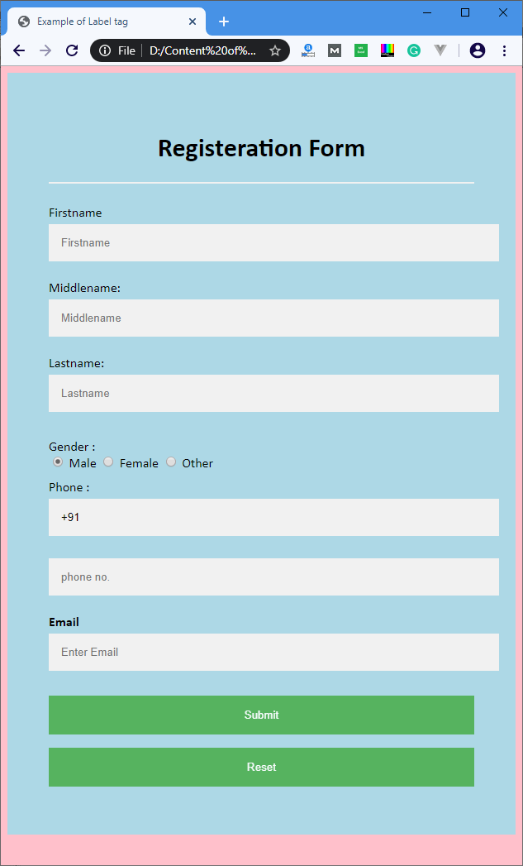

Attributes
The following table describes all the attributes of the <label> tag:
Attributes Description
for It defines the form element that a label is describing.
form It defines a form to which a label belongs.

Supporting Browsers
Element | Chrome | IE | Firefox | Opera | Safari
<label> | Yes | Yes | Yes | Yes | Yes

HTML <legend> tag
HTML <legend> tag is used to insert a title or caption to its parent element such as <fieldset>. The <legend> element must be the first child of <fieldset > element.
By using <legend> tag with <form> elements, it is easy to understand the purpose of grouped form elements.

Syntax
- <legend> Content........<legend>
Following are some specifications about the HTML <legend> tag
Display | block
Start tag/End tag | Both Start and End tag
Usage | textual

Example
- <!DOCTYPE html>
- <html>
- <head>
- <title>Legend Tag</title>
- </head>
- <body>
- <h1>Example of Legend Tag</h1>
- <form>
- <fieldset>
- <legend>Employee basic information:</legend>
- <label>First Name</label><br>
- <input type="text" name="fname"><br>
- <label>Last Name</label><br>
- <input type="text" name="lname"><br>
- <label>Enter Email</label><br>
- <input type="email" name="email"><br><br>
- <input type="Submit"><br>
- </fieldset>
- </form>
- </body>
- </html>
Output:
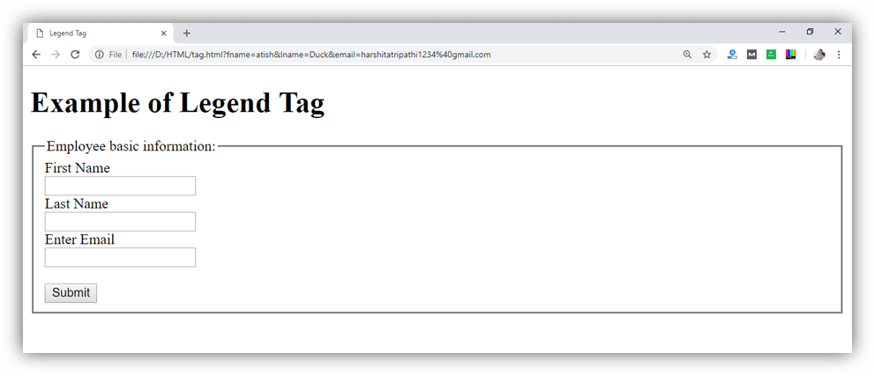

Attribute:

Tag-specific attributes:
Attribute | Value | Description
align | - top  - bottom  - left  - right | It specifies the alignment of the caption.  (Not Supported in HTML5)

Global attribute:
The <legend > tag supports the global attributes in HTML

Event attribute:
The <legend> tag supports the event attributes in HTML.

Supporting Browsers
Element | Chrome | IE | Firefox | Opera | Safari
<legend> | Yes | Yes | Yes | Yes | Yes

HTML <link> tag
HTML <link> tag is used to specify the relationship between the current document and external source.
The <link> tag is commonly used to link the external Stylesheet for the current document, but it can also use with link site icons. It is placed on the head section of the document.

Example
- <link rel="stylesheet" type="text/css" href="">
Following are some specifications about the HTML <link> tag
Display | None
Start tag/End tag | Both Start and End tag
Usage | textual

Example
- <!DOCTYPE html>
- <html>
- <head>
- <title>Link Tag</title>
- <link rel="stylesheet" type="text/css" href="htmlpages/css/link.css">
- </head>
- <body>
- <h2>Example of Link Tag</h2>
- <p>This is paragraph which is styled with external style sheet. </p>
- </body>
- </html>

- body{
- background-color: #7ac5cd;
- text-align: center;}
- h2{
- color: #006400;}

- p{
- color: #cd5c5c;
- font-size: 25px;
- font-style: italic;}
Output:
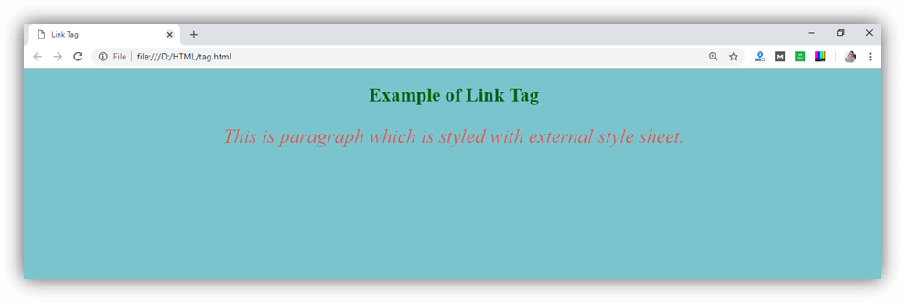

Attribute:

Tag-specific attributes:
Attribute | Value | Description
charset | char_encoding | It defines the character encoding of linked source. (Not supported in HTML5)
href | URL | It specifies the location of the linked document.
hreflang | language_code | Specifies the text language of linked source.
media | media_query | It specifies the media, for which linked source is applied.
rel | - alternate  - author  - dns-prefetch  - help  - icon  - license  - next  - pingback  - preconnect  - prefetch  - preload  - prerender  - prev  - search  - stylesheet | It describes the relationship between the current document and linked document. (required)
rev | reversed  relationship | It describes the relationship between the linked document and the current document. (Not supported in HTML5)
sizes | Height* weight | It specifies the size of the linked source. It should be only used with rel="icon."
target | _blank  _self  _top  _parent  frame_name | It determines where to load the linked document.
type | media_type | It specifies the media type of document.

Global attribute:
The <link> tag supports the global attributes in HTML

Event attribute:
The <link > tag supports the event attributes in HTML.

Supporting Browsers
Element | Chrome | IE | Firefox | Opera | Safari
<link> | Yes | Yes | Yes | Yes | Yes

