HTML Main Tag
HTML <main> tag is used to represent the main content of the <body> tag.
The <main> tag is written within <body> tag. It is used to accurately describe the primary content of a page.
The content of the main tag is directly related to the central topic of the document.
HTML <main> is a new tag and introduced in HTML5.

Points to remember:
Author should not include more than one <main> tag within a document.
The <main> element should not used as a child of an <article>, <aside>, <header>, <footer>, or <nav> element.

HTML main tag and its sub elements can be easily styled by CSS.

HTML main tag example
- <main>
- <h2>Apples</h1>
- <p>The apple is a red color pomaceous fruit of the apple tree. It is a very famous saying about apple.
- </br> "An apple in a day, keeps the Doctor away".</p>
- <article>
- <h3>Red Delicious</h3>
- <p>These bright red apples are the most common found in many supermarkets.</p>
- </article>
- <article>
- <h3>Granny Smith</h3>
- <p>These juicy, green apples make a great filling for apple pies.</p>
- </article>
- </main>
Output:

Apples
The apple is a red color pomaceous fruit of the apple tree. It is a very famous saying about apple.
"An apple in a day, keeps the Doctor away".

Red Delicious
These bright red apples are the most common found in many supermarkets.

Granny Smith
These juicy, green apples make a great filling for apple pies.

The <main> tag also supports global attributes and event attributes in HTML 5.

Supporting Browsers
Element | Chrome | IE | Firefox | Opera | Safari
<main> | Yes | No | Yes | Yes | Yes

HTML <map> tag
HTML <map> tag is used with <area> tag to define a client-side image map.
An image map is consist of an image with clickable areas, where you can click on the image, and it will open to new or the provided destination.
The <map> tag can consist of more than one <area> elements which define the coordinates and type of the area.
With the help of <map> tag, you can easily link any part of the image to other documents, without dividing the image.

Syntax
- <map name=" ">
Following are some specifications about the HTML <map> tag
Display | None
Start tag/End tag | Empty Tag(Only Start tag)
Usage | Image map

Example
- <!DOCTYPE html>
- <html>
- <head>
- <title>HTML map tag</title>
- <style>
- body{
- margin-left: 250px;}
- </style>
- </head>
- <body>
- <h2>Example of HTML Map tag</h2>
- <img src="image1.png" usemap="#web">
- <map name="web">
- <area shape="rect" coords="66,117,131,168" href="https://www.javatpoint.com/html-tutorial">
- <area shape="rect" coords="199,36,277,85" href="https://www.javatpoint.com/css-tutorial">
- <area shape="rect" coords="330,107,406,159" href="https://www.javatpoint.com/bootstrap-tutorial">
- <area shape="rect" coords="199,185,267,236" href="https://www.javatpoint.com/javascript-tutorial">
- </map>
- </body>
- </html>

Attribute:

Tag-specific attributes:
Attribute | Value | Description
name | mapname | It defines the name of the image-map.

Global attribute:
The <map> tag supports the global attributes in HTML

Event attribute:
The <map> tag supports the event attributes in HTML.

Supporting Browsers
Element | Chrome | IE | Firefox | Opera | Safari
<map> | Yes | Yes | Yes | Yes | Yes

HTML <mark> tag
HTML <mark> tag is used to highlight the some text part inside of another element such as paragraph, for reference or any notation purpose.
This is a newly added tag and introduced in HTML5.
In most of the browser, the text contained with <mark> tag renders with the yellow background, but it can be changed using CSS background-color property.

Syntax:
- <mark>write your content here....</mark>
Following are some specifications about the HTML <mark> tag
Display | Inline
Start tag/End tag | Both Start and End tag
Usage | Semantic and textual

Example
- <!DOCTYPE html>
- <html>
- <head>
- <title>Mark Tag</title>
- </head>
- <body>
- <h2>Exmaple of Mark Tag</h2>
- <p>You can easily learn designing a website with our <mark>Web designing tutorial. </mark></p>
- </html>
Output:
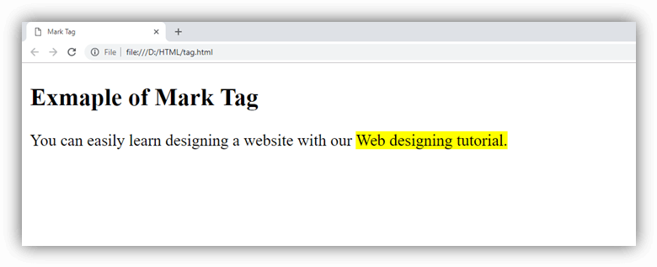

Attribute:

Global attribute:
The <mark > tag supports the global attributes in HTML

Event attribute:
The <mark> tag supports the event attributes in HTML.

Supporting Browsers
Element | Chrome | IE | Firefox | Opera | Safari
<mark> | Yes | Yes | Yes | Yes | Yes

Marquee HTML
The Marquee HTML tag is a non-standard HTML element which is used to scroll a image or text horizontally or vertically.
In simple words, you can say that it scrolls the image or text up, down, left or right automatically.
Marquee tag was first introduced in early versions of Microsoft's Internet Explorer. It is compared with Netscape's blink element.

Marquee HTML Example
- <marquee>This is an example of html marquee </marquee>

Supporting Browsers
Element | Chrome | IE | Firefox | Opera | Safari
<marquee> | Yes | Yes | Yes | Yes | Yes

HTML Marquee Attributes
Marquee's element contains several attributes that are used to control and adjust the appearance of the marquee.
Attribute | Description
behavior | It facilitates user to set the behavior of the marquee to one of the three different types: scroll, slide and alternate.
direction | defines direction for scrolling content. It may be left, right, up and down.
width | defines width of marquee in pixels or %.
height | defines height of marquee in pixels or %.
hspace | defines horizontal space in pixels around the marquee.
vspace | defines vertical space in pixels around the marquee.
scrolldelay | defines scroll delay in seconds.
scrollamount | defines scroll amount in number.
loop | defines loop for marquee content in number.
bgcolor | defines background color. It is now deprecated.

HTML Scroll Marquee
It is a by default property. It is used to scroll the text from right to left, and restarts at the right side of the marquee when it is reached to the end of left side. After the completion of loop text disappears.
- <marquee width="100%" behavior="scroll" bgcolor="pink">
- This is an example of a scroll marquee...
- </marquee>

HTML Slide Marquee
In slide marquee, all the contents to be scrolled will slide the entire length of marquee but stops at the end to display the content permanently.
- <marquee width="100%" behavior="slide" bgcolor="pink">
- This is an example of a slide marquee...
- </marquee>

HTML Alternate Marquee
It scrolls the text from right to left and goes back left to right.
- <marquee width="100%" behavior="alternate" bgcolor="pink">
- This is an example of a alternate marquee...
- </marquee>

Direction in HTML marquee
This is used to change the direction of scrolling text. Let's take an example of marquee scrolling to the right. The direction can be left, right, up and down.
- <marquee width="100%" direction="right">
- This is an example of a right direction marquee...
- </marquee>

Nested marquee example
- <marquee width="400px" height="100px" behavior="alternate" style="border:2px solid red">
- <marquee behavior="alternate">
- Nested marquee...
- </marquee>
- </marquee>

Disadvantages HTML marquee
1) Marquee may be distracting because human eyes are attracted towards movement and marquee text constantly.
2) Since Marquee text moves, so it is more difficult to click static text, depending on the scrolling speed.
3) It is a non-standard HTML element.
4) It draws user's attention needlessly and makes the text harder to read.

HTML <menu> tag
HTML <menu> tag specifies a list or menu of commands that a user can perform or activate. It is used for creating context menu as well as lists menu.
A <menu> element can contain one or more <li> or <menuitem> elements within it.

Note: The <menu> tag was deprecated in HTML 4.01 and again included in HTML 5.1 specification. But it will better to ignore it as it is experimental and not supported by many browsers.

Syntax
<menu>........<menu>
Following are some specifications about the HTML <menu> tag
Display | Inline
Start tag/End tag | Both Start and End tag
Usage | Semantic and textual

Example
- <!DOCTYPE html>
- <html>
- <head>
- <title>Menu Tag</title>
- </head>
- <body>
- <h2>Example of Menu Tag</h2>
- <menu>
- <li>Home</li>
- <li>Registration</li>
- <li>Contact-us</li>
- <li>About-us</li>
- </menu>
- </body>
- </html>
Output:
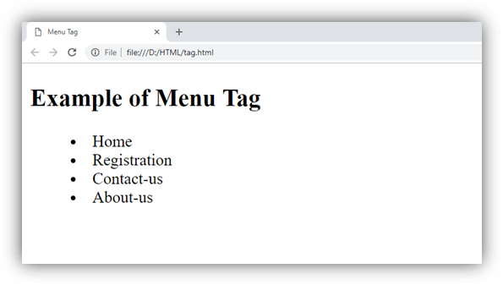

Attribute:

Tag-specific attributes:
- popup
- toolbar
- context
Attribute | Value | Description
label | text | It specifies the label for the menu.
type | It specifies the type of the menu in an HTML document.

Global attribute:
The <menu> tag supports the global attributes in HTML

Event attribute:
The <menu> tag supports the event attributes in HTML.

Supporting Browsers
Element | Chrome | IE | Firefox | Opera | Safari
<menu> | No | No | Yes | No | No

HTML <meta> tag
HTML <meta> tag is used to represent the metadata about the HTML document. It specifies page description, keywords, copyright, language, author of the documents, etc.
The metadata does not display on the webpage, but it is used by search engines, browsers and other web services which scan the site or webpage to know about the webpage.
With the help of meta tag, you can experiment and preview that how your webpage will render on the browser.
The <meta> tag is placed within the <head> tag, and it can be used more than one times in a document.

Syntax:
- <meta charset="utf-8">
Following are some specifications about the HTML <meta> tag
Display | None
Start tag/End tag | Empty Tag(Only Start tag)
Usage | Document Structural

Following are some specific syntaxes of meta tag which shows the different uses of meta Tag.
<meta charset="utf-8">
It defines the character encoding. The value of charset is "utf-8" which means it will support to display any language.
<meta name="keywords" content="HTML, CSS, JavaScript, Tutorials">
It specifies the list of keyword which is used by search engines.
<meta name="description" content="Free Online tutorials">
It defines the website description which is useful to provide relevant search performed by search engines.
meta name="author" content="thisauthor">
It specifies the author of the page. It is useful to extract author information by Content management system automatically.
- 5. <meta name="refresh" content="50">
It specifies to provide instruction to the browser to automatically refresh the content after every 50sec (or any given time).
<meta http-equiv="refresh" content="5; url=https://www.javatpoint.com/html-tags-list">
In the above example we have set a URL with content so it will automatically redirect to the given page after the provided time.
<meta name="viewport" content="width=device-width, initial-scale=1.0">
It specifies the viewport to control the page dimension and scaling so that our website looks good on all devices. If this tag is present, it indicates that this page is mobile device supported.

Example
- <!DOCTYPE html>
- <html>
- <head>
- <meta charset="utf-8">
- <meta name="keywords" content="HTML, CSS, JavaScript, Tutorials">
- <meta name="description" content="Free Online tutorials">
- <meta name="author" content="thisauthor">
- <meta http-equiv="refresh" content="5; url=https://www.javatpoint.com/html-tags-list">
- <meta name="viewport" content="width=device-width, initial-scale=1.0">
- </head>
- <body>
- <h2>Example of Meta tag</h2>
- <p>This example shows the use of meta tag within an HTML document</p>
- </body>
- </html>

Attribute:

Tag-specific attributes:
= New in HTML5
Attribute | Value | Description
charset | character_set | It specifies the character encoding of an HTML page.
content | text | It contains the value of the attribute "name" and "http-equiv" in an HTML document, depending on context.
http-equiv | - Content-type  - default-style  - refresh | It specifies the Information given by the web server about how the web page should be served.
name | - application-name  - author  - description  - generator  - keywords | It specifies the name of document-level metadata.
scheme | format/URL | It specifies the scheme in which metadata is described. (Not Supported in HTML5)

Global attribute:
The <meta> tag supports the global attributes in HTML

Event attribute:
The <meta> tag supports the event attributes in HTML.

Supporting Browsers
Element | Chrome | IE | Firefox | Opera | Safari
<meta> | Yes | Yes | Yes | Yes | Yes

HTML Meter Tag
HTML <meter> tag is used to measure data within a given range. It defines a scalar measurement with range. It is also known as a gause.
It should be used to display disk usage, voting population etc.
The HTML meter tag is new in HTML5 so you must use new browsers.

Attributes of HTML Meter Tag
HTML <meter> tag supports the global and event attributes as well as some specific attributes.
Attributes | Description
value | It is a mandatory attribute which is used to specify a value in numbers. The number may be integer or floating point number.
form | It specifies one or more forms to which meter element belongs to.
high | It specifies a range that is considered as high value.
low | It specifies a range that is considered as low value.
max | It specifies the maximum value defined in the range.
min | It specifies the minimum value defined in the range.
optimum | It specifies the optimum value for the gauge.It is an optional attribute.

HTML Meter Tag Example
Let's see the progress example with min, max and value attributes.
- <p>Display a gauge:</p>
- <meter value="30" min="1" max="100">30 out of 100</meter><br>
- <meter value="0.8">80%</meter>
Output:

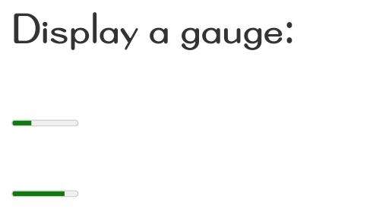
Styling Meter
You can apply CSS code on meter tag.
- meter{
- width: 300px;
- height: 30px;
- }
Output:

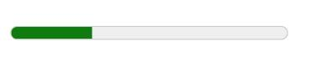
Supporting Browsers
Element | Chrome | IE | Firefox | Opera | Safari
<meter> | Yes | Yes | Yes | Yes | Yes

HTML <nav> tag
HTML <nav> tag is used to represent a section which contains navigation links, either within current document or to another document. Examples of some navigation links are menu, table of contents, indexes, etc.
The <nav> tag is newly added tag in HTML5.

Tips: You can use multiple links within a page, but it's not necessary to put all the links withintag. It must contain only major block of navigation links.

Syntax
<nav>.....</nav>
Following are some specifications about the HTML <nav> tag
Display | Block
Start tag/End tag | Both Start and End tag
Usage | Structural

Example
- <!DOCTYPE html>
- <html>
- <head>
- <title>Nav Tag</title>
- <style>
- a{
- text-decoration: none;
- color: green;
- font-size: 20px;
- padding: 8px;
- }
- a:hover{
- color: blue;
- }
- h1{
- text-align: center;
- }
- </style>
- </head>
- <body>
- <h1>Example of Nav tag</h1>
- <nav>
- <a href="#">Home</a> |
- <a href="#">Courses</a> |
- <a href="#">About-us</a> |
- <a href="#">Contact-us</a> |
- </nav>
- </body>
- </html>

Attribute:

Tag-specific attributes:
The <nav> tag does not contain any specific attribute in HTML.

Global attribute:
The <nav> tag supports the global attributes in HTML

Event attribute:
The <nav> tag supports the event attributes in HTML.

Supporting Browsers
Element | Chrome | IE | Firefox | Opera | Safari
<nav> | Yes | Yes | Yes | Yes | Yes

HTML <noframes> tag (Not supported in HTML5)
HTML <noframes> tag is used to contain an alternative text to display if the browser does not support the <frame> content. It will only work, if the browser does not support the frame else, it will be ignored by the browser.
The <noframes> tag should be used within <frameset> element.

Note: Do not use <noframes> as it is deprecated and currently not supported by HTML5.

Syntax
<noframes>........</noframes>
Following are some specifications about the HTML <noframes> tag
Display | Block
Start tag/End tag | Both Start and End tag
Usage | With Frames

Example
- <!DOCTYPE html>
- <html>
- <head>
- <title>Noframe tag</title>
- </head>
- <frameset cols="50%,50%">
- <frame src="https://www.javatpoint.com/html-table">
- <frame src="https://www.javatpoint.com/css-table">
- <noframes>Sorry! Your browser does not support frames. </noframes>
- </frameset>
- </html>

Attribute:

Tag-specific attributes:
The <noframes > tag does not contain any specific attribute in HTML.

Global attribute:
The <noframes> tag only supports the global attributes in HTML.

Event attribute:

Supporting Browsers
Element | Chrome | IE | Firefox | Opera | Safari
<noframes> | Yes | Yes | Yes | Yes | Yes

HTML NoScript Tag
HTML <noscript> tag is used to define an alternate content for the users who have disabled scripting from the browser and want to access the web page.
The <noscript> element can be used within <head> and <body> tags.
While using noscript tag inside <head> element, <noscript> must contain <link>, <style>, and <meta> tags.
The text inside the <noscript> element will be displayed if the user's browser is not script supporting.
The example of noscript tag is given below:
- <script>
- document.write("Welcome to JavaTpoint")
- </script>
- <noscript>Sorry! Your browser does not support JavaScript.!</noscript>
Output:
Welcome to JavaTpoint

Difference between HTML4 and HTML5
In HTML 4.01, <noscript> tag can be used inside the <body> tag only but in HTML5 it can be used inside <head> and <body> tag.

Difference between HTML and XHTML
The noscript tag is not supported in XHTML.

The noscript tag supports global and event attributes in HTML.

Supporting Browsers
Element | Chrome | IE | Firefox | Opera | Safari
<noscript> | Yes | Yes | Yes | Yes | Yes

HTML <object> tag
HTML <object> tag is used to embed multimedia files on webpage. The <object> tag can include multimedia files such as video, audio, image, PDF, Java Applets, or another page on your page.
HTML <param> tag also used with <object> tag to pass parameters to plugin which has been included with <object> tag.
If you insert text between the <object> and </object> tags, then it will only be displayed if the browser does not support the <object> tag.

Syntax
- <object data="" type=""></object>
Following are some specifications about the HTML <object > tag
Display | Inline
Start tag/End tag | Both Start and End tag
Usage | Embed external resource

Example
Embedding a Video:
- <!DOCTYPE html>
- <html>
- <head>
- <title>Obejct Tag</title>
- </head>
- <body>
- <h2>Example of Object tag</h2>
- <object height="250" width="500" data="https://www.youtube.com/embed/O5hShUO6wxs"></object>
- </body>
- </html>
Output:
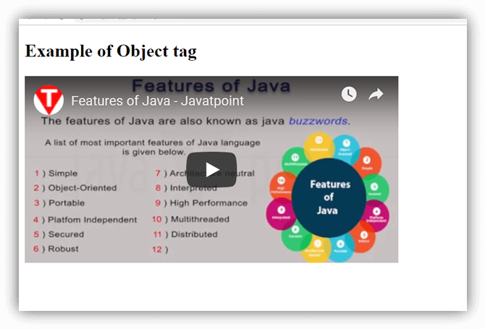
Embedding a gif image:
- <!DOCTYPE html>
- <html>
- <head>
- <title>Obejct Tag</title>
- </head>
- <body>
- <h2>Example of Object tag</h2>
- <object height="250" width="500" data="circle.gif">Sorry!,Your browser does not support</object>
- </body>
- </html>
Output:
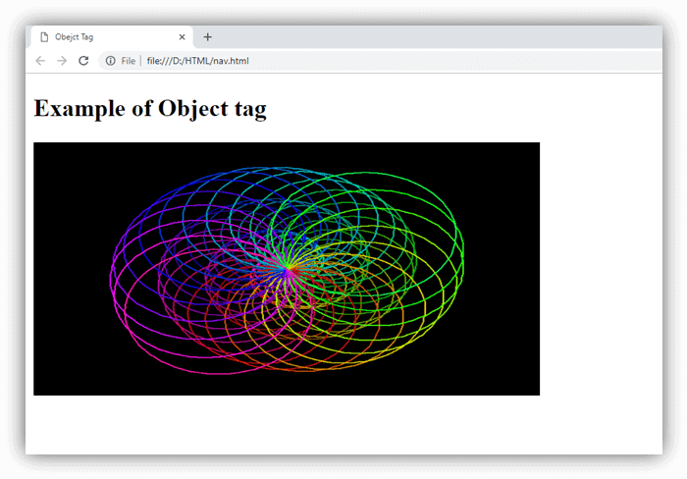

Attribute:

Tag-specific attributes:
Attribute | Value | Description
data | URL | It specifies the address of the resource.
type | content_type | It determines the content type of the resource specified by data.
archive | URL | It specifies the space-separated list of URL's for archives of resources for the object. (Not supported in HTML5).
border | pixels | It sets the width of the border around the <object> (Not supported in HTML5).
classid | URL | It specifies the URL for the object implementation. (Not supported in HTML5).
codebase | URL | It specifies the base path where to find the code for the object. (Not supported in HTML5).
form | form_id It | specifies the form element that the object element is associated with.
height | pixels | It defines the height of the object.
width | pixels | It determines the width of the object.
typemustmatch | boolean | It specifies that resource should be embedded if type attribute matches with the actual content type of the resources provided on the data attribute.
name | name | It defines the name for the object.

Global attribute:
The <object > tag supports the global attributes in HTML

Event attribute:
The <object > tag supports the event attributes in HTML.

Supporting Browsers
Element | Chrome | IE | Firefox | Opera | Safari
<object> | Yes | Yes | Yes | Yes | Yes

HTML <optgroup> tag
HTML <optgroup> tag is used to group related <options> in a drop down list within <select> element.
Using <optgroup> tag with <select> makes easier to access the dropdown list especially if list has large number of options.

Syntax
- <optgroup label=" ">........</optgroup>
Following are some specifications about the HTML <optgroup> tag
Display | Inline
Start tag/End tag | Both Start and End tag
Usage | Forms and Inputs

Example
- <!DOCTYPE html>
- <html>
- <head>
- <title>Optgroup Tag</title>
- <style>
- body{
- text-align: center;
- }
- select{
- font-size:20px;
- font-weight:bold;
- color:green;
- }
- </style>
- </head>
- <body>
- <h2>Example of optgroup tag</h2>
- <label>Select your favourite brand</label><br>
- <select>
- <optgroup label="Laptop Maufacturur">
- <option value="dell">Dell</option>
- <option value="hp">HP</option>
- <option value="lenovo">Lenovo</option>
- <option value="acer">Acer</option>
- </optgroup>
- <optgroup label="Mobile Manufacturer">
- <option value="apple">Apple</option>
- <option value="nokia">Nokia</option>
- <option value="samsung">Samsung</option>
- <option value="coolpad">Coolpad</option>
- </optgroup>
- </select>
- </body>
- </html>
Output:
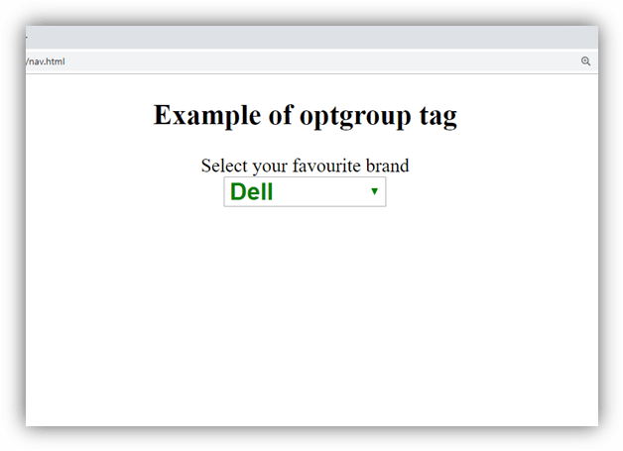

Attribute:

Tag-specific attributes:
Attribute | Value | Description
disabled | disabled | If it is set then options of that optgroup will be disabled.
label | text | It defines the label for the group which will be displayed in the drop-down list. It is required attribute.

Global attribute:
HTML <optgroup> tag supports the global attributes in HTML

Event attribute:
HTML <optgroup> tag supports the event attributes in HTML.

Supporting Browsers
Element | Chrome | IE | Firefox | Opera | Safari
<optgroup> | Yes | Yes | Yes | Yes | Yes

HTML <option> tag
HTML <option> tag is used to define options in a dropdown list within <select> or <datalist> element. A dropdown list must have at least one <option> element.
The related <option> of a dropdown list can be grouped using <optgroup> element which helps to understand a large list.

Tips: The <option> tag can be used without any attribute, but it should be used with value attribute which specifies what send to the server.

Syntax
- <option value="">.....</option>
Following are some specifications about the HTML <option> tag
DisplayInlineStart tag/End tagBoth Start and End tagUsageForms and Inputs
Display | Inline
Start tag/End tag | Both Start and End tag
Usage | Forms and Inputs

Example
- <!DOCTYPE html>
- <html>
- <head>
- <title>Option Tag</title>
- <style>
- body{
- text-align: center;}
- </style>
- </head>
- <body>
- <h2>Example of option tag</h2>
- <form>
- <select>
- <option>-------Select Your Favorite Color----------</option>
- <option value="yellow" style="color: violet;">Violet</option>
- <option value="white" style="color: blue;">Blue</option>
- <option value="black" style="color: black;">Black</option>
- <option value="green" style="color: green;">green</option>
- <option value="red" style="color: red;">Red</option>
- </select>
- </form>
- </body>
Output:
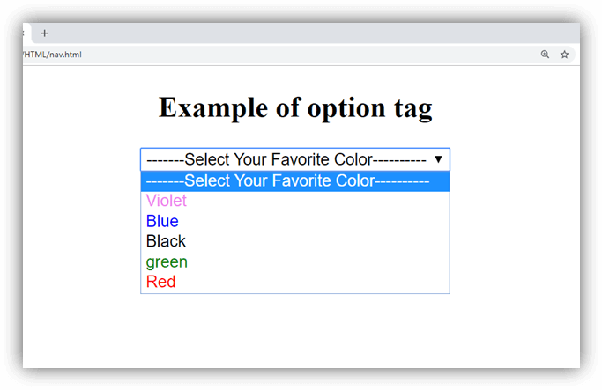

Attribute:

Tag-specific attributes:
Attribute | Value | Description
disabled | disabled | If it is set then that option will be disabled.
label | text | It defines the name for the list item.
selected | selected | If it is set, then it will be selected by default in the list.
value | text | It specifies the data which is sent to the server.

Global attribute:
HTML <option> tag supports the global attributes in HTML

Event attribute:
HTML <option> tag supports the event attributes in HTML.

Supporting Browsers
Element | Chrome | IE | Firefox | Opera | Safari
<option> | Yes | Yes | Yes | Yes | Yes

HTML <output> tag
HTML <output> tag is used to display the result of some calculation (performed by JavaScript) or the outcome of a user action (such as Input data into a form element).
The <output> tag is a newly added tag and was introduced in HTML5.

Syntax
<output>......</output>
Following are some specifications about the HTML <output> tag
Display | Inline
Start tag/End tag | Both Start and End tag
Usage | Forms and Input

Example
- <!DOCTYPE html>
- <html>
- <head>
- <title>Output Tag</title>
- </head>
- <body>
- <p>Calculate the Sum of the two Numbers</p>
- <form oninput="res.value=parseInt(a.value)+parseInt(b.value);">
- <label>Enter First Value.</label><br>
- <input type="number" name="a" value=""/><br>
- +<br/>
- <label>Enter First Value.</label><br>
- <input type="number" name="b" value=""><br>
- =<br>
- Output is:<output name="res"></output>
- </form>
- </body>
- </html>
Output:
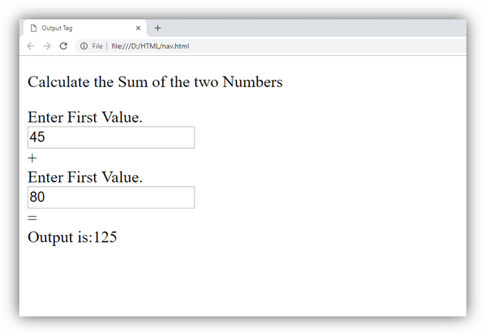

Attribute:

Tag-specific attributes:
Attribute | Value | Description
for | element_id | It specifies the list of other element's ids which indicates the relationship between the result of the calculation and the input elements.
form | form_id | It specifies the form element to which this element is associated with.
name | name | It defines the name for the output element.

Global attribute:
HTML <output> tag supports the global attributes in HTML.

Event attribute:
HTML <output> tag supports the event attributes in HTML.

Supporting Browsers
Element | Chrome | IE | Firefox | Opera | Safari
<output> | Yes | Yes | Yes | Yes | Yes

HTML <param> tag
HTML <param> tag is used to pass the parameters to the object that has been embedded using <object> element.
We can use more than one <param> tag within an <object> element in any order, but each tag must contain name and value attribute and should be placed at the start of the content.
The <param> tag controls the behaviour of the <object> element using a different pair of the name of value attributes, such as autoplay, controller, etc.

Syntax
- <param name=" " value="">
Following are some specifications about the HTML <param> tag
Display | Inline
Start tag/End tag | Empty Tag(End tag forbidden)
Usage | Programming

Example
- <!DOCTYPE html>
- <html>
- <head>
- <title>Param Tag</title>
- </head>
- <body>
- <h2>Example of Param Tag</h2>
- <object data="https://www.youtube.com/embed/JHq3pL4cdy4" >
- <param name="controller" value="true">
- </object>
- </body>
- </html>
Output:
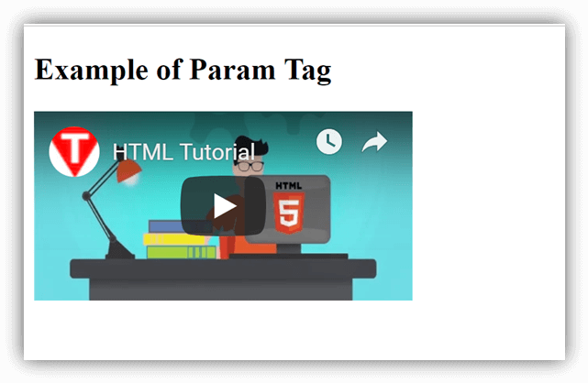

Attribute:

Tag-specific attributes:
Attribute | Value | Description
Name | text | It determines the name of the parameter.
value | text | It determines the value of the parameter.
type | content_type | It specifies the media type of the parameter, and it only used if the valuetype is set to "ref." (Not Supported in HTML5)
valuetype | - data  - ref  - object | It determines the type of the value attribute. (Not Supported in HTML5)

Global attribute:
HTML <param> tag supports the global attributes in HTML.

Event attribute:
HTML <param> tag supports the event attributes in HTML.

Supporting Browsers
Element | Chrome | IE | Firefox | Opera | Safari
<param> | Yes | Yes | Yes | Yes | Yes

HTML <picture> tag
HTML <picture> tag is used in responsive web designing where we need to load the different images based on their viewport, height, width, orientation, and pixel density.
The <picture> tag contains one or more <source> elements and one <img> elements.
According to the viewport, the matching image will be loaded from different <source> tag, and if no source contains the matching image, then the default image present in <img> tag will be displayed on the browser.
This tag is a new tag in HTML5.

Syntax
- <picture>
- <source srcset="" media="">
- <img src="">
- </picture>
Following are some specifications about the HTML <picture> tag
Display | Inline
Start tag/End tag | Both Start and End tag
Usage | Image

Example
- <!DOCTYPE html>
- <html>
- <head>
- <title>Picture Tag</title>
- <style>
- body{
- text-align: center;
- }
- p{
- font-size: bold;
- font-size: 20px;
- color: green;
- }
- </style>
- </head>
- <body>
- <h2>Example of picture tag</h2>
- <p>Resize the page to see the different versions of the images at different viewports, and as per viewport image will be automatically changed.</p>
- <picture>
- <source srcset="download1.jpg" media="(min-width: 750px)">
- <source srcset="pic2.jpg" media="(min-width: 450px)">
- <img srcset="rose.jpg" alt="default image" style="width: auto;">
- </picture>
- </body>
- </html>
Output:
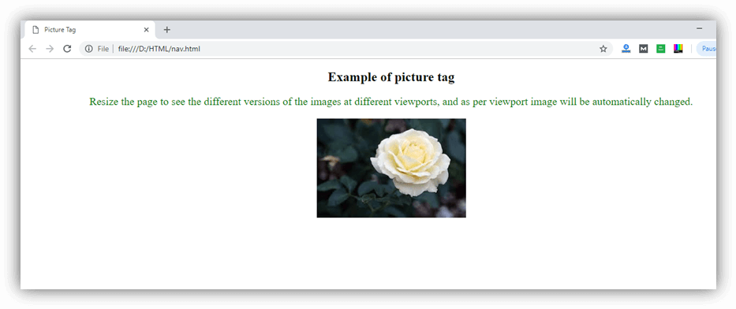

Attribute:

Tag-specific attributes:
Attribute | Value | Description
media | media_query | It defines and accept any media query which can be defined in CSS.
srcset | URL | It defines the URL of the image which can be used for different situations. (Required)
type | video/ogg  video/mp4  video/webM  audio/ogg  audio/mpeg | It determines the MIME type
src | URL | It specifies the location of the image.

Global attribute:
HTML <picture> tag supports the global attributes in HTML.

Supporting Browsers
Element | Chrome | IE | Firefox | Opera | Safari
<picture> | Yes | No | Yes | Yes | Yes

HTML pre tag
The HTML <pre> tag is used to specify pre formatted texts. Texts within <pre>.......</pre> tag is displayed in a fixed-width font. Usually it is displayed in Courier font. It maintains both space and line break.
It is widely used to display language examples e.g. Java, C#, C, C++ etc because it displays the code as it is typed.

HTML pre tag example
- <pre>
- This is a formatted text
- by using the HTML pre tag. It maintains
- both space and line break.
- </pre>
Output:
This is a formatted text
by using the HTML pre tag. It maintains
both space and line break.

HTML pre tag example: Java code within pre
- <pre>
- package com.javatpoint;
- public class FirstJava{
- public static void main(String args[]){
- System.out.println("hello java");
- }
- }
- </pre>
Output:
package com.javatpoint;
public class FirstJava{
public static void main(String args[]){
System.out.println("hello java");
}
}

If you remove pre tag from the above example, all the text will be displayed in a single line.
Output without pre:
package com.javatpoint; public class FirstJava{ public static void main(String args[]){ System.out.println("hello java"); } }

width attribute
The HTML <pre> tag also supports the width attribute. The width attribute specifies the desired width of the pre-formatted text. But, it is not supported in HTML 5.

Supporting Browsers
Element | Chrome | IE | Firefox | Opera | Safari
<pre> | Yes | Yes | Yes | Yes | Yes

HTML Progress Tag
HTML <progress> tag is used to display the progress of a task. It provides an easy way for web developers to create progress bar on the website. It is mostly used to show the progress of a file uploading on the web page.
The HTML progress tag is new in HTML5 so you must use new browsers.

Attributes of HTML Progress Tag
HTML <progress> tag supports the global and event attributes as well as 2 specific attributes.
Tag | Description
value | It defines that how much work the task has been completed.
max | It defines that how much work the task requires in total.

The progress tag should be used to represent progress of a task only, not for just a gauge (disk pace usage). For such purpose, <meter> element is used.

HTML Progress Tag Example
Let's see HTML progress example without attribute.
<progress></progress>
Let's see the progress example with value and max attributes.
- Downloading progress:
- <progress value="43" max="100"></progress>

Styling Progress Bar
You can apply CSS code on progress tag.
- progress{
- width: 300px;
- height: 30px;
- }
Output:


HTML Progress Tag with JavaScript
The <progress> tag should be used in conjunction with JavaScript to display the progress of a task.
- <script>
- var gvalue=1;
- function abc(){
- var progressExample = document.getElementById ('progress-javascript-example');
- setInterval (function ()
- {
- if(gvalue<100){
- gvalue++;
- progressExample.value =gvalue;
- }
- abc();
- }, 1000);
- }
- </script>
- <progress id="progress-javascript-example" min="1" max="100"></progress>
- <br/><br/>
- <button onclick="abc()">click me</button

Supporting Browsers
Element | Chrome | IE | Firefox | Opera | Safari
<progress> | Yes | Yes | Yes | Yes | Yes

HTML Quotes
HTML quotes are used to put a short quotation on your website. To do so, you need to use HTML q tag and HTML blockquote tag.

HTML q tag
HTML q tag is used to put small quotation. To do so, write your text within <q>.............</q> tag.
- <p> Great quote on love and life.</p>
- <p> Dr. Seuss once said : <q>Reality is finally better than your dreams.</q></p>
Output:
Great quote on love and life.
Dr. Seuss once said : Reality is finally better than your dreams.

HTML blockquote tag
HTML blockquote tag is used to define a large quoted section. If you have a large quotation then put the entire text within <blockquote>.............</blockquote> tag.
- <p> Read this inspirational story.</p>
- <blockquote> According to scientists, the bumblebee's body is too heavy and its wing span too
- small. Aerodynamically, the bumblebee cannot fly. But the bumblebee doesn't know that and it
- keeps flying. When you don't know your limitations, you go out and surprise yourself. In hindsight, you
- wonder if you had any limitations. The only limitations a person has are those that are self-
- imposed. Don't let education put limitations on you.</blockquote>
Output:
Read this inspirational story.
According to scientists, the bumblebee's body is too heavy and its wing span too small. Aerodynamically, the bumblebee cannot fly. But the bumblebee doesn't know that and it keeps flying. When you don't know your limitations, you go out and surprise yourself. In hindsight, you wonder if you had any limitations. The only limitations a person has are those that are self- imposed. Don't let education put limitations on you.

Supporting Browsers
Element | Chrome | IE | Firefox | Opera | Safari
<q> and <blockquote> | Yes | Yes | Yes | Yes | Yes

HTML Tags which are used in Quotations and Citation
Tag | Description
<abbr> | It defines the abbreviation or an acronym.
<address> | It is used to define the contact information of the document writer.
<bdo> | It defines the direction of the text.
<blockquote> | It is used to define a section that is quoted from another source.
<q> | It is used to put the small quotations.
<cite> | It defines the title of source from where quotation or work is taken.
<define> | It is used to define a definition term.

HTML <rp> tag
HTML <rp> tag is used to provide fall back parenthesis for the content which is to be shown in the browser, if browser does not support display of ruby annotations.
The ruby annotations are used to display certain characters in several Asian languages, using <ruby> element.
The <rp> tag must enclose the <rt> element with parenthesis which contains the annotation's text.
The <rp> tag is new in HTML5.

Syntax
<rp>.....</rp>
Following are some specifications about the HTML <rp> tag
Display | Inline
Start tag/End tag | Both Start and End tag
Usage | Textual

Example
- <!DOCTYPE html>
- <html>
- <head>
- <title>HTML rp tag</title>
- <style>
- body{
- text-align: center;
- }
- rt{ font-size: 18px;
- color: green;
- }
- </style>
- </head>
- <body>
- <h1>Example of rp tag</h1>
- <ruby>
- 漢<rp>(</rp><rt>Kan</rt><rp>)</rp>
- 字 <rp>(</rp><rt>ji</rt><rp>)</rp>
- </ruby>
- </body>
- </html>
Output:
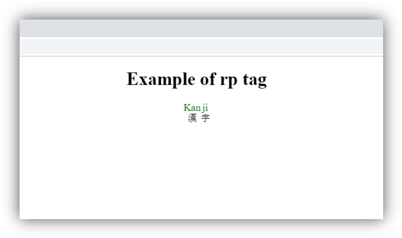

Attribute:

Tag-specific attributes:
The <rp> tag does not contain any specific attribute.

Global attribute:
The <rp> tag supports the global attributes in HTML

Event attribute:
The <rp> tag supports the event attributes in HTML.

Supporting Browsers
Element | Chrome | IE | Firefox | Opera | Safari
<rp> | Yes | Yes | Yes | Yes | Yes

HTML <rt> tag
HTML <rt> tag provides translation, pronunciations, or transliteration information for the east Asian characters present in ruby language annotation.
The <rt> tag must be enclosed within <ruby> and <rp> (optional) element.
The <rt> tag is new in HTML5.

Syntax
- <rt>........ </rt>
Following are some specifications about the HTML <rt> tag
Display | Inline
Start tag/End tag | Both Start and End tag
Usage | Formatting

Example
- <!DOCTYPE html>
- <html>
- <head>
- <title>HTML rt tag</title>
- <style>
- body{
- text-align: center;
- }
- rt{ font-size: 10px;
- color: green;
- }
- </style>
- </head>
- <body>
- <h1>Example of rt tag</h1>
- <ruby>
- 大哥<rt>Big Brother</rt>
- </ruby>
- </body>
- </html>
Output:
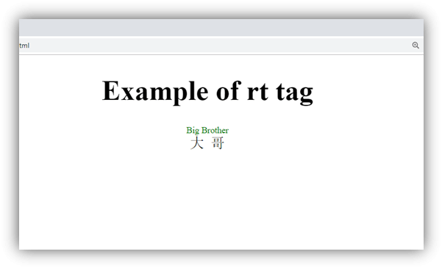

Attribute:

Tag-specific attributes:
The <rt> tag does not contain any specific attribute.

Global attribute:
The <rt> tag supports the global attributes in HTML

Event attribute:
The <rt> tag supports the event attributes in HTML.

Supporting Browsers
Element | Chrome | IE | Firefox | Opera | Safari
<rt> | Yes | Yes | Yes | Yes | Yes

HTML <ruby> tag
HTML <ruby> tag is used to represent ruby annotations on the web page. Ruby annotations are useful if we want to show the pronunciation of East Asian characters like Chinese and Japanese Chinese.
The <ruby> tag enclosed one or more <rt> elements which give the pronunciation of ruby annotations and displays above the annotation characters. It can also contain <rp> (optional) element which is used as a fall-back parenthesis for the browser which does not support the ruby annotation.
HTML <ruby> tag can also be used to represent small annotation which is relevant to the main content, apart from East Asian language.
The <ruby> tag is new in HTML5.

Syntax
<ruby>......</ruby>
Following are some specifications about the HTML <ruby> tag
Display | Inline
Start tag/End tag | Both Start and End tag
Usage | formatting

Example
- <!DOCTYPE html>
- <html>
- <head>
- <title>HTML ruby tag</title>
- <style>
- body{
- text-align: center;
- }
- rt{ font-size: 10px;
- color: green;
- }
- </style>
- </head>
- <body>
- <h1>Example of ruby tag</h1>
- <p>East Asian Langugae Annotation</p>
- <ruby>
- 大哥<rt>Big Brother</rt>
- </ruby>

- <p>Noraml Annotaion Representation of Expiry date</p>
- <ruby>
- 2022<rp>(</rp><rt>Year</rt><rp>)</rp>
- 12<rp>(</rp><rt> Month</rt><rp>)</rp>
- 06<rp>(</rp><rt>Date</rt><rp>)</rp>
- </ruby>
- </body>
- </html>
Output:
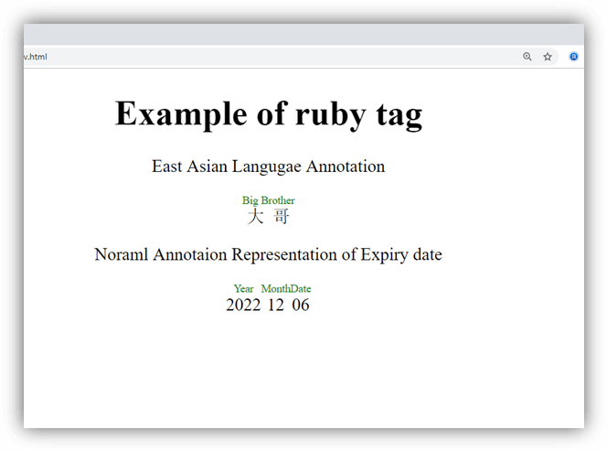

Attribute:

Tag-specific attributes:
The <ruby> tag does not contain any specific attribute.

Global attribute:
The <ruby> tag supports the global attributes in HTML

Event attribute:
The <ruby> tag supports the event attributes in HTML.

Supporting Browsers
Element | Chrome | IE | Firefox | Opera | Safari
<ruby> | Yes | Yes | Yes | Yes | Yes

HTML <s> tag
HTML <s> tag is used to represent the range of content which is no longer accurate or relevant in some way. The text written between <s> (start) and </s> (end) tag, renders as a strike a line through the text.

Note: Do not confuse with <del> and <s> as <del> is used for the text which is deleted or removed from document and <s> represent the text which is no longer accurate.

Syntax
- <s> Write your content here.....</s>
Following are some specifications about the HTML <s> tag
Display | Inline
Start tag/End tag | Both Start and End tag
Usage | Formatting

Example
- <!DOCTYPE html>
- <html>
- <head>
- <title>HTML s tag</title>
- <style>
- body{
- text-align: center;}
- s{
- color: green;
- }
- </style>
- </head>
- <body>
- <h2>Example of s tag</h2>
- <p><s>The last date of apply for online classes is 12/02/2019</s></p>
- <p>The last date of apply for online classes is 13/03/2019</p>
- </body>
- </html>
Output:
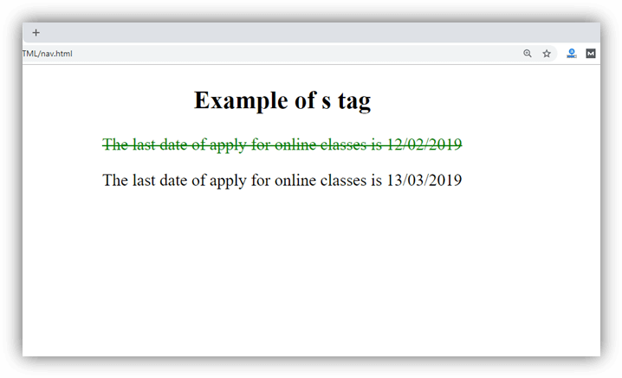

Attribute:

Tag-specific attributes:
The <s> tag does not contain any specific attribute.

Global attribute:
The <s> tag supports the global attributes in HTML

Event attribute:
The <s> tag supports the event attributes in HTML.

Supporting Browsers
Element | Chrome | IE | Firefox | Opera | Safari
<s> | Yes | Yes | Yes | Yes | Yes

HTML <samp> tag
HTML <samp> tag is a phrase tag which is used to represent the sample output from a computer program or a script, in the browser.
The content written between the <samp> and </samp>, tags renders in a browser?s default monospace font.

Note: The <samp> tag is not deprecated yet, but you can also use CSS property to achieve the same result.

Syntax
- <samp>Write sample output here.....</samp>
Following are some specifications about the HTML <samp> tag
Display | Inline
Start tag/End tag | Both Start and End tag
Usage | textual

Example
- <!DOCTYPE html>
- <html>
- <head>
- <title>HTML samp tag</title>
- <style>
- body{
- text-align: center;
- }
- </style>
- </head>
- <body>
- <h2>Example of samp tag</h2>
- <p>I am trying to install a software on my system but it is continuously giving an error message:
- </p>
- <p><samp>Error 5: Access is denied.</samp></p>
- </body>
- </html>
Output:
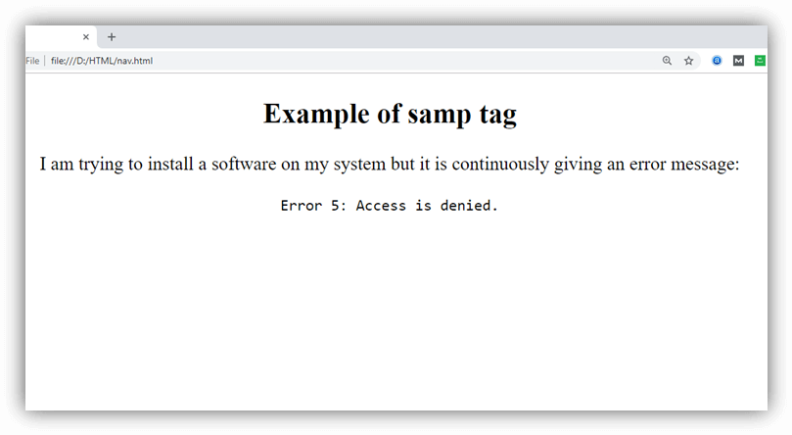

Attribute:

Tag-specific attributes:
The <samp> tag does not contain any specific attribute.

Global attribute:
The <samp> tag supports the global attributes in HTML

Event attribute:
The <samp> tag supports the event attributes in HTML.

Supporting Browsers
Element | Chrome | IE | Firefox | Opera | Safari
<samp> | Yes | Yes | Yes | Yes | Yes

HTML Script Tag
HTML script tag is used to specify client-side script such as JavaScript. It facilitate you to place a script within your HTML document.
JavaScript is used for image manipulation, form validation, and dynamic content.
The syntax of script tag is given below:
- <script>
- //code to be executed
- </script>

Attributes of HTML script tag
Attribute | Description | Compatibility
src | It specifies the URL of an external script file. | HTML 4.01, HTML5
type | It specifies the media type of the script. | HTML 4.01
async | It is a boolean value which specifies that the script is executed asynchronously. | HTML5
defer | It is a boolean value which is used to indicate that script is executed after document has been parsed. | HTML 4.01, HTML5

Usage of script tag
There can be two usage of HTML script tag:
- to embed script code
- to link script file

Embed script code
The script tag can be used within <body> or <head> tag to embed the scripting code. Let's see the example to have script tag within HTML body.
- <script type="text/javascript">
- document.write("JavaScript is a simple language for javatpoint learners")
- </script>
Output:
JavaScript is a simple language for javatpoint learners

Let's see the example to have script tag within HTML head tag.
- <script type="text/javascript">
- function msg(){
- alert("Hello Javatpoint");
- }
- </script>

Link script file
The script tag can be used to link external script file by src attribute. It must be used within the <head> tag only.
- <script type="text/javascript" src="message.js" />

Supporting Browsers
Element | Chrome | IE | Firefox | Opera | Safari
<script> | Yes | Yes | Yes | Yes | Yes

HTML Section Tag
The HTML <section> tag is used to define sections in a document. When you put your content on a web page, it may contains many chapters, headers, footers, or other sections on a web page that is why HTML <section> tag is used.
HTML <section> is a new tag introduced in HTML5.

HTML section tag example
CSS code:
- section{
- border:1px solid pink;
- padding:15px;
- margin:10px;
- }
HTML code:
- <h2> Indian Leader</h2>
- <section>
- <h3> Jawaharlal Nehru </h3>
- <p> Jawaharlal Nehru was the first Prime Minister of India and a central figure in
- Indian politics for much of the 20th century. He emerged as the paramount leader of the Indian
- independence movement under the tutelage of Mahatma Gandhi. -Source Wikipedia </p>
- </section>
- <section>
- <h3>Subhas Chandra Bose </h3>
- <p>Subhas Chandra Bose was an Indian nationalist whose attempt during World War II to rid India of
- British rule with the help of Nazi Germany and Japan left a troubled legacy.
- The honorific Netaji (Hindustani language: "Respected Leader"), first applied to Bose in Germany,
- by the Indian soldiers of the Indische Legion and by the German and Indian officials
- in the Special Bureau for India in Berlin, in early 1942, is now used widely throughout India. -source Wikipedia</p>
- </section>
Output:

Indian Leader

Jawaharlal Nehru
Jawaharlal Nehru was the first Prime Minister of India and a central figure in Indian politics for much of the 20th century. He emerged as the paramount leader of the Indian independence movement under the tutelage of Mahatma Gandhi. -Source Wikipedia

Subhas Chandra Bose
Subhas Chandra Bose was an Indian nationalist whose attempt during World War II to rid India of British rule with the help of Nazi Germany and Japan left a troubled legacy. The honorific Netaji (Hindustani language: "Respected Leader"), first applied to Bose in Germany, by the Indian soldiers of the Indische Legion and by the German and Indian officials in the Special Bureau for India in Berlin, in early 1942, is now used widely throughout India. -source Wikipedia

The <section> tag supports global and event attributes in HTML 5.

Supporting Browsers
Element | Chrome | IE | Firefox | Opera | Safari
<section> | Yes | Yes | Yes | Yes | Yes

HTML <select> tag
HTML <select> tag is used to create a drop down list with multiple options. The <option> element is nested within <select> tag for defining options in a list.
The <optgroup> element can be used for grouping related options in a list.
If you want to send data to server then use <select> tag within <form> element.

Syntax
- <select>
- <option></option>
- </select>
Following are some specifications about the HTML <select> tag
Display | Inline
Start tag/End tag | Both Start and End tag
Usage | Input

Example
- <!DOCTYPE html>
- <html>
- <head>
- <title>HTML select Tag</title>
- <style>
- .img{
- background-image: url("india.jpg");
- background-size: cover;
- background-position: center;
- height: 100%;
- width: 100%;
- background-repeat: no-repeat;
- position: fixed;
- top: 0;
- left: 0;
- }
- </style>
- </head>
- <body>
- <div class="img">
- <h2>Example of select tag</h2>
- <form>
- <label>Choose your Favorite city in India</label>
- <select>
- <option>New Delhi</option>
- <option>Indore</option>
- <option>Jaipur</option>
- <option>Jodhpur</option>
- <option>Chandigarh</option>
- <option>Mumbai</option>
- <option>Bengaluru</option>
- <option>Lucknow</option>
- <option>Amritsar</option>
- </select>
- </form>
- </div>
- </body>
- </html>
Output:
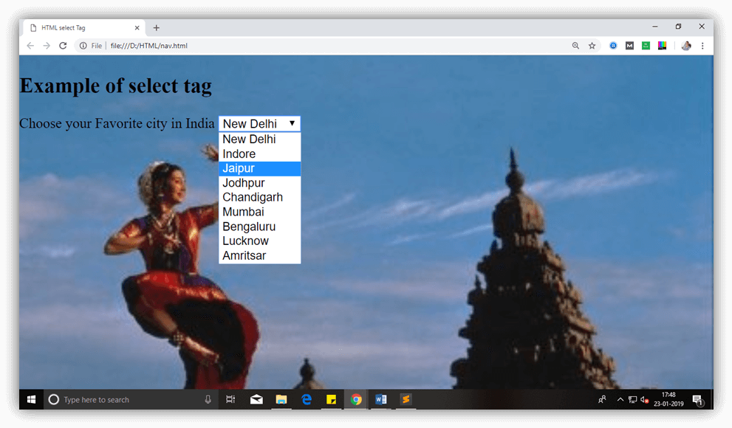

Attribute:

Tag-specific attributes:
Attribute | Value | Description
autofocus | autofocus | This attribute let automatically focused the drop-down list on page load.
disabled | disabled | It is used to disable the control and user cannot interact with the drop-down list.
form | form-id | It specifies one or more forms, to which select belong to.
multiple | multiple | If it sets then a user can select multiple options from the list.
name | name | It determines the name for the drop-down list.
required | required | If it specified, user must select that field before submitting the form.
size | number | It specifies the visible number of options in the list.

Global attribute:
The <select> tag supports the global attributes in HTML.

Event attribute:
The <select> tag supports the event attributes in HTML.

Supporting Browsers
Element | Chrome | IE | Firefox | Opera | Safari
<select> | Yes | Yes | Yes | Yes | Yes

HTML <small> tag
HTML <small> tag makes text font by one size smaller than the document?s base font size (Such as large to medium, medium to small, etc.)
In HTML5, <small> tag is used for identifying secondary importance such as copyright, side comments, and legal notices.

Tips: The <small> tag can be nested which means we can use <small> tag inside one another for multiple times, and it will continue to decrease the font size than its surrounding text.

Syntax
- <small>Write your content here...... <small>
Following are some specifications about the HTML <small> tag
Display | Inline
Start tag/End tag | Both Start and End tag
Usage | textual

Example
- <!DOCTYPE html>
- <html>
- <head>
- <title>HTML small tag</title>
- </head>
- <body>
- <h2>Example of small tag</h2>
- <p style="color: green;">This is normal font size.....
- <small style="color: blue;">It is smaller than previous...
- <small style="color: red;">It is smallest.</small>
- </small>
- </p>
- </body>
- </html>
Output:
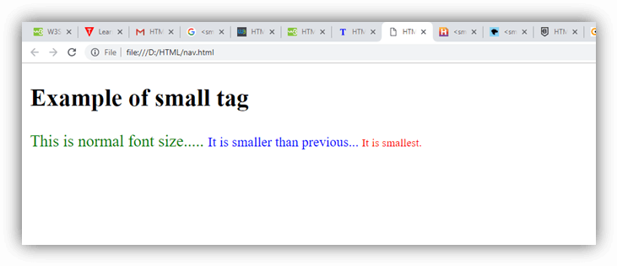

Attribute:

Tag-specific attributes:
The <small> tag does not contain any specific attribute.

Global attribute:
The <small> tag supports the Global attributes in HTML.

Event attribute:
The <small> tag supports the Event attributes in HTML.

Supporting Browsers
Element | Chrome | IE | Firefox | Opera | Safari
<small> | Yes | Yes | Yes | Yes | Yes

HTML <source > tag
HTML <source> tag is used as a child element to define more than one media resources for <audio>, <video>, and <picture> element.
It is used to provide the same media content with different formats such as mp3, mp4, etc.
When we embed multiple resources with the same content but different format then the browser may choose the most compatible format and display or play that media file.
The <source> tag was introduced in HTML5.

Syntax
- <source src=" " type=" ">
Following are some specifications about the HTML <source> tag
Display | Inline
Start tag/End tag | Empty tag( Only start tag)
Usage | Media resource

Example
- <!DOCTYPE html>
- <html>
- <head>
- <title>HTML source tag</title>
- </head>
- <body>
- <h2>Example of source tag</h2>
- <video controls="controls" height="200" width="300">
- <source src="flower.webm" type="video/webm" >
- <source src="flower.mp4" type="video/mp4">
- Your browser does not support the HTML5 video element.
- </video>
- </body>
- </html>
Output:
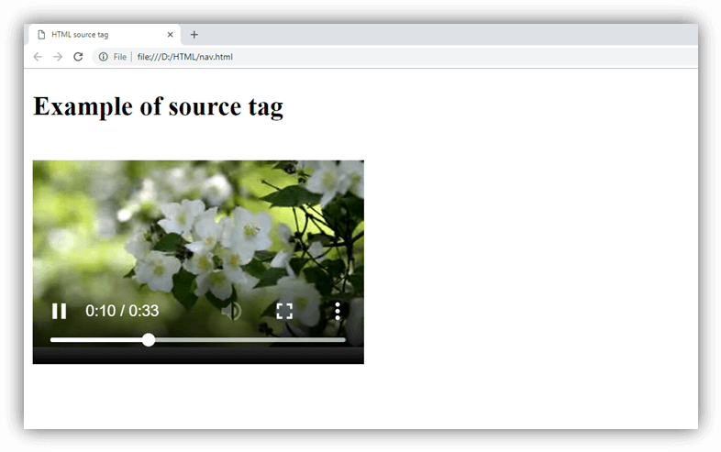

Attribute:

Tag-specific attributes:
Attribute | Value | Description
media | Media_query | It determines that for which media/device the linked source is optimized.
sizes |  | It specifies acceptable image sizes for different page layout.
src |  | It determines the URL of media files.
srcset |  | Specifies the URL of the image for different situations. It is only used when <source> is child of <picture> element.
type | video/ogg  video/mp4  video/webm  audio/ogg  audio/mpeg | It determines the media type of resource.

Global attribute:
The <source> tag supports the Global attributes in HTML.

Event attribute:
The <source> tag supports the Event attributes in HTML.

Supporting Browsers
Element | Chrome | IE | Firefox | Opera | Safari
<source> | Yes | Yes | Yes | Yes | Yes

HTML <span> tag
HTML <span> tag is used as a generic container of inline elements. It is used for styling purpose to the grouped inline elements (using class and id attribute or inline style).
The <span> tag does not have any default meaning or rendering.
The <span> tag can be useful for the following task:
- To change the language of a part of the text.
- To change the color, font, background of a part of text using CSS
- To apply the scripts to the particular part of the text.

Note: HTML <span> is much similar as <div> tag, but <div> is used for block-level elements and <span> tag is used for inline elements.

Syntax
- <span>Write your content here......</span>
Following are some specifications about the HTML <span> tag
Display | Inline
Start tag/End tag | Both Start and End tag
Usage | Styles and semantics

Example
- <!DOCTYPE html>
- <html>
- <head>
- <title>Span Tag</title>
- </head>
- <body>
- <h2>Example of span tag</h2>
- <p>I have choosen only
- <span style="color: red;">red</span>,
- <span style="color: blue;">blue</span>, and
- <span style="color: green;">green</span> colors for my painting.
- </p>
- </body>
- </html>
Output:
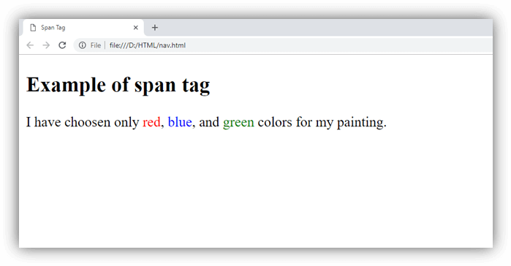

Attribute:

Tag-specific attributes:
The <span> tag does not contain any specific attribute in HTML.

Global attribute:
The <span> tag supports the Global attributes in HTML.

Event attribute:
The <span> tag supports the Event attributes in HTML.

Supporting Browsers
Element | Chrome | IE | Firefox | Opera | Safari
<span> | Yes | Yes | Yes | Yes | Yes

HTML <strike> tag (Not supported in HTML5)
HTML <strike> tag was used to strike a line through the text, contained within it.

Note: Do not use <strike> tag as it is obsolete now and not supported by HTML5, you can use <del>, <s> or CSS to achieve the same result.

Syntax
- <strike>Your content here....</strike>
Following are some specifications about the HTML <strike> tag
Display | Inline
Start tag/End tag | Both Start and End tag
Usage | Formatting

Example
- <!DOCTYPE html>
- <html>
- <head>
- <title>strike Tag</title>
- </head>
- <body>
- <h2>Example of strike tag</h2>
- <p><strike>This is not a valid paragraph</strike></p>
- <p>This is a valid paragraph</p>
- </body>
- </html>
Output:
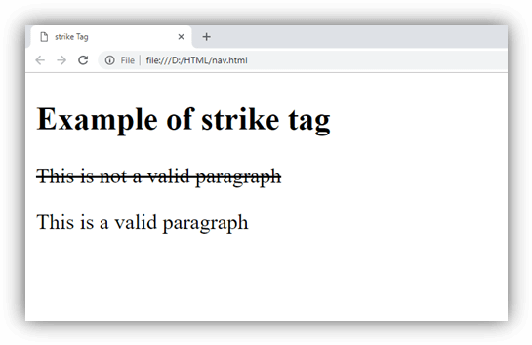

Attribute:

Tag-specific attributes:
The <strike> tag does not contain any specific attribute.

Supporting Browsers
Element | Chrome | IE | Firefox | Opera | Safari
<strike> | Yes | Yes | Yes | Yes | Yes

HTML <strong> tag
HTML <strong> tag is a phrase tag which is used to represent the important text of a document on the browser. The text within <strong> text has semantic importance for the search engines and emphasize the text with special intonation.
The text within <strong> tag renders in bold font on the browser by default; however it can be changed using CSS.

Note: Do not use <strong> tag just for making text bold, and if you want to make your text bold without any semantic importance then use <b> or CSS property.

Syntax
- <strong>Write your important content....</strong>
Following are some specifications about the HTML <strong> tag
Display | Inline
Start tag/End tag | Both Start and End tag
Usage | Formatting

Example
- <!DOCTYPE html>
- <html>
- <head>
- <title>Strong tag</title>
- <style>
- h1,h2{
- text-align: center;
- }
- h2{
- color: green;
- }
- </style>
- </head>
- <body>
- <h1>Example of strong tag</h1>
- <h2>Weather forecasting</h2>
- <p>The weather is not good today.
- <strong>It may heavy rain today, so it will better to be in your home.</strong>
- </p>
- </body>
- </html>
Output:
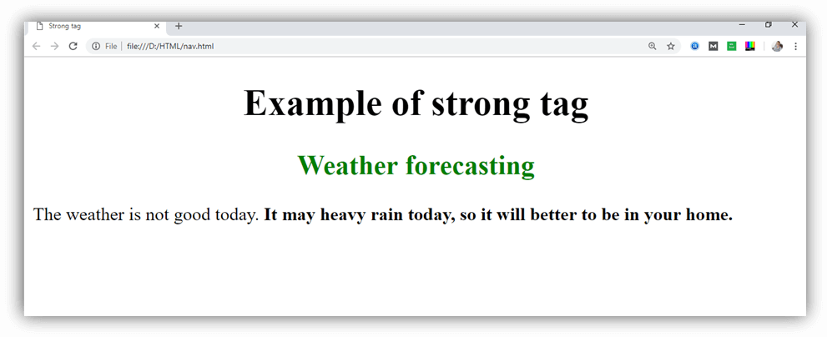

Attribute:

Tag-specific attributes:
The <strong> tag does not contain any specific attribute.

Global attribute:
The <strong> tag supports the Global attributes in HTML.

Event attribute:
The <strong> tag supports the Event attributes in HTML.

Supporting Browsers
Element | Chrome | IE | Firefox | Opera | Safari
<strong> | Yes | Yes | Yes | Yes | Yes

HTML Style
HTML Style is used to change or add the style on existing HTML elements. There is a default style for every HTML element e.g. background color is white, text color is black etc.
The style attribute can by used with any HTML tag. To apply style on HTML tag, you should have the basic knowledge of css properties e.g. color, background-color, text-align, font-family, font-size etc.
The syntax of style attribute is given below:
- style= "property:value"

HTML Style color
The color property is used to define the text color.
Let's see a simple example of styling html tags by color property of css.
- <h3 style="color:green">This is Green Color</h3>
- <h3 style="color:red">This is Red Color</h3>
Output:

This is Green Color

This is Red Color

HTML Style background-color
The background-color property is used to define background color for the HTML tag.
Let's see an example of styling html tag by of css background-color property
- <h3 style="background-color:yellow;">This is yellow background</h3>
- <h3 style="background-color:red;color:white">This is red background</h3>
Output:

This is yellow background

This is red background

HTML Style font-family
The font-family property specifies the font family of the HTML tag.
Let's see an example of styling html tag by css font-family property
- <h3 style="font-family:times new roman">This is times new roman font family</h3>
- <p style="font-family:arial">This is arial font family</p>
Output:

This is times new roman font family
This is arial font family

HTML Style font-size
The font-size property is used to define the text size of the HTML tag.
Let's see an example of font-size property
- <h3 style="font-size:200%">This is 200% h3 tag</h3>
- <p style="font-size:200%">This is 200% p tag</p>
Output:

This is 200% h3 tag
This is 200% p tag

HTML Style text-align
The text-align property is used to define the horizontal text alignment for the HTML element.
Let's see an example of styling html tag by css text-align property
- <h3 style="text-align:right;background-color:pink;">This text is located at right side</h3>
- <p style="text-align:center;background-color:pink;">This text is located at center side</p>
If you want to put heading at center or left, use "text-align:center" or "text-align:left" respectively.
Output:

This text is located at right side
This text is located at center side

HTML5 doesn't support <center> tag which is supported in older version of HTML.

Supporting Browsers
Element | Chrome | IE | Firefox | Opera | Safari
style attribute | Yes | Yes | Yes | Yes | Yes

HTML <sub> tag
HTML <sub> tag is termed as Subscript tag and which is used to define subscript text. The text within <sub> renders with a lower baseline and with a smaller font than surrounding text font.
The <sub> tag is useful for presenting mathematical formula and chemical formulas such as H₂O.

Syntax
<sub>.........</sub>
Following are some specifications about the HTML <sub> tag
Display | Inline
Start tag/End tag | Both Start and End tag
Usage | Textual

Example
- <!DOCTYPE html>
- <html>
- <head>
- <title>Sub Tag</title>
- <style>
- body{
- text-align: center;
- }
- p{
- color: green;
- }
- </style>
- </head>
- <body>
- <h2>Example of sub tag</h2>
- <p>The chemical formula for Sulphuric acid is: H<sub>2</sub>SO<sub>4</sub></p>
- </body>
- </html>
Output:
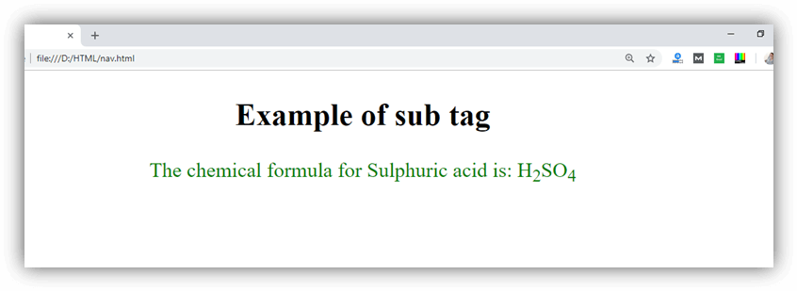

Attribute:

Tag-specific attributes:
The <sub> tag does not contain any specific attribute.

Global attribute:
The <sub> tag supports the Global attributes in HTML.

Event attribute:
The <sub> tag supports the Event attributes in HTML.

Supporting Browsers
Element | Chrome | IE | Firefox | Opera | Safari
<sub> | Yes | Yes | Yes | Yes | Yes

HTML Summary Tag
The HTML <summary> tag is used with <details> tag. It is used as a summary, caption or legend for the content of a <details> element.
It is used within the <details> tag. It must have a closing tag.
The <summary> tag is new and introduced in HTML 5.

HTML summary tag example
- <details>
- <summary>JavaTpoint Summary</summary>
- <p> JavaTpoint is a popular tutorial website.</p>
- <p>You can learn various tutorials on JavaTpoint such as HTML, CSS, JavaScript, Java, Android.</p>
- </details>
Output:
JavaTpoint Summary
JavaTpoint is a popular tutorial website.
You can learn various tutorials on JavaTpoint such as HTML, CSS, JavaScript, Java, Android.

Let's see another example of HTML summary tag.
- <details>
- <summary>MacBook Pro Specification</summary>
- <ul>
- <li><strong>13.3-inch LED-backlit glossy widescreen display</strong> with edge-to-edge, uninterrupted glass (1280 x 800-pixel resolution).</li>
- <li><strong>2.4 GHz Intel Core i5 dual-core processor</strong> with 3 MB shared L3 cache for excellent multitasking.</li>
- <li><strong>Intel HD Graphics 3000</strong> with 384 MB of DDR3 SDRAM shared with main memory.</li>
- <li><strong>500 GB Serial ATA hard drive</strong> (5400 RPM)</li>
- <li><strong>4 GB installed RAM</strong> (1333 MHz DDR3; supports up to 8 GB)</li>
- </ul>
- </details>
Output:
MacBook Pro Specification
- 13.3-inch LED-backlit glossy widescreen display with edge-to-edge, uninterrupted glass (1280 x 800-pixel resolution).
- 2.4 GHz Intel Core i5 dual-core processor with 3 MB shared L3 cache for excellent multitasking.
- Intel HD Graphics 3000 with 384 MB of DDR3 SDRAM shared with main memory.
- 500 GB Serial ATA hard drive (5400 RPM)
- 4 GB installed RAM (1333 MHz DDR3; supports up to 8 GB)
The <summary> tag supports only Global attributes in HTML 5. There are no other specific attributes used with <summary> tag.

Supporting Browsers
Element | Chrome | IE | Firefox | Opera | Safari
<summary> | Yes | No | No | No | No

HTML <sup> tag
HTML <sup> tag is termed as a superscript tag which is used to define superscript text. The text within <sup> tag appears with an upper baseline and renders with smaller font size than surrounding text.
The <sup> tag is useful for defining Mathematical formulas and footnotes.

Syntax
<sup>......</sup>
Following are some specifications about the HTML <sup> tag
Display | Inline
Start tag/End tag | Both Start and End tag
Usage | Textual

Example
- <!DOCTYPE html>
- <html>
- <head>
- <title>HTML sup Tag</title>
- <style>
- body{
- text-align: center;
- }
- </style>
- </head>
- <body>
- <h2>Example of sup tag</h2>
- Following is the famous Pythagorean Theorem:
- <p style="font-size: 20px; color: green;"><var>a</var><sup>2</sup>+<var>b</var><sup>2</sup>=<var>c</var><sup>2</sup>
- </p>
- <p>Where a, b, and c represents the sides of right angle triangle</p>
- </body>
- </html>
Output
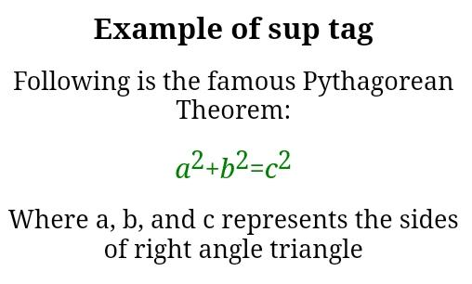

Attribute:

Tag-specific attributes:
The <sup> tag does not contain any specific attribute.

Global attribute:
The <sup> tag supports the Global attributes in HTML.

Event attribute:
The <sup> tag supports the Event attributes in HTML.

Supporting Browsers
Element | Chrome | IE | Firefox | Opera | Safari
<sup> | Yes | Yes | Yes | Yes | Yes

HTML SVG
The HTML SVG is an acronym which stands for Scalable Vector Graphics.
HTML SVG is a modularized language which is used to describe graphics in XML. It describe two-dimensional vector and mixed vector/raster graphics in XML. It is a W3C recommendation. SVG images and their behaviors are defined in XML text files. So as XML files, you can create and edit an SVG image with text editor, but generally drawing programs like inkspace are preferred to create it.
SVG is mostly used for vector type diagrams like pie charts, 2-Dimensional graphs in an X,Y coordinate system etc.
The <svg> element specifies the root of a SVG fragment. You can animate every element and every attribute in SVG files.

HTML SVG Circle Example
Let's see the example to draw circle by svg tag.
- <svg width="100" height="100">
- <circle cx="50" cy="50" r="40" stroke="yellow" stroke-width="4" fill="red" />
- </svg>
Here, we are using cx, cy and r attributes of circle tag. These attributes can't be used with svg rect tag.
Output:


HTML SVG Rectangle Example
Let's see the example to draw rectangle by svg tag.
- <svg width="200" height="100">
- <rect width="200" height="100" stroke="yellow" stroke-width="4" fill="red" />
- </svg>
Here, we are using width and height attributes of rect tag.
Output:

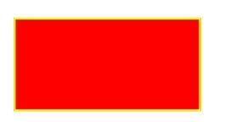
HTML SVG polygon Example
Let's see the example to draw polygon by svg tag.
- <svg height="210" width="500">
- <polygon points="100,10 40,198 190,78 10,78 160,198"
- style="fill:red;stroke:yellow;stroke-width:5;fill-rule:nonzero;" />
- </svg>
Here, we are using points attribute of polygon tag.
Output:


Why SVG is preferred over other image formats?
SVG images can be saved as the smallest size possible. Unlike bitmap image formats like JPG or PNG, it does not contain a fixed set of dots. So it is also easy to print with high quality at any resolution.
SVG images can be zoomed to a certain level without degradation of the picture quality.
SVG images and their behaviors are defined in XML text files, so they can be created and edited with any text editor.

HTML <tbody> tag
HTML <tbody> tag is used to group the table rows (<tr>) together, which indicates that this is body part of a table (<table>).
The <tbody> tag must be a child of <table> element.
The <tbody> is used along with <thead> and <tfoot> which shows the different part of the table that are table head, table body, and table footer, however, it does not affect the layout of the table.
These elements can be used for providing semantic information which can be helpful in accessibility purpose, or rendering the header at top and footer at the bottom while printing a large table.

Tips: The <tbody> tag must contain one or more <tr> elements.

Syntax
<tbody>............</tbody>
Following are some specifications about the HTML <tbody> tag
Display | Inline
Start tag/End tag | Both Start and End tag
Usage | Table body

Example
- <!DOCTYPE html>
- <html>
- <head>
- <title>HTML tbody tag</title>
- <style>
- body{
- margin-left: 195px;"
- }
- </style>
- </head>
- <body>
- <h2>Example of the tbody tag</h2>
- <table border="1" bgcolor="#98f5ff">
- <thead>
- <tr>
- <th>EmpId</th>
- <th>Name</th>
- <th>Email-Id</th>
- </tr>
- </thead>
- <tbody>
- <tr>
- <td>121</td>
- <td>John</td>
- <td>john123@gmail.com</td>
- </tr>

- <tr>
- <td>122</td>
- <td>William </td>
- <td>william56@gmail.com</td>
- </tr>

- <tr>
- <td>123</td>
- <td>Amit</td>
- <td>amitk98@gmail.com</td>
- </tr>
- </tbody>
- </table>
- </body>
- </html>
Output:
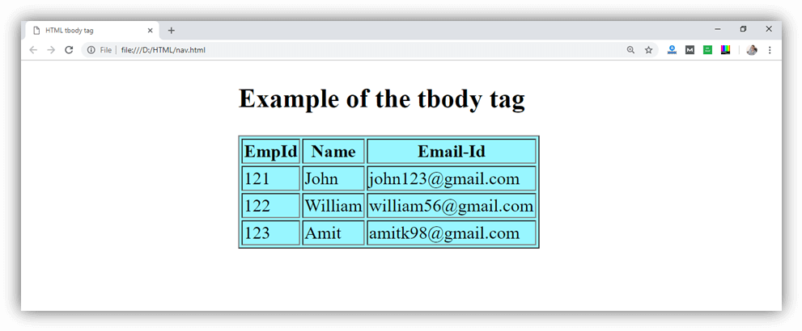

Attribute:

Tag-specific attributes:
Attribute | Value | Description
align | right  left  center  justify  char | It determines the alignment of the content inside the <tbody> element. (Not Supported in HTML5)
char | character | It specifies the alignment of the <tbody> content to the character. (Not Supported in HTML5)
charoff | Number | It specifies the number of characters the content will be aligned from the character specified by the char attribute. (Not Supported in HTML5)
valign | top  middle  bottom  baseline | It determines the vertical alignment of the content inside the <tbody> element. (Not Supported in HTML5)

Global attribute:
The <tbody> tag supports the Global attributes in HTML.

Event attribute:
The <tbody> tag supports the Event attributes in HTML.

Supporting Browsers
Element | Chrome | IE | Firefox | Opera | Safari
<tbody> | Yes | Yes | Yes | Yes | Yes

HTML <td> tag
HTML <td> tag is used to specify the cells of an HTML table which contain data of the table. The <td> tag must be the child element of <tr> (table row) tag. Each table row can contain multiple <td> data elements.
The grouped <td> elements of a <tr> tag renders as a single row in the table. The content of the <td> elements is regular and left-aligned in the table by default.

Syntax
<td>.......</td>
Display | Inline
Start tag/End tag | Start and End tag
Usage | Table content

Example
- <!DOCTYPE html>
- <html>
- <head>
- <title>HTML td tag</title>
- <style>
- th{
- background-color: #6495ed;
- }
- th,td{
- border: 1px solid black;
- padding: 10px;
- }
- </style>
- </head>
- <body>
- <h2>Example of td Tag</h2>
- <table style=" border-collapse: collapse; background-color:#dcdcdc;">
- <tr>
- <th>Product</th>
- <th>Quantity</th>
- <th>Price</th>
- </tr>

- <tr>
- <td>Books</td>
- <td>5</td>
- <td>589</td>
- </tr>

- <tr>
- <td>T-shirt</td>
- <td>5</td>
- <td>3500</td>
- </tr>

- <tr>
- <td>Jeans</td>
- <td>2</td>
- <td>5000</td>
- </tr>
- </table>
- </body>
- </html>
Output:
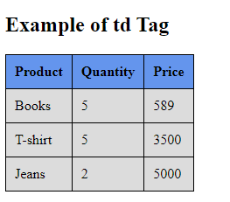

Fixed column width using <td> tag in a table
In an HTML table, the dimensions of the rows and columns in a table are automatically adjusted by the browser so that the contents fit in the row. However, there can be a situation where the width of the columns needs to be fixed or equal-sized. So there are various techniques to fix the width of the column.
<td> tag width attribute: The <td> tag width attribute is used to fix the width of a particular column. With this, we can assign a numeric value to this attribute or in terms of percentage.
Following is an example of fixing the column width using the <td> tag width attribute.

Example 1
- <! DOCTYPE html>
- <html>
- <head>
- <title> HTML td tag with fixed width </title>
- <meta charset = "UTF-8" />
- <meta name = "viewport" content = "width=device-width,
- initial-scale = 1.0" />
- <style>
- @import url(https://fonts.googleapis.com/css?family=Bangers);
- body {
- text-transform: uppercase;
- text-align: center;
- white-space: nowrap;
- color: #fff;
- background-color: #E1332D;
- }
- table.center {
- margin-left: auto;
- margin-right: auto;
- }
- th {
- background-color: #6495ed;
- }
- th,td {
- border: 1px solid red;
- padding: 10px;
- }
- thead {
- display: table-header-group;
- color: green;
- font-weight: bold;
- }
- h2 {
- text-align: center;
- font-weight: normal;
- color: #fff;
- text-transform: uppercase;
- font-size: 1em;
- white-space: nowrap;
- font-size: 4vw;
- z-index: 1000;
- font-family: 'Bangers', cursive;
- text-shadow: 5px 5px 0 rgba(0, 0, 0, 0.7);
- @include skew(0, -6.7deg, false);
- @include transition-property(font-size);
- @include transition-duration(0.5s);

- }
- thead {
- border-top: 1px solid #ccc;
- padding:10px;
- width: 120px;
- background-color: #004496;
- color: #fff;
- font-family: arial;
- font-size: 12px;

- }
- td {
- border-top: 1px solid #ccc;
- padding:10px;
- width: 120px;
- background-color: #004496;
- color: #fff;
- font-family: arial;
- font-size: 12px;

- }
- th {
- border-top: 1px solid #ccc;
- padding:10px;
- width: 120px;
- background-color: #004496;
- color: #fff;
- font-family: arial;
- font-size: 12px;

- }
- h3 {
- text-align: center;
- font-weight: normal;
- color: #fff;
- text-transform: uppercase;
- font-size: 1em;
- white-space: nowrap;
- font-size: 3vw;
- z-index: 1000;
- font-family: 'Bangers', cursive;
- text-shadow: 5px 5px 0 rgba(0, 0, 0, 0.7);
- @include skew(0, -6.7deg, false);
- @include transition-property(font-size);
- @include transition-duration(0.5s);

- }
- </style>
- </head>
- <body>
- <h2> Example </h2>
- <h3> Fixed column width using td Tag </h3>
- <table class = "center" style = " border-collapse: collapse; background-color:#dcdcdc;">
- <thead>
- <tr>
- <td width = "10%" style = "color:red;"> Sr. No </td>
- <td width = "40%"> Product </td>
- <td width = "20%"> Quantity </td>
- <td width = "30%"> Price </td>
- </tr>
- </thead>

- <tr>
- <td style = "color:red;"> 1 </td>
- <td> Books </td>
- <td> 5 </td>
- <td> 589 </td>
- </tr>

- <tr>
- <td style = "color:red;"> 2 </td>
- <td> T-shirt </td>
- <td> 5 </td>
- <td> 3500 </td>
- </tr>
- <tr>
- <td style = "color:red;"> 3 </td>
- <td> Jeans </td>
- <td> 2 </td>
- <td> 5000 </td>
- </tr>
- <tr>
- <td style = "color:red;"> 4 </td>
- <td> Suits </td>
- <td> 3 </td>
- <td> 6000 </td>
- </tr>

- </table>
- </body>
- </html>
Explanation:
In the above example, we have created an example of fixing the column width using the <td> tag width attribute.
Output:
Following is the output of this example.
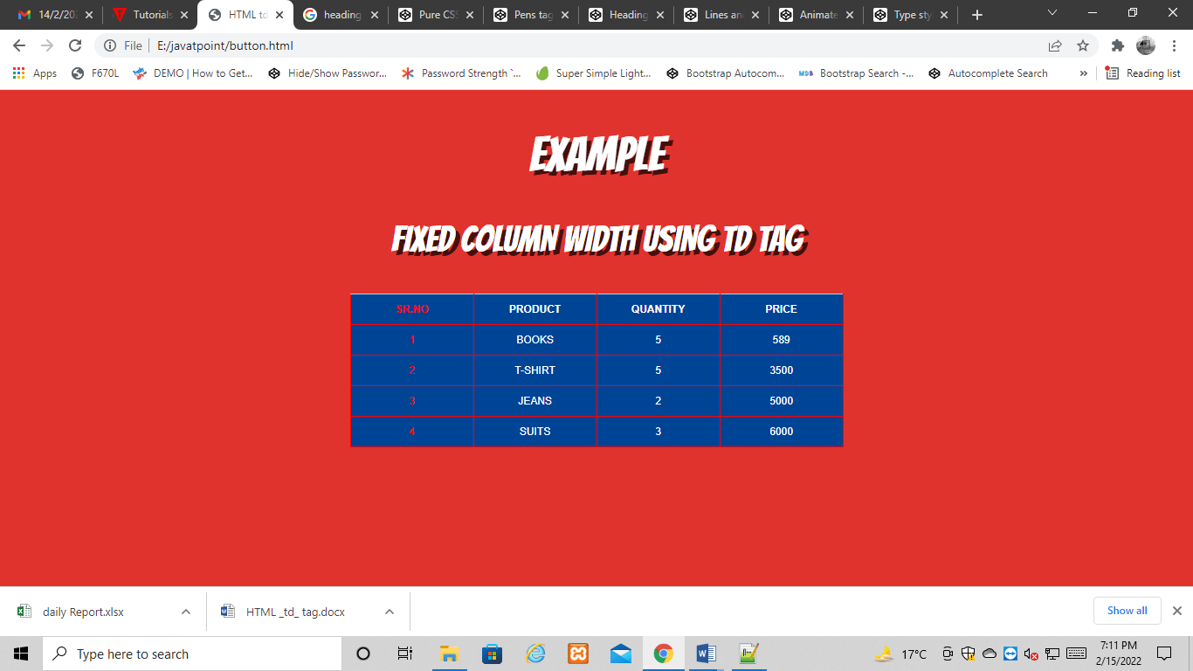

Example 2:
- <! DOCTYPE html>
- <html>
- <head>
- <title> HTML td tag with Equal width column </title>
- <meta charset = "UTF-8" />
- <meta name = "viewport" content = "width=device-width,
- initial-scale = 1.0" />
- <style>
- body {
- font-family: "Open Sans", sans-serif;
- line-height: 1.25;
- }
- table {
- border: 1px solid #ccc;
- border-collapse: collapse;
- table-layout: fixed;
- width: 100%;
- }
- table caption {
- font-size: 1.5em;
- margin: .5em 0 .75em;
- }
- table tr {
- border: 1px solid #ddd;
- padding: .35em;
- }
- table tr:nth-child(even) {
- background: #f8f8f8;
- }
- table th {
- padding: .625em;
- text-align: left;
- }
- table td {
- padding: .625em;
- text-align: left;
- }
- table th {
- background: #999;
- color: #fff;
- font-size: 1.85em;
- letter-spacing: .1em;
- text-transform: uppercase;
- }
- table td {
- white-space: nowrap;
- overflow: hidden;
- text-overflow: ellipsis;
- }
- @import url(https://fonts.googleapis.com/css?family=Bangers);
- body {
- text-transform: uppercase;
- text-align: center;
- white-space: nowrap;
- color: #fff;
- background-color: #E1332D;
- }
- h2 {
- text-align: center;
- font-weight: normal;
- color: #fff;
- text-transform: uppercase;
- font-size: 1em;
- white-space: nowrap;
- font-size: 3vw;
- z-index: 1000;
- font-family: 'Bangers', cursive;
- text-shadow: 5px 5px 0 rgba(0, 0, 0, 0.7);
- @include skew(0, -6.7deg, false);
- @include transition-property(font-size);
- @include transition-duration(0.5s);

- }
- thead {
- border-top: 1px solid #ccc;
- padding:10px;
- width: 120px;
- background-color: #004496;
- color: #fff;
- font-family: arial;
- font-size: 12px;

- }
- td {
- border-top: 1px solid #ccc;
- padding:10px;
- width: 120px;
- background-color: #004496;
- color: #fff;
- font-family: arial;
- font-size: 12px;

- }
- th {
- border-top: 1px solid #ccc;
- padding:10px;
- width: 120px;
- background-color: #004496;
- color: #fff;
- font-family: arial;
- font-size: 18px;

- }
- h3 {
- text-align: center;
- font-weight: normal;
- color: #fff;
- text-transform: uppercase;
- font-size: 1em;
- white-space: nowrap;
- font-size: 2vw;
- z-index: 1000;
- font-family: 'Bangers', cursive;
- text-shadow: 5px 5px 0 rgba(0, 0, 0, 0.7);
- @include skew(0, -6.7deg, false);
- @include transition-property(font-size);
- @include transition-duration(0.5s);

- }
- </style>
- </head>
- <body>
- <h2> Example </h2>
- <h3> Equal Sized column width using td Tag </h3>
- <table>
- <thead>
- <tr>
- <th scope = "col"> Sr. No </th>
- <th scope = "col"> Product </th>
- <th scope = "col"> Quantity </th>
- <th scope = "col"> Price </th>
- </tr>
- </thead>
- <tbody>
- <tr>
- <td style = "color:red;"> 1 </td>
- <td> Books </td>
- <td> 5 </td>
- <td> 589 </td>
- </tr>

- <tr>
- <td style = "color:red;"> 2 </td>
- <td> T-shirt </td>
- <td> 5 </td>
- <td> 3500 </td>
- </tr>
- <tr>
- <td style = "color:red;"> 3 </td>
- <td> Jeans </td>
- <td> 2 </td>
- <td> 5000 </td>
- </tr>
- <tr>
- <td style = "color:red;"> 4 </td>
- <td> Suits </td>
- <td> 3 </td>
- <td> 6000 </td>
- </tr>
- </tbody>
- </table>
- </body>
- </html>
Explanation:
In the above example, we have created an example of equal size column width using <td> tag.
Output:
Following is the output of this example.
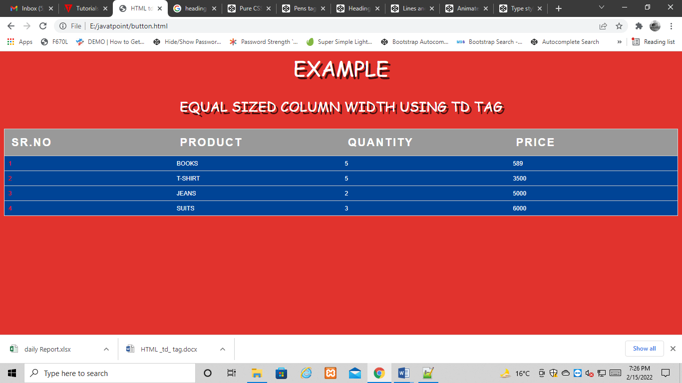

Fixed column width using <col> tag in a table
<col> tag: The <col> tag in a table is used to fix the width of a particular column. With this, we can assign a numeric value to this attribute or in terms of percentage.
Following is an example of how to fix the column width using the <col> tag.

Example 1:
- <! DOCTYPE html>
- <html>
- <head>
- <title> Html fixed width using col tag </title>
- <meta charset = "UTF-8" />
- <meta name = "viewport"
- content = "width=device-width,
- initial-scale = 1.0" />
- <style>
- @import url(https://fonts.googleapis.com/css?family=Bangers);
- body {
- text-transform: uppercase;
- text-align: center;
- white-space: nowrap;
- color: #fff;
- background-color: #E1332D;
- }
- table {
- border: 1px solid black;
- border-collapse: collapse;
- margin-left: auto;
- margin-right: auto;
- }
- th {
- border: 1px solid black;
- border-collapse: collapse;
- margin-left: auto;
- margin-right: auto;
- }
- td {
- border: 1px solid black;
- border-collapse: collapse;
- margin-left: auto;
- margin-right: auto;
- }

- table {
- width: 50%;
- }
- table.fixed {
- table-layout: fixed;
- }
- table.fixed td {
- overflow: hidden;
- }
- thead {
- display: table-header-group;
- color: green;
- font-weight: bold;
- }
- h2 {
- text-align: center;
- font-weight: normal;
- color: #fff;
- text-transform: uppercase;
- font-size: 1em;
- white-space: nowrap;
- font-size: 4vw;
- z-index: 1000;
- font-family: 'Bangers', cursive;
- text-shadow: 5px 5px 0 rgba(0, 0, 0, 0.7);
- @include skew(0, -6.7deg, false);
- @include transition-property(font-size);
- @include transition-duration(0.5s);

- }
- thead {
- border-top: 1px solid #ccc;
- padding:10px;
- width: 120px;
- background-color: #004496;
- color: #fff;
- font-family: arial;
- font-size: 12px;

- }
- td {
- border-top: 1px solid #ccc;
- padding:10px;
- width: 120px;
- background-color: #004496;
- color: #fff;
- font-family: arial;
- font-size: 12px;

- }
- th {
- border-top: 1px solid #ccc;
- padding:10px;
- width: 120px;
- background-color: #004496;
- color: #fff;
- font-family: arial;
- font-size: 12px;

- }
- h3 {
- text-align: center;
- font-weight: normal;
- color: #fff;
- text-transform: uppercase;
- font-size: 1em;
- white-space: nowrap;
- font-size: 3vw;
- z-index: 1000;
- font-family: 'Bangers', cursive;
- text-shadow: 5px 5px 0 rgba(0, 0, 0, 0.7);
- @include skew(0, -6.7deg, false);
- @include transition-property(font-size);
- @include transition-duration(0.5s);

- }
- </style>
- </head>
- <body>
- <h2> Example </h2>
- <h3> Fixed column width using col Tag </h3>
- <div style = "overflow-x: auto;">
- <table>
- <col style = "width: 10%;" />
- <col style = "width: 40%;" />
- <col style = "width: 20%;" />
- <col style = "width: 30%;" />
- <tr>
- <th> Sr. No </th>
- <th> Product </th>
- <th> Quantity </th>
- <th> Price </th>
- </tr>
- <tr>
- <td style = "color:red;"> 1 </td>
- <td> Books </td>
- <td> 5 </td>
- <td> 589 </td>
- </tr>
- <tr>
- <td style = "color:red;"> 2 </td>
- <td> T-shirt </td>
- <td> 5 </td>

- <td> 3500 </td>
- </tr>
- <tr>
- <td style = "color:red;"> 3 </td>
- <td> Jeans </td>
- <td> 2 </td>
- <td> 5000 </td>
- </tr>
- <tr>
- <td style = "color:red;"> 4 </td>
- <td> Suits </td>
- <td> 3 </td>
- <td> 6000 </td>
- </tr>
- </table>
- </div>
- </body>
- </html>
Explanation:
In the above example, we have created an example of fixing the column width using the <col> tag.
Output:
Following is the output of this example.
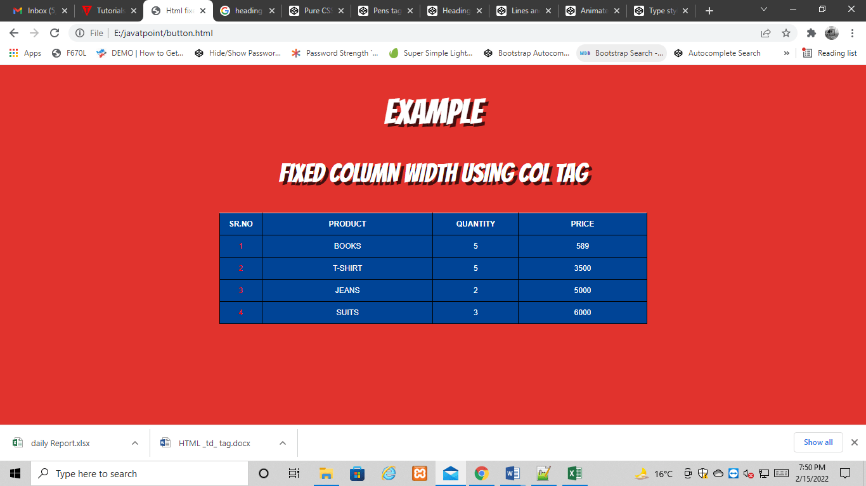

Attribute:

Tag-specific attributes:
Attribute | Value | Description
abbr | text | It defines the abbreviated version of content of the cell. (Not Supported in HTML5)
align | left  right  center  justify  char | It specifies the alignment of the content of the cell. (Not Supported in HTML5)
axis | category_name | It Categorizes Cells. . (Not Supported in HTML5)
bgcolor | rgb(x,x,x)  #xxxxxx  Color_name | It sets the background color of the cell. (Not Supported in HTML5)
char | character | It specifies the alignment of the content of cell to the character. (Not Supported in HTML5)
charoff | number | It determines the number of characters the content aligned from the character specified by the char attribute. (Not Supported in HTML5)
colspan | number | It determines the number of columns a cell should span.
headers | header_id | It determines one or more header cells to which a cell is related.
height | %  pixels | It determines the height of a table cell. (Not Supported in HTML5)
nowrap | nowrap | If it sets then content inside the cell should not wrap. (Not Supported in HTML5)
rowspan | number | It determines the number of rows a cell should span.
scope | col  colgroup  row  rowgroup | It specifies the cells that the header element relates to. (Not Supported in HTML5)
valign | top  middle  bottom  baseline | It determines the vertical alignment of the cell content. (Not Supported in HTML5)
width | %  pixels | It determines the width of the cell.(Not Supported in HTML5)

Global attribute:
The <td> tag supports the Global attributes in HTML.

Event attribute:
The <td> tag supports the Event attributes in HTML.

Supporting Browsers
Element | Chrome | IE | Firefox | Opera | Safari
<td> | Yes | Yes | Yes | Yes | Yes

HTML <template> tag
Either the client side or the server side is where templates are created. Nowadays, most websites use some kind of template. When a request enters the server, the server's templating engine puts the necessary templates together and sends the built page down to the browser. A front-end framework that supports templates or a specific templating library is used for any client-side templating that isn't done on the server side.
Since React and other contemporary JavaScript frameworks are so well-liked, many people disregard HTML and plain JavaScript. Today, JavaScript and plain HTML are still used to build the majority of websites. The HTML5 element known as "template" gives developers a reliable method for managing templates in the browser. The HTML5 <template> element gives developers a powerful method for managing templates in the browser, simplifying and improving the maintainability of the whole web writing process.
In this article, we'll learn about HTML template tags, how to use them, and their advantages and disadvantages.

Meaning and Examples
When the website loads, certain HTML material that is concealed from the user is placed within the <template> tag as a container.
JavaScript can be used subsequently to render the content inside the <template> tag.
If we have reusable HTML code, we can utilize the <template> element only after we specifically request it. If we want to accomplish this without using the template element, we must write the HTML code in JavaScript to stop the browser from rendering it.

What does the Tag <template> Mean?
An HTML5 element called "template" is used to hold HTML code fragments that aren't immediately visible once a website loads. We may copy and paste this element into an HTML page. Since it is kept on the client side, the content of the <template> is concealed from clients. The rendering of templates in the browser doesn't begin until we use JavaScript to activate them. JavaScript is employed to add content to a web page from a template to a web page from a template, JavaScript is employed.
It can also be helpful if we want to reuse the same material in our HTML document repeatedly without making any changes.
Anywhere within the <head>, <body>, <frameset>, or <table> elements is acceptable for the <template> tag.
In HTML5, the template> tag is a brand-new element.
Syntax:
<template>.........</template>

Web Template Types
Website templates can be downloaded as standalone zip files, as a custom web builder interface component, or as part of an HTML editor program. They could have a responsive, adaptive, static, or mobile-specific design. File extensions include .html, .htm, .php, and .asp. They will all be created using HTML and CSS code. Whether it's a desktop computer, tablet, or smartphone, the layout will adapt in width if it's marked as "responsive" to accommodate the unique device viewing screen.

What can be Included in a Web Template?
The features that may be included in a design include text,.jpg,.png, or.gif pictures, jQuery and CSS3 animation, shopping carts, contact forms, dynamic image galleries and slideshows, a PDF download links page, and video players (including embedded Youtube videos).
When choosing a website template, make sure it already has the features, scripts, and apps we need for our web development project because web template styles and code differ greatly from vendor to vendor. The pre-made pages may be customized by adding text, stock images, scripts, and third-party plugins. The provided stock photos can be altered or swapped out with the user's own.jpg files as needed for the project.
Templates for the HTML markup are stored in a built-in <template> element. The browser ignores the content, which just validates the syntax, but we may access it and utilize it in JavaScript to generate new components.
Theoretically, we could design any invisible element in HTML and use it to store HTML markup. What makes <template> unique?
First of all, even though it typically requires a correct surrounding tag, its content can be any acceptable HTML.
For instance, we could insert the following table row <tr>:
- <template>
- <tr>
- <td>Contents</td>
- </tr>
- </template>

An Example for Template
- <!DOCTYPE html>
- <html>
- <body>

- <h1>Template Element Example</h1>

- <p>To view the template element's concealed content, click the button below.</p>

- <button onclick="showContent()">show content</button>

- <template>
- <h2>Flower</h2>
- <img src="C:\Users\Maram Ujwala\Pictures\Saved Pictures\Images\Flower 1.jpg" width="60" height="40">
- </template>

- <script>
- function showContent() {
- let temp = document.getElementsByTagName("template")[0];
- let clon = temp.content.cloneNode(true);
- document.body.appendChild(clon);
- }
- </script>

- </body>
- </html>
Output:
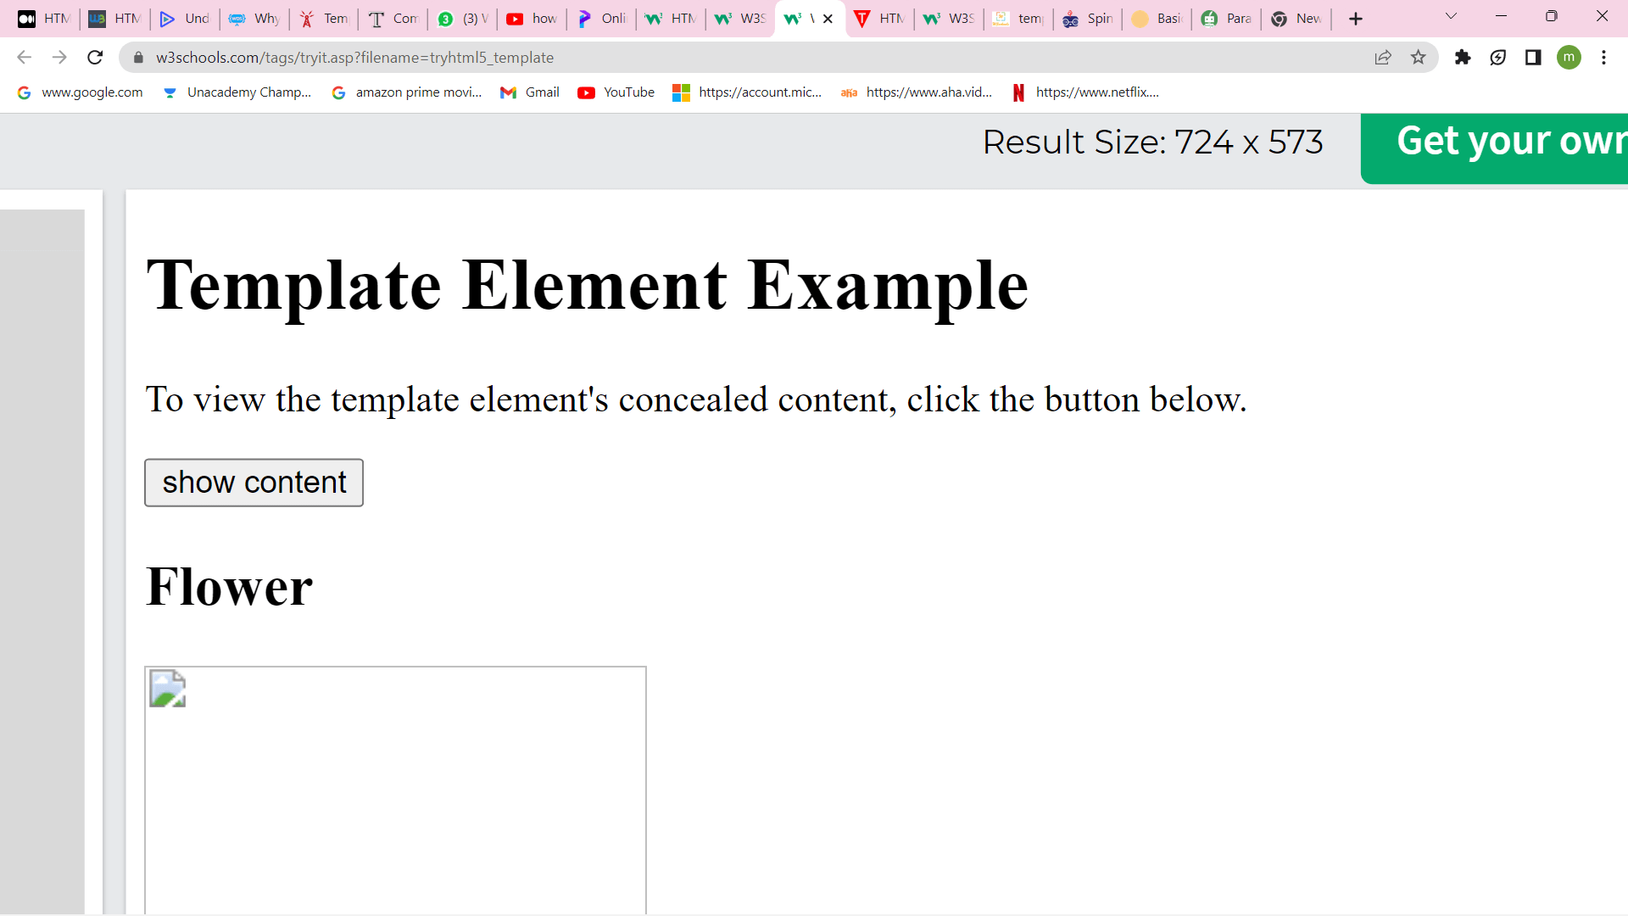
When we click on show content, a flower image is displayed as shown below.


Another Example of a Template Element
- <!doctype html>
- <html>
- <head>
- <title>HTML Page</title>
- <meta name="description" content="HTML page">
- <meta name="keywords" content="html example">
- </head>
- <body>
- HTML content
- </body>
- </html>
Output:
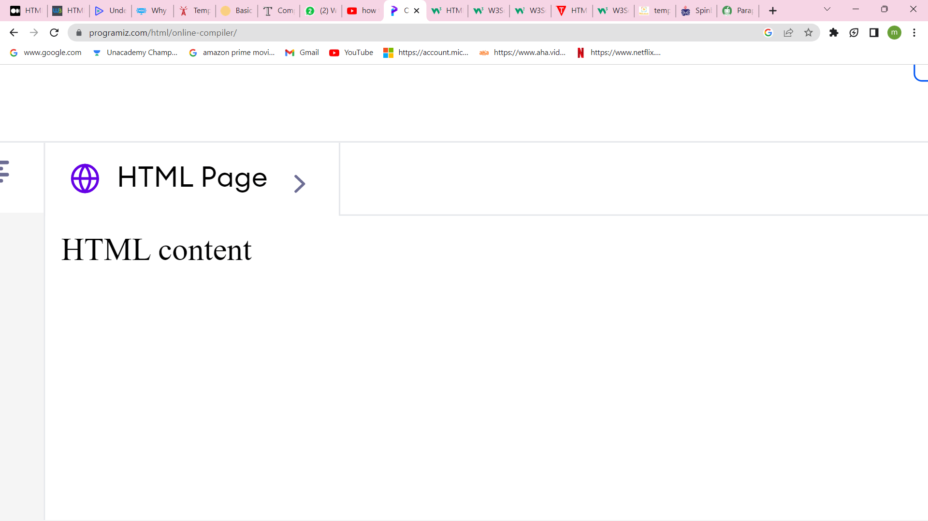
Let's deconstruct it:
- Line 1: This special tag, which appears at the beginning of the page and specifies the kind of code being used, is used to identify the type of code.
- The HTML page is opened and closed by the HTML tags on lines 2 and 12. The paper includes all of its contents.
- The head tags on lines 3 and 7 specify where the document's head will appear. Items below are supplemental information that goes with the paper.
- The title tag in line 4 specifies the document's title. It will be shown at the very top of the browser window.
- The meta tags on lines 5 and 6 are used to describe the document.
- The body tags on lines 9 and 11 enclose the document's actual content.

The Doctype
This tag should always be the first one on a page. It ought to be placed just before the html tag at the top. You'll see that this tag starts with an exclamation point (!) as opposed to the other tags.
- <!doctype html>
Technically speaking, it is not a tag but rather a directive to the browser for how to read the remaining text. We just use the term "HTML" to describe HTML 5. Since several varieties of HTML may be used, it was crucial to identify which.

The Head
- <head> </head>
Ancillary data is placed in the HTML document's head section. While not a part of the text, this information relates to it. There are several things.
However, the aforementioned template covers the fundamental elements that any page needs.

The Title
We may give the document a title by using the title tag. This is employed several times:
- It will be shown at the top of the browser's window.
- The title from your bookmarked version of this page will be utilized.
- When listing your page in their search results, search engines take into account the title.
- When someone connects to your page from another website, the title may be used.
- Given all the locations it is used, the title tag may be rather significant. Spend some time making sure it is both brief and detailed.

Meta Tags
- <meta name="description" value=" ">
- <meta name="keywords" value=" ">
The two meta tags for the description and keywords follow in the head. These can be utilized by other systems (like when your page is linked to social networking and other sharing sites) and are used by search engines (to varying degrees).
The description serves as a summary of the subject matter of the page. This will often appear on the results pages of search engines beneath your title.
The keywords meta tag is used to offer a list of terms that would fit the subject matter of the page. Previously, search engines gave this feature of your page some weight, but because of misuse, it currently carries very little weight. However, you should still include it for completeness' sake and also because you could get black-listed by some search engines if you don't include it. They argue that the quality of your page will be lower if you are lazy and can't be bothered to include this tag since you are likely to be lazy in other areas as well.

The Body
- <body> < /body>
The actual content of your page goes here. All of this stuff would typically be included in tags that describe the sort of content it is. To keep things simple, we omitted this form from the previous example. We'll begin demonstrating the many types of tags that may be applied in the next section.

Advantages of <template> Element
- The HTML event and global attributes are both supported.
- It aids in the development of reusable markups.
- It supports a wide range of browsers.
- It applies to front-end frameworks.
- Site performance and speed are enhanced because it only operates when engaged.

Disadvantages of <template> Element
- It just uses Javascript. The template element's output won't be seen by users whose browsers have Javascript disabled.
- Accessibility issues; certain older screen readers are affected.

Summary to Sum Up
Any syntactically sound HTML can be used as <template> content.
Content within a <template> is regarded as being "out of the document" and has no bearing on anything.
We can use JavaScript to access template.content and copy it so we can reuse it in another component.
The <template> tag is quite distinctive because:
- As an alternative to utilizing a template string within a script, the browser validates HTML syntax within it.
- Nevertheless permits the usage of any top-level HTML elements, including ones that are useless without the appropriate wrappers (such as <tr>).
- When put into the document, the material becomes interactive: scripts run, <videos autoplay>, etc.
- There are no iteration mechanisms, data binding, or variable replacements built into the <template> element, but we can add things on top of it.

HTML Textarea
The HTML <textarea> tag is used to define a multi-line text input control.
It can hold unlimited number of characters and the texts are displayed in a fixed-width font (usually courier).
The size of the HTML textarea is defined by <cols> and <rows> attribute, or it can also be defined through CSS height and width properties.

HTML Textarea Example
- <textarea rows="9" cols="70">
- JavaTpoint textarea tag example with rows and columns.
- </textarea>
Output:

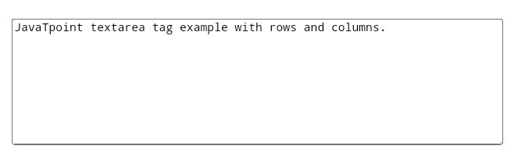
Supporting Browsers
Element | Chrome | IE | Firefox | Opera | Safari
<textarea> | Yes | Yes | Yes | Yes | Yes

New HTML 5 Textarea Attributes
Attribute | Description
autofocus | It specifies that a text area should be automatically get focused when the page is loaded.
form | It specifies one or more forms the textarea belongs to.
maxlength | It specifies the maximum number of characters allowed in the text area.
placeholder | It specifies a short hint that describes the expected value of a textarea.
required | It specifies that textarea must be filled out.
wrap | It specifies that how the texts in the textarea are wrapped at the time of the submission of the form.

HTML Textarea form attribute
The form attribute specifies one or more forms the text area belongs to.
- <form action="updates.jsp" id="usrform">
- Name: <input type="text" name="usrname">
- <input type="submit">
- </form>
- <br>
- <textarea rows="9" cols="70" name="comment" form="usrform">
- Enter text here...</textarea>
- <p>The text area above is outside the form element, but should still be a part of the form.</p>
- <p><b>Note:</b> The form attribute is not supported in Internet Explorer.</p>
Output:
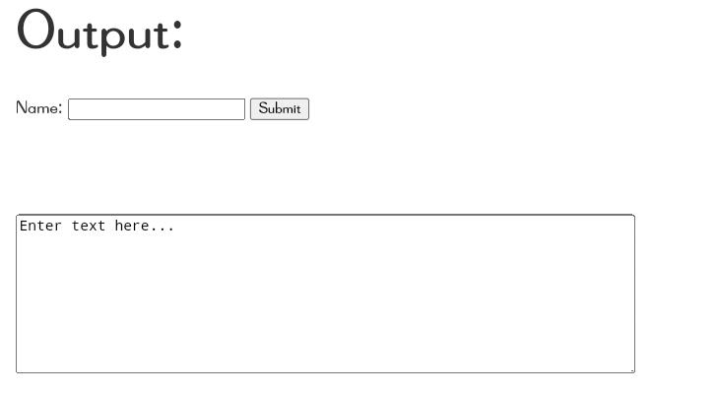
The textarea element above is outside the form , but it is still the part of the form.
Note: The form attribute is not supported in Internet Explorer.

HTML <tfoot> tag
HTML <tfoot> tag is used to define the set of rows which represents footer of an HTML table. The <tfoot> tag must contain one or more <tr> element.
The <tfoot> tag is used as a child element of HTML table (<table>) along with <thead> and <tbody> elements, where <thead> defines table header and <tbody> defines the table body.

Tips: The <thead>, <tbody>, and <tfoot> elements do not affect the table layout, and if you want to apply the change in table layout then use CSS properties.

Syntax
- <tfoot>
- <tr></tr>
- <tr></tr>
- lt;/tfoot>
Following are some specifications about the HTML <tfoot> tag
Display | None
Start tag/End tag | Start and End tag
Usage | HTML Tables

Example
- <!DOCTYPE html>
- <html>
- <head>
- <title>HTML tfoot Tag</title>
- <style>
- table{
- border-collapse: collapse;
- }
- thead,tfoot{
- background-color:#3f87a6;
- }
- tbody{
- background-color:#97ffff;
- }
- </style>
- </head>
- <body>
- <h1>Example of tfoot tag</h1>
- <table border="1" >
- <thead>
- <tr>
- <th>Items</th>
- <th>Quantity</th>
- <th>Expenditure</th>
- </tr>
- </thead>
- <tfoot>
- <tr>
- <th>Total</th>
- <th>90</th>
- <th>4175</th>
- </tr>
- </tfoot>
- <tbody>
- <tr>
- <td>Books</td>
- <td>5</td>
- <td>1500</td>
- </tr>
- <tr>
- <td>Drawing-Paper</td>
- <td>50</td>
- <td>800</td>
- </tr>
- <tr>
- <td>Marker</td>
- <td>35</td>
- <td>1875</td>
- </tr>
- </tbody>
- </table>
- </body>
- </html>
Output:
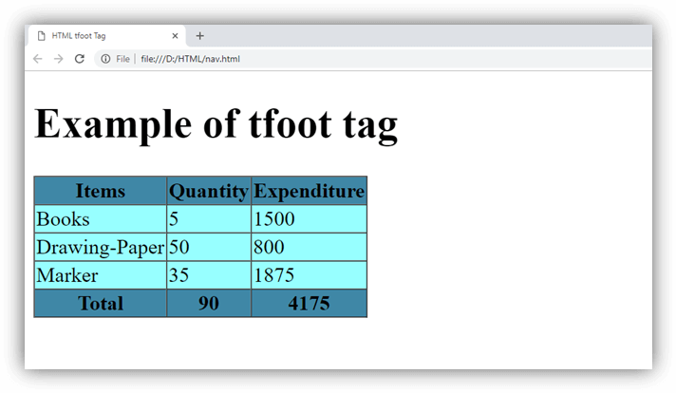

Attribute:

Tag-specific attributes:
Attribute | Value | Description
align | right  left  center  justify  char | It determines the alignment of the content inside the <tfoot> element. (Not Supported in HTML5)
char | Character | It specifies the alignment of the content inside the <tfoot> element to the character. (Not Supported in HTML5)
charoff | Number | It specifies the number of characters the content will be aligned from the character specified by the char attribute. (Not Supported in HTML5)
valign | top  middle  bottom  baseline | It determines the vertical alignment of the content inside the <tfoot> element. (Not Supported in HTML5)

Global attribute:
The <tfoot> tag supports the Global attributes in HTML.

Event attribute:
The <tfoot> tag supports the Event attributes in HTML.

Supporting Browsers
Element | Chrome | IE | Firefox | Opera | Safari
<tfoot> | Yes | Yes | Yes | Yes | Yes

HTML <th> tag
In an HTML table there are two types of cells:
- Header cell - It contains the header information (created using <th> element)
- Data Cells - It contains the main data of the table (created using <td> element).
HTML <th> tag is used to define the header cells of an HTML table. The header cell renders as bold and centered by default on the browser, but you can change its default style using CSS properties.
The <th> tag must be used as a child element of the <tr> element within <table> element. The size of the table is auto-adjustable as per the content size.

Syntax
- <th>Content....... </th>
Following are some specifications about the HTML <th> tag
Display | None
Start tag/End tag | Both Start and End tag
Usage | HTML Tables

Example
- <!DOCTYPE html>
- <html>
- <head>
- <title>HTML th Tag</title>
- <style>
- table{
- border-collapse: collapse;
- width: 70%;}
- th,td{
- background-color: #528b8b;
- padding: 10px;
- }
- </style>
- </head>
- <body>
- <h2>Example of th tag</h2>
- <table border="1">
- <tr>
- <th>Month</th>
- <th>Date</th>
- </tr>
- <tr>
- <td>January</td>
- <td>20.01.2018</td>
- </tr>
- <tr>
- <td>February</td>
- <td>01.02.2018</td>
- </tr>
- <tr>
- <td>March</td>
- <td>15.03.2018</td>
- </tr>
- </table>
- </body>
- </html>
Output:
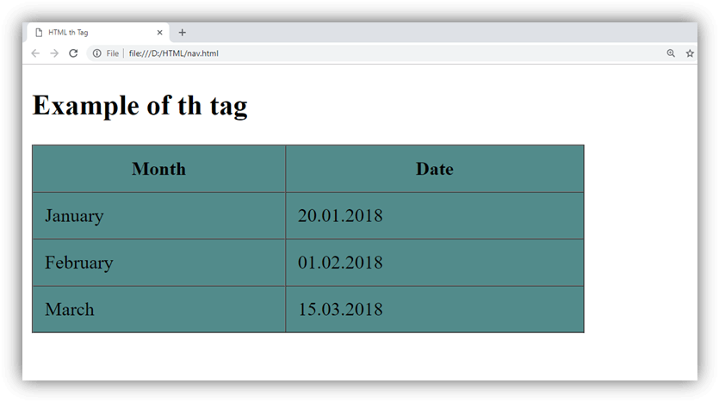

Attribute:

Tag-specific attributes:
Attribute | Value | Description
abbr | text | It defines the abbreviated version of content of the header cell. (Not Supported in HTML5)
align | left  right  center  justify  char | It specifies the alignment of the content of the header cell. (Not Supported in HTML5)
axis | category_name | It Categorizes header Cells(Not Supported in HTML5)
bgcolor | rgb(x,x,x)  #xxxxxx  Color_name | It sets the background color of the header cell. (Not Supported in HTML5)
char | character | It specifies the alignment of the content of the header cell to the character. (Not Supported in HTML5)
charoff | number | It specifies the number of characters the header cell content will be aligned from the character specified by the char attribute. (Not Supported in HTML5)
colspan | number | It determines the number of columns a header cell should span.
headers | header_id | It determines a space-separated list of header cells which contains information of the cells is related.
height | %  pixels | It determines the height of a table header cell. (Not Supported in HTML5)
nowrap | nowrap | If it sets then content inside the header cell should not wrap. (Not Supported in HTML5)
rowspan | number | It determines the number of rows a cell should span.
scope | col  colgroup  row  rowgroup | It specifies the cells that the header element relates to. (Not Supported in HTML5)
valign | top  middle  bottom  baseline | It determines the vertical alignment of the cell content. (Not Supported in HTML5)
width | %  pixels | It determines the width of the header cell.(Not Supported in HTML5)

Global attribute:
The <th> tag supports the Global attributes in HTML.

Event attribute:
The <th> tag supports the Event attributes in HTML.

Supporting Browsers
Element | Chrome | IE | Firefox | Opera | Safari
<th> | Yes | Yes | Yes | Yes | Yes

HTML <thead> tag
HTML <thead> elements is used to define header of an HTML table. The <thead> tag is used along with <tbody> and <tfoot> tags which defines table header, table body, and table footer in an HTML table.
The <thead> tag must be child of <table> element, and it must be used before any <tbody>, <tr>, or <tfoot> elements.
The <thead> tag should contain at least one row <tr> element inside it.

Syntax
- <thead>
- <tr>
- </tr>
- lt;/thead>
Following are some specifications about the HTML <thead> tag
Display | Inline
Start tag/End tag | Start and End tag
Usage | Table header

Example
- <!DOCTYPE html>
- <html>
- <head>
- <title>HTML thead Tag</title>
- <style>
- table{
- border-collapse: collapse;
- margin: 15px;}
- thead{
- background-color:#005cb9;}
- tbody{
- background-color: #d4caca;}
- th,td{
- padding: 12px;}
- </style>
- </head>
- <body>
- <h2>Example of thead tag</h2>
- <table border="1">
- <caption>Population of India</caption>
- <thead>
- <tr>
- <th>Year</th>
- <th>Population</th>
- </tr>
- </thead>
- <tbody>
- <tr>
- <td>2015</td>
- <td>1,309,053,980</td>
- </tr>
- <tr>
- <td>2016</td>
- <td>1,324,171,354</td>
- </tr>
- <tr>
- <td>2017</td>
- <td>1,339,180,127</td>
- </tr>
- <tr>
- <td>2018</td>
- <td>1,354,051,854</td>
- </tr>
- </tbody>
- </table>
- </body>
- </html>
Output:
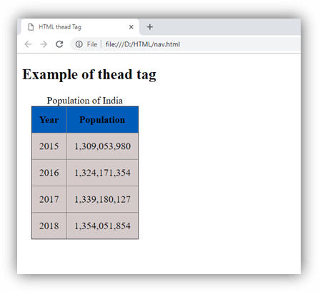

Attribute:

Tag-specific attributes:
Attribute | Value | Description
align | right  left  center  justify  char | It determines the alignment of the content inside the <thead> element. (Not Supported in HTML5)
char | Character | It specifies the alignment of the content inside the <thead> element to the character. (Not Supported in HTML5)
charoff | Number | It specifies the number of characters the content that will be aligned from the character specified by the char attribute. (Not Supported in HTML5)
valign | top  middle  bottom  baseline | It determines the vertical alignment of the content inside the <thead> element. (Not Supported in HTML5)

Global attribute:
The <thead> tag supports the Global attributes in HTML.

Event attribute:
The <thead> tag supports the Event attributes in HTML.

Supporting Browsers
Element | Chrome | IE | Firefox | Opera | Safari
<thead> | Yes | Yes | Yes | Yes | Yes

HTML Time Tag
HTML <time> tag is used to define date and time. It displays time value in a 24 hour clock or a precise date in a Gregorian calendar in HTML.
It is used to encode dates and times in a machine-readable way to make easy to mark or schedule your task.
It also helps search engines to produce smarter search results.
HTML <time> is a new tag and introduced in HTML5.
Let's see the syntax to define date and time.
- <time>Define Time and Date here</time>

Attribute
There is only one specific attribute of HTML5 time tag.
Attribute | Description
datetime | It is used to define machine-readable date/time within the time element.

HTML time tag example
- <p>We open our shop at <time>09:00</time> am.</p>
- <p>The business meeting is scheduled on <time datetime="2009-02-18">next wednesday</time>.</p>
- <p>The wedding of Salman's sister was scheduled at <time datetime="2014-11-19 T0 7:00-09:00">7pm last wednesday </time>.</p>
Output:
We open our shop at 09:00 am.
The business meeting is scheduled on next wednesday.
The wedding of Salman's sister was scheduled at 7pm last wednesday .

In this example, First line in the body tag defines basic usage of time tag.
Second line shows how to use the datetime attribute to provide contents in a machine-readable format.
Third line uses the datetime attribute to provide an even more specific date and time.

The <time> tag also supports global attributes and event attributes in HTML 5.

Supporting Browsers
Element | Chrome | IE | Firefox | Opera | Safari
<time> | Yes | Yes | Yes | Yes | Yes

