HTML Title
HTML title tag is used to provide a title name for your webpage. It is necessary for Search Engine Optimization (SEO).
The HTML title tag must be used inside the <head> tag.
The title of the page is displayed on the title bar of the browser.
Let's see the example of HTML title tag.
- <!DOCTYPE html>
- <html>
- <head>
- <title>First web page.</title>
- </head>
- <body>
- <p>Welcome to my first web page.</p>
- </body>
- </html>
Here you see that we are using two elements, the head tag and the title tag. The whole title element is within the head tag.
The head element which appears before body element just contains the information about the page but it doesn't display on the browser window. So, to display a title name on the web page, title element is used.
If you look at the above example, you will see that "First web page" will be displayed on the tab/ title bar of the browser. Content(text) between <title>.............</title> is shown on the title bar.

Supporting Browsers
Element | Chrome | IE | Firefox | Opera | Safari
<title> | Yes | Yes | Yes | Yes | Yes

HTML <tr> tag
HTML <tr> tag is used to define the rows in the table. The <tr> tag can consist one or more <th> head cells and <td> data cells to define a single row of HTML table.
The <tr> tag must be a direct child of <table> element or it can be nested child of <thead>, <tbody>, and <tfoot> elements.

Syntax
- <tr>.......</tr>
Following are some specifications about the HTML <tr> tag
Display | Inline
Start tag/End tag | Start and End tag
Usage | Table content

Example
- <!DOCTYPE html>
- <html>
- <head>
- <title>HTML tr tag</title>
- <style>
- table{
- border-collapse: collapse;
- margin-left: 350px;
- }
- th,td{
- padding: 25px;}
- th{
- background-color: #005cb9;}
- td{
- background-color:#98f5ff;}
- </style>
- </head>
- <body>
- <h2>Example of tr tag</h2>
- <table border="1">
- <caption><b>Top Three performers of Winter Olympic Medals</b></caption>
- <tr>
- <th>Rank</th>
- <th>Country</th>
- <th>Total medals</th>
- </tr>
- <tr>
- <td>1</td>
- <td>Norway</td>
- <td>329</td>
- </tr>
- <tr>
- <td>2</td>
- <td>United State</td>
- <td>282</td>
- </tr>
- <tr>
- <td>3</td>
- <td>Germany</td>
- <td>228</td>
- </tr>
- </table>
- </body>
- </html>
Output:
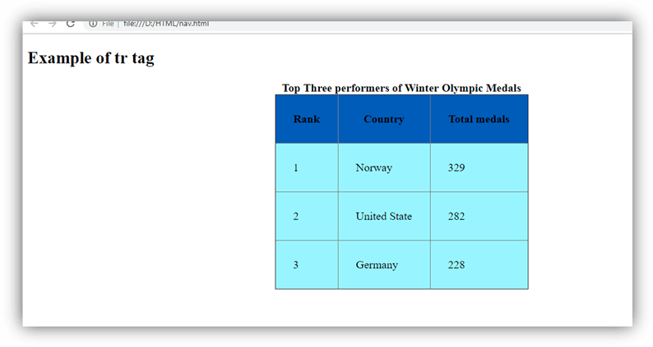

Attribute:

Tag-specific attributes:
Attribute | Value | Description
align | right  left  center  justify  char | It determines the alignment of the content in the table row. (Not Supported in HTML5)
bgcolor | rgb(x,x,x)  #xxxxx  color_name | It defines the background color of the table row. (Not Supported in HTML5)
char | character | It specifies the alignment of content to the character. (Not Supported in HTML5)
charoff | number | It specifies the number of character the table row content will be aligned from the character, and which is specified by char attribute. (Not Supported in HTML5)
valign | Top  Middle  Bottom  baseline | It specifies the vertical alignment of the table row content. (Not Supported in HTML5)

Global attribute:
The <tr> tag supports the Global attributes in HTML.

Event attribute:
The <tr> tag supports the Event attributes in HTML.

Supporting Browsers
Element | Chrome | IE | Firefox | Opera | Safari
<tr> | Yes | Yes | Yes | Yes | Yes

HTML <track> tag
HTML <track> tag is used to define time-based text tracks for a media file. The <track> tag must use as child element of <audio> and <video> elements.
The <track> tag is used to add subtitle, caption, or any other form of text which displayed when a media file plays.
HTML <track> is new tag in HTML5.

Syntax
- <track src=" " kind=" " srclang=" " label=" ">
Following are some specifications about the HTML <track> tag
Display | None
Start tag/End tag | Only start tag(End tag forbidden)
Usage | HTML media

Example
- <!DOCTYPE html>
- <html>
- <head>
- <title>HTML track Tag</title>
- </head>
- <body>
- <h2>Example of track tag</h2>
- <video controls="controls">
- <source src="flower.mp4" type="video/mp4">
- <track src="flower.vtt" kind="subtitles" srclang="en" label="English">
- Sorry!Your browser does not support the track
- </video>
- </body>
- </html>
In the above example, we have used flower.vtt file to add subtitle in the video file. Following is the flower.vtt file:
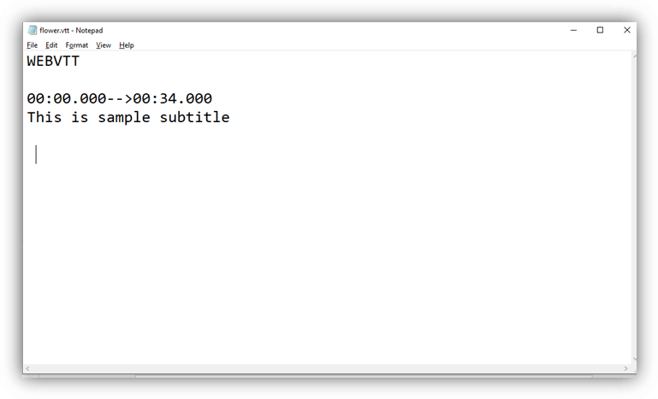

How to create WEBVTT file:
Following are some basic steps to create WEBVTT file for <track> tag:
- Open text editor in your PC such as Notepad
- Write WEBVTT as the first line in the editor
- Leave a blank line
- Specify the time duration in the proper format (you can also provide numbering and add CSS).
- Enter and write your text which you want to add a subtitle or caption, and repeat step 3 to 5 until you finish it.
- Save it using .vtt extension.
Now your WEBVTT file is ready to use.

Attribute:

Tag-specific attributes:
Attribute | Value | Description
default | default | It specifies that the track should be enabled unless the user?s preferences indicate that another track is more important.
kind | captions  chapters  descriptions  metadata  subtitles | It specifies that which type of text track you want to add.
label | text | It specifies the title of the text track.
src | URL | It defines the URL of the track file.
srclang | language_code | It defines the language of the track text content, such as English, Germany, etc.

Global attribute:
The <track> tag supports the Global attributes in HTML.

Event attribute:
The <track> tag supports the Event attributes in HTML.

Supporting Browsers
Element | Chrome | IE | Firefox | Opera | Safari
<track> | Yes | Yes | Yes | Yes | Yes

HTML <tt> tag (Not supported in HTML5)
HTML <tt> tag was used to define text in monospaced font or fixed-width fonts so that it would render as teletype, text-only screen, or line printer on the browser.
Note: Do not use HTML <tt> tag, as it is not supported in HTML5, instead of you can use following tags for better use:
- <code>: To represent the computer programming code
- <pre>: To preserve line break and indentation in plain text.
- <kbd>: To represent keyboard input.
- <var>: To represent variables in an equation
- <samp>: To represent the text as sample output.

Syntax
Following are some specifications about the HTML <tt> tag
Display | Inline
Start tag/End tag | Start and End tag
Usage | Formatting

Example
- <!DOCTYPE html>
- <html>
- <head>
- <title>HTML tt tag</title>
- </head>
- <body>
- <h2>Example of tt tag</h2>
- <p>This is paragraph with default font</p>
- <p><tt>This is teletype paragraph</tt></p>
- </body>
- </html>
Output:
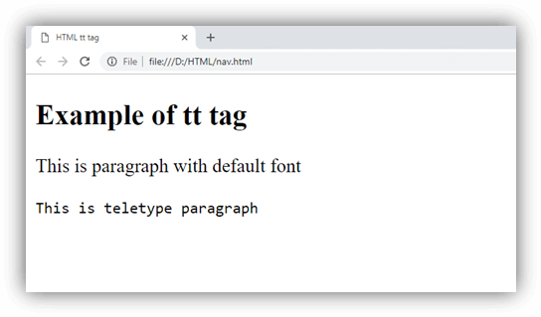

Attribute:

Tag-specific attributes:
The <tt> tag does not contain any specific attribute.

Supporting Browsers
Element | Chrome | IE | Firefox | Opera | Safari
<tt> | Yes | Yes | Yes | Yes | Yes

HTML <u> tag
HTML <u> tag is used to define a span of inline text with a non-textual annotation. It rendered as an solid underlined text, but it can be changed using CSS properties. This tag was deprecated in HTML 4.0 and redefined in HTML5.
In HTML5, <u> tag is used to represent the text that is stylistically different with normal text.

Tips: The use of <u> tag should be ignored as it may generate confusion for a hyperlinked text.

Syntax
Following are some specifications about the HTML <u> tag
Display | Inline
Start tag/End tag | Start and End tag
Usage | Formatting

Example
- <!DOCTYPE html>
- <html>
- <head>
- <title>HTML u tag</title>
- <style>
- u {
- text-decoration: red wavy underline;}
- </style>
- </head>
- <body>
- <h2>Example of u tag</h2>
- <p>This tag can be useful to identifying <u>spelling mistakes </u>in an document.</p>
- </body>
- </html>
Output:
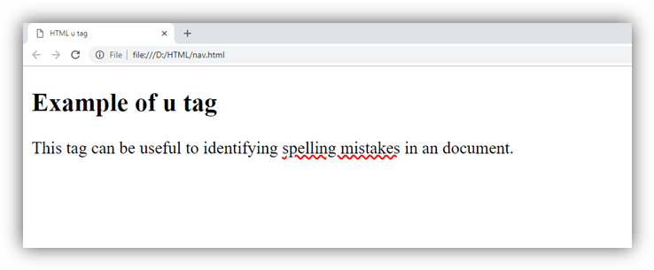

Attribute:

Tag-specific attributes:
The <u> tag does not contain any specific attribute.

Global attribute:
The <u> tag supports the Global attributes in HTML.

Event attribute:
The <u> tag supports the Event attributes in HTML.

Supporting Browsers
Element | Chrome | IE | Firefox | Opera | Safari
<u> | Yes | Yes | Yes | Yes | Yes

HTML <var> tag
HTML <var> tag is a phrase tag which is used to define the variable for a mathematical equation, or in the programming context.
The content within <var> tag renders in italic font in most of the browsers, but it can be overridden using appropriate CSS.
Following are some related elements of <var> tag, which can also be used for the same context:
- <code>: To determine the computer programming code.
- <kbd>: To determine the keyboard input.
- <samp>: To determine the sample output.

Syntax
<var>........</var>
Following are some specifications about the HTML <var> tag
Display | Inline
Start tag/End tag | Start and End tag
Usage | Formatting

Example
- <!DOCTYPE html>
- <html>
- <head>
- <title>HTML var tag</title>
- </head>
- <body>
- <h2>Example of var tag</h2>
- <p>Following is equation for distributive law</p>
- <p><var>a</var>(<var>b</var>+<var>c</var>)=<var>ab</var>+<var>ac</var></p>
- </body>
- </html>
Output:
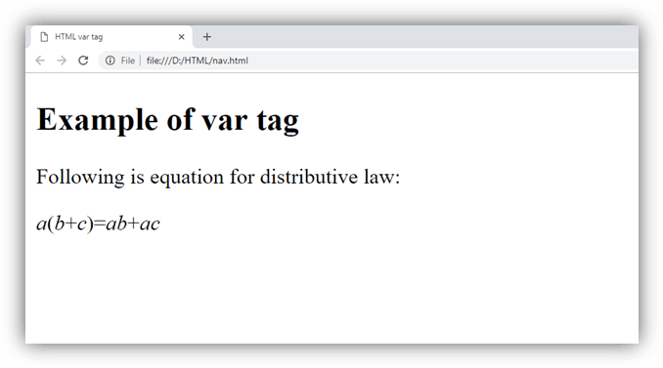

Attribute:

Tag-specific attributes:
The <var> tag does not contain any specific attribute in HTML.

Global attribute:
The <var> tag supports the Global attributes in HTML.

Event attribute:
The <var> tag supports the Event attributes in HTML.

Supporting Browsers
Element | Chrome | IE | Firefox | Opera | Safari
<var> | Yes | Yes | Yes | Yes | Yes

HTML Video Tag
HTML 5 supports <video> tag also. The HTML video tag is used for streaming video files such as a movie clip, song clip on the web page.
Currently, there are three video formats supported for HTML video tag:
- mp4
- webM
- ogg
Let's see the table that defines which web browser supports video file format.
Browser | mp4 | webM | ogg
Internet Explorer | yes | no | no
Google Chrome | yes | yes | yes
Mozilla Firefox | yes | yes | yes
Opera | no | yes | yes
Apple Safari | yes | no | no

Android also supports mp4 format.

HTML Video Tag Example
Let's see the code to play mp4 file using HTML video tag.
- <video controls>
- <source src="movie.mp4" type="video/mp4">
- Your browser does not support the html video tag.
- </video>
Let's see the example to play ogg file using HTML video tag.
- <video controls>
- <source src="movie.ogg" type="video/ogg">
- Your browser does not support the html video tag.
- </video>

Supporting Browsers
Element | Chrome | IE | Firefox | Opera | Safari
<video> | Yes | Yes | Yes | Yes | Yes

Attributes of HTML Video Tag
Let's see the list of HTML 5 video tag attributes.
Attribute | Description
controls | It defines the video controls which is displayed with play/pause buttons.
height | It is used to set the height of the video player.
width | It is used to set the width of the video player.
poster | It specifies the image which is displayed on the screen when the video is not played.
autoplay | It specifies that the video will start playing as soon as it is ready.
loop | It specifies that the video file will start over again, every time when it is completed.
muted | It is used to mute the video output.
preload | It specifies the author view to upload video file when the page loads.
src | It specifies the source URL of the video file.

HTML Video Tag Attribute Example
Let's see the example of video tag in HTML where are using height, width, autoplay, controls and loop attributes.
- <video width="320" height="240" controls autoplay loop>
- <source src="movie.mp4" type="video/mp4">
- Your browser does not support the html video tag.
- </video>

MIME Types for HTML Video format
The available MIME type HTML video tag is given below.
Video Format | MIME Type
mp4 | video/mp4
ogg | video/ogg
webM | video/webM

HTML Wbr Tag
HTML <wbr> tag is used to specify a line break opportunity within an HTML document.
Without wbr tag, it is very difficult to read a long single word or a sentence. Without wbr tag, single long word can wrap or not wrap at all, it creates problem for the layout of the page.
Without <wbr> tag, users will have to scroll right to read a long complete word or sentence.
The <wbr> tag is new and introduced in HTML 5.

The wbr tag doesn't break line.

Difference between <wbr> and <br> tag
The <br> tag forces a line break while <wbr> tag only represents a line break opportunity. It only facilitate the browser to line break if necessary (for example at the end of page .

How to test <wbr> tag
To test HTML wbr tag, write too many characters without wbr tag, it will enable a scroll bar for you. But if you write too many characters within wbr tag, it will not enable a scroll bar but break the line.

HTML wbr tag example
- <p> This is a world record for the largest word,
- a 45-letter word appears in a major dictionary
- <i>pneumonoultramicroscopicsilicovolcanoconiosis</i>
- </p>
- <p>Here's what it looks like without using the <code>wbr</code> tag...<br/>
- <i> pneumonoultramicroscopicsilicovolcanoconiosis </i></p>
- <p> It will look like this after using wbr tag. </p>
- <i> pneu<wbr>monoultra<wbr>microsc<wbr>opicsili<wbr>covolcan<wbr>iosis</i>
Output:
This is a world record for the largest word, a 45-letter word appears in a major dictionary pneumonoultramicroscopicsilicovolcanoconiosis
Here's what it looks like without using the wbr tag...
pneumonoultramicroscopicsilicovolcanoconiosis
It will look like this after using wbr tag.
pneumonoultramicroscopicsilicovolcaniosis

The <wbr> tag supports global and event attributes in HTML 5.

Supporting Browsers
Element | Chrome | IE | Firefox | Opera | Safari
<wbr> | Yes | Yes | Yes | Yes | Yes

