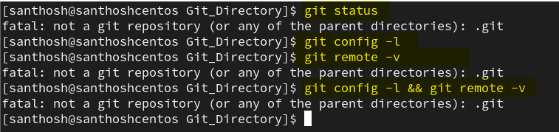

1. Configure Your Identity (One-Time Setup)
Git requires your name and email before allowing you to commit. Run:
git config --global user.name “git user name”
git config --global user.email "useremail@gmail.com"
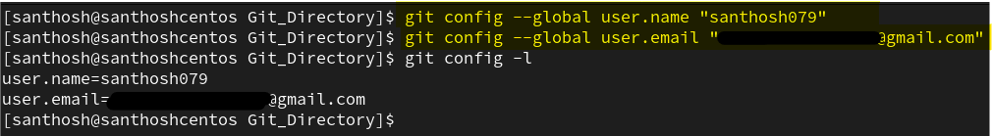

2. GitHub Authentication (Important)
GitHub no longer accepts your account password for git push. When prompted for your password during git push, you must use a Personal Access Token (PAT):
- Generate one on GitHub: Profile Settings $\rightarrow$ Developer settings $\rightarrow$ Personal access tokens (Tokens (classic)) $\rightarrow$ check the repo scope $\rightarrow$ copy the token.
- Use your GitHub username (santhosh079) as the username and paste the token when prompted for the password.

3. Run the Commands in Order
Now you can run the commands directly in your terminal:
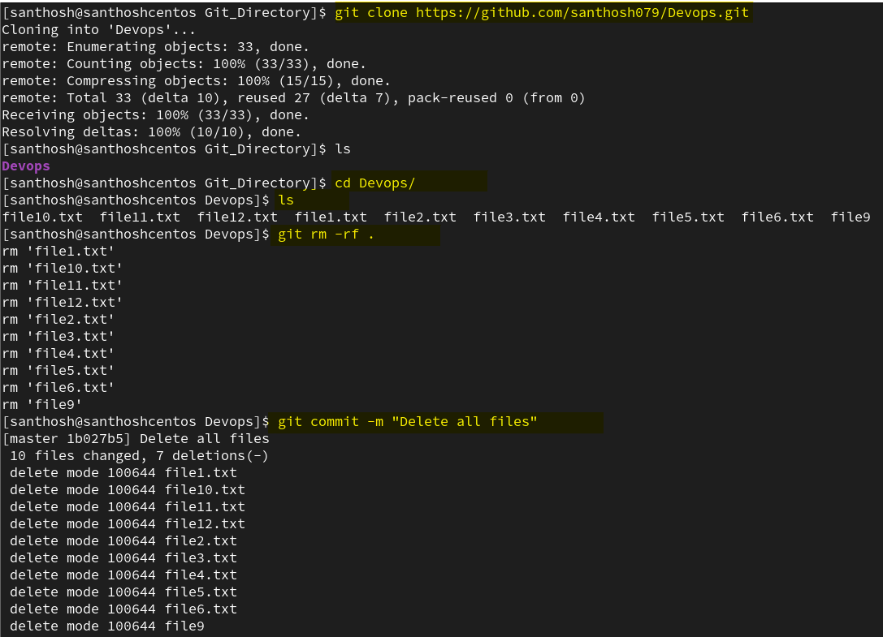

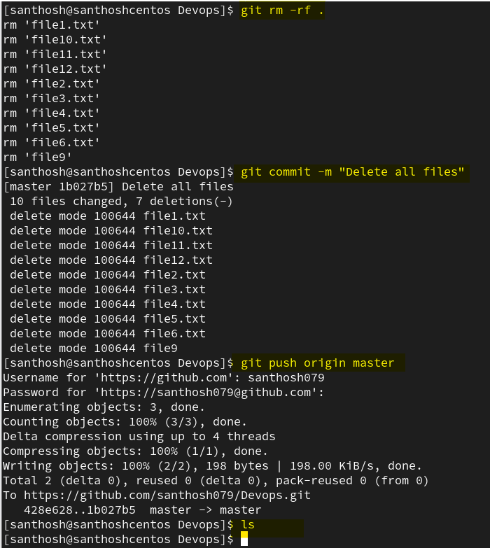

Push the directory from git to github.
