You can skip entering your Personal Access Token every time using either the Git Credential Helper or SSH keys.

Option 1: Use Git Credential Helper (Easiest)
This saves your credentials so you only enter them once.
Store permanently in plain text on disk:
Bash
git config --global credential.helper store

Run your next git push, enter your username and PAT once, and Git will save them in ~/.git-credentials for all future commands.
Or store in memory with a timeout (More secure):
Bash
# Caches credentials in memory for 8 hours (28800 seconds)

git config --global credential.helper 'cache --timeout=28800'

Option 2: Embed the Token in the Remote URL
If you prefer not to use the credential helper, you can embed your PAT directly into the repository’s remote URL:
Bash

git remote set-url origin https://santhosh079:<YOUR_PAT_TOKEN>@github.com/santhosh079/Devops.git

Replace <YOUR_PAT_TOKEN> with your actual token. Git will authenticate automatically on every push without prompting.

Option 3: Switch to SSH Keys (Best Practice)
SSH keys eliminate the need for PAT tokens during pushes entirely.
- Generate an SSH key:
Bash
ssh-keygen -t ed25519 -C your_email@example.com

(Press Enter to accept defaults).
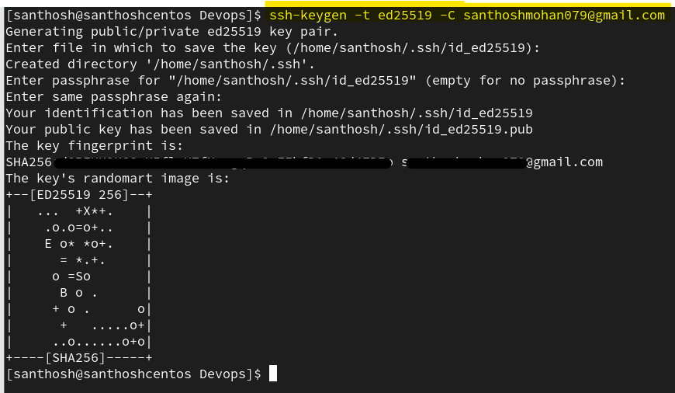
- Display and copy your public key:
Bash
cat ~/.ssh/id_ed25519.pub

• ssh-keygen: The OpenSSH tool used to create, manage, and convert SSH authentication key pairs (a private key and a public key).
• -t ed25519: Specifies the type (-t) of key algorithm to create. Ed25519 uses the EdDSA signature scheme with Curve25519, offering higher security, faster signature generation, and significantly shorter key lengths compared to traditional RSA.
• -C "your_email@example.com": Adds a comment (-C) to the public key file. While commonly filled with an email address to identify which machine or user owns the key (e.g., when viewing keys in GitHub or GitLab settings), it functions purely as an informational label and does not affect authentication.

- Add it to GitHub:
  - Go to GitHub Settings $\rightarrow$ SSH and GPG keys $\rightarrow$ New SSH key.
  - Paste the key and save.
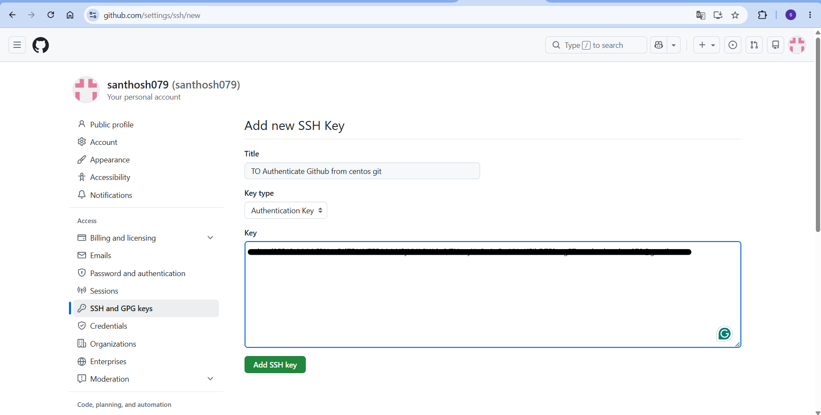
- Change your repository remote to SSH:
Bash
git remote set-url origin git@github.com:santhosh079/Devops.git

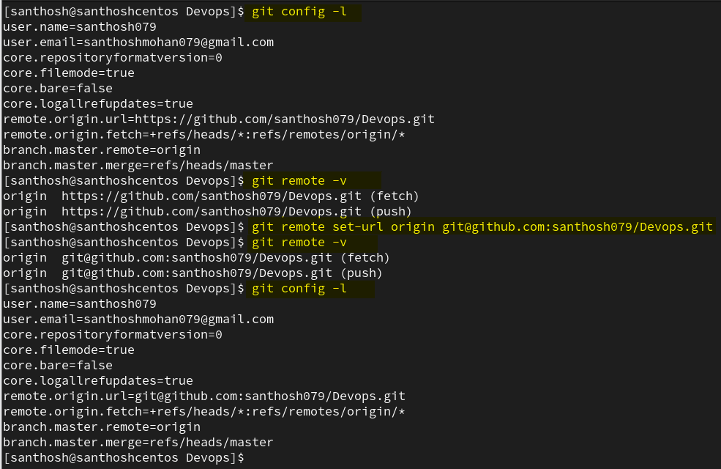

After this, all git push and git pull operations authenticate automatically via your SSH key.
Validate it by executing below commands.

