**Task-12**

**Q1.)**

Create a table Empl to store the below data’s

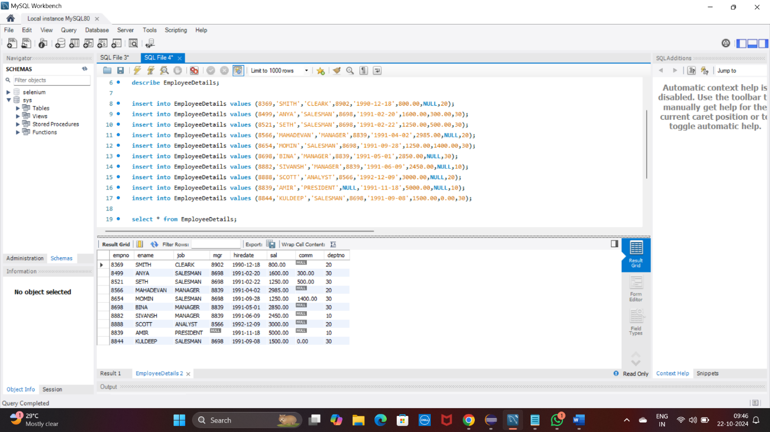

**A.Display Name and Salary of employees whose salary**

**greater than or equal to 2200.**

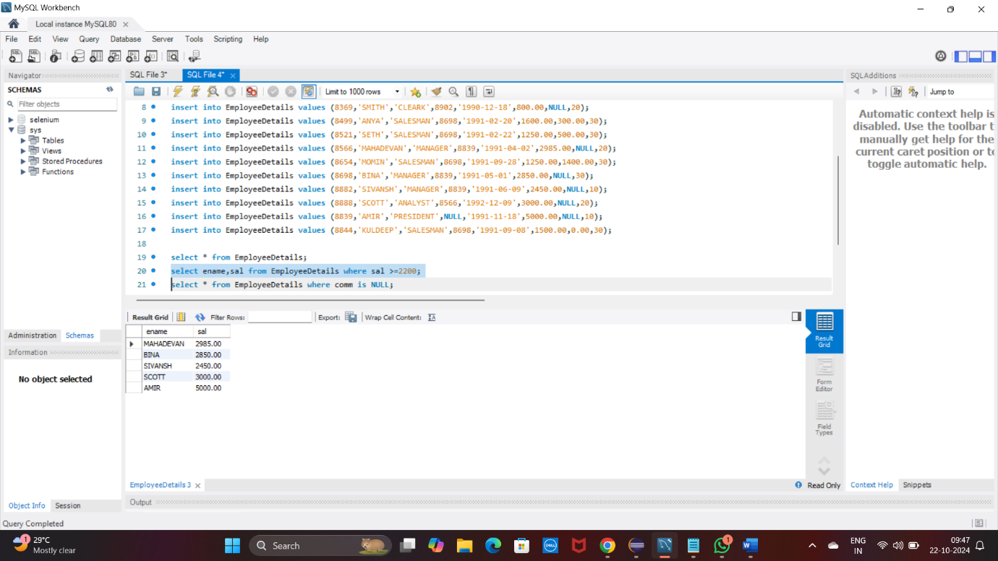

**B.Display details of employees who are not getting**

**Commission**

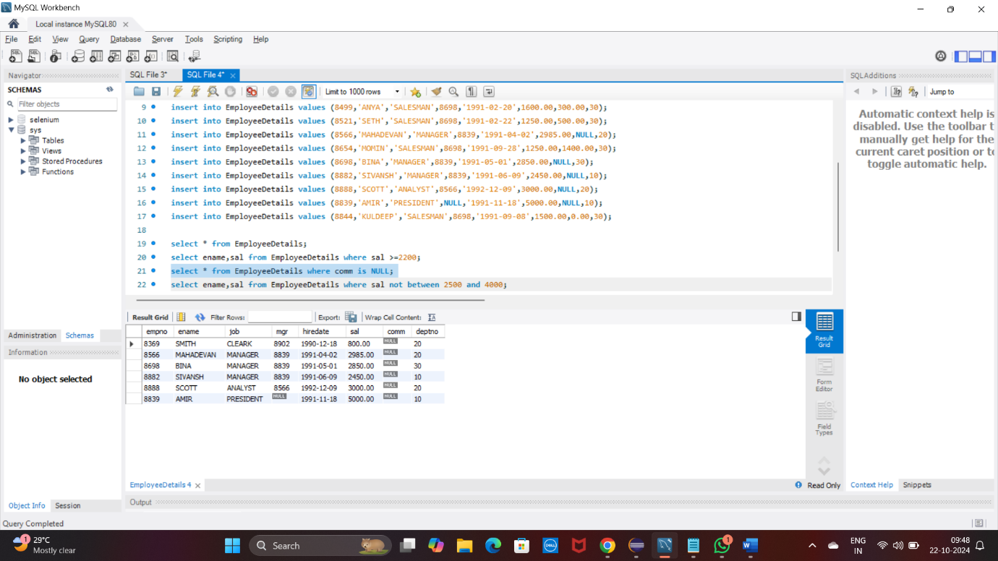

**C.Display names and sal of employees who don’t have salary range between 2500 to 4000**

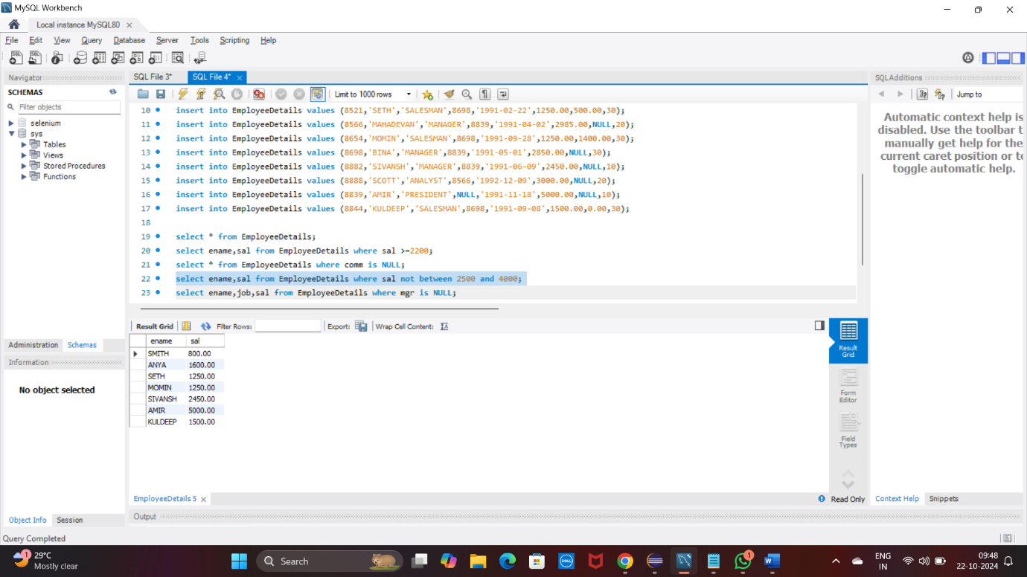

**D.Display names,job title and salary of employees,who don’t have manager**

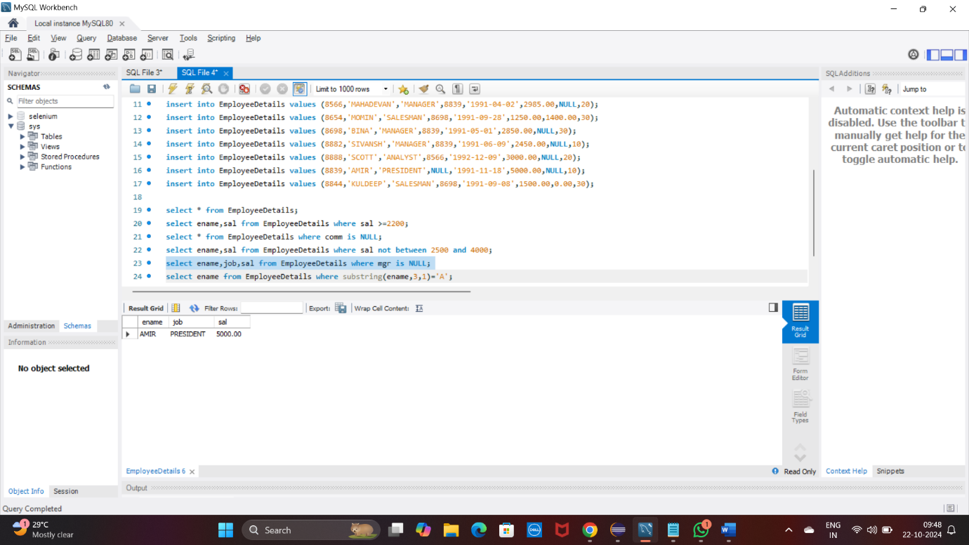

**E.Display names of an employees,whose name contains ‘A’**

**as third alphabet**

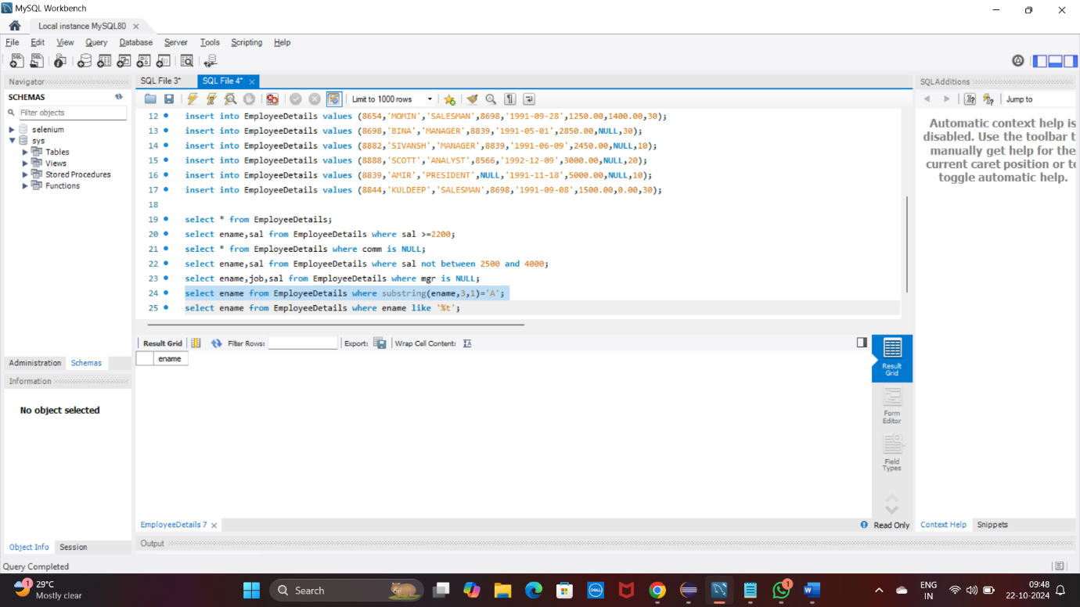

**F.Display names of an employees,whose name contains ‘T’**

**as the last alphabet**

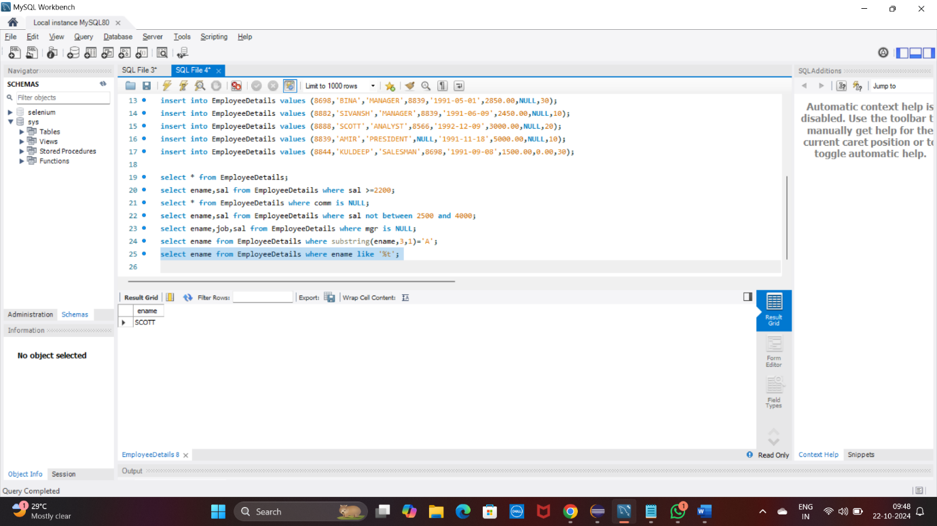

**Q.2)**

**Program for JDBC connectivity and to insert the data**

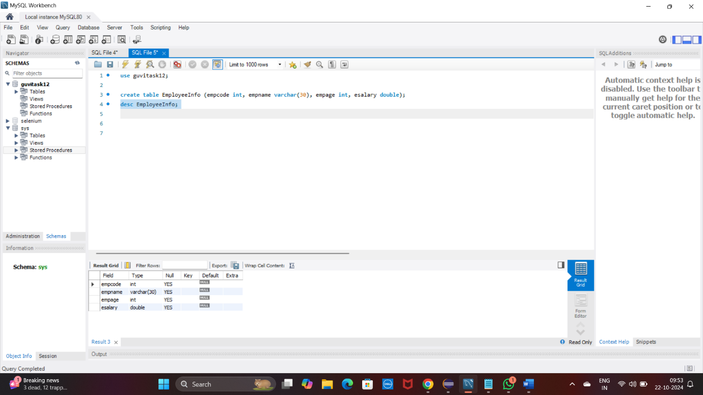

**Inserting to SQL**

