**Online Train Ticket Reservation system**

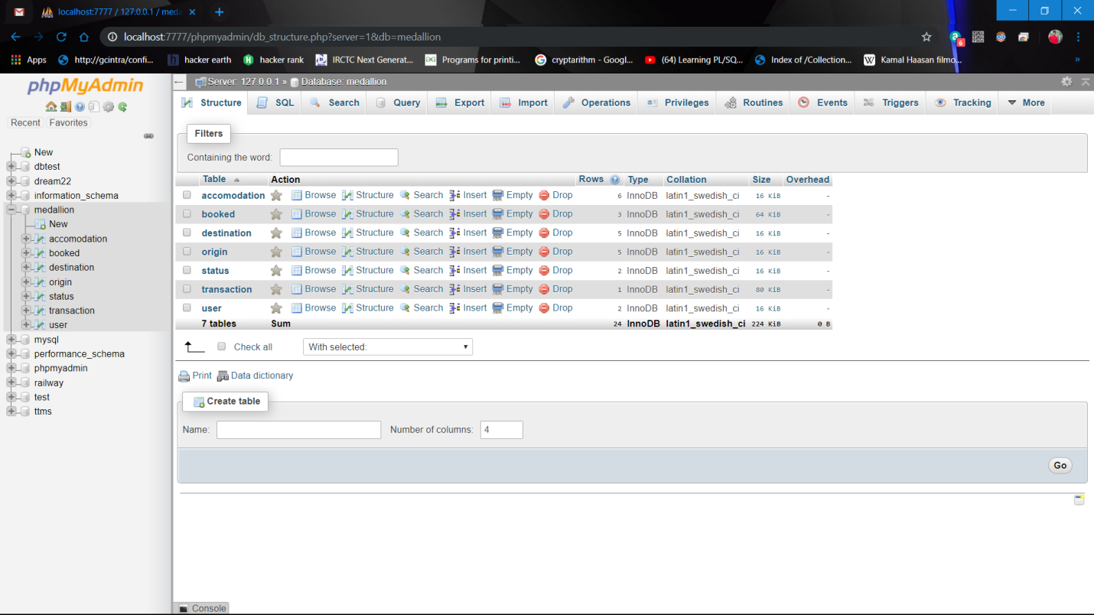

1. The table ‘transaction’ should contain the attributes of all the information about the persons who have booked in the reservation system.

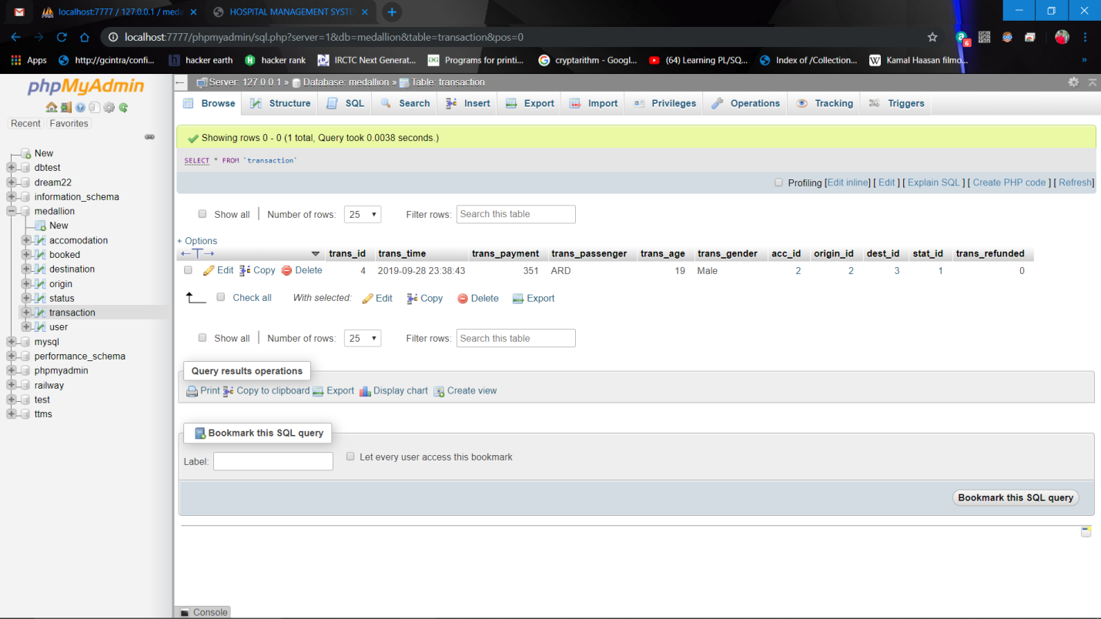

1. The table ‘booked’ should contain the attributes of all the information about the persons who have booked in the reservation system and their status are under waiting list.

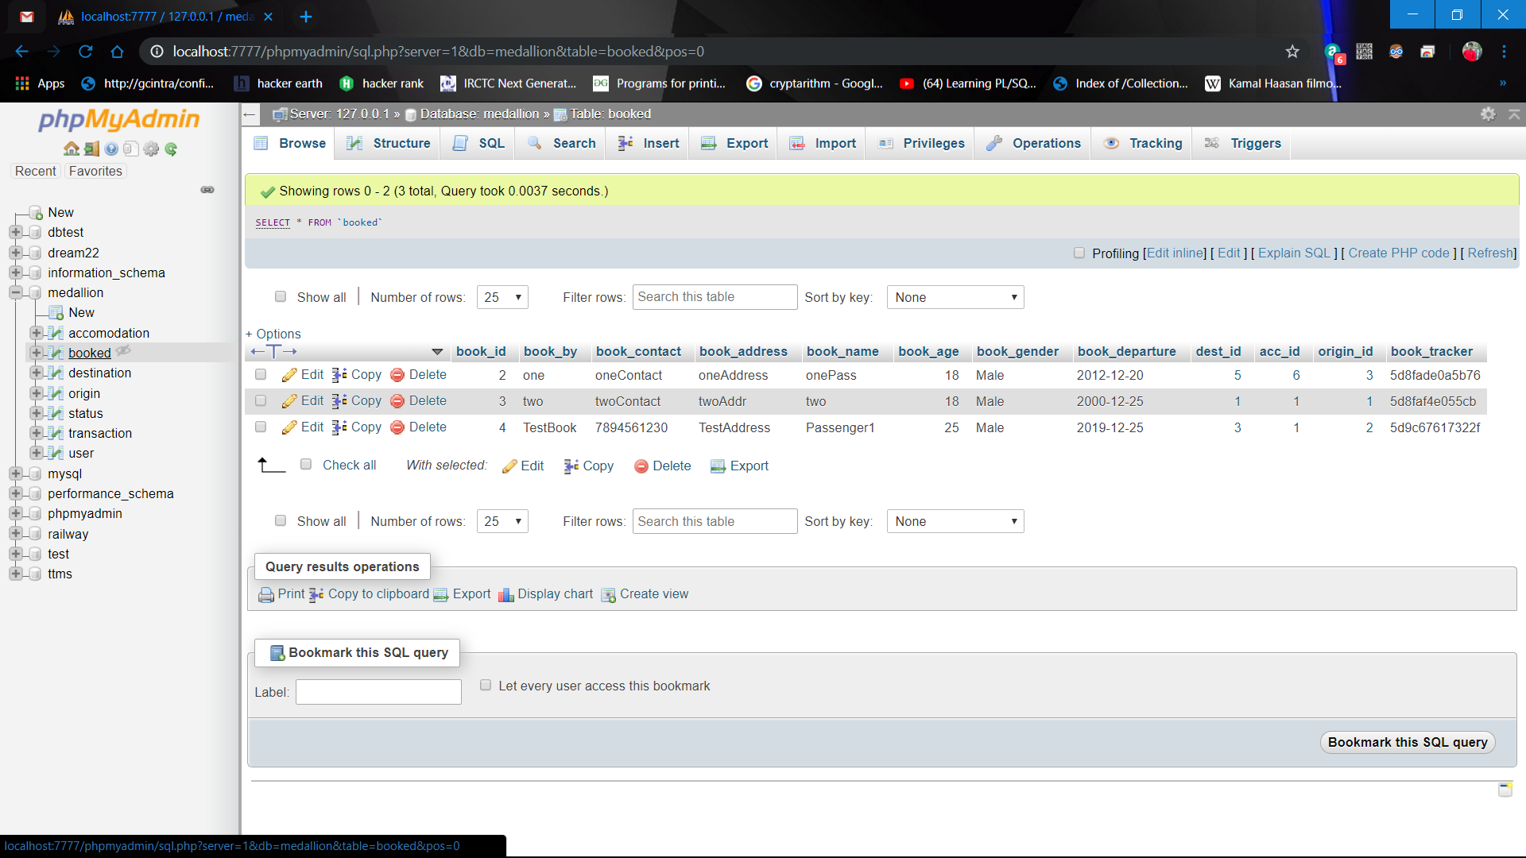

**Modules:**

**Welcome page**

**“index.php”** our welcome page have 4 sections, Home(Fig.1.1), About(Fig.1.2), Contact(Fig.1.3) and an admin Login(Fig.1.4).

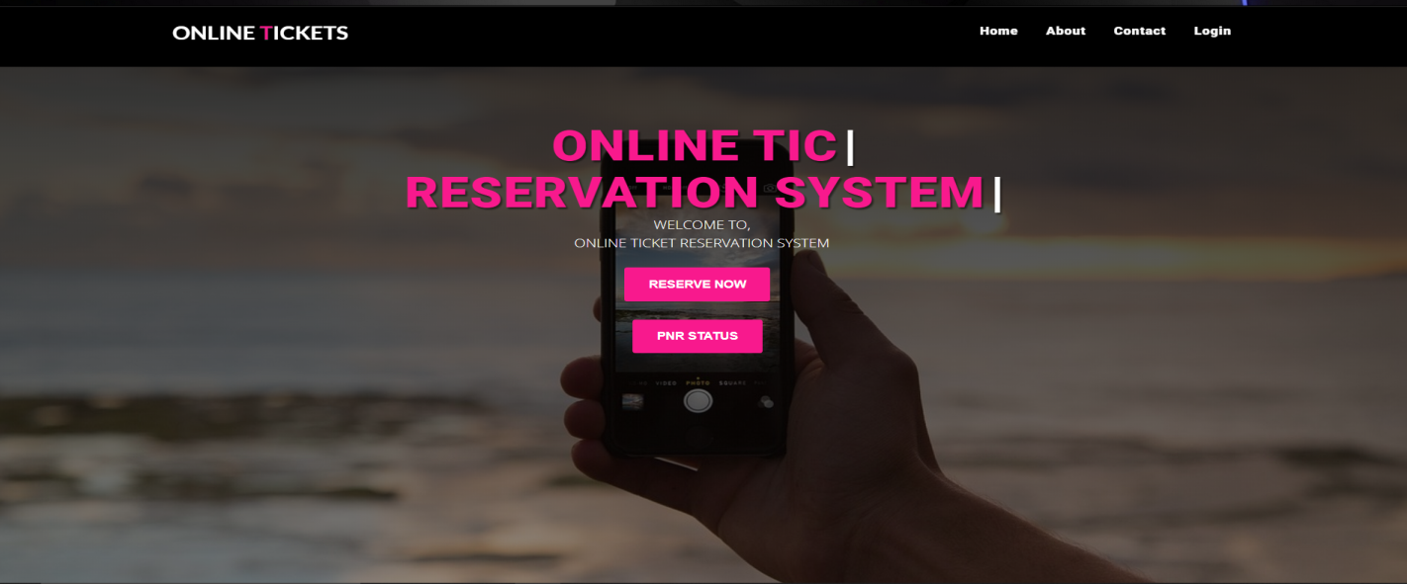

**Section #home**

<section class="main-heading" id="home">

<div class="overlay">

<div class="container">

<div class="row">

<div class="main-heading-content col-md-12 col-sm-12 text-center">

<h1 class="main-heading-title"><span class="main-element themecolor" data-elements=" Online Ticket, Online Ticket, Online Ticket"></span></h1>

<h1 class="main-heading-title"><span class="main-element themecolor" data-elements=" Reservation System, Reservation System, Reservation System"></span></h1>

<p class="main-heading-text">WELCOME TO,<br/>ONLINE TICKET RESERVATION SYSTEM</p>

<div class="btn-bar">

<a href="reserved.php" class="btn btn-custom theme_background_color">Reserve Now</a>

</div>

<div class="btn-bar">

<br/>

<a href="status.php" class="btn btn-custom theme_background_color">PNR Status</a>

</div>

</div>

</div>

</div>

</div>

</section>

**Section #about:**

<section class="aboutus white-background black" id="two">

<div class="container">

<div class="row">

<div class="col-md-12 text-center black">

<h3 class="title">ABOUT <span class="themecolor">Project</span></h3>

<p class="a-slog">The project is for online Train ticket reservation system. Once the payment for the booked seats have been accepted the user gets an E-Mail to the registered Mail ID.</p>

</div>

</div>

</div>

</section>

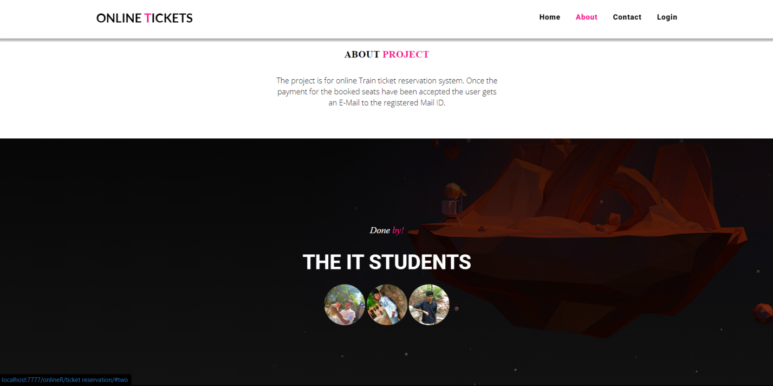

**Section #contact**

<section class="inspiration" id="four">

<div class="overlay">

<div class="container">

<div class="row">

<article class="col-md-12 text-center">

<div class="intermediate-container">

<div class="subheading">

<h4>Done <span class="themecolor">by!</span></h4>

</div>

<div class="heading">

<h2>The IT Students</h2>

<img src="ard.jpeg" alt="Avatar" class="avatar">

<img src="santhosh.jpeg" alt="Avatar" class="avatar">

<img src="selva.jpeg" alt="Avatar" class="avatar">

</div>

</div>

</article>

</div>

</div>

</div>

</section>

<section class="sub-form text-center" id="eight">

<div class="container">

<div class="col-md-12">

<h3 class="title">EMail to our <span class="themecolor"> News letter</span></h3>

<p class="lead">For any grievances</p>

</div>

<div class="row">

<div class="col-md-3 col-sm-3"></div>

<div class="col-md-6 center-block col-sm-6 ">

<form id="mc-form">

<div class="input-group">

<input type="email" class="form-control" placeholder="Email Address" required id="mc-email">

<span class="input-group-btn">

<button type="submit" class="btn btn-default">E-Mail us <i class="fa fa-envelope"></i> </button>

</span> </div>

<label for="mc-email" id="mc-notification"></label>

</form>

</div>

</div>

</div>

</section>

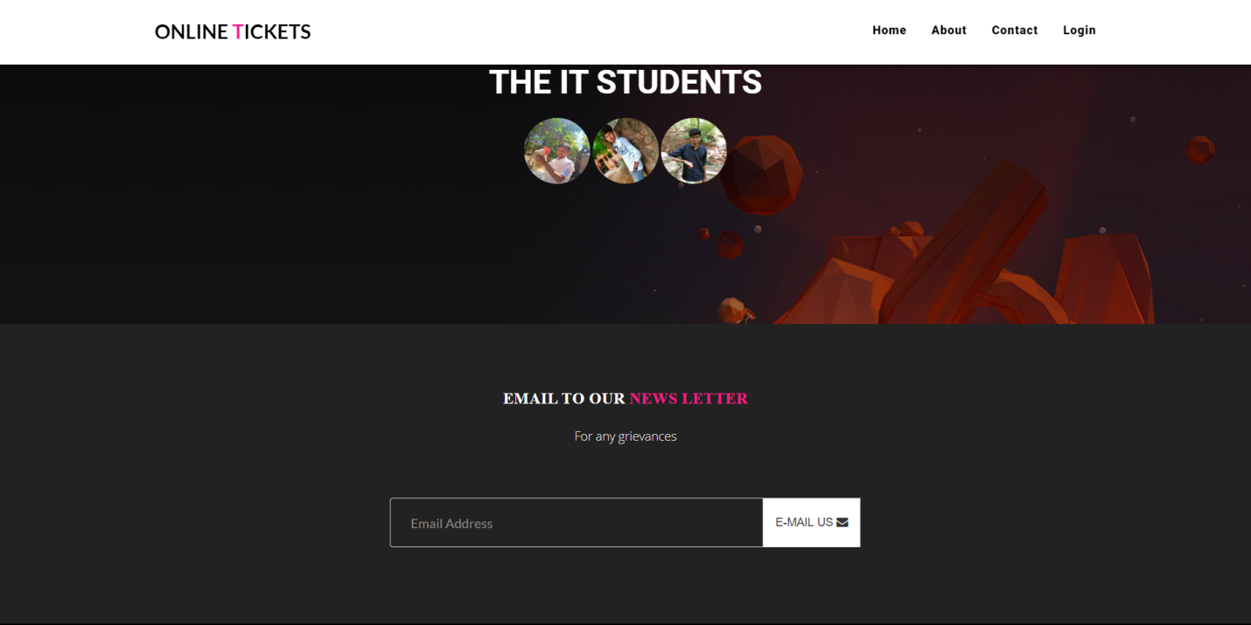

**Module 1:** Admin login, from the login section of the welcome page we give access for the admin to make the booked ticket whether to be “Confirmed” or to be “Cancelled”. The login process is carried out based on the username and password that needs to be entered by the user, the validation for this is done using **php**.

Code snippet:

<div class="col-md-3"></div>

<div class="col-md-6">

<div class="panel panel-success">

<div class="panel-heading">

<h3 class="panel-title">Please Login Here</h3>

</div>

<div class="panel-body">

<form class="form-horizontal" role="form" id="form-login">

<div class="form-group">

<label class="control-label col-sm-2" for="un">Username:</label>

<div class="col-sm-10">

<input type="text" class="form-control" id="un" placeholder="Enter Username" autofocus="" required="">

</div>

</div>

<div class="form-group">

<label class="control-label col-sm-2" for="pwd">Password:</label>

<div class="col-sm-10">

<input type="password" class="form-control" id="pwd" placeholder="Enter password" required="">

</div>

</div>

<div class="form-group">

<div class="col-sm-offset-2 col-sm-10">

<div class="checkbox">

<label><input type="checkbox"> Remember me</label>

</div>

</div>

</div>

<div class="form-group">

<div class="col-sm-offset-2 col-sm-10">

<button type="submit" class="btn btn-default">Login

<span class="glyphicon glyphicon-check" aria-hidden="true"></span>

</button>

</div>

</div>

</form>

</div>

</div>

</div>

<div class="col-md-3"></div>

<?php require_once('modal/message.php'); ?>

<script type="text/javascript" src="../assets/js/jquery-3.1.1.min.js"></script>

<script type="text/javascript" src="../assets/js/bootstrap.min.js"></script>

<script type="text/javascript">

$(document).on('submit', '#form-login', function(event) {

event.preventDefault();

/* Act on the event */

// console.log('test');

var un = $('#un').val();

var pwd = $('#pwd').val();

$.ajax({

url: '../data/login.php',

type: 'post',

dataType: 'json',

data: {

un: un,

pwd : pwd

},

success: function (data) {

// console.log(data);

if(data.valid == true){

window.location = data.url;

}else{

$('#modal-message').find('#body-cont').text(data.msg);

$('#modal-message').modal('show');

$('#un').val("");

$('#pwd').val("");

$('#un').focus();

}

},

error: function(){

alert('Error: L99+');

}//

});

});

</script>

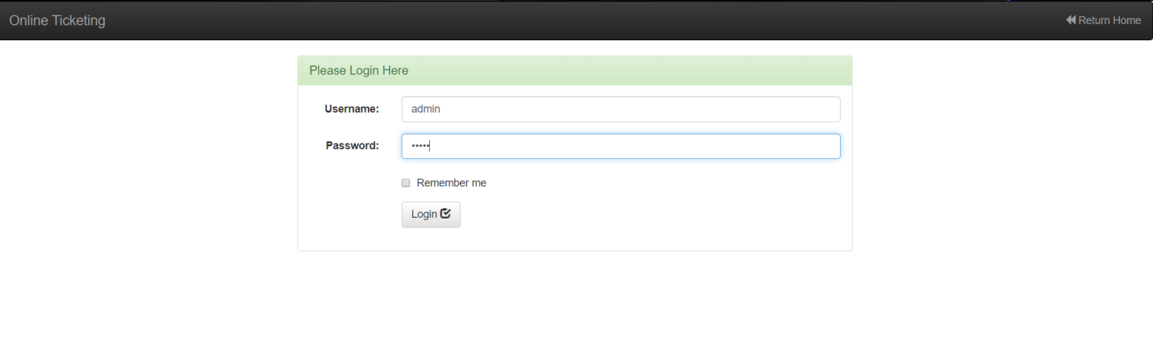

**Module 2:** To reserve tickets, from the welcome page (Fig.1.1) there is a dedicated button “RESERVE NOW”. On clicking the button, the users can reserve tickets for their journey from the ORIGIN places and the DESTINATION places listed from the Database.

To reserve tickets, the users are asked to follow the following 4 steps and these steps are been processed with the help of concern HTML, PHP files:

1. ITINERARY(**reserved.php**)

Here, the traveller is asked for their schedule details of their journey.

Code snippet:

<div class="container-fluid">

<div class="col-md-4"></div>

<div class="col-md-4">

<div class="panel panel-default">

<div class="panel-body">

<h2>

<center>ITINERARY</center>

</h2>

<div class="container-fluid">

<form class="form-horizontal" role="form" id="form-itinerary">

<div class="form-group">

<label for="">Origin:</label>

<select class="btn btn-default" id="orig-id">

<?php foreach($origins as $o): ?>

<option value="<?= $o['origin_id']; ?>"><?= $o['origin_desc']; ?></option>

<?php endforeach; ?>

</select>

</div>

<div class="form-group">

<label for="">Destination:</label>

<select class="btn btn-default" id="dest-id">

<?php foreach($destinations as $d): ?>

<option value="<?= $d['dest_id']; ?>"><?= $d['dest_destination']; ?></option>

<?php endforeach; ?>

</select>

</div>

<div class="form-group">

<label for="">Departure Date:</label>

<input type="date" class="btn btn-default" id="dept-date">

</div>

<button type="submit" class="btn btn-success">NEXT

<span class="glyphicon glyphicon-arrow-right" aria-hidden="true"></span>

</button>

</form>

</div>

</div>

</div>

</div>

<div class="col-md-4"></div>

</div>

<script type="text/javascript" src="assets/js/jquery-3.1.1.min.js"></script>

<script type="text/javascript" src="assets/js/bootstrap.min.js"></script>

<script type="text/javascript">

$(document).on('submit', '#form-itinerary', function(event) {

event.preventDefault();

/* Act on the event */

var validate = "";

var origin = $('select[id=orig-id]').val();

var dest = $('select[id=dest-id]').val();

var dept = $('input[id=dept-date]').val();

if(dept.length == 0){

alert('Please Select Departure Date!');

}else{

$.ajax({

url: 'data/session_itinerary.php',

type: 'post',

dataType: 'json',

data: {

oid : origin,

did : dest,

dd : dept

},

success: function (data) {

console.log(data);

if(data.valid == true){

window.location = data.url;

console.log('sss');

}

},

error: function(){

alert('Error: L161+');

}

});

}//end dept kung == 0

});

</script>

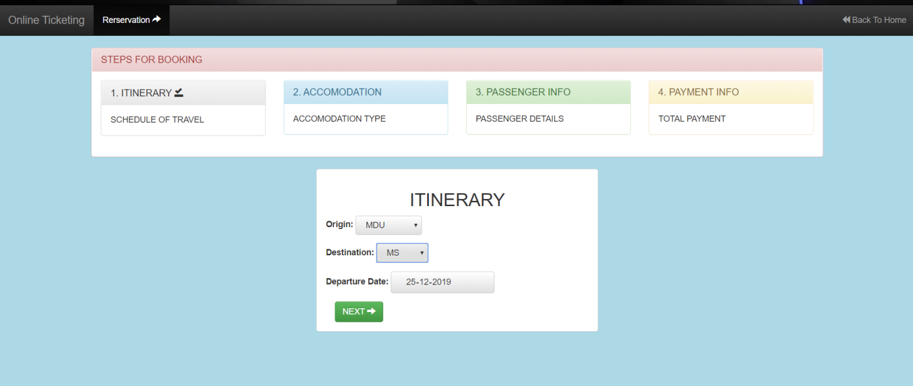

1. ACCOMMODATION(**accommodation.php**)

In this section, the traveller is asked to choose the type of accommodation they are willing to travel and asked to give the number of passengers who are going to travel.

Code snippet:

<div class="container-fluid">

<div class="col-md-3"></div>

<div class="col-md-6">

<div class="panel panel-default">

<div class="panel-body">

<h2>

<center>ACCOMODATION</center>

</h2>

<div class="container-fluid">

<form class="form-horizontal" role="form" id="form-acc">

<table id="myTable-party" class="table table-bordered table-hover" cellspacing="0" width="100%">

<thead>

<tr>

<th> <span class="glyphicon glyphicon-record" aria-hidden="true"></span>

Accomodation

</th>

<th>

<center>

Slots

</center>

</th>

<th>

<center>

Fare

</center>

</th>

</tr>

</thead>

<tbody>

<?php require_once('data/get_all_accomodations.php'); ?>

<tr>

<td>

<input value="<?= $getSit['acc_id']; ?>" type="radio" name="acc">

<?= $getSit['acc_type']; ?>

</td>

<td align="center">

<?= $getSit['acc_slot'] - $totalSit['sit']; ?>

</td>

<td align="center"><?= $getSit['acc_price']; ?></td>

</tr>

<tr>

<td>

<input value="<?= $getEcoA['acc_id']; ?>" type="radio" name="acc">

<?= $getEcoA['acc_type']; ?>

</td>

<td align="center">

<?= $getEcoA['acc_slot'] - $totalEcoA['ecoA']; ?>

</td>

<td align="center"><?= $getEcoA['acc_price']; ?></td>

</tr>

<tr>

<td>

<input value="<?= $getEcoB['acc_id']; ?>" type="radio" name="acc">

<?= $getEcoB['acc_type']; ?>

</td>

<td align="center">

<?= $getEcoB['acc_slot'] - $totalEcoB['ecoB']; ?>

</td>

<td align="center"><?= $getEcoB['acc_price']; ?></td>

</tr>

<tr>

<td>

<input value="<?= $getTour['acc_id']; ?>" type="radio" name="acc">

<?= $getTour['acc_type']; ?>

</td>

<td align="center">

<?= $getTour['acc_slot'] - $totalTour['ecoT']; ?>

</td>

<td align="center"><?= $getTour['acc_price']; ?></td>

</tr>

<tr>

<td>

<input value="<?= $getCab['acc_id']; ?>" type="radio" name="acc">

<?= $getCab['acc_type']; ?>

</td>

<td align="center">

<?= $getCab['acc_slot'] - $totalCab['ecoC']; ?>

</td>

<td align="center"><?= $getCab['acc_price']; ?></td>

</tr>

<tr>

<td>

<input value="<?= $getDel['acc_id']; ?>" type="radio" name="acc">

<?= $getDel['acc_type']; ?>

</td>

<td align="center">

<?= $getDel['acc_slot'] - $totalDel['ecoD']; ?>

</td>

<td align="center"><?= $getDel['acc_price']; ?></td>

</tr>

</tbody>

</table>

<div class="form-group">

<label for="">Total # of Passenger:</label>

<input type="number" min="1" class="form-control" name="totalPass" plactreholder="Total # of Passenger" autocomplete="off">

</div>

<button type="submit" class="btn btn-success">NEXT

<span class="glyphicon glyphicon-arrow-right" aria-hidden="true"></span>

</button>

</form>

</div>

</div>

</div>

</div>

<div class="col-md-3"></div>

</div>

<script type="text/javascript" src="assets/js/jquery-3.1.1.min.js"></script>

<script type="text/javascript" src="assets/js/bootstrap.min.js"></script>

<script type="text/javascript">

$(document).on('submit', '#form-acc', function(event) {

event.preventDefault();

/* Act on the event */

var acc = $('input[name="acc"]:checked').val();

var totalPass = $('input[name="totalPass"]').val();

if(acc == null){

alert('Please Select Accomodation!');

}else{

// console.log(acc);

if(totalPass.length == 0){

alert('Please Enter Number of Passenger!');

}else{

$.ajax({

url: 'data/session_accomodation.php',

type: 'post',

dataType: 'json',

data: {

acc : acc,

tp : totalPass

},

success: function (data) {

console.log(data.slot);

// window.location = "passenger.php";

if(data.slot >= 0){

window.location = "passenger.php";

}else{

alert('Not Enough Slot!');

}

},

error: function(){

alert('Error: L175+');

}

});

}//end totalPass

}//end acc == null

});

</script>

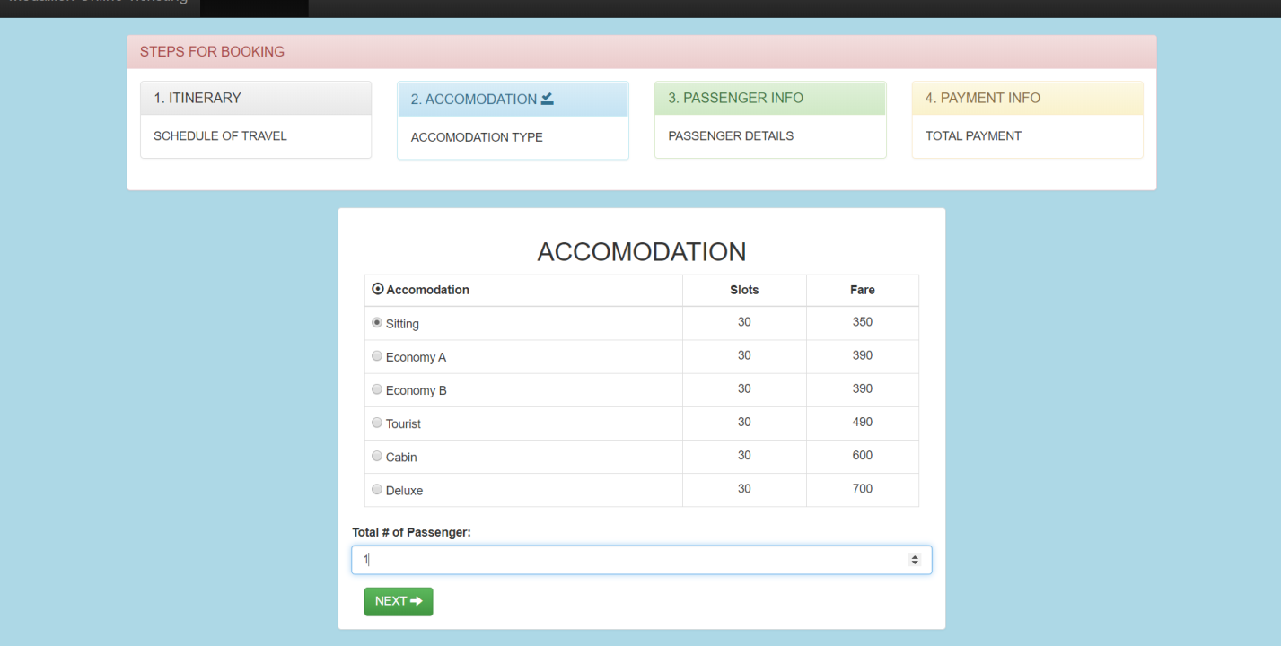

1. PASSENGER INFO(**passenger.php**)

In this section, the one who books the travel are asked to mention the passenger(s) information along with his information for contact purposes.

Code snippet:

< div class="container-fluid">

<div class="col-md-4"></div>

<div class="col-md-4">

<div class="alert alert-danger">

<button type="button" class="close" data-dismiss="alert" aria-hidden="true">&times;</button>

<strong>Message!</strong> Please review your passenger information.

You cannot change your reservation once you proceed.

</div>

<div class="panel panel-default">

<div class="panel-body">

<h2>

<center>PASSENGER INFO</center>

</h2>

<div class="container-fluid">

<form class="form-horizontal" role="form" id="form-pass">

<div class="form-group">

<label for="">Booked By:</label>

<input type="text" class="form-control" id="book-by" placeholder="Enter Name"

autofocus="" required="" autocomplete="off">

</div>

<div class="form-group">

<label for="">Contact:</label>

<input type="text" class="form-control" id="cont" placeholder="Enter Contact" required="" autocomplete="off">

</div>

<div class="form-group">

<label for="">Address:</label>

<input type="text" class="form-control" id="address" placeholder="Enter Address" required="" autocomplete="off">

</div>

<br />

<?php

$tb = $_SESSION['totalPass'];

$count = 1;

for($i = 0; $i < $tb; $i++){

?>

<div class="panel panel-primary">

<div class="panel-heading">

<h3 class="panel-title">Booked(<?= $count; ?>)</h3>

</div>

<div class="panel-body">

<div class="container-fluid">

<div class="form-group">

<label for="">Full Name (<?= $count; ?>):</label>

<input type="text" class="form-control" id="fN<?php echo $i; ?>"

placeholder="Enter Fullname" required autocomplete="off">

</div>

<div class="form-group">

<label for="">Age: (<?= $count; ?>):</label>

<input type="number" class="form-control" id="age<?php echo $i; ?>"

placeholder="Enter Age" required autocomplete="off">

</div>

<div class="form-group">

<label for="">Gender: (<?= $count; ?>):</label>

<select class="btn btn-default" id="gender<?php echo $i; ?>">

<option value="Male">Male</option>

<option value="Female">Female</option>

</select>

</div>

</div>

</div>

</div>

<?php

$count++;

}//end for

?>

<button type="submit" class="btn btn-success">NEXT

<span class="glyphicon glyphicon-arrow-right" aria-hidden="true"></span>

</button>

</form>

</div>

</div>

</div>

</div>

<div class="col-md-4"></div>

</div>

<?php require_once('admin/modal/message.php'); ?>

<script type="text/javascript" src="assets/js/jquery-3.1.1.min.js"></script>

<script type="text/javascript" src="assets/js/bootstrap.min.js"></script>

<script type="text/javascript">

$(document).on('submit', '#form-pass', function(event) {

event.preventDefault();

/* Act on the event */

var bookBy = $('#book-by').val();

var cont = $('#cont').val();

var address = $('#address').val();

var counter = <?= $i; ?>;

for(var i = 0; i < counter; i++){

var fN = $('#fN'+i).val();

var age = $('#age'+i).val();

var gender = $('#gender'+i).val();

$.ajax({

url: 'data/save_booked.php',

type: 'post',

dataType: 'json',

data: {

bookBy : bookBy,

cont : cont,

address : address,

fN : fN,

age : age,

gender : gender

},

success: function (data) {

// console.log(data);

if(data.valid == true){

window.location = data.url;

}

},

error: function(){

// alert('Error: L192+');

}

});

}//end for

alert('Booked Successfully!');

});

</script>

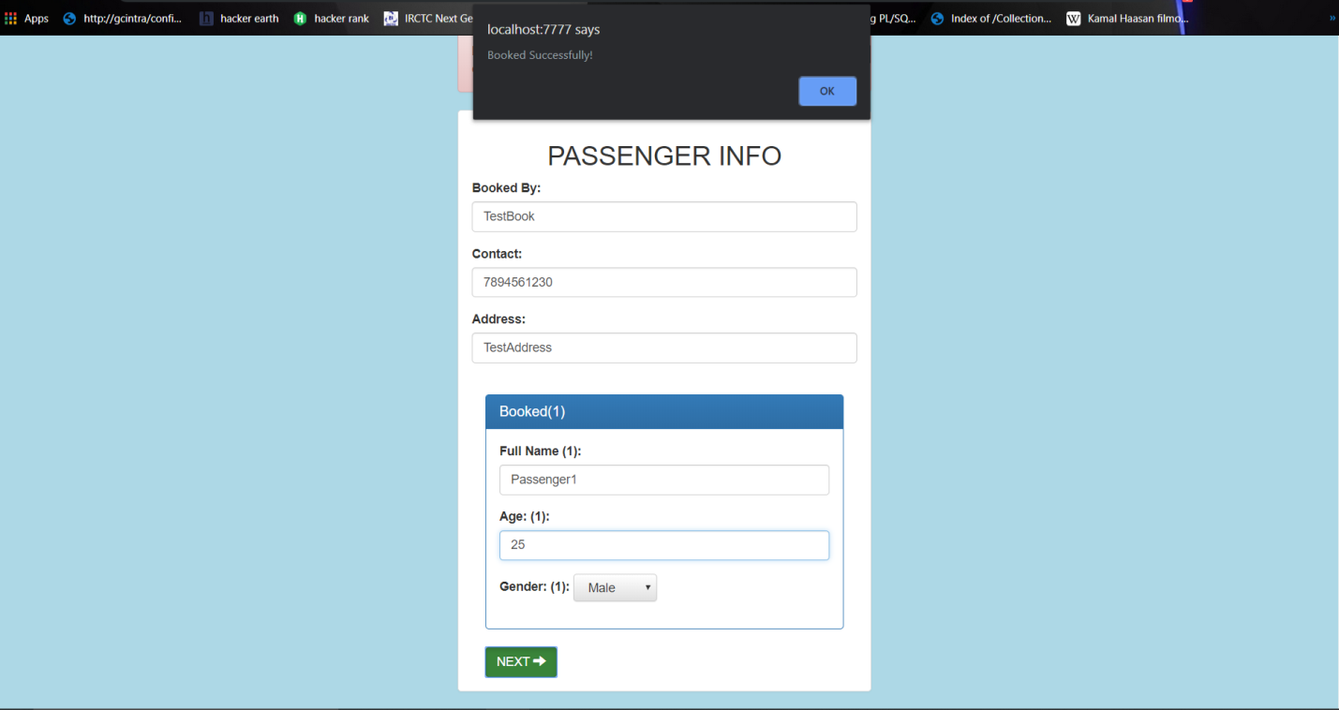

1. PAYMENT INFO(**payment.php**)

At last, in this section, the travellers gets a gist of the information that they need to travel and they’ll be given with a booking id with which they can check the status of their ticket by going into the PNR Status from the welcome page(Fig.1.1).

Code snippet:

<div class="container-fluid">

<div class="col-md-3"></div>

<div class="col-md-6">

<div class="panel panel-default">

<div class="panel-body">

<h2>

<center>PAYMENT INFO</center>

</h2>

<br />

<div class="panel panel-success">

<div class="panel-heading">

<h3 class="panel-title"><center>DEPARTURE</center></h3>

</div>

<div class="panel-body">

<strong>

<i>Medallion Transport, M/V Lady of All Nations</i>

<h3>

<?php require_once('data/depart_from_to.php');

echo $origin['origin_desc'];

?>

-

<?= $dest['dest_destination']; ?>

</h3>

<p>Departure Date: <?= $_SESSION['departure_date']; ?> @9:00AM</p>

</strong>

<i>Estimated Arrival Time: The Next Day @3:00PM</i><br />

<strong>

<?php require_once('data/get_accomodation.php');

echo $accomodation['acc_type'];

?>

</strong>

</div>

</div>

<div class="panel panel-success">

<div class="panel-heading">

<h3 class="panel-title">CONTACT INFO</h3>

</div>

<div class="panel-body">

<?php require_once('data/getBooked.php'); ?>

<strong>Book By:</strong> <?= ucwords($bookByInfo['book_by']); ?><br />

<strong>Contact #:</strong> <?= $bookByInfo['book_contact']; ?><br />

<strong>Address:</strong> <?= $bookByInfo['book_address']; ?><br />

</div>

</div>

<div class="container-fluid">

<strong>

<span class="glyphicon glyphicon-user" aria-hidden="true"></span>

PASSENGERS</strong>

<table id="myTable-party" class="table table-bordered table-hover" cellspacing="0" width="100%">

<thead>

<tr>

<th>

<center>

Name

</center>

</th>

<th>

<center>

Age

</center>

</th>

<th>

<center>

Gender

</center>

</th>

<th>

<center>

Departure Price

</center>

</th>

</tr>

</thead>

<tbody>

<?php

require_once('data/getBooked.php');

$totalPayment = 0;

$tracker = '';

foreach($bookPass as $bp):

$name = $bp['book_name'];

$name = ucwords($name);

$price = $bp['acc_price'];

$totalPayment += $price;

$tracker = $bp['book_tracker'];

?>

<tr align="center">

<td><?= $name; ?></td>

<td><?= $bp['book_age']; ?></td>

<td><?= $bp['book_gender']; ?></td>

<td><?= $price; ?></td>

</tr>

<?php endforeach; ?>

<tr>

<td></td>

<td></td>

<td align="right"><strong>TOTAL:</strong></td>

<td align="center"><strong><?= $totalPayment; ?></strong></td>

</tr>

</tbody>

<strong>- Booked ID: <?= $tracker; ?></strong>

</table>

<center>

<a href="index.php" class="btn btn-success">Return Home

<span class="glyphicon glyphicon-backward" aria-hidden="true"></span>

</a>

</center>

</div>

</div>

</div>

</div>

<div class="col-md-3"></div>

</div>

<script type="text/javascript" src="assets/js/jquery-3.1.1.min.js"></script>

<script type="text/javascript" src="assets/js/bootstrap.min.js"></script>

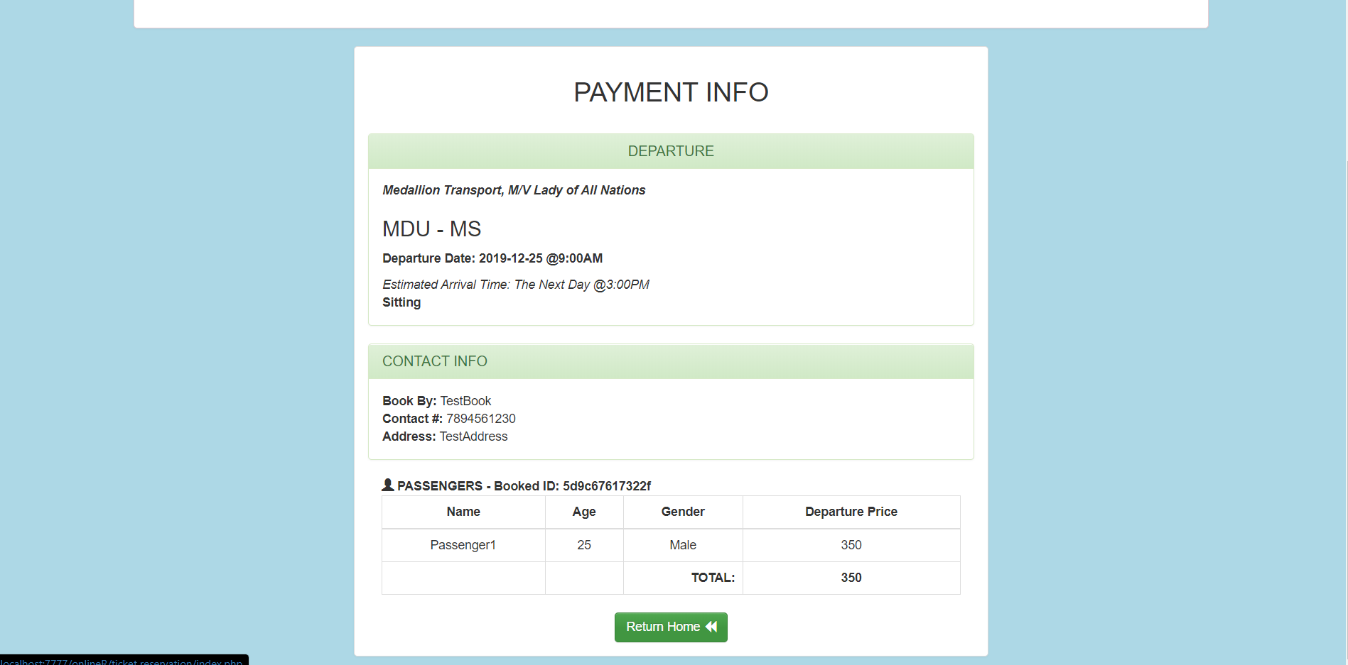

**Fig.1.5**

**Module 3:** PNR Status, In this module the travellers can check their ticket status by giving the Origin station, Destination station and PNR number, i.e., the booking-id that would’ve been displayed in the PAYMENT INFO section of **Module 2(Refer, Fig.1.5)**.

Code snippet:

<div class="container-fluid">

<div class="col-md-4"></div>

<div class="col-md-4">

<div class="panel panel-default">

<div class="panel-body">

<h2 style="text-align: center">PNR STATUS</h2>

<div class="container-fluid">

<form class="form-horizontal" role="form" id="form-pnr" onsubmit="pnr.php" method = "POST">

<div class="form-group">

<label for="">Origin:</label>

<select class="btn btn-default" id="orig-id">

<?php foreach($origins as $o): ?>

<option value="<?= $o['origin_id']; ?>"><?= $o['origin_desc']; ?></option>

<?php endforeach; ?>

</select>

</div>

<div class="form-group">

<label for="">Destination:</label>

<select class="btn btn-default" id="dest-id">

<?php foreach($destinations as $d): ?>

<option value="<?= $d['dest_id']; ?>"><?= $d['dest_destination']; ?></option>

<?php endforeach; ?>

</select>

</div>

<div class="form-group">

<label for="">PNR Number:</label>

<input type="text" id="pnr-numb">

</div>

<button type="submit" class="btn btn-success">SUBMIT

<span class="glyphicon glyphicon-arrow-right" aria-hidden="true"></span>

</button>

</form>

</div>

</div>

</div>

</div>

<div class="col-md-4"></div>

</div>

<script type="text/javascript" src="assets/js/jquery-3.1.1.min.js"></script>

<script type="text/javascript" src="assets/js/bootstrap.min.js"></script>

