Week – 1 Java FSE

Design Principles and Patterns

Exercise – 1 : Implementing Singleton Pattern

Logger.java
package singleton_pattern;

public class Logger {
private static volatile Logger instance;
private Logger() {
System.out.println("Logger constructor is initialized");
}
public static Logger getInstance() {
//first-check
if(instance == null) {
synchronized(Logger.class){
//double-check
if(instance == null) {
instance = new Logger();
}
}
}
return instance;
}
}

Test.java
package singleton_pattern;

public class Test {
public static void main(String[] args) {
Logger log1 = Logger.getInstance();
Logger log2 = Logger.getInstance();
if(log1 == log2) {
System.out.println("Successful: Both log1 and log2 are of same instances");
}else {
System.out.println("Failure: Both log1 and log2 are of different instances");
}
}
}

OUTPUT

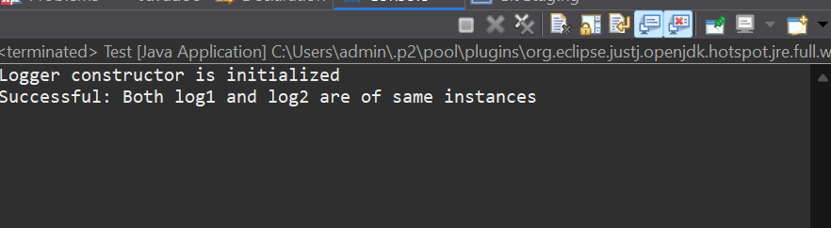

Exercise – 2: Implementing the Factory Method Pattern

Document.java
package documents;

public interface Document {
void create();
void write();
void read();
void save();
}

ExcelDocument.java
package documents;

public class ExcelDocument implements Document{
public void create() {
System.out.println("A excel document is now created");
}
public void write() {
System.out.println("Writing contents into the excel document...");
}
public void read() {
System.out.println("Analysing the content inside the excel document");
}
public void save() {
System.out.println("Saving the excel document...");
}
}

PdfDocument.java
package documents;

public class PdfDocument implements Document{

public void create() {
System.out.println("A pdf document is now created");
}
public void write() {
System.out.println("Writing contents into the pdf document...");
}
public void read() {
System.out.println("Analysing the content inside the pdf document");
}
public void save() {
System.out.println("Saving the pdf document...");
}

}

WordDocument.java
package documents;

public class WordDocument implements Document {
public void create() {
System.out.println("A word document is now created");
}
public void write() {
System.out.println("Writing contents into the word document...");
}
public void read() {
System.out.println("Analysing the content inside the word document");
}
public void save() {
System.out.println("Saving the word document...");
}
}

DocumentFactory.java
package factories;
import documents.Document;
public abstract class DocumentFactory {
public abstract Document createDocument();
}

ExcelDocumentFactory.java
package factories;
import documents.*;
public class ExcelDocumentFactory extends DocumentFactory{
public Document createDocument() {
return new ExcelDocument();
}
}

PdfDocumentFactory.java
package factories;
import documents.*;
public class PdfDocumentFactory extends DocumentFactory{
public Document createDocument() {
return new PdfDocument();
}
}

WordDocumentFactory.java
package factories;
import documents.*;
public class WordDocumentFactory extends DocumentFactory{
public Document createDocument() {
return new WordDocument();
}
}

Test.java
package testing;
import documents.*;
import factories.*;
public class Test {
public static void main(String[] args) {
DocumentFactory word = new WordDocumentFactory();
word.createDocument().create();
word.createDocument().read();
word.createDocument().save();
System.out.println();

DocumentFactory pdf = new PdfDocumentFactory();
pdf.createDocument().create();
pdf.createDocument().read();
pdf.createDocument().save();
System.out.println();

DocumentFactory excel = new ExcelDocumentFactory();
excel.createDocument().create();
excel.createDocument().read();
excel.createDocument().save();
}
}

OUTPUT
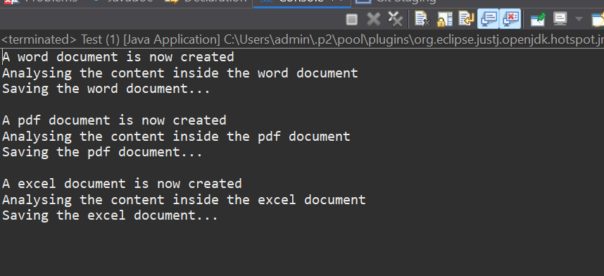
Exercise – 3 : Implementing the Builder Pattern

Computer.java
package builder_pattern;

public class Computer {
private String cpu;
private String brand;
private String ram;
private String storage;

private Computer(Builder builder) {
this.cpu = builder.cpu;
this.brand = builder.brand;
this.ram = builder.ram;
this.storage = builder.storage;
}

@Override
public String toString() {
return "Computer [CPU=" + cpu + ", RAM=" + ram + ", Storage=" + storage + ", Brand=" + brand + "]";
}

public static class Builder{
private String cpu;
private String brand;
private String ram;
private String storage;

public Builder setCpu(String cpu) {
this.cpu = cpu;
return this;
}

public Builder setBrand(String brand) {
this.brand = brand;
return this;
}

public Builder setRam(String ram) {
this.ram = ram;
return this;
}

public Builder setStorage(String storage) {
this.storage = storage;
return this;
}

public Computer build() {
return new Computer(this);
}
}
}

BuilderTest.java
package builder_pattern;

public class BuilderTest {
public static void main(String[] args) {
Computer gamingPC = new Computer.Builder()
.setCpu("Intel i9")
.setRam("32GB")
.setStorage("1TB SSD")
.build();

// Office PC
Computer officePC = new Computer.Builder()
.setCpu("Intel i5")
.setBrand("DELL")
.setRam("8GB")
.setStorage("512GB SSD")
.build();

System.out.println("Gaming PC: " + gamingPC.toString());
System.out.println("Office PC: " + officePC.toString());
}
}

OUTPUT:
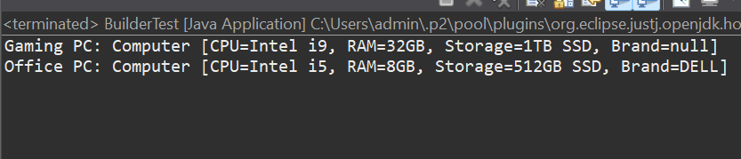

EXERCISE - 4: Implementing the Adapter Pattern

PaymentProcessor.java
package adapter_pattern;

public interface PaymentProcessor {
void processPayment(double amount);
}

NetBanking.java
package adapter_pattern;

public class NetBanking {
public void makePayment(double amount) {
System.out.println("Net Banking credentials were used to pay " + amount);
}
}

Gpay.java
package adapter_pattern;

public class Gpay {
public void paymentMode(double amount) {
System.out.println(amount + " is paid using Gpay");
}
}

CashOnDelivery.java
package adapter_pattern;

public class CashOnDelivery {
public void successPayment(double amount) {
System.out.println(amount + " was directly paid on delivery");
}
}

NetBankingAdapter.java
package adapter;
import adapter_pattern.*;
public class NetBankingAdapter implements PaymentProcessor{
private NetBanking netBanking;
public NetBankingAdapter(NetBanking netBanking) {
this.netBanking = netBanking;
}
public void processPayment(double amount) {
netBanking.makePayment(amount);
}
}

GpayAdapter.java
package adapter;
import adapter_pattern.*;
public class GpayAdapter implements PaymentProcessor{
private Gpay gpay;
public GpayAdapter(Gpay gpay) {
this.gpay = gpay;
}
public void processPayment(double amount) {
gpay.paymentMode(amount);
}
}
CashOnDeliveryAdapter.java
package adapter;
import adapter_pattern.*;
public class CashOnDeliveryAdapter implements PaymentProcessor{
private CashOnDelivery cod;
public CashOnDeliveryAdapter(CashOnDelivery cod) {
this.cod = cod;
}
public void processPayment(double amount) {
cod.successPayment(amount);
}
}
Test.java
package testing;
import adapter_pattern.*;
import adapter.*;
public class Test {
public static void main(String[] args) {
PaymentProcessor gpayProcessor = new GpayAdapter(new Gpay());
PaymentProcessor codProcessor = new CashOnDeliveryAdapter(new CashOnDelivery());
PaymentProcessor netBankingProcessor = new NetBankingAdapter(new NetBanking());
gpayProcessor.processPayment(10000);
codProcessor.processPayment(29377);
netBankingProcessor.processPayment(10398);
}
}

OUTPUT:
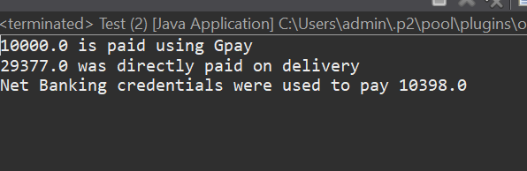

Exercise - 5: Implementing the Decorator Pattern

Notifier.java
package notifier;

public interface Notifier {
void send(String message);
}

EmailNotifier.java
package notifier;

public class EmailNotifier implements Notifier{
public void send(String message) {
System.out.println("Message: " + message);
}
}

NotifierDecorator.java
package notifier;

public abstract class NotifierDecorator implements Notifier{
protected Notifier notifier;
public NotifierDecorator(Notifier notifier) {
this.notifier = notifier;
}
public void send(String message) {
notifier.send(message);
}

}

SlackNotifierDecorator.java
package decorator;

import notifier.*;

public class SlackNotifierDecorator extends NotifierDecorator{
public SlackNotifierDecorator(Notifier notifier) {
super(notifier);
}
@Override
public void send(String message) {
super.send(message);
notifySlack(message);
}
public void notifySlack(String message) {
System.out.println("You have received an Slack message");
System.out.println(message);
}
}

SMSNotifierDecorator.java
package decorator;
import notifier.*;
public class SMSNotifierDecorator extends NotifierDecorator{
public SMSNotifierDecorator(Notifier notifier) {
super(notifier);
}
@Override
public void send(String message) {
super.send(message);
notifySMS(message);
}
public void notifySMS(String message) {
System.out.println("You have received an SMS message");
System.out.println(message);
}
}

Main.java
package testing;

import notifier.*;
import decorator.*;

public class Main {
public static void main(String[] args) {
Notifier baseNotifier = new EmailNotifier();

Notifier smsNotifier = new SMSNotifierDecorator(baseNotifier);

Notifier slackNotifier = new SlackNotifierDecorator(smsNotifier);

slackNotifier.send("System alert found!");
}
}

OUTPUT:
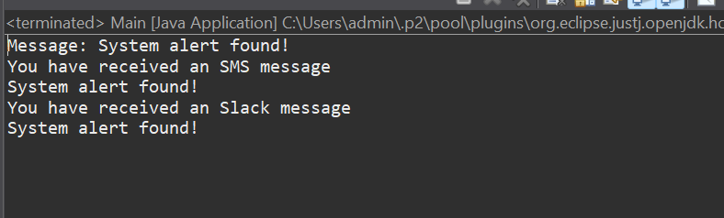

Exercise - 6: Implementing the Proxy Pattern

Image.java
package proxy;

public interface Image {
void display();
}

RealImage.java
package proxy;

public class RealImage implements Image{
private String fileName;
public RealImage(String fileName){
this.fileName = fileName;
loadImageFromDisk();
}
private void loadImageFromDisk() {
System.out.println("Loading image: " + fileName);
}

public void display() {
System.out.println("Displaying image: " + fileName);
}
}

ProxyImage.java
package proxy;

class ProxyImage implements Image {
private RealImage realImage;
private String filename;

public ProxyImage(String filename) {
this.filename = filename;
}

public void display() {
if (realImage == null) {
realImage = new RealImage(filename);
}
realImage.display();
}
}

ProxyPatternExample.java
package proxy;

public class ProxyPatternExample {
public static void main(String[] args) {
Image image = new ProxyImage("example.jpg");

image.display();

image.display();
}
}

OUTPUT:
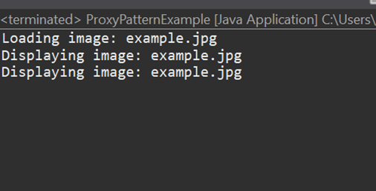

Exercise - 7: Implementing the Observer Pattern

Observer.java
package observation;

public interface Observer {
void update(String stockName, double stockPrice);
}

MobileApp.java
package observation;

public class MobileApp implements Observer {
private String appName;

public MobileApp(String appName) {
this.appName = appName;
}

@Override
public void update(String stockName, double stockPrice) {
System.out.println(appName + " MobileApp: " + stockName + " price updated to $" + stockPrice);
}
}

WebApp.java
package observation;

public class WebApp implements Observer {
private String appName;

public WebApp(String appName) {
this.appName = appName;
}

@Override
public void update(String stockName, double stockPrice) {
System.out.println(appName + " WebApp: " + stockName + " price updated to $" + stockPrice);
}
}

Stock.java
package observation;

public interface Stock {
void registerObserver(Observer o);
void removeObserver(Observer o);
void notifyObservers();
}

StockMarket.java
package observation;
import java.util.ArrayList;
import java.util.List;

public class StockMarket implements Stock {
private List<Observer> observers = new ArrayList<>();
private String stockName;
private double stockPrice;

public void setStockData(String stockName, double stockPrice) {
this.stockName = stockName;
this.stockPrice = stockPrice;
notifyObservers();
}

public String getStockName() {
return stockName;
}

public double getStockPrice() {
return stockPrice;
}

@Override
public void registerObserver(Observer o) {
observers.add(o);
}

@Override
public void removeObserver(Observer o) {
observers.remove(o);
}

@Override
public void notifyObservers() {
for (Observer o : observers) {
o.update(stockName, stockPrice);
}
}
}

Test.java
package observation;

public class Test {
public static void main(String[] args) {
StockMarket market = new StockMarket();

Observer mobile = new MobileApp("ABC");
Observer web = new WebApp("XYZ");

market.registerObserver(mobile);
market.registerObserver(web);

market.setStockData("CTS", 3575.50);
market.setStockData("TCS", 1432.30);

market.removeObserver(web);

market.setStockData("Zoho", 422.75);
}
}

OUTPUT:
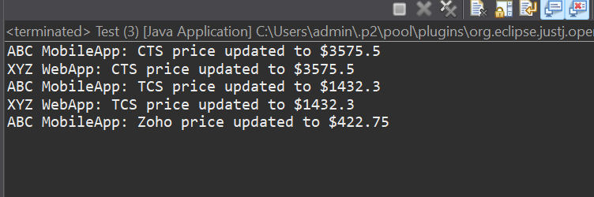

Exercise - 8 : Implementing the Stratergy Pattern

PaymentStratergy.java
package stratergy;

public interface PaymentStratergy {
void pay(double amount);
}

PaymentContext.java

package stratergy;

public class PaymentContext {
private PaymentStratergy strategy;

public void setPaymentStrategy(PaymentStratergy strategy) {
this.strategy = strategy;
}

public void payAmount(double amount) {
if (strategy == null) {
System.out.println("No payment strategy selected.");
} else {
strategy.pay(amount);
}
}
}

PayPalPayment.java
package stratergy;

public class PayPalPayment implements PaymentStratergy {
private String email;

public PayPalPayment(String email) {
this.email = email;
}

@Override
public void pay(double amount) {
System.out.println(amount + " was paid using PayPal account: " + email);
}
}

CreditCardPayment.java
package stratergy;

public class CreditCardPayment implements PaymentStratergy {
private String cardNumber;
private String name;
private String cvv;

public CreditCardPayment(String cardNumber, String name, String cvv) {
this.cardNumber = cardNumber;
this.name = name;
this.cvv = cvv;
}

public void pay(double amount) {
System.out.println(amount + " was paid using Credit Card by " + name);
}
}

Test.java
package stratergy;

public class Test {
public static void main(String[] args) {
PaymentContext context = new PaymentContext();

// Pay using Credit Card
PaymentStratergy creditCard = new CreditCardPayment("123456789098765", "XYZ", "123");
context.setPaymentStrategy(creditCard);
context.payAmount(2500.00);

// Pay using PayPal
PaymentStratergy payPal = new PayPalPayment("xyz@paypal.com");
context.setPaymentStrategy(payPal);
context.payAmount(1800.50);
}
}

OUTPUT:
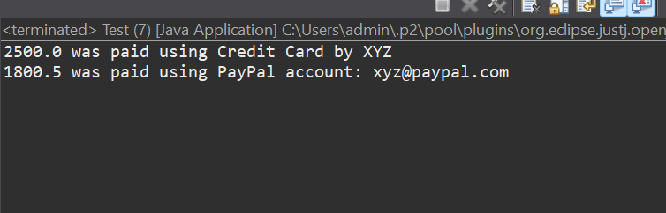

Exercise - 9 : Implementing the Command Pattern

Command.java
package command;

public interface Command {
void execute();
}

RemoteControl.java
package command;

public class RemoteControl {
private Command command;

public void setCommand(Command command) {
this.command = command;
}

public void pressButton() {
if (command != null) {
command.execute();
} else {
System.out.println("No command yet...");
}
}
}

Light.java
package command;

public class Light {
public void turnOn() {
System.out.println("Light is turned ON");
}

public void turnOff() {
System.out.println("Light is turned OFF");
}
}

LightOnComand.java
package command;

public class LightOnCommand implements Command {
private Light light;

public LightOnCommand(Light light) {
this.light = light;
}

@Override
public void execute() {
light.turnOn();
}
}

LightOffCommand.java
package command;

public class LightOffCommand implements Command {
private Light light;

public LightOffCommand(Light light) {
this.light = light;
}

@Override
public void execute() {
light.turnOff();
}
}

Test.java
package command;

public class Test {
public static void main(String[] args) {
Light bedroomLight = new Light();

Command lightOn = new LightOnCommand(bedroomLight);
Command lightOff = new LightOffCommand(bedroomLight);

RemoteControl remote = new RemoteControl();

// Turn on the light
remote.setCommand(lightOn);
remote.pressButton();

// Turn off the light
remote.setCommand(lightOff);
remote.pressButton();
}
}

OUTPUT:
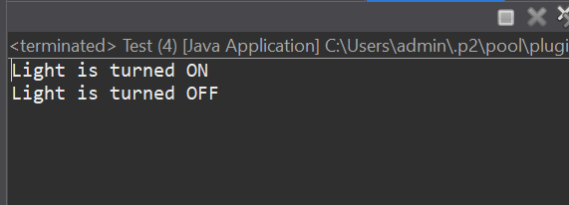

Exercise - 10: Implementing the MVC Pattern
Student.java
package mvcpattern;

public class Student {
private String name;
private String id;
private String grade;

public Student(String name, String id, String grade) {
this.name = name;
this.id = id;
this.grade = grade;
}

public String getName() {
return name;
}
public void setName(String name) {
this.name = name;
}

public String getId() {
return id;
}
public void setId(String id) {
this.id = id;
}

public String getGrade() {
return grade;
}
public void setGrade(String grade) {
this.grade = grade;
}
}

StudentController.java
package mvcpattern;

public class StudentController {
private Student model;
private StudentView view;

public StudentController(Student model, StudentView view) {
this.model = model;
this.view = view;
}

public void setStudentName(String name) {
model.setName(name);
}

public void setStudentId(String id) {
model.setId(id);
}

public void setStudentGrade(String grade) {
model.setGrade(grade);
}

public String getStudentName() {
return model.getName();
}

public String getStudentId() {
return model.getId();
}

public String getStudentGrade() {
return model.getGrade();
}

public void updateView() {
view.displayStudentDetails(model.getName(), model.getId(), model.getGrade());
}
}

StudentView.java
package mvcpattern;

public class StudentView {
public void displayStudentDetails(String name, String id, String grade) {
System.out.println("The student details are displayed below: ");
System.out.println("Name : " + name);
System.out.println("ID : " + id);
System.out.println("Grade : " + grade);
}
}

Test.java
package mvcpattern;

public class Test {
public static void main(String[] args) {
Student student = new Student("ABC", "21121122001", "A+");
StudentView view = new StudentView();
StudentController controller = new StudentController(student, view);
controller.updateView();
controller.setStudentName("XYZ");
controller.setStudentGrade("O");
controller.updateView();
}
}

OUTPUT:
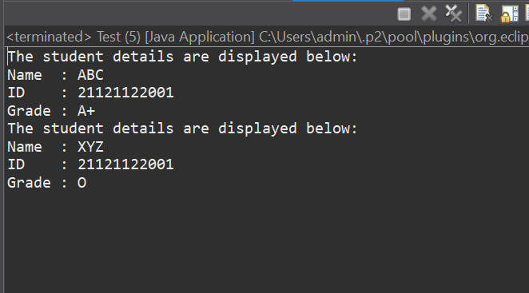

Exercise - 11: Implementing Dependency Interjection

CustomerRespository.java
package dependency_interjection;

public interface CustomerRepository {
String findCustomerById(String id);
}

CustomerRepositoryImpl.java
package dependency_interjection;

public class CustomerRepositoryImpl implements CustomerRepository {
@Override
public String findCustomerById(String id) {
return "Customer[ID = " + id + ", Name = ABC]";
}
}

CustomerService.java
package dependency_interjection;

public class CustomerService {
private CustomerRepository customerRepository;
public CustomerService(CustomerRepository customerRepository) {
this.customerRepository = customerRepository;
}
public void getCustomerDetails(String id) {
String customer = customerRepository.findCustomerById(id);
System.out.println(" Fetched: " + customer);
}
}

Test.java
package dependency_interjection;

public class Test {
public static void main(String[] args) {
CustomerRepository repository = new CustomerRepositoryImpl();
CustomerService service = new CustomerService(repository);
service.getCustomerDetails("Customer101");
}
}

OUTPUT:
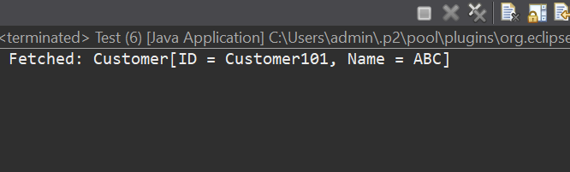

Algorithms_Data Structures

Exercise - 1 : Inventory Management System

Product.java
package inventory_management_system;

public class Product {
int productId;
String productName;
int quantity;
double price;

public Product(int productId, String productName, int quantity, double price) {
this.productId = productId;
this.productName = productName;
this.quantity = quantity;
this.price = price;
}

public String toString() {
return "ID: " + productId + ", Name: " + productName + ", Quantity: " + quantity + ", Price: " + price;
}
}

InventorySystem.java
package inventory_management_system;
import java.util.HashMap;
import java.util.Map;
import java.util.Scanner;

public class InventorySystem {
private Map<Integer, Product> inventory = new HashMap<>();

public void addProduct(Product p) {
inventory.put(p.productId, p);
System.out.println("Product is added.");
}

public void updateProduct(int productId, int quantity, double price) {
if (inventory.containsKey(productId)) {
Product p = inventory.get(productId);
p.quantity = quantity;
p.price = price;
System.out.println("Product is updated.");
} else {
System.out.println("Product is not found.");
}
}

public void deleteProduct(int productId) {
if (inventory.remove(productId) != null) {
System.out.println("Product is deleted.");
} else {
System.out.println("Product is not found.");
}
}

public void viewInventory() {
if (inventory.isEmpty()) {
System.out.println("Inventory is empty.");
} else {
System.out.println("Current Inventory:");
for (Product p : inventory.values()) {
System.out.println(p.toString());
}
}
}

public static void main(String[] args) {
InventorySystem system = new InventorySystem();
Scanner sc = new Scanner(System.in);
boolean flag = true;

while (flag) {
System.out.println("\n1. Add Product\n2. Update Product\n3. Delete Product\n4. View Inventory\n5. Exit");
int choice = sc.nextInt();

switch (choice) {
case 1:
System.out.print("Enter ID, Name, Quantity, Price: ");
int id = sc.nextInt();
String name = sc.next();
int qty = sc.nextInt();
double price = sc.nextDouble();
system.addProduct(new Product(id, name, qty, price));
break;

case 2:
System.out.print("Enter ID to update, new Quantity, new Price: ");
id = sc.nextInt();
qty = sc.nextInt();
price = sc.nextDouble();
system.updateProduct(id, qty, price);
break;

case 3:
System.out.print("Enter ID to delete: ");
id = sc.nextInt();
system.deleteProduct(id);
break;

case 4:
system.viewInventory();
break;

case 5:
flag = false;
System.out.println("Exiting...");
break;
}
}
sc.close();
}
}

OUTPUT:
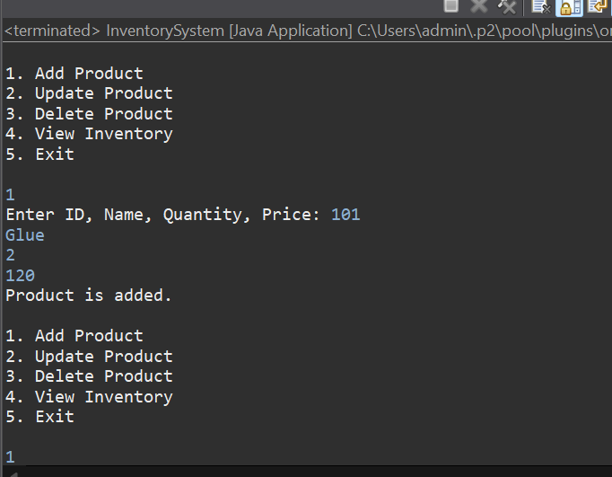
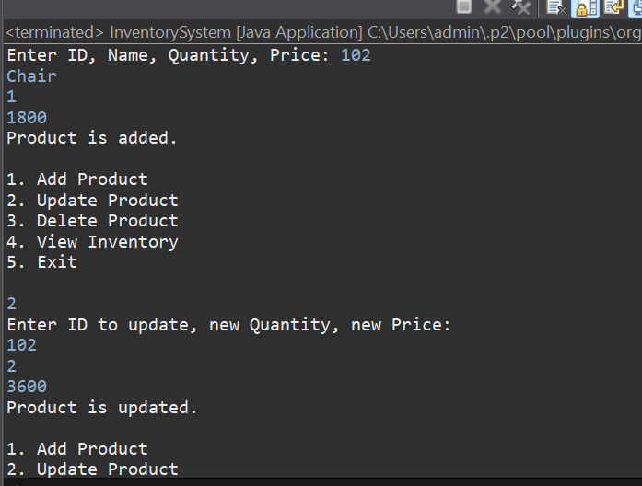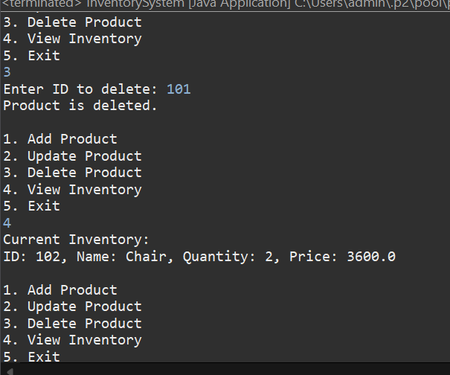
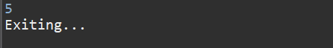

Exercise - 2 : E - Commerce Platform Search Function

Product.java
package ecommerce_search_function;

public class Product {
int productId;
String productName;
String category;

public Product(int productId, String productName, String category) {
this.productId = productId;
this.productName = productName;
this.category = category;
}

public String toString() {
return "ID: " + productId + ", Name: " + productName + ", Category: " + category;
}
}

LinearSearch.java
package ecommerce_search_function;

public interface LinearSearch {
int linearSearch(Product[] products, String targetName);
}

BinarySearch.java
package ecommerce_search_function;

public interface BinarySearch {
int binarySearch(Product[] products, String targetName);
}

ProductNameComparator.java
package ecommerce_search_function;
import java.util.Comparator;

public class ProductNameComparator implements Comparator<Product> {
@Override
public int compare(Product p1, Product p2) {
return p1.productName.compareToIgnoreCase(p2.productName);
}
}

ProductSearch.java
package ecommerce_search_function;

import java.util.Arrays;

public class ProductSearch implements LinearSearch, BinarySearch {

public int linearSearch(Product[] products, String targetName) {
for (int i = 0; i < products.length; i++) {
if (products[i].productName.equalsIgnoreCase(targetName)) {
return i;
}
}
return -1;
}

public int binarySearch(Product[] products, String targetName) {

Arrays.sort(products, new ProductNameComparator());

int low = 0, high = products.length - 1;
while (low <= high) {
int mid = (low + high) / 2;
int compare = products[mid].productName.compareToIgnoreCase(targetName);

if (compare == 0)
return mid;
else if (compare < 0)
low = mid + 1;
else
high = mid - 1;
}
return -1;
}
}

Main.java
package ecommerce_search_function;

public class Main {
public static void main(String[] args) {
Product[] products = {
new Product(1, "Laptop", "Electronics"),
new Product(2, "Shoes", "Fashion"),
new Product(3, "Watch", "Accessories"),
new Product(4, "Phone", "Electronics")
};

ProductSearch search = new ProductSearch();

int linearIndex = search.linearSearch(products, "Watch");
System.out.println("Linear Search found at index: " + linearIndex);

int binaryIndex = search.binarySearch(products, "Watch");
System.out.println("Binary Search found at index: " + binaryIndex);
}
}

OUTPUT:

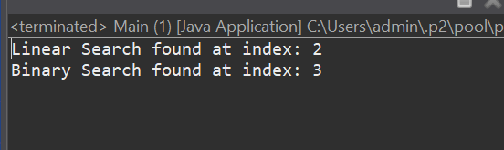

Exercise - 3: Sorting Customers Orders

Order.java
package sorting_customer_orders;

public class Order {
int orderId;
String customerName;
double totalPrice;

public Order(int orderId, String customerName, double totalPrice) {
this.orderId = orderId;
this.customerName = customerName;
this.totalPrice = totalPrice;
}

@Override
public String toString() {
return "Order ID: " + orderId + ", Customer: " + customerName + ", Total Price: Rupees " + totalPrice;
}
}

BubbleSort.java
package sorting_customer_orders;

public class BubbleSort {
public static void bubbleSort(Order[] orders) {
int n = orders.length;
for (int i = 0; i < n - 1; i++) {
for (int j = 0; j < n - i - 1; j++) {
if (orders[j].totalPrice > orders[j + 1].totalPrice) {
Order temp = orders[j];
orders[j] = orders[j + 1];
orders[j + 1] = temp;
}
}
}
}
}

QuickSort.java
package sorting_customer_orders;

public class QuickSort {
public static void quickSort(Order[] orders, int low, int high) {
if (low < high) {
int pivotIndex = partition(orders, low, high);
quickSort(orders, low, pivotIndex - 1);
quickSort(orders, pivotIndex + 1, high);
}
}

private static int partition(Order[] orders, int low, int high) {
double pivot = orders[high].totalPrice;
int i = low - 1;

for (int j = low; j < high; j++) {
if (orders[j].totalPrice < pivot) {
i++;
Order temp = orders[i];
orders[i] = orders[j];
orders[j] = temp;
}
}

Order temp = orders[i + 1];
orders[i + 1] = orders[high];
orders[high] = temp;

return i + 1;
}
}

Main.java
package sorting_customer_orders;

public class Main {
public static void main(String[] args) {
Order[] orders = {
new Order(101, "Ram", 799.99),
new Order(102, "Ravi", 1199.50),
new Order(103, "Deepak", 649.25),
new Order(104, "Shyam", 4999.00),
new Order(105, "Sami", 2399.75)
};

System.out.println("Original Orders:");
for (Order o : orders) System.out.println(o.toString());

System.out.println("\n Using Bubble Sort:");
BubbleSort.bubbleSort(orders);
for (Order o : orders) System.out.println(o.toString());

System.out.println("\nUsing Quick Sort:");

orders = new Order[]{
new Order(101, "Ram", 799.99),
new Order(102, "Ravi", 1199.50),
new Order(103, "Deepak", 649.25),
new Order(104, "Shyam", 4999.00),
new Order(105, "Sami", 2399.75)
};
QuickSort.quickSort(orders, 0, orders.length - 1);
for (Order o : orders) System.out.println(o.toString());
}
}

OUTPUT:
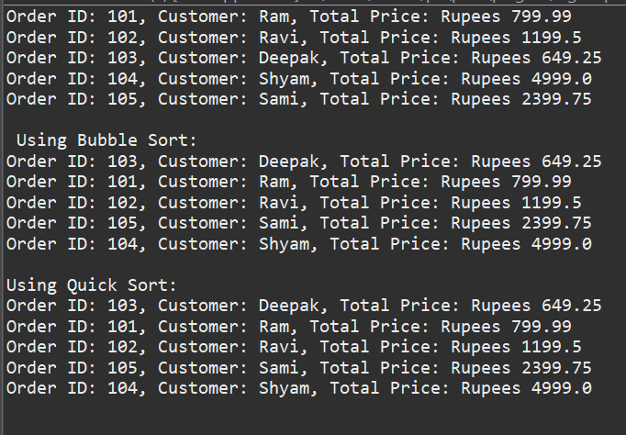

Exercise - 4 : Employee Management System

Employee.java
package employee_management_system;

public class Employee {
int employeeId;
String name;
String position;
double salary;

public Employee(int employeeId, String name, String position, double salary) {
this.employeeId = employeeId;
this.name = name;
this.position = position;
this.salary = salary;
}

public String toString() {
return "ID: " + employeeId + ", Name: " + name +
", Position: " + position + ", Salary: Rupees " + salary;
}
}

EmployeeManagementSystem.java
package employee_management_system;

public class EmployeeManagementSystem {
private Employee[] employees;
private int count;

public EmployeeManagementSystem(int size) {
employees = new Employee[size];
count = 0;
}

public void addEmployee(Employee emp) {
if (count < employees.length) {
employees[count] = emp;
count++;
System.out.println("Employee is added.");
} else {
System.out.println("Cannot add more employees. Array is full.");
}
}

public void traverseEmployees() {
System.out.println("Employee List:");
for (int i = 0; i < count; i++) {
System.out.println(employees[i].toString());
}
}

public void searchEmployee(int id) {
for (int i = 0; i < count; i++) {
if (employees[i].employeeId == id) {
System.out.println("Employee Found:");
System.out.println(employees[i].toString());
return;
}
}
System.out.println("Employee with ID " + id + " not found.");
}

public void deleteEmployee(int id) {
for (int i = 0; i < count; i++) {
if (employees[i].employeeId == id) {
for (int j = i; j < count - 1; j++) {
employees[j] = employees[j + 1];
}
employees[count - 1] = null;
count--;
System.out.println("Employee is deleted.");
return;
}
}
System.out.println("Employee is not found.");
}
}

Main.java
package employee_management_system;

public class Main {
public static void main(String[] args) {
EmployeeManagementSystem system = new EmployeeManagementSystem(5);

system.addEmployee(new Employee(101, "Ram", "Developer", 55000));
system.addEmployee(new Employee(102, "Ravi", "Tester", 48000));
system.addEmployee(new Employee(103, "Neha", "Manager", 75000));

system.traverseEmployees();

system.searchEmployee(102);

system.deleteEmployee(102);
system.traverseEmployees();
}
}

OUTPUT:

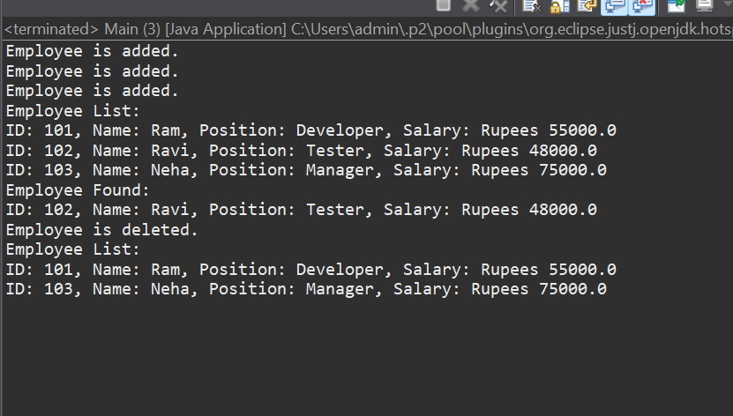

Exercise - 5 : Task Management System

Task.java
package task_management_system;

public class Task {
int taskId;
String taskName;
String status;

public Task(int taskId, String taskName, String status) {
this.taskId = taskId;
this.taskName = taskName;
this.status = status;
}

@Override
public String toString() {
return "Task ID: " + taskId + ", Name: " + taskName + ", Status: " + status;
}
}

TaskNode.java
package task_management_system;

class TaskNode {
Task task;
TaskNode next;

public TaskNode(Task task) {
this.task = task;
this.next = null;
}
}

TaskManager.java
package task_management_system;

public class TaskManager {
private TaskNode head;

// Add a task to the end
public void addTask(Task task) {
TaskNode newNode = new TaskNode(task);
if (head == null) {
head = newNode;
} else {
TaskNode current = head;
while (current.next != null) {
current = current.next;
}
current.next = newNode;
}
System.out.println("Task added.");
}

// Traverse and display all tasks
public void traverseTasks() {
TaskNode current = head;
if (current == null) {
System.out.println("No tasks available.");
return;
}
while (current != null) {
System.out.println(current.task.toString());
current = current.next;
}
}

// Search a task by ID
public void searchTask(int id) {
TaskNode current = head;
while (current != null) {
if (current.task.taskId == id) {
System.out.println("Task found:");
System.out.println(current.task.toString());
return;
}
current = current.next;
}
System.out.println("Task with ID " + id + " not found.");
}

// Delete a task by ID
public void deleteTask(int id) {
if (head == null) {
System.out.println("No tasks to delete.");
return;
}

if (head.task.taskId == id) {
head = head.next;
System.out.println("Task deleted.");
return;
}

TaskNode current = head;
TaskNode prev = null;

while (current != null && current.task.taskId != id) {
prev = current;
current = current.next;
}

if (current == null) {
System.out.println("Task not found.");
} else {
prev.next = current.next;
System.out.println("Task deleted.");
}
}
}

Main.java
package task_management_system;

public class Main {
public static void main(String[] args) {
TaskManager manager = new TaskManager();

manager.addTask(new Task(1, "Design UI", "Pending"));
manager.addTask(new Task(2, "Write Backend", "In Progress"));
manager.addTask(new Task(3, "Test App", "Pending"));

System.out.println("\nTasks:");
manager.traverseTasks();

System.out.println("\nSearching for Task ID :");
manager.searchTask(2);

System.out.println("\nDeleting Task ID :");
manager.deleteTask(2);

System.out.println("\nUpdated Task List:");
manager.traverseTasks();
}
}

OUTPUT:
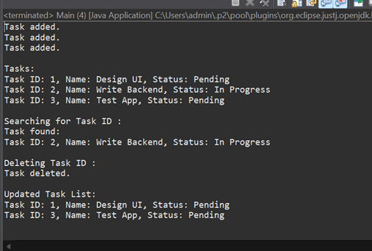

Exercise - 6: Library Management System

Book.java

package library_management_system;

public class Book {
int bookId;
String title;
String author;

public Book(int bookId, String title, String author) {
this.bookId = bookId;
this.title = title;
this.author = author;
}

public String toString() {
return "ID: " + bookId + ", Title: " + title + ", Author: " + author;
}
}

LinearSearch.java
package library_management_system;

public interface LinearSearch {
int linearSearch(Book[] books, String targetTitle);
}

BinarySearch.java
package library_management_system;

public interface BinarySearch {
int binarySearch(Book[] books, String targetTitle);
}

BookTitleComparator.java
package library_management_system;

import java.util.Comparator;

public class BookTitleComparator implements Comparator<Book> {
@Override
public int compare(Book b1, Book b2) {
return b1.title.compareToIgnoreCase(b2.title);
}
}

LibrarySearchSystem.java
package library_management_system;

import java.util.Arrays;

public class LibrarySearchSystem implements LinearSearch, BinarySearch {

// Linear Search
public int linearSearch(Book[] books, String targetTitle) {
for (int i = 0; i < books.length; i++) {
if (books[i].title.equalsIgnoreCase(targetTitle)) {
return i;
}
}
return -1;
}

// Binary Search
public int binarySearch(Book[] books, String targetTitle) {
Arrays.sort(books, new BookTitleComparator()); // Sort first

int low = 0, high = books.length - 1;
while (low <= high) {
int mid = (low + high) / 2;
int cmp = books[mid].title.compareToIgnoreCase(targetTitle);
if (cmp == 0)
return mid;
else if (cmp < 0)
low = mid + 1;
else
high = mid - 1;
}
return -1;
}
}

Main.java
package library_management_system;

public class Main {
public static void main(String[] args) {
Book[] books = {
new Book(101, "The Alchemist", "Paulo Coelho"),
new Book(102, "Wings of Fire", "APJ Abdul Kalam"),
new Book(103, "Harry Potter", "J.K. Rowling"),
new Book(104, "Atomic Habits", "James Clear")
};

LibrarySearchSystem system = new LibrarySearchSystem();

System.out.println("Linear Search: Finding 'Harry Potter'");
int linearResult = system.linearSearch(books, "Harry Potter");
if (linearResult != -1)
System.out.println(books[linearResult].toString());
else System.out.println("Book not found.");

System.out.println("\nBinary Search: Finding 'Atomic Habits'");
int binaryResult = system.binarySearch(books, "Atomic Habits");
if (binaryResult != -1)
System.out.println(books[linearResult].toString());
else System.out.println("Book not found.");
}
}

OUTPUT:
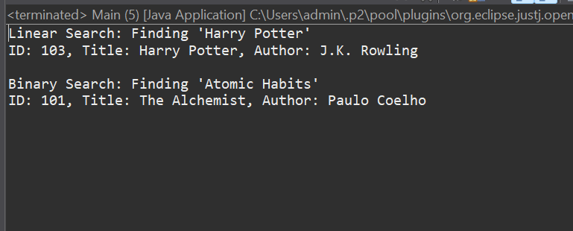

Exercise - 7: Financial Forecasting

FinancialForecast.java
package financial_forecasting;

public class FinancialForecast {
//Future Value = Present Value × (1 + rate) ^ years - Formula

public static double predictFutureValue(double presentValue, double rate, int years) {
if (years == 0)
return presentValue;
return predictFutureValue(presentValue * (1 + rate), rate, years - 1);
}

public static void main(String[] args) {
double initial = 10000;
double rate = 0.05;
int years = 5;

double futureValue = predictFutureValue(initial, rate, years);
System.out.printf("Future Value after %d years: Rupees %.2f\n", years, futureValue);
}
}

OUTPUT:
