Web API: I have used Db first approach and I have only wrote 2 methods for data retrieval and Insert.

Angular: I have only added patient List and Add new Patient features

Screen 1: Patient List

In this page I have displayed patient list from API. I wrote test cases for this page only

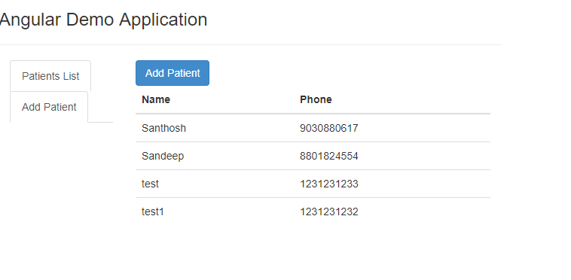

Screen 2: Add Patient

This page is used to add patient details in database using Web API.

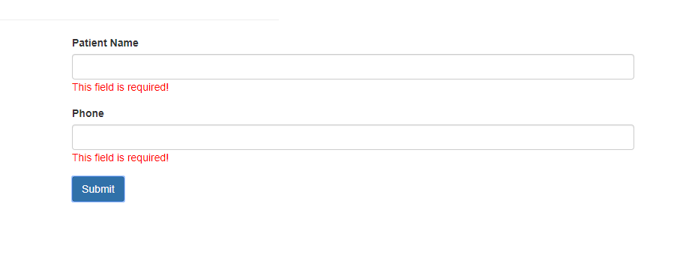

After Adding it will redirect to Patient List Page

