1a) Dart program to print numbers from 1 to 10 using loops
import 'dart:io'; // Importing standard I/O library (optional here)
void main() {
print("=== Using for loop ===");
forLoopExample();
print("\n=== Using while loop ===");
whileLoopExample();
print("\n=== Using do-while loop ===");
doWhileLoopExample();
}
// Function to print numbers using for loop
void forLoopExample() {
for (int i = 1; i <= 10; i++) {
print(i);
}
}
// Function to print numbers using while loop
void whileLoopExample() {
int i = 1;
while (i <= 10) {
print(i);
i++;
}
}
// Function to print numbers using do-while loop
void doWhileLoopExample() {
int i = 1;
do {
print(i);
i++;
} while (i <= 10);
}
Output:
=== Using for loop ===
1
2
3
4
5
6
7
8
9
10

=== Using while loop ===
1
2
3
4
5
6
7
8
9
10

=== Using do-while loop ===
1
2
3
4
5
6
7
8
9
10
2a) Dart program to check whether a given number is even or odd
import 'dart:io';
void main() {
// Asking user for input
stdout.write("Enter a number: ");
int number = int.parse(stdin.readLineSync()!);
// Checking even or odd
if (number % 2 == 0) {
print("$number is an Even number.");
} else {
print("$number is an Odd number.");
}
}
Output:
Enter a number: 8
8 is an Even number.
2b.),7b)Explore various Flutter widgets (Text, Image, Container, etc.).
Steps:
Step 1: Open VS code
Step 2: ctrl+ shift + P type and select Flutter: New Project
Step 3: choose Flutter Application
Step 4: Enter project name ex: Flutter_Application1
Step 5: choose folder location and wait for project creation to complete
Step 6: open lib/main.dart and delete existing code and type below:
import 'package:flutter/material.dart';

void main() => runApp(MyApp());

class MyApp extends StatelessWidget {
const MyApp({super.key});

@override
Widget build(BuildContext context) {
return MaterialApp(
home: Scaffold(
body: Column(
children: [
Text('Hello Flutter!'),
Image.network(
'https://flutter.dev/images/flutter-logo-sharing.png',
height: 80,
),
Container(
padding: EdgeInsets.all(10),
color: Colors.amber,
child: Text('Inside Container'),
),
],
),
),
);
}
}

Step 7: Bottom right corner choose device: ex: edge /chrome / android emulator
Step 8: press F5 or run start debugging or in terminal use command
“flutter run”(recommended).
Output:
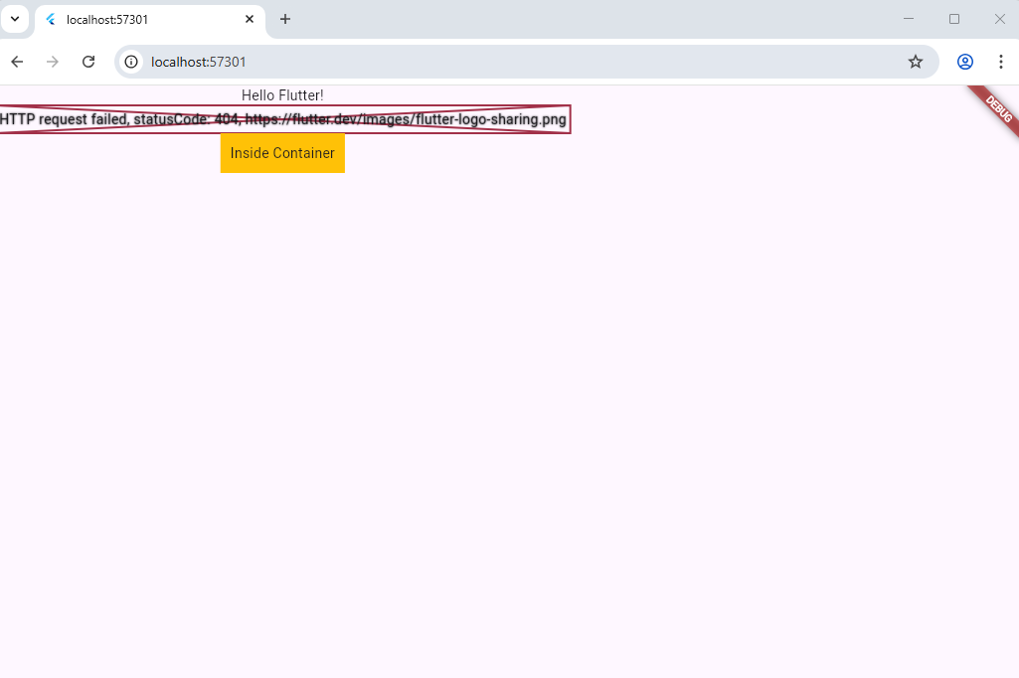

3a)Dart program to find the largest of two numbers

import 'dart:io'; // Import for reading user input

void main() {
// Taking first number input
stdout.write("Enter first number: ");
int num1 = int.parse(stdin.readLineSync()!);

// Taking second number input
stdout.write("Enter second number: ");
int num2 = int.parse(stdin.readLineSync()!);

// Finding and displaying the largest number
if (num1 > num2) {
print("$num1 is the largest number.");
} else if (num2 > num1) {
print("$num2 is the largest number.");
} else {
print("Both numbers are equal.");
}
}
Output:
Enter first number: 25
Enter second number: 40
40 is the largest number.

3B),8b) Write program to illustrate Stateful widgets in Flutter.

import 'package:flutter/material.dart';

void main() {
runApp(StateDemoApp());
}

class StateDemoApp extends StatelessWidget {
@override
Widget build(BuildContext context) {
return MaterialApp(
title: 'Stateful Widget Demo',
home: Scaffold(
appBar: AppBar(
title: Text('Stateful Widget Example'),
),
body: Center(
child: MyStatefulWidget(),
),
),
);
}
}

// Stateful widget: holds state (counter in this example)
class MyStatefulWidget extends StatefulWidget {
@override
_MyStatefulWidgetState createState() => _MyStatefulWidgetState();
}

class _MyStatefulWidgetState extends State<MyStatefulWidget> {
int _counter = 0;

void _incrementCounter() {
setState(() {
_counter++; // updates the state
});
}

@override
Widget build(BuildContext context) {
return Column(
mainAxisAlignment: MainAxisAlignment.center,
children: [
Text(
'I am a Stateful Widget',
style: TextStyle(fontSize: 24, color: Colors.green),
),
SizedBox(height: 16),
Text(
'Counter: $_counter',
style: TextStyle(fontSize: 20),
),
SizedBox(height: 16),
ElevatedButton(
onPressed: _incrementCounter,
child: Text('Increment Counter'),
),
],
);
}
}
Output:
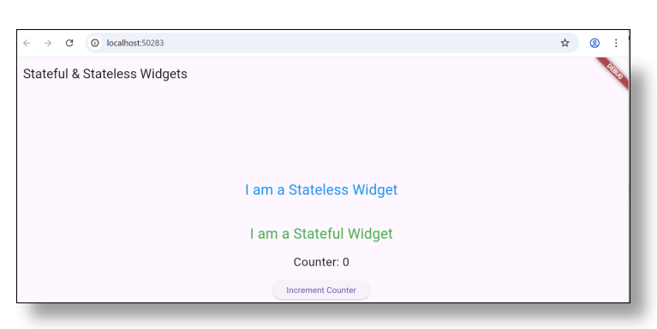
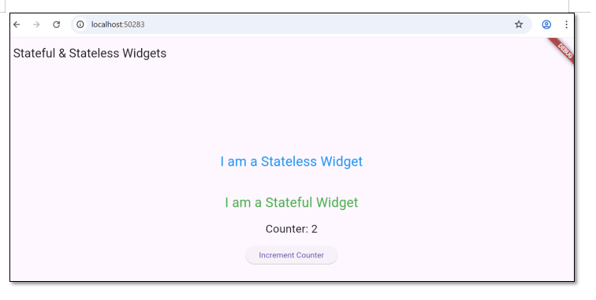

4 A) Write a dart program to find factorial of a number.
Program:
import 'dart:io'; // Import for reading user input

void main() {
// Asking user to enter a number
stdout.write("Enter a number: ");
int num = int.parse(stdin.readLineSync()!);

int factorial = 1;

// Calculating factorial using a for loop
for (int i = 1; i <= num; i++) {
factorial = factorial * i;
}

// Displaying the result
print("Factorial of $num is $factorial");
}
Output:
Enter a number: 5
Factorial of 5 is 120

4 B),9b) Design a responsive UI that adapts to different screen sizes.
import 'package:flutter/material.dart';

void main() => runApp(const MyApp());

class MyApp extends StatelessWidget {
const MyApp({super.key});

@override
Widget build(BuildContext context) {
return MaterialApp(
home: Scaffold(
appBar: AppBar(title: const Text("Responsive UI Example")),
body: LayoutBuilder(
builder: (context, constraints) {
if (constraints.maxWidth < 600) {
return const Center(
child: Text("Mobile Layout", style: TextStyle(fontSize: 24)),
);
} else {
return const Center(
child: Text("Desktop Layout", style: TextStyle(fontSize: 32)),
);
}
},
),
),
);
}
}
Output:
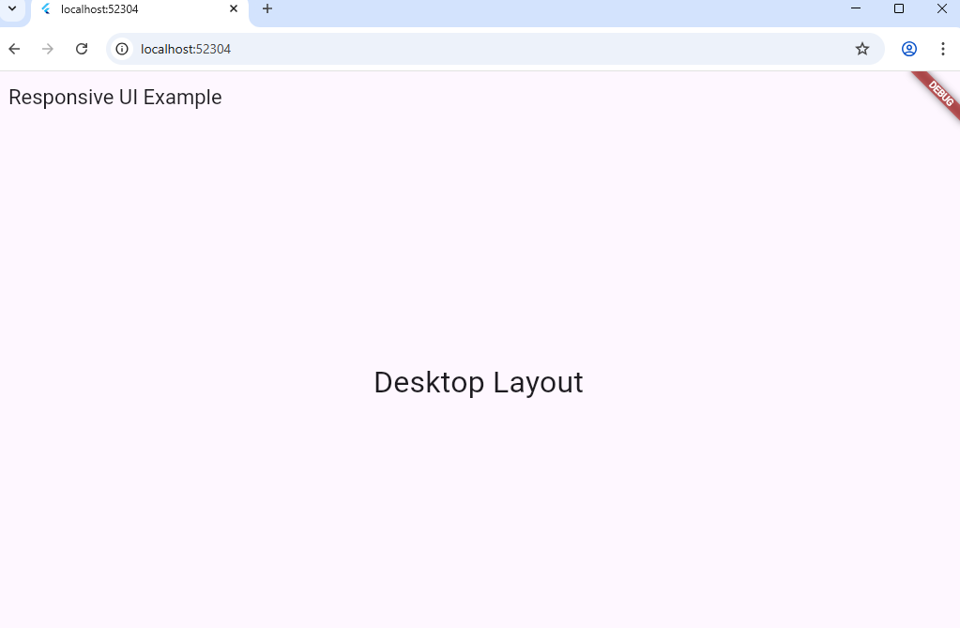

5 A) Write a dart program to generate fibonacci series.
Program:
// Dart program to generate Fibonacci series

import 'dart:io'; // Import for reading user input

void main() {
// Asking user to enter the number of terms
stdout.write("Enter the number of terms: ");
int n = int.parse(stdin.readLineSync()!);

int first = 0, second = 1, next;

print("Fibonacci Series up to $n terms:");

for (int i = 1; i <= n; i++) {
print(first);
next = first + second;
first = second;
second = next;
}
}
Output:
Enter the number of terms: 7
Fibonacci Series up to 7 terms:
0
1
1
2
3
5
8
5 B),10) Write programs to illustrate Stateless widgets in Flutter.
Program:
import 'package:flutter/material.dart';

void main() {
runApp(StateDemoApp());
}

class StateDemoApp extends StatelessWidget {
@override
Widget build(BuildContext context) {
return MaterialApp(
title: 'Stateless Widget Demo',
home: Scaffold(
appBar: AppBar(
title: Text('Stateless Widget Example'),
),
body: Column(
mainAxisAlignment: MainAxisAlignment.center,
children: [
MyStatelessWidget(),
],
),
),
);
}
}

class MyStatelessWidget extends StatelessWidget {
@override
Widget build(BuildContext context) {
return Center(
child: Text(
'I am a Stateless Widget',
style: TextStyle(fontSize: 24, color: Colors.blue),
),
);
}
}
Output:
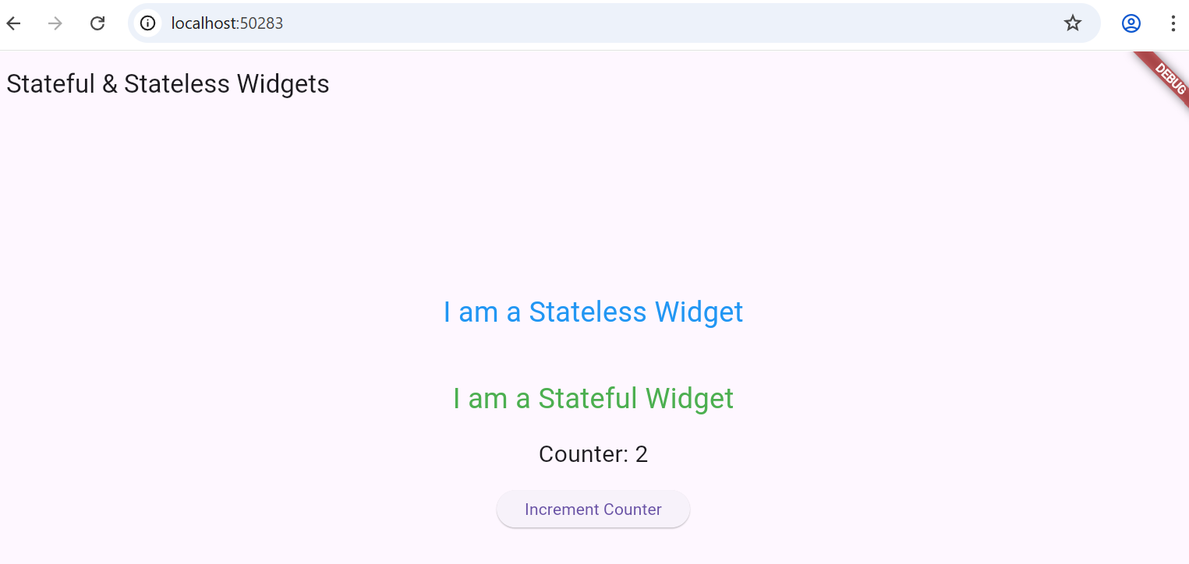

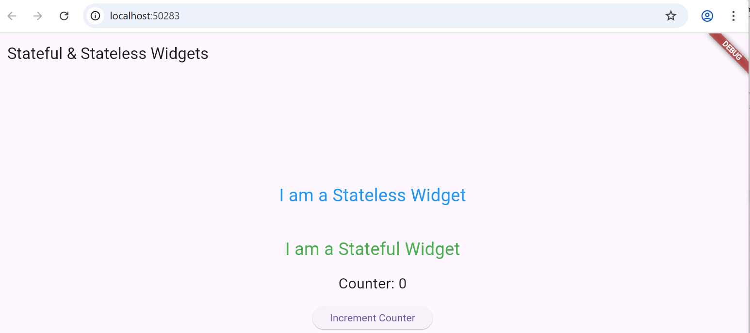
6 A) Write a dart program to check palindrome number.
Program:
// Dart program to check whether a given number is a palindrome

import 'dart:io'; // Import for reading user input

void main() {
// Asking user to enter a number
stdout.write("Enter a number: ");
int number = int.parse(stdin.readLineSync()!);

int temp = number;
int reverse = 0;

// Reversing the number
while (temp > 0) {
int digit = temp % 10;
reverse = (reverse * 10) + digit;
temp = temp ~/ 10;
}

// Checking if the number is palindrome
if (number == reverse) {
print("$number is a Palindrome number.");
} else {
print("$number is not a Palindrome number.");
}
}
Output:
Enter a number: 121
121 is a Palindrome number.
Enter a number: 123
123 is not a Palindrome number.
7 A) Write a dart program using functions.
Prorgram:
// Dart program using functions to add two numbers

import 'dart:io'; // Import for user input

void main() {
// Asking user to enter two numbers
stdout.write("Enter first number: ");
int num1 = int.parse(stdin.readLineSync()!);

stdout.write("Enter second number: ");
int num2 = int.parse(stdin.readLineSync()!);

// Calling the function and storing result
int result = addNumbers(num1, num2);

// Displaying the result
print("The sum of $num1 and $num2 is $result");
}

// Function to add two numbers
int addNumbers(int a, int b) {
return a + b;
}
Output:
Enter first number: 10
Enter second number: 20
The sum of 10 and 20 is 30
8 A) Write a dart program checking if a number is prime.
Program:
// Dart program to check whether a given number is prime

import 'dart:io'; // Import for reading user input

void main() {
// Asking user to enter a number
stdout.write("Enter a number: ");
int num = int.parse(stdin.readLineSync()!);

if (isPrime(num)) {
print("$num is a Prime number.");
} else {
print("$num is not a Prime number.");
}
}

// Function to check if a number is prime
bool isPrime(int n) {
if (n <= 1) return false; // 0 and 1 are not prime numbers
for (int i = 2; i <= n ~/ 2; i++) {
if (n % i == 0) {
return false; // If divisible, not a prime
}
}
return true; // Otherwise, it is prime
}
Output:
Enter a number: 7
7 is a Prime number.
Enter a number: 9
9 is not a Prime number.
9 A) Write a dart program find largest of three numbers.
Program:
// Dart program to find the largest of three numbers

import 'dart:io'; // Import for reading user input

void main() {
// Asking user to enter three numbers
stdout.write("Enter first number: ");
int num1 = int.parse(stdin.readLineSync()!);

stdout.write("Enter second number: ");
int num2 = int.parse(stdin.readLineSync()!);

stdout.write("Enter third number: ");
int num3 = int.parse(stdin.readLineSync()!);

// Finding the largest number
if (num1 >= num2 && num1 >= num3) {
print("$num1 is the largest number.");
} else if (num2 >= num1 && num2 >= num3) {
print("$num2 is the largest number.");
} else {
print("$num3 is the largest number.");
}
}
Output:
Enter first number: 25
Enter second number: 40
Enter third number: 15
40 is the largest number.
10 A) Write a dart program find sum of elements in an array.
Program:
// Dart program to find sum of elements in an array

void main() {
// Declaring and initializing an array
List<int> numbers = [10, 20, 30, 40, 50];

// Variable to store sum
int sum = 0;

// Using for loop to calculate sum
for (int i = 0; i < numbers.length; i++) {
sum += numbers[i];
}

// Display the result
print("The sum of array elements is: $sum");
}
Output:
The sum of array elements is: 150

