Sri Eshwar College of Engineering
U23IT484 - Cloud Computing Technologies
Inventory Service on AWS with CI/CD Pipeline
Aim and Procedure for All Rounds
Detail | Information
Project Title | Inventory Service: Race-Condition-Safe Stock Management on AWS
Student Name | Sri Santhosh K
Roll Number | 24AM101
Use Case | Two cashiers sell the last unit of a product at the same moment; stock must never become -1
Region | ap-south-1 (Mumbai), two Availability Zones

1. Common Aim
To design, build and deploy a secure, scalable and highly available Inventory Service on AWS, hosted on Amazon ECS Fargate with a MySQL 8 (InnoDB) database on Amazon RDS, that prevents the overselling race condition (stock becoming -1 when two cashiers sell the last unit at the same moment), and to deliver it through a fully automated CI/CD pipeline using GitHub Actions.

Common Objectives
- Apply AWS global infrastructure, networking and security best practices (VPC, public and private subnets, security groups, IAM least privilege).
- Remove the race condition using three techniques: atomic UPDATE, SELECT ... FOR UPDATE, and optimistic locking with a version column.
- Store data durably and economically using Amazon RDS, Amazon S3 and Amazon ECR.
- Automate testing, image build, push and rolling deployment on every push to the main branch.
- Prove correctness under concurrent load, with final stock never below zero.

Common Technology Stack
Layer | Technology
Application | Node.js 20, Express, mysql2 (connection pool)
Database | Amazon RDS MySQL 8.0, InnoDB engine, private subnet
Containers | Docker, Amazon ECR, Amazon ECS on Fargate
Networking | VPC, Internet Gateway, NAT Gateway, Application Load Balancer
Security | IAM roles, GitHub OIDC, AWS Secrets Manager, security groups
Infrastructure as Code | Terraform (terraform/ folder)
CI/CD | GitHub Actions (.github/workflows/deploy.yml)
Observability | CloudWatch Logs, CloudWatch Alarms, Amazon SNS

2. Round Overview
Round | Component | Max Marks | Key Deliverable
Round 1 (i) | Online Quiz Assessment | 20 | Quiz score
Round 1 (ii) | Cloud Infrastructure Design | 20 | Architecture diagram
Round 2 (i) | Implement AWS Storage | 10 | S3, RDS and ECR configured
Round 2 (ii) | Build End to End AWS Solution | 10 | Working ALB URL with CRUD
Round 3 | Data Integration and Deployment | 30 | Live CI/CD deployment and load test

3. Round 1 (ii): Cloud Infrastructure Design
Maximum Marks: 20

Aim
To design a secure, highly available and scalable multi-AZ AWS architecture on which the Inventory Service will run.

AWS Services and Tools Used
- Design tool: draw.io (diagrams.net) for the architecture diagram
- AWS services in the design: VPC, ALB, ECS Fargate, RDS MySQL, S3, ECR, Secrets Manager, IAM, CloudWatch, SNS

Procedure
- Capture requirements. Two cashiers can sell at the same moment, stock must never be negative, the database must not be reachable from the internet, the service must survive the loss of one AZ, and deployments must be automated.
- Choose the Region and AZs. Use ap-south-1 with two Availability Zones.
- Design the network. Create VPC inv-vpc (10.0.0.0/16) with two public subnets (ALB and NAT Gateway) and two private subnets (ECS tasks and RDS), one of each in every AZ. Attach an Internet Gateway to the public route table and route the private subnets to the NAT Gateway.
- Design the security group chain. alb-sg allows ports 80 and 443 from the internet; ecs-sg allows port 3000 from alb-sg only; rds-sg allows port 3306 from ecs-sg only.
- Select compute and data services. Run the Node.js API on ECS Fargate (2 tasks), store stock data in RDS MySQL 8 with InnoDB, keep exports and backups in S3, images in ECR and credentials in Secrets Manager.
- Design the delivery path. GitHub Actions assumes an IAM role through OIDC (no stored AWS keys), pushes the image to ECR and updates the ECS service.
- Design scaling and monitoring. Add target-tracking auto scaling at 60% CPU (minimum 2, maximum 4 tasks) and CloudWatch alarms for ALB 5xx errors, ECS CPU and RDS CPU that notify through SNS email.
- Draw the diagram. Show the Region, VPC, both AZs, all subnets, the ALB, ECS tasks, RDS, NAT, IGW, S3 and ECR, with the direction of traffic and the security group rules.
- Record the design decisions in the table below.
Component | AWS Service | Placement | Reason
Load balancer | Application Load Balancer | Public subnets | Single entry point, health checks
Application | ECS Fargate | Private subnets | No servers to manage, not public
Database | RDS MySQL 8 (InnoDB) | Private subnets | Row-level locking, transactions
Object storage | Amazon S3 | Regional | Durable exports and backups
Image registry | Amazon ECR | Regional | Private container images
Secrets | Secrets Manager | Regional | No passwords in code or images
Outbound access | NAT Gateway | Public subnet | ECR pulls from private subnets

Expected Output / Evidence
- Architecture diagram showing AZs, subnets, security group flow and data flow
- Design decision table with the reason for each service

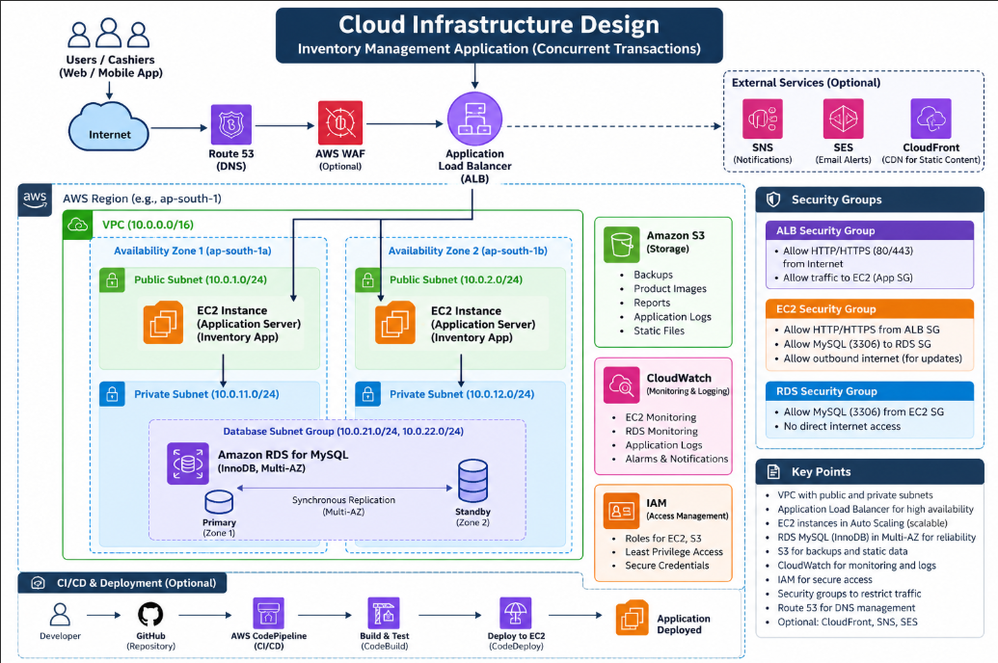

4. Round 2 (i): Implement AWS Storage
Maximum Marks: 10

Aim
To implement durable, secure and cost-optimised AWS storage for the Inventory Service data, exports and container images.

AWS Services and Tools Used
- Amazon S3: order exports and database dumps
- Amazon RDS: transactional stock and order data
- Amazon ECR: Docker images
- AWS CLI and Terraform: terraform/s3.tf and terraform/rds.tf

Procedure
- Create the S3 bucket. Create a bucket named inv-exports-<yourname> in ap-south-1, through the console or through Terraform (s3.tf).
- Block public access. Enable all four Block Public Access settings.
- Enable versioning so overwritten or deleted exports can be recovered.
- Enable default encryption with SSE-S3 (AES-256).
- Add a lifecycle rule that moves objects to the STANDARD_IA storage class after 30 days.
- Restrict access. Allow only the ECS task role to read and write this bucket, scoped to this bucket only.
- Configure RDS storage. Create the RDS MySQL 8.0 instance (db.t3.micro) in the private subnets with Publicly Accessible set to No, storage encryption enabled and automated backups retained for 7 days.
- Create the ECR repository inventory-app with scan on push enabled and a lifecycle policy that keeps the last 10 images.
- Verify S3 by uploading and listing a test object with the commands below.
aws s3api put-bucket-versioning --bucket inv-exports-<yourname> \
--versioning-configuration Status=Enabled
echo "storage test" > test.txt
aws s3 cp test.txt s3://inv-exports-<yourname>/test.txt
aws s3 ls s3://inv-exports-<yourname>/

Expected Output / Evidence
- Screenshot of the S3 bucket showing versioning, encryption and the lifecycle rule
- Screenshot of the RDS instance showing private access, encryption and backup retention
- Screenshot of the ECR repository settings
- Terminal output of the test upload and listing

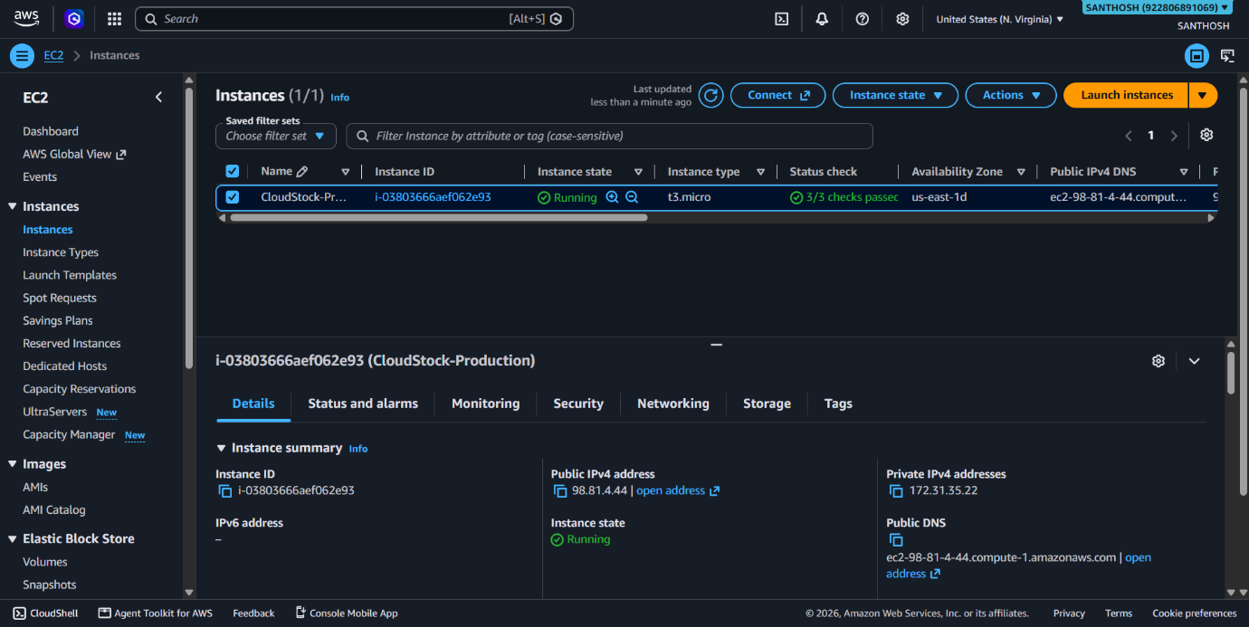

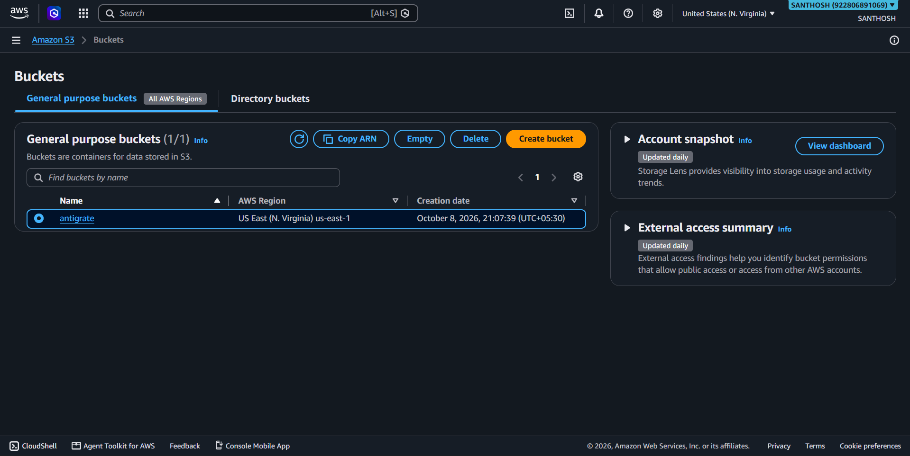

5. Round 2 (ii): Build End to End AWS Solution
Maximum Marks: 10

Aim
To build and run the complete Inventory Service end to end on AWS, from container image to a public Application Load Balancer URL that serves the CRUD and sell APIs.

AWS Services and Tools Used
- Local tools: Docker, Node.js 20, Terraform, AWS CLI, Git
- AWS services: VPC, ALB, ECS Fargate, ECR, RDS, Secrets Manager, CloudShell

Procedure
- Verify locally first. Start the stack with Docker Compose and confirm the health endpoint and tests pass before touching AWS.
docker compose up -d --build
curl http://localhost:3000/health
npm test
- Configure AWS access. Run aws configure with an IAM user and set the region to ap-south-1.
- Create the infrastructure. Run Terraform from the terraform folder and note the outputs (ALB DNS name, ECR URL, role ARN).
cd terraform
terraform init
terraform apply -var="github_repo=<user>/inventory-app" \
-var="alert_email=<email>"
- Push a bootstrap image. The ECS service needs an image to exist in ECR before its tasks can start.
aws ecr get-login-password --region ap-south-1 | \
docker login --username AWS --password-stdin <ECR_URL>
docker build -t <ECR_URL>:latest .
docker push <ECR_URL>:latest
- Load the database schema. RDS is private, so open AWS CloudShell, create a VPC environment in inv-vpc using a private subnet and the ecs-sg security group, then fetch the password from Secrets Manager and load sql/schema.sql (upload the file to CloudShell first).
aws secretsmanager get-secret-value --secret-id inv/db \
--query SecretString --output text
sudo dnf install -y mariadb105
mysql -h <RDS_ENDPOINT> -u <user> -p <dbname> < schema.sql
- Confirm the service is healthy. In the ECS console check that 2 tasks are running, then call the health endpoint through the ALB.
curl http://<ALB_DNS>/health
- Test CRUD through the ALB URL (Create, Read, Update, Delete) and one sell request.
curl -X POST http://<ALB_DNS>/inventory -H "Content-Type: application/json" \
-d '{"sku":"X1","name":"Pen","qty":100}'
curl http://<ALB_DNS>/inventory/X1
curl -X PUT http://<ALB_DNS>/inventory/X1 -H "Content-Type: application/json" \
-d '{"qty":150}'
curl -X POST http://<ALB_DNS>/sell/atomic -H "Content-Type: application/json" \
-d '{"sku":"X1","cashier":"c1"}'
curl -X DELETE http://<ALB_DNS>/inventory/X1

Expected Output / Evidence
- Screenshot of the ECS service showing 2 running tasks
- Screenshot of the healthy target group in the ALB
- Terminal output of the CRUD and sell requests against the ALB URL

6. Round 3: Data Integration and Deployment
Maximum Marks: 30

Aim
To integrate the application with its data layer and storage, deploy it through an automated CI/CD pipeline, and validate correctness under concurrent load.

AWS Services and Tools Used
- GitHub and GitHub Actions with OIDC role assumption
- AWS: ECR, ECS Fargate, RDS, Secrets Manager, S3, CloudWatch, SNS
- Testing tools: Jest with supertest, k6, scripts/race-demo.js

Procedure
- Verify data integration. Confirm the ECS task definition injects the database host, user, password and name from the inv/db secret, and that the application reads and writes rows in RDS through the ALB.
- Seed test data using scripts/seed.sql from the CloudShell VPC environment.
- Create the GitHub repository and push the project code.
- Replace the placeholders for the AWS account ID in task-def.json and the workflow, and confirm that the github_repo value used in Terraform matches the repository name exactly.
- Add repository variables in GitHub (Settings, Secrets and variables, Actions) for the values read by the workflow, such as the ALB DNS name.
- Review the pipeline stages in .github/workflows/deploy.yml: test (MySQL 8 service container), build and push the image tagged with the commit SHA, render the task definition, deploy to ECS, and run the smoke test.
- Test the pull request path. Open a pull request and confirm that only the test job runs and no deployment happens.
- Trigger the deployment. Merge or push to the main branch and watch the Actions tab until every job is green.
git add .
git commit -m "Deploy inventory service"
git push origin main
- Verify the rollout. In ECS, confirm a new task definition revision, a rolling replacement of tasks, and a healthy target group. The deployment circuit breaker rolls back automatically if the new tasks fail health checks.
- Show a second automated deployment. Make a small code change, push it, and confirm the pipeline deploys a new image without any manual step.
- Run the race-condition test locally to show the bug and the fixes side by side.
npm run race-demo
- Run the load test on AWS. Seed a product with 1000 units, then run k6 against the ALB (100 virtual users for 30 seconds on /sell/atomic).
k6 run -e ALB=<ALB_DNS> scripts/k6-load.js
- Validate the result. Query RDS and confirm the final quantity is 0 and never negative, even though far more requests were sent than there was stock.
mysql -h <RDS_ENDPOINT> -u <user> -p <dbname> \
-e "SELECT sku, qty FROM inventory WHERE sku='X1';"
- Export data to S3. From CloudShell, export the orders table to a CSV file and copy it to the S3 bucket to demonstrate integration between RDS and S3.
mysql -h <RDS_ENDPOINT> -u <user> -p <dbname> -B \
-e "SELECT * FROM orders" > orders.tsv
aws s3 cp orders.tsv s3://inv-exports-<yourname>/orders.tsv
- Check monitoring. Open the CloudWatch log group of the ECS service, review the alarms and confirm the SNS email subscription is confirmed.
- Clean up after evaluation. Empty the S3 bucket (including versions) and delete ECR images if Terraform reports they are not empty, then destroy the stack to stop hourly charges from the NAT Gateway and RDS.
cd terraform
terraform destroy

Expected Output / Evidence
- Screenshot of a fully green GitHub Actions run (test, build, deploy, smoke test)
- Screenshot of the new ECS task definition revision and healthy tasks after deployment
- Output of npm run race-demo and the k6 summary
- RDS query result showing final quantity 0 and never negative
- S3 bucket listing showing the exported orders file

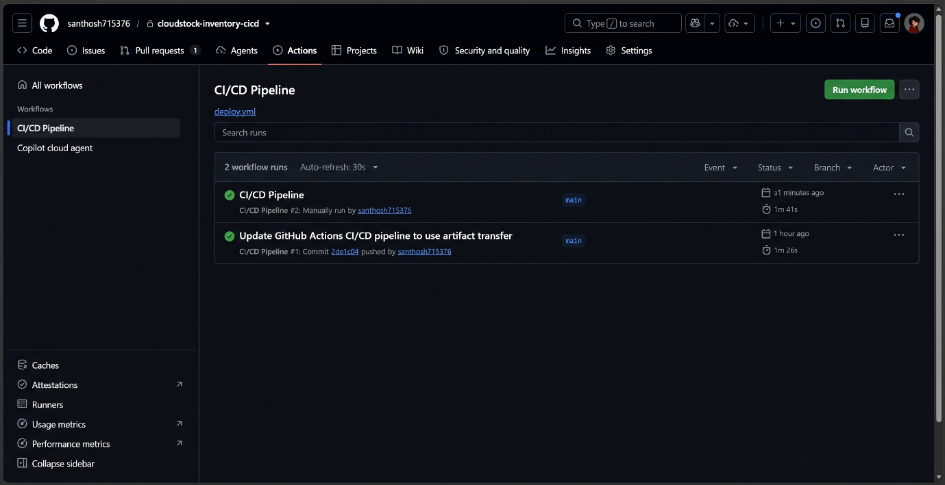

7. Placeholders to Replace
Replace every value in angle brackets with your real value before running a command.
Placeholder | Meaning
<ACCOUNT_ID> | 12-digit AWS account ID (task-def.json and workflow)
<user>/inventory-app | GitHub username and repository name
<email> | Email address that receives CloudWatch alarm notifications
<yourname> | Unique suffix for the S3 bucket name
<ECR_URL> | ECR repository URL from the Terraform outputs
<ALB_DNS> | Application Load Balancer DNS name from the Terraform outputs
<RDS_ENDPOINT> | RDS instance endpoint
<user>, <dbname> | Database user and name stored in the inv/db secret

