1. Write a Pandas program to create a line plot of the historical stock
prices of Alphabet Inc. between two specific dates.
Aim:
To create a line plot of the historical stock prices of Alphabet Inc. between two specific dates using Pandas and Matplotlib.
Algorithm
- Import the required libraries (pandas and matplotlib.pyplot).
- Read the stock price dataset (alphabet_stock.csv) using pd.read_csv().
- Convert the Date column into datetime format using pd.to_datetime().
- Specify the start date and end date for the required period.
- Filter the dataset to include only the records between the selected dates.
- Plot the Closing Price against the Date using plt.plot().
- Add the chart title, x-axis label, y-axis label, and grid.
- Display the line plot using plt.show().
Code:
import pandas as pd
import matplotlib.pyplot as plt # type: ignore

df = pd.read_csv("Csv/Lab4.csv")

df["Date"] = pd.to_datetime(df["Date"])
start_date = "2022-01-05"
end_date = "2022-01-12"

stock = df[(df["Date"] >= start_date) & (df["Date"] <= end_date)]

plt.figure(figsize=(8,5))
plt.plot(stock["Date"], stock["Close"], marker="o")

plt.title("Historical Stock Prices of Alphabet Inc.")
plt.xlabel("Date")
plt.ylabel("Closing Price ($)")
plt.grid(True)
plt.xticks(rotation=45)

plt.show()
Output:
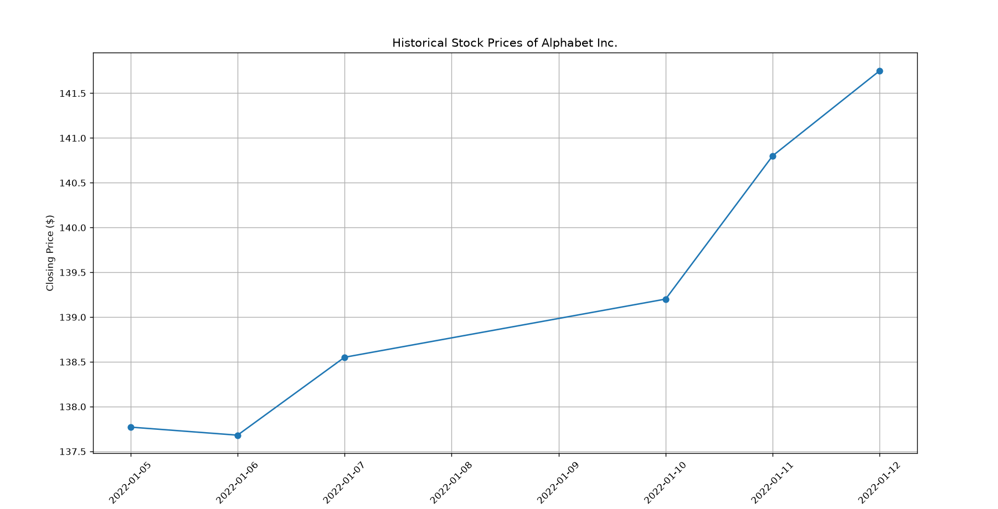

Result:
The historical stock prices of Alphabet Inc. between the specified dates were successfully filtered and displayed as a line graph using Pandas and Matplotlib. The graph clearly shows the variation in the company's closing stock prices over the selected time period.

2. Write a Pandas program to display the IDs of employees who have done two or more jobs in the past.
Aim:
To create a bar plot of the trading volume of Alphabet Inc. stock between two specific dates using Pandas and Matplotlib.
Algorithm
- Import the required libraries (pandas and matplotlib.pyplot).
- Read the stock dataset (alphabet_stock.csv) using pd.read_csv().
- Convert the Date column into datetime format using pd.to_datetime().
- Specify the start date and end date.
- Filter the records between the selected dates.
- Plot the Volume against the Date using plt.bar().
- Add the chart title, axis labels, and rotate the date labels.
- Display the bar plot using plt.show()
Code:
import pandas as pd
import matplotlib.pyplot as plt

df = pd.read_csv("Csv/Lab4.csv")

df["Date"] = pd.to_datetime(df["Date"])

start_date = "2022-01-05"
end_date = "2022-01-12"

stock = df[(df["Date"] >= start_date) & (df["Date"] <= end_date)]

plt.figure(figsize=(8,5))
plt.bar(stock["Date"].dt.strftime("%Y-%m-%d"), stock["Volume"])

plt.title("Trading Volume of Alphabet Inc.")
plt.xlabel("Date")
plt.ylabel("Trading Volume")
plt.xticks(rotation=45)

plt.show()

Output:
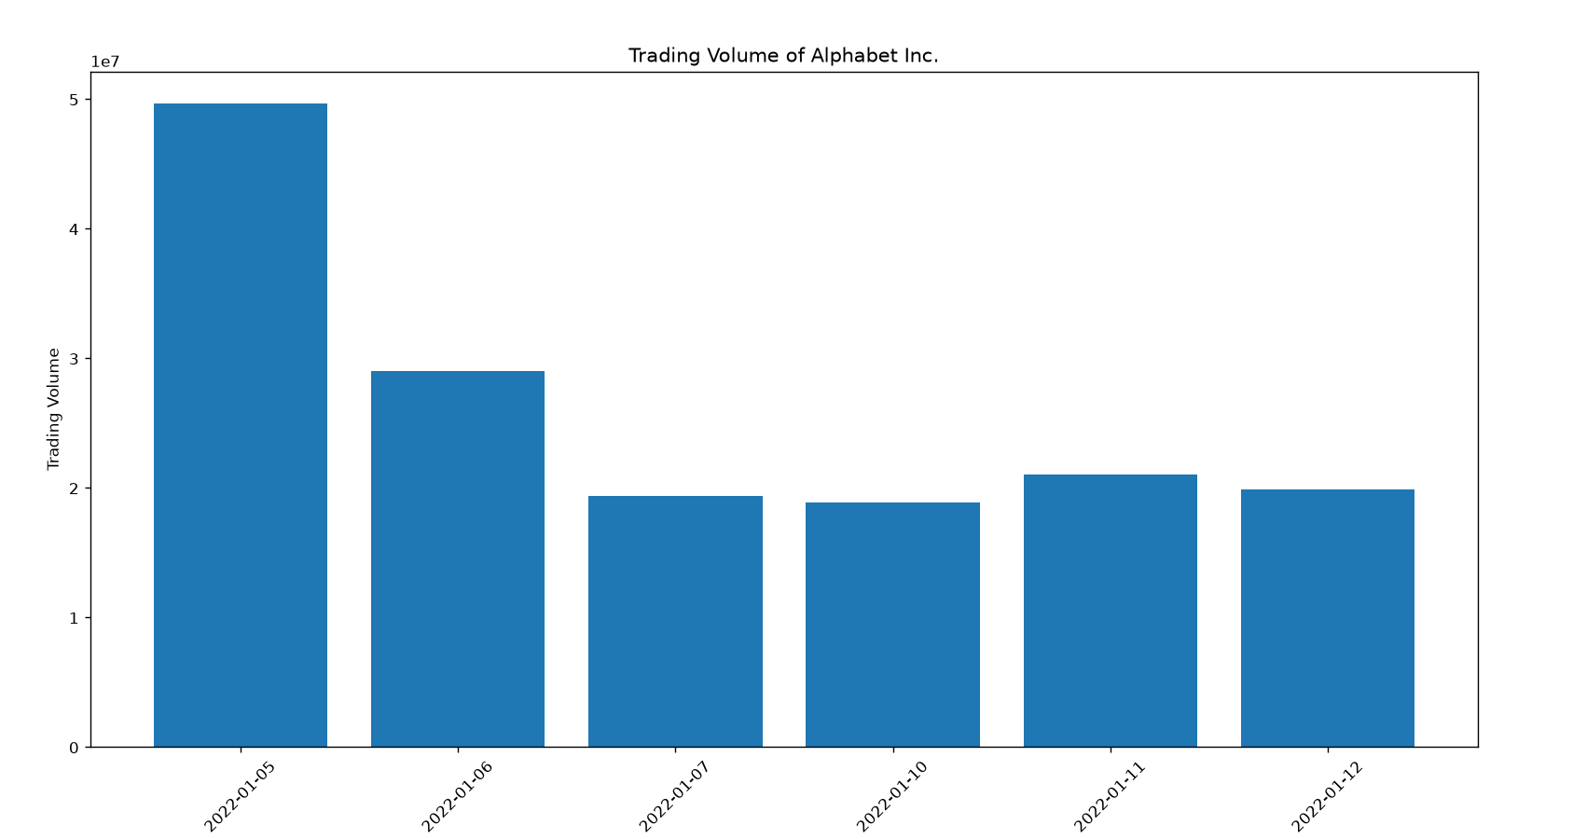

Result:
The trading volume of Alphabet Inc. stock between the specified dates was successfully filtered and displayed as a bar plot using Pandas and Matplotlib. The chart clearly represents the daily trading volume for the selected period.

