1. **Quick Sort**

public class main{

static void swap(int[] arr, int i, int j)

{

int temp = arr[i];

arr[i] = arr[j];

arr[j] = temp;

}

static int partition(int[] arr, int low, int high)

{

int pivot = arr[high];

int i = (low - 1);

for (int j = low; j <= high - 1; j++) {

if (arr[j] < pivot) {

i++;

swap(arr, i, j);

}

}

swap(arr, i + 1, high);

return (i + 1);

}

static void quickSort(int[] arr, int low, int high)

{

if (low < high) {

int pi = partition(arr, low, high);

quickSort(arr, low, pi - 1);

quickSort(arr, pi + 1, high);

}

}

public static void printArr(int[] arr)

{

for (int i = 0; i < arr.length; i++) {

System.out.print(arr[i] + " ");

}

}

public static void main(String[] args)

{

int[] arr = { 10, 7, 8, 9, 1, 5 };

int N = arr.length;

System.out.println("Array before sorting:");

printArr(arr);

quickSort(arr, 0, N - 1);

System.out.println("\nArray after sorting:");

printArr(arr);

}

}

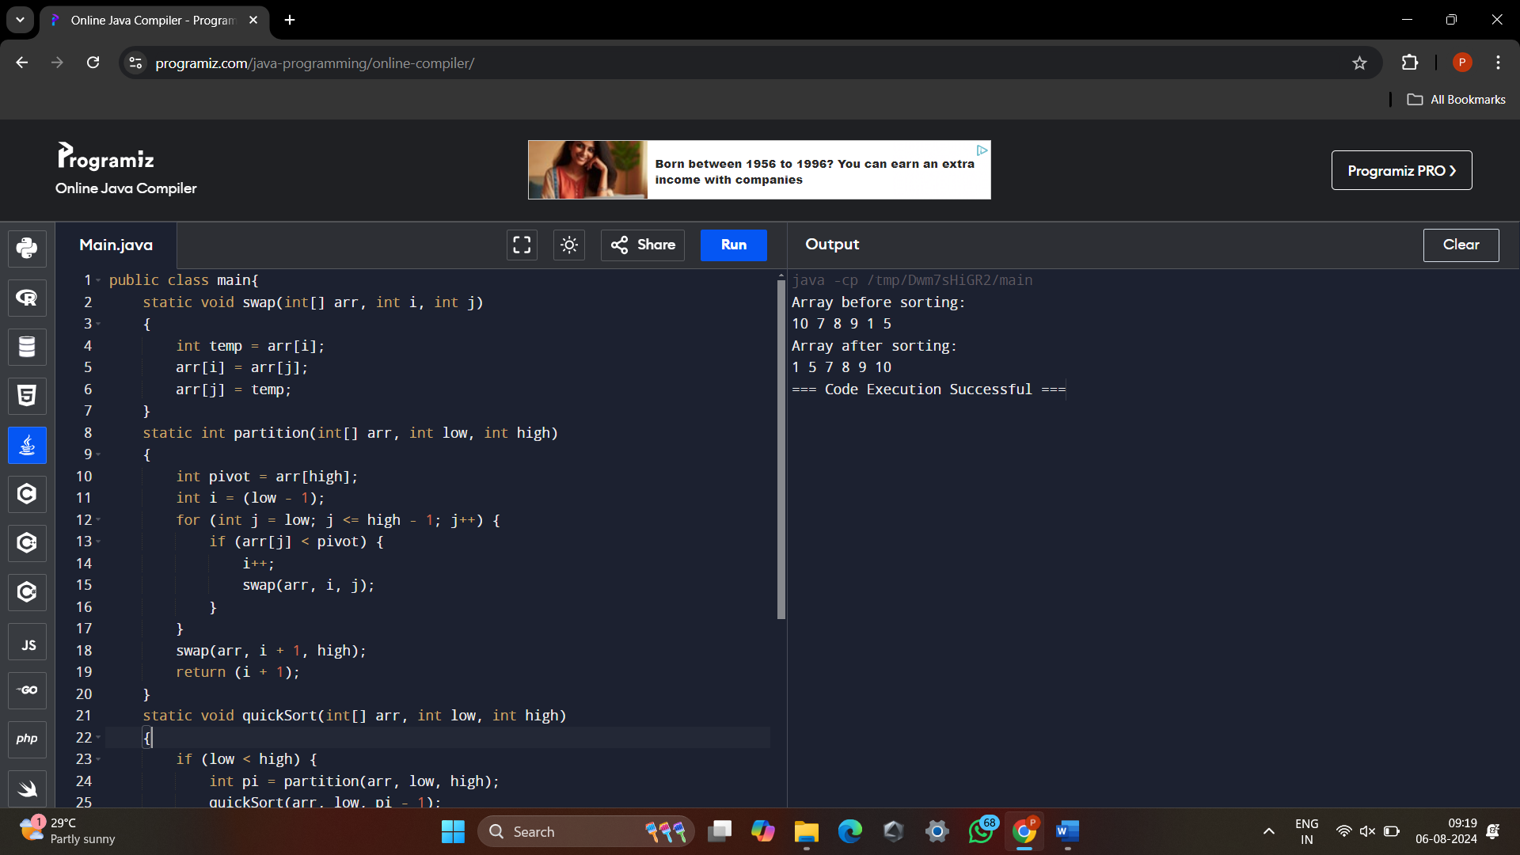

2. **Bubble Sort**

public class BubbleSort{

public static void main(String[] args){

int[] a={1,6,4,9,3};

int i,j,temp;

System.out.println("Array before Sorting: ");

for(i=0;i<a.length;i++){

System.out.print(a[i]+"\t");

}

for(i=0;i<a.length;i++){

for(j=0;j<a.length-1;j++){

if(a[j]<a[j+1]){

temp=a[j];

a[j]=a[j+1];

a[j+1]=temp;

}

}

}

System.out.println("\nArray after Sorting: ");

for(i=0;i<a.length;i++){

System.out.print(a[i]+"\t");

}

}

}

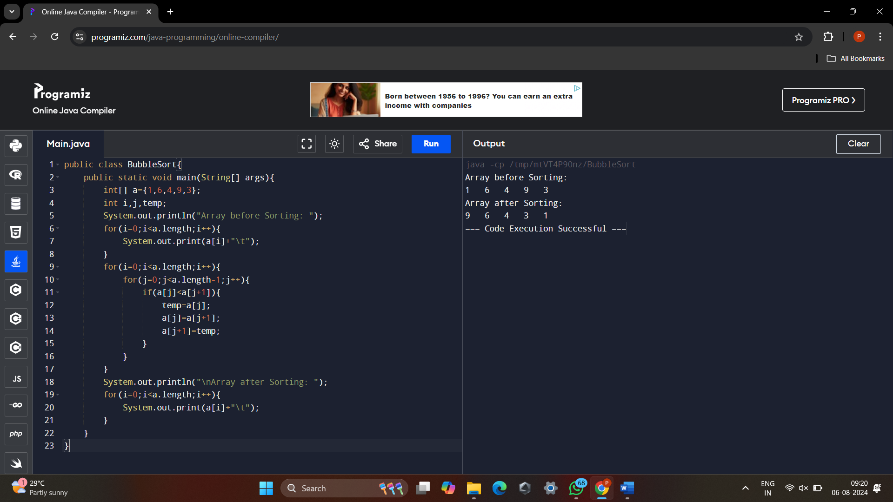

3. **Binary Search**

class BinarySearch {

int binarySearch(int a[], int low, int high, int key){

while (low <= high) {

int mid = (low + high) / 2;

if (a[mid] == key) {

return mid;

}

else if (a[mid] > key) {

high= mid - 1;

}

else {

low = mid + 1;

}

}

return -1;

}

public static void main(String args[])

{

BinarySearch obj= new BinarySearch();

int arr[] = {10,20,50,70,100};

int n = arr.length;

int key = 70;

int res = obj.binarySearch(arr, 0, n - 1, key);

System.out.println("Key is "+key);

if (res == -1)

System.out.println("Element not present");

else

System.out.println("Element found at position "+ (res+1));

}

}

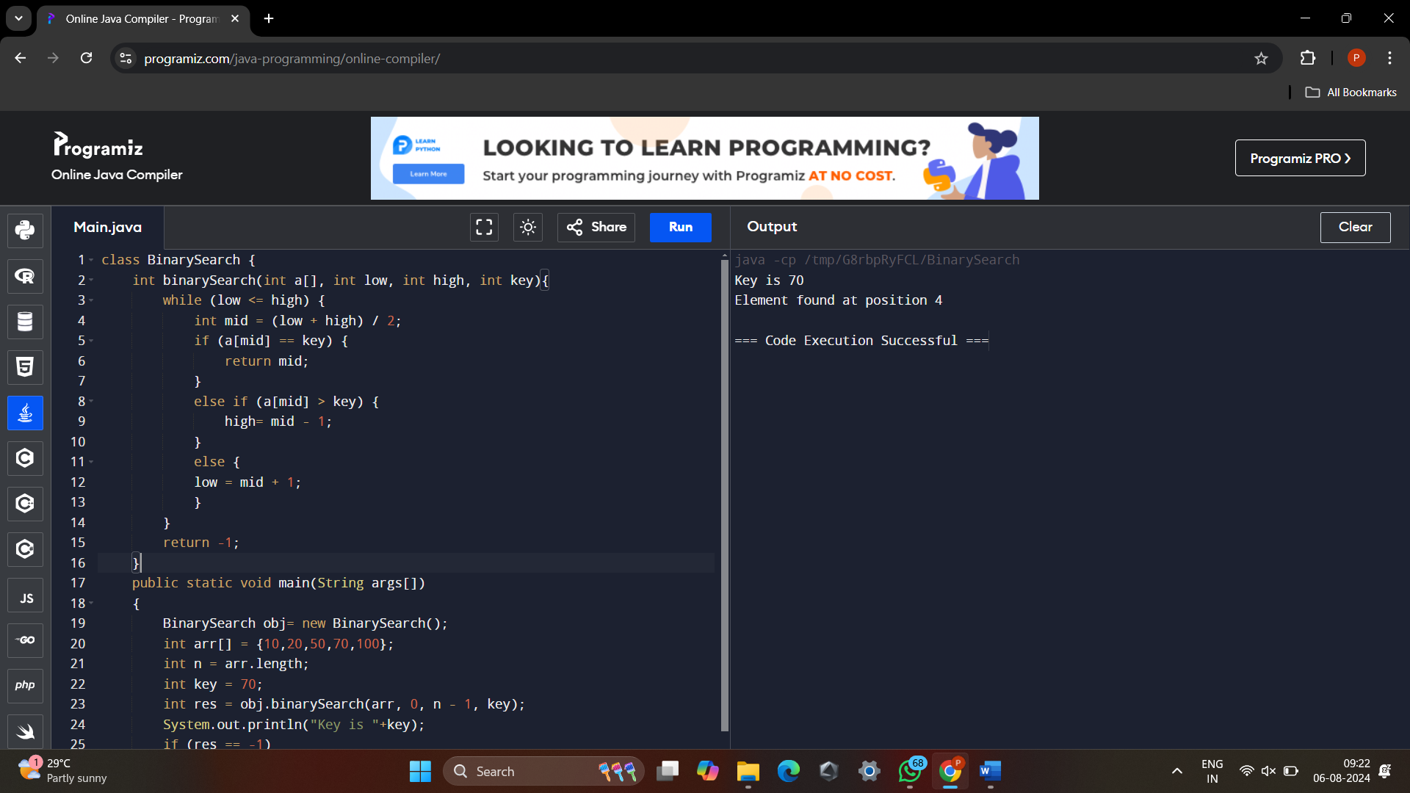

4. **Linear Search**

public class LinearSearch{

public static void main(String[] args){

int[] a={1,7,3,8,9,10};

int key=10;

int pos=-1;

int i;

for (i=0;i<a.length;i++){

if(a[i]==key){

pos=i;

}

}

if(pos>0){

System.out.println("The element is present in "+(pos+1)+" position");

}

else{

System.out.println("The element is not present in the array");

}

}

}

