**Loan Application and Approval System**

**Software Design Document  
  
Use Case Diagram**

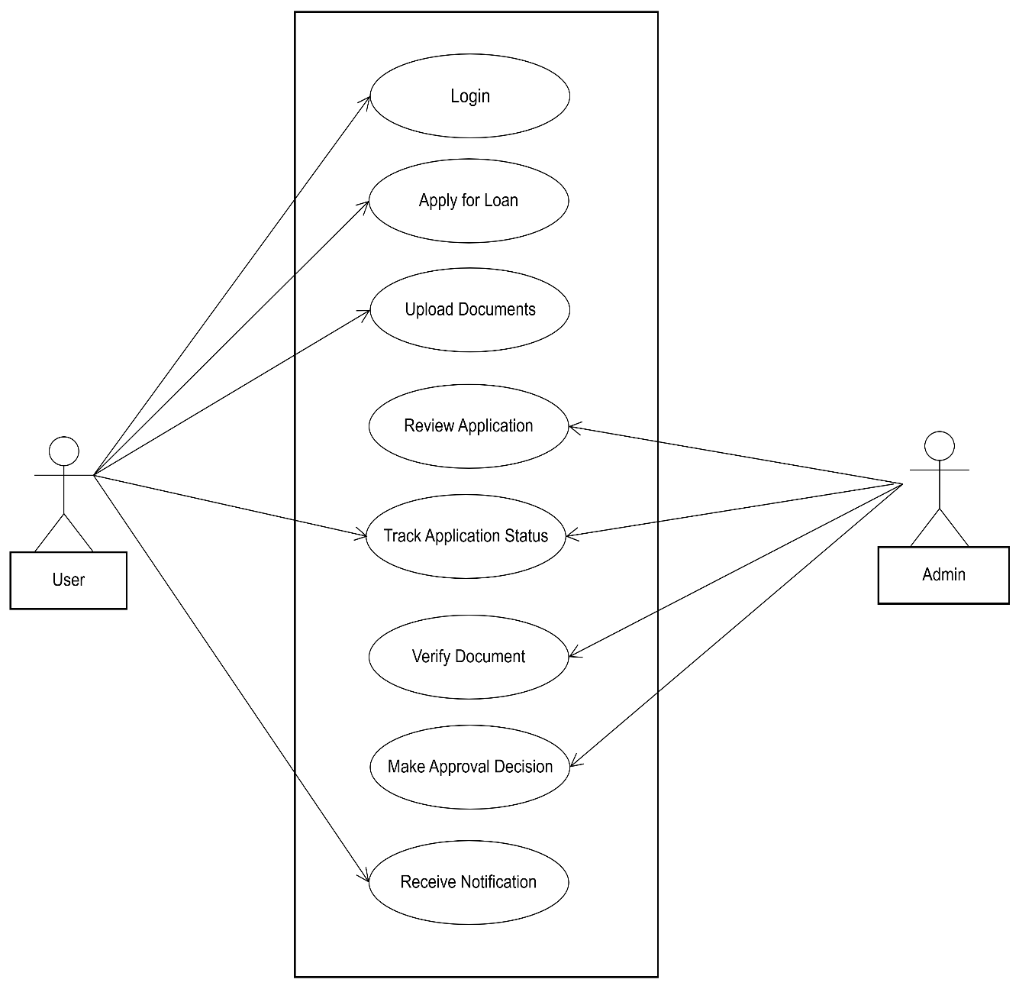

**Class Diagram**

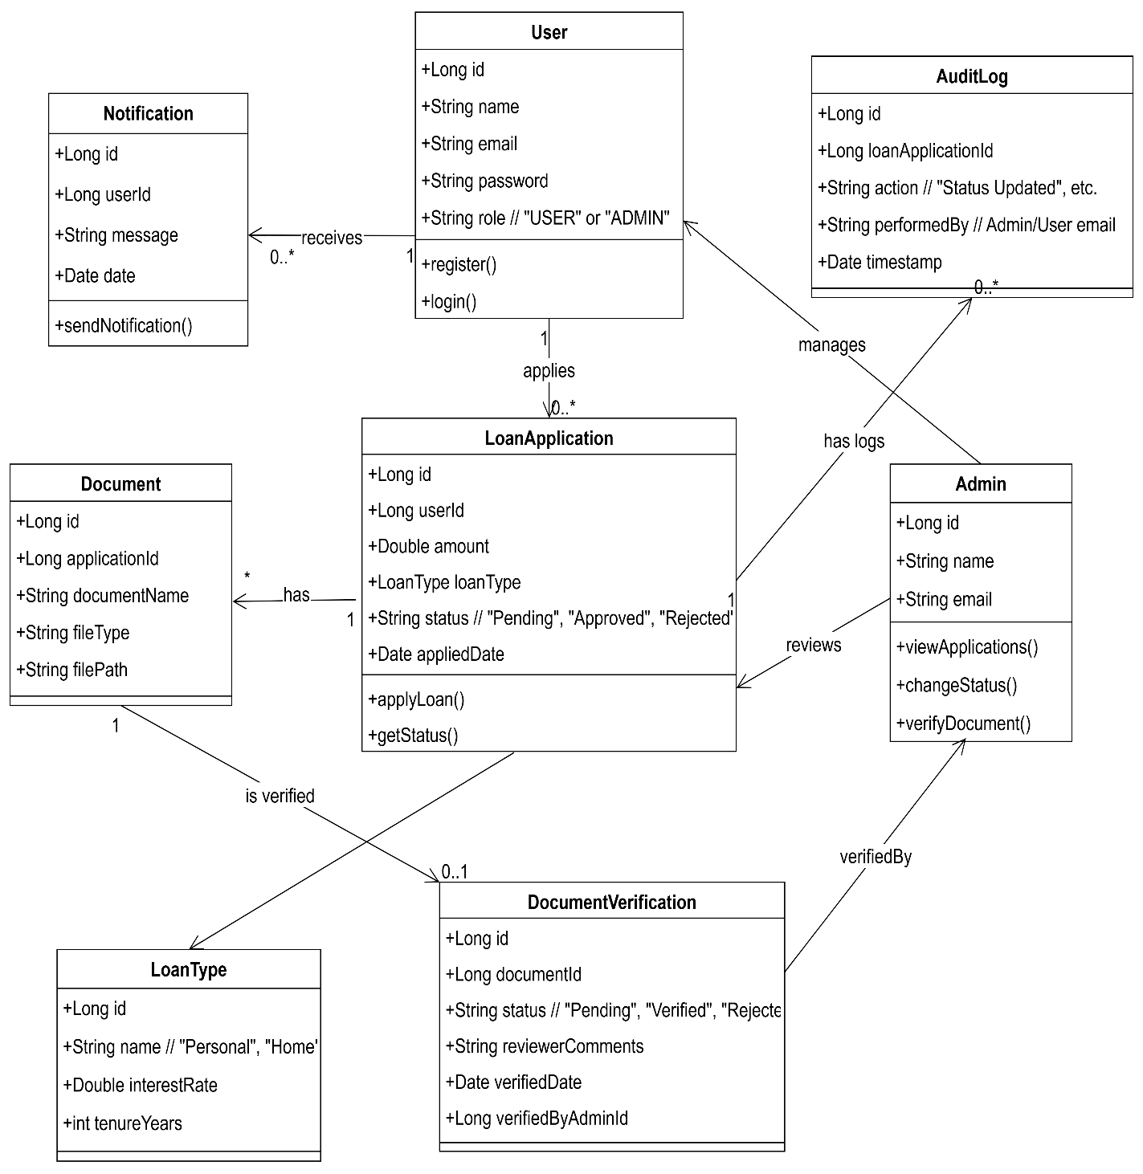

**ER Diagram**

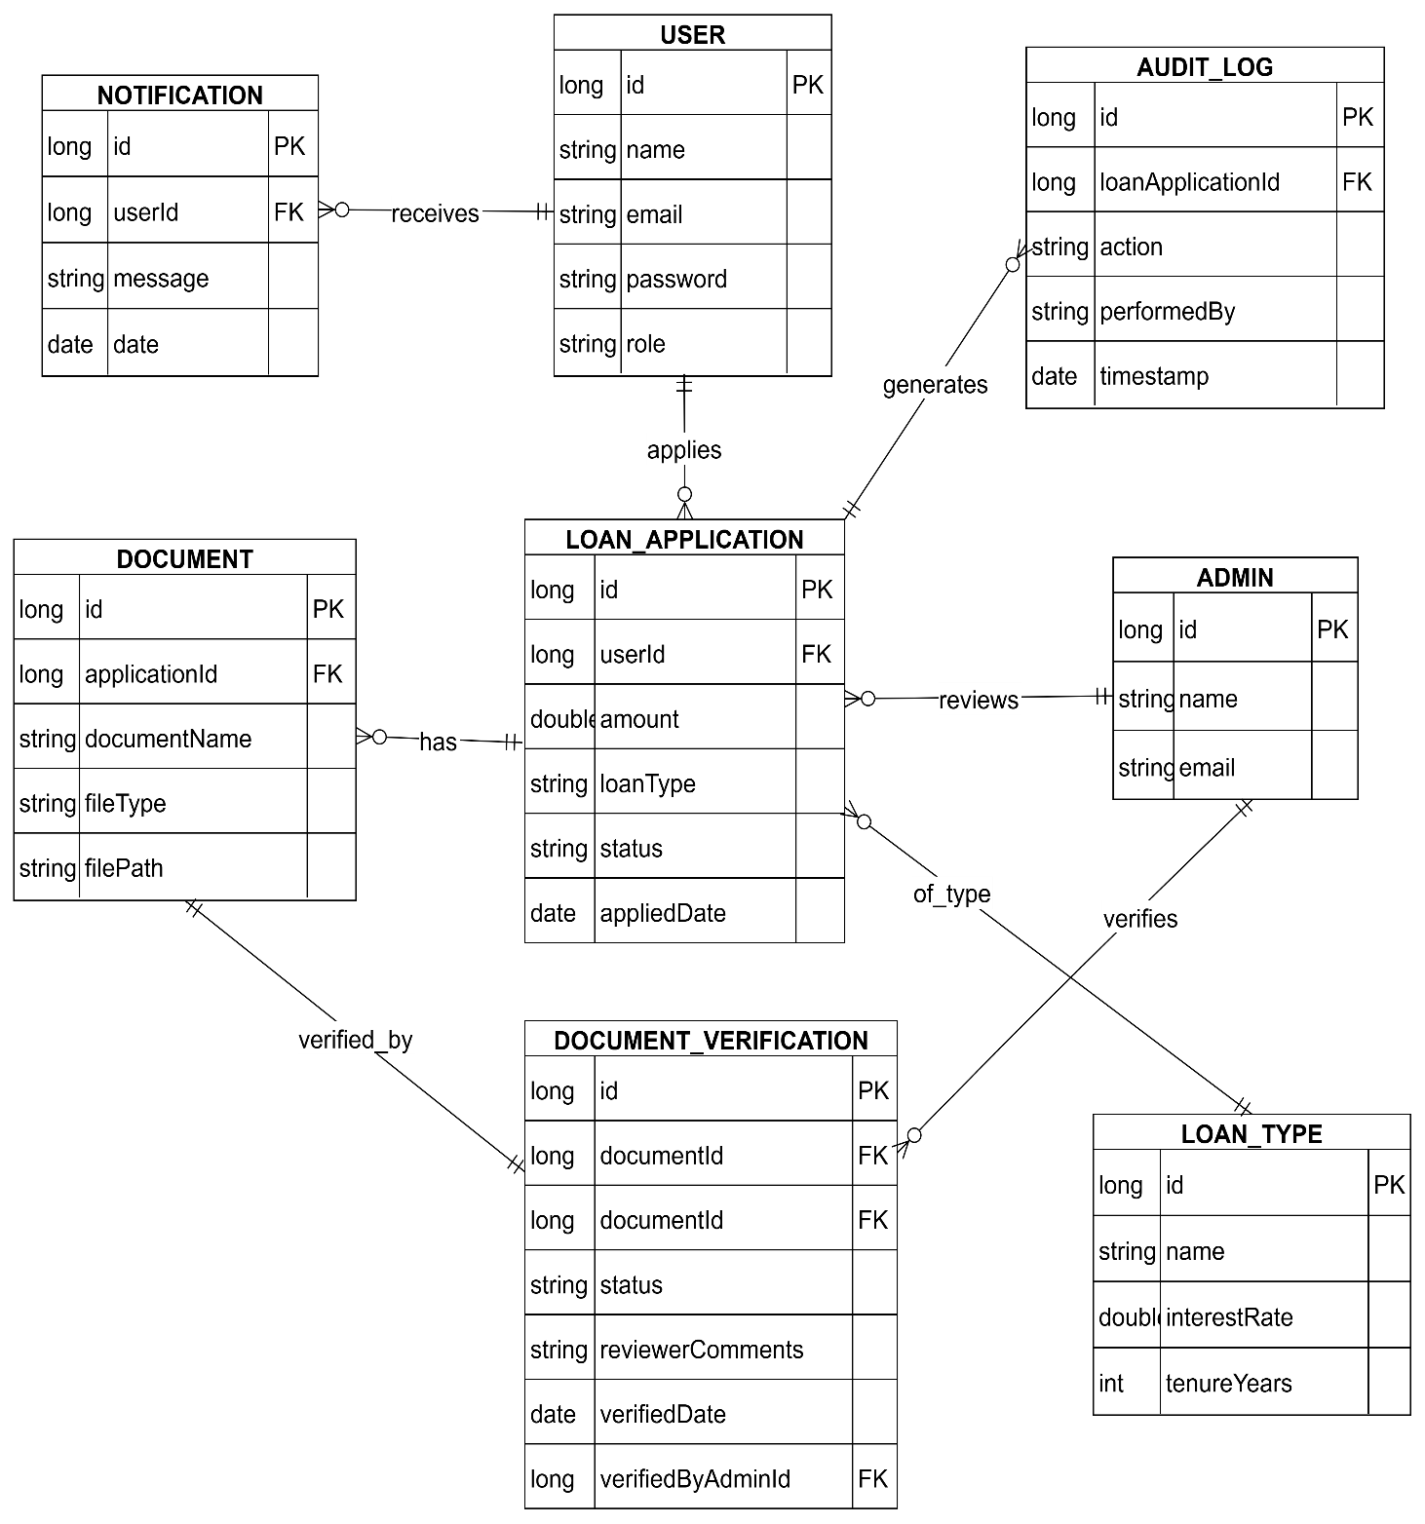

**Sequence Diagram**

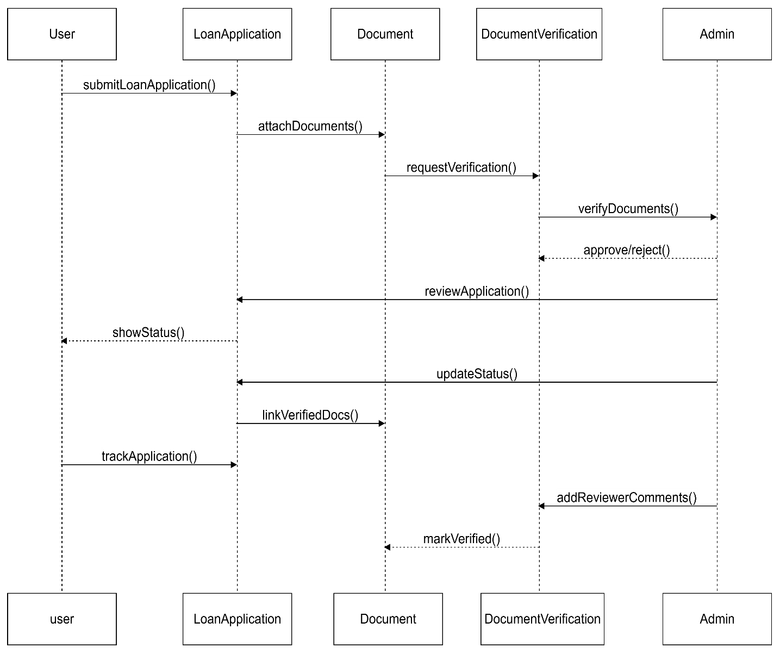

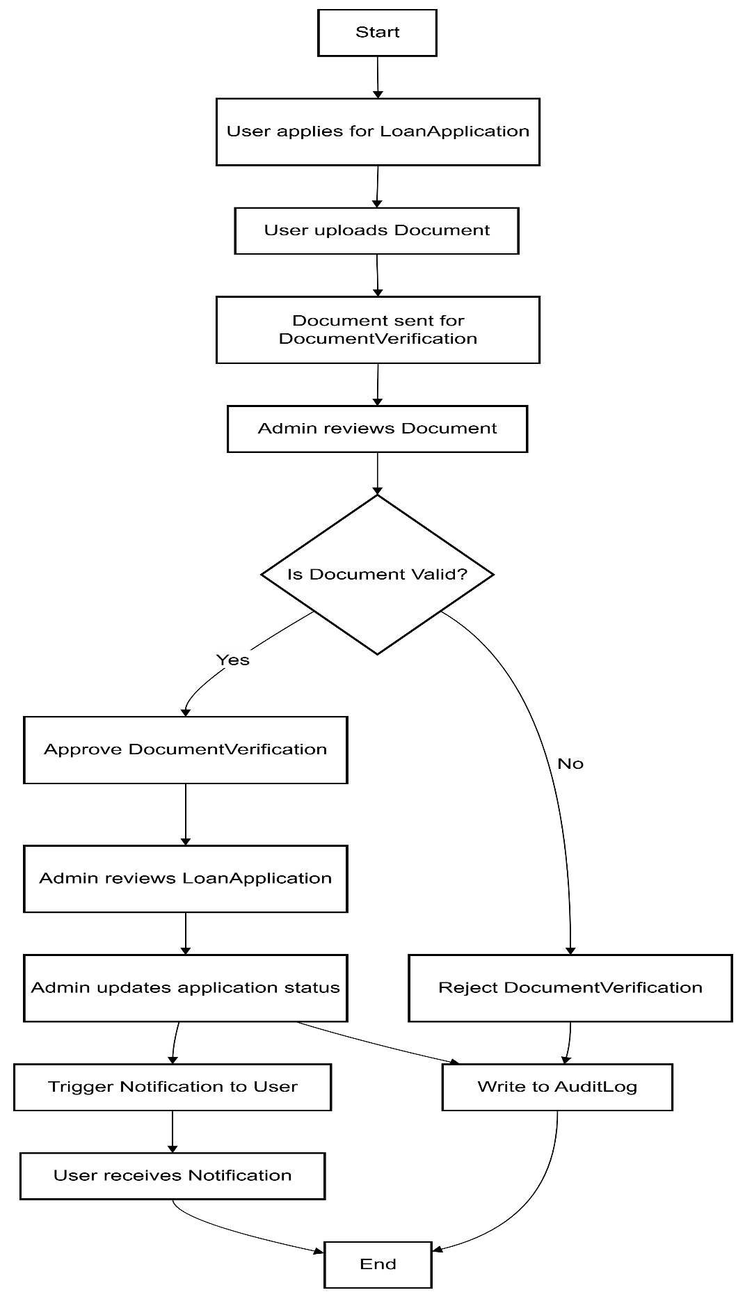**Activity Diagram**