**Loan Application and Approval System**

**Software Requirements Specification**

**1. Introduction**

This document outlines the requirements for a Loan Application and Approval System designed to streamline the end-to-end loan processing lifecycle for financial institutions.

**2. System Overview**

The system is a web and mobile-based platform that facilitates loan applications, credit assessments, document verification, approval workflows, and disbursement. The system supports multiple roles:

* **User**: Can register, login, apply for loans, and receive notifications.
* **Admin**: Manages users, reviews applications, changes loan statuses, and verifies documents.

**3. Design Considerations**

**Assumptions:**

* End-users will have internet access.
* The system integrates with external credit bureau APIs (e.g., Experian, Equifax).
* REST/SOAP interfaces are available for core banking integration.

**Constraints:**

* Must support 500+ concurrent users.
* Compliant with GDPR, PCI DSS, and applicable data protection regulations.
* Critical operations must respond within 2 seconds.

**4. System Architecture**

**Architecture Style:**

Microservices-based 3-tier architecture:

* **Presentation Layer**: React.js (Web), Native (Android/iOS)
* **Application Layer**: Java Spring Boot services:
  + User Management
  + Loan Application Processing
  + Document Verification
  + Audit Logging
* **Data Layer**:
  + PostgreSQL (Relational data)
  + MongoDB (Document data)
  + Object Storage (User-uploaded files)

**Deployment:**

* Docker + Kubernetes (Container orchestration)
* Multi-AZ for High Availability

**5. Modules & Components**

**1. User Management**

* Registration and Login
* Role-based access
* Notification sending/receiving

**2. Loan Application Processing**

* Application form submission
* Status tracking
* Associated document handling

**3. Document Verification**

* Manual and autS3:53 PMomated document validation
* Document verification status

**4. Admin Review & Approval**

* Admin reviews applications
* Status change (Pending, Approved, Rejected)
* Admin verifies documents

**5. Audit Log Management**

* Track changes to loan applications
* Record reviewer/admin actions

**6. Scope**

The system will support the following:

* User registration and authentication
* Loan application submission and status checking
* Document upload and verification
* Admin review of applications
* Notifications to users
* Audit trail of operations

**7. Functional Requirements**

**User Role (Applicant):**

* Register/Login
* Submit loan applications with documents
* Track application status
* Receive notifications

**Admin Role:**

* View and review loan applications
* Change application status
* Verify document authenticity
* Access audit logs

**Loan Application:**

* Attributes: ID, userId, amount, loanType, status, appliedDate
* Associations: has documents, is reviewed by admin, triggers audit logs

**Document:**

* Attributes: ID, applicationId, name, filePath, fileType
* Has one-to-one relationship with DocumentVerification

**DocumentVerification:**

* Attributes: ID, documentId, status, reviewerComments, verifiedDate, verifiedByAdminId

**LoanType:**

* Attributes: ID, name, interestRate, tenureYears

**Notification:**

* Attributes: ID, userId, message, date
* Sent to user upon status updates or alerts

**AuditLog:**

* Attributes: ID, loanApplicationId, action, performedBy, timestamp

**8. Non-Functional Requirements**

* **Performance**: Supports 500 concurrent users with < 2 sec response time
* **Security**:
  + AES-256 encryption for data at rest
  + TLS 1.2+ for data in transit
* **Availability**: 99.9% uptime target
* **Auditability**: Immutable logging for all system operations
* **Compliance**: GDPR, PCI DSS, Local regulations

**Software Design Document  
  
Use Case Diagram**

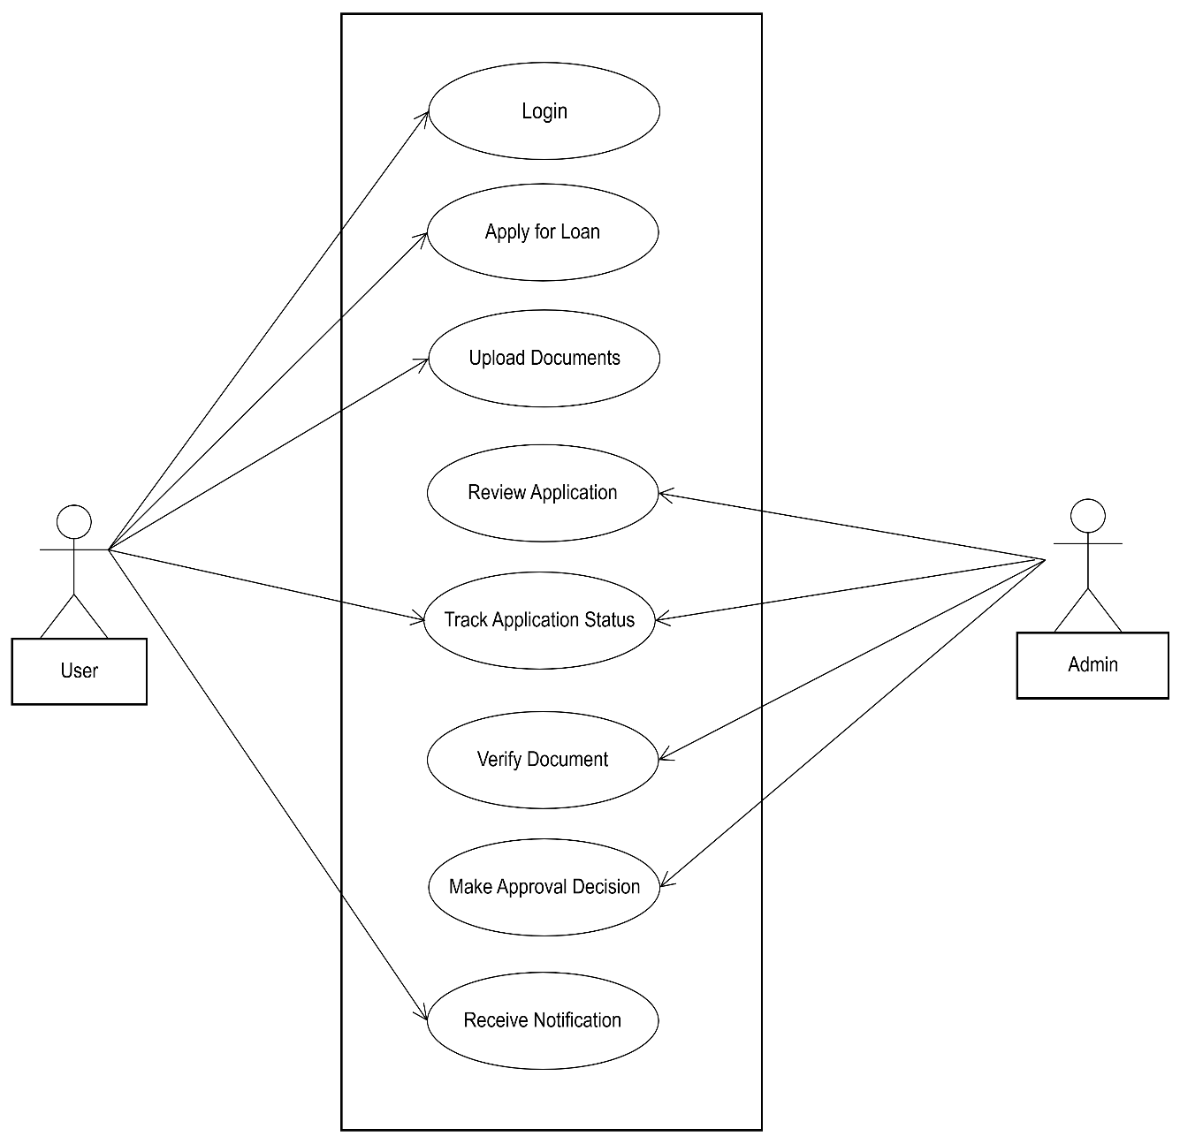

**ER Diagram**

