**Char vs Byte stream**

Byte stream access a file byte by byte. Only max of 8 bits of information is processed as a single character even it is larger than 8 bits.

Character stream can access a file with 8 or 16 according to the encoding. It automatically wraps the bytes to character based on the encoding. Now-a-days most of the documents use 16 bit encoding and character stream is used to access these texts.

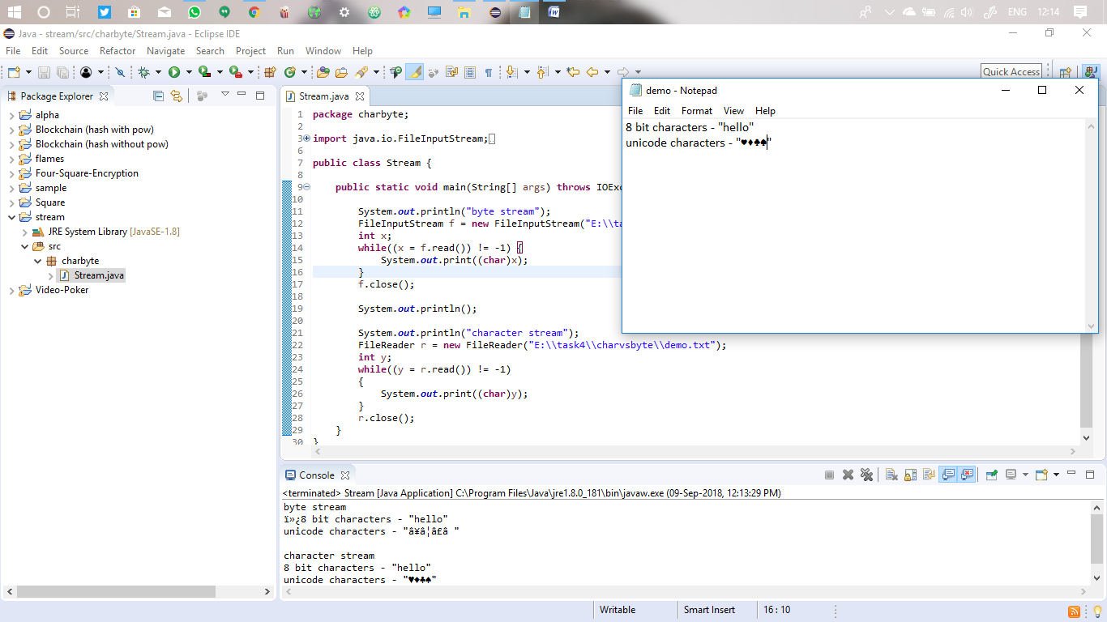

**Char datatype**

Java uses Unicode to represent char datatype. Therefore the size of character is 16 bits fixed. They do not change in size in different operating system and hence it is platform independent. The char in C is just 8 bit integer datatype from 0 to 127, so that it can contain only 128 symbols. We can’t include other language letters or special symbols. To avoid this Unicode encoding was started in which character contains 16 bits from 0 to 216-1. Now we can have 216 symbols. JVM uses this encoding and the size of char is 2 bytes.

**Character stream to byte stream**

OutputStreamWriter is used to convert the character stream to byte stream. This converts the Unicode characters to 8 bit wrapped character set. Similarly InputStreamReader is used to convert from byte stream to character stream.

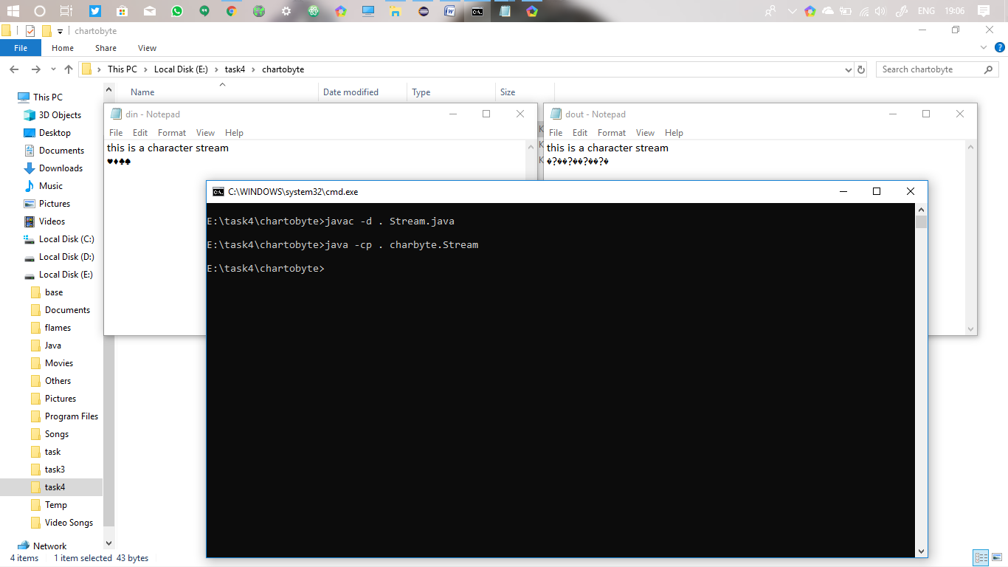

**Writing string to a file**

A string can be written to a file using FileOutputStream. But this accepts only byte of type int. So we need to convert a string to byte before we write this to a file.

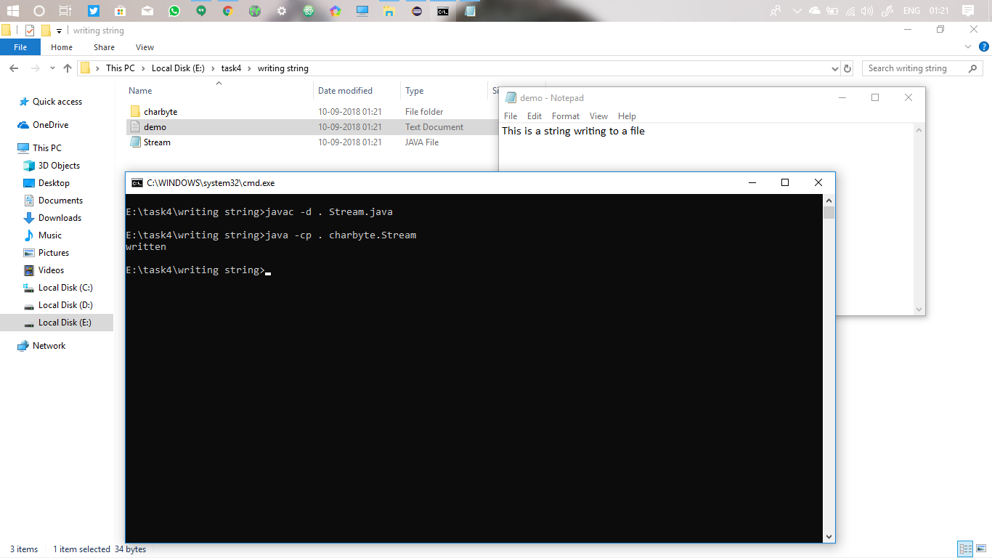

**Printing stderr to file**

PrintStream is used to print anything to a file. Here we can pass the FileOutputStream object to this stream and we can drop these output and errors to these files.

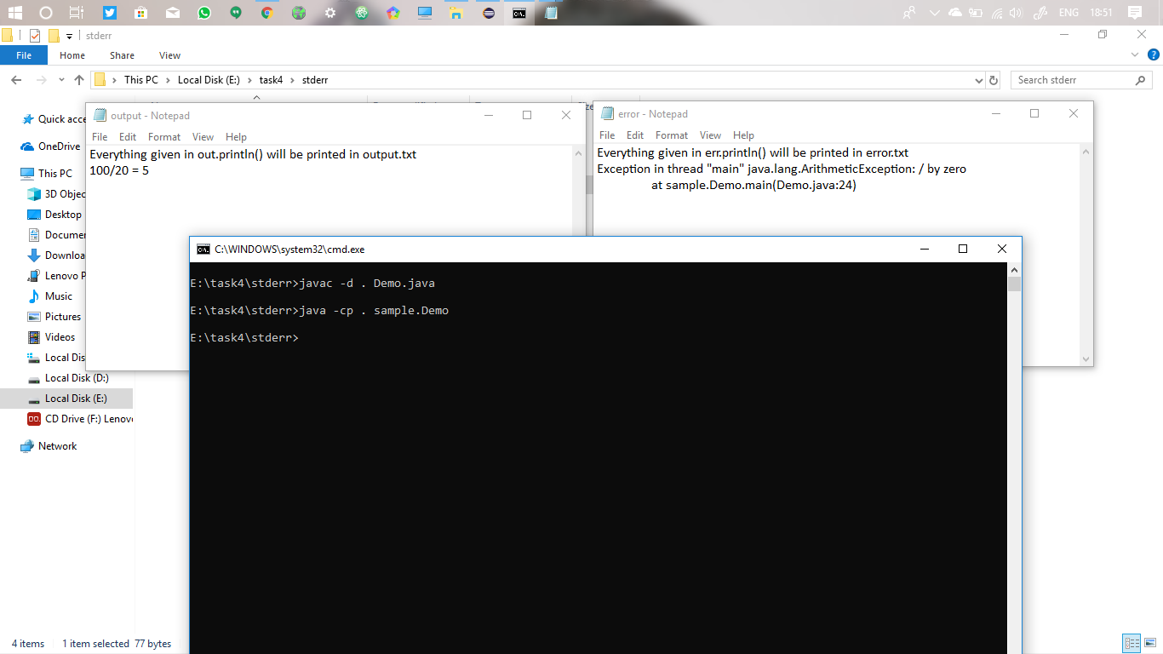

**Read a file**

FileInputStream is used to read a file as byte and InputStreamReader converts byte to character. Thus we can print the read file to the console.

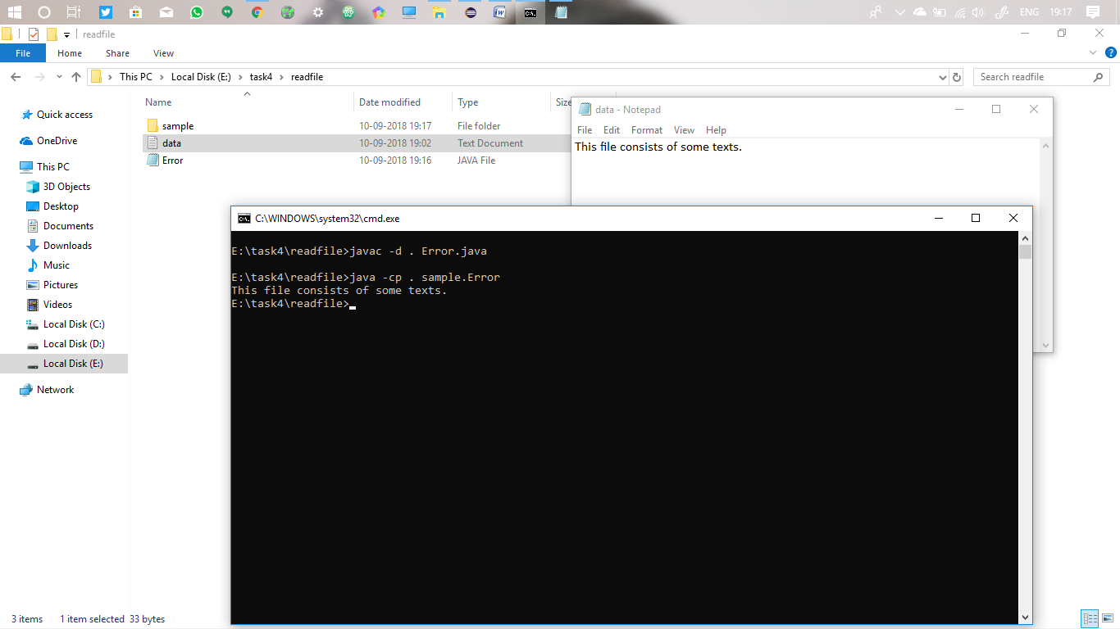

**Student database**

Here number of students marks of different classes are stored in a folder and it is accessed one by one from File options. It is then read from the file using BufferedReader and it is split according to our idea and it is stored in separate variable.

Now the age is checked whether it passes the condition and then stored to a file using FileOutputStream and PrintStream.

