**Title of the Paper (Times New Roman 16, Bold, Capitalised each Word, Line Spacing 1.0, Centre)**

Author1, Author2*) and Author3 (Times New Roman 13, Line Spacing 1, Centre)

*1Affiliation, Address, (Times New Roman, 11, Italic, Line Spacing 1, Centre)*

*2Affiliation, Address, (Times New Roman, 11, Italic, Line Spacing 1, Centre)*

*(*Corresponding Author: abc@cimfr.nic.in)*

**ABSTRACT (**Times New Roman 12, Upper Case, Line Spacing 1, Centre)

To cover main object, scope and findings of the work within 300 words. (Times New Roman, 11Pt, Line Spacing 1, Justified)

*Keywords: maximum five words separated by commas* (*Times New Roman 11, Italic, Line Spacing 1, Justified)*

# INTRODUCTION (HEADING: TIMES NEW ROMAN 12PT, UPPERCASE, BOLD, LINE SPACING 1, JUSTIFIED)

Margin of the paper is **Top 25.4mm (1 inch), bottom 25.4mm (1 inch), right 25.4mm (1 inch),left 25.4mm (1 inch)and Gutter size 12.7mm (0.5 inch), Gutter position in left.** Main text should be in **black, times new roman 12pt,line spacing 1, justified.**Authors are responsible for ensuring the accuracy of all information contained in their manuscripts (e.g., proper names of organizations, data and findings, references, etc.). Manuscripts must be prepared in proper English. SI units or acceptable metric equivalents must be used throughout.

One blank line between two paragraphs (by putting enter with before and after 0pt, line spacing 1) is maintained throughout the manuscript. The manuscript should be preferably within 3500 words.

# METHODOLOGY (HEADING: TIMES NEW ROMAN, 12PT, UPPERCASE BOLD, LINE SPACING 1, JUSTIFIED)

Main text should be in times new roman 12pt, line spacing 1, justified. Authors are responsible for ensuring the accuracy of all information contained in their manuscripts (e.g., proper names of organizations, data and findings, references, etc.). Manuscripts must be prepared in proper English. SI units or acceptable metric equivalents must be used throughout the manuscript.

One blank line between two paragraphs (by putting enter with “before and after 0pt, line spacing 1”) is maintained throughout the manuscript.

## First level sub-heading of the manuscript (Times New Roman 12pt, Sentence Case, Bold Line Spacing 1)

Main text should be in Times New Roman 12ptLine Spacing 1, Justified.

One blank line between two paragraphs ((by putting enter with “before and after 0pt, line spacing 1”) is maintained throughout the manuscript.

### *Second level sub-heading of the manuscript (Times New Roman 12pt, Sentence Case, Line Spacing 1, Bold, Italic)*

Main text should be in Times New Roman 12pt Line Spacing 1, Justified.

One spaceblank line between two paragraphs ((by putting enter with “before and after 0pt, line spacing 1”) is maintained throughout the manuscript.

#### Third level sub-heading of the manuscript (Times New Roman 12pt, Sentence Case, Line Spacing 1, Italic)

Main text should be in Times New Roman 12pt Line Spacing 1, Justified.

One blank line between two paragraphs ((by putting enter with “before and after 0pt, Line Spacing 1”) is maintained throughout the manuscript.

# TABLE

In the text, tables must be inserted as close to the first point of reference as possible. Please leave oneblank line (by putting enter with before and after 0pt, line spacing 1) above and below the table caption. Captions must be centered above tables. Tables and table captions must be typeset in 12pt Times New Roman font with spacing of before and after 0pt, line spacing 1.

Also leave oneblank line (by putting enter with before and after 0pt, line spacing 1) below the table. Tables must be cited sequentially in the text as Table 1.

Table 1: Geo-mining parameters of the study mine. (Times new roman 12pt line spacing 1, centrally aligned)

|  |  |  |
| --- | --- | --- |
| 1 | 3 | 5 |
| 58 | 48 | 52 |
| 12 | 45 | 78 |

The text should be started after leaving one blank line (by putting enter with before and after 0pt, line spacing 1) below the table.

# FIGURE

The term “figure” denotes graphical representations including charts, graphs, drawings, photographs, etc. Figures must be inserted as close as possible to their first reference. Figures must be numbered consecutively and must have descriptive titles placed just below them. Figures should fit within the type area. Paste copies of figures; photographs etc. at the required size onto the typescript where you want them to appear in the text. Do not place them sideways on a page. Photograph/figures should have good contrast. All texts in the figure should be Times new roman, 12 pt. Figure captions must be typeset in 12pt Times New Roman.

Please leave one blank line (by putting enter with before and after 0pt, line spacing 1) between the figure and the main text. Figure should be centrally aligned. Also leave one blank line (by putting enter with before and after 0pt, line spacing 1) between figure and its caption. Figures must be cited sequentially in the text as Figure 1.

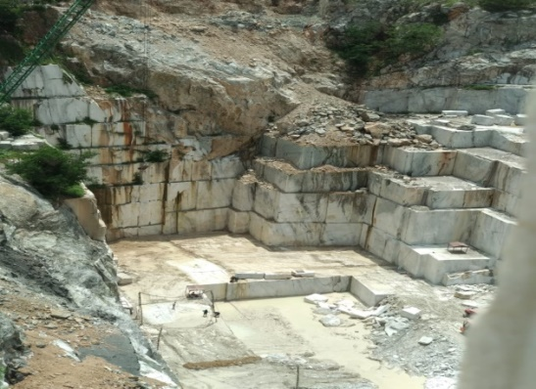

Figure 1: Opencast working in the marble quarry.

# EQUATIONS

Equations displayed in your paper should be numbered sequentially, with an equation centered in the middle of a page, and its number set flush to the right edge of the page and enclosed in parentheses as shown below:



In the main text of the paper, equations may be abbreviated in forms such as “Eq. (1).”

# REFERENCES

The references in the text must be cited by following ways:

(Das and Mandal, 2019) for two authors and (Das et al., 2019) for more than two authors.In the text.the citations can be as follows:

As discussed by Das et al. (2019)

In the list of references, the citations should be listed in alphabetical order. References must be in 10pt. Times New Roman, line spacing 1.

**For journal article (APA format of referencing should be followed.)**

1. Das, A. J., Mandal, P. K., Paul, P. S., Sinha, R. K., &Tewari, S. (2019). Assessment of the Strength of Inclined Coal Pillars through Numerical Modelling based on the Ubiquitous Joint Model. *Rock Mechanics and Rock Engineering*, *52*(10), 3691-3717.

**For book**

1. Pietruszczak, S. (2010). Fundamentals of plasticity in geomechanics. Boca Raton, 4th ed. FL: CRC Press, 580p.
2. Jaeger, J. C., Cook, N. G., & Zimmerman, R. (2009). Fundamentals of rock mechanics. 1st ed.John Wiley & Sons, 489p.

**For article published in the proceedings of seminar/conference**

1. Das, A. J., Mandal, P. K. & Kushwaha, A. (2017). Effect of Fault on the Stability of Workings during Underground Extraction of Coal. *In Proceedings of the International Conference on NexGen Technologies for Mining and Fuel Industries (NxGnMiFu-2017)*, 15-18 Feb., New Delhi, India, pp. 155-164.