2.

create database assignment5;

use assignment5;

/* Question 2*/

create table employee (empid int(4), salary int(10));

insert into employee value(1,100);

insert into employee value(2,200);

insert into employee value(3,300);

Select * from employee;

Select max(salary) as Secondhighestsalary from Employee where Salary not in (select Max(Salary) from Employee);

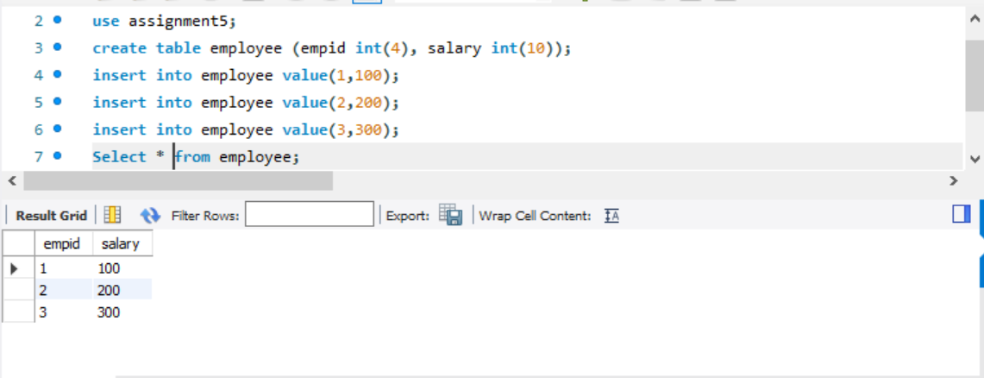

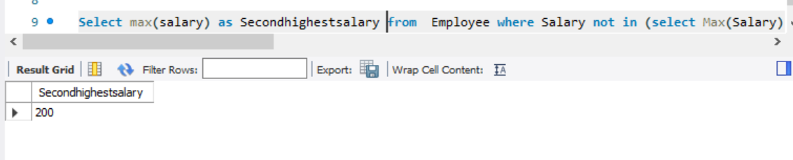

3. /* Question 3*/

Create table Customers(id int(4) primary key, name varchar(10));

create table Orders(id int(4), custid int(4),foreign key(id) references Customers(id));

select * from orders;

insert into Customers values(1,'Joe'),(2,'Henry'),(3,'Sam'),(4,'Max');

select * from Customers;

insert into orders values(1,3),(2,1);

select name as Customer_Name from Customers where id not in (select custid from orders);

select name as Cust_Name from Customers where not exists(select 1 from orders where Customers.id = orders.custid);

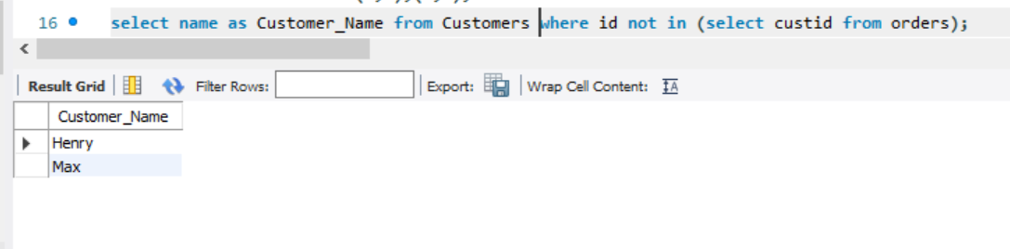

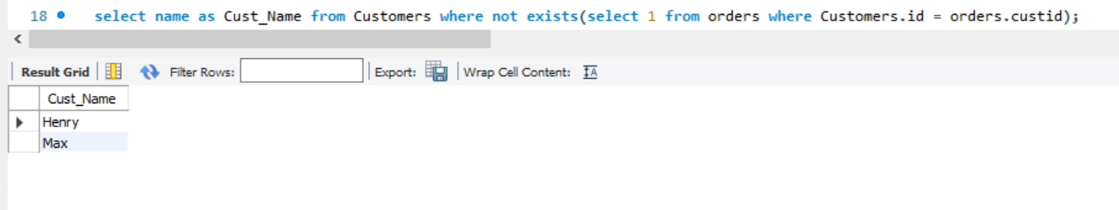

4. /* Question 4*/

Create table Person(Personid int(4) primary key, Firstname varchar(10), Lastname varchar(10));

desc Person;

create table Address(Addressid int(10) primary key , Pid int(4),City Varchar(10), State varchar(10), foreign key (pid) references Person(personid));

insert into Person values(123,'Santhu','Veera'),(234,'Deepu','Veera'),(456,'Naga','Deepthi');

insert into Address values(36316, 123, 'Tampa', 'Florida'),(82712,234,'Phoenix','Arizona'),(72713,456,'Dallas','Texas');

Select * from Person;

Select * from Address;

select Person.FirstName, Person.LastName, Address.City, Address.State from

Person left join Address on Person.Personid = Address.Pid;

drop table Address;

