February 12th,2021

SQL : Structured Query Language—language which is used to storing, manipulating and retrieving data stored in relational database.

* MS SQL Server using T-SQL,
* Oracle using PL/SQL,
* MS Access version of SQL is called JET SQL

SQL Architecture:

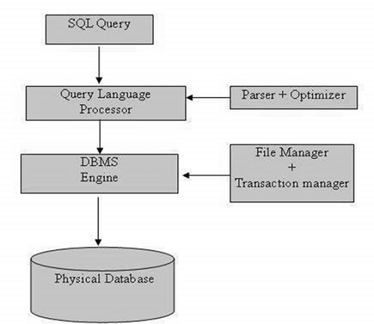

DDL(Data Definition Language)

* Create – used to create table
* Alter – used to modify the columns in the table.
* Drop – used to delete entire table

DML(Data Manipulation Language)

* Insert – create a record in the table
* Update – modifies the records
* Delete – delete records
* Select – retrieves certain records from one or more tables.

DCL(Data Control Language)

* Grant – gives privileges to user.
* Revoke -- Takes back privileges granted from user.

A NULL value in a table is a value in a field that appears to be blank, which means a field with a NULL value is a field with no value.

SQL Constraints:

Constraints are the rules enforced on data columns on a table. These are used to limit the type of data that can go into a table. This ensures the accuracy and reliability of the data in the database.

* NOT NULL – it doesn’t allow null values but allows duplicate values.
* Unique – it doesn’t allow duplicates, but it allows null values
* Primary Key – combination of unique and not null. (each row records in the table is unique and doesn’t allow null values).
* Foreign Key – Uniquely identifies a record in another database table.
* Check – ensures that all values in a column satisfy certain conditions
* Index – used to create and retrieve database