COLLECTIONS:
- is a framework that provides an architecture to store and manipulate a group of objects.
- Used to perform operations on data such as searching, sorting, insertion, manipulation, and deletion.
- Provides many interfaces – SET, List, Queue, Deque
- Classes like ArrayList, Vector, LinkedList, PriorityQueue, Hash Set, Linked HashSet, Tree Set.
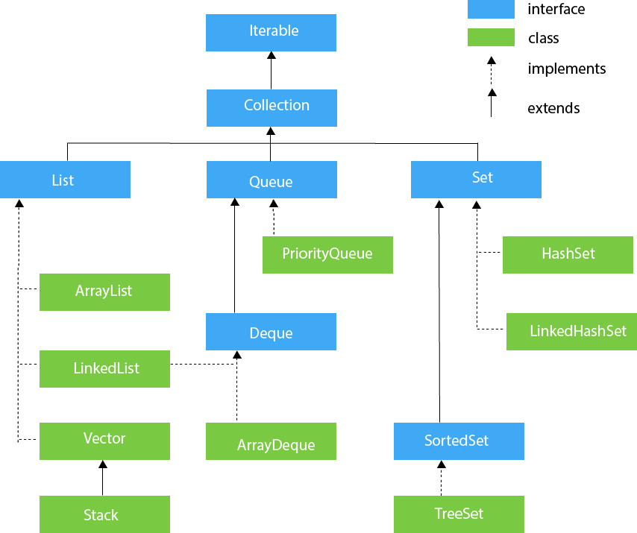
- ITERATOR INTERFACE provides the facility of iterating the elements in a forward direction only.
- Methods:
  - Public boolean next() – it returns true if the iterator has more elements otherwise it returns false.
  - Public Object next()- it returns the element and moves the cursor pointer to the next element.
  - Public void remove()-it removes the last elements returned by the iterator.
- Iterable Interface is the root interface for all the collection classes. It contains only one abstract method (Iterator< T> iterator())
- The Collection Interfaces is the interface that is implemented by all the classes in the framework. It declares the method that every collection will have.
- LIST INTERFACE is the child interface of the Collection interface. It inhibits a list type data structure ( Which stores data in an ordered collection of objects). It has duplicate Values.
  - List<Datatype> name = new ArrayList();
  - List<Datatype> name = new LinkedList();
  - List<Datatype> name = new Vector();
  - List<Datatype> name = new Stack();
    - The list provides the facility to maintain the ordered collection. Follows indexed based methods to insert, update, delete and search the elements.

- ARRAY LIST:
  - Maintains insertion order and is non-Synchronized.
  - Uses a dynamic array to store, it is like to size limit.
  - Allows duplicate elements of different data types.
  - Data can be randomly accessed, works on an index basis.
  - ArrayList inherits AbstractList class and implements the List interface.
  - Manipulation is a little bit slower than Linked List because a lot of shifting is required if an element is removed from the array.
    - public class ArrayList<E> extends AbstractList<E> implements List<E>, RandomAccess, Cloneable, Serializable
  - Array List non-generic elements
    - ArrayList list = new ArrayList();
  - Array List Generic Elements
    - ArrayList<String> List = new ArrayList<String>();

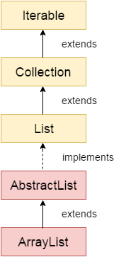
- LINKEDLIST:
  - Maintains insertion order and is non-Synchronized.
  - Uses a doubly-linked list to store data, provides a linked list data structure.
  - Allows duplicate elements.
  - Manipulation is faster as no shifting is required.
  - LinkedList class extends AbstractSequentialList class and implements List and Deque interfaces.
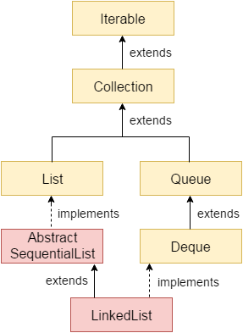
- VECTOR:
  - Similar to array list but it is synchronized
  - Dynamic array to store the data elements.
- STACK:
  - Subclass of the vector(it contains all methods of vector class).
  - Implements Last in first out data structure.
- QUEUE INTERFACE:
  - Maintains First in first out.
  - Defined as an ordered list that is used to hold the elements which are about to process.
  - Classes like Priority Queue, Deque, and Array Deque
    - Queue<String> name = new PriorityQueue();
    - Queue<String> name = new ArrayDeque();
- PRIORITY QUEUE:
  - Holds the elements or objects which are to be processed by their priorities.
  - Doesn’t allow null values to be stored in the queue.
- DEQUE:
  - The double-ended queue which enables operation from both ends(Can remove the element and add elements from both sides)
    - Deque name = new ArrayDeque();
- ARRAY DEQUE:
  - Implements deque interface. We can delete elements from both ends.
  - Faster than ArrayList and stack.
- SET INTERFACE:
  - Package – java.util
  - Represents the unordered set of elements which doesn’t allow us to store the duplicate items.
  - Can store at most one null value in the Set.
  - Implemented by HashSet, LinkedHashSet, and Tree Set.
    - Set<datatype> name = new HashSet<datatype>();
    - Set<datatype> name = new LinkedHashSet<datatype>();
    - Set<datatype> name = new TreeSet<datatype>();
- HASHSET:
  - Implements Set interface and inherit AbstractSet class.
  - Stores the elements by using a mechanism called hashing.
  - Represents the collection that uses a hash table for storage.
  - Used to store elements in Hash Set.
  - Contains unique items and allows null values.
  - Non-Synchronized doesn’t maintain insertion order.
  - The default capacity of HashSet is 16, and the load factor is 0.75.
  - Best for search operations.
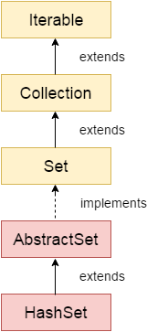
- LINKEDHASHSET:
  - Represents the LinkedList implementation.
  - Class is a hashtable and implementation of the set interface. Inherits HashSet class and implements set interface.
  - Extends HashSet Class and implements set interface.
  - Contains unique elements ad null elements.
  - Maintains the insertion order.
  - Non-Synchronized.
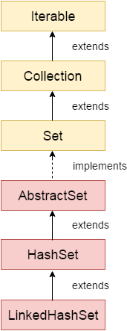
- SORTEDSET INTERFACE:
  - Alternate of set Interface that provides a total ordering on its elements.
  - Elements are arranged in ascending order.
    - SortedSet<Datatype> set = new TreeSet();
- TREES:
  - Implements the set interface that uses a tree for storage.
  - Contains unique elements and doesn’t allow null values.
  - Access and retrieval time is fast.
  - Elements stored in Ascending order.
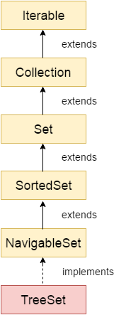

Interview Questions:
- Differences between Array and Collection
- These are similar regarding references of objects and manipulating the data.
But major differences are arrays are always of fixed size. Arrays stores homogeneous. Arrays don’t have readymade methods for sorting searching etc.
- Collections can be changed dynamically. In collections, we can store heterogeneous. Collections have readymade methods(Sorting, searching, etc) to use. Differences between
- ArrayList and LinkedList
  - Array List provides constant time for search operation better to access values, with time complexity of O(1). It doesn’t implement the deque interface.
  - LinkedList is better for manipulation with O(n/2) time complexity to access the elements. It implements a deque interface.
- ArrayList and Vector
- ArrayList is not synchronized and not a legacy class. Increases its size by 50% of the array size. It is not a threadsafe as it is not synchronized.
- The vector is Synchronized. It is a legacy class. Increases its size by doubling the array size. It is threadsafe as its method of synchronization.
- Iterator and List Iterator:
- Iterator traverses the elements in the forward direction only. Used in List, Set, and queue. The iterator can only perform remove operation while traversing the collection.
- List Iterator traverses the elements in backward and forward directions both. Used in the list only. Can perform add, remove and set operation while traversing the collection.
- HashSet and TreeSet:
- Hashset maintains no order but the tree set has ascending order. HashSet is impended by hash table whereas the tree set implemented by a tree structure.
- HashSet is faster than trees. HashSet is backed by Hashmap whereas the tree set is backed up by treemap.
- Set and Map
- Set contains unique values. Holds a single number of null values.
- The map contains both keys and values and contains unique keys with duplicate values. Map can include a single null key with n number of null values.
- HashSet and HashMap
- HashSet contains only values whereas HashMap includes the entry(key, value).it is iterated. Implements set interface. Cannot have duplicate values. Contains only a single number of a null value.
- Hash Map needs to convert into a set to be iterated. implements the Map interface. contains duplicate values with unique keys. Hashmap can hold a single null key with n number of null values.
- Hashmap and TreeMap
- Hashmap has no order. Implemented by a hash table. Sorted by key or value. Contains a null key with multiple null values.
- Treemap has ascending order. Implemented by a tree structure. sorted by a key. Cannot hold a null key but can have multiple null values.

