13th January 2021
INTRODUCTION:
- Software is of two types:
- System Software (Example: Operating Systems like Windows, Linux, Android, macOS)
- Application Software (Applications used in Computer Example: Notepad, Ms Office)

- The system understands only machine language(10010011)
First Programming Language was developed by IBM(FORTRAN-1954). But it was only used for MATH.
Machine Language→ Assembly Language → Programming Language
(10000110011)
MOV(A,10)
MOV(B,20)
ADD(A,B)
c = a+b;

- The assembler converts the assembly language into machine language.
- The compiler converts Programming Language into machine language.
- C Language was developed in 1972.
  - Used for both System and application software.
  - It is a structured language.
- Java was developed in 1992, Which is an Open-Source Software. It follows 6 OOPS Concepts.
- PHP was developed in 1996, which is also an Open-Source software. But it follows 3 OOPS concepts.
- .NET was developed in 2002, which is a paid source. But it follows 6 OOPS concepts same as JAVA.

OOPS:
- Class -- Collection of objects, variables, and methods.
  - Does not exist and no memory is allocated for a class.
- Objects
  - Exists and memory is allocated for the objects.
  - It has properties and action.
Program:
Class Person{
int age;
Age, height are properties of a person.
float height;
void readt(){
Actions of a Person
}
void eat(){
}
}
Person Santhu;
(Santhu is an object which has memory )
Santhu.age = 27;

14th January 2021
- C ,C++ → platform dependent (.exe – Executable file with 1’s and 0’s).
- Windows(1001110001) → 1’s and 0’s generated by windows will not work in LINUX & MACOS.
- Java → Platform Independent (byte code → .class)
- JVM(Java Virtual Machine) – It takes the byte code and converts code into machine understandable language based on respective OS (Windows, LINUX, MACOS..).
  - JVM presents inside the Software (JDK—JAVA Development Kit)
  - JVM allocates and deallocates the memory.
- It is categorized into three types.
  - JAVA SE (Standard Edition) –Used to develop Client-side or Desktop Application or system Applications (Example: Games, MS Office, etc.)
  - **JAVA EE (Enterprise Edition) – Used to develop web applications (Websites) (Examples: Gmail, Facebook, etc.)
  - JAVA ME (Micro Edition) – Used to develop mobile applications. Previously Nokia used to develop the application using Java ME. Now Java ME is replaced with Android, MACOS, etc.).

Javac (Java Compiler)
Java (Java Interpreter)

LIBRARIES
JVM

JRE(Java Runtime Environment)

JDK( Java Development Kit)
RULES:
- Class Name:
  - starts with a capital letter ( Scanner, ArrayList, ResultSetMetaData…)
- Method name:
  - starts with a small letter and next word starts with Capital letter. ( get() , getMessage() , printStackTrace())
- Variable name:
- Starts with a to z or A to Z or special characters like _ or $.
- Digits(0-9) are allowed after a character or special characters.
    - Example : int 123total; //Wrong
int _total123; //Correct
- It is case sensitive ( Ex: int NUMBER, number ; )
- Reserved keywords can’t be used. (Ex: for, while, break, if, else ... etc)
- Spaces are not allowed between the names.
    - Example: int area of triangle; //WRONG
int area_of_triangle; // Correct
- Every statement ends with ;
- JVM executes program if only it has Main method.
- println() – is a method to print output [ System.out.println(“Message”) ]
- System – is a class.

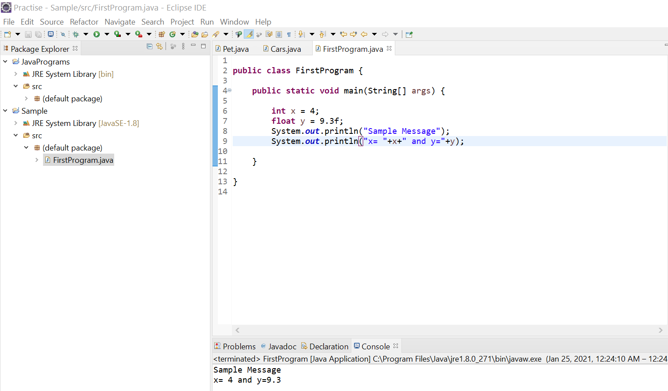

15th January 2021
- How to create the objects:
Syntax:
Classname object = new Classname(); ( New is a keyword that allocates the memory in JVM at runtime)
- JVM has 5 memory areas.
  - Method area
  - Heap area → Object memory is created.
  - Stack area
  - Native area
  - PC
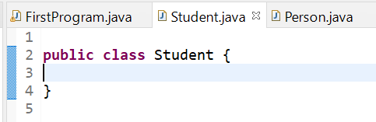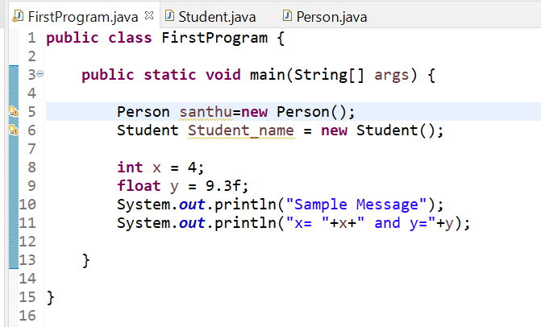
- Types of Variables:
  - Primitive Variables // Ex: int x=10;
    - Classified into 3 types:
- instance variables
- static variables
- local variables.
  - Non-Primitive Variables // Class object_name= new Class();
- Instance Vs Static:
- Object memory is created by a new keyword in the Heap area. The instance Variable depends on objects. Objects depend on the NEW keyword.
- Static memory is created by class name in the method area. It is declared once and common for all objects.
- Static can be used with the following :
- Variable – depends on class name or object.
  - A static variable is necessary to save memory (Example: For all the students in the same college have the same college name . Therefore, the College name is static).
  - For static variables, one memory is allocated and is used for all the objects in the class.
- Method
- Class
- Block
- Object
- Default Values:- JVM allocated default values
  - Int → 0
  - String → Null
  - Boolean → False

18th January 2021
Methods:
- Main() – start of program execution
- Println() – to print output
- The Set of instructions to perform an action or task is known as methods.
- Methods are 2 types:
  - Predefined
  - User-defined
- Every method has two properties:
  - Return type
    - Void --- nothing is returning
  - Parameters
Syntax: return_type method(para1,para2….){
}
- Based on return type and parameters the methods are classified into four types:
  - Method without return type and parameters.
    - Example: void sum()
  - Method without return type and with parameters.
    - Example: void sum(float a,float b)
  - The method with a return type and without parameters.
    - Example: int sum()
  - The method with return type and parameters.
    - Example: int sum(int a,int b)
Example:
Seller (Sub)
Buyer (Main)
- With parameters i.e; many values are transferred from the main block to the sub-block.
- With return type i.e; only one value can be transferred from the sub-block to the main block.

19th January 2021
JVM has 5 memory areas:
- Method Area – Static variable, Method, Block, class, Object
- Heap Area – Instance variable, method, and block
- Stack Area – local variables
- PC -
- Native Area –
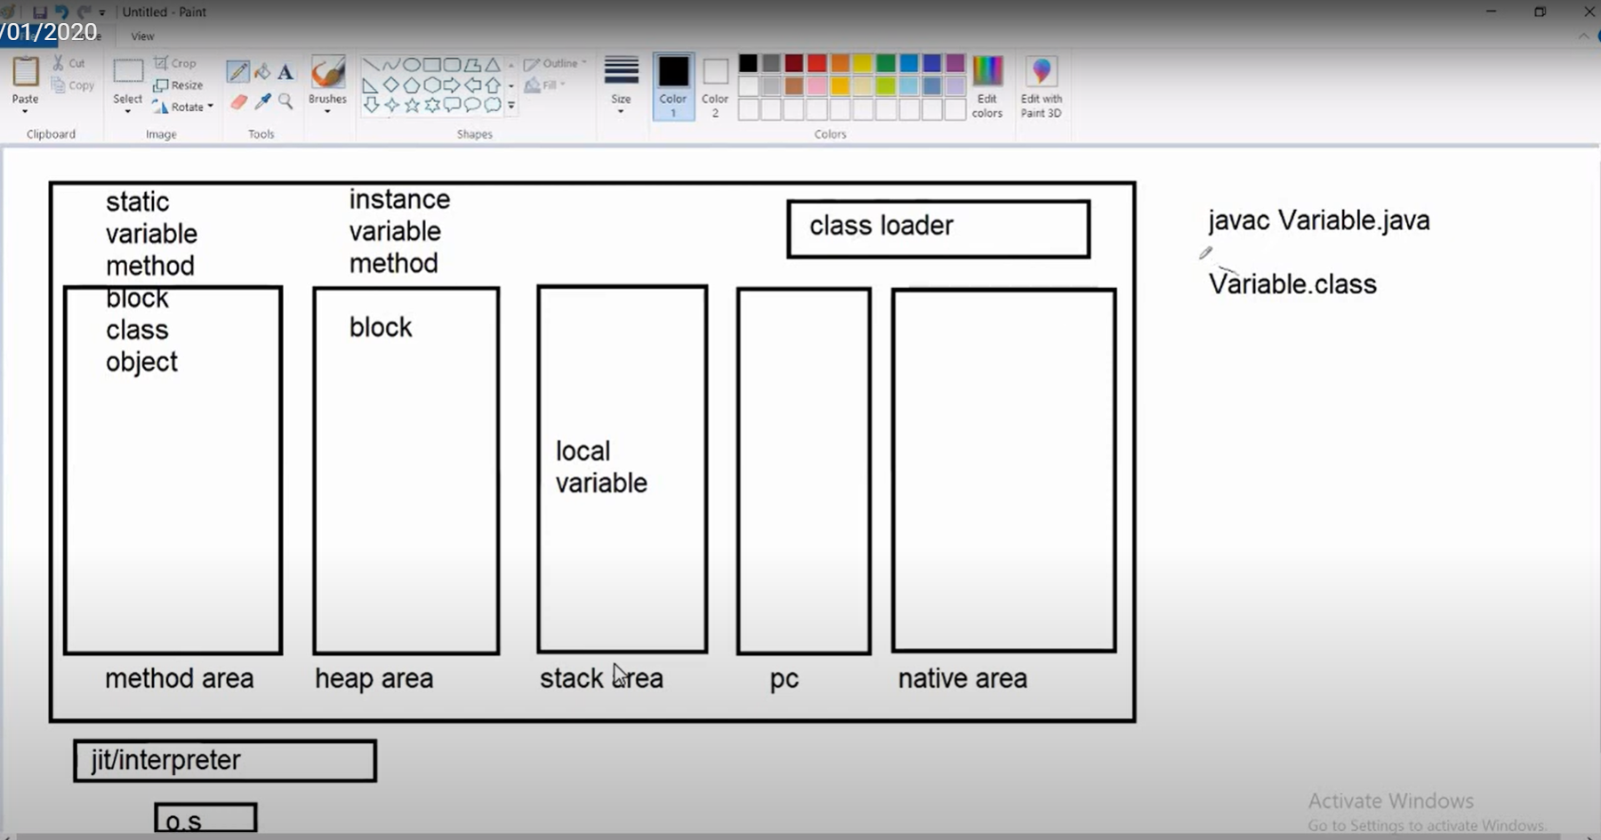
- ClassLoader → . class is stored in the class loader. (executes a class and memory is allocated based on object type→
- In Java, instance variables and static variables can be used inside the instance methods. Instance variables cannot be used in the static methods.
- Importing Packages:
  - Import java.util.Classname;
  - Import,java.util.*;
  - Java.util. ArrayList; // Declaring the package along with class name it is used only once.
- Java Consists of packages that contain 2 types: 1. User-defined, 2. Predefined classes.
  - The package consists of classes.
    - Example:
Class Person {
Int age;
Float height;
Void eat(){
}
}

- If we want to access the class, we need to import the packages. If we want to access the variables and methods, we need to create an object for the class.
  - Java.util.*;
  - Java.io.*;
  - Java.lang.*;
- Scanner class :
SYNTAX:
Scanner sc = new Scanner(System.in);

POLYMORPHISM:
- Poly → Many
- Morphism → Forms/ states/properties
- Method Overloading
  - Method name same with a different type of parameters or order of parameters or number of parameters.
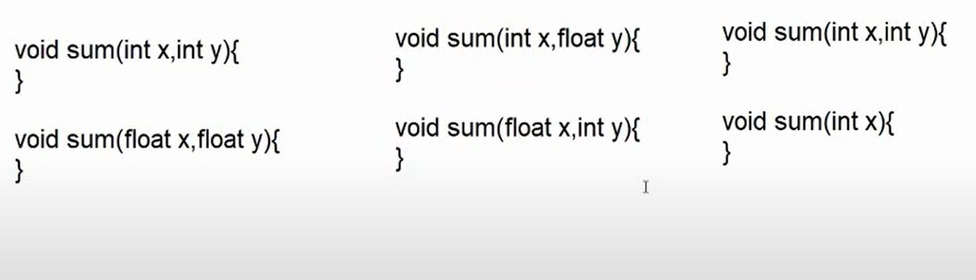
- Method Overriding

20th January 2021

INHERITANCE:
- Acquiring the properties of the superclass(Parent class /Base) to subclass(Child Class/derived).
- Reusability – Code can be reused.
- Also known as “is-a” relation.
- Does not support multiple inheritances directly. It supports multilevel & Hierarchical inheritance.
- Extends keyword is used.
- Outside of the method, we can declare variables, assigning values, or creating an object. We cannot print the data out method.
- Multilevel Inheritance:
  - When a class extends a class, which extends another class then this is called multilevel inheritance.
Example:
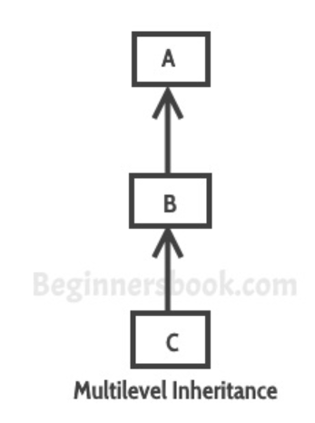
C inherits properties from B. B inherits properties from A. Here B is a parent class of C. A is the parent class of B.

- HIRERARICHAL INHERITANCE:
  - The single parent class is inherited by multiple child classes.
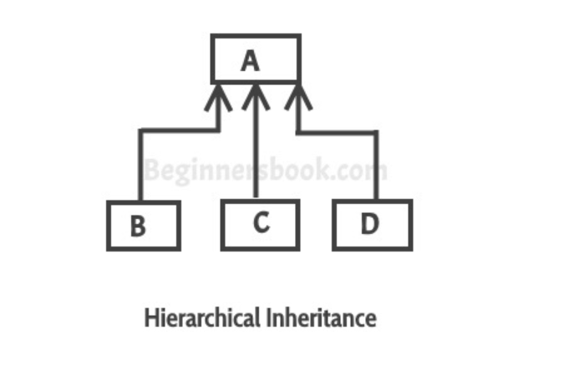

21st January 2021

CONSTRUCTORS:

- It is a method that is used to initialize objects. It takes part in object creation.
- To initialize the variables of a class we use a constructor.
- Constructors cannot be abstract, final, static, and synchronized while methods can be.
- Constructors do not have return types while methods do.

SYNTAX:
classname obj_name = new constructor();
Example : Person Santhu = new Person();
- Properties:
  - Constructor name should be same a class name.
  - The constructor has only one property i.e; parameters.
  - Constructor cannot have any return type i.e; not even void.
  - Constructor gets executed automatically when object is created i.e; once per object creation.
- Types of Constructor:
  - Without Parameters (Zero argument constructor)
Drawback:
    - The values initialized for the zero arguments constructor are the same for all the objects.
  - With Parameters (parameterized constructor) – to have a different value we use a parameterized constructor.
- In JVM object is stored into “this” keyword.” this” keyword acts as a class object. Super keyword – holds the object of the parent class.
- Final keyword –variables declared as final cannot change the value. If final is declared for a class, we can’t inherit the class.

Is-A relation: depends on inheritance.
Has-A relation: also known as composition

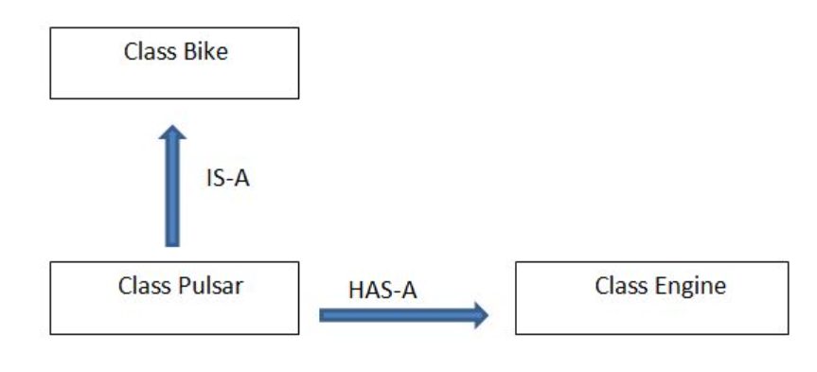
25th January 2021

Method Overriding:
- Same method name, with the same type of parameter or order of parameters and same no of parameters.
- Inheritance must for method overriding(mandatory)
- Separate classes and objects are required.
Class Casting:
- Converting one class object to another class.
- It is classified into two types:
  - Upcasting→ Converting the subclass to the superclass.
  - Downcasting -→ Converting the Superclass to subclass.
- In JVM, deallocates the memory using a garbage collector. Garbage collectors use the method finalize () to clear the memory.
26th January 2021
Abstract Class:
- Collection of abstract methods and concrete methods.
  - Abstract Methods: the methods without any implementation.
  - Concrete Methods: the method with implementation.
- We can write the abstract methods inside the abstract classes.
- We can’t instantiate the abstract classes(i.e; Object creation is not possible.)
- The abstract methods have different implementations in the subclasses.
- The concrete method has the same implementation for all the classes.
27th January 2021
Interfaces:
- An interface is a pure abstract method that doesn’t have any concrete methods.
- It cannot contain a constructor.
- Interface methods are default public and abstract.
- Interface attributes are default public, static and final.
- In java, multiple inheritances can be achieved with interfaces using the implements keyword.
- A class must use implements keywords to override the method.
- For interface, we can’t instantiate the object memory.
- Interface can’t implement another interface.
- Nested Interface → if one interface resides in another interface.
29th January 2021
Inner Classes :
- Inner classes are classified into two types:
  - Static Inner class
  - Non-Static Inner class
- Nested Inner class – The class within the class is called a nested Inner class. (Object within the Object class, class within the class)
- Local Inner class—class within a method is a local variable.
- Anonymous Inner class—class without any name is called an anonymous inner class. Using Superclass constructor we need to declare. Anonymous inner class always extend a class or implement an interface. Since an anonymous class has no name, It is not possible to define a constructor. These are accessible only at the point where it is defined.

1st February 2021
Loops & Array:
- While: at the first condition is validated. (Entry Level Loop)
- Do-while: Condition is validated later. (Exit level loop)
- Array: An array is a group of like-typed variables that are referred to by a common name.
- String: A group of characters is known as a string.
- Literals(String s =” Hello “)
- New(String x = new String(“hello”)
- The string is immutable which value cannot be changed.
- StringBuffer is mutable (value can be changed). It is Synchronized.
- StringBuilder is mutable(values can be changed). It is non Synchronized.

2st February 2021
Wrapper Class
- Wrapper class is used to convert eight primitive data type(byte, short,int,long, float, double,char and boolean)into objects like int to Integer, float to Float, double to Double, etc.
Eg: int a=10; ///Variable
Integer I = new Integer(a);//object
- Auto-Boxing:
- Auto-unboxing:
Generics:
- Using Generics, it is possible to create classes that work with different data types.
- An entity such as class, interface, or method that operates on a parameterized type is called generic entity.
- <> to specify parameter types in generic class creation.

3rd February 2021
Collections:
- It is a group of individual objects.
- <E> is the type of elements in this collection
Set:
- It is also a group of individual objects
- It doesnot allow duplicate values.
- Allows hetrogenous elements and null values.
HashSet:
- It follows random order.
- LinkedHashSet follows insertion order.
  - Java LinkedHashSet class contains unique elements only like HashSet.
  - Java LinkedHashSet class provides all optional set operation and permits null elements.
  - Java LinkedHashSet class is non synchronized.

TreeSet:
- It follows ascending order.
List:
- Allow duplicate values, null values , hetrogenous elements(Doesn’t restrict)
ArrayList:
- It follows insertion order.
- Non-synchronized.
LinkedList:
- Follows insertion order
Vector:
- Follows insertion order. It implements like an Interface.
- Syunchronized
Stack:
- Linear Data Structure which follows a particular order in which operations ae performed.
- Push and pop method---Insertion and deletion happends on same end.(Last in first out)
