STUDENT RECORDS MANAGEMENT SYSTEM
A Mini CRUD-Based Web Application
Project Report — VSB Skill Vault Activity 3
Technology Stack: HTML, CSS, JavaScript (Client-Side)
Submitted by: SANTHOSH BALAJI N
Roll No.: 922525104144 | Class/Section: II-CSE-C
Date: 17 September 2026

1. Project Overview
This report documents the design, development, and testing of a mini web application built to satisfy the VSB Skill Vault Activity 3 SOP for a Complete CRUD-Based Web Application. The application, Student Records Management System, allows a user to Create, Read, Update, and Delete student academic records through a single-page, responsive web interface.
The project was implemented using plain HTML, CSS, and JavaScript — one of the technology stacks explicitly permitted by the SOP — with the browser's localStorage API used as the persistent data store in place of a server-side database. This keeps the application fully self-contained and runnable by simply opening the HTML file, while still exercising every CRUD operation, validation rule, and UX requirement called for in the SOP.

2. Problem Statement
Academic departments and class coordinators frequently need a quick way to record and maintain student information — name, roll number, email, department, year, and CGPA — without setting up a full database server. Manual record-keeping (spreadsheets, paper registers) is error-prone and hard to search or update. This project addresses that gap with a lightweight, browser-based records manager that any non-technical user can operate directly, with no installation or backend setup required.

3. Objectives
- Design and build a responsive, user-friendly interface for managing student records.
- Implement all four CRUD operations: Create, Read, Update, and Delete.
- Apply client-side validation for every input field (required fields, email format, numeric range).
- Provide search/filter functionality across name, roll number, and department.
- Persist data locally so records survive a page reload.
- Provide clear success/error feedback (toast notifications) after every operation.
- Document the system architecture, data design, and test results.

4. Technology Stack
Layer | Technology | Purpose
Structure | HTML5 | Page structure, semantic form and table markup
Styling | CSS3 (custom properties, Flexbox, Grid) | Responsive layout, light/dark theming
Fonts | Google Fonts (Source Serif 4, IBM Plex Sans/Mono) | Typography
Logic | Vanilla JavaScript (ES6, IIFE module pattern) | CRUD logic, validation, rendering, event handling
Data storage | Browser localStorage (JSON) | Client-side persistence layer (acts as the "database")

No external JavaScript frameworks or build tools are used — the entire application is a single, self-contained .html file, which satisfies the SOP's frontend track (HTML, CSS, JavaScript) without requiring a backend server.

5. System Architecture
The application follows a simple client-side MVC-like pattern within one file:
- View: HTML markup for the entry form, toolbar/search bar, and records table.
- Controller: JavaScript event listeners (form submit, button clicks, search input) that validate input and call the CRUD functions.
- Model / Data layer: an in-memory JavaScript array (records) that is synchronized with localStorage on every change via load() and save() functions.
Architecture flow:
User → HTML/CSS UI → JavaScript event handlers → CRUD functions (addRecord / render / updateRecord / deleteRecord) → localStorage (JSON) → re-render table

6. Data Design (Student Record Schema)
Since the app uses localStorage instead of a relational database, each student record is stored as a JSON object inside an array under the key src_student_records_v1. The schema below plays the role of the SOP's required table design:
Field | Type | Constraints
id | String (auto-generated) | Primary key — generated as r + timestamp + random suffix
name | String | Required, not empty
roll | String | Required, not empty
email | String | Required, must match valid email pattern
dept | String (enum) | Required — one of the listed departments
year | String (enum) | Required — one of the listed years
cgpa | Number (string input) | Required, numeric, range 0–10

7. CRUD Implementation Details
Operation | Trigger | Function | Result
Create | Submit form (Add mode) | addRecord(data) | New record pushed to array, saved, table re-rendered, success toast shown
Read | Page load / search input | load() + render() | All records (or filtered subset) displayed in the table
Update | Click ✎ then Save changes | startEdit(id) → updateRecord(id, data) | Existing record replaced in place, table re-rendered
Delete | Click 🗑 then confirm | deleteRecord(id) | Record removed from array and storage after confirmation dialog

8. Validation Rules Implemented
- Name and roll number: required, cannot be blank.
- Email: must match a standard email regex pattern.
- Department and Year: required dropdown selections.
- CGPA: required, numeric, and constrained to the 0–10 range.
- Invalid fields are highlighted with an error border and inline helper text; the form will not submit until all fields are valid.
- Delete is a destructive action and requires explicit confirmation via a browser confirm() dialog.

9. UI Screenshots

9.1 Add Record Form (Create)
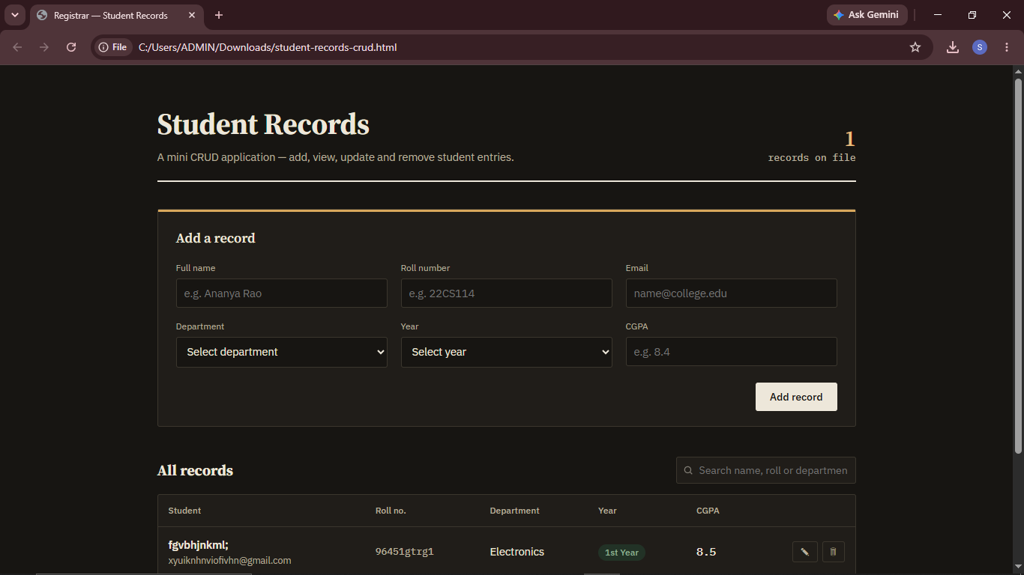
Fig 9.1 — The entry form used to add a new student record.

9.2 Records Table (Read)
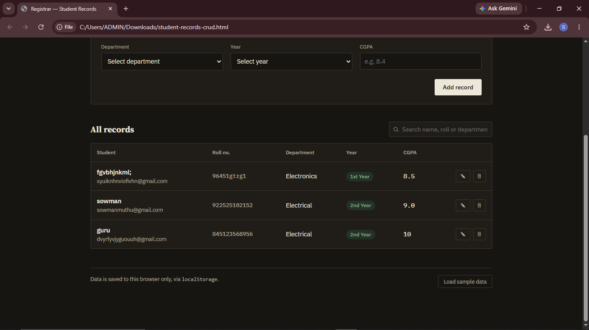
Fig 9.2 — All student records listed in the table view.

9.3 Edit Mode (Update)
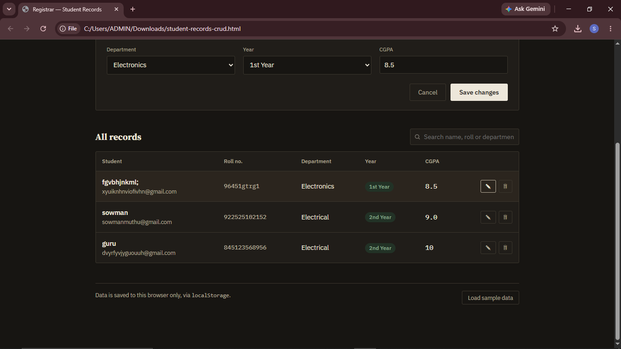
Fig 9.3 — Record loaded into the form in 'Edit record' mode, showing the Save changes button.

9.4 Records List / Search Bar
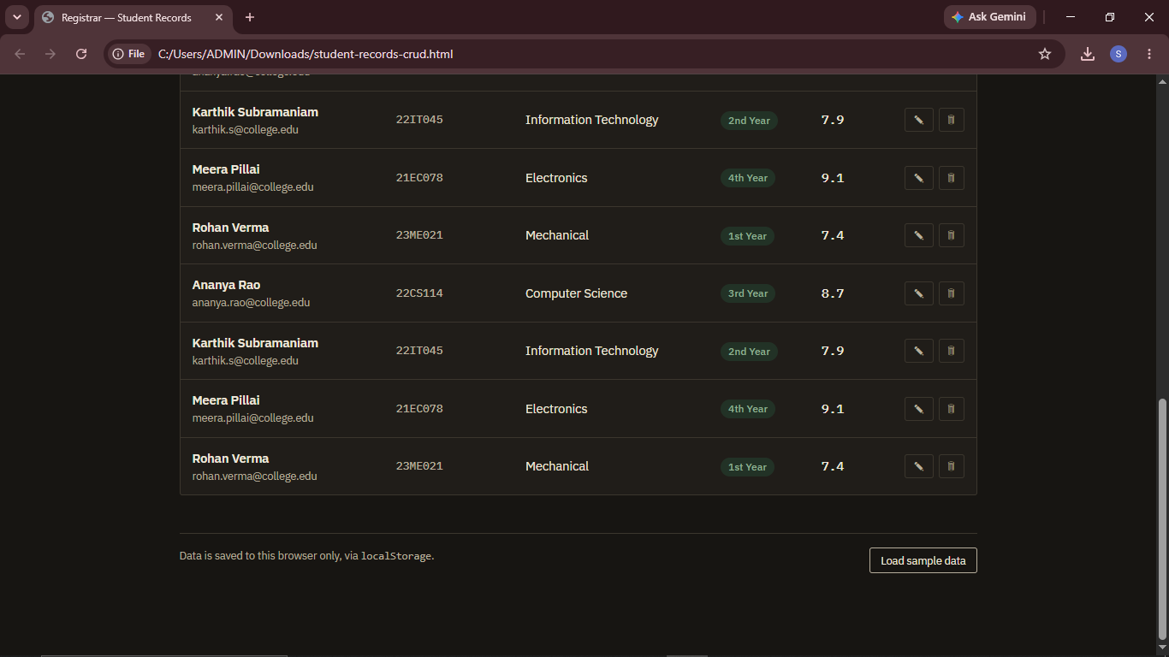
Fig 9.4 — Full records list with the search bar available for filtering by name, roll number, or department.

9.5 Delete Confirmation
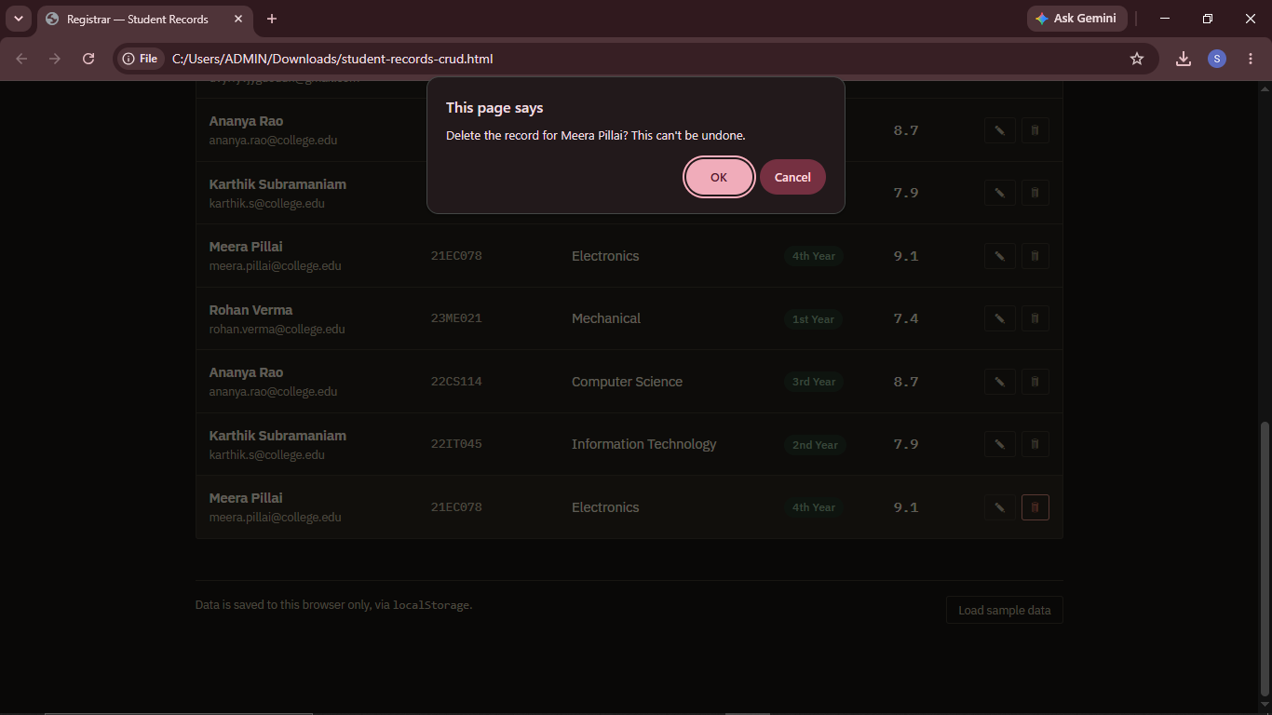
Fig 9.5 — Browser confirmation dialog shown before a record is permanently deleted.

9.6 Delete Success Feedback
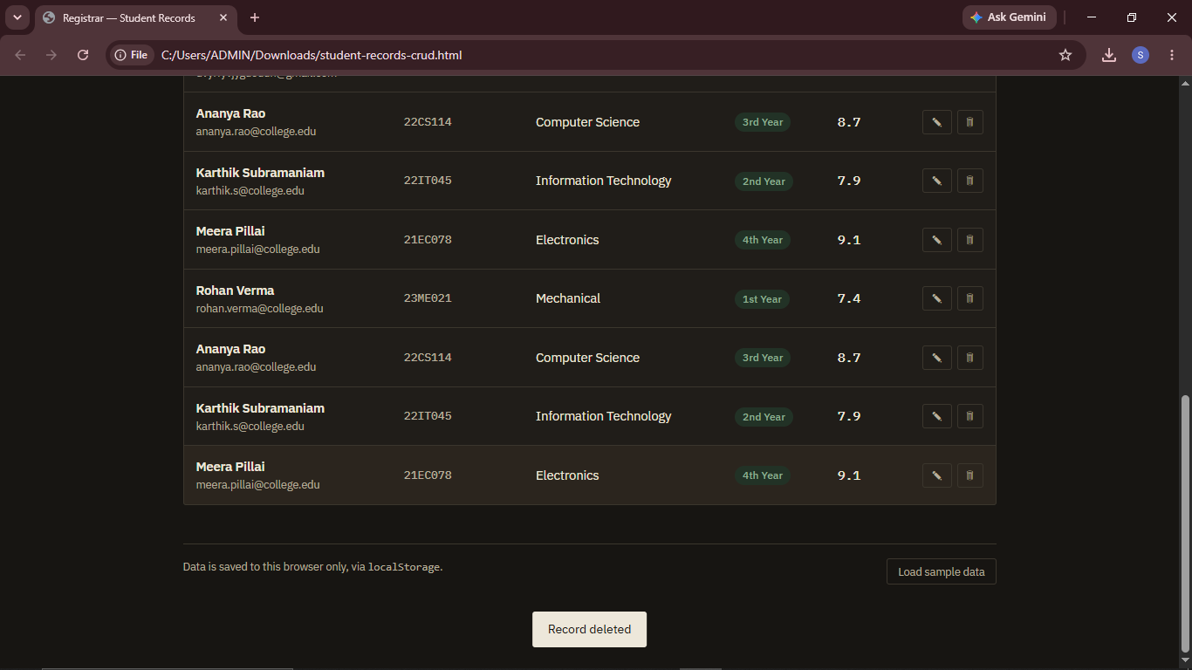
Fig 9.6 — Toast notification confirming the record was deleted.

10. Testing Procedure and Results
Manual functional testing was performed directly in the browser (Chrome), covering both valid and invalid inputs as required by the SOP:
Test Case | Input | Expected Result | Actual Result
Create — valid data | All fields filled correctly | Record added, toast "Record added" | Pass
Create — missing required field | Name left blank | Field highlighted red, form blocked | Pass
Create — invalid email | "abc123" | Email field highlighted, form blocked | Pass
Create — CGPA out of range | CGPA = 12 | Field highlighted, form blocked | Pass
Read — empty state | No records in storage | "No records yet" empty-state message shown | Pass
Read — populated table | 4+ records loaded | All records rendered with correct columns | Pass
Update — valid edit | Change CGPA and save | Row updates immediately, toast "Record updated" | Pass
Update — cancel edit | Click Cancel mid-edit | Form resets to Add mode, no data changed | Pass
Delete — confirm | Click delete, confirm dialog | Record removed, toast "Record deleted" | Pass
Delete — cancel | Click delete, dismiss dialog | Record remains unchanged | Pass
Search/filter | Type partial name or department | Table filters live to matching rows | Pass
Persistence | Reload the page | All records reload from localStorage | Pass
Responsiveness | Resize to mobile width | Form grid collapses to single column, table scrolls horizontally | Pass

11. Installation and Execution Steps
- Download / clone the project folder containing student-records-crud.html.
- No dependencies, build step, or server are required.
- Open student-records-crud.html directly in any modern web browser (Chrome, Edge, Firefox).
- The app loads with zero records; click "Load sample data" to populate demo entries, or use the form to add your own.
- All data is stored locally in the browser via localStorage and will persist between sessions on the same browser/device.

12. Challenges and Solutions
Challenge | Solution
No backend/database available for a quick mini-project | Used the browser's localStorage API as a lightweight persistent data layer, avoiding the need for a server while still fully exercising CRUD logic
Preventing invalid or incomplete records from being saved | Implemented field-by-field client-side validation with visual error states before allowing form submission
Keeping the UI usable on small screens | Used CSS Grid with media-query breakpoints so the form and table reflow for tablet and mobile widths
Accidental data loss on delete | Added a confirmation dialog before any delete operation completes

13. Future Enhancements
- Migrate the data layer to a real backend (Django REST Framework or Spring Boot) with a MySQL/PostgreSQL database for multi-user, multi-device access.
- Add authentication so only authorized staff can add/edit/delete records.
- Add server-side validation and REST API endpoints (as outlined in the SOP) to complement the existing client-side checks.
- Add sorting, pagination, and CSV export for larger datasets.
- Add unit/integration tests (e.g., Jest) for the CRUD functions.

14. Conclusion
The Student Records Management System successfully implements all four CRUD operations, complete client-side validation, search/filtering, and a responsive, accessible interface, meeting the core learning objectives of the SOP for a mini CRUD-based web application. While it currently uses localStorage instead of a server-backed database, the architecture is intentionally modular, and the roadmap in Section 13 outlines a clear path to a full-stack version with a REST API and relational database.

15. Source Code and Repository
Main file: student-records-crud.html
Git repository: https://github.com/santhoshbalaji0507/Student-Record-Management-System-.git

