Toward a Transaction Standard for Asynchronous AI-Mediated Care Review: A Proposed Framework
Santhosh Basineni
Independent Researcher
Mounika Avirineni
Independent Researcher

Abstract—A growing number of independent commercial and research systems implement some form of artificial-intelligence-mediated intake followed by physician review, decoupled from real-time scheduling. Each defines its own internal representation for how a case is submitted, escalated, queued, and resolved, with no shared transaction format across implementations. This mirrors the state of pharmacy claims processing prior to the adoption of the NCPDP Telecommunication Standard, under which a common transaction and segment structure replaced bespoke point-to-point integration between every payer and pharmacy. This paper proposes an analogous transaction framework for asynchronous, AI-mediated care review, a defined set of message types spanning intake submission, conservative emergency escalation, distributed asynchronous review, and structured disposition, specified as a profile over existing Fast Healthcare Interoperability Resources (FHIR) resources rather than as a competing data model. Coverage verification, cost estimation for redirected services, and claim submission are specified as payer-facing transactions grounded in the decision timeframes already required under the CMS Interoperability and Prior Authorization Final Rule, with network status left as an explicit, informed patient preference rather than an architectural default. The framework is illustrated with five worked scenarios. This paper presents the architecture and transaction model as a foundation for community and standards-body discussion; a complete technical specification, including full data-element schemas, code tables, and a reference implementation, is presented as separate, forthcoming work.
Index Terms—health information interoperability, HL7 FHIR, healthcare standards, asynchronous telehealth, artificial intelligence, transaction protocols, provider credentialing, prior authorization, NCPDP.

I. Introduction
Multiple independent systems now implement some variant of AI-mediated intake followed by physician review that is decoupled from live scheduling. A commercial asynchronous care platform was deployed with a large integrated health system as early as 2022 [2], a peer-reviewed evaluation of an AI-assisted virtual urgent-care model found its suggested dispositions comparable to or better than physicians' final recommendations in the majority of reviewed cases [4], and a 2025 industrial research system demonstrated a rigorously evaluated paradigm of asynchronous physician oversight of AI-conducted intake [6]. Each of these systems defines its own internal representation of the underlying workflow. None defines an interoperable transaction format that another vendor's intake system, review platform, payer, or scheduling system could implement independently.
This is a familiar juncture. Before the adoption of the NCPDP Telecommunication Standard [1], pharmacy claims adjudication required bespoke integration between every individual pharmacy and every payer; a shared transaction and segment structure subsequently made the entire ecosystem interoperable without requiring any single participant to adopt another's proprietary format. Health Level Seven International (HL7) has itself identified the analogous gap for the current moment: as agent-based clinical systems mature, the standards community will require, in the words of an HL7 practitioner writing on the organization's own blog, fine-tuned specifications for representing what AI model tools are, what they can do, and how their expected inputs and outputs should be structured [8].
The coordination this framework digitizes is, today, primarily a channel problem rather than a technology gap. Whether a case is covered, what a service will cost, and whether a claim or authorization has been approved are most often exchanged by phone, fax, or manual portal entry rather than a structured transaction: only 35% of medical prior authorizations are conducted fully electronically industry-wide [14], and the standards body responsible for administrative transaction adoption names reducing call-center costs and manual phone-based work as an explicit goal of further electronic adoption [14]. Physicians report spending an average of 13 hours a week on prior authorization alone, and two in five physician practices employ staff whose sole function is this coordination [15]. Each transaction defined in this paper, intake, escalation, review, disposition, registration, availability, coverage, cost estimation, authorization, and claims, corresponds to a category of exchange conducted today primarily by a person on a phone or a fax machine. Positioning AI at the center of that exchange, structuring what a patient, a reviewing organization or physician, and a payer each need to communicate to one another, is this framework's implicit case for reducing that channel's burden; this paper does not itself measure that reduction, only defines the structured alternative to the channel producing it.
The same client-neutral principle applies to every party in this exchange, not the patient alone. A reviewing physician or organization, and a payer, may equally interact with these transactions through a purpose-built application or a general-purpose AI-assistant connector, the same category of connector already used to bring a patient's own health data into a conversational assistant [5]. Routing an exchange through such a connector is not merely a channel substitution for the phone call or fax it replaces; a conversational interface can also contextualize a structured response for whoever is reading it, explaining what a coverage determination or a redirected disposition actually means for that party, rather than presenting a bare code. Prior work on AI-mediated clinical oversight has already shown a purpose-built review interface can measurably reduce the time and effort a professional needs to process a case relative to an unstructured consultation [6]; the transactions and client-neutrality defined in this framework are intended to make an equivalent effect available on the patient and payer sides of the same exchange, not only the reviewing physician's.
These three, patient, reviewing organization or practitioner, and payer, are the transacting parties this framework directly governs. A specialist engaged through a redirect participates as a reviewing organization or practitioner in its own right under Section V. A laboratory or diagnostic facility fulfilling an ordered test is not modeled as a distinct role; the order and result exchange itself is left to existing FHIR DiagnosticReport and Observation patterns. Where the ordered test requires an in-person visit, that visit is scheduled using the same Appointment Request and Confirmation transactions defined in Section IV for specialist referrals. A prescription resulting from a Disposition Response is, by design, handed off to the existing NCPDP Telecommunication Standard for the pharmacy leg of that transaction. Care coordinated on a patient's behalf by a caregiver or authorized proxy, and the specific mechanism by which an Emergency Escalation establishes live contact, are real and unresolved questions this framework does not yet address.
This paper proposes such a framework, not as a ratified standard, but as a concrete architectural and transaction proposal intended to open that process. Section II reviews the systems and standards this proposal builds on. Section III states the design principles the framework must satisfy. Section IV defines the proposed case-flow transaction set. Section V defines how organizations and practitioners register and signal availability. Section VI defines coverage, cost-estimation, and payer-facing transactions. Section VII maps each transaction to underlying FHIR resources. Section VIII walks through five illustrative scenarios. Section IX addresses governance and the path from proposal to adoption. Section X names the limitations this proposal does not resolve.

II. Background and Related Work
Commercial deployment: An AI-driven intake platform was launched with a large health system's virtual urgent-care service in 2022 [2] [3]. These deployments demonstrate commercial viability but do not publish or propose an interoperable transaction format.
Clinical evaluation: A retrospective study comparing an AI system's initial suggested disposition to the reviewing physician's final recommendation found the AI's suggestion rated of comparable or higher quality in the majority of cases where the two differed [4].
Data-access infrastructure: A 2026 health-data connector enables users to bring longitudinal laboratory and clinician-authored data into general-purpose AI assistants through remote Model Context Protocol connectors [5].
Academic precedent: The most directly related published work proposes and rigorously evaluates a paradigm of asynchronous physician oversight, in which an AI system conducts guarded history-taking and defers individualized decisions to a single overseeing primary care physician [6]. This work is a single-overseeing-physician model rather than a distributed, credential-scoped reviewer pool, and does not propose an interoperable message format. A related industrial architecture uses a coordinated constellation of specialist agents for lower-acuity patient-facing communication tasks [7].
Standards and regulatory context: FHIR is the dominant substrate for health data interoperability, and CDS Hooks provides a pattern for triggering decision-support interactions [10] [11]. HL7 launched a new implementation community in March 2026 focused on high-frequency device data [9]. The CMS Interoperability and Prior Authorization Final Rule already requires impacted payers to implement FHIR-based APIs and issue decisions within fixed timeframes [13]. No existing implementation guide connects intake, review, credentialing, and payer participation into a single transaction set.

III. Design Principles
The framework is governed by seven principles. First, every non-emergency case must receive disposition from a credentialed human reviewer. Second, emergency escalation is architecturally separate from routine asynchronous review. Third, review assignment is queue-based and scoped by verified credential and current availability. Fourth, disposition is returned as a structured, coded response rather than free text. Fifth, the framework is defined as a profile over existing FHIR resources. Sixth, the framework is agnostic to how any participant interacts with it: a purpose-built application and a general-purpose AI-assistant connector are equally valid clients. Seventh, network-status constraints on the reviewer pool are an informed patient preference, not an architectural default.

IV. Proposed Case-Flow Transaction Model
Eight transaction types govern the clinical case flow, summarized in Table I.
TABLE I. PROPOSED CASE-FLOW TRANSACTION TYPES
Code | Transaction | Core Elements | FHIR Basis
IS | Intake Submission | Case ID, structured symptom/history data, urgency score | QuestionnaireResponse, Observation, Encounter
EE | Emergency Escalation | Priority flag, red-flag indicators, live-endpoint reference | ServiceRequest (priority=stat), Communication
ARR | Async Review Request | Full case file, AI-suggested disposition, confidence metadata | Task (status=requested, pool-scoped)
RC | Review Claim | Reviewer identifier, credential scope, claim timestamp | Task (status: requested→in-progress)
DR | Disposition Response | Outcome code (confirm/redirect), reason-type code, urgency designation, next action | Task (status→completed), new ServiceRequest if redirected
APR | Appointment Request | Target org/practitioner reference, selected Slot reference, urgency designation | Appointment (status=proposed)
APC | Appointment Confirmation | Confirmed or alternate Slot, location/logistics reference | Appointment (status: proposed→booked)
CSQ | Case Status Query | Case ID | Task read/search interaction

The Emergency Escalation transaction is architecturally distinct from the Async Review Request, not a variant of it. The Review Claim transaction allows any credentialed, available reviewer to accept responsibility for a queued case, while preventing two reviewers from independently claiming the same case. Disposition Response carries an expedited-or-standard urgency designation on any redirect outcome.
When a Disposition Response redirects to a specialist referral or in-person care, the patient's own client submits an Appointment Request against a Slot the target has exposed through its own Availability Update. The reviewing physician's role ends at the Disposition Response. An Appointment Confirmation finalizes the booking.
Not every appointment originates from a fresh redirect. A Disposition Response may instead establish a recurring order, represented as a FHIR CarePlan with a repeating ServiceRequest. No new transaction type is required: the recurring order generates the same Appointment Request each time it comes due.

V. Registration, Credentialing, and Availability
Three additional transactions are proposed, summarized in Table II. Organization Registration establishes a healthcare organization as a participant. Practitioner Registration establishes an individual reviewer. Availability Update allows a registered, verified practitioner to signal current eligibility to claim cases.

TABLE II. PROPOSED REGISTRATION AND AVAILABILITY TRANSACTION TYPES
Code | Transaction | Core Elements | FHIR Basis
OR | Organization Registration | Organizational NPI, legal name, technical endpoint, verification status | Organization, Endpoint
PR | Practitioner Registration | Individual NPI, state license & issuing state, credential scope, organizational affiliation(s), verification status | Practitioner, PractitionerRole
AU | Availability Update | Practitioner reference, credential-scope filter, availability status, expiry | Schedule, Slot

This framework intentionally does not define a new credentialing authority. Verification status is intended to be established against the National Plan and Provider Enumeration System and state medical board licensure records. A revocation is a status transition on the existing Practitioner Registration record. An Async Review Request is only claimable by a practitioner with both a verified Practitioner Registration and a current Availability Update.

VI. Coverage, Cost Estimation, and Payer Conformance
This framework does not resolve the network-status question architecturally. Network status is instead treated as a patient preference, informed by the coverage information this section defines.
Four transactions establish this, summarized in Table III. Coverage Eligibility Check verifies the patient's benefit and returns available options segmented by network status. Cost Estimate Request and Response apply when a Disposition Response redirects to a service requiring payer cost confirmation. Prior Authorization Trigger hands redirect cases to HL7's existing Da Vinci Prior Authorization Support implementation guide. Claim Submission and Response handle billing for the review encounter itself, and a lab or facility fulfilling a redirected order uses the same transaction pair for its own billing.

TABLE III. PROPOSED COVERAGE AND PAYER-FACING TRANSACTION TYPES
Code | Transaction | Core Elements | FHIR Basis
CEC | Coverage Eligibility Check | Coverage ID, service type, network-status query | CoverageEligibilityRequest / Response
CER / CES | Cost Estimate Request / Response | Redirected service type, expedited-or-standard designation, network option selected, estimate or pending status | Claim (use=predetermination) / ClaimResponse
PAT | Prior Authorization Trigger | Redirected service type, reference to external exchange | Handoff to Da Vinci PAS implementation guide
CLM / CLR | Claim Submission / Response | Encounter reference, billed service, disposition reference | Claim (use=claim) / ClaimResponse

Rather than propose a new response-time obligation, this framework adopts the decision timeframes payers are already required to meet under the CMS Interoperability and Prior Authorization Final Rule: seventy-two hours for expedited requests and seven calendar days for standard requests [13]. Scheduling for a standard-designated redirect proceeds automatically once the seven-day window closes, whether or not a response has arrived.
The client that originated the case receives Cost Estimate Response updates as a push notification, proposed as a FHIR Subscription. A payer may equally expose Coverage Eligibility Check and Cost Estimate Response through a general-purpose AI connector rather than a dedicated portal.

VII. Relationship to Existing Standards
Each transaction is proposed as a profile over existing FHIR resources. An Intake Submission is a QuestionnaireResponse and Observation resources linked to an Encounter. An Emergency Escalation is a ServiceRequest with an urgent priority flag paired with a Communication resource. An Async Review Request is a Task in a requested state, scoped to a credential-defined pool. A Review Claim transitions that Task to in-progress. A Disposition Response transitions the Task to completed. Appointment Request and Confirmation profile the FHIR Appointment resource.
Organization Registration profiles Organization and Endpoint. Practitioner Registration profiles Practitioner and PractitionerRole. Availability Update profiles Schedule and Slot. Coverage Eligibility Check profiles CoverageEligibilityRequest/Response. Cost Estimate Request and Response profile Claim and ClaimResponse using FHIR's predetermination use case. Prior Authorization Trigger is a handoff to Da Vinci PAS rather than a new resource. Client neutrality across all three parties is consistent with how SMART App Launch already allows any authorized client to interact with a FHIR server [12].

VIII. Illustrative Scenarios
Fig. 1 summarizes the three transacting parties and the transaction categories connecting them.
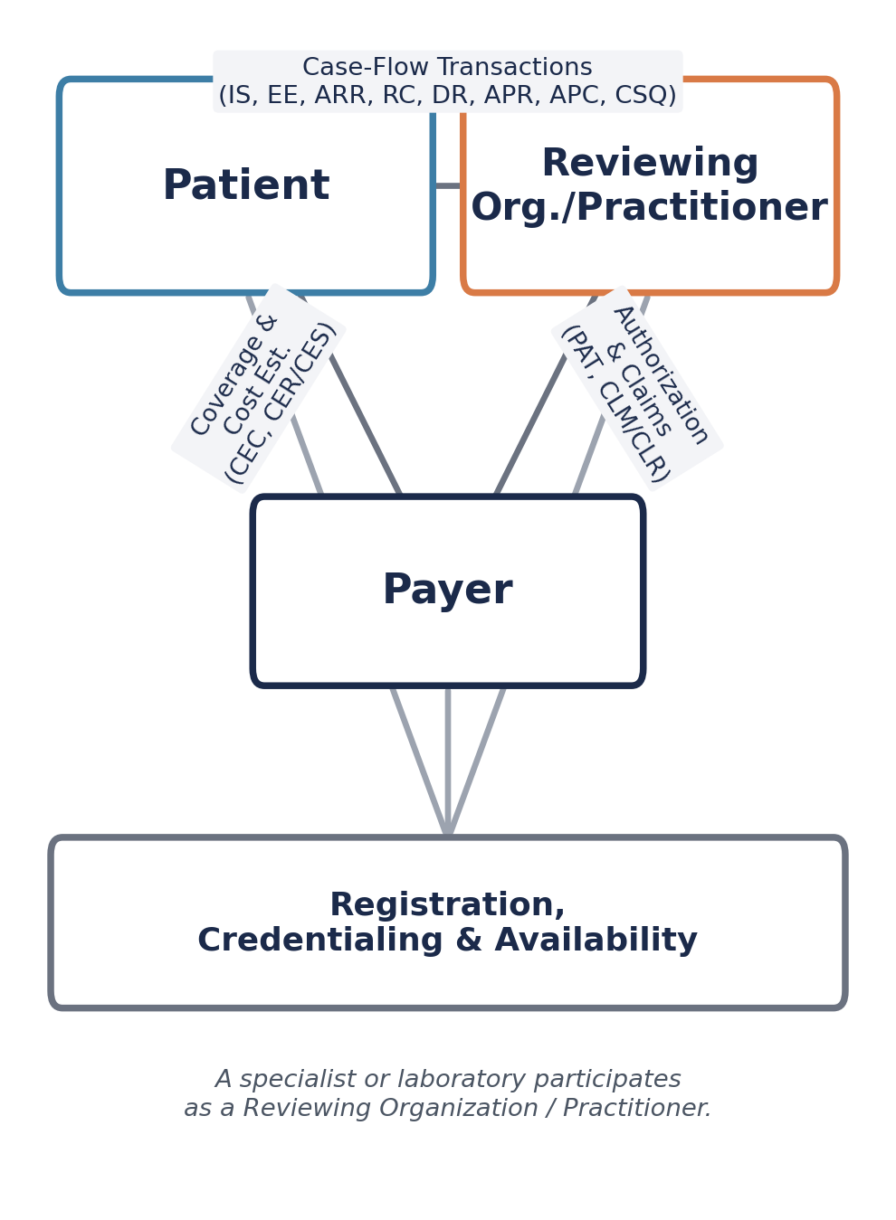
Fig. 1. Transacting parties and transaction categories.
Fig. 2 depicts the core case-flow sequence.
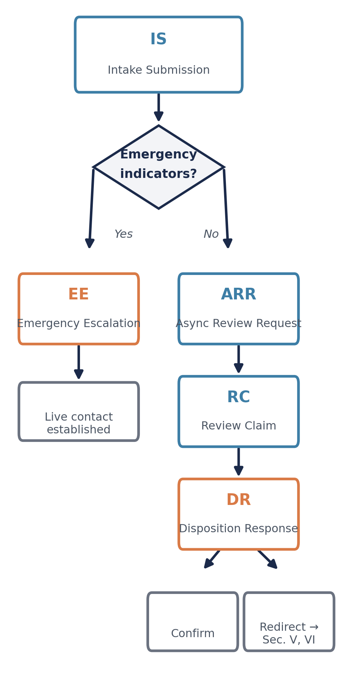
Fig. 2. Core case-flow sequence, from Intake Submission through the emergency fork to a Disposition Response.
Scenario A, routine disposition. A patient reports dysuria through a reference web application. An Async Review Request enters the queue. A physician, reviewing the queue through their own AI-assistant connector, issues a Review Claim and returns a Disposition Response confirming the AI-suggested antibiotic course.
Scenario B, emergency escalation. A patient reports crushing chest pain through a conformant AI-assistant connector. An Emergency Escalation transaction fires immediately, bypassing the queue entirely.
Scenario C, standard-designated redirect with cost estimate. A Disposition Response redirects to an orthopedic specialist referral. A Coverage Eligibility Check returns in-network and out-of-network options; the patient selects in-network. A Cost Estimate Response arrives on day five of the seven-day window as a subscription notification; the connector then books the appointment.
Scenario D, redirect requiring a lab result. A Disposition Response redirects to bloodwork. The connector books the draw. The result is pushed to the patient immediately while re-entering the queue as a new Async Review Request; the ordering physician's Disposition Response confirms no further action.
Scenario E, a recurring standing order. A CarePlan calls for a quarterly A1C panel. The patient's connector tracks the schedule, reminds the patient, and books the draw without a new Intake Submission. The result follows the same pattern as Scenario D.

IX. Governance and Toward Adoption
This paper proposes a framework; it does not constitute a ratified standard. In the interim, the specification artifacts are intended to be published as a FHIR Implementation Guide hosted from a public GitHub repository, the same workflow HL7 Work Groups use while a guide is in development.
The specification itself belongs with a neutral standards body, for the same reason the NCPDP Telecommunication Standard is maintained by NCPDP rather than any single switch or pharmacy chain. Credentialing is a verification step against the National Provider Identifier system. Hosting the registration directory is left open to multiple independent implementers. Payer conformance follows the same pattern: the cost-estimate timeframes are drawn directly from the CMS Interoperability and Prior Authorization Final Rule.
Client choice correlates with organizational scale: an individual patient or small organization is a natural adopter of a general-purpose AI connector; a large health system may expose these transactions through infrastructure it already operates. Neither path is exempt from registration, credentialing, and conformance. Neither major consumer AI assistant platform makes a Business Associate Agreement available for its free consumer chat product; a connector carrying these transactions must be built on an eligible API or enterprise surface with Zero Data Retention configured [18] [19] [20].

X. Limitations and Open Questions
Care coordinated by a caregiver or authorized proxy, and the specific mechanism by which an Emergency Escalation establishes live contact, remain unresolved. Accountability when a physician confirms an AI-suggested disposition that later proves wrong is not addressed. This framework assumes a patient has some conforming client; patients without reliable connectivity or a smartphone are not served by the transactions defined here. The five scenarios in Section VIII are illustrative worked examples, not an empirical evaluation; no reference implementation yet exists validating the transaction set under concurrent access.

XI. Conclusion
The constituent pieces of AI-mediated asynchronous care review are each independently mature, deployed commercially, evaluated in peer-reviewed research, or already legally required in adjacent form. What is absent is a shared transaction format connecting them, and a governance model that keeps the specification, credentialing, and implementation of that format in separate hands. This paper proposes such a framework and stakes the foundation for a complete technical specification and reference implementation to follow.

About the Authors
Santhosh Basineni is an independent researcher with over 13 years of experience in healthcare software engineering, specializing in pharmacy benefits management and claims adjudication.
Mounika Avirineni is an independent researcher.

References
[1] NCPDP (National Council for Prescription Drug Programs), Telecommunication Standard Implementation Guide.
[2] Business Wire, "GYANT Launches Asynchronous Care Platform with Intermountain Healthcare to Handle Urgent Care Cases Virtually," Jun. 2022.
[3] Business Wire, "GYANT Launches with Walmart Health Virtual Care to Automate Intake and Streamline Virtual Visits for Members Nationwide," Jun. 2022.
[4] D. Zeltzer, Z. Kugler, L. Hayat, T. Brufman, R. Ilan Ber, K. Leibovich, T. Beer, I. Frank, R. Shaul, C. Goldzweig, and J. Pevnick, "Comparison of Initial Artificial Intelligence (AI) and Final Physician Recommendations in AI-Assisted Virtual Urgent Care Visits," Annals of Internal Medicine, vol. 178, pp. 498-506, Apr. 2025.
[5] HIT Consultant, "Function Launches Secure Health Data Connector for ChatGPT, Claude, and Perplexity," Aug. 2026.
[6] E. Vedadi, D. Barrett, N. Harris, E. Wulczyn, et al., "Towards physician-centered oversight of conversational diagnostic AI," arXiv:2507.15743, Jul. 2025.
[7] S. Mukherjee, P. Gamble, M. S. Ausin, N. Kant, et al., "Polaris: A Safety-focused LLM Constellation Architecture for Healthcare," arXiv:2403.13313, 2024.
[8] HL7, "Building the Standards Infrastructure for Healthcare AI: Lessons from the Interoperability Journey," HL7 Blog, Nov. 2025.
[9] HL7, "Caliper FHIR Accelerator," HL7 Blog, Mar. 2026.
[10] HL7 International, HL7 FHIR (Fast Healthcare Interoperability Resources) Specification.
[11] HL7 International, CDS Hooks Specification.
[12] HL7 International, SMART App Launch Implementation Guide.
[13] Centers for Medicare & Medicaid Services (CMS), "CMS Interoperability and Prior Authorization Final Rule (CMS-0057-F)," Jan. 2024.
[14] CAQH CORE, "Priority Topics."
[15] American Medical Association, 2025 Prior Authorization Physician Survey.
[16] "21st Century Cures Act: Patient-Facing Implications of Information Blocking," PubMed, 2021.
[17] The Conversation, "The 21st Century Cures Act requires that patients receive medical results immediately, and new research shows patients prefer it that way," 2026.
[18] U.S. Department of Health and Human Services, Office for Civil Rights, "The Access Right, Health Apps, & APIs."
[19] Anthropic, "Business Associate Agreements (BAA) for Commercial Customers," Anthropic Privacy Center.
[20] OpenAI, "Enterprise privacy at OpenAI."

