Toward a Transaction Standard for Asynchronous AI-Mediated Care Review: A Proposed Framework
Santhosh Basineni
Independent Researcher
Mounika Avirineni
Independent Researcher

Abstract
A growing number of independent commercial and research systems implement some form of artificial-intelligence-mediated intake followed by physician review, decoupled from real-time scheduling. Each defines its own internal representation for how a case is submitted, escalated, queued, and resolved, with no shared transaction format across implementations. This mirrors the state of pharmacy claims processing prior to the adoption of the NCPDP Telecommunication Standard, under which a common transaction and segment structure replaced bespoke point-to-point integration between every payer and pharmacy. This paper proposes an analogous transaction framework for asynchronous, AI-mediated care review, a defined set of message types spanning intake submission, conservative emergency escalation, distributed asynchronous review, and structured disposition, specified as a profile over existing Fast Healthcare Interoperability Resources (FHIR) resources rather than as a competing data model. Coverage verification, cost estimation for redirected services, and claim submission are specified as payer-facing transactions grounded in the decision timeframes already required under the CMS Interoperability and Prior Authorization Final Rule, with network status left as an explicit, informed patient preference rather than an architectural default. The framework is illustrated with five worked scenarios. This paper presents the architecture and transaction model as a foundation for community and standards-body discussion; a complete technical specification, including full data-element schemas, code tables, and a reference implementation, is presented as separate, forthcoming work.
Index Terms—health information interoperability, HL7 FHIR, healthcare standards, asynchronous telehealth, artificial intelligence, transaction protocols, provider credentialing, prior authorization, NCPDP.

I. Introduction
Multiple independent systems now implement some variant of AI-mediated intake followed by physician review that is decoupled from live scheduling. A commercial asynchronous care platform was deployed with a large integrated health system as early as 2022 [2], a peer-reviewed evaluation of an AI-assisted virtual urgent-care model found its suggested dispositions comparable to or better than physicians' final recommendations in the majority of reviewed cases [4], and a 2025 industrial research system demonstrated a rigorously evaluated paradigm of asynchronous physician oversight of AI-conducted intake [6]. Each of these systems defines its own internal representation of the underlying workflow. None defines an interoperable transaction format that another vendor's intake system, review platform, payer, or scheduling system could implement independently.
This is a familiar juncture. Before the adoption of the NCPDP Telecommunication Standard [1], pharmacy claims adjudication required bespoke integration between every individual pharmacy and every payer; a shared transaction and segment structure subsequently made the entire ecosystem interoperable without requiring any single participant to adopt another's proprietary format. Health Level Seven International (HL7) has itself identified the analogous gap for the current moment: as agent-based clinical systems mature, the standards community will require, in the words of an HL7 practitioner writing on the organization's own blog, fine-tuned specifications for representing what AI model tools are, what they can do, and how their expected inputs and outputs should be structured [8].
The coordination this framework digitizes is, today, primarily a channel problem rather than a technology gap. Whether a case is covered, what a service will cost, and whether a claim or authorization has been approved are most often exchanged by phone, fax, or manual portal entry rather than a structured transaction: only 35% of medical prior authorizations are conducted fully electronically industry-wide [14], and the standards body responsible for administrative transaction adoption names reducing call-center costs and manual phone-based work as an explicit goal of further electronic adoption [14]. Physicians report spending an average of 13 hours a week on prior authorization alone, and two in five physician practices employ staff whose sole function is this coordination [15]. Each transaction defined in this paper, intake, escalation, review, disposition, registration, availability, coverage, cost estimation, authorization, and claims, corresponds to a category of exchange conducted today primarily by a person on a phone or a fax machine. Positioning AI at the center of that exchange, structuring what a patient, a reviewing organization or physician, and a payer each need to communicate to one another, is this framework's implicit case for reducing that channel's burden; this paper does not itself measure that reduction, only defines the structured alternative to the channel producing it.
The same client-neutral principle applies to every party in this exchange, not the patient alone. A reviewing physician or organization, and a payer, may equally interact with these transactions through a purpose-built application or a general-purpose AI-assistant connector, the same category of connector already used to bring a patient's own health data into a conversational assistant [5]. Routing an exchange through such a connector is not merely a channel substitution for the phone call or fax it replaces; a conversational interface can also contextualize a structured response for whoever is reading it, explaining what a coverage determination or a redirected disposition actually means for that party, rather than presenting a bare code. Prior work on AI-mediated clinical oversight has already shown a purpose-built review interface can measurably reduce the time and effort a professional needs to process a case relative to an unstructured consultation [6]; the transactions and client-neutrality defined in this framework are intended to make an equivalent effect available on the patient and payer sides of the same exchange, not only the reviewing physician's.
These three, patient, reviewing organization or practitioner, and payer, are the transacting parties this framework directly governs, not an exhaustive list of everyone a disposition may ultimately involve. A specialist engaged through a redirect participates as a reviewing organization or practitioner in its own right under Section V, rather than as a fourth role. A laboratory or diagnostic facility fulfilling an ordered test is not modeled as a distinct role; the order and result exchange itself is left to existing FHIR DiagnosticReport and Observation patterns. Where the ordered test requires an in-person visit, such as a blood draw or imaging study, that visit is scheduled using the same Appointment Request and Confirmation transactions defined in Section IV for specialist referrals, treating the lab or imaging facility as another registered participant rather than a fifth role. What this framework does address is what happens once a result returns. Federal information-blocking rules generally require a finalized result be released to the patient without delay, with only narrow, individualized exceptions [16], and a large patient survey found the substantial majority prefer immediate access, reporting no more worry after viewing results directly than before [17]. This framework does not gate that release. Instead, a finalized result is pushed to the patient's client at the same moment it re-enters the review loop as a new Async Review Request, preferably routed back to the original ordering practitioner within a defined window before falling back to the general pool. The patient's AI connector is expected to provide immediate contextual framing for the raw result, consistent with Design Principle 6, while clearly indicating that a clinician's Disposition Response is still pending; the clinician's subsequent interpretation then follows as a further notification through the same channel. This satisfies the immediacy patients are legally entitled to and largely prefer, without leaving interpretation to the connector alone. A prescription resulting from a Disposition Response is handed off, by design, to the existing NCPDP Telecommunication Standard for the pharmacy leg of that transaction, the same handoff pattern this framework already uses for prior authorization in Section VI, rather than redefining dispensing logic this framework has no reason to duplicate. Care coordinated on a patient's behalf by a caregiver or authorized proxy, and the specific mechanism by which an Emergency Escalation establishes live contact, are real and unresolved questions this framework does not yet address.
This paper proposes such a framework, not as a ratified standard, which requires the institutional legitimacy of a recognized standards body, but as a concrete architectural and transaction proposal intended to open that process. Section II reviews the systems and standards this proposal builds on. Section III states the design principles the framework must satisfy. Section IV defines the proposed case-flow transaction set. Section V defines how organizations and practitioners register and signal availability. Section VI defines coverage, cost-estimation, and payer-facing transactions, including how network status is left to informed patient choice. Section VII maps each transaction to underlying FHIR resources. Section VIII walks through five illustrative scenarios. Section IX addresses governance and the path from proposal to adoption. Section X names the limitations and open questions this proposal does not resolve.

II. Background and Related Work
Commercial deployment: An AI-driven intake platform was launched with a large health system's virtual urgent-care service in 2022, routing eligible patients to an asynchronous visit and populating the case directly into the reviewing clinician's record system; the same platform was subsequently deployed with an additional national virtual-care operator [2] [3]. These deployments demonstrate commercial viability but do not publish or propose an interoperable transaction format, nor address payer-facing coverage or cost transactions.
Clinical evaluation: A retrospective study comparing an AI system's initial suggested disposition to the reviewing physician's final recommendation across real virtual urgent-care encounters found the AI's suggestion rated of comparable or higher quality in the majority of cases where the two differed [4]. This establishes clinical viability for the disposition step but is a quality evaluation, not an interoperability proposal.
Data-access infrastructure: A 2026 health-data connector enables users to bring longitudinal laboratory and clinician-authored data into general-purpose AI assistants through remote Model Context Protocol connectors [5]. This addresses data access into a conversational AI context, a related but distinct problem from the case-routing, disposition, and payer transactions proposed here.
Academic precedent: The most directly related published work proposes and rigorously evaluates a paradigm of asynchronous physician oversight, in which an AI system conducts guarded history-taking and defers all individualized diagnostic and management decisions to a single overseeing primary care physician who reviews the case asynchronously [6]. In a randomized, blinded virtual clinical examination across sixty scenarios, this system outperformed both nurse-practitioner and physician control groups on intake quality and diagnostic composite performance. This work establishes the clinical and safety case for asynchronous oversight in detail, but is a single-overseeing-physician model rather than a distributed, credential-scoped reviewer pool, and neither proposes an interoperable message format nor addresses coverage, cost, or payer participation. A related industrial architecture uses a coordinated constellation of specialist agents for lower-acuity patient-facing communication tasks [7], illustrating further independent convergence on adjacent designs without a shared transaction layer between them.
Standards and regulatory context: FHIR is the dominant substrate for health data interoperability in the United States, and CDS Hooks already provides a pattern for triggering decision-support interactions at defined points in a clinical workflow [10] [11]. HL7 launched a new implementation community in March 2026 focused on integrating high-frequency personal and medical device data [9], evidence of active expansion into adjacent AI-era interoperability problems. Separately, the CMS Interoperability and Prior Authorization Final Rule already requires impacted payers to implement FHIR-based prior-authorization application programming interfaces and to issue decisions within fixed timeframes [13], establishing regulatory precedent this framework draws on directly in Section VI rather than proposing new payer obligations from first principles. Taken together, this body of commercial, clinical, standards, and regulatory work establishes that the constituent pieces are each independently mature. No existing implementation guide connects them into a single transaction set spanning intake, review, credentialing, and payer participation.

III. Design Principles
The framework is governed by seven principles. First, every non-emergency case must receive disposition from a credentialed human reviewer. Second, emergency escalation is a distinct, priority transaction, evaluated conservatively, and is architecturally separate from routine asynchronous review. Third, review assignment is queue-based and scoped by verified credential and current availability, established through the registration and availability transactions defined in Section V. Fourth, disposition is returned as a structured, coded response rather than free text, so downstream systems can act on it programmatically. Fifth, the framework is defined as a profile over existing FHIR resources rather than a competing data model. Sixth, the framework is agnostic to how any participant, patient, reviewing organization or practitioner, or payer, interacts with it: a purpose-built application and a general-purpose AI-assistant connector are equally valid clients for any role, provided each produces a conforming transaction. Seventh, network-status constraints on the reviewer pool are an informed patient preference communicated through the intake client, not an architectural default; the framework must expose sufficient cost and network information, defined in Section VI, for that preference to be genuinely informed rather than forcing a resolution in either direction.

IV. Proposed Case-Flow Transaction Model
Fig. 1 summarizes the three transacting parties this framework governs and the transaction categories connecting them, before the specific transactions within each category are defined in the remainder of this and the following two sections.
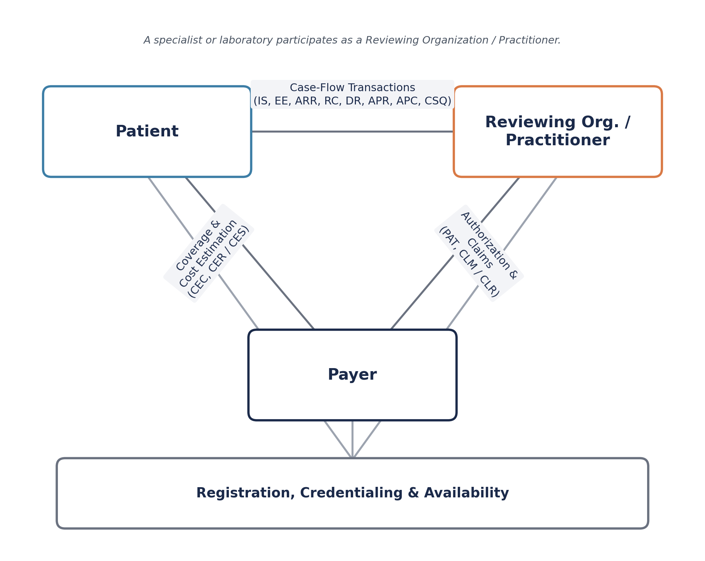
Fig. 1. Transacting parties and transaction categories. A specialist or laboratory participates as a Reviewing Organization / Practitioner rather than as a fourth party.
Eight transaction types govern the clinical case flow, summarized in Table I. This is a proposed set at the level of purpose and core elements; complete field-level schemas and code tables are scoped to the forthcoming full specification described in Section IX.
TABLE I. PROPOSED CASE-FLOW TRANSACTION TYPES
Code | Transaction | Core Elements | FHIR Basis
IS | Intake Submission | Case ID, structured symptom/history data, urgency score | QuestionnaireResponse, Observation, Encounter
EE | Emergency Escalation | Priority flag, red-flag indicators, live-endpoint reference | ServiceRequest (priority=stat), Communication
ARR | Async Review Request | Full case file, AI-suggested disposition, confidence metadata | Task (status=requested, pool-scoped)
RC | Review Claim | Reviewer identifier, credential scope, claim timestamp | Task (status: requested→in-progress)
DR | Disposition Response | Outcome code (confirm/redirect), reason-type code, urgency designation, next action | Task (status→completed), new ServiceRequest if redirected
APR | Appointment Request | Target org/practitioner reference, selected Slot reference, urgency designation | Appointment (status=proposed)
APC | Appointment Confirmation | Confirmed or alternate Slot, location/logistics reference | Appointment (status: proposed→booked)
CSQ | Case Status Query | Case ID | Task read/search interaction

The Emergency Escalation transaction is architecturally distinct from the Async Review Request, not a variant of it: a true emergency cannot be routed into the same queue as routine cases and rely on prioritization alone. The Review Claim transaction allows any credentialed, available reviewer to accept responsibility for a queued case without a central scheduler assigning it, while preventing two reviewers from independently claiming the same case. Disposition Response carries an expedited-or-standard urgency designation on any redirect outcome, independent of the original intake classification; this designation governs the payer-facing timelines defined in Section VI. Fig. 2 depicts this sequence, including the point at which Disposition Response either confirms the case or redirects it into the transactions defined in Sections V and VI.
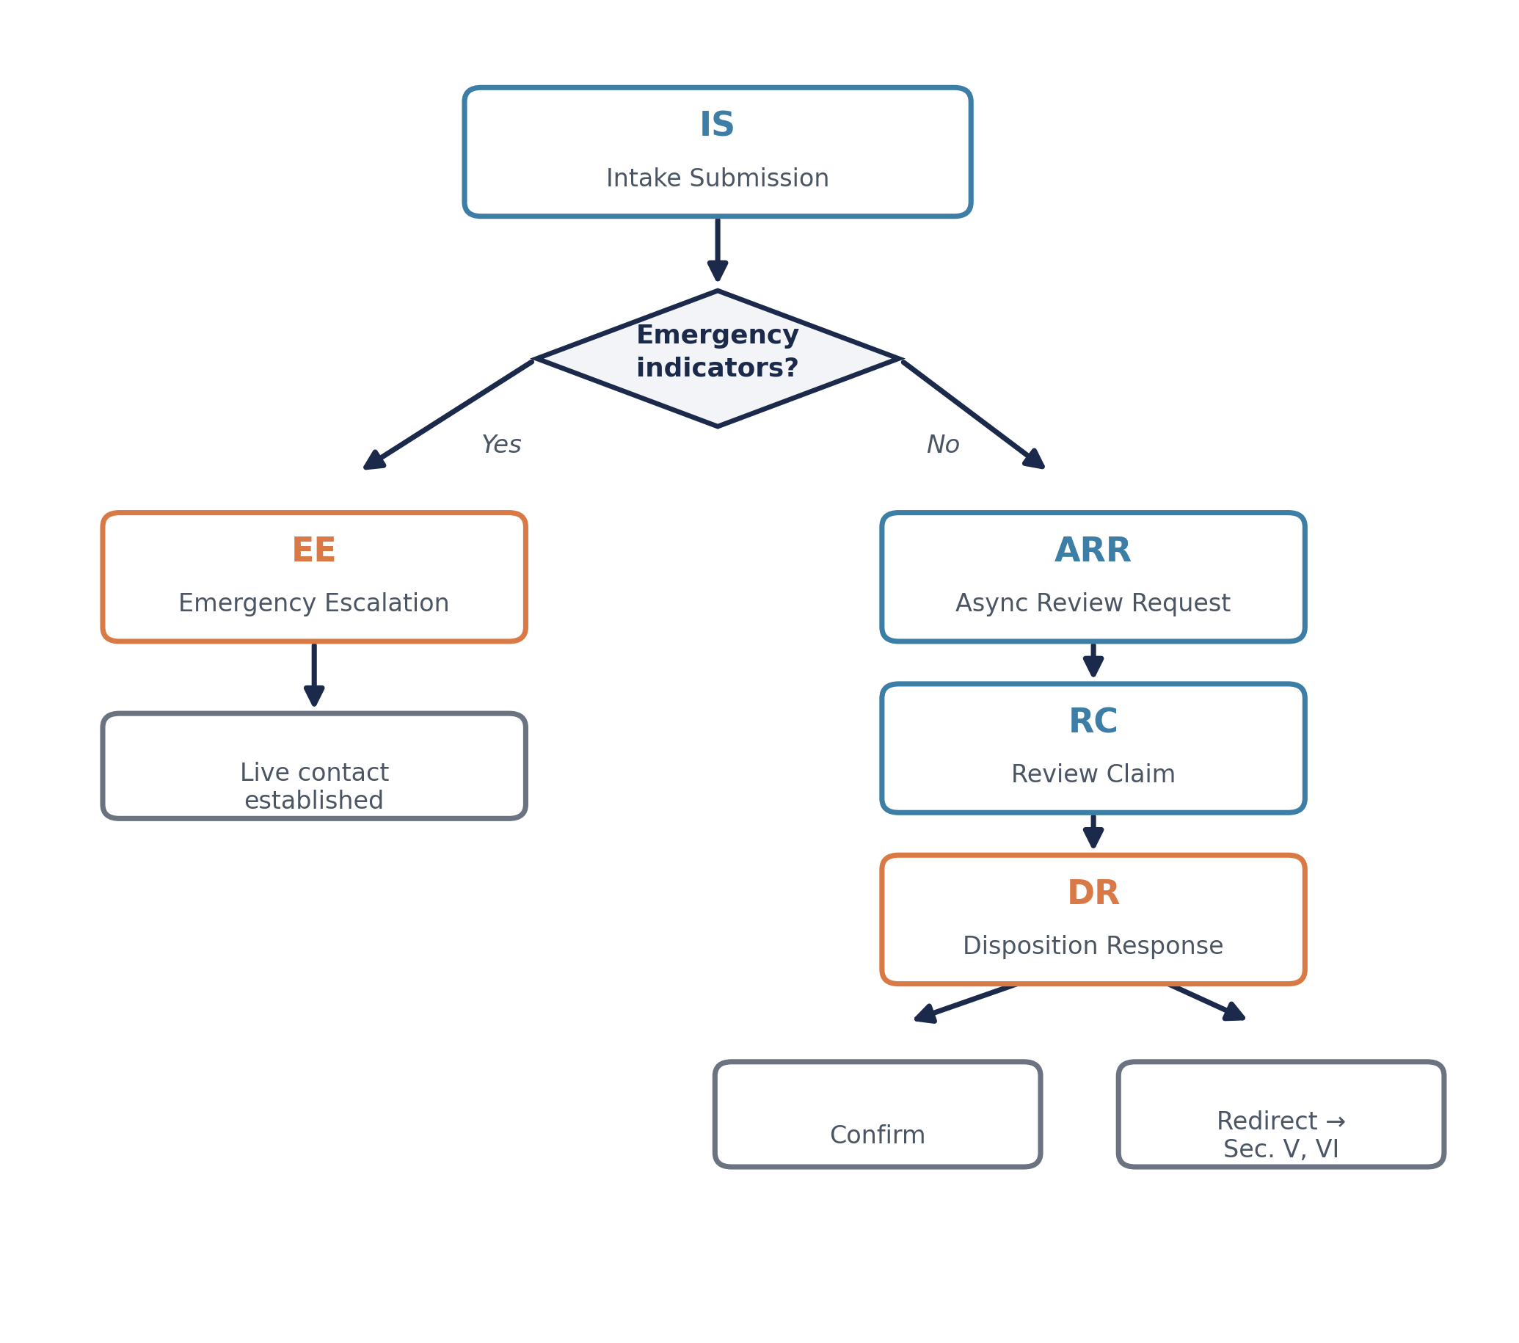
Fig. 2. Core case-flow sequence, from Intake Submission through the emergency fork to a Disposition Response.
When a Disposition Response redirects to a specialist referral or in-person care, the resulting appointment is booked through the same client-neutral pattern as intake: the patient's own client, a reference web application or their AI-assistant connector, submits an Appointment Request against a Slot the target organization or practitioner has exposed through its own Availability Update, the same registration and availability transactions defined in Section V applied to a referral target rather than an async-case reviewer. The reviewing physician's role ends at the Disposition Response; scheduling is not performed by a referral coordinator or the reviewing organization's staff on the patient's behalf, which would simply reintroduce the phone-based coordination this framework is intended to displace. An Appointment Confirmation finalizes the booking or, where the requested Slot was claimed concurrently, offers the next available alternative. A patient's AI connector may act on their explicit instruction, for example securing the earliest available in-network opening, without the connector making that choice unprompted.
Not every appointment originates from a fresh redirect. A Disposition Response may instead establish a recurring order, represented as a FHIR CarePlan with a repeating ServiceRequest, a quarterly laboratory panel tied to an ongoing condition rather than a single ad hoc request. Tracking when the next occurrence falls due, reminding the patient as it approaches, and initiating the Appointment Request once it is, are treated as an ordinary extension of the patient's own client acting on their behalf, consistent with the same connector role already established for a one-time booking. No new transaction type is required: the recurring order is a CarePlan-scoped ServiceRequest generating the same Appointment Request each time it comes due, without a new Intake Submission or Disposition Response triggering it.

V. Registration, Credentialing, and Availability
The transaction model in Section IV assumes a pool of verified, currently available reviewers already exists. This section defines how that pool is established, the piece a purely clinical transaction set would otherwise leave implicit.
Three additional transactions are proposed, summarized in Table II. Organization Registration establishes a healthcare organization as a participant, carrying its organizational National Provider Identifier, legal name, a technical endpoint, and a verification status. Practitioner Registration establishes an individual reviewer, carrying their individual National Provider Identifier, state medical license and issuing state, a credential-scope declaration, organizational affiliation, and a verification status. Availability Update allows a registered, verified practitioner to signal current eligibility to claim cases, scoped by credential type and carrying an expiry after which the signal lapses.
TABLE II. PROPOSED REGISTRATION AND AVAILABILITY TRANSACTION TYPES
Code | Transaction | Core Elements | FHIR Basis
OR | Organization Registration | Organizational NPI, legal name, technical endpoint, verification status | Organization, Endpoint
PR | Practitioner Registration | Individual NPI, state license & issuing state, credential scope, organizational affiliation(s), verification status | Practitioner, PractitionerRole
AU | Availability Update | Practitioner reference, credential-scope filter, availability status, expiry | Schedule, Slot

This framework intentionally does not define a new credentialing authority. Verification status is intended to be established against existing authoritative sources, the National Plan and Provider Enumeration System and state medical board licensure records, rather than a self-asserted or newly invented credential. The transactions carry the resulting verification status; they do not compute it. A revocation is a status transition on the existing Practitioner Registration record rather than a separate transaction type. An Async Review Request is only claimable by a practitioner with both a verified Practitioner Registration and a current Availability Update matching the case's required credential scope.

VI. Coverage, Cost Estimation, and Payer Conformance
Sections IV and V establish who reviews a case and how. This section addresses a question left open so far: whether the reviewer pool should be constrained to a patient's in-network physicians, and how a payer participates in the framework at all.
This framework does not resolve the network-status question architecturally. Restricting the reviewer pool to in-network physicians protects the patient from unexpected cost but narrows and slows the pool the distributed-review model depends on for speed; leaving it unrestricted preserves speed but exposes the patient to potential out-of-network cost. Resolving this centrally in either direction would substitute the framework's judgment for the patient's own. Network status is instead treated as a patient preference, informed by the coverage information this section defines, and communicated through whichever client originated the case, consistent with Design Principle 7.
Four transactions establish this, summarized in Table III. Coverage Eligibility Check verifies the patient's benefit for the review or redirected service and returns available options segmented by network status and estimated cost-share, the information the patient's choice depends on. Cost Estimate Request and Response apply when a Disposition Response redirects to a service requiring payer cost confirmation, and are proposed as a predetermination-type claim rather than a live billing claim, since no service has yet been rendered. Prior Authorization Trigger hands redirect cases requiring formal authorization to HL7's existing Da Vinci Prior Authorization Support implementation guide rather than defining new authorization semantics. Claim Submission and Response handle billing for the review encounter itself, and a lab or facility fulfilling a redirected order uses the same transaction pair for its own billing rather than a separate mechanism.
TABLE III. PROPOSED COVERAGE AND PAYER-FACING TRANSACTION TYPES
Code | Transaction | Core Elements | FHIR Basis
CEC | Coverage Eligibility Check | Coverage ID, service type, network-status query | CoverageEligibilityRequest / Response
CER / CES | Cost Estimate Request / Response | Redirected service type, expedited-or-standard designation, network option selected, estimate or pending status | Claim (use=predetermination) / ClaimResponse
PAT | Prior Authorization Trigger | Redirected service type, reference to external exchange | Handoff to Da Vinci PAS implementation guide
CLM / CLR | Claim Submission / Response | Encounter reference, billed service, disposition reference | Claim (use=claim) / ClaimResponse

Rather than propose a new response-time obligation, this framework adopts the decision timeframes payers are already required to meet under the CMS Interoperability and Prior Authorization Final Rule: seventy-two hours for expedited requests and seven calendar days for standard requests [13]. For a payer to be a conforming participant, Cost Estimate Response must be returned within these same windows. Framing conformance this way means participation is largely an extension of infrastructure impacted payers are already obligated to build, not a new one. Critically, scheduling for a standard-designated redirect proceeds automatically once the seven-day window closes, whether or not a response has arrived, and correspondingly at seventy-two hours for an expedited designation, so that a slow or non-responsive payer cannot indefinitely block care.
The client that originated the case is expected to receive Cost Estimate Response updates as a push notification rather than requiring the patient to poll, proposed as a FHIR Subscription against the relevant resource rather than a bespoke mechanism defined solely for this framework. Consistent with Design Principle 6, a payer may equally expose Coverage Eligibility Check and Cost Estimate Response through a general-purpose AI connector rather than a dedicated portal, allowing the same conversational interface a patient or reviewing organization already uses to also surface and explain the payer's response, rather than requiring a separate channel solely for that party.

VII. Relationship to Existing Standards
Rather than defining new base resources, each transaction is proposed as a profile over existing FHIR resources, following the pattern established by prior implementation guides such as those developed under HL7's Da Vinci accelerator. An Intake Submission is represented as a QuestionnaireResponse and Observation resources linked to a new Encounter. An Emergency Escalation is a ServiceRequest with an urgent priority flag paired with a Communication resource. An Async Review Request is a Task in a requested state, scoped to a credential-defined pool rather than an individual Practitioner reference. A Review Claim transitions that Task to in-progress and binds it to a specific Practitioner. A Disposition Response transitions the Task to completed, carrying a structured outcome extension and generating a new ServiceRequest on redirect. Appointment Request and Confirmation profile the FHIR Appointment resource, referencing the Slot selected from the target's Availability Update in the same manner Review Claim references a reviewing practitioner's own availability. A Case Status Query is a standard Task read or search interaction.
Organization Registration profiles Organization and Endpoint. Practitioner Registration profiles Practitioner and PractitionerRole, with credential scope via specialty and available-service-type elements. Availability Update profiles Schedule and Slot, with an open Slot representing a live availability window.
Coverage Eligibility Check profiles CoverageEligibilityRequest and CoverageEligibilityResponse. Cost Estimate Request and Response profile Claim and ClaimResponse using FHIR's existing predetermination use case, distinguishing a non-binding estimate from a live claim without a new resource. Prior Authorization Trigger is intentionally not profiled as a new resource at all; it is a handoff to the Da Vinci Prior Authorization Support implementation guide, consistent with this framework's position that authorization semantics already have an owner. Claim Submission and Response profile Claim and ClaimResponse in ordinary billing use, and push notification for Cost Estimate Response is proposed as a FHIR Subscription rather than a mechanism invented for this purpose. Client neutrality across all three parties, patient, reviewing organization or practitioner, and payer, is consistent with how SMART App Launch already allows any authorized client to interact with a FHIR server through a common authorization pattern [12]; this framework assumes an equivalent authorization layer rather than defining a new one.

VIII. Illustrative Scenarios
Scenario A, routine disposition. A patient reports dysuria through a reference web application. An Intake Submission is generated; the urgency classifier detects no emergency indicators. An Async Review Request enters the queue. A physician with a verified Practitioner Registration and current Availability Update, reviewing the queue through their own AI-assistant connector rather than a dedicated portal, issues a Review Claim and returns a Disposition Response confirming the AI-suggested antibiotic course. No Emergency Escalation or coverage transaction is generated.
Scenario B, emergency escalation. A patient reports crushing chest pain through a conformant AI-assistant connector. The urgency classifier flags emergency indicators immediately. An Emergency Escalation transaction fires, establishing live contact and bypassing the queue entirely. No Async Review Request or coverage transaction is generated for this encounter.
Scenario C, standard-designated redirect with cost estimate. A patient's Intake Submission describes joint pain lasting several weeks; no emergency indicators are detected, and a physician's Disposition Response redirects the case to an orthopedic specialist referral, designated standard. A Coverage Eligibility Check returns two options: a lower-cost in-network specialist and a faster-available out-of-network specialist. The patient, through the same connector used for intake, is shown both the cost and availability difference and selects the in-network option. A Cost Estimate Request is submitted as a predetermination claim; the payer has seven calendar days to respond. On day five, a Cost Estimate Response confirming the cost-share arrives as a subscription notification to the patient's connector, with no polling required. The connector then submits an Appointment Request against an open Slot from the specialist's exposed Availability Update; an Appointment Confirmation finalizes the booking. Had the payer not responded within the seven-day window, the same Appointment Request and Confirmation sequence would have proceeded at its close regardless.
Scenario D, redirect requiring a lab result. A patient's Intake Submission describes persistent fatigue; no emergency indicators are detected, and the reviewing physician's Disposition Response redirects to bloodwork, designated standard, generating a new ServiceRequest. Because the requested panel needs an in-person draw, the patient's connector submits an Appointment Request against an open Slot from a registered lab's Availability Update, and an Appointment Confirmation books the draw for the following morning. The lab fulfills the order and finalizes a DiagnosticReport through existing FHIR result-reporting patterns. The result is pushed to the patient's connector the moment it is finalized, with immediate contextual framing, while simultaneously entering the queue as a new Async Review Request. The original ordering physician, available within the same day, issues a Review Claim and returns a Disposition Response confirming the result requires no further action. The patient's connector delivers this final interpretation through the same notification channel used throughout the case.
Scenario E, a recurring standing order. A physician managing a patient's diabetes has previously established a CarePlan calling for an A1C panel every three months. The patient's connector tracks this recurring ServiceRequest, reminds the patient a week before the panel is due, and, on the patient's confirmation, submits an Appointment Request against an open Slot from a registered lab's Availability Update, without a new Intake Submission or Disposition Response triggering it. The Appointment Confirmation books the draw. Once the result returns, it is pushed to the patient's connector immediately and re-enters the queue as a new Async Review Request, following the same pattern as Scenario D, and the reviewing physician's Disposition Response updates the CarePlan for the next occurrence.

IX. Governance and Toward Adoption
This paper proposes a framework; it does not constitute a ratified standard. Legitimacy for a specification of this kind is ordinarily established through voluntary multi-vendor adoption or formal advancement through a recognized standards body's working group and balloting process. This paper is offered as the starting artifact for either path.
In the interim, before any formal standards-body sponsorship, the specification artifacts themselves, FHIR StructureDefinitions, ValueSets, and example instances for the transactions defined in Tables I through III, are intended to be published as a FHIR Implementation Guide using HL7's own open-source IG Publisher toolchain, hosted from a public GitHub repository and built to a static site, the same workflow HL7 Work Groups themselves use while a guide is still in development. If a Work Group later sponsors formal adoption, the guide can migrate to HL7's own build and publication infrastructure without a change in underlying tooling or format.
A specification of this kind also requires a governance answer distinct from its technical content: who registers organizations and practitioners, who hosts the resulting directory, and who builds client applications must not collapse into a single owner. Three roles are deliberately kept separate. The specification itself belongs with a neutral standards body, not with any implementing vendor, for the same reason the NCPDP Telecommunication Standard is maintained by NCPDP rather than by any single switch or pharmacy chain. Credentialing is a verification step against the National Provider Identifier system and existing state licensing boards, as described in Section V. Hosting the registration directory, availability signaling, and reference client applications is left open to multiple independent implementers. Payer conformance follows the same pattern: rather than establishing new obligations, the cost-estimate timeframes in Section VI are drawn directly from the CMS Interoperability and Prior Authorization Final Rule, so a payer's existing compliance work is largely reusable rather than duplicated. In practice, a small number of implementations may come to dominate through adoption, but the specification itself should not name or require any particular one.
In practice, client choice is likely to correlate with organizational scale, an extension of the multiple-implementer pattern above rather than an exception to it. An individual patient, and a small organization without a dedicated integration budget, a solo practitioner's office, a small independent lab, are the most natural adopters of a general-purpose AI connector as their interface to this framework, since building bespoke software is not a realistic expectation for either. A large health system, national payer, or laboratory network may instead expose these transactions through infrastructure it already operates. Neither path is privileged under Design Principle 6, and neither is exempt from it: a participant reached only through a general-purpose connector still registers, is credentialed, and produces conforming transactions under Sections V and VI exactly as a participant with its own dedicated system does. The connector is a choice of interface, not a substitute for participation in the standard.
This distinction has a direct regulatory consequence. Under HIPAA guidance from the Department of Health and Human Services, a covered entity is generally not required to enter a Business Associate Agreement with a general-purpose AI connector a patient independently selects to exercise their own right of access, and is not liable for that connector's subsequent handling of the data, provided the connector was not developed for or provided by the covered entity itself [18]. That protection does not automatically run the other direction: a reviewing organization, payer, or lab that itself chooses to expose Coverage Eligibility Check, Availability Update, or any other transaction through a general-purpose AI connector, rather than a patient independently choosing one, is likely establishing a business associate relationship requiring its own agreement with that connector's provider, since the connector is then acting on the covered entity's behalf rather than at the patient's independent direction. Client neutrality under Design Principle 6 describes what transaction format a connector must produce; it does not resolve which side of this distinction a given deployment falls on, and implementers on the provider, payer, or lab side should treat that determination as a compliance question separate from this framework's transaction model.
This determination also depends on which product surface a connector is built on, not only on who directs the transaction. Neither major consumer AI assistant platform makes a Business Associate Agreement available for its free or standard consumer chat product; a connector built on those surfaces cannot be brought into HIPAA compliance regardless of who initiates the exchange [19] [20]. Both instead offer eligible configurations, specifically their first-party APIs and enterprise-tier products, under which a signed Business Associate Agreement applies and Zero Data Retention can be enabled so inputs and outputs are not retained beyond the call needed to serve the request. A connector carrying these transactions on behalf of a reviewing organization, payer, or lab must be built on one of these eligible surfaces with Zero Data Retention configured, not a consumer chat interface. Patient-directed use through a consumer surface avoids covered-entity liability under the access-right exception described above, but does not by itself limit how that provider's consumer product retains the data outside a HIPAA context.
A complete technical specification, full data-element tables for every transaction defined in Tables I through III, formal code systems, conformance requirements, and a reference implementation validating the transaction set against real case flows, is presented as separate, forthcoming work.

X. Limitations and Open Questions
Several matters that bear directly on safe deployment remain outside this proposal's scope. Care coordinated on a patient's behalf by a caregiver or authorized proxy, and the specific mechanism by which an Emergency Escalation establishes live contact, whether a live clinician queue, a telehealth operator, or emergency dispatch, are named in Section I as unresolved and remain so; this framework does not specify either.
Accountability when a physician confirms an AI-suggested disposition that later proves wrong is not addressed. Existing legal and professional frameworks for supervisory liability may or may not extend cleanly to this arrangement, and this framework takes no position on the question, leaving it to the same professional and legal channels that already govern a clinician's sign-off on any decision-support tool.
This framework also assumes a patient has some conforming client, a web application or an AI-assistant connector, capable of participating. Patients without reliable connectivity, without a smartphone, or without functional literacy in whatever language a given connector operates in are not served by the transactions defined here, and the framework does not itself specify a fallback path for that population; any real deployment would need one.
Finally, the five scenarios in Section VIII are illustrative worked examples, not an empirical evaluation. No reference implementation yet exists validating that the transaction set, and specifically the Task state machine underlying Async Review Request, Review Claim, and Disposition Response, behaves correctly under concurrent access, such as two reviewers claiming the same case simultaneously. That validation is scoped to the forthcoming full technical specification referenced throughout this paper, not resolved here.

XI. Conclusion
The constituent pieces of AI-mediated asynchronous care review, conversational intake, conservative emergency escalation, distributed physician review, structured disposition, provider registration and credentialing, and payer-facing coverage and cost transactions grounded in existing prior-authorization regulation, are each independently mature, deployed commercially, evaluated in peer-reviewed research, or already legally required in adjacent form. What is absent is a shared transaction format connecting them, and a governance model that keeps the specification, credentialing, and implementation of that format in separate hands. This paper proposes such a framework, built as a profile over existing FHIR resources and existing regulatory timeframes rather than new obligations invented from first principles, and stakes the foundation for a complete technical specification and reference implementation to follow.

References
[1] NCPDP (National Council for Prescription Drug Programs), Telecommunication Standard Implementation Guide.
[2] Business Wire, "GYANT Launches Asynchronous Care Platform with Intermountain Healthcare to Handle Urgent Care Cases Virtually," Jun. 2022.
[3] Business Wire, "GYANT Launches with Walmart Health Virtual Care to Automate Intake and Streamline Virtual Visits for Members Nationwide," Jun. 2022.
[4] D. Zeltzer, Z. Kugler, L. Hayat, T. Brufman, R. Ilan Ber, K. Leibovich, T. Beer, I. Frank, R. Shaul, C. Goldzweig, and J. Pevnick, "Comparison of Initial Artificial Intelligence (AI) and Final Physician Recommendations in AI-Assisted Virtual Urgent Care Visits," Annals of Internal Medicine, vol. 178, pp. 498-506, Apr. 2025.
[5] HIT Consultant, "Function Launches Secure Health Data Connector for ChatGPT, Claude, and Perplexity," Aug. 2026.
[6] E. Vedadi, D. Barrett, N. Harris, E. Wulczyn, et al., "Towards physician-centered oversight of conversational diagnostic AI," arXiv:2507.15743, Jul. 2025.
[7] S. Mukherjee, P. Gamble, M. S. Ausin, N. Kant, et al., "Polaris: A Safety-focused LLM Constellation Architecture for Healthcare," arXiv:2403.13313, 2024.
[8] HL7, "Building the Standards Infrastructure for Healthcare AI: Lessons from the Interoperability Journey," HL7 Blog, Nov. 2025.
[9] HL7, "Caliper FHIR Accelerator," HL7 Blog, Mar. 2026.
[10] HL7 International, HL7 FHIR (Fast Healthcare Interoperability Resources) Specification.
[11] HL7 International, CDS Hooks Specification.
[12] HL7 International, SMART App Launch Implementation Guide.
[13] Centers for Medicare & Medicaid Services (CMS), "CMS Interoperability and Prior Authorization Final Rule (CMS-0057-F)," Jan. 2024.
[14] CAQH CORE, "Priority Topics."
[15] American Medical Association, 2025 Prior Authorization Physician Survey.
[16] "21st Century Cures Act: Patient-Facing Implications of Information Blocking," PubMed, 2021.
[17] The Conversation, "The 21st Century Cures Act requires that patients receive medical results immediately, and new research shows patients prefer it that way," 2026.
[18] U.S. Department of Health and Human Services, Office for Civil Rights, "The Access Right, Health Apps, & APIs."
[19] Anthropic, "Business Associate Agreements (BAA) for Commercial Customers," Anthropic Privacy Center.
[20] OpenAI, "Enterprise privacy at OpenAI."

About the Authors
Santhosh Basineni is an independent researcher with over 13 years of experience in healthcare software engineering, specializing in pharmacy benefits management and claims adjudication.
Mounika Avirineni is an independent researcher.

