Initially I importing all the dependencies.

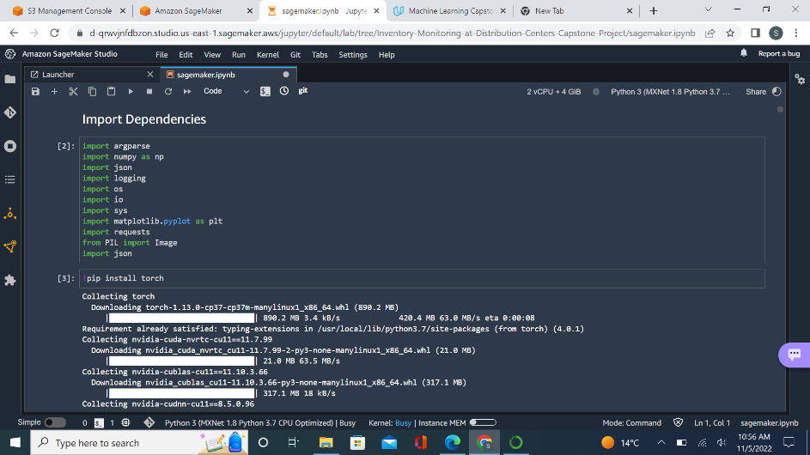

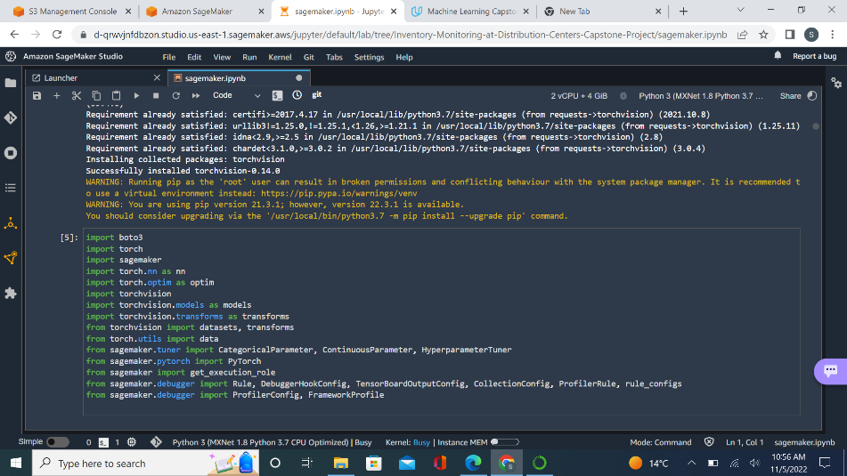

Then I am preparing the data.

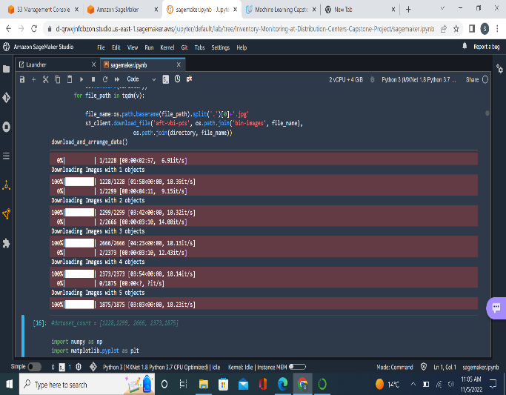

We visualized the data distribution.

This is the Amazon bin dataset Image.

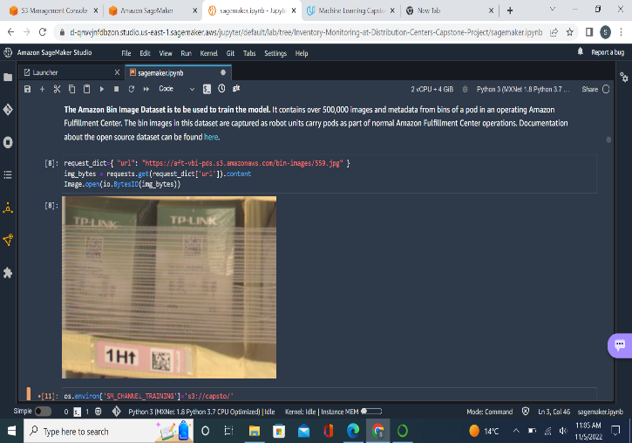

I started tuning the hyperparameters and used fit for the tuner.

I got the best hyperparameters.

The I fit the estimator for training.

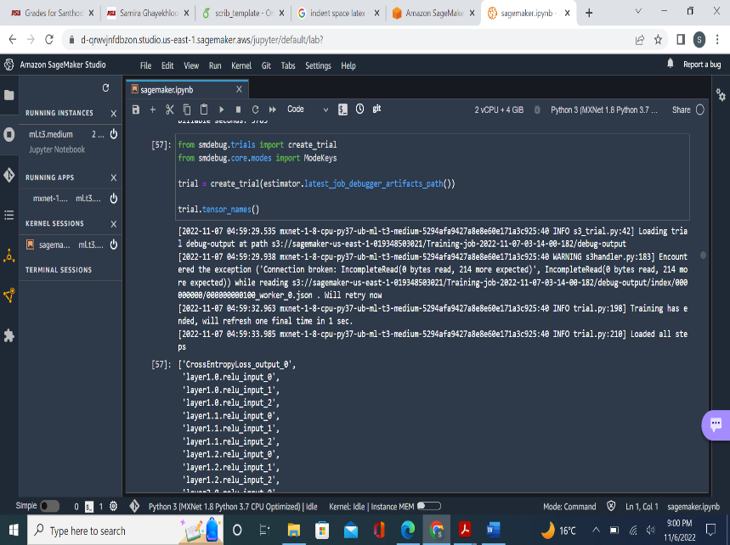

Validating Loss:

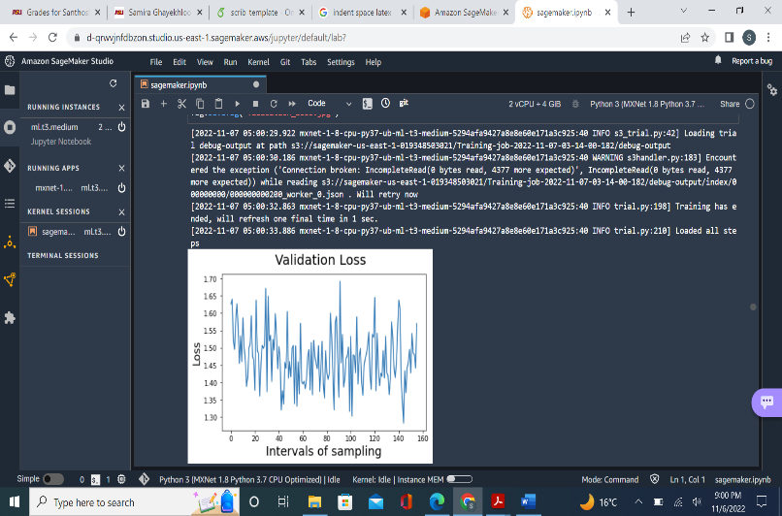

Cross Entropy output:

And finally fit the model for multi-instances.

