Development environment setup for .Net Core with Visual Studio Code

**Prerequisites:**

1. .Net Core SDK 3.0
2. [C# extension](https://marketplace.visualstudio.com/items?itemName=ms-vscode.csharp) from the VS Code Marketplace ([OmniSharp](https://github.com/OmniSharp/omnisharp-roslyn))

**Analance dependencies:**

1. Mongo setup

* Install **mongodb** (Version **4.0** and above)
* Install **robo3t**
* Execute **Core DB Script** located in “.\App_Data\Script\” of your **AnalanceCore** repository.

1. Consul (Consul should be running before starting services)

* Find the consul setup file (**consul_setup_1.5.3_windows_amd64.zip**) located in “.\ThirdParty\” of your **AnalanceCore** repository.
* Extract it in your preferred location.
* And follow the readme.txt to run the consul.

**Steps:**

1. Open a folder where solution(.sln) file of your repository is located.
2. You can configure which services to run by using the "**Run Analance Services**" compound located at the end of the **launch.json (located inside “.\.vscode\” folder of the repository)** file**.**

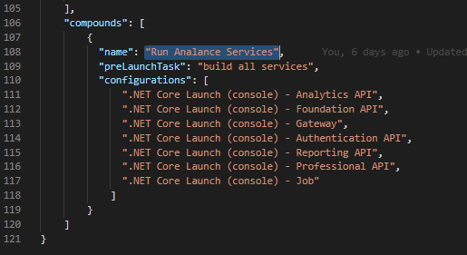

1. To **Run** the services, navigate to **Debug** section in the side bar, select the debug option as “**Run Analance Services**”. And click **Run** icon near the dropdown.

**Debug section in VS Code:**

 Find **launch.json** by clicking the settings icon.

**Nuget configurations:**

* Replace the **Nuget.config** file (located in %userprofile%\AppData\Roaming\NuGet) with the below text (double click the attachment to get the code),



* Configure the **appsettings.yml** file based on your local setup.

**References:**

* <https://docs.microsoft.com/en-us/dotnet/core/tools/?tabs=netcore2x>
* <https://docs.microsoft.com/en-in/dotnet/core/tutorials/with-visual-studio-code>
* <https://github.com/OmniSharp/omnisharp-vscode/blob/master/debugger-launchjson.md> (launch.json)
* <https://code.visualstudio.com/docs/editor/tasks> (tasks.json)

**Plugins for C#/.Net development:**

* [VSCode Solution Explorer](https://marketplace.visualstudio.com/items?itemName=fernandoescolar.vscode-solution-explorer)