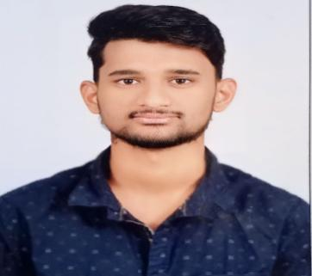

# PROFILE

* Conflict Resolution
* Good Analytical and Communication Skills
* Organizational Skills
* Bias of action

# CONTACT

**PHONE:** 93926122214

## ADDRESS:

**H. No:** 11-25-867/1, Kothawada, Warangal, Telangana. (506002) **EMAIL ID:**

[santhoshdasi441@gmail.com](mailto:santhoshdasi441@gmail.com)

# HOBBIES.

* + Cooking
  + Reading Well-known stories
  + Gaming

# PERSONALITY TRAITS

* Adaptability and Flexibility
* Communication Skills
* Fair level of patience and Ability to work in team.

DASI

SANTHOSH

# CAREER OBJECTIVE:

To serve as a Technical Professional in a challenging and evolving environment where my skills are utilized, and I get an opportunity to learn and hone my skills.

# ALMA MATER:

**B. TECH :** Vaagdevi Engineering College (2020-2024) Bollikunta, Warangal. (Affiliated JNTUH)

## Secured CGPA - 7.0 (Up to 2-2 Semester)

**INTERMEDIATE :** Krishnaveni Junior College, Hanamakonda (2018-2020) in CSE Stream.

(Telangana State Board of Technical Education)

## Scored marks: 906

**SSC :** New Raman High School, Warangal

(2017-2018) (Board of Secondary Education, Telangana)

## Secured CGPA - 9.3 TECHNICAL SKILLS

* C, C++ LANGUAGE
* Python Programming language
* Java programming language
* HTML, CSS & JAVASCRIPT
* MS - OFFICE (MS-Word, MS-Power point, MS-Excel)

# ACHIEVEMENTS

* Certified from VIBA as A+ in the HTML, CSS and JS.
* Certified from DBMS Workshop conducted by TASK.
* Qualified JEE Examination In Intermediate.

# PERSONAL PROFILE

Father’s Name - D.Rajamouli Gender - Male Marital status - Unmarried Nationality - Indian

Date of Birth - 10-12-2003 Location - Warangal

Languages - Telugu,

Known Hindi, English.

## ACADEMIC PROJECT:

.

# DECLARATION:

I hereby declare that above mentioned information is true to the best of my knowledge.

**DASI SANTHOSH**