SR UNIVERSITY
School of Computer Science and Artificial Intelligence

DAV PROJECT REPORT
AGRICULTURE CROP ANALYTICS
Data Analytics and Visualization

Submitted by
K. SURYA
P. SHIVA SAI
G. SANTHOSH
Course: Data Analytics and Visualization (25CAI202PC201)
Academic Year: 2026–27
Submitted to SR University in partial fulfilment of the academic project requirements.

CERTIFICATE
This is to certify that the project report entitled “AGRICULTURE CROP ANALYTICS” is a bonafide record of work carried out by K. SURYA, P. SHIVA SAI and G. SANTHOSH in partial fulfilment of the requirements for the course Data Analytics and Visualization (25CAI202PC201) at the School of Computer Science and Artificial Intelligence, SR University, Warangal, during the academic year 2026–27, under my supervision.
The results presented in this report have been prepared from the agriculture crop analytics dataset supplied for this project.
______________________________
Faculty Signature
Date: __________________
Place: Warangal

TABLE OF CONTENTS
- 1. PROJECT GOAL
- 2. DATA OVERVIEW
- 3. DATA CLEANING PROCESS
- 4. DATA ANALYSIS
- 5. VISUALISATION
- 6. FINAL CONCLUSION
- 7. FUTURE OUTCOMES AND LIMITATIONS
- APPENDIX A: CODE AND PROJECT LINKS
- APPENDIX B: SCREENSHOTS AND EVIDENCE
Note: Page numbers may be updated after final formatting and addition of institution-specific details.

1. PROJECT GOAL

1.1 Problem Statement
Agriculture is influenced by several factors such as crop type, season, soil, rainfall, temperature, irrigation, fertilizer use, labour and market price. These factors affect crop production, yield per hectare and profitability. Without organized data analysis, it is difficult to compare crop performance, understand seasonal differences and identify patterns across farming records. Agriculture Crop Analytics uses data analytics and visualization to examine the supplied farm dataset and present insights that can support data-informed agricultural planning.

1.2 Objectives
- Collect and organize agriculture-related records in a structured dataset.
- Clean and preprocess the data so it is suitable for analysis.
- Explore crop, season, soil and irrigation patterns.
- Study production, yield, cost, revenue, profit and disease-risk indicators.
- Create visualizations that communicate the analysis clearly.
- Develop a dashboard-ready set of findings to support agricultural decision-making.

1.3 Questions Addressed by the Analysis
- Which crops contribute the highest total production and average yield per hectare?
- How does crop production vary across Kharif, Rabi and Zaid seasons and across years?
- How do recorded yield levels differ by irrigation type and soil type?
- What relationships are visible among cultivated area, yield, revenue and profit?
- What is the distribution of the recorded disease-risk categories?

2. DATA OVERVIEW

2.1 Data Source
The analysis uses the project-supplied file agriculture_crop_analytics_500_rows(3).csv. The external provider and source URL were not included with the file; therefore, the dataset is treated as a project-supplied CSV.
Dataset provider: Project-supplied CSV file (external origin not specified).
Dataset URL: Not supplied.
Date accessed: 07 November 2026.

2.2 Dataset Size and Coverage
Number of records: 500
Original number of columns: 25 (including one blank index-like column named Unnamed: 0).
Analysis columns: 24 after removing the blank index-like column.
Year coverage: 2023–2026.
Geographic fields: State and District.

2.3 Important Variables and Data Types
Variable / Column | Data type | Description
State, District | Text | Geographic location of the farm record
Crop, Season, Soil_Type | Text | Crop, agricultural season and soil category
Year | Integer | Year associated with the record
Area_Hectares | Decimal | Cultivated area in hectares
Rainfall_mm, Avg_Temperature_C, Humidity_Percent | Decimal | Recorded weather and climate measures
Irrigation_Type | Text | Recorded irrigation method
Water_Usage_Liters | Integer | Recorded water use in litres
Fertilizer_kg, Pesticide_Liters, Seed_Quantity_kg | Decimal | Agricultural input quantities
Labor_Hours, Crop_Duration_Days | Numeric | Labour input and crop duration
Yield_Tons, Yield_Per_Hectare | Decimal | Production and yield measures
Production_Cost_INR, Market_Price_INR_per_Ton | Numeric | Cost and market price measures
Revenue_INR, Profit_INR | Decimal | Financial outcome measures
Disease_Risk | Text | Low, Medium or High risk category

2.4 Target or Outcome Variables
The main agricultural outcome measures are Yield_Tons and Yield_Per_Hectare. Revenue_INR and Profit_INR are used to examine the financial outcomes. Disease_Risk is an additional categorical field. The project performs exploratory analysis and does not build a predictive model.

2.5 Sample of Raw Data
State | District | Crop | Season | Year | Area_Hectares | Yield_Tons | Yield_Per_Hectare | Profit_INR | Disease_Risk
Andhra Pradesh | Guntur | Sugarcane | Zaid | 2026 | 2.34 | 217.6 | 92.99 | 674472.77 | Low
Uttar Pradesh | Agra | Groundnut | Rabi | 2023 | 6.86 | 20.79 | 3.03 | -142487.09 | Low
Maharashtra | Nashik | Onion | Zaid | 2024 | 5.26 | 103.73 | 19.72 | 1385115.4 | Low
Rajasthan | Udaipur | Sugarcane | Rabi | 2023 | 6.1 | 633.42 | 103.84 | 1963700.37 | Medium
Punjab | Ludhiana | Sugarcane | Kharif | 2023 | 3.76 | 309.03 | 82.19 | 704797.57 | Low

3. DATA CLEANING PROCESS
The uploaded CSV was inspected using Python and Pandas. All 500 farm records were retained. The column Unnamed: 0 is an index-like field and contains one missing value; it was excluded from the analysis because it does not represent an agricultural measurement. The remaining 24 analytical columns contain no missing values.

3.1 Missing Values
The original file contains one missing value in Unnamed: 0 and zero missing values in each of the 24 agricultural data columns. No imputation was required for the analytical fields.

3.2 Duplicate Records
The duplicate-row check found 0 exact duplicate rows. No rows were removed for duplication.

3.3 Data Type Corrections
The Year field is numeric; the area, weather, input, yield and financial fields are numeric; the remaining descriptive fields are treated as categorical/text variables. No date parsing was needed because the dataset does not contain a date column.

3.4 Outliers and Consistency
The numeric fields were reviewed using descriptive statistics and minimum/maximum ranges. The supplied dataset does not include external validation limits for rainfall, input quantities, yield or financial values. Therefore, observed extremes were retained and should be validated against original farm records before operational use.

3.5 Before-and-After Dataset Summary
Measure | Before cleaning | After cleaning
Rows | 500 | 500
Columns | 25 | 24 analytical columns
Missing values | 1 (in Unnamed: 0) | 0 in analytical columns
Exact duplicate rows | 0 | 0
Index-like field | Unnamed: 0 present | Excluded from analysis

4. DATA ANALYSIS
Analysis was performed on all 500 records using Pandas. Crop and season summaries, irrigation and soil comparisons, yearly production totals, descriptive statistics, disease-risk counts and correlations were calculated from the supplied file.

4.1 Descriptive Statistics
Measure | Result
Farm records | 500
Total cultivated area | 2,052.04 hectares
Total crop production | 34,738.20 tons
Average yield per hectare | 17.93 tons/hectare
Total production cost | ₹90,842,268.22
Total revenue | ₹268,660,438.15
Total recorded profit | ₹177,818,169.93
Average rainfall | 987.65 mm
Average temperature | 26.74 °C
Disease risk counts | Low: 190, Medium: 193, High: 117

4.2 Crop-wise Analysis
Crop | Records | Total yield (tons) | Avg yield (t/ha) | Profit (INR)
Sugarcane | 53 | 16,163.50 | 81.56 | 45,271,075
Onion | 56 | 5,632.77 | 22.87 | 64,121,136
Tomato | 52 | 5,384.95 | 25.94 | 56,086,797
Potato | 48 | 4,167.33 | 25.14 | 54,624,388
Wheat | 52 | 775.37 | 3.71 | -7,201,249
Maize | 53 | 744.83 | 3.34 | -8,423,634
Rice | 42 | 735.88 | 4.18 | -6,013,842
Groundnut | 45 | 467.30 | 2.16 | -6,724,604
Cotton | 46 | 356.13 | 1.97 | -5,469,159
Pulses | 53 | 310.14 | 1.36 | -8,452,737

4.3 Season-wise and Year-wise Analysis
Season | Records | Total yield (tons) | Average yield (t/ha)
Kharif | 151 | 10,995.70 | 16.66
Rabi | 160 | 13,377.29 | 20.70
Zaid | 189 | 10,365.21 | 16.60

Year | Records | Total yield (tons) | Total profit (INR)
2023 | 133 | 8,026.12 | 37,520,285
2024 | 118 | 10,335.87 | 49,856,808
2025 | 113 | 6,704.73 | 34,915,860
2026 | 136 | 9,671.48 | 55,525,216

4.4 Irrigation and Soil Analysis
Irrigation type | Records | Avg yield (t/ha) | Avg water use (L)
Borewell | 104 | 22.06 | 205,153
Rainfed | 90 | 19.54 | 37,881
Sprinkler | 97 | 17.83 | 139,756
Drip | 91 | 15.51 | 94,972
Canal | 118 | 15.01 | 159,649

Soil type | Records | Average yield (t/ha)
Loamy | 77 | 22.40
Black | 88 | 19.34
Red | 78 | 19.34
Alluvial | 81 | 16.66
Sandy | 94 | 16.10
Clay | 82 | 14.22

4.5 Relationships Between Variables
Yield_Tons and Yield_Per_Hectare have a positive correlation of 0.81. Revenue_INR and Profit_INR have a very strong positive correlation of 0.99. Area_Hectares and Production_Cost_INR also have a strong positive correlation of 0.93. Correlation describes association and does not establish cause and effect.

4.6 Key Findings
- Total recorded crop production is 34,738.20 tons across 500 farm records and 2,052.04 hectares.
- Sugarcane has the highest total crop production at 16,163.50 tons in the supplied records.
- Rabi has the highest seasonal production (13,377.29 tons), while 2024 has the highest yearly production (10,335.87 tons).
- Loamy soil has the highest average yield per hectare (22.40 tons/hectare) among the recorded soil groups.
- Medium disease risk is the most frequent category (193 records).
- Yield and financial indicators vary substantially by crop; comparisons should consider crop type, area and other farm conditions.

5. VISUALISATION
The following figures are generated from the supplied agriculture crop analytics dataset. Each chart includes a title, labelled axes or legend, units where applicable, and a short interpretation.
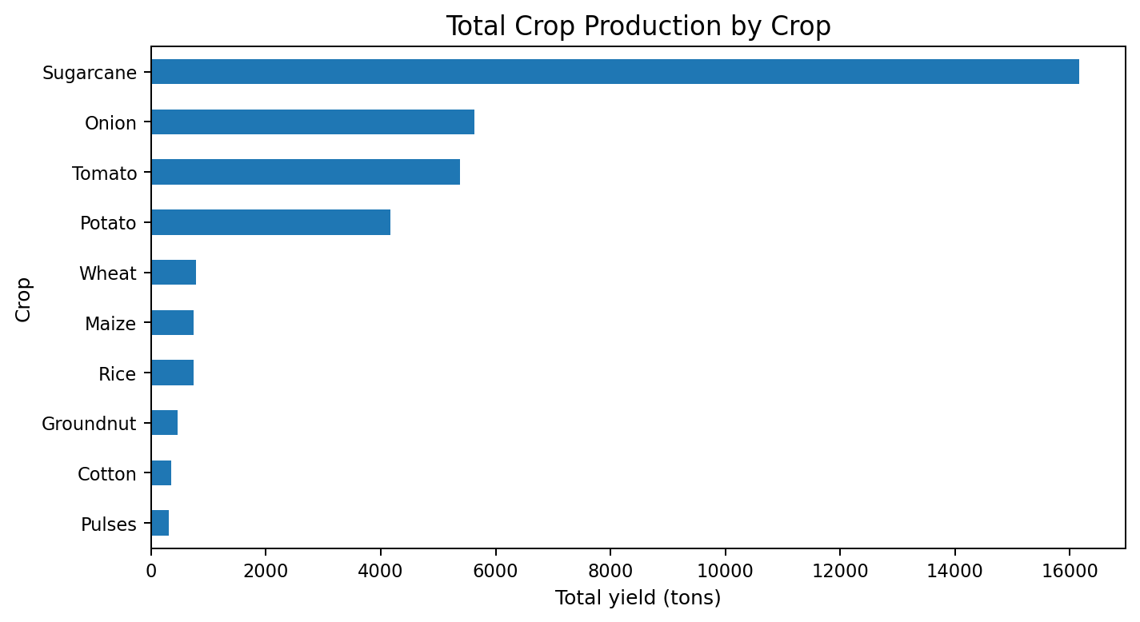
Figure 5.1: Total crop production by crop. Sugarcane contributes the largest total production in this dataset, followed by Onion, Tomato and Potato.
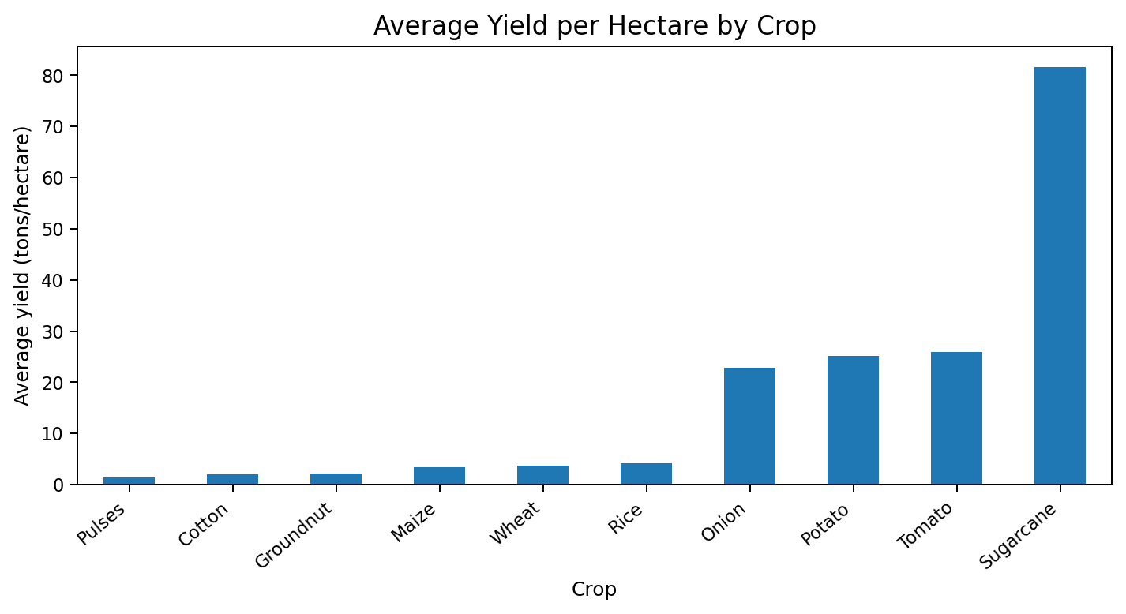
Figure 5.2: Average yield per hectare by crop. This chart compares yield intensity rather than total production, so it helps distinguish high total output from high per-hectare performance.
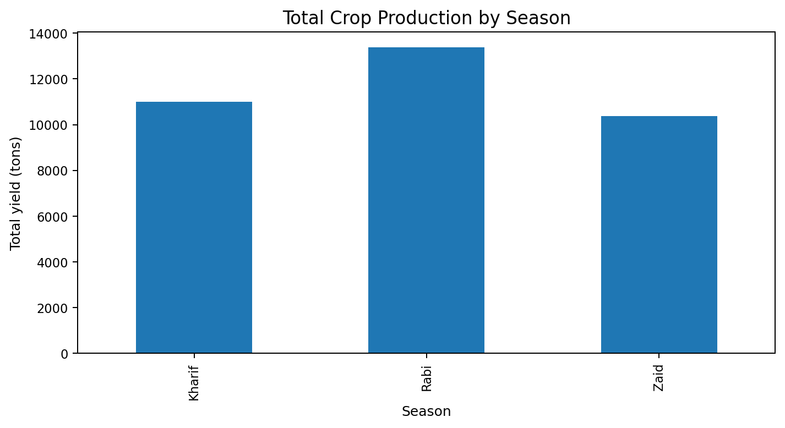
Figure 5.3: Total crop production by season. Rabi records the highest total production among the three seasons in the supplied dataset.
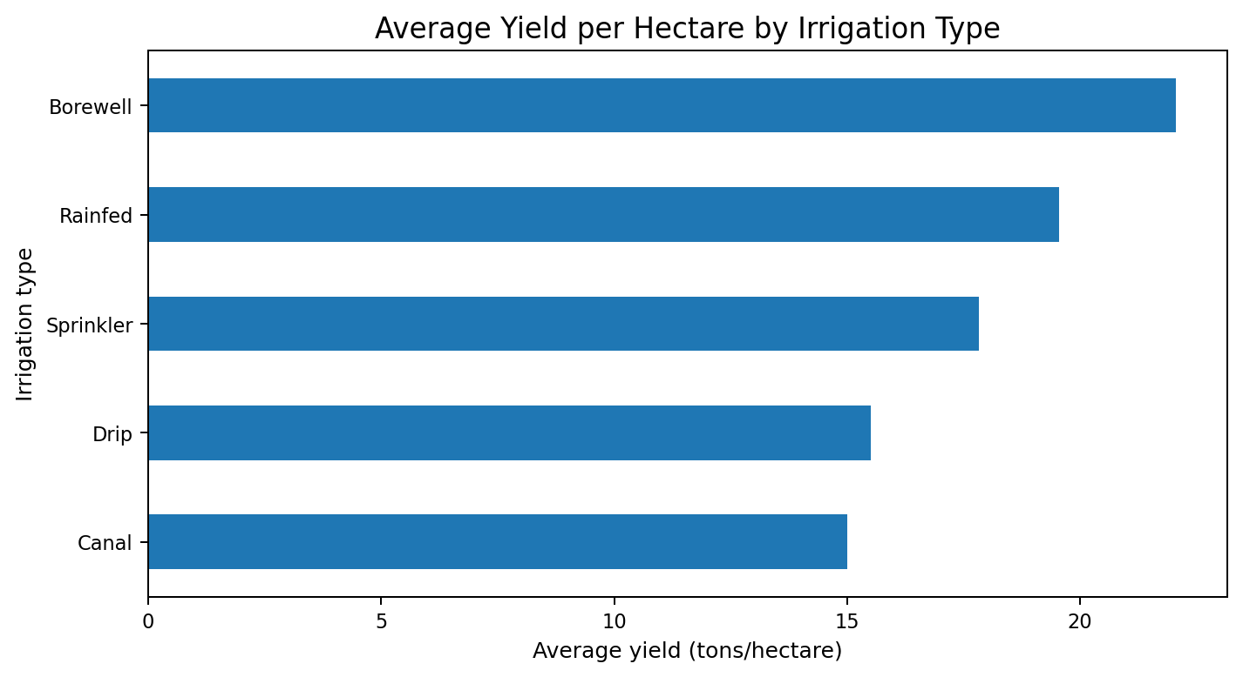
Figure 5.4: Average yield per hectare by irrigation type. Borewell has the highest observed average yield per hectare in these records; this is descriptive and does not prove the irrigation method caused the difference.
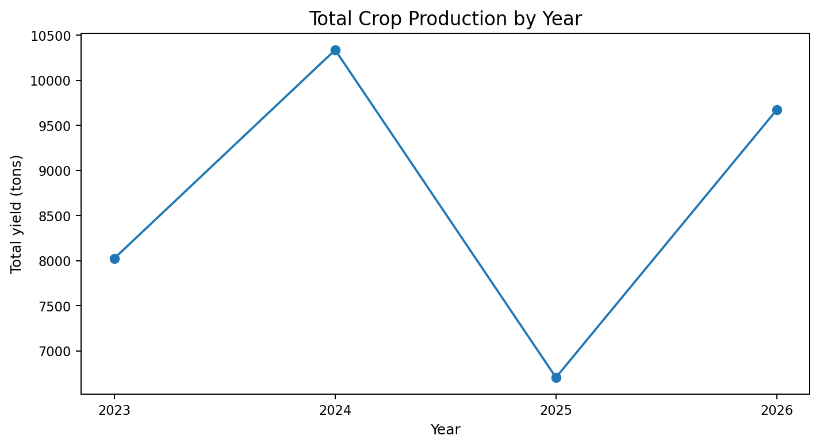
Figure 5.5: Total crop production by year. The chart compares yearly totals from 2023 to 2026; the 2026 records have the highest total in this dataset.
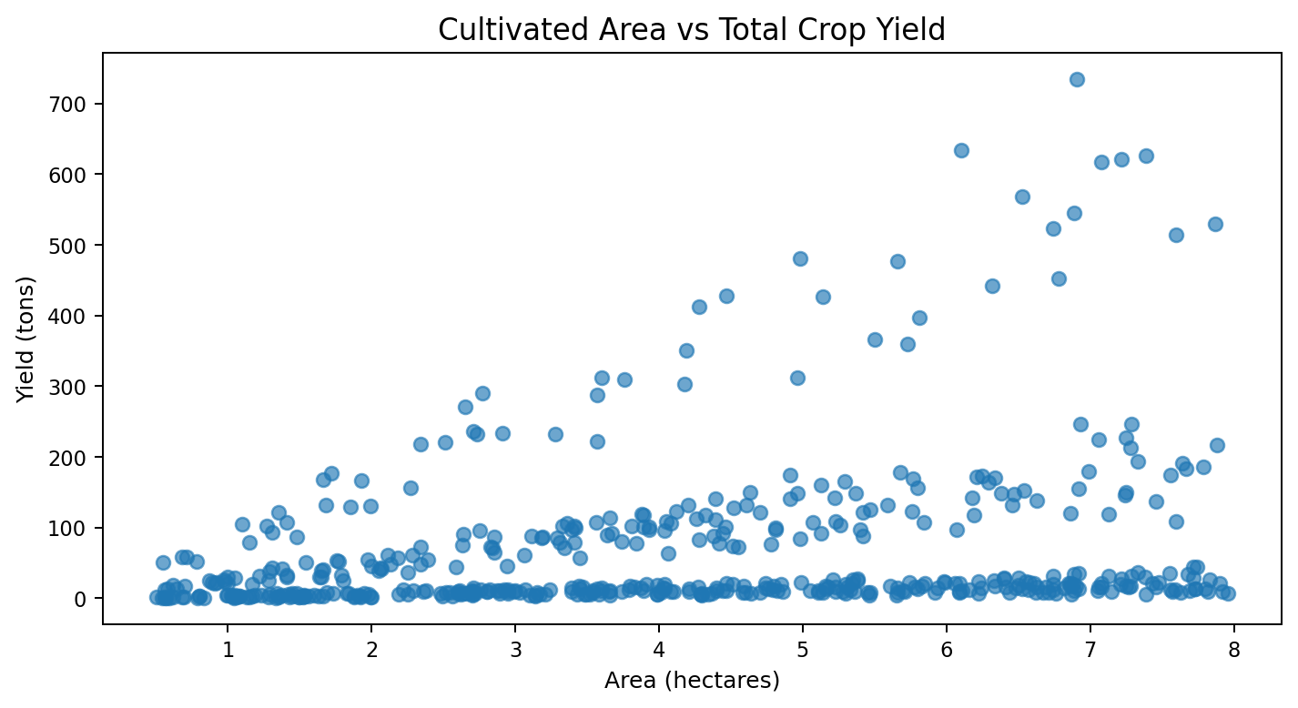
Figure 5.6: Cultivated area versus total crop yield. The plot shows a positive association between area and total yield, while the spread indicates that other factors also vary.
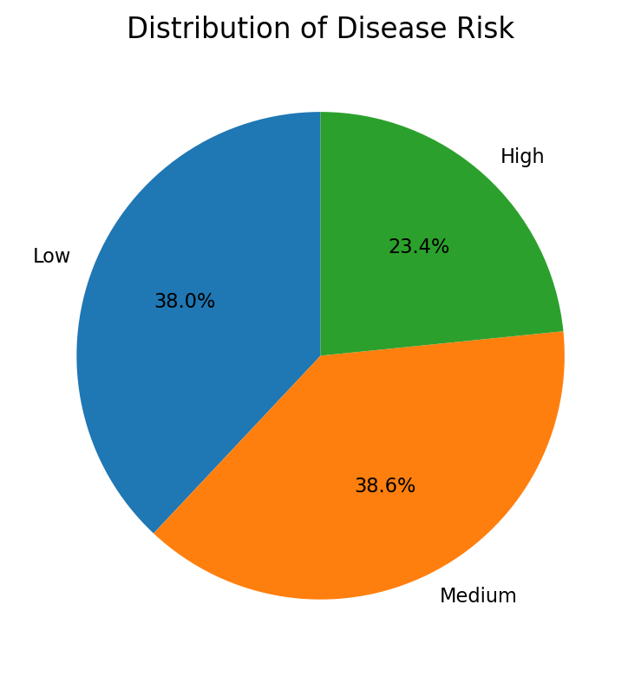
Figure 5.7: Distribution of disease risk. Medium and Low categories account for most records, with High risk representing the smallest group.

5.8 Dashboard Design and Explanation
A Power BI dashboard for this project can bring the main indicators and charts together on one page. Suggested KPI cards are total farm records, total cultivated area, total crop production, average yield per hectare, total revenue and total profit. Suggested visuals include crop-wise production, season-wise production, yearly production trend, irrigation-wise average yield and disease-risk distribution. Slicers can be added for State, District, Crop, Season, Year, Soil_Type and Irrigation_Type. The current deliverable contains static report charts; it is not an exported interactive Power BI dashboard.

6. FINAL CONCLUSION
Agriculture Crop Analytics demonstrates how data analytics and visualization can be used to examine farm records and summarize crop production, yield, agricultural inputs and financial outcomes. The project workflow includes dataset inspection, data cleaning, exploratory analysis, statistical summaries and chart creation.
The analysis of 500 records reports total crop production of 34,738.20 tons and an average yield of 17.93 tons per hectare. Sugarcane records the highest total production, Rabi is the highest-production season, and 2024 has the highest yearly production in the dataset. The results provide a descriptive view of the supplied records and can help identify areas for further investigation.

6.1 Answers to the Project Questions
- Highest total crop production: Sugarcane (16,163.50 tons).
- Seasonal pattern: Rabi has the highest recorded seasonal production.
- Yearly pattern: 2024 has the highest recorded annual production.
- Soil and irrigation comparisons: Loamy has the highest average yield by soil group; Borewell has the highest average yield by irrigation type.
- Relationships: yield measures and financial outcomes show positive associations in the supplied data; correlation is not proof of causation.
- Disease-risk distribution: Medium is the most common category.

7. FUTURE OUTCOMES AND LIMITATIONS

7.1 Limitations
- The external source and collection method of the dataset were not provided, so representativeness cannot be confirmed.
- The dataset contains 500 records across the years 2023–2026; it may not represent all regions, farms or seasons.
- The index-like Unnamed: 0 column contains one missing value and was excluded from analysis; the agricultural columns themselves have no missing values.
- The dataset does not include detailed farm-level time series or data provenance for independent verification.
- Observed correlations and group differences do not prove cause-and-effect relationships.
- The current project performs descriptive analysis and does not provide validated crop-yield predictions or recommendations.

7.2 Future Scope
- Collect more verified farm records from additional districts and years.
- Integrate reliable weather, soil-test and market-price information.
- Build predictive models for crop yield, disease risk and farm profitability, followed by proper validation.
- Develop an interactive Power BI dashboard with filters and drill-down analysis.
- Compare irrigation and input efficiency while controlling for crop, area, soil and climate conditions.
- Create periodic data updates so trends can be monitored over time.

7.3 Expected Outcomes if the Project Continues
With larger, verified and regularly updated data, the project could provide more representative comparisons and support improved agricultural planning. Predictive models and decision-support features would need to be developed and tested before claiming that they improve yield, reduce costs or increase farm profitability.

APPENDIX A: CODE AND PROJECT LINKS
Programming environment: Python
Libraries: Pandas, NumPy and Matplotlib (for data processing and visualization).
Dataset file: agriculture_crop_analytics_500_rows(3).csv (500 rows × 25 original columns; 24 analytical columns after excluding Unnamed: 0).
Python notebook/source code: Not supplied as a separate file.
Power BI report file/dashboard link: Not supplied.

A.1 Key Code Snippets
import pandas as pd
import matplotlib.pyplot as plt
df = pd.read_csv("agriculture_crop_analytics_500_rows(3).csv")
df = df.drop(columns=["Unnamed: 0"])
# Dataset checks
print(df.shape)
print(df.isnull().sum())
print(df.duplicated().sum())
# Crop-wise production
crop_yield = df.groupby("Crop")["Yield_Tons"].sum().sort_values(ascending=False)
crop_yield.plot(kind="bar", title="Total Crop Production by Crop")
plt.xlabel("Crop")
plt.ylabel("Yield (tons)")
plt.tight_layout()
plt.show()
# Seasonal production
print(df.groupby("Season")["Yield_Tons"].sum())
# Correlation analysis
print(df[["Area_Hectares", "Yield_Tons", "Yield_Per_Hectare",
"Revenue_INR", "Profit_INR"]].corr())

APPENDIX B: SCREENSHOTS AND EVIDENCE
- B.1 Raw CSV dataset sample: represented by the sample records in Chapter 2.
- B.2 Data cleaning output: represented by the missing-value and duplicate checks in Chapter 3.
- B.3 Descriptive statistics: represented by the summary table in Chapter 4.
- B.4 Visualization outputs: Figures 5.1 to 5.7 in Chapter 5.
- B.5 Power BI dashboard: add a screenshot only after an interactive Power BI report has been created.
Submitted by: K. SURYA, P. SHIVA SAI and G. SANTHOSH.
Faculty Signature: ______________________________

SUBMISSION CHECKLIST
- Verify faculty name/signature and any required roll numbers.
- Confirm dataset source details if available.
- Review the student names and add official roll numbers if required.
- Add Python notebook/repository link if created.
- Add an actual Power BI screenshot only if the dashboard has been built.
- Update page numbers and table of contents after final editing.

