**Auto scaling:**Autoscaling is the service which maintains the desired ec2 instances and launches the instances automatically whenever we have

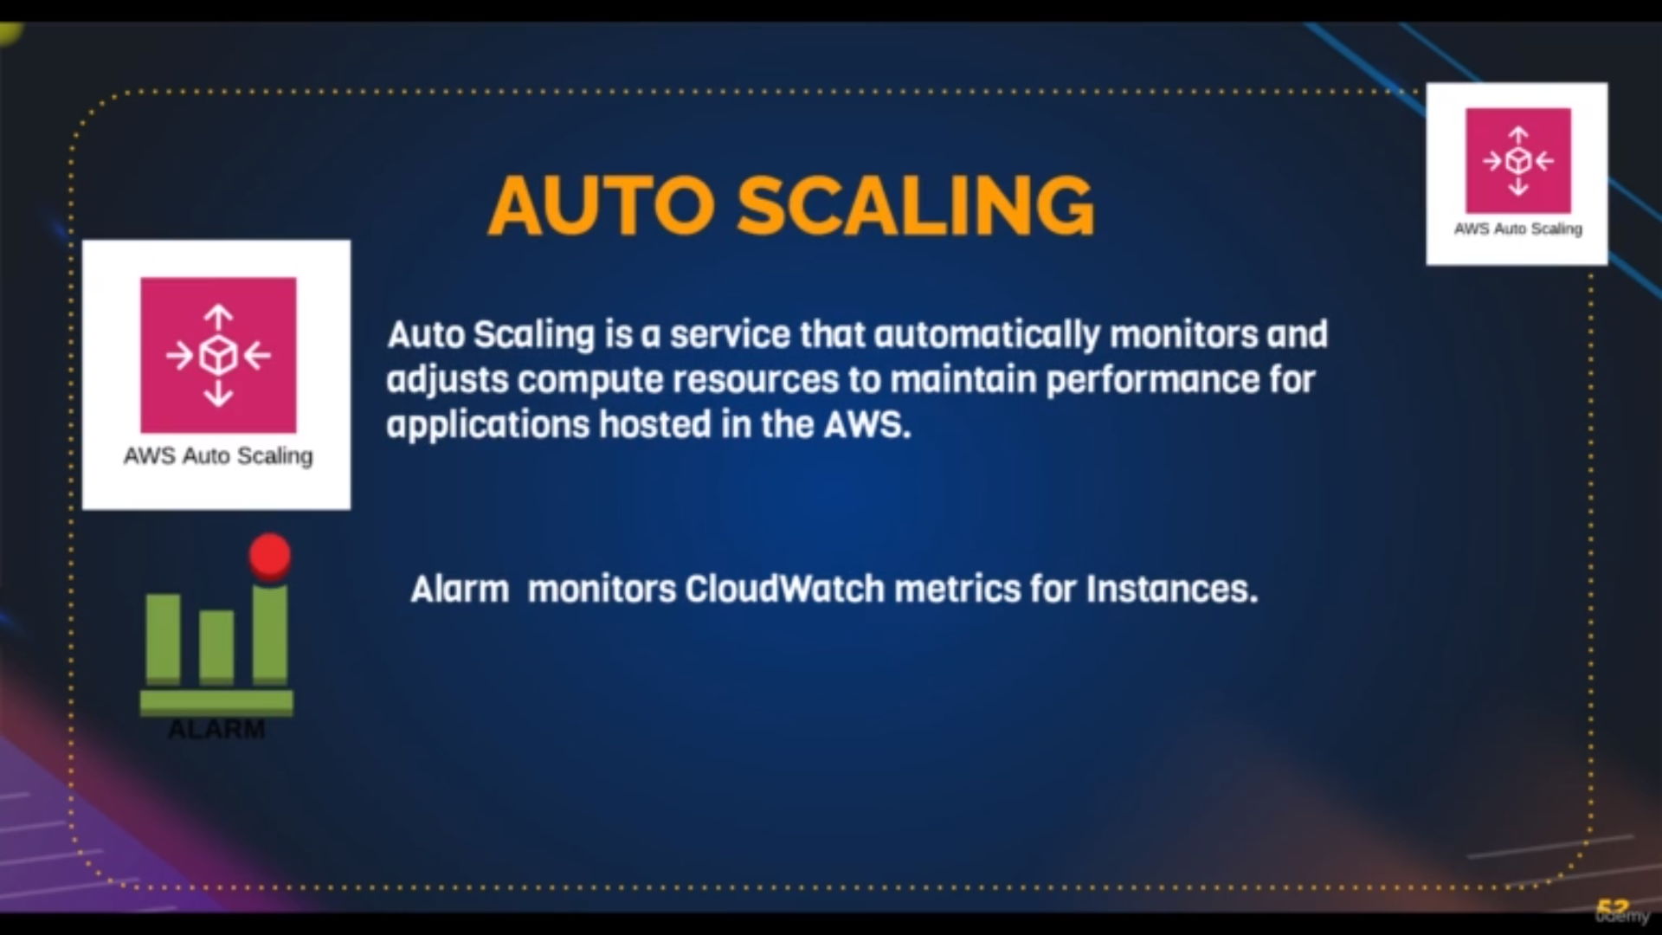it uses cloud watch alarms for scaling up and down

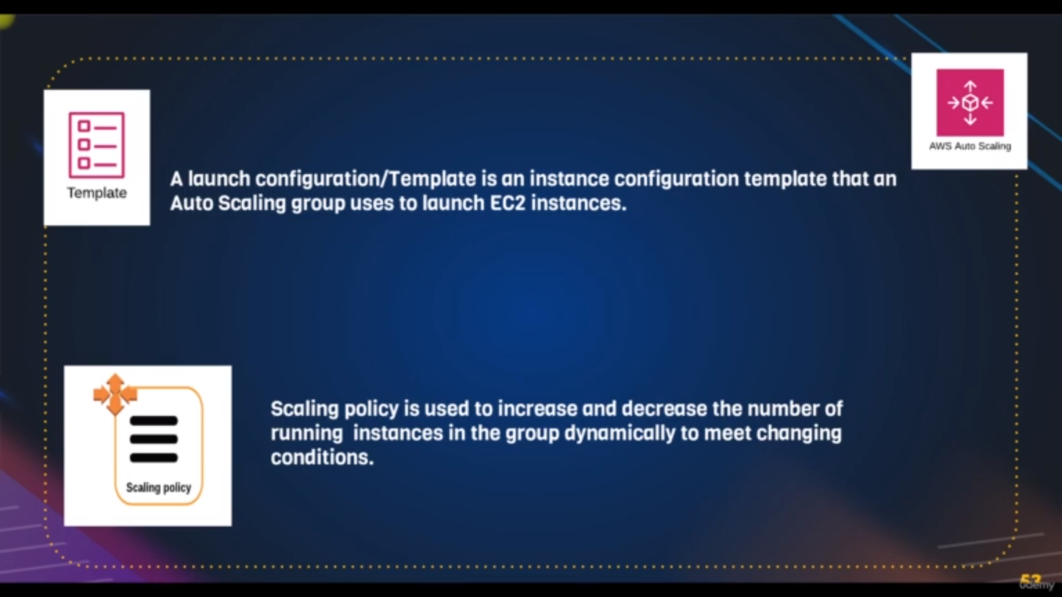scaling up means increasing ec2’s automatically and scaling down means viceversa

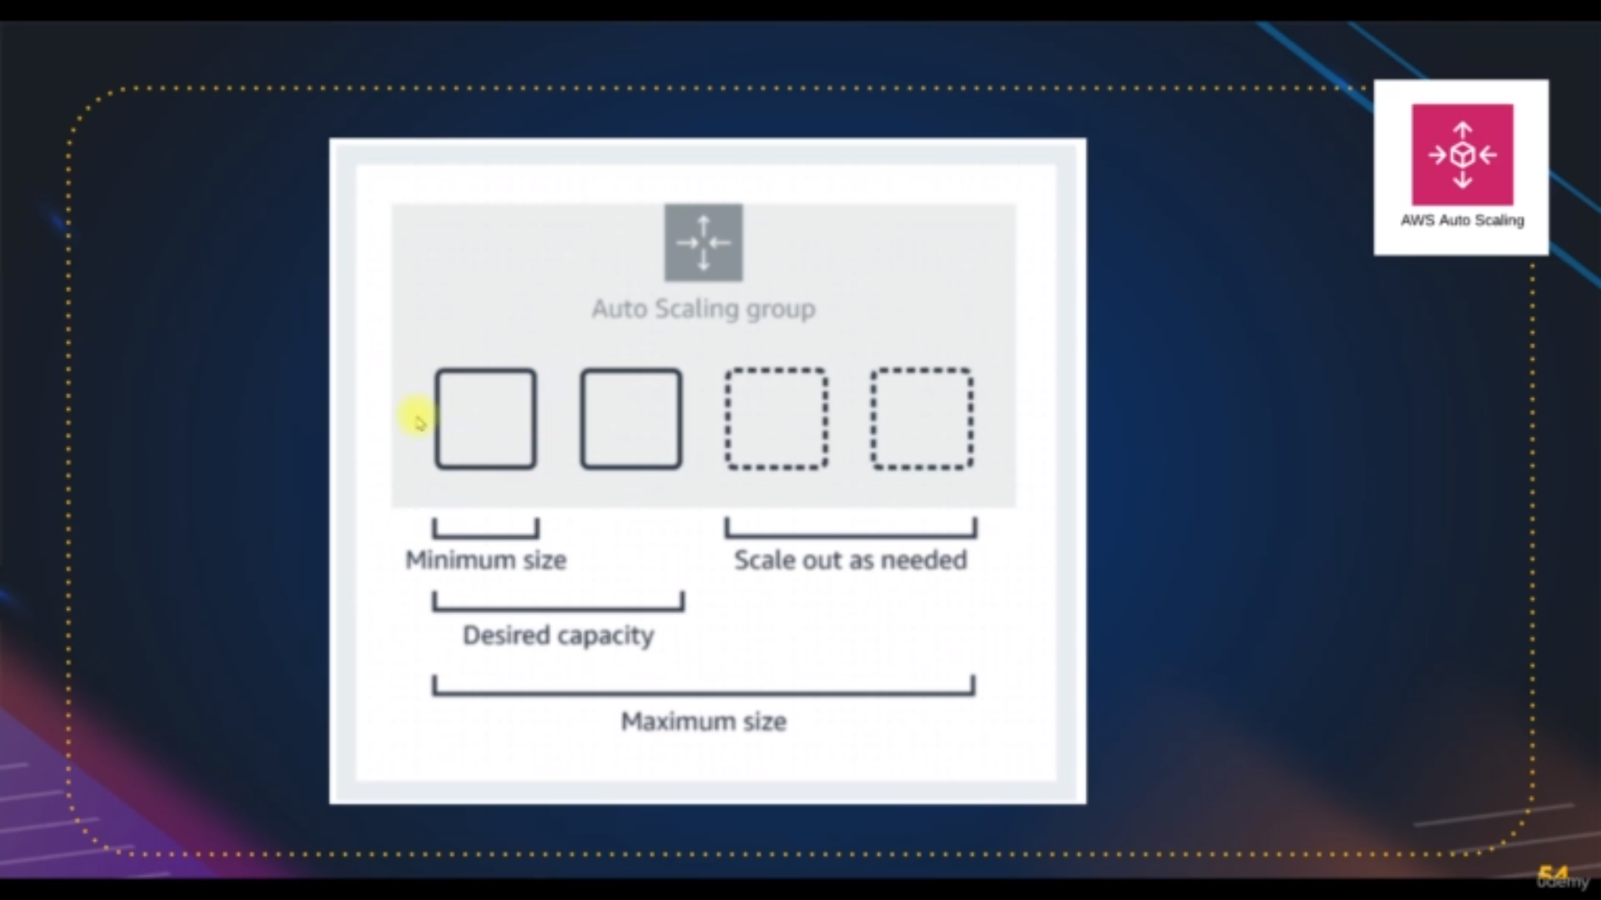minimum size is the size where the no of instances cannot be terminated when minimum state

Desired capacity is no of instance in while creating autoscaling group

maxmum size is no of instance in maximum state

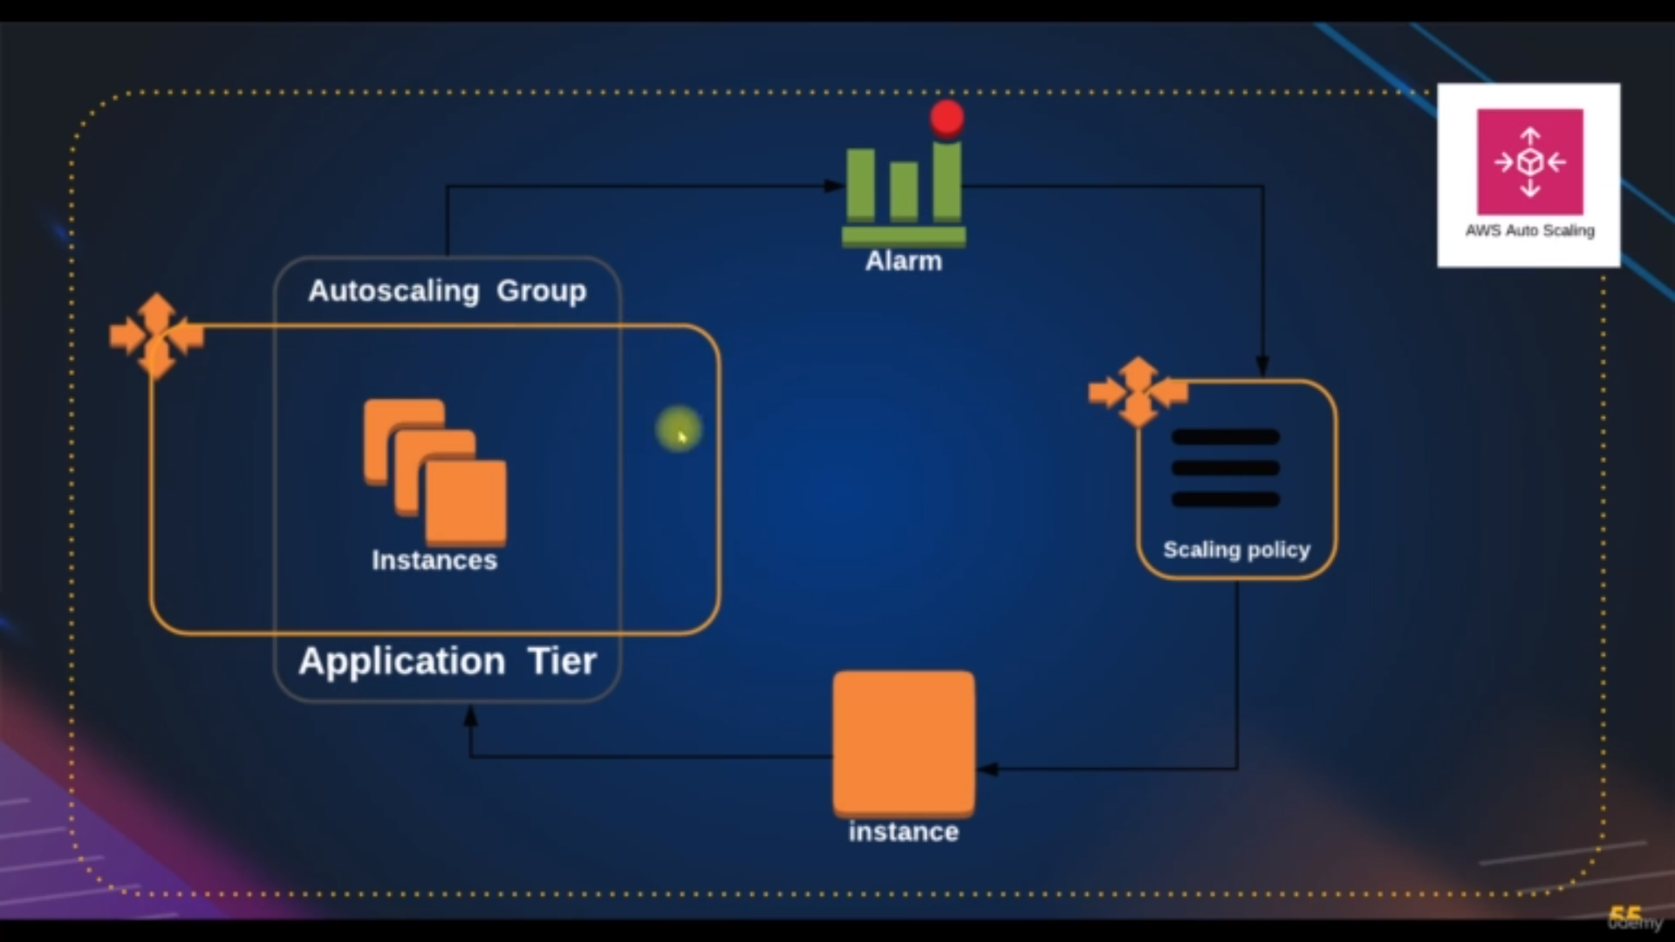flow of autoscaling

For Autoscaling we need prequisites:

1. target groups

2.load balancer

3. template

Steps:

path: Go to the left panel of ec2-dashboard

step1: click on create autoscaling group

step2: write the name of autoscaling group and select the template

step3:click on next and select the all zones[as per video]

step4:select attach existing load balancer and select the target group

and check **ELB [**which check the all harware and s/w so that if it is not working

autoscale delete the group]

stpe5:click on next and select the max,min and desired capacity,scaling policy,metric and utilization

step6: click on next add one notification

step7: click on next and add tag

step8: read the overview and click on create autoscaling group

if you want change or edit the template

path: go to the autoscaling group and click on details tab and from there edit the template