**EBS[Elastic Block Storage]:**it is Amazon's block-level storage solution used with the EC2 cloud service **to store persistent data**

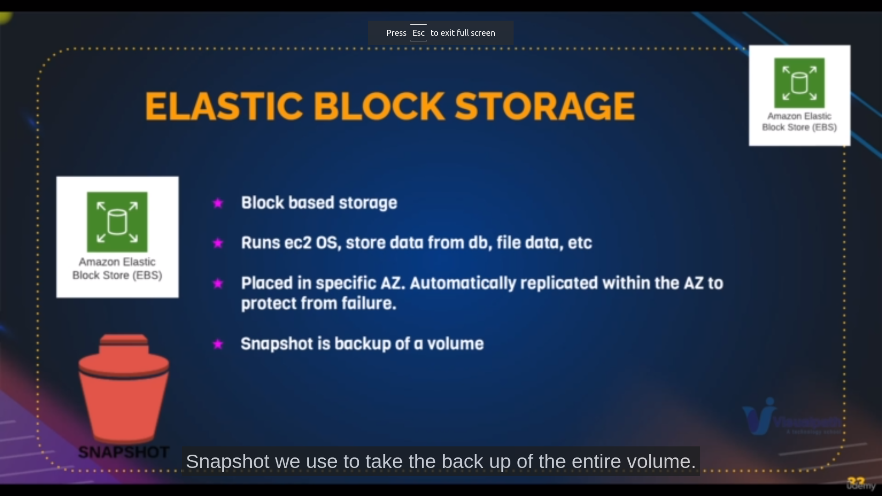services of that ebs provides

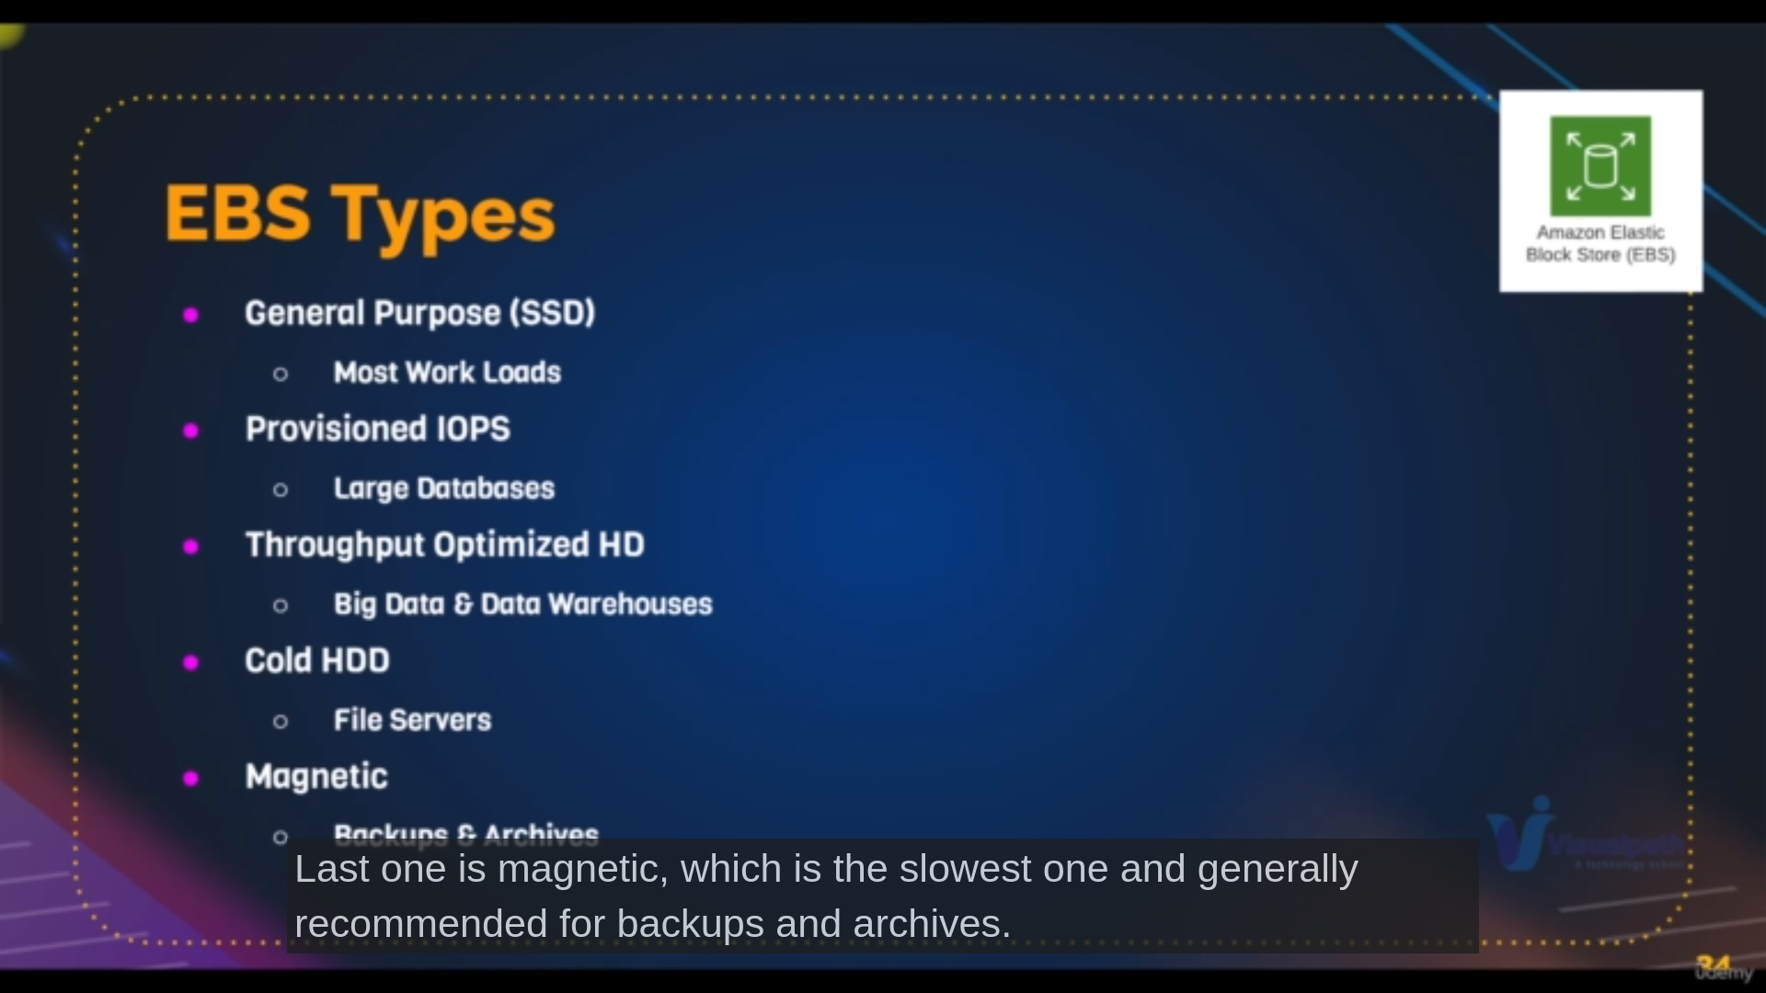Types of EBS most used is General Purpose

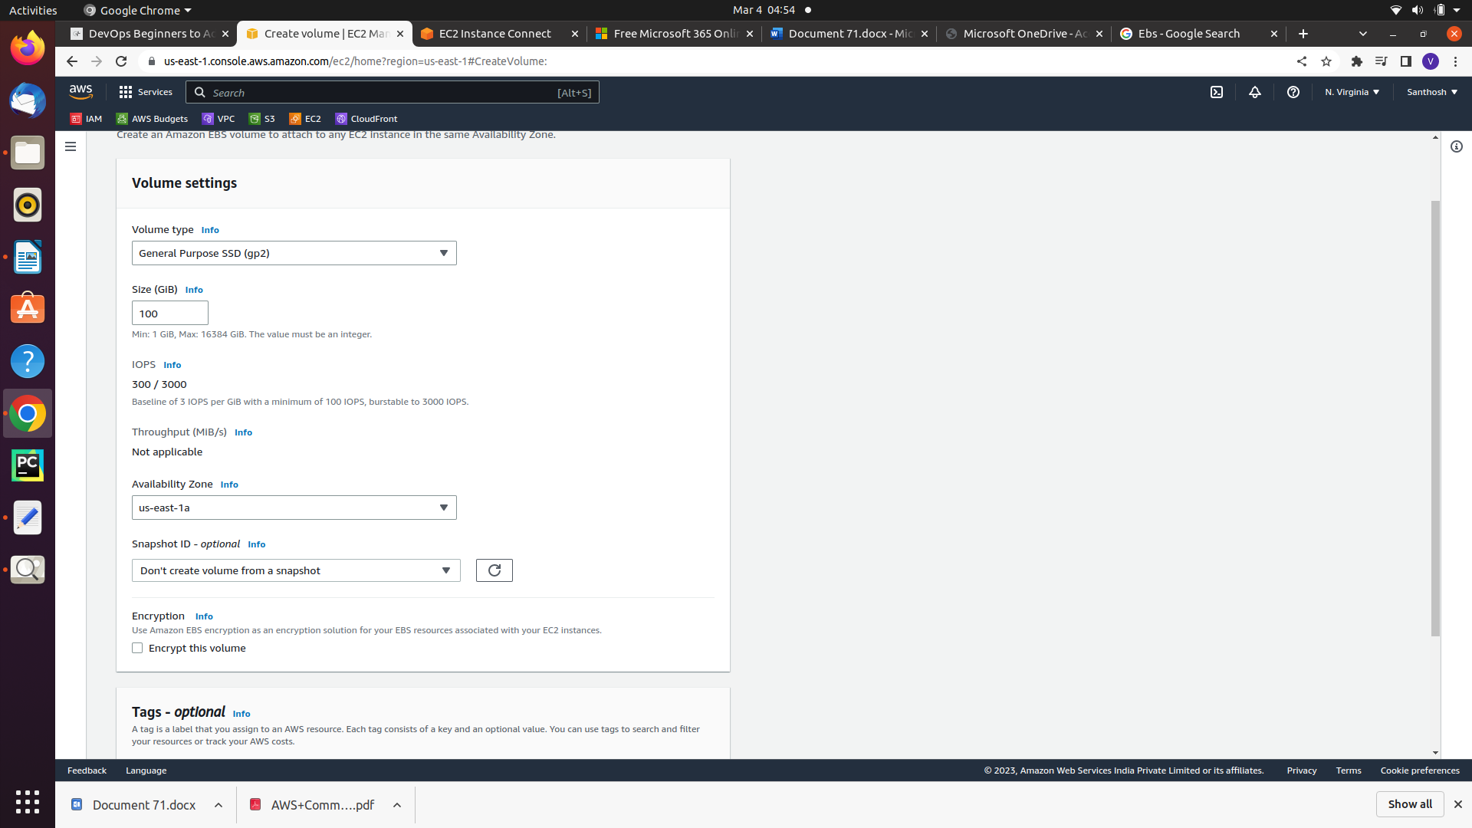img 1a

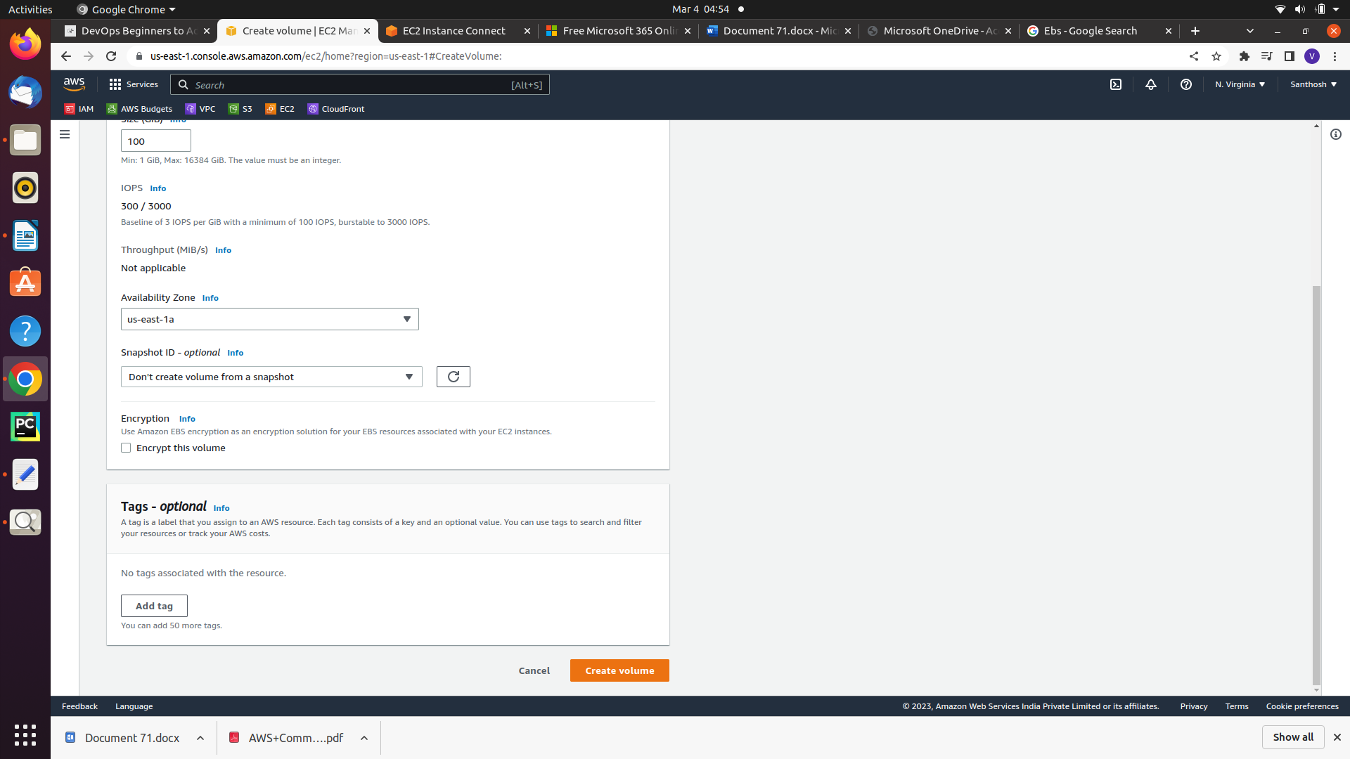img 1b

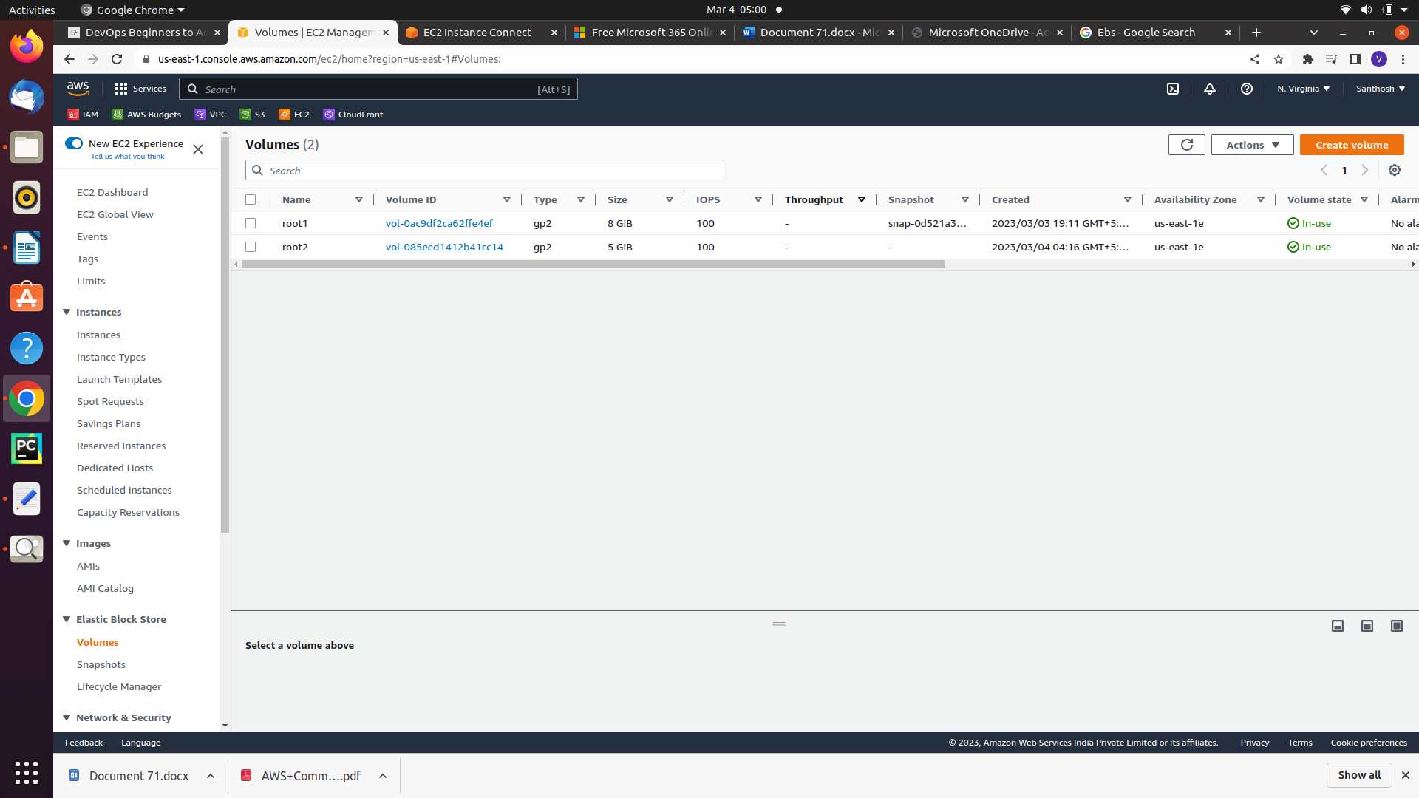img1c

**Steps to Create EBS**

path:In EC2 dashboard left pannel you will find ElasticBlockStorage

step1: click on Volumes

step2: click on create Volumes

step3: select volume type [mostly take General Purpose][img 1a,1b

step4: select size [last size is 30Gb for free tier]

step5:select AZ’s [take AZ’s which instance there]

step6: write the name of Ebs in tags selection

step7: click on create[you’ll redirected to [img1c] image]

Note: if it volume state is avaialabe it is not attached any instance or if it is inuse then viceversa

step8: click on Actions and click attach volume and select your instance and attach

Mounting can be done after launching linux machine

This can be done by below commands

Commands: 1 cd

2 aws --version

3 clear

4 cd

5 mkdir tmp

6 cat tmp/a

7 cat > tmp/a

8 clear

9 clear

10 df -h

11 fdisk -l

12 fdisk /dev/xvdf

13 fdisk -l

14 fdisk /dev/xvdf

15 fdisk -l

16 fdisk /dev/xvdf

17 fdisk -l

18 df -h

19 mkfs

20 cd /dev

21 ls

22 mkfs.ext4 /dev/xvdf1

23 ls

24 cd

25 ls

26 mv tmp /tmp

27 ls

28 mv /tmp/tmp .

29 mv /tmp/a /tmp

30 cd

31 cd tmp

32 mv tmp/a /tmp

33 ls

34 cd

35 cd ..

36 ls

37 cd

38 ls

39 cd tmp

40 ls

41 cd .

42 mount /dev/xvdf1 /root/tmp

43 unmount /root/tmp

44 vi /etc/fstab

45 mount -a

46 mv /tmp/a .

48 history

Explanation:

mounting is nothing but linking the harddisk to particular directory [it means whatever you write in that directory it goes to that harddisk]

partition is nothing but dividing the hard disk to parts

filesystem is nothing but making particular partition into a type a system of file that file works for some fuctionality

10: shows the mount point of disk

11: it shows the partitions of disk and also disk

12: it is used parition the disk where you can find multiple option then you enter the letter n then your partition is done by default settings

22: it will create the extension for your partition disk

42: it will mount the partion disk to the root/tmp directry[temporary]

44: for permenant mount we have to edit this file as shown below

for xvdf1

#

UUID=b7bb0196-d24d-41e5-8fc6-fd0638f1a194 / xfs defaults,noatime 1 1

/dev/xvdf1 /root/tmp .ext4 defaults,noatime 0 0

~

47 vi /etc/selinux/config

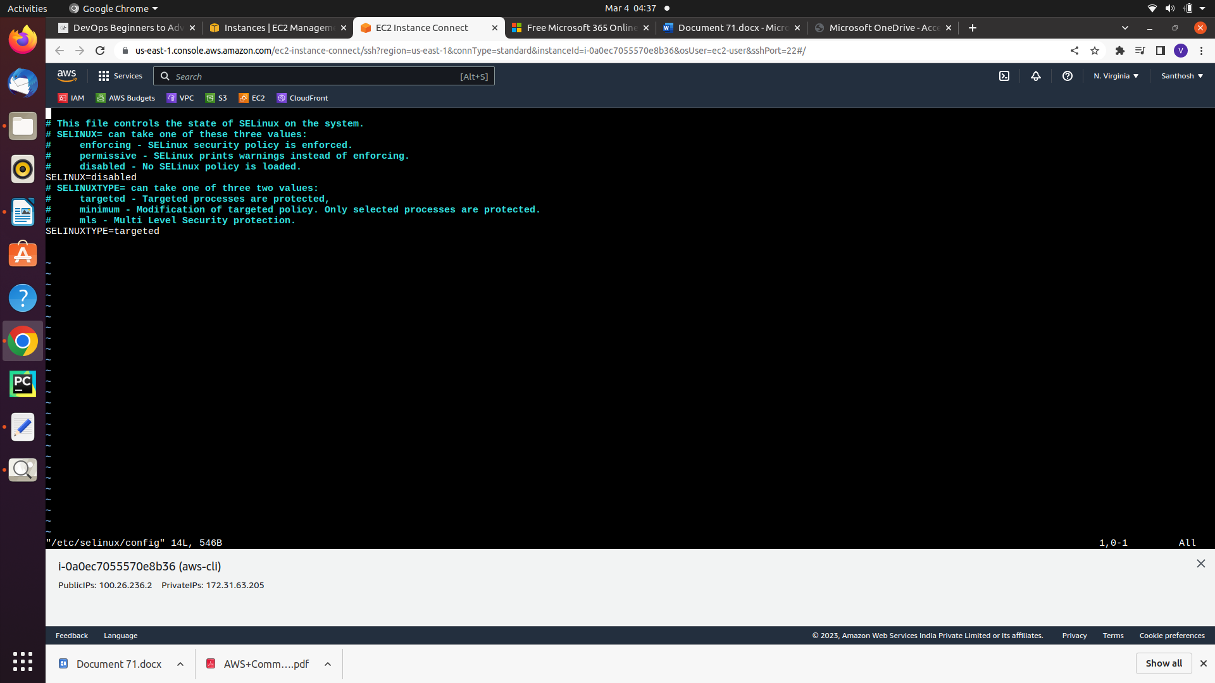this image for selinux disable mode if the data doesnt come after mounting

**SnapShot:**

Ebs is snapshot Generally a backup for volume whenever we lost our data we will get the usage of snapshot

**Steps To Create Snapshot:**

path: Go to instance→ click on volumes in leff panel ec2-dashboard

step1: click on action and click on snapshot

step2: it will directs you to another page where give the description

step3[optional]: you can also change volume size and zone if you want to change in size and also attach to another instance

Note: unmounting the previous volume can solve the problem of overriding the data

step4: Go for the snapshot in same left panel

step5: click on actions select create volume from snapshot

step: after that volume is created and do the same steps what you do for volume

**Actions:**

we can also create image from our snapshot also if it is a root volume

we can also copy our snapshot from one region to another region

we can also modify permissions like we can permission of all iam user

and also another account user by entering their emailid

**Cleanup:**

makesure your instance is terminated

your volume is deleted

your snapshot is deleted

Go to ec2-dashboad check everthing is there ec2-cleanup