**Elastic load balancer:**

A load balancer is a device that acts as a reverse proxy and distributes network or application traffic across a number of servers. Load balancers are used to increase capacity (concurrent users) and reliability of applications.

Generally it will pass the user requests to different servers simultaneously

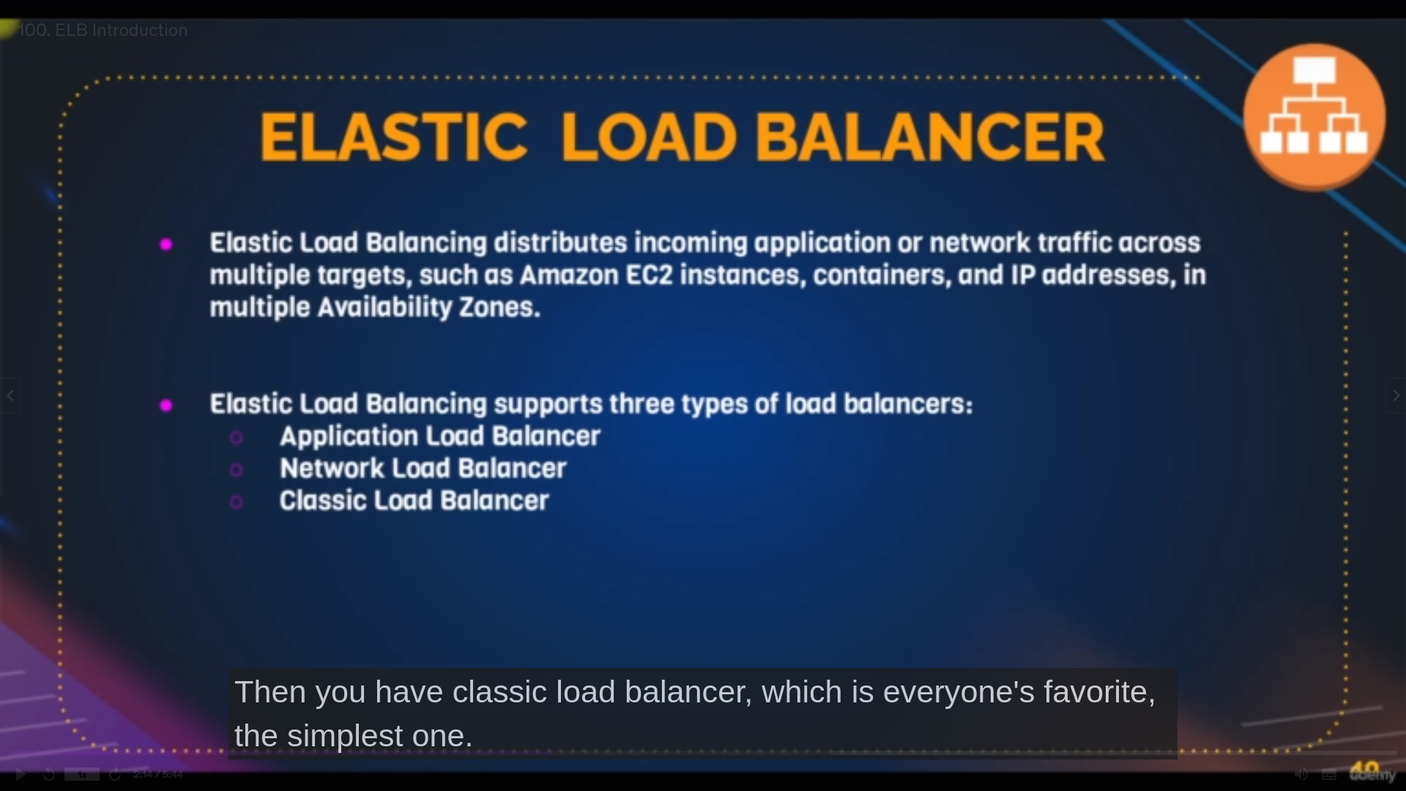description and types of load balancers

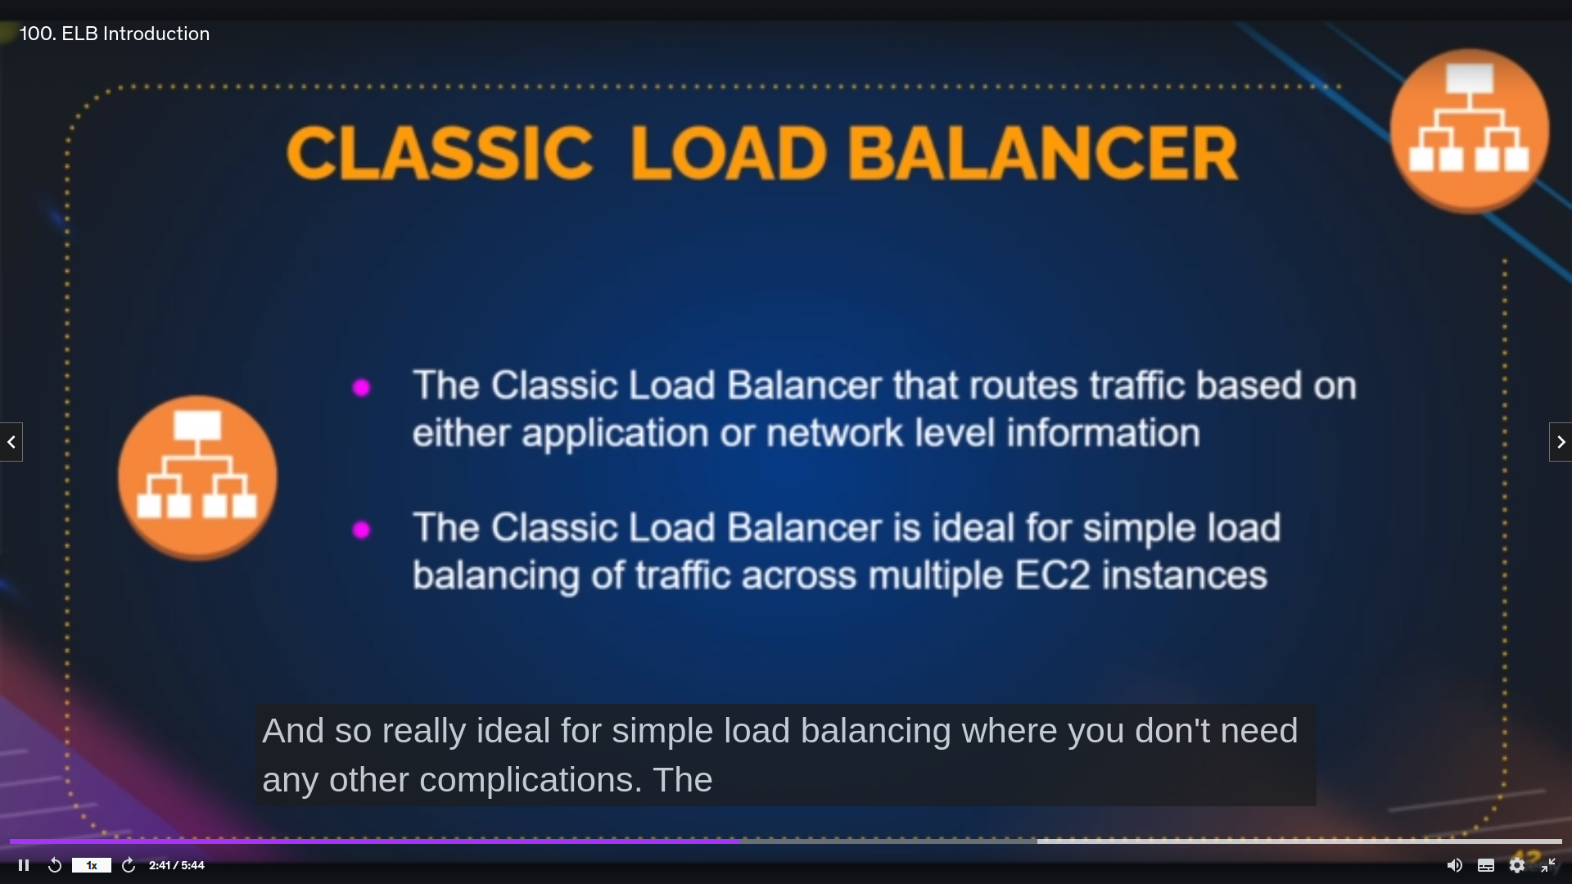it is used for Generall purpose in aws

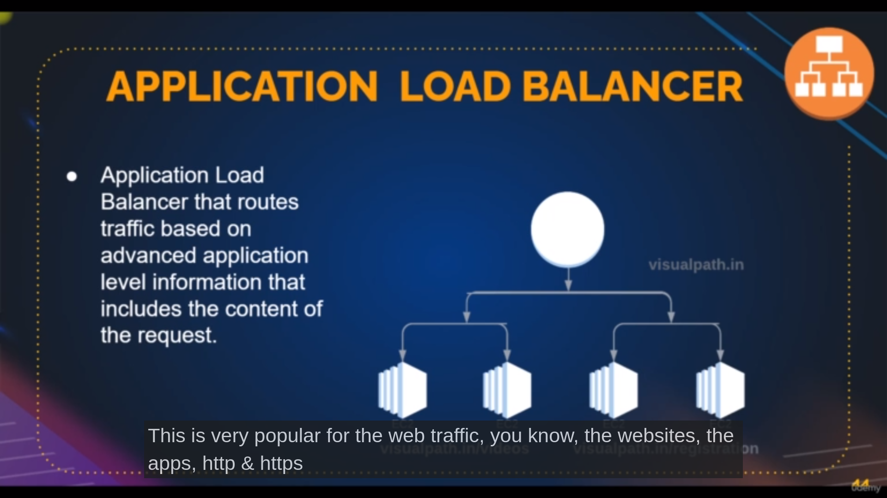it is used in layer7 from osi model

basically it is used for http and https requests

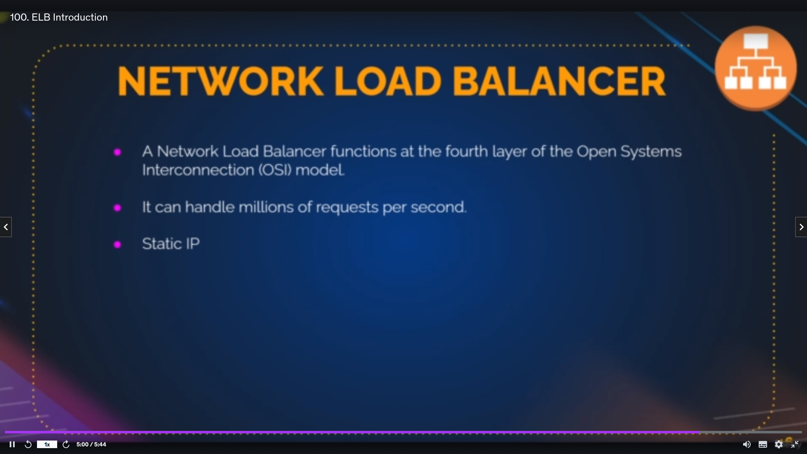it is used in layer4 from osi model

basically it is used when we multiplerequest to distribute

only this has statci ip

above two have endpoint which is attached to ip addres which is dynamic

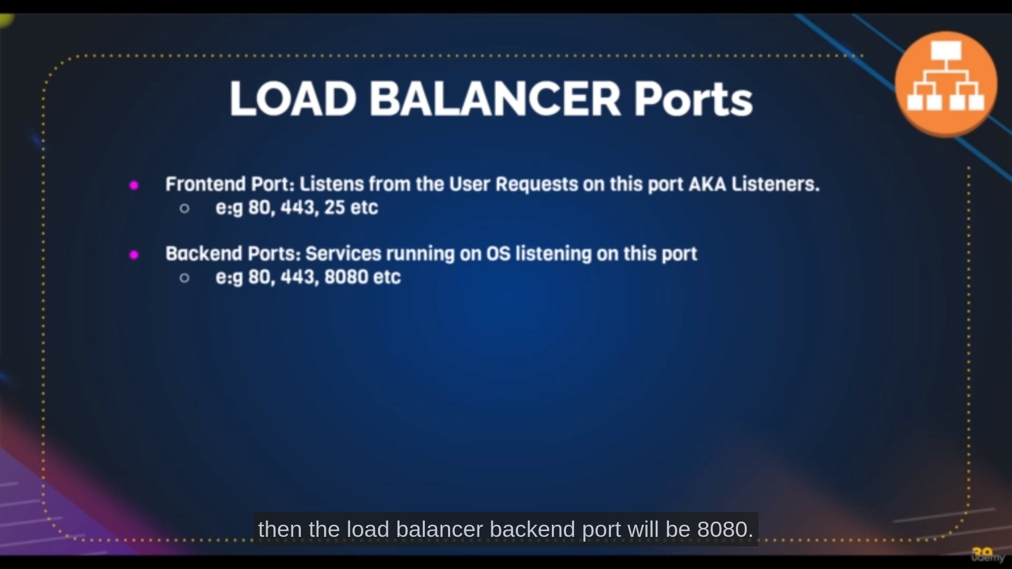frontend port receives the user requests

backend port is for internal communication

Before launcing the elastic load balance we need to create target gropus

**Target Groups**

target groups binds all instances at one point

**Steps:**

**path**: you can find it on left panel of ec2

**step1**: click on create target group

**step2**: select instance in Basic Configuration and enter target group name

**step3**: enter port and protocol on which port our instaces are running and also protocol version [as per the project these are defualt settings fro web]

**step4**: enter the path where the websites for health checkup

[if the path where website is not working the taget group make it has helathfailed so that the traffic doesnt go ther]

**step6**: click on next and select instances below that also click on **include as** **pending** below and click on create target group

**Load balancer:**

**path**: same where the target group is there

**step1**: click on create load balancer

**step2**: select application load balancer[or whichever you want

**step3**: enter elb name

**step4**; select insternetfacing [which means elb available to access on interent]

**step5**: select elb ipadress type

**step6**: select the region from where the loadbalnacet should available

**step7**:select the security group and add our target group in **listeners and routing [**try to create your own sg group for the first time]

**step8**: click on create load balancer

even though if dont getting page through load balancer endpoint kindly check instances security groups

**CleanUp:**

first delete the load balancer

after delete the target groups

and terminate instances