**Cloud watch:**

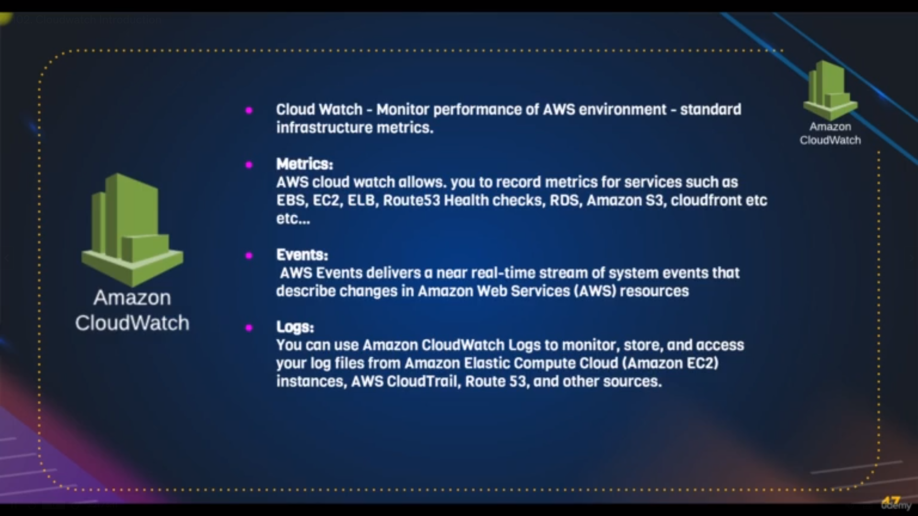it is used to get the metrics and logs and also events of the amazon resoureces

**Commands:**

5 stress -c 4 -t 60

7 nohup stress -c 4 -t 360 &

explanation:

5: it will create 4 process and runs upto 60 sec

7: same as above but run in background

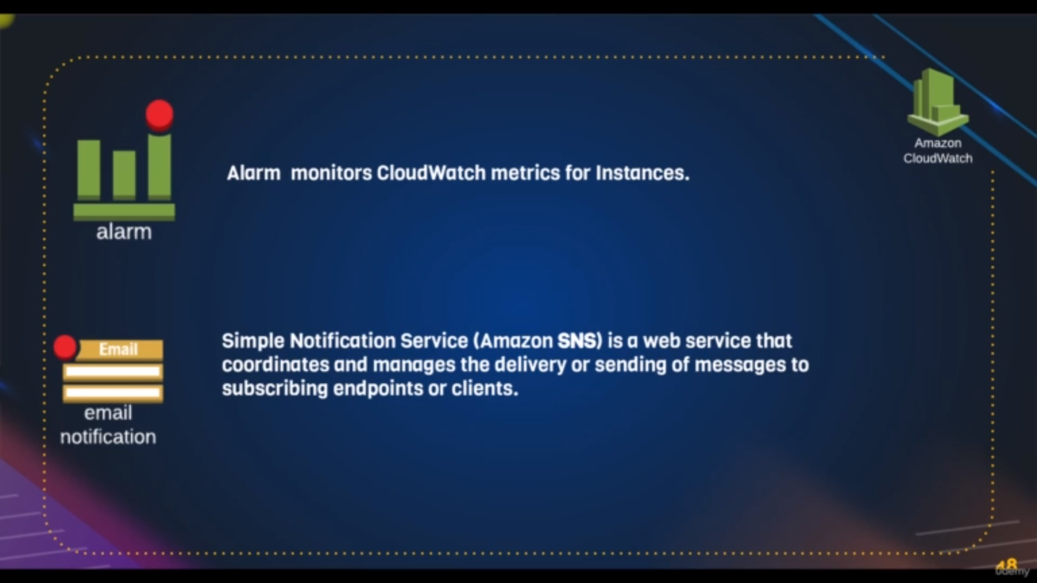By using metric we create alarms and notification whenever the resources exceedss our budget or needs

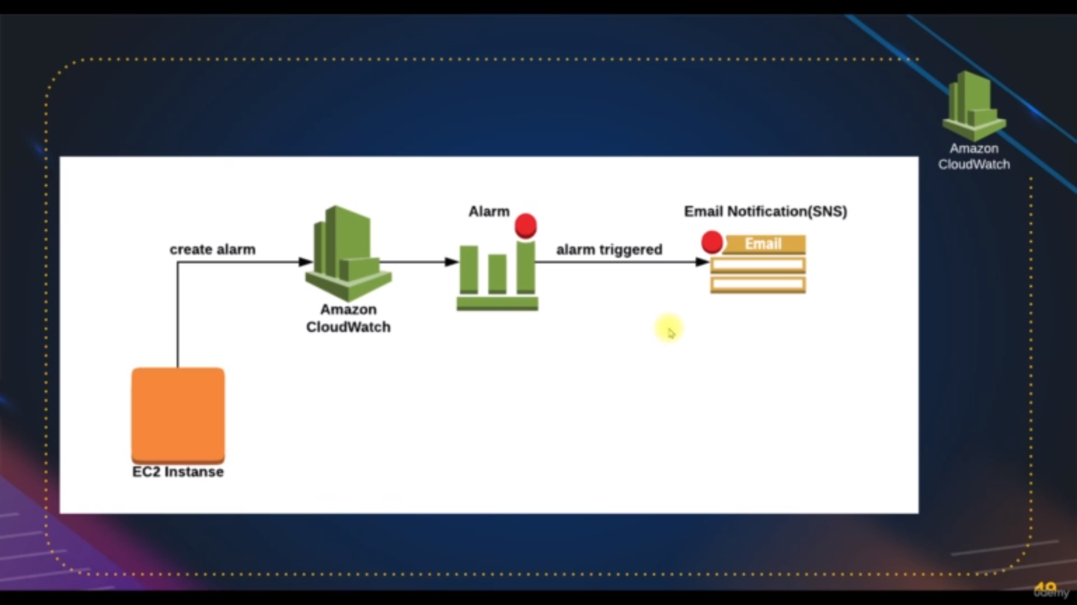flow of cloud watch alarm

Steps:

for cloud watch maksure the manage **detailed monitering is enbled** which is found after selecting ec2 instacne [in below panel go to monitering tab in which we will found it on one button link] because of this we get metrics

**path**: go to cloud watch dashboad and go for all alarms

**step1:** click on create alarm

**step2**: click on select metric which will direct to another page you have resouce[ex: ec2] , select which type metric[per-instance metric] and also on what based you want alarm[ex: cpu utiliazating of that ec2] after that click on select metric

**step3**:select the time that how many minutes that our metric are there continusly A/c to conditon and also select condition and write threshorl value which the cpu utilizatin

for example: I selected the 1 minute period which is time and

conditon greter than or equal to and threshold value is 50

it means if our instance cpu utilization is equal or more than 50 upto 1minute we will get alarm

**step4**: select or create new topic which means you have to add email address and topic name

you can also add autoscaling and also more ec2 or terminating existing

**step5**: create alarm

**if our instance cpu utilization is equal or more than 50 upto 1minute we will get alarm**