**Containers:**

container is a process which act like light weight virtual machine for particular

service like nginx for web service it is light weight bcos it has s/w files that is required for

particular service

for example for nginx it just need the s/w that runs webservices s/w files

image is nothing but archieving or zipping the particular container

Docker Dameon is the responsibility for creating ,removing,etc of containers

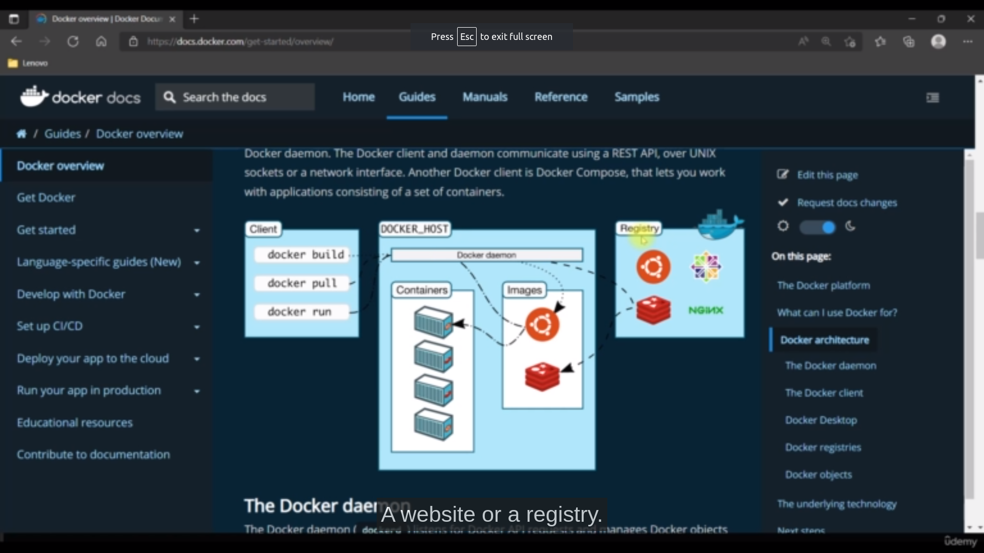Images shows how docker works

docker-compose:

Compose is a tool for defining and running multi-container Docker applications. With Compose, you use a YAML file to configure your application’s services. Then, with a single command, you create and start all the services from your configuration.

Microservice vs monolithic architecture

In monothic all services are tightly coupled means if we change the code in one service then we have to reload the whole applications

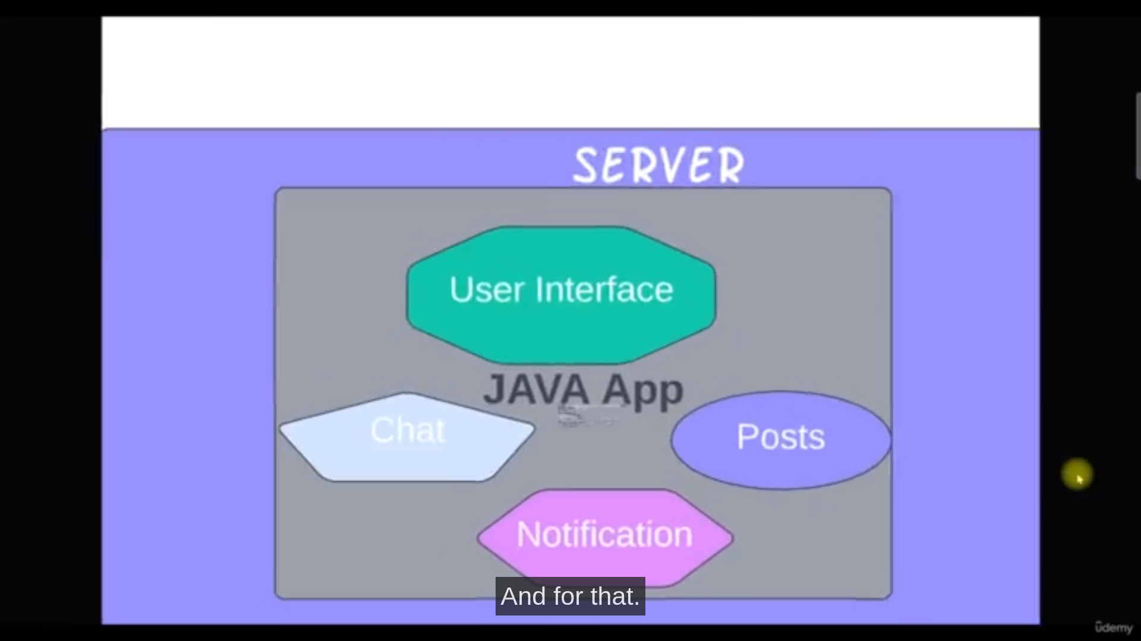

In microservice all services are loosely coupled means if we change the code in one service then we no need to reload the whole applications

for micro services api gate is the most import s/w which will only connects all services

