**{02-08-22}**

**Database: to store the datea**

**RDS Respiratory Distress Syndrome(AWS)**:

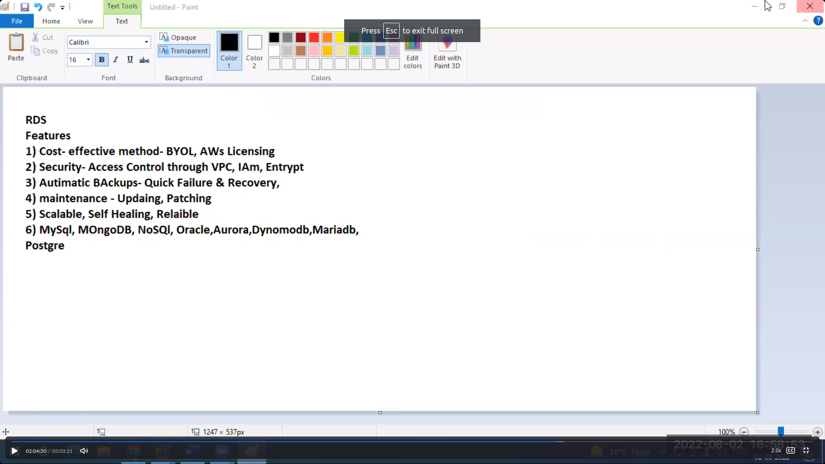

[About database file is shared in slack]

AWS rds creation:

Steps

1. Search rds in search bar and click on create database
2. Select standard which will give option perfectly
3. Select mysql in engine option which is free eligible
4. Select mysql 57.22 version which is stable
5. Select free tier in templates and move on to settings
6. Type the password for admin
7. Selct instance configuration as t2.micro
8. Uncheck the enable autoscaling mode
9. Select public acess yes
10. Select security group which has 3306 open
11. Select any subnet
12. Click on addition configuration and write one initial dbname and uncheck the automated backups

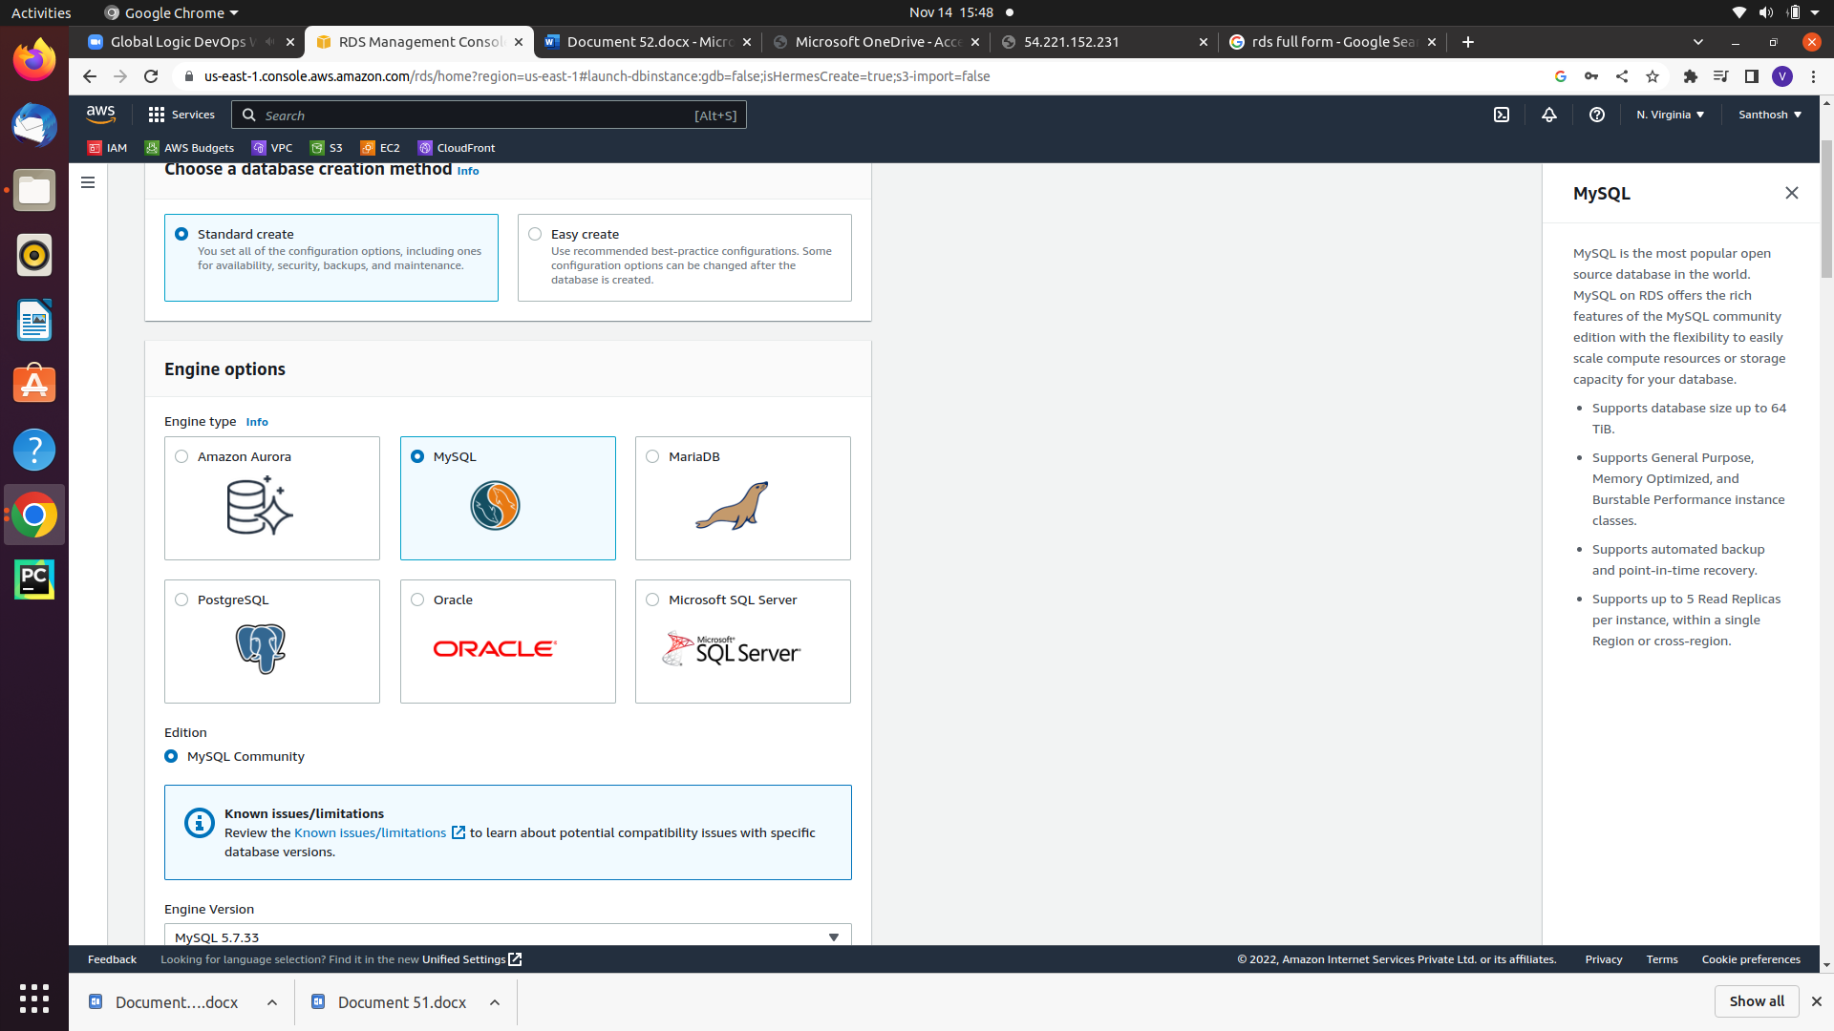

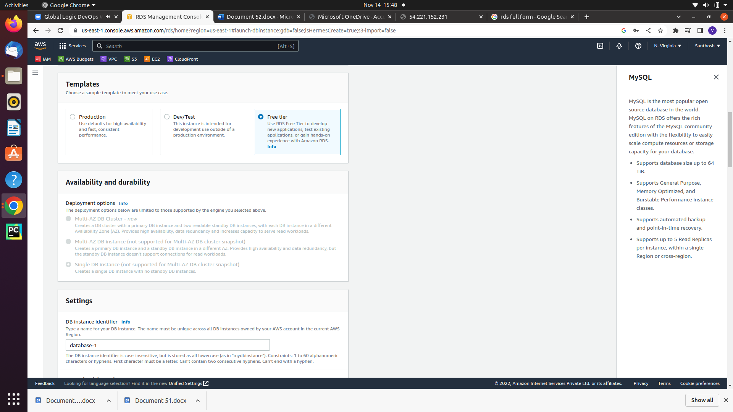

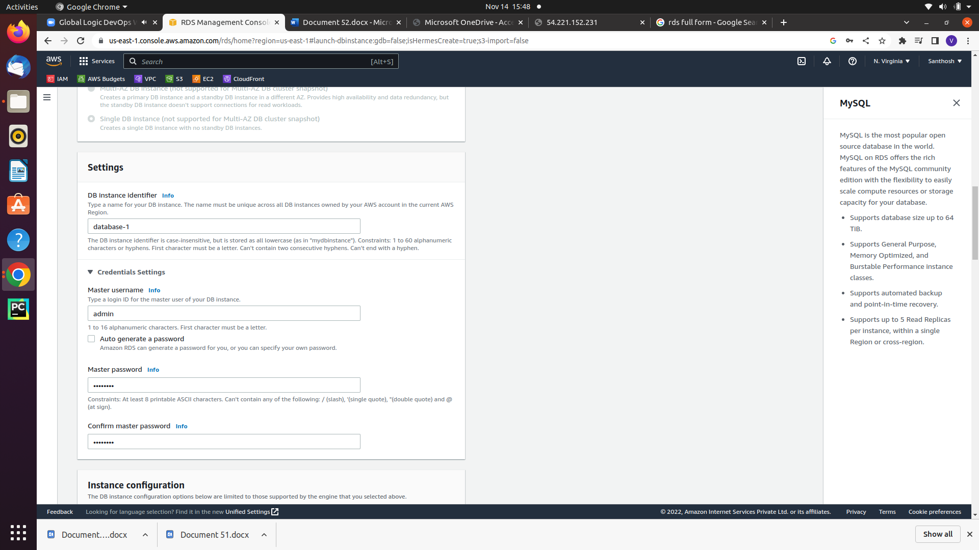

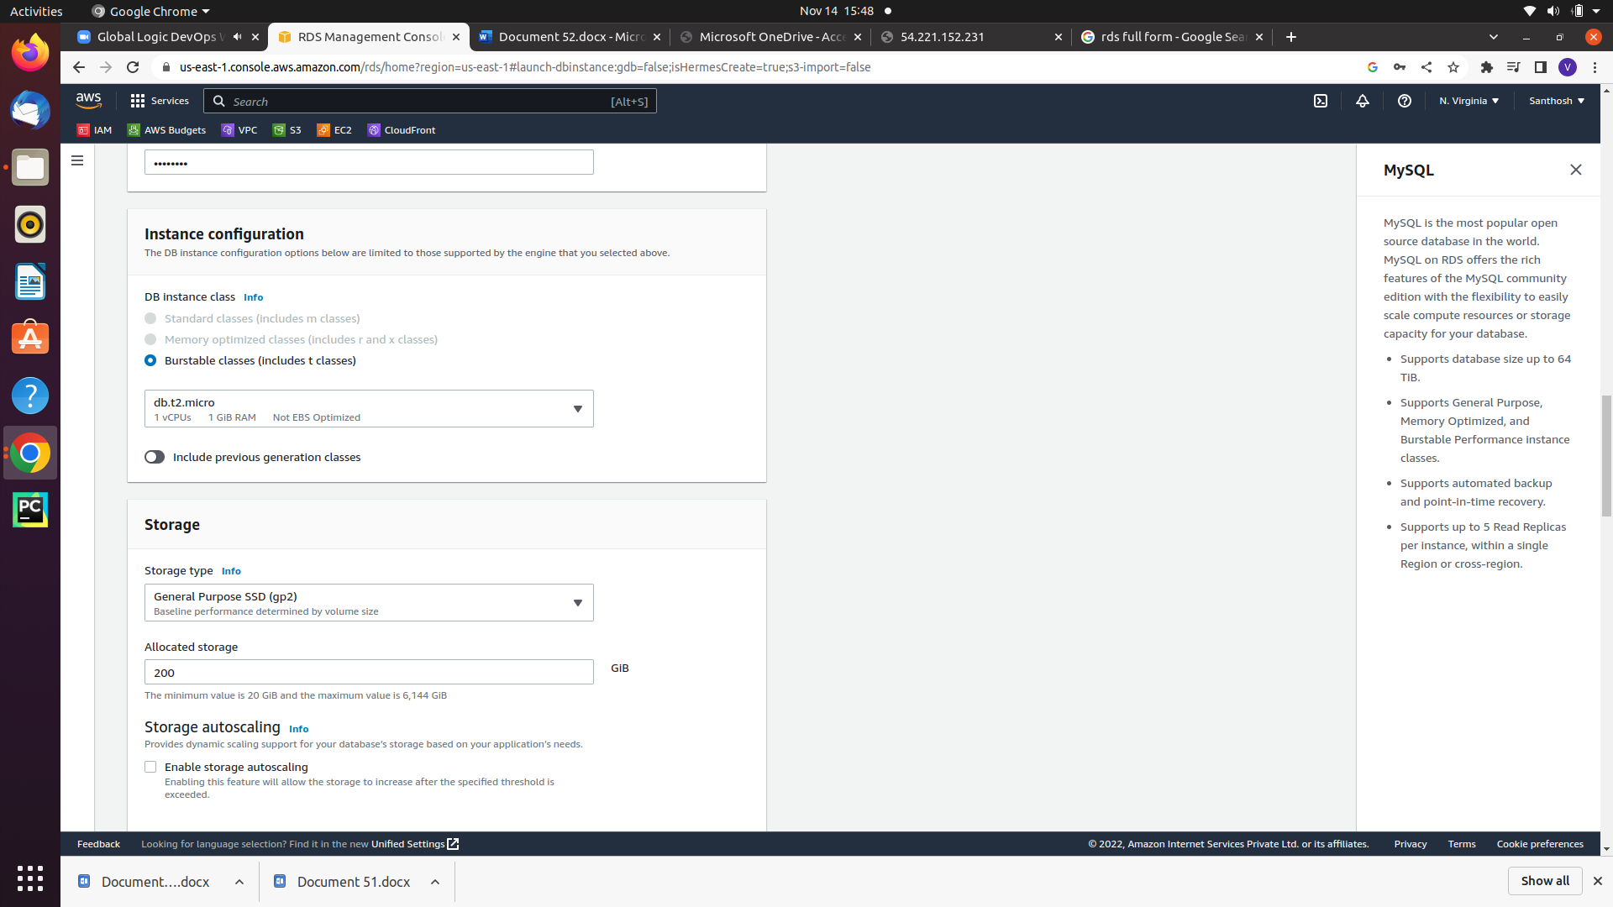

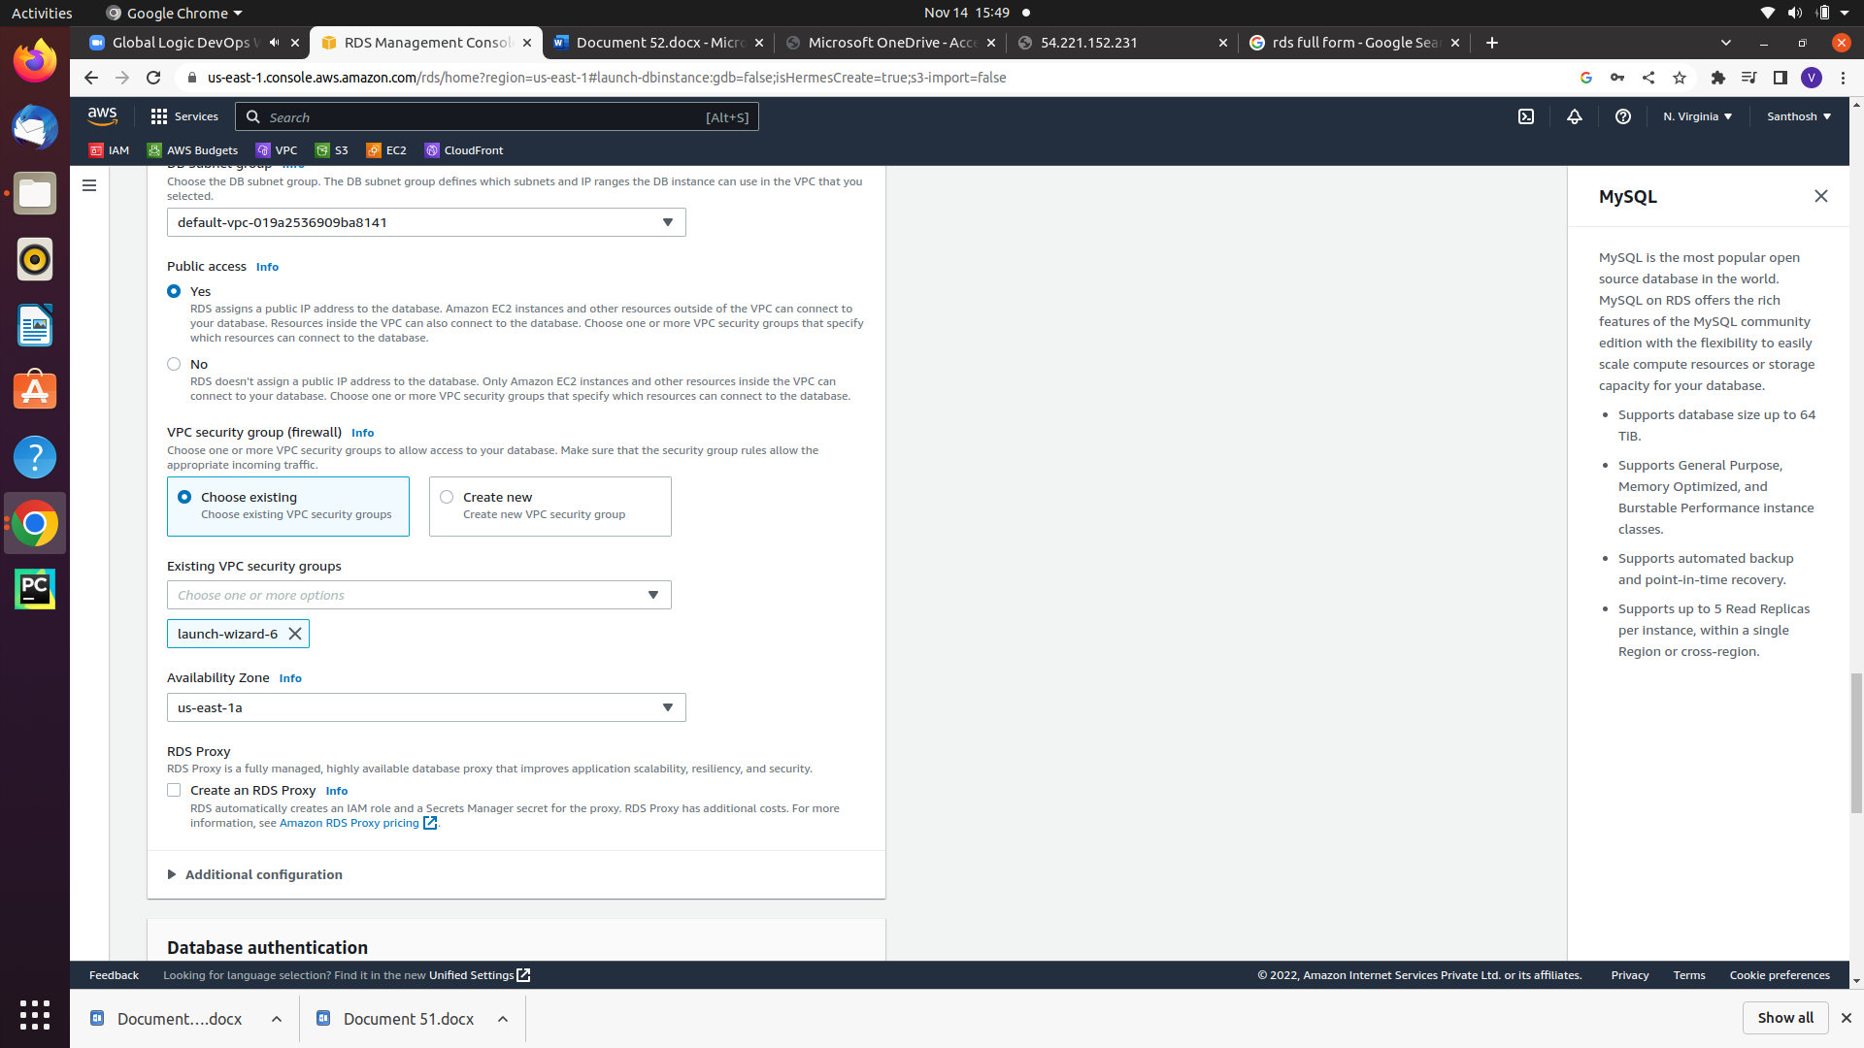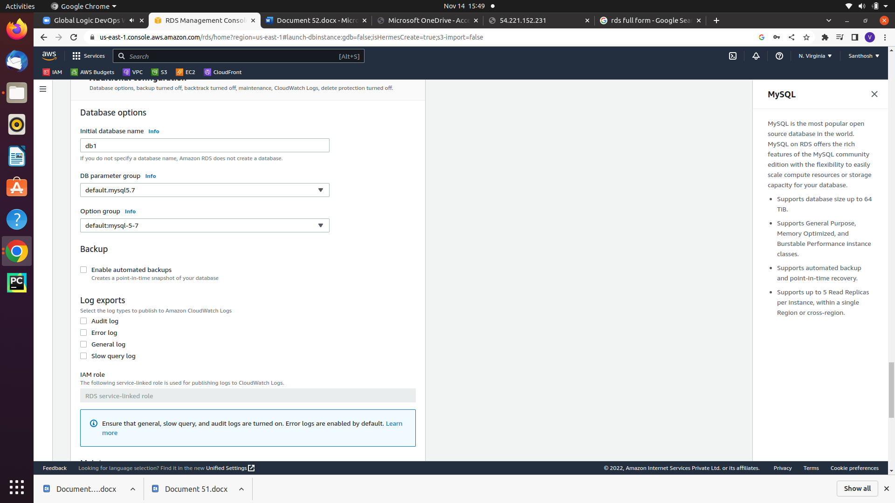

1. Launch an instalnce with 3306 (mysql aurora) security group and same subnet of rds
2. Connect with instances and run the command

**yum install mysql**

15. Go to the aws rds page click on database link and copy the [endpoint] command and run the this command

**mysql -h [endipoint] -u admin -p db1**

**Try to execut some commands**