**[3-8-22]**

**Docker Day-3**

**mrng:docker network adapter,vlumes**

**evng: volumes**

**Mrng:**

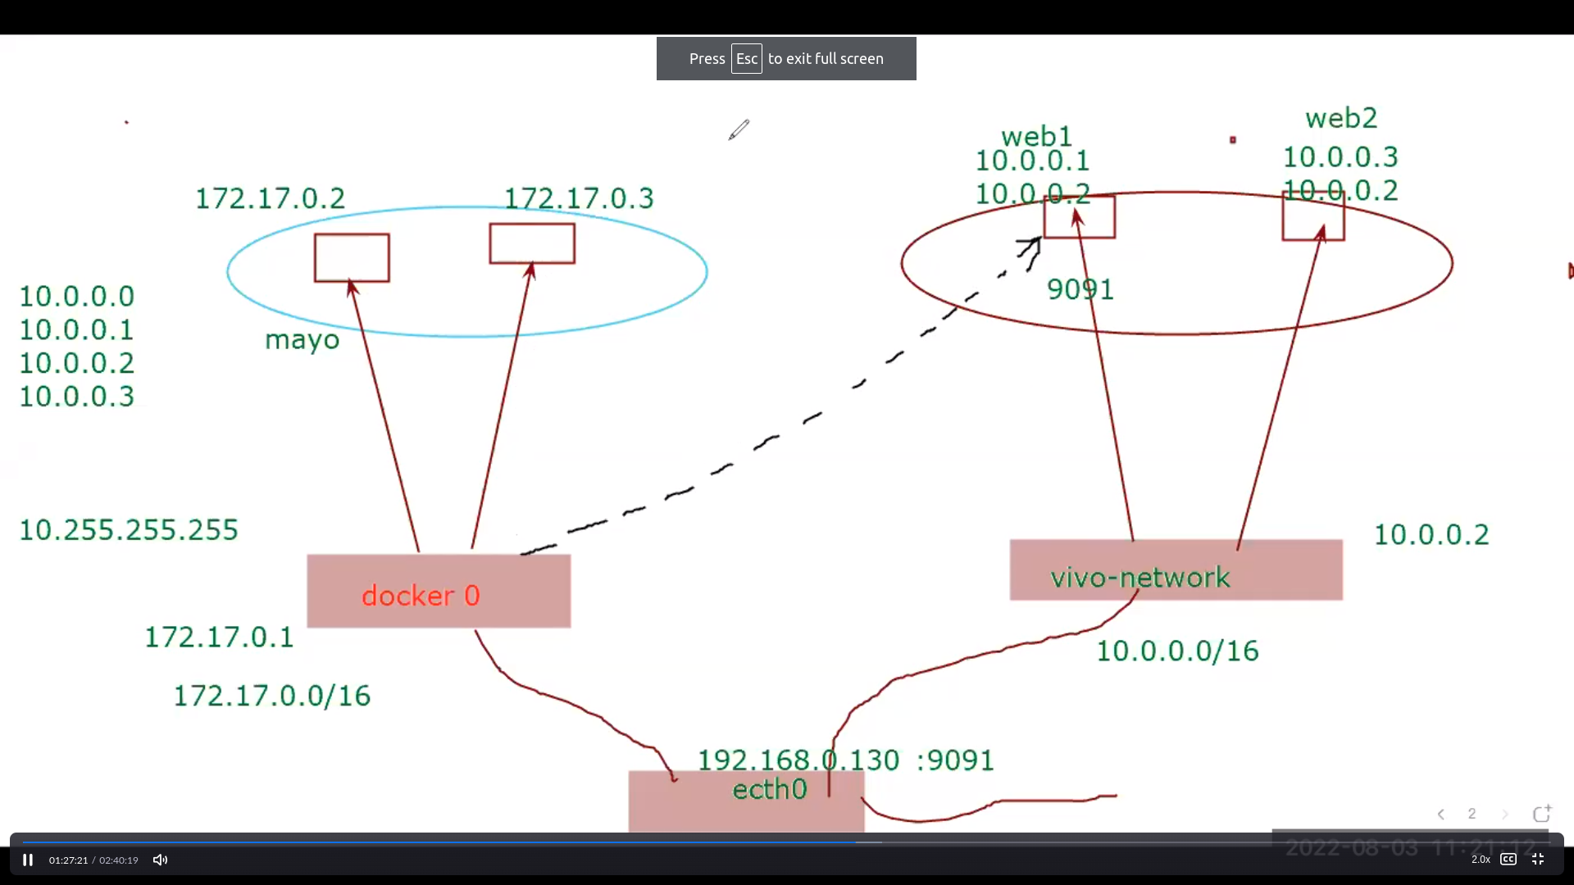

By this image we have to do a task

We have to create one customized bridge launch the two each containers on both default and customized

As of two different bridge connection is not possible initially because two diffenet subnets

Commands

11 yum install docker

12 clear

15 docker network create --subnet 10.1.0.0/16 --gateway 10.1.0.1 apple

16 docker network ls

20 docker network create vivo

23 docker run -d a1 --net apple -p 9091:80 httpd

24 docker run -d --name a1 --net apple -p 9091:80 httpd

25 docker run -d --name a2 --net apple -p 9091:80 httpd

26 docker ps

27 docker ps -a

28 docker run -d --name a3 --net apple -p 9092:80 httpd

29 docker run -d --name v1 --net vivo -p 9093:80 httpd

30 docker run -d --name v3 --net vivo -p 9094:80 httpd

31 docker ps

32 brctl

33 brctl show

34 docker network inspect vivo

35 docker network inspect apple

36 docker ps

37 docker exec -it a1 bash

38 docker exec -it v1 bash

39 docker network connect vivo a1

40 docker exec -it a1 bash

44 dccker inspect v1

45 docker inspect v1

46 docker exec -it a1 bash

48 brctl show

52 docker exec -it v1 bash

55 docker inspect a1

56 docker exec -it v1 bash

docker network connect vivo a1

Explanation:

25 :container is created but not runs because above container is used in the same port

39: to connect with the vivo bridge and disconnect from apple

56: to disconnect with the vivo bridge and connect from apple

Docker volume:

Whenever the container is removed the data which in the container is also removed so for that purpose we use docker volume.

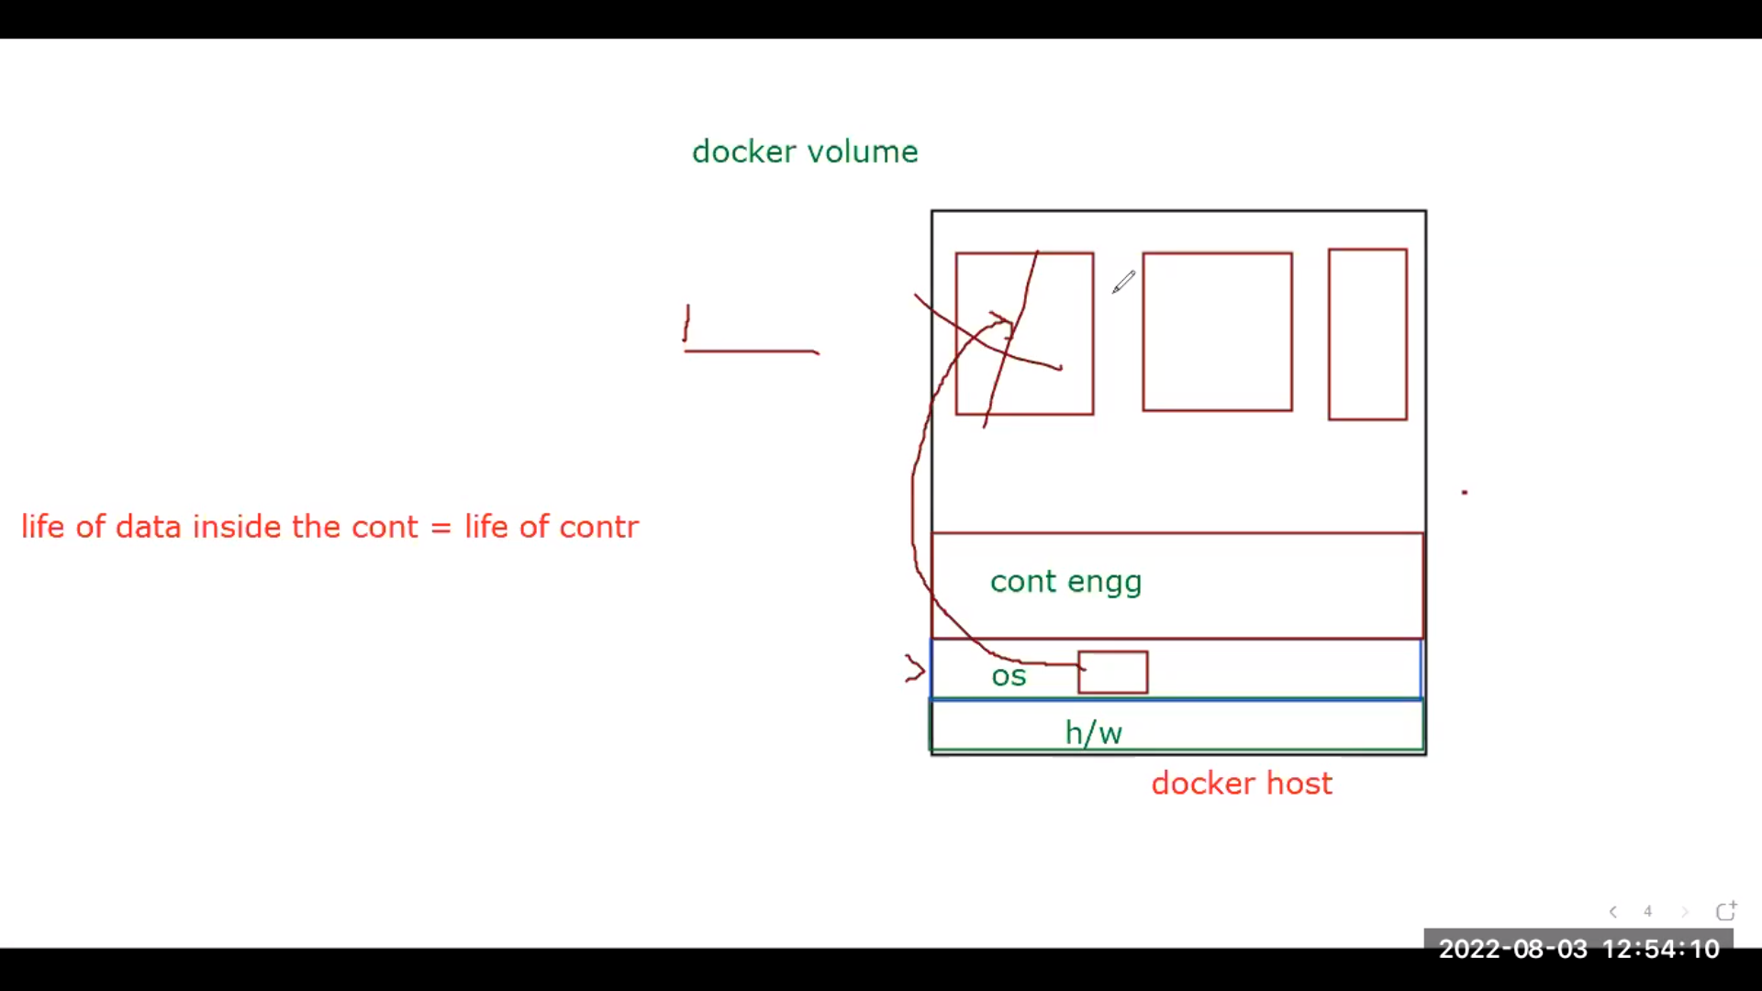

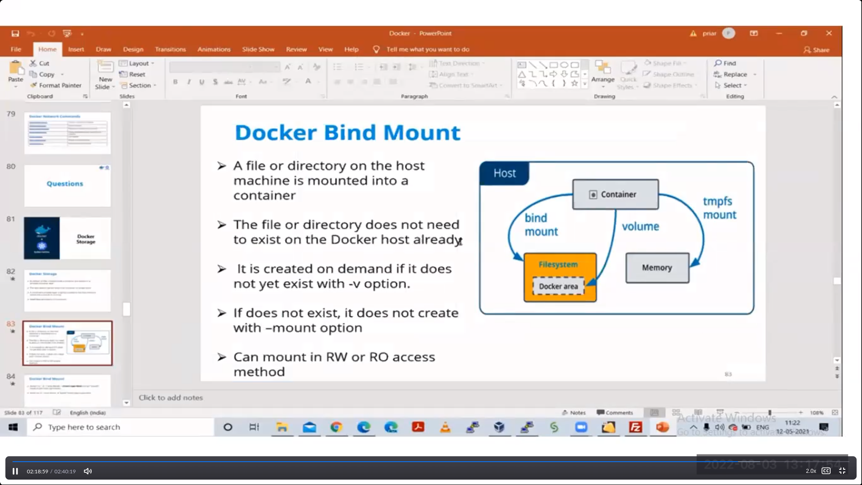

Types of docker volumes:

A)BindMount: In this we have to make dir in base machine and mount with container folder while creating container.

Note whateever the files and directories in createddir are reflected in the respected bindmounting in the diretory of the container

Commands:

62 docker network remove vivo

63 docker ps

64 docker rm -f $(docker ps -a -q)

65 docker network remove vivo

66 docker network remove apple

67 cleart

70 mkdir /data

71 cd /data

73 cat > index.html

74 docker run -d --name c1 --memory=10M --cpus=0.000005 -p 9092:80 -v /data:/usr/local/apache2/htdocs httpd

75 docker exec -it c1 bash

76 docekr inspect c1 |grpe -i ipaddr

77 docekr inspect c1 |grep -i ipaddr

78 docker inspect c1 |grep -i ipaddr

79 curl 172.17.0.2

80 brctl show

81 docker ps

Explanation:

65: to remove network adapter In order romove this first you have to remove containers or endpoints attached to that adapter

70: creates the directory

72: creates all properties along with volumen which bindmount

B)Volume:

For docker volumes we no need create separate directory you just have to mention volume it will created in the path ‘/var/lib/docker/volumes

Commands:

83 docker run -d --name c2 -p 9093:80 -v v1:/usr/local/apache2/htdocs httpd

84 docker volume ls

85 docker run -d --name c3 -p 9094:80 -v v2:/usr/share/nginx/html nginx

86 cd /var/lib/docker

87 ls

88 cd volumes

89 ls

90 cd v1

91 ls

92 cd _data

93 ls

94 cat index.html

95 pwd

96 cd ..

97 cd v2

98 ls

99 cd ..

100 cd v2

101 cd _data

102 ls

103 cat index.html

104 history

105 touch a1

106 ls

107 docker exec c3 -it bash

108 docker exce -it c3 bash

109 docker exec -it c3 bash

110 docker rm -f $(docker ps -a -q)

111 docker run -d --name c4 -p 90:80 -v vol2:/usr/local/apache2/htdocs httpd

112 docker exec -it c4 bash

113 docker volumes

114 docker volume

115 docker volume ls

116 docker run -d --name c5 -p 91:80 -v v2:/usr/local/apache2/htdocs httpd

117 docker exec -it c5 bash

Explanation:  
 83: creating the container wiith volume

84: shows all volumes of the contaienr

86: path where all docker files exits including container volumes

88: /var/lib/docker/volumes : show our volumes [/var/lib/docker/volumes/v1/_data : whatever u write in this reflect in c2 containerfolder and viceversa]

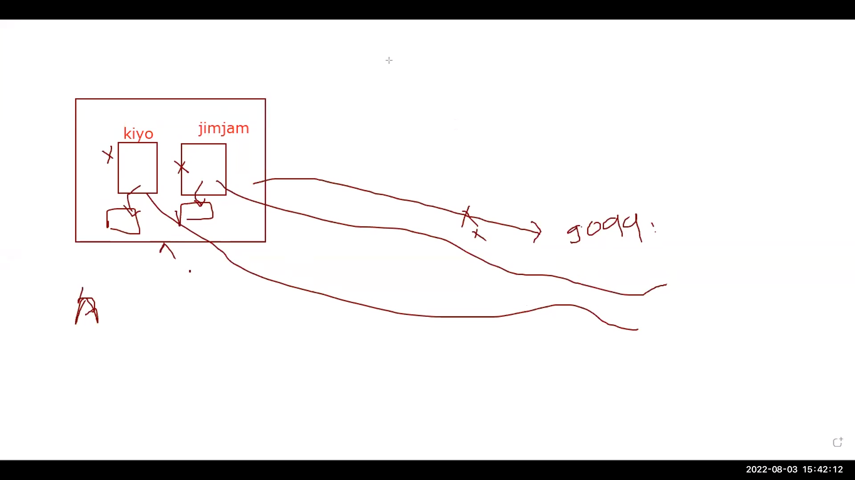

**Note**: whenever we delete the container the data volume not delete and wheneve we attach to another cotainer it will reflect to that container

116: I deleted the contaier and attached its volume to another container and reflection worked

Commands:

119 docker volume prune

120 docker rm -f $(docker ps -a -q)

121 docker volume prune

Expalnation:

119: to delete volumes

Note if you want delete the volume delete container first and delete volumes

tmfs:

Temp type of memory it come from RAM Memory of the container

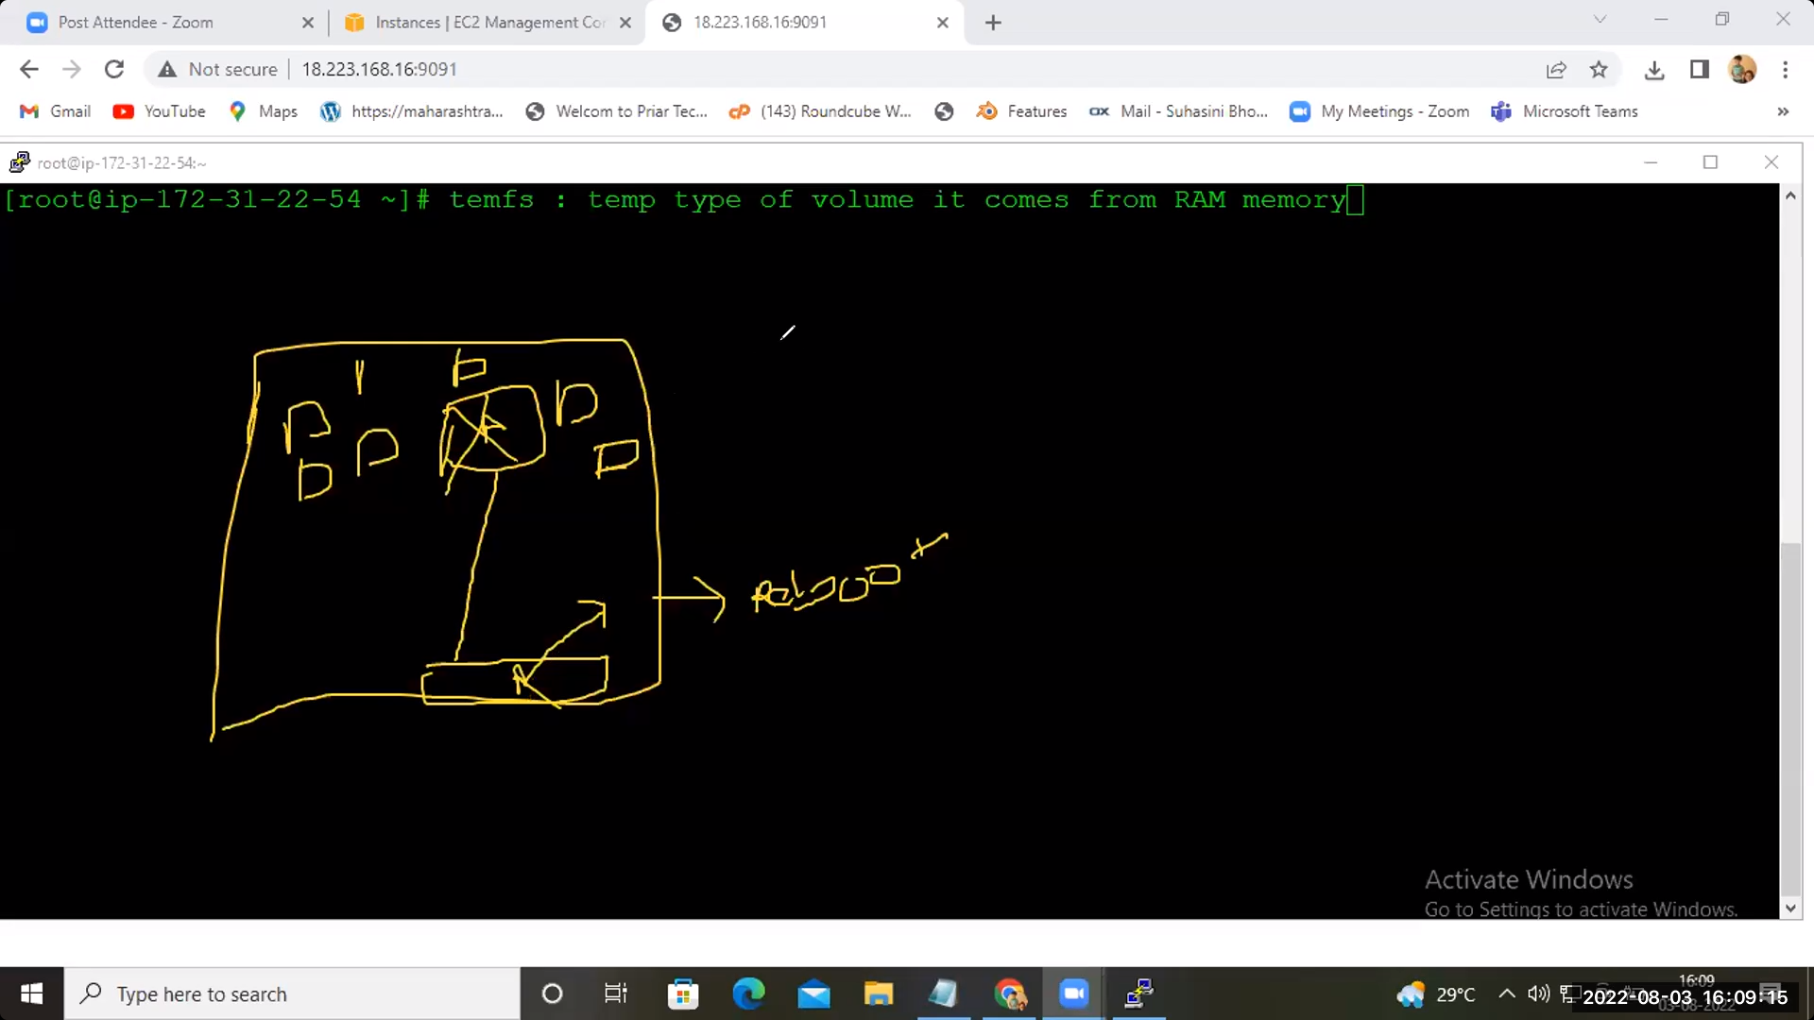

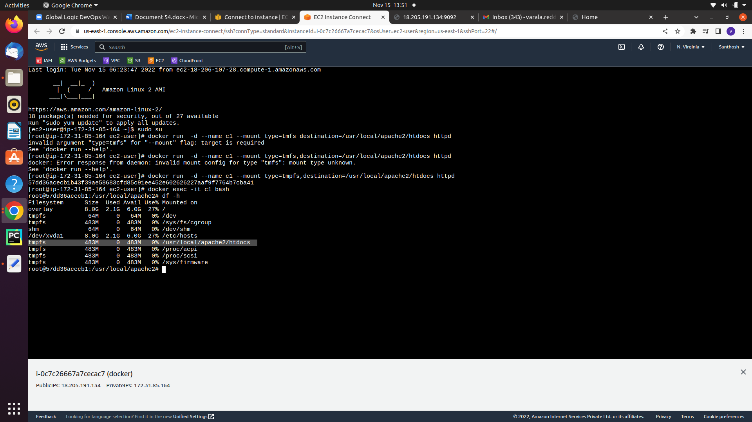

Command:

125 docker run -d --name c1 --mount type=tmpfs,destination=/usr/local/apache2/htdocs httpd

126 docker exec -it c1 bash

Expalantion:

125: to create the temperory volume inside the contaiener ram itself