**DockerDay-Mrng- processid,ports,hosts**

**Evng-docker network**

**Mrng:**

Note: Removing the image when we launch the container with the same image at first is not possible because of dependecy between them so if you want to remove the image stop the container and delete

In some case it is not even possible

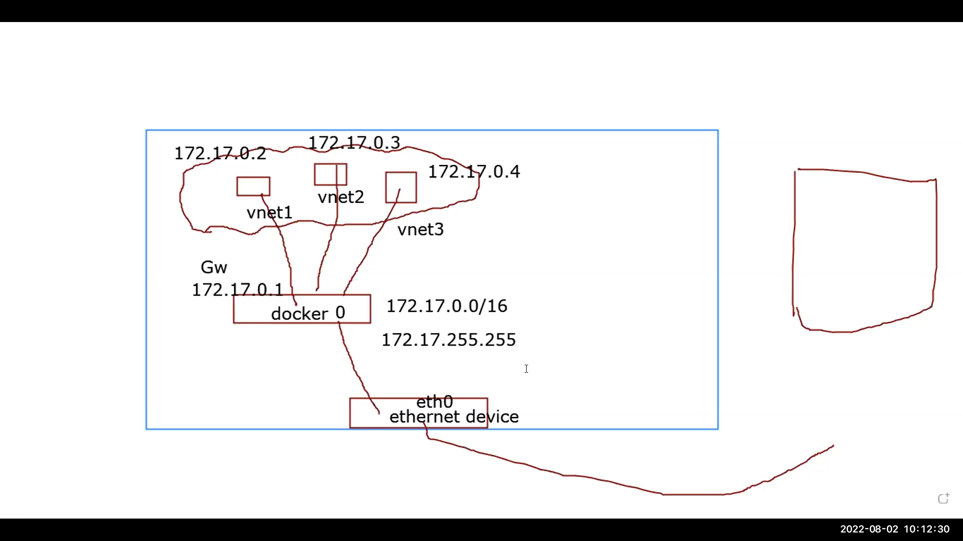

In this we have three different adapters (ifconfig) are conneted to outside using public ip

lancared adapter [eth0]

docker adapter {docker 0}

container adapter [vnet1,vnet2]

Commands:

1 yum install docker

3 systemctl start docker

4 systemctl enable docker

6 docker run -d --name web httpd

7 docker ps

8 docker exec -it web bash

9 ip a s

10 docker network ls

11 docker run -d --name web1 nginx

12 docker exec -it web1 bash

14 docker inspect web1 |grep -i ipaddr

Explanation:

9 : Same as ifconfig to show the adapter

10: it shows the connections

Container1 commands:

1 cd /usr/share/nginx/html

5 cat index.html

7 apt-get update

8 apt-get install net-utils

9 ls

12 cat > index.html

13 exit

14 history

Explanation:

1 it is the index.html path for nginx container where we write our code

Container2 Commands:

1 apt-get update

2 apt-get install net-tools

3 ifconfig

5 apt-get install iputils-ping

6 ping google.com

7 exit

8 ip a s

9 exit

10 exit

11 ls

12 cd htdocs

13 ls

14 pwd

15 history

Explanation:

/usr/local/apache2/htdocs : it is the index.html path for httpd container where we write our code

14: present working directory

Commands:

15 curl 172.17.0.3

16 history

17 ip a s

18 ifconfig

19 docker exec -it web1 bash

20 docker exec -it web bash

21 docker run --name sam1 -d --memory 10M --cpus="0.000001" httpd

22 docker run --name sam2 -d --memory 12M --cpus="0.000002" httpd

23 docker run --name sam3 -d --memory 13M --cpus="0.000003" httpd

24 docker ps

25 docker inspect sam1

26 docker inspect sam2

27 docker run --name sam5 -d --memory 13M --cpus="0.000003" -h linux3.apple.com httpd

28 docker inspect sam5

32 lsof

33 top

34 ps x -l

35 cd /proc

Explanation:

16: commands executed previously

21: creating container with specific memory and cpu usage

25: to check for memory and cpuusage

27: same as 21 but with hostname and domain name[linux3.apple.com= linux3:hostname and apple.com: domainname]

32: list of open file [don’t use]

33: used to check processes with nice values[ [-20 t0 19 (–20:higest priority,19: lowest priority}]

34: used to check the process along with parent process id

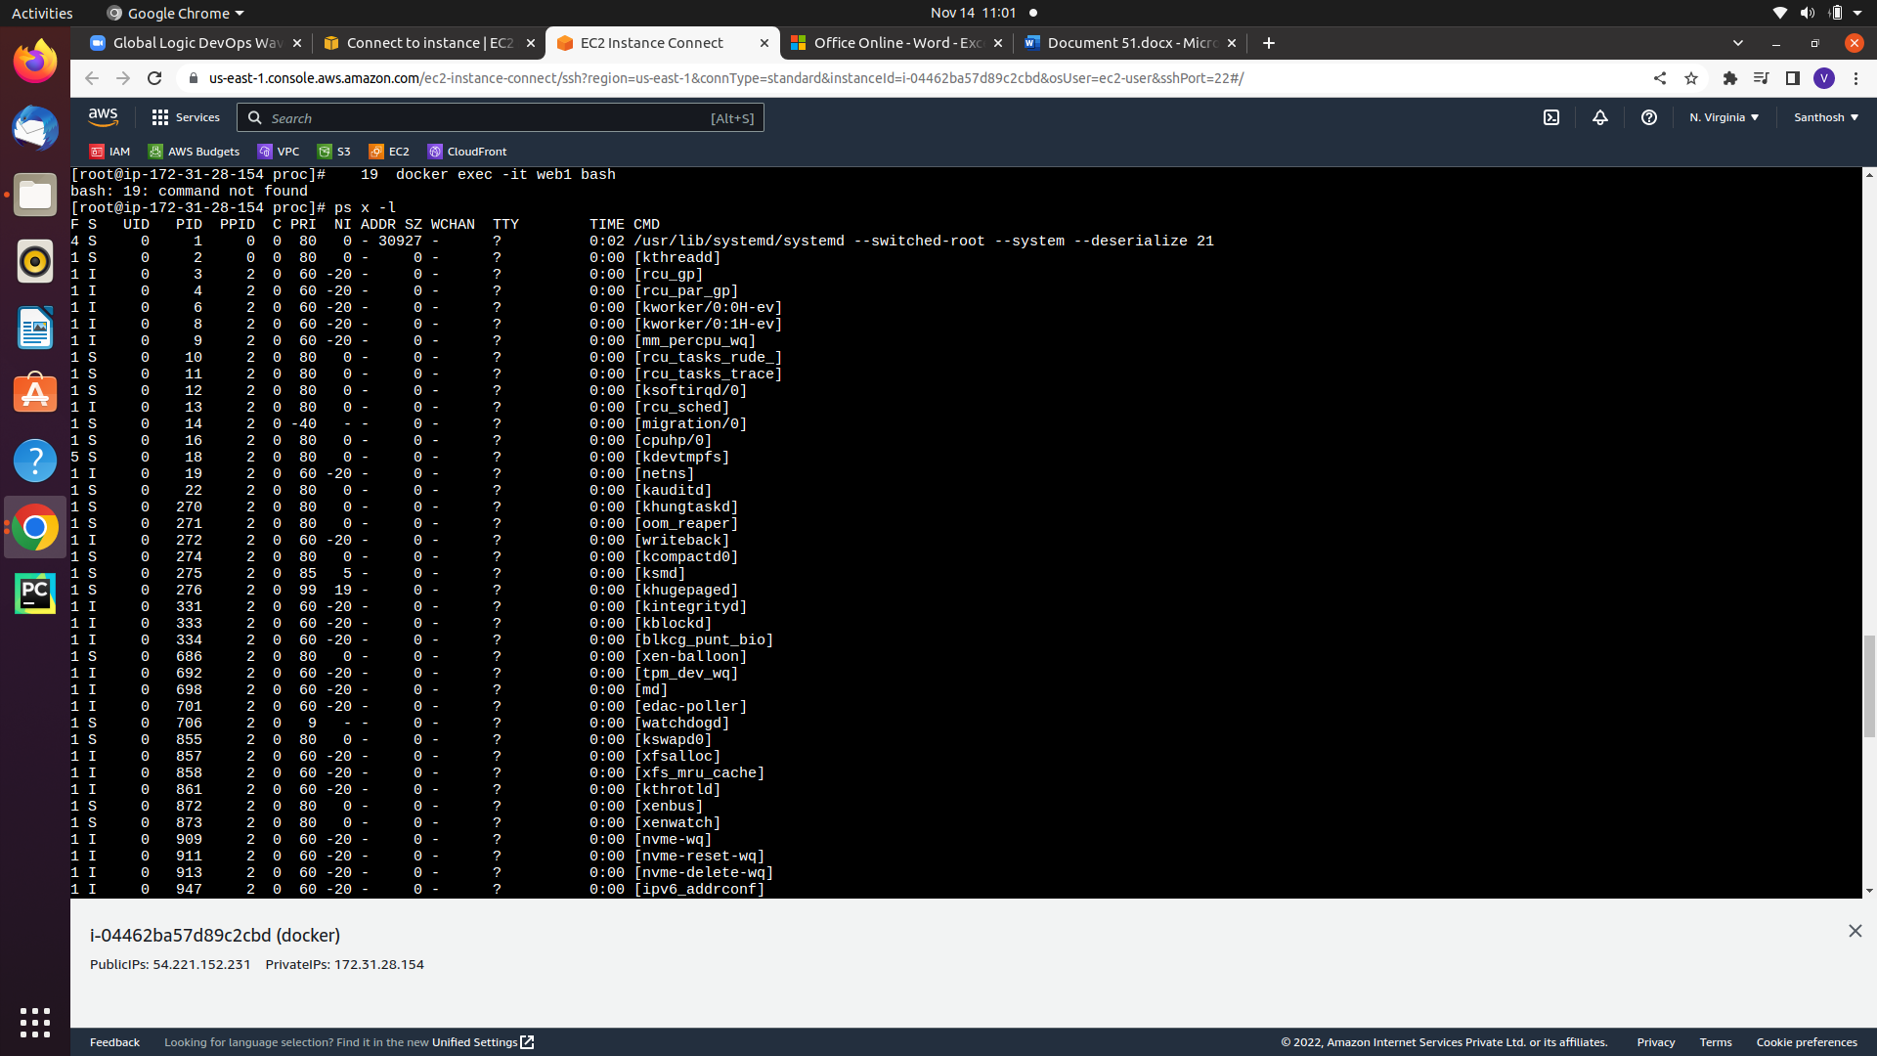

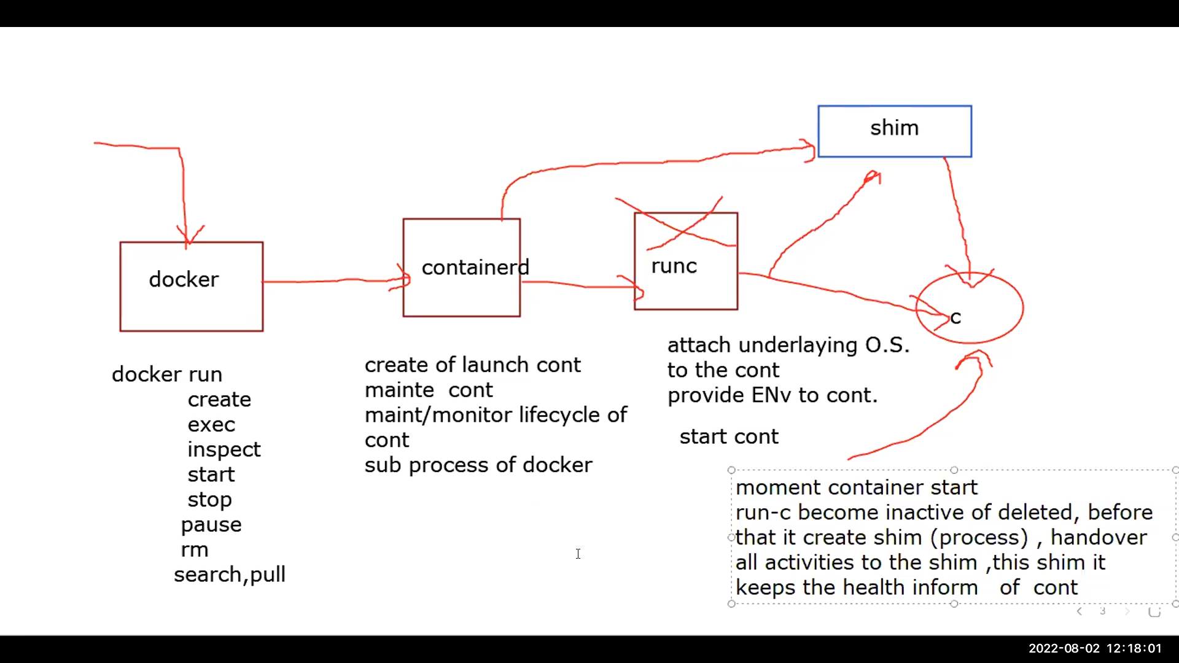

Process of docker machine and flow

Commands explanation:

ps fxa |grep docker -A 3 : It shows the process id of above images

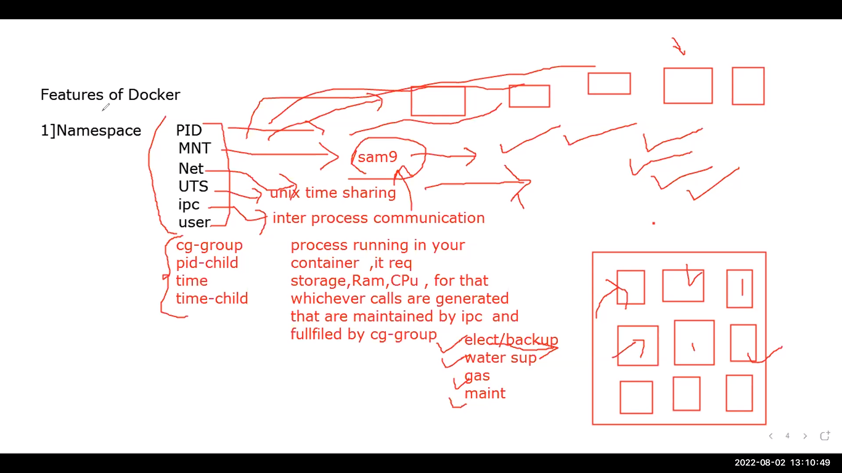Container namespace attributes

Pid: process id of cotainer

Mnt: mountpoint of container to acces it multiple times

Net: all networkthings like installing and uninstalling

UTS: it is share tme for file creation and etc

user: create root user by default

Command expalantion:

cd /proc/4737/ns : ls gives all the attributes as shown in images [4737 particular process id it may chagess]

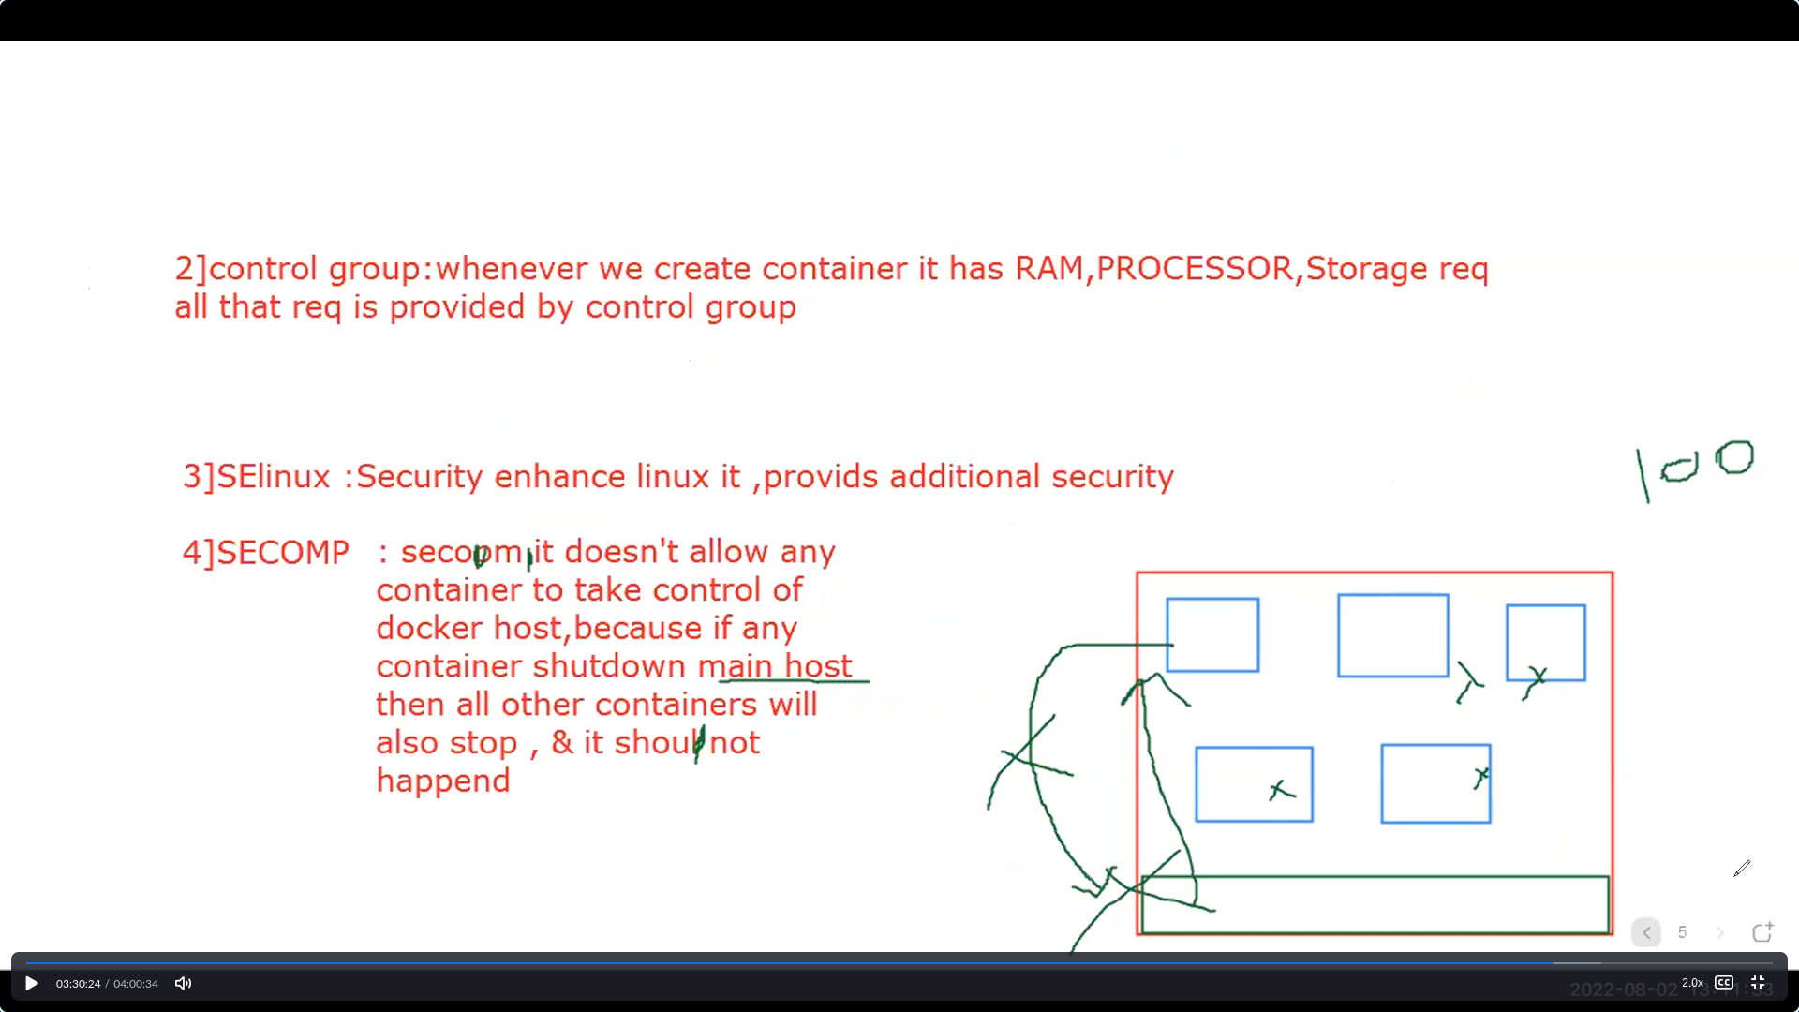Cg-group attribute

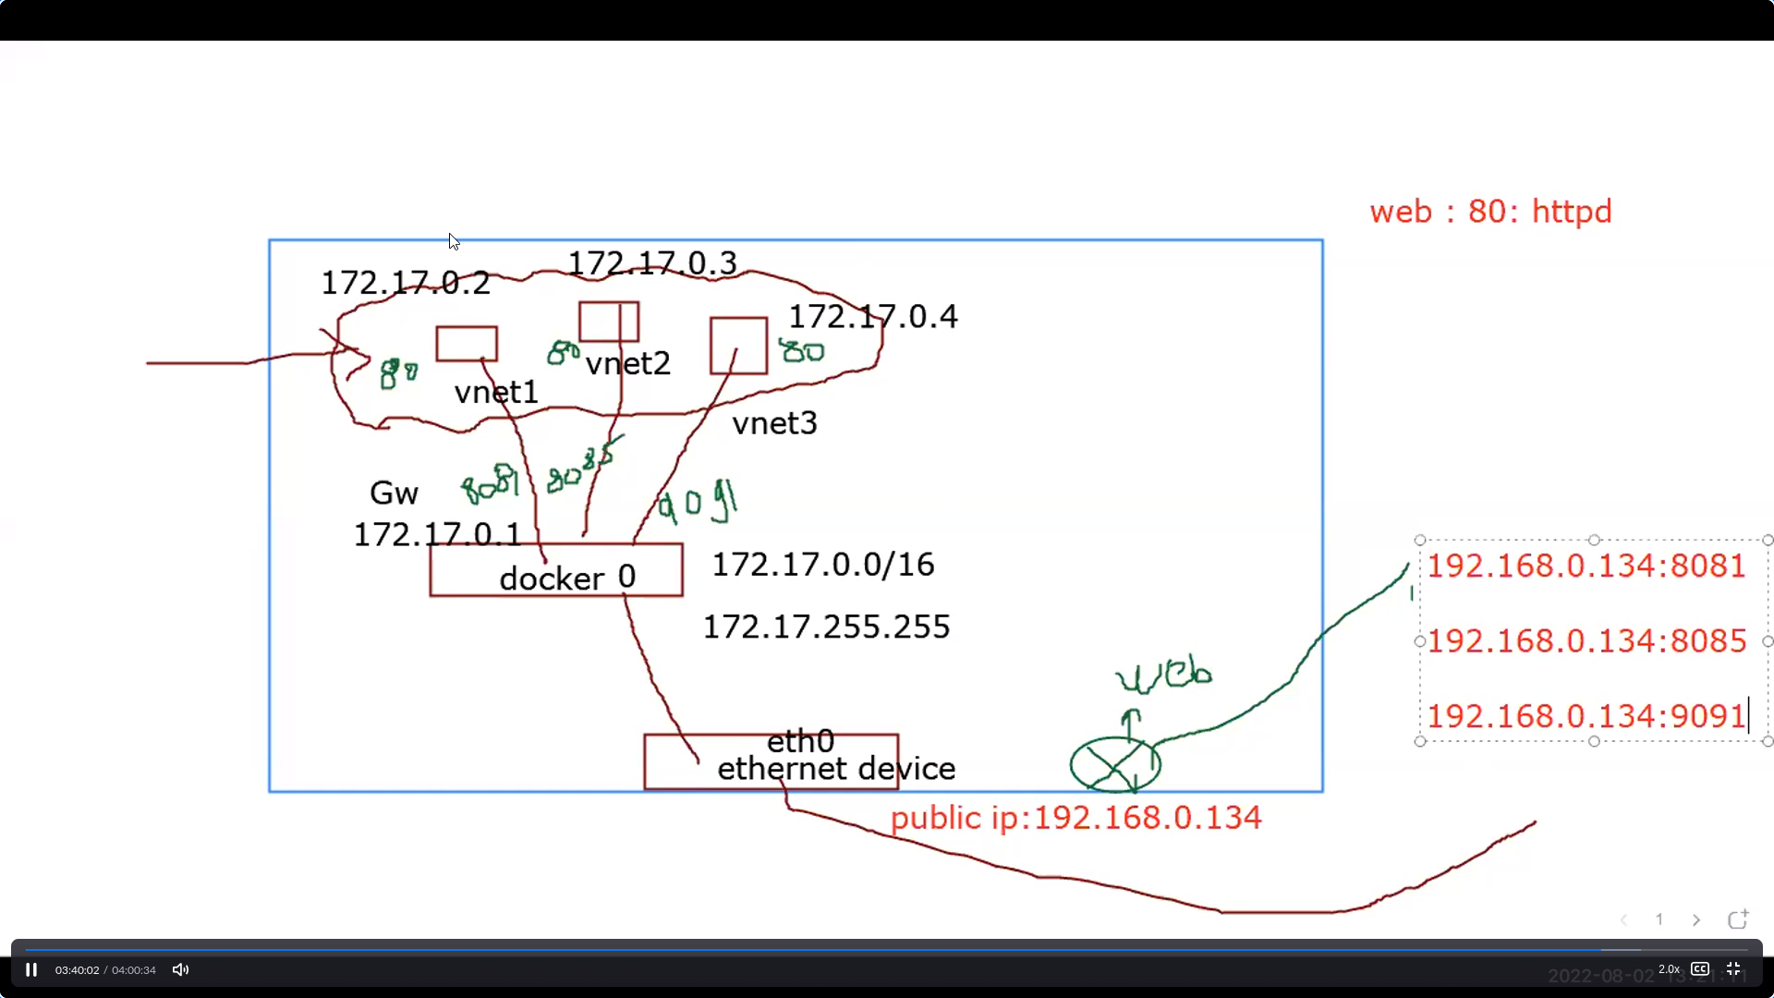

To access the our html page we have to separate port no for each container as shown in img

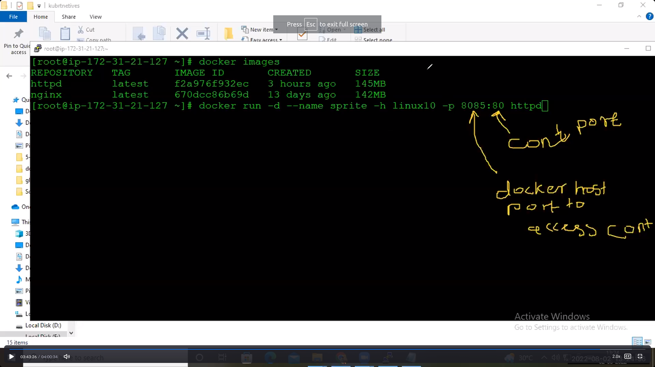

Command and explanation:

In above image tha command explains that creating container using port no

**Evng:**

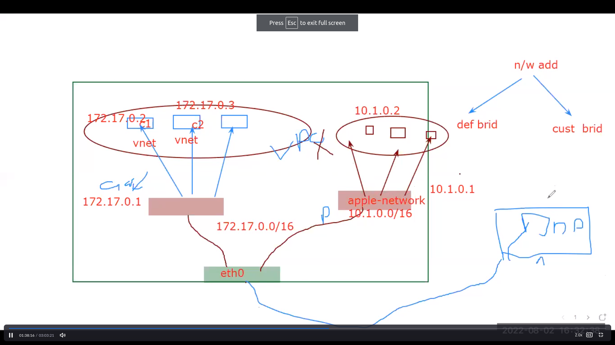

Type of adapters

Default adapter[defualt 0]: defaultly created while installing docker

Three subnerwork for default docker 0 adapter

A) bridge: communication b/w contaiers and also interenet

B) host : communication b/w two containers of same subnet

C) loop or null : no communication

Customized adapter: creating own adapter

Task: launch two container and communicate b/w one container to another container\

Commands:

65 docker network list

66 brctl show

67 docker network inspect bridge

68 docker network create vivo

70 brctl show

71 docker network list

72 docker network create --subnet 10.2.0.0/16 --gateway 10.2.0.1 apple

73 docker network list

74 ifconfig

75 ip a s

76 docker run -d --name c1 -p 8089:80 --net vivo httpd

77 ip a s

Explanation:

65: to show adapters

67: to show details abount particular adapter

68: creating customized adapter

69: show which container connected to which adapter

72: creating customized adapter with customized subnet and gateway

76: creating container with customized adapter